
BMIH4005
Marketing Essentials
Component 2- Marketing Plan
Lecturer: Dr Jayne Griffith-Parry, Dr Huw Thomas, Neil Dyer, Ruth Taylor-Davies, Deborah Lloyd.
Student Name- Riyadh Mridha
Student ID- 2111510

Table of Contents
Introduction 3
The Marketing Mix of “Son Brull Hotel & Spa” 5
Creating Customer Value and Engagement 6
Usage of Digital Marketing Effectively 7
The Microenvironment of Marketing 8
The Microenvironment of Marketing 9
Conclusion 10
References 11

Introduction
Marketing is a customer-oriented value-creating method of companies and companies marketing to capture customer value. Proper marketing plans can lead a company to the peak of success. Both the macro and micro environments are essential for organizations like “Son Brull Hotel & Spa”. This task will include the 4P’s of the organization along with creating value for the customer. Discussing the usage of digital marketing will also include the micro and macro environment affecting the organization (Grewal & others, 2020).

Business Overview
“Son Brull Hotel & Spa” is an eighteenth-century hotel that was famous for its Jesuit that has been converted into luxury recently. It operates its business in Mallorca Island and provides the best hotel and spa services to its consumers. This Spanish hotel has been successful in holding its name and fame in the business for around two centuries.
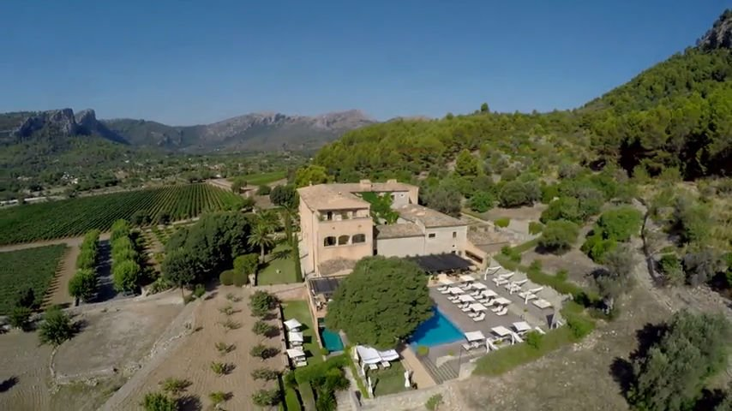

Figure 1: A birds-eye view of “Son Brull Hotel & Spa” (Relais & Chateaux,2021)
Mission
To provide better residential and spa service to consumers
Vision
To prove itself as one of the best hotel and spa centres in the world.

The Marketing Mix of “Son Brull Hotel & Spa”
4P’s or the marketing mix of an organization indicates the success of an organization. The marketing mix includes product, price, place, and promotion and all of them are stated below in the context of “Son Brull Hotel & Spa” (Thabit & Raewf, 2018).
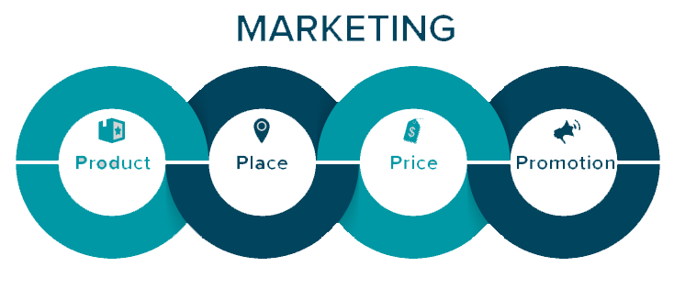
Figure 2: The marketing mix (C-tech, 2021)
Product: Product or service is the profit-making tool of organizations. The product includes the services of “Son Brull Hotel & Spa” which are residential services, spa services, related services, and so forth. To attain the desired goal of the organization, it must ensure the quality of its products and services (Blut & others, 2018).
Price: After product, price is the second important measure that can make the organization profitable and it is the exchange that brings success to organizations. “Son Brull Hotel & Spa” must ensure fair prices to its products.
Place: It is the target market position where organizations give their services to consumers. Even higher quality products at cheap price range become faded if the placement of business is not chosen right and “Son Brull Hotel & Spa” must ensure it (Blut & others, 2018).

Promotion: In the first three P’s, companies created value and set their price and place, but this final P will let the people know about the product and service of “Son Brull Hotel & Spa”. It breaks the communication barrier related to information by using advertisements, personal selling, and other promotional services.

Creating Customer Value and Engagement
Companies need to critically think about the value they are providing to customers. Customers will indeed move to the markets where they will get the best benefits using the lowest investment. Not only “Son Brull Hotel & Spa” but also every other organization must ensure the satisfaction of their customers (Leroi-Wereleds, 2019).
We know that market is a set of existing and potential customers of the product or service the organization is selling. So, “Son Brull Hotel & Spa” must ensure that they work for the satisfaction of the existing customers and the potential customers as well. To engage customers with its services and products, the organization must ensure that it provides some competitive advantages to its customers (Barari & others, 2021).
Building profitable customer relationships is one of the most important measures of the entire marketing process. To ensure customer engagement and satisfaction, organizations must work giving this work their most priority. “Son Brull Hotel & Spa” must look for the customer perceived value that will make a seasonal customer to the organization fixed and profit-making customers.
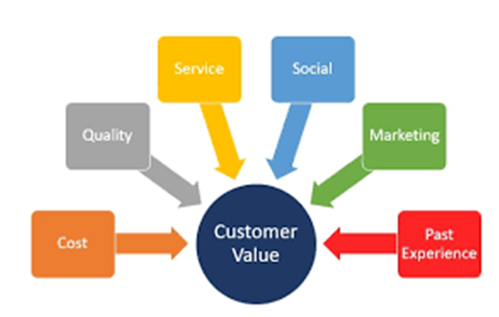
Figure 3: Customer value (Leroi-Wereleds, 2019)

Usage of Digital Marketing Effectively
In the era of science and technology, using digital marketing tools is a must. Digital marketing can be referred to as making value for customers and letting them know about the product or service via digital platforms (Hanlon, 2019).
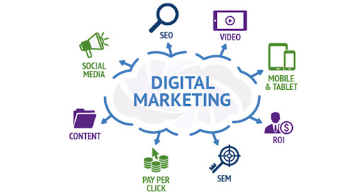

Figure 4: Digital marketing (Hanlon, 2019)
Various digital platforms are popular nowadays such as SEO marketing, Social Media Marketing, Email marketing, Content marketing, Video marketing, and so on. “Son Brull Hotel & Spa” can use one of them effectively for the advertisement of their products and services and this will surely increase sales and promotions as well (Bala & Verma, 2018).

The Microenvironment of Marketing
The microenvironment of marketing of “Son Brull Hotel & Spa” can be analysed using the SWOT analysis of the organization. The microenvironment includes the overall internal and external, positive and negative factors related to the organization only.
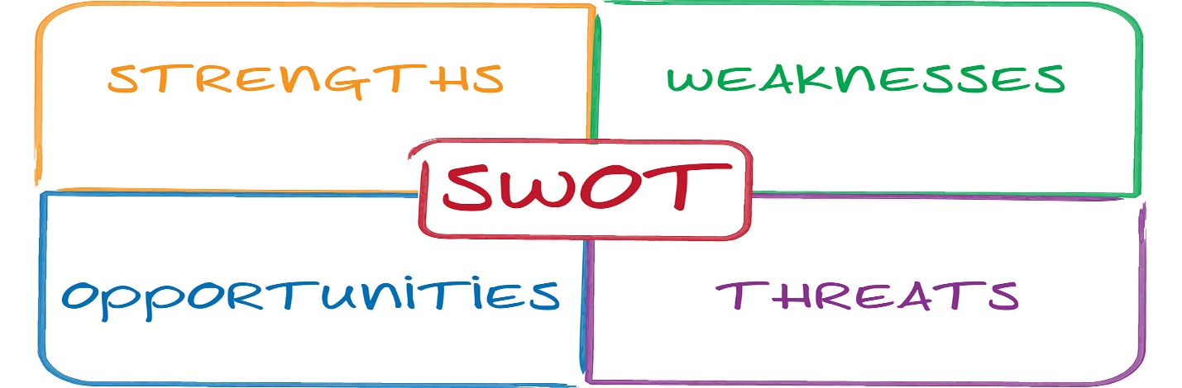
Figure 5: SWOT analysis (GURL, 2017)
The SWOT analysis of “Son Brull Hotel & Spa”
Strengths  The organization can identify their inner strengths that can be used for its business. The success of organizations lies within using the strengths properly to negate threats and weaknesses (GURL,2017). | Weaknesses  The organization’s weaknesses are from their insides and it indicates the failure rate of the organization. The more an organization can decrease their weaknesses, the more the organization can be (GURL, 2017).
Opportunities  This external factor is positive for organizations and helps bring success to the organization. “Son Brull Hotel & Spa” must use their opportunities properly to increase the profit margin. | Threats  Threats are negative external factors for the organization that harm the organization’s production, sales, marketing, distribution, finance, and various other important operations.

The Microenvironment of Marketing
To know the microenvironment of “Son Brull Hotel & Spa”, it is a must to use the PESTEL analysis that includes the macroenvironmental factors that affect business in their operations (Matovic, 2020).
The PESTEL analysis of “Son Brull Hotel & Spa”
Political Factors | Political factors like instability of political conditions can harm business and on the other hand, positive political factors like government stability, political stability, and so forth can help organizations bring success.
Economic Factors | Economic conditions of the customers directly impact the sales of the organizations. During the COVID_19 pandemic, consumers lost their income level and that caused businesses like “Son Brull Hotel & Spa” to face a downward slope on their profit margin (Matovic, 2020).
Social Factors | This factor includes the life cycle, lifestyle, age, etc. that are responsible for the change in consumers buying behaviour that keeps a huge impact on the operations of “Son Brull Hotel & Spa”.
Technological Factors | Using new technologies and taking advantage of them are included in the technological factors. The organization must use technology to attain the desired vision (Matovic, 2020).
Environmental Factors | The world is facing a scarcity of raw materials and “Son Brull Hotel & Spa” should ensure the effective use of the scarce resources to get the most possible output.
Legal Factors | Legal factors include laws regarding business and e-commerce platforms. Laws ensure the legal usage of resources accurately and give businesses advantages like not facing fraud and much more.

Conclusion
Businesses become popular and successful in the long run by using marketing in the best possible way. Understanding the marketplace and the environment affecting the business positively and negatively, externally and internally is also important. This task has shown the marketing mix together with the value creation for customers and effective usage of digital marketing. The micro and macro environment of business are also described in the context of “Son Brull Hotel & Spa”. This assignment has helped me gain vast knowledge about marketing (Deepak & Jeyakumar, 2019).

References
Bala, M. and Verma, D., 2018. A critical review of digital marketing. M. Bala, D. Verma (2018). A Critical Review of Digital Marketing. International Journal of Management, IT & Engineering, 8(10), pp.321-339.
Barari, M., Ross, M., Thaichon, S. and Surachartkumtonkun, J., 2021. A meta‐analysis of customer engagement behaviour. International Journal of Consumer Studies, 45(4), pp.457-477.
Blut, M., Teller, C. and Floh, A., 2018. Testing retail marketing-mix effects on patronage: A meta-analysis. Journal of retailing, 94(2), pp.113-135.
Deepak, R.K.A. and Jeyakumar, S., 2019. Marketing management. Education Publishing.
Grewal, D., Hulland, J., Kopalle, P.K. and Karahanna, E., 2020. The future of technology and marketing: A multidisciplinary perspective.
GURL, E., 2017. SWOT analysis: A theoretical review. Labib
Hanlon, A., 2019. Digital marketing: strategic planning & integration. Sage.
Leroi-Werelds, S., 2019. An update on customer value: state of the art, revised typology, and research agenda. Journal of Service Management.
Matovic, I.M., 2020. PESTEL Analysis of External Environment as a Success Factor of Startup Business. conscious, p.96.
Thabit, T. and Raewf, M., 2018. The evaluation of marketing mix elements: A case study. International Journal of Social Sciences & Educational Studies, 4(4).


