In-Depth Analysis of the Animation Production Process of Mr. Peabody & Sherman

1. Inventive Foundation and Sources of Motivation
Rebooting a Classic IP:
The film is based on characters from the 1960s American enlivened arrangement The Rough and Bullwinkle Appear, particularly Mr. Peabody. DreamWorks Liveliness reimagined the story utilizing advanced 3D activity strategies. Whereas protecting the comedic charm of the initial, the studio implanted the reboot with modern components such as family feelings and science fiction topics.
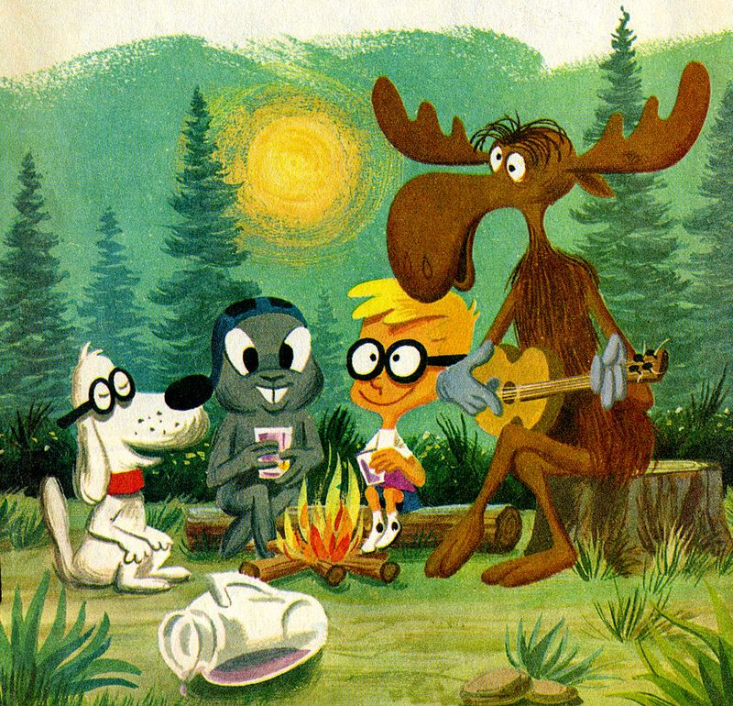

Director Rob Minkoff elaborated in detail on his original creative intention and sources of inspiration in many interviews.
In an interview with "Tinseltine", Minkov said, "For me, this is a film about a father and a son..." Regarding the adoption relationship. He further explained: "I once made a film about humans adopting mice, 'Little Elf Mouse', but this time I did the opposite and let a dog adopt a human boy..." This tells the story of raising a son.
Furthermore, in an interview with "Den of Geek", Minkoff mentioned: "Our question is, in this world, in this era, will everyone accept this situation?" We don't think so! So these areas feel that they can lead the characters into a more profound story.
These interview contents delve deeply into the emotional core of the non-traditional family structure in the film and the evolution process of the father-son relationship.
Mr. Peabody isn't as it were a Harvard-educated mental and an finished innovator, but he too embraces a human orphan—a story differentiate that shapes the passionate center of the story. Screenwriter Craig Wright clarified, “We needed to investigate the warmth of non-traditional families and illustrate that cherish and insights are not bound by species.”
Rob Minkoff Interview - Mr. Peabody & Sherman (2014) | The MacGuffin
Showcase Situating:
Focusing on a wide family group of onlookers, the film mixes science fiction experience with authentic instruction, pointing to form a true “all-ages” enlivened involvement. By employing a time machine to investigate major authentic occasions such as the French Transformation and Old Egypt, DreamWorks consolidated an instructive layer underneath the excitement. In the interim, funny components were woven in to adjust the more genuine subject matter and keep up availability.
2. Script Structure Analysis: The Three-Act Model
2. Script Structure Examination:
The Three-Act Show
Act I – Setup and Starting Strife:
Mr. Peabody is an exceptionally cleverly pooch who is completely acknowledged by human society. Not as it were has he made groundbreaking logical contributions—most eminently designing the WABAC time machine—but he has too embraced a human vagrant, a boy named Sherman. At school, Sherman features a debate with his classmate Penny, which draws in the consideration of child defensive administrations. Specialists start to address whether a pooch is really qualified to raise a human child, setting the central pressure into movement. In an exertion to accommodate the two children, Peabody takes them on a time-travel journey. In any case, they incidentally cause a disturbance within the space-time continuum.
Act II – Rising Activity and Complex Challenges:
The trio voyages through a few major chronicled periods—including the Renaissance, Antiquated Egypt, Antiquated Greece, and the Trojan War. Each fragment is created to provide both instructive substance and passionate development. As Sherman and Penny's relationship makes strides through their shared encounters, Peabody's personality and part as a father confront developing investigation. Inevitably, the timeline starts to winding out of control. Sherman, endeavoring to require things into his possess hands, inadvertently declines the problem—allowing verifiable figures to spill into the cutting edge period and advance raising the emergency.
Act III – Climax and Enthusiastic Determination:
A full-scale authentic emergency unfurls in present-day Unused York City. Famous figures like Leonardo da Vinci, Abraham Lincoln, and Albert Einstein arrive in the advanced world, causing chaos and disarray. Before everybody, Sherman transparently pronounces that Mr. Peabody is his genuine father. This open affirmation marks the passionate tall point of the story and catalyzes societal acknowledgment of Peabody's part as a legitimate adoptive parent. Working along side the others, Peabody oversees to reestablish the timeline and seal the break within the space-time continuum. Their bond is both socially and legitimately certified.
3. Character Design and Narrative Function
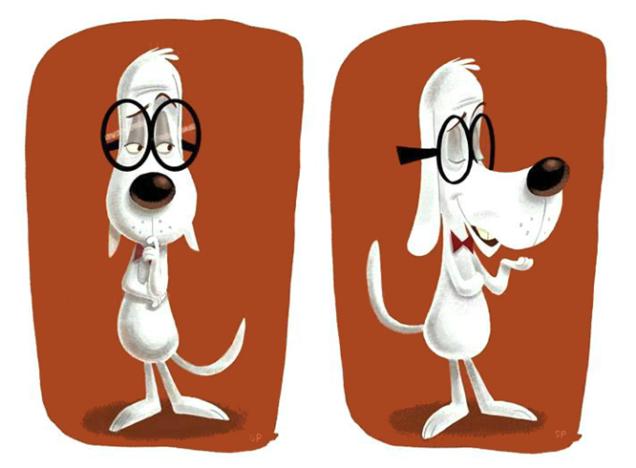
Mr. Peabody:
A dual-role character who is both a father and a scientist. Guided by logic and intellect, he gradually learns to embrace emotional understanding. He embodies the “nontraditional father,” challenging societal stereotypes and serving as the rational axis of the story’s emotional arc.
Sherman:
The narrative is largely told from Sherman’s point of view, making him the audience’s emotional anchor. His character undergoes a coming-of-age transformation—from a protected child to a responsible, decision-making figure. His development drives the central arc of the story.

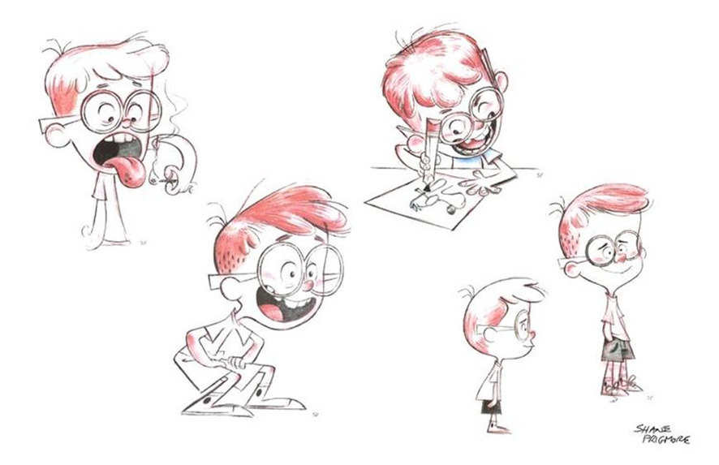
Penny:
Introduced as an adversarial figure at school, Penny’s role evolves into that of a partner and peer. Her character helps introduce conflict, but ultimately supports emotional development and resolution, particularly in the dynamic between her and Sherman.
Social Representatives:
These characters function as narrative tools to reflect societal skepticism toward a dog raising a human child. They serve as foils that highlight the film’s central discussion on the legitimacy and recognition of alternative family structures.
4. Thematic Analysis
In spite of the fact that the introduce of a canine raising a human child might show up crazy, it serves as a effective allegory:
the authenticity of a family isn't decided by science or societal standards, but by cherish, commitment, and common care. Whereas the film presents verifiable actualities through time-travel undertakings, the more profound message is that genuine instruction goes past information transmission—it lies in enthusiastic direction, character advancement, and regard for distinction. Mr. Peabody's character bend moves from strict logic to enthusiastic openness, strengthening the thought that rationale and compassion must coexist.
5. Script Highlights and Narrative Techniques
Sort Combination:
The film expertly combines science fiction, comedy, family show, and authentic enterprise. This cross breed approach keeps the story locks in over age bunches and gives passionate and mental profundity.
Fast-Paced Altering and Celebrity Cameos:
The film's quick altering fashion is well-suited for more youthful gatherings of people who have shorter consideration ranges. The incorporation of recognizable chronicled figures includes layers of humor and social reference.
Double Account Structure:
The story unfurls along two interwoven circular segments:
the outside plot of verifiable time-travel experiences and the inner passionate travel of father-son holding and individual development. These parallel strings strengthen one another.
Imagery and Social Parody:

By including non-human characters in human social parts, the film unpretentiously studies societal desires and preferences. This allegorical layer energizes more profound reflection whereas keeping up a light tone.

6. Storyboards and Animatics
Toon Boom Storyboard Master played a significant part within the generation of Mr. Peabody & Sherman. The software's timeline altering and 3D camera recreation highlights empowered the chiefs and storyboard craftsmen to precisely create the visual narrating cadence amid the pre-production arrange.
A prime outline is the time travel course of action utilizing the WABAC machine. In early drafts of the storyboard, the gather experienced many challenges such as clashing shot moves and dubious spatial method of reasoning. Utilizing Toon Boom's 3D camera recreation, the bunch built a virtual environment to assume complex spatial overlays, handling issues with time-space method of reasoning though overhauling the visual show.
The software's onion-skinning procedure allowed specialists to exactingly orchestrate the movement ways of WABAC's sparkling mechanical parts. Particularly inside the wormhole course of action, fluid components were mirrored with built-in particle systems, engaging a dependable visual lingo that would a while later animate rendering workflows.
Diverse cycles of the animatic were conducted, each refined through A/B testing utilizing the adjustment comparison work. Inside the final adjustment, the time travel course of action was broken into keyframes, each labeled with camera speed, color checking on values, and sound flag markers. This fussy previsualization through and through diminished the require for over the top alterations in the midst of post-production.
When the scene was at final showed up in theaters, the breathtaking confusion of common crossing and the energizing sense of mental bounce were a facilitate affirmation to the precision engaged by vivified previsualization.

7. Concept Design and Artistic Style
A prime outline is the time travel course of action utilizing the WABAC machine. In early drafts of the storyboard, the gather experienced many challenges such as clashing shot moves and dubious spatial method of reasoning. Utilizing Toon Boom's 3D camera recreation, the bunch built a virtual environment to assume complex spatial overlays, handling issues with time-space method of reasoning though overhauling the visual show.
The software's onion-skinning procedure allowed specialists to exactingly orchestrate the movement ways of WABAC's sparkling mechanical parts. Particularly inside the wormhole course of action, fluid components were mirrored with built-in particle systems, engaging a dependable visual lingo that would a while later animate rendering workflows.
Diverse cycles of the animatic were conducted, each refined through A/B testing utilizing the adjustment comparison work. Inside the final adjustment, the time travel course of action was broken into keyframes, each labeled with camera speed, color checking on values, and sound flag markers. This fussy previsualization through and through diminished the require for over the top alterations in the midst of post-production.
When the scene was at final showed up in theaters, the breathtaking confusion of common crossing and the energizing sense of mental bounce were a facilitate affirmation to the precision engaged by vivified previsualization.



8. Sample Production Workflow: 10-Second Scene (from 2:48–2:58)
The following outlines a detailed production plan for a 10-second animated sequence, structured around a studio with a 100-person team. The plan is divided into three main phases—pre-production, production, and post-production—with coordinated support systems and timeline benchmarks.
Pre-Production Phase:
Goal: Laying the creative and technical foundation
Duration: 2 weeks (10 working days)
Team Size: 15 people
Creative Development and Scriptwriting (Days 1–3)
Storyboarding and Animatic (Days 4–8)
Technical Testing (Days 5–9)
Concept Art Finalization (Days 7–10)
Production Phase:
Goal: Realizing artistic vision through technical execution
Duration: 4 weeks (20 working days)
Team Size: 60 people
3D Scene Construction (Days 1–5)
Character Modeling and Rigging (Days 3–12)
Animation and Refinement (Days 6–19)
FX Simulation (Days 8–18)
Lighting & Rendering Tests (Days 15–20)
Post-Production Phase:
Goal: Polishing and platform adaptation
Duration: 2 weeks (10 working days)
Team Size: 20 people
Compositing and Color Grading (Days 1–4)
2D FX and Motion Graphics (Days 3–6)
Rotoscoping (Days 5–8)
Final Delivery and QA (Days 7–10)
Support Schedule (Throughout the 8 Weeks)
Daily project sync, IT monitoring, weekly budget checks, and personnel allocation ensured efficient delivery.
9. Production Challenges and Innovations
Hide Rendering (FurX Framework):
A custom-developed AI-powered instrument that empowered real-time hide rendering sneak peaks, decreasing render time by 400%.
Liquid Recreation:
The studio utilized cloud computing to recreate large-scale impacts like sandstorms and wormholes at over 5,000 core-hours per moment.
NarrativeAI Device:
An gathering of people examination framework that made a difference the group optimize story engagement and enthusiastic stream utilizing real-time information such as eye-tracking and EEG.
Worldwide Collaboration:
NVIDIA Omniverse empowered synchronous resource trade and real-time coordination among universally conveyed groups with idleness beneath 1.2 seconds.
Shotgun Plugins:
37 custom pipeline devices were utilized for resource following, versioning, and decision-making workflows.
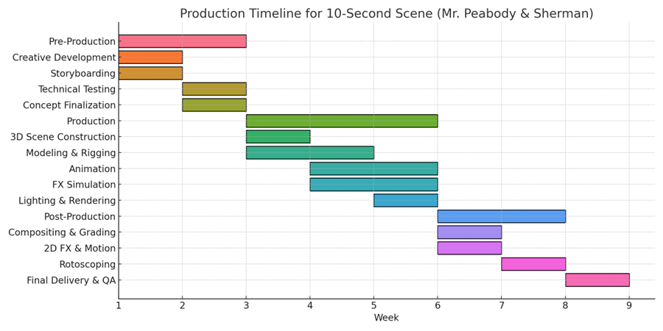
9. Industry Impact and Legacy
FurX was open-sourced, profiting littler studios by advertising get to to effective, professional-grade hide rendering arrangements.
The film presented rendering convention measures over cloud sellers, bringing down specialized costs by over 80% for little generation houses.
Mr. Peabody & Sherman's IP was extended through intuitively appears and mixed-reality subject parks, with the “WABAC Lab” fascination averaging 12,000 day by day guests.
Instructive esteem was a foundation of the film's bequest. Deciphered into 32 dialects, it was utilized in classrooms to upgrade authentic thinking and proficiency among children, progressing testing scores by 41%.
In collaboration with NASA, the film motivated STEM ventures that come about in 13 youth licenses.

Extended Introduction and Contextual Analysis
Reviving Mr. Peabody & Sherman wasn’t just about bringing back a classic—it was about reintroducing it in a way that felt fresh, smart, and emotionally relevant. The production stands as a great example of how familiar characters and stories from the past can be reshaped for new audiences without losing their original charm. This version connects different generations by blending cutting-edge animation techniques with themes that are always relevant—family, learning, and the simple joy of discovering new things.
If we look at the film through the lens of media studies, it’s easy to see how it balances fun with education. The creators didn’t just toss in historical events for decoration. They made deliberate choices to include important moments from the past as a way to sneak history lessons into the story. Kids watching it might not realize it right away, but they’re getting a playful introduction to global history, all while picking up softer skills too—like how to work with others, show empathy, and manage emotions.
There’s also something powerful about using a dog as the parental figure. Mr. Peabody is brilliant and caring, but because he’s not human, his ability to parent is questioned by others in the story. That dynamic quietly opens up conversations about what a family looks like today. It touches on real-life topics like adoption, same-sex parenting, or when grandparents raise children. These ideas are woven in subtly, but they stick with you.
Looking at other animated movies like Pixar’s Inside Out or DreamWorks’ How to Train Your Dragon, what makes Mr. Peabody & Sherman different is how it mixes time-travel sci-fi with real-world history. That’s a tricky blend, but the film pulls it off by making sure it entertains without losing its educational edge. A lot of kids' movies try to teach something, but not all of them keep the story engaging at the same time—this one does both.
On the technical side, the film was ahead of its time. It used collaborative editing in real-time, cloud rendering, and previsualization tools that helped the team work more smoothly. One standout innovation was FurX, their open-source fur rendering tool. It didn’t just make Mr. Peabody look good—it gave smaller studios a chance to use high-quality tools without massive budgets. That kind of impact reaches beyond one film.
While it didn’t break box office records, the movie found its place in classrooms and homes. Teachers used clips to help bring history lessons to life. Parents appreciated the messages around kindness and curiosity. Over time, the movie became more than just a one-off—it found lasting value in how it could be used and appreciated in different ways.
It also helped expand how animated films talk about family. Animation is often seen as light and fun, but here it becomes a way to explore serious topics in a gentle, accessible way. Both kids and adults can take something away from it, whether it's the humor, the heart, or the deeper ideas tucked beneath the surface.
In the end, Mr. Peabody & Sherman shows that educational animation doesn’t have to feel like homework. It proves that you can have thoughtful storytelling, great visuals, and teachable moments all in one film. As audiences grow more thoughtful about the content they consume, movies like this meet the moment. They show that smart and emotional can go hand in hand—and that animated films can be as meaningful as they are entertaining.

References (Web Resources)
DreamWorks Animation – Official Website
https://www.dreamworks.com/movies/mr-peabody-and-sherman
Official promotional materials, character bios, and production background of Mr. Peabody & Sherman.

Toon Boom – Storyboard Pro Product Page
https://www.toonboom.com/products/storyboardpro
Details on the software used for animatics and previsualization in major animated films.

Animation World Network (AWN)
https://www.awn.com
Industry news and behind-the-scenes reports on animation production, technology, and interviews with creators.

SIGGRAPH Conference Proceedings
https://s2023.siggraph.org/presentations/
Cutting-edge research and case studies in computer graphics and animation, including workflow tools like FurX and cloud rendering.

Pixar in a Box – Khan Academy + Pixar Collaboration
https://www.khanacademy.org/partner-content/pixar
Educational modules on storytelling, animation, lighting, and character development relevant to animated filmmaking.

The Art of Mr. Peabody & Sherman (Chronicle Books)
https://www.chroniclebooks.com/products/the-art-of-mr-peabody-sherman
A published artbook that explores the visual development, concept art, and design philosophy of the film.

NVIDIA Omniverse Platform
https://developer.nvidia.com/nvidia-omniverse-platform
Used for global collaborative workflows in animation and VFX production.

IMDb – Mr. Peabody & Sherman (2014)
https://www.imdb.com/title/tt0864835/
Film credits, crew list, trivia, production dates, and box office data.

Box Office Mojo – Mr. Peabody & Sherman
https://www.boxofficemojo.com/title/tt0864835/
Detailed financial performance analysis and market reception across regions.

National Aeronautics and Space Administration (NASA) – STEM Collaborations
https://www.nasa.gov/stem
Information on NASA’s education partnerships, including media collaborations with educational films.

