Electric Vehicles



Prepared for

Dr. Kenny Tang

Module: Global Business Environment

Prepared from

Petya Nedeva - 1816235

Introduction
Just like most industries, the automobile industry has in the current decade been disrupted by technology evidenced through the emergence of EVs (electric vehicles) which have continued to experience unprecedented growth globally. As noted by Huczynski and Buchanan (2013), the development of hybrids and EVs is eroding sales if petrol driven cars. According to a 2018 Deloitte report, EV sales will experience tremendous growth, increasing from 2 million units in 2018 to 4 million in 2020, 12 million in 2025 to 21 million in 2030 as manufacturing costs significantly subside.
Figure 1: Outlook for annual global passenger car and light duty vehicle sales
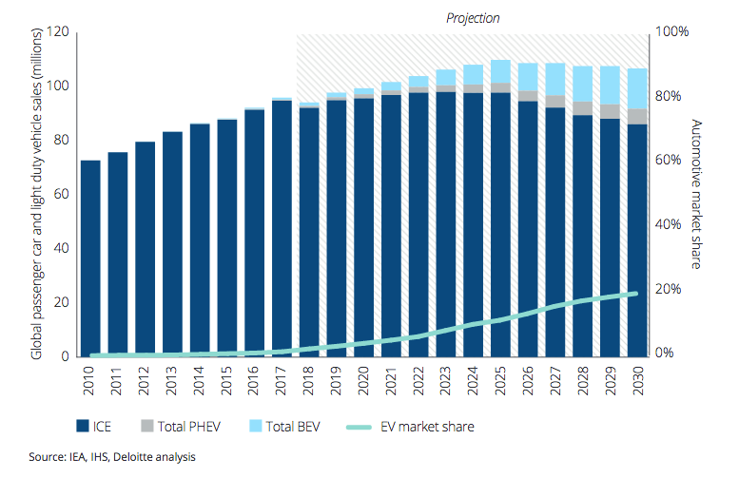Source: Deloitte 2019.

As the EV market continues to expand, the profitability of traditional OEMs has been negatively impacted. As incumbents and new suppliers continue to enter the market, competition has continued to grow and is forecast to grow further (Hertzke et al 2019).
A 2018 Deloitte report has also noted that new entrants will present a major threat as their combined share will be the largest globally as shown below.
Figure 2: Electric vehicle production forecast of major OEMs and new entrants
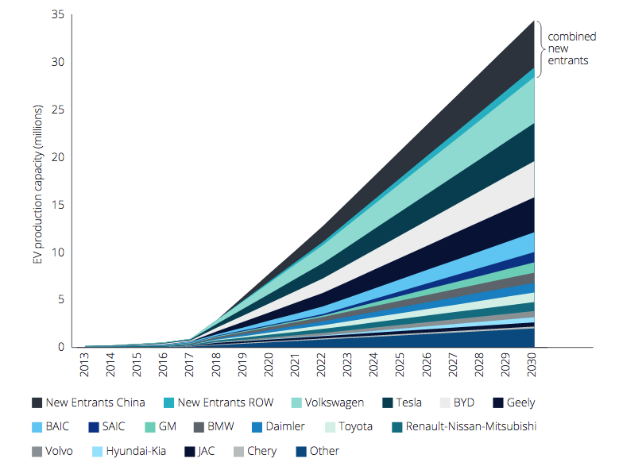
Source: Deloitte 2019

This essay paper analyzes the business environment of the automobile industry, assessing the growth of the EV market.
Using different frameworks including PESTLE, Porters five forces and Porters generic value chain, the essay will analyze macro and micro factors impacting the EV business environment well as the industry structure at large.

External forces

A firm’s business environment consists of both external and internal factors that have potential to impinge of its success (Grant 2016; Johnson et al 2017). According to Huczynski and Buchanan (2013), external facts can include suppliers, customers, regulatory agencies, competitors, and partners in joint ventures. However, the three major trends impacting most organizations are technology, demographics and globalization. The identification of environmental issues is done through a process called environmental scanning which involves collection of information from several sources including magazines, Newspapers, government statistics, internet sites, demographic analysis, specialist research and consulting agencies, market research etc. (Huczynski and Buchanan 2013).
Figure 3: Business environment
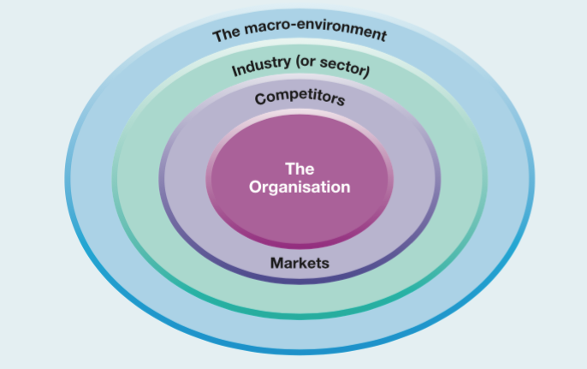
Source: Johnson et al 2017

PESTEL for EV industry

Political environment
Policies and measures put in place by different governments globally are perhaps key drivers that have had notable influence on the growth and development of EVs. Fiscal incentives to support the purchase of EVs, regulatory measures such as waivers to access restrictions , as well as policies to support the deployment of charging infrastructures have all boosted EV production and purchase(Deloitte 2018; IEA 2019).

Economic environment
Perhaps, the biggest barrier to EV adoption is their premium cost. Irrespective of government incentives, EVs are still very unaffordable with the least expensive EV on the market at around $30,000 (Peters 2019) yet the number of taxpayers earning under $30,000 per year, accounts for more than 48% of the United States population (Dale 2019). As of 2018, only 205 Americans earned over $50 million while 750 million earned 1 million annually, making up the smallest percent of rich Americans (Dale 2019). As noted by Berman 2019, Forty-five percent of EV buyers make over $200,000 a year. Peters (2019) has posited that whereas EVs make up only 1% of the market, most of it is concentrated in affluent areas such as Washington and San Francisco. This is a major barrier, in fact EVs will not become mass market cars until they become much more affordable, to own, yet they are becoming more expensive as credits wane out.

Environmental issues
Several measures have been put up by governments to encourage adoption of EVs globally (Transport and Environment Org 2018). Among them are city access restrictions, fuel economy and emission standards. Over 20 cities plans to ban gasoline and diesel cars by 2030 and others sooner. For instance, Paris plans to ban gasoline and diesel vehicles from the city centre by 2030, Copenhagen by 2019. Central London and other town centres across the UK will introduce zero emission zones from 2025, while Oxford will ban non-EVs from its centre from 2020 (Deloitte 2018).

Other factors
Socially, consumers have continued to turn away from diesel cars due to air concern issues with 69% of European consumers showing low or no preference for diesel cars (Environment & Transport 2018). Other concerns for EVs adoption include; shortages in battery-cell production leading to long waiting periods for some EVs in Europe, growing competition (Hertzke et al 2019). Lack of EV infrastructure and longer charging times (Deloitte 2018). Technology has continued to change the way cars operate, with electric, hybrid and solar energy systems deposing the internal combustion engine and fuel-fed engines (Kirkland 2019).

Porters five forces & conclusion

Threat of entry (High)
The ease with which an industry can be entered highly influences the intensity of competition (Johnson et al 2017). Naturally, the automobile industry is characterized by high barriers to entry which has been good for incumbents. These barriers include; scale & experience, access to supply and distribution channels, expected retaliation, legislations and differentiation (Grant 2016). However, tech companies have overcome these barriers through increased funding. As of 2019, e-mobility funding grew from $2 billion in Q1 2019 to $4.4 billion in Q 2 with Tesla and Nothvolt raising the highest (Jacobs 2019). In fact, the market is forecast to become more competitive with new entrants commanding the largest share globally, as shown in figure 2 (Deloitte 2018).

Threat of substitutes (high)
According to Johnson et al (2017), substitutes have so much power in that they can reduce demand of a product to the extent of becoming obsolete. Currently, the substitutes for EVs can include anything from trains, buses, ride hailing apps, autonomous vehicles to bicycles as long as their environmental performance can match the one of EVs. Currently, the threat is high because of their premium costs.

Bargaining power of buyers (high)
The buyer’s bargaining power is high because of the many available substitutes which are cheaper than EVs. Considering the number of new entrants entering the EV manufacturing industry, the bargaining power of buyers is forecast to become higher as supply exceeds demand. According to a 2018 Deloitte report, supply is forecast to be at least 14 million units above the forecast consumer demand.

Bargaining power of suppliers (high)
Currently, the bargaining power of suppliers is high which is leaving EV sellers with no option but to sell them at premium costs. Other thanTesla which manufactures its batteries, most car manufacturers buy their batteries from suppliers at very high costs. The recent shortages in battery cell production which led to disruptions in the supply chain of European manufactures (Hertzike 2019) is a classic sign of the high power held by suppliers.

Competitive rivalry (high)
The EV industry like the global automobile industry in general is highly competitive and this intensity is set to increase as a number of entrants from both traditional OEMS and tech companies join the industry. According to a 2018 Deloitte report, the competition in the market will intensify as a number of new entrants join the EV market. In fact, supply will exceed demand with at least 14 million units above the forecast consumer demand as shown below.
Figure 4: The supply/ demand gap forecast in the EVs industry
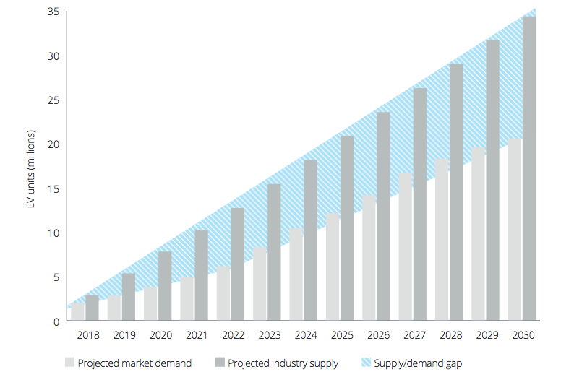

Organisation changes - evaluate the changes driving move towards EVs and the reasons for these organizational changes– critical assessment
In order to boost EV growth, the automobile industry has experienced changes in technology, structure, and the supply chain with the innovation in manufacturing techniques, strategies,capabilities, and business models.

Changes in production strategy
Several companies from startups to mature car manufacturers are in a race to deliver EVs to the market very fast, with China leading the race with nearly 500 electric-vehicle manufacturers. In this increasingly competitive industry, some companies especially new ones have experienced manufacturing challenges resulting in delays as well as increased costs. As a result, automobile manufacturers have come up with some strategies in order to survive and keep a chunk of the market share.
One of the notable strategies is partnerships between incumbent car manufacturers and new EV manufacturers. Companies have come up with this strategy in order to cut electrification costs, which is the industry’s major challenge currently. Several international companies have partnered with Chinese EV manufacturers e.g the partnership between Toyota and BYD, BMW and Great Wall, Volkswagen and Anhui Jianghuai Automobile Group etc (Bloomberg 2017; Shepherd 2019; Ma 2019). Such partnerships have proved advantageous for startups as they gain in-depth knowledge of best practices in automotive-production and process optimization, helping them avoid production delays and other issue.
In order to increase rollout speed and gain a competitive advantage, different manufacturers have come up with different production strategies. Some companies have decided to use their existing ICE techniques but swapping engines (conversion route) whereas others are starting from scratch with an EV powertrain (the purpose built route).
The conversion route is common among incumbents such as Jaguar Land Rover who have continued to use their existing infrastructure to produce fully electric, hybrids and plugin hybrids from the same platform. This has acted as a barrier to new entrants and given them a competitive advantage. On top of that, this route offers them flexibility to scale production up or down depending on available demand. This also helps them cut costs (CB Insights 2019; McCrea 2019).
Tech companies like Tesla have however invested in the all-purpose built route, starting from scratch. The competitive advantage of companies like Tesla is the fact that they are manufacturing everything from battery packs to the cars. This is helping them dominate the market (Deloitte 2018).

Conclusion
As EV adoption continues to gain momentum across different regions, boosted by government support, improving infrastructure and growing air concern issues among consumers the competition is continuing to grow with both incumbents and new entrants vying to get a share of the market. While the industry is still faced with challenges such as long charging time, lack of infrastructure and the high battery costs involved, the industry is continuing to evolve with companies innovating continuously in order to gain a competitive advantage. However, considering the rate at which the industry is growing, supply is set to exceed demand, a situation that will most likely to render most OEMs obsolete. Never the less partnerships among incumbents and new entrants provide opportunities for both while growing innovation and investment in the battery system will soon reduce costs which will likely extend to consumers increasing adoption chances.

New opportunities

Porters generic value chain
The value chain was first developed by Michael Porter as a framework to demonstrate how various categories of business activities, link together to create a product or service both within an organization and externally within the wider value system linking organisations. Porter noted that for organisations to create competitive advantage, they need to understand those activities that deliver value which he categorized in the following figure (Johnson et al 2017).
Figure 5: Porters value chain
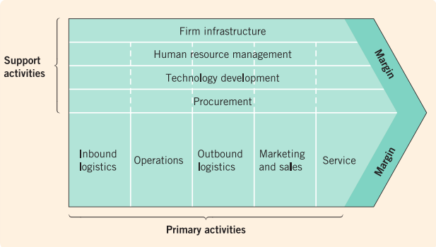

As the nature of the components used in electric vehicle manufacturing changes from mechanical engineering to electrical and electronic engineering, the economics and nature of activities involved in both the design and production of these components will also be very different. This will have huge implications for both supply chain and the value chain (Transport Intelligence 2019).
When Porters value chain is applied to electric vehicles, it can help to show clusters of value adding activities that are significant in delivering organizational strategy and achieving competitive advantage. In the following figure, some of the value adding activities within the manufacture of electric vehicles are identified as follows;
Figure 6: The EV value chain
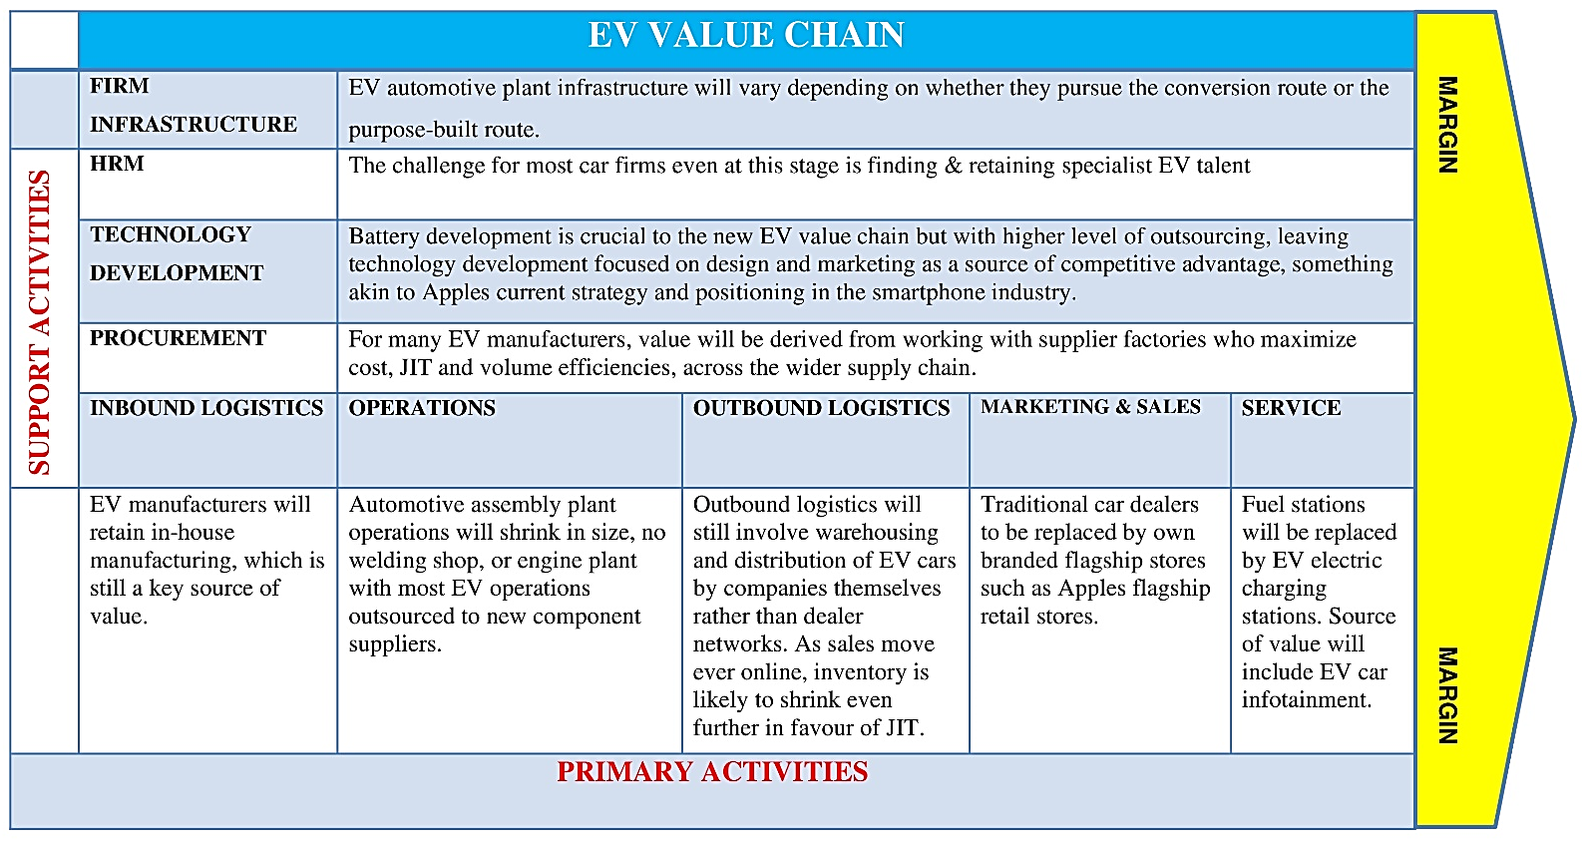

New business opportunities
The so much needed improvement of the EV structure from batteries to charging systems, dealer networks, recycling services of components such as batteries to software are creating a great deal of business opportunities for both the auto industry as well as other businesses.
Providing EV charging infrastructure
As global adoption of EV vehicle continues to grow, so will the need for convenient charging places which will create new business opportunities. Investing in charging stations is thus a major opportunity, currently, the business is booming in countries like Norway where EV adoption has grown very fast. According to industry reports, increasing deployment of EV charger in future could translate to stronger demand for the facility.
- Electric car dealership
- Partnerships with EV charging station providers to offer charge and chill services such as cafes is a major opportunity
- Forging partnerships with solar companies.
- Forging partnership with electric utilities

Discontinued businesses

As the industry continues to grow, and competition intensifies, most companies especially startups dealing in only EV production are at a risk of going obsolete. In China, the market is made up of both domestic and foreign companies with at least 500 companies registered too produce EVs (Soat 2019). However, with tax incentives waning, these companies are faced by even lower customer demand which will most likely result in closure of most. Currently, many manufacturers in China are now announcing layoffs and cutbacks. In August, NIO announced layoffs for over 1,000 employees. Many EV companies in China are expected to stop operations, particularly domestic startups, as sales numbers continue to decrease due to the subsidy elimination. As noted earlier, the industry supply will exceed demand by 2030, this will result in failure to sale and low profitability forcing most to divest in order to cut their losses.
Another industry that is threatened is the oil industry, in fact, renewable electricity is likely to replace at least 40% of oil demand (Scott 2019). The author goes ahead to note that wind and solar energy combined with battery electric vehicles will most likely produce six to seven times more useful energy at the wheels than will oil at $60 per barrel for gasoline powered light-duty vehicles. Disruption by the renewable energy industry as well as electric vehicles pose a major threat to the oil industry has never before. I fact, it would have to be priced at $10-$20 a barrel to remain competitive as a transport fuel (Scott 2019). Conventional powertrain suppliers as well as their employees are also at risk of losing out if they can't convert operations to supply battery car components (Eisenstein 2019).

Conclusion
As EV adoption continues to gain momentum across different regions, boosted by government support, improving infrastructure and growing air concern issues among consumers the competition is continuing to grow with both incumbents and new entrants vying to get a share of the market. While the industry is still faced with challenges such as long charging time, lack of infrastructure and the high battery costs involved, the industry is continuing to evolve with companies innovating continuously in order to gain a competitive advantage. However, considering the rate at which the industry is growing, supply is set to exceed demand, a situation that will most likely render most OEMs obsolete. Never the less partnerships among incumbents and new entrants provide opportunities for both while growing innovation and investment in the battery system will soon reduce costs which will likely extend to consumers increasing adoption chances.
Though the industry is going to provide business opportunities for some industries such as renewable energy, recycling services for car batteries as well as charging infrastructure, it will also disrupt some industries especially the oil industry and conventional powertrain suppliers as well as their employees.

References
Berman Bradley (2019) “The Biggest Challenge Facing Electric Cars Is Still Affordability” InsideEVs [Online] at https://insideevs.com/news/342350/the-biggest-challenge-facing-electric-cars-is-still-affordability/
Bloomberg (2017) “VW Teams With Chinese Partners in €10 Billion Electric-Car Push” Industry Week [Online] at https://www.industryweek.com/leadership/growth-strategies/article/22024573/vw-teams-with-chinese-partners-in-10-billion-electriccar-push
Dale Oliver (2019) “Median Income in America: What is the Average Salary in The US?” Money Check [Online at https://moneycheck.com/average-income-salary-america/
Deloitte (2019) “New Markets. New Entrants. New Challenges. Battery Electric Vehicles” [Online] at https://www2.deloitte.com/content/dam/Deloitte/uk/Documents/manufacturing/deloitte-uk-battery-electric-vehicles.pdf
Eisenstein Paul A (2019) “Electric vehicles pose 'real risk' for autoworkers, with fewer parts — and jobs — required” CBNC [Online] at https://www.nbcnews.com/business/autos/electric-vehicles-pose-real-risk-autoworkers-halving-number-people-required-n1060426
Grant, M. Robert (2016) “Contemporary Strategy Analysis: Text and cases edition” 9th ed., John Wiley.
Hertzke P, Muller N, Schaufuss P, Schenk S and Wu T (2019) “Expanding electric-vehicle adoption despite early growing pains” McKinsey & Company [Online] at https://www.mckinsey.com/industries/automotive-and-assembly/our-insights/expanding-electric-vehicle-adoption-despite-early-growing-pains
Huczyński, A., & Buchanan, D. (2013) “Organizational Behaviour” 8th ed., Pearson Education
IEA (2019) “Global EV outlook 2019” [Online] at https://www.iea.org/reports/global-ev-outlook-2019
Jacobs Paul Jan (2019) “$6,3 Billion investments in e-Mobility start-ups H1 2019” EVBoosters [Online] at https://evboosters.com/63-billion-investments-in-e-mobility-start-ups-h1-2019/
Johnson, G., Scholes, K., Regner, P., Angwin, D., and Whittington, R. (2017) “Exploring strategy: Text and cases” 11th ed., Pearson Education
Ma Jie (2019) “Toyota Teams Up With China’s BYD on Electric Vehicles” Bloomberg [Online] at https://www.bloomberg.com/news/articles/2019-07-19/toyota-teams-up-with-byd-to-develop-electric-vehicles-for-china
McCrea Bridget (2019) “5 Ways Electric Vehicles are Impacting the Auto Supply Chain” Source Today [Online] at https://www.sourcetoday.com/supply-chain/article/21867389/5-ways-electric-vehicles-are-impacting-the-auto-supply-chain
Peters Eric (2019) “Electric vehicles are becoming unaffordable” NewsDay [Online at https://www.newsday.com/opinion/commentary/electric-vehicles-environment-cost-expensive-1.34462235
Soat Raquel (2019) “Chinese EV Subsidy Elimination Could Mean Trouble for Some EV Companies” Forbes [Online] at https://www.forbes.com/sites/pikeresearch/2019/10/17/chinese-ev-subsidy-elimination-could-mean-trouble-for-some-ev-companies/#6b9121613005
Scott Mike (2019) “Economics of Electric Vehicles Mean Oil's Days As A Transport Fuel Are Numbered” Forbes [Online at https://www.forbes.com/sites/mikescott/2019/09/02/economics-of-electric-vehicles-mean-oils-days-as-a-transport-fuel-are-numbered/#2ebac53e5102
Shephard Christian (2019) “BMW and Great Wall begin work on electric vehicle factory in China” Financial Times [Online] at https://www.ft.com/content/4bd43846-1286-11ea-a225-db2f231cfeae
Transport & Environment (2018) “City bans are spreading in Europe” [Online] at https://www.transportenvironment.org/sites/te/files/publications/City%20bans%20are%20spreading%20in%20Europe_Report.PDF
Transport Intelligence (2019) “The Future Mobility: Electric Vehicle Supply Chain Architecture” [Online] at https://www.ti-insight.com/product/logistics-markets/

