

A Recommendation Framework for the purpose of Viewing Personalised Registration Numbers on a Vehicle using Augmented Reality

by
Lewis Wells

Supervisor: Dr Tim Bashford
Second Marker: Andrew Baker

Project submitted as part of the requirements for the award of MSc (Hons) Software Engineering (Web Development)

January 2020

Declaration
I, Lewis Wells declare that I am the sole author of this project; that all references cited have been consulted; that I have conducted all work of which this is a record, and that the finished work lies within the prescribed word limits.

This work has not previously been accepted as part of any other degree submission.
Signed | L.Wells | Date | 31-01-2020

Form of Consent
I, Lewis Wells hereby consent that my project, submitted in candidature for the BEng Computer Systems and Electronics degree, if successful, may be made available for inter-library loan or photocopying (subject to the law of copyright), and that the title and abstract may be made available to outside organisations.
Signed | L.Wells | Date | 31-01-2020

Abstract
The following report fundamentally aims to determine if a recommendation framework has any impact on the development of augmented reality applications with particular reference to visualising personalised registration numbers on a vehicle.

The report will outline the aim and objectives of the project and delineate how the Author intends to structure the endeavour to provide direction and transparency during the research and development process.

The core aspect of the research derives of a literature review, this section contains any literature which the Author believe has significant relevance and substance pertaining to augmented reality. The literature review contains information gathered from researching credible sources and identifying key Authors in the field of choice, it comprises of content relating to augmented reality, best practices and principles for the implementation of AR, AR software development kits, personalised registration number, limitations of augmented reality, development platforms and optical character recognition.

Suitable research/development methodologies will be discussed with analysis and discussions to the benefits they have on the project, this section will include the Authors fastidious approach to the software development and will outline hardware and software resources required for the project to be successful.

This report will include a design and implementation section which will outline the requirements of the development process and include the recommendation framework proposed, any designs, diagrams or flowcharts which have been constructed by the Author to support the development of the intended application. The implementation segment will delineate how the Author has implemented the functionality based on the recommendation framework and explains how the requirements have been adhered to.

The paper will proceed to outline the results of the completed application and defining the tests which have been conducted to access the validity of the recommendation framework.

Finally, the paper will conclude with a conclusion, discussion and reflection sections which distinctly delineate the successfulness of the project and discuss any issues, recommendations and the Authors personal response to the work achieved.

Table of Contents
Declaration 2
1 Abstract 3
2 Introduction 8
2.1 Aims & Objectives 10
2.1.1 Aims 10
2.1.2 Objectives 10
3 Literature review 12
3.1 Augmented Reality 12
3.1.1 The History of AR 13
3.1.2 What is augmented reality? 13
3.1.3 Types of Augmented Reality 14
3.2 Limitations of Augmented Reality 21
3.3 AR software development kits 23
3.4 Optical character recognition 34
3.5 Personalised Registration Numbers 37
3.6 Development Platforms 39
3.7 Literature review conclusion 42
4 Methodology 44
4.1 Research Methodology 45
4.1.1 Philosophy 45
4.1.2 Approach 45
4.1.3 Strategies 46
4.1.4 Risks and Limitations 46
4.1.5 Validity, Reliability and Generalisability 47
4.2 Development Methodology 49
4.2.1 Feature Driven Development 50
4.2.2 Extreme Programming 54
4.3 Resources 55
4.3.1 Hardware Resources 55
4.3.2 Software Resources 56
4.3.3 Information Resources 58
4.4 Methodology Conclusion 59
5 Design 60
5.1 Requirements 60
5.2 Recommendation Framework 61
5.3 Minimal Viable Product 64
5.4 User Interface 64
5.5 Proposed System/Feature Design 67
6 Implementation 72
7 Results & Discussion 78
8 Conclusion & Recommendations 86
8.1 Conclusion 86
8.2 Recommendations 89
9 Reflection 90
10 References 91
11 Appendix 91
12 Bibliography 95

Table of Figures
Figure 1 – Marker-less AR, Pokémon Go. 14
Figure 2 - QR Code [7]. 15
Figure 3 - Car model [9]. 15
Figure 4 - Vuforia object recognition [9]. 16
Figure 5 - Projection based AR example [11] 17
Figure 6 - Superimposition-based AR. 18
Figure 7 - Google Translate [12]. 19
Figure 8 - C-arm application [12]. 21
Figure 9 - ARCore Motion Tracking [20]. 24
Figure 10 - ARCore Environmental Understanding [21].. 25
Figure 11 - ARCore Light Estimation [22]. 26
Figure 12 - Image target features [24]. 30
Figure 13 - Image target features (2) [24]. 30
Figure 14 - Image Target Standard [24]. 31
Figure 15 - User Defined Target Flow [28]. 32
Figure 16 - Stages of OCR [32]. 34
Figure 17 - Registration Format. 36
Figure 18 - Prefix Licence Number. 37
Figure 19 - Suffix Licence Number. 37
Figure 20 - Dateless Licence Number. 37
Figure 21 - Benefits of Agile Methodologies [39]. 48
Figure 22 - Comparison between Traditional and Agile methodologies [39]. 49
Figure 23 - Extreme Programming Approach [39]. 53
Figure 24 - Proposed user interface 1. 64
Figure 25 - Proposed user interface 2. 65
Figure 26 - Proposed system architecture [18]. 66
Figure 27 - Superimposition design. 67
Figure 28 - Flowchart (offensive input). 68
Figure 29 - Registration availability and price lookup. 70
Figure 30 - Unsupported format Vuforia. 72
Figure 31 - Unity3D superimposition concept. 73
Figure 32 - 3D text mesh. 74
Figure 33 - User defined superimposed registration. 74
Figure 34 - UI design (canvas 1). 75
Figure 35 - UI design (canvas 2). 75
Figure 36 - Completed application view. 78
Figure 37 - Features of registration number. 81
Figure 38 - Features of registration number with vehicle. 82
Figure 39 - Stationary UI (1 metre). 83
Figure 40 - Stationary UI (2 metre(. 84

Introduction
This report has been commenced to evaluate the benefit of an augmented reality recommendation framework when implementing the technology. Particular reference will be concentrated towards the implementation of augmented reality for the purpose of visualising personalised registration numbers on a vehicle.

The augmented reality technology has evolved in recent decades to develop into a serviceable technology which can provide assistance in the construction industry, medical support, game development, education and the development of immersive AR experiences, some of which will be deliberated in this paper. Augmented reality is presenting itself as an interesting and emerging technology, the integration of virtual objects provides users with means of perceiving digital objects in a real-world environment. The technology doesn’t stop at visual modalities, it can also incorporate other modalities such as auditory, haptic, somatosensory and olfactory to enhance the augmented experience [1].

Whilst there is extensive documentation and evidence on useful implementations of the technology, the Author considers that the creation of a recommendation framework could potentially be beneficial when implementing the complex technology. There are numerous factors which can be beneficial or detrimental in the creation of erudite AR experiences, a recommendation framework could identify such influences and define best principles and practices to assist in the design and development of AR applications.

Recommendation frameworks enable users to proficiently adhere to a specific set of rules and regulations when utilising them, this project will discuss current existing frameworks, tools, technologies and techniques which have importance in the implementation of augmented reality applications. The recommendation framework produced will perform as a testable conception, the conception will then be used as guidance in the development of an augmented reality application. The validity of the recommendation framework will be verified by the result of the development, this will then determine if the hypothesis stated can be accepted or rejected after evaluating the ascertained information from the results.

Aims & Objectives
Aims and objectives delineate the overall purpose of the project and how the Author intends on achieving the desired results. They provide essential presidency when managing project structure and assist in the deliverance of the desired outcome. The aim(s) intend to describe the problem which Author aims to provide a solution to, whilst the objectives outline specific methods of achieving the aim(s).

Aims
The overall aim of project is to determine if an augmented reality recommendation framework has a beneficial impact on the development of an AR system for viewing personalised registration plates.

Objectives
The following objectives describe the procedures the Author has followed during the process of the project:

- To explore current available tools/platforms for developing mobile applications which can support and assist in the development of augmented reality applications.
- Determine current best practices and principles supplementary to the implementation of augmented reality.
- Identify research and development methodologies to provide crucial structure for the approach to the research and development aspect of the project.
- Produce tests to determine the effectiveness of the recommendation framework, the tests will establish if the recommendation framework has been successful.

Literature review
This section will discuss and review any literature which the Author believes to be applicable to this project, it will identify key Authors of creditable research literature and the information contained within, compare and contrast any opinions or observations which are professed, provide evidence of how the sources contribute to topic of interest and encompass the views of the Author of this project to dispute any findings proposed. The reviewing of literature is a fundamental in the creation of a recommendation framework, the literature will define best practices and principles which can be used to develop an application to determine if the recommendation framework has been successful.

Augmented Reality

Augmented reality is presenting itself as an interesting and emerging technology, the integration of virtual objects provides users with a way of perceiving digital objects in a real-world environment. Augmented reality doesn’t stop at visual modalities, it can also incorporate other modalities such as auditory, haptic, somatosensory and olfactory to enhance the augmented experience [2]; However, for the purpose of this project it can be assumed that only the visual aspect is required to successfully adhere to the aims and objectives outlined.

The History of AR

Ivan Sutherland is often credited for being the elementary driving force in the creation of the first AR prototype, in the 1960’s the computer graphics pioneer developed a “see-through” to exhibit 3d graphics with the students from the University of Utah. In subsequent decades with technological advancements, the technologies growth increasingly improved and in the early 90’s Boeing Corporation developed an AR system which permitted visually impaired users navigational assistance via audio overlays [3].
Finally, in the year 2000, Hirokazu Kato published the software “ARToolKit”. The software enabled video capture tracking of real-world behaviours and coalesced the capture with interactions of virtual objects. A user could experience this technology by using camera which has an established connection to the internet, the software was fundamental in the creation of flash-based AR applications [4].

What is augmented reality?

According to H. Shoaib, “An AR system supplements the real world with virtual (computer-generated) object that appear to coexist in the same space as the real world”. This subsequently describes augmented reality as appearing to include virtual objects within the real-world environment [5].

Augmented reality and virtual reality are transposed reflections of each other in regard to what they aim to achieve and deliver for the user. Whilst augmented reality superimposes digital elements in a real-world scenario; Virtual reality provides a comprehensive immersion experience which isolates the user in an environment which is completely simulated [6].

Types of Augmented Reality
Identification of the forms of augmented reality is fundamental phase in appreciating/comprehending what the technology proposes, evaluating the possibilities will inexorably result in clarification when implementing the solution.

The four common types of augmented reality are:

- Marker-less AR – Often referred to as location based or position based which frequently utilises GPS (global positioning system) to supply data which is typically based on the users’ location. This form of AR technology needs no existing knowledge of the environment to superimpose a computer-generated image into the scene [7]. A prime example of location-based AR is Niantic’s augmented reality game – Pokémon Go. The application utilises a device’s GPS to track a user’s location, it then integrates the information gathered to interact with an in-game map and superimposes a virtual object in the user’s real-time camera feed (Figure 1) [8].

Figure 1 – Marker-less AR, Pokémon Go.

- Marker-based AR – Effectively the inverse of Marker-less AR, this technology requires a specific detection of visual object to then overlay a pre-determined virtual object in the scene [7]. Markers often consist of black and white colours to help define the marker from the background when the frame is captured, a common example of this is a QR code (Figure 2); however, with recent technological advances particularly with smart phones camera quality, pretty much any image can be used as a marker for AR [5].

Figure 2 - QR Code [7].
Marker-based AR is not limited to static images, software companies are pushing the boundaries of AR capabilities and have found innovative new techniques of recognising 3D objects (Figure 3, Figure 4), this allows developers to create more dynamic applications which demonstrate the limitations of augmented reality [9].

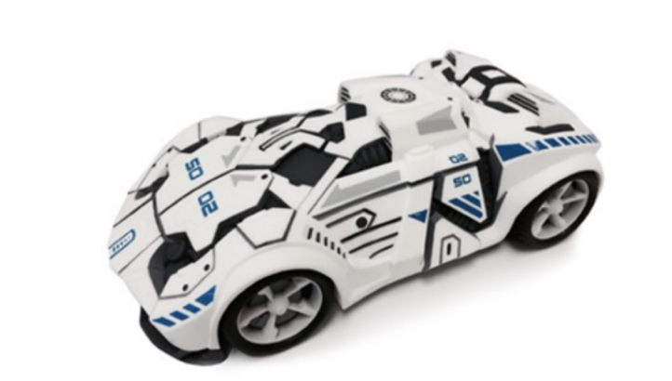
Figure 3 - Car model [9].
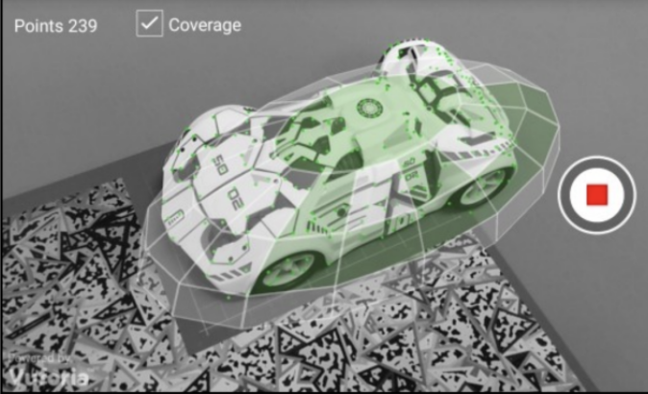
Figure 4 - Vuforia object recognition [9].

The ability to identify and track 3D objects works similarly to 2D recognition but the process of achieving this is more intensive [10]. Vuforia provide an object scanner for consumers to recognise and track 3D objects, a data file is generated then contained object data of the scanned object [9].

- Projection-Based Augmented Reality – This type of AR allows users to interaction with a projection as if the projection was an object [7]. Sophisticated projectors can potentially generate immersive light forms or project neoteric information onto a surface. Projection based AR aims to provide users with a futuristic experience, it is partially prevalent in training operations for employees to increase their productivity and efficiency.
Figure 5 illustrates an implementation of projection-based AR for tele-maintenance support.

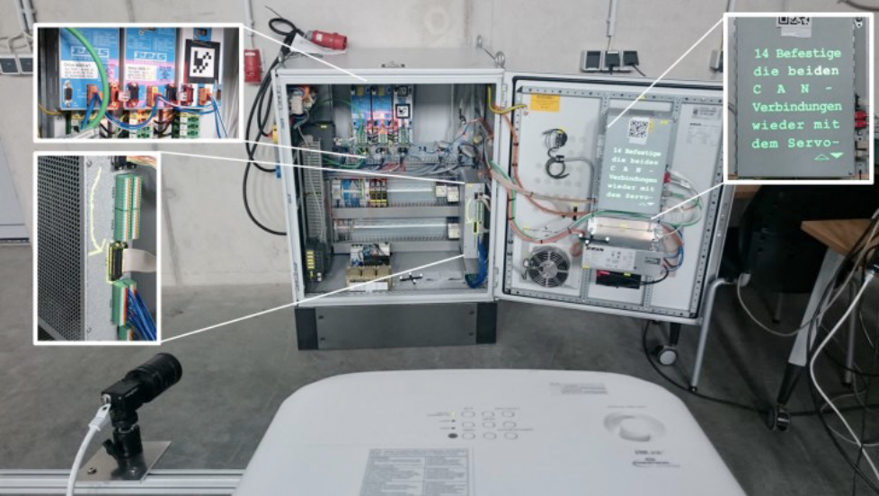
Figure 5 - Projection based AR example [11]
The use of project-based AR enabled a remote tele-communications expert to advise a local technician on the correct procedure to a fixing a problem because the remote expert could effectively share the same environment, the technology enables the remote technician to visualise the components of the machine which contains a defect, providing for more precise instructions for the local engineer [11].
- Superimposition Based Augmented Reality – Has similar characteristics to marker-based AR, however the augmented image which has been inserted into the scene can partially or completely replace the original image [7]. In regard to this project, it can be assumed that superimposition-based AR and marker-based AR are the two ideal candidates to achieve the outcome desired. Figure 6 demonstrates an example of superimposition-based AR, the original view of a landmark is completely replaced by an augmented display.

Figure 6 - Superimposition-based AR.

A popular mobile application which has been identified as extremely relevant to the research into augmented reality is Googles’ Translate. Google has had a feature for many years which allows the conversion between languages bases on text input, in recent years they released a mobile application which allows users to see an augmented conversion using their cameras on their smart phones [12].

Google made use of an existing piece of software called Word Lens which understands characters/words, and using optical character recognition, translates the words to the desired language. This technology was then incorporated into Googles’ Translate application [12] (Figure 7).

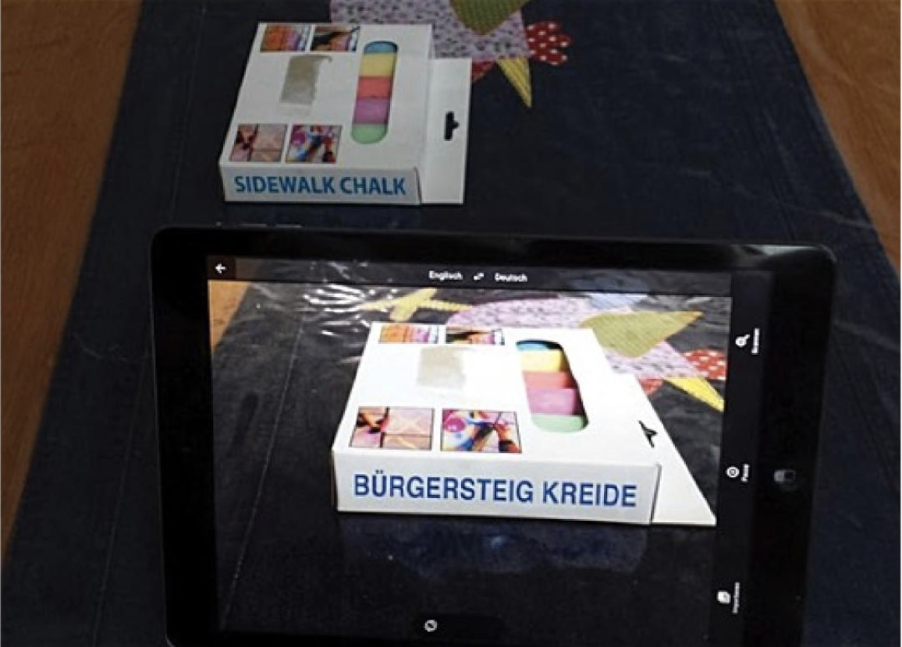
Figure 7 - Google Translate [12].

Whilst the project may not require character or word recognition, it has similar ambitions to what Word Lens provides. The intention is to use a form of recognition to recognise the licence plate (via characters or image), then insert an augmented display which will overlay/replace that image.

Optical character recognition is a technology which can certainly provide substance to this project, especially when considering vehicle registration plates (UK) contain an ideal contrast from background to text. Using the software discussed would enable a user to scan an image or use a real-time feed from a camera to determine a registration plate number on a vehicle.

Limitations of Augmented Reality

Augmented reality has advanced into an extremely interesting and useful technology which has been supported with the innovative devices and software which is now available. In previous years, one of the main limitations surrounding AR was the devices which support it; or in reflection, devices what did not support it. The technology previously often required mounted headsets and specific devices to be able to visualise what AR can provide [13]; However, with the technological advancements particularly on mobile devices, the limitation is not as significant. Some of the prevalent limitations associated with mobile devices are the limited processing power, limited memory and storage [14].

In recent years augmented reality has presented itself as an incredibly incipient technology, it is increasingly pushing the boundaries of human-computer interaction and has established a prominent position particularly in industry and construction [4]. There are copious applications and implementations of software which successfully demonstrate the scope of this technology, an example of a sophisticated implementation is demonstrated below (Mobile C-arm).

Mobile C-arm

X-ray imaging has provided medical practitioners with an approach for diagnosing patients in recent decades, it has revolutionised the means of discovering potential problems within patients without the use of surgery. X-ray interpretations often divide the view of the patient by supplying internal or external view of the patient. C-arm aims to bridge this separation by empowering physicians with the ability to effectively view inside a patient. C-arm endeavours to extend the traditional two-dimensional view from an x-ray with a regular video camera, the camera is assembled coaxially with the optics on the x-ray machine to provide strictly specific image pairs (Figure 8). There are numerous employments within the clinical industry of C-arm (CamC), some of the applications of this are to direct needle surgeries/biopsies and assisting orthopaedic screw positioning [12].

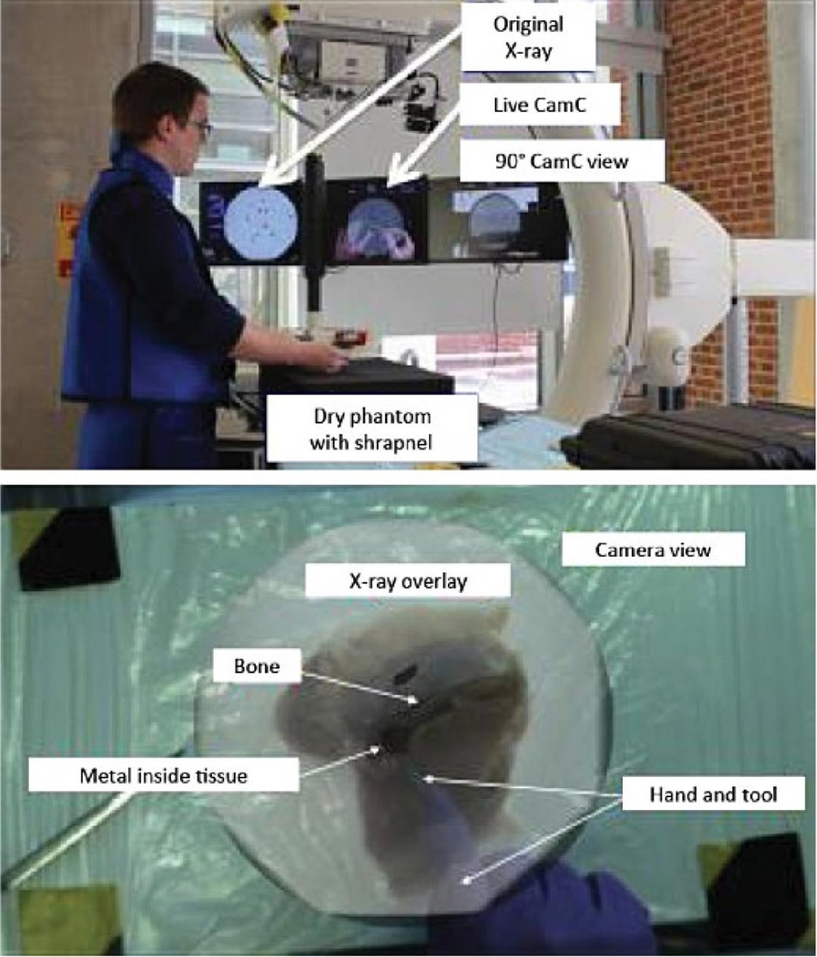
Figure 8 - C-arm application [12].
Mobile C-arm is an example of the capability of the technology, careful consideration regarding possible concerns which could potentially impair or limit the result should be contemplated.

One of the most prevalent concerns particularly affecting AR applications which incorporate outdoor environments is lighting conditions. Lighting conditions can be controlled indoors (to a certain extent), unfortunately weather conditions which are presented is a condition which cannot be regulated, this can have detrimental effects on the superimposition of virtual objects and the ability to track images/objects at runtime. This concern is particularly relevant to this project if the Author implements AR technology to operate on real vehicles, the environment conditions at that particular time could potentially generate unwanted results. Fortunately, this problem has been identified so platform providers and AR tool sets are advancing to address the issue [15].

AR software development kits
Augmented reality software development kits comprise of a collection of tools contained inside a single installation suite. The SDK is the central industrial software engine which commands the development and conception of AR applications and experiences. The chief purpose of an AR SDK is to execute the non-frivolous undertaking of amalgamating the digital material and data with the real world [16] [17]. The proficiencies of the SDK will categorically provide the support and foundations associated with the features and functionality in the application, so it is imperative that careful consideration regarding the choice of SDK is assumed. It is obligatory that the chosen SDK is capable of delivering what the project requires, this would suggest that research into feasible software development kits would unequivocally benefit the development and planning of this project.

There are several augmented reality software development kits currently available with the key purpose of providing developers with sophisticated features such as: AR tracking, AR recognition and AR content rendering. AR software development kits are primarily used to effectively identify images or 3D objects, track them, and adroitly render the scenes in the application [18].

Identifying a suitable software development kit for this project is key, it will assist in the development process of the application and provide the Author with means of completing the development requirements.

ARCore

ARCore is a software development kit developed by tech giant Google, the software development kit permits developers to create complex augmented reality applications [19]. The SDK consists of 3 primary functions:

Motion Tracking – One of the major features provided by ARCore is motion tracking, the tracking of a user’s movement and position within a 2D and 3D space is critical in identifying visual feature aspects via a device’s camera view or image [20]. Figure 9 illustrates an example of how a user’s position being tracked in relation to the feature points acknowledged by the SDK.

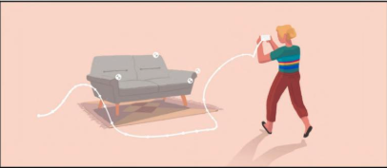
Figure 9 - ARCore Motion Tracking [20].

Environmental Understanding – To achieve the best possible AR experience it is essential that the developed AR application has a respectable understanding of its environment. To realise this experience ARCore provides methods of identifying physical objects and surfaces which exist in the user’s reality, ARCore accomplishes this by exercising a technique described as meshing. Meshing aims to identify objects and surfaces via a camera feed or image and then superimpose computer generated objects/images into the real-world environment [21]. An example of this is demonstrated in Figure 10 below:

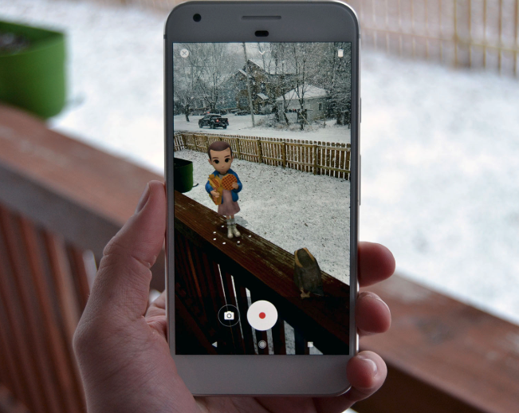
Figure 10 - ARCore Environmental Understanding [21]..

Light Estimation – Light Estimation is only feasible if sufficient motion tracking and environmental understanding standards are achieved. The SDK uses a combination of the user’s position in conjunction with the environmental understanding of the environment and virtual objects position as a method of analysing light levels. The light level information gathered can be utilised to determine the lighting and shading of the virtual objects superimposed into a user’s view. Figure 11 exhibits the impact placated lighting conditions can have on a virtual object [22].

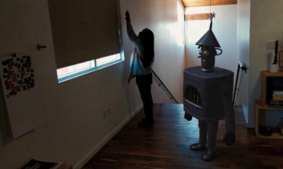
Figure 11 - ARCore Light Estimation [22].

motion tracking capabilities to enable a device to determine its position relative to the real world, using an environmental understanding algorithm the SDKL also has capacity to detect the size and location of flat surfaces and has functionality for devices to estimate the current, live lighting conditions of the environment.

A comparative study of Augmented Reality SDK’s was conducted by D. Amin et al, the journal discusses augmented reality and evaluates the preeminent AR SDK options what are currently available. The Authors state that “The paper presents a detail survey of various augmented reality SDK’s. Basic difference between augmented reality and virtual reality, working of AR system is explained in section 2 with different tracking mechanism used in augmented reality. Related work done using several AR SDK’s is discussed in section 3. Augmented reality SDK’s along with their features are discussed in detail in section 4 and comparison of AR SDK’s based on different criteria is discussed in section 5. Finally, section 6 concludes the paper” [23].
ARToolKit

The open-sourced computer tracking library was produced to enable developers to create modern AR applications which support the overlaying of virtual content in the real-world. The position and orientation of the virtual aspect is delineated by distinguishing the locations and orientation of the marker based on the computer algorithm it utilises.

Amin et al. define the ARToolKit library as “ARToolKit library consists of AR module which contains marker tracking routines, calibration and parameter collection, Video module having video routines for capturing the video input International Journal on Computational Sciences & Applications (IJCSA) Vol.5, No.1,February 2015 19 frames, sub module is a collection of graphic routines based on the OpenGL and GLUT libraries, Gsub_Lite module has a collection of graphics routines, which is platform independent. It was designed for personal computers and not for embedded devices. Hence porting it directly to mobile platforms was difficult and impractical because it uses a lot of FPU calculations. But over the time lot of ARToolKit extension have been developed which support mobile platforms also” [23].
The Author’s also state that some of the key features are:

- “Has ability to use any square marker patterns also simple black squares can be tracked” [23].
- “Easy camera calibration code” [23].
- “Tracking is fast enough for real time AR applications” [23].
- “Provides cross platform video library with multiple input sources (USB), support multiple format (RGB, YUV), multiple camera tracking” [23].

Metaio

Metaio is a flexible framework that comprises of multiple components such as: rendering, capturing, sensory and tracking functionality, along with the Metaio interface which provides the connection and communication between the components and the AR application.

One of the key benefits of the Metaio SDK is that it is attuned with a lot of the major platforms regarding software development (Android OS, IOS, Windows). The platform agnostic interfaces which Mataio supports provides affluent communication with every environment.

The SDK’s feature set comprises of 2D and 3D image tracking (marker-based and marker-less), sustenance for QR code reading, functionality for 3D rendering and optimisation selections for specific mobile chips.

The following SDK’s have been identified as being possible candidates for use in the creation and development of the Licence Plate AR application:

Vuforia

A complex SDK which enables developers to rapidly create highly dependable, mobile-centric, immersive AR simulations. Vuforia utilises computer visualisation expertise to ascertain and trace image targets and 3D objects in real time. The SDK facilitates developers with the ability to control and locate virtual objects relative to where they require them in a real-world environment; Additionally, any digital information or assets can be superimposed into the real-world scenario, relative to where the developer requires them to locate. This visualisation can be observed via the use of an AR supported smart phone or tablet [9] [24].

Vuforia has a comprehensive degree of documentation which developers can exhaust, some of the documentation which is relevant to this project is:

Optimising target detection and tracking stability

The Vuforia SDK is capable of recognising and tracking image/3D targets by evaluating the contrast-based features of the targets that are distinctive to the device’s camera. It is possible to improve the recognition and tracking performance by managing the focus on the hosts camera, also ensuring the developed application has been designed with the consideration of the user experience as a focal point of the application [9].

Target star rating system – Any target images which are used in the AR application have a star rating assigned to it based on the extracted feature data from the images, the extracted feature data is then compared to the data that is represented in the image target in the live camera feed. Ideally the image target would comprise of a 5-star rating (max rating), although target images which reside at the lower end of the scale can also be tracked and are augmentable [24].

The target rating system analyses the features associated with the target image, a feature consists of objects or shapes contained within an image which comprises apparent jagged/sharp detailing. See figures 12 and 13 below:
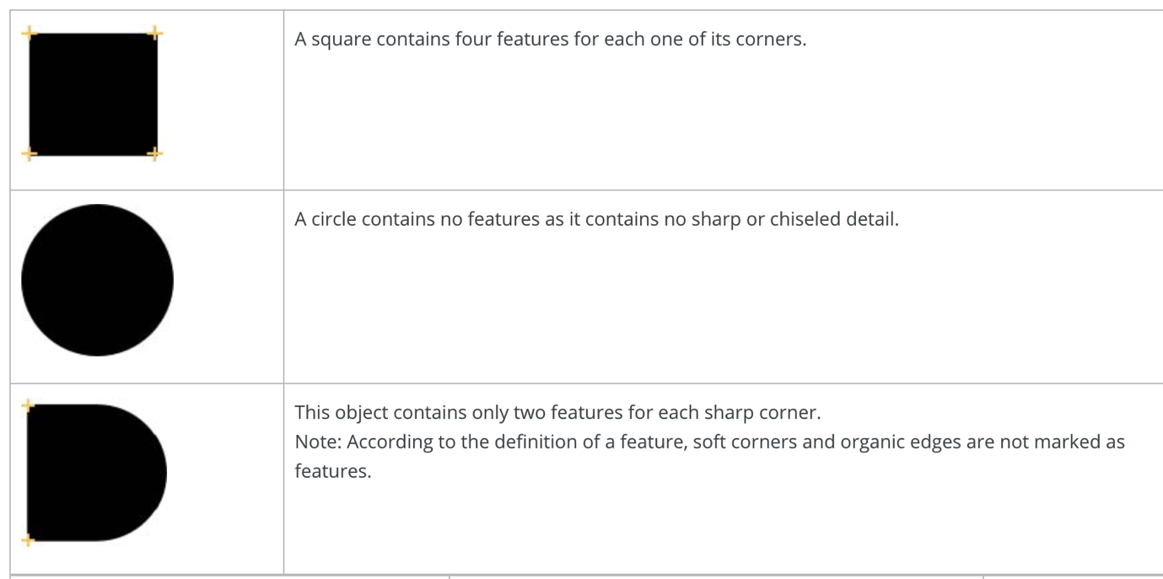
Figure 12 - Image target features [24].
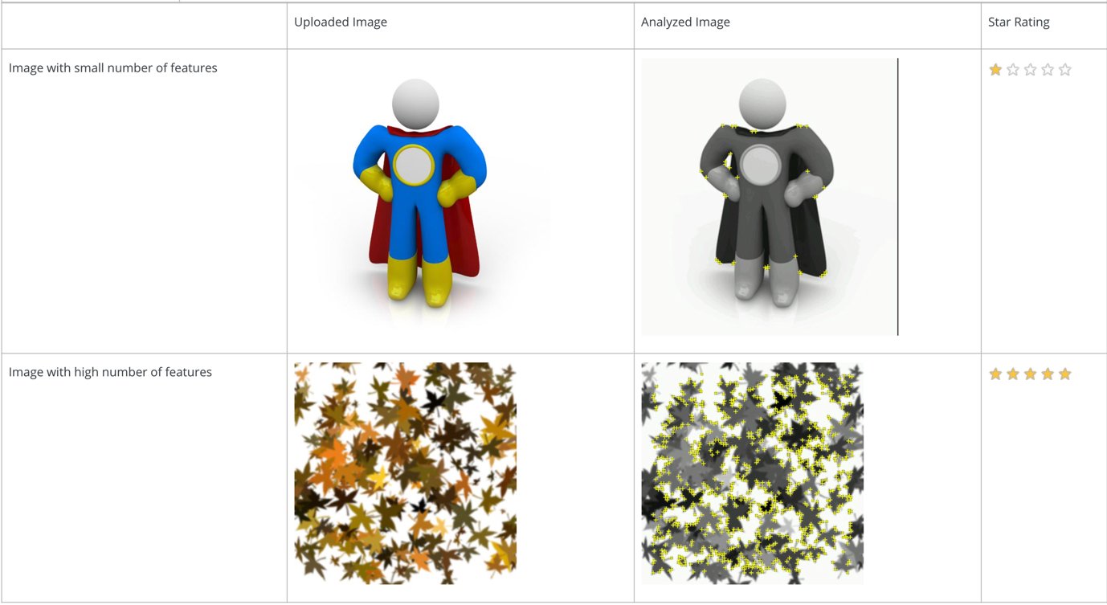
Figure 13 - Image target features (2) [24].

The importance of features in image targets can be understood from Figure 12 and Figure 13, regardless of contrast, the Vuforia SDK can detect images with clearly defined edges at ease; opposed to an image which contains soft corners and organic edges [24].

To ensure the image target can be effectively trackable the image target should be (Figure 14):
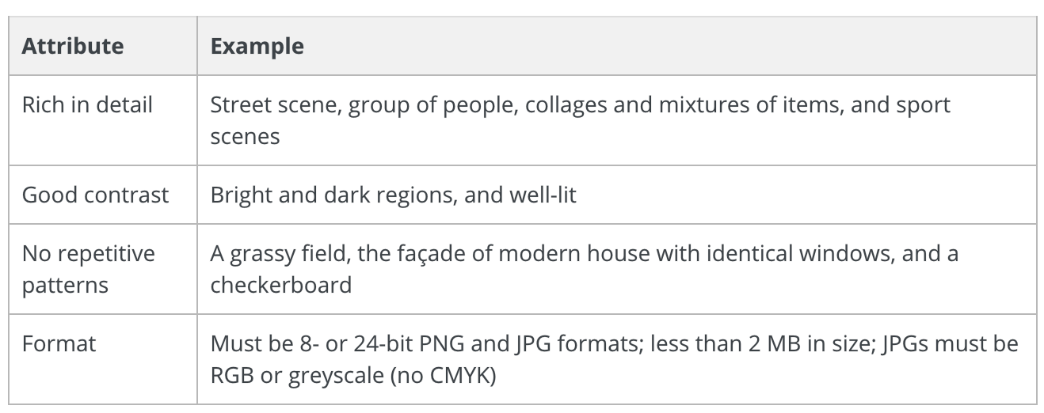
Figure 14 - Image Target Standard [24].

Target size – To attain the minimum size that a given image target should permit, it is advised that the camera to target distance is divided by 10. For example, an image target which is 30cm in length, would proficiently be detected from up to 3 metres away (30cm x 10). This advisory is subject to lighting conditions, camera quality/focus and invariably will require a star rating which reflects the ability to recognise the image target [25].

Printed Target texture/appearance – The tracking quality of the image target can radically vitiate if the surface of a printed targets is not flat; Additionally, glossy surfaces from printouts may results in complications surrounding the lighting conditions, reflections from light sources can results in the image target appearing distinctively different and therefore resulting in the SDK not recognising it [26].

User defined targets

The user defined targets feature provides the proficiency of selecting an image target at runtime which the applications then recognises. Typically, image recognition uses a pre-defined target is declared for the application to have knowledge of the image data, this feature aims to negate the requirement for a pre-defined target by enabling the user to determine it at runtime. This functionality is achieved by capturing the camera frames chosen by a user at a specific moment and allows the user to experience the benefit of augmented reality when desired [27].

The recommended attributes for selecting a target at runtime are consistent with Figure 15, the user should aspire to replicate the section of this report which discusses optimising image targets.

The Vuforia documentation outlines how the user defined process operates:
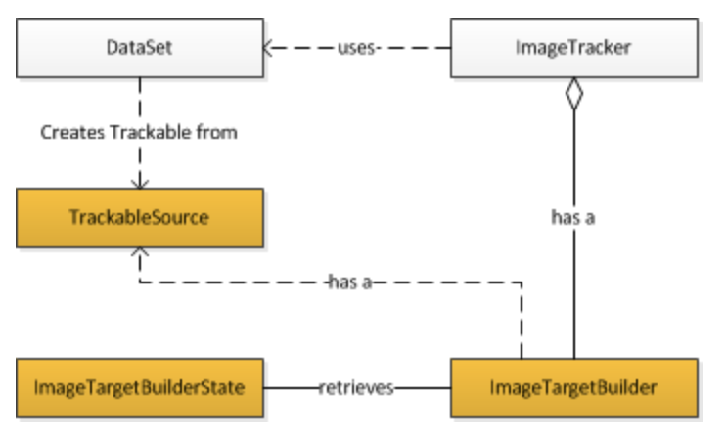
Figure 15 - User Defined Target Flow [28].
The ImageTargetBuilder class exposes an API for controlling the building progress and retrieving a TrackableSource for instantiating a new trackable upon successful completion [28].

Optical character recognition
Optical character recognition (often referred to as text recognition) comprises of the use of technology to distinguish text (printed or handwritten) within digital images or physical records [29]. The technology surveys a document or digital image which contains text, decodes the characters, then proceeds to convert the text into code which can then be used for processing the data contained in it [30]. OCR uses an image or document and analyses it for to determine a contrast between light and dark regions, the regions identified are then determined to be background and text respectively. After the regions are determined, the dark region is further processed to establish if the text consists of a letter, or a numeric character [30] [29].

The process of establishing what character are contained in the image/document typically derives from two algorithms:

- Pattern detection – The software is provided with examples of text in various formats, the examples utilised are then compared to achieve recognition against the text in the image/document in question [31] [29].
- Feature detection – Using the contrast of a given image or document features are ascertained, the features entail any angled lines, crossed lines or curved lines and are then used to compare against the text in the image/document being analysed [32].
Most OCR systems then convert the verified characters into ASCII code, computer systems can then supplementary manipulate the ASCII code obtained from the text [32]. This process is illustrated in Figure 16.

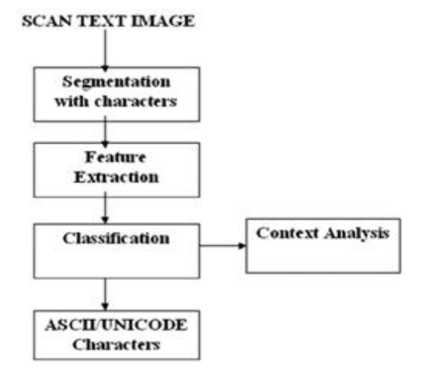
Figure 16 - Stages of OCR [32].

OCR systems are commonly utilised as a form of data entry using physical paper form such as passport documentation, receipts, mail and bank statements. The text which is extracted from any of the mentioned data sources processed and digitalised to ensure that they can be digitally revised, explored, stored more densely, displayed on the Web, and consumed by machine processes for instance – intellectual computing, system/machine translation, text-to-speech and text extracting [33]. This sentiment is shared by R.Mithe et al. who states “OCR is a technology that enables you to convert different types of documents such as scanned paper documents, PDF files or images captured by a digital camera into editable and searchable data. Images captured by a digital camera differ from scanned documents or image. They often have defects such as distortion at the edges and dimmed light, making it difficult for most OCR applications, to correctly recognize the text.” [34].

In recent years there has been significant advancements in OCR, this has invariably resulted in the increase of applications and software which utilise it [31]. Some of the latest and innovative cases consist of:

Tesseract – According to C.Patel et al. “Tesseract is an open source optical character recognition engine. It was developed at HP in between 1984 to1994. It was modified and improved in 1995 with greater accuracy. In late 2005, HP released Tesseract for open source. It is highly portable. It is more focused towards providing less rejection than accuracy. Currently only command base version is available. As of now Tesseract version 3.01 is released and available for use. HP never used it. Now it is developed and maintained by Google. It provides support for various languages” [35].

OCR space – OCR space is an API which provides functionality to parse images and pdf documents and return the extracted text from them as a JSON response [36]. The online service allows any device which is connected to the internet to use this service and the basic version of the service is free. OCR space would enable an API request to be made in the environment of choice, the response from the API (JSON) would then be interpreted to extract the desired text [36].

Google Cloud Vision API – This technology allows developers to integrate vision recognition features in applications, some of the features include image labelling, optical character recognition facial feature detection and automated explicit content flagging [37]. The intricate cloud technology enables the extraction of text from images and documentation, and also has functionality to extract text from handwritten documentation [37].

Personalised Registration Numbers
Personalised registration numbers allow consumers to personalise a registration which pertains to a vehicle, in recent years their popularity has increased, they can now be purchased online via the DVLA website or third-party vendors [38].

Any number plate produced for use on UK roads must comply with specific regulations, some of the most notable regulations are:

- They must be made from a reflective material.
- Display the characters which make up the licence number in black text.
- Use white background for the front of a vehicle and yellow for the back.
- Must contain any background pattern.
- The Mandatory font which should be used on all registration plates is Charles Wright font.

The current format for new registration number is shown in Figure 17:

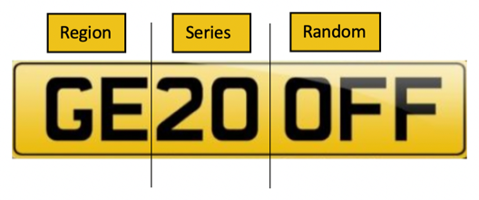
Figure 17 - Registration Format.

- Region – The segment represents the region where the vehicle was first registered [38].
- Series – The indicates the issue date of the licence number [38].
- Random – Random 3 letters which are positioned at the end of the licence plate [38].

The other formats of registration numbers consist of:

- Prefix number plates – Introduced in 1983, they entail of one letter at the beginning which identifies the age of the vehicle, followed by up to three numbers, then three letters at the end of the plate (Figure 18) [38].

Figure 18 - Prefix Licence Number.
- Suffix number plates – Issued between 1963 – 1983, comprising of three letters which proceed up to three numbers followed by a letter which distinguishes the age of the vehicle (Figure 19) [38].


Figure 19 - Suffix Licence Number.
- Dateless licence plates – Issued before 1963, comprises of up to four numbers followed by up to three letters, or vice versa (Figure 20) [38].


Figure 20 - Dateless Licence Number.

Development Platforms

Identifying an appropriate platform to develop the application is key in delivering the functionality required for the project. The development platform must adhere to the following requirements to be considered a suitable candidate:

- Support AR development – Augmented reality is at the central focus for the project, it is integral that the chosen development platform supports AR development. This is possibly the most important requirement as most game engines provide characteristic functionality concerning game development; but do not support AR development.
- Create user interfaces – A user interface will be required for the user to interact with when entering a registration-plate they would like to visualise on vehicle.
- Modelling – Ensuring that the software supports model rendering, texturing and shading is integral in supplying a product which has a professional appearance and will also assist in the integration of assets in the AR environment.
- Plugins/SDK’s – Multiple software development kits have been identified to assist in the development process, it is essential that the development platform can incorporate them to ensure the implementation aspect of this project can be achieved.
There are numerous development platforms which can deliver the requirements outlined above, the following platforms have been recognised as suitable possibilities:

Unity3D

Unity3D is a cross-platform game engine created by Unity Technologies for the development of creative media, particularly video games. It provides developers with a sophisticated integrated development environment with a simplistic graphical user interface to assist in the creation of video games and simulations.

The game engine was launched in 2005 with the goal to create “an affordable game engine with professional tools for amateur game developers while democratizing the game development industry [38]”. The game engine was initially available on MAC OS X only, but in recent years has now been made available for windows machine and can deploy games and simulations to over 25 different platforms.

Unity3D is renowned for its simple export process, ease of usability, rapid and efficient C# scripting, supplying an extensive asset store which contains copious amounts of 2D and 3D assets, and has an incredible community forum which enables users to confidently debug any issues they encounter.

Some of the key benefits of using Unity3D are:

- 2D and 3D development – Unity3D supports development in 2D and 3D when creating games/simulations.
- Multi-framework support – The Unity game engine supports coding frameworks such as: C#, JavaScript and Action Script.
- Affluent user interface – The user interface is lightweight, fast and efficient, creating a comfortable development experience. Game assets can be imported rapidly and rendering times are expeditious.
- Community/learning – There is an active and supportive development community whom can assist in debugging any issue what arise in the development; In addition, tutorials are plentiful and often at no cost.

Unreal Engine 4

The Unreal Engine is a game engine designed by Epic Games; it was initially demonstrated when Epic Games developed the first-person shooter, Unreal. The Unreal Engine 4 was released 14 years after the original game engine (Unreal Engine) and continues to be a leading choice of platform when developing games.

Some benefits of using the Unreal Engine 4 are:

- Open source – The game engine is open source which ensures that development is made easier and more efficient.
- Rendering/post-processing – The engine supplies users with the best rendering quality currently available across development platforms, it also has incredibly fast post-processing and has extensive support for many of the features contained in the game engine.
- Memory – typically uses less memory and resources when creating AR projects; although developers can get creative on methods to optimising the amount of memory/processing power required for running AR applications.
- Graphics – This game engine delivers state of the art gaming graphics to enhance the users experience.
- Multiplatform development – Similar to Unity3D, the Unreal Engine 4 supports multiplatform development which enables it to deploy to platforms such as: Nintendo, Xbox One, PlayStation 4, IOS, Android and VR platforms such as OSVR and Oculus Rift.

Literature review conclusion
The first step of the literature review was to gain a systematic understanding of the augmented reality technology, this inaugurated with looking at the history of the technology to try and ascertain an understanding on where AR began and where it has advanced to. During the research into the history of AR the Author gained an understanding of the different types of the technology, this has proceeded with the preferred types being - superimposition-based AR and Marker-based AR. These types could potentially allow the Author to implement functionality to recognise a pre-defined registration plate, then ensue to overlay an augmented display (personalised registration) over the pre-existing registration plate.

Identifying the limitations of augmented reality was imperative in achieving the knowledge required to discern if the primary goals where possible. This involved examining innumerable amounts of documentation and journals to identify current applications which use the technology and gain an understanding of the implementation of them. It became extremely obvious that augmented reality has presidency particularly within the gaming, medical and construction industry. Some of the most popular AR applications discovered consisted of: Pokémon Go, Google Translate and Mobile C-arm. Software development companies have certainly pushed the limitations of what is achievable from AR, it can be acknowledged that this is something what will only advance as technology and hardware progress over the coming decades. The only restrictions/limitations realised surrounding the technology involve the hardware which uses it: depending on performance optimisations when using AR, it can be noticeably CPU/memory intensive; although when considering what this application aims to achieve, this possible drawback should not occur because of the simplistic nature of the application.

Optical character recognition was identified as being a possible component of the solution, several implementations of it where analysed with the prominent leader being Google Translate. This could be a probable technology which could be incorporated into the application to delineate the current registration of the target vehicles registration plate, this could conceivably provide the application with a focal point to overlay the augmented display. OCR has particular importance in the dynamic recognition of a target registration plate, if the application ever intends on dynamically recognising any registration plate then this technology will most certainly have prominence in the application.

Research into software development kits has resulted in the Author attaining awareness of their importance within AR development. Software development kits have major precedence in delivering high quality, immersive AR applications. The two primary software development kits identified comprise of Vuforia and ARCore, both provide advanced tooling and features to assist in the creation of immersive AR experiences. Vuforia’s principal features which are applicable to this project consisted of image/object tracking and the user-defined targets capability. Alternatively, ARCore shares similar features with Vuforia but after researching the capabilities of it, ARCore potentially has enhanced light estimation capabilities but it is possible to use the two SDK’s collectively.

It was obligatory that appropriate research concerning development platforms ensued, a development platform is central when testing if the Authors recommendation framework works by developing an application which adheres to the standards which will be outlined in it. Ultimately, the majority of the comparisons between different game engines orbit around the proficiency to deliver better game graphics and game development abilities, a lot of the comparison benefits do not apply to this project as the project aims to deliver a real time capture which only aims to incorporate an augmented superimposition. This would invalidate the need to choose a game engine based on the quality of graphics or primary benefits which the majority of engines are designed to provide. During the process of realising a development platform, the two options which provided the best possible environment to build AR applications consisted of Unity3D and Unreal Engine 4. Comparing the two game engines has resulted in Unity3D being the superior option predominantly because of the accommodating community, the capability to work with numerous software development kits, and online tutorials and support which can assist in the development of the application.

The recommendation framework should consist of best practices and principles and software commendations which have been deemed to beneficial for the implementation of augmented reality for the purpose of viewing personalised registration plates.

Methodology
The identification of suitable research and development methodologies are fundamental in constructing projects which require research and developmental elements. Identifying suitable methodical approaches will inevitably provide greater structure and direction for the project.

Research Methodology
A research methodology is principally a systematic approach to the elucidation of a problem; the methodology delineates how the research should be conducted. Recognising an effective approach is key in retrieving the information required and it ensures that whomever is undertaking the research, is doing it in the most proficient way.

Philosophy
A combination of a positivistic and phenomenological approach is believed to be decidedly beneficial to this project. The philosophy will principally consist of qualitative exploration which will assumingly result in a recommendation framework which is open to interpretation. The opinions of key Authors will be used in conjunction with the Author of this report to conclusively establish if the framework suggestion has been successful. Following this philosophy, the Author anticipates minimal data collection and evaluation from test subjects but intends to use existing data in the form of principles and practices to conclude on the result of the successfulness of the framework and project. The philosophy will discuss current recommendations and develop a new approach which will consist of new and existing recommendations.

Approach
An amalgamation of inductive and deductive approaches could be advantageous to this project. The deductive element of this project is the Author outlining the hypothesis and developing a research strategy to determine the validity of it, with the inductive aspect potentially deriving from analysing the implementation results contrary to the recommendation framework.

Strategies

Literature Review
The literature review was imperative in achieving an understanding concerning augmented reality, mobile application development, personalised registration criteria, optical character recognition and AR software development kits. A comprehensive understanding in each of the fields is important in the process of delivering a recommendation framework, without the extensive research the final recommendation would be erroneous.

Software Development
Software development is an integral process in determining the feasibility of the recommendation framework which the Author advocates. The advocated framework will be used to construct a mobile AR licence plate recognition application which facilitates users with the capability of viewing a personalised registration number on a vehicle/image.

Risks and Limitations
There are numerous risks and limitations associated with any project and this project is no different. The following discussion outlines the main risks and limitations attendant to the project and how the Author aims to minimalize the risk they present.

- Time constraint – Possibly the biggest threat to achieving the outcome desired. There has been an allocation of time which has been proposed for the Author to complete the development and report for the project, this time is insufficient so requires the Author to work around their day job and family life. The Author aims to minimise this risk by being organised (creating a plan of work) and attending regular meetings with the Authors project supervisor to ensure that the quality of work is at an appropriate standard required for MSc level.
- Inexperience – The project has required the Author to identify relevant and appropriate software to undertake a development section of the project. A potential risk is that the software is incapable of delivering the requirements or the Author dissipates endless hours familiarising themselves with the software and the implementation. The Author is confident after completing the literature review that the software is sufficiently capable of delivering the requirements so does not anticipate this risk occurring. When considering countering the possibility of expending too much time familiarising with software user interfaces and navigation, the Author has undertaken tutorials on Plural Sight which should reduce the probability of desecrating too much time on this.

Validity, Reliability and Generalisability

Validity
The Authors deems the appropriate approach to the research is to undertake research into many forms of literature which has relevance to the field in question (augmented reality), this would include: augmented reality, mobile development, AR best practices and principles, constructive software development kits, image analysing software, previous implementations of AR with particular reference to mobile applications, development platforms, registration/personalised registration criteria and current available frameworks to compare and contrast against.

The approach to create a recommendation framework can be definitively proven if the recommendation framework suggested, results in a successful implementation with particular reference to the effectiveness of the recommendation framework. Regardless of the outcome of the implementation the Author aims for the outcome to not provide any particular significant revelations, the framework is intended to be designed not as a step-by-step tutorial, but as a guidance charter for implementing augmented reality.

Reliability
The outcome from the research undertaken has given the Author clear direction on the creation of a recommendation framework. The information ascertained from the research is incredibly relevant, reliable and instructive. However, should this information be consumed in the future then there is no guarantee that it will still be relevant due to technological advancements, research which produces new findings, or an Authors perspective may contrast against the opinion/recommendation stated in this report.

Generalisability
The results of the research can be applied to any system which intends on implementing augmented reality, but with specific focus on image and object recognition. Defining a standard when implementing such as technology can provide excellent guidance, information and clarity on some of the atypical or common concerns surrounding this specialised field. The results can assumedly be targeted at individuals or organisations whom aim to deliver a product which incorporates the AR technology, the framework produced therefore is intended to a significant substance to the majority of AR projects.

Development Methodology
As the project can be deemed characteristically small, an agile methodology is presumed to be more beneficial. The traditional approach requires heavy documentation, which is not necessarily required for this project. The illustration below demonstrates some of the benefits of expending an agile methodology (Figure 21).
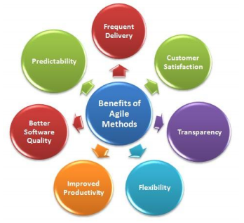
Figure 21 - Benefits of Agile Methodologies [39].

There is the potential for the user requirements to increase or necessitate change during the software development process, this negates the use of a traditional method as they are renown for being increasing difficult to make adaptations to software after the planning stage. This sentiment is shared by Gurpreet Singh Matharu in their study into ‘Agile software development methodologies’ where the Author states “The software industry has shifted from traditional software development models to agile based development in response to ever increasing software complexity and dynamic user requirements. Unlike the traditional models, agile methods are characterized by shorter development cycles, higher customer interaction, incremental delivery, frequent redesign with accommodation of changes necessitated by dynamic user requirements” [39].

The table below illustrates some key differences between the two approaches (Figure 22):
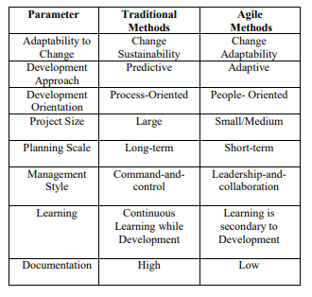
Figure 22 - Comparison between Traditional and Agile methodologies [39].
Software development methodologies are typically produced for teams of people undertaking a software development project, as this project only has one individual to effectively perform all the roles associated with delivering the product, then an adaptation or hybrid of methodologies can be deemed beneficial for the software development process.

The Author has acknowledged that the Agile ethos should be incorporated to assist in the software development process, the following Agile methodologies have been identified as suitable candidates to support the development process.

Feature Driven Development

Feature driven development is an agile software development methodology which aspires to deliver software through an incremental and iterative process. It incorporates numerous renowned procedures into a cohesive totality to provide a robust process which is commonly utilised to deliver software effectively [40].

Feature driven development was designed to adhere to a 5-step development process during the project lifecycle, these steps are:

Develop an overall model – step one of the process comprises of domain and development team members collaborating to construct an object model, this is an iterative process and is traditionally overseen by a chief architect. This process ensures that a collective understanding regarding the concepts of the problem domain are achieved, it also certifies that the team is capable of communicating collectively to discuss the key problem domain concepts. At this stage of the software development life cycle the current the focus around the current object model primarily focuses on the breadth of the model; depth can be achieved through the project iterations, with the model being the core concept which is conversed over [40].

Build a feature list – Although the first step of the process could imply that feature driven development is model motivated process because of the extensive focus on the object model. However, feature driven development is requirement-driven, consumer valued requirements are obtained and used as features to propel the project with the model used as guidance [40].

A typical feature would be estimated to take between 3 and 10 days, traditionally no longer than 10 to complete. Dissimilar to Extreme Programming and SCRUM which utilise a backlog of user-stories which contain requirement driven processes which must be achieved; FDD exercises a 3-tier hierarchy which is referred to as a feature list, the feature list inevitably contains a list of organised features relating to the project [41].

Plan by feature – This stage consists of a project-wide scheme to generate a development plan. Key concepts associated with creating a development plan are, ordering of the features which are planned to be implemented, the impact the features will have on the team, and the complexity involved with implementing the features discussed. Multiple refinements of features contained within a given project is a common occurrence, it is important that clarity surrounding the development sequence and allocation of business events to developers [41].

Design by feature – A chief programmer will essentially have a “work package” which consists of numerous features which are relevant to a number of classes. It is customary for the Chief Programmer to form a Feature Team which involves the Chief Programmer ascertaining which developers are to be considered/participating in the development of the “work package” of features [41].

Build by feature – Development of the software is divided into features; a developer can complete a client-valued function (feature) then the feature is tested and reviewed by a chief programmer [40].

The renowned procedures include:

Domain object modelling – The domain object model comprises of discovering and explicating the domain of the challenge proposed, the outcome of this will provide context to implement the features on [41].

Developing by feature – During the deliverance of the features, any function which is considered too complicated to release in a two-week period will be broken-down into smaller functions until it is deemed to be a feature [41].

Individual class (code) ownership – Refers to any well-defined segments of code should be allocated to an individual. The individual is responsible for the performance, reliability and veracity of the class which contains the code [40].

Feature teams – small teams are constructed to collectively collaborate in the design decisions regarding the project, numerous designs will be discussed and together the team will conclude with the one chosen [40].

Inspections – The process of inspecting the code to identify any defects or bad practice, this can be achieved by peer review or group review [40].

Configuration management – Primary used to identify the source code of any of the accomplished features, integral in ascertaining a history of completed work and provides evidence of classes/code which has been enhanced from previous versions.

Regular builds – Ensures the latest version of the software can be exhibited to a client and supports the early discovery of defects which could affect current/future features.

Visibility of progress and results – typically managers would lead the project using regular, applicable and accurate advancement reports.

Extreme Programming
Extreme programming is considered a lightweight methodology which enforces iterative software development for the purpose of creating an impeccable standard of software whilst increasing productivity [39].

Figure 23 illustrates the Extreme Programming approach:

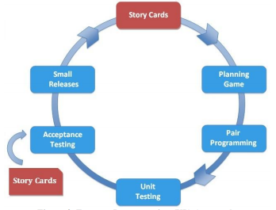
Figure 23 - Extreme Programming Approach [39].

It can be acknowledged from Figure 23, the different stages incorporated in the XP model. Story cards are utilised to delineate the requirements on, the story cards then proceed to be split into small tasks which can be undertaken by the developer [39].

Some of the key principles which this methodology adheres to are, requirements on story cards, simplicity, continuous interaction, test-driven development, refactoring and pair programming. This project repudiates the need or does not permit any collaboration on the project, so the pair programming aspect will be declared impassive and will not be included. However, the other concepts of the methodology ensure that the focus is on the user requirements and the deliverance of software which convenes the requirements, it focusses on the rapid deliverance of software with any additional features added on at the end [39].

Resources

Hardware Resources
As the project has a development aspect to it, multiple hardware choices have been made to ensure the development phase can be achieved, the hardware resources which the Author has deemed relevant are:

Home computer – The most important piece of software, this allows the Author to write the report which relates to the major project submission, allows the Author to perform the relevant research pertaining to the topic of interest and allows the Author to install software required for the project such as Unity3D. A computer is essential for the development aspect as the chosen development platform and any additional tools must be installed on it, this software is often CPU intensive so ensuring the computer has the specifications to operate the software is crucial.

Android device – An Android device (S9) was used to deploy the completed application to. The Author owns an Android phone, so it was considered judicious to use it, rather than purchase an IOS device. Note: research was done to ensure that the device used (S9) had sufficient specifications to run the completed application.

Camera – The project requires a camera to visualise the augmentation, using the camera on the Authors mobile device will enable this process.

Software Resources

The project required specific software requirements to achieve the overall goal, the software requirements included:

Unity3D – As discussed in the literature review; Unity3D was identified as being the primary game engine/IDE of choice, previous experience using the engine and the incredibly supportive development forums where pivotal in selecting this as the desired game engine to complete the application.

Microsoft Word – Microsoft Word was chosen as the desired word processor to complete and documents the accompanying report for the project, it provides a simplistic user interface which the Author is familiar with.

VS Code – VS Code was required for editing the C# scripts via Unity3D, this allowed the Author to develop the code used in the AR application.

Vuforia SDK – Vuforia was recognised as an integral part of the development process, numerous applications discovered used this framework and concluded to outline the importance of it. Vuforia was integral in identifying image targets used in the application, it supplied a dataset with the image data to ensure the licence plate provided in the application could be recognised.

Unity Remote – Unity Remote in an application which is downloadable on IOS and Android, it is integral in viewing the delivered application on (in this case) an Android device. This can be used throughout the development process to test the current progress of the application and help debug. Unity Remote will enable the Author to visualise the completed application as if it were deployed on the device; Furthermore, the project requires a camera to visualise the augmentation, using the Android devices camera will allow this process to be achieved.

Android APK – The Android APK is required to successfully deploy the finalised application to the Android device, it this case it will enable a distributed version of the application which contains the application code, assets and resources to be installed on the target device which then can be used to demonstrate the application. If the Android APK is not installed the application cannot be deployed to the Android device.

Plural Sight – Pluralsight is an online education service which provides a multiplicity of educational videos for software engineers to learn from. The service has an important role in the project when considering the Authors lack of familiarity with using Unity3D, utilising this service will give the Author the basic navigational and user interface skills required to undertake the development of the application. This will hopefully minimise the time expended on creating the application.

Marvel App – This online resource allows users to generate design specifications for applications deployed on numerous devices. This will allow the Author to create user interface specifications to assist in the development of the UI elements in the application.

StarUML – StarUML will be responsible for creating any diagrams which represent any activity or architecture design of the developed application.

Trello – This online service will assist in managing the user-stories/features discussed, the Author can view/track exactly what features need to be completed, whilst describing exactly what needs to be done for successful completion of each feature.

Information Resources
The only external data required for the project is the current available personalised registration numbers, as part of the development requirements the Author would like to provide the user with the capability to query if a specific registration number is available; if not then suggest one what closely resembles it. This functionality can only be achieved if the Author receives a snapshot of the latest available registration plates to query against. The DVLA can provide a snapshot of the current available personalised registrations, this can be used during the development process to ascertain if a particular registration or alternative is available.

Methodology Conclusion

Identification of both research and development methodologies is key in approaching the project and determining to accept or reject a hypothesis. Undertaking the process of delineating both methodologies ensures the process is maintained to a prohibitive level of effectiveness and proficiency.

It has been identified that a combination of approaches and philosophies will benefit the research element to the project more effectively than adhering to a single one. At this stage, the Author does not anticipate any surveys or questionnaires to be conducted, so the conclusion to accept or reject the hypothesis stated will solely be decided on the implementation based on the recommendation framework.

The research methodology concludes to describe how the Author aims to gather information and data to help assist in the deliverance of the aims and objectives and describes the intention of use for the information obtained.

When initially proposing the concept of this project the Author had identified Extreme Programming as the preferred option of software development methodology; However, after careful consideration it was decided that a hybrid combination of Extreme Programming and Feature Driven Development would enhance the software development process.

Extreme Programming encompasses an iterative process which includes the use of story cards which contain the desired requirements. The Author has familiarity with the concept of story cards and wishes to propose the concept of story cards which integrate the features for the project. The story cards will contain the feature to be undertaken, a description of what is expected which will be a result of any requirements stated in the design section. The features define what task is to be undertaken regardless to how diminutive it may appear. Combining the story cards which contain the requirements and the desired feature implementation should produce an effective software development process. The software development lifecycle will aim to adhere principally to the extreme programming approach: planning, design, implementation then testing with the incorporation of features on story cards. The iterative approach is highly relevant to this project to help overcome issues discussed in the risk and limitations section, the ability to iterate over each phase recursively can potentially produce a lifecycle which considers the possibility of unexpected issues arising.

Design
The design phase of the project is critical in outlining a design which befits the recommendation framework, the design will be utilised as a director of the software development process, alongside the methodologies discussed in section 4. The first step of the design stage is to delineate the requirements of the project.

Requirements
Requirements are fundamental in understanding the behaviour of an application, a clearly defined set of requirements ensures that the design and development stages progress fluently. The following requirements delineate how the developed application should behave:

- Visualise a personalised registration number on a vehicle.
- The superimposed visualisation must comply with the specifications outlined for a suitable, legal licence plate, in particularly the font of the text on the licence plate.
- The registration number a user enters must be checked for offensive criteria.
- A user must have the capability of checking if the registration number is available.
- Return a price relative the registration number.

Based on the requirements and the research commenced the Author has concluded with the following recommendation framework:

Recommendation Framework
- Stationary Screen Space – When designing user interfaces for AR experiences, careful consideration must be concentrated towards the user interface. The user interface should behave analogously like a traditional mobile applications UI irrespective of what is being portrayed from the camera feed via the device’s camera. All UI elements should be fixated and present like conventional applications would do which do not provide AR experiences. For example: UI buttons should be consistently accessible regardless of the position of camera or distance to image/object targets, this ensures that the user can experience the applications full potential while maintaining a high degree of usability and accessibility.

- Environment Variables – Understanding the limitations of using AR applications in challenging environments is fundamental in creating immersive experiences. As discussed in section 1: image/object recognition typically uses pre-defined targets; for these targets to be recognised, they image/object what represents the target must be consistent with the target in real-time. This proposes exigent challenges particularly concerning lighting conditions, lighting conditions can have a detrimental effect on the ability for images and objects to be recognised. Most common SDK’s use contrast-based features to optimise the detection of targets, ensuring that any application developed adheres to this principle will result in an application which has better performance capabilities concerning the delivery of the AR experience. To certify that the application proposed has the preeminent possibility of locating image/object targets; it is suggested that the environment which contains the image/object targets is well-lit and dry, and the pre-defined image targets consist of images/objects which are resonant in detail and have virtuous contrasts which equal the pre-defined targets used.

- Object and Image Detail/Correspondence – To achieve the best results possible from the augmentation, detailed objects should be superimposed which push the capabilities of target hardware to maximise the user experience, using detailed, recognisable and appealing superimposed objects will typically achieve this goal. The superimposed object/image should enhance the view of the user to amplify the AR experience, the object detail should amalgamate into the view in this case creating a visualisation of a personalised registration plate on a vehicle. It is imperative to establish a correspondence which connects the superimposed object/image and the real-world object/image, it is essential in projecting the visualisation required.

- Personalised Experience – Creating AR applications which invoke personal user elements provide a much more engaging user experience, the user can establish an emotional/relational connection if the personalised experience is realised. Allowing users to customise elements of the application may result in the application being more relatable, this could be achieved in this application by allowing the user to define the personalised registration they aim to realise and/or visualising the personalised registration number on a vehicle of their choice.

- Software Development Environment/Engine – Unity3D has been identified as the primary choice of development platform, the other potential candidate was the Unreal Engine 4 but when considering the requirements, aims and objectives, Unity3D was the exemplar development platform for developing AR experiences.

The game engine has substantial support for AR development consisting of extensive documentation for AR development, and an incredibly supportive community forum where developers discuss any issues or bugs they have with their applications. In addition, there are copious tutorials online which present professional tutorials to enable the Author to further their knowledge of AR implementations and assist in the development process with ideas and advice on executing functionality required.

Unity3D provides a simplistic user interface for development purposes, navigation skills and familiarity with the UI can be achieved using Plural Sight online service which provides instructive demonstrations for using Unity3D.

The platform has an innovative asset store where developers can download assets, models and plugins for their applications. It also supports the inclusion of numerous AR software development kits and plugins, having this capability to utilise such tools could potentially be the difference in realising the desired outcome.

- AR Software Development Kit – Vuforia software development kit can provide immeasurable value to this framework due to the complex features it supplies. It has sophisticated image/object recognition and tracking capabilities and undoubtfully is one of the prime AR software development kits available. The SDK adds particular value to this framework by facilitating the practice of image/object recognition, this has fastidious relevance when considering the method of recognising vehicle registration plates. A proposed concept is for the registration plate of a vehicle to be recognised to produce a superimposed image which consists of a user defined personal registration number. Users must adhere to the recommendations discussed relating the optimising the image targets to achieve maximum efficiency.

Minimal Viable Product
A minimal viable product is essentially a version of a product which has enough features and functionality to be used by consumers, the consumers provide necessary feedback to assist the relevant parties with information regarding the product for future development.

When considering the development aspect and the complexity of it, achieving the initial recognition and augmentation on a static image can be deemed acceptable. This can minimise one of the risks discussed in the research (time constraint) as the Author can solely focus on an image where the environment variables are consistent. If the successful implementation of the requirements is achieved and the Author acknowledges that there is sufficient time to attempt implementing the functionality on real vehicles/any vehicles, then the Author will proceed to attempt it. Acquiring user feedback on usability and recommendations can be collected to then improve the MVP which has been released.

User Interface
The user interface design is a fundamental element of the project, producing a UI design can increase the efficiency when developing the application and allow it to operate more intuitively. A user interface will increase the ease of usability when consumers use it, although the application is simplistic in nature, it is imperative that any icons or visual elements are clearly defined and easy to understand what operation will be performed if used.

When considering the user interface, it is crucial that the requirements and recommendation framework are cogitated to ensure that the most professional and effective UI is delivered.

The proposed user interface is illustrated in Figures 24 and 25 below:

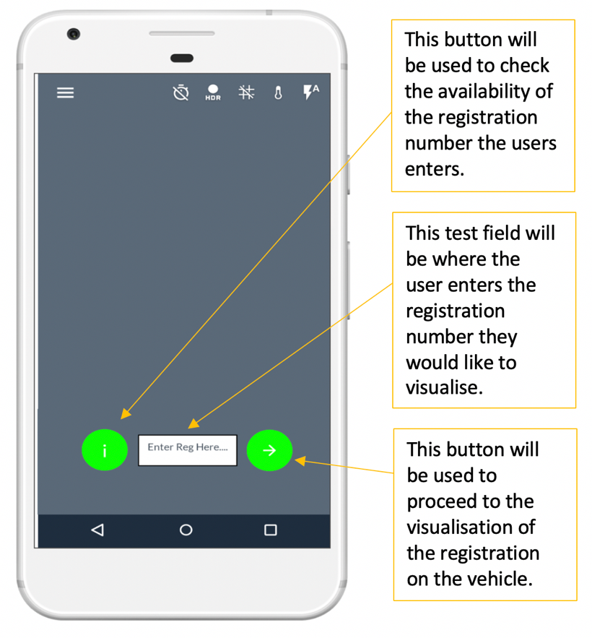
Figure 24 - Proposed user interface 1.

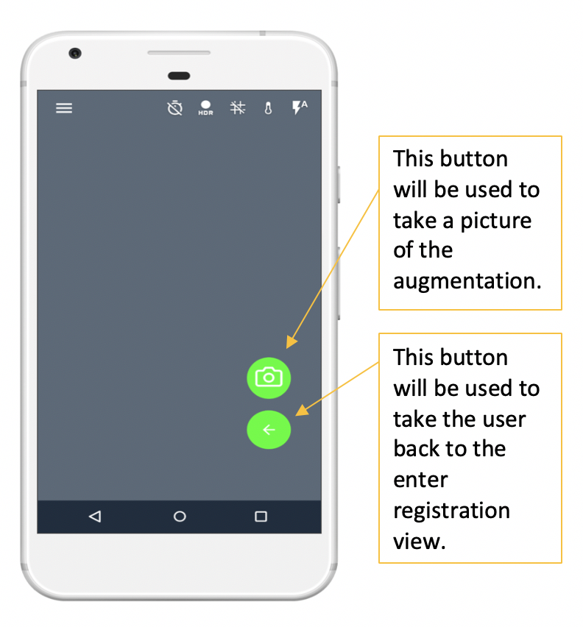
Figure 25 - Proposed user interface 2.

The proposed user interface has been created with simplicity and usability as the forefront of focus. Any buttons or interactive elements should be intuitive to ensure a user can comfortably distinguish what each interactive element accomplishes. The user interface has been designed to only have two displays which will interchange depending on what the user is aspiring to do, one screen for entering the desired registration number (which includes the availability check), then a second screen which will proceed the first when the user clicks the arrow button.

Proposed System/Feature Design
The proposed system architecture will be highly influenced by the software development kit used, the Vuforia SDK has complex libraries and tools which can assist in the process of image/object recognition. The system architecture which is responsible for the recognition element of the application is illustrated in Figure 26 below:
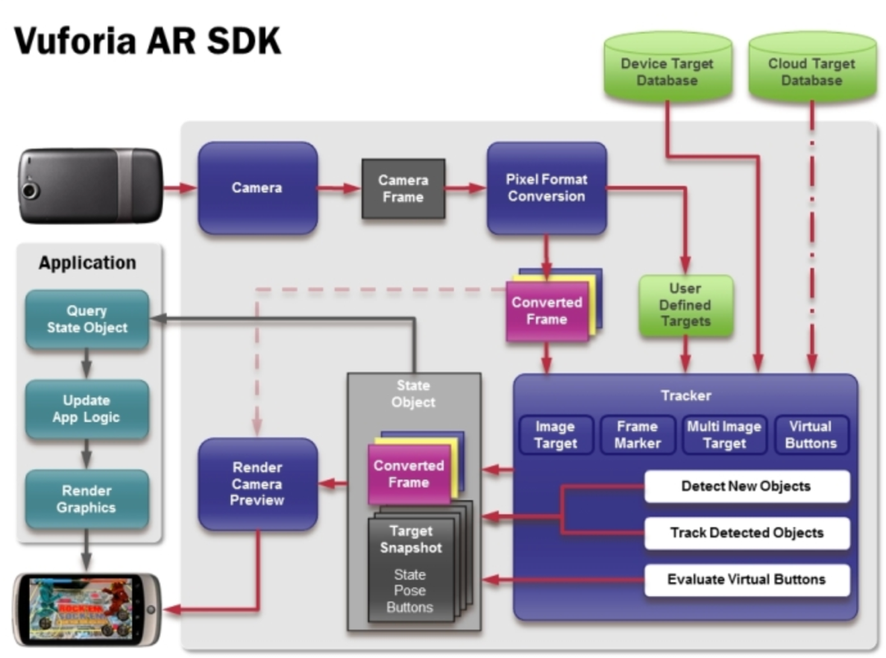
Figure 26 - Proposed system architecture [18].
The proposed architecture details different components of the projected system, the Device Target Database will be responsible for storing any image target data, the tracker traces any known images, then the preview is rendered before the superimposed image is display to a user.

Image recognition process

The image recognition process is a pivotal element to the application achieving requirements discussed, careful consideration regarding how this can be achieved must be considered to facilitate a successful implementation. When considering the anticipated appearance when the image has been recognised and the superimposed image has been incorporated into the view, it is imperative that the view looks professional and appears as if the vehicle truly has that licence plate on it. This view is to give a user the best experience of visualising a personalised registration on their vehicle and actually defers from what most augmented reality applications aim to achieve in respect to visualising the disparity of the superimposed image to the real world. In most cases a user will want to see the virtual object what has been superimposed, in this case it would provide for a more real and effective experience of the augmentation was not apparent when occurring. Figure 27 illustrates the preferred view of the augmentation occurring:

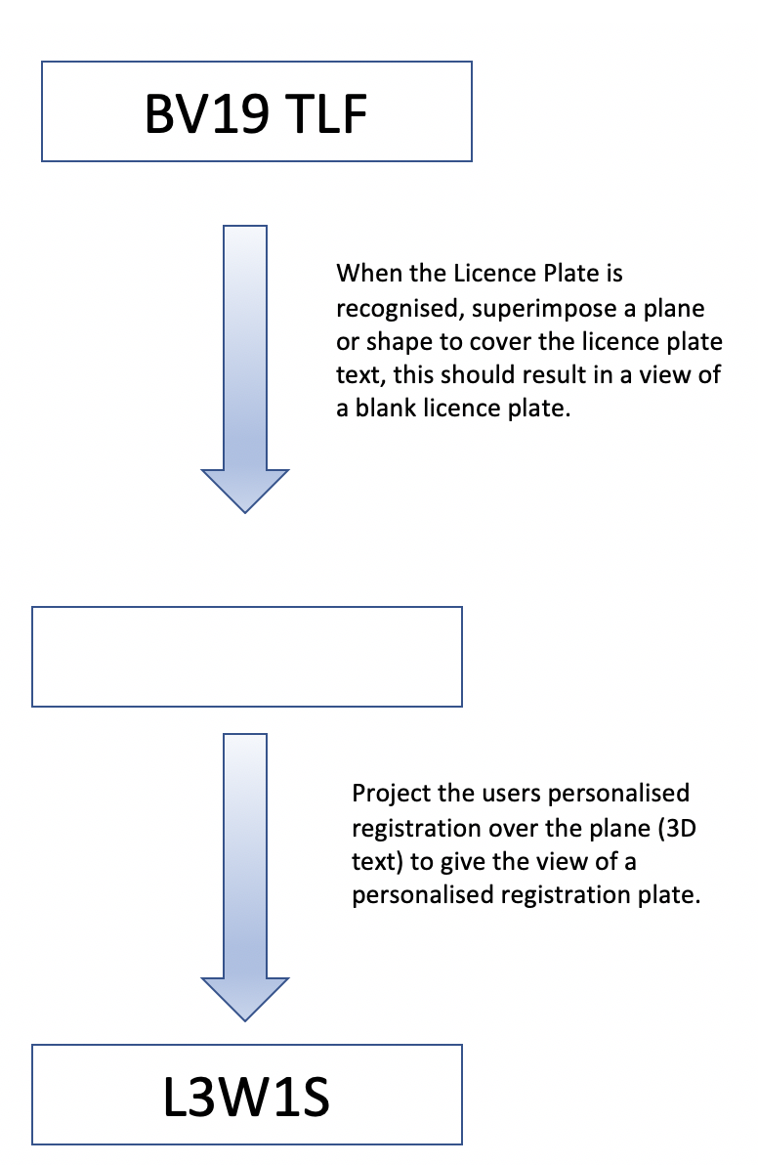
Figure 27 - Superimposition design.
The above intended solution should be sufficient for the user to experience a personalised registration plate as part of the MVP discussed. The image recognition process is a fundamental stage in delivering aspects of the requirements and objectives.

Offensive Registration Check

To resolve the possibility of a user entering an offensive registration number it is essential that the input they provide is checked for offensive characters/words. The following flowchart illustrates the Authors intentions regarding this issue:

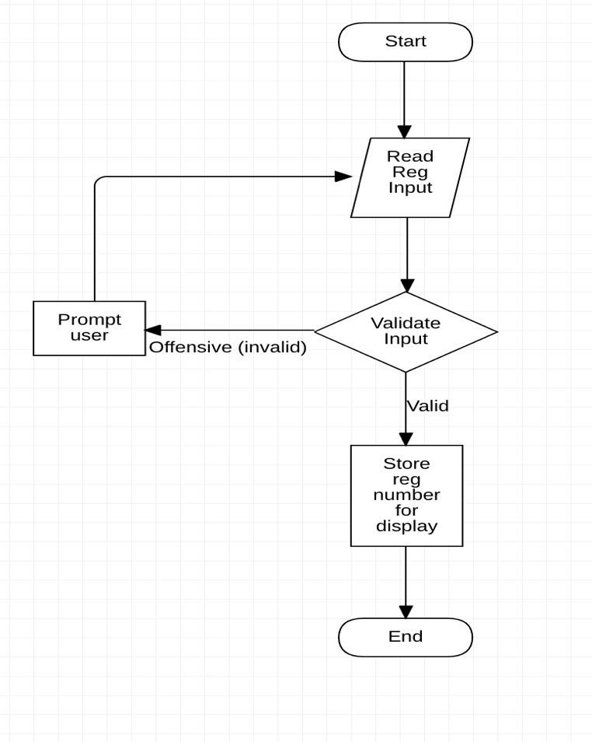
Figure 28 - Flowchart (offensive input).
Figure 28 outlines the flow of activity during the process of examining the input (registration number) from a user, the input will be checked to determine if it is offensive; if there is any impertinent characters or words found, the user will be prompted to enter the registration again.

Personalised Registration Lookup

As part of the requirements, a user must have the capability of determining of a registration number is available for purchase. Fortunately, the DVLA provide a snapshot of all the available personalised registrations which is accessible in multiple formats (JSON, CSV). The intention is to parse the registration number (string) entered, then check the dataset (snapshot) to see if it is available. If the registration is not available, then attempt to suggest an alternative registration which has similarities to the original one entered. In addition, if the registration is available then the price of the number must be obtained so the user can be informed. This process is shown in Figure 29:

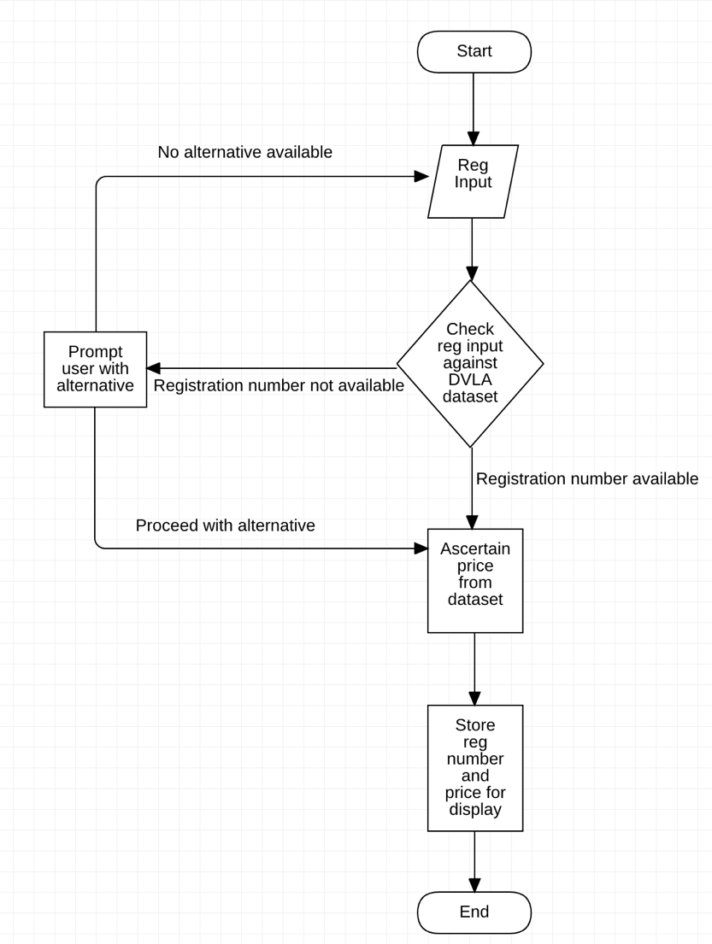
Figure 29 - Registration availability and price lookup.

The requirements have outlined what behaviour is expected from the completed application, they delineate what comportment the user should expect to find when using the application.

The recommendation framework created will ultimately result in being successful if the desired implementation concludes in an outcome which satisfies the aim and objectives, along with the requirements. Careful consideration pertaining to the recommendation framework was needed to create a framework which could be used for anyone whom wants to achieve similar goals outlined in this report. The recommendation framework consists of best practices and principles associated with the augmented reality technology and has been developed by the Author through investigating countless AR projects and researching literature which is associated with the technology.

Multiple flow charts/diagrams have been created to explain the thought process of the Author when undertaking developmental aspects of the project. The diagrams provide a high-level view of the task to be implemented, this should provide assistance when the actual functionality is employed.

Implementation
The implementation of the design will ultimately determine if the recommendation framework is suitable for the implementation of augmented reality for the purpose of viewing personalised registration plates.

Each stage of the software development process will adhere to the software development methodology approach delineated in section 4 of this report, the following implementation will include aspects of the development which the Author found interesting, challenging and relevant.

Following the recommendation frameworks suggestion, Unity3D and Vuforia SDK where chosen as the development platform and software development kit respectively. The Unity 3D environment was set up to enable it to use Vuforia SDK, then the SDK was imported into the environment and configured to authorise the toolset which it offers.

One of the fundamental steps in the implementation process was to identify a suitable image target which could be used to superimpose the augmented display onto, this would be realised by using Vuforia’s developer portal to determine if the image was augmentable. As discussed as part of the literature and in the recommendation framework the image must be deemed augmentable or the image is regarded as being impractical. This stage of the development produced the first challenge, the portal can only accept images which are 8bit greyscale or 24bit RGB, the image which the Author attempted to use did not satisfy this criteria (Figure 30), so the image had to be converted to a supported format using an online service.

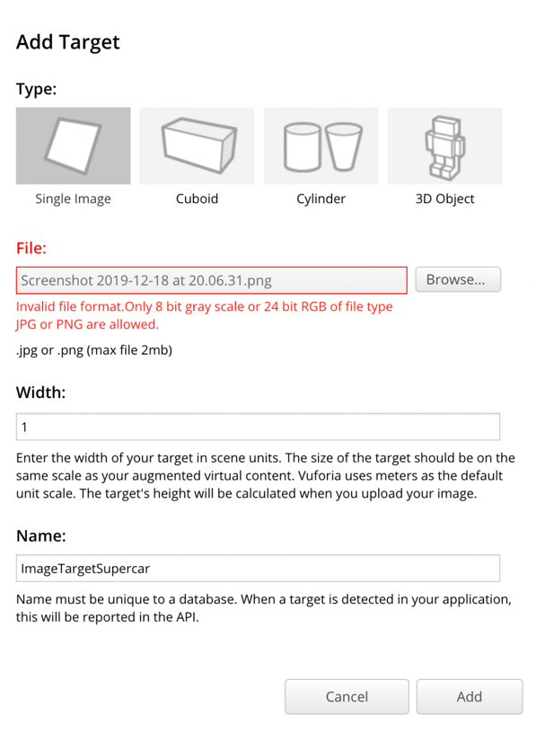
Figure 30 - Unsupported format Vuforia.

The image recognition process was the central, most significant functionality which must occur in the application, obtaining this behaviour would provide substance to some of the key principles outlines in the recommendation framework. The process followed the image recognition process discussed in the design section (5.5), this process was adhered to during the implementation in Unity3D (Figure 31).

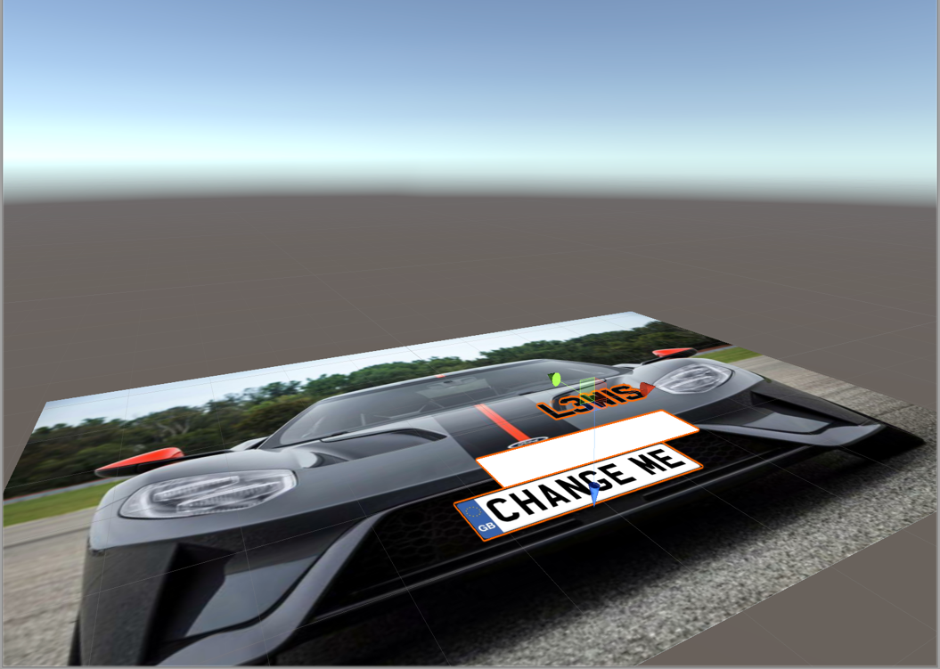
Plane to cover the original registration number.

Pre-defined superimposed text (L3W1S).
Image Target
Figure 31 - Unity3D superimposition concept.

Allowing a user to define a registration number was a requirement defined in the design stages, this requirement was achieved by creating a 3D text mesh. The 3D text mesh was essential in presenting the superimposed text to a user which replicated the font used on real-world registration plates, the font was imported to Unity3D and applied to the text mesh. The following illustrations explain how this functionality was implemented:

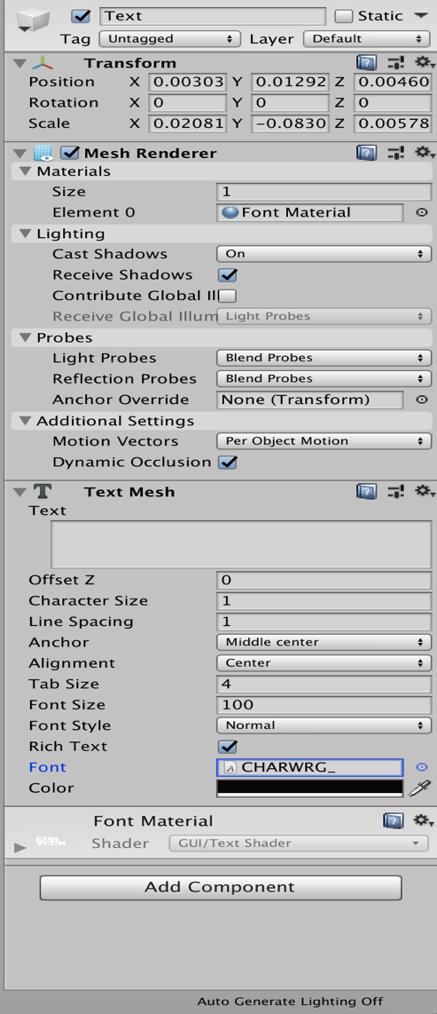
Figure 32 - 3D text mesh.

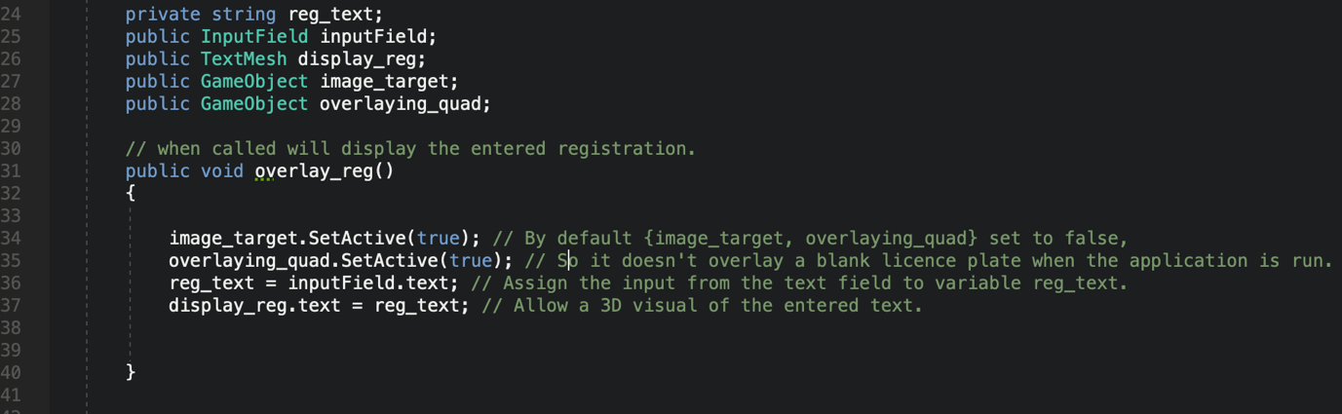
Figure 33 - User defined superimposed registration.
Figure 32 and 33 illustrate aspects of the process of allowing users to define the registration of their choice. Ensuring that the font was indicative of a real-world registration plate was imperative in providing the user with a personalised experience which was a principle outlined in the recommendation framework.

The user interface was kept simplistic and only included interactive elements which are essential to functionality of the application, a canvas was created which contains an input field and two buttons, ensuring it conforms to the UI design declared in section 5. The user interfaces for the application are illustrated below (Figure 34 and 35):
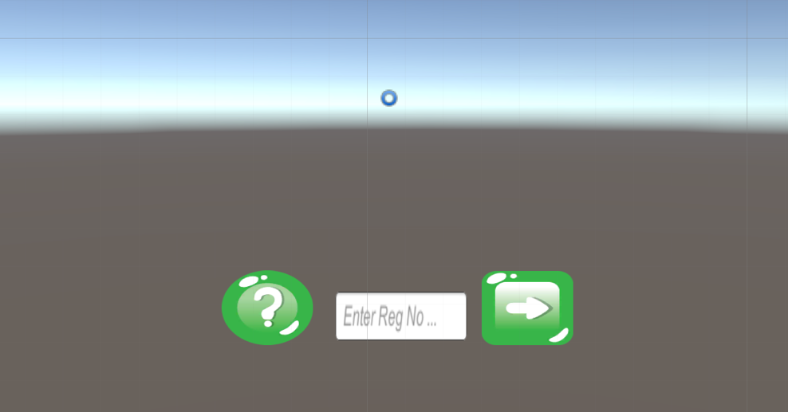
Figure 34 - UI design (canvas 1).

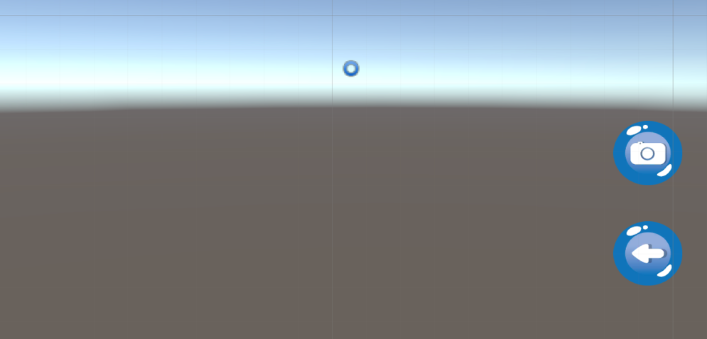
Figure 35 - UI design (canvas 2).

The UI design for both canvases represent the design outlined in section 5, the simplistic nature of the design optimises the usability of the application and provides for simple navigation via the informative icons demonstrated.

The implementation aimed to adhere to the requirements and recommendation framework suggested by following the designs and best practices and principles outlined. Unanticipated challenges provided for a development process which was difficult and time consuming, the unfortunate situation regarding the incapacity to retrieve the snapshot containing the personalised registration numbers was something which couldn’t have be forecasted. Fortunately, the implementation work around the Author implemented essentially provides the same experience for a user, without using real, valid data.

Story cards where created to determine which feature was to be completed, the story cards included the feature, a description of the requirements for that feature, issues encountered when commencing the feature, and finally the outcome of the feature when it was completed. This process ensured that the development aspect of the project was monitored sufficiently, it also provided evidence to support a decision to accept or reject the recommendation framework because it gave the Author transparency over what elements did and didn’t work when developing against the framework suggested. A full breakdown of the features can be viewed in Appendix 1.

The Agile approach to the software development has proven to be the right choice predominantly due to the iterative process it followed, the Agile ethos conforms to changing requirements and aims to provide redundancy measures pertaining to unforeseen issues. After each feature was implemented it was tested (if functional), this process ensured that the feature operated as intended and followed the development approach stated in section 4.

Results & Discussion
This section will discuss the results obtained from the implementation of the AR experience based on the recommendation framework devised. The Author will evaluate the influence the recommendation framework has had on this process and describe how the objectives have been conformed to.

The following illustration (Figure 36) displays the completed applications during runtime on an image of a vehicle:

Figure 36 - Completed application view.

One of the key elements discussed in the framework was environment variables, the framework discussed the effect lighting conditions can have on the capability of achieving the superimposition desired. The following illustrations show the application being tested in different lighting conditions:

The figures show that although the lighting conditions changed, it did not have clear implications on the ability to recognise the target. The only noticeable difference between the images tested was the Authors implementation method was more visible (white plane overlaying existing registration number).

The above illustrations display the results of examining the effects different lighting conditions have on the capability of superimposing digital content.

The following tests evaluated the effectiveness of the recognition when tested at different ranges. The Author recommended the Vuforia SDK to assist in this process and the supporting documentation stated that the required distance to target ratio should be 1:10 (target size: distance from target). The Author declared the target as 50cm so that would imply that optimal distance would be up to 5 metres, the following tables describes the results of tests conducted in different lighting/weather conditions:

Distance to target | Conditions | Light estimation | Superimposition
1 metre | Wet/Rainy | Dark – Street lights | Yes
2 metres | Wet/Rainy | Dark – Street lights | Yes
3 metres | Wet/Rainy | Dark – Street lights | Yes
4 metres | Wet/Rainy | Dark – Street lights | Yes
5 metres | Wet/Rainy | Dark – Street lights | Yes
6 metres | Wet/Rainy | Dark – Street lights | Yes
7 metres | Wet/Rainy | Dark – Street lights | Yes
8 metres | Wet/Rainy | Dark – Street lights | Yes
9 metres | Wet/Rainy | Dark – Street lights | Yes
10 metres | Wet/Rainy | Dark – Street lights | Yes
11 metres | Wet/Rainy | Dark – Street lights | No

Distance to target | Conditions | Light estimation | Superimposition
1 metre | Wet/Rainy | Overcast - Moderate | Yes
2 metres | Wet/Rainy | Overcast - Moderate | Yes
3 metres | Wet/Rainy | Overcast - Moderate | Yes
4 metres | Wet/Rainy | Overcast - Moderate | Yes
5 metres | Wet/Rainy | Overcast - Moderate | Yes
6 metres | Wet/Rainy | Overcast - Moderate | Yes
7 metres | Wet/Rainy | Overcast - Moderate | Yes
8 metres | Wet/Rainy | Overcast - Moderate | Yes
9 metres | Wet/Rainy | Overcast - Moderate | Yes
10 metres | Wet/Rainy | Overcast - Moderate | Yes
11 metres | Wet/Rainy | Overcast - Moderate | No

The results of the distance recognition test show that the lighting conditions did not affect the capability of the recognition on the vehicle. Test 1 was conducted at night but the environment included street lighting which definitely benefitted the recognition process because of the reflective material licence plates use, unfortunately at this time of the year sun is I short supply, this resulted in the Author not completing a test which had direct natural light on the vehicle/licence plate. Based on the research during the literature review this would have proposed the highest possible chance of viewing an image recognition deficiency. This is a text could be performed in the feature over a longer period of time and more extreme conditions to obtain more consistent and accurate results. Illustrations pertaining to the distance tests can be viewed in appendix 1.

An important proportion of the recommendation framework indicated that sufficient object/image detail was required to maximise the recognition process, is it essential that the target has sufficient features to be recognisable by the software. The following test illustrates how using just the licence plate number (with minimal features), defers from using an image with more detail:

Using only registration number

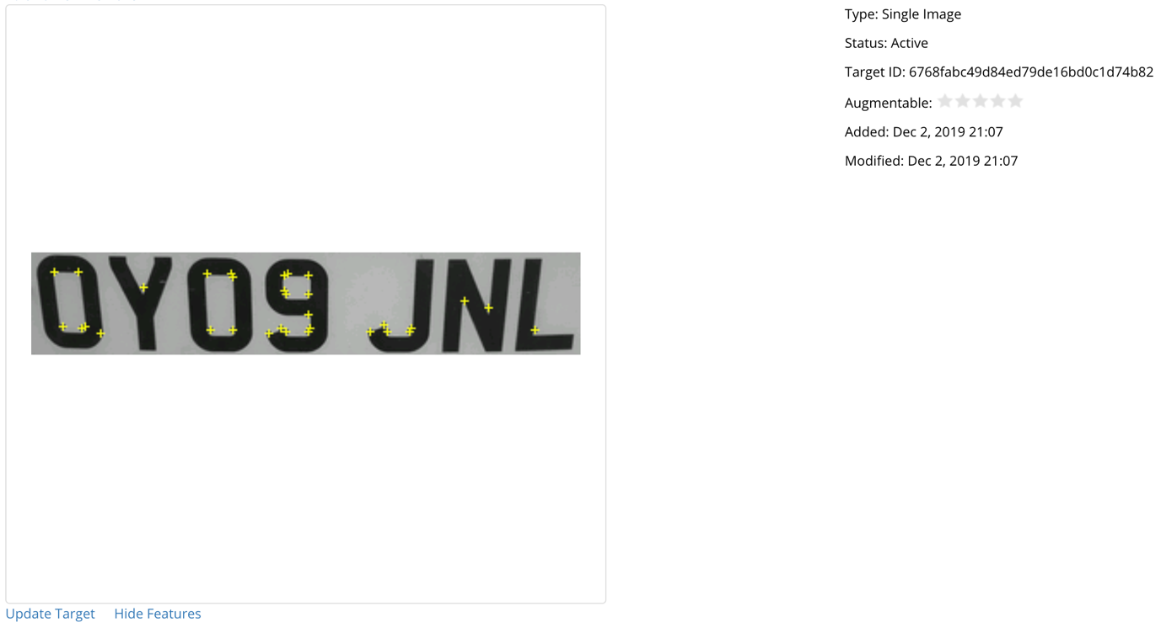
Figure 37 - Features of registration number.

Using identical registration number with more vehicle captured

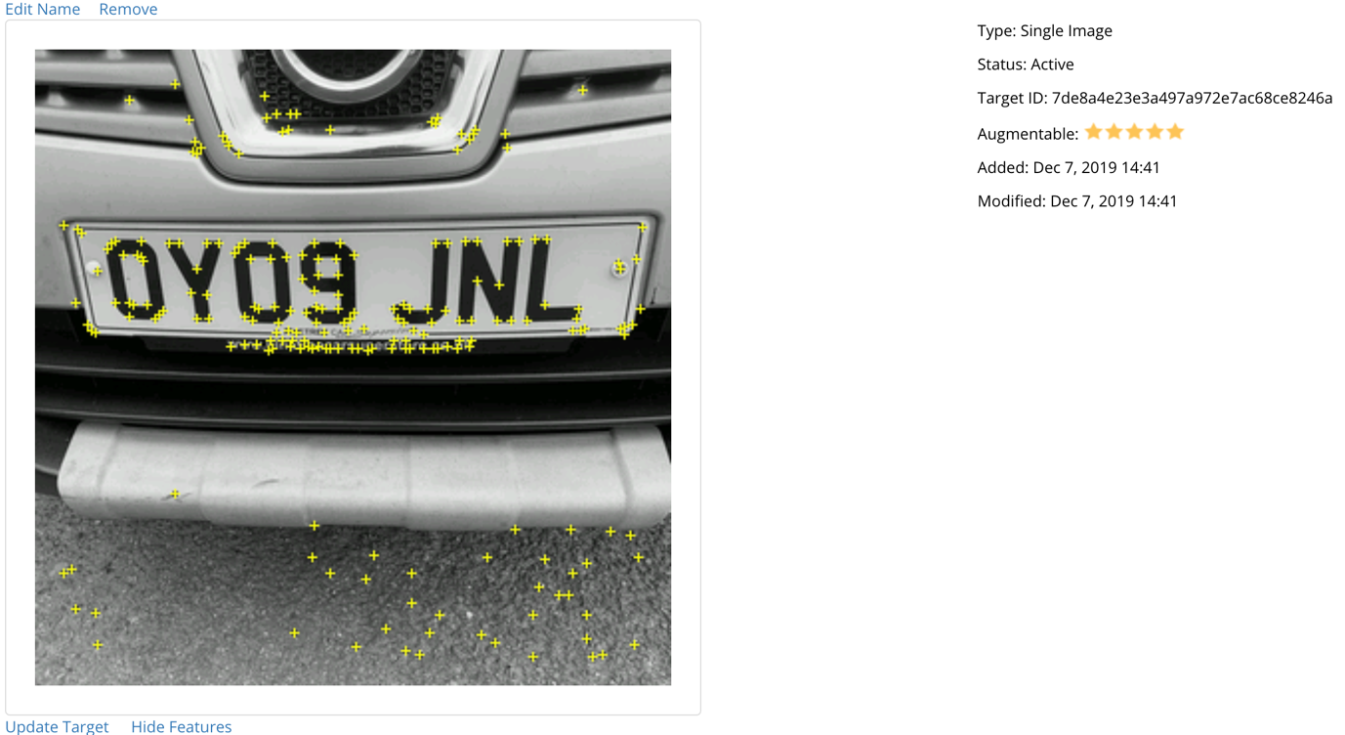
Figure 38 - Features of registration number with vehicle.
Figure 37 has significantly less feature points than Figure 38, it has a zero-star rating which means the registration number alone, is not augmentable. The Author had discussed the importance of using images/objects with many features on them to optimise the recognition capability, this sentiment of the recommendation framework was considered so the Author used an image which elevated the possibility of being recognised.

One of the recommendations outlined in the framework was stationary screen space, the Author followed this guidance and fixated the buttons and input field to specific locations on the user interface. Positioning the UI elements in anchored locations ensures that access to them to perform functionality and navigation is maintained, the UI elements also do not change irrespective of superimposition or distance to target image/object. Evidence of this is illustrated below:

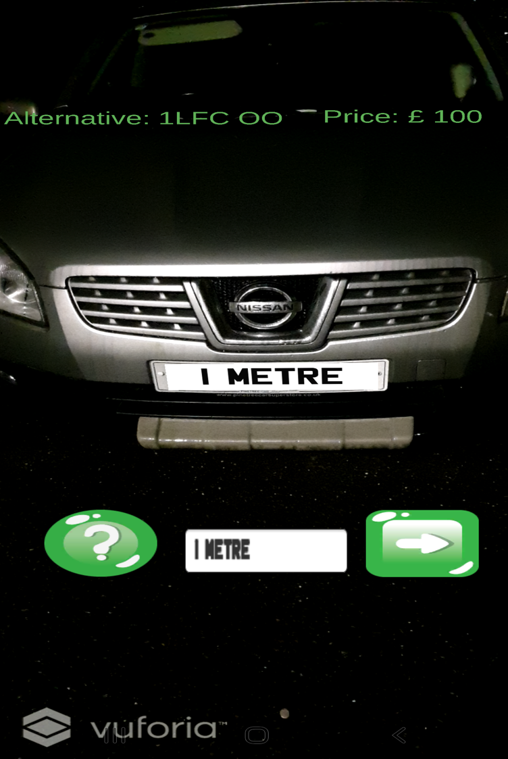
Figure 39 - Stationary UI (1 metre).

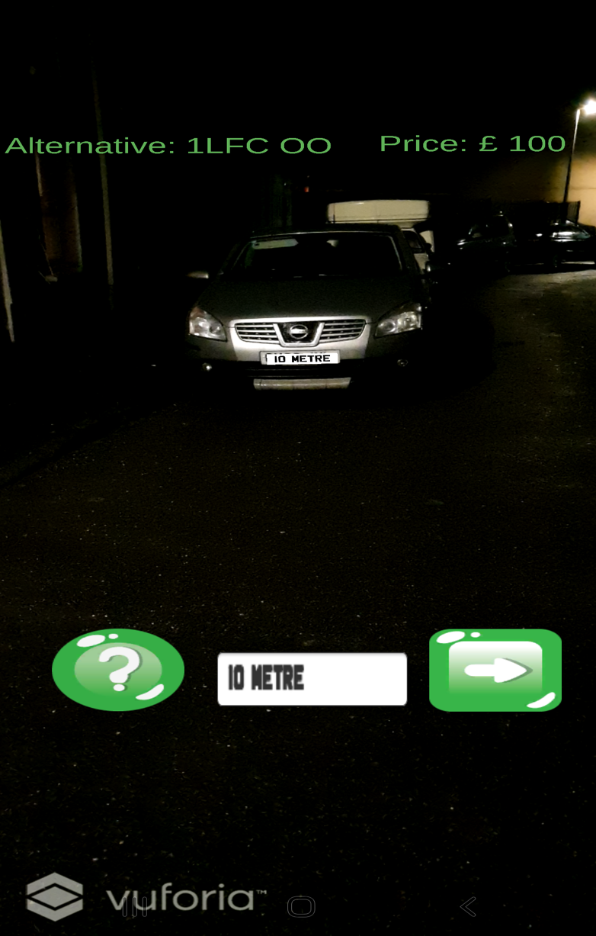
Figure 40 - Stationary UI (2 metre(.
The UI remains stationary regardless of the distance to the image target, guaranteeing maximum usability.

Conclusion & Recommendations

Conclusion
The subsequent conclusion pronounces how the objectives have deduced with fastidious indications to specific aspects of the work undertaken, it will discuss how the Author has ascertained the information and provide an analysis of the key features which have resulted in the Author determining the success of the project.

When undertaking the research into literature pertaining to augmented reality, numerous journals, books and online resources presented the Author with important literature to gain an understanding of the technology. The information sources also helped identify prominent software, limitations, approaches and best practices and principles when undertaking the project. A comparative study of software development kits provided a particularly interesting analysis of AR SDK’s and concluded with the Vuforia SDK being the superlative choice. This section was invaluable in the creation of the recommendation framework as it provided evidence of current implementations and the risks and inadequacies when using the technology. Additionally, the literature review was accomplished sufficiently by adhering to the research methodology philosophy which provided a structured plan of gathering the information required to develop a recommendation framework. The mixed methods approach ensured clear direction relating to information gathering and how the information would be utilised.

The design section enabled the developer to apply problem solving techniques to deliver the aim and objectives outlined. A recommendation framework was created here to provide the Author with suggestions and advice concerning the implementation of the augmented reality technology. Designs where constructed to advocate the enactment of developing against the requirements which contained the functionality of the application.

Each stage of the development followed a hybrid of methodological approaches which consisted of feature driven development and extreme programming. The hybrid approach simplified the development process and produced well-defined story cards which depicted the features to be completed, each feature was accompanied by a description, an outcome, and any issues faced during the development to feedback any relevant information which could determine the success of the framework.

The implementation stage was especially difficult because of some of the difficulties which the Author was presented with, these difficulties comprised of:

- Personalised registration snapshot – The latest snapshot was required for the project to determine if a user’s requested licence number was available, and at what cost. Anyone can have access to this data by competing a contract to ensure there is no misuse of the data. The Author found it extremely difficult obtaining it from the designated API and spent countless weeks in communication with the API support team to resolve the issue but all to no avail. The decision was made to replicate the behaviour (provide the user with testable outcome when querying availability of a registration number) to provide an application which from the outside appeared to have no issues.

- Usability of Unity3D – Although the Author had sessions on the online service Plural Sight, the development platform takes judicious practice to become familiar with. Difficulties included: placing and anchoring UI elements, passing data from one scene to another, understanding the 2D and 3D objects which can be used and the benefits of using them, creating materials and texture for design purposes, and the general navigation of the development platform.

The aim was to determine if an augmented reality recommendation framework has a beneficial impact on the development of an AR system for viewing personalised registration plates. The Author feels like this aim has been achieved by developing the framework and successfully implementing an AR application which respectably followed the guidance delineated in it. The framework was pivotal to the production of the application which would comply with standards discussed by other Authors. Evaluating the recommendation framework and what the project has delivered it can definitely be considered a success.

Recommendations
The following recommendations have been identified as possible improvements to this project:

- Using a database for the PR dataset – The Author unfortunately never obtained the snapshot of PR registration numbers but confirmed that there was a total of 53 million. A dataset of this size would inevitably require a database to ensure that querying it can be as efficient and responsive as possible.
- Capturing image target at runtime – The Author used pre-defined image targets to complete the AR application which required the application to have an understanding of the target objects/images before compiling. Allowing the application to create image targets at runtime would result in an application which could in theory “dynamically recognise any registration plate”, this would result in the production of a product which has greater usability and less constraints surrounding the functionality of it.
- Efficient code – The majority of the code implemented was designed to produce an application which replicated the behaviour of an application which had the PR dataset included and had sophisticated algorithms to determine the price of a registration number and check if it contained any offensive criteria. This would have taken significant time to implement which was the major constraint associated with the project.
- Adjustment to framework – The only additional element the Author would add to the recommendation framework is – Visual Expectancy. Traditionally, AR applications would intend on completely replacing an object or image target, for projects similar to this, it can be acknowledged that more consideration regarding the visual aspect could have been contemplated. The Author did not account for how the overlaying quad would appear in different lighting conditions, the Author aimed to get a more professional look by only covering the registration number but would recommend that future Authors consider the possibility of using algorithms which get the average colour pixel to determine the colour/shade of the overlaying quad.

Reflection
This project has been an incredible learning experience and has allowed Me to carry out research and development on a technology which is exceedingly interesting and is making significant advancements and will continue to in the coming decades. I feel that the literature reviewed was essential to the creation of the recommendation framework and unquestionably had a significant impact on the rest of the project.
In reflection I would have liked to have obtained data from users to ascertain which registration numbers are commonly desired and the maximum price they would pay for a registration number. It would have been interesting to try to determine the common genre of registration number people commonly desire and compare the results to show representations of data in the form of statistics and graphs.

The only drawback from the project I have was the difficulty proving evidence that the recommendation framework was a success, results would typically derive of graphs, statistics and data which provides conclusive and incontestable evidence that a theory has been proven/disproven and is less inclined to be contested by subjective opinion.

References

[1] | D. R. Berryman, “Augmented Reality: A Review,” Medical Reference Services Quarterly , vol. 31, no. 2, pp. 212 - 218, 2012.
[2] | W. Barfield, Fundamentals of Wearable Computers and Augmented Reality, Boca Raton: CRC Press, 2015.
[3] | M. L. N. J. J.-A. A. G. S. M. R. C. J. G. D. Yolanda Blanco Fernández, “A step forward in immersive learning about Human History by augmented reality, role playing and social networking,” Expert Systems with Applications, vol. 41, no. 10, pp. 4811 - 4828, 2014.
[4] | R. P. D.W.F. van Krevelen, “A Survey of Augmented Reality Technologies, Applications and Limitations,” The International Journal of Virtual Reality, vol. 9, no. 2, pp. 1-20, 2010.
[5] | S. W. J. Huma Shoaib, “A Survey of Augmented Reality,” University of the Punjab, Punjab, 2015.
[6] | S. P. S. S. V. B. Raviraj S. Patkar, “Marker Based Augmented Reality Using Android OS,” International Journal of Advanced Research in Computer Science and Software Engineering, vol. 3, no. 5, pp. 64 - 69, 2013.
[7] | K. K. C. G. Anuroop Katiyar, “Marker Based Augmented Reality,” Advances in Computer Science and Information Technology (ACSIT) , vol. 2, no. 5, pp. 1-5, 2015.
[8] | H. K. K. A. J. S. E. K. Janne Paavilainen, “The Pokémon GO Experience: A Location-Based Augmented Reality Mobile Game Goes Mainstream,” in Proceedings of the 2017 CHI Conference on Human Factors in Computing Systems, Colorado, 2017.
[9] | K. B. Jonathan Linowes, Augmented Reality for Developers: Build practical augmented reality applications with Unity, ARCore, ARKit, and Vuforia, Packt Publishing Ltd, 2017.
[10] | C. M. J. R. S. P. Y. B. G. Shaunak Shirish Deshmukh, “3D Object Tracking And Manipulation In Augmented Reality,” International Research Journal of Engineering and Technology, vol. 05, no. 01, pp. 287 - 289, 2018.
[11] | K. S. Florian Leutert, “Projector-based Augmented Reality for Telemaintenance Support,” in International Federation of Automatic Control, Wurzburg, 2018.
[12] | T. H. Dieter Schmalstieg, Augmented Reality: Principles and Practice, Addison-Wesley Professional, 2016.
[13] | M. B. A. N. D. A. H. ,. M. H. A. R. Danakorn Nincareana, “Mobile Augmented Reality: the potential for education,” in 13th International Educational Technology Conference, 2013.
[14] | R. P. A. B. N. Sungkur, “Augmented reality, the future of contextual mobile learning,” Interactive Technology and Smart Education, vol. 13, no. 02, pp. 123 - 146, 2016.
[15] | J. E. S. I. D. H. Joseph L. Gabbard, “The Effects of Text Drawing Styles, Background Textures, and Natural Lighting on Text Legibility in Outdoor Augmented Reality,” Home > Presence: Teleoperators and Virtual Environments, vol. 15, no. 1, pp. 16 - 32, 2006.
[16] | J. M. P. E. L. Michael Chu, “Integrating mobile Building Information Modelling and Augmented Reality systems: An experimental study,” utomation in Construction, vol. 85, no. 01, pp. 305 - 316, 2018.
[17] | D. R. G. Jens Grubert, Augmented Reality for Android Application Development, Packt Publishing Ltd, 2013.
[18] | R. G. Jens Grubert, Augmented Reality for Android Application Development, Packt Publishing Ltd, 2013.
[19] | M. Lanham, Learn ARCore - Fundamentals of Google ARCore, Packt Publishing Ltd, 2018.
[20] | M. W. Paweł Nowacki, “Capabilities of ARCore and ARKit Platforms for AR/VR Applications,” in Engineering in Dependability of Computer Systems and Networks , Wroclaw, 2019.
[21] | B. B. Arnis Cirulis Kristaps, “3D Outdoor Augmented Reality for Architecture and Urban Planning,” in 2013 International Conference on Virtual and Augmented Reality in Education , Valmiera, 2013.
[22] | M. S. A. C. B. M. Tommy Jensen, “Realtime image-based lighting for outdoor augmented reality under dynamically changing illumination conditions,” in Proceedings of the First International Conference on Computer Graphics Theory and Applications, Setúbal, 2016.
[23] | S. G. Dhiraj Amin, “Comparative Study of Augmented Reality SDK's,” International Journal on Computational Sciences & Applications (IJCSA) , vol. 5, no. 1, pp. 11 - 26, 2015.
[24] | J. Glover, Unity 2018 Augmented Reality Projects: Build four immersive and fun AR applications using ARKit, ARCore, and Vuforia, Packt Publishing Ltd, 2018.
[25] | C. R. Morales, Developing Augmented Reality applications with Unity 3D and Vuforia, eAcademicBooks LLC, 2015.
[26] | “A Case Study of the Health of an Augmented Reality Software Ecosystem: Vuforia,” in International Conference of Software Business, Ljubljana, 2016.
[27] | N. A. D. P. F. A. I. Nurhadi Saparudin, “Implementation of Object Tracking Augmented Reality Markerless using FAST Corner Detection on User Defined-Extended Target Tracking in Multivarious Intensities,” in Journal of Physics: Conference Series, 2019.
[28] | J. C. Youngo Lee, “Tideland Animal AR: Superimposing 3D Animal Models to User Defined Targets for Augmented Reality Game,” International Journal of Multimedia and Ubiquitous Engineering, vol. 09, no. 04, pp. 343 - 348, 2014.
[29] | D. A. A. K. P. N. Venkata Rao, “Optical character recognition technique algorithms,” Journal of Theoretical and Applied Information Technology , vol. 83, no. 02, pp. 275 - 282, 2016.
[30] | S. J. Shankar Lonare, “Transfer learning based Optical Character Recognition using Natural Images,” International journal of recent trends in engineering and research, vol. 05, no. 12, pp. 8 - 14, 2019.
[31] | A. I. A. Muna Ahmed Awel, “International Research Journal of Engineering and Technology,” Review on optical character recognition, vol. 06, no. 06, pp. 3336 - 3339, 2019.
[32] | S. Singh, “Optical Character Recognition Techniques: A Survey,” Journal of Emerging Trends in Computing and Information Sciences, vol. 4, no. 6, pp. 545 - 550, 2013.
[33] | K. M. P. B. S. K. G. Arindam Chaudhuri, Optical Character Recognition Systems for Different Languages with Soft Computing, Springer, 2017.
[34] | S. I. N. D. Ravina Mithe, “Optical Character Recognition,” International Journal of Recent Technology and Engineering (IJRTE), vol. 2, no. 1, pp. 72 -75, 2013.
[35] | A. P. D. P. Chirag Patel, “Optical Character Recognition by Open Source OCR Tool Tesseract: A Case Study,” International Journal of Computer Applications, vol. 55, no. 10, pp. 50 - 56, 2012.
[36] | A. S. ,. K. D. Nitin Ramesh, “Improving Optical Character Recognition Techniques,” International Journal of Engineering & Technology, vol. 7, no. 2, pp. 361 - 364, 2018.
[37] | N. S. R. V. G. Manpreet Kaur, “Proposed Approach for Layout & Handwritten Character Recognization in OCR,” International Research Journal of Engineering and Technology, vol. 6, no. 4, pp. 1206 - 1216, 2019.
[38] | J. K. Haas, “A History of the Unity Game Engine,” Digital WPI, Worchester, 2014.
[39] | A. M. H. S. P. U. Gurpreet Singh Matharu, “Empirical Study of Agile Software Development Methodologies: A Comparative Analysis,” ACM SIGSOFT Software Engineering Notes, vol. 40, no. 1, pp. 1-6, 2015.
[40] | M. N. H. Ashraf Ferdouse Chowdhury, “Comparison between Adaptive Software Development and Feature Driven Development,” in Proceedings of 2011 International Conference on Computer Science and Network Technology, Harbin, China, 2011.
[41] | I. G. S. R. J. Adila Firdaus, “Secure Feature Driven Development (SFDD) Model for Secure Software Development,” International Conference on Innovation, Management and Technology Research, vol. 129, no. 1, pp. 546 - 553, 2013.

Appendix
Appendix 1 – Distance recognition tests.
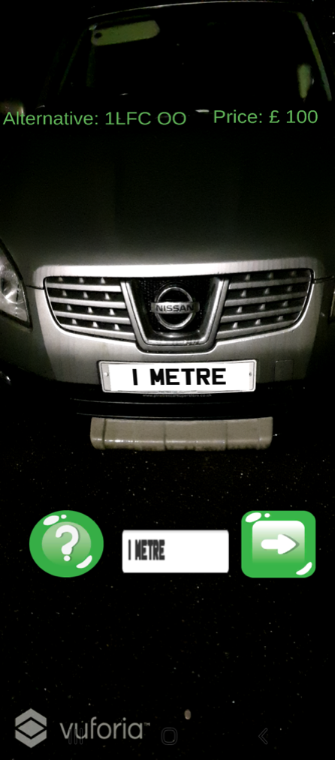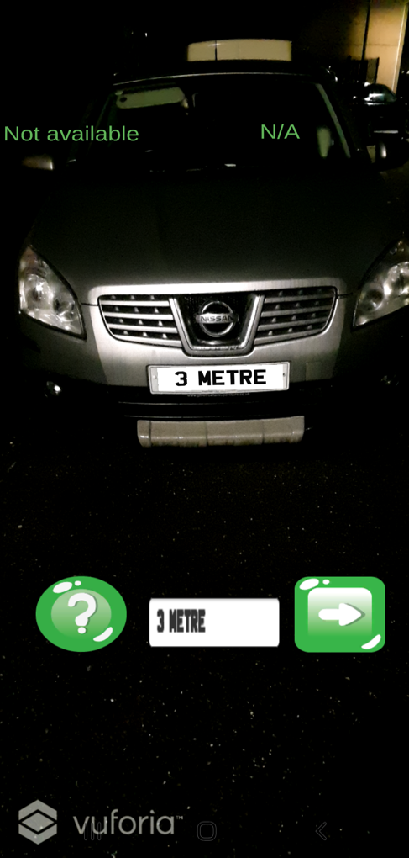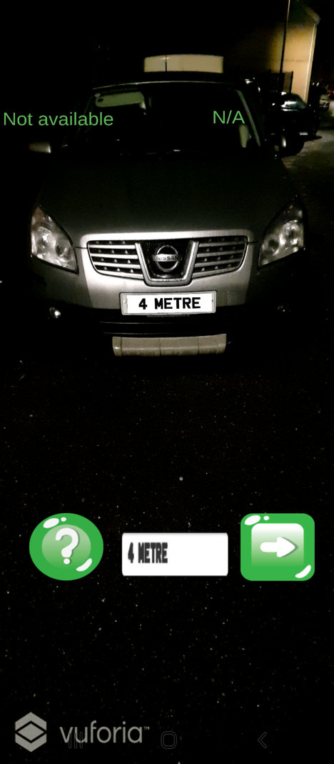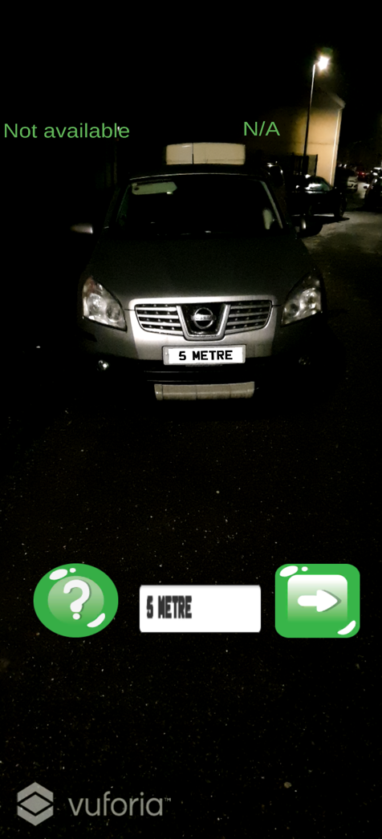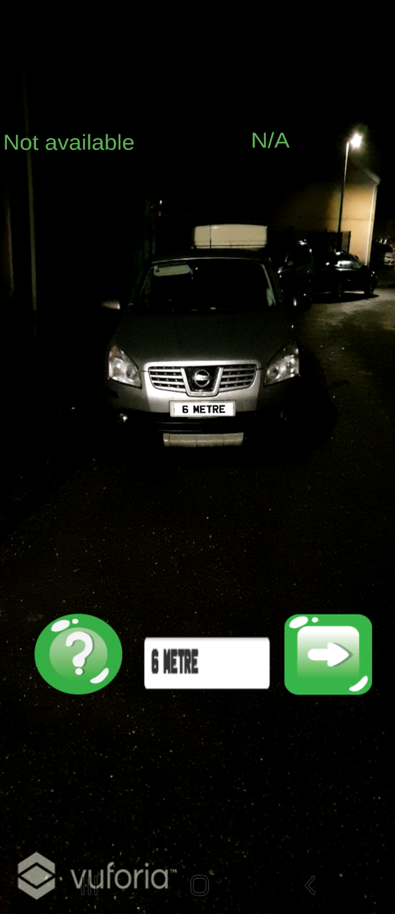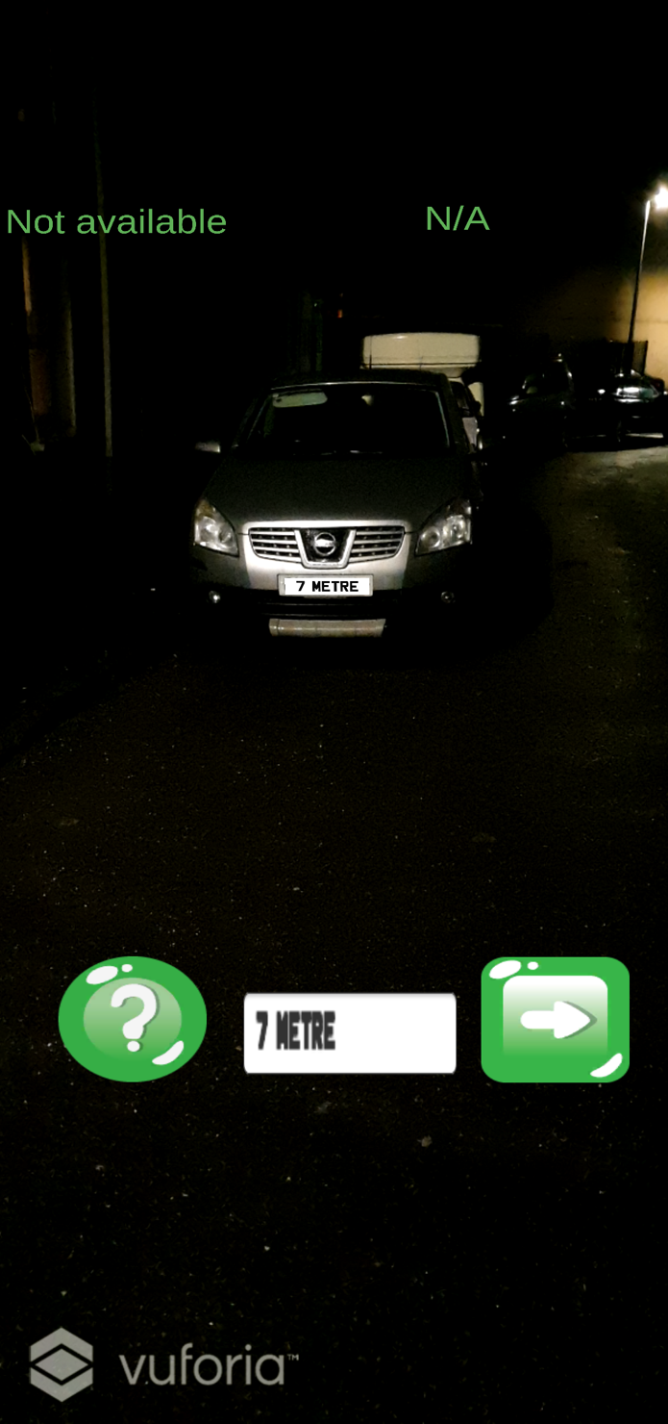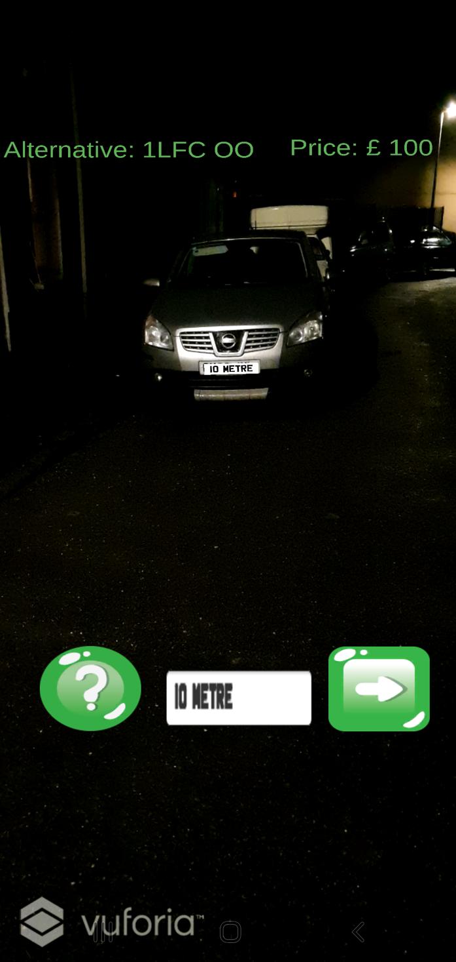

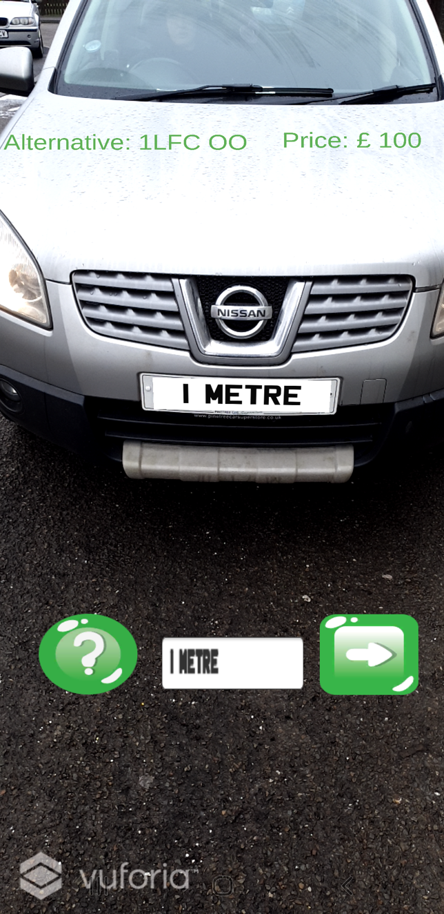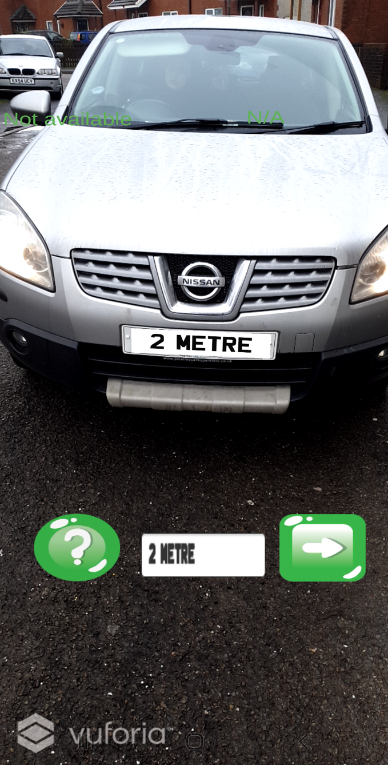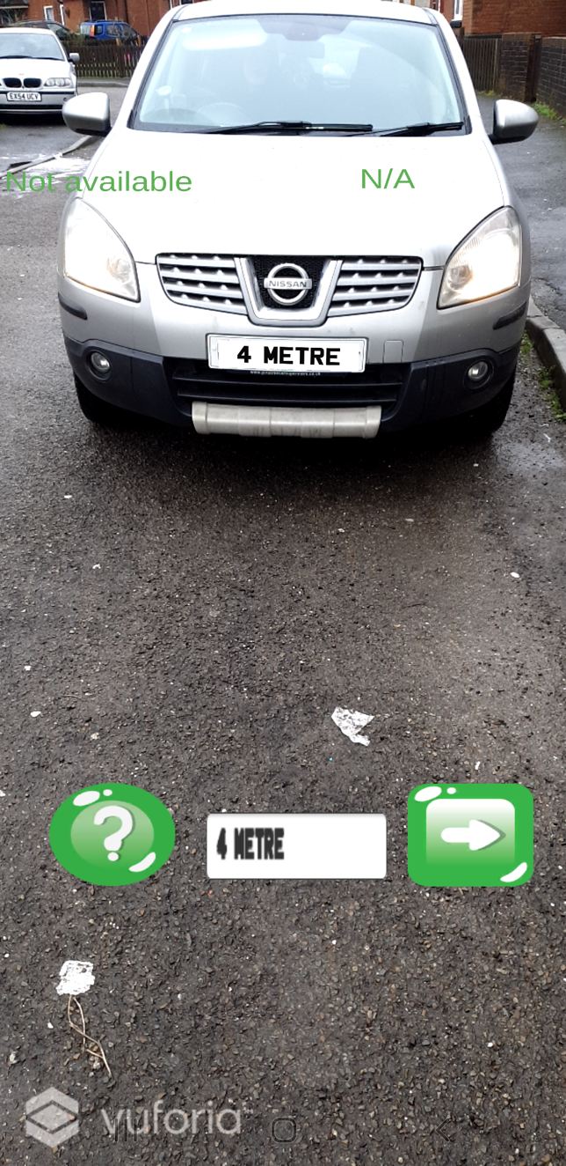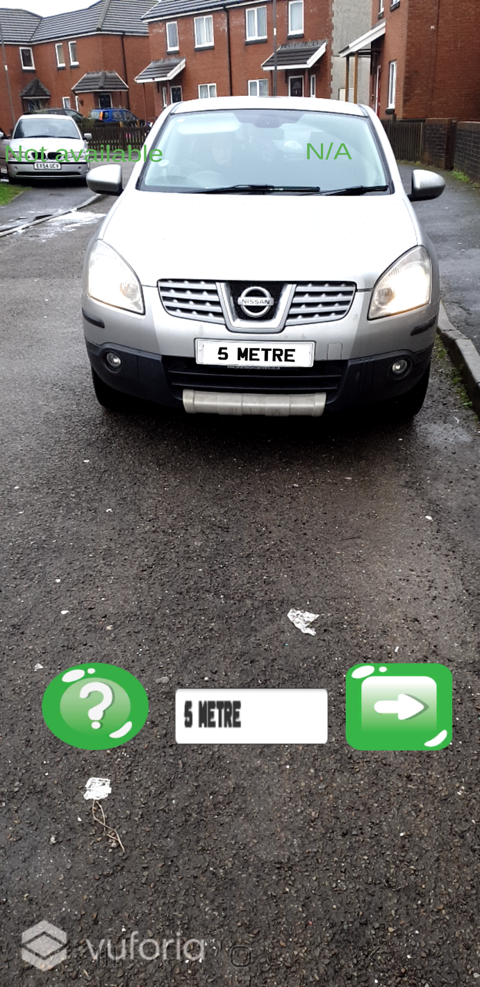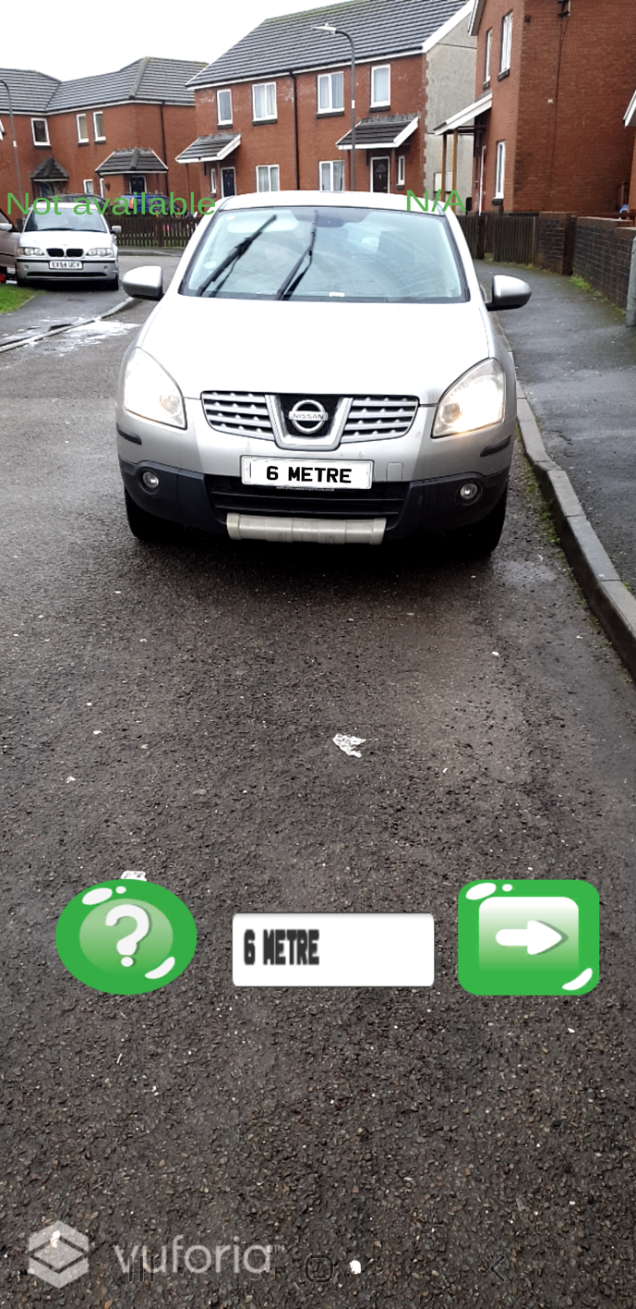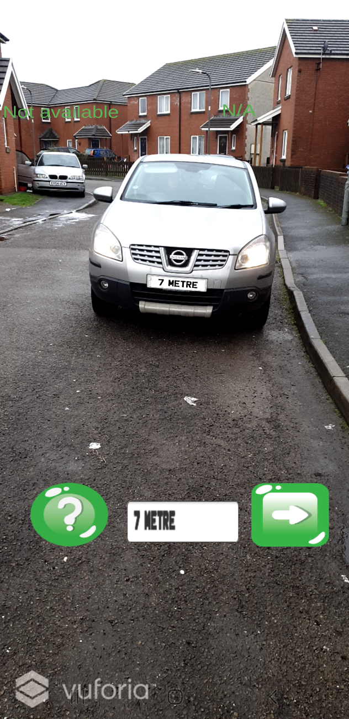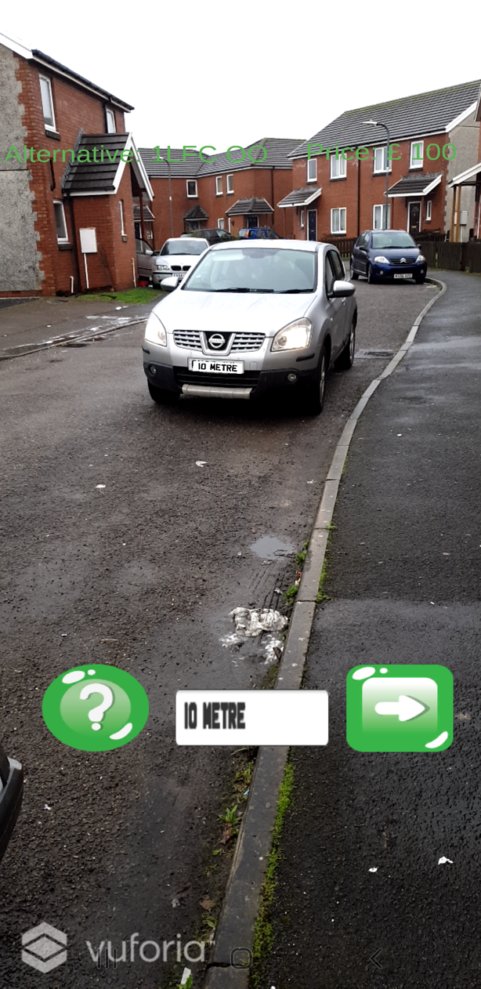

Appendix 2 – Feature board

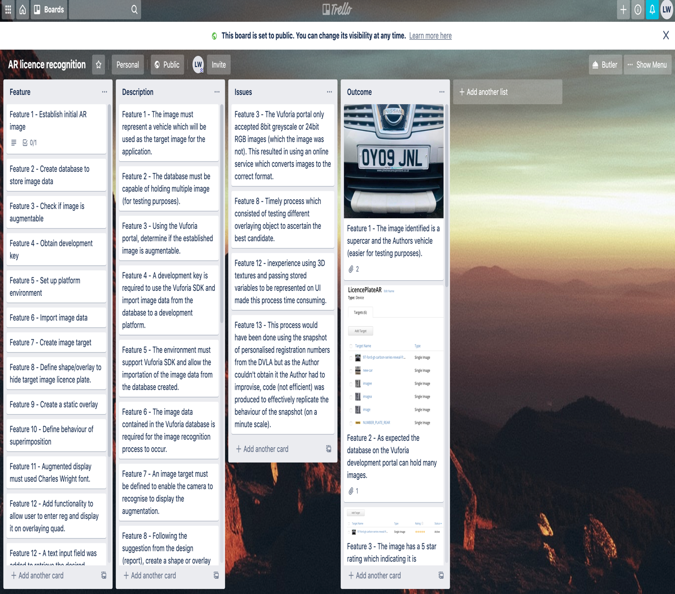
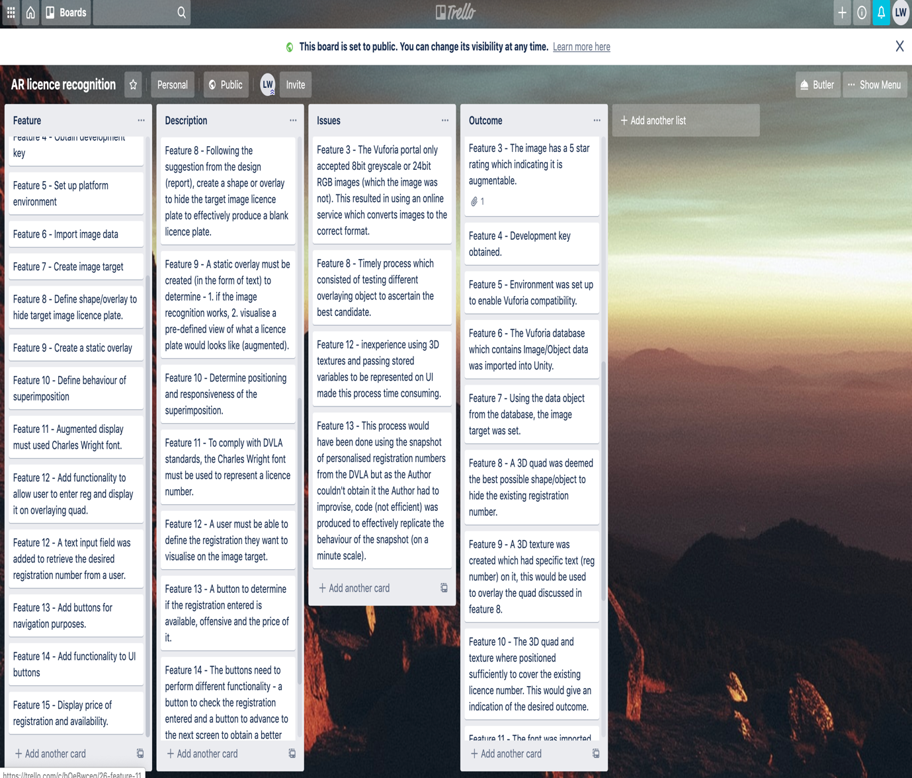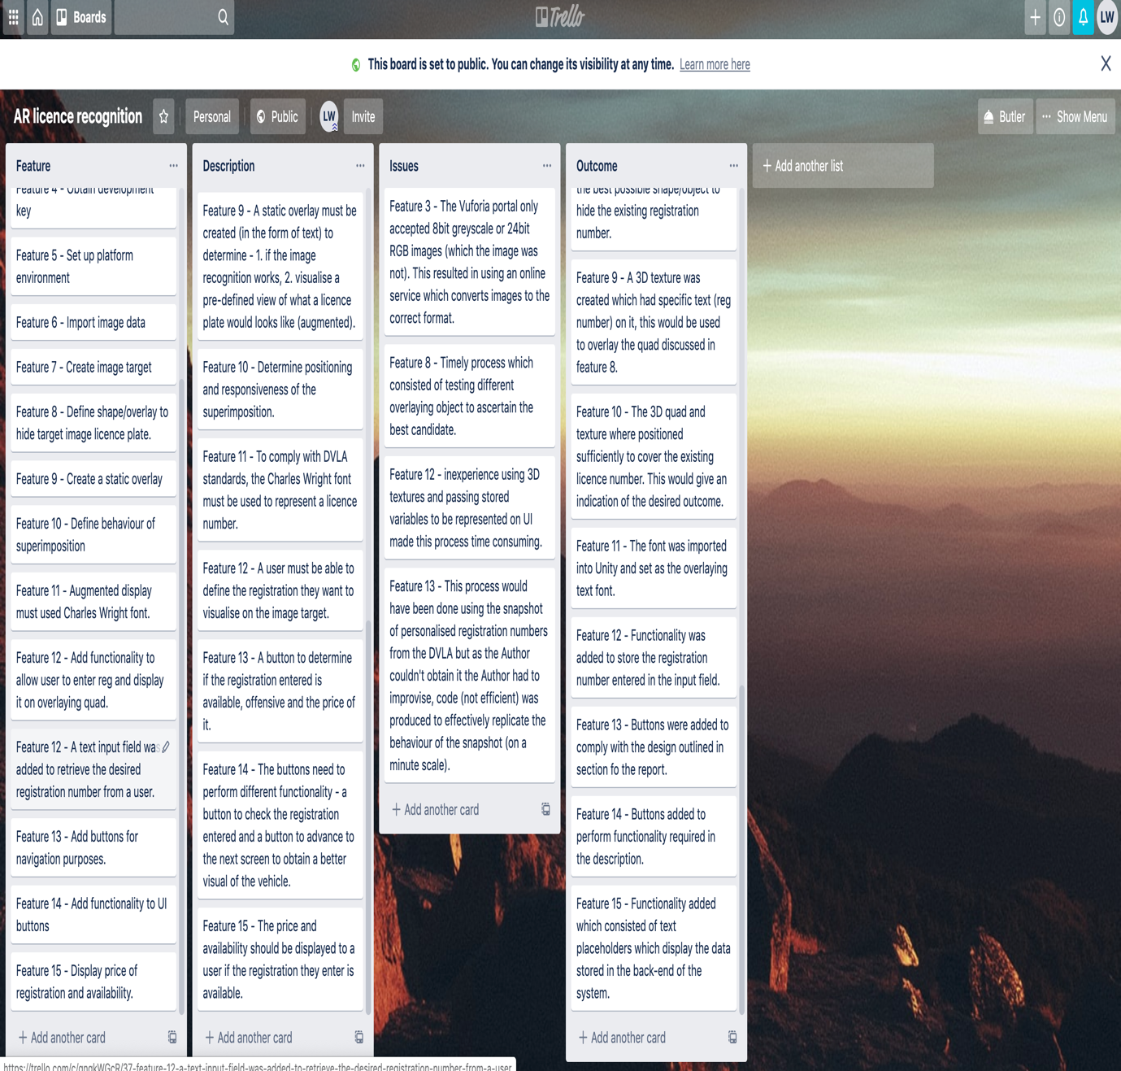
For a better view, the Author has linked the board below:
https://trello.com/b/YCwmDAui/ar-licence-recognition

Code link https://drive.google.com/drive/folders/1dMaVK8dgBdfAJxA111lQS6V2v9Yla39h?usp=sharing

