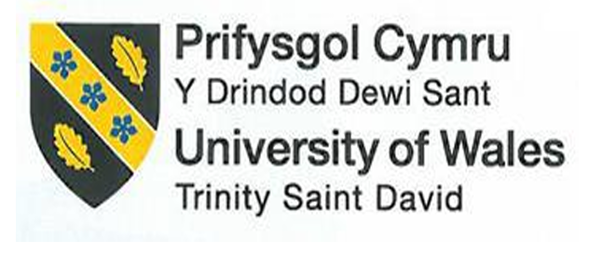
BMIH5004
Management and Organisational Behaviour

Student Name: Baby Najnin Lima
Student ID: 2133582
Date : 31.05.24
Executive Summary
Hilton Hotel includes relevant strategic direction, organisational culture, current transformation efforts, and the effect of these initiatives. Priorities for Hilton are to deliver exceptional guest experiences, advance people and sustainability, and drive innovation. Its ability to function as a leader in the hospitality industry globally stems from its approach to organisational culture in balancing competition with cooperation and employee participation.
The latest update to the digital guest experience platform and added sustainability programs have notably altered guest sat scores, NPS scores and green badge ratings. An already efficient staff whose change management had been tuned to Dobson was poised to deliver the ultimate fulfilment. Through their dedication to an exceptional culture, improvements, and cutting-edge technology, Hilton has solidified themselves as the go-to choice for luxury hospitality. The following executive summary summarizes Hilton’s strategic philosophy, cultural keeps, recent activities and implications to delivery and maintenance.

Table of Contents
1. Introduction 1
2. Organisational Structure, culture and initiatives taken by the company in order to change 2
2.1 Define and analyse the Structure and Culture of an Organisation 2
2.2 Importance of organisational culture in relation to overall performance 4
2.3 Recent change initiatives, their impact and how well these were managed 6
2.4 The organisation’s strategic direction 7
3. Conclusion 8
Reference list 9

1. Introduction
What makes up an organisation’s structure is the norms, policies, and procedures that it puts in place to achieve its goals. The values, norms, and attitudes of an organisation are all parts of its culture. To succeed, the company needs both of these. Organisational culture and structure vary from one company to another based on factors such as size, industry, and level of activity. The Hilton Hotel Company is the subject of this article. Hilton Hotels & Resorts is the flagship brand of the American multinational hospitality firm Hilton. It runs resorts and hotel chains globally. Conrad Hilton was the original founder of the firm.
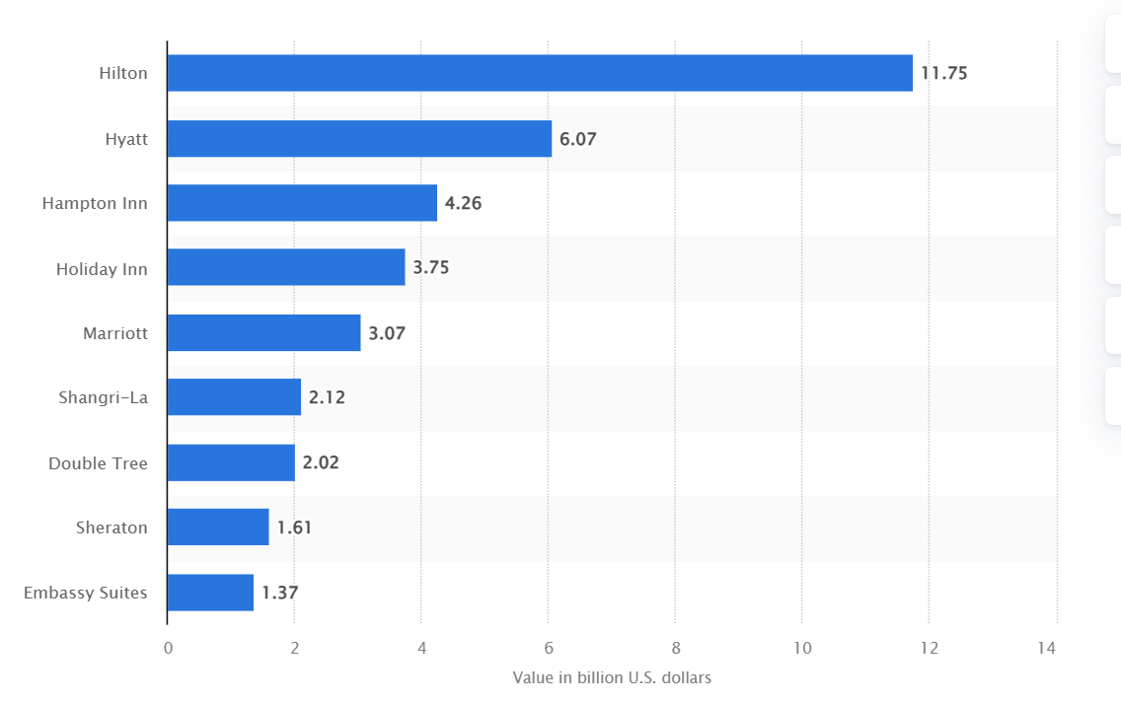
Figure 1: Leading hotel brands based on brand value worldwide in 2023(in billion U.S. dollars)
(Source: Statista, 2019)
The most valuable hotel brand in 2023 was Hilton, which had a global brand value of over $12 billion USD across the whole globe. In addition to Holiday Inn, Hampton Inn, and Hyatt, the list also included a number of other well-known hotel brands for consideration. The Royalty Relief approach was used in order to determine and evaluate the branding value of each individual hotel. Using this method of brand valuation, organisations have the potential to get a more comprehensive understanding of their market position. This may be accomplished via a number of processes, including the forecasting of projected revenues and the measurement of brand strength. One of the factors that contribute to the success of the hotel chain is the fact that Hilton Worldwide Holdings owns, runs, or franchisees a number of other significant brands.

2. Organisational Structure, culture and initiatives taken by the company in order to change

2.1 Define and analyse the Structure and Culture of an Organisation
The challenges encountered by an organisation and the strategies it formulates to overcome both internal and external obstacles shape the way of life of that firm. The business’s efforts effectively tackle environmental challenges, therefore upholding these guiding ideals. According to Übius and Alas (2009), there are four kinds of organisational culture: clan culture, commercial culture, advertisement culture, and culture of hierarchy.
Hilton Hotels is primarily representative of a market culture that is defined by a competitive spirit, a strong emphasis on target achievement, and results-driven procedures. This culture places a strong emphasis on market share, profitability, and customer satisfaction, which is consistent with Hilton’s mission to provide outstanding guest experiences and uphold its position as a leader in the hospitality sector (Hilton. 2019). Their emphasis on teamwork, employee engagement, and a supportive work environment are further indications of clan culture. Nonetheless, Hilton is positioned within the framework of market culture due to its overarching drive for excellence and market leadership, as well as its structured strategies and objectives, which create a dynamic and competitive organisational environment.
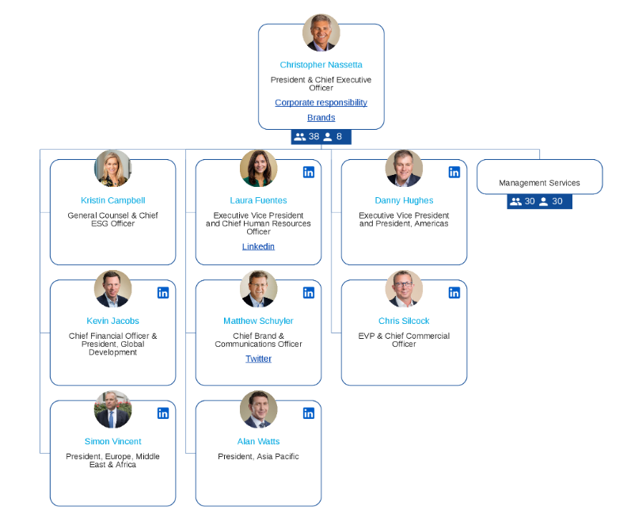
Figure 3: Organisational Structure of Hilton Hotel
(Source: Organimi, 2024)
Hilton’s organisational structure is divisional. The reason for this is that Hilton’s C-suite is accountable for overseeing several functional and geographic divisions. Additionally, the corporation organises its properties and operations into three distinct sectors (Organimi, 2024).
Ownership: Properties that are directly owned by Hilton.
Management and franchise: Properties that are either directly managed by Hilton or licenced to others for operation.
Timeshare: Hilton Grand Vacations offers a variety of timeshare properties (Organimi, 2024)
Mission and Vision: From luxurious full-service hotels and resorts to more budget-friendly rooms and suites, Hilton Hotels has it all, making it the go-to choice for accommodation (Rockett, 2024). By making a positive impact on neighbourhoods, offering Team Members meaningful employment, and providing tourists with meaningful experiences, it aspires to spread the warmth and light of hospitality across the globe.

2.2 Importance of organisational culture in relation to overall performance
When it comes to the performance of the organisation, the organisational culture is also a significant factor. According to Osei et al. (2023), this encompasses the fundamental principles, perceptions, and even social and performance norms that determine the manner in which employees collaborate with one another. It is beneficial to a company's bottom line to have a lower employee turnover rate since it reduces the amount of money spent on hiring and training new employees. In the process of developing something new, shifting speeds, and strengthening sprints during building times, as mentioned by Volti and Croissant (2024), culture plays a role in bridging the gap between change and those transitions.
The mission is to create a high-performance culture that ultimately perpetuates Hilton Hotels and Resorts as the number one choice for a luxury hospitality experience (Manoharan, Madera and Singal, 2024). As one of the most recognised names in the industry, Hilton’s culture and company values are those of customer service excellence, teamwork, and innovation (Yampolska, 2023).
This strong positive organisational culture at Hilton increases the level of employee satisfaction and engagement, hence increasing overall productivity and decreasing turnover rates (Maganti, 2023). When employees know they are valued, and when they understand how their work contributes to the company’s objectives, they are more likely to deliver exceptional service, which manifests itself in improved guest service scores and repeat business as per the statement of Marwaha, Sharma and Sharma (2024).
Handy’s Model of Organisational Culture
Four different management philosophies, each with its own set of values, are proposed by Handy’s theory. These values and standards gradually mould the company’s culture.

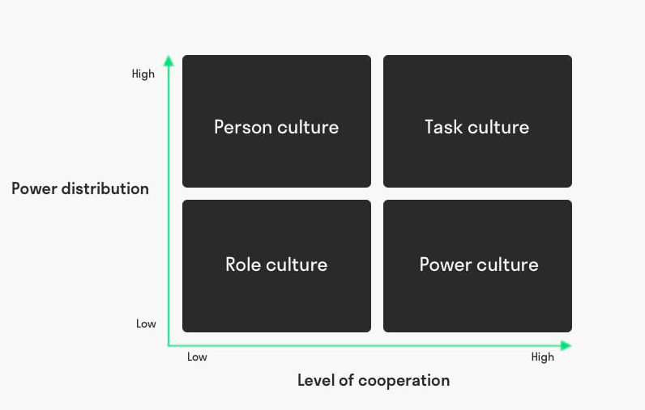
Figure 3: Handy’s Model of Organisational Culture
(Source: Mikušová, Klabusayová and Meier, 2023)
Power Culture: A power culture is characterised by a concentration of power, whereby a handful of influential individuals typically hold all the cards. This element is demonstrated by the fact that senior executives at Hilton make corporate-level strategic decisions. This centralised decision-making procedure ensures that any properties worldwide consistently adhere to the brand’s standards and strategic direction.
Role Culture: Roles, responsibilities, and processes are all clearly defined within the context of role culture. Certain aspects of Hilton are a reflection of the Role culture, which is characterised by the utilisation of a hierarchical structure and a clearly defined job description.
The advantage of individual employees at all levels knowing what they are required to do and what they are required to do in order to perform, this provides efficiency and consistency in performing the process.
Task Culture: It sets up teams to deliver a piece of work. Hilton encourages team effort and collaborates with its cross-functional teams to contribute to projects such as the opening of new hotels, marketing, or innovations in service. In doing so, a task-oriented approach that encourages a fluid and nimble working environment is cultivated, stimulating creativity and problem-solving flexibility enabling Hilton to quickly innovate and respond to changing patterns in the market and indicative trends about what customers want, and helping it remain competitive.
Person Culture: A person's culture focuses on the nature and the rights of the individual in a world where they work together with a group in order to achieve their own personal goals in life. At Hilton, that translates into a dedicated effort to caring for team members. This includes, however, is not limited to, access to training and development programs, opportunities for career growth and recognition programs.

2.3 Recent change initiatives, their impact and how well these were managed
Hilton Hotels has also conducted a primary digital guest experience platform renovation as part of one of its latest modification programs to engage its customers better and increase brand loyalty (Linxi, 2021). This effort included a tech upgrade to enhance customization, smoother booking experiences and better lines of communication. The change had a large impact, resulting in a higher guest satisfaction score and more repeat bookings overall properties. Hilton was another change initiative as it promoted sustainable practices in its operation to reduce its carbon footprint on the environment (kg-admin, 2023). One element in this was fostering sustainable practices and launching energy-efficient systems and waste reduction programs for guests and staff. However, the blow was softened by the fact that it helped push Hilton towards the right direction in the end, resulting in recognition for its eco-friendly initiatives and stronger green branding.
Hilton managed both initiatives very well, being an effective leader, communicator and stakeholder manager from the beginning of the change process. It set clear goals and objectives and used performance metrics to follow-up and evaluate the mastery of its mission. Staff were trained and supported in transitioning and using new systems. Guest satisfaction, brand reputation, and environmental sustainability have been significantly higher at Hilton Hotels from these new change initiatives. Hilton continues to implement operations and procedures relating to guest experiences, including its guidelines, as part of its commitment to customer service and responsible travel, from repairing keyless entry to contactless check-in, as well as cleaning procedures and management of public spaces.
Dobson’s guide to changing culture
Dobson’s guide to changing culture emphasizes several key principles that align with Hilton Hotels’ recent change initiatives and their management. Firstly, the guide highlights the importance of clear communication and transparency throughout the change process (Mullins and Dosser, 2013). Hilton effectively communicated the goals, benefits, and expectations of its digital guest experience and sustainability initiatives to guests, employees, and stakeholders, ensuring everyone understood the purpose and impact of these changes. Secondly, Dobson emphasises the need for strong leadership and commitment from top management (Mullins, 2020). Hilton demonstrated effective leadership by championing these initiatives, and providing resources and support.
Dobson also highlights the importance of employee engagement and power in this transformation of work culture (Mullins, 2016). Educating employees on the changes, working with labour to determine changes, and thanking them for their contributions to the change initiatives were ways Hilton involved them in the process of change. This inspired employees to adopt new technologies, provide outstanding guest experiences, and support sustainability. Additionally, Dobson’s guide laboured to focus a Highlight to the necessity to stick to and evaluate the effect of the modified procedures. Bring performance metrics to life, Hilton measured how well the hotel performs in terms of guest satisfaction, repeat business, and contributing to reducing environmental impact.

2.4 The organisation’s strategic direction
The three main pillars of Hilton Hotels’ strategic direction are creating extraordinary guest experiences, advancing sustainable practices, and encouraging an innovative culture. Hilton’s goal is to be the friendliest company in the world. To that end, it offers guests personalised services, cutting-edge amenities, and an unwavering dedication to going above and beyond. Regarding sustainability, Hilton is committed to lessening its impact on the environment through the adoption of green initiatives like waste management plans, energy-efficient systems, and ethical sourcing (Linxi, 2021). The company’s goal of minimising the effect on the environment while illuminating the world with the warmth and light of hospitality is in line with these initiatives.
Furthermore, the innovative mindset spread across the entire Hilton spectrum digital guest experiences to employee training and development is also reflective of Hilton’s strategic direction (kgi-admin, 2023). By embracing next-generation technologies and creative strategies, Hilton also expects to enhance its leadership and further contribute to sustainability across the industry with this investment in the future.

3. Conclusion
Hilton Hotels Strategy Hilton Hotels’ strategy of focusing on its customers and sustainability goals and innovating around those is reflected in its organizational culture and structure. The company market culture enforces an aggressive tone, methodology and performance-centric rewards rooted in principles of clan culture. The divisional structure offers support to Hilton’s wide array of operations making it one of the most successful global players among hospitality chains.
Hilton has put a range of recent initiatives into place while successfully managing positive organizational culture and effective change management that has had strong alignment with Dobson’s guide. For example, these guest satisfaction brand reputation and environmental sustainability results have achieved a significant impact, such as the performance of initiatives such as the upgrade of digital guest experience platform and sustainability programs. Strategically leading with a high-performance culture and commitment to continuous improvement, Hilton is the choice for luxury hospitality experiences that should solidify its continued dominance in the luxury hospitality industry.

Reference list
Hilton. 2019. Learn more about Hilton Culture. [online] Hilton.com. Available at: https://jobs.hilton.com/us/en/culture.
kgi-admin, 2023. Hilton Worldwide’s path to emission reduction: analyzing targets and achievements. [online] Hotel Management Network. Available at: https://www.hotelmanagement-network.com/data-insights/hilton-worldwide-net-zero-targets/#:~:text=Hilton%20has%20implemented%20various%20initiatives.
Linxi, X., 2021, September. The Digital Transformation Strategy of Hilton During COVID-19. In 2021 International Conference on Financial Management and Economic Transition (FMET 2021) (pp. 317-321). Atlantis Press.
Maganti, S., 2023. TRANSFORMATIVE IMPACT: EXPLORING THE INTEGRATION OF ARTIFICIAL INTELLIGENCE IN HUMAN RESOURCE MANAGEMENT.
Manoharan, A., Madera, J.M. and Singal, M. eds., 2024. The Routledge Handbook of Diversity, Equity, and Inclusion Management in the Hospitality Industry. Routledge.
Marwaha, P., Sharma, S. and Sharma, G., 2024. IMPACT OF ORGANIZATIONAL CULTURE ON EMPLOYEE’S PERFORMANCE AND JOB SATISFACTION IN HOTEL INDUSTRY. PUSA Journal of Hospitality and Applied Sciences, 10(1), pp.19-25.
Mikušová, M., Klabusayová, N. and Meier, V., 2023. Evaluation of organisational culture dimensions and their change due to the pandemic. Evaluation and Program Planning, 97, p.102246.
Mullins, L and Dosser, P. 2013. Hospitality Management and Organisational Behaviour (5th Ed) Harlow, Pearson.
Mullins, L. 2016. Management and Organisational Behaviour (11th edition) Harlow: Pearson
Mullins, L. 2020. Organisational Behaviour in the Workplace (12th edition) Harlow: Pearson
Organimi, 2024. Hilton’s Organizational Structure [Interactive Chart]. [online] Organimi. Available at: https://www.organimi.com/organizational-structures/hilton/.
Osei, M.B., Papadopoulos, T., Acquaye, A. and Stamati, T., 2023. Improving sustainable supply chain performance through organisational culture: A competing values framework approach. Journal of Purchasing and Supply Management, 29(2), p.100821.
Rockett, G., 2024. Hilton’s approach to diversity, equity and inclusion management. In The Routledge Handbook of Diversity, Equity, and Inclusion Management in the Hospitality Industry (pp. 321-331). Routledge.
Statista. 2019. Most Valuable Hotel Brands Worldwide 2019 | Statista. [online] Statista. Available at: https://www.statista.com/statistics/732907/most-valuable-hotel-brands-worldwide/.
Übius, Ü. and Alas, R., 2009. Organizational culture types as predictors of corporate social responsibility. Engineering economics, 61(1).
Volti, R. and Croissant, J., 2024. Society and technological change. Waveland Press.
Yampolska, O., 2023. Specifics of organizational culture in multinational corporation (based on Radisson Hotel Group case) (Doctoral dissertation, Private Higher Educational Establishment-Institute “Ukrainian-American Concordia University").

