LEVEL/ LEfEL 4

Student Name: Emma Williams
Student P Number: P1904789
Module Title: L4 - Introduction to Web and Database Concepts
Module Code: ACCA4023
Assignment Title: HTML & CSS Web Development
Module Tutor: Gareth Jones
Word Count: 2000-2500

Section | Contents
3. | Introduction
4. | Requirements
5. | Implementation
i) | Website Screen Shots
ii) | Validation
6. | Evaluation
A. | Research terms and role in web development
i) | Website usability
ii) | Accessibility
iii) | Search engine optimisation (SEO)
B. | Evaluation of Completed Website
i) | Usefulness (usability and utility)
ii) | Search Engine Optimisation (SEO)
iii) | Accessibility
 | References
 | Appendices

Task 2: Report
3. Introduction
The author has composed this report to accompany the website ‘Purrfect Paws – A True Love Story’. The requirements were to design and code a responsive website, without the use of a development environment. Made up of a minimum of five relevant and related pages, using Hypertext Markup Language (HTML) and Cascading Style Sheets (CSS) web standards. The report proposes to outline the specifications, research, development work and testing undertaken, during the construction of the website.
4. Requirements
The website title is ‘Purrfect Paws – A True Love Story’ and was developed to celebrate the life of the author’s Bengal cat Theo, who sadly passed away this year. The website provides an insight into the life of Theo and what is to be expected when owned and living with a Bengal cat. It also provides information on the Bengal Cat breed and has links for further information from a dedicated website. Bengal cats are a pedigree breed of cat that are noted for their unique coats and markings, which make them popular, however they are also very time consuming and require true dedication and love, this website hopes to provide information and accounts of owning a Bengal, to provide a helpful insight from an owner point of view.
The website was created using HTML and CSS in the Notepad++ application. It contains hyperlinks, photos and videos to capture the viewer and keep them interested and wanting to learn more. The author chose the particular colour theme, as purple is known to be an elegant colour and has a calming and soothing effect [1]. This colour best describes Theo as he was very elegant but had a calming effect on all who spent time with him.

5. Implementation
i) Screen shots of all website pages
Page One - Home
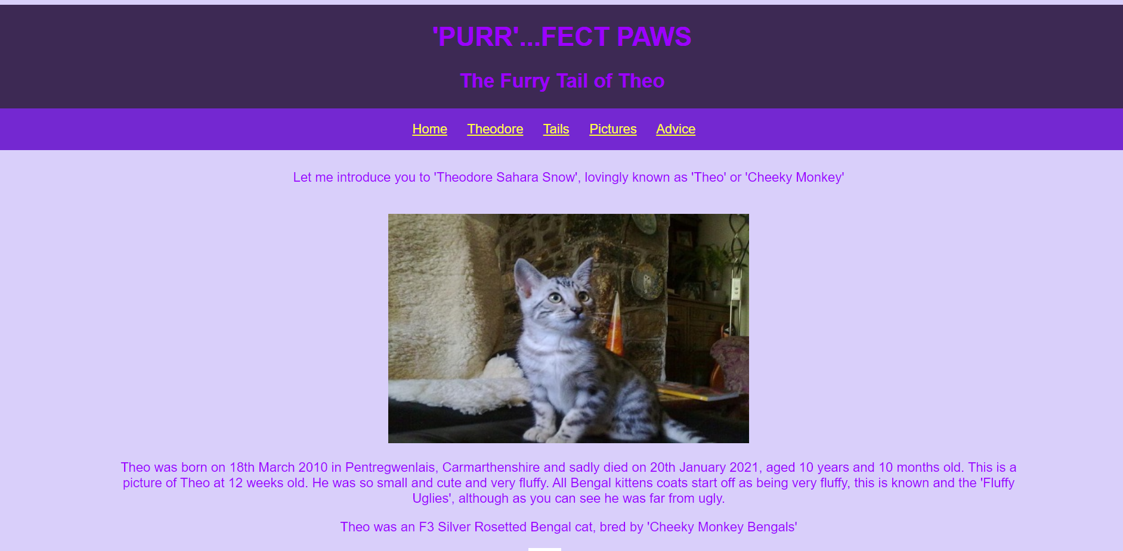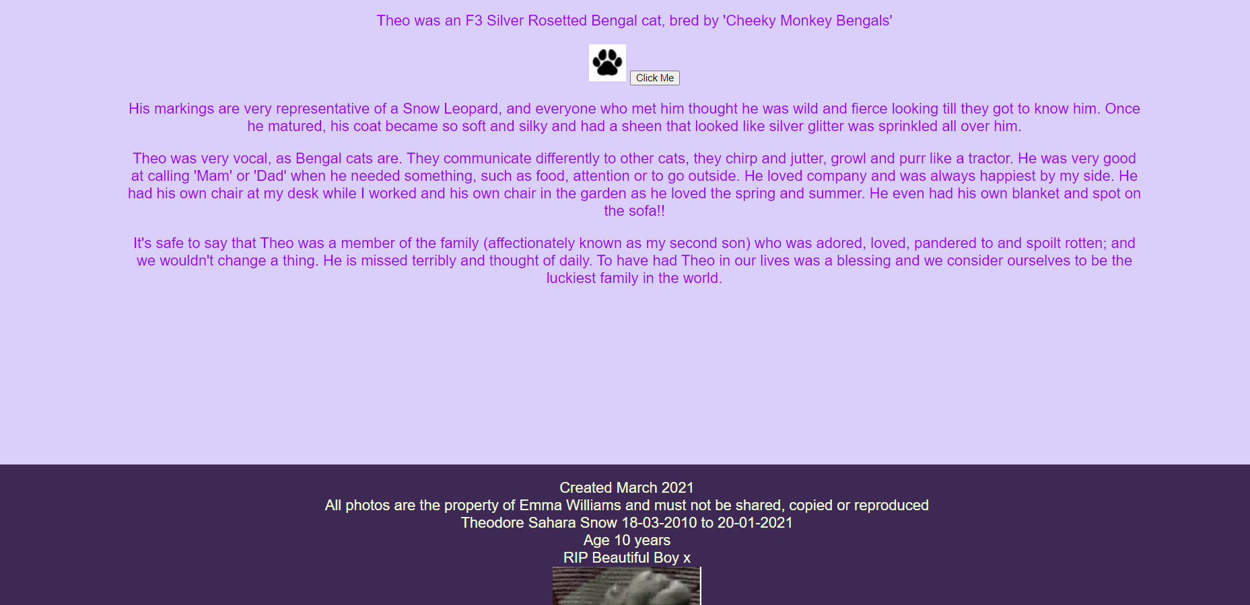
Page Two – Theodore
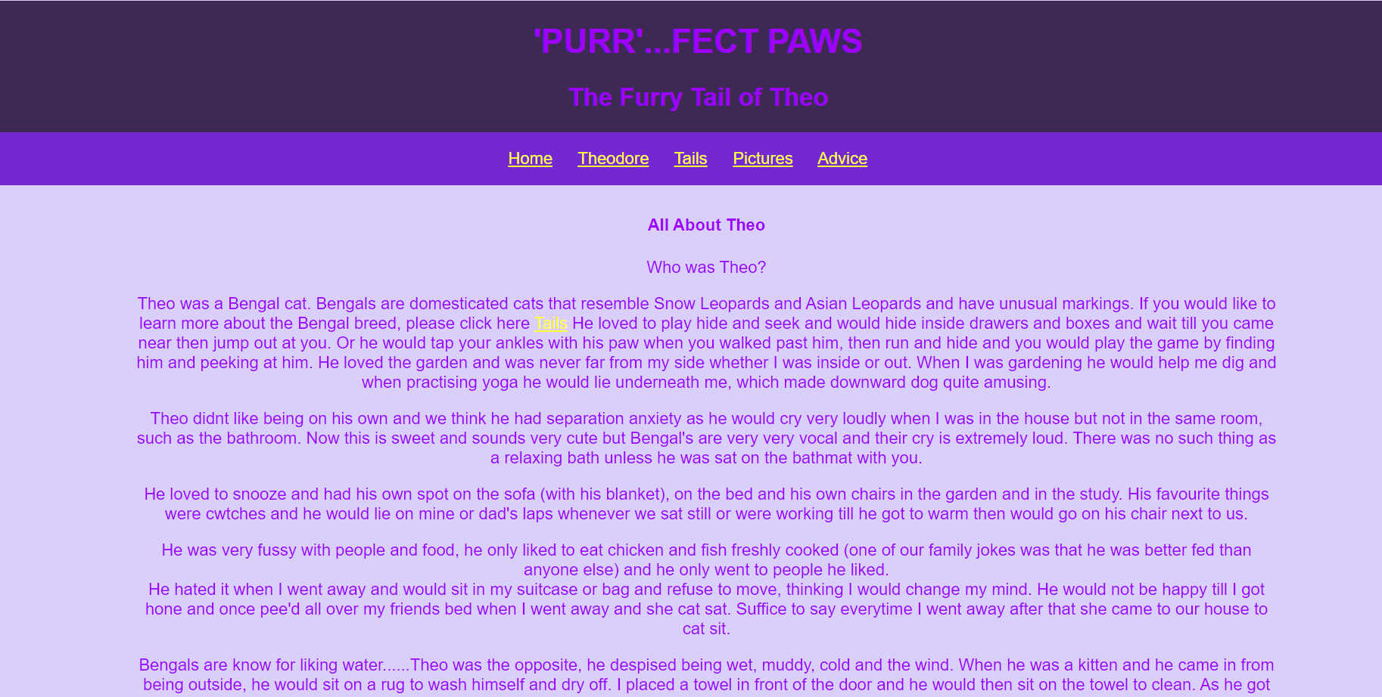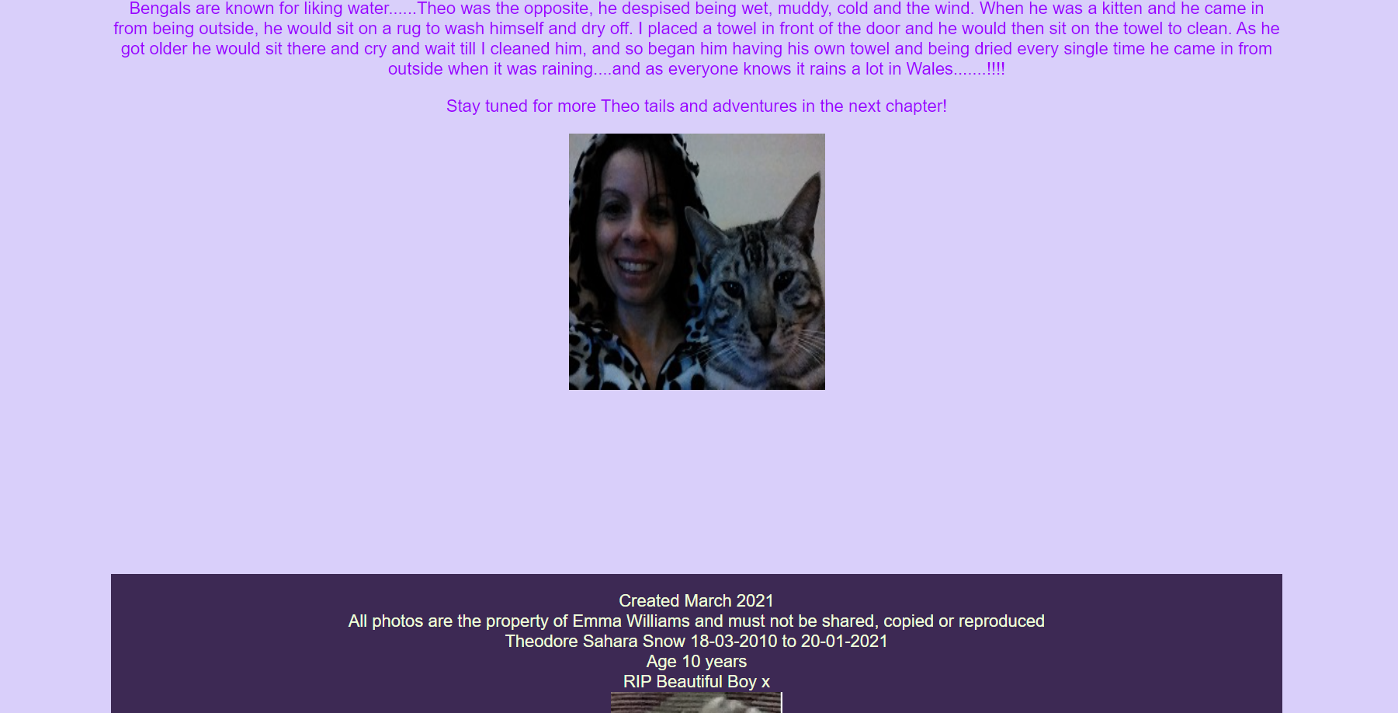
Page Three – Tails
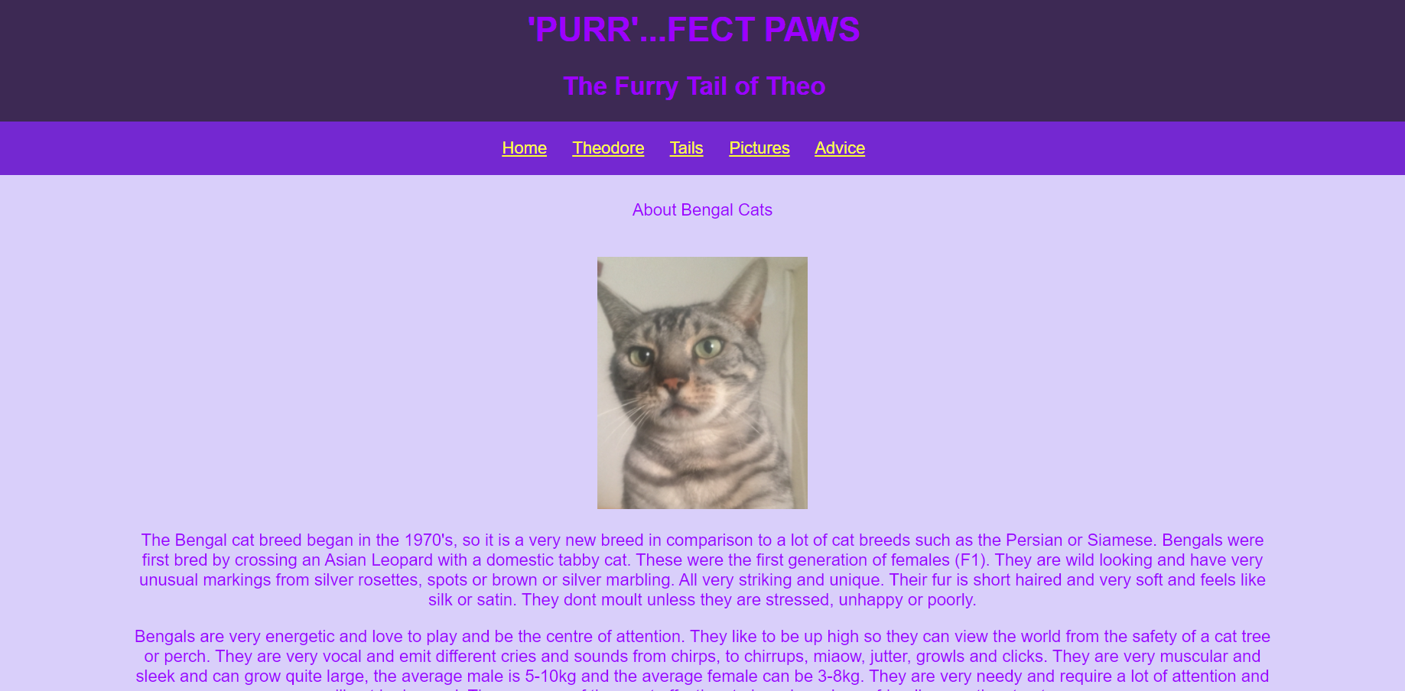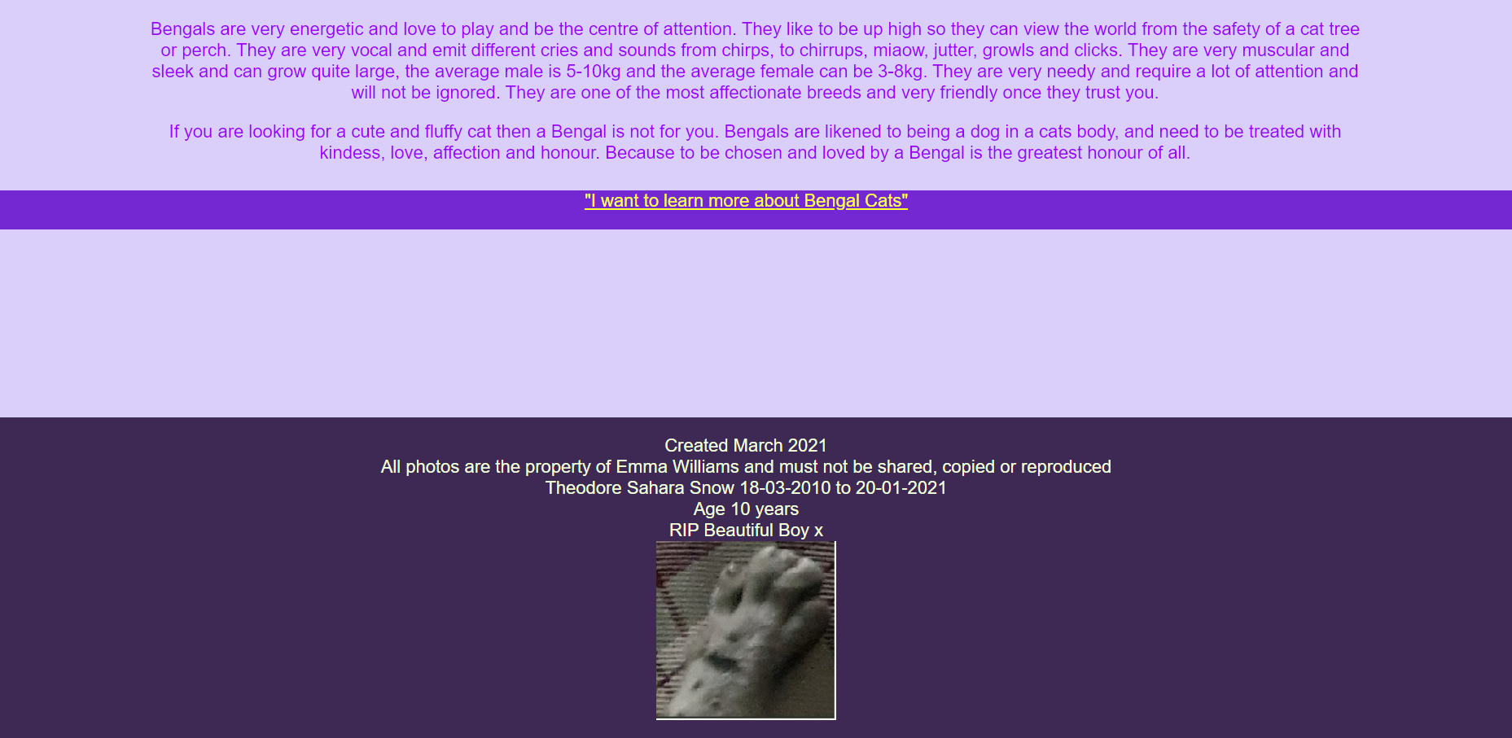
Page Four – Pictures
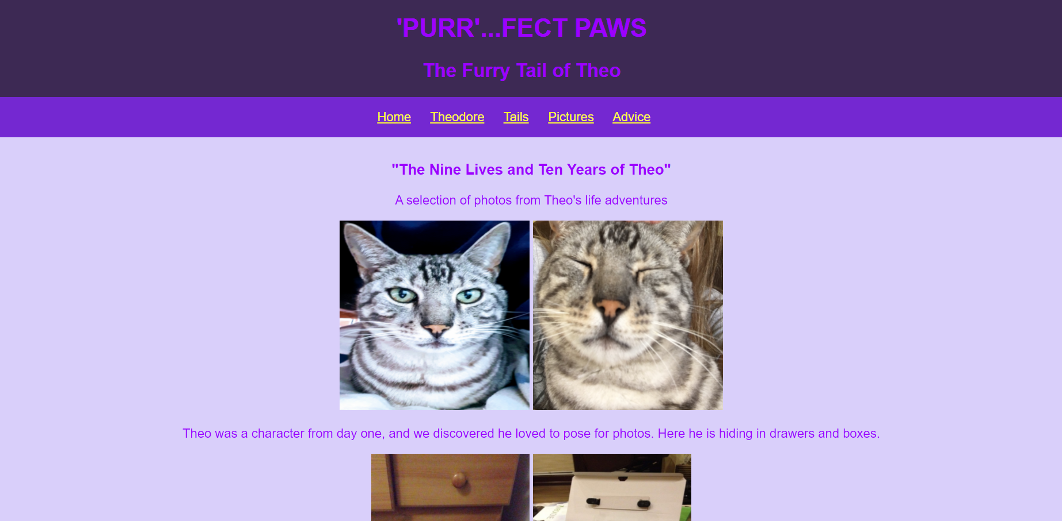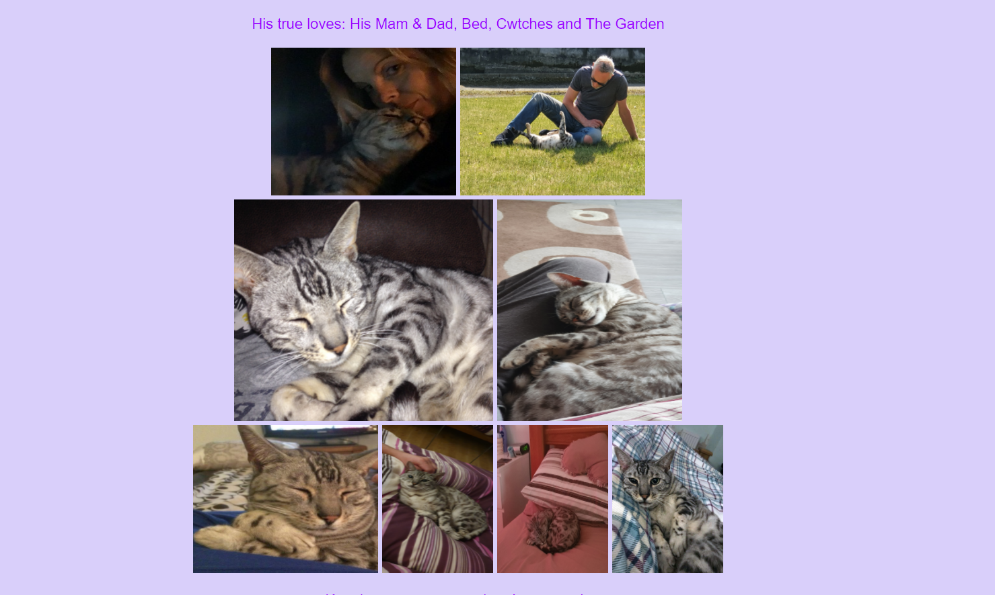
Page Five – Advice

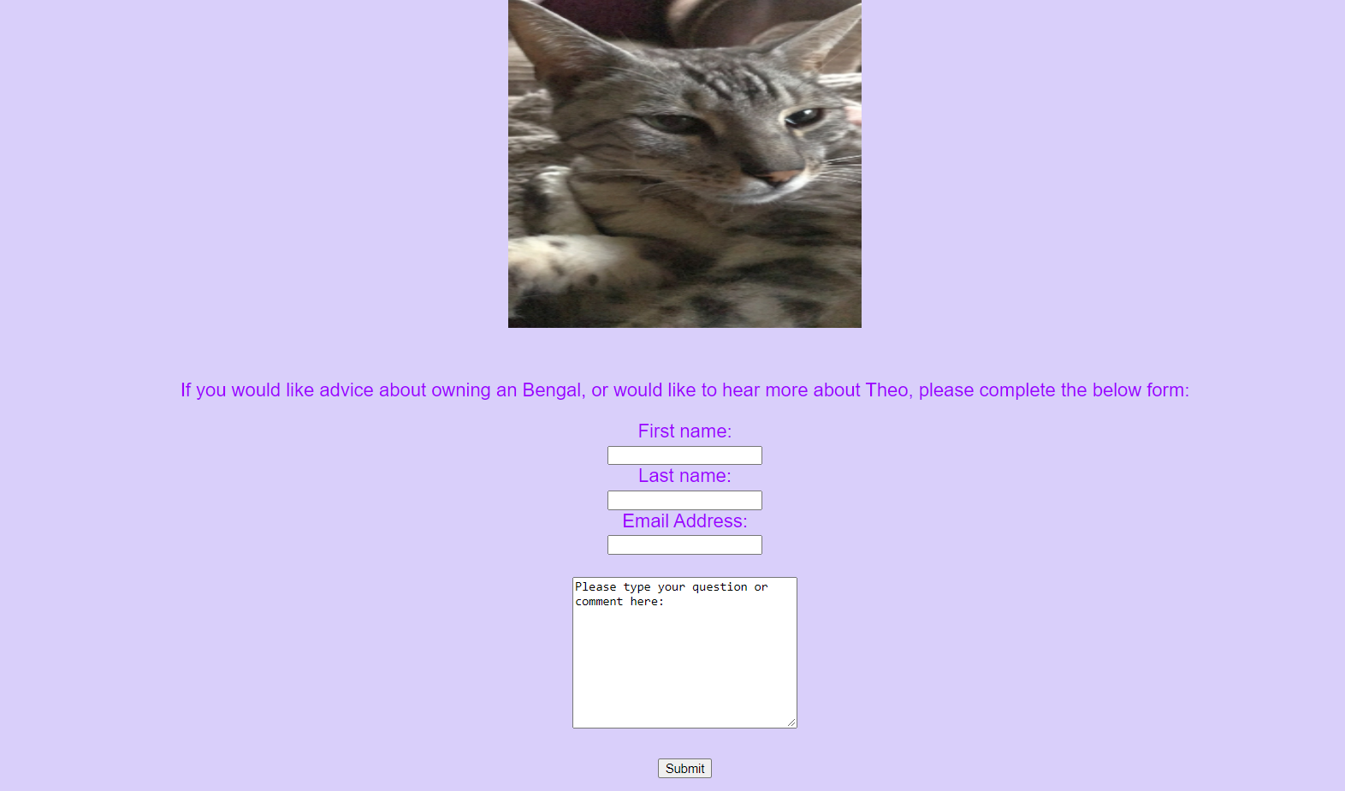

ii) Validation
The author validated the home page ‘Purrfect Paws - A True Love Story’ via file upload, using the W3 validator tool [2].
Errors found:
- Error: No space between attributes.
At line 39, column 114
;height:350px;"</img>↩ <p>Th
- Warning: Attribute < is not serializable as XML 1.0.
From line 39, column 4; to line 39, column 119
<br>↩ <img src="Theo as a baby.jpg" alt="Picture of Theo as a kitten" style="align:center;width:550px;height:350px;"</img>↩ <p
- Warning: Section lacks heading. Consider using h2-h6 elements to add identifying headings to all sections.
From line 35, column 2; to line 35, column 20
v>↩ ↩ ↩ <section id="main">↩ <di
- Error: Quote " in attribute name. Probable cause: Matching quote missing somewhere earlier.
At line 56, column 85
nter;width="200" height="200"

Some of the errors found were correctable, there were a few simple mistakes that had been made in the initial typing of the code, such as a colon missing on one line, and a line of text changed to a Heading <h3>, which improved the overall look of the page and made that particular line of text stand out. The author was unable to correct some of the errors, as when she followed the correction options as provided by the service, they seemed to break other elements of the code.
The errors highlighted that were able to be fixed were corrected and the validation carried out again and it showed that the steps taken to correct the errors were successful.
The author validated the website’s CSS ‘styles.css’ via file upload, using the W3 CSS Validation Service [3].

W3C CSS Validator results for styles.css (CSS level 3 + SVG)

Sorry! We found the following errors (3)

URI : styles.css
34 | a | Value Error : font courier is not a font value : courier
44 | #main | Value Error : text-align centre is not a text-align value : centre
69 | #link | Value Error : font courier is not a font value : courier

X3 errors were found within the CSS stylesheet. The errors were a spelling mistake with the word ‘center’ and the value for font ‘courier’ was changed to ‘arial’. The validation tool was run a second time, and the errors were no longer present.

W3C CSS Validator results for styles.css (CSS level 3 + SVG)

Congratulations! No Error Found.

6. Evaluation
A. Research and describe the terms: Useability, Accessibility and Search Engine Optimisation (SEO) and summarise the key findings and the role in web development.

i) Website usability
Usability of your website means, how easy is it to navigate? Are there any likes or dislikes? Is it easy to use? How does the user interact with the site? Is it obvious what the website is for?
There are many research methods that can be adopted to research your website and answer the above questions. But before you even begin to build it, it’s a good idea to create a wireframe diagram. This is a visual guide in the form of a drawing of how you would like your website pages to look before you begin to code them. An organised plan of item placement, how things will appear and fit. It can be created in different formats such as a hand drawn sketch or there are wireframe software tools available, such as balsamiq, Adobe, Lucidchart, etc. Some are open source and therefore free, whereas some are chargeable.
Once your website is built, but before it is published live on the internet, you will want to research the questions stated at the beginning of this paragraph, thus ensuring that when it is published, it presents the best user experience. User feedback and observations regarding interaction with the site will provide valuable data and analytics that will help with amendments to the site, to enhance and improve it for the user [4]. How you obtain that feedback can be in a variety of ways; you can ask a group of users to try the site and provide written or verbal feedback on their experience. There are software tools available that gather information, such as optimization tools that track the user’s behaviour using heatmaps, eye tracking and user recordings, some even include a questionnaire which provides a more interactive feedback experience [5]. There is no one size fits all option for usability testing, it is better to utilise multiple methods to be able to reach and gather a variety of feedback. Each method has its limitations, therefore using a mix of methods allows the limitations to be allayed and what may be missing from one source can be covered by another [6].
ii) Accessibility
The Web Content Accessibility Guidelines (WCAG 2.1) are a range of criteria and recommendations for ensuring web content is accessible to a range of people with disabilities. There are four main principles: perceivable, operable, understandable, and robust that provide the foundation. Within each principle are 13 guidelines which determine the framework authors can work to. Each guideline has a testable success criteria, which are relatable to conformance and regulation. Sufficient and advisory techniques are the final informative categories that aid with the application of the guidelines [7].
When you begin to build your website, you need to ensure that it is able to be used by as many people as possible, regardless of impairments, such as vision, hearing, cognitive, learning or motor difficulties. The site needs to work with assistive technologies, such as screen readers, screen magnifiers and speech recognition software. Assistive technology testing needs to be included during usability testing [8]. Accessibility also means being able to access the site on a variety of platforms, such as tablet and mobile devices, laptops and large screens, without the content becoming unreadable or certain aspects such as forms, being unusable.

iii) Search engine optimisation (SEO)
On-page Search engine optimisation (SEO) is a way of adapting and changing the website structure with the addition of key words and elements to make a website more search engine friendly. This means that when you publish a website, you want viewers to be able to find that website with ease, whether they search for it specifically or whether they carry out a keyword search via a search engine. The goal is to ensure your site is on the first page of results, towards the top. Keywords can be added to the page content, file names and title tags, the inclusion of images, lists, text and videos, all improve a websites result. Make sure that every page has a unique accurate page title tag, with a meaningful keyword, that is related to your site content. For example, if the site is related to flowers, then the keywords would be flowers [9]. Making modifications to your website is for the benefit of its users. Search engines are also considered users, and therefore optimising the help they provide, can then aid others finding your website. This is referred to as technical SEO. Google advises the use of a sitemap, which is a file that indicates any changes to content or pages and HTML image tag elements such as <img> as this helps crawler bots process and find images more easily [10]. Search engines use bots to crawl pages, decipher the content and then index it to a database. When a user searches, it is this database the results are drawn from. Better indexing equals higher ranking in the results. Less than 5% navigate past the first page of search results [11] Off-page SEO are the techniques employed when advertising and marketing the site. Focusing the promotion and marketing towards how useful the site is [12]

B. Provide an evaluation of your completed website as follows:
  - Usefulness (usability and utility)
The author has tested the usability of the site with family members. Each was asked to read and use the site to see whether they liked it, was it easy to use, did it make sense and how did they find the colours and format.
They provided verbal feedback, which the author acted upon. There were issues with the size and colour of the navigation bar font, which all 3 testers agreed was too large and bright and distracted from the reminder of the page content, this was then changed to a more user friendly and less invasive colour and size.
The users found the content informative and entertaining at times and all asked further questions, the author then included an advice page with a form for users to provide their name and email to request further information or advice.
Recommendations for future improvements would be to include more structure on each page and enhance the advice page with clickable links to further pages for each advice topic, such as feeding, playing, etc.

  - Search Engine Optimisation (SEO):
On-Page SEO techniques included are:
Headings that are hierarchical
CSS stylesheet
Including the alt text with each image
The inclusion of internal and external links [12]

  - Accessibility:
The four main principles that provide the foundation for web accessibility are; perceivable, operable, understandable, and robust. Which ensure design and creation of websites are accessible by people with disabilities.
The author ensured that the HTML code used was semantic, using correct elements for operability and that all image codes have the alt attribute, which provides a text description of an image, should the image not be available [13]. The author tested the colour contrast compliance using [14]. The results showed the main header and footer font colour #DD8BE8 when used in conjunction with the background colour #3D2954, failed the colour compliance and Grayscale tests. This prompted the author to alter the font colour to ensure the pages were compliant. The author utilised the Adobe Colour Accessible colour palette generator to ensure the colours are colour blind safe. [15]

The colour contrast test results are shown below, prior to the font colour change.
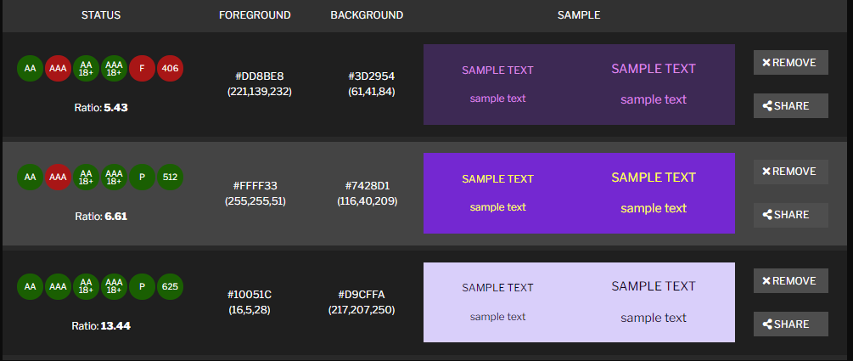
And after the font colour change with a compliance pass.
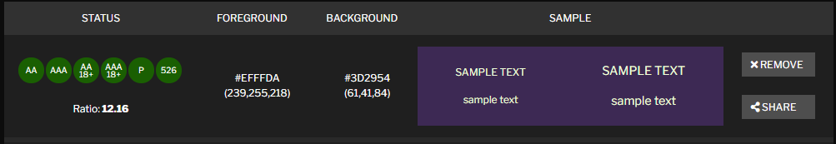
The Luminosity Contrast Ratio for the background and foreground colours, was also tested using the ‘Juicystudio Luminosity Colour Contrast Ratio Analyser’. The results showed that the ratio is: 12.16.1 which is a level AAA very good pass for the chosen colours (#3D2954 and #EFFFDA) [16]
As the website is not yet published, using accessibility testing tools was not possible, as they require the website to be live, to carry out the tests.

7.

References

[1] | Digital Printing, "The psychology of colour when designing for print," Digital Printing.co.uk, 2013. [Online]. Available: https://www.digitalprinting.co.uk/blog/psychology-colour-designing-print/. [Accessed April 2021].
[2] | W3C, "Markup Validation Service," W3C, 1994-2013. [Online]. Available: https://validator.w3.org/. [Accessed April 2021].
[3] | W3C, "CSS Validation Service," W3C, 1994-2013. [Online]. Available: http://jigsaw.w3.org/css-validator/. [Accessed 24 April 2021].
[4] | "Usability Testing Toolkit for IEEE Web Publishers," IEEE, 2021. [Online]. Available: https://brand-experience.ieee.org/guidelines/digital/other-guidelines/usability-testing/. [Accessed 24 April 2021].
[5] | "Top 21 Free Usability Testing Tools for APP and Website Testing," Mockplus Software Co, Ltd, 16 January 2019. [Online]. Available: https://www.mockplus.com/blog/post/usability-testing-tools. [Accessed 16 April 2021].
[6] | K. Whitenon, "Triangulation: Get Better Research Results by Using Multiple UX Methods," Nielsen Norman Group logoNielsen Norman Group, 21 February 2021. [Online]. Available: https://www.nngroup.com/articles/triangulation-better-research-results-using-multiple-ux-methods/. [Accessed 22 April 2021].
[7] | "Web Content Accessibility Guidelines (WCAG) 2.1," W3C, 5 June 2018. [Online]. Available: https://www.w3.org/TR/WCAG21/#input-purposes. [Accessed 20 April 2021].
[8] | Gov.UK, "Testing with assistive technologies," Accessibility community, 21 September 2020. [Online]. Available: https://www.gov.uk/service-manual/technology/testing-with-assistive-technologies. [Accessed 25 April 2021].
[9] | E. Enge, "Search Engine Optimization (SEO) for IEEE Sites," in The Art of SEO, IEEE.
[10] | "Search Engine Optimization (SEO) Starter Guide," Google, [Online]. Available: https://developers.google.com/search/docs/beginner/seo-starter-guide?hl=en%2F&visit_id=637548863180570300-736746166&rd=1#find. [Accessed 23 April 2021].
[11] | Team Linchpin, "How to Design an SEO Friendly Website that Ranks Well In Google," Linchpin, 10 March 2021. [Online]. Available: https://linchpinseo.com/how-to-design-an-seo--friendly-website/. [Accessed 25 April 2021].
[12] | A. Chris, "On-Page SEO Techniques That’ll Boost Your Rankings (Checklist Included)," Reliablesoft Digital Marketing Agency, [Online]. Available: https://www.reliablesoft.net/on-page-seo/. [Accessed 25 April 2021].
[13] | "HTML Accessibility," W3 Schools, 1999-2021. [Online]. Available: https://www.w3schools.com/html/html_accessibility.asp. [Accessed 20 April 2021].
[14] | "CONTRAST CHECKER," ACART Communications, 2017. [Online]. Available: https://contrastchecker.com/. [Accessed 20 April 2021].
[15] | "Adobe Colour," Adobe Colour, [Online]. Available: https://color.adobe.com/create/color-accessibility. [Accessed 2 April 2021].
[16] | "Luminosity Colour Contrast Ratio Analyser," Juicy Studio, 2000-2021. [Online]. Available: https://juicystudio.com/services/luminositycontrastratio.php#specify. [Accessed April 2021].
[17] | "Life's too short for bad software!," Balsamiq Studios, 2008-2021. [Online]. Available: https://balsamiq.com/. [Accessed 25 April 2021].

8. Appendices
HTML and CSS Txt listings
Home Page
<!DOCTYPE html>
<html lang="en-uk">
<head>
<title>Purrfect Paws - A True Love Story</title>
<link rel="stylesheet" type="text/css"
href= "styles.css">
<meta charset="UTF-8">
<meta name="description" content="Theo Bengal Cats">
<meta name="keywords" content="HTML, CSS, JavaScript">
<meta name="author" content="Emma Williams">
<meta name="viewport" content="width=device-width, initial-scale=1.0">
</head>

<body>
<header id="main-header">
<div class="container">
<h1> 'PURR'...FECT PAWS </h1>
<h2> The Furry Tail of Theo </h2>
</div>
</header>

<nav id="navbar">
<div class="container">
<ul>
<li><a href="C:\Users\Jon\OneDrive - University of Wales Trinity Saint David\2020-2021\Semester 2\Web Assignment\website-EW-1904789\index.html\Purrfect Paws - A True Love Story.html">Home</a></li>
<li><a href="C:\Users\Jon\OneDrive - University of Wales Trinity Saint David\2020-2021\Semester 2\Web Assignment\website-EW-1904789\index.html\Theodore.html">Theodore</a></li>
<li><a href="C:\Users\Jon\OneDrive - University of Wales Trinity Saint David\2020-2021\Semester 2\Web Assignment\website-EW-1904789\index.html\Tails.html">Tails</a></li>
<li><a href="C:\Users\Jon\OneDrive - University of Wales Trinity Saint David\2020-2021\Semester 2\Web Assignment\website-EW-1904789\index.html\Pictures.html">Pictures</a></li>
<li><a href="C:\Users\Jon\OneDrive - University of Wales Trinity Saint David\2020-2021\Semester 2\Web Assignment\website-EW-1904789\index.html\Advice.html">Advice</a></li>
</ul>
</div>
</nav>

<section id="main">
<div class="container">
<h3>Let me introduce you to 'Theodore Sahara Snow', lovingly known as 'Theo' or 'Cheeky Monkey'</h3>
<br><img src="Theo as a baby.jpg" alt="Picture of Theo as a kitten" style="align:center;width:550px;height:350px;" </img>
<p>Theo was born on 18th March 2010 in Pentregwenlais, Carmarthenshire and sadly died on 20th January 2021, aged 10 years and 10 months old. This is a picture of Theo at 12 weeks old. He was so small and cute and very fluffy. All Bengal kittens coats start off as being very fluffy, this is known and the 'Fluffy Uglies', although as you can see he was far from ugly.
<p>Theo was an F3 Silver Rosetted Bengal cat, bred by 'Cheeky Monkey Bengals'</p>
<img src="paw-print-vector-20655661.jpg" alt="Paw Print" style="width:50px;height:50px;" usemap="#cheekymonkeybengals"> <map name="cheekymonkeybengals"> <area shape="default" href="https://www.cheekymonkeybengals.co.uk/">
<button>Click Me</button>
<p>His markings are very representative of a Snow Leopard, and everyone who met him thought he was wild and fierce looking till they got to know him. Once he matured, his coat became so soft and silky and had a sheen that looked like silver glitter was sprinkled all over him.
<p>Theo was very vocal, as Bengal cats are. They communicate differently to other cats, they chirp and jutter, growl and purr like a tractor. He was very good at calling 'Mam' or 'Dad' when he needed something, such as food, attention or to go outside. He loved company and was always happiest by my side. He had his own chair at my desk while I worked and his own chair in the garden as he loved the spring and summer. He even had his own blanket and spot on the sofa!!
<p>It's safe to say that Theo was a member of the family (affectionately known as my second son) who was adored, loved, pandered to and spoilt rotten; and we wouldn't change a thing. He is missed terribly and thought of daily. To have had Theo in our lives was a blessing and we consider ourselves to be the luckiest family in the world.</p>

</div>
</section>
<footer id="main-footer">
<li>Created March 2021</li>
<li>All photos are the property of Emma Williams and must not be shared, copied or reproduced</li>
<li>Theodore Sahara Snow 18-03-2010 to 20-01-2021</li>
<li>Age 10 years</li>
<li>RIP Beautiful Boy x </li>
<img src="Theo Paw.jpg" alt="Picture of Theo's Paw" style="float:center"; width="200px"; height="200px"</img>
</footer>
</body>
</html>
Theodore
<!DOCTYPE html>
<html lang="en-uk">
<head>
<title>Theodore</title>
<link rel="stylesheet" type="text/css"
href= "styles.css">
<meta charset="UTF-8">
<meta name="description" content="Theo Bengal Cats">
<meta name="keywords" content="HTML, CSS">
<meta name="author" content="Emma Williams">
<meta name="viewport" content="width=device-width, initial-scale=1.0">
</head>

<body>
<header id="main-header">
<div class="container">
<h1> 'PURR'...FECT PAWS </h1>
<h2> The Furry Tail of Theo </h2>
</div>
</header>
<nav id="navbar">
<div class="container">
<ul>
<li><a href="C:\Users\Jon\OneDrive - University of Wales Trinity Saint David\2020-2021\Semester 2\Web Assignment\website-EW-1904789\index.html\Purrfect Paws - A True Love Story.html">Home</a></li>
<li><a href="C:\Users\Jon\OneDrive - University of Wales Trinity Saint David\2020-2021\Semester 2\Web Assignment\website-EW-1904789\index.html\Theodore.html">Theodore</a></li>
<li><a href="C:\Users\Jon\OneDrive - University of Wales Trinity Saint David\2020-2021\Semester 2\Web Assignment\website-EW-1904789\index.html\Tails.html">Tails</a></li>
<li><a href="C:\Users\Jon\OneDrive - University of Wales Trinity Saint David\2020-2021\Semester 2\Web Assignment\website-EW-1904789\index.html\Pictures.html">Pictures</a></li>
<li><a href="C:\Users\Jon\OneDrive - University of Wales Trinity Saint David\2020-2021\Semester 2\Web Assignment\website-EW-1904789\index.html\Advice.html">Advice</a></li>
</ul>
</div>
</nav>
<section id="main">
<div class="container">
<h4>All About Theo</h4>
<P>Who was Theo?</p>
Theo was a Bengal cat. Bengals are domesticated cats that resemble Snow Leopards and Asian Leopards and have unusual markings. If you would like to learn more about the Bengal breed, please click here <a href="C:\Users\Jon\OneDrive - University of Wales Trinity Saint David\2020-2021\Semester 2\Web Assignment\website-EW-1904789\index.html\Tails.html">Tails</a>
He loved to play hide and seek and would hide inside drawers and boxes and wait till you came near then jump out at you. Or he would tap your ankles with his paw when you walked past him, then run and hide and you would play the game by finding him and peeking at him. He loved the garden and was never far from my side whether I was inside or out. When I was gardening he would help me dig and when practising yoga he would lie underneath me, which made downward dog quite amusing.
<p>Theo didnt like being on his own and we think he had separation anxiety as he would cry very loudly when I was in the house but not in the same room, such as the bathroom. Now this is sweet and sounds very cute but Bengal's are very very vocal and their cry is extremely loud. There was no such thing as a relaxing bath unless he was sat on the bathmat with you.</p>
<p>He loved to snooze and had his own spot on the sofa (with his blanket), on the bed and his own chairs in the garden and in the study.
His favourite things were cwtches and he would lie on mine or dad's laps whenever we sat still or were working till he got to warm then would go on his chair next to us.</p>

He was very fussy with people and food, he only liked to eat chicken and fish freshly cooked (one of our family jokes was that he was better fed than anyone else) and he only went to people he liked.
<br>
He hated it when I went away and would sit in my suitcase or bag and refuse to move, thinking I would change my mind. He would not be happy till I got hone and once pee'd all over my friends bed when I went away and she cat sat. Suffice to say everytime I went away after that she came to our house to cat sit.
<p>Bengals are known for liking water......Theo was the opposite, he despised being wet, muddy, cold and the wind. When he was a kitten and he came in from being outside, he would sit on a rug to wash himself and dry off. I placed a towel in front of the door and he would then sit on the towel to clean. As he got older he would sit there and cry and wait till I cleaned him, and so began him having his own towel and being dried every single time he came in from outside when it was raining....and as everyone knows it rains a lot in Wales.......!!!! </p>

<p>Stay tuned for more Theo tails and adventures in the next chapter!</p>

<img src="Theo and Em.jpg" alt="Theo with Em" style="float:center;width:300px;height:300px;"</img>

<footer id="main-footer">
<li>Created March 2021</li>
<li>All photos are the property of Emma Williams and must not be shared, copied or reproduced</li>
<li>Theodore Sahara Snow 18-03-2010 to 20-01-2021</li>
<li>Age 10 years</li>
<li>RIP Beautiful Boy x </li>
<img src="Theo Paw.jpg" alt="Picture of Theo's Paw" style="float:center;width="200" height="200"</img>
</footer>
</body>
</html>
Tails
<!DOCTYPE html>
<html lang="en-uk">
<head>
<title>Tails</title>
<link rel="stylesheet" type="text/css"
href= "styles.css">
<meta charset="UTF-8">
<meta name="description" content="Theo Bengal Cats">
<meta name="keywords" content="HTML, CSS, JavaScript">
<meta name="author" content="Emma Williams">
<meta name="viewport" content="width=device-width, initial-scale=1.0">
</head>

<body>
<header id="main-header">
<div class="container">
<h1> 'PURR'...FECT PAWS </h1>
<h2> The Furry Tail of Theo </h2>
</div>
</header>
<nav id="navbar">
<div class="container">
<ul>
<li><a href="C:\Users\Jon\OneDrive - University of Wales Trinity Saint David\2020-2021\Semester 2\Web Assignment\website-EW-1904789\index.html\Purrfect Paws - A True Love Story.html">Home</a></li>
<li><a href="C:\Users\Jon\OneDrive - University of Wales Trinity Saint David\2020-2021\Semester 2\Web Assignment\website-EW-1904789\index.html\Theodore.html">Theodore</a></li>
<li><a href="C:\Users\Jon\OneDrive - University of Wales Trinity Saint David\2020-2021\Semester 2\Web Assignment\website-EW-1904789\index.html\Tails.html">Tails</a></li>
<li><a href="C:\Users\Jon\OneDrive - University of Wales Trinity Saint David\2020-2021\Semester 2\Web Assignment\website-EW-1904789\index.html\Pictures.html">Pictures</a></li>
<li><a href="C:\Users\Jon\OneDrive - University of Wales Trinity Saint David\2020-2021\Semester 2\Web Assignment\website-EW-1904789\index.html\Advice.html">Advice</a></li>

</ul>
</div>
</nav>

<section id="main">
<div class="container">
<p>About Bengal Cats</p>
<br>

<img src="Theodore.jpg" alt="Photo of Theo" style="align:center;width:250px;height:300px;"</img>
<p>The Bengal cat breed began in the 1970's, so it is a very new breed in comparison to a lot of cat breeds such as the Persian or Siamese. Bengals were first bred by crossing an Asian Leopard with a domestic tabby cat. These were the first generation of females (F1). They are wild looking and have very unusual markings from silver rosettes, spots or brown or silver marbling. All very striking and unique. Their fur is short haired and very soft and feels like silk or satin. They dont moult unless they are stressed, unhappy or poorly.
<p>Bengals are very energetic and love to play and be the centre of attention. They like to be up high so they can view the world from the safety of a cat tree or perch. They are very vocal and emit different cries and sounds from chirps, to chirrups, miaow, jutter, growls and clicks. They are very muscular and sleek and can grow quite large, the average male is 5-10kg and the average female can be 3-8kg. They are very needy and require a lot of attention and will not be ignored. They are one of the most affectionate breeds and very friendly once they trust you.</p>
<p>If you are looking for a cute and fluffy cat then a Bengal is not for you. Bengals are likened to being a dog in a cats body, and need to be treated with kindess, love, affection and honour. Because to be chosen and loved by a Bengal is the greatest honour of all.</p>
</p>
</div>
</section>

<section id="link">
<div class="container">
<a href="https://www.bengalcat.co.uk/">"I want to learn more about Bengal Cats"</a>
</p>
</div>
</section>

<footer id="main-footer">
<li>Created March 2021</li>
<li>All photos are the property of Emma Williams and must not be shared, copied or reproduced</li>
<li>Theodore Sahara Snow 18-03-2010 to 20-01-2021</li>
<li>Age 10 years</li>
<li>RIP Beautiful Boy x </li>
<img src="Theo Paw.jpg" alt="Picture of Theo's Paw" style="float:center;width="200" height="200"</img>
</footer>
</body>
</html>
Pictures
<!DOCTYPE html>
<html lang="en-uk">
<head>
<title>Pictures</title>
<link rel="stylesheet" type="text/css"
href= "styles.css">
<meta charset="UTF-8">
<meta name="description" content="Theo Bengal Cats">
<meta name="keywords" content="HTML, CSS, JavaScript">
<meta name="author" content="Emma Williams">
<meta name="viewport" content="width=device-width, initial-scale=1.0">
</head>

<body>
<header id="main-header">
<div class="container">
<h1> 'PURR'...FECT PAWS </h1>
<h2> The Furry Tail of Theo </h2>
</div>
</header>

<nav id="navbar">
<div class="container">
<ul>
<li><a href="C:\Users\Jon\OneDrive - University of Wales Trinity Saint David\2020-2021\Semester 2\Web Assignment\website-EW-1904789\index.html\Purrfect Paws - A True Love Story.html">Home</a></li>
<li><a href="C:\Users\Jon\OneDrive - University of Wales Trinity Saint David\2020-2021\Semester 2\Web Assignment\website-EW-1904789\index.html\Theodore.html">Theodore</a></li>
<li><a href="C:\Users\Jon\OneDrive - University of Wales Trinity Saint David\2020-2021\Semester 2\Web Assignment\website-EW-1904789\index.html\Tails.html">Tails</a></li>
<li><a href="C:\Users\Jon\OneDrive - University of Wales Trinity Saint David\2020-2021\Semester 2\Web Assignment\website-EW-1904789\index.html\Pictures.html">Pictures</a></li>
<li><a href="C:\Users\Jon\OneDrive - University of Wales Trinity Saint David\2020-2021\Semester 2\Web Assignment\website-EW-1904789\index.html\Advice.html">Advice</a></li>
</ul>
</div>
</nav>

<section id="Pictures">
<div class="container">
<h3>"The Nine Lives and Ten Years of Theo"</h3>
<p>A selection of photos from Theo's life adventures</p>
<img src="Theodore 2020.jpg" alt="Picture of Theodore" style="float:center;width:300px;height:300px; "</img>
<img src="IMG-5507.jpg" alt="Photo of Theo" style="align:center;width:300px;height:300px;"</img>
<p>Theo was a character from day one, and we discovered he loved to pose for photos. Here he is hiding in drawers and boxes. </p>
<img src="Theo drawer.jpg" alt="Photo of Theo in a drawer" style="align:center;width:250px;height:300px;"</img>
<img src="Theo Box_cr.jpg" alt="Photo of Theo in a box" style="align:center;width:250px;height:300px;"</img>
<p>Washing himself after being outside and sitting in my suitcase so I would take him with me</p>
<img src="Theo Cleaning_cr.jpg" alt="Picture of Theo washing himself" style="float:center;width:250px;height:200px;"</img>
<img src="Theo suitcase.jpg" alt="Picture of Theo in a suitcase" style="float:center;width:250px;height:200px;"</img>
<p>His true loves: His Mam & Dad, Bed, Cwtches and The Garden</p>
<img src="Theo and Emma.jpg" alt="Picture of Theo and his mam" style="float:center;width:250px;height:200px;"</img>
<img src="Theo and Dad.jpg" alt="Picture of Theo and his dad" style="float:center;width:250px;height:200px;"</img>
<br>
<img src="Theodore 2.jpg" alt="Picture of Theo cwtching" style="float:center;width:350px;height:300px;"</img>
<img src="Theo lap.jpg" alt="Picture of Theo cwtching on dads lap" style="float:center;width:250px;height:300px;"</img>
<br>
<img src="Theo bed 2.jpg" alt="Picture of Theo and his mam" style="float:center;width:250px;height:200px;"</img>
<img src="Theo bed 5.jpg" alt="Picture of Theo and his mam" style="float:center;width:150px;height:200px;"</img>
<img src="Theo bed EM.jpg" alt="Picture of Theo and his mam" style="float:center;width:150px;height:200px;"</img>
<img src="Theo bed.jpg" alt="Picture of Theo and his mam" style="float:center;width:150px;height:200px;"</img>
<P>Keeping me company when I was poorly</p>
<img src="Theo bed_3.jpg" alt="Picture of Theo and his mam" style="float:center;width:250px;height:200px;"</img>
</p>Theo in the garden</p>
<img src="Theo Garden 1.jpg" alt="Theo lying in the garden" style="float:center;width:250px;height:200px;"</img>
<img src="Theo Gardening.jpg" alt="Theo helping Em in the garden" style="float:center;width:250px;height:200px;"</img>
<img src="Theo sun 1.jpg" alt="Theo sunbathing on the decking" style="float:center;width:250px;height:200px;"</img>
<img src="Theo tree 1.jpg" alt="Theo in the treehouse" style="float:center;width:300px;height:300px;"</img>
<br>
<img src="Theo chair garden.jpg" alt="Theo on his garden chair" style="float:center;width:300px;height:400px;"</img>
<P>Theo at the Home Office</p>
<img src="Theodore at the Window.jpg" alt="Picture of Theo at the Window" style="float:center;width:250px;height:200px;"</img>
<img src="Theo chair.jpg" alt="Theo on his work chair" style="float:center;width:250px;height:200px;"</img>
<br>
<p>Theo doing what he did best - being adorable and lush</p>
<img src="Theo Pose_cr.jpg" alt="Picture of Theo at the Window" style="float:center;width:250px;height:350px;"</img>
<br>
<img src="Theo sofa.jpg" alt="" style="float:center;width:150px;height:200px;"</img>
<img src="Theo snack face.jpg" alt="" style="float:center;width:150px;height:200px;"</img>
<br>
<img src="Theo TV.jpg" alt="" style="float:center;width:150px;height:200px;"</img>
<img src="Theo yawn_cr.jpg" alt="" style="float:center;width:150px;height:200px;"</img>
<br>
<img src="Theo sofa 2.jpg" alt="" style="float:center;width:220px;height:200px;"</img>
<br>
<img src="Theo cute.jpg" alt="" style="float:center;width:350px;height:200px;"</img>

</div>
</section>

<footer id="main-footer">
<li>Created March 2021</li>
<li>All photos are the property of Emma Williams and must not be shared, copied or reproduced</li>
<li>Theodore Sahara Snow 18-03-2010 to 20-01-2021</li>
<li>Age 10 years</li>
<li>RIP Beautiful Boy x </li>
<img src="Theo Paw.jpg" alt="Picture of Theo's Paw" style="float:center;width="200" height="200"</img>
</footer>
</body>
</html>
Advice
<!DOCTYPE html>
<html lang="en-uk">
<head>
<title>Contact</title>
<link rel="stylesheet" type="text/css"
href= "styles.css">
<meta charset="UTF-8">
<meta name="description" content="Theo Bengal Cats">
<meta name="keywords" content="HTML, CSS, JavaScript">
<meta name="author" content="Emma Williams">
<meta name="viewport" content="width=device-width, initial-scale=1.0">
</head>

<body>
<header id="main-header">
<div class="container">
<h1> 'PURR'...FECT PAWS </h1>
<h2> The Furry Tail of Theo </h2>
</div>
</header>
<nav id="navbar">
<div class="container">
<ul>
<li><a href="C:\Users\Jon\OneDrive - University of Wales Trinity Saint David\2020-2021\Semester 2\Web Assignment\website-EW-1904789\index.html\Purrfect Paws - A True Love Story.html">Home</a></li>
<li><a href="C:\Users\Jon\OneDrive - University of Wales Trinity Saint David\2020-2021\Semester 2\Web Assignment\website-EW-1904789\index.html\Theodore.html">Theodore</a></li>
<li><a href="C:\Users\Jon\OneDrive - University of Wales Trinity Saint David\2020-2021\Semester 2\Web Assignment\website-EW-1904789\index.html\Tails.html">Tails</a></li>
<li><a href="C:\Users\Jon\OneDrive - University of Wales Trinity Saint David\2020-2021\Semester 2\Web Assignment\website-EW-1904789\index.html\Pictures.html">Pictures</a></li>
<li><a href="C:\Users\Jon\OneDrive - University of Wales Trinity Saint David\2020-2021\Semester 2\Web Assignment\website-EW-1904789\index.html\Advice.html">Advice</a></li>
</ul>
</div>
</nav>

<p><img src="Theo lush.jpg" alt="Picture of Theo at the Window" style="float:center;width:375px;height:350px;"</img></p>

<div class="container">
<p>If you would like advice about owning an Bengal, or would like to hear more about Theo, please complete the below form:</p>
<form action="/action_page.php" target="_self">
<label for="fname">First name:</label><br>
<input type="text" id="fname" name="fname" value=""><br>
<label for="lname">Last name:</label><br>
<input type="text" id="lname" name="lname" value=""><br>
<label for="email">Email Address:</label><br>
<input type="text" id="email" name="email" value=""><br><br>
<textarea name="message" rows="10" cols="30">Please type your question or comment here:
</textarea><br><br>
<input type="submit" value="Submit">
</form>
</div>

<p><video width="320" height="240" controls>
<source src="Theo Vid Outside.mov" type="video/mov">
</video>
<video width="320" height="240" controls>
<source src="Theo Vid Tree.mov" type="video/mov">
Your browser does not support the video tag
</video>
</p>

<footer id="main-footer">
<li>Created March 2021</li>
<li>All photos are the property of Emma Williams and must not be shared, copied or reproduced</li>
<li>Theodore Sahara Snow 18-03-2010 to 20-01-2021</li>
<li>Age 10 years</li>
<li>RIP Beautiful Boy x </li>
<img src="Theo Paw.jpg" alt="Picture of Theo's Paw" style="float:center;width="200" height="200"</img>
</footer>
</body>
</html>
Styles.css
body{
background-color:#D9CFFA;
color:#10051C;
font:30px arial;
text-align:center;
line-height:1em;
}
.container{
width:80%;
margin:auto;
overflow:hidden;
}
#main-header{
background-color:#3D2954;
color:#EFFFDA;
}
#navbar{
background-color:#7428D1;
color:#FFFF33;
}
#navbar ul{
padding:0;
list-style:none;
}
#navbar li{
display:inline;
}
#navbar a{
font-size:20px;
padding-right:25px;
}
a{
color:#FFFF33;
font:25px arial;
}
.container{
width:75%;
margin:auto;
overflow:hidden;
}
#main{
width:100%;
padding:10px;
text-align:center;
font:20px arial;
}
.container{
width:50%;
margin:auto;
overflow:hidden;
font:20px arial;
color:#9d00ff;

}
#Pictures{
width:100%;
padding:15px;
font:35px courier;
color:#9d00ff;
}
.container{
width:80%;
margin:auto;
overflow:hidden;
}
#link{
background-color:#7428D1;
color:#b3009b;
font:35px courier;
}

#main-footer {
background-color:#3D2954;
list-style-type:none;
color:#EFFFDA;
font:20px arial;
text-align:center;
padding:20px;
margin-top:210px;
}

