Marketing Essentials

Marketing Plan

Student Name: Petru Piron
Student ID: 2233575
Table of Contents
Introduction 3
Situational Analysis 3
SWOT Analysis 3
Customers: Segmentation and Targeting 3
Competitors: 4
Collaborators: B2B Relationships, Partnerships, Franchises 4
Climate: PESTLE Analysis 4
Objectives 5
Strategies 5
Tactics: Marketing Mix 6
Action Plan 7
Control 7
Conclusion 8
Reference 9
Appendix 10

Introduction
This marketing strategy is intended to find a marketing opportunity and create a communication plan for Hilton Hotel in the present environment. To provide the Hilton Hotel management with a thorough road map for marketing initiatives a strategy is being created. SOSTAC (Situation Analysis, Objectives, Strategy, Tactics, Action and Control) and the 4 Ps of marketing (Product, Price, Place and Promotion) are two of the important topics and frameworks that will be utilised to design the strategy. These frameworks will aid in directing the creation and execution of efficient marketing plans for the Hilton Hotel.
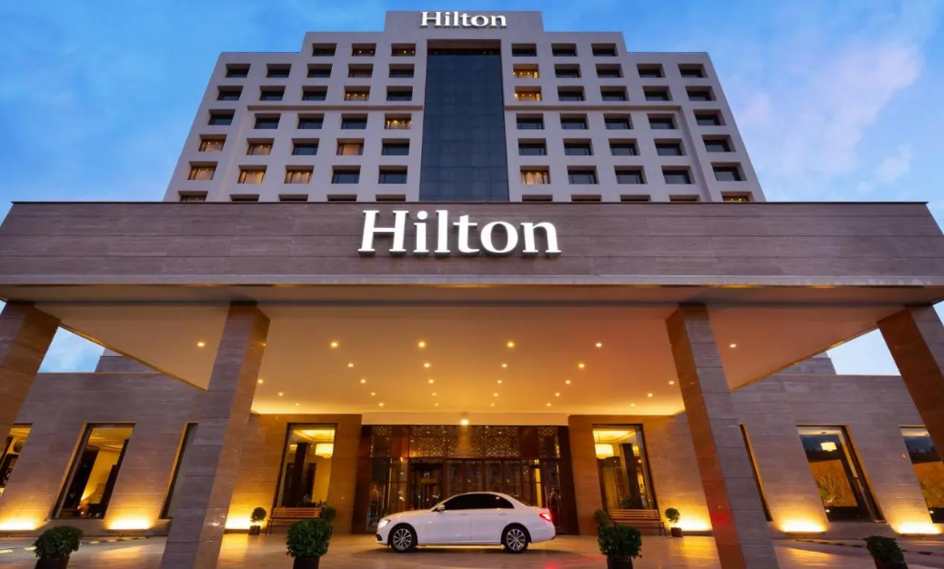
Figure 1 Hilton
Source: https://travelradar.aero

Situational Analysis

SWOT Analysis
Strength:  - Strong worldwide brand presence  - A large hotel portfolio  - High-quality service and facilities | Weaknesses:  - Inconsistent client experiences across locales  - Limited presence in developing markets  - reliance on third-party booking platforms
Opportunities:  - Expansion into new markets  - Increasing desire for luxury and experiential travel  - Increasing use of technology in the hospitality industry | Threats:  - Intense rivalry from other worldwide hotel businesses  - The economic slump is having an effect on travel and tourism.  - The negative effect of Internet travel agents on direct reservations

Customers: Segmentation and Targeting
In this part, we will undertake a detailed investigation of the Hilton Hotel's client base. This involves segmenting the market to establish unique client groups based on demographics, psychographics and behaviour. Understanding the various segments allows us to adjust our marketing efforts to successfully target and suit the individual demands and preferences of each group. This will allow Hilton Hotels to recruit and keep a loyal client base while driving revenue growth (Andaleeb, 2016).

Competitors:
The threat of New Entrants | Considering the entry barriers and the possibilities for new rivals to join the market (Bamberger and Lobel, 2017).
Bargaining Power of Suppliers | Analysing suppliers' effect on the hotel sector and their potential to affect price and quality (Göral, 2021).
Bargaining Power of Buyers | Evaluating clients' ability to negotiate prices and demand high levels of service (Zhang, et al, (2018).
The threat of Substitute Products or Services | Identifying alternatives to staying at the Hilton Hotel that guests may prefer (Wiles and Crawford, 2017).
The Intensity of Competitive Rivalry | Examining the amount of competition in the hotel business as well as rivals' tactics (Kwieciński, 2017).

Collaborators: B2B Relationships, Partnerships, Franchises
B2B Relationships: Collaborations with travel agents, airlines and corporate partners to increase reservations and improve customer service.
Partnerships: Partnerships with local tourist boards, attractions and event organisers to promote destination experiences.
Franchises: Expansion via franchise partnerships with independent hotel operators enabling Hilton Hotel to enter new areas (Formentini and Romano, 2016).

Climate: PESTLE Analysis
Political Factors | Government rules and policies governing the hotel sector  Political stability and its possible influence on the hotel business
Economic Factors | Global economic circumstances and their impact on travel and tourism  Exchange rates and their impact on foreign tourists (Khan, et al, 2020)
Social Factors | Changing customer preferences and trends in the hotel industry  Demographic considerations influencing the Hilton Hotel's target clientele
Technological Factors | Technological advancements have an influence on hotel operations and client experience.  Online platforms and digital advances are altering the sector.
Environmental Factors | Increasing focus on sustainability and environmental practises  The impact of climate change and natural catastrophes on the hotel industry
Legal Factors | Compliance with local and international laws and regulations  Employment laws and regulations impacting hotel workforce and operations (Rutherford, 2021)

Objectives
The SMART goal for this marketing plan is to increase Hilton Hotel occupancy by 15% over the next 12 months by targeting the millennial traveller segment with targeted promotional campaigns, improving the hotel's online presence and customer engagement and providing personalised experiences that align with their preferences and values. This goal focuses on measurable results a 15% increase in occupancy rate, a specific target audience of millennial travellers, a realistic timeframe of 12 months and clear actions to achieve the goal of promotional campaigns, online presence enhancement and personalised experiences (Purcarea, 2019).

Strategies
At Hilton Hotel, our value proposition is focused on providing excellent personalised experiences and superior service to our guests. We distinguish ourselves by providing magnificent lodgings, world-class facilities and customised services that suit the specific requirements and tastes of our client categories, which include business travellers, families and luxury seekers.We will use a multi-channel strategy to effectively convey our value proposition, utilising multiple marketing channels such as social media, internet adverts and targeted email campaigns. We will promote the distinctive advantages and benefits of staying at the Hilton Hotel via various channels, emphasising our dedication to great service, comfort and unforgettable experiences (Varaprasad, 2016).
In terms of service delivery, we will invest in employee training and development to ensure that our personnel exemplify our value proposition and continuously give exceptional service. We can successfully target and promote Hilton Hotel as the chosen option for discerning travellers seeking elegance, comfort, and personalised experiences by aligning our value offering with the requirements and preferences of our consumer groups. This stance will be strengthened further by using Bowman's strategy clock, which will enable us to discover and execute competitive tactics that separate us from market rivals.

Tactics: Marketing Mix
Product: The Hilton Hotel pampers its visitors with a variety of opulent extras and services. There are also large, comfortable rooms, top-notch eating choices, a fitness centre, a pool, meeting spaces and first-rate guest service. In order to ensure customer satisfaction and loyalty the hotel strives to provide each of its visitors with a delightful and memorable stay (Siakalli, Masouras, and Papademetriou, 2017).
Place (Distribution): The Hilton Hotel will use a variety of channels to make its location accessible in an effort to attract guests. The hotel will have a presence online through its official website where visitors may inquire about available rooms and make direct reservations. In order to increase its exposure and reach, the hotel will also collaborate with online travel agents (OTAs) like Expedia and Booking.com. In order to market its location and attract tourists the Hilton Hotel will also forge strategic alliances with travel agencies and tour operators.
Price: The Hilton Hotel's pricing strategy will be based on market research, taking into account aspects such as consumer value and the competitive environment. The hotel will have varied pricing points to satisfy different consumer demographics and budgets. To entice visitors and promote return visits, special packages, discounts for prolonged stays and seasonal promotions will be offered. The price plan will be disseminated through multiple channels such as the hotel's website, social media platforms and advertising efforts (Braciníková and Matušínská,2017).
Promotion: To properly market its services, the Hilton Hotel will deploy a complete promotion plan based on the RACE (Reach, Act, Convert, Engage) model and the communications mix. To reach a larger audience and stimulate interest, the hotel will use digital marketing tactics such as search engine optimisation (SEO), social media marketing, and online advertising. In addition, the hotel will work with travel influencers and bloggers to develop interesting content and raise brand awareness. Traditional advertising mediums like print and radio will also be used to target particular market groups. To tempt prospective customers, promotional efforts will showcase the hotel's distinctive characteristics, great service, and special deals (Eriksson, Forsström, and Rosenbröijer, 2016).

Action Plan
Task | Start Date | End Date | Duration (Days) | Responsible Person
Conduct Market Research | 15/04/2023 | 30/04/2023 | 15 | Marketing Team
Develop Customer Segmentation | 01/05/2023 | 05/05/2023 | 5 | Marketing Team
Develop Targeting Strategy | 06/05/2023 | 10/05/2023 | 5 | Marketing Team
Develop Value Proposition | 11/05/2023 | 20/05/2023 | 9 | Marketing Team
Develop Promotional Strategies | 21/04/2023 | 21/06/2023 | 31 | Marketing Team
Implement Promotional Campaigns | 22/06/2023 | 30/07/2023 | 39 | Marketing Team

A detailed examination of our target client categories and their preferred communication channels informs the marketing channels' schedule. We discovered that our target clients are active on social media, use online travel agents and prefer personalised contact through email marketing. As a result, our marketing channel timetable prioritises efficiently exploiting these channels. In addition, we will measure metrics like as reach, engagement, and conversions to monitor and assess the effectiveness of each channel. This information will help us make better decisions in the future and optimise our marketing efforts to obtain the desired results.
Gannt Chart:
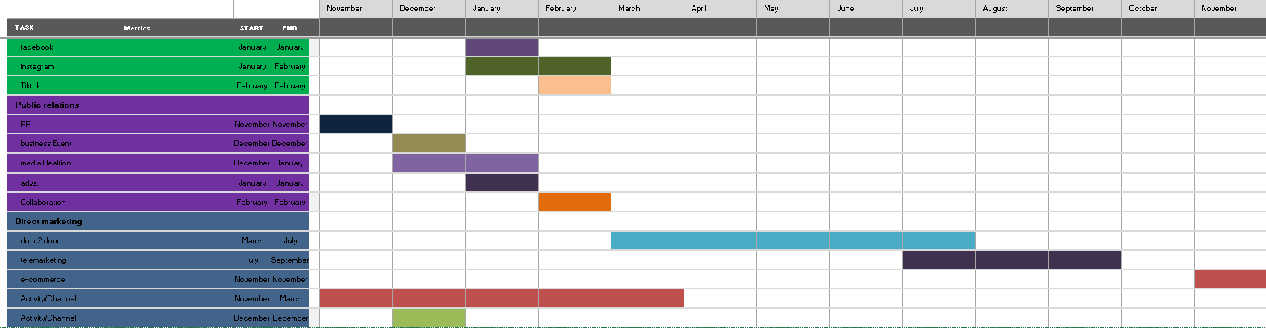

Control
The Hilton Hotel's unmatched elegance, first-rate guest service and wide variety of facilities make them part of its unique selling proposition (USP). These elements distinguish the hotel from rivals by giving customers a first-rate and outstanding experience. Multiple measures will be used to assess the marketing plan's effectiveness. These include attracting new clients via higher booking and occupancy rates as well as keeping hold of current clients through referrals and favourable reviews. Surveys and comments from visitors will also be used to determine how they feel about the hotel's offers and how they feel about the brand in general (Omilusi,2019). The marketing strategy's effectiveness will ultimately be determined by its capacity to spur revenue growth and boost profitability for the Hilton Hotel.

Conclusion
It is concluded that the Hilton Hotel's marketing strategy confronts various problems. These factors include fierce rivalry in the hotel business, shifting client tastes and needs, and probable economic volatility. To overcome these obstacles, it is advised that market trends and customer behaviour be regularly monitored, allowing for rapid modifications to marketing plans. Investing in focused advertising strategies, using digital platforms, and giving personalised experiences may also aid in attracting and retaining clients. The regular review of key performance metrics and guest comments will give insights for enhancing the marketing strategy. The Hilton Hotel can handle the hurdles and establish itself as a top option in the market by being agile and customer-focused.

Reference
- Andaleeb, S.S., (2016). Market segmentation, targeting, and positioning. In Strategic Marketing Management in Asia (pp. 179-207). Emerald Group Publishing Limited.
- Bamberger, K.A. and Lobel, O., (2017). Platform market power. Berkeley Tech. LJ, 32, p.1051.
- Braciníková, V. and Matušínská, K., (2017), December. Marketing mix of financial services from the customers perspective. In Forum Scientiae Oeconomia (Vol. 5, No. 4, pp. 36-48).
- Eriksson, N., Forsström, M. and Rosenbröijer, C.J., (2016). The Data Driven Decision RACE in eRetailing.
- Formentini, M. and Romano, P., (2016). Towards supply chain collaboration in B2B pricing: A critical literature review and research agenda. International Journal of Operations & Production Management.
- Göral, R., (2021). Competitive Analysis of the Hotel Industry in Konya by Using Porter’s Five Forces Model.
- Khan, N., Hassan, A.U., Fahad, S. and Naushad, M., (2020). Factors affecting tourism industry and its impacts on global economy of the world. Available at SSRN 3559353.
- Kwieciński, D., (2017). Measures of competitive intensity–analysis based on literature review. Central European Management Journal, 25(1), pp.53-77.
- Omilusi, M., (2019). Human tragedy as electoral strategy: Nigerian politicians and the unique selling proposition (USP) towards the 2019 general elections. Sociology International Journal, 3(2), pp.172-177.
- Purcarea, E.V.L., (2019). The impact of marketing strategies in healthcare systems. Journal of medicine and life, 12(2), p.93.
- Rutherford, D.G., (2021). Hotel management and operations.
- Siakalli, M., Masouras, A. and Papademetriou, C., (2017). e-Marketing in the hotel industry: marketing mix strategies. In Strategic Innovative Marketing: 4th IC-SIM, Mykonos, Greece 2015 (pp. 123-129). Springer International Publishing.
- Varaprasad, N., (2016). 50 years of technical education in Singapore: How to build a world class TVET system. World Scientific.
- Wiles, A. and Crawford, A., (2017). Network hospitality in the share economy: understanding guest experiences and the impact of sharing on lodging. International Journal of Contemporary Hospitality Management, 29(9), pp.2444-2463.
- Zhang, H., Zhang, J., Yang, Y. and Zhou, Q., (2018). Bargaining power in tourist shopping. Journal of Travel Research, 57(7), pp.947-961.

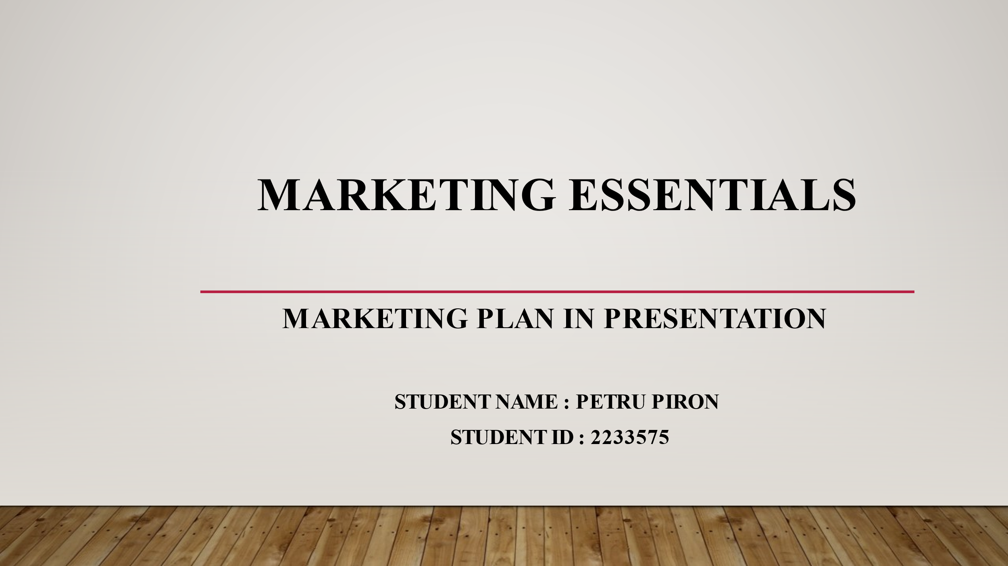
Slide 1
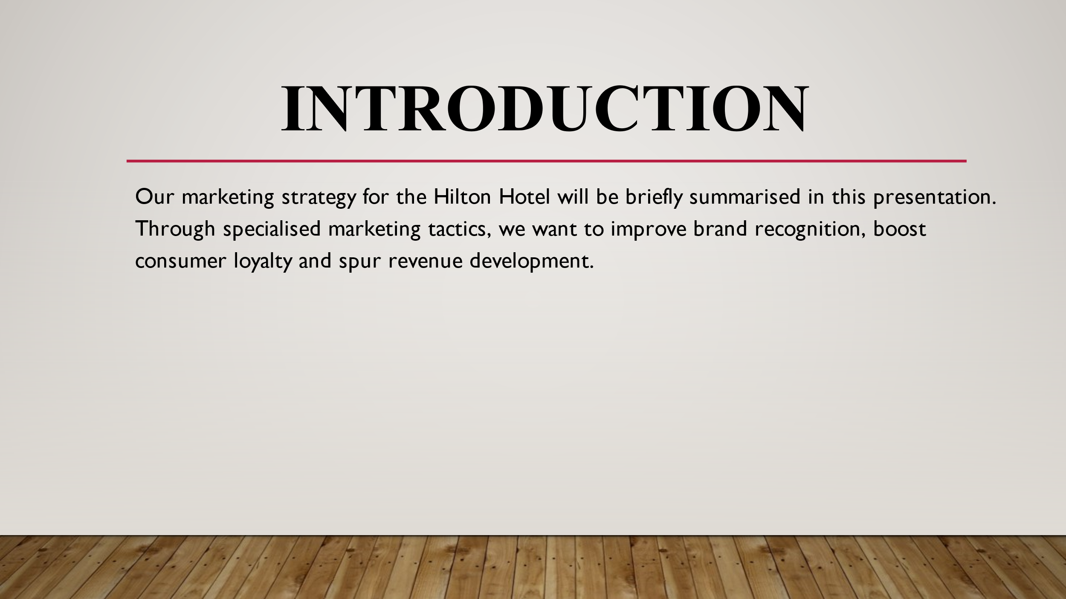
Slide 2
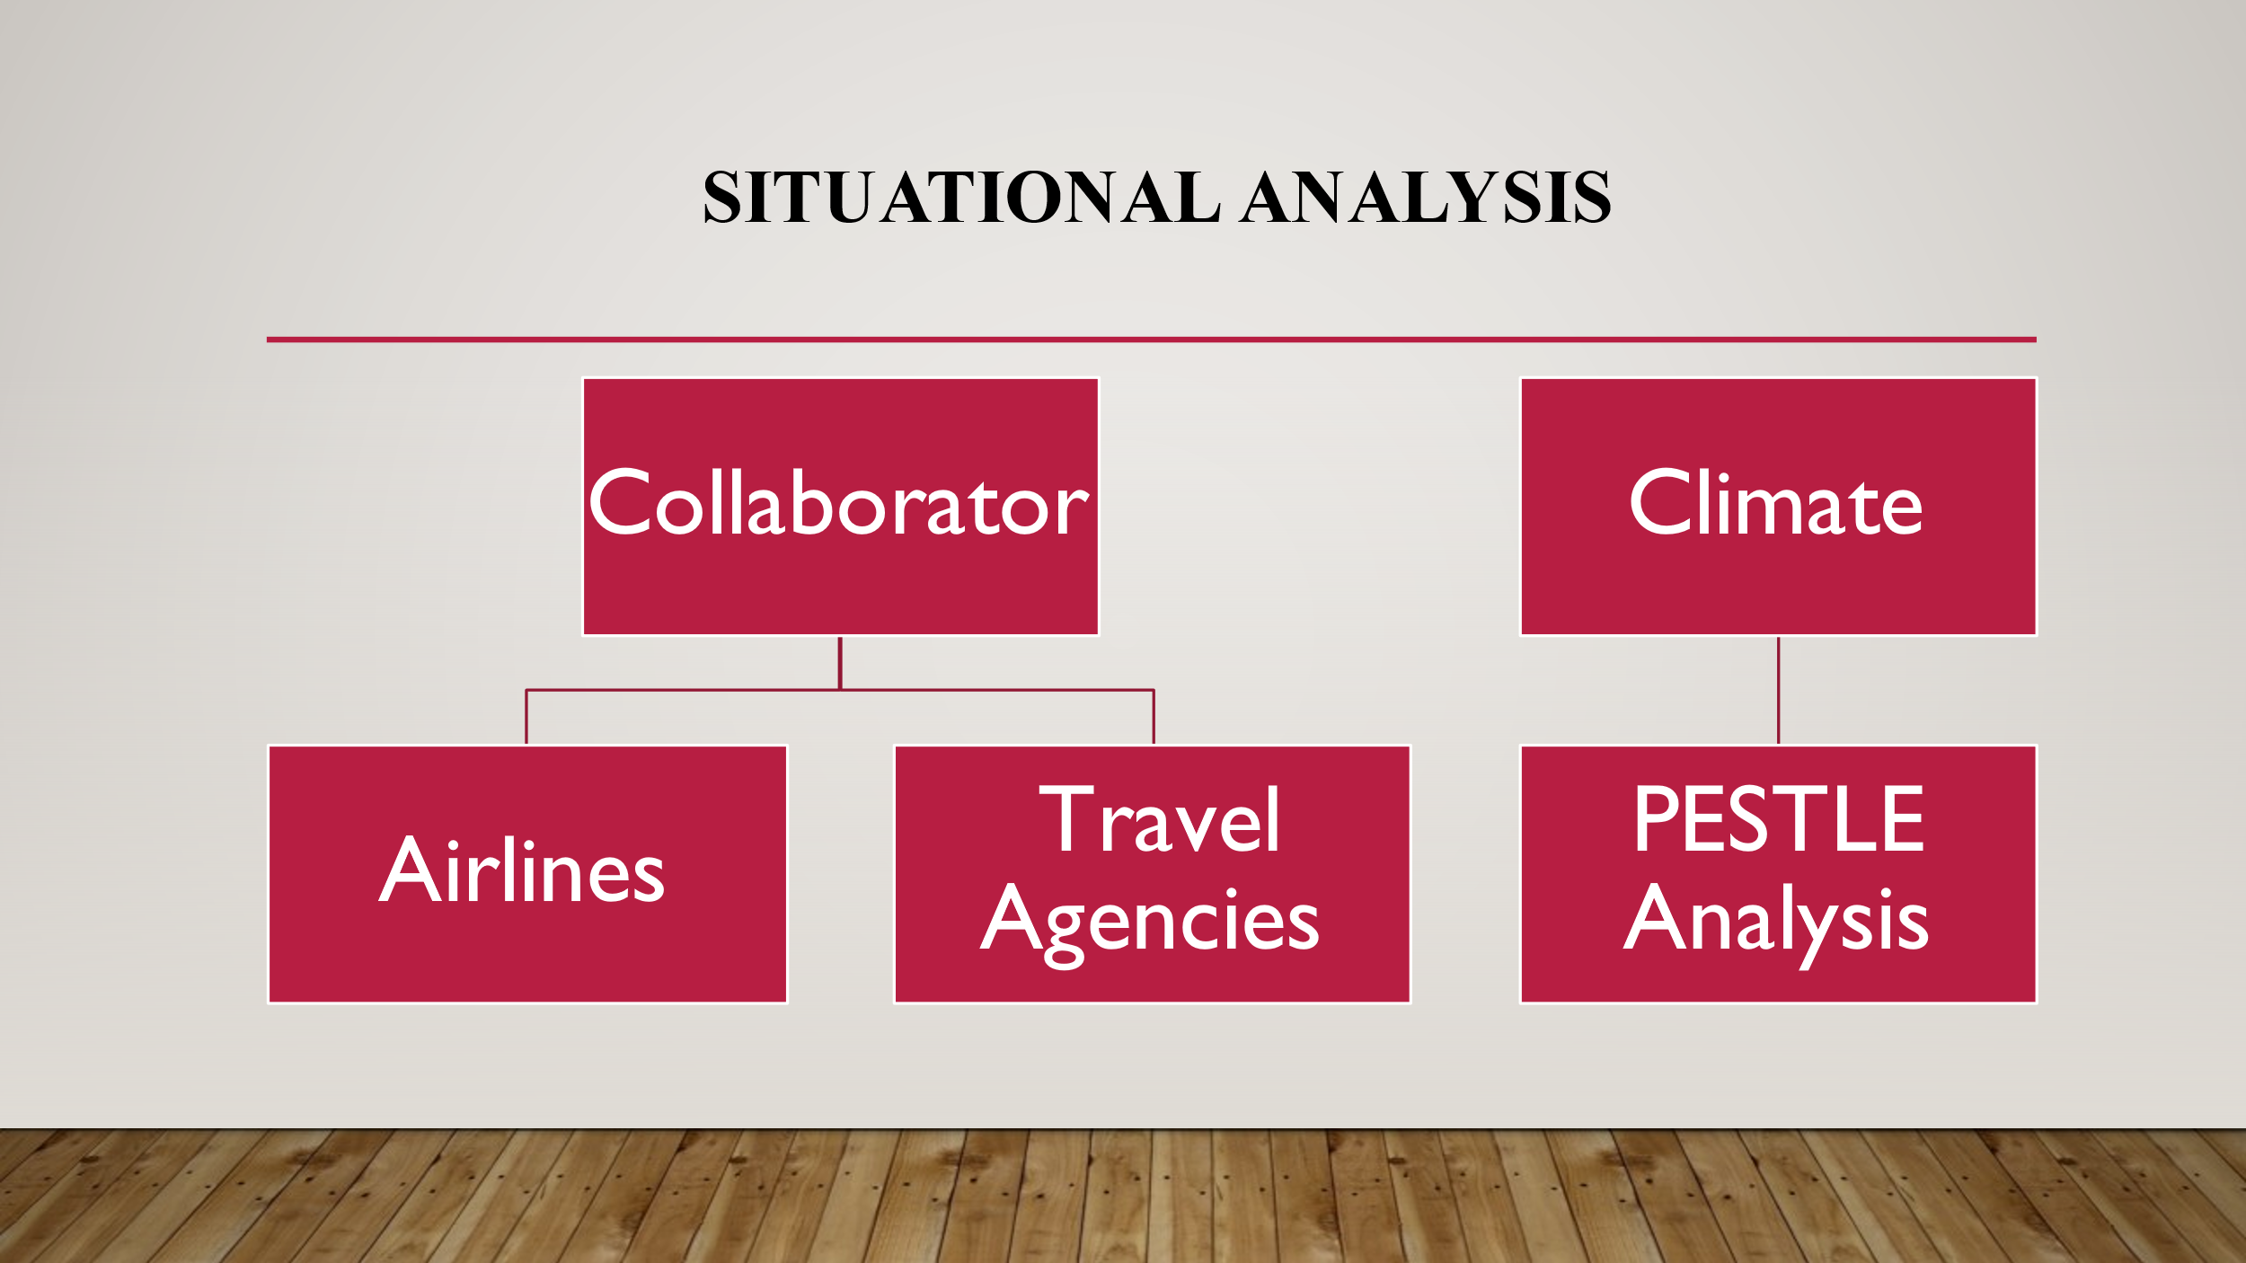
Slide 3
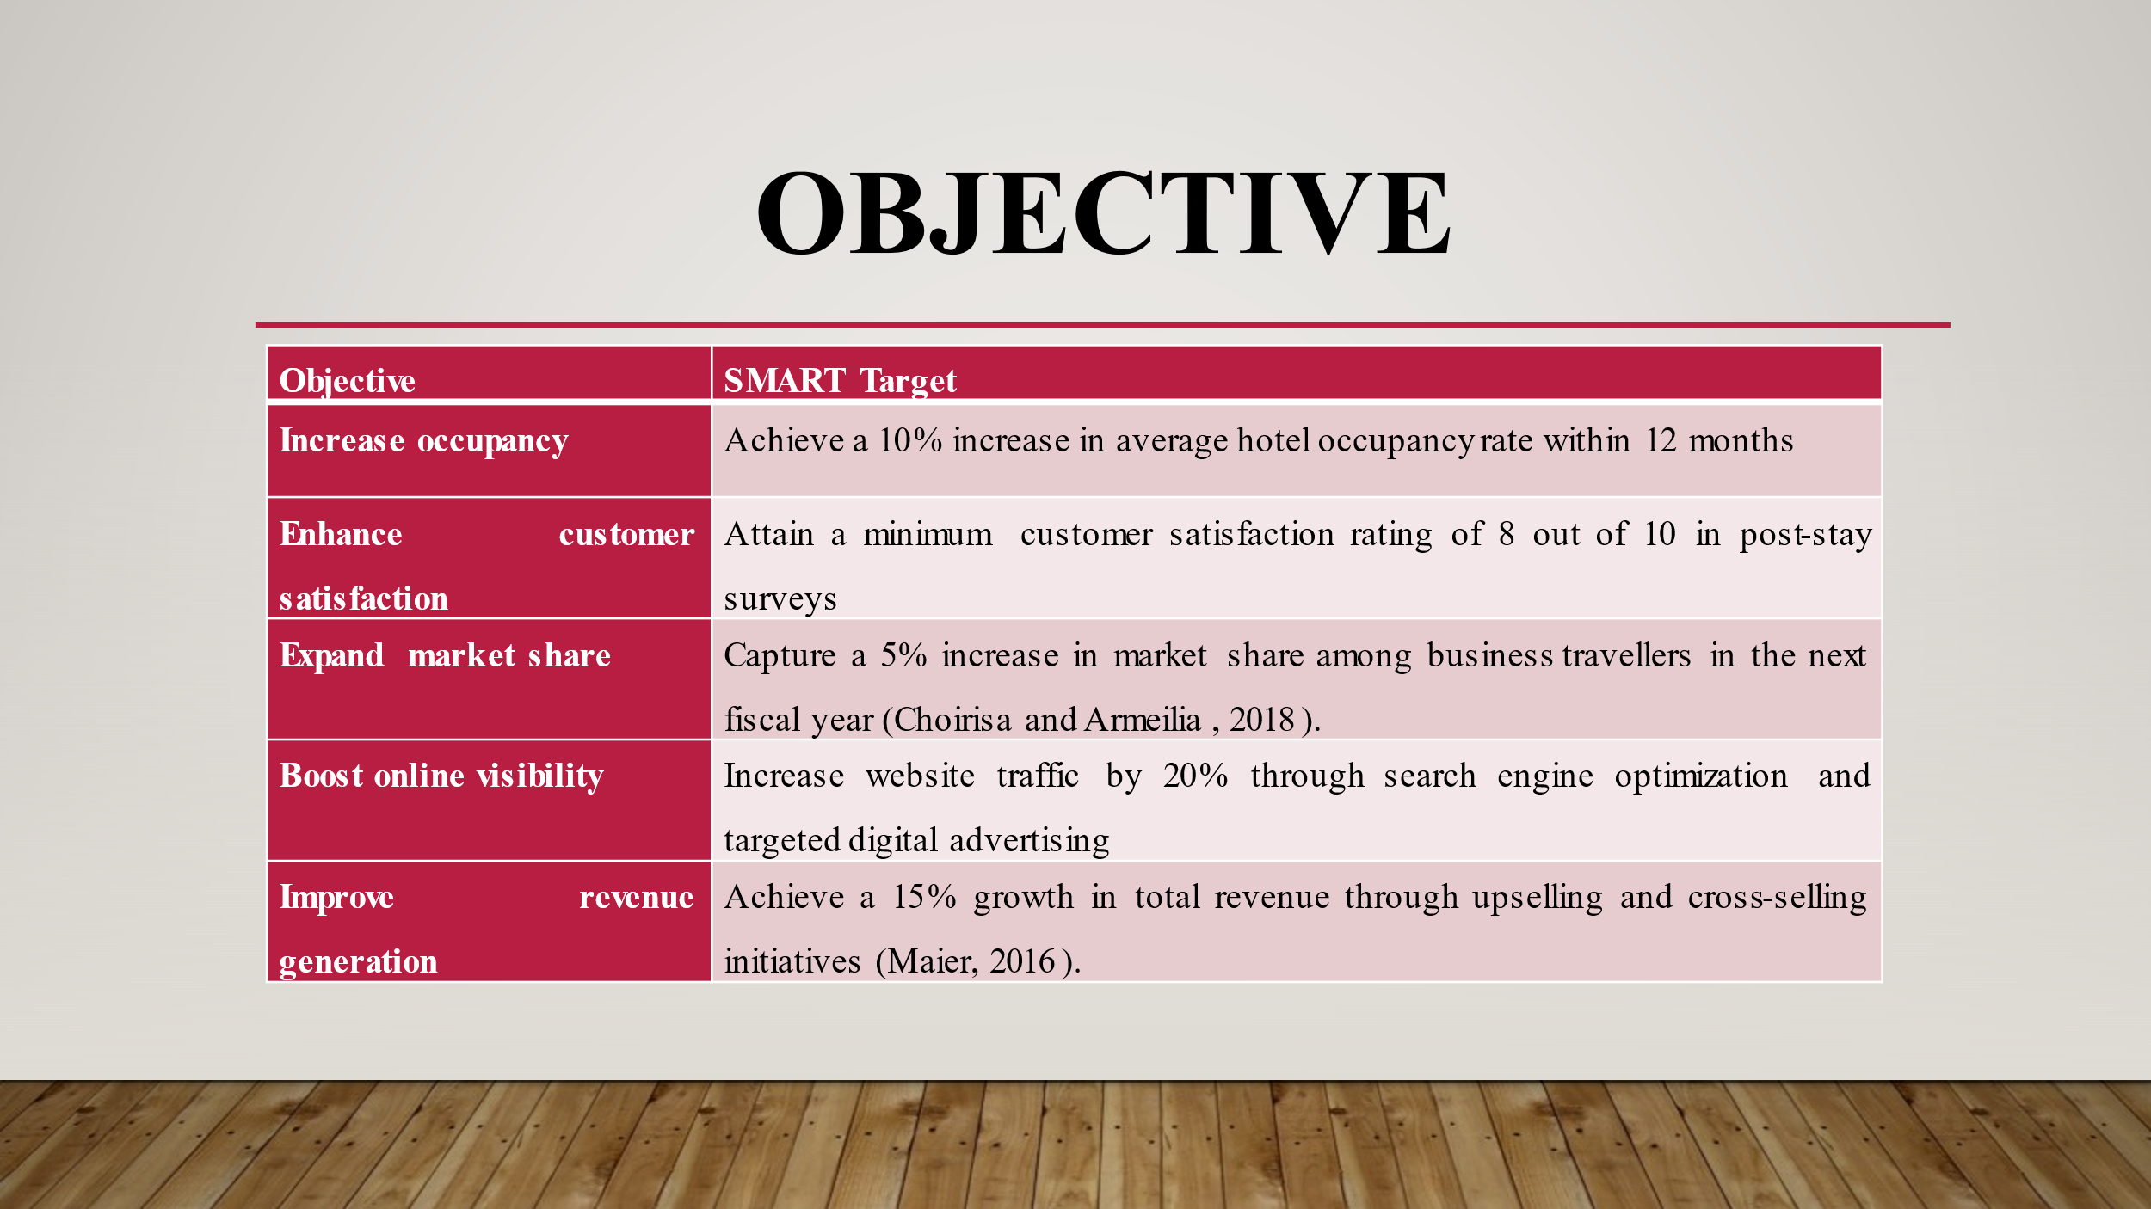
Slide 4
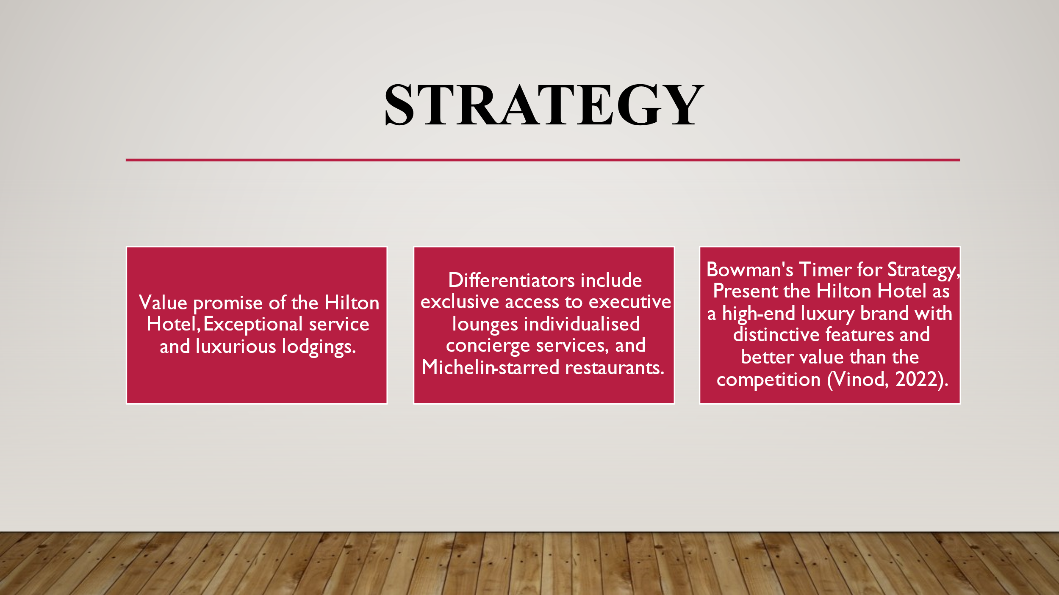
Slide 5
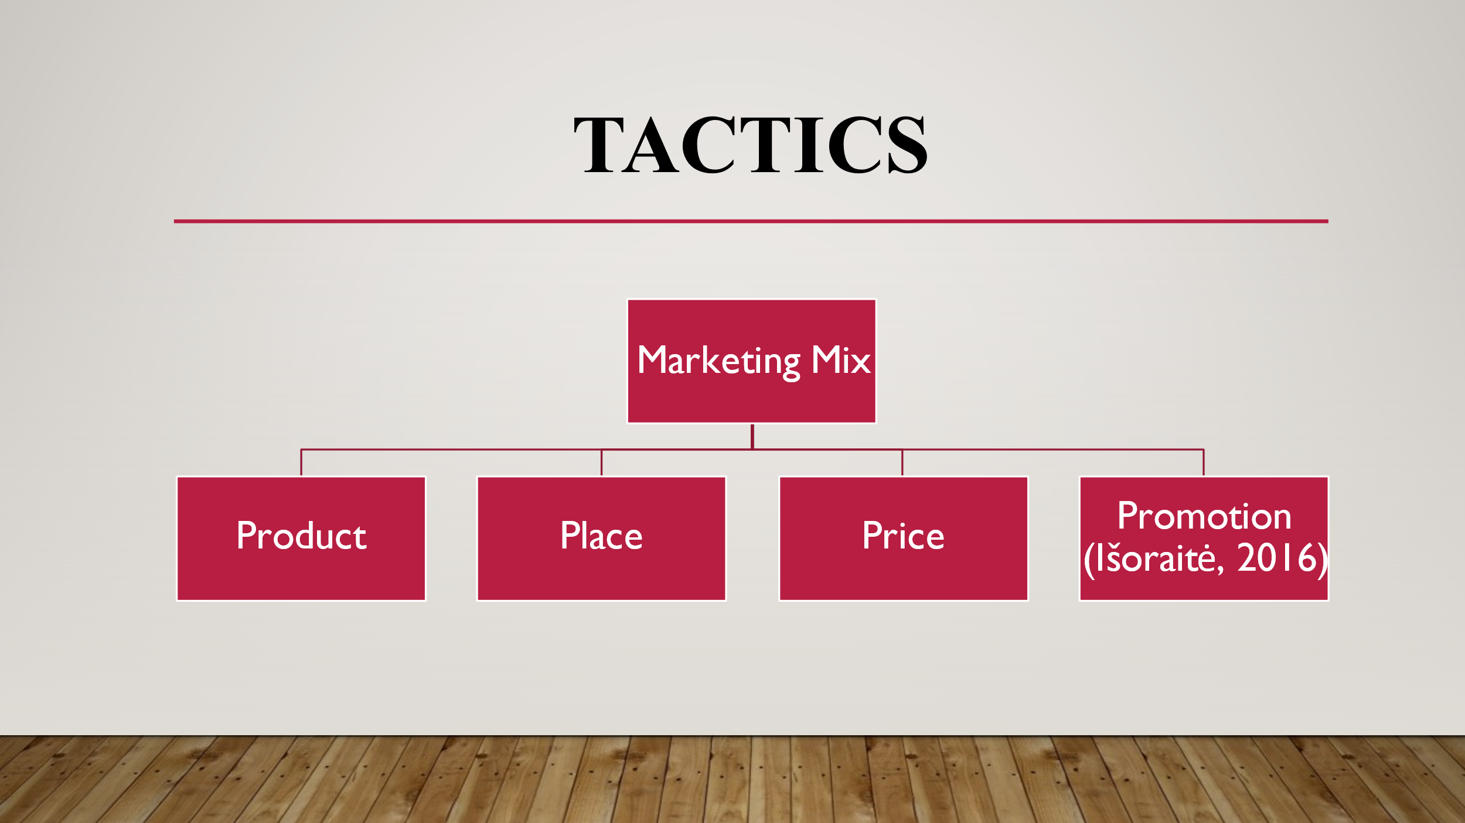
Slide 6
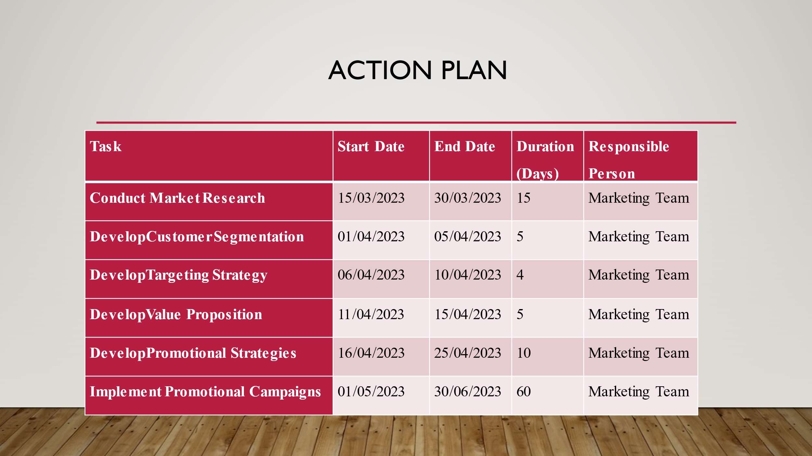
Slide 7
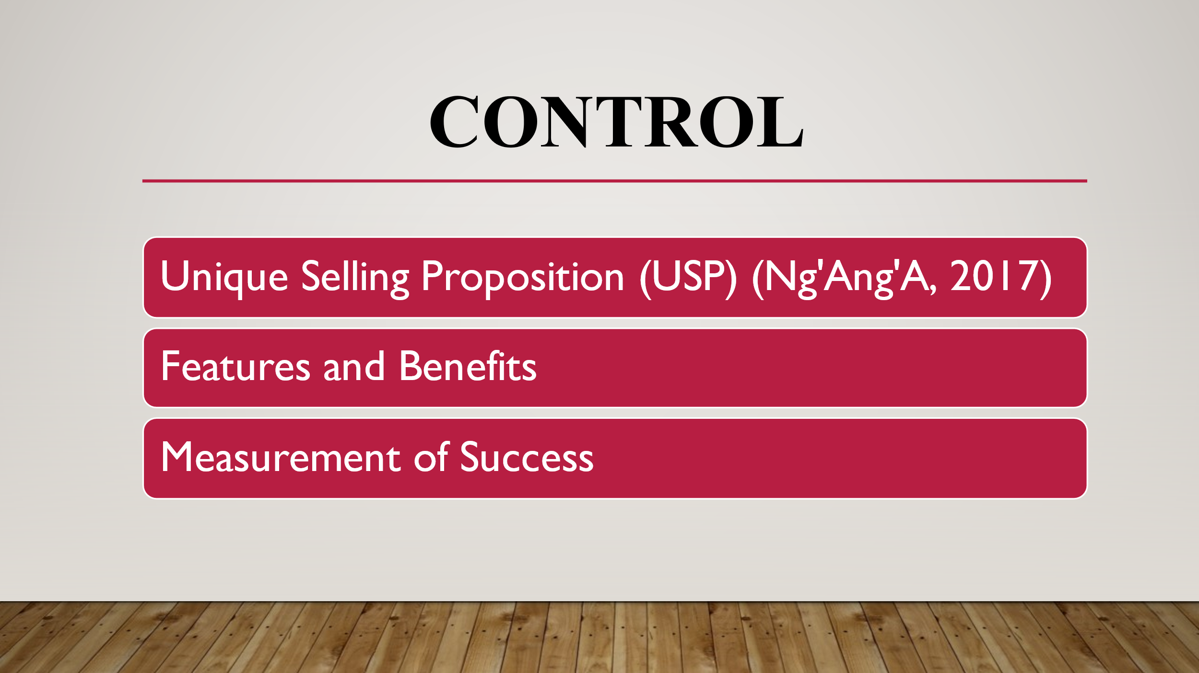
Slide 8
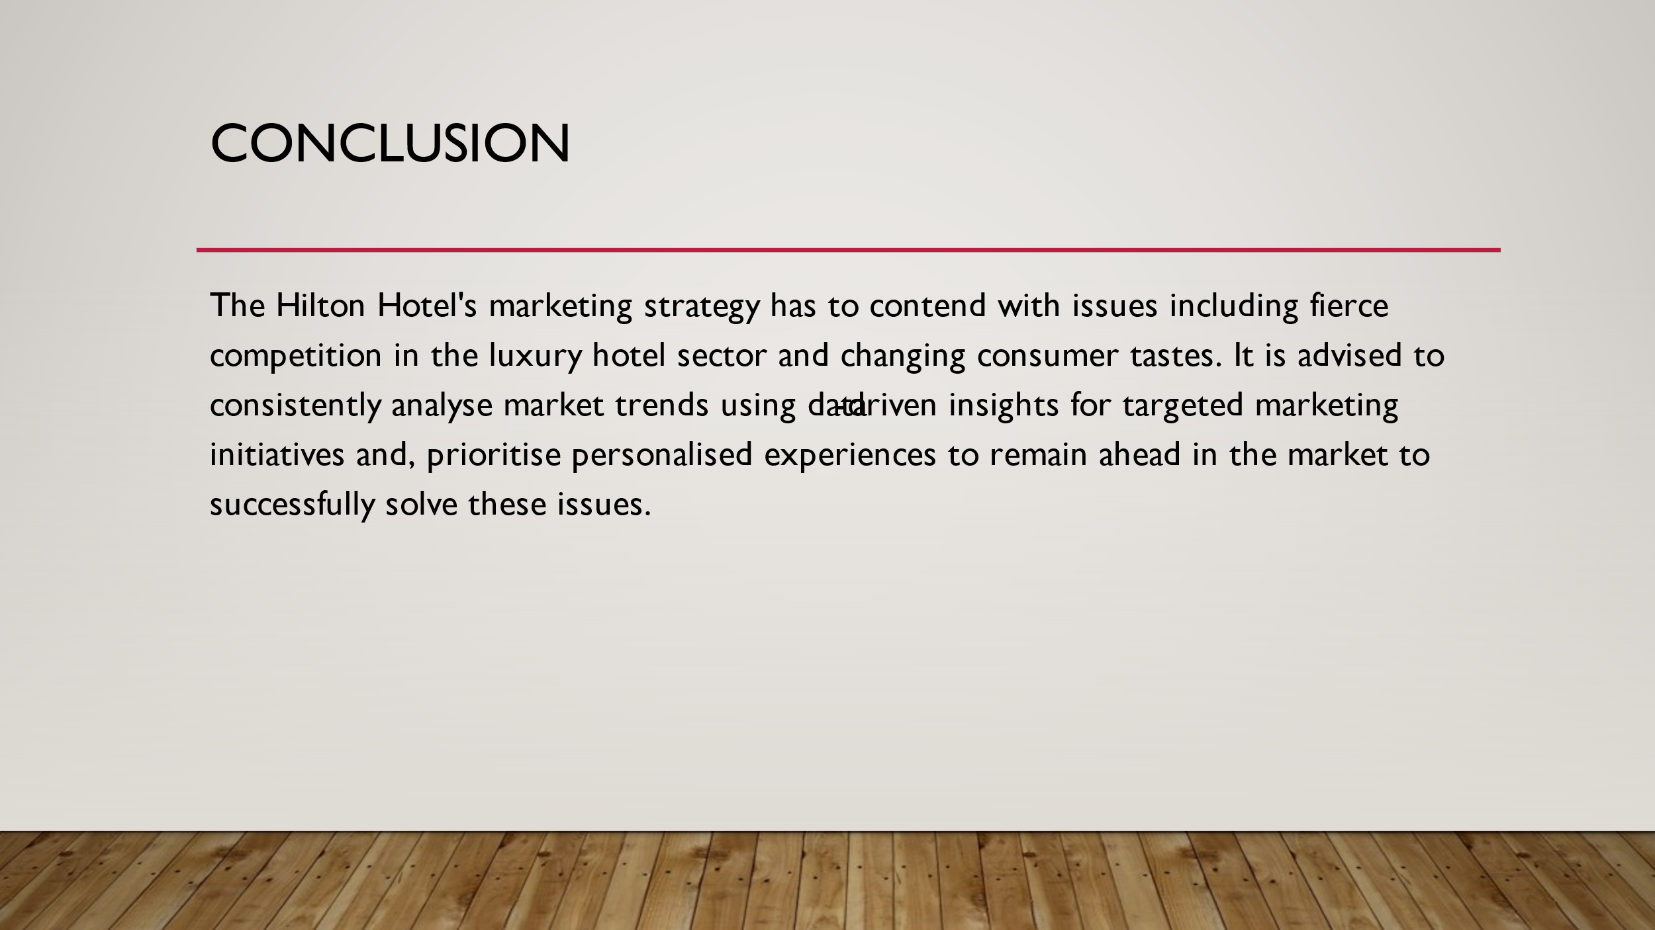
Slide 9
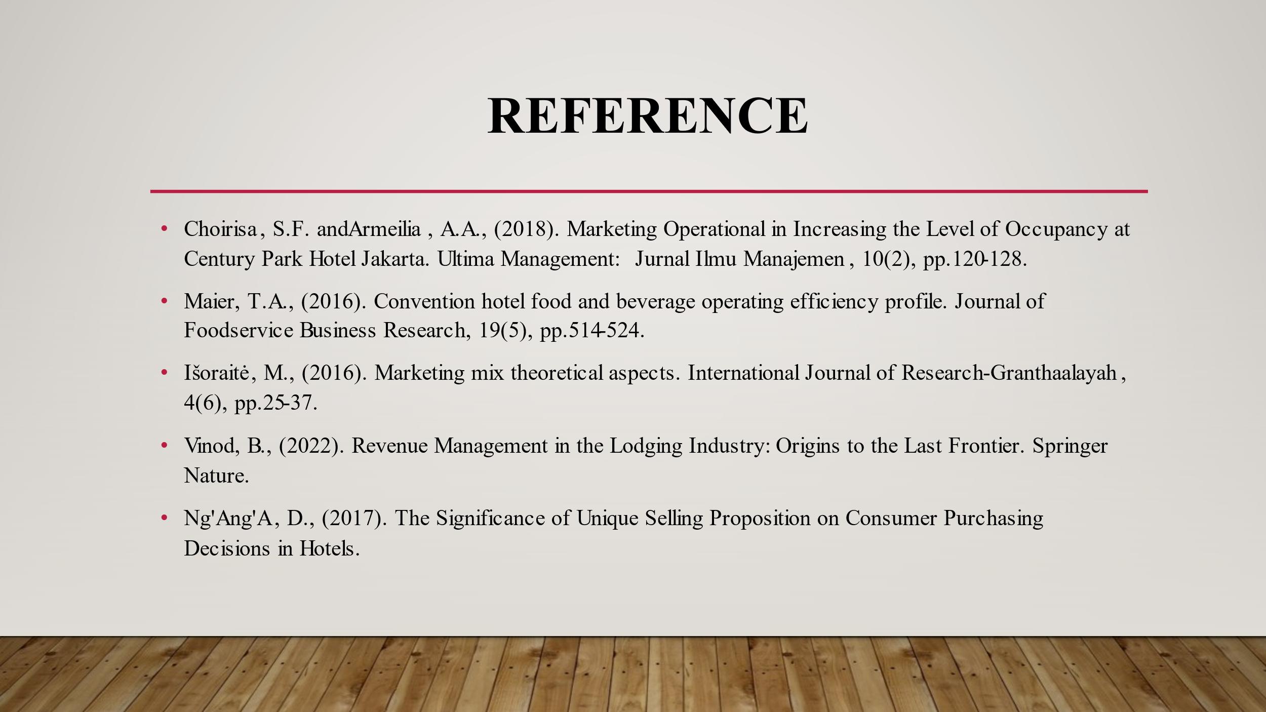
Slide 10

