Student Name: Courteney Peart

Student ID number: 1070370

Module Title: Materials in Service

Module Code: ACMA5004

Date: 18/06/2021

Time: 1pm

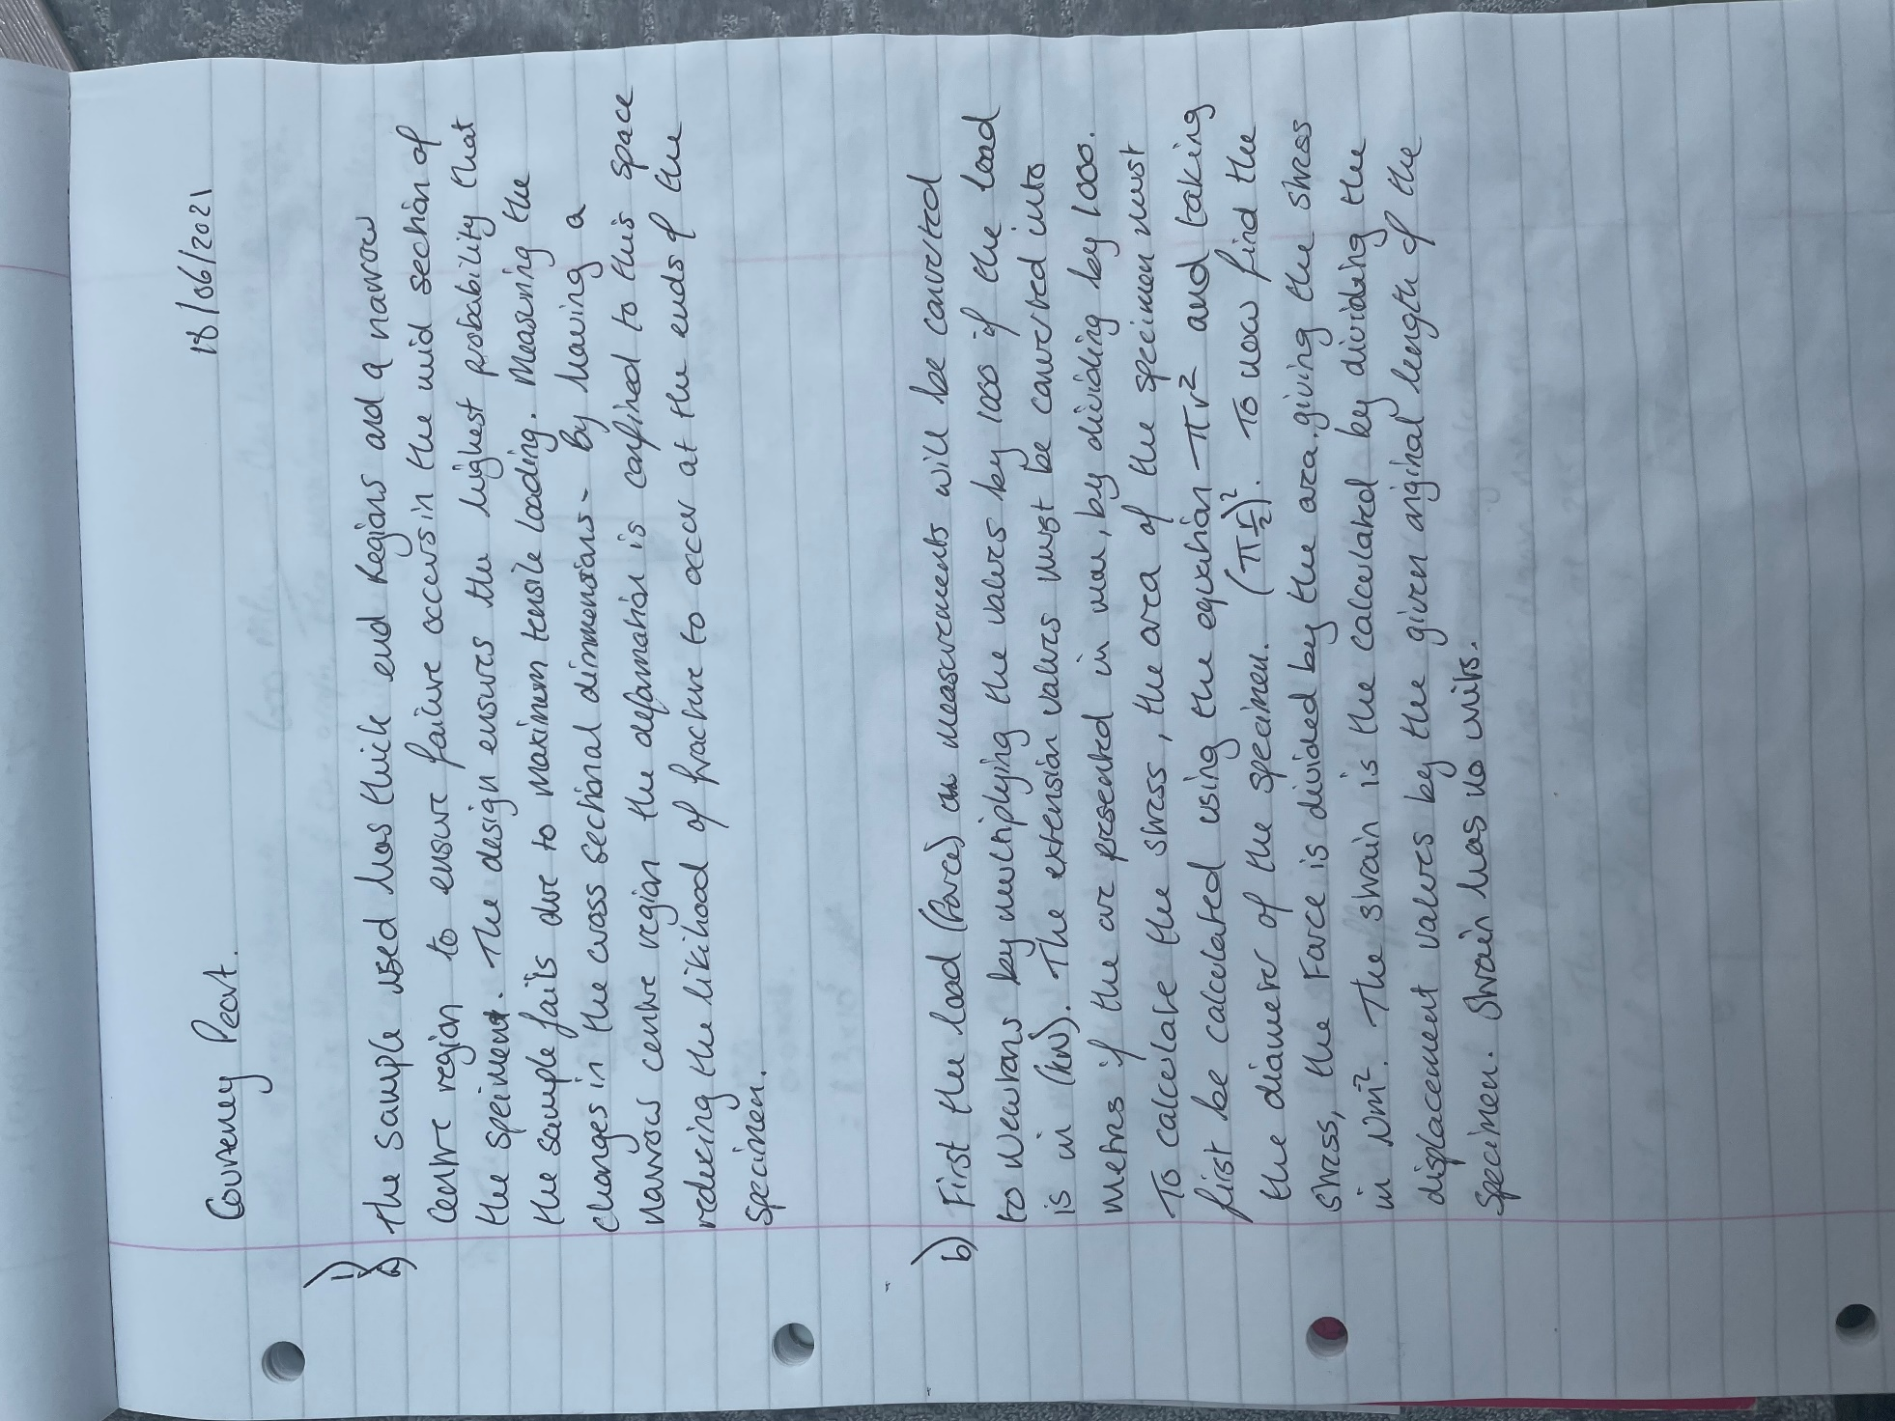

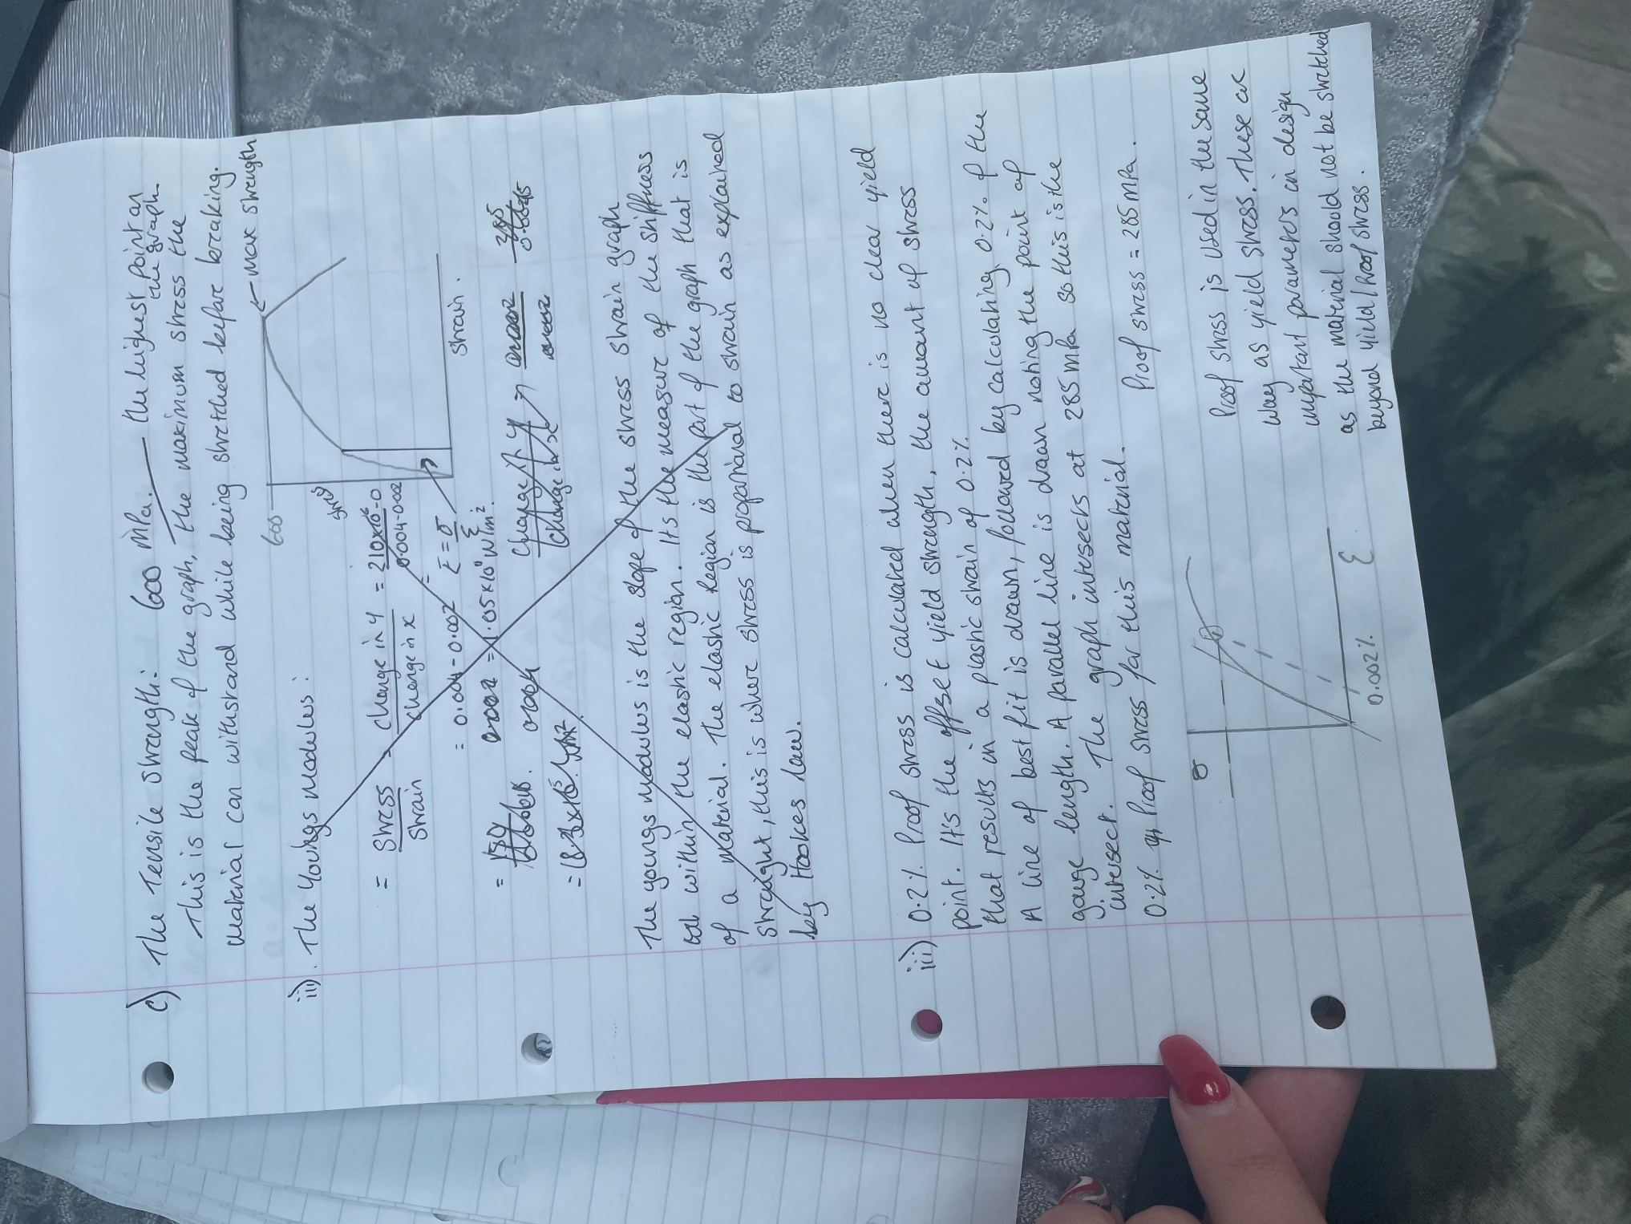

Please ignore section ii) in the above image here is my re-done answer


