University of Wales Trinity and Saint David
Student Name: Veronica Dale
Student No: 1605380
Module Code: EMPL4020
Researching and Analysing Data
Lecturer: Sheraz Alam Malik Dr

Office verses Home: Is Home the New Office?
Statistics have shown a rise in people working from home. According to a survey carried out in 2011, 59% of employers in the UK offered, teleworking for their employees. (Ryan, 2013). This reflected a 13% rise from their studies in 2006. With an increased amount of the population working this way, it could be argued that the home could be the new office in the future. (McGregor, 2013). This trend seems to have been comfortably adopted by our friends over the pond in the US, where 24% of the employed population work from home for a partial amount of their working week. (Bureau of Labour Statistics, 2015).
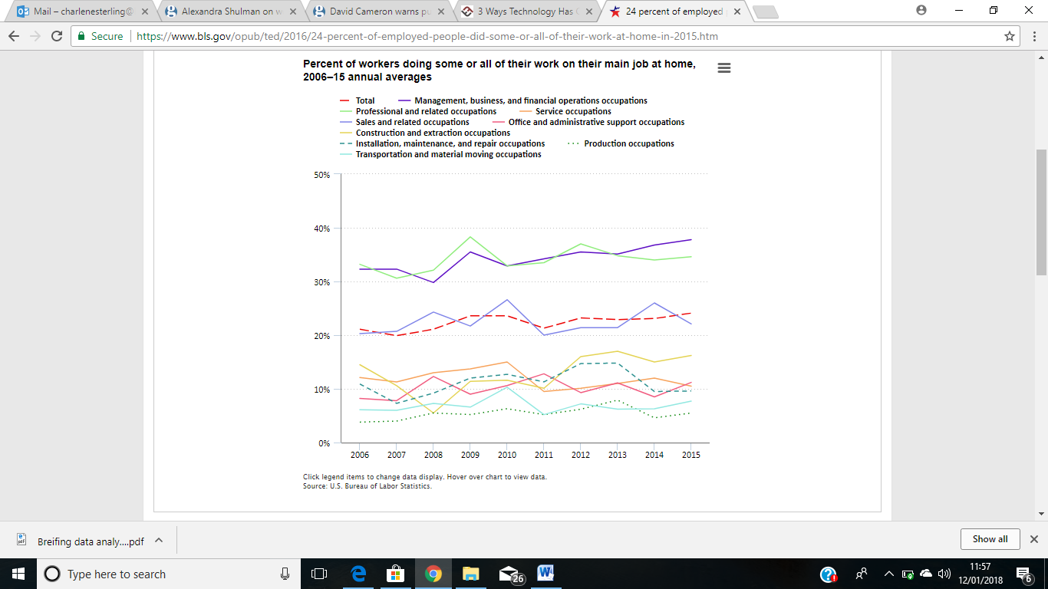

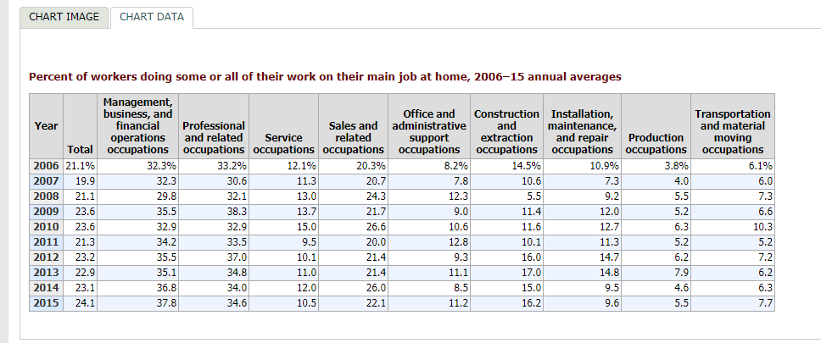
We can identify some similarities with the increased number of people working from home in the UK (Shulman, 2013), which some would object to, suggesting the traditional working methods work, and employees should remain at their desk or offices. Through the perspective of the philosophy and ideology of McGregor (2013), who suggests that working from home is the new future but he doesn’t consider the negative impacts of working from home.

Home VS the Office: The Market Place
In an effort to explore the current state of ‘the home vs office’ it would be worth considering the market, and in this case appeal for those wanting to work from home, in essence, the demand for ‘home working.’ From this perspective it may be worth considering people’s lifestyles and how they have changed. The change in the political agenda to get more unemployed people off state benefits (Mason (2015), under the Labour government with the ‘New Deal’, and seemingly, this continued under Conservative Government in a bid to reduce the deficit, reducing student funding, state benefits, and cuts to Public Services over the foreseeable future (Wintour, P. and Mulholland, H. ,2010). These organisations had to configure ways to reduce costs and overheads. And, so the market place for ‘working from home’ began to increase across Local Government offices, and public services.
This may also be seen in the private sector, where small businesses had to find new ways to reduce overheads, and outgoings. Introducing telecommuting has been viewed as an effective way of working monopolising on time and costs (Ryan, 2013).
According to Buchman, N (2018), technology played a large role in both the possibility and, therefore opportunity, to work remotely. The introduction of various media platform such as Facetime, Zoom, chat apps, Skype and cloud technology, have impacted on the workplace making it more accessible for people to work from home, and business to function out of the standard office. Forcing more and more of both the working world and its infrastructures to question whether or not we need to be in the ‘office’, when virtually and literally we have the ability to have it right there in our homes?
Office Industry Data begins as a raw form of Information, this is called Primary Data which is collecting the raw facts and figures, before Data can be used it must be processed. There are many forms of data, the main ones being letters, numbers and symbols. There are two kinds of Data:
- Qualitative Data which uses words or images to describe something.
- Quantitative Data uses categories or numbers, they can be labelled with a number. This type of data we use to construct graphs and tables of data in its raw form.
Information is data that has been processed for e.g. Information = Data + Content + meaning.
Knowledge
Information
Data

- Decision Making

- Synthesising

- Analysing

- Summarising

- Organising

- Collecting

We must first understand the relation in the different forms. We gain the Knowledge and understand while we gather the Information patterns, this leads to wisdom but we must first understand the principal.
Data becomes information when it can be viewed in specific content. It must be contextualized, categorized, Calculated and Condensed. Information is generally stoned in some sort of structure. For Information to become knowledge it must be Processed, Organized or structed in the same way. Wisdom

Secondary Data
Secondary Data, is the next part of analysing the information that has been collected.
Knowledge is something that changes over a period of time.
- Data changes every day
- Context of learning
- Why am I hear
- I am here to understand myself better
- How was the data collected?
- Where was it collected?

The difference between information and Knowledge is certainty. The information is largely based on fact that cannot be disputed as long as Data is correct.
Data becomes Information when it can be variable in a specific content. (Ackoff, R) Who benefits from working from home, Non-Retired, Self-employed. Ryan.M (2013) in her Magazine article she argues People are constantly bombarded with news about Technology that makes it easier to communicate while not in the office.
You could be walking into your Kitchen to make a cup of tea and come up with an idea. However, it has been said that the quality and the speed may be sacrificed. Virgin entrepreneur Richard Branson who constantly works from home made a quick to response to the article, he called it a step backwards.
He went on to also say, in this day and age remote working is easier and effective than before. There are lots more sings that more people are working from home in the UK.
According to the CBI a total of 59% who responded to the 2011 Survey were offering Teleworking in 2006 it was 13%.
Our friends over the pond in the US, 24% of the employees work from home at least two day a week. According to the Bureau of Labour Statistic. Some consider working from home could affect the employees chance of getting a promotion and be considered anti-social.
According to Fornell, C. (1992) There are many Individual companies and industries that monitor customer satisfaction on a regular basis However, Sweden is the first country that has measured on a national level of customer satisfaction.
This was measured in more than 30 Industries and 100 corporations. This was measured from a survey with results for the 1989-1991 index indicates that the industries that were selling homogeneous different product/services to a homogeneous market typically their CSB was much higher than other industries. (psycINFO Database Record (c) 2016 APA, the new index is intended complementary to the productive measures. This basically reflects the quantity. Low customer satisfaction forces the company to compete on prices, changes in the macro economy causes Supermarkets to compete against each other. This causes employees to become stressed as they are put under a lot of pressure to meet deadlines.
Shulman, A. (2013) suggests working from home is not an adequate alternative. The editor of British Vouge argues that it doesn’t seem right, Marissa Mayer is a woman who has been successful where so many women have failed. in reached where so many women have not. She ordered that the 11,500 Yahoo employers in the US should work in the office or leave the company.
She wants them at their desk clocking in and out she prefers them in the office. Marissa Mayer is a young mother with a small child. Her argument is that working from home can be disappointed many. This may be a way to reduce staff numbers at Yahoo. The issue is when employees work from home they’re not showing their face in the office.
However, at Vouge on many occasion team members have suggested that it would be helpful for them if they could be considered to work at home maybe two days a week. The rest of the office would be happy and would do their best to make this option of working from home work. Mayer, does not agree as says they would be on their cell phone and would also be checking emails all day, nothing would get done. Shulman, reaction is the same she believes that the employees is more productive when seated at a desk.
McGregor, H. (2013) believes working from home is the future and argues that a certain amount time in the office is essential to form good business relationships. Nevertheless, she arguers because of Technology the world has become a smaller place making it better for people to connect with one another.
School children in Pakistan can take a course in artificial intelligence taught by IVY League Professors thousands of miles away and it easier to combine work and home. In this statement McGregor asked why is a CEO Mayer, summoning Yahoo staff back into the office.
It boils down to trust, if you trust someone its easier and cheaper to work with them. McGregor, runs a business up in central London she works alongside other companies, they all of the trust the service that they receive from her and are happy to pay for it.
She runs credit checks and states that it does save time and money, if you know someone you will trust them. The company is built on mutual trust. Trust is built through Transparency and knowledge the more you know about a person you will trust the more. If you have a positive experience of working with them you will trust their future working with them.
We all know that trust has to be earned so earn it face to face and not at the end of a phone or via emails. Therefor the culture in McGregor’s company is built on trust and mutual respect. McGregor goes on to say she has sympathy for Mayer who needs to rebuild her company but feels that her team trusted each other.
Statistics show that 85% of communication is no verbal. McGregor believes in her employees as they are talented and not easy to replace, so when they ask for a little flexibility in the form of remote working she would much rather find a way to accommodate them rather than lose them.

Marissa Mayer is the first female engineer at Google and now the first CEO at Yahoo. She argues that at work, she has a reputation for being productive and fast. Mayer also prides herself on her time management. She is paid a certain amount from the work she does at the Guardian and divides it into rate per hour according to her worth, and gives her bosses three hours.
The company does not need to pay her travel because she does not travel. So therefore, it is not added to her equation. When she has done her assignments Mayer, is free to do other work such as being a parent, paying bills and even going to the gym. Occasionally she goes into the office to attend meetings or work at her desk. Mayer, is an all-or-nothing person who works on her terms she is very talented woman and we can all appreciate what she did at Google. Mayer has the same attractive effort at Yahoo. Step one is to value other people’s time and effort.

To conclude home is the new office as suggested by Keller (2013) as it enables us to be more considerate of other people’s time and social and physical separation to solely independent working but at a convenience of other duties. statement that was released to the employees by Jackie Reses and similarly backed by Mayer (Gilman. G, (2013), who is Head of Human Resources wrote "To become the absolute best place to work, communication and collaboration will be important, so we need to be working side-by-side. That is why it is critical that we are all present in our offices," This suggests that we do need social and physical interaction at the workplace as it enables us to compare ideas and solutions as a team. While on the other hand being at home where you are independently working without social physical interaction but more flexibly to not only work at your convenience but also carry out personal duties as suggested by Mayer is seen as an outdated perspective by Keller (2013). Keller also shows that Overall figures are increasing which shows that working from home is the way forward to becoming the new home office. There is an increase in the UK with people wanting to work from home (CBI, 2011). However, this does not just benefit the worker as some companies are promoting working from home to cut their overhead costs as Ryan (2013) suggests. Depending on the company and its requirements day to day each individual company will do what is best for the needs of the company and their employees.

REFERENCE LIST
Bachman, N. (2018) [Online] Available @ https://www.teachthought.com/technology/3-ways-technology-changed-modern-workplace/ [Accessed 2 Jan 2018].

Bellinger.G, D.Castro, Mills.A (2004). Data, Information, Knowledge and Wisdom. Available from [Online] Available from http://systems-thinking.org/dikw/dikw.htm [Accessed 7 January 2018].
Bureau of Labor Statistics, U.S. Department of Labor, “The Economics Daily, 24 percent of employed people did some or all of their work at home in” 2015 [Online] Available @ https://www.bls.gov/opub/ted/2016/24-percent-of-employed-people-did-some-or-all-of-their-work-at-home-in-2015.htm (Accessed January 05, 2018).

Firoozye, N. Ariff, Fauziah. (2016) Managing Uncertainty Mitigating Risk. [Online] EBOOK Available from: https://books.google.co.uk/books?id=YJQFDAAAQBAJ&pg=PA125&dq=professor+Russell+Ackoff+data+information&hl=en&sa=X&ved=0ahUKEwicrqLfnsHYAhUDDMAKHZ_0CIgQ6AEILDAB#v=onepage&q=professor%20Russell%20Ackoff%20data%20information&f=alse [Accessed 6 January 2018]
Fornell, C. (1992), National Customer Satisfaction Barometer: the Swedish experience Journal of Marketing, Vol. 56, 6-21 [Online] American Marketing Association. Available from: http://dx.doi.org/10.2307/1252129 [Accessed 6 January 2018]

Keller. E,G. (2013). Yahoo CEO Marissa Mayer's work-from-home memo is from bygone era. [Online] Available from https://www.theguardian.com/commentisfree/2013/feb/26/yahoo-ceo-marissa-mayer-memo-telecomute [Accessed 6 January 2018]
McGregor, H. (2013) Work-life and balance [Online] Available from: https://www.theguardian.com/money/2013/mar/02/working-from-home-heather-mcgregor [Accessed 6 January 2018]
Mason.R, (2013) Ed Balls cannot guarantee university funding levels under Labour. [Online] Avaiable from https://www.theguardian.com/politics/2015/feb/02/ed-balls-not-guarantee-university-funding-levels. [Accessed 6th January 2018]
Ryan, M. BBC News (2013) Teleworking: The Myth of Working from Home. [Online] Available from:http://www.bbc.co.uk/news/magazine-21588760 [Accessed 6 January 2018]
Shulman, A. (2013) Alexandra Shulman on working from home: it's not an adequate alternative [Online] Available from: https://www.theguardian.com/money/2013/mar/02/alexandra-shulman-working-from-home [Accessed 6 January 2018]
Wintour, P. and Mulholland, H. (2010) [Online] Available@ https://www.theguardian.com/politics/2010/aug/03/david-cameron-public-sector-cuts-permanent [Accessed 2 Jan 2018].

