University of Wales Trinity Saint David
Wales Institute of Science & Art



Computer Systems Fundamentals (ACCA4028)

Jacek Traczewski
2022703
January 2022
Tasks

- Investigate the specification of your own personal computer to ascertain the following information (Include pictures/screengrabs etc to show how you obtained this information)
Make and model Apple MacBook Pro M1 2020
How much RAM do you have 8GB ram LPDDR4
What is the type and capacity of your non-volatile storage 500 GB SATA
What CPU do you have, and what are its main specifications (clock speed, cache size, turbo boost speed, hyperthreading etc) M1 clock speed 3.2GHz, 16MB cache,
What connectivity/ports does your computer have, and what are their specifications (e.g. what are they used for, what speeds do they operate at etc)
I had 2 thunderbolt USB C, and jack 3,5 mm

- Your computer will have internet connectivity and be connected to a device such as a modem or router. Show how you can use operating system tools such as ipconfig to find out your machines IP and MAC address and explain what these are used for.
Also – use a benchmarking tool to discover your Upload/Download speeds and Latency timings for your internet connection. Include screengrabs/images to show your result.

MAC and IP addresses are addresses that uniquely define a device and a connection on a network. The MAC address is the number assigned to the NIC by the manufacturer. An IP address is a number assigned to a connection on a network. The fundamental difference between a MAC address and an IP address is that the MAC address uniquely identifies the device that wants to participate in the network. On the other hand, an IP address uniquely defines the network connection to the device interface. The address that uniquely defines the hardware interface is called the Media Access Control (MAC) address. The MAC address is purchased by the manufacturer by producing the interface hardware and assigns MAC addresses sequentially to the interface hardware during their manufacture. The address given to connect on the network is called the IP (Internet Protocol) address. An IP address does not uniquely identify a device on a network, but it does identify a specific connection on the network. The IP address is provided by the network administrator or by the Internet Service Provider (ISP). The IP address identifies the network and the host on that network. The IP address is used during routing as it specifically identifies a network connection. If the computer is on two networks, it will have two IP addresses.
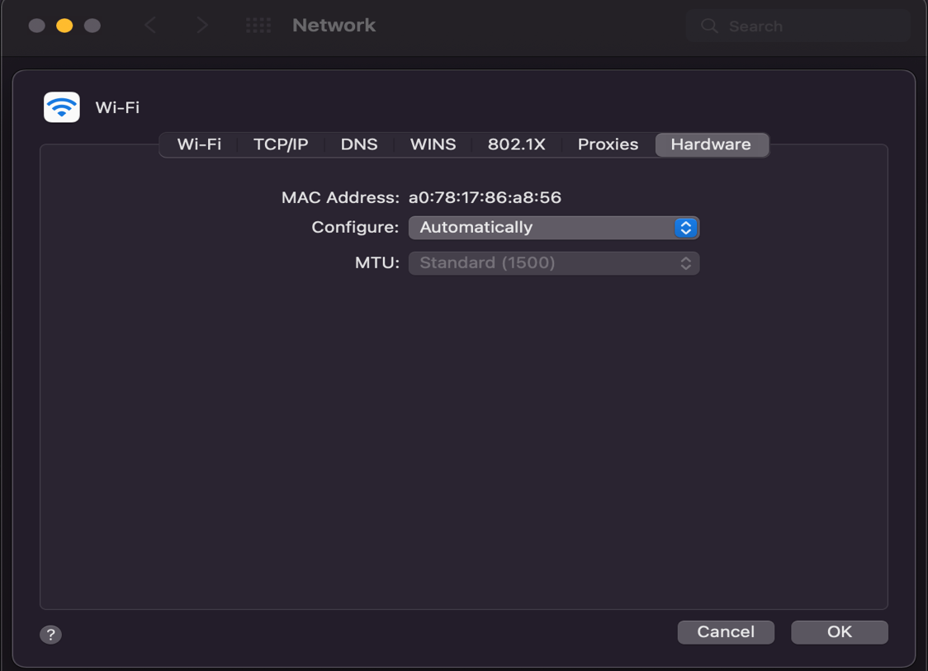
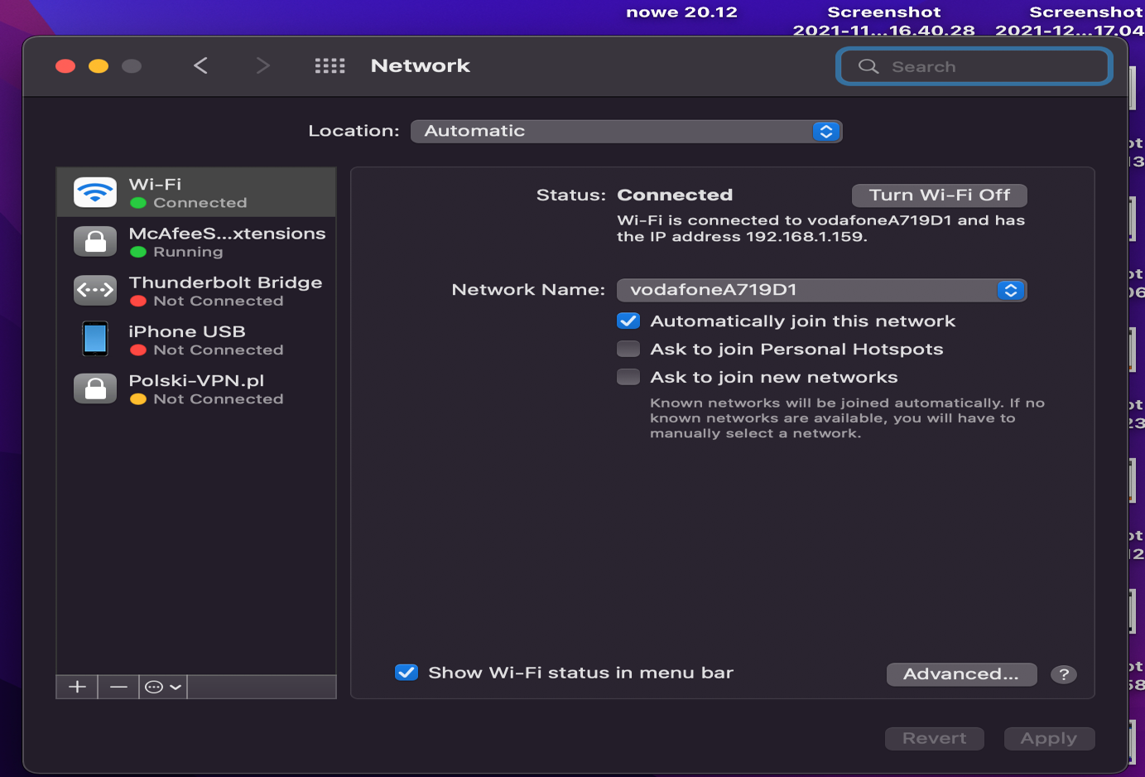

I used https://www.speedtest.net to check my internet connection.
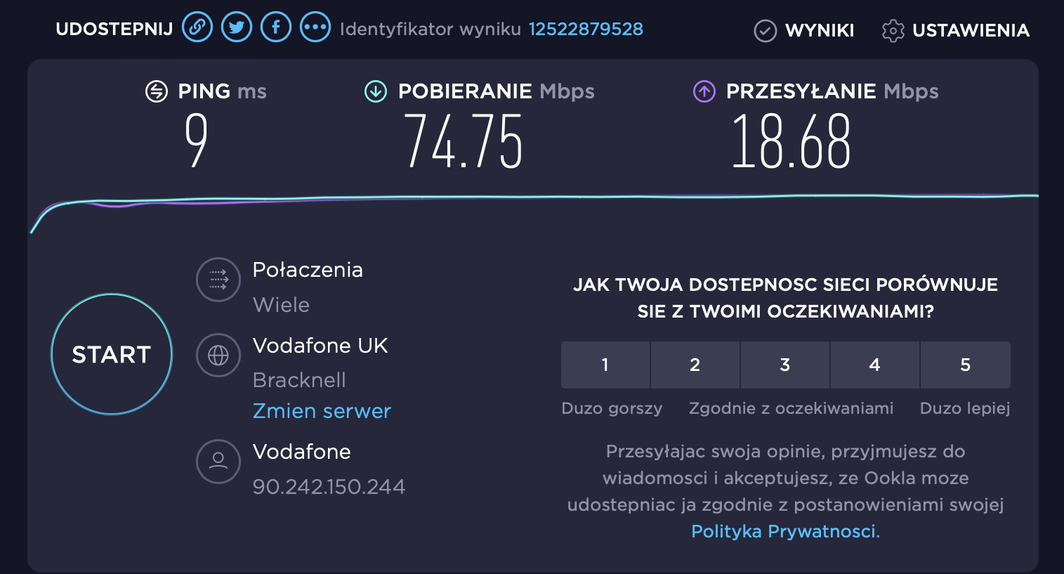
- Your modem/router will typically have a DHCP server incorporated in it. Explain its purpose. Also investigate and report on what security features you can set in your modem/router to increase the level of cyber security.
DHCP - Dynamic Host Configuration Protocol. It is in fact a protocol by which the server can dynamically obtain configuration data, especially the IP address. This is done using an external server, called a DHCP server.

The server's job is to make data and resources available to various devices, called clients. It is a way of communication that is irreplaceable at work in enterprises of several people - especially those based on online activities. It can also be extremely practical at home when you use more than one device connected to the Internet. The DHCP server uses this protocol to exchange data between individual clients.

The primary address of the home server is usually 192.168.0.1 or 192.168.1.1. Depending on the individual network administrator settings, usually devices connected to the server have numbers based on the primary one with the ending starting with -10. Depending on how wide the list of devices you compile with it, the next ones will get higher numbers.

To secure the computer in the network, it is worth changing the default network name and password. Set a firewall and change the default IP of the router, it will make it difficult to assess your network, it is good to disable WAP. Do not provide the Wi-Fi password to guests, you can use the guest network for this purpose. This way, other people will not be able to access the facilities on your network.

(PTO for task 4 )

Note:
Tasks 1-3 above will contribute 60% of the total marks
Task 4 detailed on the following page will contribute the other 40% - try to distribute your time accordingly.
- Imagine you want to expand your home network and build a HTPC (Home theatre PC) which will be connected to your Television as a display, but also connected to a separate Hi-Fi AV amplifier & speakers with Dolby Digital 5.1 surround sound.

Produce a sensible specification for the HTPC. Ensure you specify as a minimum:
a) A suitable CPU and motherboard
b) A sensible amount of RAM
c) What type and size of non-volatile storage would be suitable
d) The input/output features/ports needed
e) The features a suitable graphics card would require.
f) A suitable case and power supply
g) A suitable monitor

For all of the areas a-g, you should justify your choice with reasoning, and where possible, explain why you chose that particular option over the alternatives.

You should also produce a ‘shopping list’ of actual components (as if you were going to build the computer yourself from scratch), so perform some research using on line retailers and produce a neat table with the name, price and where possible an image of the product. Calculate the final price of your system.
DO NOT simply find a ready built PC and just present that information. You need to demonstrate that you understand WHY you chose that particular component - CPU (what are its features compared to other alternatives), WHY you decided on that quantity of RAM etc etc.
Also identify a DD 5.1 Amplifier and speaker package. Include a diagram to explain how you would set up the system in terms of positioning, how you would connect the amplifier to the HTPC to produce your audio, and how you would connect the HTPC to your home network.

For my custom build HTPC I’m chose processor intel core i7-10700 because this processor has graphics module. In my opinion motherboard MSI its perfect for this machine has all important for me ports I will be able to connect amplifier by fibre optic cable. Has HDMI port to work with my 55in tv, build in WIFI module will allowed me to get access to network. Recommendations was helpful me to pick quiet power supply EVGA. Case looks similar to amplifier and have two USB 3.0 ports on front panel, 16GB ram will be helpful to run few tasks at same time. Total cost is £859.

Components | Why? | Costs
Intel Core i7-10700 | Build in GPU Intel UHD 630 |  | £325
MSI MPG B460I GAMING EDGE WIFI | WIFI module, sound HD 8 channels, HDMI port, optical port for audio. |  | £130
GOODRAM 512GB M.2 PCIe NVMe PX500 | Fast, enough to store some pictures and movie |  | £45
HyperX FURY Black HX426C16FB3K2/16 Memory 16 GB Kit*(2 x 8 GB) 2666MHz DDR4 CL16 | Fast RAM enough to do some task at same time |  | £112
SilverStone Milo ML04 HTPC SST-ML04B | 2 x 3.0 usb port on front for flash drive |  | £76
EVGA G3 550 W 80+ Gold Certified Fully Modular ATX Power Supply | Quiet power supply |  | £60
Noctua NH-L9x65, Premium Low-Profile CPU Cooler (65mm, Brown) | Extra cooling system for processor |  | £50
Hitachi-LG BH16 Internal Blu-Ray Drive, BD BD-R BDXL DVD-RW CD-RW ROM Player/Writer | Blu ray drive |  | £61
 |  |  | Total £859

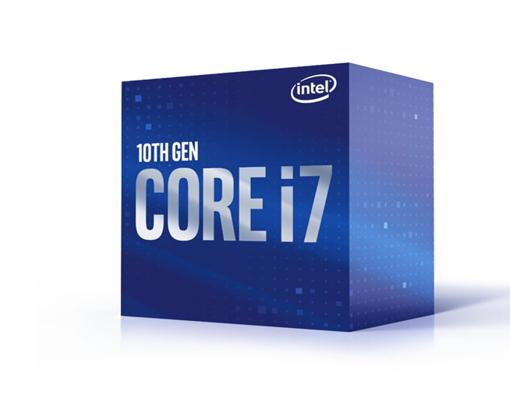
Figure 1 Intel Core i7-10700

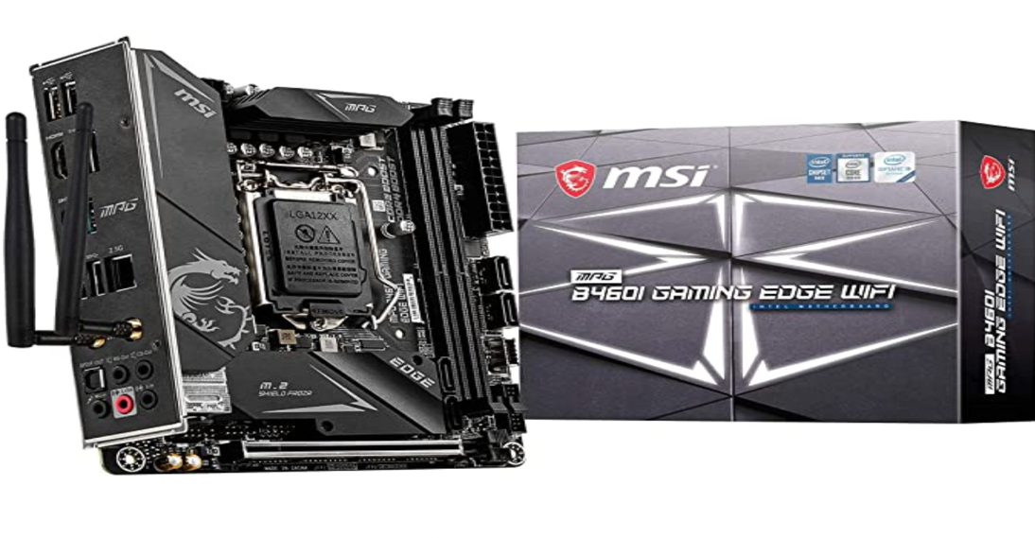
Figure 2 MSI MPG B460I GAMING EDGE WIFI

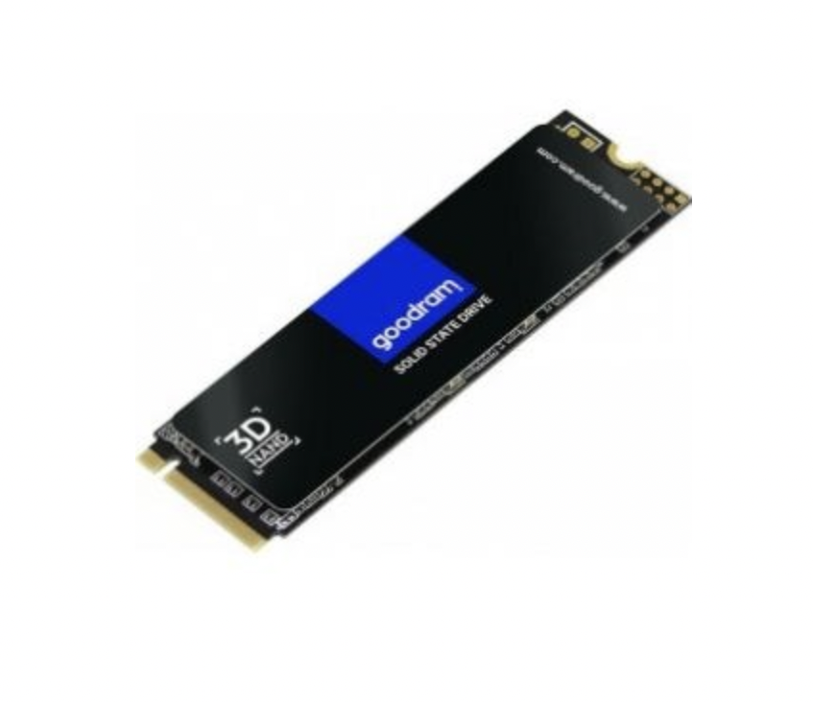
Figure 3 GOODRAM 512GB M.2 PCIe NVMe PX500

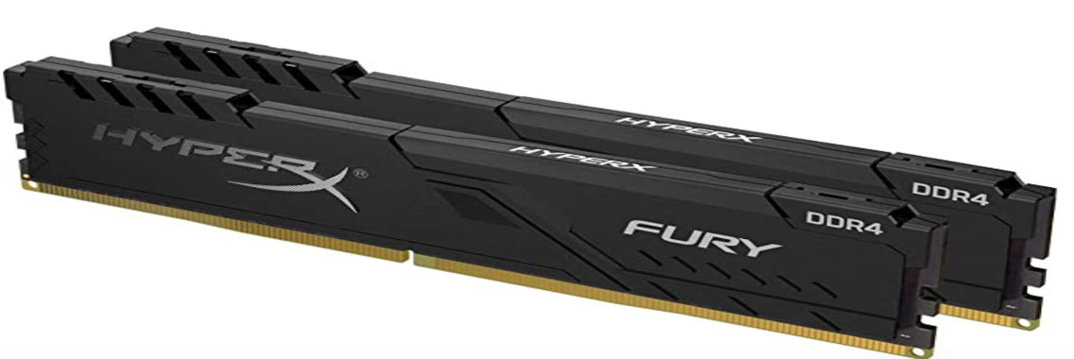
Figure 4 HyperX FURY Black HX426C16FB3K2/

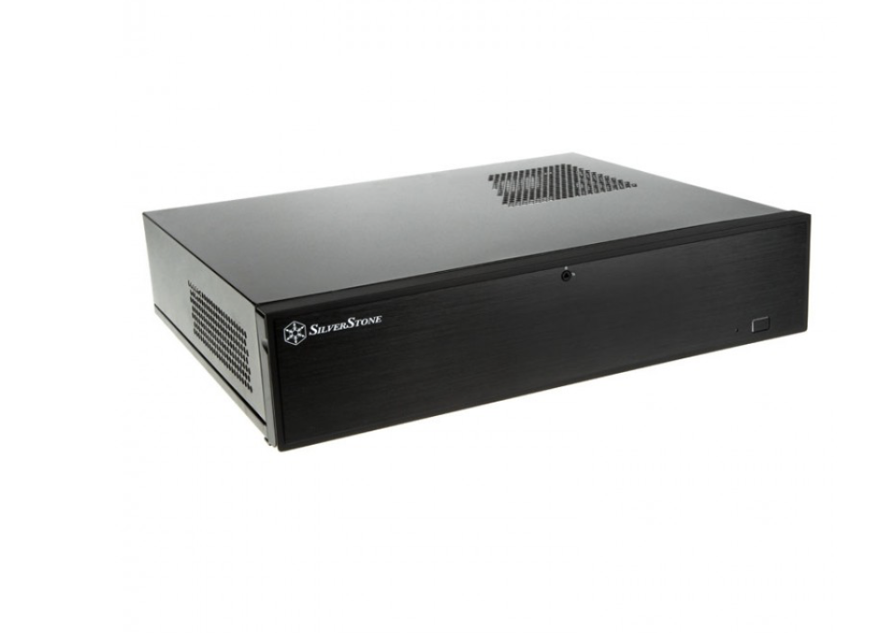
Figure 5 SilverStone Milo ML04 HTPC SST-ML04B

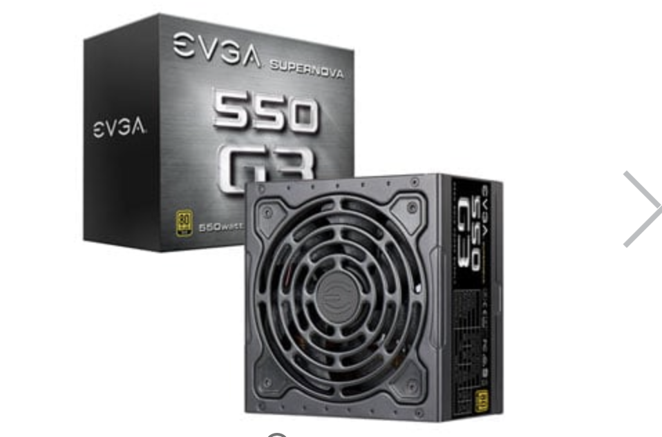
Figure 6 EVGA G3 550 W 80+ Gold Certified Fully Modular ATX Power Supply

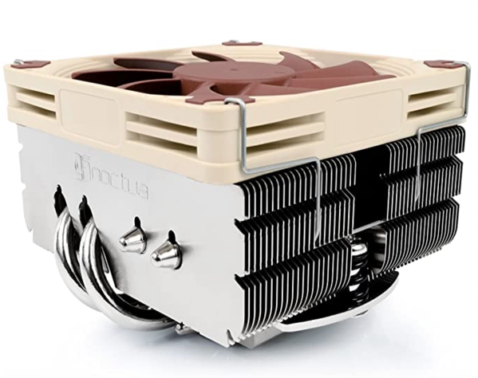
Figure 7 Noctua NH-L9x65

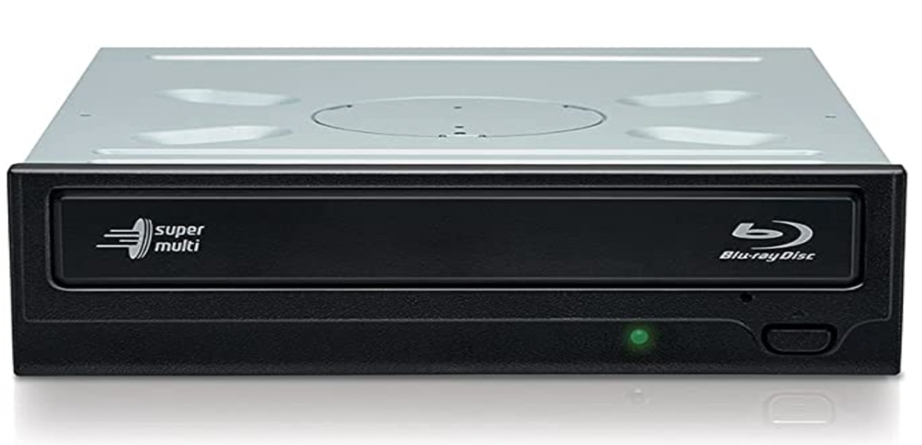
Figure 8 Hitachi-LG BH16 Internal Blu-Ray Drive

Dolby Digital - technology of lossy compression of multi-channel sound. The purpose of its creation was to provide high-quality multi-channel sound to viewers in cinema halls. Dolby Digital is the most common version, supports up to 6 channels (in a 5.1 system) - 5 in the range 20 Hz - 20 kHz and one (subwoofer) in the range 20 - 120 Hz with sampling up to 48 kHz. This format comes under different names: Dolby Digital, DD (sometimes also described as DD 2.0 and DD 5.1 for stereo and 6-channel sound), AC-3, A / 52.


