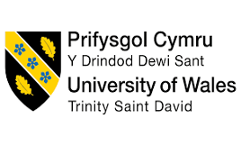

SUSTAINABLE HOSPITALITY
BMIH4011/D - LEVEL 4

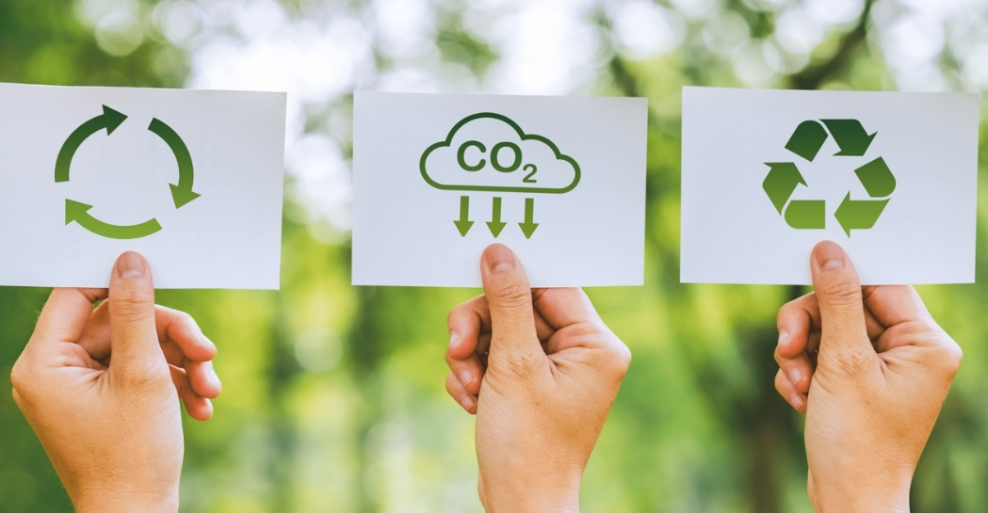
PRESENTER: Sandy Gladys Lozano Grimaldo
MODULE LECTURE: Daniel Payne
WORLD COUNT: 3000 WORDS
SUBMISSION DATE: 9TH MAY 2026
STUDENT NUMBER: 2514605

HOTEL OVERVIEW
Naturally Inspired with Timeless Aesthetics



In today’s increasingly hectic work life, fast-paced routines, and highly polluted urban environments, many travellers seek destinations that offer peace, relaxation, and a meaningful connection with nature (Clissold et al. 2022; Lončarić et al. 2021). Modern tourism is no longer focused only on luxury and comfort; guests increasingly value wellness, tranquillity, and environmentally responsible experiences (Rosenberg et al, 2021). Sandy’s Hotel is designed to meet this growing demand by providing a peaceful wellness retreats where guests can escape daily stress and reconnect with natural beauty in a calm, restorative setting (Mendoza, 2026).
Sandy’s Hotel, with the motto “Naturally Inspired, Timeless Aesthetics” is a luxury eco-resort located in Windermere, within the stunning Lake District National Park. Surrounded by lakes, forests, hills, and scenic walking trails, the hotel is built to blend harmoniously with its natural surroundings while offering premium hospitality services. The brand identity focuses on viability, wellness, and timeless design, where natural materials, and environmentally conscious operations define the guest experience.
The hotel primarily targets eco-conscious tourists, wellness travellers, families, and adventure seekers who value both comfort and nature. It also appeals to international tourists and professionals looking for restorative escapes away from busy city life. Guests can enjoy outdoor activities such as hiking, plantation, cycling, boating, and green exploration while staying in a space that promotes relaxation and mental well-being (Coventry et al, 2021).
Located in a rural destination known for its outstanding natural beauty, Sandy’s Hotel aims to redefine luxury by showing that sustainability and comfort can coexist (Lake District National Park, 2021). The hotel offers not just accommodation, but an experience of calmness, healing, and responsible tourism. By creating a place where guests can relax, breathe clean air, and appreciate nature, Sandy’s Hotel contributes to the broader vision of sustainable hospitality and destination preservation (Zrnić, 2025).

SUSTAINABILITY VISION

At Sandy’s Hotel, the vision is to create a hospitality experience that allows guests to reconnect with nature while enjoying solace, wholesomeness, and meaningful travel experiences. In today’s fast-paced urban lifestyle, people are increasingly surrounded by stress, pollution, anxiety and digital overload, creating a growing need for peaceful spaces that promote relaxation and restoration (Bray et al, 2022). The hotel is designed as a retreat where mankind can step away from mundane routines, finally get exposed to the quiescent effects of scenic views, and develop a deeper appreciation and sense of promotion of environmental responsibility (Barbour and Warr, 2026).
The philosophy of Sandy’s Hotel is built on the belief that true luxury is not defined only by premium services, but by the quality of experience and harmony with the nature. Guided by the motto, “Naturally Inspired, Timeless Aesthetics,” the hotel combines elegant hospitality with responsible tourism practices that respect and preserve the beauty of Windermere. This concept promotes slow tourism, encouraging guests to engage more mindfully with the destination rather than simply consuming it as a short-term experience (Klarin et al. 2023; Healing 2023).
The hotel follows the Triple Bottom Line approach, balancing environmental preservation, social responsibility, and economic resilience often described as people, planet, and profit (Sathiyamoorthy and Roxia R, 2024). Environmentally, the aim is to protect natural resources and minimise ecological impact (Mohamed Ali Said et al, 2024). Socially, the hotel seeks to support local communities, preserve and embrace regional culture, and create authentic connections between customers and residents (UN Global Compact, 2024). Economically, the focus is on building a long-term hospitality model that remains profitable while contributing positively to the local economy (Eila Jeronen, 2023).
What makes Sandy’s Hotel unique is its regenerative tourism approach (rariel and rariel, 2023). Rather than focusing only on reducing negative environmental impacts, the hotel aims to create positive environmental, economic and social value for the destination (rariel and rariel, 2023). Environmentally, the hotel supports biodiversity protection, destination preservation, and long-term conservation of the natural beauty of Windermere. Economically, the hotel contributes to local development by increasing employment opportunities, supporting the growth of the private sector, attracting international visitors, and generating foreign exchange through tourism spending. Although the use of natural materials, eco-conscious construction, and responsible sourcing may increase initial infrastructural costs, the long-term benefits include stronger destination value, higher visitor satisfaction, and sustainable economic resilience beyond traditional premium luxury models (Riyaz, 2024).
Socially, Sandy’s Hotel aims to preserve local culture and heritage by promoting regional traditions, local art, and authentic as well as unique food experiences from around the globe that support SDG’s (Green Pearls GmbH, 2025). The hotel encourages cultural revitalisation by creating stronger connections between visitors and the local community, helping guests experience the true identity of the location rather than a standardised luxury stay. This strengthens social connectivity, supports community pride, and enhances the authenticity of the tourism experience (Le et al, 2024). This forward-thinking model reflects the growing global demand for climate-conscious, culturally respectful, and ethically responsible travel choices (Le et al, 2024).
The hotel’s vision also aligns with wider sustainable tourism goals and global frameworks such as the United Nations Sustainable Development Goals (SDGs), particularly those related to responsible consumption, life on land and below water, climate action, good health and well-being, and sustainable communities and cities (Meng et al. 2024; Khizar et al. 2023). Sandy’s Hotel aims to become more than a place to stay it seeks to become a model for future hospitality where tourism creates lasting positive value for both people and the planet.

SUSTAINABLE PRACTICES AND STRATEGIES

The hotel is developed as a regenerative hospitality model where environmental protection, cultural integrity, and long-term economic resilience are embedded into every operational decision (rariel and rariel, 2023). Rather than treating sustainability as an add-on feature, the hotel integrates responsible resource use into its core design and customer experience, ensuring that tourism actively contributes to improving the natural and social environment of Windermere (rariel and rariel, 2023).
A key priority is the complete elimination of plastic across all hotel operations. The hotel adopts a strict zero-plastic policy, replacing all conventional plastic-based products with biodegradable, compostable or reusable alternatives. This includes wooden access cards instead of plastic key cards, biodegradable packaging for amenities, and natural material-based service items (McGrath, 2023). This approach significantly reduces plastic pollution and aligns with global efforts to transition towards circular and low-waste hospitality systems.

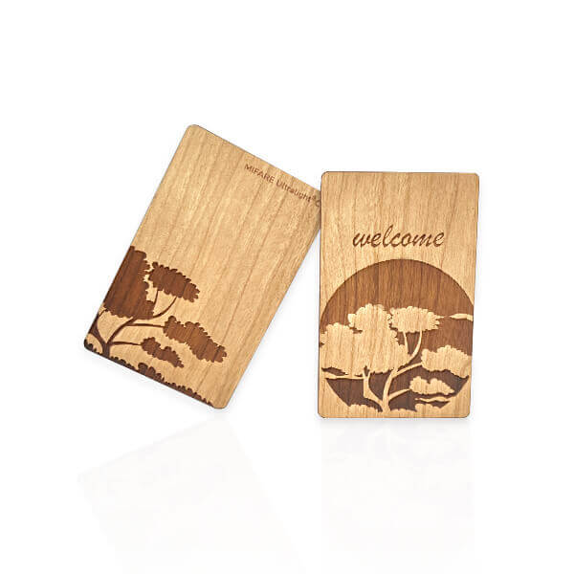
Energy efficiency and low-carbon operations are achieved through renewable and passive design strategies. Solar panels provide a major source of electricity, reducing reliance on fossil fuels, while motion-sensor lighting ensures energy is used only when required (Solar and Hanif D, 2024). Natural shading through vegetation and architectural design reduces internal heat gain, lowering dependence on air-conditioning systems (Lechner, 2009). This design-led approach reflects a shift from energy consumption to energy intelligence within hospitality infrastructure. In line with traditional passive cooling practices, the hotel will also incorporate mud rooms (earthen cooling spaces) inspired by methods commonly used in parts of Asia (Datta, 2016). These rooms use natural materials such as clay and earth to regulate indoor temperatures, helping to keep spaces naturally cool without reliance on air conditioning. This bioclimatic design approach enhances thermal comfort while significantly reducing energy consumption, further reinforcing the hotel’s commitment to low-impact, nature-aligned hospitality (Datta, 2016).
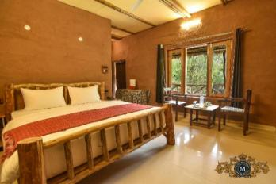
Water management is based on conservation and reuse principles. Greywater from showers and sinks is treated and reused for irrigation, reducing pressure on freshwater resources (Agnihotri et al, 2025). Efficient plumbing systems could further reduce water waste, supporting long-term resource stability.
Waste management follows circular economy principles, focusing on reduction at source rather than end-of-pipe solutions (Velenturf and Purnell, 2021). Digital systems replace paper-based communication through tablets for ordering and guest services, eliminating unnecessary printing (Katagri and Balavalad, 2025).
Material selection is rooted in natural, locally sourced, and biodegradable resources. Wooden furniture such as chairs and tables is used throughout the property, reinforcing a low-impact aesthetic and reducing embodied carbon (UK Parliament, 2021). Construction and interior design prioritise durability, renewability, and minimal environmental disruption.
Food and beverage services emphasise local sourcing, seasonal availability, and cultural authenticity. The hotel incorporates traditional eco-friendly Indian and South American serving methods such as banana leaves instead of disposable plates and bamboo-based cooking and serving techniques like bamboo biryani (Survai, 2025). These practices reduce waste while enhancing cultural value and guest experience through authentic, nature-inspired dining (Survai, 2025).
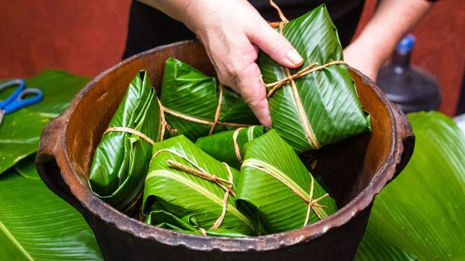
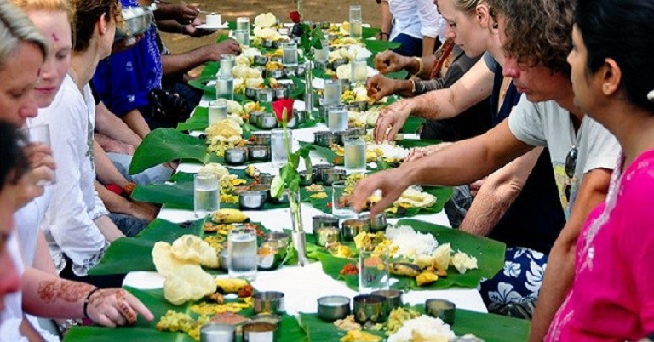
Community integration ensures that tourism benefits are distributed locally. The hotel prioritises local employment, supports small businesses, and collaborates with regional producers and artisans (Tripathi and Shukla, 2024). This strengthens the local economy, preserves cultural identity, and ensures that tourism contributes positively to community development (Tripathi and Shukla, 2024). Overall, it will demonstrate how a fully integrated, plastic-free, and nature-centred hospitality model can deliver luxury experiences while actively restoring environmental, cultural, and economic value.

GUEST EXPERIENCE
The guest experience is designed around the idea that environmental responsibility and comfort can coexist seamlessly, where sustainability is not a limitation but a core part of enjoyment, learning, and relaxation. Every stage of the guest journey is intentionally designed to strengthen the connection between visitors and the natural environment of Windermere, transforming a traditional hotel stay into an immersive, meaningful, and restorative experience.
From arrival, guests are introduced to the hotel’s eco-conscious philosophy through simple yet thoughtful practices such as wooden access cards and digital check-in systems that eliminate paper use. Rooms are designed using natural materials, energy-efficient systems, and passive cooling techniques, including shaded architecture and traditional mud room concepts that maintain a comfortable indoor temperature without excessive reliance on air conditioning. These design elements enhance comfort while encouraging guests to experience sustainable living in practice.
A key feature of the guest journey is active engagement with nature through curated outdoor and wellness-based activities (Smith, 2021). Guests are encouraged to participate in guided hiking trails, rock climbing experiences, cycling routes, and scenic nature walks that showcase the natural beauty of the Lake District. These activities are designed not only for recreation but also to promote physical well-being, mental relaxation, and environmental awareness (Bray et al, 2022). Tree plantation drives offer guests the opportunity to contribute directly to ecosystem restoration, creating a sense of personal involvement in environmental conservation (Schaerlaeckens, 2026). These experiences ensure that guests do not remain passive observers but become active participants in preserving the destination.
In addition to outdoor activities, the hotel provides educational and interactive sustainability experiences. Workshops on local biodiversity, waste reduction, and sustainable living practices help guests understand the impact of their choices in everyday life. Cooking sessions using locally sourced ingredients and traditional eco-friendly methods, such as banana leaf dining and bamboo-based preparation styles, introduce guests to culturally rich and low-waste culinary practices (Survai, 2025). These experiences also highlight how sustainability can be both practical and enjoyable.
Digital engagement tools are integrated throughout the guest journey to enhance convenience and reduce environmental impact (Katagri and Balavalad, 2025). Tablets replace printed menus and paper-based communication, allowing guests to order services, access information, and explore activity schedules in a fully digital format. This reduces paper waste while improving efficiency and accessibility (Katagri and Balavalad, 2025).
Well-being is another central element of the guest experience. Nature-based wellness activities such as outdoor meditation, yoga sessions in natural settings, and digital detox zones encourage guests to disconnect from urban stress and reconnect with themselves and their surroundings (Coventry et al, 2021). This reflects the growing global trend of wellness tourism, where travel is used as a tool for mental and physical restoration.
Community interaction is also encouraged through locally led experiences, where guests can engage with regional artisans, farmers, and cultural practitioners (UN Global Compact, 2024). These interactions provide authentic insights into local heritage while supporting the surrounding economy and preserving cultural identity (UN Global Compact, 2024).
Overall, Sandy’s Hotel ensures that sustainability is fully embedded within the guest journey, transforming it into an enriching experience where comfort, nature, learning, and responsibility come together. Guests leave not only refreshed but also more aware, inspired, and connected to the environment and the principles of responsible tourism.

CONCLUSION
The hotel represents a reimagined model of hospitality that shifts the focus from consumption-based tourism to experience-led, regenerative travel. Located in the natural setting of Windermere, the concept is built around creating a meaningful balance between guest comfort, environmental care, and long-term destination value. Rather than treating sustainability as an operational requirement, it is embedded as a guiding philosophy that shapes design, services, guest engagement, and community relationships.
The hotel demonstrates a holistic integration of environmental, social and economic dimensions. Environmentally, it prioritises low-impact infrastructure, renewable energy adoption, water reuse systems, and the elimination of plastic through biodegradable and natural alternatives. Socially, it strengthens local identity by preserving cultural heritage, supporting traditional food practices, and enabling authentic interaction between visitors and the local community. Economically, it contributes to regional development through local employment generation, collaboration with small businesses, and support for the wider tourism economy in a way that promotes long-term stability rather than short-term exploitation.
In today’s tourism landscape, where travellers are increasingly conscious of climate change, over-tourism, and ethical consumption, such an approach is both timely and necessary. Sandy’s Hotel responds to this shift by positioning itself as a destination that offers not only relaxation and luxury, but also purpose and participation. Guests are encouraged to engage with nature, reflect on their environmental impact, and experience travel in a more mindful and restorative way.
To conclude, the concept reflects innovation in hospitality by merging regenerative tourism principles with immersive guest experiences and integrated operational systems. It challenges conventional hotel models by proving that economic success, environmental responsibility, and cultural preservation can coexist. Sandy’s Hotel ultimately envisions a future of tourism where every stay contributes positively to people, place, and planet.

REFERENCES
- Agnihotri, V., Chandola, D. and Thathola, P. 2025. Grey water treatment and circular economy. Chemosphere 384, p. 144433. Available at: https://www.sciencedirect.com/science/article/abs/pii/S0045653525003765.
- AKD Furniture. 2024. How Sustainable is Wooden Furniture? AKD Furniture. Available at: https://akdfurniture.co.uk/blog/how-sustainable-is-wooden-furniture/?srsltid=AfmBOoqFVHxfm0zBZorRStOdNhx6uXfTx8_URL1NKtRgeyi5qMaxfgTK [Accessed: 8 May 2026].
- Barbour, P. and Warr, D. 2026. Hotel Design Is No Longer About Escape. It’s About Transformation.. Available at: https://www.gensler.com/blog/hotel-design-is-about-transformation [Accessed: 8 May 2026].
- Bray, I., Reece, R., Sinnett, D., Martin, F. and Hayward, R. 2022. Exploring the role of exposure to green and blue spaces in preventing anxiety and depression among young people aged 14–24 years living in urban settings: A systematic review and conceptual framework. Environmental Research 214(4), p. 114081. doi: https://doi.org/10.1016/j.envres.2022.114081.
- Clissold, R., Westoby, R., McNamara, K.E. and Fleming, C. 2022. Wellbeing outcomes of nature tourism: Mt Barney Lodge. Annals of Tourism Research Empirical Insights 3(2), p. 100077. doi: https://doi.org/10.1016/j.annale.2022.100077.
- Coventry, P.A. et al. 2021. Nature-based Outdoor Activities for Mental and Physical health: Systematic Review and meta-analysis. SSM - Population Health 16(100934), p. 100934. Available at: https://www.sciencedirect.com/science/article/pii/S2352827321002093.
- Datta, U.S. 2016. A COMPARATIVE STUDY OF THE THERMAL PERFORMANCE OF MUD AND BRICK HOUSES IN BANGLADESH. Available at: https://www.researchgate.net/publication/326410455_A_COMPARATIVE_STUDY_OF_THE_THERMAL_PERFORMANCE_OF_MUD_AND_BRICK_HOUSES_IN_BANGLADESH [Accessed: 8 May 2026].
- Eila Jeronen. 2023. Economic Sustainability. Springer eBooks, pp. 1257–1263. doi: https://doi.org/10.1007/978-3-031-25984-5_197.
- Green Pearls GmbH. 2025. Think globally, act locally: The SDGs implemented by hotels. Available at: https://www.greenpearls.com/newsroom/en/think-globally-act-locally-how-green-pearls-hotels-are-implementing-the-sustainable-development-goals/.
- Healing, F. 2023. Forest Healing. Available at: https://forest-healing.co.uk/articles/slow-tourism-and-nature-connection-practices [Accessed: 8 May 2026].
- Katagri, A.C. and Balavalad, K.B. 2025. Smart Restaurant Ordering: A Digital Transformation to Enhance Dining Experiences. International Journal of Computer Applications 186(72), pp. 58–67. doi: https://doi.org/10.5120/ijca2025924580.
- Khizar, H.M.U., Younas, A., Kumar, S., Akbar, A. and Poulova, P. 2023. The progression of sustainable development goals in tourism: A systematic literature review of past achievements and future promises. Journal of Innovation & Knowledge 8(4), p. 100442. Available at: https://www.sciencedirect.com/science/article/pii/S2444569X23001373.
- Klarin, A., Park, E., Xiao, Q. and Kim, S. 2023. Time to Transform the Way We travel?: a Conceptual Framework for Slow Tourism and Travel Research. Tourism Management Perspectives 46(1), p. 101100. doi: https://doi.org/10.1016/j.tmp.2023.101100.
- Lake District National Park. 2021. Lake District Special Qualities. Available at: https://www.lakedistrict.gov.uk/caringfor/lake-district-special-qualities.
- Le, T.H., Margarida Abreu Novais, Arcodia, C., Berchtenbreiter, R., Humpe, A. and Nguyen, N. 2024. How authenticity in events fosters social sustainability: Towards an authenticity ecosystem and implications for destination management. Tourism Management Perspectives 51, pp. 101222–101222. doi: https://doi.org/10.1016/j.tmp.2024.101222.
- Lechner, N. 2009. Heating, cooling, lighting : sustainable design methods for architects. Wiley.
- Lončarić, D., Perišić Prodan, M. and Dlačić, J. 2021. MEMORABLE TOURISM EXPERIENCES INSPIRED BY THE BEAUTY OF NATURE. Tourism and hospitality management 27(2), pp. 315–337. doi: https://doi.org/10.20867/thm.27.2.5.
- McGrath, T. 2023. 10 Plastic-Free Swaps: How Hotels Can Lead the Way for Plastic-Free - Sustainability Kiosk. Available at: https://sustainabilitykiosk.com/10-plastic-free-swaps-how-hotels-can-lead-the-way-in-embracing-the-plastic-free-july-movement/.
- Mendoza, K. 2026. The Mental Health Benefits of Attending Wellness Retreats. Available at: https://restyourselfranch.com/blog/the-mental-health-benefits-of-attending-wellness-retreats/ [Accessed: 8 May 2026].
- Meng, Z., Bhatti, S.M., Naveed, R.T., kanwal, S. and Adnan, M. 2024. Green sustainability in the hotel sector: The role of CSR, intrinsic green motivation, and personal environmental norms. PLoS ONE 19(6), pp. e0295850–e0295850. doi: https://doi.org/10.1371/journal.pone.0295850.
- Mohamed Ali Said et al. 2024. Environmental Sustainability. Advances in environmental engineering and green technologies book series, pp. 1–15. Available at: https://www.researchgate.net/publication/381812269_Environmental_Sustainability.
- rariel and rariel. 2023. The Difference Between Regenerative Tourism and Sustainable Tourism. Available at: https://www.gstc.org/regenerative-tourism/.
- Riyaz, A. 2024. Impact of Eco-Friendly Practices on Resort Profitability in the Maldives. International Journal of Modern Hospitality and Tourism 4(3), pp. 30–40. doi: https://doi.org/10.47604/ijmht.3064.
- Rosenberg, A., Lynch, P.M. and Radmann, A. 2021. Sustainability Comes to Life. Nature-Based Adventure Tourism in Norway. Frontiers in Sports and Active Living 3. doi: https://doi.org/10.3389/fspor.2021.686459.
- Sathiyamoorthy, D.G. and Roxia R. 2024. The Triple Bottom Line Approach Fundamentals. Available at: https://www.researchgate.net/publication/387424174_The_Triple_Bottom_Line_Approach_Fundamentals.
- Schaerlaeckens, E. 2026. Ignite Your Stay at Hotels for Trees: Joyful Stays Await You. Available at: https://planetmediallc.com/hotels-for-trees-where-hotel-guests-plant-trees/ [Accessed: 8 May 2026].
- Smith, M. 2021. Creating wellness tourism experiences. Routledge eBooks, pp. 364–377. Available at: https://www.researchgate.net/publication/372657691_Creating_Wellness_Tourism_Experiences.
- Solar, E.Y. and Hanif D. 2024. 5 Reasons Why Hotels Should Choose Solar Energy | EYS. Available at: https://eastyorkshiresolar.co.uk/blog/5-reasons-why-hotels-should-choose-solar-energy/.
- Survai. 2025. Why We Use Banana Leaves And Why It Matters. Available at: https://suvaidosas.ca/why-we-use-banana-leaves-and-why-it-matters/ [Accessed: 8 May 2026].
- Tripathi, R. and Shukla, D. 2024. Sustainable Development and Inclusive growth of Hospitality and Tourism Industry. Vidhyayana 9(Special Issue 2), p. 1084. Available at: https://www.researchgate.net/publication/383595333_Sustainable_Development_and_Inclusive_growth_of_Hospitality_and_Tourism_Industry.
- UK Parliament. 2021. Wood For Good. Available at: https://committees.parliament.uk/writtenevidence/36105/pdf/.
- UN Global Compact. 2024. Social Sustainability. Available at: https://unglobalcompact.org/what-is-gc/our-work/social.
- Velenturf, A.P.M. and Purnell, P. 2021. Principles for a Sustainable Circular Economy. Sustainable Production and Consumption 27(1), pp. 1437–1457. Available at: https://www.sciencedirect.com/science/article/pii/S2352550921000567.
- Zrnić, M. 2025. REDEFINING LUXURY IN ECO-FRIENDLY TOURISM DESTINATIONS WITH SUSTAINABLE HOSPITALITY. Available at: https://www.researchgate.net/publication/389086130_REDEFINING_LUXURY_IN_ECO-FRIENDLY_TOURISM_DESTINATIONS_WITH_SUSTAINABLE_HOSPITALITY.

