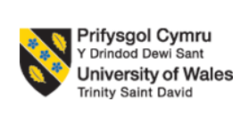

UNIVERSITY OF WALES
TRINITY SAINT DAVID
Student:Marin Hanu 1915952
MODULE: LCBB6001 INTERNATIONAL BUSINESS COMMUNICATIONS
ASSINGNMENT TITLE: ASSIGNMENT 1
PROGRAMME: BA BUSINESS MANAGEMENT
LEVEL 6/TERM 1
LECTURER: HUSAM HELMI

Executive Summary
The report has summarised the immense knowledge of business communication and its importance for the development in the international market to intensify the business process. It has been included in the report about different aspects of the Indonesian market that can be beneficial as well as challenging for Sainsbury’s business operations. Several factors of Hofstede’s Cultural Dimensions about Indonesia and the UK has been included in the report. Cultural sensitivity factors and communication barriers were included in the report to analyse the process of business in the international market. Recommendations have been included to help the company access success in future.
Table of Contents
Introduction 4
Introduction to the developing country Indonesia 5
Cultural Differences 6
Cultural Sensitivity 8
Communication barriers and challenges (UK vs Indonesia) 9
Communication strategies and Recommendations 10
Conclusion 11
References 12
Appendices 16

Introduction
With the emerging advancement in technologies and escalation in business operations, the firms are concentrating on expanding their business in different countries. International Business Communications refers to the process of transmitting information, thoughts, feelings and messages to a group or an individual with an effective approach within international borders (Mironova, 2019). This is an important practice that the organisations should oversee to develop within its work in different international countries to influence the workforce and escalate their performance effectiveness for accessing growth and success. The differences that occur in various international countries results in the emergence of several challenges regarding the production aspect in the firm. Challenges that organisations may face while operating in a different country are difficulty in getting skilled labours, implications in direct selling, effective management of projects and inventories. The report will include several information about the business communication process that helps in establishing the work processes in international countries.
Company Background
Sainsbury’s is the second-largest organisation within the supermarket industry that oversees offering high-quality foods, that concentrates on the customer satisfaction factors. The company has over 600 supermarkets operating all over the United Kingdom and about 800 convenience stores are included in the corporations. Sainsbury’s headquarter is in London, the United Kingdom incorporates 189,000 workers as of the year 2022 (about.sainsburys.co.uk, 2022). The CEO of the company is Simon Roberts, who concentrate on the development of the firm and includes various sustainability strategies. In the fiscal year of 2021, Sainsbury’s generated about 29 billion British Pounds as revenue in the pre-tax report (statista.com, 2022). The company concentrates on providing great value to their potential customers and operates with stores and online strategies as well.

Introduction to the developing country Indonesia
In order to acquire success, the firms oversee to establish their market in developing countries that have a huge opportunity for the development and escalate the growth in terms of manufacturing or production. Indonesia is regarded as one of the developing countries that have a lower GDP rate and the economic rate of the country is sophisticated as well. The GDP rate of Indonesia faced a huge decline and amounted to about 2.07% in the negative region as of the year 2020 (statista.com, 2021). Indonesia is a country that is located in Southeastern Asia and for business purposes, it is one of the best places for the establishment of companies. As of the year 2020, the unemployment rate in Indonesia was about 4.11% (statista.com, 2022). This factor indicates that Sainsbury’s have a massive opportunity to operate its business productively with the inclusion of employees that can be accessed at a low cost. It is because the country has a low employment rate and people are more conscious about their job. After the situation of uncertainty that was emerged due to the COVID-19 pandemic, the unemployment rate in the UK was escalated by about 0.6% in 2020 (statista.com, 2022).
Hence, by conceptualising these factors of Indonesia it can be concluded that the country has a huge chance of assisting the foreign organisations to establish their businesses and operate effectively. Indonesia can be considered as the ideal hub for industrial production which can allow modernisation and globalisation for businesses. Sainsbury’s should oversee to expand their business and establish it within Indonesia, in accordance with this, the company have to focus on the process of manufacturing and required machinery for it. As per the report, it has been depicted that Sainsbury has the opportunity to gain a high competitive edge and escalate its market growth and range of development. Indonesian retail market has a high chance of growth as it has been indicated that the country’s retail market will grow by about 4% till 2025 (prnewswire.com, 2022). Indonesia is a country that has a mixed economy market, which includes enterprises such as public and private. Indonesia is considered the tenth largest global market, which has an of population around 270.2 million as of 2020 (statista.com, 2021). The language that is used by the people of Indonesia is Indonesian.
The technological advancement in Indonesia has experienced a huge growth that assisted the organisations operating in the company to boost their processes and acquire success . It has helped the corporations to attain their desired aims and objectives to acquire growth in the international market. Indonesia incorporates different types of religions such as Hinduism, Christianity, Islam and many more and follows traditional culture and beliefs (indonesia.mfa.gov.ir, 2022). Hence, these factors conceptualise that Sainsbury should analyse all these factors before establishing their market in Indonesia that can assist them to intensify its business. Evaluating the factors such as population, culture, and technological advancements will help the company to effectively operate its business and identify the target audiences.

Cultural Differences
In the modern generation of business, the companies should oversee to analyse the cultural differences within the home country and in the international market. This will help the company to accelerate the business process that is regarded from scratch. Culture is defined as several ways of life through which people function that includes thoughts, beliefs, art, language, religion and many more (Giuliano, 2020). This is an important aspect that provides social and economic benefits to the society that can assist in the development and enhances the quality of life. Cultural differences can be signified by the Hofstede Cultural Dimensions, which is defined as the process of identifying the differences in culture across the countries (Huang and Crotts, 2019). This is necessary as it demonstrates the differences among the cultural aspects to understand the needs of the international market that can include in business. There are six different cultural dimensions that provide the idea of the behaviour of people while making the decisions for products.
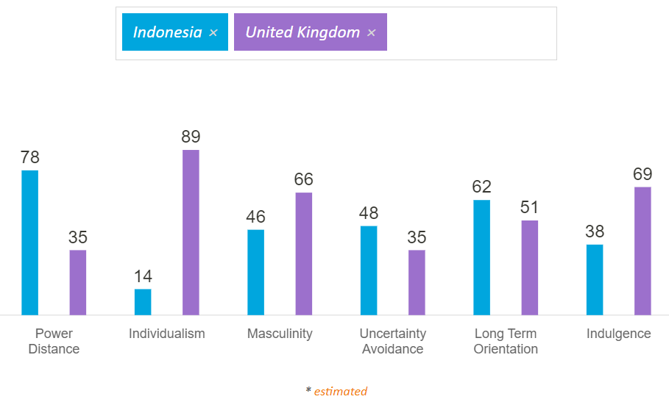
Figure No. 1: Hofstede Cultural Dimension Scores of the UK and Indonesia
(Source: hofstede-insights, 2022)
POWER DISTANCE conceptualises that the people operating in a corporation accept and expect the unequal distribution of power among the workforce. Hofstede’s country comparison tool has provided the report that the Power Distance score of Indonesia is 78 and the United Kingdom is 35 (hofstede-insights.com, 2022). This shows that Indonesia has an immense unequal distribution of power among the employees. It can help Sainsbury to effectively function its business in the country while having intense control over the employees.
INDIVIDUALISM refers to the concept of giving importance to attaining personal goals instead of organisational or collective goals, which focuses on the well-being of an individual. The score acquired by Indonesia for Individualism is 14 and the United Kingdom is 89, which indicates that the employees in the United Kingdom are more inclined towards their personal goals (hofstede-insights.com, 2022). Sainsbury’s have an immense opportunity for growth in Indonesia due to the high declination towards Collectivism that will help the company to promote teamwork within their workplace in the international market.
UNCERTAINTY AVOIDANCE depicts the process or methods that people of different countries include in their thought to reflect and avoid the implications due to the uncertainty. Indonesia is more focused on taking steps to avoid uncertainty in society or business as it has a score of 48 and the UK has 35 (hofstede-insights.com, 2022). This cultural difference factor will help Sainsbury’s to avoid the issues that can be experienced by the corporation such as COVID-19, climate change, environmental issues in Indonesia.

Cultural Sensitivity
Cultural Sensitivity is considered as being aware of differences and similarities in the cultures that exist among people without providing them with the value whether it is negative or positive (Makowski and Bebenroth, 2019). This is an important aspect that should be included in the business and actively function to provide the appropriate values and respect to reduce the barriers of culture. According to Miotto et al. (2019), gender equality is a vital aspect that the business operating in the international market should follow. This can assist them to improve their reputation among the potential customers, which can allow them to access high success in the operating nation. In Indonesia, the gender pays gap experiences differences despite accessing the same level of education, women in the country earn only 59.27% as compared to the males in Indonesia (thejakartapost.com, 2022). Hence, this factor of gender pay gaps indicates that Sainsbury’s can include several policied that undertakes and concentrate maintaining the regulations in the workplace to provide appropriate wages to both males and females.
Businesses operating in local as well as international countries needs to hire employees that have the right skills, expertise, and knowledge, which can be influenced by education. On the other hand, Belkin (2020), stated that education is an important factor that can have an impact on businesses. An appropriate approach to education can influence the success of a business for experiencing growth in future. Education promotes an effective approach to acquiring the right technological process and methods that assist the business to attain growth. In Indonesia, the literacy rate as of the year 2020 was about 96%, which includes people from the age of 15 and above (statista.com, 2022). Thus, this portrays that the HR manager of Sainsbury’s will be able to hire the right employees within the country in order to reach the expected goals and objectives of the enterprise.

Communication barriers and challenges (UK vs Indonesia)
Communication refers to the process of transferring the thoughts, feelings, necessary information, which can convey ideas with different mediums (Radovic Markovic and Salamzadeh, 2018). In business, communication is an essential aspect that can allow the managers and leaders of the corporation to motivate, inspire, and convey clear messages to the workforce. Sainsbury’s can face several barriers regarding communication while operating in the Indonesian market. After the emergence of COVID-19, the operating organisations have been facing different issues regarding communication. This is due to the work from home culture, about 23% of people were avoiding working from the office during the coronavirus (statista.com, 2022). For instance, Unilever in Indonesia concentrated on implementing the work from home that positively affected the mindset of people and increased their work intensity. This assisted the company to generate immense earnings as revenue. Unilever generated a revenue of about 43 trillion Indonesian rupiahs in the country as of the financial year 2020 (statista.com, 2021). Whereas in the United Kingdom, concentrating on this factor helped Unilever as well and they generated about 50.7 billion euros in the UK (statista.com, 2022).
The workplace environment is a crucial factor that should be incorporated in business organisations to provide employees with an effective approach to working towards the goal of the corporation (Hafeez et al., 2019). Its significance is to motivate and inspire employees for accessing success for future development. The work environment should focus on the development of diversity and inclusion in the company. Diversity and Inclusion is an essential policy that the HR manager of the company should include in their work to accelerate the effectiveness of communication among employees (Aragon and Kim, 2021). This can be an effective method of assessing the needs and perspectives of people operating in the workspace. Moreover, it can succour the marketing team of the company to analyse the market needs and trends that help the company to escalate its sales. British Petroleum is an organisation that includes this policy in their corporation, which allows them to respect employees and its potential customers (bp.com, 2022). Diversity and Inclusion allow British Petroleum to incorporate effective communication processes to increase their effectiveness for enhancing the work operations. It made British Petroleum generate about 180 billion GBP revenue all around the world (statista.com, 2021).

Communication strategies and Recommendations
In order to access success and growth in the Indonesian market, Sainsbury’s have to implement some of the necessary strategies that will magnify their business operations. Several recommendations and communication strategies are:
Marketing analysis refers to the process of productively assessing the market trends and needs of the customers within a specific industry (Dfuf et al., 2020). Focusing on the assessment of the market can help Sainsbury’s to analyse the opportunity of growth in the Indonesian market that will accelerate their work operation. As of the year 2020, Indonesia has been considered the tenth-largest market has a population of about 270.2 million (statista.com, 2021). Hence, Sainsbury’s should appropriately define its target market in the Indonesian market that can succour them to escalate their sales.
With the application of Hofstede’s Cultural Dimensions, Sainsbury’s will be able to evaluate the differences of culture between the United Kingdom and Indonesia. This will allow Sainsbury’s to inspect the requirements of people living in the country and can help the organisation to investigate the opportunity within the market. Indonesia has a score of 48 for Uncertainty Avoidance that can help the HR manager of Sainsbury’s to hire the right employees that can work productively during the need (hofstede-insights.com, 2022).
The gender pay gap in the workplaces of Indonesia has been amounted to about 60% for women as compared to men (thejakartapost.com, 2022). Thus, Sainsbury’s should focus on implementing Diversity and Inclusion for avoiding the pay gaps that will improve their social image. The employees in Indonesia will get motivated by this factor and work attentively to help the company reach their goals and objectives.
Several communication barriers in Indonesia can hinder the business operations of Sainsbury’s. Therefore, the company should focus on applying the appropriate methods of communication for the employees such as video conferencing while working from home. This will allow the leaders to manage employees productively and motivate them to work effectively. Whereas, for communicating with the potential consumers the company should use the internet while promoting or advertising the products or services. As per the report of 2020, the internet penetration rate of Indonesia has been amounted to about 70% (statista.com, 2021). Focusing on this factor will help Sainsbury’s to communicate with the potential customers and provide them with the appropriate information about products and services that can remove the communication gap between customers and the enterprise. [Refer to Appendix 1]

Conclusion
The summary of the report has concluded the details about business communications and challenges that the organisations face while operating in the international market. A brief introduction of the developing country Indonesia has been included in the report that included the aspects of the population. The relation to the culture, language, unemployment, technological advancement, and economy has been provided in the report. Hofstede’s Cultural Dimensions were undertaken in the report to provide knowledge and comprehension about Indonesia. A comparison of cultural differences was included between the United Kingdom and Indonesia to assess the effectiveness of employees and the behaviour of buyers. Several cultural sensitivity factors were incorporated to identify the process that should be established in the enterprise to gain success in the international market. Several communication challenges and barriers were provided for the business that can be faced in the global market while operating. Several communication strategies such as the use of the internet and an effective marketing approach were provided to assist Sainsbury’s for their development in the country by assessing the needs of its potential consumers. The importance of market analysis has been discussed as the recommendation for Sainsbury’s business operations’ success in Indonesia.

References
about.sainsburys.co.uk, 2022. About us [Online] Available at: https://www.about.sainsburys.co.uk/about-us [Accessed 24 March 2022]
Aragon, A. and Kim, S.S., 2021. Drivers and Barriers of Diversity and Inclusion in Business: Interviews with Nine Field Experts. DU Undergraduate Research Journal Archive, 2(1), p.5.
Belkin, I.V., 2020. The importance of the business game in the education of students of higher educational institutions in modern economic conditions. In Colloquium-journal. Polska: Warszawa, 2020.№ 33 (85), Część 2. Р. 36-40..
bp.com, 2022. Diversity, equity & inclusion at bp [Online] Available at: https://www.bp.com/en/global/corporate/careers/life-at-bp/diversity-equity-and-inclusion.html? [Accessed 24 March 2022]
Dfuf, I.A., Pérez-Minayo, J.F., Mcwilliams, J.M.M. and Fernández, C.G., 2020. Variable importance analysis in imbalanced datasets: A new approach. IEEE Access, 8, pp.127404-127430.
Furthermore, it indicates that Sainsbury should apply a diversity and inclusion policy in their workplace to effectively operate in the Indonesian market and access a huge opportunity for growth. This can assist them to gain a high competitive advantage due to enhanced reputation among its potential market.
Giuliano, P., 2020. Gender and culture. Oxford Review of Economic Policy, 36(4), pp.944-961.
Hafeez, I., Yingjun, Z., Hafeez, S., Mansoor, R. and Rehman, K.U., 2019. Impact of workplace environment on employee performance: mediating role of employee health. Business, Management and Economics Engineering, 17(2), pp.173-193.
hofstede-insights.com, 2022. COUNTRY COMPARISON TOOL [Online] Available at: https://www.hofstede-insights.com/ [Accessed 24 March 2022]
Huang, S.S. and Crotts, J., 2019. Relationships between Hofstede's cultural dimensions and tourist satisfaction: A cross-country cross-sample examination. Tourism management, 72, pp.232-241.
indonesia.mfa.gov.ir, 2022. Indonesian Culture [Online] Available at: https://indonesia.mfa.gov.ir/en/generalcategoryservices/8447/indonesian-culture [Accessed 22 March 2022]
Makowski, L. and Bebenroth, R., 2019. Effect of Language Skills and Cultural Sensitivity on Performance Satisfaction: A Case of A European-Japanese Joint Venture. European Journal of Social Sciences, 57(4), pp.393-407.
Miotto, G., Polo López, M. and Rom Rodríguez, J., 2019. Gender equality and UN sustainable development goals: Priorities and correlations in the top business schools’ communication and legitimation strategies. Sustainability, 11(2), p.302.
Mironova, N., 2019. Business Communications Management on the Internet–Global Practices and Their Dimensions in Bulgaria. Научни трудове на УНСС, 1(1), pp.87-123.
prnewswire.com, 2022. Indonesia Retail Market to grow at a CAGR of 4% by 2025|Evolving Opportunities with CT Corp., PT Erajaya Swasembada Tbk & PT Hero Supermarket Tbk |17000+ Technavio Reports [Online] Available at: https://www.prnewswire.com/news-releases/indonesia-retail-market-to-grow-at-a-cagr-of-4-by-2025evolving-opportunities-with-ct-corp-pt-erajaya-swasembada-tbk--pt-hero-supermarket-tbk-17000-technavio-reports-301455421.html [Accessed 18 March 2022]
Radovic Markovic, M. and Salamzadeh, A., 2018. The importance of communication in business management. In Radovic Markovic, M., & Salamzadeh, A.(2018). The Importance of Communication in Business Management, The 7th International Scientific Conference on Employment, Education and Entrepreneurship, Belgrade, Serbia.
statista.com, 2021. Indonesia: Growth rate of the real gross domestic product (GDP) from 2016 to 2026 [Online] Available at: https://www.statista.com/statistics/320068/gross-domestic-product-gdp-growth-rate-in-indonesia/ [Accessed 18 March 2022]
statista.com, 2021. Indonesia: Total population from 2016 to 2026 [Online] Available at: https://www.statista.com/statistics/294100/total-population-of-indonesia/ [Accessed 18 March 2022]
statista.com, 2021. Internet penetration rate in Indonesia from 2017 to 2020 with forecasts until 2026 [Online] Available at: https://www.statista.com/statistics/254460/internet-penetration-rate-in-indonesia/ [Accessed 24 March 2022]
statista.com, 2021. Net sales of PT Unilever Indonesia Tbk from financial year 2011 to 2020 [Online] Available at: https://www.statista.com/statistics/1056958/unilever-indonesia-tbk-net-sales/ [Accessed 23 March 2022]
statista.com, 2021. Operating revenue of BP from 2005 to 2020* [Online] Available at: https://www.statista.com/statistics/264185/bp-group-revenue-since-2003/ [Accessed 23 March 2022]
statista.com, 2022. Annual retail sales of Sainsbury's in the United Kingdom (UK) from financial year 2008/09 to 2020/21 [Online] Available at: https://www.statista.com/statistics/386342/sainsburys-retail-sales-united-kingdom-uk/ [Accessed 18 March 2022]
statista.com, 2022. Indonesia: Literacy rate from 2008 to 2020, total and by gender [Online] Available at: https://www.statista.com/statistics/572721/literacy-rate-in-indonesia/#:~:text=The%20literacy%20rate%20measures%20the,rate%20was%20around%2096%20percent. [Accessed 24 March 2022]
statista.com, 2022. Indonesia: Unemployment rate from 1999 to 2020 [Online] Available at: https://www.statista.com/statistics/320129/unemployment-rate-in-indonesia/ [Accessed 22 March 2022]
statista.com, 2022. Unemployment rate in the United Kingdom from May 1992 to January 2022, by country [Online] Available at: https://www.statista.com/statistics/279990/unemployment-rate-in-the-uk-by-country/ [Accessed 22 March 2022]
statista.com, 2022. Revenue of Unilever Group from 2011 to 2020, by region [Online] Available at: https://www.statista.com/statistics/269195/revenue-of-the-unilever-group-by-region/ [Accessed 23 March 2022]
statista.com, 2022. Share of Indonesian population who have been avoiding going to work during COVID-19 outbreak from February 2020 to December 2021 [Online] Available at: https://www.statista.com/statistics/1110145/indonesia-avoiding-going-to-work-during-covid-19-outbreak/ [Accessed 23 March 2022]
thejakartapost.com, 2022. Without data Indonesia’s gender equality promise falters [Online] Available at: https://www.thejakartapost.com/opinion/2022/03/08/without-data-indonesias-gender-equality-promise-falters.html [Accessed 22 March 2022]

Appendices
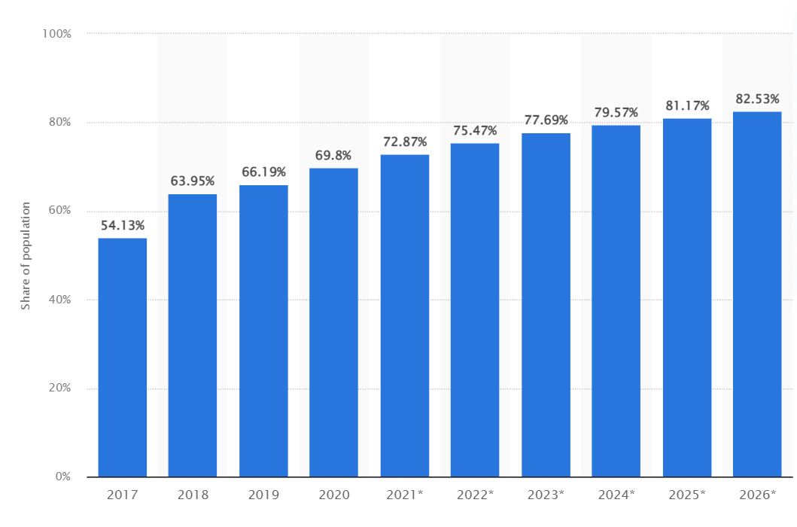
(Source: statista.com, 2021)

