AHHI5015 Contesting Conflict: War and Representation 1789–2010
Week 1: The French Revolution and the Napoleonic Wars

BACKGROUND INFORMATION REGARDING THE FRENCH REVOLUTION

Synopsis
The French Revolution saw the foundation of modern France, and is considered a landmark in the history of the nation state, of Europe and of modernity in general. Although most specifically designating the events that saw the French monarchy abolished and the institution of the First French Republic, the phrase ‘French Revolution’ can also be used generally to refer to decades of turmoil experienced by France from 1789 until 1815 – or even 1870.

- Summary of Key Events
The Revolution began in 1789 with the outbreak of social, economic and political unrest (characterised by events such as the Storming of the Bastille) and led to the overthrow France’s existing socio-political system. Known as the Ancien Régime, this political system was composed of three ‘estates’ (the nobility, the clergy and the commoners), with France being ruled by a monarchical dynasty. The Revolutionaries sought greater representation for the commoners who made up the vast majority of France’s population, and adopted the motto ‘liberté, égalité, fraternité’ to signify this. Perhaps the most significant outcome of the Revolution was the adoption of The Declaration of the Rights of Man and of the Citizen, a set of universally held human and/or natural rights. As these rights were perceived to transcend the purview of France, the Declaration of the Rights of Man is regarded a key development in the history of human rights and democratic institutions worldwide. The full text of the Declaration of the Rights of Man is included below.
In the immediate aftermath of the 1789 revolution, France was governed by a constitutional monarchy, prior to the First French Republic being declared on September 22 1792. The following year King Louis XVI and other members of the French royal family were executed – acts of regicide which ushered in the Republic’s ‘Reign of Terror,’ during which tens of thousands of ‘enemies of the revolution’ were killed. The execution of the monarchy was doubly significant because it involved the murder of Louis XVI’s wife, Marie Antoinette – a member of the Austrian royal family. As a consequence, France entered a war with the Austrian Empire and other European monarchies (Britain’s included), enjoying territorial successes in the Low Countries and Italy.
These campaigns helped solidify the reputation of the military commander Napoleon Bonaparte, who mounted a coup d’état in 1799. Instituting autocracy, Napoleon crowned himself Emperor of France in 1804 – thereby ending the First Republic. Under Napoleon’s influence and rule, France accelerated its territorial expansion in continental Europe and North Africa, engaging in a series of wars with the British Empire. These conflicts, known collectively as the Napoleonic Wars, culminated in the defeat of the French armies at the Battle of Waterloo in 1815, which led to the re-establishment of the French monarchy. Later, a Second Republic was declared in 1848, with this lasting until 1852 when Louis-Napoleon, nephew of Napoleon Bonaparte, proclaimed himself Emperor Napoleon III of the Second French Empire. The defeat of France in the Franco-Prussian War of 1870-71 led to the creation of the Third Republic, which remained the status-quo in France until the Nazi invasion of 1940.

- Periodization
In the period since the abolition of the monarchy in 1792, France has been governed by five different republics:
- The French First Republic (1792–1804)
- The French Second Republic (1848–1852)
- The French Third Republic (1870–1940)
- The French Fourth Republic (1946–1958)
- The French Fifth Republic (1958–Present)

In-between periods, France was governed by:
- The First French Empire (1792–1814, 1815)
- The Second French Empire (1852–1870).

Note: the terminology used above can be misleading. The ‘First’ and ‘Second’ Empire refers to the type of rule which governed French domestic politics, and the period when France had expansionist designs in continental Europe; however, the ending of these eras should not be thought of as indicating that France stopped being a colonial power. On the contrary, throughout the entire period under discussion, France retained imperial possessions all over the globe and, like Britain, only decolonised after World War Two (indeed, this is a topic for discussion in later weeks of HIST 366). See map below.

- Timeline
1789 Outbreak of French Revolution; storming of Bastille and institution of constitutional monarchy.
1792 First French Republic founded.
1793 Execution of King Louis XVI.
1793–1794 ‘Reign of Terror,’ during which tens of thousands of people are executed.
1794 French military successes in Flanders.
1796–1797 French military successes in Italian states.
1798–1801 French military campaigns in Egypt (eventually repelled by British).
1799 Napoleon’s coup institutes dictatorship
1803–1815 Napoleonic Wars: Napoleon’s military successes bring much of continental Europe under French control.
1804 Napoleon declares himself Emperor of France, formally abolishing First Republic.
1815 Napoleon defeated in Battle of Waterloo; monarchy re-established.
1848 Fall of King Louis-Philippe amid series of revolutions that took over Europe; Louis-Napoleon, nephew of Napoleon Bonaparte, proclaimed president of Second Republic.
1852–1870 Louis-Napoleon takes title of Napoleon III in Second Empire.
1870–1871 Franco-Prussian War, ending in French defeat, loss of Alsace-Lorraine and end of the Second Empire; Third Republic lasts until 1940.

- Map of French Empire, 18th Century to 20th Century
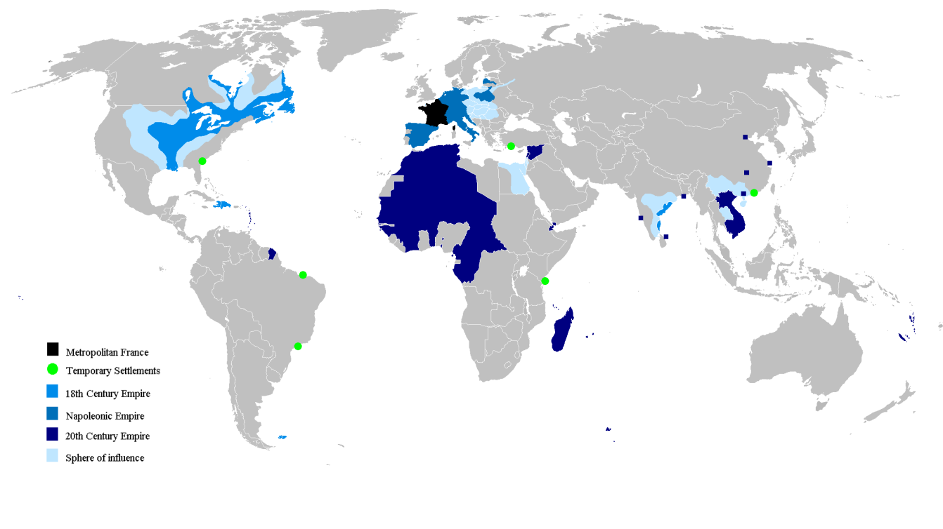

- Primary document:
The Declaration of the Rights of Man and the Citizen, 1789
Approved by the National Assembly of France, August 26, 1789
The representatives of the French people, organized as a National Assembly, believing that the ignorance, neglect, or contempt of the rights of man are the sole cause of public calamities and of the corruption of governments, have determined to set forth in a solemn declaration the natural, unalienable, and sacred rights of man, in order that this declaration, being constantly before all the members of the Social body, shall remind them continually of their rights and duties; in order that the acts of the legislative power, as well as those of the executive power, may be compared at any moment with the objects and purposes of all political institutions and may thus be more respected, and, lastly, in order that the grievances of the citizens, based hereafter upon simple and incontestable principles, shall tend to the maintenance of the constitution and redound to the happiness of all. Therefore the National Assembly recognizes and proclaims, in the presence and under the auspices of the Supreme Being, the following rights of man and of the citizen:
Articles:
- Men are born and remain free and equal in rights. Social distinctions may be founded only upon the general good.
- The aim of all political association is the preservation of the natural and imprescriptible rights of man. These rights are liberty, property, security, and resistance to oppression.
- The principle of all sovereignty resides essentially in the nation. No body nor individual may exercise any authority which does not proceed directly from the nation.
- Liberty consists in the freedom to do everything which injures no one else; hence the exercise of the natural rights of each man has no limits except those which assure to the other members of the society the enjoyment of the same rights. These limits can only be determined by law.
- Law can only prohibit such actions as are hurtful to society. Nothing may be prevented which is not forbidden by law, and no one may be forced to do anything not provided for by law.
- Law is the expression of the general will. Every citizen has a right to participate personally, or through his representative, in its foundation. It must be the same for all, whether it protects or punishes. All citizens, being equal in the eyes of the law, are equally eligible to all dignities and to all public positions and occupations, according to their abilities, and without distinction except that of their virtues and talents.
- No person shall be accused, arrested, or imprisoned except in the cases and according to the forms prescribed by law. Any one soliciting, transmitting, executing, or causing to be executed, any arbitrary order, shall be punished. But any citizen summoned or arrested in virtue of the law shall submit without delay, as resistance constitutes an offense.
- The law shall provide for such punishments only as are strictly and obviously necessary, and no one shall suffer punishment except it be legally inflicted in virtue of a law passed and promulgated before the commission of the offense.
- As all persons are held innocent until they shall have been declared guilty, if arrest shall be deemed indispensable, all harshness not essential to the securing of the prisoner's person shall be severely repressed by law.
- No one shall be disquieted on account of his opinions, including his religious views, provided their manifestation does not disturb the public order established by law.
- The free communication of ideas and opinions is one of the most precious of the rights of man. Every citizen may, accordingly, speak, write, and print with freedom, but shall be responsible for such abuses of this freedom as shall be defined by law.
- The security of the rights of man and of the citizen requires public military forces. These forces are, therefore, established for the good of all and not for the personal advantage of those to whom they shall be intrusted.
- A common contribution is essential for the maintenance of the public forces and for the cost of administration. This should be equitably distributed among all the citizens in proportion to their means.
- All the citizens have a right to decide, either personally or by their representatives, as to the necessity of the public contribution; to grant this freely; to know to what uses it is put; and to fix the proportion, the mode of assessment and of collection and the duration of the taxes.
- Society has the right to require of every public agent an account of his administration.
- A society in which the observance of the law is not assured, nor the separation of powers defined, has no constitution at all.
- Since property is an inviolable and sacred right, no one shall be deprived thereof except where public necessity, legally determined, shall clearly demand it, and then only on condition that the owner shall have been previously and equitably indemnified.

