MIDLANDS RECYCLE WATER
BUSINESS PLAN

Student Name/ID: Noreen Akhtar – 2016489
Monalisa Cosma – 1921082
Gloria Mihaela Alexe – 2019710
Tracey Arthurs – 1920224

Module Code: BMSW4006_BIRM

Assignment Section: Managing Enterprise in the 21st Century

Lecturer’s Name: Obinna Nkwocha

CONTENTS

- Business/Company Overview pg3
2. Product and Services pg4
3. Market audit pg6
4. Target Market pg7
5. Marketing Plan pg8
6. Management Team pg12
7. Financial Plan pg14

- Business/Company Overview

Name: Noreen Akhtar
Student id: 2016489

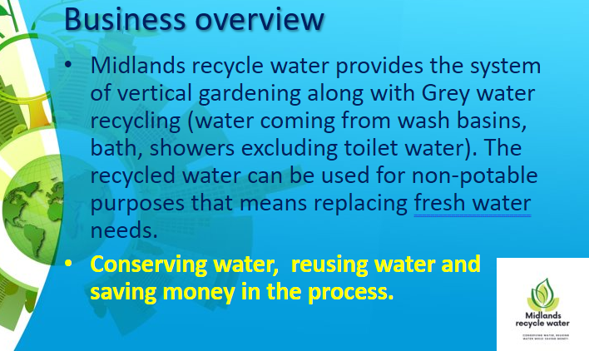
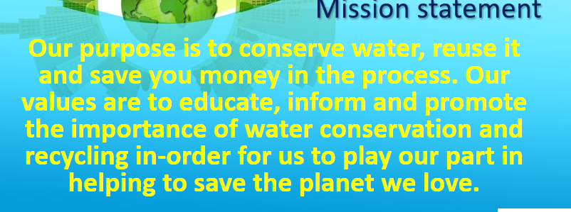
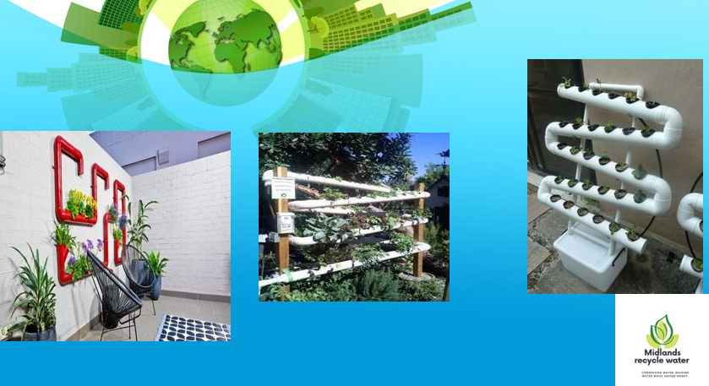
2. Product and Services

Name: Gloria Mihaela Alexe
Student id: 2019710

Product and service

Importance:
The importance of water recycling is increasing all over the world. Water recycling it can reduce the amount of polluted water and it can make it suitable for specific uses. Therefore, we have improvement which can improve the quality of the water and with a proper planning of the business can help the company improve in time. As for the improvement, the business plan it handles the expansion of the business (Schmidtova, and Formanek, 2019). The process then can make proper strategies for the business.
Quality of the product
Our main product is water. The primary goal of water recycling is that public health it is protected and the water quality it is acceptable to citizens. For the potable water recycling quality assurance is essential.
Issue with the service
Recycling water can extend water supply, save energy, and reduce the cost of wastewater; therefore, we can say water recycling is energy-intensive (that because it takes lot of energy to treat the water, however the more intensive is the treatment the more energy it is needed.
Start-up
The main for the start-up business is the water. With the start-up, us, the organizers will be able to make sure about the availability of the pure water to the citizens. We are determined to supply almost eighty litres of water to every family for their use every day. With the star-up, we must be more aware and careful about the techniques and machinery system.
Supply chain
We need to make sure the strong water supply chain collects the dirty water and supplies the pure water to the citizens. For being the most essential object for living being, the pure water supply can provide a healthy life to the citizens (Schlegel et al., 2020).
Planning of the supply is where we can provide allocation of water entitlements and supply water for the environment and develop implementation.
The UK supply chain have a lead for being recognized as a world leader in global business for water recycling.

Availability of the raw water
There are factors affecting water supply like:
1.Climate (low levels of rainfall and elevated temperature)
2.Pollution (some places have plenty of water, but pollution has made it unsafe)
Improvement
Water recycling can make significant improvements in streamlining process.
Proper maintenance
The water recycling requires cleaning the control panels in pump house and treatment plant. The tanks need to check for any deficiencies and clean it if necessary.

Conclusion
The water problem of the nation will be solved by the implementation of the business.
For the business to be successful water recycling requires careful planning, financial analysis, and the effective operation. With an increase of the planning an implementation of water recycling correct cost dates are essential.
The business should be considerate an integral and permanent part for planning in the future. Through water recycling planning, the use of it will supply flexibility to allow short terms needs and to increase water supply reliability.

References:
Journals Dearman, D., Lechner, T.A.
Honig, B. and Samuelsson, M., 2021. International Journal of the Academic Business World

3. Market audit
Name: Cosma Monalisa

Student Id :1921082

Market audit

- Introduction
Marketing as a function is under increasing pressure, to develop and to implement business- oriented methods and measures to improve not just marketing, but also overall effectiveness off business in our business we use only water ready is use and reused every day

- Importance of water
Water is necessary on our planet. With the new business plan what we have found now is possible for us to save the planet.

- Location: university and hospitals
Hospitals and universities have no need to invest more as they have already got special tanks for collecting water.
Regarding materials we`ll use bio and eco materials the plan mast covers any detail on how to implement the solution on site.
The licenses and approvals are to be issued by the local authorities and local regional suppliers.
The plan must cover any details on how to implement the solution on site.

Competitors
On our process, like any other competitor we must supplies to our client's clean water. But why choose us? Because we use only low-cost biomaterials to recycle and use over and over the same dark water transforming it into clean water.

SWOT analysis

Strengths: we use always only what we already have: dark water. No additional fees on the process.
Save the world as didn`t waste any unusable water.

Weakness: during maintenance (every 6 months) there`s a risk that any pipes brakes or get stuffy.

Opportunity: s we are new on the market, we got the opportunity to provide a service the customer`s didn`t got before and all that on a lower cost than they already got.

Threats: There`ll be always competitors trying to take over but as long as the solution implemented as it should, we`ll always get advantage of.

Pestle analysis

Promise a better world grace at our solution.
Significant impact on the client's budget as lowest costs on the market.
Given the chance to everyone to get access to clean water.
No technology is needed as our solution is as simple as everyone can benefit from.
Save the planet with our solution as all used materials bio/eco friend.
Our solutions were implemented only after getting all approvals and licenses from the local authorities.

4. Target Market
Target market

Our client covers an enormous range on the market.as we have no age restriction, no gender discrimination, no education limit, no martial importance don`t matter them status on the society, race, or religion.

5. Marketing Plan

Name: Tracey Arthurs
Student id: 1920224

MARKETING PLAN

The Marketing plan for Midlands Recycle Water (MRW), is an operational document it explains in great detail the advertising strategy that a business or organisation implements to generate leads and reach its target market. It should be well thought out, carefully researched and analysed.
The marketing plan is specific in introducing our product to our chosen market. Before the marketing plan is developed we must firstly, know who our customers are and what they require.

We’ve identified that in the 1st phase our customers will primarily be educational and health establishments such as:
- Nursery’s
- Schools
- Colleges/Universities
- Halls of residence
- Residential Care Homes
- Hospitals
According to Anglian Water. Co.uk schools spend a total of around £70 million a year on water, a large secondary school can spend as much as £20,000 per year on water. Therefore, they need to reduce the amount of water used and that the water they’ve used isn’t lost and that there is an alternative use for it, alongside saving money. Our system can potentially save up to 40% off the cost of water used. The system container collects used (grey water – from wash basins, baths, showers, excluding toilet water). The collected used water is then filtered through our vertical wall system where special plants are placed within the system to clean the water for reuse. That water can also be used in unique creative ways such as creating thriving communal/community gardens and mini allotments projects which encourages participation and has educational and health benefits. Ultimately, the system will allow the users to save money, reduce water usage and help to save the planet.

What are its aims
The aim of our marketing/sales plan is help customers gain an understanding of the products our company is offering and how our product will meet their needs. So, having a successful marketing campaign is quantified by an increase in sales.
Think about:
- Capture attention – introduce the world to Midlands Recycle Water, in terms of advertising and promotion on all platforms to all audiences because we all require ad use water.

- Educate – provide educational information to help customers make the best possible purchasing decision and present them with information to facilitate their buying decision for our product and services. People are searching for a solution that we provide and need to prove that we are experts at what we do, so if we’re not providing adequate information they will seek out our competitors

- Convert – We need to provide our prospective customers with clear concise messaging about how our product will solve their problem making it easier to choose us over the competition.
Conserve water / recycle reuse/ save money/ help to save the planet

What are its primary role?
The primary role of the marketing plan includes the following, to:
- Demonstrates to potential investors that the company will offer returns and grow into a successful business.
- Identify the most beneficial target market as already discussed we will be targeting educational and health establishments
- Look closely at our competitors, eg, Severn Trent offers a personalised water fit ways to save water, energy and money. However, this doesn’t include innovation such as MRW

4 P’s Marketing Mix
The 4P’s are: Product / Price / Place / Promotion
This will communicate our marketing vision and competitive advantage to our customers
The USP (unique selling point) of the business is:
- Water conservation
- Save money, lower water usage
- Sustainable
- Use of plants that clean/ purifies the water
- Easy to install and operate, easy to clean, durable, efficient, competitively priced

PRODUCT
The selection of our product/service and branding will be a critical part of our marketing mix
The brand identifies the goods and services of our company from others through our design MRW symbol, name or other distinguished features. It’s our company’s way to communicate to customers about our price, quality and that they know what they are getting. Our advertisement and promotion are designed to encourage and convince customers that MRW will inspire them to think about the importance of water, recycling of water, conserving water and that they are doing their part to improve and save the planet in addition to saving money.
Our marketing of MRW should be integrated, we can fuse the marketing element into the product to have one flowing stream of communication to the customer, marketing is an integral part of the business.
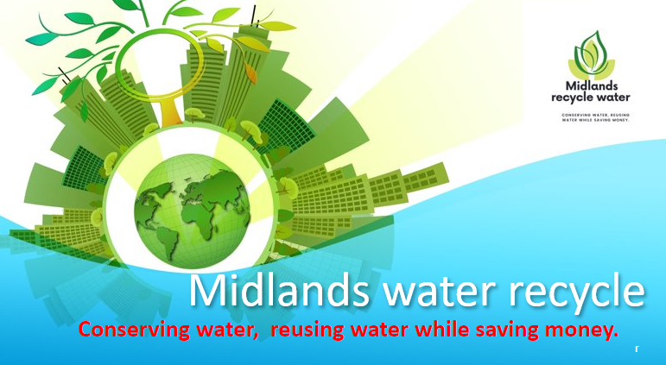

PRICE
What the price says about our product
- The Pricing strategy is not about one size fits all, it must be priced in line with our competitors until our product is established as market leader. We must take into consideration that mass market products may be priced at a lower level.
Our pricing has been reached by calculating cost of materials, overheads and labour which comes to one third of the cost plus £450 for installation:
Eg, Size 2 Medium £4350 divided by 3 = £1450 + 450 = £1900 profit

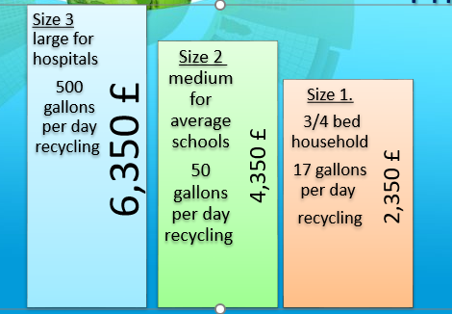

PLACE
This looks at the location of the business and its distribution, the type of business we are running will influence our choice of location and distribution system for reaching out from that place to our customers
- Our Warehouse/unit will be located in Aston Birmingham 6
- It will house our Product, equipment, van, office, trade centre
- Location is easily accessible
- Lower overheads
- Out of city centre, cheaper rent, more space, no Clean Air Zone charges, free parking
- Close to the motorway having easy access to all routes across the country

MRW offer accessories to purchase online to include information and equipment/plans to create community/school garden or allotment using their own recycled water.
PROMOTION
- We have created a brochure, leaflets, posters to promote our product and service
- Launched Social Media interest creating an interactive web-page, FaceBook, Twitter, Instagram etc, all platforms to increase traffic to our site
- Meet with the Local Authority and Primary Care Trust to gather interest and get their support and buy-in. Then consider a pilot project then endorse roll out to other education and health establishments
- Visit schools, universities, care homes and hospitals presenting our product and reinforcing our mission statement that ‘Our purpose is to conserve water, recycle, reuse it and save money in the process. Our values are to educate, inform and promote the importance of water conservation and recycling in-order for us to ply our part in helping to save the planet we love’.
- In addition to publicity, we can build positive public relations for the company through our involvement in the local community and in local, national, professional and business organizations, also:
- Special events
- Networking
- Sponsorship
- Public Speaking

References:
The Ultimate Marketing Plan (Dan S Kennedy)
Mind Tools.com
https://entrepreneurhandbook.co.uk

6. Management Team

Name: Tracey Arthurs
Student id: 1920224

MIDLANDS RECYCLE WATER
MANAGEMENT TEAM

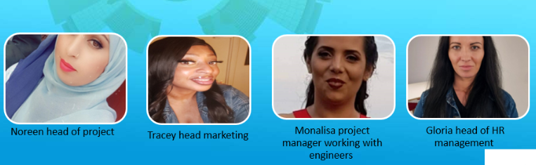

Noreen Akhtar – Head of Project responsible for overseeing all aspects of the project to ensure quality is of high standard and that everything is running according to our plans and timetable. Main duties are:
- Managing the team bringing leadership and direction
- Monitoring system built orders and progress
- Overseeing finance
- Ensuring project quality

Tracey Arthurs – Head of Marketing, overseeing digital marketing, advertising and communications. I established and run the company’s brand, image, messaging and all of the ads and marketing projects that come with it. Managing the effective delivery of the business plan and marketing strategy.
- Researching and developing marketing opportunities

Mona Lisa Cosma – Project Manager lead role planning, implementing, monitoring, controlling and completing projects. She is accountable for the project team, scope, resources and also the success or failure of a project.
- Lead the team ie contractors etc
- Monitor project progress
- Solve any issue that might arise
- Ensure stakeholder satisfaction
- Evaluate project performance

Gloria Mihaela Alexe – Head of HR Management has overall responsibility for the company’s personnel and training strategy. Advising the board on the human resource implications of its decisions, recruitment and selection, training and development, performance management, employee relations, employment law, administering pay, benefits, leave and enforcing company policy and practices

7. Financial Plan
Name: Noreen Akhtar
Student id: 2016489



