Research,
build, &
deploy
a virtualized network

(Coursework 1)

Submitted By:
Sohaan Sureshkumar
2221048
Module: Network Operating Systems and Services

Lecturer’s Name:
Carlene Campbell

Table of Contents
INTRODUCTION 3
1.1 Purpose of the Report 3
1.2 Overview of Virtualized Networks 3
1.3 Importance of Hypervisors and Network Services 3
TASK 1: RESEARCH REPORT 4
2.1 Hypervisors 4
2.1.1 Definition and its Purpose 4
2.1.2 Types of Hypervisors 4
2.1.3 Architecture and Resource Management 5
2.1.4 Scalability, Security, and Performance 5
2.1.5 Comparison of Hypervisors 6
2.2 IP Addressing 6
2.2.1 Role of IP address in Data 6
2.2.2 IPv4 VS IPv6 6
2.2.3 Subnetting and CIDR Notation 7
2.2.4 Role of IP Addressing in Virtualized Networks 7
2.2.5 Efficient Use of IP Addresses 7
2.3 Routing 8
2.3.1 Routing and Its Role 8
2.3.2 Static Routing vs Dynamic Routing 8
2.3.3 Common Routing Protocols Used 8
2.3.4 Routing in a Virtualized Network Environment 8
2.4 Network Services 9
2.4.1 Virtual Private Networks (VPNs) 9
2.4.2 Dynamic Host Configuration Protocol 9
2.4.3 Active Directory Domain Services 9
TASK 2: TECHNICAL DOCUMENTATION 10
3.1 Virtual Network Deployment 10
3.1.1 Choosing a Hypervisor 10
3.1.2 Downloading and Setting Up the Hypervisor 10
3.1.3 Configuring Virtual Machines 13
3.1.4 Testing Network Connectivity and Troubleshooting 17
3.1.4.1 Successful Connectivity Within Same Networks 17
3.1.4.2 Unsuccessful Connectivity Within Different Networks 23
3.1.5 Network Topology In a Tabular Representation 24
TASK 3: REFLECTION 25
4.1 Virtual Network Deployment 25
4.1.1 Technical Reflection: Deployment & Testing Challenges 25
4.1.2 Personal Reflection: Learning Experience & Takeaways 25
REFERENCES 26

INTRODUCTION

  - Purpose of the Report
Virtualization is widely applied in the modern computing environments for enhancing the performance of networks, resource utilization and security [1]. The objective of this report is to explain the function of virtualized networks in the enterprise environment in relation to hypervisors, IP addressing, routing and network services. It is expected to provide a clear analysis and practical experience on the implementation of a virtualized network.

  - Overview of Virtualized Networks
A virtualized network is defined as a model of computing where the physical infrastructure is virtualized, and many virtual machines (VMs) can be hosted off the same underlying infrastructure [2]. This does so to enhance scalability, reduce costs, and increase the efficiency of the network administration [1]. Virtualized networks are widely used in cloud computing, enterprise IT environments, and data centres [3]. They are realized with the help of hypervisors for VM creation and management, and networking protocols for optimal functioning of the virtualized components [2].

  - Importance of Hypervisors and Network Services
Hypervisors are the basis of virtualized environments that enable organizations to install and operate numerous operating systems on a single physical server [3]. They improve the hardware utilization, isolation and security [2]. In addition, other network services such as IP addressing, routing, DHCP, VPN, and Active Directory are also vital in the maintenance of the network stability, security and connectivity in a virtualized environment [1]. These components are important in order to understand how to build a virtualized network that is effective, robust and secure [3].

TASK 1: RESEARCH REPORT

2.1 Hypervisors
  - 2.1.1 Definition and its Purpose
A hypervisor, or Virtual Machine Monitor (VMM), is a hardware abstraction layer that allows multiple operating systems to run on the same physical hardware by partitioning hardware resources. This guarantees that each VM is isolated, and that CPU, memory, and storage are used efficiently [1]. Hypervisors cut the need for physical servers, thereby cutting costs, increasing scalability, and optimizing resource usage, which are critical in cloud computing and large enterprises [2].

  - 2.1.2 Types of Hypervisors
Hypervisors are categorized as Type 1 (Bare metal) and Type 2 (Hosted).
Type 1 hypervisors run straight on the hardware, without needing to trust a host OS. This direct interaction is more efficient, more secure and has less latency, and therefore suitable for cloud computing and enterprise virtualization [2]. Some of the examples include VMware ESXi, Microsoft Hyper-V, and Citrix XenServer which are commonly used in data centres and corporate IT infrastructures [3].
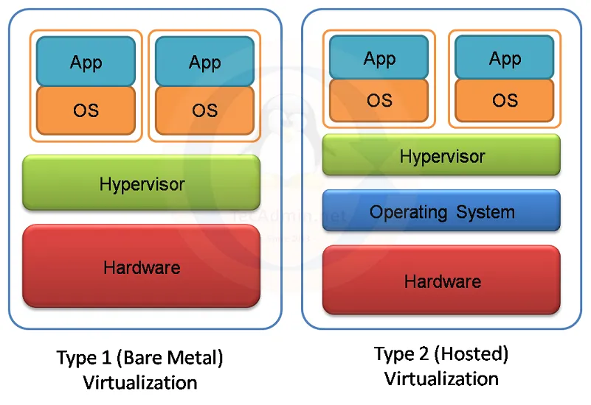
Figure 1: Types of Hypervisor Visualization [18]

Type 2 hypervisors are those that run on a host OS, meaning they depend on the existing system to control the hardware. Although they are easy to install and use, they are slower than other hypervisors because they are layered on top of the software [5]. Such hypervisors as Oracle VirtualBox and VMware Workstation are mainly used for testing, development, and the provision of different OS environments in a single computer [4].

  - 2.1.3 Architecture and Resource Management
The architecture of a hypervisor determines how it controls virtual machines, resources, and system performance. Type 1 hypervisors control directly the CPU scheduling, memory distribution and the storage access to reduce the latency and improve the scalability of the system [1].
Hypervisors of type 2 require host OS which leads to increased consumption of resources and thus reduces the efficiency [3]. Nevertheless, they are useful for those who require rapid virtualization without the need for high enterprise-grade performance [5].

  - 2.1.4 Scalability, Security, and Performance
Hypervisors enable IT infrastructure to scale efficiently, such that organizations can accommodate multiple VMs without having to accommodate this with physical hardware. This flexibility is vital in cloud computing environments where workloads are dynamically fluctuating [1].
Hypervisors sit between the virtual machines and physically separate them, preventing malware or some system failure from spreading.
The performance, however, differs with respect to the type of hypervisor. Type 1 hypervisors are faster and more efficient in the hardware control, and therefore suitable for the enterprise and cloud platforms [2]. On the other hand, Type 2 hypervisors are slower due to high latency but are still useful for development and testing [4].
  - 2.1.5 Comparison of Hypervisors
Among leading hypervisors, VMware ESXi is recommended for enterprise workloads, live migration, and high availability [1]. Hyper-V by Microsoft is a cost-effective option for organizations that are already using Windows Server by relying on it for Hyper-V [3].
For open source and lightweight virtualization, Oracle VirtualBox is available for all platforms and is extensively used for software testing [5]. At the same time, Citrix XenServer is intended for virtual desktop infrastructure (VDI) and GPU apps [5].

2.2 IP Addressing
  - 2.2.1 Role of IP address in Data
IP addressing serves as the basic means by which devices communicate and recognize one another to exchange data. Each device uses a unique IP address meaning devices can accurately deliver information and prevent lost or misrouted packets [6]. Large networks would experience decreased data transfer efficiency without structured addressing systems.
IPv4 remains the most widely applied protocol but has reached its address limits which has prompted a shift toward IPv6 usage [7]. The slow pace of IPv6 adoption persists because of compatibility problems while many organizations use IPv4 with NAT as a short-term solution for address management [8].

  - 2.2.2 IPv4 VS IPv6
The operation of data flow across networks relies on routers and switches to function properly. Through routing tables and IP addressing schemes routers establish the most efficient path for data packet transmission between different networks [9]. A local area network’s internal traffic management task falls to switches while they optimize performance by sending packets to MAC addresses [7]. The inadequate management of IP addresses produces network congestion along with elevated latency and security vulnerabilities which require subnetting and CIDR (Classless Inter-Domain Routing) strategies to optimize network performance and stability [6]. Enterprises along with service providers utilize these techniques to sustain scalable and reliable infrastructures [10].
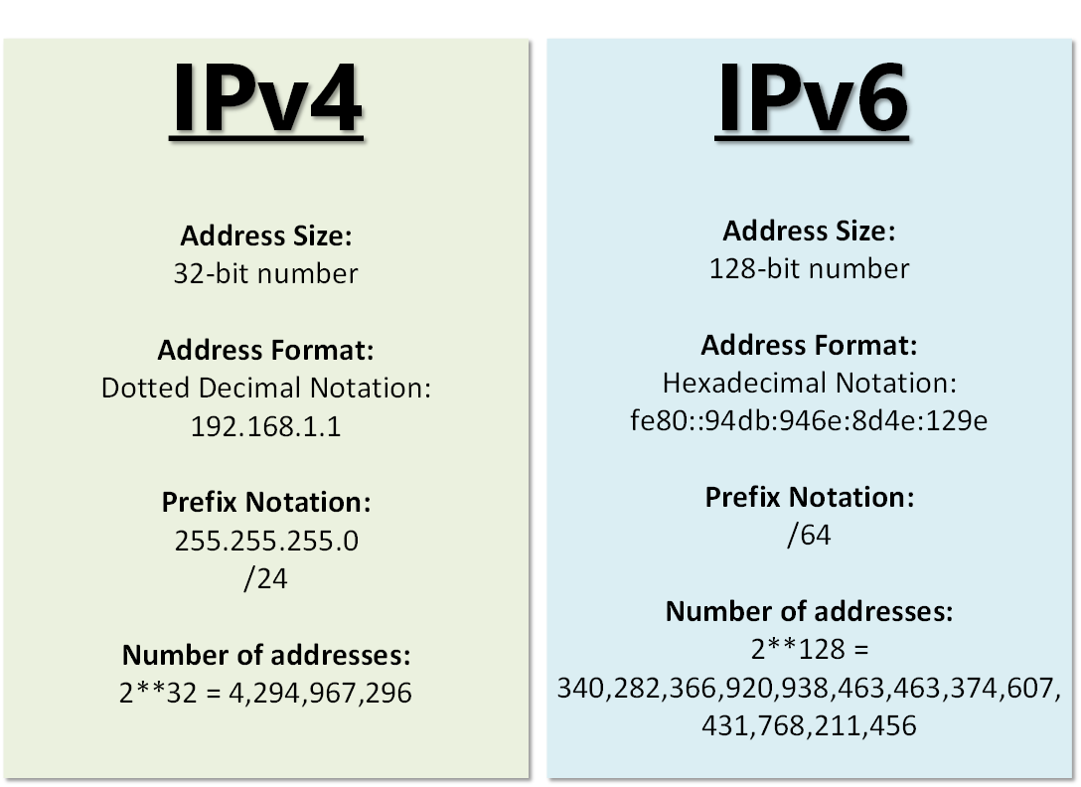
Figure 2 - Key differences between IPv4 and IPv6
  - 2.2.3 Subnetting and CIDR Notation
The 32-bit address system in IPv4 generates approximately 4.3 billion distinct addresses before depletion. The rapid increase in internet-connected devices has outpaced this available supply [6]. NAT provides a solution extending the use of IPv4 through address sharing yet introduces both latency problems and security issues among networks [8]. IPv6 provides 128-bit addresses to abolish necessary address translation devices and supports auto-configuring networks [9]. IPv6 has slow deployment conduct because organizations face transition expenses and dual-stack implementation difficulties while operating on legacy IPv4-based systems [7].

  - 2.2.4 Role of IP Addressing in Virtualized Networks
Subnetting is one of the most important ways of managing IP address space. It helps in dividing large networks into subnets to improve security, reduce congestion and avoid address conflicts [10]. CIDR enhances more flexible subnetting in flexible way as it does not have class-based restrictions on address allocation [6]. This is especially useful in enterprise level networks where IP management is huge to ensure that there is smooth operation of the network [9].
  - 2.2.5 Efficient Use of IP Addresses
This paper concludes that network security depends on IP addressing. The improper handling of IP addresses leads to several threats including IP spoofing, DDoS attacks and unauthorized access to systems [8]. Although IPv6 has stronger security features, the dual stack that is IPv4 and IPv6 coexisting can be mismanaged and lead to more vulnerabilities [7]. The future of IP addressing shall be influenced by the advancements in AI driven network management, automation, and improved security protocols to enhance the scalability and efficiency as well as minimize security risks [10].

2.3 Routing
  - 2.3.1 Routing and Its Role
Data packet transmission is at its best when it is traveling through routes of least length through networks. This is why routing protocols are used to properly have routers learn and update path information as it is an important part of maintaining efficient system performance, security, and the ability to expand networks [11] [12]. Routing decisions are made based on three different metrics which are hop count, bandwidth, and link reliability.
  - 2.3.2 Static Routing vs Dynamic Routing
The main difference between the two types of routing protocols is that static and dynamic routing protocols have their own set of advantages and disadvantages. Static routing is a form of routing that is manually configured and is highly stable and does not require a lot of resources. It is used in small and stable networks but has the disadvantage of not being very dynamic and is, therefore, not very suitable for networks with frequent changes in topology [13]. This means that any changes in the network must be done manually, which may lead to increased administrative complexity and the chances of making errors.

  - 2.3.3 Common Routing Protocols Used
A hybrid routing model is used by organizations which define static routes to guarantee critical paths and at the same time dynamic routing to optimize traffic distribution. It is still a question of routing when it comes to security. With unsecured protocols, traffic can be diverted, services interrupted, or bad routes injected, and they can be taken advantage of. To counter this, organisations use route filtering, encrypted updates, and anomaly detection systems [14].

  - 2.3.4 Routing in a Virtualized Network Environment
  - SDN software define networking and artificial intelligence optimization methods enhance routing function evolution. AI based routing systems reduce network congestion by making route changes ahead of time to optimize performance. According to research studies [12], SDN offers centralized traffic control functionality that enables organizations to realize real-time reconfiguration of routes to boost security and flexibility. Network expansion requires machine learning predictive routing integration as the essential solution for performance optimization and vulnerability reduction [11].

2.4 Network Services
  - 2.4.1 Virtual Private Networks (VPNs)
Tunnelling is done by VPNs to encrypt the traffic through the public network to gain access to the internal resources without revealing the sensitive information. They are applied in remote work, for the connection encryption, and for the lifting of geographic restrictions [15]. However, VPNs have strong authentication and can be a security risk if configured wrongly. Hence it is crucial that organizations should change their encryption protocols, should keep an eye on VPN activity, and should use multi-factor authentication (MFA) in order to prevent the risk of unauthorized access to the system [16].

  - 2.4.2 Dynamic Host Configuration Protocol
The use of DHCP also assists in the prevention of IP address confusion and assists in the expansion of the size of networks [17]. However, the use of DHCP servers is also a threat to the security of the network as well as the use of IP addresses that are not assigned properly. To reduce the risks and prevent conflicts and IP address exhaustion, it is advised that DHCP snooping should be enabled and unauthorized servers should be restricted [15].

  - 2.4.3 Active Directory Domain Services
AD DS should be used as the central authority for user authentication and access control for enterprise networks because it supports identity management. It assists the administrators in enforcing security policies, managing user permissions and optimizing resource management efforts [16]. This is not enough as AD DS is not impenetrable to privilege escalation attacks which may be caused by poor configuration. To this end, organizations should adopt the least privilege access and log all accesses [17].

TASK 2: TECHNICAL DOCUMENTATION

3.1 Virtual Network Deployment
  - 3.1.1 Choosing a Hypervisor
In this case, a Type 2 hypervisor is the right choice for this assignment for me personally since it is installed together with another operating system, which makes it easier to control and navigate through. A Type 1 hypervisor does not have this requirement since it needs bare metal installation which means it should have direct access to the hardware.

Working with a Type 2 Hypervisor reduces the complexity of the setup process and still provides a full control over networking configurations.

  - 3.1.2 Downloading and Setting Up the Hypervisor
1.
The needed operating systems such as Windows Server and Windows 11 for one network and Linux Server with a Linux Client for the other were downloaded from official websites.
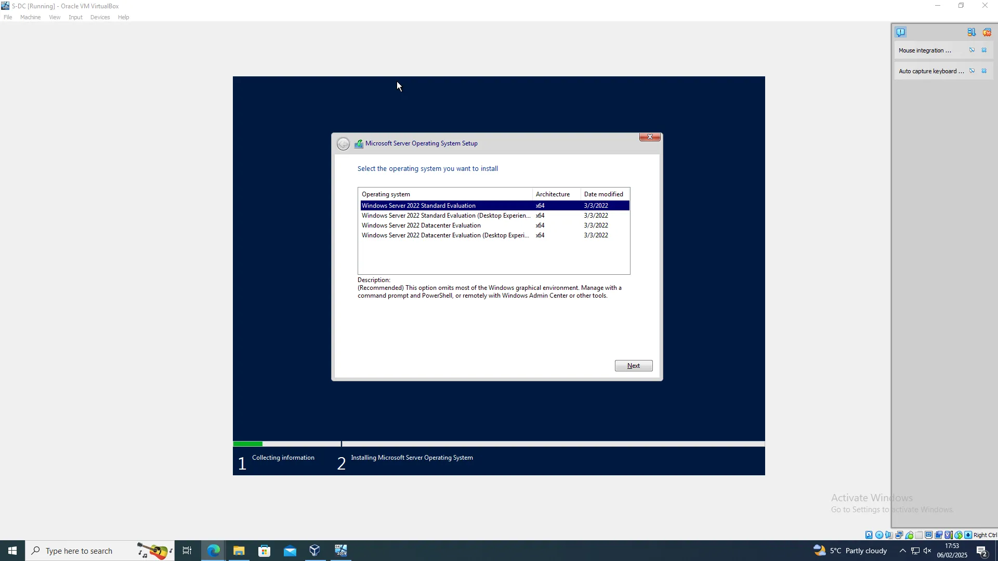
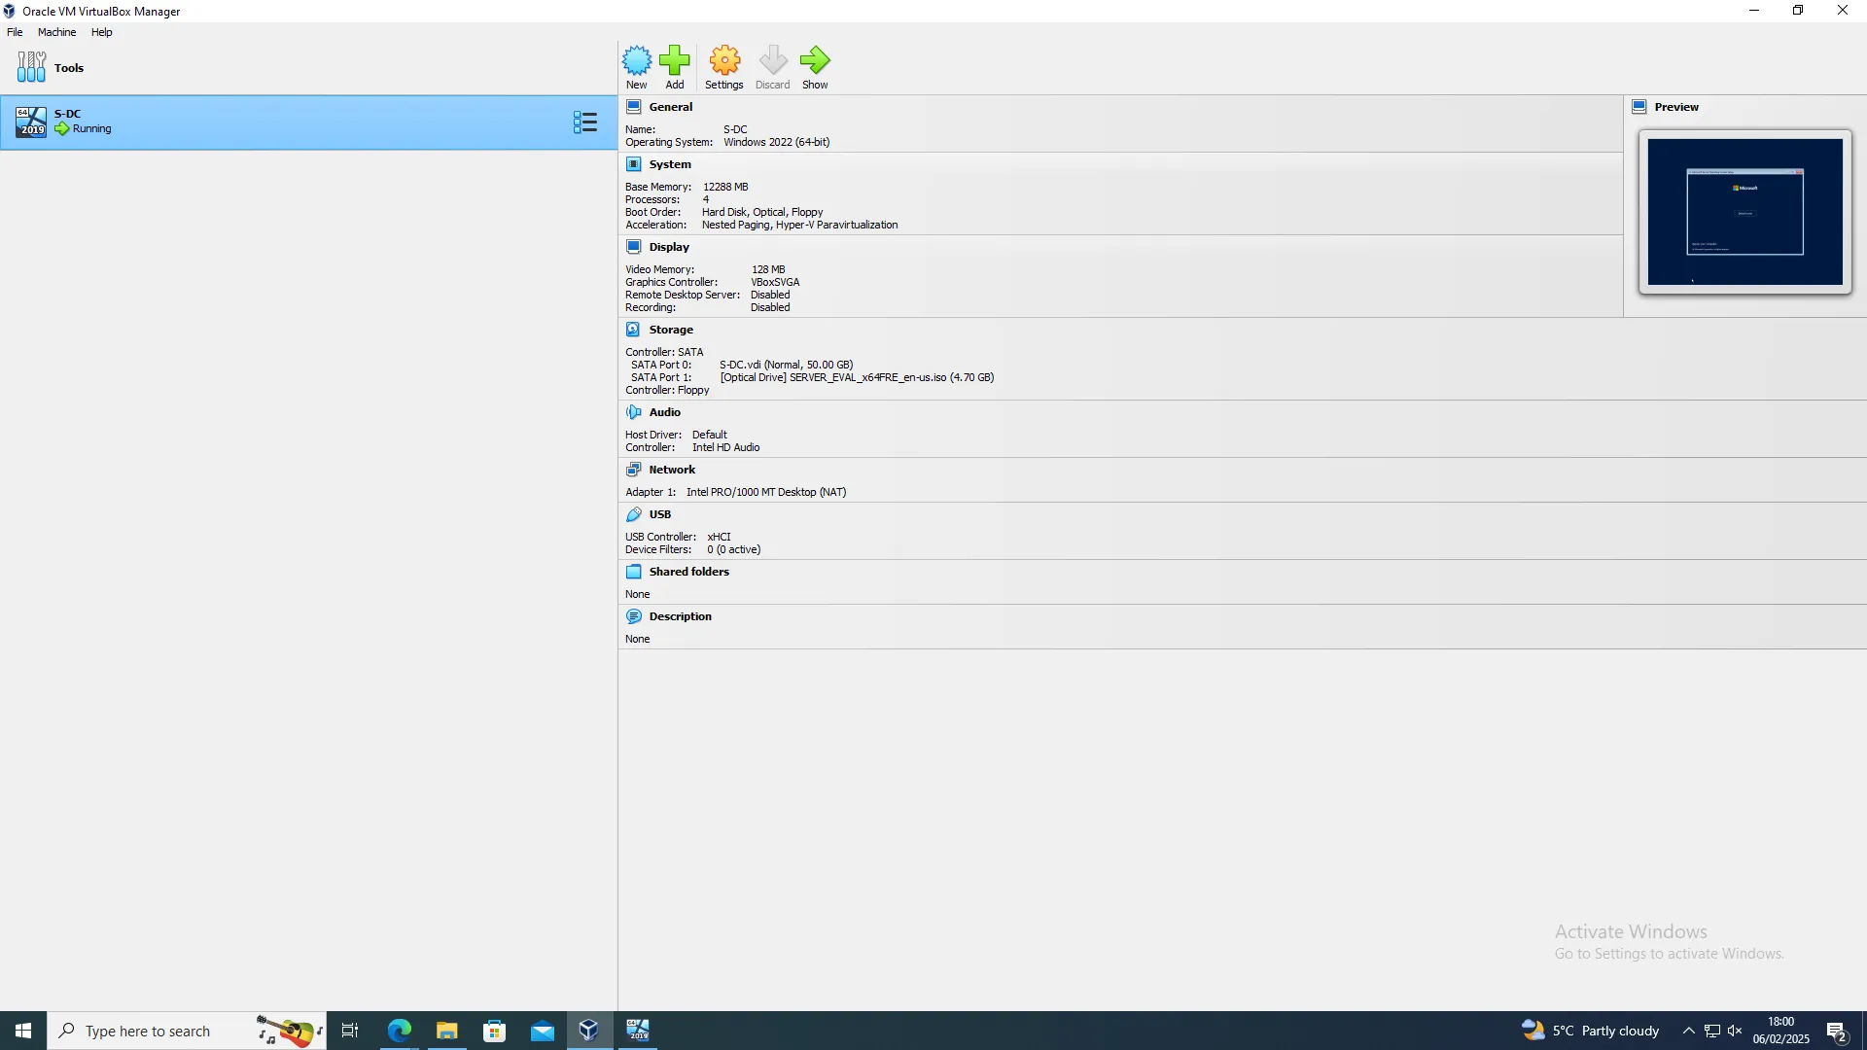
The virtual machines for both the Windows and Linux networks were built. The number of CPU, RAM and storage was set to what each system required. The network settings were also setup to mimic the given topology to enable communication between the virtual machines.

2.
The process of setting up the network consisted of installing Windows Server 2022, Windows 11, a Linux server and a Linux client in Oracle VM VirtualBox. First, Windows Server 2022 was installed, and the ISO file was inserted into the virtual machine and the normal installation process was performed. The correct edition was chosen, system files were copied, and the installation was successful.
When the Windows Server was set up, a virtual machine of Windows 11 was established. The process of installing Windows 11 involved a boot from the ISO file and then the guided setup of the OS making sure it was installed properly.
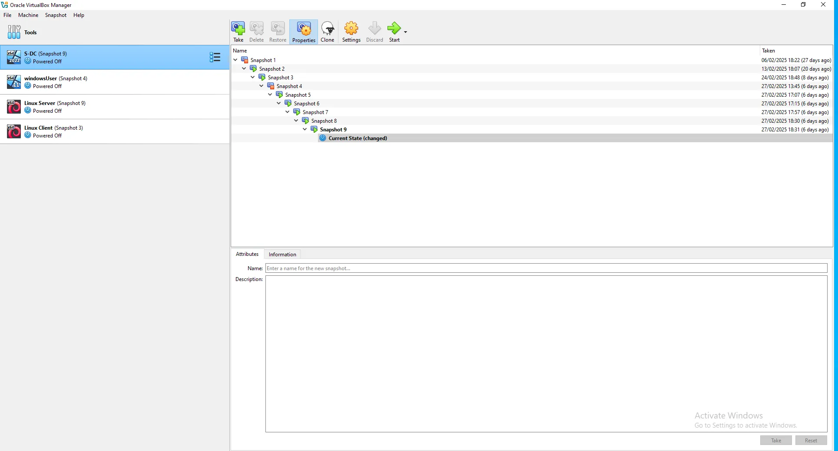
The Linux server and a Linux client were installed after the IP configuration of the Windows Client and Server. The Linux server was set up using Debian in this case and making sure that the system files were properly installed. Then the Linux client was established as one more virtual machine to finish the construction of the virtual network.

  - 3.1.3 Configuring Virtual Machines
Both the Windows Server and Windows 11 client were set to have static IP addresses in order. On the Windows Server the IPv4 settings were manually configured to be 192.168.1.1 with a subnet mask of 255.255.255.0 so that it could be the primary controller of the network. The Windows 11 client was given 192.168.1.2.
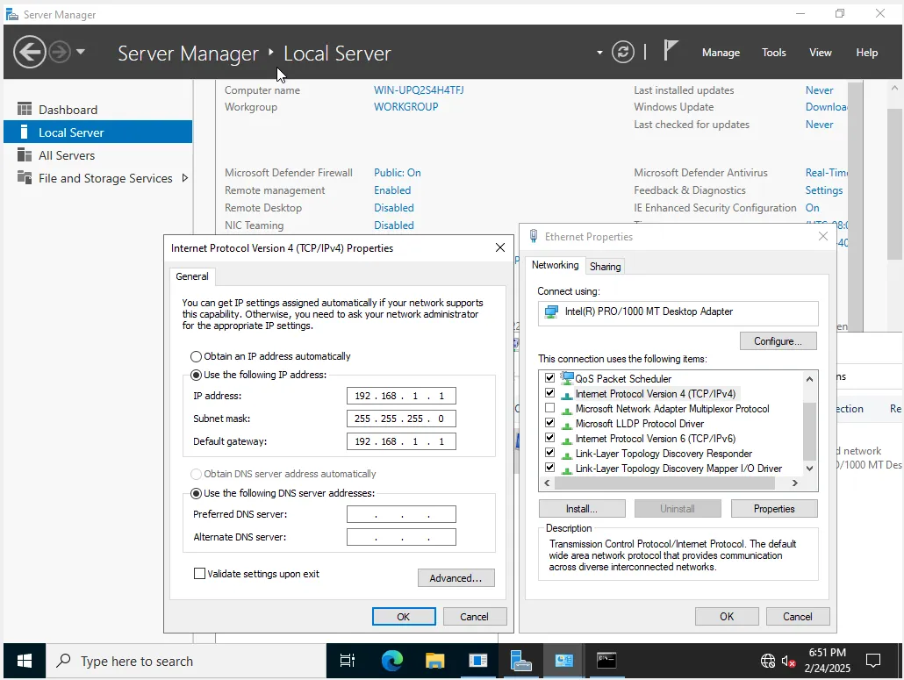
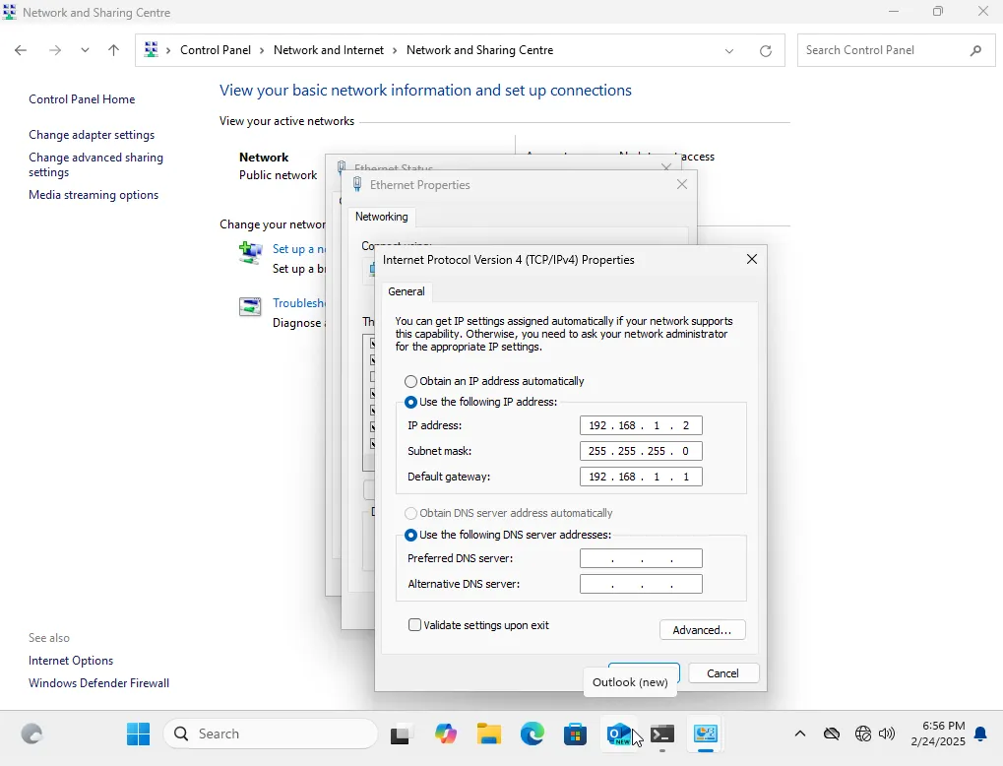
The Linux server was configured to use the interfaces file to assign static IP addresses to different network interfaces. The external interface of the Linux server which is connected to the Windows Server was given the address 10.0.0.4 while the internal interface which is connected to the Linux client was given 192.168.2.1. This way, both the Windows and Linux environments were properly isolated yet allowed to talk with their respective clients.
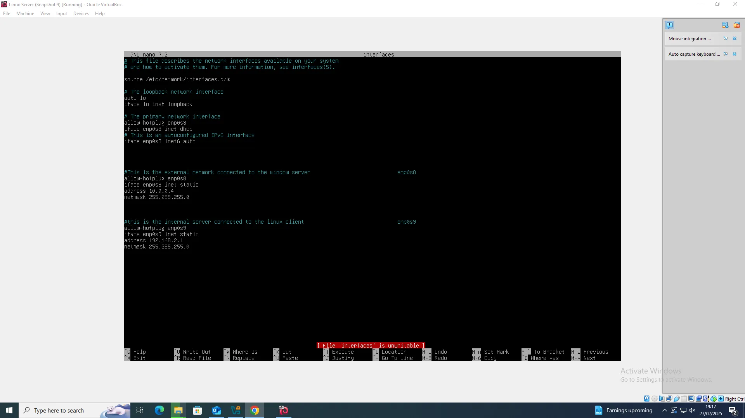

The Linux client configuration was set up with a static IP address in a similar manner. This configuration is used for connectivity within each network before routing is enabled, and it prevents traffic from flowing directly between subnets.
Below are the successful IP configurations of the Windows Server, Windows Client, Linux Server, and Linux Client respectively.
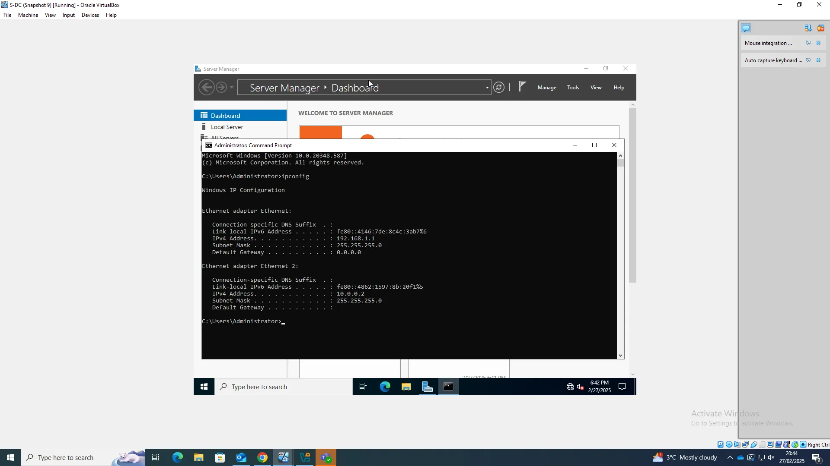
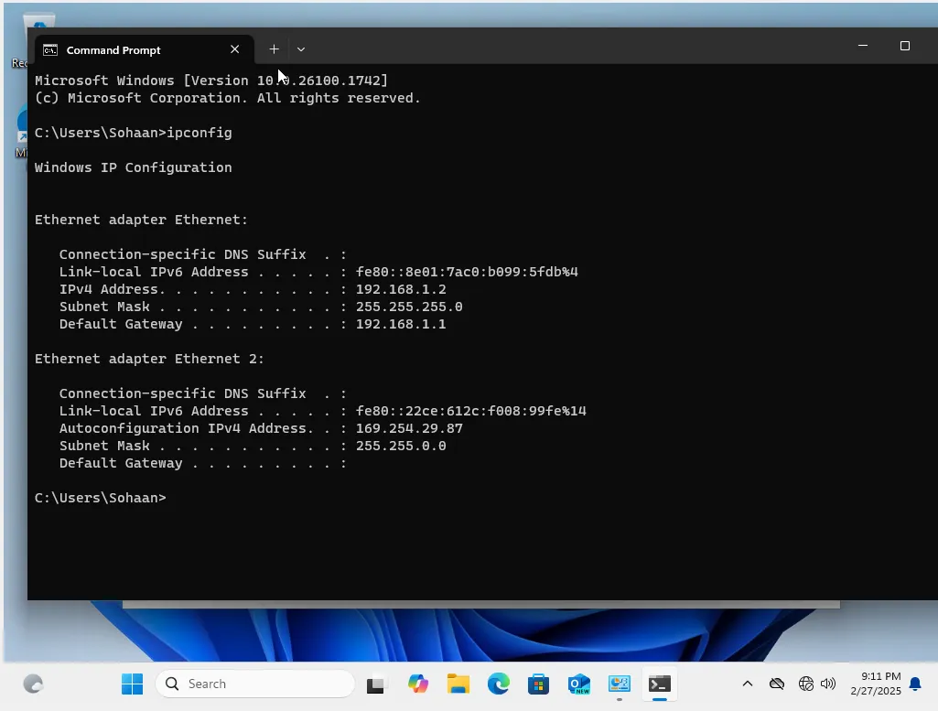
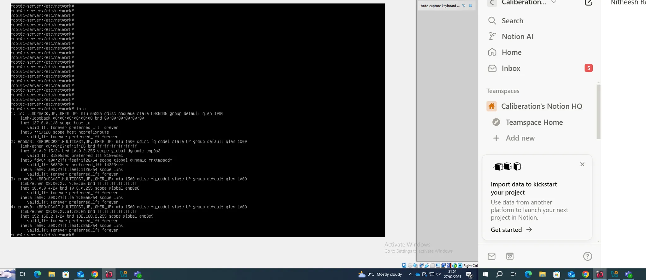
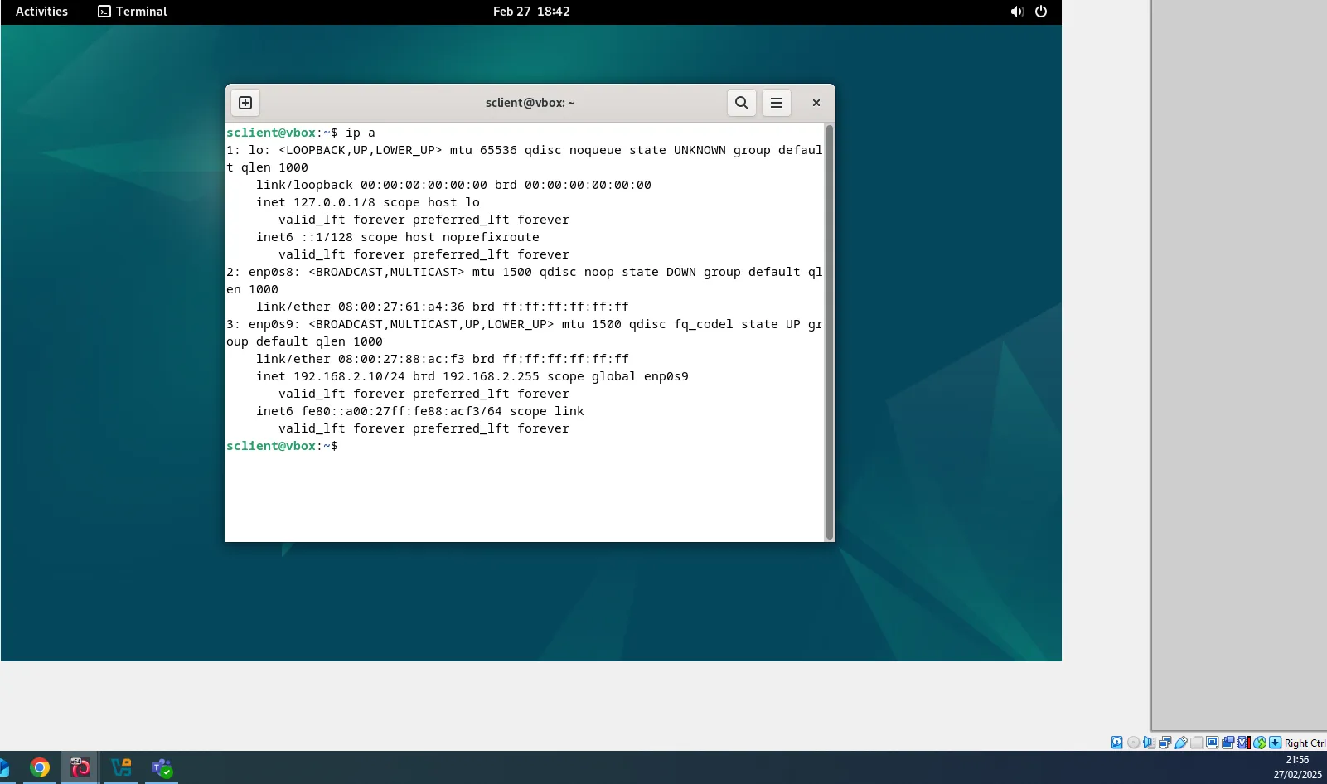

  - 3.1.4 Testing Network Connectivity and Troubleshooting
After setting up the network settings, connectivity tests were performed to confirm successful communication within the same networks.

  - 3.1.4.1 Successful Connectivity Within Same Networks
The first set of tests were conducted to check the internal connectivity among the systems that are linked to the same network. The Windows Server was able to ping the Windows 11 client with the help of static IP addresses 192.168.1.1 and 192.168.1.2, thus establishing a working connection. In the same manner, the Windows 11 client was able to ping the Windows Server, which shows the bi-directional communication. These results show that both devices were assigned to the same subnet and were able to send and receive packets without any loss.
Below are the successful pings between the Windows Client and Server, The Linux Client and Server, And the Windows Server and Linux Server.
Windows Server to Client and Client to Server:
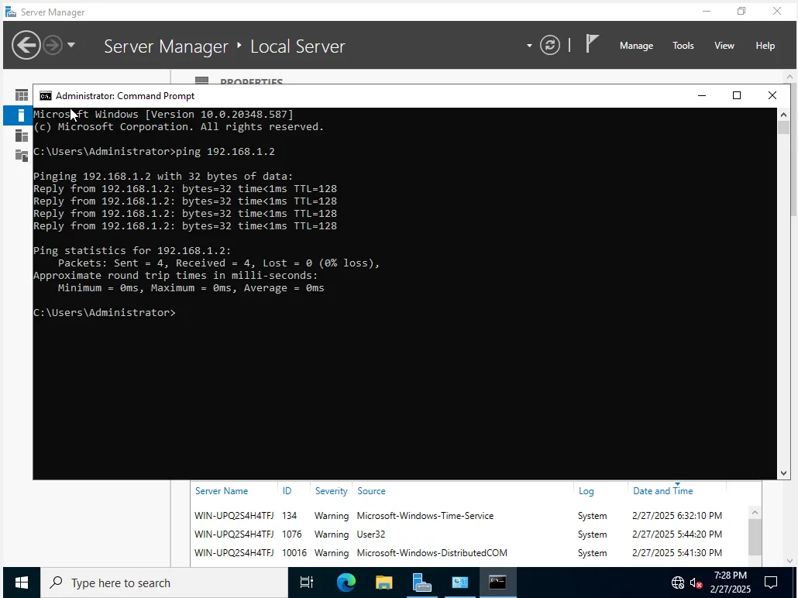
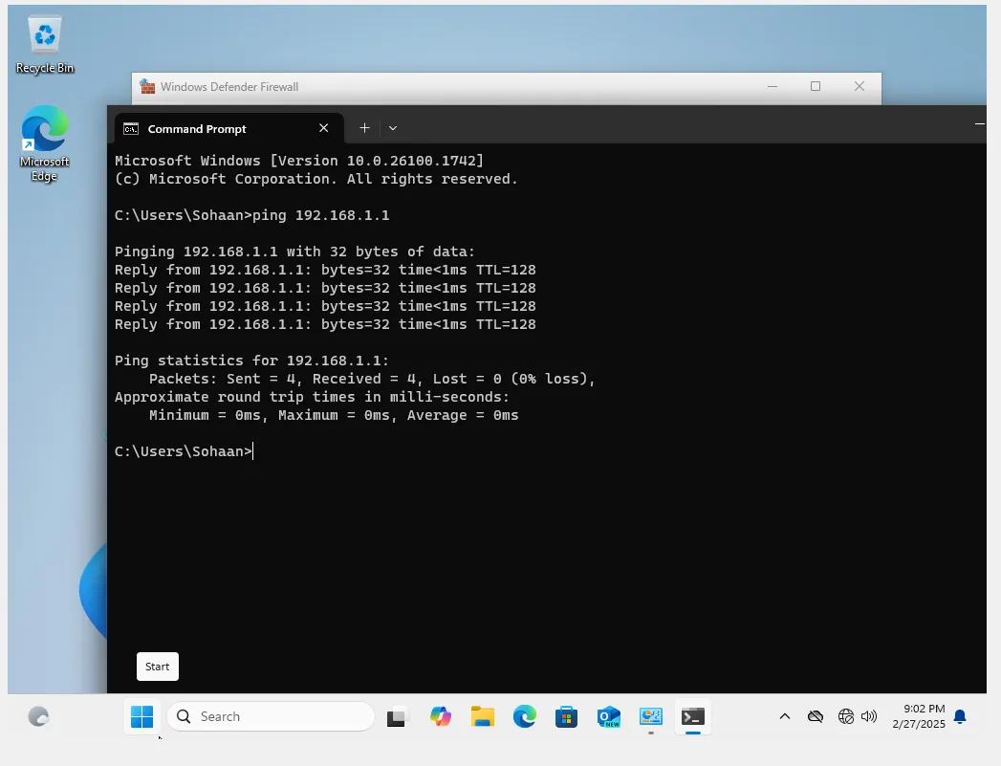
Linux Server to Client and Client to Server:
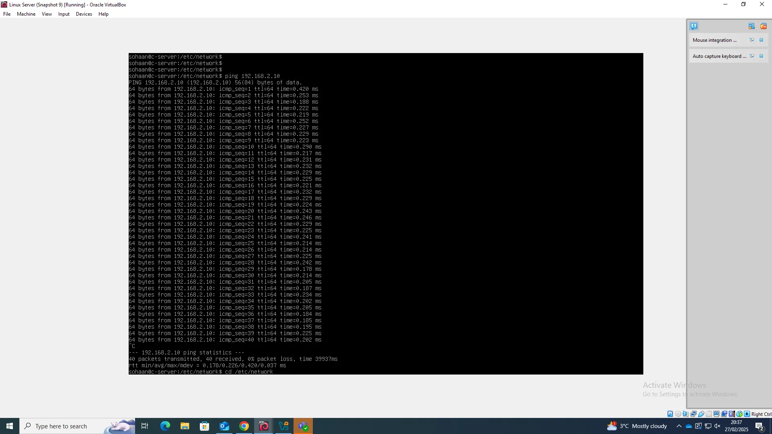
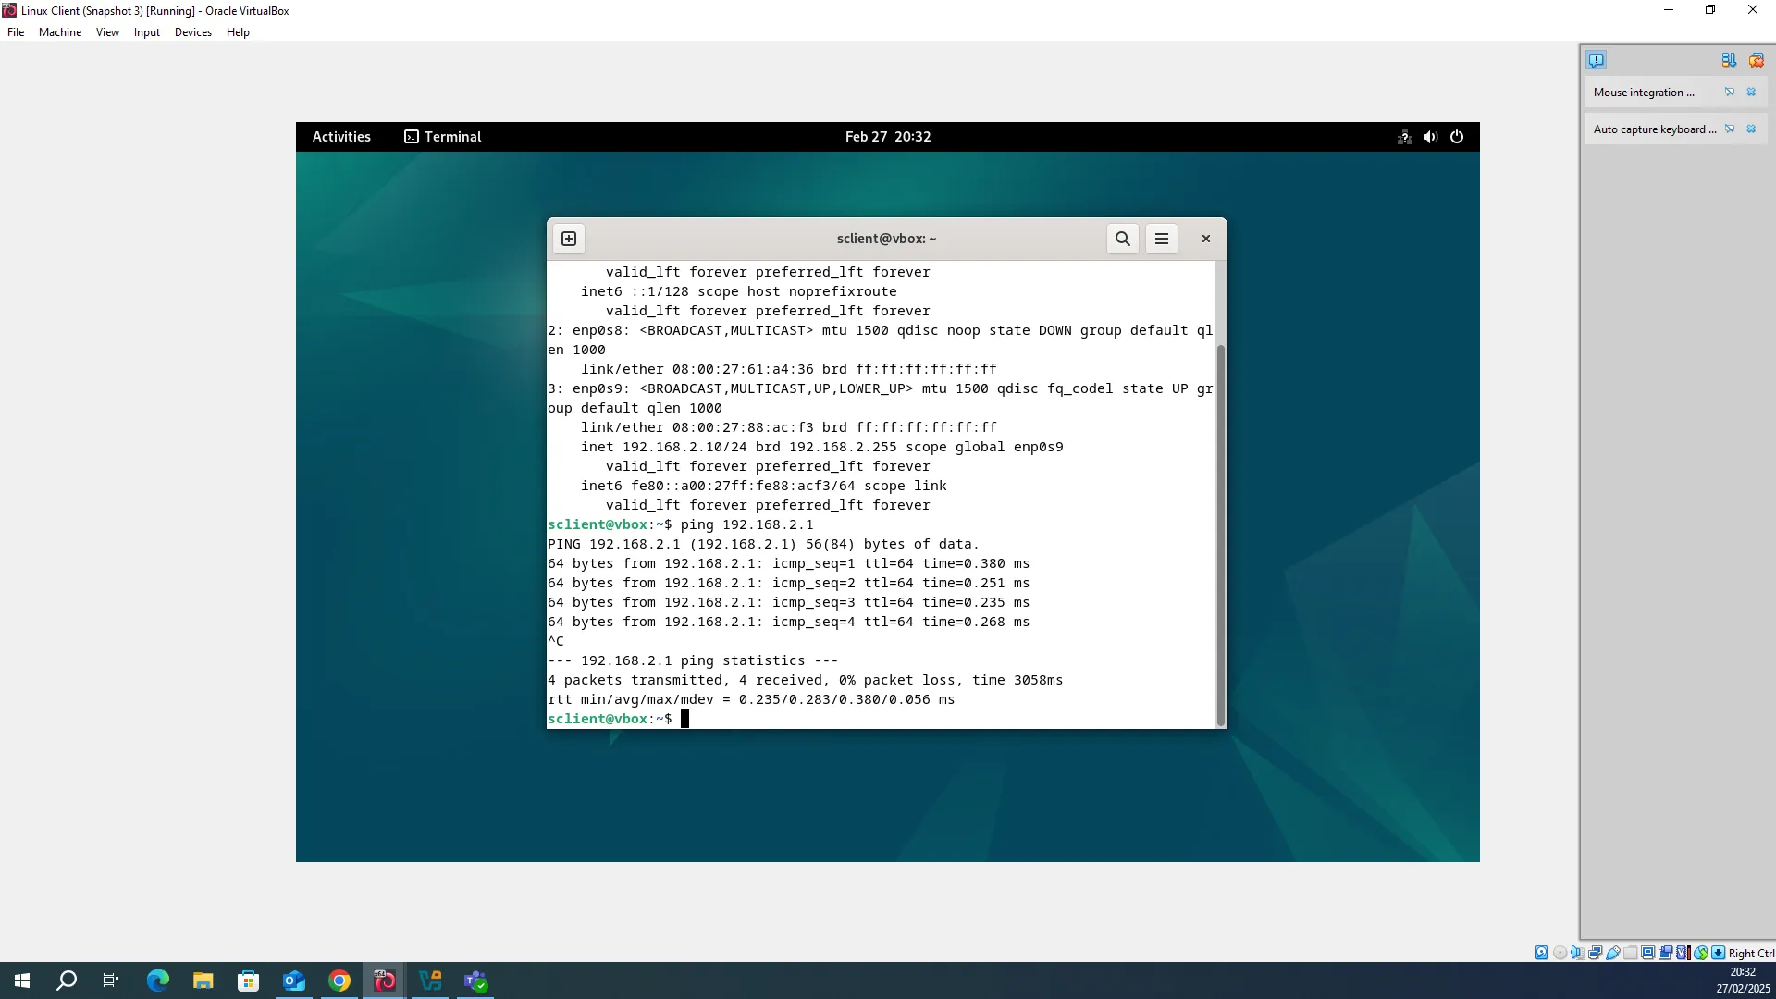
Windows Server to Linux Server and Vice versa:
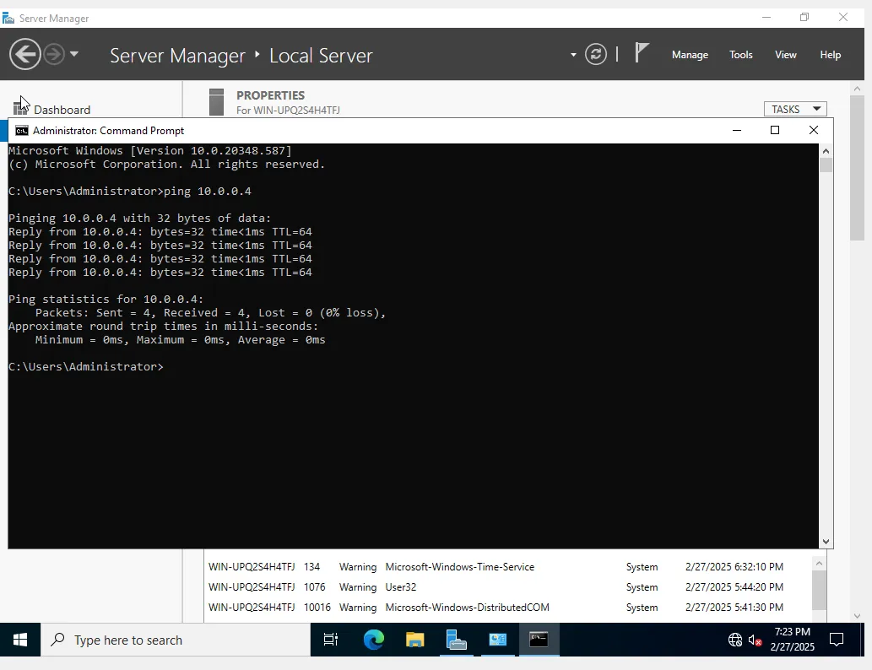
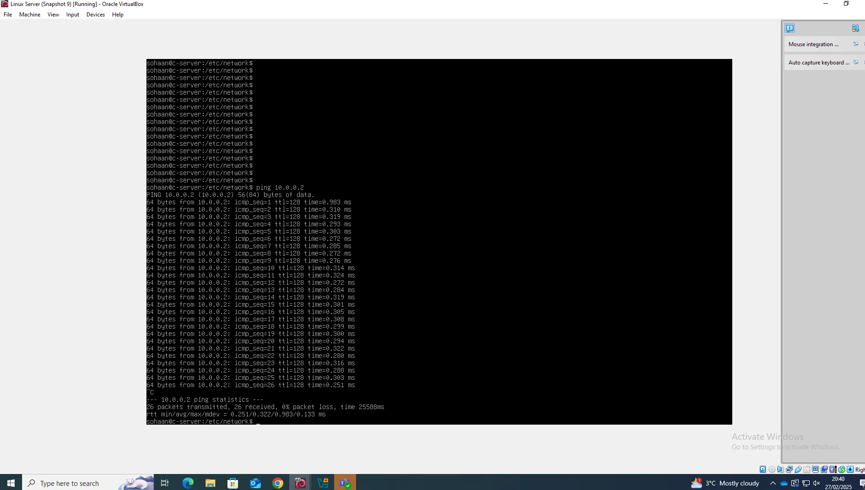

In the case of Linux environment, the Linux server was able to ping the Linux client using the IP addresses 192.168.2.1 and 192.168.2.10 respectively. In turn, a reverse test from the Linux client to the Linux server was also successful, indicating stable connectivity. The ping responses had zero packet loss, this confirmed that both machines were adequately networked and could exchange data without any loss.
Linux Server to Client and Client to Server:

Another test was performed, in this case the Windows Server was tried to be made to communicate with the Linux Server, the Windows Server (10.0.0.4) was able to ping the Linux Server (10.0.0.2). This means that the Windows and Linux environments were correctly configured in their respective subnets and were able to communicate as intended where they were expected to.
Windows Server to Linux Server and Vice versa:

  - 3.1.4.2 Unsuccessful Connectivity Within Different Networks
To validate the network segmentation, ping tests were conducted from one network to another by pinging devices. It was not possible to ping the Linux client at 192.168.2.10 from the Windows 11 client at 192.168.1.2, which gave Destination Host Unreachable, confirming that the systems could not talk while trying to ping across different network segments. In the same way, the ping from the Linux client to the Windows Server (192.168.1.1) also failed, which also indicates that the routing is not yet configured between these networks
windows client to Linux client and Vice versa:
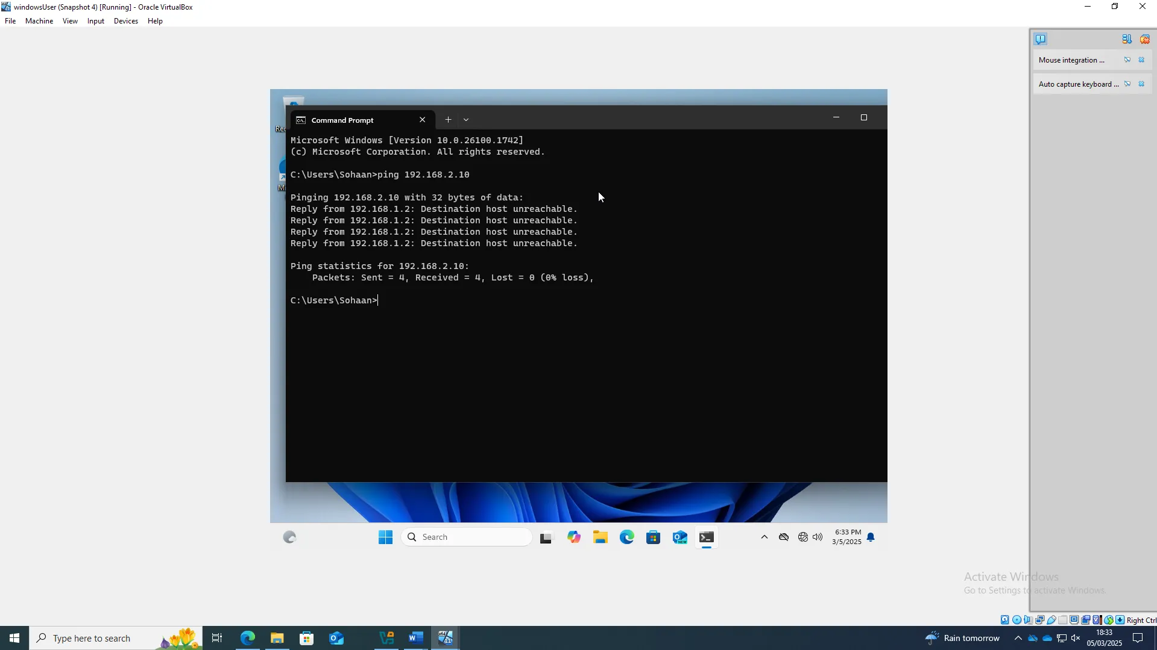
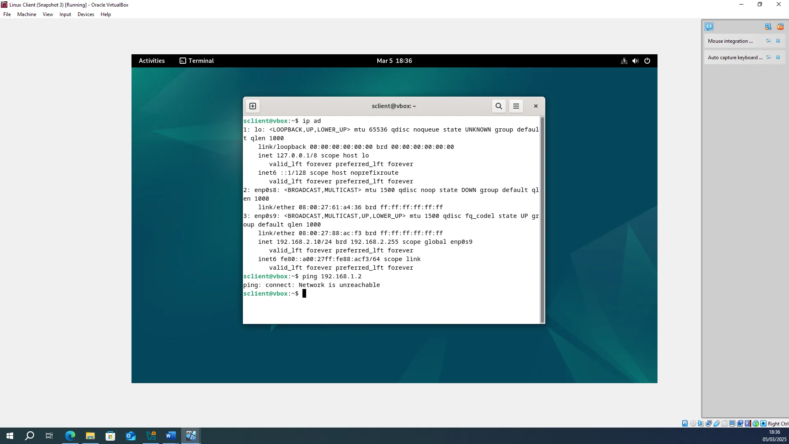
  - 3.1.5 Network Topology in a Tabular Representation

Device | IP Address | Connection Type | Connected To | Subnet
Windows Server | 192.168.1.1 | Internal | Windows Client | 192.168.1.0/24
Windows Client | 192.168.1.2 | Internal | Windows Server | 192.168.1.0/24
Windows Server | 10.0.0.2 | External | Linux Server | 10.0.0.0/24
Linux Server | 10.0.0.4 | External | Windows Server | 10.0.0.0/24
Linux Server | 192.168.2.1 | Internal | Linux Client | 192.168.2.0/24
Linux Client | 192.168.2.10 | Internal | Linux Server | 192.168.2.0/24

TASK 3: REFLECTION

4.1 Virtual Network Deployment
  - 4.1.1 Technical Reflection: Deployment & Testing Challenges
A primary issue was the Windows firewall blocking ICMP requests in the form of pings between the Windows Server and client. At first, I didn’t notice this but then I found out that both the server and client firewalls had to be disabled for the connectivity. Another difficulty was setting up the Linux server since I had no experience with Linux networking. Learning about static IPs and modifying network settings was also a process that I found quite challenging due to the troubleshooting involved.
  - 4.1.2 Personal Reflection: Learning Experience & Takeaways
Although this experience was challenging, it greatly enhanced my confidence around troubleshooting. First thing to do when having network problems should be to check firewall settings. It was also frustrating to work with Linux at times but by the end of it I felt quite comfortable using commands and configurations. In retrospect, the difficulties made the whole process more enjoyable, and I do feel more ready for the next setup.

REFERENCES
[1]
VMWare, “What is Network Virtualization? | VMware Glossary,” www.vmware.com. https://www.vmware.com/topics/network-virtualization

[2]
J.-J. B. Systems, “Explaining the Role of the Hypervisor in Virtualization & How It Benefits Businesses,” Jaffer Business Systems (Private) Limited, Apr. 17, 2023. https://jbs.live/explaining-the-role-of-the-hypervisor-in-virtualization/

[3]
“What is a Hypervisor? Types, Benefits, and Best Practices,” SentinelOne, Oct. 16, 2024. https://www.sentinelone.com/cybersecurity-101/cybersecurity/what-is-a-hypervisor/

[4]
W. Stallings, Operating systems : internals and design principles. New York, Ny: Pearson, 2018.

[5]
O. Pankevych, “Type 1 vs. Type 2 Hypervisor: What Is The Difference?,” StarWind Blog, Jul. 20, 2023. https://www.starwindsoftware.com/blog/type-1-vs-type-2-hypervisor-what-is-the-difference/

[6]
“Understanding IP Addressing and CIDR Charts,” RIPE Network Coordination Center. https://www.ripe.net/about-us/press-centre/understanding-ip-addressing/

[7]
“Understanding IPv4 and IPv6 Protocol Family | Interfaces User Guide for Security Devices | Juniper Networks TechLibrary,” www.juniper.net. https://www.juniper.net/documentation/us/en/software/junos/interfaces-security-devices/topics/topic-map/security-interface-ipv4-ipv6-protocol.html

[8]
S. B, “Differences between IPv4 and IPv6 - GeeksforGeeks,” GeeksforGeeks, Feb. 15, 2019. https://www.geeksforgeeks.org/differences-between-ipv4-and-ipv6/

[9]
D. Garn, “Introduction to IP addressing and subnetting | TechTarget,” Networking, Dec. 26, 2023. https://www.techtarget.com/searchnetworking/tip/Introduction-to-IP-addressing-and-subnetting

[10]
T. Titus, “Benefits of Automated Server Monitoring,” Pathsolutions.com, 2023, doi: https://doi.org/1063565235/1641500668494/module_61063565235_Social_links_Icons_2021

[11]
M. Kubilius, “A Comprehensive Guide to Network Routing,” IPXO, Apr. 01, 2022. https://www.ipxo.com/blog/network-routing/

[12]
Cisco Press, “Dynamic versus Static Routing (3.1.2) > Cisco Networking Academy’s Introduction to Routing Dynamically | Cisco Press,” www.ciscopress.com, Mar. 24, 2014. https://www.ciscopress.com/articles/article.asp?p=2180210&seqNum=5

[13]
geeksforgeeks, “Routing Tables in Computer Network - GeeksforGeeks,” GeeksforGeeks, Sep. 03, 2019. https://www.geeksforgeeks.org/routing-tables-in-computer-network/

[14]
Z. Ali and W. Shahzad, “Critical analysis of swarm intelligence based routing protocols in adhoc and sensor wireless networks,” International Conference on Computer Networks and Information Technology, Jul. 2011, doi: https://doi.org/10.1109/iccnit.2011.6020945.

[15]
nicole.keller@nist.gov, “Securing Network Connections,” NIST, Aug. 24, 2020. https://www.nist.gov/itl/smallbusinesscyber/guidance-topic/securing-network-connections

[16]
iainfoulds, “Best Practices for Securing Active Directory,” learn.microsoft.com, Nov. 10, 2023. https://learn.microsoft.com/en-us/windows-server/identity/ad-ds/plan/security-best-practices/best-practices-for-securing-active-directory

[17]
R. Chandramouli, “Guide to a Secure Enterprise Network Landscape,” csrc.nist.gov, Nov. 17, 2022. https://csrc.nist.gov/pubs/sp/800/215/final

[18]
R. Patel, “Understanding Hypervisors: Exploring Type-1 vs Type-2 and Full vs Para Virtualization,” Medium, Feb. 20, 2024. https://medium.com/@ravipatel.it/understanding-hypervisors-exploring-type-1-vs-type-2-and-full-vs-para-virtualization-71b4dad9abd9

[19]
“What is IPv6?,” NetworkAcademy.io. https://www.networkacademy.io/ccna/ipv6/what-is-ipv6

