

Bachelor of Arts in Applied Business
LEVEL 5

Module Name: Enterprise Development and Commercial Innovation
BMBS5000

Module Lead: Chris Wilkin
Student name: Laura Minea
Student number: 2321195

Trimester 1
2026- 2027
Contents
1. Value Proposition Canvas (VPC) 3
2. Business Mind Map 3
3. Reference list 4
4. AI Statement 6

Value Proposition Canvas (VPC)

https://canva.link/zx5g7ogt5y4o0iv

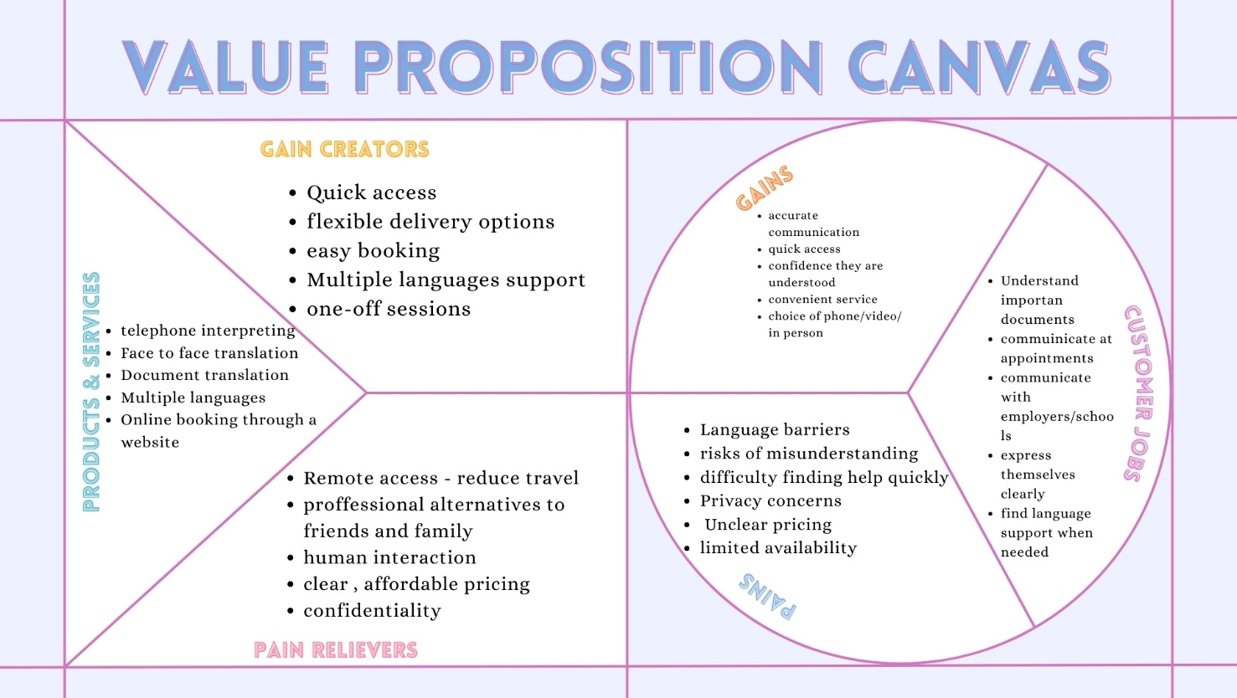

Business Mind Map

https://mm.tt/map/4098066773?t=xwUhuqTcOY

Reference list

Association of Translation Companies and Nimdzi Insights (2023) ATC UK Language Services Industry Survey and Report 2023. Available at: The 2023 ATC UK Language Services Industry Report (Accessed: 25 September 2026).
Barringer, B.R. and Ireland, R.D. (2022) Entrepreneurship: Successfully Launching New Ventures. Updated 6th edn. Harlow: Pearson.
Bender-Salazar, R. (2023) ‘Design thinking as an effective method for problem-setting and needfinding for entrepreneurial teams addressing wicked problems’, Journal of Innovation and Entrepreneurship, 12, Article 24. doi: 10.1186/s13731-023-00291-2.
Bowman, C. and Faulkner, D. (1997) Competitive and Corporate Strategy. London: Irwin.
Brown, T. (2008) ‘Design thinking’, Harvard Business Review, 86(6), pp. 84–92, 141.
Christensen, C.M., Raynor, M.E. and McDonald, R. (2015) ‘What is disruptive innovation?’, Harvard Business Review, 93(12), pp. 44–53.
Islami, X., Mustafa, N. and Topuzovska Latkovikj, M. (2020) ‘Linking Porter’s generic strategies to firm performance’, Future Business Journal, 6, Article 3. doi: 10.1186/s43093-020-0009-1.
Lindhult, E., Chirumalla, K., Oghazi, P. and Parida, V. (2018) ‘Value logics for service innovation: practice-driven implications for service-dominant logic’, Service Business, 12, pp. 457–481. doi: 10.1007/s11628-018-0361-1.
Osterwalder, A. and Pigneur, Y. (2010) Business Model Generation: A Handbook for Visionaries, Game Changers, and Challengers. Hoboken, NJ: John Wiley & Sons.
Osterwalder, A., Pigneur, Y., Bernarda, G. and Smith, A. (2014) Value Proposition Design: How to Create Products and Services Customers Want. Hoboken, NJ: John Wiley & Sons.
Porter, M.E. (1980) Competitive Strategy: Techniques for Analyzing Industries and Competitors. New York: Free Press.
Puchała-Ladzińska, K. (2016) ‘Machine translation: A threat or an opportunity for human translators?’, Studia Anglica Resoviensia, 13. doi: 10.15584/sar.2016.13.9.
Rivera-Trigueros, I. (2022) ‘Machine translation systems and quality assessment: a systematic review’, Language Resources and Evaluation, 56, pp. 593–619. doi: 10.1007/s10579-021-09537-5.
Sarasvathy, S.D. (2001) ‘Causation and effectuation: Toward a theoretical shift from economic inevitability to entrepreneurial contingency’, Academy of Management Review, 26(2), pp. 243–263. doi: 10.5465/AMR.2001.4378020.
Shepherd, D.A. and Patzelt, H. (2021) Entrepreneurial Strategy: Starting, Managing, and Scaling New Ventures. Cham: Palgrave Macmillan. doi: 10.1007/978-3-030-78935-0.
Vieira, L.N. (2020) ‘Automation anxiety and translators’, Translation Studies, 13(1), pp. 1–21. doi: 10.1080/14781700.2018.1543613
Witell, L. (2025) Service Innovation and Management : Digitalization, Service Infusion and Customer Experience. 1st ed. Edited by L. Witell. Cham: Springer Nature.

AI Statement
I confirm that I have not presented any AI generated text as my own work. I confirm I have copies of my drafts, notes, and other resources I used before, and after the use of AI tools which I may be asked to
provide in evidence.

