
EFECTIVE TEAM WORKING AND COMMUNICATION WITHIN THE WORKPLACE

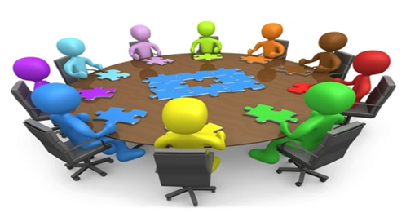
December 16, 2022
SIMONA MARILENA PATRASCU
2123259

WORD COUNT:2182

EXECUTIVE SUMMARY

The purpose of this report is to highlight key issues and challenges faced by management department of local council followed by some recommendation and suggestion which will allow them to implement productive practices which can enhance the overall productivity of the organization and help the managers to fulfil the needs and demands of the employees effectively. Moreover, the report signifies numerous communication model like Berlo, Shannon-Weaver and Schram and teamwork theories including Tuckman and Belbin which will help human resource department to formulate effective techniques to improve the functioning of the business organization.

Contents
EXECUTIVE SUMMARY 1
1.0 TERM OF REFERENCE 3
2.0 INTRODUCTION 4
3.0 MAIN FINDINGS 5
3.1 BELBIN’S THEORY 5
3.2 TUCKMAN’S THEORY 6
3.3 SPECIFIC ISSUES AND CHALLENGES 8
3.4 BERLO 9
3.5 SHANNON-WEAVER 10
3.6 SHRAMM 10
4.0 RECOMMENDATIONS 12
5.0 CONCLUSION 13
6.0 REFERENCES 14
7.0 APPENDICES 15

TERM OF REFERENCE

This report was requested by Melanie Squire on the date 16 of December 2022, the purpose of the report is to show all the areas and lectures covered in the module Effective Team Working and Communication.

2.0 INTRODUCTION

Effective teamwork and communication are essential in an organization to understand the views and opinions of other people and also help an individual to present their ideas in front of the managers. Teamwork is essential for the success and growth of an organization. Working in team reduces work load and leads of innovation in an organizational framework. When employees work collectively around a same work it improves the productivity of the work and ensure that task and duties are divided in a proper way according to the skill set of employees (Donald and Carter, 2020).

3.0 MAIN FINDINGS

3.1 BELBIN’S THEORY
Meredith Belbin suggests the teamwork theory form the point of view of employees and highlighted nine major team role that can help employee to analyses their own strengths and weaknesses in order to perform the task effectively and productively. The nine-role elaborated by Belbin are:
• The Resource investigator- These individuals are proficient in networking and are extrovert in nature. They are positive workers who want to explore new opportunities and bring new innovation in their organization.
• The Team worker- they are extroverts and friendly in nature. They are good listener and provides assistance to their team members to inspire them work effectively.
• The Co-Ordinator- They are an individual who have strong interpersonal skill and communication skill, they are in managerial position but their style of conducting activities in quite different from shapers.
• The Plant- they do not consider facts while implementing a decision and are considers as free thinker and provide innovative and creative ideas to execute a certain task.
• The Monitor evaluator- the monitor evaluator make decision based on certain facts and rational thinking in contrast to emotion and instincts. They are the individual who excel at critical thinking and strategic planning and have a strong determination for work.
• The Specialist- a specialist is a member who is an expert in a particular field. They serve as the valuable asset to an organization as they deliver specialized knowledge to conduct a task in a productive manner.
• The Shaper- the shaper is the extrovert who motivate themselves and other to perform their respective task effectively. They remain calm and positive and like in work under pressure (Kurtzo, et.al, 2019). They like to work in a challenging and competitive environment and encourages other members to accept challenges in their daily life.
• The Implementer- they like to properly organize their things in order to perform their task.
• The Completer Finisher- they are the perfectionist who look for fine details which help them to check finished task and provide suitable solution for errors.
This theory will help managers to differentiate between distinct roles that an individual performs while working in an organization. The leaders of the council should conduct research within the organization in order to understand the role portrayed by the employees. They can also provide effective training to employees in order to encourage them to perform their duties well. However, the managers must figure out what qualities they are seeking in employees which can help company to grow and flourish.

3.2 TUCKMAN’S THEORY

Tuckman theory was developed by Bruce Tuckman in the year 1965. As per this approach the leader of the council can divide the performance of the team under 5 stages including forming, storming, norming, performing and adjourning. He suggested that team take time to grow through clearly defined stages, from forming a team to cohesive, task focused team. Each particular stage plays a crucial role in forming an effective and productive team:
• Forming- At the first stage the managers should unite the team members with each other and should instruct them about their respective roles and responsibilities in a polite and pleasant manner. The senior members delegate instruction to their subordinates and the team members are at their best behavior and focused on themselves (Guttenberg, 2020). At this stage the team leader must understand the attitude and behavior of employees, the manager must distribute task and responsibilities to employees effectively according to their respective interest.
• Storming- In this stage the team members of the council should allow employees to gain knowledge about the characteristics of each member. The managers can face difference in opinion among employees and they may disagree with each other in order to perform a particular task in this stage. The team members may also question their authority and mentors for the work and personalities may clash. This stage can also lead to conflicting situation among employee which can impact the productivity of the team.
• Norming- At this stage people start to respect each other and appreciate the strength of team members. Each employee seriously takes their respective responsibilities to perform a certain task and contribute effectively in achieving organizational objectives (Robb, 2022). Teams begin to trust themselves during this phase as they accept the vital contribution of each member to the team. The top managers must leave employee to solve a particular situation at in order to check their problem-solving skills.
• Performing- It take a lot of time and efforts to reach at performing stage, it is considered as the era of high performance. In the performing stage, the team members are confident, motivated and familiar with their project work and can handle the operations and function without any supervision.
• Adjourning- The Tuckman added this fifth stage in 1977. In this stage, the team is disbanded as the required task is complete for which team was formed.
The managers of the local council can adopt this model in order to analyses on which stage their team is working and can apply suitable measures to make their team more product who can highly contribute in the success and growth of an organization. It will help them to solve conflict between employees by providing them effective training and development programs.
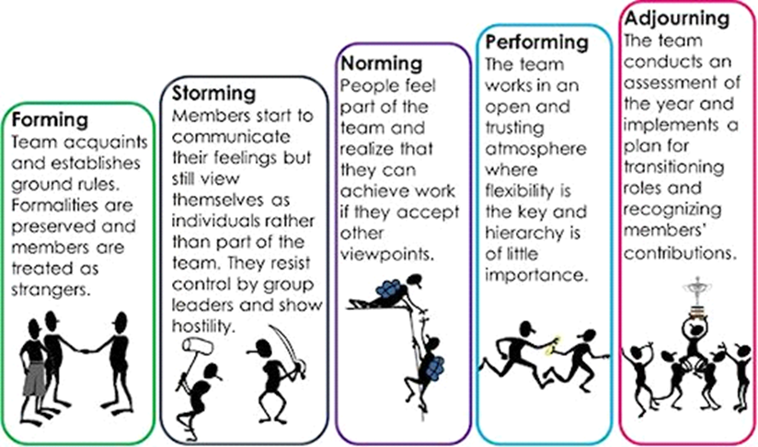

3.3 SPECIFIC ISSUES AND CHALLENGES

The major issues and challenges that the local council includes employee turnover which has created a problem of shortage of labor in an organization. In the organization Andrea Jones who is the in charge of human resource department who managers a workforce of 96 people divided in 12 teams. The people of the organization are working from home during the pandemic, but with the conditions getting better the managers want to encourage employee to return to office premises which will help them to improve the mental health of employees, to offer better working condition to them and in order to conduct the activities if the business (Kiweewa, et.al, 2018). The major challenges faced by the organization are briefly stated below:
• Shortage of labor- The employees do not want to return to office to peruse business activity however, the managers are persuading employees to return premises this has created a shortage of labor in an organizational framework.
• Lack of induction- It is the responsibility of managers to provide induction to the fresh employees hired in the course of business so as to educate them about the working and operations of the business.
• Team management- The team has been placed in two separate building which can create a problem to manage different team. Some team does not have a proper manager which has lead social worker to work under pressure as they do not have proper instruction to execute their task and responsibility, which is also a cause of employee turnover (Holbeche, 2018).
• Workplace culture- When the senior employees returned to office premise, they have to face new faces, this has created the problem of miscommunication among workforce. There is no proper structure to delegate the information in the organization and managers are using informal way in delivering the duties which has caused severe mistakes in the working. (Scholl, 2018)
• Workload- The managers have provided bundle of case studies to employees which has created workload and stress in the organization and no proper training and induction has been provided to the employees which has created chaos in the workplace.

3.4 BERLO

This communication model is divided into four categories which will help managers to formulate proper communication within an organization. The stages are as follows:
- Source- Source or sender is a person who initiates the conversation and transfer it to the receiver by properly converting the information into message. The speaker should have effective communication skill and must put the message in a proper way which is understandable by the receiver (Leahy, Cotter and Oldham, 2019).
- Message- It is the process in which converts the thoughts sender into a message, the process is also known as encoding. A proper message contains following elements content, structure and code. The message should be portrayed in a well-defined structure which receiver can understand properly.
- Channel- It is the medium through which the message is been delivered to the receiver.
- Receiver- Receiver is the person who gets the message conveyed by the sender. After analyzing and understanding the message the receiver must provide relevant feedback to the sender. This process is also known as decoding

3.5 SHANNON-WEAVER

It is one of the famous models of communication which is created by Warren Weaver and Claude Shannon in 1948 (Carradini, 2020). They depict how message is been communicated between sender and receiver. There are seven components which forms the base of the model:
- Sender- Sender is the person who originates the message. The message should be in a proper format which is feasible for the receiver.
- Transmitter- It is also known as encoder; it can be a person or machine which helps in encoding the message so that the receiver can read it and understand it.
- Channel- It serves as the medium through which the sender has sent the message.
- Noise- The process of the communication should be free from any disturbance which as it could affect the meaning of the message. (Orbe and Harris, 2022)
- Decoder- It could be a machine or equipment and a person which will help receiver to understand the information conveyed by sender.
- Receiver- Receiver is the person who receives the message delivered by the sender.
- Feedback- It is the response of the receiver to the sender in respect to the message or information delivered by the sender.

3.6 SHRAMM

This model focuses on three elements of communication which is required to complete the process of communication which includes the source, message and the destination which is the receiver (Bergman, 2019).
The head of the HR department in the local council can use Berlo communication model as it will allow them to delegate instruction in a productive and effective manner and offer clear information to the employees to execute their respective task in the organization, it will eventually help in improving the performance of an individual as they have proper understanding of the task that has to be performed. However, the managers should follow the principle of unity of command and direction which signifies that an individual should be liable to one boss and must receive order from one person in order to avoid confusion which can affect their performance.

4.0 RECOMMENDATIONS

The managers must recruit high skilled employees which can highly contribute in the growth and development of the department. The human resource department should try to fill to managerial position which can provide required instruction to the team members. Then they should work to recruit social worker to stabilize the team. Each team consist of team manager, deputy manager, a consultant and nine social worker and the HR department should try to fill top position first and then work to recruit social worker (Mohanty and Mohanty, 2018). The managers must provide equal opportunities to each employee to present their views and opinion, The managers must not consider employees as inferior and involve in the managerial decision-making process.
The HR manager should provide effective training and development programs which will help employees to understand the functionality of the department. The managers should use formal way of delegating information in the department al framework in order to provide proper instruction to the employees. The managers must conduct induction and training programs and this should be conducted in the first week to educate employees about the functions of the company.
The managers must work to relieve the workload among employees by properly dividing task between employees and must implement activities to relieve the stress among employees and must create a competitive environment in which employees like to work and must create a healthy and positive working condition.

5.0 CONCLUSION
The above report evaluates the significance of team work in a group which can help businesses to gain competitive edge in the market. The report highlights the major teamwork theories including Tuckman and Belbin theory which managers can implement and formulate in order to enhance team productivity and efficiency in the department. Furthermore, the report signifies major issues and challenges that the department has faced which could affect the operations of the department. The issues faced by the organization are employee’s turnover, lack of induction and workload on which managers should pay greatest importance. In addition to this the report demonstrates numerous communication model which can help managers to formulate instruction in an organization structure.

6.0 REFERENCES
Bergman, M., 2019. Toward a Pragmatistic Perspective on Models of Communication. In Models of Communication (pp. 47-63). Routledge.
Carradini, S., 2020. A comparison of research topics associated with technical communication, business communication, and professional communication, 1963–2017. IEEE Transactions on Professional Communication, 63(2), pp.118-138.
Donald, E.J. and Carter, A., 2020. Overview of Common Group Theories. Group Development and Group Leadership in Student Affairs, p.17.
Guttenberg, J.L., 2020. Group development model and Lean Six Sigma project team outcomes. International Journal of Lean Six Sigma.
Holbeche, L.S., 2018. Organizational effectiveness and agility. Journal of Organizational Effectiveness: People and Performance.
Kiweewa, J.M., Gilbride, D., Luke, M. and Clingerman, T., 2018. Tracking growth factors in experiential training groups through Tuckman’s conceptual model. The Journal for Specialists in Group Work, 43(3), pp.274-296.
Kurtzo, F., Edgar, L.D., Edgar, D.W., Graham, D.L. and Russell, M., 2019. Exploring communication tendencies of program facilitators. Journal of Applied Communications, 103(1).
Leahy, R., Cotter, A. and Oldham, M., 2019. A STUDY OF THE FACTORS ESSENTIAL FOR EFFECTIVE TEAMWORK IN TERTIARY EDUCATION. In INTED2019 Proceedings (pp. 3130-3133). IATED.
Mohanty, A. and Mohanty, S., 2018. The impact of communication and group dynamics on teamwork effectiveness: The case of service sector organisations. Academy of Strategic Management Journal, 17(4), pp.1-14.
Orbe, M.P. and Harris, T.M., 2022. Interracial communication: Theory into practice. Waveland Press.
Robb, M.A., 2022. Stages of Group Development and Group Preparation. Group Art Therapy, pp.107-115.
Scholl, W., 2018. Effective teamwork—A theoretical model and a test in the field

7.0 APPENDICES
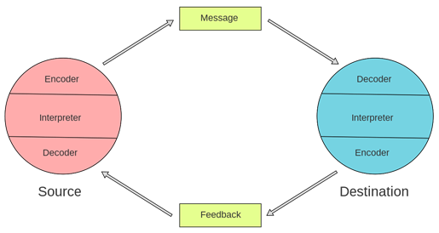

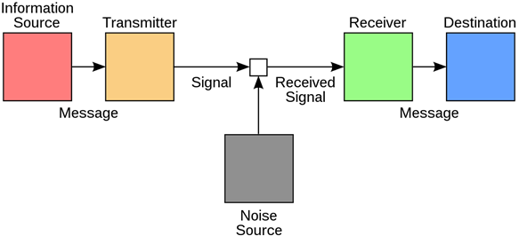

In Understanding group behavior (pp. 127-146). Psychology Press

