Developing Workplace Critical Thinking

Student Liliana calin
Id 1818714

Report

Table of contents
1 Introduction
2 Analysing on personal belief value and attitude
4 Analysis of critical thinking , belief and attitude for the workplace
5 Management theories , important aspect , at the workplace
6 Management theories in personal own aspect
7 Critical thinking of people with different belief , value , attitude to having a different understand of an situation
8 Conclusion
9 References
10 Apendix
1 INTRODUCTION

Nowadays the aspect of the values ,belief, and attitudes for everyone is having an important role in our society , organization, of life . The acceptance and the respect for each person and its culture is an important skills which we should develop and demonstrate humanly . The background and the differences between us is making everyone unique . The culture , traditions, languages , are the factors which can define us like a person . In term of business we can give many examples of workers with different backgrounds Different aspects , Different culture and beliefs. That don’t stop an industry to grow up or be successfully developed . In this report I will took about an organization which is pret a manager RESTAURANT . This brand was s established in 2004 in united kingdom . The company had around 450 outlets no just in uk also international . Pret builds its culture around three “ Core Behaviours” which are : passion , clear talking, team working . I choose speak about because my experience work in this restaurant can help me to discuss better, analyse some different aspects of the belief values , attitudes and also count some management theories . Pret a manager is a diversity restaurant that they have meals for allergic people at nuts, gluten , and they can change the meal as the customer want . The employee ask every customer if they can eat that meal and give all the information of the ingredients . Pret a manger is trying to offer their customers healty products and organic coffee . They also like help the environment doing rewards to customers who recycling the cups using again and again . They also do different offers

Pret a Manger Organization . Fig 3
like more ingredients for the same price , or some discounts . We can see that the pret a manager restaurants appreciate the values of each customer and they accept everyone needs. Same as I mentioned in my report and my idea of respect each person and accept their differences . That’s an important key factor accept the belief , values, and attitude of each person. In perhaps I will enchase the report with different theories that will help this module to analyse and discuss important aspects . Also I will make a critical analysis of my own values attitude and belief .

2 Analysing on personal belief value and attitude
Values, belief’s and attitudes are only part of human dimensions information potentially available for making decisions. Over the years , social theories has developed and enhanced knowledge of peoples behaviours which bring a lot of benefits and promote environmental sustainability . Researches of attitude-behaviour has developed and caried in a particular manner in the context of clear theorys management given their potential for guiding intervention strategies that influence diversity and human well-being (Schultz ,2011).
In our society nowadays attitudes , beliefs , and values is a integral part of a human characteristics. These are important aspects who every person can judge and see in their way , but there are some critical difference who can be analysed to understand the human behaviour . These aspects makes everyone unique and different. Human values signify to sustainable life purpose that people achieve , thinking in what is the most important for them. That can be recognized throughout ones experience of collecting life acts and pretend to be secure . The values that impact importance to persons tend to touch different manners to take an decision and how they feel their surroundings , and their actions . Value accomplishment is one definition why the people accept to stay in that organization , and when the the company doesn’t help attain their values many of them decide to refuse working for the company .

The relationship between values , attitudes, behaviour. Fig 6
3 Difference between beliefs , values, attitudes and their interpretation.

The biggest difference between attitudes and value is that the attitude is the way who someone can express himself without / with words . Attitudes can build up in accordance with ones value. Attitudes are convictions that we generally accept to be true . Values are the moral principals ethics and standards of behaviour . Value and attitudes are some components of a personal overall behaviour . 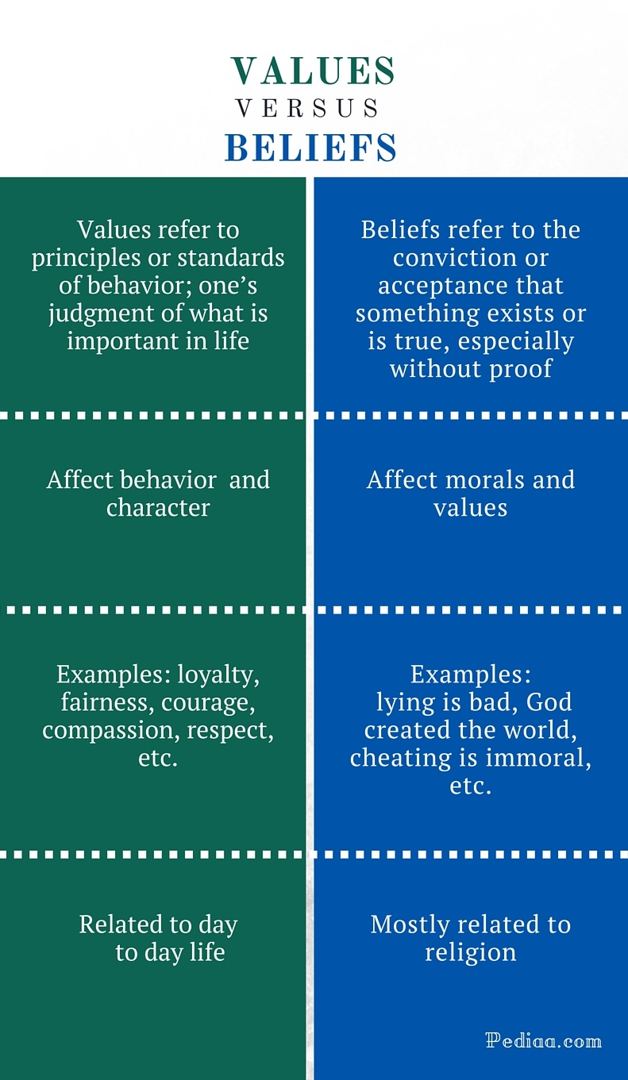
The difference between belifes, value. Fig 7
A system of beliefs thoughts can be the morals , to get a decision about what is good or bad or create an idea about what is wrong or right . Ethics have more social value and acceptance than values , when people start being assessed more their moral character than their ethics . Morals can be the key characteristic for leading the living in the correct direction where can be mixed with the person values and can be positive or negative depending of the person choose . This can be connected to ones religion, a political system , or a business society , and are developed because of value rather than being regulated by values .
. In next slide below of this slide will be evaluate the theory of the very famous psychologist Milton Rokeach . b
Theory of Rokeach
Milton Rokeach is a big psychologist and scientist who discovered a idea and a definition that can help us analyse the difference between this three concepts. The theory of Milton Rokeach will be discussed in this report to recognize the particular difference and definition of these three aspects in a particular mode (Wang and pizam, 2011). The scientist name the theories as the building steps to human behaviour . The scientist give a name such us Rokeach Value Survey or RVS theory . This theory was exposed in a book . “ The name of this bock is the nature of human Values” . in the year 1970 (Beck, 2013). Agreeing to the theory of these aspect , there are certain level of human behaviour in these theories . The scientist discovered that the beliefs are the perception of existing aspects which can be correct or wrong. Milton Rokeach defined ethical humans as an permanent belief that a specific type of conduct or end-state of existence is personally or socially preferable to an opposite or discuss mode or end of being . According to Milton Rokeach values influenced the action , the attitudes and the judgement . In my work experience in this coffee shop pret a manger as a team leader I must understand the core behaviours belief of this organization which are: passion, clear talking, team working , target customers. This organization promotes fresh natural eating and stay focused on ethics and sustainability to run the business . The vision of this company is short and to the point . It should communicate the essence of the business strategy . The company has tree levels of organizational culture which are artefacts , values /beliefs, and underlying assumption . The core value of pret a manger is shared goals , principals and standards . e,g. passion, integrity , quality , diversity , leadership. Understanding personality encompasses the relatively stable feelings , thoughts , and behavioural patterns a person has. Our personality can be different but understanding other personalities give us a clue about attitudes behavioural . The management of this organization have a good understands of the importance of communication between employees that everyone could accept modifications of behaviour accordingly. Pret a manager makes sure that that all the team working share the common purpose between employees and organization. Pret a manger has a perfect balance between the mean and goal orientation. There is a emphasize of the importance of accomplishing the goals , and sometime encourage employees to assume risks if they are worthwhile . Employees are focusing to promote health competition. Focusing in in the goal orientation they put a lot effort to accomplished that goal.
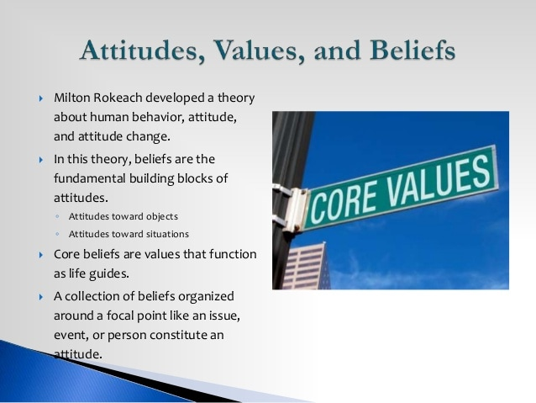
Milton Rokeach values theory. Fig 4

4 Analysis of critical thinking , belief and attitude behaviour for the workplace

Our conduct is not only about how is our character , values, and favourites , its same the facts and situationn . We can understand our background , offer solutions and do an action properly . Vision definition can be taken as the process that can persons see and understand environmental inducements .Groups of managers are active , stressed and they focused on the final line , they don’t have lot time to think and take care about emotions , well-existence . Is comprehensible but try to eliminate this stress can be more beneficious for the organization and the environment.
My belief ,values , and attitude have a important role in the organization I worked as an team leader on pret a manger . This organization is an important key player on the market. My belief in the workplace is that I have to take care of how I’m talking and treating every costumer and communicate more tactfully. According to the three aspects I try to give a shape of my own standards and behavioural to offer everyone a good attendance and try to make of my work a grateful environment . Try to be nice and empathize with the costumers is very important because we know the customers are the main key for having a successfully organization. In my work I try to communicate with all the customers and try to show them my values behind my words . according to my value I try to put the customers first in the top and try to view and discover the mindset of the customer first time doing properly . I try to give customer the information necessary and the correct suggestion of his needs . Pret a manager is a coffee shop / food that are respecting everyone needs and tastes . We as employees we must teel them what ingredients have that particular product or we can teel them what options or modifications we can do for be more convenient to customers. So clearly pret a managers is a company who respects and accepts different culture and aspects that the people have . I believe that maintain a good communication with the customers is more efficient that any other strategy or marketing publicity it sure the most efficient way for express what the organization can offer and their strengths . An example of a real event of my life is one day when I start my work I meet a difficulty that we run out of stock and was impossible to get what we need in that day and the supplier doesn’t answer because we must have a booking before meet him . After a short time of waiting I decide to tell the customers what products we have , and what meals we can combine to help sale the products that the customers doesn’t prefer and make it more approachable and effortless . The customers was very happy for diversification and the products which they consumed . I get a appreciation of my superiors and I solve that issue whit brio. As the purpose of the organization is to guarantee sustainability and development into the market . The growth can be done in a particular way . The aptitude to know and adapt to the social trends , communication, and priorities that induce and performance is critical to management success . The situational leadership is about being competent and confident in most situations by having a wide of range perspectives social ways combined with self knowledge . The mostly amounts of relationship behaviour and task behaviour can be used and spoked to the next in order to support their requires and advance improvement . I can say this theory I adopt after the strategy which I improved at my workplace.

5 Management theories , important aspect , at the workplace
Managing is a principal factor and task for an organization that human can develop . From the time human beings start building social organizations to achieve purposes and objectives they could not achieve as individuals, managing has been needed to established the coordination of particular efforts . Management is the process of rules and ways how a organization is keeping an environment where persons , teamworking , groups efficiently comply selected purposes ( Koontz and Weihrich 1990,p.4) .
The store manager plays an important role in the process management ( Schmenner and Swink, 1998). The process management of any store of pret a manger is making use of the next process which is named as the process model. I t ensures the smooth functioning of activities store , It start with the management of raw materials delivered from suppliers . After that it comes the managing personal which is the most important part of the performance of the business .
The success of this organization depends on the quality management and their leadership involvement . The company operates in a highly competitive market . Managers must think strategic because they are who will offer sound and effective guidance and leadership to guarantee a competitive advantage to the company. To know the needs of strategic leadership and management and to achieve the goal of the company managers must have a good understanding of the organization , vision, mission and long term objectives. Pret a manger build its ethics around three core behaviours : passion, clear talking , team working . Pret a manger is making use of the theory x and Y management by Douglas Mc Gregor . The phycologist discover this theory in 1960s. This theory is related to opposite style of management . Theory x describe the authoritarian management style and perceive the employee which is negligent to complete his task correctly , and the employees who doesn’t make much effort to get a efficient way to complete the goals of the organization . Alternatively theory y is the opposite of theory x . This theory is about the pleasure to stay connected and feel enjoyable the workplace . This theory is making suggestion to employees to put effort , feel approachable , and offer a good team work , communication , so the employees is feeling appreciate and them can offer success for the organization. The employees who are involved in complex problem solving and creative thinking process can ensure efficiency and problem solving in a correct way . When organizations work with qualified teamwork persons , they are waiting to create interaction by mixing their capabilities , but in essence those differences can turn into obligations . A team is created of individuals , and personality that can grout that holds the team togheter . They must to be capable to work together , and they have to be involved with each other . This type of team player encourage all the players to work towards the team goals . There are many characteristics of amazing groups but one key factor is the variety in team leaders . Diversity in different culture , backgrounds, age, society are important for best performing teams, but so too mental diversity . The importance off all this aspects is just they must have present the common goal .

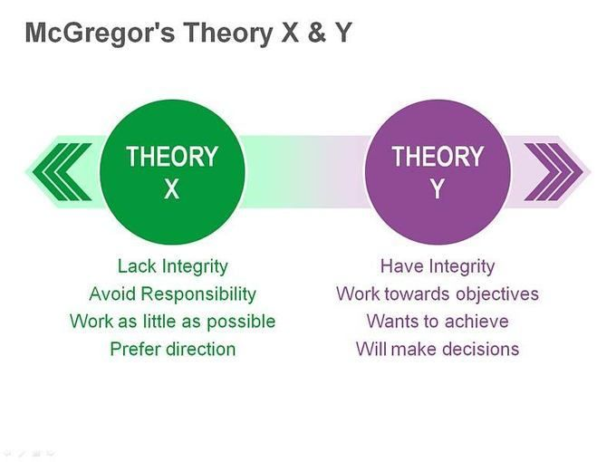

Figure 4 Theory X and Theory Y of management
Source: ( Fishbein and Ajzen ,2010)

6 Management theories in personal own aspect

In my workplace I face a lot of different situation day on day considering the style of management and the rest of staff . Me as a team leader , I have to meet with the employees and the upcoming situations that was happening. I try to learn about that situation and try to show my best part of humanity and try to understand them . I ensure that my team work feel great and confident with me and believe in their potential so they feel encourage from my side and that ensure me a good leadership front my superiors. My role was that lead with the situations and the employees in a proper manner and make sure that the employee have a good knowledge about how important is the service customer, teamworking, communication, confidence , so they help me to do a better team work . I faced a difficult situation that an customer makes a complaint about the information of that particular product because she feel misunderstand with the staff . Taking into account that the front staff was the least who receive complaints about service customer , the customer still say that didn’t receive the enough information so I speak with my colleague and I remember him and discuss about how important is the customer service and the way how must be treat all of them because without customer there is not business . So I try to explain and remember his position and encourage about how good is doing his job. So he take an different attitude and think in the discussion so he explain doble to the customer to make sure feel happy and comfortable with our service . However I get a bad example of one of the employee that he don’t like to receive extra information and wasn’t integrate in a team , and comply with the rules that everyone follows . So there is different situation of management theories same like I give the example anterior about the theory X and Y we clearly can see that we can face unexpected situations even as an employee or team leader, manager. The importance of the manner that we can lead them is up to us to choose the mode of management of the organization. There are many ways to categorize and describes management styles , the thesis and the antithesis that comes to mind when the management of organization is to be examined is democratic versus authoritarian . As organization leader you want to receive the best out of your substitutes and the efficient leaders know how to motivate and encourage their teamwork to develop them a high performance on tasks willingly , efficiently and effectively . An amazing and efficient management style can be achieved if you start inspiring workers can develop higher satisfaction work .

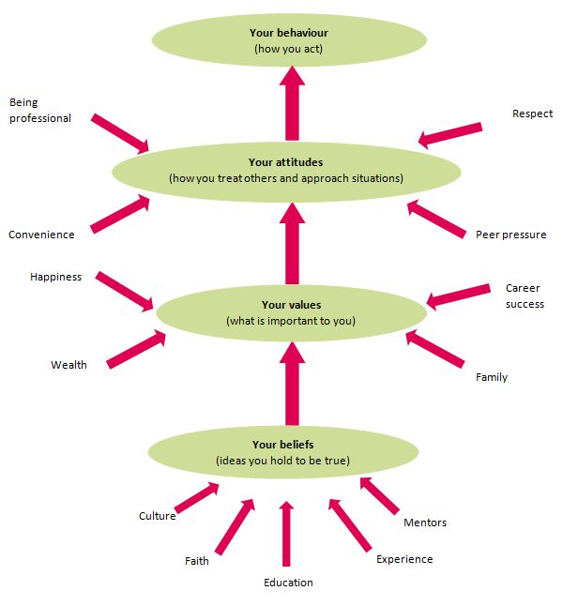

Psychology : Personal beliefs, values, attitudes and behaviour. Fig 2

7 Critical thinking of people with different belief , value , attitude to having a different understand of an situation
Cultural competence is the ability of human to have a good interaction, work, and develop significant relationship between persons of variety of different ethics . Cultural backgrounds can include the beliefs, traditions , and actions of persons . Increasing ethical competence is a long process of developing self-awareness , improving social skills and behaviours to gain the ability to support for others . It goes past tolerance , which implies that one is simply eager to supervise different circumstances . Instead , it includes knowing and respecting diversity through our actions in all contexts . 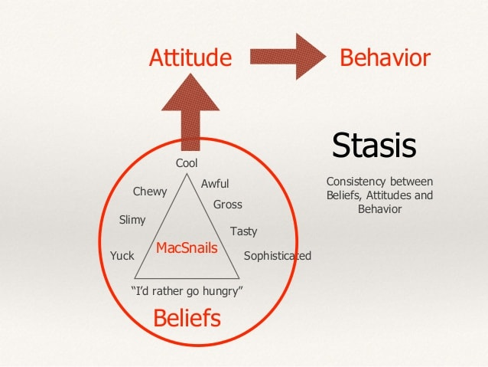
Beliefs attitude and behaviour .Fig 5
Workplace can be compromised on persons . Human relationship are the connections that happened between people . A strong efficiency in the workplace depends on the persons character , attitudes , and values , along with their motivations to growth . Personality and attitude demonstrate hoe we can react to conflict , crisis , and others workplace situations. Having a good understanding of the personality and characteristics of employees is crucial for a company . The ability of a leader is develop the aptitude to change the diversity of individual traits within groups into cooperation , helping in organization competitiveness .
In my workplace at pret a manger I can say that I meet and faced some dares from different situations and aspects. Starting from staff with different mindset and different understanding to interpret the situations . I meet situations where I had to treat and deal with the situational aspect differently. In every circumstances I had to adapt my beliefs , values and attitudes towards and make use of my own sense accordingly to match with the others . As a team leader in pret a manger I had to deal with a chain of customers all day and try to manage part of my team. There is a lot of activities and performance issues faced every day at work. Some of this happenings affect my own values, attitudes and belief , because day after day differs from time to time and different work aspects and mindset . The culture and education serve for behaviour of the employees . I can say that each worker has a unique perspective on the world and has their own set of values. The theory of individual behavioural aspect leads to the different interpretation of the same aspect . Some of my colleagues has different values beliefs and attitudes as mine , so they think that we can not make assumption about that differences ,so they decide to discuss with my superiors and let them taking action if is needed furthered . Managers think that having the same goal of an organization and follow the rules properly , is the key of success for a business. I believed with the behavioural theorist that understanding human behaviour at work like motivation will improved productivity , and higher level of performance . An efficient manager must view and recognize the reward of his staff and their performance and productivity doing this the employees will fell encourage and confidents .

Conclusion
Organizational culture is the kit of shared values , beliefs, and norms that influence the way how staff think , feel, and behave in the workplace. An organizations culture can have an impact on organizational effectiveness .
As my report suggests , the aspects of theories beliefs, values, attitudes differ from one to another person . The style management also can be differently accordingly otherwise there will not be organizational efficiency in any aspect. I can say that the values, attitudes, beliefs can affect others /own performance as well. These factors are integrated from the people with different beliefs and values . I also discus about my own values , beliefs, and attitude according to the employees motivational factors and management theories . The findings I discuss in a critical analysis about values beliefs, attitudes on my own and overall theories . In a business a leadership style called “transformational leadership” is often the most effective approach to use . This leaders have integrity , they can get people inspiration and share a vision of the future, they can set a same goal , they motivate people setting the same goal , they manage delivery , and communicate well with their team . In essence Employee should treat the same . The strongest relationship that create between cultural , attitudes and behaviour of the manager is also closely connected to the same point of view of the staff . The importance of doing this is that employees help growth an organization and leaders lead with the acts of employees . We can say that is a lot of theories about beliefs , attitudes and values . This characteristics are in every human and the differences between those depends of our personality and about how able we are to manage in a correct way for respect the human behaviours. Depends of our attitudes we can express ourself character . Having a positive attitude is bring us the references in society . My report express about what are the beliefs and what theories we can use to get a better understanding of what is culture , what is the differences between persons and how we can look behaviour manners. There are many theories and situations that we can meet everywhere and in my case I agree to accept everyone ethics and morals to get a better acknowledge of organizational culture or day after day life . Coaching concentrating leadership can provide a platform for sustainable organizational competency and be an appropriate approach to involving and developing each other . The workplace will be healthier , in the mean will be created a enjoyable atmosphere , cooperation , trust and meaning. Having this attitudes is the key factor for an successful organization and their management .

Reference
Baird , R. (2016). The Philosophical life . Lanham , MD : University Press of America .
Ajzen ,I . (1991). The theory of planned behaviour . Organizational behaviour and Human Decision Processes ,50, 179-211.
Kotler P (1995) Marketing management : Analysis , Planning , implementation and control, Prentice Hall , Englewood Cliffs , NJ.
Rokeach , M. Beliefs , Attitudes and Values : A Theory of Organization and Change ; Jossey -Bass : San Francisco , CA , USA , 1968.
Robin , M.; Williams ,J. Reviewed Work : The Nature of Human Values .by Milton Rokeach . Polit . Sci .Q .1974 , 89, 399-401.
Adair , J & Allen ,M 2003, The concise time management and personal development , Thorogood , New York , NY.
Fishbein , M. and Ajzen, I . (2010). Belief, attitude, intention, and behaviour . Reading , Mass .: Addison-Wesley .
McGregor , D .( 1960/1985) , The Human Side of Enterprise , McGraw -Hill, New York , NY .
Pratkanis ,A ., Breckler, S . and Greenwald ,A . (2014). Attitude Structure and Function. Hoboken: Taylor and Francis .
Bulach , C., Lunenburg , F.C., & Potter ,L. (2012). Creating a culture for high -performing schools: A comprehensive approach to school reform (2nd ed.). Lanham , MD: Rowman and Littlefield .
Burns , T., & Stalker , G. M (1961). The management of innovation . London, UK.
Denison , D.R. (1990). Corporate culture and organizational effectiveness . New York , NY: Wiley .
Dovidio, J. F., S.E., Kawakami, K., & Hodson , G. (2002) . “ Why can’t we just get along ? Interpersonal biases and interracial distrust “. Cultural Diversity &Ethic Minority Psychology 8 (2) : 88- 102.
Hayes ,A.F., & K.J.(2010). Quantyfing and testing indirect effects in simple mediation models when the constituent paths are nonlinear . Multivariate Behavioural Research ,45,627-660.
Schultz , P.W.(2011). Conservation means behaviour .Conservation Biology ,25, 1080 -1083.

10 Appendix
Mc Gregor Theory X and Y of management ( Fishbein and Ajzen ,2010). Fig 1
Psychology : Personal beliefs, values , attitudes and behaviour .Fig 2
Pret a Manger Organization . Fig 3
Milton Rokeach values theory. Fig 4
Belifes , Attitudes and Behaviour .Fig 5
The relationship between values , attitudes, behaviour. Fig 6

