Student name: Inderdeep Singh Sidhu 2119841
Programme: Quantity Surveying
Module code: ACBA6004
Module: Advanced construction and engineering
Assignment title: Building services and energy
Lecturer: Alun Watkins

Morgans hotel

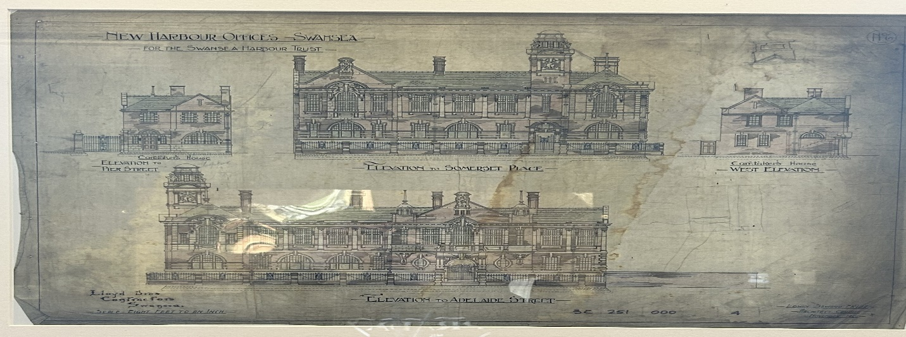
(Sidhu, unknown).

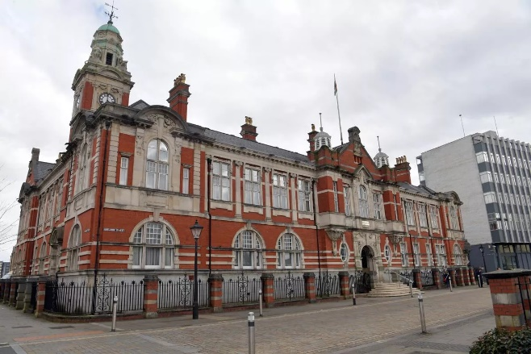
(Sidhu, 2024).

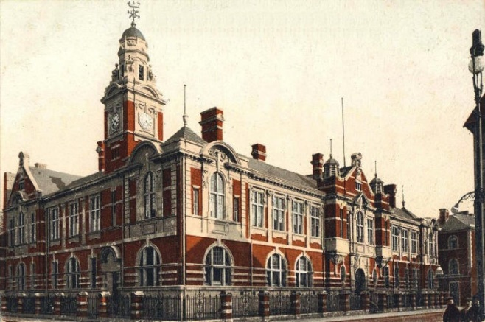
(Sidhu, unknown).

(Sidhu, 2024).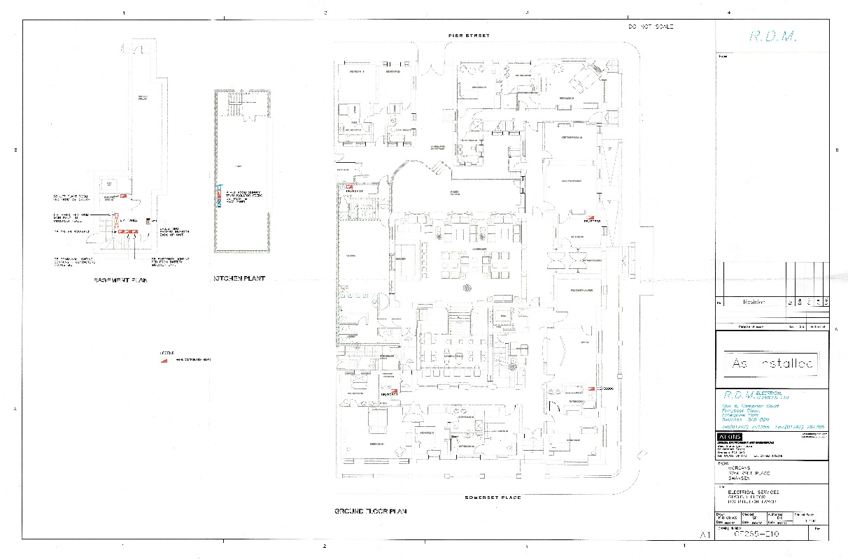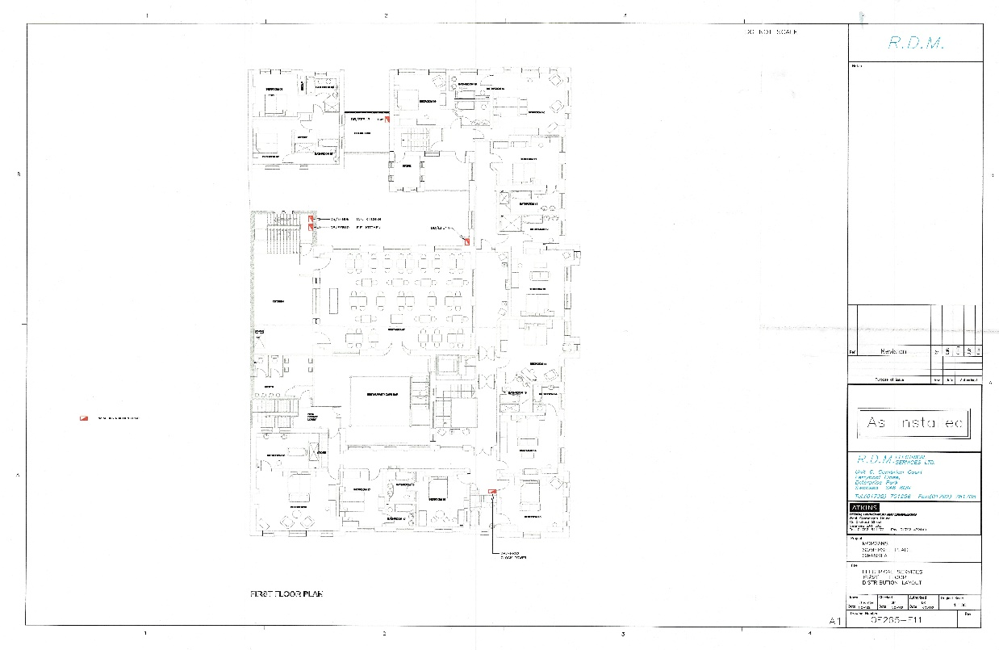
(Sidhu, 2024).
(Sidhu, 2024)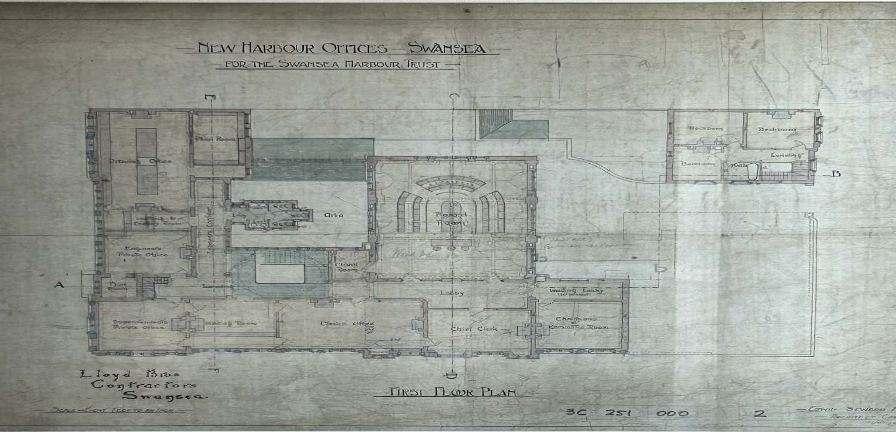 (Sidhu, 2024)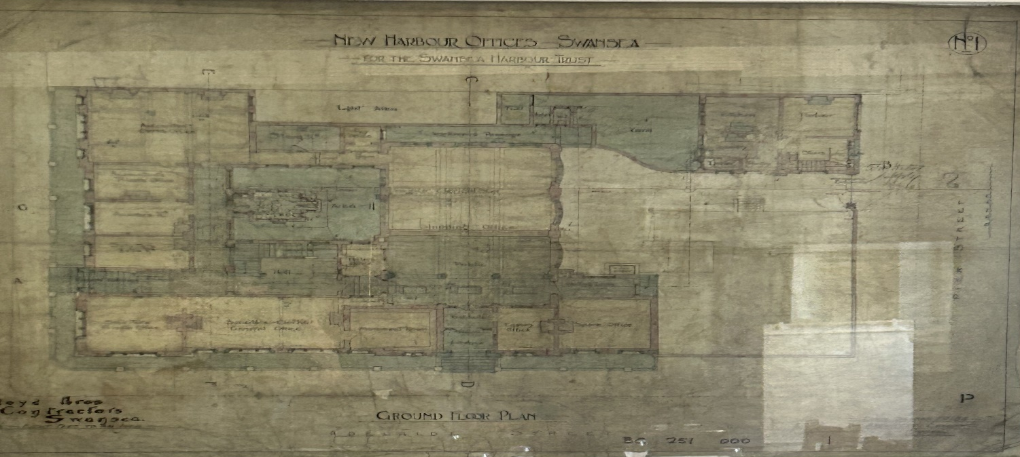

Contents
History of the building 5
Purpose and usage 6
Characteristics 7
Age 7
Architectural Design/style: 7
Gross Internal Floor Area: 7
Number of Rooms: 7
External facade 7
Economic value 7
Employment 7
Tourism 7
Hosting events 7
Value to Society/social value 7
Historical significance 7
Community engagement 7
Hospitality Experience 7
Influence on the Environment 7
Energy Efficiency 7
Waste Management 7
Green Initiatives 7
Conclusion 7
In the following discussion, I will explain the architectural excellence and functionality of the building through looking at its structural approach, materials, and heating/lighting strategies. 8
Load bearing masonry 8
Braced frames and trusses 8
Roofs 8
Doors and windows: 8
Drainage 9
Lighting 9
Heating 9
Conclusion 10
This section of the report will highlight the building's strengths in light of current regulatory changes. Updating specifications for future construction to meet today's requirements is the focus. Examining methods to make the structure more sustainable and efficient. 10
Wi-Fi 10
Up to date air conditioning unit 10
Better insulation in the building 11
Sash design windows 11
Low output electric and heating 12
Solar panels 12
Building regulations 13
Cost of building 13
Operational energy use/Cost of operations and maintenance 13
End of life reuse/recycling 13
Offsite manufacturing 14
Conclusion 14
References 15

History of the building
Swansea Harbour Trust was founded by Parliament in 1791. The trust had to enlarge and preserve Swansea's harbour in Glamorganshire. After an uncertain beginning in a quickly expanding South Wales, the body achieved much. The trust's activity grew by the end of the nineteenth century. Given the extent of business at the time, the trustees opted to create a purpose-designed building that reflected the trust's role to Swansea's industry. (Anon., n.d.). Previous names for the building have included "The Swansea Harbour Trust Office", The British Transport Docks Board Office" and " The Associated British Ports Office", reflecting the names of the building's occupiers (wikipedia, n.d.). Now it is widely recognized as the Morgans hotel after this grade 2 listed building had a healthy refurbishment inside of the premises.

The board of trustees then created a design brief with professional opinions to meet their operational and aesthetic requirements. The design competition among potential architects was based on that brief, and Edwin Seward of Cardiff's design was chosen from over 100 entries and construction began. Seward was overjoyed to win the competition and work with a client who only used the best materials. Seward and Lloyd Brothers of Swansea were able to design an amazing facility for the Harbour Trust since the internal and external material requirements were top-notch. They also recruited the best craftsmen directly or through subcontracting. (Online, n.d.).

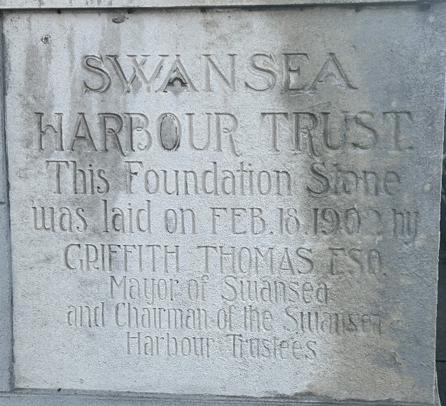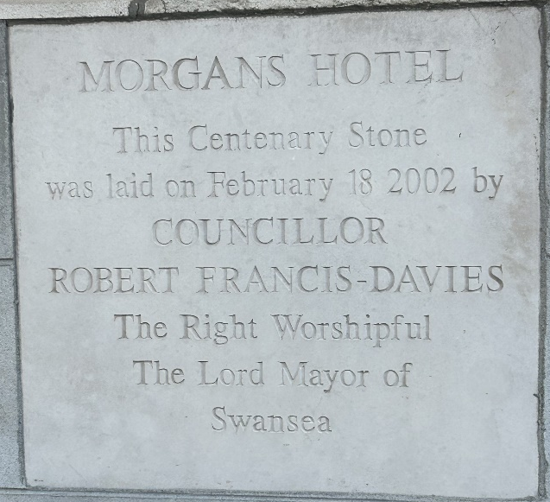
(Images taken by author of first stone laid previously and then stone laid recently)

All who attended the opening ceremony on 12 October 1903 noticed that the combination of effective design, excellent supplies, and talented craftsmen had produced a superb, handsome construction that was an asset to the Harbour Trust and Swansea. What the Cambrian reporter who covered the opening event said is intriguing. The new building has substantially changed this portion of Swansea. The extensive brick expanse with Portland stone joining illuminates the bleak surrounds.
(SwanseaDocks, n.d.)
The Morgan's Hotel in Swansea is a remarkable example of architectural elegance and holds great historical importance. Created during the early 1900s, this renowned building exhibits a timeless attraction because of its exquisite design and everlasting attractiveness. The structure displays an array of architectural styles and has a large gross interior floor area, allowing space for numerous rooms. Besides its physical characteristics, the hotel is also a central point for economic and social activities in the region, operating as an anchor for corporate and community events. Additionally, a study of its impact on the environment highlights its commitment to environmentally friendly practices. This assignment explores the complex aspects of The Morgan's Hotel, examining its historical, current, and future importance. (n.d.).

Purpose and usage
The Morgans Hotel is a four-star establishment in the middle of Swansea that welcomes business and leisure guests alike. For customers, the hotel is primarily a place to stay, eat, and host events. In addition to boosting Swansea's tourism and providing an unforgettable experience for guests, it is an important part of the hospitality business. (MorgansHotel, n.d.).

Characteristics
Age: In terms of age, the Morgans Hotel has been around since 1902, making it more than a century young. The building's historical significance contributes to the qualities of charm and character that it possesses. (MorgansHotel, n.d.).

Architectural Design/style: The structure is designed to combine elements of the Victorian and Edwardian architectural styles. It has elaborate detailing, decorative components, and an enduring aesthetic that represents the sophistication of the period in which it was constructed. The architecture has been conserved and incorporated into the interior design of the contemporary hospitality establishment. (MorgansHotel, n.d.).

Gross Internal Floor Area: The Morgans Hotel has a total gross internal floor area of roughly 5,000 square metres, and some of the places that it provides are as follows: guest rooms, eating areas, conference rooms, and event spaces. (Wikipedia, n.d.).

Number of Rooms: The hotel has forty-two individual rooms, ranging from modest accommodation to lavish suites. Each room is designed to provide comfort and a one-of-a-kind atmosphere, combining the architectural allure of the past with the conveniences of the present. (MorgansHotel, n.d.)

External facade: The decorative exterior is clad in red Cattybrook brick and Portland white stone and topped by a Greek statue-clad clock cupola (Wikipedia, n.d.). A magnificent entryway with a wrought-iron canopy, wide windows ornamented with artistic detailing, and a symmetrical arrangement that oozes refinement are all aspects that can be found on the exterior front of the building. The external facade area information is not readily available.

Economic value
Employment: In terms of employment, the Morgans Hotel makes a substantial contribution to the economy of the surrounding area by offering job possibilities to its personnel in a variety of areas, such as those in the front-of-house, housekeeping, culinary, and managerial departments.

Tourism: The Morgans Hotel, which is a renowned establishment in Swansea, is responsible for attracting tourists to the city. These tourists ultimately contribute to the growth of the local economy by spending money on lodging, dining, and other leisure activities.

Hosting events: The hotel's conference rooms, and event spaces are frequently used for business meetings, conferences, and social events, which results in the hotel generating revenue and aiding the tourism and events industry in the surrounding area.

Value to Society/social value
Historical significance: The historical significance of the hotel lies in its contribution to the cultural value of Swansea by establishing a connection between guests and the city's history, while also adding to a sense of place and legacy.

Community engagement: The Morgans Hotel is committed to actively engaging with the community in which it is located by organising events, helping local initiatives, and taking part in collaborative efforts to improve the overall well-being of Swansea inhabitants.

Hospitality Experience: By offering a hospitality experience that is both one-of-a-kind and unforgettable, Morgans Hotel contributes to the favourable view of Swansea as a tourist destination, which in turn encourages return visits and positive word-of-mouth.

Influence on the Environment
Energy Efficiency: The hotel has undergone renovations to improve its energy efficiency. These upgrades include the incorporation of current technology such as energy-efficient heating and cooling systems, smart building management systems, and LED lighting. (MorgansHotel, n.d.).

Waste Management: The hotel's dedication to environmental responsibility is demonstrated by the implementation of sustainable waste management procedures, which include recycling activities and the reduction of single-use plastics. (MorgansHotel, n.d.).

Green Initiatives: It is possible that the Morgans Hotel has made investments in green initiatives, which include eco-friendly amenities, water-saving measures, and the utilisation of sustainable materials in its operations. These activities have contributed to a smaller environmental imprint. (MorgansHotel, n.d.).

Conclusion
Ultimately, The Morgans Hotel in Swansea illustrates sustained sophistication and cultural value and architectural masterpiece. Erected in 1902, combines elements of Victorian and Edwardian styles, expressing a compelling sense of heritage. The hotel perfectly combines tradition with contemporary comforts, boasting forty-two individual rooms and a spacious interior. Outside the walls, the exquisite outside wall attracts tourists with its symmetrical charm. From a financial viewpoint, it encourages job creation, boosts tourism, and serves as a venue for staging events. Socially, it is strongly connected to Swansea's heritage and actively includes the local community. The Morgans Hotel leads the way in promoting energy efficiency, waste management, and green initiatives, creating a sustainable standard in the hospitality industry.

In the following discussion, I will explain the architectural excellence and functionality of the building through looking at its structural approach, materials, and heating/lighting strategies.

Load bearing masonry - From the 1700s to the mid-1900s, load-bearing masonry was the most popular approach for major buildings. Large buildings are rarely built with it today, although residential constructions are. Thick, massive red Cattybrook brick and Portland stone walls support the entire structure with lime or clay mortar known as ‘clom’, including the horizontal floor slabs, which can be reinforced concrete, wood, or steel. Damp courses were non-existent, only gradually introduced during the 1920s. (UnderstandConstruction, n.d.).

Braced frames and trusses: Braced frames and trusses were often used to reinforce structural stability and resist horizontal forces. These systems, usually made from iron or steel, have been used to minimise the impact of wind and seismic tensions on tall or big structures.
(UnderstandConstruction, n.d.).

Roofs: The architectural type of roofs has evolved from heavy oak to thinner softwood timbers because of upgraded supply and construction techniques. The Victorian period saw the application of pre-cast-iron trusses and steel in roof buildings.
(CADW, n.d.)
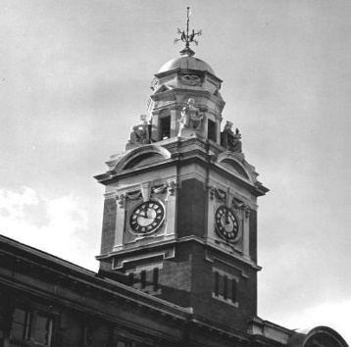
(Sidhu, 2024)

Doors and windows: Doors and windows are essential for keeping the character of a building and its building period. Oak was the primary material until the mid-18th century, when painted softwood became fashionable. Casement windows have been made from cast or wrought iron, bronze, or steel, with lead strips holding the glass panes together. Small-paned timber box sash windows were popular during the Georgian era. Glass panes grew throughout the Victorian era due to emerging manufacturing technologies. (CADW, n.d.).

Drainage: the sort of material used to allow the flow of water to run smoothly off roofs were made of cast iron during that period.

Lighting: During the 1900s, Welsh major structures often used gas and electric lighting systems for lighting. Gas lamps were common in the early years of the century, gradually becoming replaced by electric lighting as improvements in technology were made. Gas lights were suspended from ceilings or attached to walls, providing illumination in various spots. During the century, the installation of electric lighting grew more common with the addition of decorative fixtures like chandeliers and sconces in notable buildings. (1900s, n.d.).

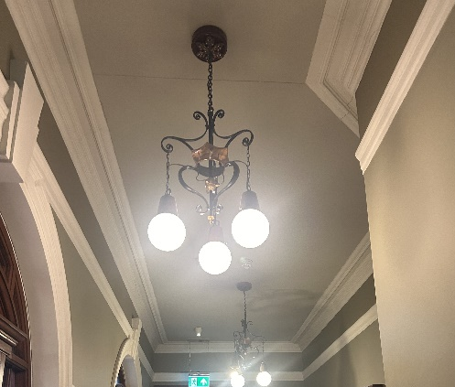
(Sidhu, 2024)

Heating: Such appliances use heat to increase the temperature of water to its point of boiling, enabling it to move through a change in phase that turns it into steam. They are fueled by electricity, gas, or oil, and were common in buildings during that era. (Sealed, n.d.).

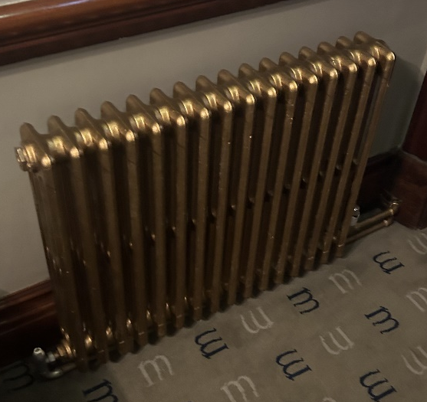
(Sidhu, n.d.)

Conclusion
To summarise, the development of large architectural buildings and materials from the era of the Victorians to the present represents an amazing journey. Advances in engineering, materials science, and architectural design have made possible the ability to achieve unparalleled heights, construct new and creative structures, and apply environmentally friendly techniques. Modern structures employ steel and concrete frameworks, energy-efficient glass, and cutting-edge technologies, which is an apparent contrast to the Victorian era's reliance on brick, stone, and cast iron. Modern buildings stress safety, sustainability, and aesthetic adaptability, showing an important change in construction techniques. The field of design has made tremendous improvements, displaying our ability to test limits and choose a future defined by efficiency, flexibility, and ecological awareness.

This section of the report will highlight the building's strengths in light of current regulatory changes. Updating specifications for future construction to meet today's requirements is the focus. Examining methods to make the structure more sustainable and efficient.

This Grade 2 listed hotel must maintain vital components to safeguard its historical and cultural significance. These characteristics highlight architectural styles, craftsmanship, and historical tales, giving the property its own unique character and this is something that Morgans hotel has done perfectly. Keeping such elements as the glass-stained windows, coving and memorabilia recognises the hotels heritage and provides authenticity and charm to the guest experience. By protecting these characteristics, owners contribute to the local community's cultural tapestry and attract visitors seeking modern comfort and a journey across the hotel's rich history. Other features which are good about this building include:

Wi-Fi: A Grade 2 listed UK hotel with Wi-Fi satisfies current guest expectations by providing seamless connectivity. It helps travellers stay connected for business, online interaction, and pleasure. Wi-Fi makes hotels more competitive and encourages tech-savvy tourists. Online bookings, digital check-ins, and local information boost consumer satisfaction. Wi-Fi additionally offers smart room controls, streaming services, and virtual concierge services, increasing the historic building's appeal without causing damage the structure itself.
(Techtarget, n.d.).

Up to date air conditioning unit: Installing air conditioning in a UK Grade 2 hotel has numerous advantages. First, it offers a controlled and cosy indoor environment, which raises guest pleasure. Second, it minimises humidity and temperature variations from destroying the building's history. Energy-efficient modern air conditioning systems assist with sustainability goals. Reference: English Heritage's historic building HVAC rules promote comfort and preservation. (heritage, n.d.).

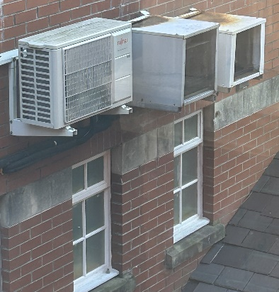
(Sidhu, 2024)

Reducing embodied energy and carbon in construction materials is essential for sustainable building practices. Eco-friendly materials with lower embodied energy and carbon footprint are available. When selecting materials for a project in the UK, consider the local availability, the specific requirements of the construction, and adherence to building codes and regulations. Sustainable certifications like BREEAM or LEED can guide your choices toward materials that contribute to a lower environmental impact. Below are options to consider for future upgrades:

Better insulation in the building – Safeguarding a Grade 2 listed hotel's heritage while upgrading insulation involves a delicate balance between energy efficiency and conservation. Internally, brick building requires adequate insulation. Straw bale walls give low carbon footprint and wonderful insulation, while sheep's wool floors offer thermal and acoustic benefits without compromising historic ambiance. Preservation experts must be consulted. Cork, a low-embodied-energy material, fits beneficial on the roof. Selecting minimal impact on the environment combines current needs with historical preservation, keeping functionality and history. (Homebuilding, n.d.).

Sash design windows - A Grade 2 listed buildings historical appeal can be kept with triple-glazed windows for energy efficiency. Selecting friendly designs like timber-framed triple-glazed windows that imitate classic sashes to maintain aesthetics and insulation. Converting to entirely sash windows matches the building's heritage. Low-emissivity coatings and argon gas filling boost thermal performance without affecting appearance. U-values ensure energy savings and comfort through good insulation. The hotel can combine modern efficiency with historical preservation without risking its listed status by working with heritage authorities to comply with conservation rules. (Gowercroft, n.d.).

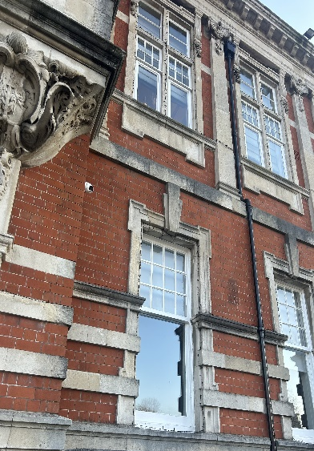
(Sidhu, 2024)

Low output electric and heating: For a Grade 2 listed hotel in the UK, implementing a low-output electric and heating system involves balancing modern energy efficiency with the preservation of historical features. In such cases, underfloor heating systems with low wattage per square meter can be an excellent choice. These systems provide even heat distribution, ensuring comfort without compromising the aesthetics of the space. Consider electric underfloor heating mats or cables, carefully installed to minimize impact on the existing structure.
(Which, n.d.).

In terms of electric heating, infrared panels with low output can be discreetly integrated, offering targeted warmth without the need for extensive alterations. These panels emit radiant heat, mimicking the sun's natural warmth, and can be strategically placed to supplement existing heating systems, providing an energy-efficient solution while respecting the building's heritage.
(Suryaheating, n.d.).

To maximize energy efficiency, smart heating controls can be integrated, allowing for zoned temperature control and scheduling to optimize heating patterns. Collaborating with heritage preservation authorities ensures that any alterations adhere to conservation standards, striking a balance between contemporary energy solutions and the protection of the Grade 2 listed building's historic value.
(Energy5, n.d.).

Solar panels: Historical preservation and sustainable technology are easily built into a Grade 2 listed hotel with solar panels. Architectural individuality and modest placement maintain the building's attractiveness. It respects history while achieving modern energy needs with renewables. By achieving environmental standards, the hotel welcomes eco-conscious customers and minimises its carbon footprint. Solar panels reduce energy costs gradually, improving financial sustainability. These actions may also qualify the hotel for government funding, thereby improving its responsible and progressive image. Installing solar panels on a Grade 2 listed hotel connects the past and future by integrating historical protection with renewable energy. (Esegroup, n.d.).

Building regulations: Local planning organisations manage the procedure of getting listed building consent, which is required to carry out alterations that protect the unique architectural or historical value of listed buildings. This involves slight renovations such as replacing doors or painting. The main objective is to preserve the historical traits, materials, and layout. It is often advised against performing substantial alterations, such as replacing traditional windows with UPVC. Routine maintenance generally does not require permission, but demolition always requires consent. Submission includes the incorporation of a heritage impact statement as well as thorough plans. Proposals that are both sensitive and accurate, backed up by evidence, have an opportunity to obtain approval. (CADW, n.d.).

Cost of building: The construction contract was granted to Messrs. Lloyd Bros. of Swansea for a total amount of £14,567.00. Additionally, an extra contract worth £3,667.00 was issued to them for the purpose of constructing an expansion at the southern end of the structure. Griffith Thomas inaugurated the new Harbour Office building on October 13, 1903. (SwanseaDocks, n.d.).

Operational energy use/Cost of operations and maintenance: The figures for energy consumption, operational and maintenance costs are not readily available but given the construction of the building, I can assume by visually noticing that the windows are half sash and half modern, and the lack of insulation on internal walls, operational costs and energy usage would be high. Due to this building being of a high-quality spec, assumptions can be made that maintenance of the building would also fall into a fairly high region of cost.

End of life reuse/recycling: This building has outstanding end-of-life reuse and recycling potential, allowing sustainable preservation. Saving the red Cattybrook brick and Portland stone which are valuable materials, the chimneys, and the four-face clock tower to reuse historical characteristics. Wales' only four-face clock tower is rare and cultural. Reusing the durable, well-crafted foundations helps the environment. Reusing windows decreases waste and preserves the building's architecture. Using such approaches ensures an environmentally friendly legacy for the building.
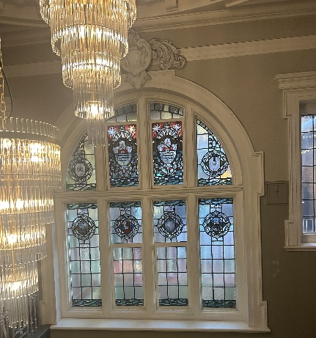
(Sidhu, 2024)

Offsite manufacturing: Increasing attention on eco-conscious construction has prompted a requirement for off-site construction and will likely see a consistent growth rate which started in 2023. Off-site building offers sustainability by using regulated manufacturing processes that ensure precise specifications and efficient utilisation of materials. This approach lowers after construction concerns and repairs, unlike traditional methods which end up in too much waste. The implementation of efficient transportation in off-site building reduces emissions and chaos, while the adaptability and reusability of materials contribute to long-term sustainability. Additionally, off-site constructing offers environmental, ecological, and economic benefits due to its minimal site problems, adaptability, and efficient transportation. If morgans were to further expand this building, then using this approach would add to their sustainability and green foot values.
(CleggAssociates, n.d.)

Conclusion
Morgans Hotel's Grade 2 listed property balances heritage with efficiency. Wi-Fi, advanced air conditioning, low-output electric and heating, and solar panels can enhance guest experience, energy efficiency, and financial sustainability. Triple-glazed windows, straw bale walls, sheep's wool floors, cork roofing, and eco-friendly insulation showcase sustainability without compromising heritage. Local planning regulations and end-of-life reuse and recycling initiatives advance the hotel's eco-friendliness. Modern construction trends indicate off-site production may transform Morgans' historical property greener and more sustainable.

References
1900s, n.d. https://www.1900s.org.uk/1900s-lighting.htm. [Online].
Anon., n.d. http://www.swanseadocks.co.uk/docksnewsite/harbouroffice.html.. [Online].
CADW, n.d. https://cadw.gov.wales/advice-support/historic-assets/listed-buildings/listed-building-consent. [Online].
CADW, n.d. https://cadw.gov.wales/sites/default/files/2021-02/Teaching%20resources%20-%20Understanding%20traditional%20%28pre-1919%29%20and%20Historic%20buildings.pdf. [Online].
CleggAssociates, n.d. https://cleggassociates.co.uk/why-offsite-construction-is-the-more-sustainable-choice/#:~:text=Not%20only%20does%20surplus%20material,in%20excess%20materials%20and%20waste.. [Online].
Energy5, n.d. https://energy5.com/the-benefits-of-thermostats-in-energy-management-for-energy-star-rated-buildings. [Online].
Esegroup, n.d. https://esegroup.co.uk/can-solar-panels-be-installed-on-listed-buildings-in-the-uk/. [Online].
Gowercroft, n.d. https://www.gowercroft.co.uk/news/what-is-the-difference-between-a-sash-window-and-a-casement-window/. [Online].
heritage, E., n.d. (Source: English Heritage, "Environmental Controls for Historic Buildings")..
Homebuilding, n.d. https://www.homebuilding.co.uk/advice/eco-insulation. [Online].
MorgansHotel, n.d. https://www.morganshotel.co.uk/history/. [Online].
MorgansHotel, n.d. https://www.morganshotel.co.uk/history/. [Online].
Online, W., n.d. https://www.walesonline.co.uk/news/wales-news/soft-porn-secret-passageways-fascinating-14547813. [Online].
Sealed, n.d. https://sealed.com/resources/how-to-heat-a-large-old-house-efficiently/#:~:text=get%20the%20scoop.)-,Boilers%20and%20radiators,'re%20not%20very%20efficient. [Online].
Sidhu, I., 2024. Current first floor plan. Swansea: s.n.
Sidhu, I., 2024. Currernt ground floor plan. Swanasea: s.n.
Sidhu, I., 2024. Morgans Hotel in different eras. swansea: s.n.
Sidhu, I., 2024. picture of clock tower on Morgans hotel. Swansea: s.n.
Sidhu, I., 2024. Picture of current air con system. Swansea: s.n.
Sidhu, I., 2024. Picture of lighting system. Swansea: s.n.
Sidhu, I., 2024. Picture of Morgans hotel. Swansea: s.n.
Sidhu, I., 2024. Picture of previous first floor plan. Swansea: s.n.
Sidhu, I., 2024. Picture of previous ground floor plan. Swansea: s.n.
Sidhu, I., 2024. Picture of Stained glass and chandelier. Swansea: s.n.
Sidhu, I., 2024. Picture of Windows on Morgans hotel. Swansea: s.n.
Sidhu, I., n.d. Picture of heating system. s.l.:s.n.
Sidhu, I., unknown. Drawing of Morgans hotel. Swansea: s.n.
Sidhu, I., unknown. Morgans hotel image. Swansea: s.n.
Suryaheating, n.d. https://www.suryaheating.co.uk/blog/much-energy-can-i-save-infrared-heating-panel/#:~:text=It%20uses%20less%20energy%2C%20is,afraid%20to%20get%20in%20touch.%20.. [Online].
SwanseaDocks, n.d. http://www.swanseadocks.co.uk/docksnewsite/harbouroffice.html. [Online].
SwanseaDocks, n.d. http://www.swanseadocks.co.uk/docksnewsite/harbouroffice.html#:~:text=Constructed%20in%20red%20Cattybrook%20brick,window%20portraying%20various%20maritime%20and. [Online].
Techtarget, n.d. https://www.techtarget.com/searchmobilecomputing/definition/ad-hoc-network. [Online].
UnderstandConstruction, n.d. https://www.understandconstruction.com/load-bearing-masonry-construction.html#:~:text=Load%20bearing%20masonry%20construction%20was,scale%20structures%20are%20being%20built.. [Online].
Which, n.d. https://www.which.co.uk/reviews/underfloor-heating-systems/article/electric-underfloor-heating-a8qUj3T04EXw. [Online].
wikipedia, n.d. https://en.wikipedia.org/wiki/Morgans_Hotel,_Swansea. [Online].
Wikipedia, n.d. (https://en.wikipedia.org/wiki/Morgans_Hotel,_Swansea). [Online].
Wikipedia, n.d. https://en.wikipedia.org/wiki/Morgans_Hotel,_Swansea. [Online].

