Kieran Brown (2204069)
University Of Wales Trinity St David
Applied Computing – Operating Systems
Assignment 1

Table of Contents

Page 3 – 5: Task 1
Page 5 - 9: Task 2
Page 10 – 14: Task 3
Page 15 – 18: Task 4
Page 19 – 23: Task 5
Page 23: Conclusion
Page 24 – 27: Appendices
Page 28 – 29: Bibliography

Task 1 - Key functions of general Operating Systems
Briefly describe the key functions of popular general-purpose Operating Systems with several screenshots showing where some of the functions can be seen/monitored/managed. Approx. 500 words, cite several reference sources.

Memory & Process Management
Memory and process management are fundamental functions of mostly every operating system in the modern day. It enables users to multitask and utilise resources and applications efficiently.
Memory Management is the allocation and deallocation of memory to ensure the RAM is used as efficiently as possible. “This involves the allocation of memory blocks to specific processes as the demands for the CPU change.” [1] By doing this it ensures that each process has enough memory to be executed and in turn prevent processes that does not belong to them. Techniques like virtual memory are commonly used to allow the OS to effectively manage memory by using space as an extension to RAM.
Process management is the overlooking of the processes within an operating system, ensuring that the execution is correct. It includes process scheduling where the operating system determines how long, and which order the process is executed. By doing this ensures that thew processes communicate effectively and cooperate.
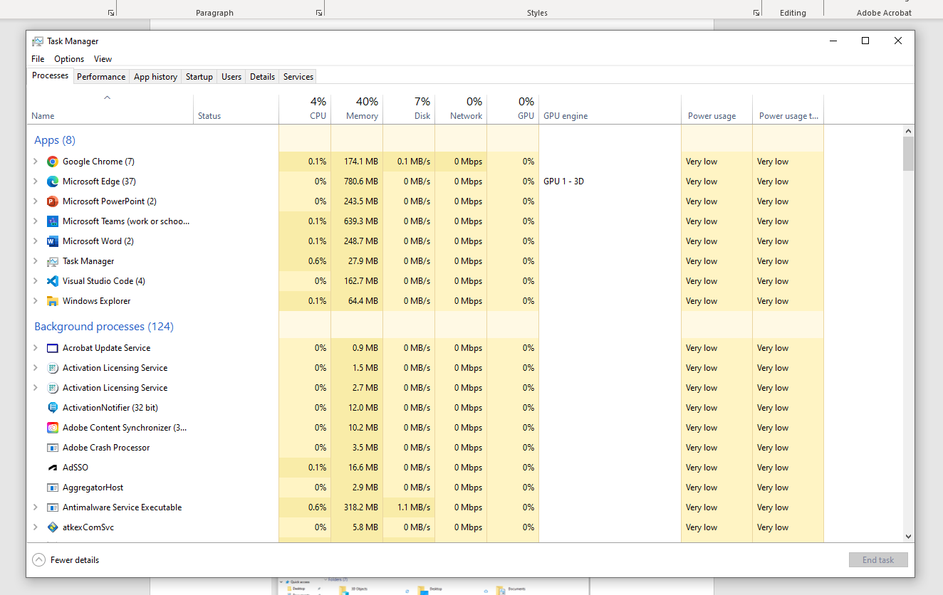

File Management
File management in an operating system refers to the organisation of files stored within a computers storage system, such as cloud, network storage, hard drives, and solid-state drives. “It includes tasks such as file creation, deletion, naming, classification, and access control.” [2] File management also holds file metadata such as type, size, creation date, permissions, and information. Overall, file management in an OS ensures support to various user and application requirements.
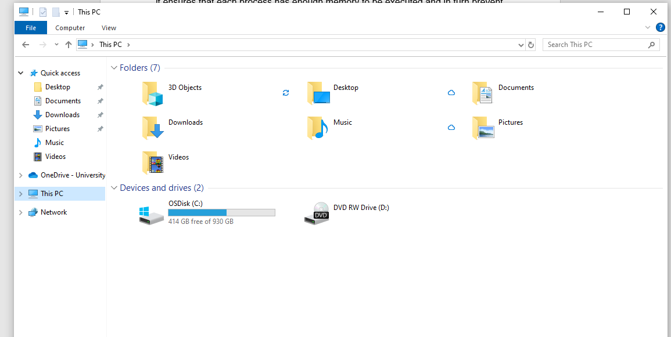

Device Management: I/O Devices
Device management in operating systems manage “all the hardware or virtual devices of a computer or PC” [3] which involves controlling, and coordinating different hardware devices that are connected to the system. These can be devices such as a mouse, keyboard, speakers, monitors and more. The operating system communicates between these io devices by managing device drivers, which translates the software requests into commands that are understood by the hardware, enhancing the overall user experience and system efficiency.
Network Management
Network management in operating systems monitors performance of the networking within the operating system. It involves configuring network settings, managing networking devices, implementing protocols, and ensuring security. Operating systems provide interfaces for configuring IP addresses and other network protocols while optimising its performance. This ensures that “network resources are made available to users efficiently, effectively and quickly” [4] which optimises the overall performance of the operating system.
System Security
System security in operating systems includes the use of mechanisms aimed to keep the system secure from malicious activities such as hacking and unauthorised threats. It includes the encryption of data to protect integrity and privacy by using firewalls and anti-virus software’s. Security within the operating system is paramount for maintaining a secure system.

Task 2. Use of Windows OS CLI commands.
Document the use of approx. 10 Batch or PowerShell commands, with screenshots and accompanying narration. Approx. 350 words, cite several reference sources.

DIR

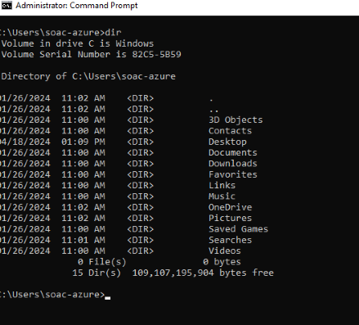
The DIR command was used to ‘Display a list of a directory’s files and subdirectories’ [5] By doing this it enables the user to have all files on that specific directory all on one page.

CLS

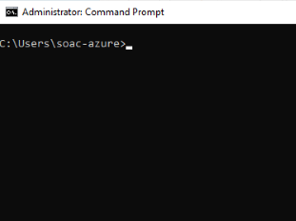
The CLS command was then used to clear the command prompt screen ready to ensure that the command prompt screen was tidy.

Cd
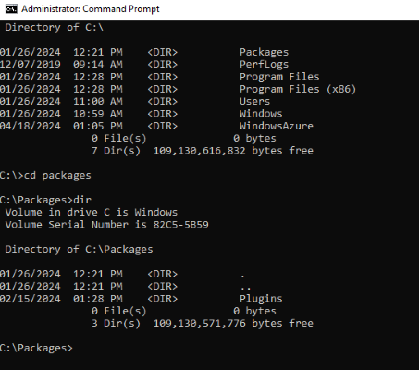
The CD command is the change directory prompt. It is used to ‘change the current directory to the parent directory’ [6]

Cd..

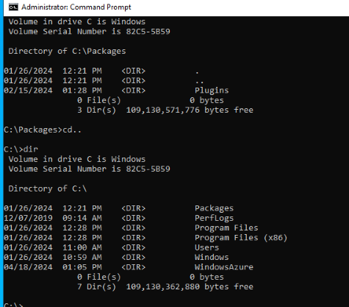
The CD.. command is used to move back one level in the command prompt.

Mkdir test
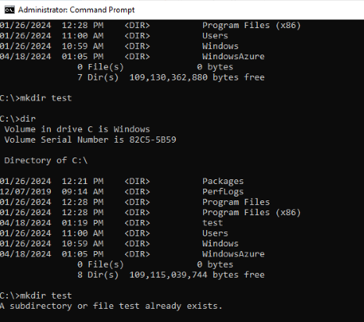
The MKDIR test command is used to create a new directory or folder with the name ‘test’.

Rmdir test
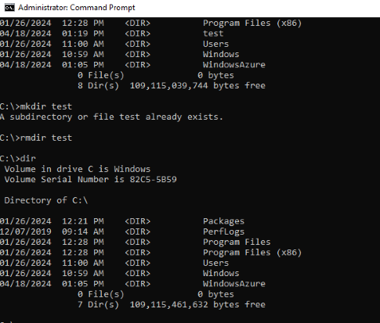
Once the test folder had been created. RMDIR test was used to delete that specific file.

Help
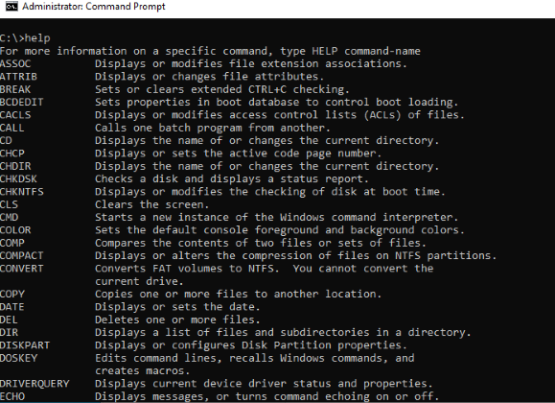
The help command is used to display a list of available commands. Each command shown has a brief description explaining what it does.

ping
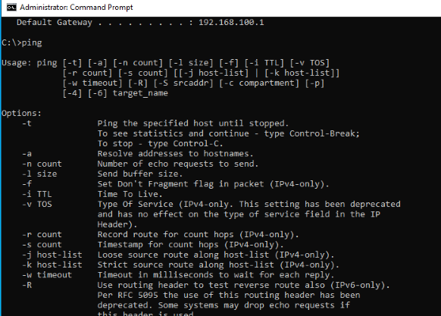
The ping command in windows ‘sends ICPMP/IP ‘echo’ packets over the network to the designated address’ [7] this is used to test the connectivity between two devices by sending packets of data and measuring the response time.

Ipconfig/displaydns
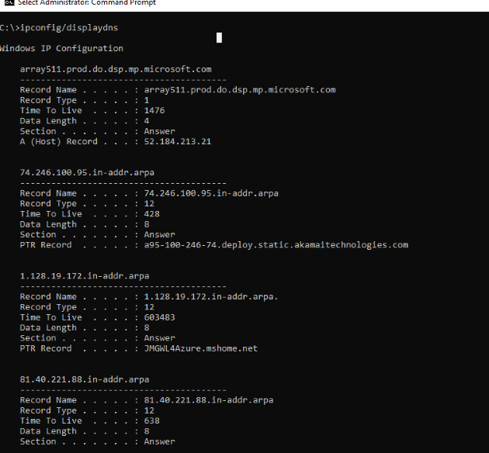
The IPCONFIG/DISPLAYDNS command is used to ‘provide you with a list of all the DNS records stored in the cache.’ [8] including all DNS resource records that have been preloaded from the hosts.

Getmac

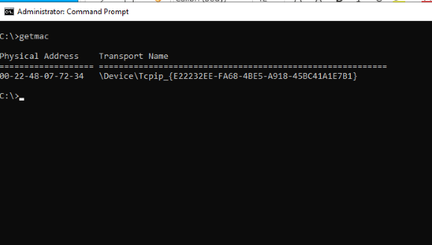

The getmac command is used to display the MAC address of network adapters on the system.
Task 3. Use of Linux OS CLI commands.
Document the use of approx. 10 Bash commands, with screenshots and accompanying narration. Approx. 350 words, cite several reference sources.

Echo
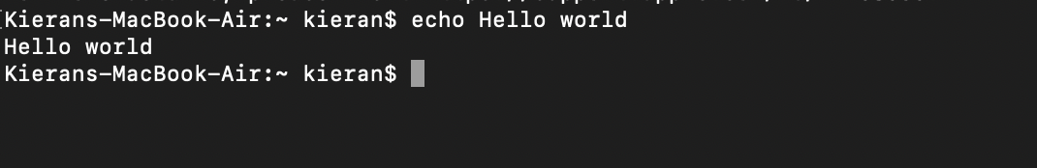
The echo command is used to display the text inserted which is often used in scripts to print messages.

Pwd

PWD stands for ‘print working directory’. This command ‘prints the current working directory path, starting from the root (/)’ [9]

Date



The ‘Date’ command simply displays the current date and time of when the command is entered

Whoami

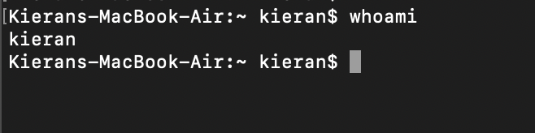

The ‘WHOAMI’ command ‘displays the username of the current user’ [10]
Ls

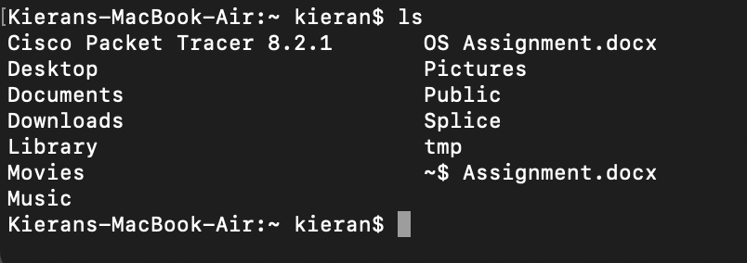

The LS command is used to list all of the contents of the directory that a user is currently in

cd
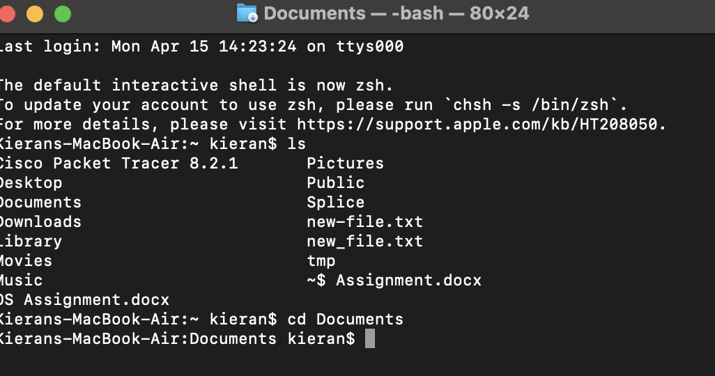

CD command stands for ‘change directory’. Like windows the CD command is used to change the current directory a user is in.

Cd . .

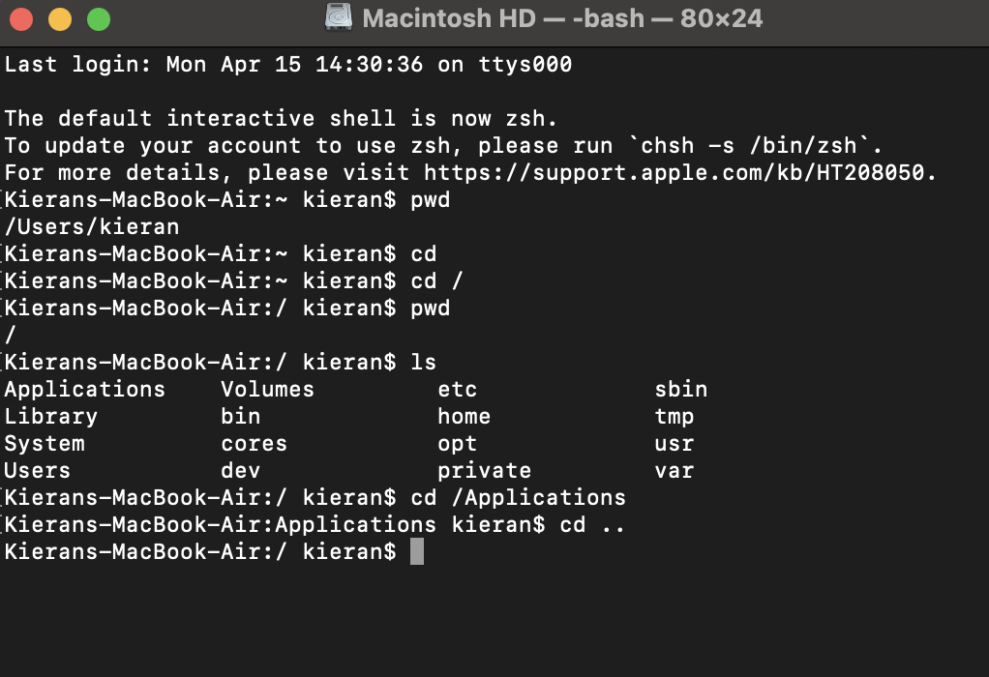

The CD.. command is used to go back one directory

Clear

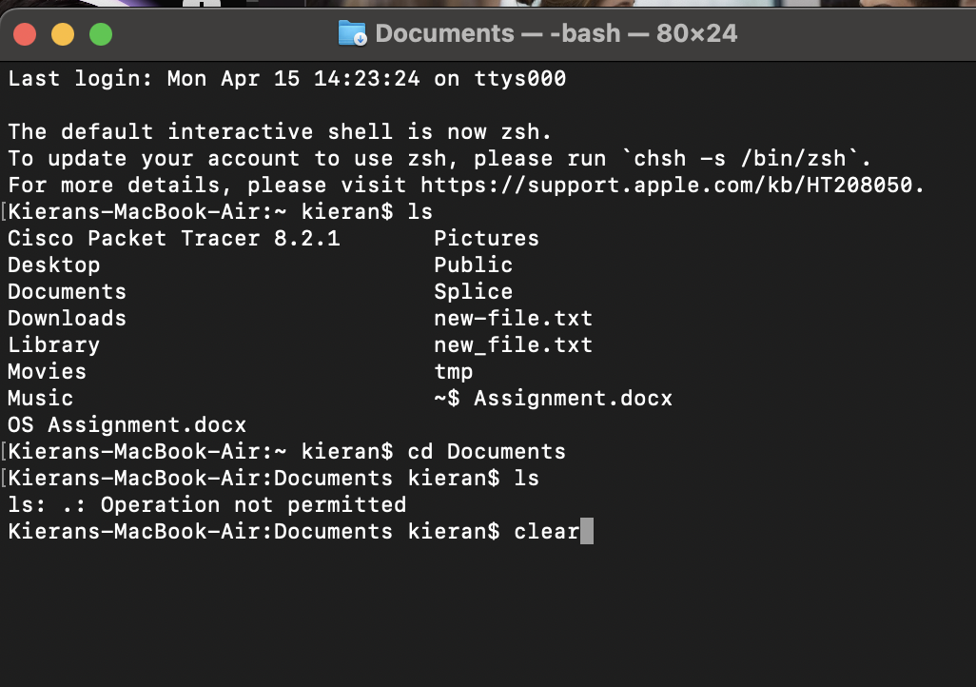
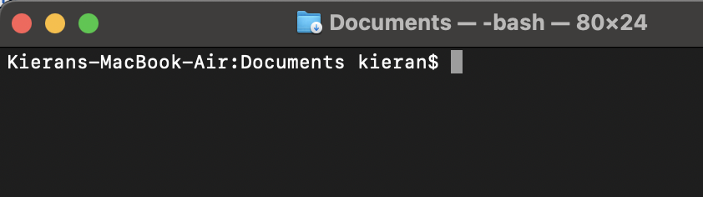

Clear is used to clear all of the text in the terminal

If config

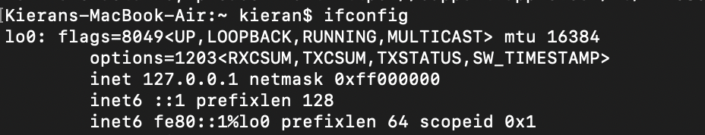

The ifconfig command is used to present ‘the current configuration for a network interface when no optional parameters are applied’ [11]

Cat /etc/resolv.conf

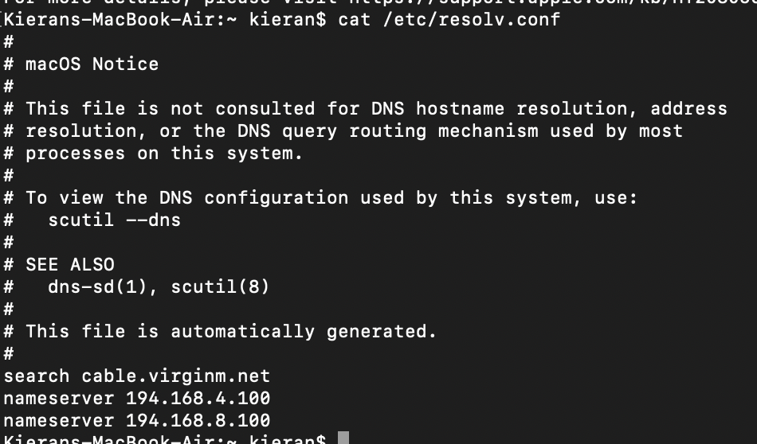

The cat/etc/resolv.conf command is used to translate ‘domain names to IP addresses by querying the Domain Name Server (DNS). [12]

Task 4. Use of Windows OS scripts.
Demonstrate key features of a Win. OS scripting language by documenting the use of Batch or PowerShell scripts, with screenshots and accompanying narration. Approx. 350 words, cite several reference sources.

Variable

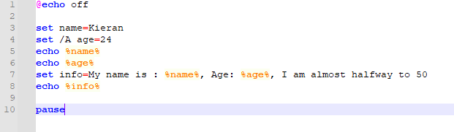
This is the script that was used for the variable. A name and age were entered. To use variables ‘use set to create variables, and then use them in the same way you would use the numbered variables %0 through %9’ [13] For this script only two variables were used. Name and age.

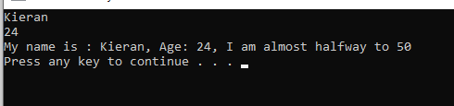

This is what the script looked like when it was run. It has shown my name and age

Input, If and Goto

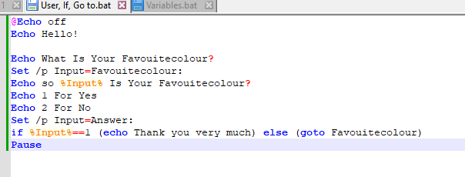
For the input, if and goto script, It was designed to ask the users favourite colour. The user would be asked to insert their favourite colour and then a prompt would be shown to ask a clarifying question of so …. is your favourite colour. Once this had been confirmed it would then present a thank you message.

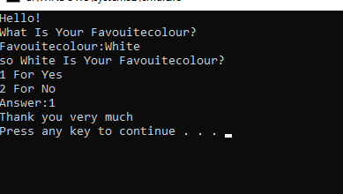
This is what the script looked like when it was run. As the favourite colour is white, the programme clarified with the user to make sure that it was correct. After doing so, it showed a thank you message.

For Loop

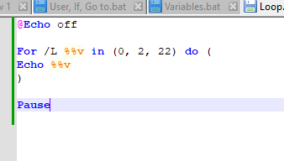
This for loop script needed to show multiple of 2s starting at 0 and ending at 22. Once this had been completed the programme was required to stop. An /L switch was required in this script. ‘The /L switch us used to denote that the loop is used for iterating through ranges’ [14]

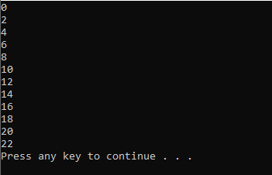
This is the programme after being run. It clearly states all multiples of 2 from 0 to 22.

Functions

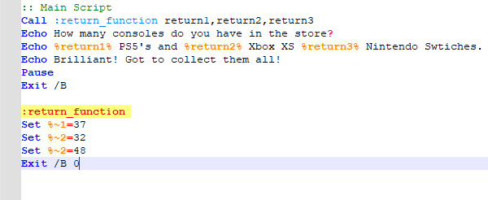

This function script was created to show the number of gaming consoles in stock currently in a store. It includes a PS5, Xbox XS and a Nintendo Switches.

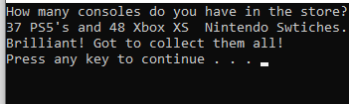

This is the script run showing how many consoles are in stock

Array

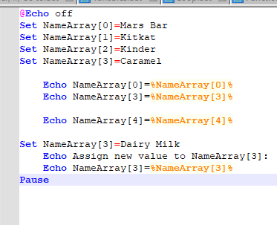

This script shows the value of NameArray index 0 being , Mars bar. Array index 3 is originally Caramel. However this needed to be changed to Dairy Milk. To do this it was required to “create an array using the command ‘set’” [15]. Once the arrays were set it was then possible to change index 3 from Caramel to Dairy Milk.

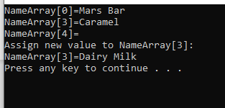

This shows the script run, successfully changing the value of index 3 from caramel to dairy milk.

Task 5. Use of Linux OS scripts.
Demonstrate key features of a Linux OS scripting language by documenting the use of Bash scripts, with screenshots and accompanying narration. Approx. 350 words, cite several reference sources.

Variable
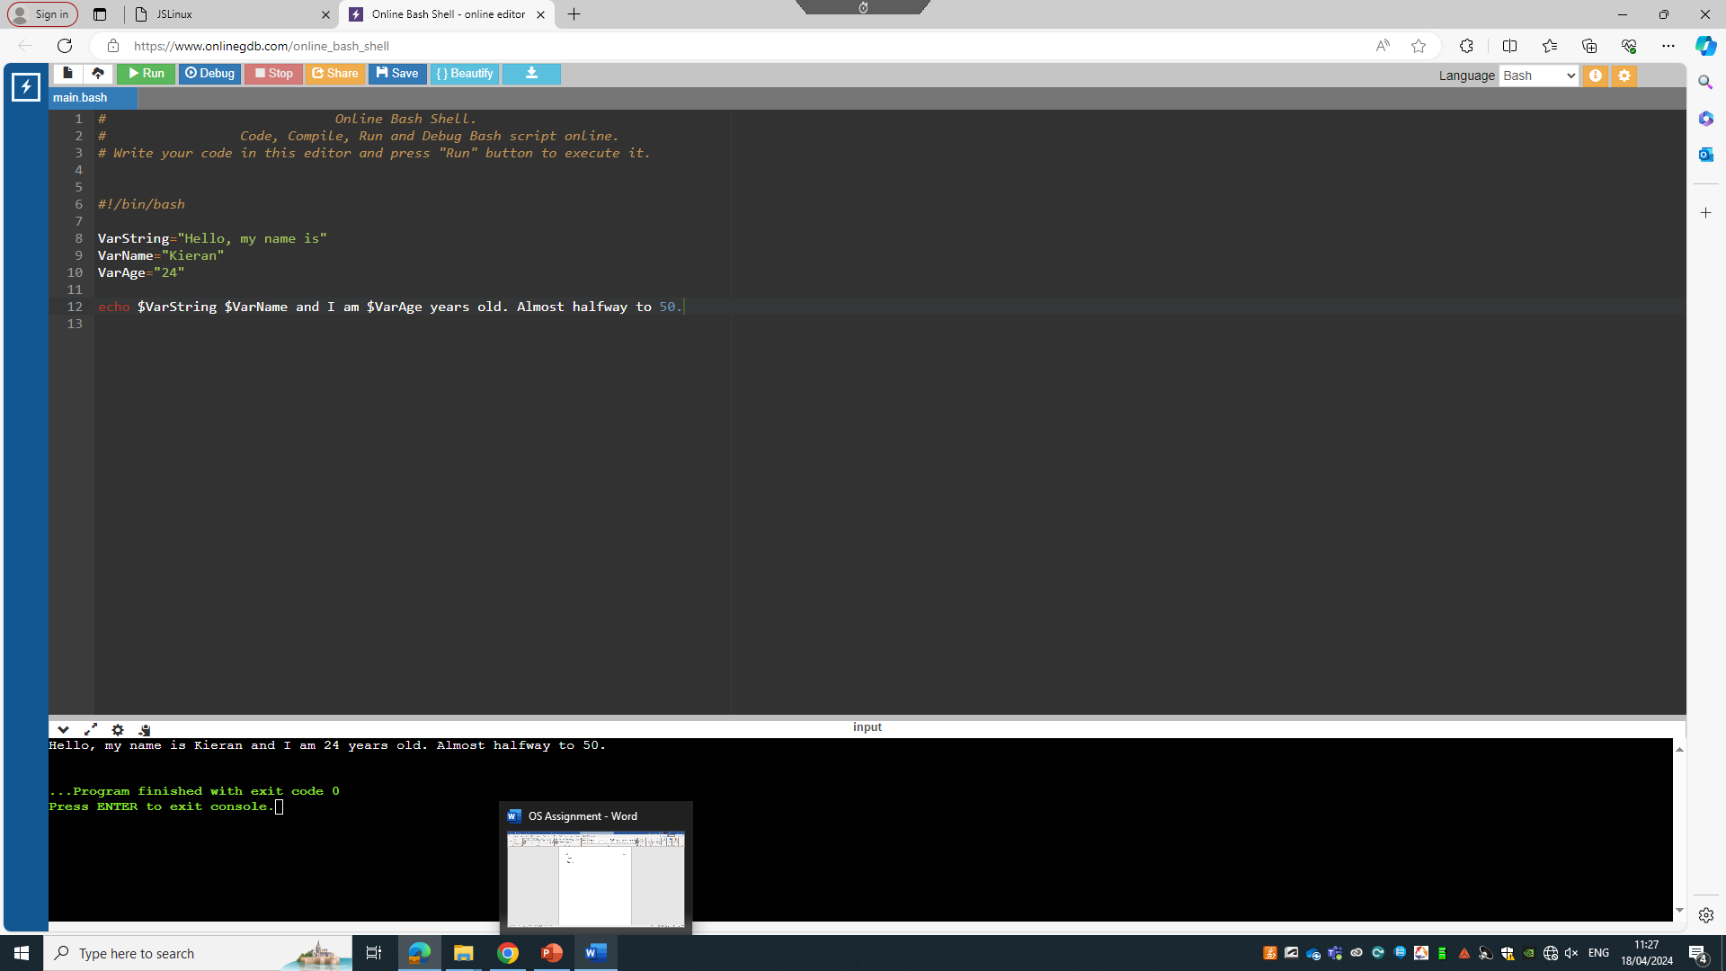
This is the script that was used for the variable. A name and age were entered.
Firstly the variables were set using VarString, VarName and VarAge. Once this had been inserted ‘the VALUE of this variable is retrieved by putting the '$' in at the beginning.’[16]

This is the output after the script was run. Showing my name and age

If statement + Until Loop + Input

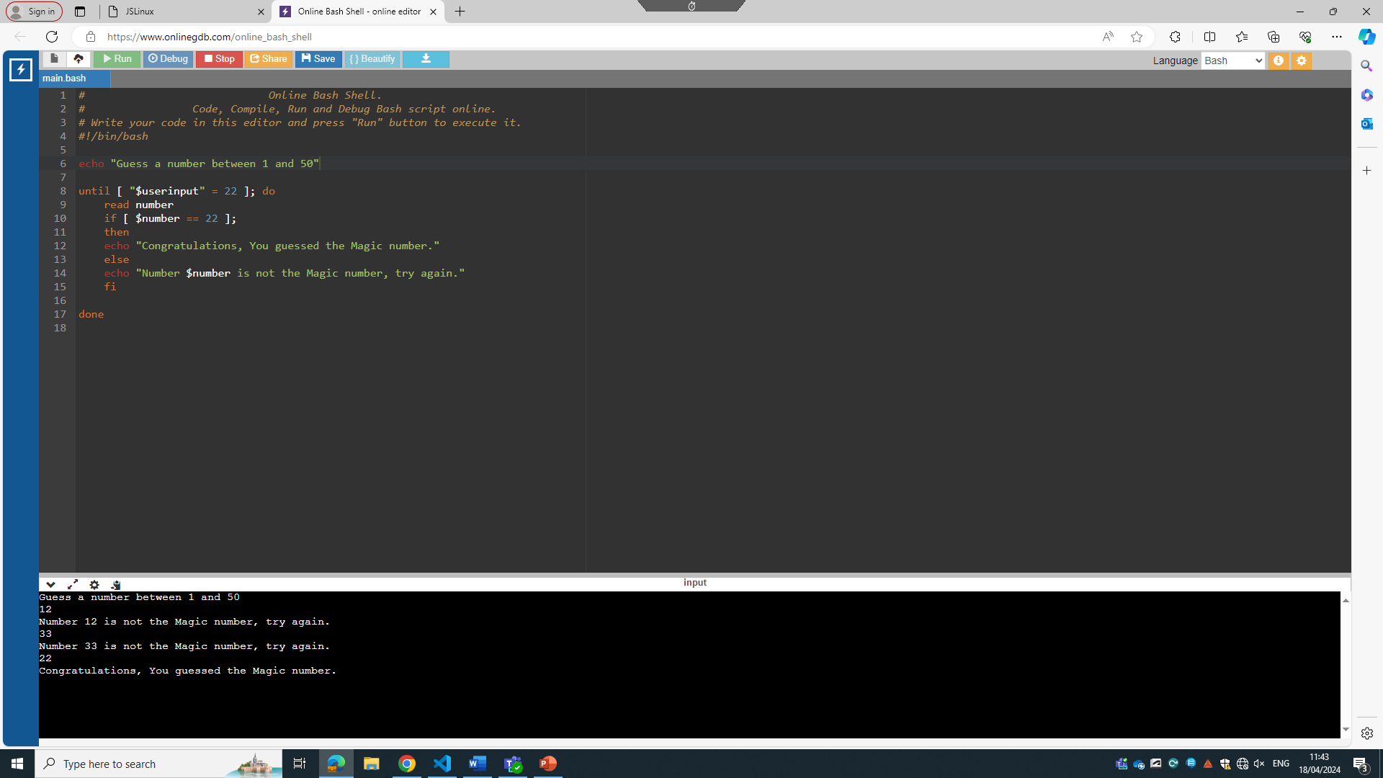

This script is written as a guess the number between 1 and 50 game. Firstly, the script was written to give 1 guess. However, as the numbers are far apart it would only be fair to give more than 1 chance. Because of this, an until loop was included to provide the user with more than 1 guess at the magic number.
After the user input the use of an if statement were required to ‘check if a condition is true and will execute a code block depending on condition.’ [17] This ensured that if the number entered by the user was correct or incorrect. The right prompt would show. Finally, the echo command was used to insert text into the prompt messages.

This is the outcome when the if statement + until + Input loop script was run

Array

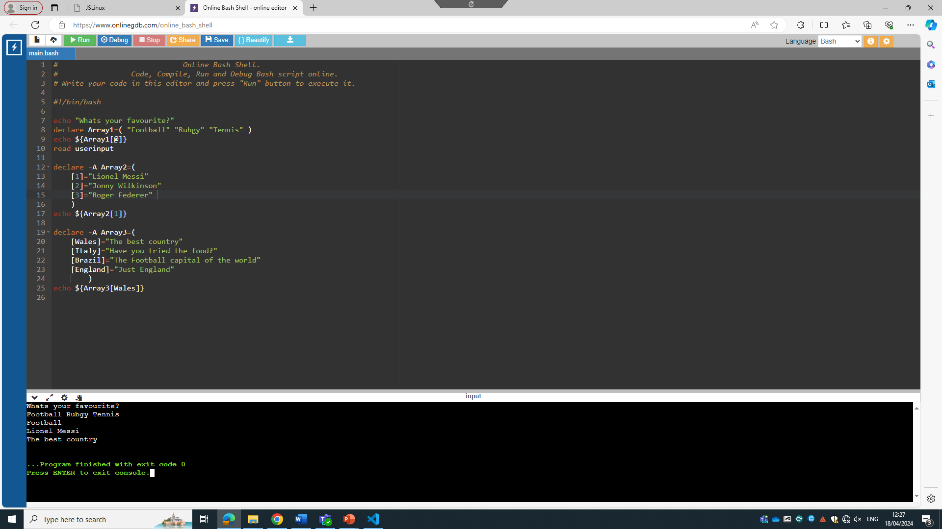
This script was created to firstly ask the users preference in sport. After the users choice input of football, rugby or tennis it would present the user with arguably the best player in that specific sport. Array 3 included a short sentence on each of the 4 countries listed

This is the script that was used for array. When run it successfully asks and allows the user to pick one of the three options and provides them with the correct player in that sport.

Case Statement

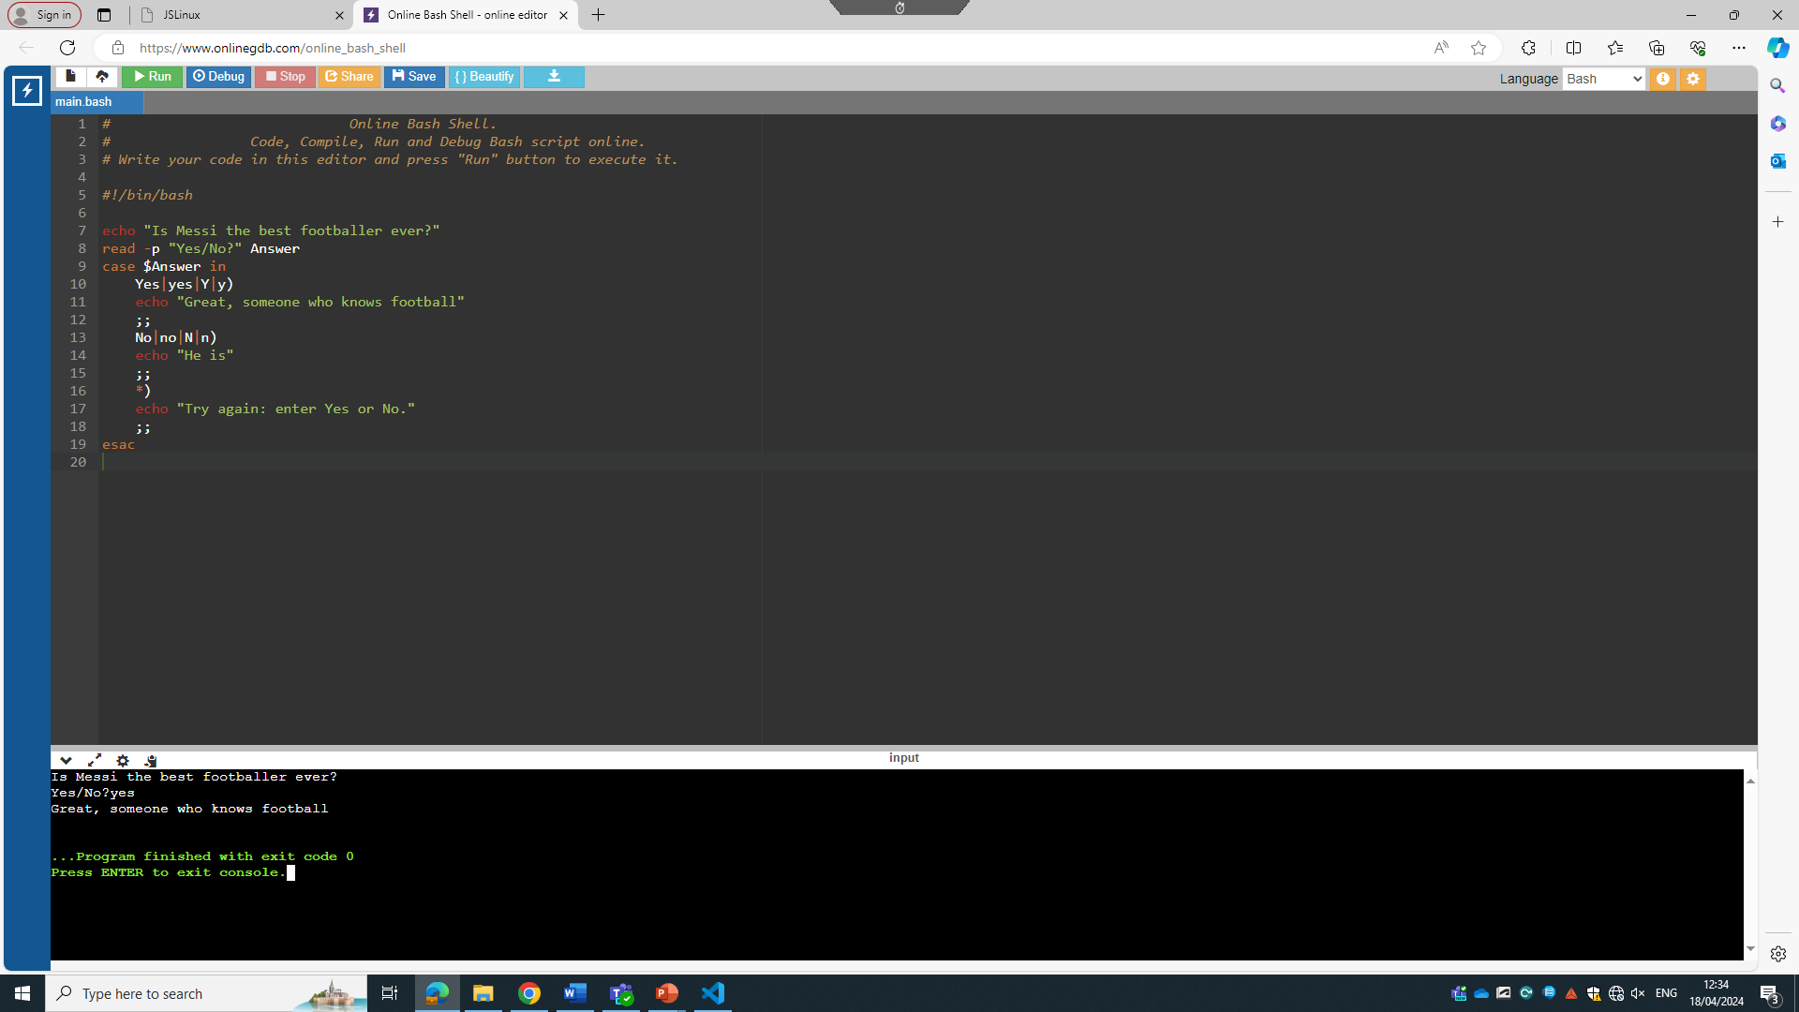
For the case statement script, it asks is Messi the best footballer ever. It was created to make sure that the user knows that Messi is the best footballer ever. It provides the user with a yes or no option. If the user states yes it should present a message ‘Great, someone who knows football’. However if the user enters no it should show a message saying ‘he is’. Anything else would not be valid for an answer which is why *) was used to show anything else is not valid. To use a case statement in bash you need to ‘start with the word case and follow it with a variable or an expression that you are trying to match’ [18]. This implies that after echo and the user input is inserted case would need to be used. The research was followed and the correct structure was used to complete the script

This is the script after being run showing the user saying that Messi is the best footballer ever. It successfully provided the user with the correct message.

Functions

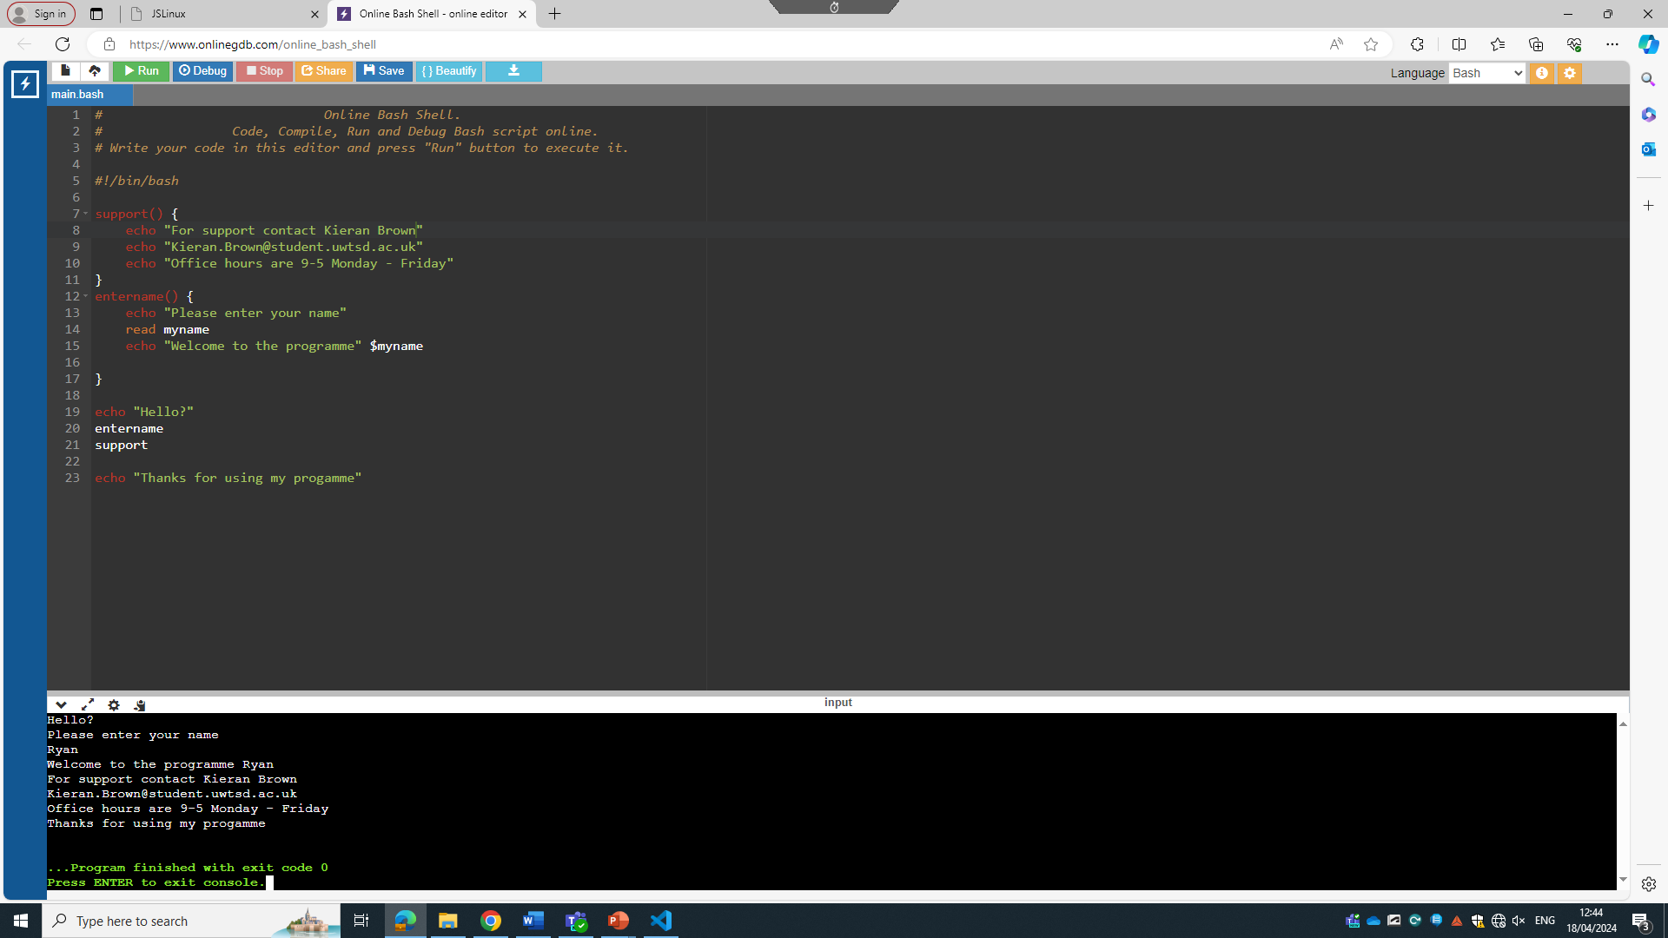
This is the functions script. This script was created to give information to users on how to get support. It needed to show the name of the person, their email, and the available days and times. Firstly the user would need to enter their name. They would then be greeted and then the function would operate showing all of the information set for the support workers contact details and office hours.

This is the run script, successfully letting the user input their name and providing them with the necessary information to get in touch with the support worker.

Conclusion

In conclusion, using both windows and Linux commands and scripts has provided a valuable insight to the operational aspects of both operating systems. Throughout the completion of the assignment, a good understanding of the scripting capabilities was achieved.

Using Linux offered a range of different powerful tools for data manipulation and extraction. The scripts were written successfully, and all achieved their set goals and expectations. On the other hand. Although Windows batch commands and scripts successfully achieved what was set out, they did not offer as much insight and processing capabilities as bash.

Overall, this assignment helped understand the importance of each operating systems and their similarities. It also helped gain an insight to what their operating systems can do.

Appendices

Types of OSs

There are a wide range of operating systems that are used today:

MacOS: MacOS is an operating system that is developed by Apple for their Macintosh computers. They include a user-friendly interface and are mostly known for their ease of integration with other Apple devices such as Apple Watch, iPhones and iPads. MacOS is popular for creative tasks such as music producing, photo editing and video editing.

Windows OS: Windows OS is an operating system that is developed by Microsoft and is the most widely used operating systems in the world. Windows holds a very powerful operating system that is known to be one of the best in the current market. Windows OS is commonly used for general computing, office work and gaming.

Linux: Linux is another very powerful operating system that is commonly used in servers, embedded systems and supercomputers. It has very popular distributions such as ubuntu, CentOS, Fedora and Debian.

Android: Android is an Operating system that is developed by Google. It is generally a mobile operating system that is primarily used on Samsung phones, Smart TVs, Smartwatches and Samsung tablets.

iOS: iOS is another Apple developed operating system. However, Unlike MacOS, iOS is primarily used for iPhones and iPads. It has a very smooth performance standard and has a top of the range security system.

Chrome OS: Chrome OS is an operating system which is also developed by Google. However, Chrome OS is a Linux based operating system. It is used in all chromebooks which are small laptops which optimise in web browsing, online collaborating, education and document editing.

Online Linux Course

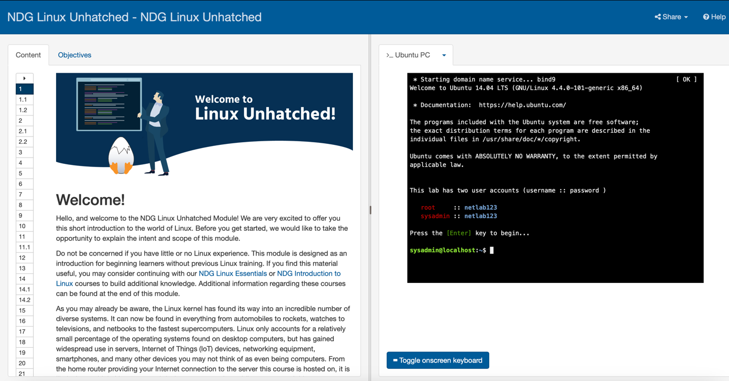

This is the online NDG Linux Unhatched course that I have enrolled to. It is used to introduce beginners to a range of Linux commands starting with easy commands to more complex as the course continues
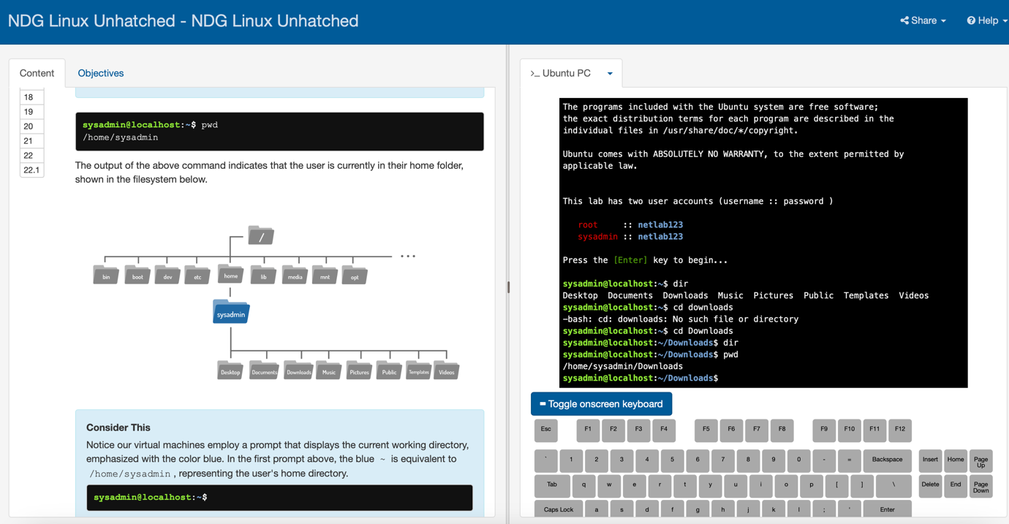

In this slide, it introduced the pwd command which stands for ‘Printing Working Directory’. This command is used to discover which directory the user is currently located within the file system.

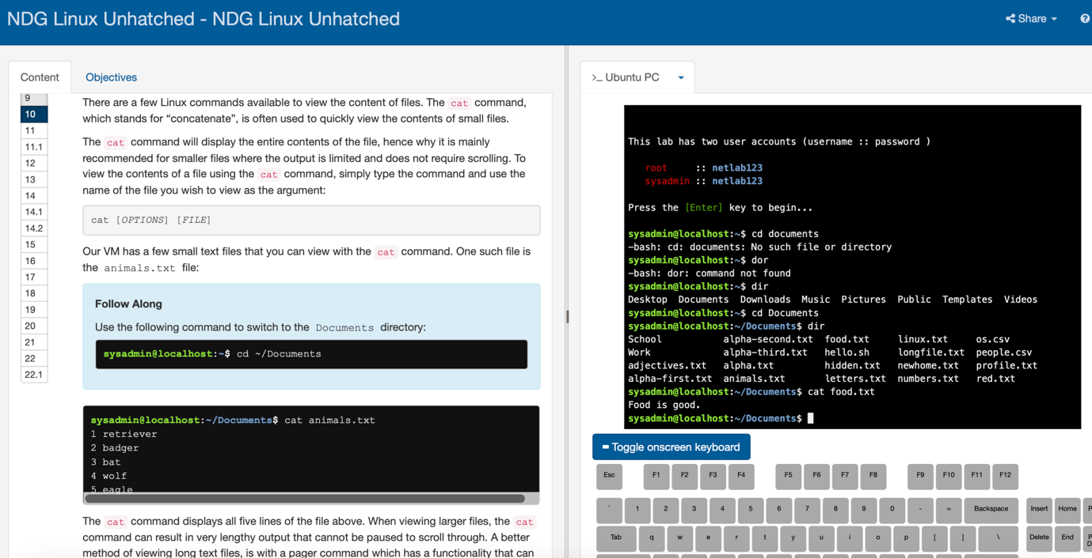

In this slide, it introduced the ‘cat’ command. The cat command is used to view the contents of a selected file. It is often used to quickly display smaller files rather than larger files. It starts with the command [options] [file]

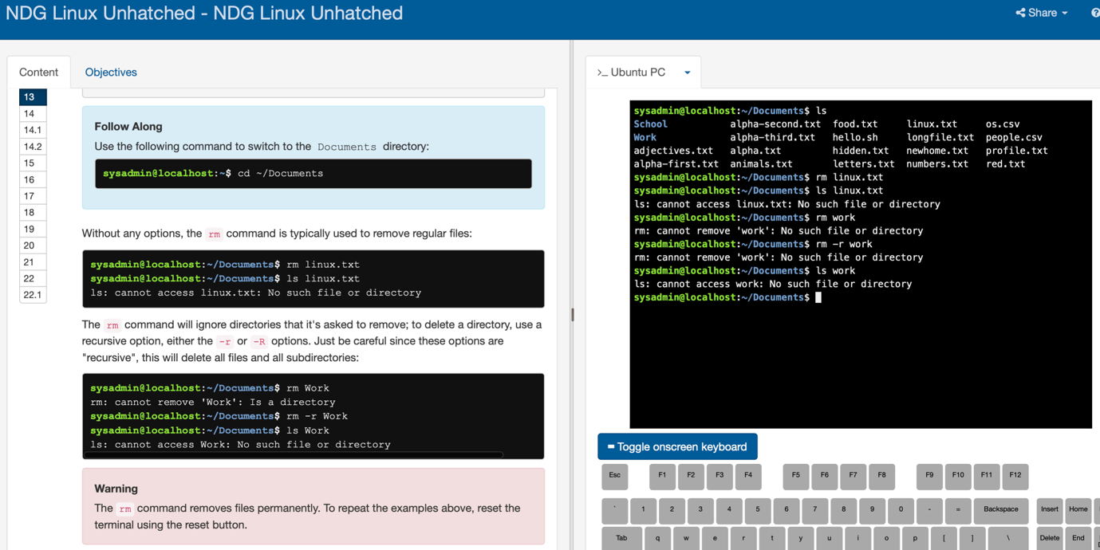

This slide shows how to remove files with Linux. The command used in this screenshot is ‘rm’ which stands for removing files. Once these files are deleted, they will be permanently deleted. This is why users need to ensure that they are certain when using this command.


After completing the course module on the introductory of Linux commands. This is the screen that I was greeted with.

Bibliography
[1] R. Sheldon, “What is memory management? - Definition from WhatIs.com,” WhatIs.com, Jun. 2022. Available: https://www.techtarget.com/whatis/definition/memory-management#:~:text=Memory%20management%20is%20the%20process. [Accessed: Apr. 09, 2024]

[2] Prepbytes, “File Management in Operating System,” PrepBytes Blog, Jan. 31, 2023. Available: https://www.prepbytes.com/blog/operating-system/file-management-in-operating-system/#:~:text=A%3A%20File%20management%20in%20an,%2C%20classification%2C%20and%20access%20control.. [Accessed: Apr. 09, 2024]

[3] P. Singh, “Device Management in Operating System,” Scaler Topics, Oct. 13, 2022. Available: https://www.scaler.com/topics/device-management-in-operating-system/#. [Accessed: Apr. 09, 2024]

[4] O. Cooperation , “What is Network Management?,” OpenText. Available: https://www.opentext.com/what-is/network-management#. [Accessed: Apr. 09, 2024]

[5] JasonGerend, “dir,” learn.microsoft.com. Available: https://learn.microsoft.com/en-us/windows-server/administration/windows-commands/dir. [Accessed: Apr. 12, 2024]

[6] S. Singh, “What is the difference between typing ‘cd..’ and just ‘cd’ in a batch file? What are the effects of each, if any at all?,” Quora, 2019. Available: https://www.quora.com/What-is-the-difference-between-typing-cd-and-just-cd-in-a-batch-file-What-are-the-effects-of-each-if-any-at-all#:~:text=In%20a%20batch%20file%2C%20%22cd. [Accessed: Apr. 12, 2024]

[7] TutorialsPoint, “Batch Script - PING,” www.tutorialspoint.com. Available: https://www.tutorialspoint.com/batch_script/batch_script_ping.htm#:~:text=This%20batch%20command%20sends%20ICMP. [Accessed: Apr. 13, 2024]

[8] L. Ballejos, “IPConfig Commands | A Complete Guide | NinjaOne,” www.ninjaone.com, Mar. 30, 2024. Available: https://www.ninjaone.com/blog/ipconfig-commands/#:~:text=ipconfig%20displaydns%20and%20press%20enter. [Accessed: Apr. 15, 2024]

[9] B. Marijan, “The pwd Linux Command {in 10 Examples},” Knowledge Base by phoenixNAP, Dec. 22, 2021. Available: https://phoenixnap.com/kb/pwd-linux#:~:text=The%20pwd%20Linux%20command%20prints. [Accessed: Apr. 15, 2024]

[10] GeeksForGeeks, “whoami command in Linux with example,” GeeksforGeeks, Dec. 06, 2017. Available: https://www.geeksforgeeks.org/whoami-command-linux-example/. [Accessed: Apr. 15, 2024]

[11] IBM, “ifconfig Command,” www.ibm.com, Aug. 30, 2023. Available: https://www.ibm.com/docs/en/aix/7.2?topic=i-ifconfig-command. [Accessed: Apr. 15, 2024]

[12] C. M. Jun, “The /etc/resolv.conf File | Baeldung on Linux,” www.baeldung.com, Mar. 11, 2023. Available: https://www.baeldung.com/linux/etc-resolv-conf-file#:~:text=Specifically%2C%20it%20translates%20domain%20names. [Accessed: Apr. 15, 2024]

[13] JasonGerend, “set,” learn.microsoft.com. Available: https://learn.microsoft.com/en-us/windows-server/administration/windows-commands/set_1. [Accessed: Apr. 15, 2024]

[14] TutorialSupport, “Batch Script - Looping through Ranges,” www.tutorialspoint.com. Available: https://www.tutorialspoint.com/batch_script/batch_script_looping_through_ranges.htm. [Accessed: Apr. 15, 2024]

[15] GeeksForGeeks, “Batch Script - Arrays,” GeeksforGeeks, Mar. 15, 2022. Available: https://www.geeksforgeeks.org/batch-script-arrays/. [Accessed: Apr. 15, 2024]

[16] Kess, “BASH Programming - Introduction HOW-TO: Variables,” tldp.org. Available: https://tldp.org/HOWTO/Bash-Prog-Intro-HOWTO-5.html. [Accessed: Apr. 16, 2024]

[17] TheRealDavidEsquerra, “Bash is powerful! Lets build a simple number guesser game.,” CodeX, Apr. 26, 2022. Available: https://medium.com/codex/bash-is-powerful-lets-build-a-simple-number-guesser-game-a28081351f7b. [Accessed: Apr. 16, 2024]

[18] A. Jotwani, “Bash Case Statement Syntax and Examples,” www.warp.dev. Available: https://www.warp.dev/terminus/bash-case-statement#:~:text=Start%20with%20the%20word%20case. [Accessed: Apr. 16, 2024]

