Süleymaniye Cami, Koran and Mathematics
Wenjing Yu 1804905 HPAH6009

Contents
Details of Architecture 3
exterior 3
Interior 4
Mausoleums 6
Complex 7
Significance 8
Myth 8
Material 9
Koran 10
Mathematics 12

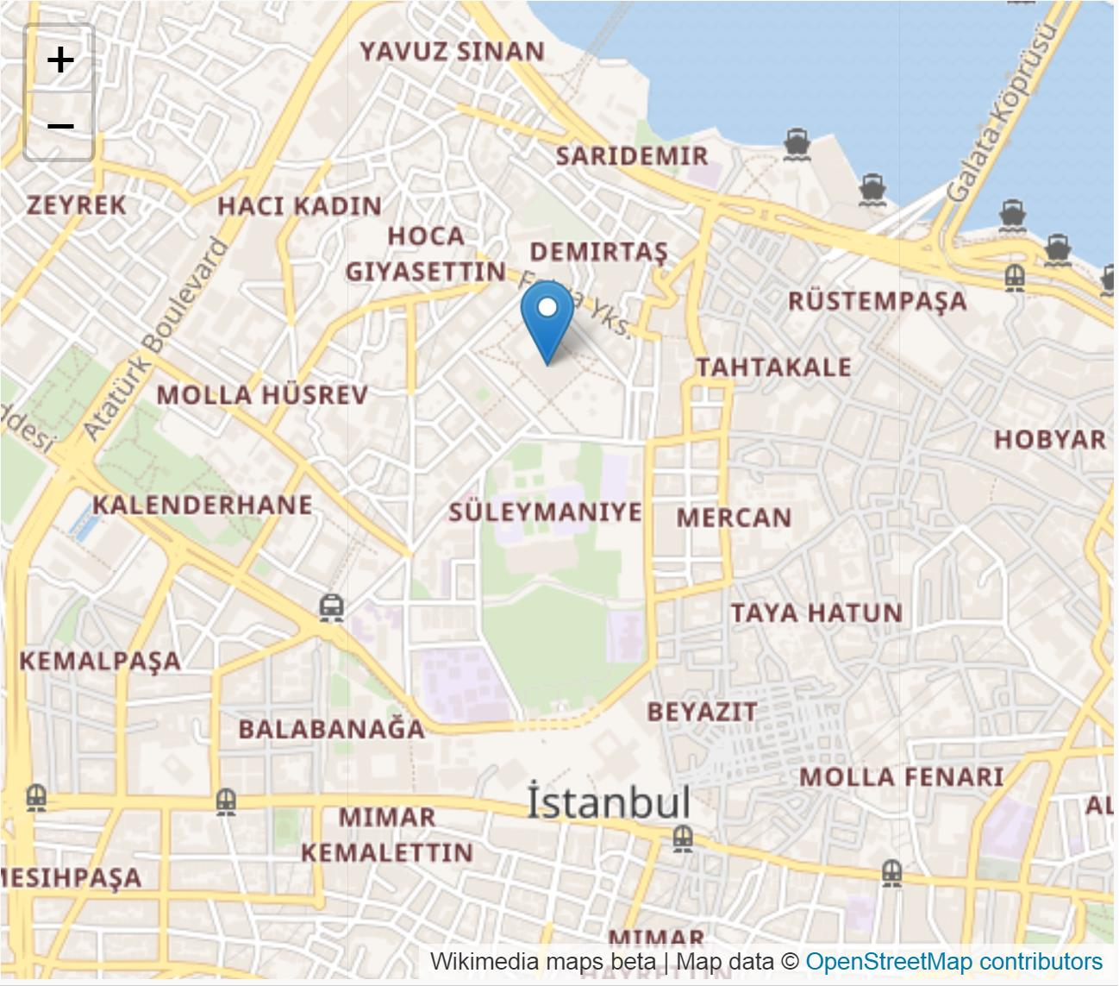
The Süleymaniye Cami is one of several major mosques in Istanbul, Turkey. It was built in a very short time from 1550 to 1557 commissioned by Süleyman I and is the most important work of architect Mimar Sinan. It is the second largest mosque in the city, and one of the best-known sights of Istanbul. In terms of size and visual impact, the Süleymaniye represents the apex of Ottoman imperial architecture executed in the capital city. [1]
The whole complex is built on a complex and steep third hill, which combines the hill with the surrounding streets and alleys using an extraordinary architectural scheme. For example, the third and fourth Islamic schools, completed in 1558 and 1559, descended stepwise to Golden Cape Bay, a masterpiece in the history of architecture. Red Iznick tiles were first used inside the mosque.

Details of Architecture

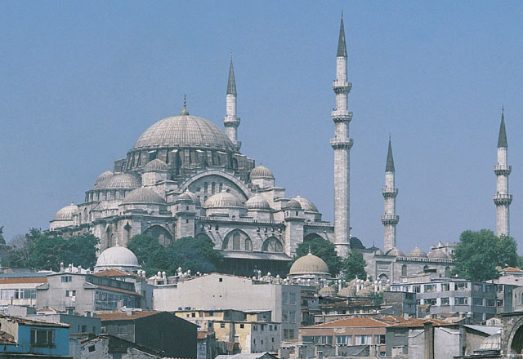
exterior
Necipoglu Gülru. 2005. The Age of Sinan: Architectural Culture in the Ottoman Empire. London: Reaktion Books.
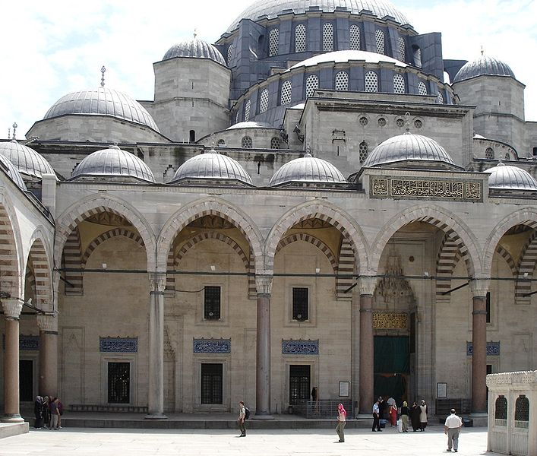
Like the other imperial mosques in Istanbul, the entrance to the mosque itself is preceded by a forecourt with a central fountain. The courtyard is of exceptional grandeur with a colonnaded peristyle with columns of marble, granite, and porphyry. The northwest facade of the mosque is decorated with rectangular Iznik tile window lunettes. The mosque is the first building where the Iznik tiles include the brightly colored red clay under the glaze.
Süleymaniye Cami, G.dallorto
Four minarets were built, the two at the far corners of the courtyard being calculatedly lower than the pair at each side of the mosque itself with the result that they imply the silhouette of a triangle. [2]Taller minarets have three galleries (serifes) and rise to a high of 63.8 m (209 feet) without their lead caps and 76 m (249 feet) including the caps. Four minarets were used for mosques endowed by a sultan (princes and princesses could construct two minarets; others only one). The minarets have a total of 10 galleries, which by tradition indicates that Süleyman I was the 10th Ottoman sultan.
The main dome is 53 meters (174 feet) high and has a diameter of 26.5 meters (86.9 feet) from outside which is exactly half the height. At the time it was built, the dome was the highest in the Ottoman Empire when measured from sea level, but still lower from its base and smaller in diameter than that of Aya Sophia. And it is said that Sinan, the architect of the mosque, wanted to make it larger than Aya Sophia at first, but in the end, he failed to do so.

Interior
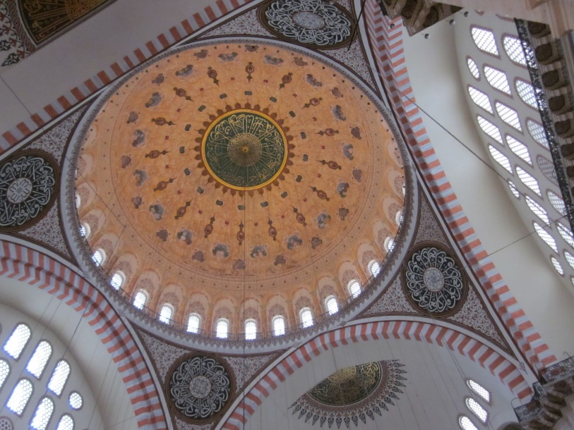
The interior of the mosque is almost a square, 59 meters (194 feet) in length and 58 meters (190 feet) in width, forming a single vast space. The dome is flanked by semi-domes, and to the north and south arches with tympana-filled windows, supported by enormous porphyry monoliths. Sinan decided to make a radical architectural innovation to mask the huge north-south buttresses needed to support these central piers. He incorporated the buttresses into the walls of the building, with half projecting inside and half projecting outside, and then hid the projections by building colonnaded galleries. There is a single gallery inside the structure, and a two-story gallery outside.
View of the dome, Sharon C. Smith (photographer)
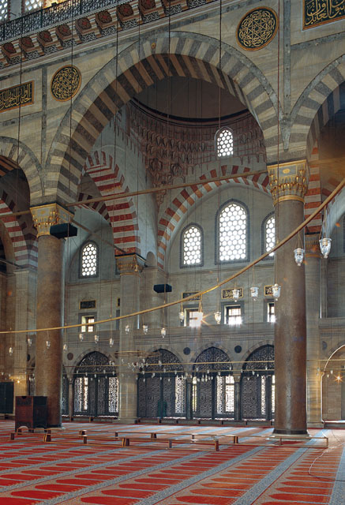
The interior decoration use stained-glass windows restricted to the qibla wall. Iznik tile revetments are only used around the mihrab. The repeating rectangular tiles have a stencil-like floral pattern on a white ground. The flowers are mainly blue with turquoise, red and black but green is not used. On either side of the mihrab are large Iznik tile calligraphic roundels with text from the Al-Fatiha surah of the Koran. The white marble mihrab and mimbar are also simple in design, and woodwork is restrained, with simple designs in ivory and mother of pearl.
Necipoglu Gülru. 2005. The Age of Sinan: Architectural Culture in the Ottoman Empire. London: Reaktion Books.

Mausoleums
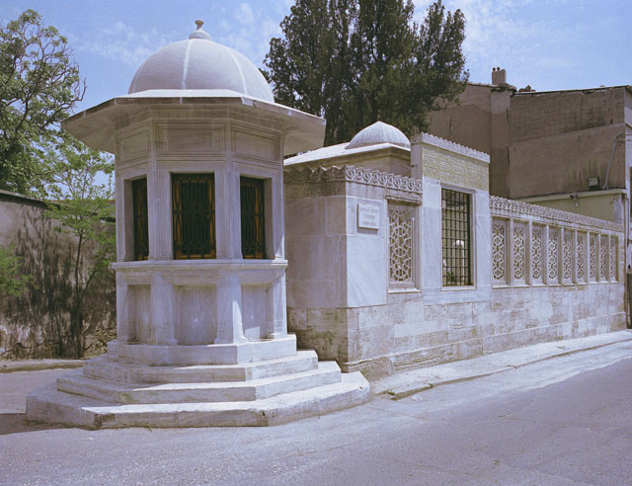
In the walled enclosure behind the qibla wall of the mosque are the separate mausoleums (türbe) of Sultan Süleyman I and his wife Hurrem Sultan (Roxelana). Hurrem Sultan's octagonal mausoleum is dated 1558, the year of her death. The 16 sided interior is decorated with colorful Iznik floral tiles, with a tile inscription above them to turn the high octagon into a garden. [3]The seven rectangular windows in the middle are surmounted by tiled lunettes and epigraphic panels. Between the windows are eight mihrab-like hooded niches. The ceiling is now whitewashed but retains the crystal roses that give glitter to the starscape.[4]
View of tomb from street, with sabil at corner, Necipoglu Gülru. 2005. The Age of Sinan: Architectural Culture in the Ottoman Empire. London: Reaktion Books.
The much larger octagonal mausoleum of Süleyman I was probably not completed until the following year of his death. The mausoleum is surrounded by a peristyle with a roof supported by 24 columns and has the entrance facing east rather than the usual north. Under the portico on either side of the entrance are Iznik tiled panels. These are the earliest tiles that are decorated with the bright emerald green color that would become a common feature of Iznik ceramics. The interior has a false dome supported on eight columns within the outer shell. There are 14 windows set at ground level and an additional 24 windows with stained glass set in the tympana under the arches. The walls and the pendentives are covered with polychrome Iznik tiles. Around the room above the windows is a band of inscriptive tiled panels. The text quotes the Throne verse and the following two verses from the Koran. In addition to the tomb of Süleyman I, the mausoleum houses the tombs of his daughter Mihrimah Sultan and those of two later sultans: Süleyman II (ruled 1687-1691) and Ahmed II (ruled 1691 to 1695)

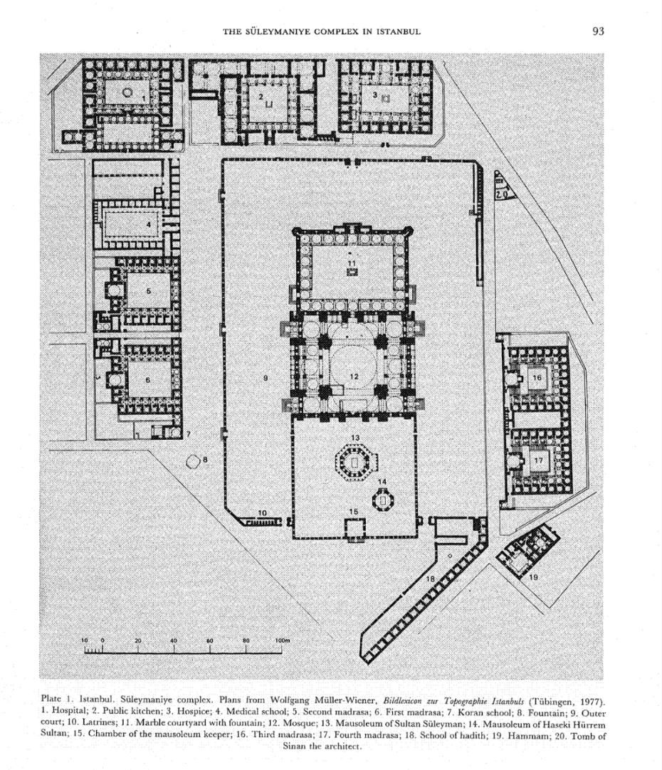
Complex
As with other imperial mosques in Istanbul, the Süleymaniye Mosque was designed as a külliye, or complex with adjacent structures to service both religious and cultural needs. It is a rationally planned socioreligious complex with geometrically organized dependencies, consisting of the monumental Süleymaniye mosque and two mausolea(tombs of the sultan and his wife Haseki Hürrem Sultan, built in a walled enclosure) at the center, separated by an outer courtyard from four general madrasas; two specialized madrasas—one for the study of medicine, and the other for the study of hadith; a Koran school for children; a hospital; a hotel; a public kitchen; a hammam; a caravanserai; and rows of small shops.[5]
Necipoglu-Kafadar, G. (1985). The Suleymaniye Complex in Istanbul: An Interpretation. Muqarnas, 3, p.92.
Just outside the mosque walls, to the north is the tomb of Sinan.

Significance
The analysis of Süleymaniye Cami can be divided into many different symbolic levels. [6]It includes functional level analysis, such as cultural association and myth, formal language of architecture and many inscriptions produced by the use of certain building materials. At the same time, we can also find some common things from the design in a mathematical way.

Myth
Aya Sofia is considered to be the imitation of templum Novum salomonis, so Süleyman used the same style (vault, two semi-vaults, two gables) in building his mosque to reinforce this tradition. Like the Cathedral of Aya Sophia, Süleyman sent boats to bring priceless pillars from the Jupiter Temple in Baalbek. He also brought pillars from the conquered islands of Rhode, Belgrade, and Malta. All this shows that it is not accidental to imitate Solomon. Each stone pillar from a distance symbolizes the commemoration of a different nation.
There are two huge rose granite pillars under each wall. Legend has it that the two roots come from Alexandria and Baalbeck. According to the Islamic literature, Baalbek's temple is regarded as Solomon's palace for the Queen of Sheba. The other two came from a palace in Istanbul and another place (possibly an arena). Two other pillars from Alexandria sank in a big storm. The four pillars also represent Mohammed's four heirs: Abu Berkel, Omar I, Osman Ibn Afan and Ali Ibn Ibn Talib. Accordingly, there are four schools of Islamic law and four Islamic universities around the mosque. The four halls of the mosque also symbolize Mohammed's four "friends" (heirs).
Contemporary people regard the Süleymaniye Cami as the second Kaaba (the cube). Surprisingly, the enemy of the Ottoman Empire, Iranian Czar Thames Po I, wrote a letter to Süleyman when the mosque was opened: he called it a holy place and wrote that the mosque reminded him of the "holy room of Allah" (i.e. Kaaba). This connection is not accidental. A small piece of Kaaba’s sacred black meteorite was embedded at the north entrance of Süleyman’s tomb.
Compared with Aya Sofia, the interior decoration of Süleymaniye Cami is very simple, and it is completely subordinated to the needs of the building. The crystal structure of the building should almost always attract visitors rather than its surface. In the whole building, the Euclidean geometry is fully reflected (for example the four minarets said before).

Material
Another area of interest is the careful selection of materials. The three main types of building stone used in the complex were küfeki (limestone), od tasi (Firestone), and mermer (Proconnesian marble), which was procured primarily from the Marmara region. Lime-stone and firestone were quarried, while the marble was simply gathered, in the manner practiced since the Byzantine era, using the same equipment and teams in an enormous effort to acquire appropriate stone components. From 1549 to 1557, an abundant supply of rare and precious colored architectural elements—columns, entablatures, voussoirs, facings, veneers, pavements, and jambs—were collected both from ancient cities and from contemporary buildings in which ancient materials had been reused. Sources included a mosque in Nicaea (Iznik) and houses in Istanbul, 108 even ones belonging to statesmen. In Neandria (Ezine), columns abandoned in the ancient quarry were collected.
The stone specifications in the registers indicate size, form, dimension, and color qualities. Terms used include yek pare (monolithic), pare (piece, fragment), ala (first-rate), alaca (Turkish: colored), reng-amiz (Persian: colored), and ablak(Arabic: black and white). Ablak evidently refers here to both pink Nean-drian granite and Tenedos marble. [7]

Koran
The calligraphy inside the mosque consists entirely of verses from the Koran, with the exception of the foundational text, which celebrates the unlimited rights of the sultan.
The dome has been a symbol of the sky for centuries. The dome and the half dome below it were described as twin brothers of the celestial orbit. "The earth challenges the sky with an arch higher than heaven." The fountain in the front yard symbolizes the river in heaven. The whole mosque is seen as a symbol of heaven, and the fine calligraphy reinforces the metaphor. Like most Ottoman buildings, it is symbolically important to fill the mosque with light through stained glass windows, and it can be seen from many mosques built by Sinan. With the use of alternating domes on the east and west sides, Sinan achieves the same spatial expansion as would be provided by a half dome, yet with a lighter structure. On the other hand, with this scheme, the corner domes are better connected with the rest of the encircling spaces, heightening the effect of continuity and spatial flow. [8]Comparing with Aya Sophia again, Süleymaniye Cami has better light especially more glass windows on the dome and walls of the mosque.
In my opinion, Aya Sophia uses the huge space reflecting the endless sky, while in Süleymaniye Cami, although there are four pillars supporting the dome, the windows on the dome and lights in the hall can be seen as stars in the sky.
For example, the calligraphy on the glass window quotes from Koran chapter 24, the light: “Allah is the light of heaven and earth, his light is like a lampstand, the lampstand has a lamp, the lamp in a glass cover, the glass cover is like a bright star, with auspicious olive oil burning the lamp; It is not eastern, it is not western, and its oil, even without a fire, almost shines -- light on light -- and Allah directs those he desires toward his light. Allah has given many parables to all men. Allah knows everything.”
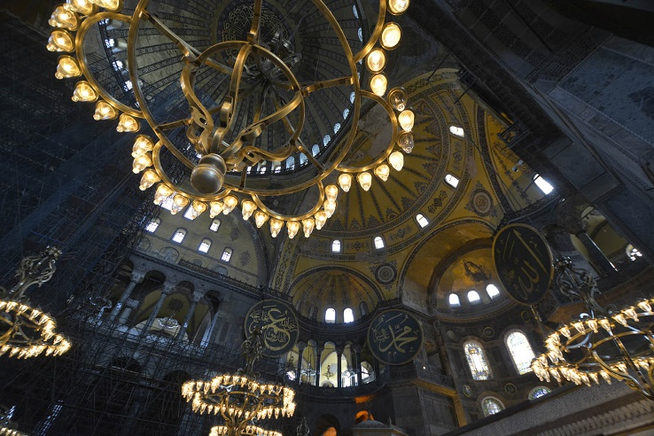
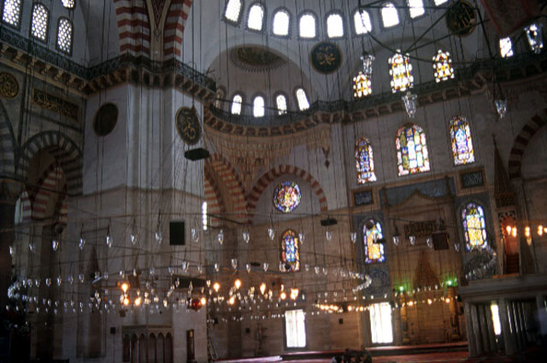
That is to say, the mosque seems to be illuminated by the light of Allah. At night, the mosque is illuminated by more than 2,000 glass lights, with the interior resembling a star-studded dome.
Lights in Süleymaniye Cami, Tim Bradley(photographer), Aga Khan Award for Architecture
Lights in Aya Sophia, Barbara J. Anello-Adnani (photographer), Barbara J. Anello

Many of these verses from the Koran refer to heaven. For example, in chapter 39, sentence 73:
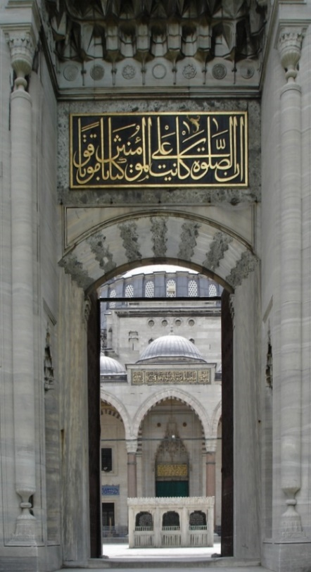
“Let us live in idyll. You are pure, so please go in and live forever."
Apart from that, the calligraphy above the entrance to the mosque also suggests that the mosque is the entrance to heaven on earth (chapter13, sentence24; chapter16,sentence32) :
"Peace be with you! This is your reward for your perseverance. Surely the goodness of posterity is beautiful.”
"Peace be with you, and you may enter the paradise for your good deeds."
The mosque was built on the third of seven hills in Golden Horn, Istanbul. In this position, it is very obvious in the skyline of the whole city, from which one can overlook the whole city. From there one can see "the whole world," writes Ivy Selby. A tall mosque, beyond all the surrounding buildings, sits above the city, with its falling vaults, symbolizing Sultan's national structure at the top of the Ottoman Empire.

Mathematics
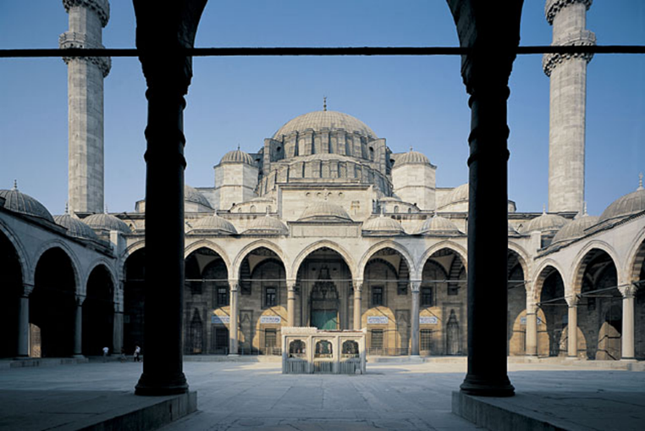
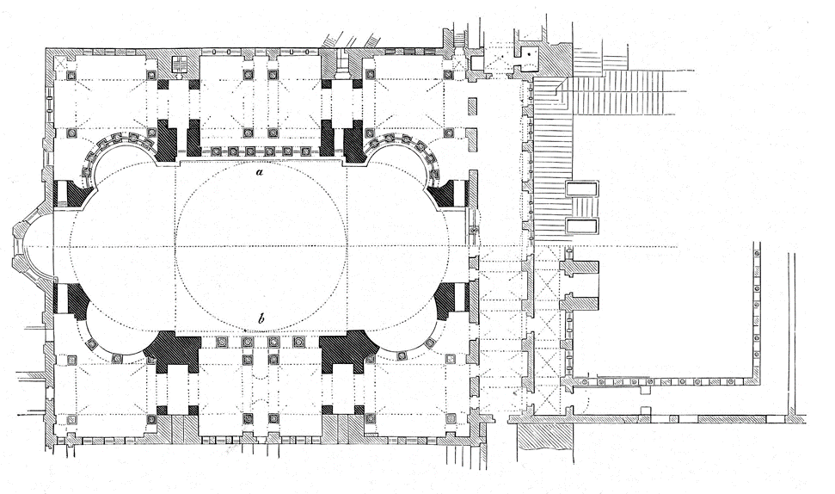
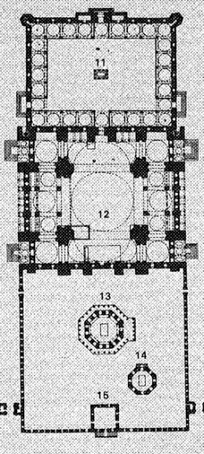
On the other hand, if we look at Süleymaniye Cami from a mathematical point of view, we can find more interesting thing about it. Firstly, it is easily to find that the whole building follows the principle of axial symmetry which means the same design in left and right. However, it is not the only mosque designed in this way, the duplication dome layout design, which is a development of the multiple dome layout design, for example, the Ulu Cami in Bursa, Turkey, can be the representative of this type. The form of the layout in this type is rectangular in both the horizontal axis and the transverse axis.[9]
Upper: Necipoglu Gülru. 2005. The Age of Sinan: Architectural Culture in the Ottoman Empire. London: Reaktion Books.

Left: Plan of Süleymaniye Cami, The Suleymaniye Complex in Istanbul: An Interpretation. Muqarnas, 3, p.92.

Right: Plan of Aya Sophia, German Wikipedia, by Rainer Zen

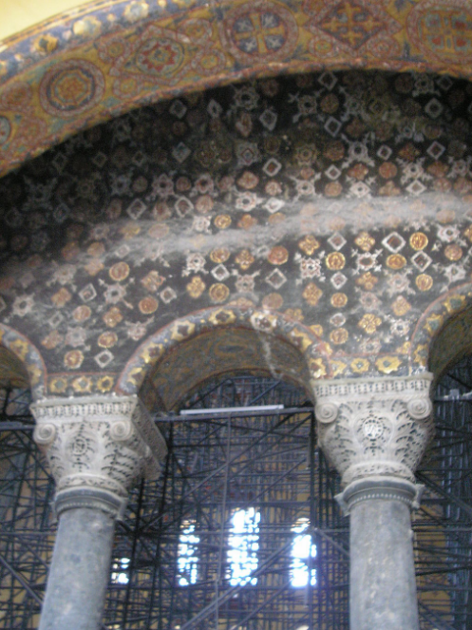
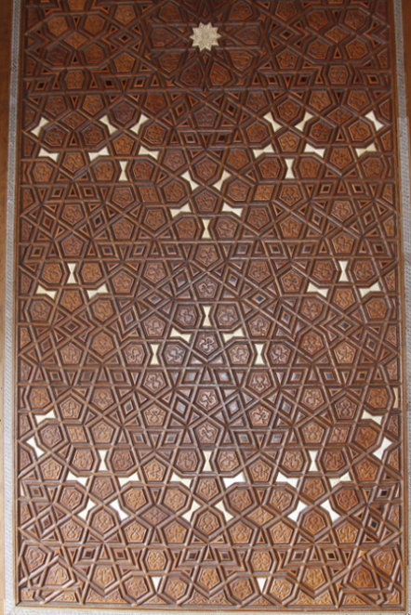
As for another common thing of the mosques, it should be in the interior of them, the decorations which also show the wisdom of the architects. The typical example is the mosaic on the wall, muqarnas and other decorations on the dome which can reflect a rotational symmetry design. The mosaics are woven with ideal patterns, such as diamonds, pentagons, hexagons, decagons, etc. All of them are calculated accurately and handy according to the nature and shape of decoration.

Left: Mosaic in Süleymaniye Cami, © José Luiz Bernardes Ribeiro / CC BY-SA 3.0
Right: Mosaics in the upper gallery, or enclosure, of the Aya Sophia
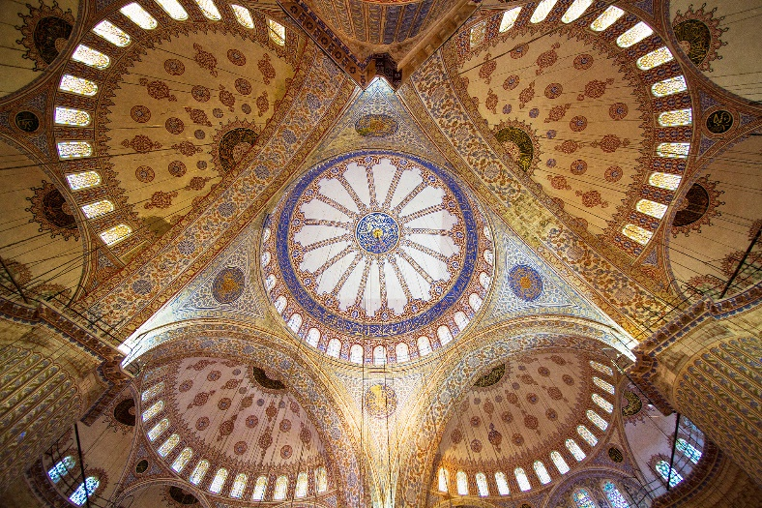
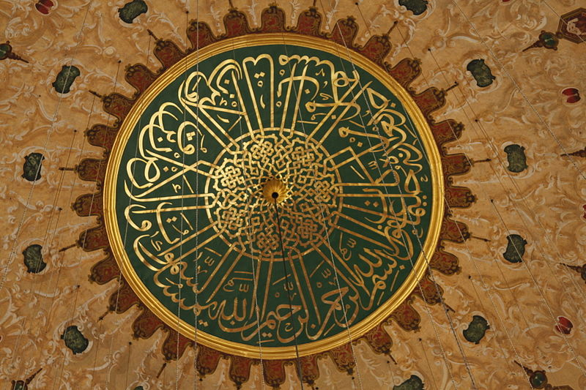
Left: Domes of the Blue Mosque, Christian Perez
Right: Dome of Süleymaniye Cami, José Luiz

The amazing design is known worldwide now and not only the architects, but also the scholars are impressed by it, Peter Lu, professor in mathematics, Harvard University says "If only the architect thought hard about arranging various shapes of tiles, and took the straight line as the keynote, it would not be possible to have any changeable and arbitrary graphics. We re-examine the decorative figures of ancient Islamic architecture and find that the precise and delicate mathematical formulas and meanings are not only the hardships of architects but the wisdom of mathematicians.”
In short, architecture is the epitome of a culture, including history, technology, belief, and many other fields. All the things we know now is just a corner of an iceberg, there are still lots of work to do in the future.

[1] Archnet.org. (2018). Süleymaniye Külliyesi | Archnet. [online] Available at: https://archnet.org/sites/2024.
[2] Goodwin, G., & Sinan. (1993). Sinan : Ottoman architecture and its values today. London: Saqi.p.38
[3] Goodwin, G., & Sinan. (1993). Sinan : Ottoman architecture and its values today. London: Saqi.p.45.
[4] Goodwin, G., & Sinan. (1993). Sinan : Ottoman architecture and its values today. London: Saqi.p.45.
[5] Necipoglu-Kafadar, G. (1985). The Suleymaniye Complex in Istanbul: An Interpretation. Muqarnas, 3, p.92.
[6] Necipoglu-Kafadar, G. (1985). The Suleymaniye Complex in Istanbul: An Interpretation. Muqarnas, 3, p.92.
[7] Kolay, İ. and Çelik, S. (2006). OTTOMAN STONE ACQUISITION IN THE MID-SIXTEENTH CENTURY: THE SÜLEYMANİYE COMPLEX IN ISTANBUL. Muqarnas Online, 23(1), p.255.
[8] Ozgules, M. (2008). Fundamental Developments of 16th Century Ottoman Architecture: Innovations in the Art of Architect Sinan. IDEAS Working Paper Series from RePEc, IDEAS Working Paper Series from RePEc, 2008.
[9] Mustafa, F. and Hassan, A. (2013). Mosque layout design: An analytical study of mosque layouts in the early Ottoman period. Frontiers of Architectural Research, 2(4), p.448.

