
HOTEL TRINITY

Housekeeping Team Member Development Plan

Md Jewel Ahmed (2117693)
Module: BMIH4006
Lecturer: Tristan Hawkins

Hello!!!
Welcome to Hotel Trinity
We're so excited to add you to our team, and we're sure your skills and past experience will prove invaluable. Our employees are our most important assets. Hotel Trinity is a 4 star hotel which is located in the central area of London that offers our guests, hotel facilities available during their stay as well as restaurants and bars. Prior to working in your allocated area, you will go through an eight-weeks housekeeping team development plan. Throughout this time, you will be kept in under supervision of our housekeeping experts and instructed as to what we require. You will be given a tour of Hotel Trinity to be shown the areas in that you will be having to work. On the same day, you will be informed of the hotel's standard operating procedures, as well as work schedules. We are available to assist you in every way we can, we would like you to feel at ease collaborating with us, and our guests could perhaps see in you a welcoming, proficient, and compassionate staff. If you require any assistance with your work or feel uncertain with situations please ask your Head of department of housekeeping and your colleagues to resolve the matter. On your initial day of work, you will be given your lobby log in detail which you will find the employee handbook, training information on general safety, fire safety, office safety, health and safety, and manual handling videos along with keys, fobs to access rooms. We look forward to working with you as part of our team here at Hotel Trinity, and we wish you all the very best of luck.

Induction Plan  - Welcome  - Meet your team/ Meet your Managers  - Familiarisation of Hotel and Departments  - Hotel And Local Area Knowledge  - Hotel Facilities  - Schedule and point of contact  - Uniform/Dress code/Name badge  - Fire Assembly Point  - Lobby Log in  - Employee Handbook (online)  - General Safety training (online)  - Office Safety training (online)  - Fire Safety (video)  - Health and Safety (video)  - Manual Handling (video) | 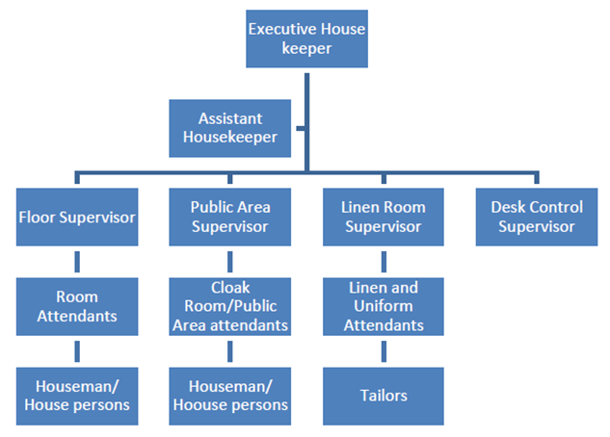

Housekeeping Team Member Development Plan
Employee Name/ID Number: | Mentor/Buddy:

Week-1 | Week-2 | Week-3 | Weel-4
Housekeeping Principles-Daily Routine  ARRIVAL: Uniform, name badge, sign in, morning brief, prioritise your board of rooms, prepare housekeeping cart and collect keys.  CLEANING SHIFT: Prepare a guest room for cleaning, prepare and clean guest bathroom for cleaning, clean guest room, replace amenities and final check.  END OF SHIFT: Clean and return equipment, return your completed housekeeping allocation board, log and store any lost property, return & sign back in your housekeeping keys and sign out. | Personal hygiene in housekeeping  WHEN TO WASH YOUR HANDS  Before any food preparation, consuming, and handling a cut as well as grazes.  After having a smoke or taking a break, after using bathroom, blowing your nose. When coughing or sneezing, touching dirty linen or rubbish, taking care of cuts or grazes. | Characteristics of Housekeeping personnel  FOLLOW THE VALUABLE CHARACTISTICS: Ethics and politeness, courteous and respectfulness friendly behaviour, sincerity and commitment, eagerness to be of genuine service. Paying particular attention to details, highly efficient and effective communication and interpersonal skills.  Competencies  Customer engagement, dependability, effective listening, versatility, planning skills, team cohesion, authenticity, trustworthiness, and high levels of enthusiasm are all considered necessary. | Cleaning agents  Washing-up liquids, drain-cleaning products, disinfectants, toilet cleaners, bleach, sanitisers, de-scalers.  Housekeeping equipment  THINGS TO CONSIDER WITH THE HOUSEKEEPING TROLLEY:  Separate bags for rubbish and soiled linen, multiple shelves for organisation, compartments for amenities and refreshments, smooth multi directional wheels and brakes, vacuum bracket and holder.

Week | Complete | Employee | Mentor/Buddy | Date
1 | Yes/No
2 | Yes/No
3 | Yes/No
4 | Yes/No

Housekeeping Team Member Development Plan
Employee Name/ID Number: | Mentor/Buddy:

Week-5 | Week-6 | Week-7 | Week-8
Cleaning Operations  Maintain the cleanliness and upkeep of the accommodations and public areas. Housekeeping tasks include hoovering, mop the floor, wiping down, and cleaning in hotel lobbies, stairs, lifts, and lounge areas, along with guest rooms. Work schedules can be organised using the room availability list, check-ins, and check-outs. Replenish rooms amenities, organise linens, towels, and room supplies. Laundry operations to policy, Inspect and turn mattresses to the operation policy.  WHAT TO LOOK FOR: Thorough inspection of bed bugs, Shedding of insect skins, amniotic fluid smears on sheets, black faecal matter stains on mattresses, and bed bug eggs are all signs of bed bugs. | Security  Modern slavery and human trafficking. Stay safe-preventing and reacting to active attack situations/suspicious item and activity/external threat and panic alarm. The following are the primary security concerns these are lost and found property, customer theft, employee theft, and suspicious activity. | Workplace Health & safety (WH&S) in housekeeping  Safe use of cleaning agents and chemicals, safe use of cleaning equipment, monitor safe work practices, safe use of housekeeping cart, monitor working equipment. Maintain the privacy and security of guest rooms. Implement all safety and security procedures and guidelines. Report any operational issues that pose a safety risk. Document and report hotel property damages. Follow the policy of personal hygiene standards. | COSHH Assessment  A COSHH study focussed on the risks and hazards associated with potentially dangerous substances used at work. Keep in mind that health risks are not limited to substances labelled as 'hazardous.' Some harmful substances, such as wood dust from sanding or silica dust from tile cutting, can be produced by the method you use. Consider the dangers, Evaluate who may be physically harmed and also how. Identify the risks and take appropriate precautions. Modifying the procedure to reduce risks, storage, operating procedures, cleaning, and the law.

Week | Complete | Employee | Mentor/Buddy | Date
5 | Yes/No
6 | Yes/No
7 | Yes/No
8 | Yes/No

References:
Health and Safety Executive, (2022). How to carry out a COSHH risk assessment [Online]. Available at: https://www.hse.gov.uk/toolbox/harmful/coshh.htm (Accessed 12 November 2022).
Invest in people, (2019). Employee development plan – everything you need to know [Online] Available at: https://www.investorsinpeople.com/knowledge/employee-development-plan/ (Accessed 12 November 2022).
Pereira, A., (2022). 40 Thoughtful Welcome Messages for New Employees [Online] Available at: https://toughnickel.com/business/36-Thoughtful-Welcome-Messages-for-New-Employees (Accessed 12 November 2022).
Rajak, H., (2020). Housekeeping Department Hierarchy in small, medium, large and chain hotels [Online] Available at: https://hmhub.in/hierarchy-in-small-medium-large-and-chain-hotels/ (Accessed 12 November 2022).
Typsy, (2019). Personal hygiene in housekeeping [Online] Available at: https://www.typsy.com/lessons/personal-hygiene-in-housekeeping (Accessed 12 November 2022).
Typsy, (2019). Workplace health & safety (WH&S) in housekeeping [Online] Available at: https://www.typsy.com/lessons/workplace-health-and-safety-in-housekeeping (Accessed 12 November 2022).

