

Student Name: Sabbir Ansar Hussain
Student number: 2233891
Assignment 2
Title: A Critical Analysis of Marriott International: Organisational Structure, Change Initiatives, and Strategic Direction
Programme: BA (Hons) International Hotel Management
Module: Management & Organisational Behaviour
Module Code: BMIH5004
Lecturer’s Name: Antoinette Milne
Word count: 2030

I confirm that I have not presented any AI generated text as my own work. I confirm I have copies of my drafts, notes, and other resources I used before, and after the use of AI tools which I may be asked to provide in evidence.

Executive Summary
This analysis explores Marriott International through its organisational framework corporate culture and strategic planning strategies while examining their change management systems. Marriott International exists within a dual organisational framework that merges functional systems with divisional approaches to create worldwide unity alongside local responsiveness. Through its people-first corporate focus, Marriott empowers staff to excel operationally by prioritising sustainability and diversity within its workforce.
The hospitality sector leader Marriott today emerges from recent transformations affecting digital solutions sustainability procedures and health safety procedures. Through effective use of Kotter’s 8-step change model Marriott achieves seamless transitions together with stakeholder alignment.
The continued success of Marriott depends on AI-enhanced customer personalisation together with faster sustainability efforts and more advanced leadership development programs. Multiple investments in smart room technology combined with green energy initiatives and next-generation workforce training will protect its future business success. Strategic recommendations that Marriott adopts will support ongoing innovation and guest experience excellence while enabling sustainable growth in this changing hospitality industry.

Table of Contents
Executive Summary 2
Introduction 4
Organisational Structure, Culture, and Goals of Marriott International 6
Organisational Structure 6
Corporate Culture and Its Influence on Operations 8
Goals of Marriott International 8
Recent Change Initiatives at Marriott International 10
Identification of Recent Change Initiatives 10
Evaluation of Change Management 11
Strategic Direction of Marriott International 13
Conclusion 15
Recommendations 16
Reference List 17

Introduction
In 2023 Marriott International maintained a wide selection of hotel properties which resulted in more than 8.7 thousand hotel establishments worldwide. The worldwide count of Marriott International hotels has increased by 100 percent throughout the last ten years. Most of this real estate exists beyond United States borders (Statista, 2023). Buyout activity started with Canadian chain Delta Hotels in 2015 and continued with American chain Starwood Hotels and Resorts in 2016. A breakdown of Marriott International, Inc.'s global properties shows regional growth from 2016 to 2023 according to this data. The Marriott brand operated 799 hotels across Europe during 2023. The region of North America contained approximately a thousand Marriott properties (Statista Research Department, 2024).
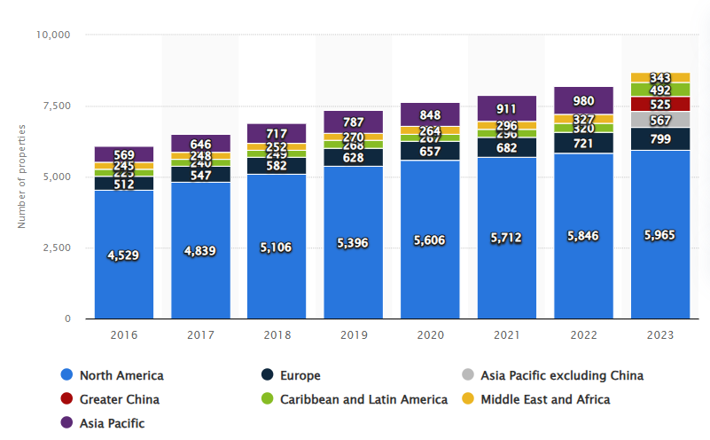
Figure: Number of Marriott International properties worldwide 2016-2023
Source: (Statista Research Department, 2024)
An examination of Marriott International's management structure and cultural values remains the focus while explaining its future strategic pathway. This assessment will investigate operational effects resulting from Marriott's corporate structure before evaluating its cultural framework which impacts employee output alongside major objectives of both corporate and individual hotel divisions. Marriott’s recent change initiatives along with their outcomes and potential effects on Marriott's future development are examined in this report. Marriott International’s strategic direction will be examined through a focus on market leader strategies that maintain its current position. The final part of this analysis provides recommendations for Marriott to enhance its international hospitality market position.

Organisational Structure, Culture, and Goals of Marriott International

Organisational Structure
The organisational structure of Marriott International combines functional structure elements with matrix structure elements. A matrix structure exists at the company since it blends functional and divisional configurations. Marriott operates with marketing sales and operational groups which they establish alongside geographical-based units across their organisation. With this organisational structure, the largest hotel chain in the world can deliver global standardization while also achieving regional diversity and localized adaptability (Dudovskiy, 2023).
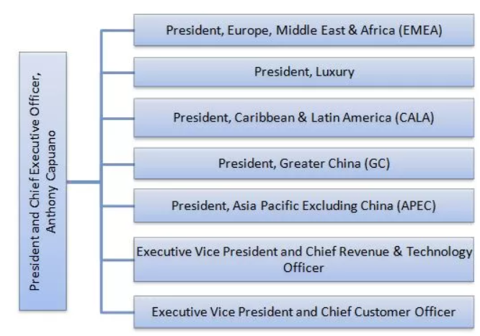
Figure: Organisational Structure of Marriott International
Source: (Dudovskiy, 2023)

Within Marriott's organisational vision, the power to make important decisions rests highly within the central authorities. Through their positions as CEO and executive team, the organisation allows them to make crucial decisions. Across its entire chain, Marriott maintains brand continuity together with standard service quality through centralized decision-making authority (Dudovskiy 2023). Marriott International gains various benefits through its combination of organisational structure features. The matrix system enables Marriott International to operate with both worldwide standardization and individual regional adaptation capabilities. Each regional structure enables the hotel chain to deliver customised operational approaches based on respondents' needs. Centralized authority enables Marriott International to deliver a uniform brand identity together with service excellence throughout all its hotel properties (Mullins, 2023).
Under Marriott's operational system, the franchise and ownership model serve as a fundamental organisational component. Franchising functions as a business system when product or service owners (franchisors) enable affiliated dealers (franchisees) to market their brands through distribution networks (Mullins, 2019). Businesses that operate under franchising often must pay their franchisor royalties which allows them access to use commercial materials processes and products (Cuofano, 2022). Hoteliers running Marriott establishments under franchise agreements must follow company standards while maintaining Marriott's brand identity through their operations. Marriott employs this model to extend globally across various properties which reduces financial exposure yet stops all properties from being company-owned and ensures brand synergy.
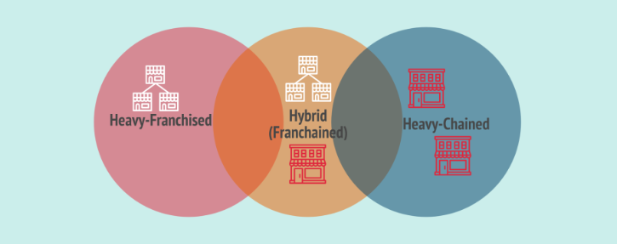
Figure: Franchising Business Model
Source: (Cuofano, 2022)

Corporate Culture and Its Influence on Operations
Toward its inception in 1927 by J. Willard and Alice Marriott both Marriott International and its corporate culture have anchored themselves to core values that still steer operations today. The company culture at Marriott International stresses putting people first combined with excellence-driven leadership that welcomes transformation and maintains ethical conduct and a global service approach (Dudovskiy 2023). Through its strong cultural foundation, Marriott manages its operations by creating workplaces that support inclusion and team member well-being. When employees experience professional growth, the company generates high employee satisfaction combined with strong loyalty levels. A commitment to excellence as a core value motivates Marriott International to deliver superior customer service alongside operational excellence (Marriott International, 2024). Marriott adopts an approach to change which helps it monitor industry trends while using ongoing innovation to adapt to customer needs. The fundamental cultural constructs are organised as follows.
- Empowerment and Career Development: The Marriott Development Academy serves as one of many training programs that Marriott designed to support employee progression while delivering extensive talent development options. The training of employees throughout all levels results in better service quality (Armstong, 2021).
- Diversity and Inclusion: Through its "Global Diversity and Inclusion Council" and Women’s Leadership Development Program Marriott pushes forward its concerted efforts to achieve workplace diversity. The improved global workforce together with higher employee morale resulted from this initiative.
- Sustainability and Corporate Social Responsibility (CSR): Through active sustainability involvement Marriott helps reduce carbon emissions while practicing responsible sourcing ethics. The hotel industry matches customer demands for sustainable hospitality services through its present initiatives (Robbins et al., 2017).

Goals of Marriott International
All organisational elements derive from Marriott International's fundamental set of beliefs that define its identity. During its evolution, the driving beliefs which prioritise people service alongside excellence and adaptability along with integrity and planetary advocacy will continue to guide the company. Team members at Marriott International share a distinguished heritage alongside an active work environment. Marriott International's founder predicts that "Family First creates a business process which states Take care of associates, and they will take care of the customers (Marriott International, 2024)." Since its founding more than 95 years ago Marriott International has built its reputation as a great workplace through the founder's guiding belief. Around the world, the people-first culture of Marriott International maintains a track record of earning global recognition through awards (Huczynski et al., 2019). Associate growth and success opportunities are essential components in the fundamental structure of the company.

Recent Change Initiatives at Marriott International

Identification of Recent Change Initiatives
Marriott International has established a series of visionary benchmarks for industry evolution through 2025 (Marybeth Collins, 2024). Through its commitment to sustainable operations, the company actively extends its positive impact throughout the communities where its hotels operate. Marriott International responds to market evolution and global developments through various change initiatives.
- Digital Transformation & AI Integration: AI-based guest service solutions, including mobile check-ins and chatbots, have been added to Marriott operations through which they offer improved staff capabilities and better customer mobility and dialogue. Digital transformation represents a top priority for Marriott as the company prepares to spend $1 billion on transformational projects during its full-year investment (Wilkinson, 2024). The company performs system deployments of cloud-based technologies to deliver better customer interactions together with operational effectiveness. Through AI technology Marriott aims to enhance digital booking systems while using artificial intelligence to minimize kitchen waste and optimise company workflows.
- COVID-19 Health and Safety Protocols: The "Commitment to Clean" program from Marriott Jr. delivered both revised cleaning protocols and started contactless operations to support guest protection. Through its Serve 360 sustainability and social impact platform, Marriott demonstrates worldwide dedication to creating positive results through sustainable practices (Jiang and Wen, 2020).
- Sustainability Initiatives: Marriott is dedicated to reaching net-zero carbon emissions by 2050 while continuing its ecological growth through single-use plastic elimination along with introducing energy-efficient building designs. By 2030 Dell intends to reduce GHG outputs with a goal of cutting scope 1 and 2 emissions by 46.2% along with scope 3 emissions by 27.5% from a 2019 starting point (Dell Galen, 2024). As part of its sustainability initiatives, Marriott has established targets to reduce energy usage through renewable energy adoption and optimised greenhouse gas footprint management for its acquired supplies.

Evaluation of Change Management
By following Kotter’s 8-Step Change Model Marriott developed an organised change management approach that united stakeholders and produced a seamless adjustment process. Organisations along with any initiatives with human participants can use Kotter’s 8-Step Change Model as a framework to produce effective change implementations (Mutomorro, 2023).
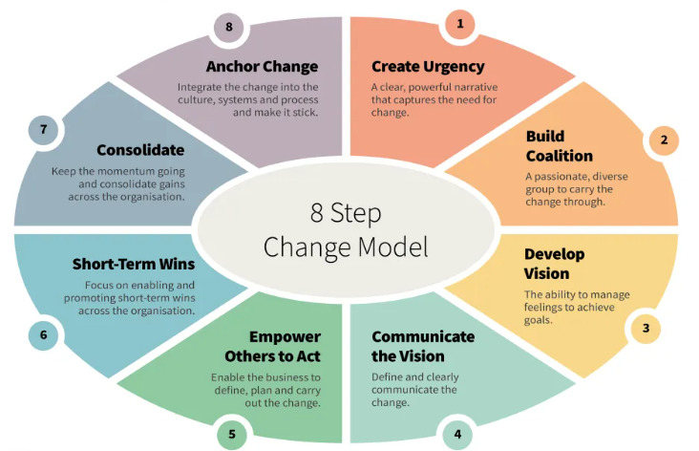
Figure: Kotter’s 8-Step Change Model
Source: (Mutomorro, 2023)
The need for organisational change became clear to Marriott employees because their research showed that markets evolved while customer expectations grew beyond operational limits (Mutomorro, 2023). Marriott established powerful alliances through its partnership between leadership teams and employees together with key stakeholders who guided the transformation process (Arnold, 2020). The organisation achieved employee engagement through training initiatives, timely information dissemination and honest conversations and then provided necessary equipment and innovation opportunities. Focus on short-term accomplishments was identified and then celebrated to sustain forward momentum and build better results. The company cultivated sustainability by implementing new processes into its operating framework and through ongoing monitoring and required modifications of these processes (Armstrong, 2012). Through their strategic approach, Marriott accomplished change initiatives alongside maintaining consistent service quality employee satisfaction and workforce engagement.

Strategic Direction of Marriott International
Marriott targets to achieve status as the world’s best-loved travel partner for all its interactions which include guests alongside owners and franchisees together with shareholders and associated team members (Mullins, 2023). Marriott aims to handle long-term business growth through distinctive hiring techniques and talent development alongside performance management to keep associates engaged. The organisation of programs and opportunities offers dual advantages by supporting Marriott communities and boosting business strength (Marriott, 2025). Responsible hotel management produces economic opportunity while benefiting environmental health. The strategic aim of Marriott International incorporates multiple essential elements which combine to drive expansion and preserve its market leadership position within hospitality.
- Asset-Light Business Model: Marriott builds its growth by providing management and franchise services for hotels instead of maintaining ownership. The business model permits quick growth across new regions by keeping financial investment low while offering enhanced market-entry adaptability.
- Growth Through Acquisitions: The company Marriott records notable growth achievements through its pattern of strategic acquisitions. Marriott’s portfolio obtained major new property names with its 2016 Starwood acquisition bringing brands like Sheraton and W into its assortment (Boddy, 2017). Ongoing acquisitions including Delta Hotels and Resorts together with Hoteles City Express enhance the company's market power.
- Focus on Bleisure Travelers: Marriott reserves their services for "leisure" travellers a category of customers who manage to merge business obligations with leisure activities. The segment addresses business travellers who lengthen their business visits with leisure time as well as younger guests searching for larger spaces with Marriott meeting diverse accommodation needs.
- Customer-Centric Approach: Through personalised experiences along with innovative services Marriott builds customer satisfaction and loyalty (Armstong, 2021). Through its "Commitment to Clean" program and modern digital initiatives, Marriott shows its determination to deliver services that match ever-changing customer needs.

Conclusion
The combination of Marriott International's hybrid structure with its strong culture and ambitious direction enables both worldwide stability and adjusted operations at local levels. A basic commitment to employees guides the organisation toward building a motivated workforce which drives outstanding service levels and achieves high customer satisfaction. The hospitality industry's dynamic nature becomes manageable for Marriott through three major change initiatives: digital transformation alongside sustainability efforts and health and safety enhancements. Through the implementation of Kotter’s 8-Step Change Model Marriott led organisational modifications successfully and sustained employee satisfaction and operational performance in the process. The company employs an asset-light business model combined with acquisitions together with customer-oriented innovations to advance its global market expansion. Long-term hospitality market success for Marriott needs persistent dedication to innovative practices alongside ecosystem sustainability together with talent advancement work as spearheading elements of ongoing growth.

Recommendations
Marriott International can reinforce its industry position by directing efforts toward three fundamental areas discussed below.
- Enhancing Digital Transformation: The strategic implementation of AI-driven personalisation will better guest experiences when combining predictive analytics and automated services. A major expansion of hospitality properties requiring smart room technology with voice-activated controls should start in 2026 to secure market competition (Mullins et al., 2013).
- Expanding Sustainability Efforts: Existing net-zero carbon initiatives at Marriott can be accelerated through the implementation of environmentally friendly construction methods throughout all newly built properties. Conducting solar power generation in sunny climates such as Dubai and California alongside water conservation initiatives across all facilities could satisfy future customer demands by 2030.
- Strengthening Employee Engagement: Marriott will strengthen its existing leadership development programs aimed at Gen Z workers by implementing mentorship programs across every regional hub by 2025 (Mullins, 2019). Hilton's leadership training methods that Marriott adopted would boost employee retention while strengthening service delivery standards.
The business strategies will secure Marriott's expansion trajectory while strengthening its market position as a leader.

Reference List
1.Armstong, M. (2021). Armstrong's handbook of performance management (7th Ed), London: Kogan Page
2.Armstrong, M. (2012). Armstrong’s Handbook of Management and Leadership (3rd Ed), London: Kogan Page.
3.Arnold, J. (2020). Work Psychology (7th edition) Harlow: Pearson Education Limited.
4.Boddy, D. (2017). Management: An Introduction (7th Ed), Harlow, Pearson
5.Cuofano, G. (2022). What Is A Franchising Business Model? [online] FourWeekMBA. Available at: https://fourweekmba.com/franchising/ [Accessed 30 Jan. 2025].
6.Dell Galen (2024). Marriott International Sets Ambitious Climate Goals, Targets Net-Zero by 2050. [online] TravelWires. Available at: https://www.travelwires.com/marriott-international-sets-ambitious-climate-goals-targets-net-zero-by-2050 [Accessed 30 Jan. 2025].
7.Dudovskiy, J. (2023). Marriott Organisational Structure Overview. [online] Research-Methodology. Available at: https://research-methodology.net/marriott-organisational-structure-overview/ [Accessed 30 Jan. 2025].
8.Huczynski, A. and Buchanan, D. (2019). Organisational Behaviour (10th Ed), Harlow: Pearson
9.Jiang, Y. and Wen, J. (2020). Effects of COVID-19 on hotel marketing and management: a perspective article. International Journal of Contemporary Hospitality Management, 32(8), pp.2563–2573.doi: https://doi.org/10.1108/IJCHM-03-2020-0237.
10.Marriott (2025). 2015 UPDATE ON BUSINESS MODEL AND SUSTAINABILITY STRATEGY AMERICAS EUROPE ASIA PACIFIC MIDDLE EAST AND AFRICA TOTAL. [online] Marriott. Available at: https://www.marriott.com/marriottassets/Multimedia/PDF/CorporateResponsibility/serve360/2015_BusinessModelandSustainabilityStrategy.pdf [Accessed 30 Jan. 2025].
11.Marriott International (2024). Core Values and Heritage | Marriott International Corporate Values. [online] Marriott.com. Available at: https://www.marriott.com/culture-and-values/core-values.mi [Accessed 30 Jan. 2025].
12.Marybeth Collins (2024). Marriott International’s Vision for a Sustainable Future. [online] Environment Energy Leader. Available at: https://www.environmentenergyleader.com/stories/marriott-internationals-vision-for-a-sustainable future,44880#:~:text=Marriott%20International%20sets%20bold%2C%20ambitious,impacts%20beyond%20its%20hotels'%20walls. [Accessed 30 Jan. 2025].
13.Mullins, L. (2019). Organisational Behaviour in the Workplace (12th edition) Harlow: Pearson
14.Mullins, L. (2023). Management and Organisational Behaviour (13th edition) Harlow: Pearson
15.Mullins, L. and Dosser, P. (2013). Hospitality Management and Organisational Behaviour (5th Ed) Harlow, Pearson.
16.Mutomorro (2023). Kotter’s 8 Step Change Model - Easy Walkthrough - Mutomorro. [online] mutomorro.com. Available at: https://mutomorro.com/kotters-8-step-change-model/ [Accessed 30 Jan. 2025].
17.Robbins, S. and Judge, (2017). Organisational Behaviour (17th edition) Harlow: Pearson Education Limited.
18.Statista (2023). Topic: Marriott International. [online] Statista. Available at: https://www.statista.com/topics/1872/marriott-international/#topicOverview [Accessed 30 Jan. 2025].
19.Statista Research Department (2024). Number of Marriott International properties worldwide 2016-2023, by region. [online] Statista. Available at: https://www.statista.com/statistics/297262/number-of-marriott-international-properties-worldwide-by-region/ [Accessed 30 Jan. 2025].
20.Wilkinson, L. (2024). Marriott gears up for another year of major tech spending. [online] CIO Dive. Available at: https://www.ciodive.com/news/marriott-international-tech-spend-digital-transformation-plan-ai/715036/ [Accessed 30 Jan. 2025].

