Assignment 1
Sarah Campion
Human Resource Management (BMMB7007)
Deadline – Friday 25 March 2022
Recruitment and selection within the Welsh Ambulance Services NHS Trust – Exploring the use of an applicant tracking system and pre-employment checks.

Executive Summary

The Welsh Ambulance Services NHS Trust (WAST) is a public sector organisation that forms part of the National Health Service (NHS) in Wales. They host a large workforce of around 3000 employees that cover a variety of different roles and functions. Known throughout the UK as an innovative and clinically progressive organisation, it is imperative that there is a strong and advancing workforce in place to support this (Welsh Ambulance Service, 2022). With the demands on the health service increasing and organisations exploring how things can be done differently, recruitment and selection of the right candidates is crucial.
This report has been designed to provide information surrounding the recruitment practices and systems in place that support WAST’s continuing employment of new external staff as well as internal movements within the organisation. It focuses on the use of an Applicant Tracking System (ATS) and its connection with the pre-employment check stage of the shortlisting process. From the analysis, short-, medium- and long-term recommendations have been advised for action with the hope that the flaws within the system are to be addressed. To support the findings, research has been conducted through the interrogation of literature: online articles, journals and textbooks.
In general, within WAST, responsibility for recruitment is situated with line managers. The process involves interaction between several stakeholders: a shared services function, the line manager, the ATS and recruits. Flaws have been identified across the individual areas as well as how they interact together and how they work together has a significant impact on the overall effectiveness of the recruitment process. The ATS of choice is also used by many other public sector organisations which has its own benefits and drawbacks. It is useful in offering consistency and the ability to monitor all aspects of the recruitment process, but there is limited scope to tailor the system specifically to the needs of the organisation. In relation to the pre-employment checks, the benefits of using an ATS are not maximised.
The literature demonstrated that pre-employment checks are a very useful tool for organisations in ensuring that the right candidate has been selected for the role along with providing the organisation with an appropriate amount of assurance that all legal obligations and checks have been carried out. For WAST, it is a compulsory stage that often causes much frustration. The analysis identified issues in the recruitment process for internal and external candidates and a lack of variation between the two pathways. Stakeholder experience was also considered here.
Following the review; short, medium and long term recommendations have been devised.
The short-term recommendations aim to immediately improve the level of support that is provided to line managers by maximising the use of existing functions: shared services and HR teams. Also, to ensure that stakeholder satisfaction is high, it is recommended that there is regular engagement with recruits as they move through the pre-employment tasks.
In the medium term, it would be recommended that the role of the line manager would be further explored and how relationships between stakeholders can be improved. The introduction of data to support decision making would be beneficial at this stage.
Finally, the longer-term recommendations consider improvements to the system in terms of design and use as well as the review and development of the pre-employment check process for internal and external candidates.

Contents

Executive Summary 2
1. Introduction - Organisational Overview 5
2. Human Resource Management (HRM) Function 5
3. Recruitment and Selection in WAST 5
3.1 Applicant Tracking System (ATS) 7
3.2 Pre-Employment Checks 8
4. Conclusion 10
5. Recommendations 11
5.1 Short Term 11
5.2 Medium Term 11
5.3 Long Term 11
6. Reference List 12
7. Appendices 14

1. Introduction - Organisational Overview
The Welsh Ambulance Services NHS Trust (WAST) is just one of many Trust’s/Health Boards that form part of our National Health Service (NHS) here in Wales. Operating throughout the country, the organisation covers a population of around 3 million people. Employing over 3000 individuals, the Trust considers their workforce an integral part of the service. Positions are based within a variety of roles; voluntary, frontline, and corporate/support services; all of which have their part to play in the operation of the service (Welsh Ambulance Service, 2022). To maintain and support this considerable and diverse workforce, the organisational structure has been designed to include a directorate that is wholly responsible for workforce and organisational development. This function is led by a director who has a position on the Trust Board.

2. Human Resource Management (HRM) Function
In terms of the HRM function, a dedicated team of business managers, advisors and specialists provide support and advice on different specialist areas. However, many responsibilities have devolved to the line manager in line with the modern approach to HRM. The HR team often act in more of a supportive capacity as opposed to managing (Powell,2022). WAST is underpinned by a strong leadership and management strategy as well as strategies focused on Health and Wellbeing and Treating People Fairly, which all form part of the organisational strategic objectives.

3. Recruitment and Selection in WAST
WAST have been introduced as an organisation who are committed to their workforce and with this, comes the requirement to have continual foresight on the recruitment, development, and retention of staff. An integral part of this is not only employing the right candidates but having appropriate staffing levels to be able to meet current and projected demand. This approach is supported by Whitehouse (2018) who recognised the importance of future planning by HR teams, to prevent being in a position where demand cannot be met. With demand only increasing and the health sector often described as “in crisis” (Whitehouse, 2018) getting the recruitment process right has never been so important for the organisation.
Recruitment is not without resourcing or financial impact and the entirety of the system is complex. It is directly impacted by external factors such as demographics and talent pools (Laumer, Maier and Eckhardt, 2015). This is particularly apt, as post Covid-19 pandemic, HR teams are being faced with recruitment challenges that have not previously been seen, with some labelling it the Great Resignation. Organisations are now required to respond differently and quickly to such challenges in order to recruit and retain a stable workforce (Thompson, 2021).
Within WAST, each directorate has ownership of their recruitment with the exception of mass recruitment for the clinical workforce. The process involves:
- The use of an Applicant Tracking system (ATS) to upload and monitor all aspects of the recruitment process.
- A shared services function which is described by CIPD (2021) as a central function that maintains and coordinates all HR related activities. It is known to be a source of expert knowledge and a way of providing a consistent approach across a business.
- The line/recruiting manager
- Recruits
For the recruitment process to run smoothly, there is a requirement for all stakeholders and functions to work effectively individually, as well as together. Inefficiencies have been identified in both and for the overall process to be improved these will need to be addressed. This report will focus on the use of the ATS and its role within the pre-employment (background) checks which form part of Stage 5, as illustrated below in Fig 1.
Figure 1
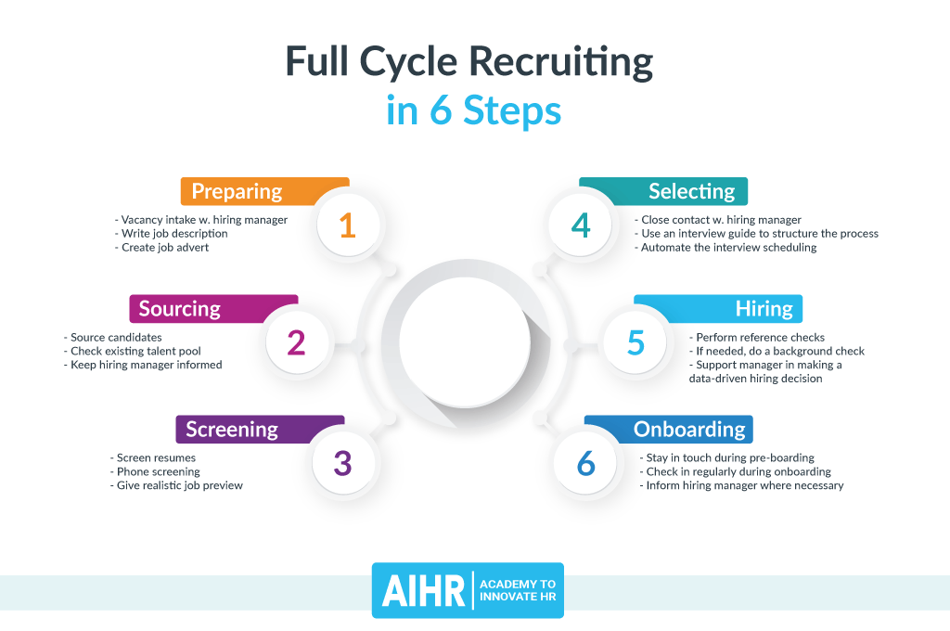
(Full Cycle Recruiting in 6 Steps, no date)

3.1 Applicant Tracking System (ATS)
Opting to use a technology-based solution to organise and monitor recruitment is beginning to become a trend shared Stone et al. (2013), a trend that has also been followed by WAST. How recruitment is processed within WAST is replicated across the wider NHS sector with each individual organisation taking the lead on their recruitment and similarly, using the one system to advertise vacancies. Although with the introduction of such systems comes a financial cost (Laumer, Maier and Eckhardt, 2014), using one system has been found to make it easier from both the applicants and employer’s perspective in terms of ease of access and having a centralised point of information (Finding a job in the NHS, 2020).
Provided by Civica Services, NHS Wales has access to an ATS known as NHS Jobs to the public and Trac from an internal user interface. Trac is an ATS used by many other public sector organisations and offers companies the opportunity to have full control of their recruitment process from advertising and vacancy management to the completion of pre-employment checks. Other benefits include but are not limited to; built in Key Performance Indicators (KPI’s); to ensure an organisation meets all legal and performance requirements and a quick transition for employees into their new role (Recruitment management software-trac,2022). By moving away from manual processes and introducing Trac, organisations such as The Midlands and Lancashire Commissioning Support Unit (MLCSU) have seen a notable improvement in their time to hire which can be understood as the identification of a vacancy, advertising and receiving applications to lastly applicant tracking (Midlands and Lancashire CSU exceed their recruiting targets and deliver great customer service using Trac, 2021). Use of such systems is supported by Torrington et al. (2020) who indicate that this method is becoming increasingly popular in large organisations during the more formal stages of shortlisting.
Torrington et al’s. (2020) statement is reflective of WAST who could be described as a large organisation and have surpassed its use for just the formal stages of shortlisting. Although, in relation to the improvements noted by the MLSCU (2021) such as improvements in starting time and a positive customer experience, this is debatable from experiences in WAST. Potentially, the introduction of the ATS might have resulted in overall improvements in WAST’s time to hire period, but this is not communicated to those individuals/teams who are responsible for recruitment. The benefits of the system are often overshadowed by time consuming processes that the ATS prompts the user to follow. Agreeably, the use of the ATS makes for ease of vacancy management and tasks within the shortlisting process such as scoring (Torrington et al., 2020) however collectively with flaws in other areas of the system, it often hinders the pre-employment check process.

Figure 2
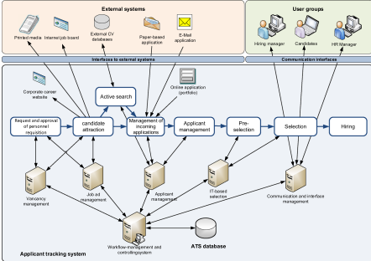
(Eckhardt et al. 2012, Cited in Laumer, Maier and Eckhardt, 2014)
On the contrary, an excellent study by Laumer, Maier and Eckhardt (2014) into the introduction of an ATS and analysis of processes within the business function of an organisation, revealed significant benefits for businesses, as illustrated above in Fig 2. It was found that having a consistent system leads to less variables throughout a business, to which cannot be contested. Consistency promotes trust, improves customer service and connects real time with plans. It can also assist with the development of reporting mechanisms (Universal Creative Solutions, 2021). Consistency is important for any organisation, nevertheless not one size always fits all. Variables such as job role, individual requirements and sector need to be considered and it is questionable whether the ATS can effectively manage these variables. This is particularly apparent during the pre-employment checks stage.

3.2 Pre-Employment Checks
The pre-employment check stage begins when an individual is notified of their success and a conditional letter is issued. This is recorded and monitored through the ATS.
Pre-employment checks standardly look at proof of qualifications, right to work in the UK, criminal record, references and health checks but this list is not limited. These checks are not only relevant within WAST but are issued by all NHS employers (Chartered Institute of Personnel Development, 2020). According to Whyman (2019), pre-employment checks are one of the most beneficial ways of confirming whether the right candidate has been selected for the position. It is widely known that it can often be a difficult process as varying rules and legalities exist, however if carried out effectively the organisation would reap the rewards. It is a useful tool to prove the validity of prior information shared and to allow for a trusting relationship to be developed between the employing organisation and the recruit (Martinez, 2020). Other benefits include providing the employer with a level of assurance that all legal and ethical processes are followed and furthermore, that no discrimination has been applied during the process (Hosain, M. et al., 2020). For WAST, having that level of assurance is key to mitigating the level of risk the organisation is exposed to.
It is evident from the literature that has been explored, that there are a number of reasons for implementing pre-employment checks. The critique of this area within WAST is not why they are carried out but over the relevance of the checks in relation to job role, internal and external candidates and the duration of the process. Up until this point, the ATS provides a streamlined approach however the full benefits of the system are not realised here. Laumer, Maier and Eckhardt (2014) suggest that when introducing an ATS it should not be done in isolation but in conjunction with business process management. An important factor to also consider when analysing the performance of the recruitment process is stakeholder satisfaction (Hirzel, 2008, cited in Laumer, Maier and Eckhart, 2014).
A timeline provided by a recent recruit (Appendix 1) reveals the delays experienced by the system, with the overall process, inclusive of notice period totalling 4 months. Delays such as these make it increasingly difficult for an organisation to implement future plans. An important point to note from their account is the sequential order in which the pre-employment checks were fulfilled with the references being requested first. The individual was fortunate enough to have a supportive releasing line manager, but this might not be applicable in every instance. It has the potential to place the individual in a very difficult position for many months prior to changing their role (Chippendale, 2022).
A benefit of the system is that it allows for both shared services and the manager to monitor all pre-employment checks but there is a distinct lack of clarity as to who is accountable for following up on outstanding checks. This can often result in instances of unnecessary communication between the two parties and duplication of effort which further increases the time frame of an already lengthy process. The intended purpose of an ATS is to allow for better utilisation of time and resource, but instead is becoming increasingly time intensive (Lawler and Mohrman, 2003). Alongside the software, there is a need to consider whether human error is also a contributing factor or is it a combination of both.
WAST employ both patient and non-patient facing roles which controls the level of required checks but there is an absence of consistency across role types. This is also applicable to the approach for internal and external candidates and on many occasions there has been little difference in the time taken to complete the process. Torrington et al. (2011) state that by opting to employ internally, it should shorten the recruitment process and allow them to start much quicker. This has not been identified at WAST. For both groups of candidates this causes significant delays in start dates which can subsequently result in uncovered workloads thus creating a backlog of work or the re-allocation of work to existing staff. Accepting that there may be an opportunity to start elements of their new role whilst working their notice period, this is dependent on the flexibility of the releasing line manager.
The issues identified have the potential to negatively impact stakeholders, performance and the ability to meet organisational objectives. This is also highlighted by Stone et al. (2013) who state that there is a need to consider the relationship between the selection process and the organisation’s ability to achieve their goals.
The way in which the organisation responded to mass recruitment during the pandemic demonstrated the speed in which new ways of working can be developed and introduced. It also identified areas for improvement in current recruitment practices.

4. Conclusion
This review has highlighted the significant role that technology continues to play in the world of recruitment and how it has supported many organisations’ s focus in this area of business. It has become clear that there is a need to develop a swift and engaging recruitment process that can contend with the ever-developing needs of our workforce, both currently and in the future. The first half of the report focused on WAST’s current approach to recruitment and how this related to their overall strategic objectives with the second half looking more closely at areas of improvement within the current recruitment process. This included the use of an ATS and its relationship with the pre-employment check stage.
The literature supports that an ATS hosts a wealth of benefits to any organisation of this size however various improvements need to be adopted in order to access its full potential. To be effective, these improvements need to be both individually and collectively. The analysis revealed that the pre-employment check stage is significantly increasing the time to hire period which is subsequently having wider implications for stakeholders such as those raised by Chippendale (2022). Line managers lack clarity and support on accountability and ownership and are often engaging in time consuming tasks. Moving forward, stakeholder satisfaction and organisational reputation also need to be considered. WAST is an organisation that requires a strong workforce that can continue to support the increasing demands on the health service, and it is vitally important to recognise the role that recruitment and selection plays in meeting organisational objectives.

5. Recommendations
The following recommendations are based upon the key areas of discussion and are defined as short, medium, and long term. Following the Covid-19 pandemic, the organisation is now in its recovery phase so there has been consideration towards budgetary constraints within the public sector. To reflect this, the recommendations aim to have minimal financial impact on the organisation.

5.1 Short Term (3-6 months)
There is a need for an immediate focus on improving the level of support that is provided to line managers by shared services and WAST’s HR function, in terms of navigating the pre-employment checks. Ideally, the duration of the pre-employment check stage would be reduced immediately however realistically, this will take some time. It is suggested to introduce a focus on regularly engaging with recruits during the pre-employment check process to improve their experience and increase their stakeholder satisfaction (Academy to Innovate HR, no date).

5.2 Medium Term (6-12 months)
It is recommended that the involvement of line managers within the recruitment process is interrogated further and ways of improving stakeholder relationships are developed to remove some of the inefficiencies in the system. There is a requirement for there to be clearly defined roles and responsibilities which could potentially require further training and guidance. Secondly, it was noted as part of the findings that recruiting managers were not provided with recruitment activity data. To be able to effectively implement improvements, managers need to be provided with their data to support the introduction of changes and decision making.

5.3 Long Term (12+ months)
The long-term recommendation is to explore the potential for system changes in relation to design and use but also considering that this is not a system solely used by WAST. There is a need to address the different employment check pathways for internal and external candidates and to develop internal mechanisms to support the process. It would also be beneficial if the expertise and support that is provided to mass recruitment could be extended to other departments.

6. Reference List

Academy to Innovate HR (no date) Full Cycle Recruiting: All You Need to Know. Available at: Full Cycle Recruiting: All You Need to Know - AIHR (Accessed: 13 March 2022).
Chartered Institute of Personelle Development. (2020) Pre-employment Checks Guidance for Organisations. Available at: pre-employment-checks-guide-dec-2020_tcm18-51572.pdf (cipd.co.uk) (Accessed: 11 March 2022).
Chartered Institute of Personelle Development. (2021) HR Shared Services. Available at: HR Shared Services | Factsheets | CIPD (Accessed: 13 March 2022).
Chippendale, J. (2022) Email to Sarah Campion, 15 March.
Finding a Job in the NHS (2020) Available at: Step Into The NHS :: NHS Jobs (Accessed: 9 March 2022).
Full Cycle Recruiting in 6 Steps (no date) Available at: Full Cycle Recruiting: All You Need to Know - AIHR. (Accessed: 13 March 2022).
Hosain, M. et al. (2020) ‘Social Networking Information and Pre-Employment Background Checks: The Mediating Role of Sustainable Organizational Reputation’, Sustainability, 12(8), pp. 3090.doi: 10.3390/su12083090.
Laumer, S., Maier, C. and Eckhardt, A. (2014) ‘The Impact of Business Process Management and Applicant Tracking Systems on Recruiting Process Performance: An Empirical Study’, Journal of Business Economics, 85(4), pp. 421–453. doi: 10.1007/s11573-014-0758-9.
Lawler III, E. E. and Mohrman, S. A. (2003) ‘HR as a Strategic Partner: What Does It Take to Make It Happen?’, Human Resource Planning, 26(3), pp. 15–29. Available at: https://search-ebscohost-com.ezproxy.uwtsd.ac.uk/login.aspx?direct=true&db=bth&AN=10964093&site=ehost-live (Accessed: 13 March 2022).
Thompson, D. (2021) The Great Resignation is Accelerating. Available at: The Great Resignation Is Accelerating - The Atlantic (Accessed: 14 March 2022).
Martinez, A. (2020) How to take an Ethical Approach to Employee Screening. Available at: How to take an ethical approach to employee screening (peoplemanagement.co.uk) (Accessed: 9 March 2022).
Midlands and Lancashire CSU Exceed their Recruiting Targets and Deliver Great Customer Service Using Trac (2021) Available at: Civica Health & Care (Accessed: 11 March 2022).
Powell, R. (2022) ‘Lecture 1’ [PowerPoint Presentation]. BMMB7007: Human Resource Management. University of Wales Trinity St David. Available at: Course: Human Resource Management (BMMB7007) (uwtsd.ac.uk) (Accessed 14 March 2022).
Recruitment Management Software – Trac (2022) Available at: Recruitment management software - Trac | Civica (Accessed: 9 March 2022).
Stone, D. et al. (2013) ‘Factors Affecting the Effectiveness and Acceptance of Electronic Selection Systems’, Human Resource Management Review, 23(1), pp. 50-70. doi: 10.1016/j.hrmr.2012.06.006.
Torrington, D. et al. (2013) Human Resource Management. 8th edn. Harlow: Pearson Education.
Torrington, D. et al. (2020) Human Resource Management. 11th edn. Harlow: Pearson Education, Limited.
Universal Creative Solutions (2021) Why is Consistency Important in Business. Available at: Why is Consistency Important in Business (universalcreativesolutions.com) (Accessed: 21 March 2022).
Welsh Ambulance Service (2022) About us. Available at: Welsh Ambulance Service NHS Trust - About Us (wales.nhs.uk) (Accessed: 11 March 2022).
Whitehouse, E. (2018) The NHS Crisis: Can HR help?. Available at: The NHS crisis: can HR help? (peoplemanagement.co.uk) (Accessed: 9 March 2022).
Whyman, H. (2019) Effective Pre-employment Screening. Available at: Effective pre-employment screening (peoplemanagement.co.uk) (Accessed: 9 March 2022).

7. Appendices

Appendix 1
The timeline below illustrates the pre-employment check process for a recent recruit into the Trust.
Date | Action
27/09/21 | Conditional offer of employment received along with guidance for the completion of the DBS checks, occupational health clearance and references. Permission given to contact referee (had to be current employer) and DBS paperwork submitted.
30/09/21 | Referee contacted and acceptable reference received which was the current employer/line manager. Unable to tender notice at this stage as the offer of employment was still conditional however current employer is now in the knowledge that I wish to leave. Notice period is three months. My employer now wishes to succession plan.
30/09/21 | Received appointment for Face-to-Face pre-employment occupational health checks for 13 October in North Wales (150 miles away) at 11:00. Enquired as to the availability to complete this closer to home given the distance and short lead time however they were unable to facilitate. Arranged days annual leave although line manager is fully aware. Thankfully maintaining confidentiality to wider team within current employment.
01/10/21 | CRB forms countersigned and submitted
09/10/21 | DBS will issue disclosure
13/10/21 | Face to Face occupational health appointment
21/10/21 | Occupational health issue clearance including EPP blood result. As of the 21 October this represents all conditions of employment met.
01/11/21 | Email received stating there was a delay in issuing unconditional offers, but email could be taken as confirmation that the offer is now unconditional and a start date can be arranged.
18/11/21 | Received unconditional offer letter.
17/01/21 | Commenced new role

(Chippendale, 2022)

