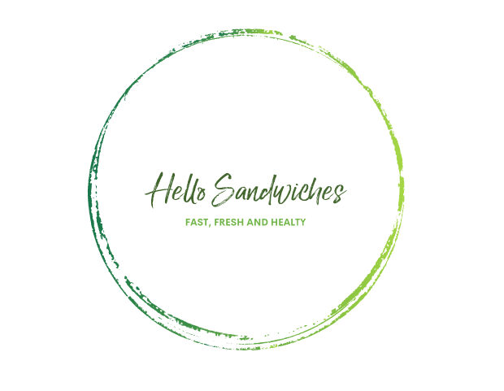

STUDENT ID 2022563
STUDENT NAME ANNA BUONOCORE
MODULE CODE LCBB5001

TABLE OF CONTENTS
INTRODUCTION 3
TASK 1 3
CUSTOMER DECISION MAKING PROCESS 3
PLC : PRODUCT LIFE CYCLE 4
4’s P 5
FEASIBILITY 5
SWOT 6
VRIO 6
MARKET RESEARCH 6
PRIMARY DATA 7
SECONDARY DATA 8
TASK 2 9
GIBBS REFLECTIVE CYCLE 9
CONCLUSION 10
REFERENCESES 11

INTRODUCTION
This sheet will develop my own business plan outlining my business proposal and key aspects, includes detailed information regarding the product/service and the process I went through.to turn my idea into a business.
This business plan aims to establish the development of a place for people to go for a healthy and fresh lunch break.

TASK 1
The new business idea is named Hello sandwiches ( Hel – being healthy and low for low cost and low calorie) is a new concept idea meant to be a quick and healthy choice for lunch or snack as well as affordable, the idea focuses on the instant preparation of sandwiches with healthy options such as rye bread , gluten free and seeded that can be chosen from the menu or prepared according to the customers' need or tastes.
The target market is aimed at all those people such as office workers, workers or students who, due to busy lives and limited time for lunch breaks, often choose pre-packaged or ready-to-eat foods in minutes such as those in fast food restaurants, the aim of this business is to provide them with a healthier option at affordable prices.
Food is the basic necessity for the life and this idea wants to focus on two concepts, Health and fast, health because it is a healthy choice although, the timing of preparation will be fast.

CUSTOMER DECISION MAKING PROCESS
The idea was brought forward after consideration of customer decision making process as detailed below:

There are 5 stages until it actually purchases and then review what it purchased (Prasad et al, 2014):

- Recognition of need ( I need lunch)
The first step in the process is to understand what exactly the customer is actually looking for. In this case, the business idea is focused on people who are daily looking for food idea to eat during their lunch break
- Information search (what are the food options?)
At this stage the client begins to decide and their gather information how best to meet their needs, it might create a list of pros and cons to make sure it is making the correct decision.
- Evaluation of alternatives (What kind of food should I eat?)
In this stage the client is checking out different services in order to choose what they define best choice purchases. The client may have made his decision through marketing advertising, by following the suggestions of someone, or simply followed his own logical conclusion.
- Purchase decision (buying the lunch)
In this part of stage the customer collects all the information and makes the purchase
- Post- purchase evaluation (Was it the right choice for lunch?) Last stage which is critical, it is where the customer wonders whether the choice matches or exceeds expectations. If the customer at this stage thinks it is satisfied with their choice, they will likely become a returning customer or recommend their choice to friends and family. Therefore, this is the stage where I can create a good relationship with the customer.

PLC : PRODUCT LIFE CYCLE
Product life cycle is the process from when a product is first produced util it is removed from the market, same product may stay in a long maturity stay. It Is include 4 stages, introduction, growth, maturity and decline (Rink and Swan, 1979).

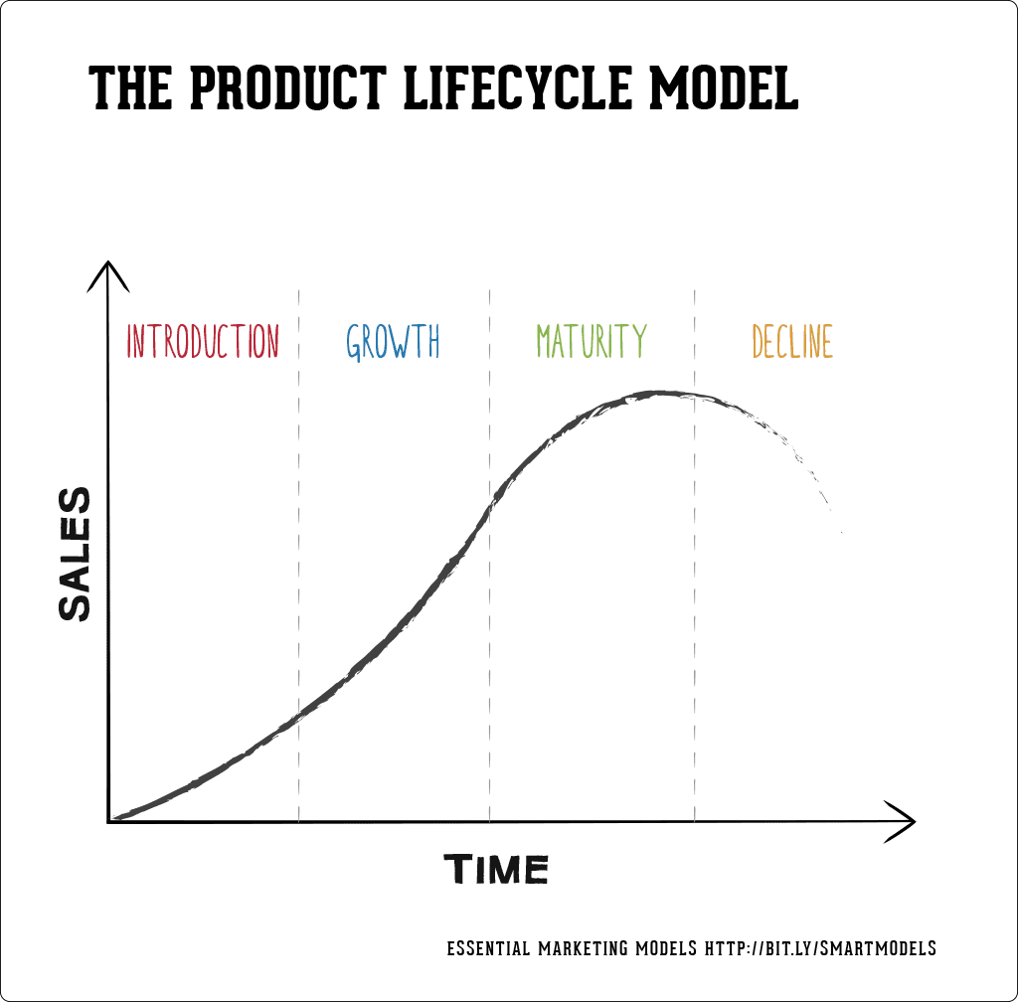

- INTRODUCTION: The first stage begins the product life cycle with the introduction of the product. Once the product has been developed and is ready to be introduced to the market for the first time. Marketing and promotion are at their best at this stage, to build demand for the product and gain consumer interest. It is an important stage, although it will not determine the success of the product.
- GROWTH: at this point the business can have a significant increase in consumer demand. If the sales growth the business itself will tend to expand.
- MATURITY: At this stage the product reaches maturity, it is the most profitable stage of the PLC, as production volume increases, production and marketing costs decrease. The maturity stage changes for each brand, some have a longer maturity stage. to avoid decline and competition At this point, the company needs new ideas or modify existing ones to face competition.
- DECLINE: in this last stage the product is saturated, the sales can drop significantly, companies can innovate to keep the product alive for as long as possible, by producing new products or alternative.

4’s P

The four Ps were introduced in the 1950s; they are key considerations implemented to successfully market a product or service. The 4 P's are product, price, place, and promotion (Twin,2022).
- PLACE : how convenient it is, the place where the product will be purchased is important to optimize sales. Hello sandwiches, will be present in strategic locations where it can easily capture the people' curiosity, it will rise in busy places such as tubes, offices and schools.
- PRODUCT: Creating a marketing campaign begins with understanding the product itself. What does it have that our competitors do not? Who needs it and why? In based of consumer demand, my idea is meant to be an answer to all those people who are looking for a healthy and quick lunch. The business offers a convenience product.
- PRICE: It is the selling price of the product after calculating all expenses. The item should be sold at the right price, not too low not too high.
- PROMOTION: the audience who will be the future consumers, needs to be informed about the product, in this case using flyers in places such as the entrance to parks, subway, and large supermarkets. Email marketing and online advertising, which are of paramount importance because it can capture the visibility of so many people in a very short time, which is why Hello Sandwiches, will be present online since the beginning with video and ads posted on major social platforms such as Instagram and tik toc.

FEASIBILITY
Feasibility is the preliminary evaluation of a business idea, this study considers the viability of a business idea, focuses on any problems that may arise, and helps the entrepreneur understand whether the idea can be successful (Greene, F.J., 2020).

SWOT is a 4-stage analysis which helps the business to determine the pros and cons, using strengths to overcome weakness, using opportunities to overcome threats (Armstrong,2020)
- STRENGHTS: about sandwich will offer the costumer, reasonable price and fresh food will be the strengths of the company.
- WEAKNESSES: Where the business struggle in comparison to others? it about what can be improved. Customer demands and choice diets are increasingly varied, we will strive to improve the menu so much enough offered to all customers, Halal options will be added to the menu.
- OPPORTUNITIES: What the business can do to improve its branding? When you know your customers and their habits the business can look for new opportunities to increase sales, such as changing the menu according to consumer demand and increasing online presence by relying on services such as uber eats
- THREATS: These are external factors that negatively impact the business. One of the big threats has been the Covid - pandemic, labor shortages and rising costs have led customers to choose to cook at home.

VRIO analysis was developed by an American business professor Dr Jay Barney in 1991, it helps the company identify the resource and capabilities that give them a sustained competitive advantage. VRIO stands for valuable, rare, inimitable ad organized, it is internal analysis that help to determinate quality and usefulness of a business resources and capabilities (Sridharan, 2017).

- VALUABLE All resources must have value; they acquire value when they enable all firms to gain an advantage, If any of the resources will be valuable, the company will be at a competitive disadvantage.
- RARE If there are few firms offering a certain product, these are considered rare; the more rare resources the firm has, the more competitive advantage it can have .
- INIMITABLE It is about what make the business unique, this provides the business with a temporary advantage, although all resources can be easily imitated by competitors.
- ORGANIZED the business needs proper organization to use and monitor its resources.

MARKET RESEARCH

PRIMARY DATA
A Survey was used to collect the information, it is a research method used to collect data from a predefined group of respondents for whom it helped to obtain information, It was a mixed survey with multiple choices, and open-ended questions.
The survey targeted 30 people, 14 men and 16 women aged between 18 and 45+ (Fig. 1 and 2), through them it was possible to find out most of the information about their behavior when choosing lunch and their food preferences.
The diet choice based on the responses collected divides between vegan and meat eater, Vegans are 41% of respondents, this part of the survey made me realize that the menu needs to include more vegan options than I was considering. (fig3)
Seed bread seems to be the preferred choice of respondents, it is described as tastier and healthier, brown bread and gluten-free for those with tolerance, no one seems to prefer white bread(fig4).
To complete their meal deal 57% of respondents opted for meal deal salad as their choice, followed by 29% chips, and only 14% would choose fruit.(fig5)
What everyone seems to agree on is the price, most people welling to pay up to £10 (fig6)
When was asked: What's came first when you look for your lunch idea? Good percentage answered something quick, followed by cheap and healthy.

fig1
Interpretation: Out of 30 responses 53% (16) respondents female and 47% (14) Male

fig2
Interpretation: out of 30 responses 23% (7) respondents 18-24, 57% (17) respondents 25-34, 13 %(4) respondents 35-44, 7% (2)respondents 45+

fig 3
Interpretation: out of 30 responses 7% (3) responses vegetarian, 52% (15) responses meet eater and 41% (12) responses vegan.

fig 4
Interpretation: out of 30 responses 0% white bread, 40% (12) responses seeded, 27% (8) responses gluten free, 33% (10) brown.

fig 5
Interpretation: out of 30 responses 14% (5) responses fruit, 29% (10) responses chips, 57% (15) responses salad.
fig.6
Interpretation:out of 30 responses 13% (4) responses 4/6, 20% (6) responses 7/8£, 67% (20) responses 9/10£ and 0% responses 11£+

SECONDARY DATA
The crucial factor before starting a new business is to study the market, in order to know the goods and services demanded by consumers.
The sandwich is nationally the favorite lunch of the British by consuming 11.5 billion sandwiches a year,the 72% of lunch expenses are allocated to sandwiches (www.lovebritishfood.co.uk, 2021).
In 2021, British consumers spent more than 530 million pounds on sandwiches, sandwiches and baguettes, representing a big increase in value of about 156 million from the previous year(Statista, n.d.).
There is a lifestyle change by customers, who prefer plant-based or vegetarian sandwiches instead of meet, the third of sandwiches offer are meatless, some major brands in the territory have increased plant-based options while others have decreased them.
Tesco's vegetarian and plant-based offerings have dropped by more than a quarter from 2019 figures (Tesco,2021), Pret a manger instead, offer a balance of options, even though veggie sandwiches cost 9 % more than meat (Pret,2020).

TASK 2

GIBBS REFLECTIVE CYCLE

Gibbs model is a reflective cycle leading you through six stages, becomes useful when it is necessary to identify your areas of strength and development. Description, feeling and evaluation are relate to what happened at the beginning and during the experience, while analysis, conclusion and action plan refer to how to improve the overall experience and future performance. “It is from the feelings and thoughts emerging from this reflection that generalisations or concepts can be generated. And it is generalisations that allow new situations to be tackled effectively.” (Gibbs,1988)

DESCRIPTION: The assessment required me to propose and create a business idea, among the many ideas that came to my mind I decided to focus on one in particular idea is to offer people on the run, a lunch option, healthy, simple and fast, from these needs I gave birth to Hello Sandwiches, is a new business idea that offers freshly stuffed sandwiches.
FELLINGS: The biggest anxiety in starting the business was the financial part, I never underestimated the importance of finance before starting my business, I always calculated all the costs including things like licensing and permits. I focused on a business that was low-investment but at the same time could bring profit from the very beginning starting my business. Insecurity and fear of failure are playing a major role during the launch of my new business, but the determination and desire to start this new journey are even stronger.
EVALUATION: The concurrency in the market is high, but the strength of my business is the freshness of the products and the opportunity to give customers several choices to create the sandwich they desire. The people who participated in the questionnaire seemed interesting to the idea the positive feedback encouraged me to continue my business idea.
ANALYSIS: I could not take tips from any previous entrepreneurship experience, since I did not have one. However, what I have been taught in class and my experience as a client have helped me to pursue this business idea. In terms of my strength this is detailed below :
The type of communication that I'm good at is verbal, when we speak, we are communication much more than just a context of our words, by choosing pith, tone and content, we can be sure that the message is received exactly as intended.
For the majority of my working life I worked as a store manager in a store, this has helped me so much to develop my communication skills as this is of fundamental relevance to interact with customers and increase sales.
Transformational leadership is the style of leadership that I would like to adopt for my business, I have worked under different leadership styles, I can say with certainty that the one that suits me best is the transformational leadership style, my aim is to motivate my employees by promoting teamwork, providing them with supportive feedback as and when needed (Pillai and Williams, 2004). There are advantages and disadvantages of each leadership style; I will examine my idea of leadership based on employee performance and results; I will understand whether this type of leadership can be suitable for my company.

CONCLUSION: After this business plan I am definitely more confident, in the implementation and management of a future business plan.
ACTION PLAN: Inexperience as an entrepreneur leaves me with points to fill and learn, the action I commit to take are an online leadership course that in a short time will give me a better understanding of how to run my business the proper way.
To monitor my business I also will schedule a monthly review meeting that will be a time to review my team's performance and business progress.
Another action I should have considered earlier is the availability of space to rent to open my business, which is quite difficult to find for rent nowadays, especially in certain areas of London such as near stations, schools, and offices.
In my area of interest, there are buildings under construction that offer premises to rent for commercial use, which is a nice addition that will help me easily expand my business.

CONCLUSION
Entrepreneurs must have a complete picture of all the concepts they need; the idea is only the main part of the job.
As research has shown, Brits invest a high percentage of their money in their lunch, which happens most of the time away from home, although they continue to prefer quick and healthy options, the budget they want welling in lunch is quite small.
The market is very competitive, but my business will have strengths that large produce chains usually overlook, such as freshness and variety of choice.
My business idea turns out to be in line with the market demands of the British, overall, after due analysis, it seems to be a business that can be productive in United Kingdom.

REFERENCESES

- Andeason, A.R. (1965) Attitudes and Consumer Behavior: A Decision Model in New Research in Marketing (Preston)
- Armstrong, M. and Taylor, S. (2020) Armstrong’s Handbook of Human Resource Management Practice. London: Kogan Page, Limited.
- Gibbs, G. (1988). Learning by Doing: A Guide to Teaching and Learning Methods. Oxford: Oxford Further Education Unit
- Greene, F.J., 2020. Entrepreneurship theory and practice. Bloomsbury Publishing.
- Pillai, R. and Williams, E.A (2004) “Transformational leadership, self-efficacy, group cohesiveness, commitment, and performance” Journal of Organizational change management, Vol 17. Issue 2 pp. 144-159.
- Prasad, R.K. and Jha, M.K., 2014. Consumer buying decisions models: A descriptive study. International journal of innovation and applied studies, 6(3), p.335.
- Pret a Manger (2020) Pret’s 2020 En - vironment Social & Governance Report. Available at: https://downloads.ctfassets. net/4zu8gvmtwqss/lP49jnKXqHQU4qKANk - LOj/a7276f3918873e027ac5b10e64dc3a14/ Pret_A_Manger_2020_ESG_Report.pdf
- Rink, D.R. and Swan, J.E. (1979). Product life cycle research: A literature review. Journal of Business Research, [online] 7(3), pp.219–242
- Sridharan, M. (2017). Think Insights | VRIO framework for sustained competitive advantage. [online] Think Insights. Available at: https://thinkinsights.net/strategy/vrio-framework/#:~:text=Organization-
- Statista. (n.d.). Sandwiches & baguettes: market value 2020. [online] Available at: https://www.statista.com/statistics/281823/market-value-of-sandwiches-and-baguettes-in-the-uk-from-2007/.
- Tesco (2021) Tesco Serving shoppers a little better every day. Annual Report and Financial Statements 2021. Available at: www.tescoplc.com/media/757589/tesco_annual_re - port_2021.pdf
- Twin, A. (2022). Four Ps of Marketing: Know What They Are. [online] Investopedia. Available at: https://www.investopedia.com/terms/f/four-ps.asp.
- www.lovebritishfood.co.uk. (2021). Why the British love a Sandwich. [online] Available at: https://www.lovebritishfood.co.uk/why-the-british-love-a-sandwich.

- Which gender are you?
Male Female

- Please check your age group
18-24 25-34 35-44 45+

- How often do you eat out for lunch a week?
never rarely sometimes most of time always

- How much ore you welling to pay for your lunch?
4/6£ 7/8£ 9/10£ 11+

- How long you can wait for your lunch?
10 minutes
20 minutes
30+ minutes

- What type of bread do you usually eat?
white
gluten free
brown
seeded

- What could be your meal deal choice

Chips Fruit Salad

- How would you describe your current lifestyle/diet choice?
- Vegan
- Vegetarian
- Meat eater
- Other………

- Would like to find Hello Sandwiches on delivery platform?
- Where do you usually find a new restaurant or food idea?
- Social media
- Friends
- Casual pick

- What's came first when you look for your lunch idea?
…………………………………………………………………………….

- How are you interested with the new business idea?
- Not very interested
- Neutral
- Very interested

Thank you for your feedback.
Hope to see you soon, Hello Sandwiches.

