

Task 1 – Reading Task Template
Upload your photo of your A3 in-class notes here:
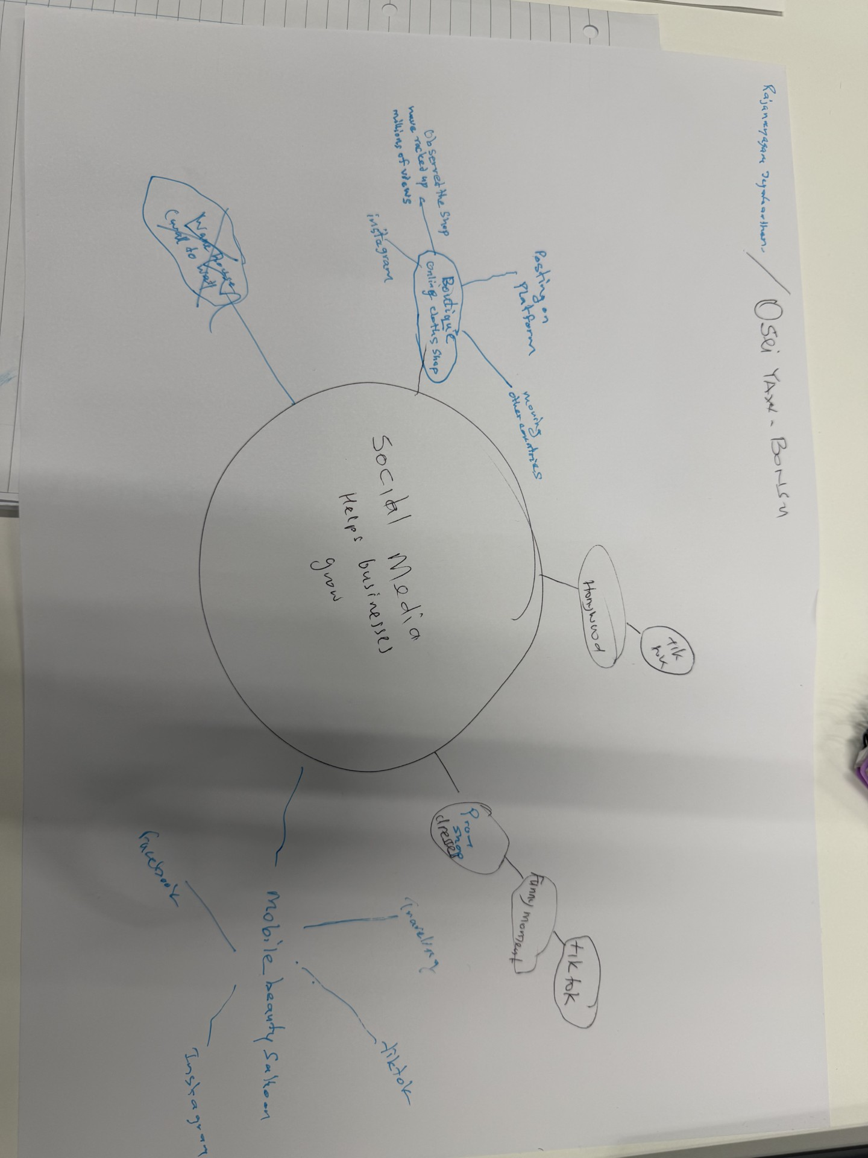

1. Answer these questions using the sentence starters below
The main idea is that social media help small businesses to grow in many ways.
b. What are two key points they are business promotion and which social media platform to chose

c. What part of the text did you find most important? Why? The part of social media platform is important because it was use in promoting businesses significantly
The benefit of how social media makes business grow

d. Was anything unclear or difficult to understand?
Social media have many platforms and unclear how the platform is choosing
I

e. How did your group help you understand the text better? discuss and shared ideas. The group study has helped me to have wide understanding of how social media can be use in so many ways to benefit the growth of businesses

My group helped me by
3. One sentence reflection
The challenge is how find the right social media platform that will best for a particular business

