Character and Creature Animation

Introduction
In this report I will write about how I approached the character and creature animation course work project, from the initial ideas and concepts to the storyboard creation to the block out animation in Autodesk Maya, to the final animation within Autodesk Maya and finally to the final 1080p renders that were created and then to wrap it up I will give my conclusion on how I thought the project went, and how I would have improved upon it if I had to do it again in the future.

Brief
The brief of the course work, was to create 5 separate animations within Autodesk Maya that consisted of 7 to 8 seconds of animation time each, totalling on 35 to 40 seconds all together. There were 9 different scenes/options that were available and I would have to choose 5 scenarios for this projects.
The following topics were: Goosebumps, that tingling sensation, shuddering, creepy-crawling, arggh! Waiting for news, That first interview, first baby or delivery. Expectation and anticipation. A “caged tiger”, waiting for the inevitable. Slapstick, Collisions and comedy touches. Bread and butter animation gags. Predator, A hunting, predatory creature/being. Stalking, or, (to turn it around) being hunted. Find a happy place, Being aggressive or malicious. Frustration and annoyance and displays of anger. Icarus soars!, Graceful, artistic, arcs of flight and/or falling through space. A star is born!, Being on the stage/in the spotlight. Singing for your supper. This is your moment in The X Factor/The Voice. I’ve got a great idea, Grasping, clawing, struggling….in a predicament or needing to act quickly. Desperation. Bushido, The warrior/swordsman/fighter. Samurai or one-last-bout? The ultimate warrior. The way of the - animated - warrior.
The scenarios that I personally chose were as followed: Predator, Find a happy place, Icarus soars!, I’ve got a great idea and bushido.

Ideas and concept
In this section of the report I will write about how I created the ideas and storyboards for the 5 animation scenarios. When I decided what my 5 animation choices would be for the character and creature animation course, I started to think of different ideas that I could do for the animations until I settled on the final versions.

Icarus Soars!
When it came to creating ideas for the Icarus Soars scenario, I many ideas, as to what could be animate. My first idea was to animate a dragon soaring through the air and breathing fire on the ground below, I decided to scrap this idea fairly quickly in the process, due to the following reasons: I’m still fairly new to using Autodesk Maya’s FX panel, and thus wasn’t confident in using it for this project and the second reason was because the various rigs that I explored to see if it were feasible were very complex in how it was rigged and some outright wouldn’t work, most likely due to version compatibility.
My second ideas was to have a lot of butterflies or moths, flying around an object, e.g. light post, this idea was more feasible, however, wasn’t very creative, as you would not really see the animation due to the sheer amount of butterflies or moths that would be seen, so this idea was also scraped fairly quickly.
The idea that would become the final concept for the animation, would be to animate a bird, not specifically any kind of bird, but bird flying towards a post and landing onto it, this idea would be the most feasible for me to accomplish, as birds are much smaller than dragons and there are a ton of slow motion footage of birds landing on objects, which will be a massive help in animating the bird landing on the post. The rigged model that I found for this idea was a bald eagle.

Concept
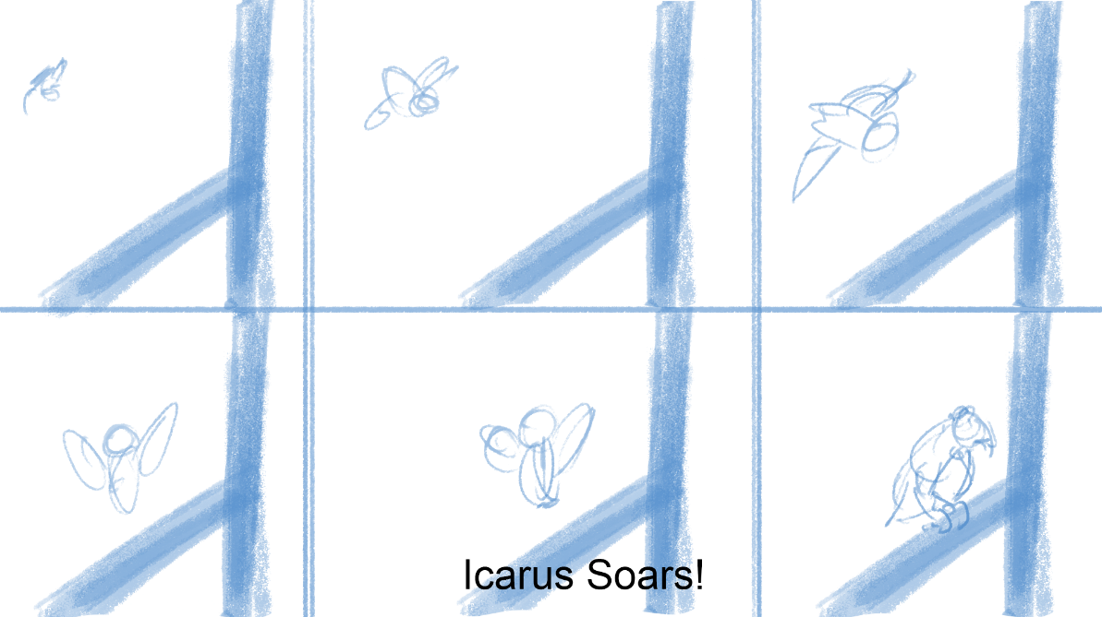
When it came to creating the storyboards for the bald eagle animation, due to the time constraints, in which each animation has to be between 7 and 8 seconds, I decided it would be simpler if I animated the bald eagle already in mid flight, flying towards the camera and likewise towards the post where it will land onto the post, these concept were created within Adobe Photoshop CC.

Predator
When it came to creating the ideas and concepts for the predator scenario, I only had the one idea, which stuck with me, this idea was for a Xenomorph to “look” around as if it has sensed something, as xenomorphs done have eyes, which leads me to believe that they sense instead of seeing: the xenomorph “looks“ around before turning to the camera and moving forward as if the xenomorph has found its pray.

Concept
When it came to how the animation would be played out, I decided for the Xenomorph to be turned away from the camera, to a side view, the creature would then look to the left side of it then rotating behind it towards the camera, before turning its whole body towards the camera then finally walking a couple of step forward before roaring.
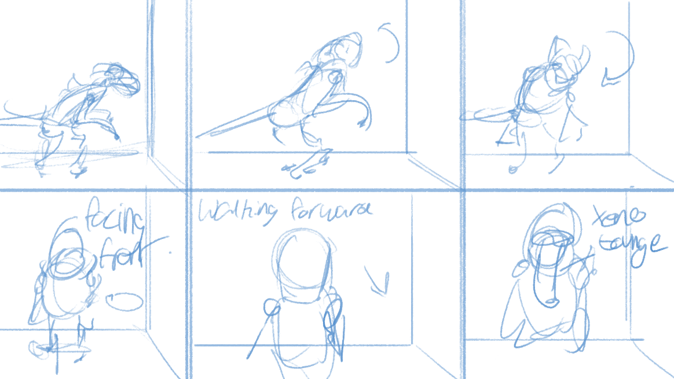

Find a happy place
Finding a happy place was all about a character getting angry in one way or another, so the immediate idea that came to mind was a gamer getting angry because he/she lost in whatever game that they are playing, and this would be the final idea for the find a happy place scenario, however what did change is how the character would act in the animation.

Concept
The original idea for how the animation would play out was for the main character which was decided to be a boy once I finalised the character rig choice, was for the main character to be wearing a VR headset before taking it off and throwing it across the room breaking it, however, to save time animating I decided to change the setting to him sitting on the couch playing with a controller moving about before he looses the game and anger begins to take hold, to which he will then throw the controller at the camera.
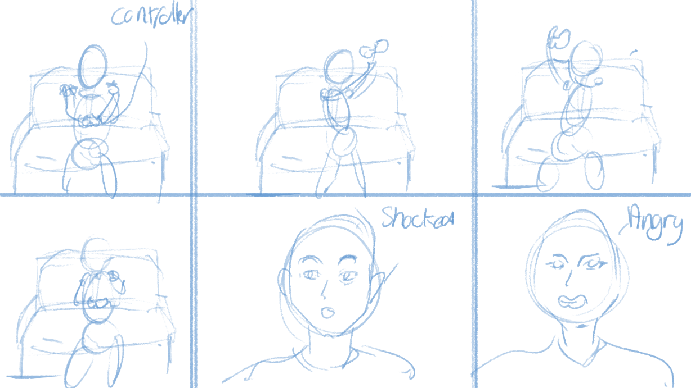

I’ve Got A Great Idea
When it came to creating ideas and concepts for this scenario, the first idea I had was for a spaceman/woman to have an air leak and begin to choke due to lack of oxygen and decompression, however failing to find a rig with my requirements I was forced to create a new idea, this idea would be for the main character to pick a piece of food and swallow it in one piece before going down the wrong hole and chocking on the food, before spitting it back out.
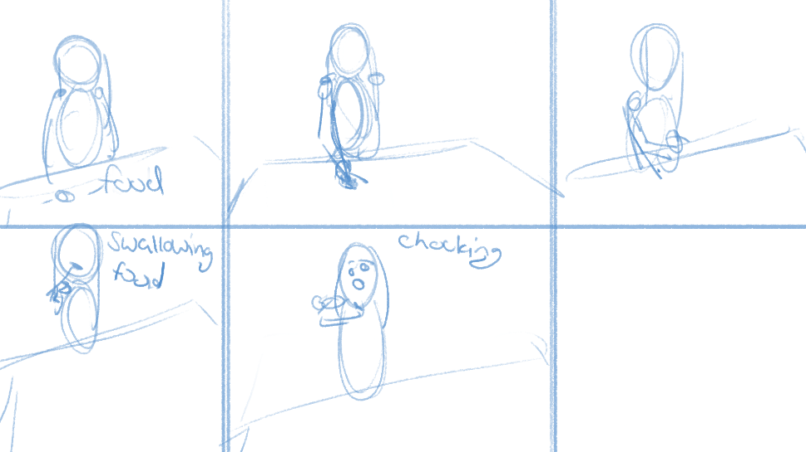

Bushido
When it came to creating the ideas for the final animation scenario, I got a bit stuck on what I could accomplish, as what I already had planned in my head would have been too long for the animation time limit of 8 seconds, so I had to think I bit more on what I could do for this section, in the end I came up with animation that could be used within a video game.

Concept
How this animation is meant to be played out is, the main character will out her hand behind her back to where the sword is and unsheathe it to prepare to battle any oncoming forces.
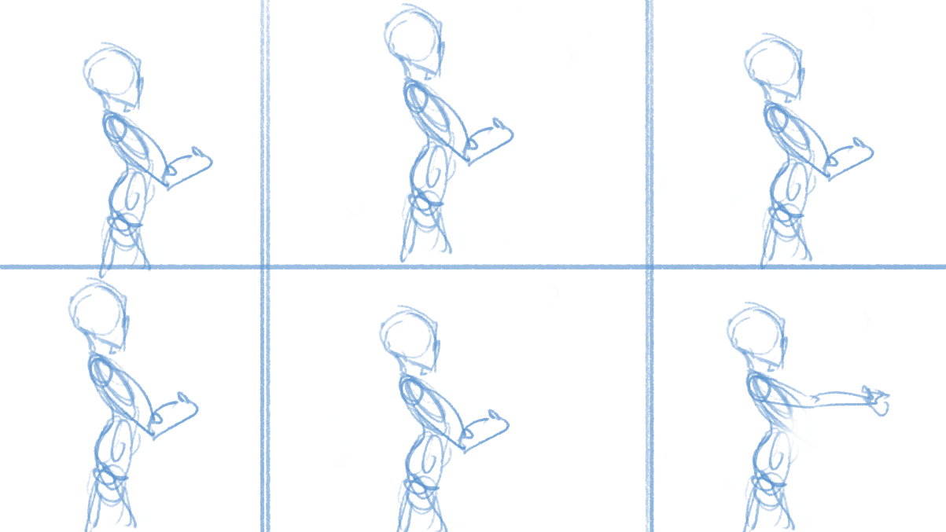

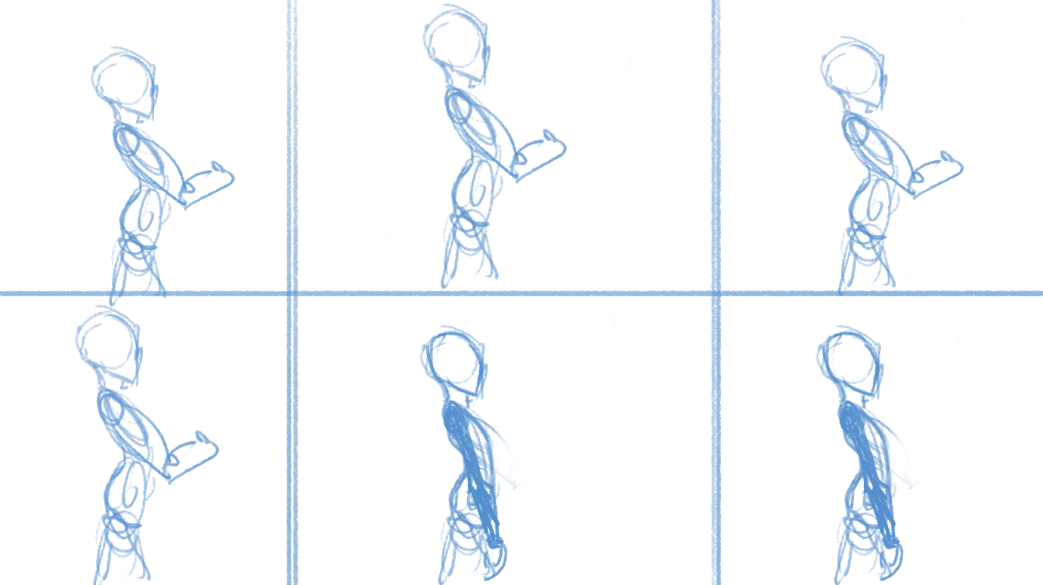

Rigs
In this section of the report I will write about the rigs that I found for use for the character and creature animation and how my experience with them were.
I came across these rigs on a website called, nelsonhurts.com, where both free and premium rigs are stored, the website are not the creators of the rigs but contain link to where the rigs can be downloaded from those who did create the rigs. The majority of the rigs that I used where from various online universities that offer their rigs for free for educational purposes.
My personal experience with using these rigs where extremely good, as I were using rigs character rigs that were created properly, with complex rigs for both the body and the face so that I could create advance facial animations instead of using character morphs to manipulate the eyes and mouth etc. The rigs themselves also moved extremely well unlike my own rigs where a lot of clipping happens due to my lack of knowledge on topologizing the characters with the contours of the face and body in mind. Overall my experience with using these professional character rigs where good.
I also talked with Karol, who I part of the same class, in order to make sure that we are not using the same rigs as each other, as 3 of the 5 animation scenarios we are both working on, so we made sure that we are both doing completely different things, from the rigs and to the animation story.

Animating the characters within Autodesk Maya
In this section of the report I will write about my experience with animating within Autodesk Maya, talking about how if any animation where changed from the storyboard and why, and difficulties in animation with the character rigs that I downloaded online and any references that I used in order to help me animate the character and creatures better.
These character and creature rigs were animated within Autodesk Maya at 25fps each, this is to avoid any inconsistencies through each animation scenario, however this would prove to be fairly difficult to accomplish due to rendering inconsistencies, however I will write about in the rendering section.
When I came to animating the 5 different animation scenarios, I changed many settings in order to make animating easier for me, I changed the tool settings to change the axis orientation from object to world, what this allowed me to do, was to animate without the gizmo tool changing, view image below for example.
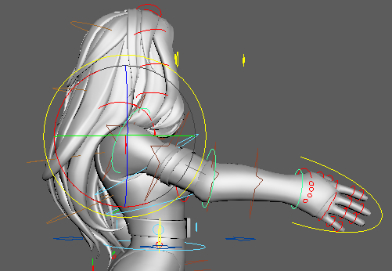
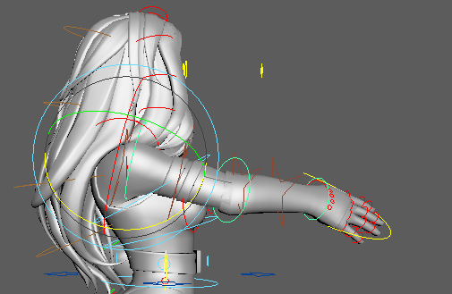

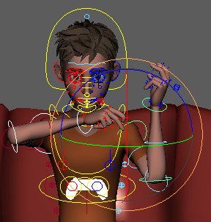
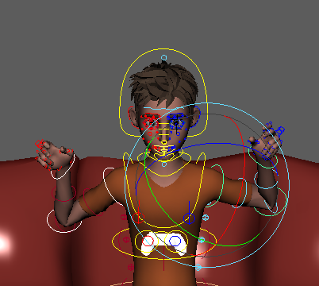
The left image above shows the axis orientation set to object, which is the default setting when Autodesk Maya is opened, as you can see on the left image, the gizmo orientation changes when you move an object, in this case her shoulder is the join that I rotated upwards, however in the right image that is above I have changed the axis orientation from object to world, doing this freezes the gizmo tool in place, so when I go to rotate her shoulder upwards, the gizmo tool remains in the same location, this is useful because when selecting both his/her shoulders as seen in the image below, the rotation orientation is opposite.

In the left image above, with the axis orientation set to world, you can see within the image, that the arms are moving in the same direction as each other, this makes it easier and faster to get the character rig in the position that you need at a quicker pace, however as you can see by the right image above, with the axis orientation set to the default object orientation, when I go to rotate the arms they rotate opposite each other, this makes it harder for me to animate faster as I have to rotate once shoulder to its position then I have to select the other and move that shoulder, this may not seem like much, but this really effects my ability to animate, it slows me down by quite a bit, not by much on small things, but these small things add up in the end.
I used the camera sequencer when necessary as some scenes contain multiple shots, and I wanted to have a camera showing the full body to then switch to just the face to show the emotion, and it became confinement to use the camera sequencer instead of animating the camera and setting some of the point in the animation graph to stepped that that the camera would teleport to the next position, using the camera sequencer saved me time.

Rendering
In this section of the report I will write about my experiences with rendering the scenes and write about any issues that I encountered when attempting to render the scenes.
I rendered each character and creature scenarios at HD 1920 by 1080p in AVI format, this is because AVI as far as I’m aware is the only video format that with no plugins Autodesk Maya supports, baring QuickTime, however that format is no longer supported by Apple themselves.
I mentioned in the previous section above, that I encountered issues with rendering, this is because what I rendered didn’t match the time lime, I would have 175 frames whilst using 25fps which equates to 7 seconds, however when rendered this would become something more like 4 seconds of animation time instead of 7 seconds that It should be, everything was correct within Autodesk Maya, the scene was at 25fps and the playback was at 25fps and it rendered at 25fps however for whatever reason, the frames would not match, so I was forced to add additional frames to the scene from 175 frames to 230 frames, this when rendered would be around 7 seconds.

Adobe Premiere
In this section of the report I will write about my experiences with using Adobe Premiere to create the final compilation reel that contained all of the character and creature animation that I created for this course, I will write about any issues that I encountered.
Now that all of the character and creature animation have been completed I now need to create a compilation reel that contains all of the character and creature animations, to do this I used Adobe Premiere to add all of the final animation renders that were created and imported them into the Adobe Premiere time line In order to export them into the final compilation reel however I encountered a problem doing this, for some reason Adobe Premiere wouldn’t recognise my AVI rendered files, they could import into the scene however the video footage was black throughout the whole footage, to fix this I used handbreak to convert the AVI file format to MP4 file formats to see if that would solve the issue, importing the newly converted filed into Adobe Premiere did indeed fix the issue that I was having.

Conclusion
In this section of the report I will write my conclusion which will include my thoughts on the project in whole, what I think could have been done better, and how I would change the animation if I were to do it again in the future.
In conclusion my animating experience for this module was fairly decent, I enjoyed animating with the professional rigs that I downloaded, as they were far superior to the ones that I have created, as they have good body and facial rigs, and are properly weight painted, I did have some issues rendering but I was able to improvise on them, to make sure I was within the time limit that was created for us.
If were to redo the character and creature animations, I would like to include more facial animations within the rigs, I did include some facial animation, however my understanding on how the face works isn’t fully there yet, this is something I would like to expand upon in the future.
Words: 2534 (excluding bibliography)

Bibliography
Handbreak https://handbrake.fr/ (accessed 19/05/2020)
Top character rigs for maya free and premium http://www.nelsonhurst.com/top-character-rigs-for-maya-free-and-premium/ (Accessed 19/05/2020)
Malcom rig https://www.animschool.com/DownloadOfferResponse.aspx?key=5162020b74ac1d507 (Accessed 19/05/2020)
troungCGartist https://gumroad.com/truongcgartist?sort=page_layout (Accessed 19/05/2020)
Slow motion bird https://www.youtube.com/watch?v=HcNgYI9H0BM (Accessed 19/05/2020)

