Name: ASHVINBHAI RAYMALBHAI CHAUDHARY
Student Number:2408901
Module Code:LCHS7006
Module Title:Quality Assurance and service improvement
Lecturer’s Name:Oluwadamilola Tayo
Assignment Title: Service Improvement Report: Enhancing Quality And Patient Safety In The Bristol Royal Infirmary Case

TABLE OF CONTENTS
1. Introduction 3
1.1 System-Level Failure and Organisational Learning 4
2. Donabedian Model Analysis 4
3. Root Cause Analysis 5
3.1 Fishbone Diagram 5
3.2 5 Whys Analysis 6
4. SWOT Analysis 6
5. Recommendations and Service Improvement Strategy 8
5.1 Strengthening Clinical Governance 8
5.2 Implementation of the PDSA Cycle 8
5.3 Improving Organisational Culture 9
5.4 Enhancing Data-Driven Decision Making 10
5.5 Workforce Development and Training 10
5.6 Application of Lean Principles 10
5.7 Policy and Regulatory Improvements 11
6. Implementation Strategy 11
6.1 Short-Term (0–6 months) 11
6.2 Medium-Term (6–18 months) 12
6.3 Long-Term (18+ months) 12
7. Conclusion 12
References 14

1. Introduction
Provision of quality, safe and effective healthcare is one of the priority areas in the contemporary health systems especially in the highly complicated and high-risk medical institutions like in paediatric cardiac surgery. The Bristol Royal Infirmary Enquiry has been a major failure of the UK National Health Service (NHS) with preventable fatalities occurring as a result of institutional lapses in organisational governance, leadership, and quality assurances (Kennedy, 2001). Although there were warning signs, the organisation did not apply timely and effective interventions, which allowed unsafe clinical practices, which evolved over a long period of time.
In the context of public health, the Bristol case demonstrates how the lack of clinical governance and organisational culture can directly undermine the patient safety outcomes. Transparency, accountability and continuous monitoring play a vital role in effective healthcare systems to guarantee good care delivery. Nevertheless, Bristol did not have strong audit procedures and well-organised performance evaluation, which was a major cause of poor service delivery and even delayed corrective measures (Care Quality Commission, 2025). This underscores the key role of integrating holistic quality assurance systems in healthcare organisations in order to identify risks and mitigate them before they occur.
This report critically analyzes the root causes of the Bristol failure through existing theoretical frameworks which include the Donabedian Model, the Fishbone (Ishikawa) Diagram and the 5 Whys method. These models are well known to have a systematic way of analysing the quality of healthcare and to detect the root causes of failure in complex systems (Tossaint-Schoenmakers et al., 2021). Moreover, a SWOT analysis is implemented to evaluate weaknesses within an organisation, and external forces that affect service performance.
The report further explores the most significant matters of policy related such as poor regulatory control, lack of transparency, and the inconsistency in applying the patient safety schemes. Policies like clinical governance structures, duty of candour are aimed at facilitating accountability, but their effectiveness strongly depends on commitment to leadership and organisational culture (Public Health England, 2020).
Results of this analysis will be used to make recommendations based on evidence. The recommendations are underpinned by well-known quality improvement approaches, such as the Plan-Do-Study-Act (PDSA) cycle and the Lean principles, which are meant to facilitate a continuous improvement process, optimise patient safety, and reinforce healthcare delivery systems.

1.1 System-Level Failure and Organisational Learning
A factor that should be taken into account when examining the Bristol Royal Infirmary case is the involvement in the form of system level failure, as opposed to personal clinical error. Although earlier assumptions were usually centered on the abilities of certain practitioners, later assessments pointed out that the inherent problems existed in such profound organisational frameworks and systems of governance (Mazzucato and Kattel, 2026). This represents a wider change in quality literature on healthcare which echoes that patient safety incidents are almost never due to single error occurrences, but rather are due to complex interplay among organisational processes, human factors, and system design.
Moreover, the Bristol case provides insight into the necessity to incorporate the learning mechanisms into the healthcare systems. It is not just proper to learn how to recognise failures, but the organisation should also make sure that the lessons are carefully recorded and put into practice. Lack of effective feedback loops and organisational learning at Bristol also helped to perpetuate poor performance in the long term. Inclusion of ongoing learning systems, which are backed by audit structures and performance checks, is thus vital in eliminating repeat of the same failures (Adebowale and Etukudoh, 2022).
Besides, the case throws some light on the increasing role of patient-centred care in recent medical systems. It is possible to increase transparency and accountability by involving patients and families in decision making processes, and boosting trust in healthcare services. This is in line with the modern patient safety practices, which focus on teamwork, transparency and collective accountability in admission of quality care (WHO, 2021).

2. Donabedian Model Analysis
The Donabedian Model offers a systematic approach to assessing the quality of healthcare using three components that are interrelated namely structure, process and outcomes (McCullough et al., 2023). Its use in the Bristol Royal Infirmary case illustrates the failures in all these dimensions, showing it as a system that failed in all aspects of patient outcomes.
Structurally, the organisation did not have efficacious clinical governance schemes, strong performance surveillance, and formal audit schemes. These weaknesses reduced responsibility and did not allow to detect falling clinical performance early on. Effective governance is critical to enforce control and adopt uniform care standards in healthcare organisations (NHS England, 2022). Such systems were not available in Bristol and the lack of them in the city did not subject unsafe practices to proper scrutiny.
Process wise, there were failures as noted in clinical decision-making, communication and evidence-based practice adherence. The absence of organized monitoring and feedback mechanisms led to inconsistency in delivering care which gave more chances to the occurrence of clinical errors and adverse occurrences. Clinical processes are essential in achieving patient safety and better patient outcomes, especially in high-risk settings (Connor et al., 2023).
These structural and procedural gaps ended up yielding undesirable results, such as high rates of deaths and poor patient safety. The Donabedian Model is a useful tool to demonstrate the causation between system design and outcomes by showing that system flaws in organization and processes can have detrimental effects (Tossaint-Schoenmakers et al., 2021).
Nonetheless, the model is also limited especially in its inability to consider the organisational culture and the leadership procedures as well. The formats of hierarchy and transparency in the Bristol case contributed to poor performance greatly (Sirrs, 2024). Hence, the complexity of such failures in the healthcare system needs to be understood with supplementary analytical instruments.

3. Root Cause Analysis

3.1 Fishbone Diagram
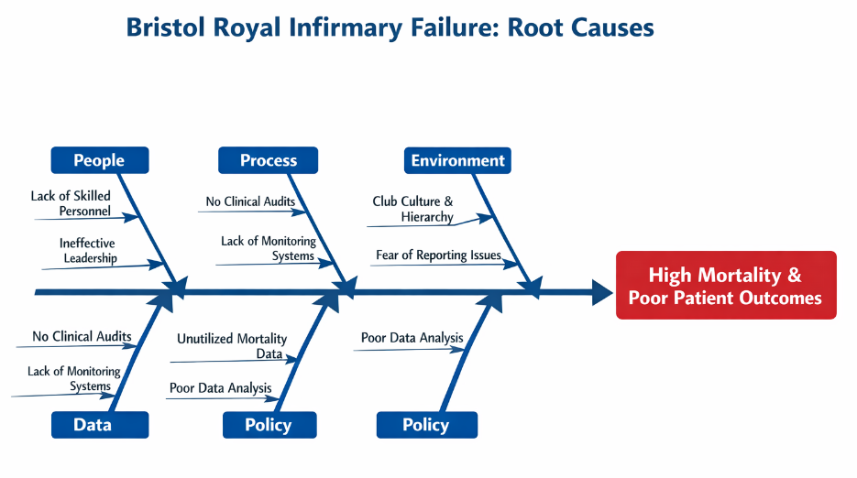
Figure 1: Fishbone Diagram
(Source: Draw.io)
The Fishbone (Ishikawa) Diagram shows various contributing factors to the Bristol failure in important categories, with the complexity of systemic failures stressed. In five major areas, there were key issues. Lack of skilled personnel and poor leadership was experienced under people. Process wise, due to the lack of clinical audits and systematic monitoring systems, poor performance did not get detected (Dickerson, 2023). Hierarchical club culture influenced the environment, preventing open dialogue and limiting staff to be able to express their concerns. In terms of data, the lack of effective use of mortality statistics restricted evidence-based decision-making. Lastly, the absence of accountability was aided by weak policy frameworks and systems of governance.
Another key factor that had a detrimental influence was the organisational culture and the lack of transparency and reporting systems. It is well known that poor safety culture is a significant factor leading to healthcare failures since it does not allow early detection and intervention (Sirrs, 2024).

3.2 5 Whys Analysis
The 5 Whys method offers a greater understanding of what may be the cause of the issue by taking failures detecting one layer at a time:
Why high mortality? → Poor clinical outcomes
Why were outcomes poor? Lack of monitoring and competence
Why lack of monitoring? → No audit systems
Why would no audits have been done? → Low governance
Why did governance fail? → Cultural and leadership failure
This assessment shows the main underlying causes of governance failure and organisational culture. Effective dictatorial mechanisms are vital in making sure that there is accountability and that the safety standards of patients are upheld (NHS England, 2023).
Though the two tools are useful, they are limited. The Fishbone Diagram assigns no priorities to causes and the 5 Whys method can simplify the complicated healthcare system. Nevertheless, together they give a complete picture of the systemic failure.

4. SWOT Analysis
Strengths | Weaknesses
The NHS provides a strong structural foundation and access to resources for delivering healthcare services. | Weak governance structures limited accountability and oversight, contributing to poor clinical outcomes (Care Quality Commission, 2025).
Established healthcare infrastructure supports service delivery across multiple levels. | Poor communication systems reduced transparency and delayed intervention.
Availability of skilled workforce (potential capacity). | Lack of performance monitoring and absence of clinical audit systems affected service quality.
Opportunities | Threats
Advancements in digital health systems can improve monitoring and decision-making processes (WHO, 2025). | Reputational damage resulting from clinical failures can reduce public trust.
Implementation of structured performance frameworks can enhance patient safety outcomes. | Legal consequences and regulatory scrutiny may impact organisational stability.
Adoption of quality improvement methodologies such as PDSA and Lean can strengthen service delivery. | Continued lack of improvement may lead to long-term systemic failure (NHS England, 2026).
Table 1: SWOT Analysis
(Source: Self-made)
This discussion also points to the necessity of improvement in the strategy and continuous monitoring to eliminate the organisational weaknesses and exploit opportunities to benefit patients and service quality.

5. Recommendations and Service Improvement Strategy
The Bristol Royal Infirmary case analysis shows that patient outcomes were the main elements associated with ineffective governance, organisational culture, and performance monitoring. These interrelated problems drive the necessity of an organized and evidence-based solution to service improvement. To remove these weaknesses, it will be necessary to incorporate strong systems that would facilitate accountability, ongoing assessment, and a safety culture in healthcare organisations.

5.1 Strengthening Clinical Governance
One of the main recommendations is to implement an extensive clinical governance framework that would allow accountability and ongoing quality monitoring of healthcare. Clinical governance offers a logical method to sustain and enhance standards of care with an organized control, risk framing, and performance assessment (NHS England, 2022). This is the case in the Bristol case where no such systems were in place to ensure that poor clinical practices were not challenged.
Mandatory clinical audits could not be implemented in all departments: this is necessary to make sure that the performance would be evaluated on a regular basis against the defined standards (World Health Organization, 2024). Moreover, there should be accountability lines whose responsibility is clearly outlined and addressed. Determining performance in relation to the rest of the country would also facilitate in identifying the gaps and facilitate uniformity in delivery of care. Such measures would be effective in identifying instances of bad performance early and helping in taking corrective measures in time. There is evidence that effective governance frameworks have a direct linkage to better patient safety performance and organisational performance (WHO, 2024).

5.2 Implementation of the PDSA Cycle
The Plan-Do-Study-Act (PDSA) cycle of continuous improvement should be utilized to support the incorporation of interventions into organisations by testing and refining interventions in a structured and cyclic fashion. The PDSA model is based on analysing performance, developing specific interventions, measuring their effectiveness, and ensuring the one-size-fits-all quality modifications throughout the organisation (Chowthi-Williams, 2025).
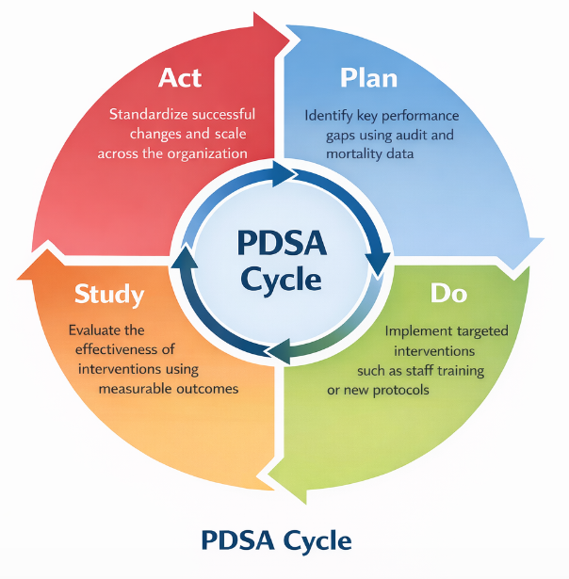
Figure 2: PDSA Cycle
(Source: Self-made)
Such an approach encourages a process of active learning and evolution, enabling healthcare organisations to act in response to the arising issues. The PDSA cycle will guarantee improvement is evidence-based and long lasting by relying on quantifiable results to evaluate performance. It is also known to be a powerful healthcare quality improvement tool, especially in more complicated clinical settings, where continuous assessment is a necessity (Institute for Healthcare Improvement, 2025).

5.3 Improving Organisational Culture
One of the key concerns raised in the Bristol case was that it consisted of a hierarchy of club culture that prevented open communications and narrowed the reporting of concerns. To attain sustainability of change and promote patient safety, then, improvement of organisational culture is necessary. Healthcare organisations need to instill the culture of transparency and openness, in which employees can expertly voice their concerns without the fear of being victimized (Delpino et al., 2023).
Promotion of whistleblowing systems and lessening the levels of hierarchy between employees can facilitate improved communication and teamwork. A leader can contribute so significantly to the organisational culture by expectation setting and modeling behaviours that will result in patient safety being given the utmost priority. It has been shown that a positive safety culture also has a tight connection with better patient outcomes and fewer clinical mistakes (Murray et al., 2024).

5.4 Enhancing Data-Driven Decision Making
The Bristol case was largely contributed by the inability to use mortality data in an efficient manner which exemplifies the significance of data-driven decision making in healthcare. Contemporary healthcare has to embrace the use of superior data monitoring and data analysis methods in order to enhance their performance and patient safety outcomes.
Real-time data monitoring systems can help organisations to monitor clinical performance and to detect possible risks at an early stage (Jadhav and Jena, 2023). The informed decision making and continuous improvement can be provided with the regular analysis of clinical outcomes and performance indicators. Moreover, clear reporting of performance information will improve accountability and instill confidence in the people. Digital health technology offers considerable facilitation of better monitoring rules and assists in proactive intervention plans (Hoffmann et al., 2025).

5.5 Workforce Development and Training
Quality of services depends on the ability and performance of the healthcare professionals. This should be done by continuously enhancing their professional growth to ensure that personnel have the expertise and knowledge needed to provide quality care. These are routine competency tests, continuous clinical training programmes and leadership programs.
An investment in developing the workforce can not only improve clinical performance but it also contributes to the deployment of governance and quality improvement systems (Bhaladhare and Rishipathak, 2025). Leadership training is considered to be especially important in enhancing accountability and pushing organisational change. Indications indicate that highly-educated medical workers are more prepared to provide safe and effective services, consequently leading to better patient outcomes in general (Connor et al., 2023).

5.6 Application of Lean Principles
Lean methodology involves the enhancement of efficiency because of eradicable waste and optimal process of the workflow. Under the healthcare setting, the principles of Lean may be utilized to minimize service delivery and minimize treatment delays (Gültaş, 2023). This strategy places the need to enhance interdepartmental coordination as well as effectiveness of resources utilization.
Lean can also help in improving the quality of service and patient satisfaction because it will minimize redundant processes within the clinical process and improve patient flow (Alobaid et al., 2024). The implementation of Lean concepts assists in providing prompt and effective healthcare services with high standards of care.

5.7 Policy and Regulatory Improvements
To track down such failures in the future, it is important to strengthen the policy implementation. Though some models like the Duty of Candour and clinical governance guidelines would facilitate transparency and accountability, they may only be effective when they are regularly enforced and organisational commitment ensured (Public Health England, 2020).
The key to ensuring the quality of healthcare is to improve the control mechanisms of regulatory bodies and adherence to the standards of safety in the country (Asamoah, 2025). Moreover, greater accountability and more transparency on how healthcare systems operate can be achieved by fully disclosing information to the public. Such measures will make sure organisations strive to live up to the standards and continually advance service delivery.

6. Implementation Strategy
To successfully introduce the recommendations, it is essential to have a systematic and gradual implementation plan, which would be sustainable and long-term. A systematic implementation plan will help the healthcare organisations mitigate immediate risks and slowly inculcate the practice of continuous improvement towards everyday operations.

6.1 Short-Term (0–6 months)
The priority in the short-term is to put in place underlying systems enabling quality improvement and patient safety. This involves performing baseline measurements on clinical performance in order to detect the gaps and areas of concern. The use of compulsory clinical audits should be introduced to maintain a routine monitoring and assessment of service delivery (Moutlana, 2022). Furthermore, governance committees ought to be introduced to monitor performance and hold them accountable, and co-ordinate the improvements. These are the first steps that are essential to detect the risks in the immediate and design the systematic framework of the continued quality assurance (NHS England, 2022).

6.2 Medium-Term (6–18 months)
The medium-term phase is supposed to aim at instilling a process of improvement and solidifying the organisational capacity. The adoption of PDSA cycles within the departments will allow on-going assessment and improvement of the interventions (World Health Organization, 2025). Meanwhile, implementation of digital monitoring systems can contribute to the improved data to gather and evidence-based decision making. Providing specific staff training programmes is also critical to enhance clinical competence and support the values of patient safety. This stage has the role of guaranteeing the incorporation of improvements into daily practice and effective workforce.

6.3 Long-Term (18+ months)
The focus in the long-term should be on maintaining the improvements and fostering a culture of lifelong learning. Organisations are supposed to measure outputs and evaluate the success of the implemented strategy and improve strategies where needed (Vuong and Nguyen, 2022). The effective interventions must be scaled throughout an organisation to provide uniformity with regard to service delivery. This can be done by keeping quality improvement and adjusting to evolving difficulties and ensuring long term success and improvement in patient outcomes.

7. Conclusion
The Bristol Royal Infirmary case is one of the harsh failures in quality assurance in healthcare, which was caused by a systemic inability in governance, organisational culture, and monitoring of performance. The current report has shown that the situations of poor patient outcomes were not caused by the single clinical errors but were the outcome of related structural and procedural failures.
Theoretical models, such as the Donabedian Model, the Fishbone Analysis, and the 5 Whys approach, have enabled a thorough insight into these problems. These models emphasize the significance of well-developed governance systems, effective clinical processes and continuous monitoring as components in providing patient safety.
The results highlight how the culture of an organisation is important in influencing healthcare performance. Even well-designed systems may be sabotaged by a lack of transparency and accountability, and this can result in long term harm to the patient. Hence, sustainable change in governance and processes depends on bettering of culture.
The main recommendations of this report include improvements in clinical governance, introducing continuous improvement practices, and data-driven decision-making. Application of appropriate tools including PDSA cycle and Lean principles offers a systematic means of accomplishing long term advancements.
Finally, this case emphasizes the role of learning what has failed in the recent past to enhance health services in the future. A proactive and systematic quality assurance strategy will help healthcare organisations to promote patient safety, increase the quality of services and restore confidence with the population.

References
Adebowale, O.J. and Etukudoh, E.A., 2022. Endurance rig standardization for fuel systems: eliminating rig-induced failures through engineering process control. Shodhshauryam, International Scientific Refereed Research Journal, 5(6), p.155.
Alobaid, S.K., Alzahrani, A.M.M., Alsharif, F.S., Alomar, A.E.H., Almustanyir, H.M.S., Sagr, A.A., Alsomali, S.A.Y., Alkhatib, M.I., Turkistani, N.A. and Ahmed, A., 2024. Enhancing patient-centered care through process improvement: A systematic review of patient satisfaction outcomes. Journal of Ecohumanism, 3(8), pp.975-982.
Asamoah, D., 2025. The role of health services regulation in healthcare delivery. Electr J Med Dent Stud, 14(1).
Bhaladhare, R. and Rishipathak, P., 2025. Strategies of quality improvement in healthcare organizations on sustainable healthcare system. Discover Social Science and Health, 5(1), p.74.
Care Quality Commission (2025). The state of health care and adult social care in England 2024/25. [online] Cqc.org.uk. Available at: https://www.cqc.org.uk/publications/major-report/state-care/2024-2025/summary.
Chowthi-Williams, A., 2025. 7 Planning Quality Improvement in Healthcare. Leading Quality Improvement in Nursing, Health & Social Care.
Connor, L., Dean, J., McNett, M., Tydings, D.M., Shrout, A., Gorsuch, P.F., Hole, A., Moore, L., Brown, R., Melnyk, B.M. and Gallagher‐Ford, L., 2023. Evidence‐based practice improves patient outcomes and healthcare system return on investment: Findings from a scoping review. Worldviews on Evidence‐Based Nursing, 20(1), pp.6-15.
Delpino, R., Lees-Deutsch, L. and Solanki, B., 2023. ‘Speaking Up’for patient safety and staff well-being: a qualitative study. BMJ Open Quality, 12(2).
Dickerson, J.E., 2023. Clinical audit, quality improvement and data quality. Anaesthesia & Intensive Care Medicine, 24(8), pp.486-489.
Gültaş, P., 2023. Improving Lean Clinics (Lean Healthcare): A Voice of Employee Approach to Reduce Waiting Times. Düzce Üniversitesi Sosyal Bilimler Dergisi, 13(2), pp.198-213.
Hoffmann, C., Avery, K.N., Macefield, R.C., Snelgrove, V., Rooshenas, L., Bekker, H.L., Hopkins, D., Cabral, C., Blazeby, J.M., Gibbison, B. and Hickey, S., 2025. Patient and surgeon perspectives of a large-scale system for automated, real-time monitoring and feedback of shared decision-making integrated into surgical practice: a qualitative study. BMJ open, 15(6), p.e099090.
Institute for Healthcare Improvement (2025). Plan-Do-Study-Act (PDSA) Worksheet. [online] Ihi.org. Available at: https://www.ihi.org/library/tools/plan-do-study-act-pdsa-worksheet.
Jadhav, B. and Jena, B., 2023. Hospital Performance Management: Implementation of Real-Time Monitoring System for Clinical Sector. In Data-Centric AI Solutions and Emerging Technologies in the Healthcare Ecosystem (pp. 263-279). CRC Press.
Kennedy, I. (2001). The report of the public inquiry into children’s heart surgery at the Bristol royal infirmary learning from Bristol. [online] Available at: https://www.bristol-inquiry.org.uk/final_report/the_report.pdf.
Mazzucato, M. and Kattel, R., 2026. Market-Shaping States: A new theory of public sector capacities and capabilities.
McCullough, K., Andrew, L., Genoni, A., Dunham, M., Whitehead, L. and Porock, D., 2023. An examination of primary health care nursing service evaluation using the Donabedian model: A systematic review. Research in nursing & health, 46(1), pp.159-176.
Moutlana, H.J., 2022. Conducting an audit of clinical services. Southern African Journal of Anaesthesia and Analgesia, 28(5), p.3.
Murray, J., Sorra, J., Gale, B. and Mossburg, S., 2024. Ensuring patient and workforce safety culture in healthcare. Ensuring Patient and Workforce Safety Culture in Healthcare.
NHS England (2022). Governance, Patient Safety and Quality. [online] NHS England. Available at: https://www.england.nhs.uk/mat-transformation/matrons-handbook/governance-patient-safety-and-quality/.
NHS England (2023). Patient Safety. [online] England.nhs.uk. Available at: https://www.england.nhs.uk/patient-safety/.
NHS England (2026). NHS England» Performance report. [online] England.nhs.uk. Available at: https://www.england.nhs.uk/long-read/performance-report-24-25/.
Public Health England (2020). Duty of Candour. [online] GOV.UK. Available at: https://www.gov.uk/government/publications/nhs-screening-programmes-duty-of-candour/duty-of-candour.
Sirrs, C., 2024. The moment of patient safety: iatrogenic injury, clinical error and cultures of healthcare in the NHS. Social History of Medicine, 37(1), pp.93-115.
Tossaint-Schoenmakers, R., Versluis, A., Chavannes, N., Talboom-Kamp, E. and Kasteleyn, M., 2021. The challenge of integrating eHealth into health care: systematic literature review of the Donabedian model of structure, process, and outcome. Journal of medical Internet research, 23(5), p.e27180.
Vuong, T.D.N. and Nguyen, L.T., 2022. The key strategies for measuring employee performance in companies: a systematic review. Sustainability, 14(21), p.14017.
WHO (2024). WHO Results Report 2024-2025. [online] Who.int. Available at: https://www.who.int/about/accountability/results/who-results-report-2024-2025.
WHO (2025). Fact sheet: Quality Health Services. [online] www.who.int. Available at: https://www.who.int/news-room/fact-sheets/detail/quality-health-services.
World Health Organization, 2021. Global patient safety action plan 2021-2030: towards eliminating avoidable harm in health care. World Health Organization.
World Health Organization, 2024. The assessment process for listing of performance evaluation laboratories in connection with WHO prequalification of in vitro diagnostics: information for candidate laboratories.
World Health Organization, 2025. WHO labour care guide: Implementation resource package.

