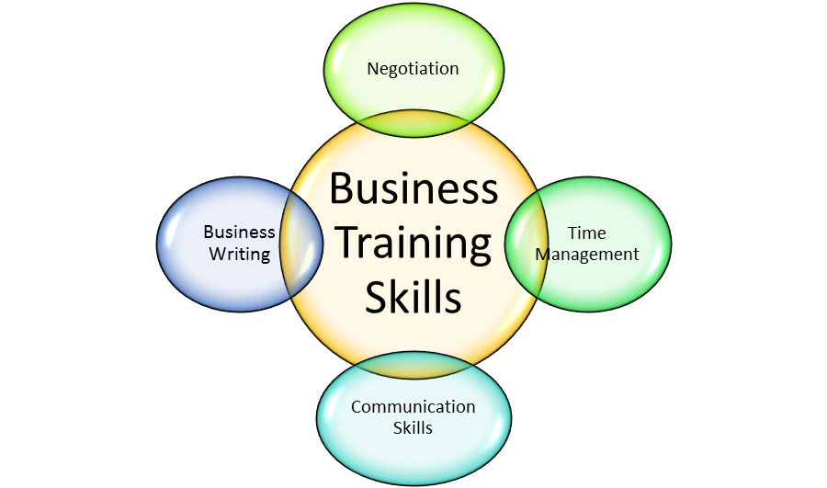

BUSINESS SKILLS FOR INTERNATIONAL HOTEL INDUSTRY

MODULE CODE: M4X 01917
STUDENT NAME: ARIANNA SGAMBATI
STUDENT ID: 1816097
MODULE LECTURER’S NAME : DALE CLARKE.

Table of contents

Introduction pag.3
Literature review pag.3
SWOT ANALYSIS pag.3
PROFESSIONAL DEVELOPMENT PLAN pag.5
REFLECTIONS AND ANALYSIS pag.6
CONCLUSION pag.7
REFERENCES pag.7

INTRODUCTION
As part of the assessment for this module, we have been tasked with writing a report around the employability skills for the hotel industry. The assignment’s requirements are analysing my skills and abilities using tools such as SWOT analysis and the Personal Development Plan. I will use both these tools and then reflect upon the findings. I will also make use of theoretical knowledge I gained during the University courses in order to demonstrate my understanding and to explain the link between my skills and abilities and my career aspirations. The aim of this report is to help me gain a better understanding of my skills and capabilities and compile a PDP which I will then discuss with my tutors . According to Brian Tracy “95% of everything that you think, feel,do,and achieve is the result of habit. That what I want achieve with the right training of my habit.
Literature review
The present report has been elaborated with the help of online sources and books. I also made use of specialist articles which deal with aspects related to the hotel industry and employability. All sources I used within my report have been cited and correspondingly referenced, using the Harvard referencing style. Also I been really inspired from Antony Robbins “how to improve your state of mind, health and financial”, regarding coaching ourselves into the right state of mind for face the everyday life style.

SWOT ANALYSIS
In order to apply the SWOT analysis method, I will start with defining the concept of “skills” and employability skills and outline their importance in today’s hospitality market.
Skills can be defined as abilities or capabilities, gained through consistent learning efforts with the purpose of undertaking job related tasks. A specific category of skills are interpersonal skills which related to the ability of interacting with other individuals. (BusinessDictionary.com, 2019)
Skills can be of different types:
- Hard skills – can be learnt; are teachable, quantifiable; can be acquired through training or education. Examples of hard skills: foreign language skills, typing abilities, training certificates, etc.
- Soft skills – subjective, such as “people skills”, cannot be quantifiable but can be learnt but not through formal training but rather through examples and practical situations. Examples: flexibility, problem solving capabilities, team-player skills, leadership skills, etc. (The Balance Careers, 2019)
Employability skills are the whole range of skills, including soft and hard skills need by an employee to be suitable for a job role, in a certain industry. Employers are looking for certain employability in potential employees, which they believe will enable potential candidates to perform the role efficiently.
Examples of employability skills:
- Communication skills; people’s skills – ability to communicate at all levels
- Ability to work under pressure
- Ability to meet deadlines
- Abilities of problem solving
- Initiative and self-motivation
- Quicker learning abilities
- Team working skills
- Good organisational skills
- Negotiating skills (Exeter.ac.uk, 2019)
After being employed in the hospitality industry since 2015, I have gained invaluable experience and skills, which I will utilise towards securing a new role in the Hotel industry. Some of these skills are transferable and will allow me to perform my duties efficiently in the hotel industry.
The SWOT analysis was designed by Albert Humphrey, whilst he was a researcher at the Stanford Research Institute. The model is a tool evaluating the Strengths, Weaknesses, Opportunities, and Threats or internal and external environment affecting an individual or organisation in achieving their goals and objectives. (Academy, 2019)
The SWOT analysis is use in both professional and personal contexts, for the purpose of evaluating assets and capabilities in order to maximize potential.
As follows, I will perform a self-analysis using the SWOT model:
 | STRENGTHS | WEAKNESSES | OPPORTUNITIES | THREATS
ACADEMIC | Good command of English  Ability to understand new information quickly  Good memorising skills | Poor public speaking skills  Limited knowledge about the Hotel industry in the UK | Studying with the University of Wales  Opportunities met through the workplace  Good training opportunities in the UK compared to my home country, Italy | Unforeseen circumstances  Unforeseen changes caused by a potential Brexit with a potential impact on my Student finance
PERSONAL | Hard worker  Emphatic nature  Ambitious nature  Great desire to learn and to improve myself  Abilities to organise myself and other in achieving goals and objectives | Tendency to overthink  Perfectionism  Nervousness when in front of large audiences  Poor presentation abilities | Belonging to a great team at the University  Opportunity to meet new people and learn about other cultures  Opportunities to explore the UK closer | Job instability  Increased competition

Personal Development Plan

Personal development plans are processes allowing individuals to assess current circumstances, to determine short, medium and long term goals and targets and to identify area of improvement and how this can be reached. (Routledge and Carmichael, 2007). According to this plan I create my personal PDP.
 | Short Term (<1 year) | Medium Term (1 – 1.5 years) | Long Term (1.5 – 3 years)
Goals for this timescale | Improve my hotel industry knowledge and market intelligence related | Graduate from University  Possess great business skills for the Hotel Industry  Develop great market intelligence | Be in a leadership or managerial role in the hotel industry
Skills and abilities for this time scale | Develop a solid formal English skills  Improve Powerpoint skills and presentation skills | Understand the Hotel industry hierarchical organization  Identify the exact role I would like to have within this industry | Leadership skills  Great organisational skills  In-depth understanding and sound knowledge about operations management in the Hotel Industry
How I will acquire the above  . | Reading and research in both personal time and the one spent at the University | Attend job fairs for the industry  Develop a LinkedIn network | Show commitment and desire of learning and self-improvement after gaining employment in this industry
Potential resources | Time  Emotional intelligence  Support from family and friends  Support from University  Patience | Commitment  Ambition  Resilience | Adequate attitude  Industry expertise
Time scale | Before 1 year | After the 1 year deadline but no longer than 1 year and 2 months | -The final goals should be accomplished by the end of the fourth year from my induction in the  University.

The above plan will be discussed with my University tutors. In order to increase the plan’s efficiency, I will review this periodically so that I updated it accordingly with the changes that might occur.
I believe that the development plan is achievable and in elaborating I, I used realistic estimations. Further research is still required as circumstances can change and unforeseen events can occur from both academic and professional life. In terms of my area of improvement, I will make use of all academic resources such as the E-Library offered by the University of Wales. I see great potential and benefits in having access to this library as it will allow me to save money that I would have spent for buying these materials. I also find the e-library a very useful tool as it allows the reader to read another book, should the current one not be 100% fit for purpose.
I am also planning to do some self-learning and to commit some of my personal time towards improving my Powerpoint skills. My plan is to watch a number of online tutorials and to exercise in my own time. I find this a challenge, similar to the one of learning how to use the Microsoft Office package.
I am also interested in attending job fairs so that I gain practical experience of the interview process for the Hotel Industry and also have the opportunity to connect with professionals in this field.
I will also enquire with my current employer about potential training sessions which might be available for me. I believe that any additional training and learning will be beneficial for my self-development.
Researching the Internet with the aim of finding innovative ways of self-improvement, I came across the packages offered by the Palgrave personal development planning tools, which will help me set up goals in a more efficient way, and approach development in a more structured I way.
I also believe that having the right attitude and mind-set is an important aspect in achieving success in terms of development. I feel that this journey will be an exciting one and I will successfully complete it and will achieve my goals accordingly. I also feel that my personal background is a good starting point in developing a career in the hotel industry.
At present, I am equipped with the right tools for success and I am grateful for being able to study with the University of Wales.

Conclusion

Today’s market is at the highest competitive level ever. This has lead individuals who aspire for careers in this field to start planning very early, as early as the University level. The need for more efficient employees is therefore clear, in a dynamic industry where the needs and expectations of customers are changing very rapidly. I believe that my current skill-set and the experience I gained during my professional life up to date are definitely an advantage for me and my future career in Hotel Management. The present assignment has helped me understand more about my skills and capabilities but also to see what my improvement areas are and to find an action plan regarding this.

Refererences
- Academy, P. (2019). Marketing Theories - SWOT Analysis. [online] Professionalacademy.com. Available at: https://www.professionalacademy.com/blogs-and-advice/marketing-theories---swot-analysis [Accessed 8 Jul. 2019]
- Anthony Robbins (2017) how to improve your state of mind, health and financial (book)
- Brian Tracy (2018) The power of habit:7 steps to successful Habits.(book).
- BusinessDictionary.com. (2019). Do you know this term?. [online] Available at: http://www.businessdictionary.com/definition/skill.html [Accessed 8 Jul. 2019]
- Exeter.ac.uk. (2019). [online] Available at: https://www.exeter.ac.uk/ambassadors/HESTEM/resources/General/STEMNET%20Employability%20skills%20guide.pdf [Accessed 8 Jul. 2019]
- Routledge, C. and Carmichael, J. (2007). Personal development and management skills. London: Chartered Institute of Personnel and Development.
- The Balance Careers. (2019). Hard Skills vs. Soft Skills: What's the Difference?. [online] Available at: https://www.thebalancecareers.com/hard-skills-vs-soft-skills-2063780 [Accessed 8 Jul. 2019]

