University of Wales Trinity Saint David
School of Engineering

Workshop Technical Report for Session 17th October 2019
Engineering Applications and Study Skills
M4X02063

Iestyn Webber
1901363
03/02/2020

Contents
1 Introduction 1
1.1 For Workshop Session 1
1.1.1 Aims 1
1.1.2 Objectives 1
1.2 For Technical Report 1
1.2.1 Aims 1
1.2.2 Objectives 1
2 Background Research 2
2.1 Health and Safety 2
2.2 Machine Use 2
3 Methodology 3
4 Evaluation 6
4.1 Evaluating Performance 6
4.2 Aims and Objectives 6
5 Conclusion & Discussion 7
5.1 Achievements 7
5.2 Learning 7
6 References 8

Figure 1 - Work Piece at Beginning of Session, PPE 3
Figure 2 - Equipment and Technical Drawing 4

Introduction
This technical report’s purpose is to assess the specified workshop session, evaluating all that was achieved, and skills acquired. It can be separated into two sections of aims: aims set while undertaking the workshop session, and aims to be achieved within the report itself, meaning correct working and an efficient and effective report.

For Workshop Session

Aims
- To accurately follow the methodology for the work piece.
- To work in a safe and appropriate manner.

Objectives
- Refer to the technical drawing to ensure correct measurements.
- Follow the health and safety guides at all times.
- Ensure the proper procedure for operating machinery is obeyed.

For Technical Report

Aims
- To clearly relay the methodology followed in the session.
- To assess all experience gained during the session.

Objectives
- Create a concise, step-by-step methodology.
- Analyse achievements to review skills obtained.
- Evaluate performance to provide a breakdown of strengths and improvements needed.

Background Research
References 1 and 2 are sections of a document provided by UWTSD prior to attending machine workshop sessions. They outline the rules to follow regarding health and safety when working within workshops. Reference 1 provides general health and safety guidelines in a numbered list, from describing PPE to appropriate behaviour within the workshop. Reference 2 focuses solely on guidelines regarding use of the mill; while general workshop rules applied, this session focused on the mill making the information in source 2 especially crucial. Since provided by the University and designed as a signoff form, they provide important and reliable information.
Source 3 is taken from a government website, Health and Safety Executive. The document is specifically about safety while in engineering workshops, giving statistics on common incidents and regulations and guidelines to avoid them. Being a government website and so focused its information is highly valid.

Methodology
Since this was not the first session of the semester, at the beginning of this session, the work piece was in its second week of progression. As a result, the methodology for the session began midway through completion of the work piece.
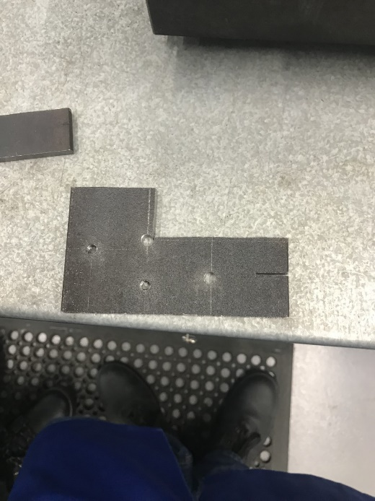
Figure 1 - Work Piece at Beginning of Session, PPE
Equipment required for the session was:
- Hacksaw.
- Mill.
- Digital height gauge.
- PPE including a dust coat, steel toe cap boots and protective glasses (Health & Safety Guidelines, UWTSD 2019) – see figure 1.
Health and safety is a vital component of working effectively in a machine workshop. Not only should appropriate PPE be worn but steps must be taken to prevent hazards within the machine workshop, including positioning of other students and objects and slippery floors caused by spillages (HSG129, 1999).
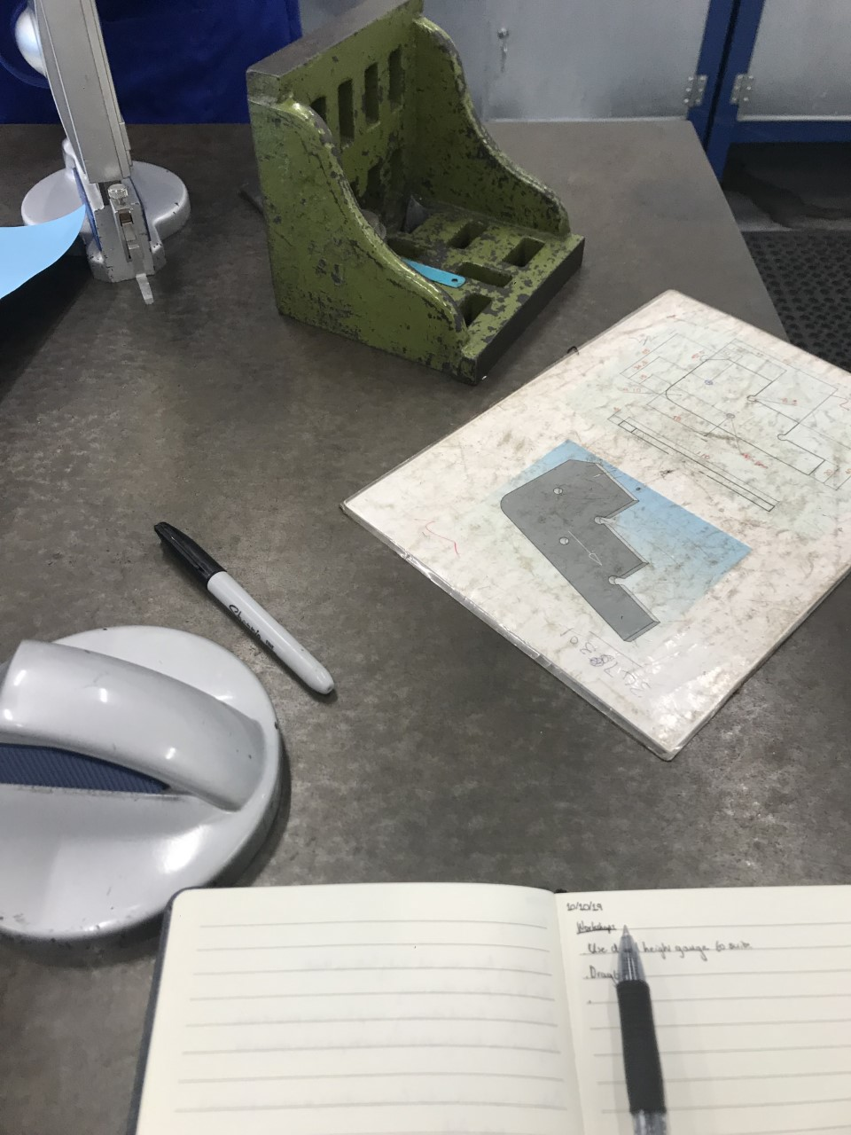
Figure 2 - Equipment and Technical Drawing
The first step for the session was using the hacksaw to finish cutting shoulders along lines scribed in session one (see Figure 1). This created “steps” on the piece and was done to within 2mm of the marks, so the mill was used to cut to the final measurement. This was the optimal method as hacksaws are too inaccurate to cut neatly along a measured line, but with a mill which can only take 0.5mm per cut, trimming a large shoulder would take too long.
The piece was set ready to be milled. To mill accurately, the piece was put in the vice and the vice tightened. Once tightened, a rubber mallet was used to tap the piece until it lay flat along the base, as it would lift from the base as the vice tightened. This ensured a flat surface allowing measurement and a level cut.
The mill was activated following the correct procedure, requiring the guard to be moved across. To set zeroes, the mill was aligned in the x and y axes by being moved to the work piece on each axis while on until a cutting noise was heard. The mill was stopped, and this was set as the zero point for its axis. Concluding set up, 0.200mm was cut along the top edge to create a flat surface, repeated to practice technique.
The work piece was measured using the digital height gauge (zeroed before measuring). On this dimension the measurement was 4.14mm greater than the 65mm specified in the technical drawing (see figure 2). The work piece was cut to 65mm according to the mill, then remeasured to ensure the cut was within tolerance.
The final stage was milling the shoulder. Since the bit on the mill is a certain length, the shoulder had to be milled in halves. For each half, the bit was aligned with the shoulder and moved 0.500mm in. This created a rounded cut, so the mill was swept along the z axis, flattening the face.

Evaluation

Evaluating Performance
Individual performance was effective throughout the workshop session. Steps of the methodology were completed while referring to the technical drawing and following health and safety guidelines, focusing on those regarding the mill (MTB04 Milling Safety Rules, UWTSD 2019). Particular adeptness was observed at safe practice with switching the mill on and off relative to usage.
In terms of weakness, inaccuracies were found in the work piece compared to dimensions within the technical drawing. This was attributed to larger margins being milled while close to markings, so to improve smaller margins with regular dimension checks would be necessary to remain in tolerance.

Aims and Objectives
Through this assignment all objectives except one were met, thus all aims were met, as objectives were goals set in order to achieve the predetermined aims. The aim not met was providing a concise methodology, as difficulty was found thoroughly explaining detail while keeping information and structure to a concise manner.

Conclusion & Discussion

Achievements
During this session, the predominant achievement was the ability to operate the mill in an appropriate manner. This resulted in effective and accurate working, creating a suitable work piece which followed technical specifications. Also, the strict adhesion to guidelines meant a safe environment was achieved, both for the mill operator and all others within the workshop.

Learning
Learning was undertaken on a macro scale in terms of skills learned operating the mill and correct procedure doing so, meaning a large base of knowledge surrounding workshop skills was establoished. However, smaller amounts of information were also learned, becoming the crucial stages to a higher level of work. For example, learning about tapping the work piece flush with the base ensures especially neat and level milling, heightening the quality of work.

References
- Health and Safety Guidelines – provided by UWTSD, October 2019
- Machine Shop MTB04 Milling Safety Rules – provided by UWTSD, October 2019
- HSG129, HSE 1999 - https://www.hse.gov.uk/pUbns/priced/hsg129.pdf (accessed 03/02/2020)

