Website Redesign for Online Business Presence
Lecturer: Sadeque Imam Shaikh
ACCA5019_LON
Business and web management
Constantin Ovidiu Strinu (2321711)

UWTSD
https://ovidiu26ova.wixsite.com/edunext-2
2025
Contents
INTRODUCTION 4
1. EduNext Website Redesign 5
1.1 Analysis of Current Website Issues 5
1.1.2 Poor Information Architecture and Navigation 5
1.1.3 Outdated Visual Design and Weak Branding 6
1.1.4 Insufficient Course Information and Ineffective CTA 6
1.1.5 Non-Responsive Layout and Mobile Issues 6
1.1.6 Accessibility Concerns 7
1.2 Proposed Solutions and Redesign Justification 7
1.2.1 Simplified Information Architecture 7
1.2.2 Enhanced Visual Identity and Brand Trust 7
1.2.3 Improved Course Presentation and CTA Placement 7
1.2.4 Mobile-First Responsive Grid 8
1.2.5 Accessibility and Inclusive Design 8
2. Responsive Design Implementation 8
3. Implementation 9
4. Conclusion 10
5. Reflection on Project Experience and Real-Life Learning 10
REFERENCES 12
Appendix A – Moodboard 13
Appendix B – Wireframes 14
15
16
APPENDIX C – INTERACTIVE PROTOTYPE SCREENS 18
APPENDIX D – RESPONSIVE DESIGN TESTING (WIX) 22

Figure 1 EduNext Moodboard (Created in Framer) 12
Figure 2 Homepage Wireframe (Framer) 13
Figure 3 About Page Wireframe (Framer) 14
Figure 4 Courses Wireframe (Framer) 15
Figure 5 Register Wireframe (Framer) 16
Figure 6 Contact Wireframe (Framer) 16
Figure 7 Homepage Prototype (Wix) 17
Figure 8 About Page Prototype (Wix) 18
Figure 9 Courses Page Prototype (Wix) 19
Figure 10 Register Page (Wix) 20
Figure 11 Contact Page Prototype (Wix) 20

INTRODUCTION
The rapid evolution of digital learning platforms has transformed user expectations around usability, accessibility, and mobile performance. In today’s competitive e-learning landscape, providers must adopt modern UI/UX principles to remain relevant and meet the needs of increasingly mobile-first learners. EduNext, an established online learning provider, faces several challenges, particularly in navigation, accessibility, content clarity, and mobile responsiveness. These reflect common issues identified in recent research, where outdated layouts and fragmented visual design undermine engagement and course completion rates [1], [2].
This report critically evaluates the redesign of EduNext’s interface and presents a structured, research-driven solution grounded in contemporary UX, accessibility, and responsive design literature. The project prioritises usability, inclusivity, and clarity, aligning with user-centred design (UCD) principles throughout.
Three key design artefacts were developed: a moodboard, low- to mid-fidelity wireframes, and an interactive prototype. Framer was used to create the moodboard and wireframes, while Wix enabled responsive behaviour testing across various screen sizes. This multi-tool workflow reflects best practices in UX design, which emphasise iterative development, cross-platform validation, and early feedback cycles [3].
The redesign focuses on five core objectives: simplifying navigation, modernising visual identity, improving course discovery, ensuring accessibility compliance (WCAG 2.1 AA), and delivering a responsive, mobile-first layout.
Overall, this introduction outlines the context, goals, and relevance of the redesign. By combining academic insights with practical implementation, the report demonstrates how UCD strategies can improve engagement, inclusivity, and digital performance in educational platforms.

1. EduNext Website Redesign
While the EduNext platform is functionally established, it exhibits several shortcomings characteristic of legacy e-learning systems. These limitations adversely affect key performance areas, including user engagement, accessibility compliance, and conversion efficiency. As such, a comprehensive redesign was both timely and necessary to bring the platform in line with contemporary UI/UX standards, evolving industry benchmarks, and user-centred design (UCD) methodologies. This section provides a critical evaluation of the existing platform's constraints and introduces a set of targeted, research-informed solutions grounded in academic literature and recognised best practices from the fields of digital design and online learning.

Analysis of Current Website Issues
A systematic assessment of EduNext’s existing interface identified multiple design, structural, and usability issues aligned with patterns discussed in UX and HCI literature. These include:

Poor Information Architecture and Navigation
The current site layout features an inconsistent navigation structure, non-standard menu placement, and a lack of logical grouping for course categories. Studies highlight that poorly structured information architecture increases cognitive load and significantly lowers task completion rates [4]. Moreover, users tend to abandon educational platforms when they cannot identify relevant content within the first 10–20 seconds of navigation [5].
The wireframes developed for the redesigned platform clearly demonstrate an effort to simplify the site’s navigational structure. Primary navigation has been reorganised using conventional, easily recognisable labels such as Home, Courses, About, and Contact. This design decision aligns with Jakob’s Law, which posits that users develop expectations based on familiar digital experiences and are more comfortable using interfaces that follow established patterns [6]. By adhering to such conventions, the redesign aims to reduce cognitive friction and improve overall usability.

1.1.3 Outdated Visual Design and Weak Branding
The current EduNext interface displays notable visual inconsistencies, including mismatched typography, low-resolution imagery, and a lack of cohesive visual identity. These issues weaken the user experience and undermine the platform’s credibility. Research in digital learning consistently shows that strong visual aesthetics significantly influence users’ trust and engagement [7].
The moodboard created in Framer addresses these deficiencies by establishing a cohesive visual system. It features a unified colour palette of blues and purples, associated with trust and creativity, paired with modern Poppins typography for readability. High-quality imagery enhances professionalism and impact. These choices align with design principles known to improve user motivation and perceived platform quality [8].

1.1.4 Insufficient Course Information and Ineffective CTA
The original course layout lacks persuasive structure, with key elements, such as call-to-action (CTA) buttons, placed below the fold, reducing engagement. Research shows that positioning CTAs above the fold can boost conversion rates by up to 84% [9], while users rely on clear course summaries (e.g., duration, cost, level) to inform enrolment decisions [10].
The redesigned wireframes address this by introducing structured course cards with clean imagery, concise descriptions, level indicators, durations, and prominent Enrol buttons. This approach applies the principle of progressive disclosure, reducing cognitive load while improving clarity and user control [11], supporting better decision-making and higher satisfaction.

1.1.5 Non-Responsive Layout and Mobile Issues
Mobile responsiveness is essential in modern e-learning, as over 70% of learners now access content via mobile devices [12]. The current EduNext interface presents major usability issues on smaller screens, including overlapping text, static imagery, and poorly adapted navigation. To address this, responsive testing was conducted using Wix’s simulator to validate layouts across mobile, tablet, and desktop breakpoints. This aligns with best practices in responsive design, which emphasise iterative testing for consistency, readability, and functionality [13]. Optimising for mobile not only meets user expectations but also improves accessibility and engagement in mobile-first learning environments.

1.1.6 Accessibility Concerns
Accessibility is not only a matter of inclusion but also a legal obligation under the UK Equality Act 2010. Research shows that accessible design benefits all users by improving overall usability and engagement [14].
The redesign addresses key accessibility issues by implementing high contrast ratios, a correct heading hierarchy, large readable fonts, and clearly identifiable interactive elements. These changes align with WCAG 2.1 AA standards [15].

1.2 Proposed Solutions and Redesign Justification

1.2.1 Simplified Information Architecture
The redesigned top-level menu improves clarity by offering immediate access to core site sections. Courses are now grouped into logical categories, and a prominent search bar has been introduced to reduce time-to-content and streamline navigation. This structure reflects established information architecture principles supported by large-scale UX research.

1.2.2 Enhanced Visual Identity and Brand Trust
The updated visual direction, informed by the moodboard, establishes a consistent and contemporary brand identity. The selected colour palette and typography enhance both readability and emotional engagement, while generous spacing and subtle card shadows create visual hierarchy and depth. This minimalist approach aligns with research indicating that clean, simplified layouts improve content comprehension and reduce bounce rates in e-learning environments.

1.2.3 Improved Course Presentation and CTA Placement
The redesigned course cards incorporate best practices in persuasive interface design, featuring a consistent layout, prominent call-to-action (CTA) buttons, visual indicators of course difficulty (e.g., icons or badges), and concise teaser text to aid decision-making. These elements are shown to enhance perceived
value and increase the likelihood of user conversion in digital learning environments.

1.2.4 Mobile-First Responsive Grid
Responsive testing conducted in Wix confirms the effective use of fluid grids, flexible images, rem-based typography, and collapsible mobile navigation. These elements reflect a mobile-first design philosophy, which supports faster load times and improved SEO, both critical for maintaining competitiveness in the online education sector.

1.2.5 Accessibility and Inclusive Design
The redesign integrates key inclusive design practices, including sufficient colour contrast, accessible form fields, descriptive alt text, generous spacing, and predictable navigation patterns. These enhancements not only ensure compliance with accessibility standards but also build user trust and broaden EduNext’s reach to a more diverse audience.

2. Responsive Design Implementation
Responsive design is essential for modern online learning platforms, particularly as mobile-first access now accounts for over 70% of user interactions [12]. The original EduNext site lacked consistency across devices, leading to usability issues, reduced engagement, and lower enrolment rates.
A mobile-first redesign was implemented and tested using Wix’s responsive simulation tools. This approach supports faster load times, improved performance metrics such as Largest Contentful Paint (LCP), and better SEO, key factors in user retention and discoverability [13].
Key improvements include fluid grids for proportional layout scaling, rem-based typography for responsive readability, and a collapsible hamburger menu to streamline navigation on smaller screens, aligning with Jakob’s Law of interface familiarity [6]. Course cards were redesigned to stack vertically on mobile, reducing scrolling effort, while images were replaced with responsive, max-width elements to prevent layout issues and slow loading, both major causes of mobile user abandonment [5].
Accessibility enhancements based on WCAG 2.1 [14], such as readable contrast ratios, accessible form fields, and minimum tap target sizes, were also integrated to improve inclusivity and user trust [15].
Overall, the responsive redesign enhances usability, mobile performance, and EduNext’s competitiveness in a mobile-first e-learning market.

3. Implementation
The implementation phase translated the conceptual redesign into tangible design artefacts, namely the moodboard, wireframes, and interactive prototype, each grounded in UX and HCI best practices [3].
The moodboard, created in Framer, established the project’s visual direction through a curated set of colours, typography, and imagery aligned with EduNext’s brand values. The blue and purple palette was selected for its association with trust and creativity [7], while Poppins & Inter fonts and academic imagery reinforced readability and professional identity. Research confirms that early visual alignment enhances design consistency and reduces rework [8].
Wireframes were developed for key pages (homewire.png, courseswire.png, registerwire.png) to define structure, content hierarchy, and user flow. These low-fidelity layouts prioritised clarity over aesthetics, enabling early evaluation and iterative improvements. The wireframes introduced simplified navigation, repositioned CTAs above the fold, and applied progressive disclosure principles to course cards, all consistent with established usability heuristics [4], [6], [11].
The interactive prototype was built in Framer and validated through Wix’s responsive testing tools. Functional interactions such as hover states and collapsible navigation allowed for realistic user simulation and stakeholder feedback [5]. Responsive behaviour was evaluated across mobile, tablet, and desktop devices, confirming consistency in layout, typography, and navigation. The mobile-first design also incorporated accessibility features aligned with WCAG 2.1, including adequate tap-target sizing, contrast ratios, and scalable typography [14], [15].

4. Conclusion
The EduNext redesign project underscores the importance of a structured, research-led approach to UI/UX in online learning environments. The initial evaluation revealed key structural, visual, and usability issues that limited engagement, accessibility, and navigation. By applying HCI principles, responsive design practices, and accessibility standards, the redesign addressed these challenges in a clear and measurable way.
The process followed a UX methodology [3], beginning with a moodboard to establish visual identity and brand alignment. Wireframes translated these concepts into functional layouts with improved content hierarchy and navigation. The interactive prototype streamlined user journeys and reduced cognitive load [4], [11].
Responsive testing confirmed mobile-first compatibility and accessibility compliance, critical given the rise of mobile learning [12], [14]. The outcome positions EduNext as a more user-centred, accessible, and competitive platform.
Ultimately, the project shows that effective educational platform design requires more than visual appeal; it demands a deep understanding of usability, behaviour, and responsiveness. The result is a scalable, inclusive, and engaging interface shaped by iterative, evidence-based design.

5. Reflection on Project Experience and Real-Life Learning
Completing the EduNext redesign project has significantly strengthened both my technical competencies and my professional mindset as a future computing and cybersecurity practitioner. Although the project was centred on UI/UX and web design, the experience has had broader implications for my development, particularly in areas such as critical analysis, structured problem-solving, and human-centred digital thinking, skills which are essential across all modern computing disciplines.
One of the most valuable lessons I gained from this project was understanding the importance of user-centred design as a methodology rather than a collection of tools. Before starting the redesign, I tended to approach interfaces from a technical perspective, focusing more on features than on user behaviour. By working through the full UX pipeline, moodboard, wireframes, prototype, responsive testing, I realised how essential it is to understand user cognitive patterns, accessibility needs, and device contexts. These insights align closely with established HCI principles [3], and they helped me appreciate why successful digital platforms consistently prioritise user research and iterative refinement.
Using Framer and Wix in combination also improved my technical flexibility. Initially, I believed that one tool per project was sufficient, but this assignment showed me the advantages of multi-platform workflows. Framer allowed me to work with high-fidelity transitions and interactive flows, while Wix provided accurate, browser-grade responsive testing that immediately revealed layout weaknesses. This mirrors real industry practice, where designers and developers often rely on multiple environments to validate decisions early and avoid costly rework later. Learning to switch between tools efficiently is a practical skill that directly improves my ability to deliver professional digital solutions in future employment.
A further personal learning outcome was recognising the connection between UI/UX and my long-term path in cybersecurity. While the two fields seem distinct, the redesign highlighted how much user behaviour, clarity of interaction, and accessibility affect system security. A confusing interface can lead users to make poor decisions, ignore warnings, or mishandle sensitive data. This helped me appreciate the broader importance of designing secure, human-friendly interfaces, an area increasingly relevant in cybersecurity strategy and digital trust frameworks.
Overall, this project has strengthened my confidence in producing structured, research-supported work and reinforced the value of iterative design, critical thinking, and user empathy. These skills will continue to support me whether I am building secure systems, managing digital platforms, or developing user-centred solutions across my future career.

REFERENCES
[1] A. Alshammari, “Usability issues in e-learning systems: A systematic review,” IEEE Access, vol. 10, pp. 55483–55495, 2022.
[2] R. Ghosh and S. Zang, “Impact of user interface design on online learning effectiveness,” IEEE Transactions on Learning Technologies, vol. 15, no. 4, pp. 559–572, 2022.
[3] J. Preece, H. Sharp and Y. Rogers, Interaction Design: Beyond Human–Computer Interaction, 6th ed. Wiley, 2023.
[4] S. Krug, Don’t Make Me Think: A Common-Sense Approach to Web Usability, 3rd ed. New Riders, 2020.
[5] Nielsen Norman Group, “How long will users stay on a webpage?,” NN/g, 2021. [Online]. Available: https://www.nngroup.com
[6] Nielsen Norman Group, “Jakob’s Law: Users prefer familiar interfaces,” NN/g, 2020. [Online]. Available: https://www.nngroup.com
[7] L. Zhang, “Colour psychology in digital behaviour,” HCI Review, vol. 8, pp. 77–91, 2022.
[8] D. Norman, The Design of Everyday Things, rev. ed. MIT Press, 2019.
[9] C. Martin, “CTA placement and conversion optimisation,” Journal of Digital Commerce, vol. 14, no. 3, pp. 33–49, 2021.
[10] K. Adams, “Learner decision-making in online education,” E-Learning Insights Journal, 2023.
[11] A. Dix, Human–Computer Interaction, 5th ed. Pearson, 2020.
[12] T. Wilson, “Responsive design impact on e-learning and mobile usage,” International Journal of Web Engineering, 2021.
[13] Google Developers, “Mobile-first best practices,” Google, 2022. [Online]. Available: https://developers.google.com
[14] World Wide Web Consortium (W3C), “Web Content Accessibility Guidelines (WCAG) 2.1,” W3C, 2023.
[15] P. Brooks, “Brand trust and visual consistency in digital platforms,” Marketing Technology Review, 2020.

Appendix A – Moodboard
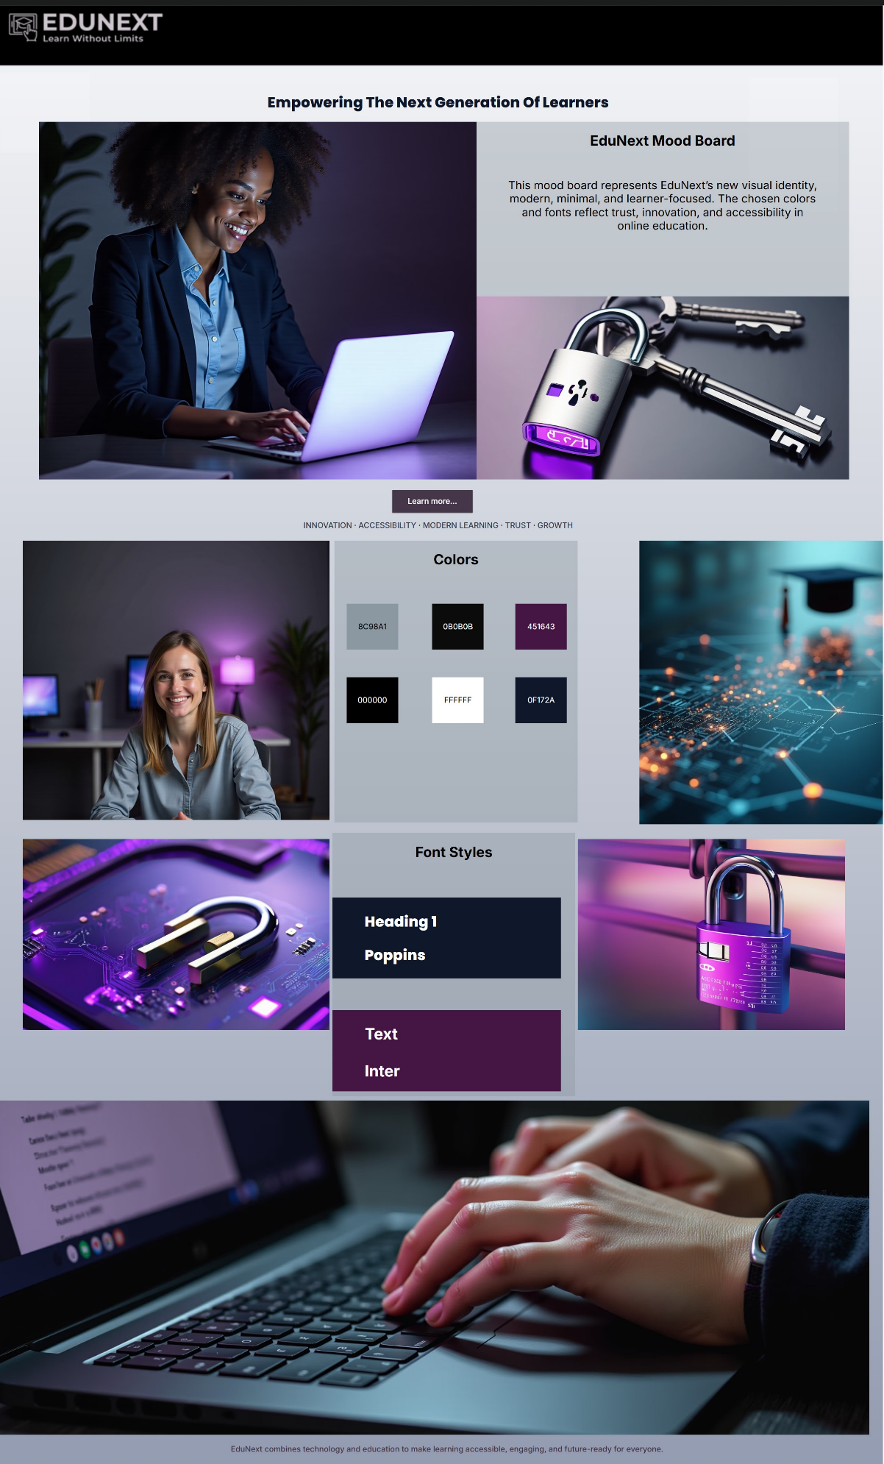
Figure 1 EduNext Moodboard (Framer)

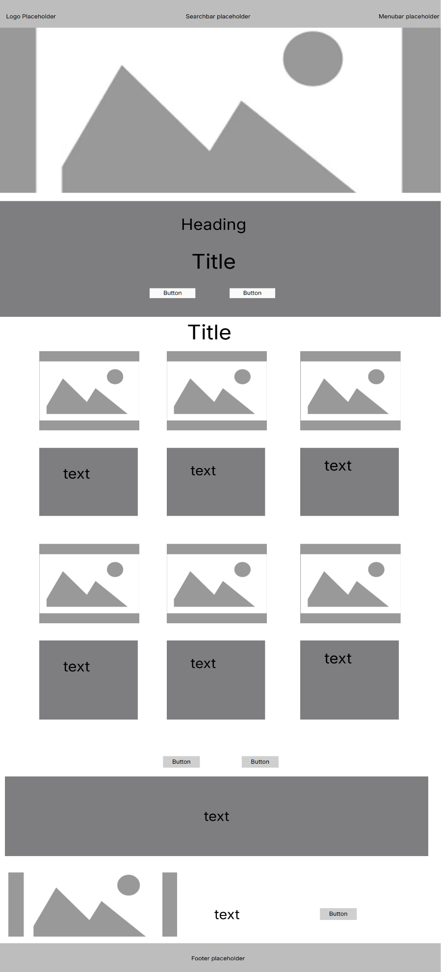
Appendix B – Wireframes
Figure 2 Homepage Wireframe (Framer)
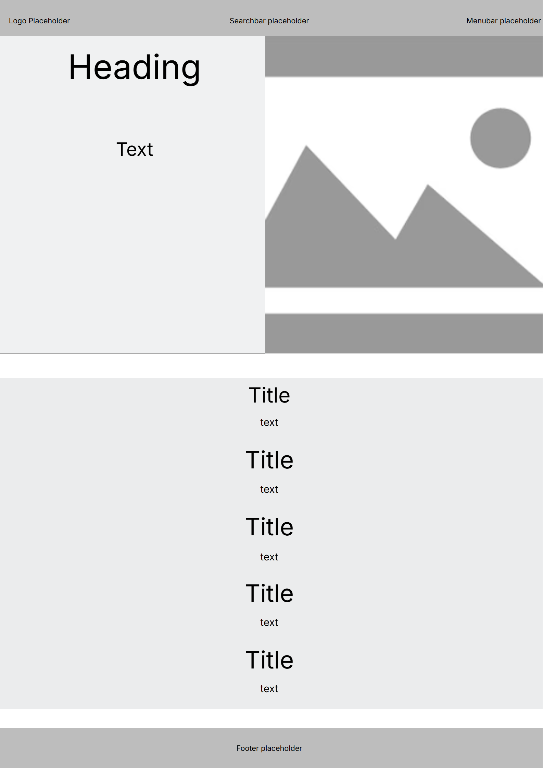
Figure 3 About Page Wireframe (Framer)

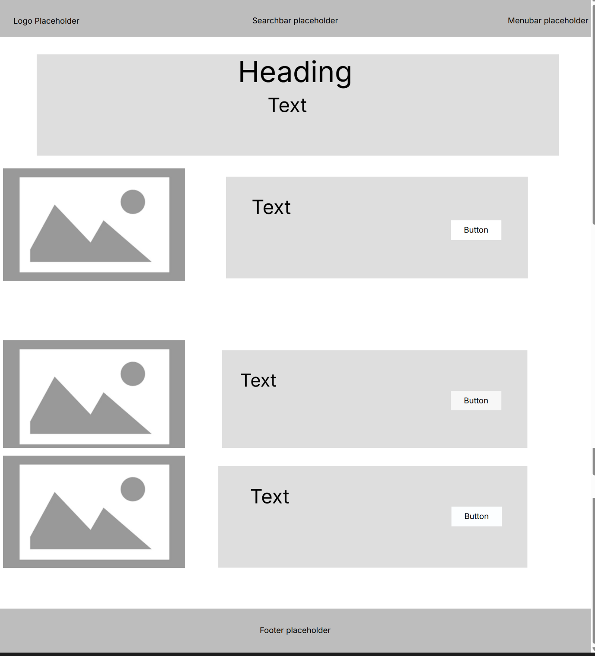
Figure 4 Courses Wireframe (Framer)

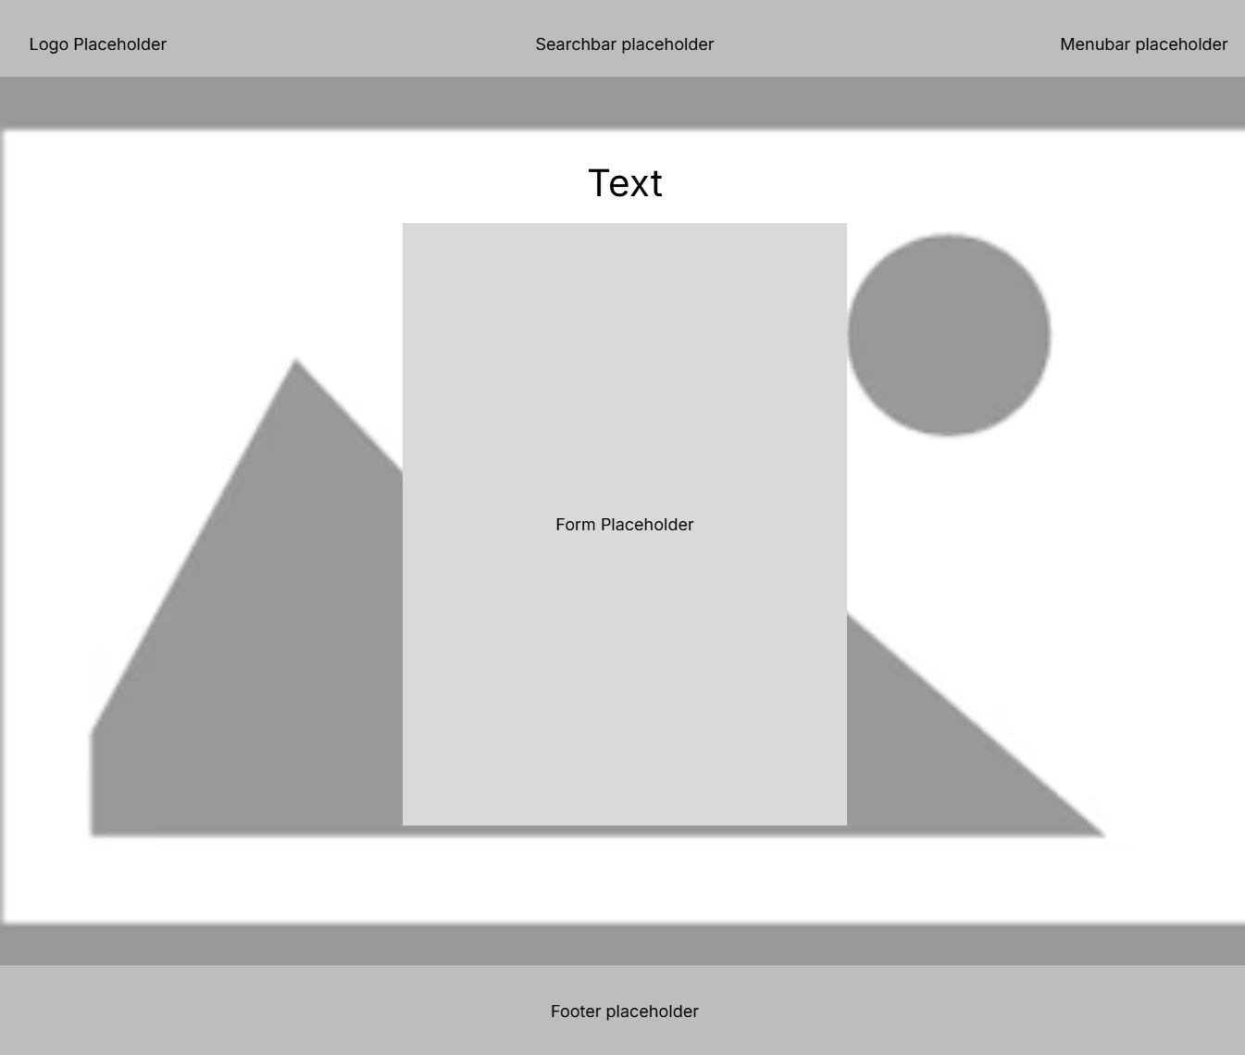
Figure 5 Register Wireframe (Framer) 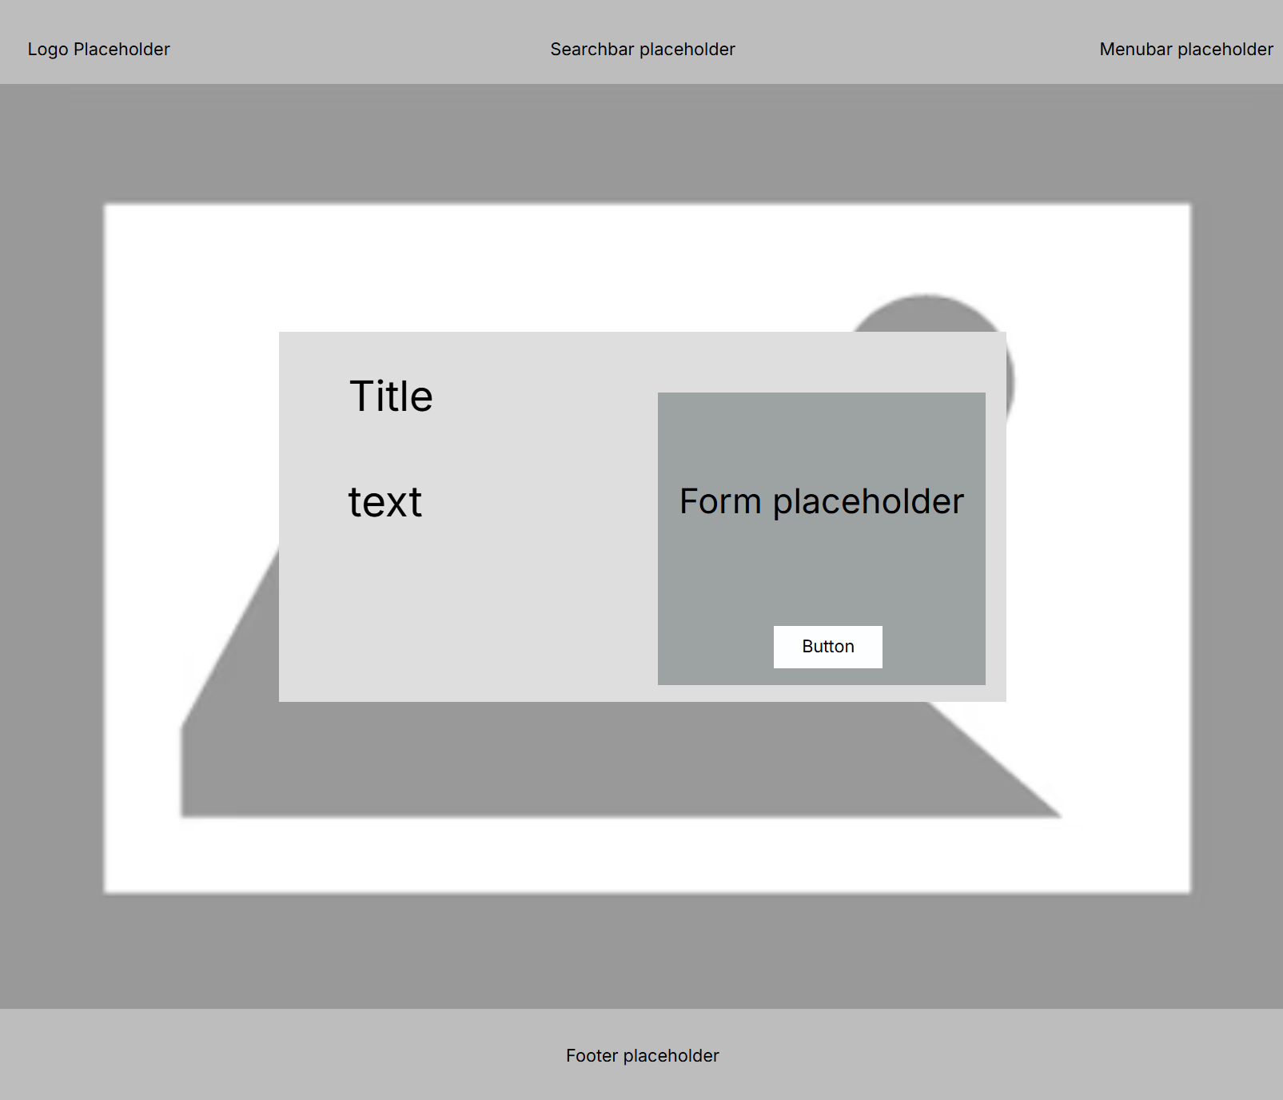
Figure 6 Contact Wireframe (Framer)

APPENDIX C – INTERACTIVE PROTOTYPE SCREENS
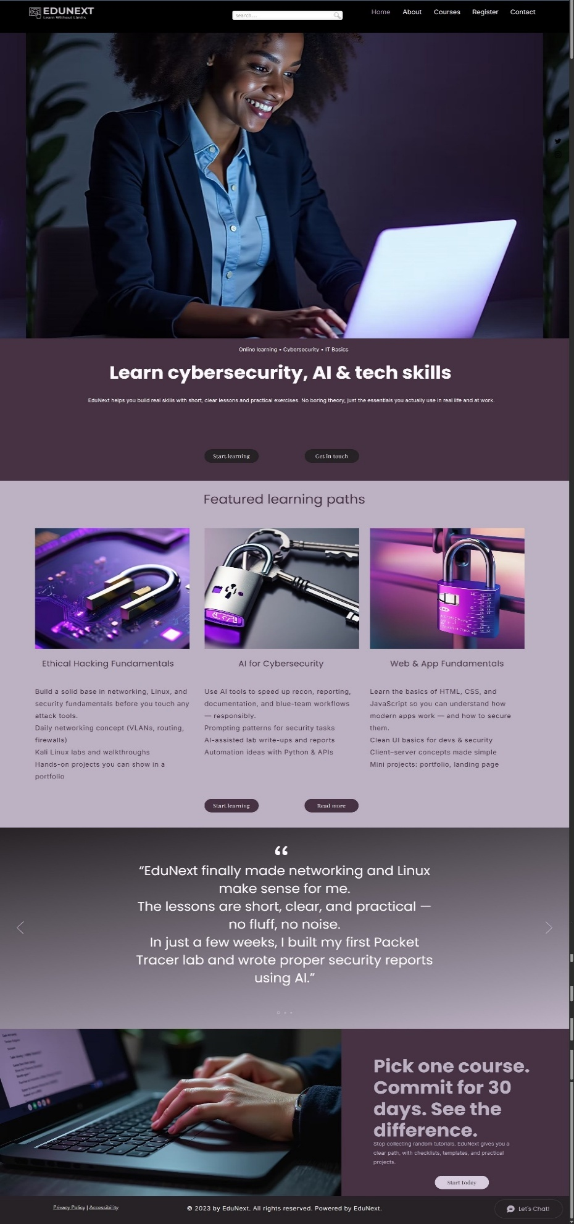
Figure 7 Homepage Prototype (Wix)
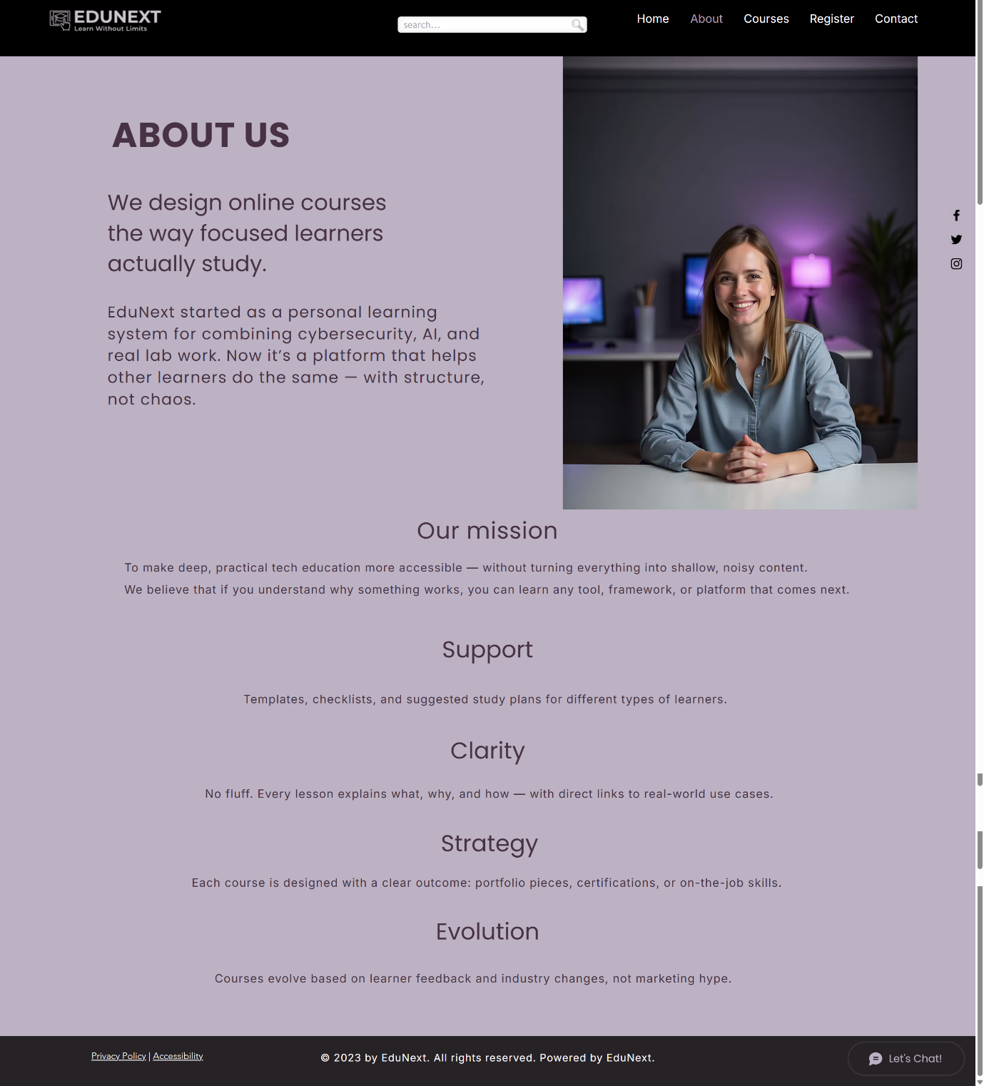
Figure 8 About Page Prototype (Wix)

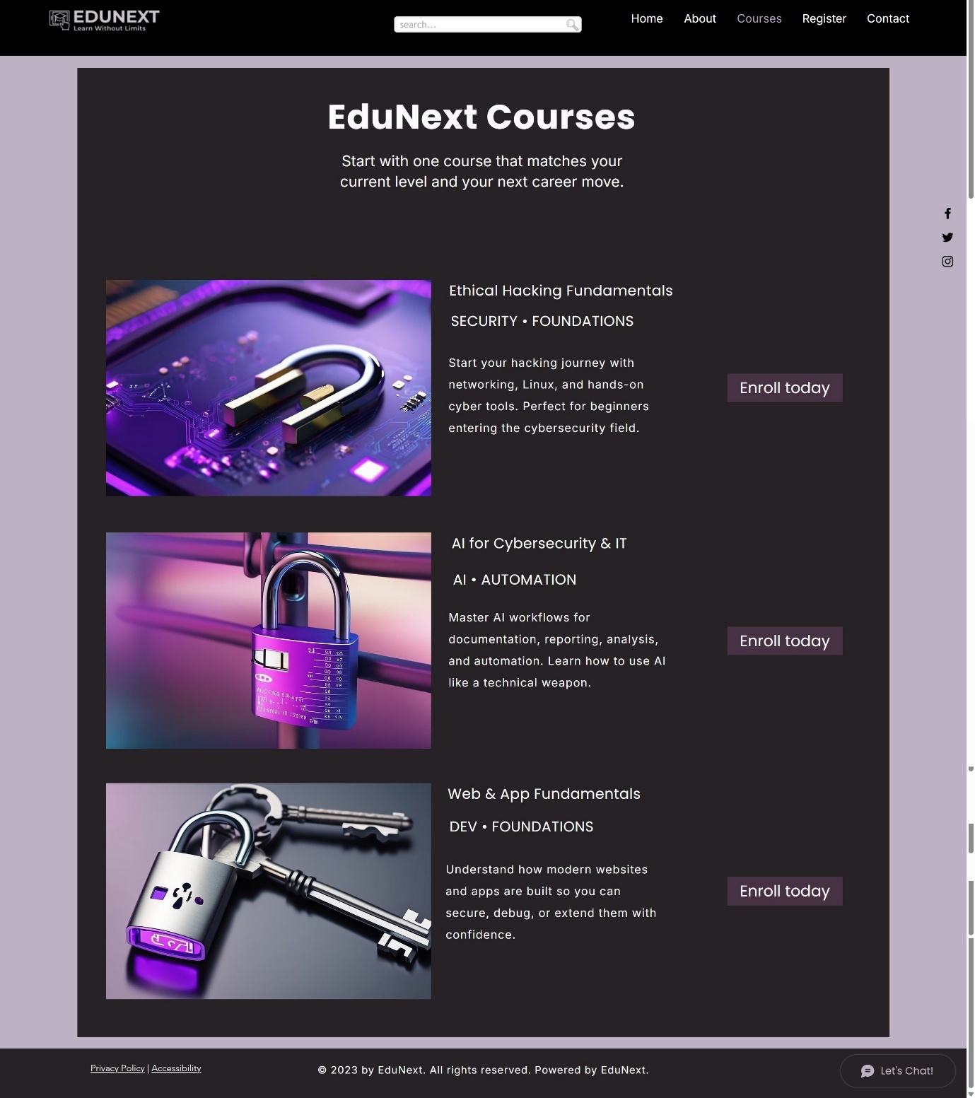
Figure 9 Courses Page Prototype (Wix)

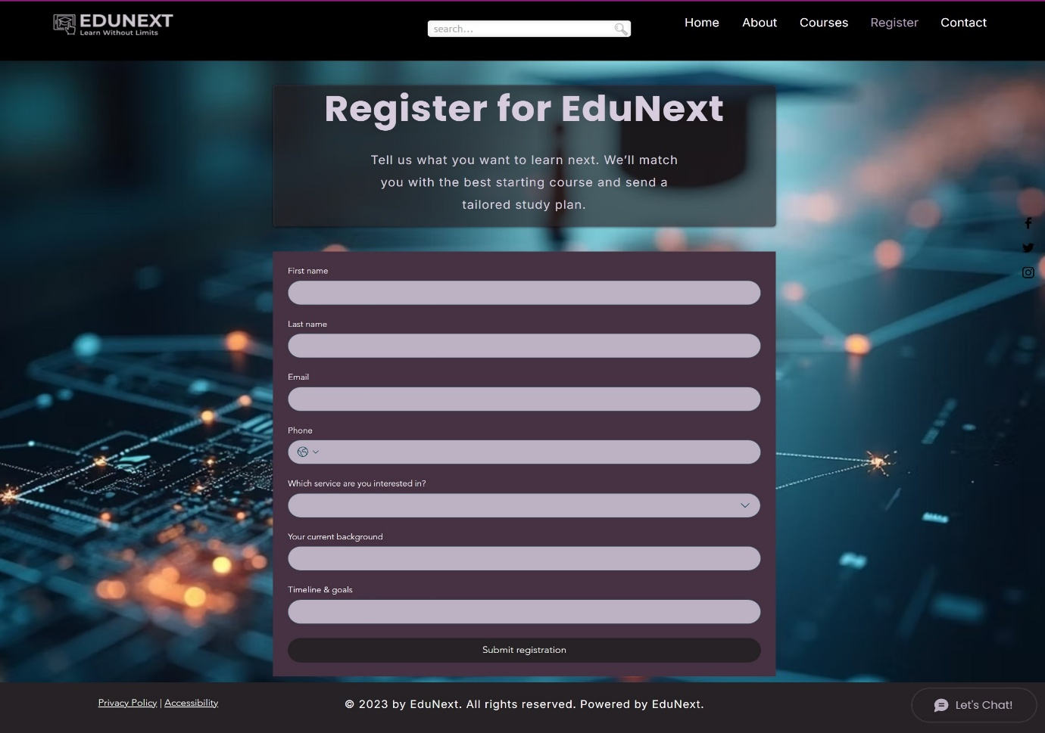
Figure 10 Register Page Prototype (Wix)
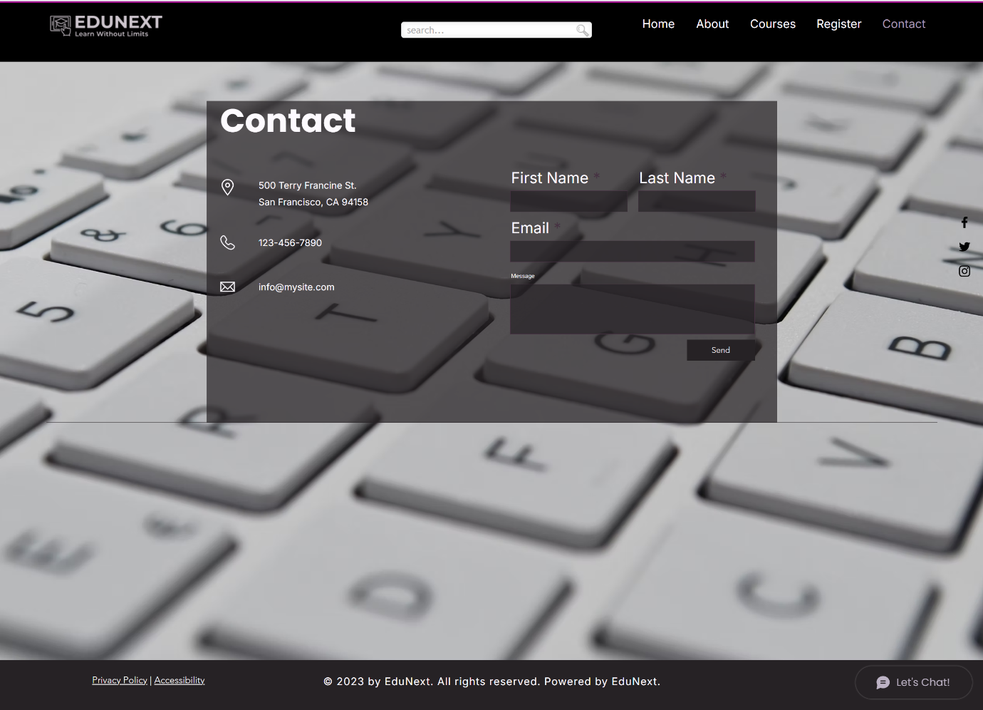
Figure 11 Contact Page Prototype (Wix)

APPENDIX D – RESPONSIVE DESIGN TESTING (WIX)

Figure 12 Home Page Mobile

