

Student Name: Amisha Leuva
Student ID Number: 2504370
Programme: Master of Business Administration
Module: Strategic Management
Lecturer: Hoang Nguyen
Module Code: LCMB7003
Assignment Title: Assessment Component-Individual Report

Table of Contents

Strategic Analysis of Apple Inc. 3
1. Organisation Context and Overview 3
2. External and Internal Environment Analysis 4
2.1 Applying the VRIO framework: 7
3. CSR and Sustainability Objectives 8
4. Comprehensive Balanced Scorecard 9
• 4.1 From a financial standpoint: 9
• 4.2 From the viewpoint of the customer: 9
• 4.3 Internal Business Processes: 9
• 4.4 Learning & Growth: 10
5. Strategic Choices and Implementation 10
6. Strategic Evaluation and Recommendation 12
• 6.1 Strengths: 12
• 6.2 Weaknesses: 12
• 6.3 Opportunities: 13
• 6.4 Threats: 13
6.2 Ansoff Matrix / BCG Positioning 13
7. Recommendations 14
Section 2: Reflective Account of the Research Process 15
REFRENCE 17

Strategic Analysis of Apple Inc.

1. Organisation Context and Overview
Steve Jobs and Steve Wozniak started Apple Inc, a worldwide technology firm with headquarters in the United States, in 1976. Apple became "one of the most famous brands in the world" thanks to its early success with personal computers. Apple, which has its headquarters in Cupertino, California, invented both the first GUI-based Macintosh computer and the personal computer (Apple I/II). Delivering the greatest user experience through cutting-edge hardware, software, and services often summed up as unleashing creativity and simplicity is at the heart of its goal. Based on a vertically integrated ecosystem, Apple creates and markets consumer electronics (iPhone, Mac, iPad, Watch, etc.), operating systems (iOS, macOS), digital content (App Store, Apple Music/TV), and services (iCloud, AppleCare). Apple's net sales in fiscal 2024 were around $391 billion, with $294.9 billion coming from products and $96.2 billion from services.
Apple is a global player in the technology and consumer electronics sector, particularly in wearables, tablets, smartphones, PCs, and digital services. Google (Android OS, cloud, apps), Microsoft (PCs, enterprise), Samsung (smartphones and electronics), and emerging Chinese firms Huawei, Xiaomi, etc. in various markets are some of its main rivals. In its premium segments, Apple frequently leads the market. For instance, Apple had a 20% market share in smartphone shipments worldwide in 2025, and by March 2026, it held 32.3% of the global smartphone vendor market, surpassing Samsung's 20.4%. The company has a dominant market position because to its design-driven innovation and great brand value, which Kantar BrandZ ranked #1 globally at $1.3 trillion. All things considered, Apple has developed a strong market position with devoted customers and premium margins because to its strategy of high-end differentiation and ecosystem lock-in.
Mission:
To develop superior, user-friendly products that employ technology and innovation to improve people's lives.
Vision:
To lead the world in innovation and employ state-of-the-art technology and flawless user experiences to shape the future.
Model of Business:
Create, produce, and market high-end goods and services while making money from ecosystem integration, digital services, and hardware sales.

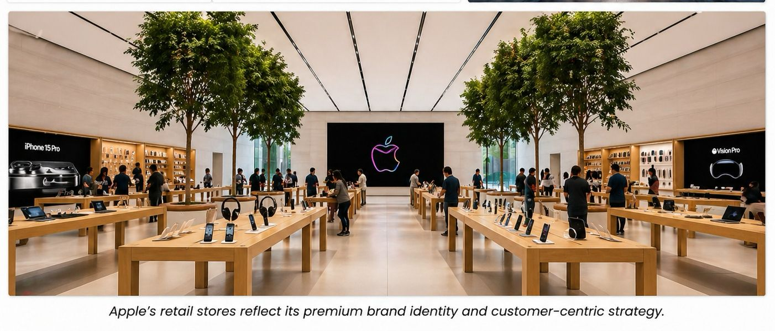
Figure .1 Apple store

2. External and Internal Environment Analysis
PESTEL – External factors:
- Political: Apple is significantly impacted by geopolitical conflicts and laws. Due to tariffs on electronics brought on by trade disputes between the United States and China, Apple has moved iPhone manufacture to India in order to avoid paying import taxes in the United States. To reduce risk, Apple's supply chain is now diverse (some Mac/iPad assembly is done in Vietnam, for example). Regulations are also imminent. For instance, Apple was fined €500 million by the EU's Digital Markets Act (DMA) in 2025 and had to modify its App Store regulations. Legal risk arises from antitrust investigations (e.g., India's CCI inquiry, U.S. DOJ/FTC lawsuit over App Store fees). Government policy and trade/legal activities are therefore crucial. Apple must abide by GDPR, antitrust, and data privacy and competition regulations while pushing to save its economic model.
- Economic: Global consumer spending and tech cycles have an impact on Apple's business. Global smartphone shipments increased by 2% in 2025, while Apple's shipments increased by 20% on an annual basis. Notes on Counterpoint Research In emerging markets, Apple's iPhone 17 spurred growth. However, there are obstacles due to inflation, currency fluctuations, and growing component costs. The expansion of the smartphone market is anticipated to be slowed by recent shortages of semiconductors and rising DRAM prices. Due to Apple's high prices, demand may decline if consumer spending becomes more constrained. Positively, Apple's robust balance sheet and substantial cash reserves ($110 billion+) offer resiliency. In general, Apple's strategic pricing and investment decisions are influenced by external variables such as cost constraints and macroeconomic stability.
- Social: In many ways, Apple's brand is favored by social trends. Apple has positioned itself in areas where consumers value privacy and a premium user experience, such as iOS's privacy features. According to Forrester (2024), 35% of UK consumers trust Apple with personal data, which is greater than for many competitors and indicates a high level of brand trust. Apple benefits from health and fitness trends as well increasing use of Apple Watches for wellness. Demand for gadgets has been fueled by changes in demographics aging populations ,utilizing smartphones ,and lifestyle connectedness remote work, entertainment at home. However, if left unchecked, social criticism (such as labor practices in the supply chain) might harm one's reputation. Overall, Apple's social assets include customer devotion and brand prestige, but it still needs to be mindful of global social issues like labor rights and privacy.
- Technological: The rapid advancement of technology presents both opportunities and risks. Apple has thousands of patents and makes significant investments in R&D ($31.4 billion in 2024, or 8% of sales). It is a leader in a number of technological fields, including sophisticated displays, M1/M2 processors, and bespoke silicon. Apple made a move into AR and VR in 2024 with the release of the Vision Pro mixed-reality headset, which has unique 3D screens and bespoke CPUs. This demonstrates Apple's capacity to lead new product categories by first doing research and then refining the product. Conversely, Apple needs to stay up to date with advancements like AI and 5G. Apple runs the risk of falling behind if it does not advance these technologies, while rivals like Google, Meta, and Samsung are making significant investments in AI-driven services and products. Apple's supply chain is also impacted by technological disruption such as processor shortages and customer demands for ongoing innovation.
- Environmental: Two significant external pressures are sustainability and climate change. With its "Apple 2030" plan, which aspires to achieve carbon neutrality throughout its entire business, supply chain, and product life-cycle by 2030, Apple has made audacious promises. It states that suppliers will reduce emissions by 38 million MWh of renewable energy in 2025 and increase the use of recycled materials in goods such as batteries that contain 100% recycled cobalt. Apple invests in carbon offsets derived from nature and develops robotic recyclers for disassembly. These initiatives are in line with many customers' ideals and worldwide sustainability trends. Though a U.S. court dismissed a lawsuit in 2026, consumers have filed lawsuits for "carbon neutral" statements, and Apple has come under fire for covertly removing an ESG metric from executive compensation in 2026. Apple's product marketing strategy will be impacted by environmental regulations, such as the EU Green Claims Directive. In conclusion, Apple has a sophisticated sustainability plan, yet it is still difficult to implement consistently.
- Legal: Political and social issues are reflected in legal considerations. Apple's data practices are restricted by privacy laws like the CCPA and GDPR, despite the company's frequent claims to be privacy-friendly. Given Apple's collection of patents, intellectual property regulations are crucial. Apple is still involved in legal disputes such as the protracted Apple v. Epic antitrust lawsuit about App Store regulations. Operations are also impacted by labor and trade laws, such as prohibitions on specific Chinese technologies. For instance, Apple's component sourcing may be indirectly impacted by U.S. restrictions on Chinese telecom suppliers. Apple's tax policies have previously been under legal scrutiny see, for example, the protracted EU tax lawsuit involving Ireland. These legal considerations can affect Apple's competitive strategies (such as fee structures) and impose compliance expenses.
- Critical success factors (CSFs) Continuous innovation, ecosystem integration, brand strength, and supply-chain efficiency are examples of critical success factors (CSFs). Rapidly creating innovative, appealing goods and services is essential to Apple's success. Key advantages include its powerful brand and integrated ecosystem of hardware, software, and services. Strong worldwide distribution, Apple Stores and an online presence, and scale economies in sourcing are further CSFs. Regulatory compliance, adjusting App Store policy, data regulations, fierce rivalry from high-end and low-cost competitors, and market saturation in mature categories (smartphones/tablets) are examples of strategic problems in the external environment. Additionally, Apple has to manage trade disputes and geopolitical threats while upholding social license such as labor norms. Thus, both Apple's special resources and more general industry trends influence success factors and problems.
Internal Environment Resources and Capabilities: Apple's financial capital, design talent, cutting-edge technology, and brand reputation are its main assets. Its brand, which offers pricing power, is the most valuable brand in the world in 2025. The company's vast intellectual property portfolio, patented technologies, bespoke silicon, and operating systems make up a significant portion of its intangible assets. Its distribution network and worldwide supply chain are also vital resources. Apple's skills include effective mass production outsourced to partners like Foxconn, a cogent product-development process, and world-class R&D and design supported by $31 billion+ in yearly R&D spend and thousands of patents. The customer experience is improved by its marketing and retail activities at more than 500 Apple Stores worldwide.
User-centric innovation and smooth hardware-software interaction are Apple's primary strengths. In order to match knowledge with decision-making and promote synergy across products, the organization is organized functionally rather than by product divisions. Apple is able to take advantage of shared features such camera technology and interfaces across devices thanks to this arrangement. Apple's substantial financial reserves enable it to make significant upfront investments in acquisitions or new technology.

2.1 Applying the VRIO framework:
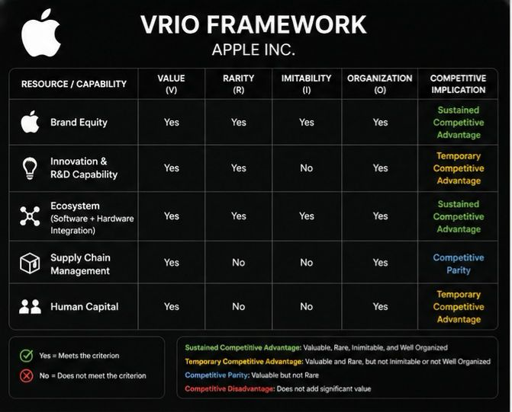
Figure. 2 VRIO FRAMEWORK APPLE INC
- Brand: Rare, valuable, and difficult to copy. Apple leads the global smartphone market share because to its well-known brand and devoted client base. High margins are made possible by the brand's premium image. Apple is set up to make the most of their brand through product lines and marketing. Branding is therefore a long-term competitive advantage.
- Innovation capacity (IP and R&D): Important and quite uncommon. Although Apple's R&D produces ground-breaking goods such the M1 chip and Retina displays, the industry as a whole is innovative. Although rivals also innovate, the mix of capital and design expertise is unique. Apple has a well-thought-out plan for turning R&D into products. Competitive advantage is supported by this competence, but future success is contingent upon the rate of innovation.
- Ecosystem/Integration: The iPhone, iOS, App Store, cloud, and services that make up Apple's integrated ecosystem are extremely valuable and uncommon. Its degree of horizontal and vertical integration is unmatched by many competitors. High switching costs are produced by this ecosystem, and in 2024, recurring service revenue reached $96 billion. This item is fully utilized by the company's App Store regulations and developer support. This is a major factor in Apple's long-term advantage.
- Supply chain and scale: Many businesses outsource manufacturing, which is a valuable but common practice. On the other hand, Apple's large purchasing power guarantees capacity and reduces costs. Value is maximized by the organization's strict quality control.
- Human capital and culture: Apple's culture emphasizes user-centric design and privacy. Although they are not completely unique, talented employees who are engineers and designers are a great resource. This is effectively used in cross-functional collaboration within Apple.
- In conclusion, Apple's competitive advantage is directly influenced by its internal strengths, which include its world-class brand, innovation pipeline, integrated product ecosystem, and financial resources. For instance, its strong profit margins and devoted clientele are the result of its leadership in both design and brand. R&D and operations are coordinated by its functional structure for quick product creation. Apple is able to retain profitability and stay ahead of competition thanks to these capabilities, value, and distinction.

3. CSR and Sustainability Objectives
Corporate responsibility is a key component of Apple's identity, the company publicly highlights. Apple presents itself as utilizing innovation to "leave the world better," and CEO Tim Cook has declared that "enterprise, at its best, serves the public good." Apple has committed to becoming carbon neutral throughout its entire supply chain and business by 2030 as part of its CSR strategy. This is achieved by procuring recycled materials (e.g., 100% recycled cobalt in batteries), using 100% renewable energy for its facilities and suppliers, and using large recycling robots like "Daisy" to recover resources. Additionally, Apple has charity projects such as community education efforts and handles social issues via its supplier code of conduct, worker rights, and safety.
Apple's economic goals are closely aligned with this CSR agenda sustainable practices match consumer expectations for eco-friendly products and strengthen brand reputation. Apple attracts values-driven consumers and guarantees long-term supply-chain stability by becoming a leader in renewable energy. For instance, employing recycled materials can save material prices in addition to reducing carbon emissions. As a result, Apple's environmental pledges complement its strategy of producing high-end, innovative goods.
Tensions do exist, though. Apple eliminated the environmental parameter from their CEO pay incentives at the beginning of 2026, indicating that financial targets may take precedence over CSR objectives. Additionally, Apple has been the target of consumer lawsuits alleging "greenwashing" (e.g., claims regarding "carbon neutral" Apple Watch models). Controversies show difficulties in communicating CSR claims, even if a U.S. court recently rejected a case ruling Apple did not purposefully mislead. All things considered, Apple's CSR strategy, particularly with regard to sustainability, is well-developed and generally in line with its long-term innovation goals nonetheless, there are concerns regarding implementation and attention. Although strategy documents show a high alignment, Apple still has to make sure that its CSR commitments are fully implemented in practice (e.g., by connecting them to incentives).

4. Comprehensive Balanced Scorecard

- 4.1 From a financial standpoint: the goal is to increase profitability and shareholder value. Return on investment (ROI), net profit margin, and sales growth rate are examples of KPIs. For instance, goals could include a profit margin above the industry norm and a 10% yearly increase in sales. initiatives to increase income from high-margin services like music and iCloud, improve supply-chain efficiency to reduce costs, and introduce new products like the upcoming iPhone cycle. Since the iPhone has historically accounted for nearly half of Apple's sales ($201 billion in 2024), maintaining strong iPhone sales while expanding Services ($96 billion in 2024) is essential to meeting financial goals.
- 4.2 From the viewpoint of the customer: The goal is to increase market share, customer satisfaction, and loyalty. KPIs include market share in important segments, customer retention rate, and Customer Satisfaction Score (CSAT) or Net Promoter Score (NPS). For instance, Apple may want to increase its market share of smartphones by a few percentage points while keeping its NPS above the industry-leading 60. Initiatives increase services such as localized Apple TV+ content to enhance customer interaction, collect user input, and ensure a smooth customer experience through product quality and AppleCare. KPIs should measure maintaining the high level of customer loyalty, which is already a strength of the brand.
- 4.3 Internal Business Processes: The goal is to promote innovation and optimize operations. The amount of new goods issued annually, R&D expenditure as a percentage of sales, operational efficiency, manufacturing lead time, defect rates, supply-chain performance, inventory turnover, and on-time delivery rate are a few examples of KPIs. The goals could be to shorten the time it takes to develop new products and introduce, say, two significant new product categories every three years. Initiatives include investments in cutting-edge production facilities such as TSMC chip factories, ongoing enhancements to the App Store approval procedure, and process integration between hardware and software teams. Here, Apple's well-known focus on design and high-quality internal procedures like engineering and testing would be monitored.
- 4.4 Learning & Growth: The goal is to maintain organizational competencies and an innovative culture. KPIs include the percentage of workers with advanced technical capabilities, employee engagement and happiness, training and development average training hours per employee, and technology adoption measures like IT system uptime or R&D patent counts. Goals (e.g., maintain >80% employee engagement and give each employee 20 hours of training annually). Hackathons, conferences, hiring top talent, and collaborations (e.g. with universities and developers) are initiatives that promote a culture of learning. High success in this area would result from Apple's well-known investments in employee development, which include yearly internal conferences and knowledge-sharing developer gatherings.
When taken as a whole, these viewpoints guarantee that Apple's strategy and mission are balanced in terms of financial performance, consumer value, operational excellence, and innovation potential. For instance, Customer and Learning KPIs make sure Apple stays creative and customer-focused, maintaining future financial performance, while Financial KPIs monitor sales and profit.

5. Strategic Choices and Implementation
Business-level strategy: It is evident that Apple prioritizes distinction over cost leadership. Instead than focusing on pricing, it competes on distinctive product design, brand reputation, and ecosystem integration. For instance, the high perceived value of the iPhone justifies Apple's premium cost, which is far higher than that of the majority of Android competitors. According to Porter's theory, Apple is a differentiated innovator because it maintains a competitive edge by emphasizing ecosystem lock-in continuity features and excellent user experience such as an intuitive user interface and high-quality construction. Decisions like creating its own performance chips and not actively entering the low-cost market are clear examples of this strategy. Apple's cost structure and brand image make the alternative cost leadership unfeasible. In order to preserve margins, I advise maintaining the focus on distinctiveness (e.g., improving device capabilities, offering distinctive services) while pursuing modest cost reductions (e.g., supply chain optimization).
corporate-level strategy: Global expansion and related diversification are part of Apple's business actions. Beyond hardware, it has expanded into services like Apple Music, iCloud, and TV+. Additionally, Apple periodically introduces new product categories (like the Apple Watch and AirPods) that are connected to its primary hardware and software strengths. A more significant diversification into the automotive industry would be the purported Apple Car "Project Titan." While carefully investigating new markets like AR/VR (Vision Pro) and perhaps transportation, I advise selective diversification to keep developing services and health/finance products while using brand credibility. Additionally, Apple ought to concentrate on market development, such as further entering growing regions like Southeast Asia and India. In order to avoid tariffs, Apple has already begun constructing an iPhone supply chain in India. It might speed up domestic production and customize products (like cheaper iPhones) to get into markets where consumers are price conscious .
Change management: In general, Apple has done a good job at handling change. Tim Cook took over for Steve Jobs with ease, and Apple has made significant strategic changes without sacrificing consistency, like switching to its own silicon chips or launching Apple Music. According to , the company's centralized structure enables quick decision-making and control over strategic changes. For instance, Apple's capacity to adopt new tactics is demonstrated by the quick scaling of the Vision Pro project and the ramp-up of services. However, there are obstacles to change. Apple's culture is risk-averse and secretive, which may make it more difficult to adopt disruptive advances. For example, Apple adopted open ecosystems and cloud gaming rather late. In order to stay flexible, I advise Apple to keep its clear strategic direction while experimenting more at the cutting edge such as with AI service incubation labs. Overall, Apple's track record indicates capable change management but, as markets and technologies change, ongoing attention to detail is required.

6. Strategic Evaluation and Recommendation
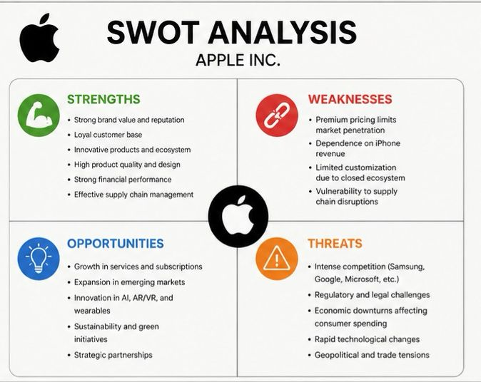
Figure. 3 SWOT ANALYSIS APPLE INC.
- 6.1 Strengths: World-class design and innovation capabilities demonstrated by substantial R&D investment and patents, a strong, integrated ecosystem of hardware and services, a devoted customer base, and a strong financial position with billions of dollars in cash. Customer interactions are further strengthened by its network of service providers and upscale retail locations.
- 6.2 Weaknesses: Apple is vulnerable in price-sensitive categories because to its high product pricing, which restrict market reach. With the iPhone accounting for around half of the company's total sales, a decline in smartphone demand could have an impact on the company's performance. Some consumers may be turned off by Apple's restricted ecosystem, which also restricts enterprise adoption. Furthermore, significant gaps are shown by the comparatively slow growth of particular segments (e.g., poor rise in iPad sales, late entry into streaming).
- 6.3 Opportunities: High-margin revenue is still generated by growing services like Apple Pay, TV+, and Arcade. Emerging markets have potential for expansion (e.g., rising smartphone adoption in India or new store openings). Opportunities arise from new technology if consumer adoption increases, Apple's debut into AR/VR (Vision Pro) could create a new market. AI developments could be used to create new intelligent capabilities for gadgets. By promoting eco-friendly designs, an increasing consumer concern, sustainability demands can be transformed into an opportunity.
- 6.4 Threats: There is still fierce rivalry from Android device manufacturers and other IT behemoths. In several markets, Android suppliers like Samsung, Huawei, and Xiaomi compete on features or cost. Apple must continue to innovate in order to avoid being outpaced by rapidly evolving technological trends (AI, 5G, AR). Margins and flexibility are threatened by geopolitical and regulatory pressures, antitrust actions in the US and EU, and supply disruptions brought on by trade disputes. Finally, if Apple's policies (such as labor standards or environmental claims) are questioned, customer action on ESG concerns can soon become detrimental to the company's brand.

6.2 Ansoff Matrix / BCG Positioning
- Market Penetration: Apple keeps expanding its market share in high-end markets (e.g. Apple Card in the US, financing plans in China).
- Market development: is the process of entering or growing in new geographic areas, focusing on demographic groups and markets where smartphone adoption is still rising.
- Product Development: Consistently releasing new iPhones, Macs equipped with M-series CPUs, experimenting with Vision Pro, Apple Car rumors, etc.
- Diversification: Wearables, streaming, iCloud, and maybe healthcare data are examples of related diversification. There is little diversification that is genuinely unconnected.
Apple's iPhone is a high-share product in an established market and may be considered a "Cash Cow" (stable cash flows), according to BCG logic. Given that they recently hit $100 billion and are expanding quickly, services appear to be a "Star" with high growth and growing share. After the pandemic slump, Mac may be a moderate "Cash Cow/Cash Cow on the Rise." iPad saw a downturn before rising in 2025. Previously a "Star," wearables and home technology are now more of a "Question Mark" in need of revitalization due to recent reductions. This implies that in order to recoup growth, Apple should make targeted investments to promote services and new product "Stars," milk iPhone and Mac cash cows, and develop wearables. Services, on the other hand, are becoming a "Star" and quickly expanding source of income. The iPad may be a question mark due to tablet market saturation, and legacy devices like the iPod are "Dogs" with low growth and low share.

7. Recommendations
Apple should stick to its differentiation strategy while making specific adjustments in order to preserve and strengthen its competitive edge.
- Grow in emerging markets: To gain market share in India, Southeast Asia, and Africa, create more reasonably priced models (like as the iPhone SE), boost local production, and customize services with local language content. According to market studies, demand for smartphones and digital services is growing in these areas.
- Invest in emerging technologies: Increase the use of AI and machine learning in products while maintaining privacy. Improved on-device Siri/ML capabilities, for example. To obtain first-mover advantages, expand AR/VR beyond Vision Pro using software compatible with iPhones and iPads.
- Expand services and ecosystem: Apple should aggressively package and cross-sell services (like Apple One subscriptions) because they are recurring and high-margin. By utilizing its reputable name, it might also expand into other service areas including financial services through Apple Pay credit, health monitoring systems, etc. Ansoff theory states that they are market development services in new markets and product development services in current clientele.
- Strengthen CSR integration: Apple should completely include environmental indicators into its fundamental strategy and communication as consumers and regulators place a greater emphasis on sustainability. For instance, reversing the 2026 pay adjustment and tying CEO incentives to long-term ESG objectives would strengthen commitment. This is consistent with the idea of purpose-driven value creation, which can be a differentiator.
- Preserve operational flexibility: Although Apple's organizational structure is effective, it occasionally exhibits bureaucracy. Use "skunkworks" teams or collaborations (like Google X) to test innovative concepts such brain-computer interfaces and next-generation batteries without impeding the main business.

These suggestions are supported by theory and real-world examples: Porter's focus on difference implies that Apple needs to continue developing features that appeal to consumers. Expanding services are supported by real-world success, such as Apple's App Store launch, which created a vast ecosystem. On the other hand, falling behind as Nokia did by sticking with outdated models highlights the necessity of taking the lead in emerging technologies. Apple can maintain its edge over time by expanding its product and service offerings and expanding its market reach while adhering to its premium brand.

Section 2: Reflective Account of the Research Process
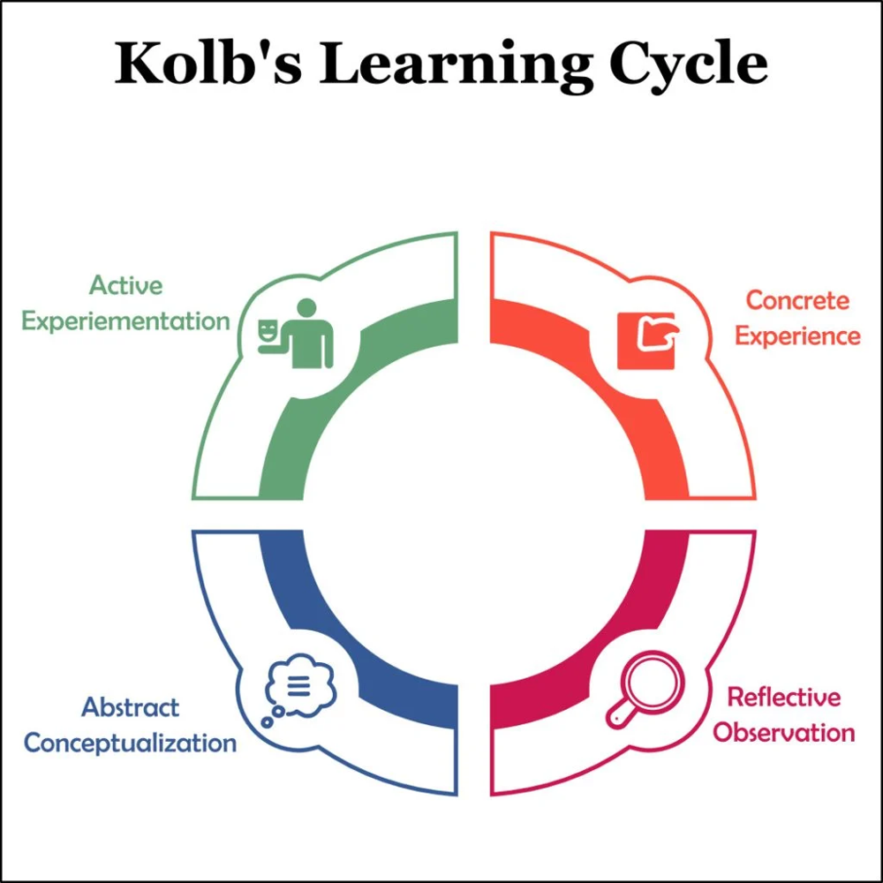
Figure . 4 KOLB’S EXPERIENTIAL LEARNING CYCLE
Concrete Experience: I started by methodically looking for reliable sources regarding Apple's approach. I looked through Apple's yearly reports, environmental reports, and reputable periodicals (Fortune, HBR, Reuters). For instance, I found Apple's 2024 10-K for accurate information and current market share news. The amount of material initially confused me, but I prioritized original sources and arranged my notes by topic (history, PESTEL, SWOT, etc.).

Reflective Observation: As I collected information, trends were apparent. PESTEL, VRIO, and the Balanced Scorecard were among the strategic frameworks that kept coming up. I cross-checked their statements with trustworthy data after noticing that a lot of website content, such as SWOT blogs, lacked citations. For example, I checked Apple's financials to confirm what other bloggers said about the company's R&D intensity. Because company reports emphasize achievement, I was wary of bias, so I also looked for opposing viewpoints such on CSR litigation. I occasionally had doubts regarding Apple's mission and vision because they are not made explicit on Apple.com; instead, I deduced them from statements made by executives and scholarly research.
Abstract Conceptualization: I derived strategic ideas by synthesizing the data. For instance, Apple's differentiation strategy was justified by the emergence of its brand and innovation as major strengths. I imagined how Apple's internal resources, such as its R&D expenditures, translated into capabilities. These concepts were arranged with the use of the VRIO and Balanced Scorecard frameworks. The HBR Balanced Scorecard article reminded me that "traditional financial measures, are out of step with the skills and competencies companies are trying to master today," which reaffirmed the inclusion of non-financial KPIs in Apple's scorecard and helped me understand the significance of balanced performance measures. Additionally, I saw that many sources lacked SWOT components, so I created SWOT and strategy grids by hand.
Active Experimentation: I would hone my search strategies to get better. For more scholarly viewpoints, I might use academic databases (Google Scholar, ABI/Inform) or set up Boolean alerts the next time. Additionally, I would include visuals. For example, I thought of making my own revenue stream charts or a chronology of Apple accomplishments. Understanding would be aided by graphing the data from sources (e.g., displaying Apple's services vs. products income). As I conducted my study, I became aware of the advantages of maintaining an annotated bibliography. In further initiatives, I intend to set aside time for introspection and make sure that every theoretical idea, such as Porter or Ansoff, is directly related to practical instances. As I did here, using Gibbs' or Kolb's cycle expressly guarantees that I learn how to conduct more efficient research in addition to gathering information. My strategic grasp of Apple has grown as a result of this reflective approach, which has also enhanced my research methodology. Moving forward, I will critically interact with sources, add creative visuals to analysis, and intentionally incorporate learning frameworks into my analysis routine.
Key Learning points: Since Apple's strategy is multifaceted, a thorough examination necessitates integrating multiple frameworks. From a strategic perspective, I discovered how Apple's environment and strengths influence its decisions. In terms of procedure, I learnt to critically consider the reliability of sources and to cross-verify material (e.g., comparing a blog's assertion with official data). I also saw the importance of using Kolb's cycle to organized reflection in order to transform research experiences into future advancements.
Graphical Note: To guarantee a comprehensive viewpoint, I tracked my own information sources by category (e.g., news, academic, corporate) in addition to using strategic frameworks as analysis tools. An illustration pie chart of my references could demonstrate my attempt to build conclusions on a variety of information by displaying a good balance of business (Apple IR), journalistic (Reuters, Fortune), and scholarly (HBR) sources.

REFRENCE
Apple Inc. | History, Products, Headquarters, & Facts | Britannica Money
https://www.britannica.com/money/Apple-Inc
Our Values - Apple
https://investor.apple.com/our_values/default.aspx
10-K 2024, 09.28.2024-2024-10-31-12-16
https://s2.q4cdn.com/470004039/files/doc_earnings/2024/q4/filing/10-Q4-2024-As-Filed.pdf
Apple leads global smartphone market with 20% share in 2025, says Counterpoint | Reuters
https://www.reuters.com/business/media-telecom/apple-leads-global-smartphone-market-with-20-share-2025-says-counterpoint-2026-01-12/
Mobile Vendor Market Share Worldwide | Statcounter Global Stats
https://gs.statcounter.com/vendor-market-share/mobile
Apple is once again the world's most valuable brand | Fortune
https://fortune.com/2025/05/16/apple-worlds-most-valuable-brand-2025/
Apple ‘aims to source all US iPhones from India’, reducing reliance on China | Apple | The Guardian
https://www.theguardian.com/technology/2025/apr/25/apple-source-us-iphones-india-china-trump-trade-war
Exclusive: Apple hit with EU antitrust complaint over App Store policies | Reuters
https://www.reuters.com/sustainability/boards-policy-regulation/apple-hit-with-eu-antitrust-complaint-over-app-store-terms-2025-10-22/
Apple leads smartphone market even as overall shipments decline, Counterpoint says | Reuters
https://www.reuters.com/business/media-telecom/apple-leads-global-smartphone-shipments-first-quarter-counterpoint-says-2026-04-10/
Apple Aims To Make Transparency The Core Of Its Trust Strategy
https://www.forrester.com/blogs/apple-aims-to-make-transparency-the-core-of-its-trust-strategy/
Vision Pro headset is Apple's next Mac and TV combined | Reuters
https://www.reuters.com/technology/vision-pro-headset-is-apples-next-mac-tv-combined-2024-02-03/
Environment - Apple
https://www.apple.com/environment/
Apple quietly removes environmental metrics from executive pay - Los Angeles Times
https://www.latimes.com/business/story/2026-02-23/apple-quietly-removes-environmental-metrics-from-executive-pay
Apple prevails in US greenwashing suit over ‘carbon neutral’ claims
https://trellis.net/article/apple-prevails-us-greenwashing-suit-carbon-neutral-claims/
In-Depth SWOT Analysis of Apple - EdrawMind Business Analyst
https://edrawmind.wondershare.com/strategy-planning/apple-swot-analysis.html
apple.com
https://www.apple.com/careers/pdf/HBR_How_Apple_Is_Organized_For_Innovation-4.pdf
The Balanced Scorecard—Measures that Drive Performance
https://hbr.org/1992/01/the-balanced-scorecard-measures-that-drive-performance-2
Apple Balanced Scorecard.docx (pdf) - CliffsNotes
https://www.cliffsnotes.com/study-notes/20058591
BCG Matrix Analysis of Apple [Detailed] - Boardmix
https://boardmix.com/analysis/bcg-matrix-of-apple/

