Global Business Environment

Assignment 2

PEST and Impact Analysis on the Swansea Stadium Management Company and the Liberty Stadium



Name: James de Kerckhove

Student Number: 1707439

Date: 5th April 2018

Contents Page

- Introduction..............................................................................................
- PEST and Impact analysis......................................................................
2.1 Political Factors...................................................................................
2.2 Economic Factors................................................................................
2.3 Social Factors......................................................................................
2.4 Technological Factors..........................................................................
- Conclusion................................................................................................

Executive summary

This report uses a PEST analysis for the Swansea Stadium Management Company (SSMC). It looks at the external factors contributing to the running of the stadium. There will be a discussion about the political, economic, social and technological factors affecting the SSMC and a conclusion in relation to their greatest threats.

The SSMC is a company responsible for the management of the liberty stadium; they oversee the maintenance and other important factors of the building's upkeep. They have been in operation at the liberty stadium since 2005 (Liberty Stadium, 2018).

This report concluded that the technological and economic factors presented the biggest threats to the liberty stadium, due to the ever-changing advancements in technology and the threat of reduced income affecting the ability of customers to attend events.

Introduction

This report includes a PEST analysis on the Swansea Stadium Management Company (SSMC). These factors are: Political, Economic, Social and Technological (Recklies, 2006). These provide an overview of the macro environmental factors that can impact an organisation. This gives a detailed insight into the management company's running of the Liberty Stadium in Swansea, which is owned by the Swansea City Football Club (SCFC).

The SSMC was opened in 2005 and is responsible for overseeing the operational management of the Liberty Stadium. This includes safety, cleaning and maintenance (Liberty Stadium, 2018).

2.1 Political

A political influence within the SSMC would be Swansea government decisions as they have ownership of the land and building, as well as the SCFC who lease the building and have a role within that decision-making process.

Another political factor would be the rise in terror attacks recently within the UK. This could cause concern with the general public about attending events at the stadium. This is managed by ensuring safety features are enforced. An example of terror attacks could be the recent incident in Salisbury with the use of a poisonous chemical on a British civilian (The Guardian, 2018).

Another political factor would be the Hillsborough disaster which caused the deaths of hundreds of people. This act then brought in policies in sports to prevent a reoccurrence (Nicholson & Roebuck, 1995).

Policies can impact businesses through issues such as finance, planning regulations and environmental obligations. This affects the Liberty stadium through having to comply with these various policies such as planning regulations, as there are currently plans to undergo a further renovation of the stadium. The SSMC has to have this approved by the Swansea government.

Brexit's political aspect can affect the stadium through having an impact on Gross Domestic Product (GDP) as it is projected to decline in coming years. Following Britain deciding to leave the European Union the value of the pound fell and trade deals are becoming a concern (Gale & Orszag, 2003). With GDP falling this will have a result of less domestic income for people to spend, which could in turn affect the SSMC.

2.2 Economic

The economic growth in Swansea is displayed below, showing a steady increase. See figure 1.

Figure 1.
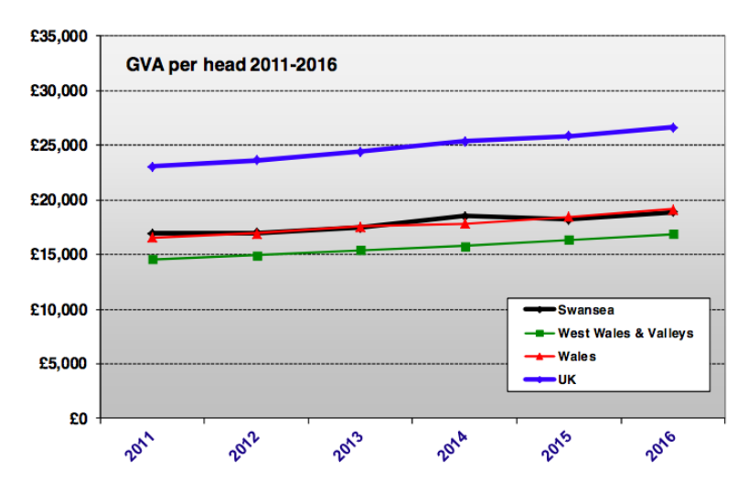
(Swansea Council, 2018)
Figure 2.
This figure shows the Gross Value Added (GVA) per head, showing Swansea is still behind other countries. The lighter shade of purple in the below figure dominates Wales, whereas the darker purple around the other countries shows better GVA.

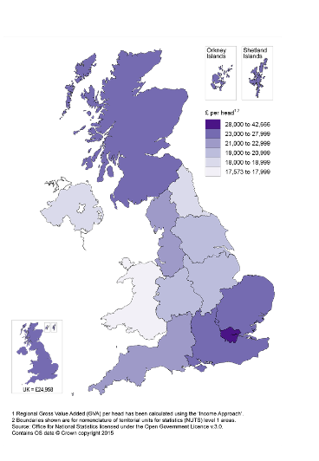
(Office for national statistics, 2015)

The macro economic environment is made up of economic indicators such as GDP, which are based on purchasing power parity (PPP). These are influenced by the role of the government.

Another indicator would be the economic growth of a country. This affects the SSMC because as the economic growth increases it brings an expectation for the facility to be at a higher standard and also brings more customers to the business. Economic growth can include inflation within an economy. The inflation within the UK has now reached 3% (BBC News, 2018). Unemployment can have a drastic effect on the economic environment of a country causing people to have less money to spend. The recession also has implications for the unemployment rate, as a recession can cause businesses to stop hiring people. There has been a surge in unemployment in Europe (Hughes & McCormick, 1987). An increase in unemployment rate can cause a decrease in business activity as a result of reducing numbers of visitors.

There has also been an increase in the interest rates set by the bank of England. They have now increased from 0.25% to 0.5% (Bank of England, 2018). This will have repercussions of, for example, mortgage payments increasing. An increase in expenditure on necessities will have the effect of a lack of available income to spend on leisure activities.

The government and economy have a huge impact for businesses looking to invest and the interest rate, GDP and other factors all contribute to the desirability of a country for investment, therefore these different factors can affect the appeal of businesses within the UK, especially as the stadium now has new investors from America.

2.3 Social

Social factors are largely based on a social culture. A business has to involve themselves with the correct cultural norms of the area in order to succeed in the location (Hofstede, 1984).

The social factor is largely important for the management company due to the complicated nature of the business. The organisation has multiple uses; the building can be hired for football, rugby, weddings, concerts and more. This brings a wide range of customers.

The stadium holds concerts in the summer time and needs to be familiar with the social culture of Swansea in order to gain the right bands to appear in the stadium that will appeal to the public. Also, they have to consider their target audience, for example whether it is the younger or older generation. The upcoming events at the stadium have to reach their target markets in order for the business to succeed and would need to consider issues such as travel arrangements, car parking and food and drink.

Another social issue could be the recent Manchester bombing which happened at an Arianna Grande concert (BBC News, 2018). This threat of terror attacks will influence behaviour of those wishing to attend concerts or games at the liberty stadium, but who may be anxious about the possibility of similar future attacks.

Hargreaves (1986) discusses the relationship between sport and power. With SCFC fans now increasing, this popularity brings power to the Liberty Stadium as a growing attraction in Swansea.

2.4 Technological

Technological factors would include the internet, mobile phones and other digital devices. The internet can provide a basis for customers to purchase tickets more easily and provide a better-quality service. However, this can reduce the function of the service desk for sales within the stadium.

As shown by Freeman (1987), technological change is a reoccurring event and an inevitability. Businesses have to cater for this as it can have dramatic affects on their success. The internet of things as discussed by Van Kranenburg et al., (2011), shows that technology has gained a massive impact on daily life and now has become a big part of the success or failure of organisations.

With the advance in technology it has made the appeal of the real world experience more challenging. Through the provision of the games on the television offering replays of crucial moments and commentary more people want to watch the game with these benefits. They can do this in their homes which are comfortable and warm, and they have food and drink and do not even need to leave the house for this experience. From this it is clear to see the challenge for the SSMC to make the appeal of the stadium increase. One factor that is not offered in this technological experience is the atmosphere of the actual game at the stadium which is an attraction for many dedicated supporters.

The availability of Wi-Fi within the stadium is another technological factor that is now crucial. Fans at the game will want to connect with friends and share unmissable moments with people they know on social media.

Technology is becoming more used in everyday life. Denning (2001) considers the involvement of technology in the future and the certainty that this will be significant.

- Conclusion

It is clear that the economic and technological factors present the biggest threat to the Liberty stadium and SSMC. The changes in technology have allowed for better substitutes, such as home entertainment systems, whereas these were not previously so available. This means the stadium will have to work hard in order to compete with this market.

Economic factors will impact heavily upon the liberty stadium, which relies on visitors having disposable income to spend on non-essential activities, such as concerts and games. In times of austerity there is a real danger of existing customers only having sufficient income to service basic needs such as mortgage payments and day to day living expenses.

This analysis did not identify a risk from competitors, which currently favours the liberty stadium's position. Although this PEST analysis provides a good insight into the outside threats to the SSMC, it does need to be constantly reviewed as the environment is ever-changing.

References:

Bank of England, 2018. The interest rate (Bank Rate). [online] Available at: <https://www.bankofengland.co.uk/monetary-policy/the-interest-rate-bank-rate> [Accessed 4th April 2018].

BBC News, 2018. Ariana Grande felt 'every name' of the Manchester bombing victims. [online] Available at: <http://www.bbc.co.uk/news/newsbeat-42974981> [Accessed 5th April 2018].

BBC News, 2018. UK inflation rate drops back to 3%. [online] Available at: <http://www.bbc.co.uk/news/business-42702752> [Accessed 4th April 2018].

Denning, P.J., 2001. The Invisible future: the seamless integration of technology into everyday life. McGraw-Hill, Inc..

Freeman, C. 1987. Technology Policy and Economic Performance: Lessons from Japan, London, Frances Pinter

Hargreaves, J., 1986. Sport, power and culture. A social and historical analysis of popular sports in Britain. Polity Press.

Hofstede, G., 1984. Cultural dimensions in management and planning. Asia Pacific journal of management, 1(2), pp.81-99.

Hughes, G. and McCormick, B., 1987. Housing markets, unemployment and labour market flexibility in the UK. European Economic Review, 31(3), pp.615-641.

KS Rao Kunchala, 2016. PESTLE Analysis: 6 Core Variables. [online] Available at: <http://www.mbahelp24.com/pestle-analysis-6-core-variables/> [Accessed 27th March 2018].

Liberty Stadium, 2018. Swansea Stadium Management Company (SSMC). [online] Available at: <http://www.liberty-stadium.com/liberty_stadium_management.php> [Accessed 27th March 2018].

Nicholson, C.E. and Roebuck, B., 1995. The investigation of the Hillsborough disaster by the Health and Safety Executive. Safety Science, 18(4), pp.249-259.

Office for National Statistics, 2015. Regional Gross Value Added (Income Approach): December 2015. [online] Available at: <https://www.ons.gov.uk/economy/grossvalueaddedgva/bulletins/regionalgrossvalueaddedincomeapproach/december2015> [Accessed 28th March 2018].

Recklies, D., 2006. PEST Analysis.

Swansea Council, 2018. Information, Research and GIS Team SWANSEA ECONOMIC PROFILE: FEBRUARY 2018. [pdf] Available at: <Swansea Economic Profile Feb-18 - Swansea Council> [Accessed 27th March 2018].

The Guardian, 2018. Salisbury attack sites face months of decontamination. [online] Available at: <https://www.theguardian.com/uk-news/2018/apr/02/salisbury-attack-sites-decontamination-russia-sergei-skripal> [Accessed 4th April 2018].

