A campaign for planting trees on roundabouts in Swansea

Introduction 2
What is the solution to this campaign? 2
The campaign steps 3
Social media for the campaign 4
How successful was the campaign 4
Next steps in the campaign 5
References 7

Name: Eva Timms
Student number 2405050
Word count: 1,940

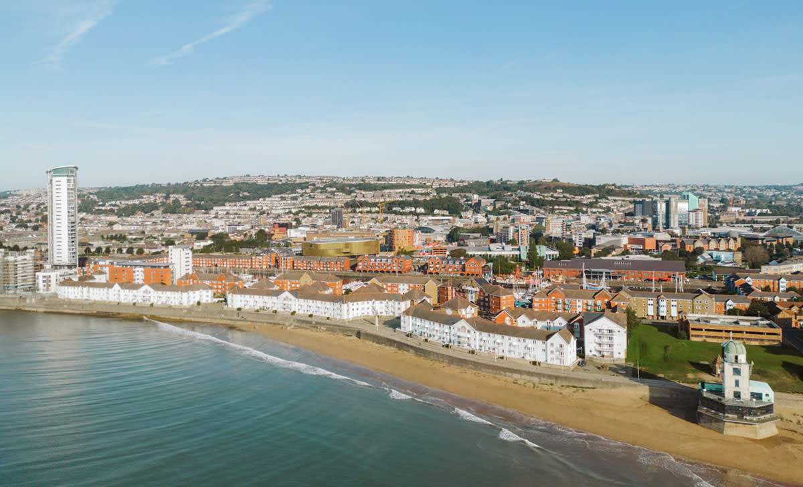
(Swansea Bay, 2025)

Introduction
This campaign aims to recognise the importance of trees in urban settings and explains how tree planting on roundabouts can make a huge difference to people's quality of life. Trees and nature can have many positive impacts on humans. Having an area of nature is important, especially in an urban setting, as it can have greater protective health effects than anywhere else. (Browning. et al. 2022) The campaign will allow people to unite and plant trees on unused land on roundabouts. There is a range of benefits, from improving human health to road safety, which the campaign is heavily based on. This campaign is going to address how climate change can be reduced in cities through planting trees and it will make Swansea a greener and happier place to live.

What is the solution to this campaign?
The aimed solution for this campaign is to plant nature and trees on unused land, such as areas on roundabouts. In Swansea, there are a few that do not have trees see Figure 6. Due to the increase of deforestation, it is essential to use up areas of land for addressing climate change, producing health benefits and delivering inclusive growth (Greenspace Scotland, n.d). The campaign is primarily for increasing the quality of life for humans as urban areas can cause many problems however, green spaces are known to have a positive impact on humans. There is a range of benefits that planting trees on roundabouts has to offer. One benefit would be improving air quality in cities. Cities are known for their bad air quality due to factors such as cars and industrial factories. It is known that trees take in carbon dioxide by photosynthesis, which does reduce carbon in the air; however, they also take in harmful particles through their leaves that may affect human health. A statistic that was found was that a single mature tree can absorb up to 50 lbs of carbon dioxide a year (Trees for Cities, 2023).

The next benefit of planting trees on roundabouts is improving physical and mental health for humans. Trees and nature have been around humans for decades. The evidence for this is paintings found in tombs indicating that they had plants in their homes. The idea of having a green space close to you can make humans feel happier as they have a place to go for relaxation or some simple exercise. Being in nature has psychological benefits such as reducing stress from everyday life, improving attention span and having a positive effect on mental restoration (Grinde and Patil, 2009). There are reasons why nature relates to good mental health and this can be because being outside in nature indicates exercise and physical movement as you are walking and getting fresh air, which feels good. Also, it can make people socialise more. If you are walking in nature with friends or family, it will make you talk to them more, which humans need to be happy. Finally, nature can provide an escape from daily stresses and a break from personal life and demands. Overall, people who are connected with nature are happier and have more positive effects and better life satisfaction (Capaldi, Dopko and Zelenski, 2014).

Another benefit of planting trees on roundabouts is their role in helping with carbon sequestration. Trees are essential for reducing carbon dioxide in the atmosphere, which has a great impact and causes climate change and global warming. Cities benefit from trees more than rural areas as cities produce the most carbon dioxide from cars, industrial buildings and factories. Even though planting trees on roundabouts can reduce carbon, the process and maintenance of this can also cause carbon emissions (Ariluoma, et al. 2021)​; however, this campaign is very minimal with how much carbon emissions are released from planting and maintaining these areas. As trees grow, more carbon dioxide can be held in them, but this also depends heavily on how large and healthy the tree is, as the bigger the tree, the more carbon it can hold (Norfolk County Council, n.d). When trees are planted on the roundabouts, they will only be saplings and will not have immediate large effects in carbon sequestration, but over time, they will grow and start to sequest more carbon.

The final main benefit of planting trees on roundabouts is its role in road safety. It is not just trees on roundabouts that help with road safety; it is also trees on streets and roads. It is proven that having a wall of trees on a street gives a psychological cue that people live there and makes people more aware of children and animals, which in turn makes them slow down (Barker, 2021). There is also a benefit of blocking cars' views when they come up to a roundabout, this can be done using trees; however, it is primarily done with visibility screens. Blocking the view of drivers coming up to the roundabout forces them to slow down and stop at the roundabout, where they can see past the trees to check if it is clear; then, they can go, which in turn reduces collisions (Stoke Gifford Journal, 2019). If there is nothing blocking drivers' views, they can see the roundabout from far away, and they will not slow down. They may judge how fast they are going wrong, which leads to collisions as they have not stopped to check if the roundabout is clear.

The campaign steps
The steps for this campaign would include a call to arms, which consists of encouraging public involvement in our campaign by discussing with the local MPs who are Torsten Bell and Carolyn Harris to help advertise and fund our campaign to plant trees across Swansea’s roundabouts. The public will also help fund the tree planting process, and this money would be used to purchase saplings at a local business, Coeden Fach Community Tree Nursery (Coeden Fach Community Tree Nursery, n.d). Also, equipment such as shovels and gardening gloves will be provided by the Swansea Council for the tree planting process. The campaign also needs to raise awareness, which will be done by figuring out the target audience, which is local people and stakeholders who are interested in investing in the community for environmental conservation. To achieve this reach of people, a range of social media platforms will be used, such as TikTok for younger individuals aged 10-19 (Dunn, 2025), Facebook for older individuals and Instagram for a range of both ages 18-24 and 25-34 (Sheikh, 2025). More events will be held to plant trees on roundabouts, and these events will be advertised on social media and the website. With more funding coming in, this campaign could reach further than Swansea, and trees could be planted on roundabouts in different places, such as Port Talbot.

Social media for the campaign
There are many ways in which this campaign can be advertised and shared across social media. For this campaign, the social media platform that was chosen was Facebook. There are a few reasons for this choice, One reason is that this campaign is primarily for older individuals who have a greater understanding of the problems in urban areas and the importance of green spaces. The highest age group of users on Facebook is 25-34 (Oberlo, n.d.), this is the age range of people that this campaign should be targeting. The Facebook page will be used to promote events, campaigns and the website, as shown in Figure 1.

The next way in which the campaign is being advertised is through a website shown in figure 7. A website is a common and accessible way of promoting a campaign, a website can hold vast amounts of information for the public to access. The website for this campaign is primarily for sharing information about the campaign, events that are happening and also volunteering opportunities. Anyone can access and view a website as they are usually accessible and easy to navigate. A website can reach a range of age groups.

The final way in which this campaign can be advertised is through a poster for events that may be happening, as shown in Figure 3. A poster can be shared online but also, can be printed out and handed out to people on the street, in public spaces such as parks or on tables in cafes or restaurants where people can grab one as they please. There are also notice boards in several places in Swansea where posters can be advertised, such as bus stops, bus and train stations, multi-story carparks (Swansea, 2024), the University of Trinity Saint Davids, or in a few pubs that allow posters to be advertised. Posters are a quick and easy way to display information, and people should be drawn into a poster if they can walk past and know exactly what it is about in a few seconds which may make them stop and properly read it.

How successful was the campaign
The campaign was relatively successful with a few people commenting on the post on the Facebook page shown in figure 2 saying that they would be interested in coming to the events and they are interested in helping aid the campaign. Also, a petition was put out to see how many people would want to start campaigning to plant trees on roundabouts in Swansea and a few people had signed the petition shown in figure 4. There are a few people who are interested in this campaign and will be willing to get involved. The campaign is going to continue to grow in popularity as people will continue to share it on social media with people they know. Once the event happens, it is predicted that more people will start to be interested in the campaign, and the next event will have an even bigger reach and gain more volunteers and supporters.

Next steps in the campaign
The next steps for this campaign would be to continue to post updates and information on the social media accounts and try and get as many followers and likes as possible so that the campaign can reach a wider audience. This campaign needs to reach individuals who can make change, such as the Swansea Council, who have the power to create change and enhance this campaign. More events will be created to encourage a range of people to join in with planting trees on roundabouts, and this may make people tell family or friends to come join them, and this will start a community of individuals who are willing to plant trees in Swansea. Finally, this campaign could grow enough that as well as planting trees on roundabouts, people could also start planting trees elsewhere such as on bare unused land in fields, on the side of the road, in parks or carparks. There is no limit to where trees can be planted if the area is unused If everyone works together, then Swansea will be a greener and happier place to live for everyone.

Conclusion
Overall, this campaign needs the help of the public and local council to make it happen. There is a range of benefits that this campaign can give. Social media is going to play a large part in making this campaign impactful as nowadays, many people are online, and it is a great way to share information with others and be informed about events or news. People are already interacting with this campaign, and a few people have signed the petition and interacted with posts. Local people are interested in this campaign; however, there needs to be a further reach. If the Swansea Council are willing to get involved, this campaign will soar with interaction from the public as well as stakeholders who are willing to help fund the campaign.

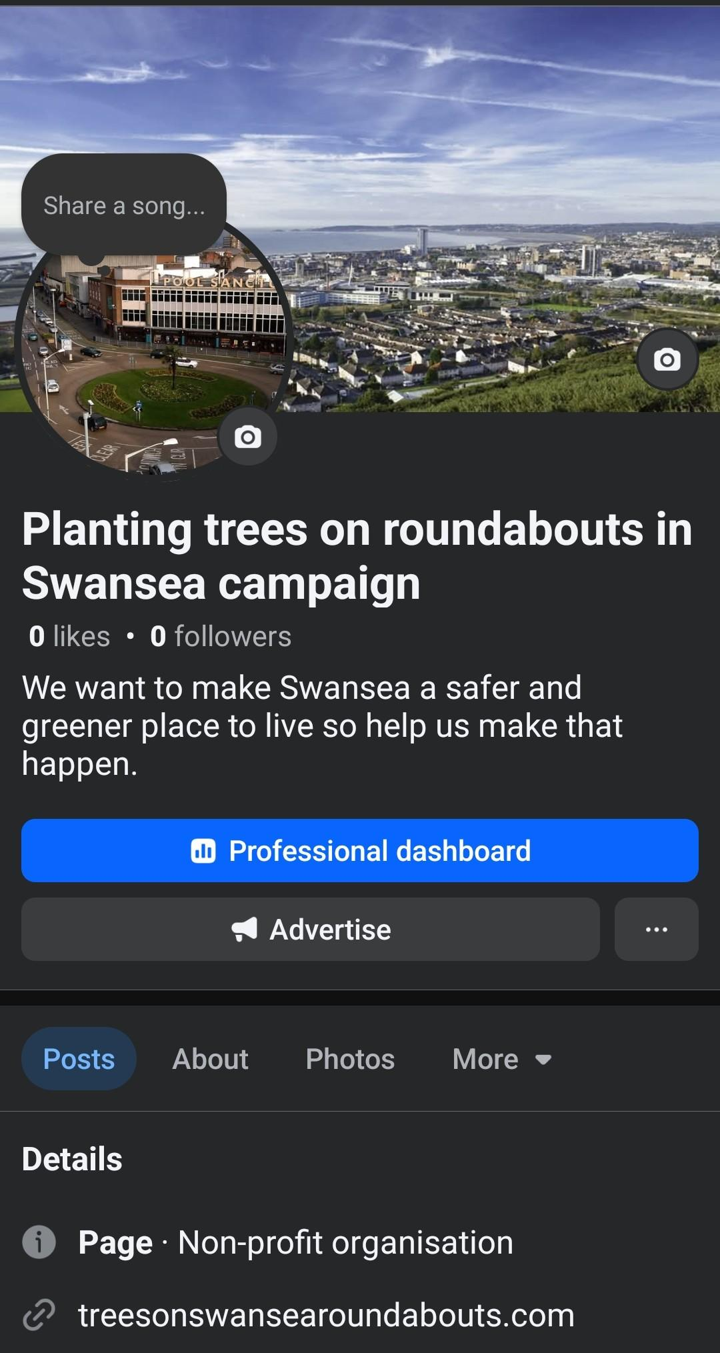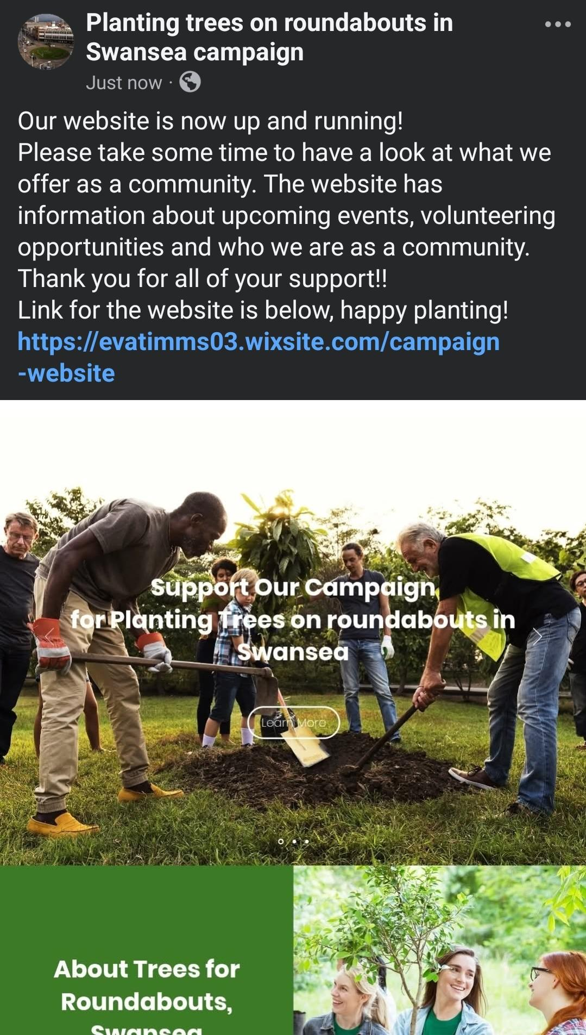
Screenshots of trees for roundabouts Facebook page, Figure 1
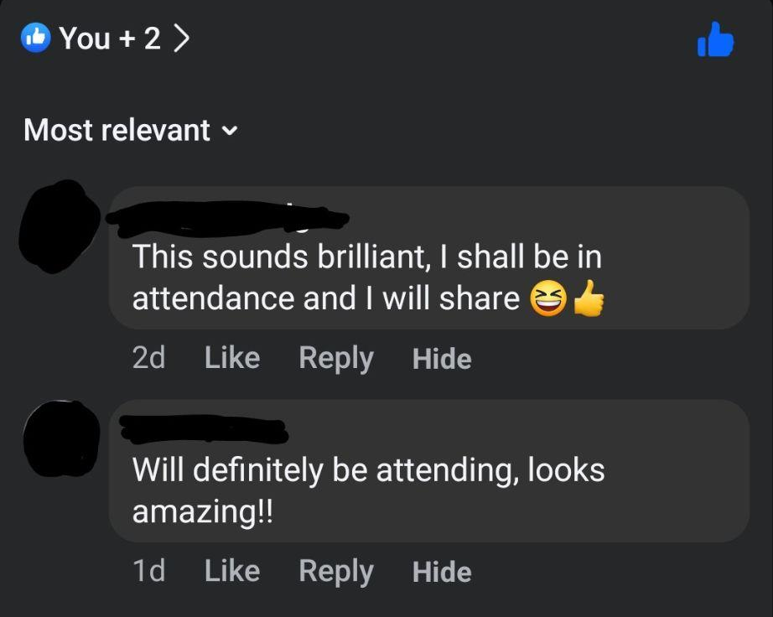
Comments from public people on Facebook page post, Figure 2

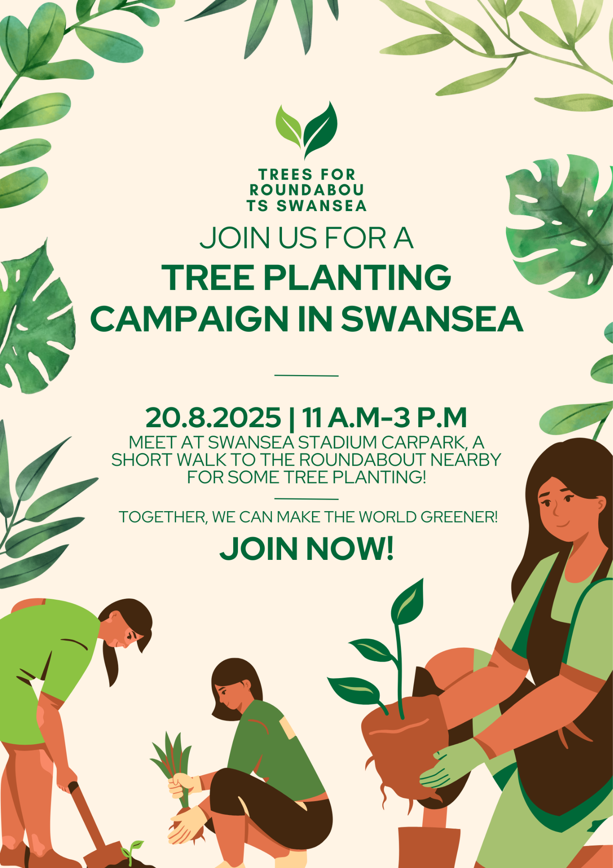
Poster for a tree planting event for this campaign, figure 3

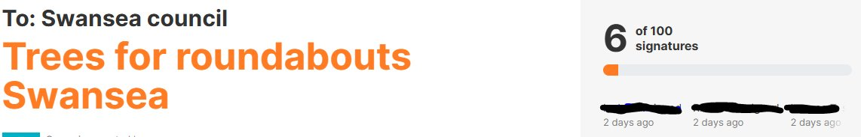
Trees for roundabouts Swansea petition, figure 4


Trees for roundabouts Swansea logo, figure 5

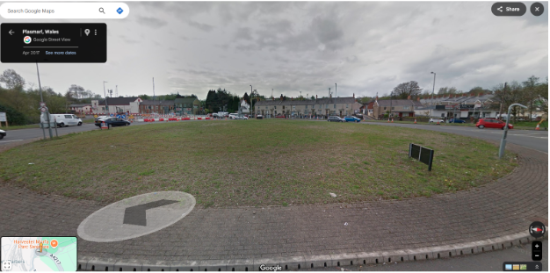
Bare roundabout located in Swansea, figure 6

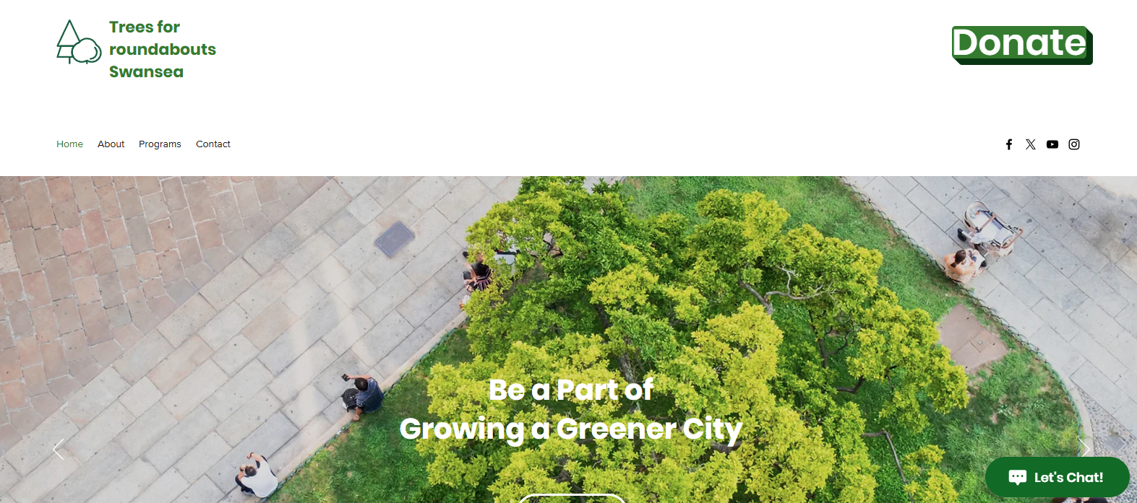
Part of trees for roundabouts Swansea website, figure 7

References
- Advertising and promotions - Swansea (2024) [online] Available at: https://www.swansea.gov.uk/advertising?lang=en. [Accessed 26.03.25]
- Ariluoma, M. et al. (2021) “Carbon sequestration and storage potential of urban green in residential yards: A case study from Helsinki,” Urban Forestry and Urban Greening, 57. Available at: https://doi.org/10.1016/j.ufug.2020.126939. [Accessed 25.03.25].​

- Barker, L. (2021) How Street Trees help make our roads safer - Trees for Streets, [online[ Available at: https://www.treesforstreets.org/how-street-trees-help-make-our-roads-safer/. [Accessed 25.03.25]
- Browning, M.H.E.M. et al. (2022) “Where greenspace matters most: A systematic review of urbanicity, greenspace, and physical health,” Landscape and Urban Planning. Elsevier B.V. [online] Available at: https://doi.org/10.1016/j.landurbplan.2021.104233. [Accessed 26.03.25]
- Capaldi, C. A., Dopko, R. L., & Zelenski, J. M. (2014). The relationship between nature connectedness and happiness: a meta-analysis. Frontiers in psychology, 5, 976. [online] Available at: https://doi.org/10.3389/fpsyg.2014.00976 [Accessed 26.03.25]
- Coeden Fach Community Tree Nursery (no date) [online] Available at: https://coedenfach.org.uk/. [Accessed 26.03.25]
- Dunn, N. (2025) Top 23 TikTok Statistics & Facts you need to know in 2025! [online] Available at: https://www.charle.co.uk/articles/tiktok-statistics/. [Accessed 26.03.25]
- Facebook Age Demographics (2024) [Updated Oct 2024] | Oberlo (no date) [online] Available at: https://www.oberlo.com/statistics/facebook-age-demographics. [Accessed 21.03.25]
- Grinde, B. and Patil, G.G. (2009) “Biophilia: Does visual contact with nature impact on health and well-being?,” International Journal of Environmental Research and Public Health. MDPI, pp. 2332–2343. [online] Available at: https://doi.org/10.3390/ijerph6092332. [Accessed 19.03.25]
- How trees store carbon - Norfolk County Council (no date) [online] Available at: https://www.norfolk.gov.uk/article/39510/How-trees-store-carbon. [Accessed 26.03.25]
- Negative impact of vacant land on communities Greenspace Scotland (no date) [online] Available at: https://www.greenspacescotland.org.uk/news/derelict-sites-contribute-to-perceptions-of-urban-decline. [Accessed 26.03.25]
- Sheikh, M. (2025) Social media demographics to inform your 2025 strategy, [online] Available at: https://sproutsocial.com/insights/new-social-media-demographics/. [Accessed 26.03.25]
- Stoke Gifford Journal (2019) Visibility screens installed at roundabout - Stoke Gifford Journal, [online] Available at: https://www.stokegiffordjournal.co.uk/2019/10/07/visibility-screens-installed-roundabout/. [Acessed 25.03.25]
- Swansea Bay (2025) Swansea. [online] Available at: https://www.visitswanseabay.com/destinations/swansea/ [Accessed 25.03.25]
- Why Cities Need Urban Trees for Clean Air | Trees for Cities (2023) [online] Available at: https://www.treesforcities.org/stories/why-cities-need-urban-trees-for-clean-air. [Accessed 25.03.25]

