SEASONAL FRUIT DRINK TO MANUFACTURED PRODUCT

Table of Contents
Chapter 1: Introduction 3
1.1 Introduction 3
1.2 Research Background and Context 3
1.3 Research Aim and Objectives 4
1.4 Research Question 5
1.5 Research Rationale 5
1.6 Research Significance 6
1.7 Research Structure 6
Reference list 8

Chapter 1: Introduction

1.1 Introduction
The beverage industry in the United Kingdom continues to experience the fundamental change as consumer preferences incline towards healthier, naturally sourced, and functionally enriched beverage decisively. Two-thirds of volume sales of soft drinks in the UK are now low-sugar products or no-sugar products, and 62% of the population now actively limit their sugar consumption (Grocery Trader, 2026). In this shifting environment, there is a large commercial gap concern about seasonal fruit drinks beverages that have been traditionally manufactured and consumed only in selected seasonal harvests that have a great unavailability to all-year-round consumers yet have the potential to be as nutritional, cultural, and flavourful. This paper is research into whether seasonal fruit drinks can be commercially produced, shelf-stored products, which can cater to the UK retail market all year round. This paper examines the external market, consumer demand trends, and business feasibility of such an undertaking utilizing proven analytical tools such as the PESTLE model and Jobs-to-Be-Done (JTBD) theory in the context of the functional and health-oriented beverage market, which continues to grow (White, 2024).

1.2 Research Background and Context
The production industry of fruit drinks and functional beverages in the UK has been enjoying a steady growth in the last 5 years. The Fruit Drink and Functional Beverage Production industry in the United Kingdom has a market size of £2.2 billion in 2026 but between 2021 and 2026, the industry experienced a compound annual growth rate of 4.0% (Griffin, 2026). This growth is not coaching but such a fundamental change in the approach of British consumers to the issue of hydration and nutrition. This industry is predicted to increase revenue at a compound annual rate of 2.6% to £2.3 billion to 2026-27 due to the growing popularity of functional drinks supported by the growing health-consciousness of consumers who are moving their purchases off fizzy beverages into lower-sugar and low-calorie beverages (Quail, 2026).
The larger functional beverage market supports this trend even further. The UK functional drinks market has become worth over £100 million in value sales with the juice shot making up only the segment with a growth rate of 47% per annum in the same period over the last 3 years and with nearly 130 million shots sold in the last one year, 6.8% household penetration has increased by 48% per annum over the same time (West, 2026; Beeson, 2026). At the same time, consumers are becoming more and more interested in products containing less sugar and fat, with any indication of high protein, fibre or functional claims like the omega-3 fortification or probiotic enrichment. Almost half of the consumers in the UK have switched to products that contain less sugar and the number of British people who consume unhealthy meals over three times per week has declined by almost 30% (Dhatrak and Khansole, 2026).
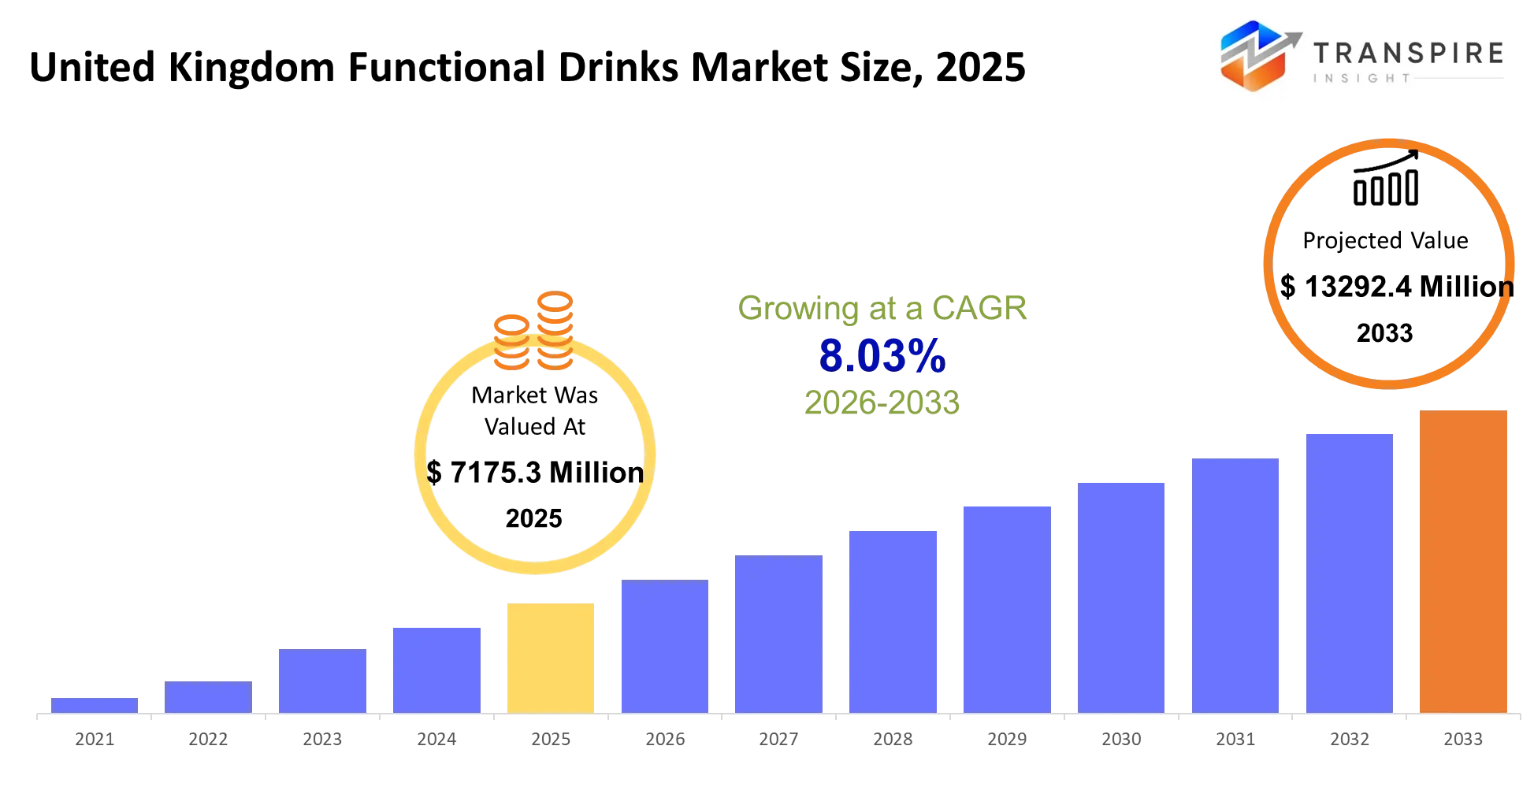
Figure: United Kingdom Functional Drinks Market
(Source: Dhatrak and Khansole, 2026)
In this context, seasonal fruits, including elderflower, sloe, damson, gooseberry and rhubarb, have their own unique flavour, nutritional characteristics which would naturally resonate better with the health conscious, novelty seeking consumer base (Sämann, 2025). They are however limited to seasonal supply, are perishable and lack manufacturing facilities to transform them into retail goods throughout the year. This mismatch between consumer desire of natural and heritage-driven flavours and lack of shelf-able fruit products based on season is the core business opportunity that this study examines.

1.3 Research Aim and Objectives
This study will attempt to assess viability of converting seasonal fruit juices into commercially pre-manufactured products to be sold throughout the whole year in the UK retail market. The research aim is to examine external market environments, consumer needs and preferences, and evaluate the business opportunities of those who plan to launch innovative and shelf-stable fruit drinks that meet the evolving health, sustainability and lifestyle trends.
- To examine the macro-environment of the UK in the PESTLE framework to determine the political, economic, social, technological, legal, and environmental factors that affect the commercialisation of the seasonal fruit beverages.
- To determine the functional, emotional, and social needs of consumers in the context of the Jobs-to-Be-Done (JTBD) framework to learn how people can be motivated to buy fruit-based beverages.
- To assess market potential, target customer segments and demand trends of manufactured seasonal fruit drinks in the UK off-trade retail market.
- To determine the general commercial viability and positioning of seasonal fruit beverages as full-year produced products and give suggestions on how to successfully enter the market.

1.4 Research Question
How feasible is it to transform seasonal fruit drinks into commercially viable manufactured products for the UK retail market, considering macro-environmental factors and consumer demand?

1.5 Research Rationale
This study is justified by the fact that there are three forces that are evident in the market. The first ones are the long-term shift of consumers to healthier, less-sugary, and functionally infantile drinks. The UK juice market is assumed to grow to USD 4.39 billion in 2025 and USD 4.73 billion in 2032 with price pressure also being high as the prices of food and non-alcoholic drinks rose by 4.5% in the year ending December 2025 according to the Office of national statistics (Albert, 2026). This price inflation is altering the habit of consumption, forcing customers to consume products that can bring both a sense of value and real nutritional quality - a positioning of which can be taken up by naturally sourced seasonal fruit drinks themselves (Claight, 2026).
The second force is the regulatory environment. In the UK, the government enacted extensive HFSS advertising demands in October 2025: preventing advertising of large amounts of fat, sugar, or salt in foods before 9 PM on television and all paid advertising of large amounts of fat, sugar or salt products online. The competitive benefits enjoyed by these drinks under such limitations are those possessing a right to claim the low-sugar, natural, and functional attributes and this is exactly the positioning that can be offered to the seasonal fruit-based products (The On Trade, 2025).
The underdevelopment of the category of seasonal fruit beverage is the third force. As the wider functional drinks sector pivots at high speed into the gut health, cognitive and stress-reduction category, seasonal fruit drinks are a product category with limited commercial manufacturing names (Albattat et al., 2025). This is a definitely existing gap between readiness of consumers and availability of products and hence investigation is both timely and commercially significant.

1.6 Research Significance
The present study not only adds to academic knowledge but also practical business skills. Academically, it builds on the PESTLE and JTBD help models to a niche yet developing sector in the UK beverage industry that has received less scholarly research. Using these established lenses to analyse seasonal fruit drinks, the study provides a repeatable methodological tool in evaluating the market entry opportunities in the related food and drinks that had not been well explored to date.
In practical perspective, practical findings can inform entrepreneurs, small-scale manufacturers, and other pre-established manufacturers of beverages whether to venture into the seasonal fruit beverage segment (Ceasar and Sundari, 2024). The study will present evidence-based knowledge on consumer demand drivers, regulatory factors, and competitive positioning recommendations that can be used to guide product development, pricing and go-to-market decisions. As the UK functional drinks market has been growing faster by 8.3% compound annual growth rate to the year 2030 and has shifted to a mainstream retail phenomenon, rather than a specialised health store category, this research topic is a commercially relevant and time-intensive opportunity (Grand View Research, 2025).

1.7 Research Structure
This study has been structured into a rational chronology of chapters aimed at developing a full-fledged argument based on evidence. After this introductory chapter, Chapter 2 provides the Literature Review critically analysing the theoretical framework on which the analysis is based, such as the PESTLE model, the JTBD framework, Porters Five Forces, the Value Proposition Canvas and the Business Model Canvas. Chapter 3 describes the Methodology, defining the secondary qualitative research approach, data sources, and analysis methods used. Chapter 4 provides the Initial Market Opportunity Analysis which utilizes the chosen structures in order to assess market size, consumer segments, demand conditions and competitive dynamics. Chapter 5 is the Conclusion and summarises important findings and evaluates the commercial potential of the opportunity identified.

Reference list
Albattat, A., Fakir, F.Z., Yi, Z. and Hussain, Z. (2025) Innovative Trends Shaping Food Marketing and Consumption, ResearchGate. Available at: https://doi.org/10.4018/979-8-3693-8542-5.
Albert, J. (2026) The UK juice market navigates health trends, inflation pressures, and premium innovation, Global Risk Community. Available at: https://globalriskcommunity.com/notes/the-uk-juice-market-navigates-health-trends-inflation-pressures-a (Accessed: 6 August 2026).
Beeson, J. (2026) Juice shot category value hits £100m, The Grocer. Available at: https://www.thegrocer.co.uk/news/juice-shot-category-value-hits-100m-as-shoppers-seek-convenient-health-hacks/718673.article (Accessed: 6 August 2026).
Ceasar, D.M.J. and Sundari (2024) Consumer perception on fruit drinks: A field survey in Tirunelveli District Tamilnadu, South India. Available at: https://www.researchgate.net/publication/380265197_CONSUMER_PERCEPTION_ON_FRUIT_DRINKS_A_FIELD_SURVEY_IN_TIRUNELVELI_DISTRICT_TAMILNADU_SOUTH_INDIA (Accessed: 6 August 2026).
Claight (2026) Juice production in the UK: Market size, businesses and employment (2025 base), Claight. Claight Corporation. Available at: https://hub.claight.com/statistics/juice-production-in-the-uk (Accessed: 6 August 2026).
Dhatrak, C. and Khansole, C. (2026) United Kingdom Functional Drinks Market, Transpire Insight. Available at: https://www.transpireinsight.com/report/united-kingdom-functional-drinks-market (Accessed: 6 August 2026).
Grand View Research (2025) UK Functional Drinks Market Size & Outlook, 2026-2033, Grandviewresearch.com. Available at: https://www.grandviewresearch.com/horizon/outlook/functional-drinks-market/uk (Accessed: 6 August 2026).
Griffin, F. (2026) Fruit Drink & Functional Beverage Production in the UK Industry Data and Analysis, Ibisworld.com. Available at: https://www.ibisworld.com/united-kingdom/industry/fruit-drink-functional-beverage-production/692/ (Accessed: 6 August 2026).
Grocery Trader (2026) Soft drinks gets healthier – consumers are moving towards low and no sugar options | grocery trader, Grocery Trader | Grocer News from Grocery Trader - Latest news and information for the multiple grocery trade in the UK. Available at: https://grocerytrader.co.uk/soft-drinks-gets-healthier-consumers-are-moving-towards-low-and-no-sugar-options/ (Accessed: 6 August 2026).
Quail, M. (2026) Juice Production in the UK Industry Data and Analysis, Ibisworld.com. Available at: https://www.ibisworld.com/united-kingdom/industry/juice-production/495/ (Accessed: 6 August 2026).
Sämann, L. (2025) Seasonal nutrition: The natural way to better health, Premiummedicalcircle.com. Premium Medical Circle. Available at: https://premiummedicalcircle.com/en/artikel/seasonal-nutrition-the-natural-way-to-better-health (Accessed: 6 August 2026).
The On Trade (2025) The Rise of Functional Beverages in the UK Market, The On Trade. Available at: https://theontrade.com/en/blog/your-business-11/trends-21/the-rise-of-functional-beverages-in-the-uk-market-241.htm (Accessed: 6 August 2026).
West, T. (2026) UK functional drinks market hits £100M, FoodManufacture.co.uk. Available at: https://www.foodmanufacture.co.uk/Article/2026/05/12/uk-functional-drinks-markets-hits-100m-in-value-sales-as-health-consciousness-grows/ (Accessed: 6 August 2026).
White, K. (2024) 2025 Trends in B2B food & beverage: A look at the UK and Europe, Apex. Available at: https://apexb2b.com/blog/2025-trends-in-food-amp-beverage-a-look-at-the-uk-and-europe/ (Accessed: 6 August 2026).

