John Lewis partnership culture change    REPORT | Executive Summary  The John Lewis Partnership has proven that tradition and seriousness have been their allies in building a strong and enthusiastic culture. The purpose of this report is to analyse the organizational culture of the John Lewis and Waitrose partnership and the impact of external factors such as the Covi-19 pandemic and Brexit. The analysis was performed by applying the cultural web model. In parallel, the ethics and values of the Partnership were analysed and how they align with the skills and abilities of individuals and how they impact on the culture of the organization. Finally, some recommendations were made to monitor the effects of the very low bonus on partners, and to listen to employees to identify their current needs.  Verginica Caracas (1906795)  Workplace Culture and its Impact on Organisational Efficiency (BMSW5105_SWAN)

Content List

1.0 Introduction………………………………………….…2

2.0 Main Finding………………………………………......4

2.1 Critical Analysis of Workplace Culture……………….…….4
.

2.1.1 Definition of Culture…………………………………...….4

2.1.2 Analysis of Cultural Web at John Lewis Partnership… 5

2.2 Critical Analysis Ethical…………………………….….10

2.2.1 Definition of Ethical judgment……………………….…10

2.2.2 CRITICAL analysis of John Lewis Partnership Ethical Stance……………………….………………………………….10

2.3 Critical Analysis Skills, Knowledge, Behaviour Employees………………………………………………......11

3.0 Conclusion ……………………….…………….12
4.0 Recommendation……………………………...12

5.0 References……………………………………...13

- Introduction
The John Lewis Partnership, founded by John Spedan Lewis in 1864 is the largest employee-owned business in the UK. By including the staff in decision-making Spedan had begun a new experiment, ` a better way of doing business`.
It owns two famous brands: John Lewis with 42 shops, and Waitrose with 332 shops. The Partnership has also two international sourcing offices, three Waitrose & Partners cookery schools, a furniture factory with distribution centres, and their own farm. (John Lewis Partnership-Who we are). “The company classifies its business operations into two reportable segments: Waitrose, and John Lewis.” (MarketLine, 2020. p41). For the past three years John Lewis Partnership was on top in” Top 50 employee-owned companies in 2020” according to RM2 (2020).

To analyse culture change at John Lewis Partnership a tool like PESTLE helps the organisation identify how six external factors (Political, Economic, Social, Technological, Legal, and Environmental) impact the organisation. From PESTLE Analysis managers gain a new perspective on future strategies, anticipate next threats that may affect the business, and take the appropriate decisions which will avoid or minimise their impact. So, PESTLE is essential because it highlights major issues which that can affect the organisation. (CIPD, 2020)
Last year the most impacting factors were Political, i.e.Brexit and Environmental: Covid-19 pandemic.
Due to uncertainty around post-Brexit trade rules, John Lewis, along with other retailers such as Debenhams and Fortnum & Masons, cancelled deliveries to the EU, and suspended deliveries to Northern Ireland. Knowing the issue of trade rules created by Brexit, John Lewis renounced international expansion by focusing on the strengths (strong and well-known brands: John Lewis and Waitrose) and the satisfaction of the UK market. (Read, 2021) In addition there is an article in The London Economic which states: “The John Lewis Partnership has warned that the hit from a no-deal Brexit would be “significant” and impossible to offset as it tumbled to a £25.9 million half-year loss.” (Mellor, 2019) Sir Charlie Mayfield, the chairman of John Lewis Partnership said that Brexit “continues to weigh on consumer sentiment at a crucial time for the sector as we enter the peak trading period.”
Another key factor was the Covid-19 pandemic that affected the retail industry. As a safety measure John Lewis Partnership had to suspend click & collect services. The retail said it consider the measure were right at a “critical point in the pandemic.” (BBC, 2021) However, customers can still collect John Lewis orders by from Waitrose stores.
Due to Covid-19 pandemic John Lewis launched a review of the business. This includes closing unprofitable stores, as well as space reduction in existing ones, and cutting employee bonuses. Against the background of the drastic decrease in profit, John Lewis was forced to diminish the bonus to the partners to 2%. This is the smallest bonus in the last 67 years. Sharon White, the new chairman of John Lewis Partnership said: "This will require a transformation in how we operate as a partnership and could take three to five years to show results. "(BBC, 2020)
Along with an article in The Guardian, John Lewis recently announced the final closure of eight stores, putting 1,500 jobs at risk, after closing eight more stores the previous year, amid a move to online shopping, this being accelerated by the Covid-19 pandemic. (Butler, 2021) About that White said:” “Today’s announcement is incredibly sad news for our affected partners, for our customers and for the communities we’ve served over many years. The high street is going through its biggest change for a generation, and we are changing with it.”

- Main Finding
  - Critical analysis of John Lewis Partnership Culture
2.1.1 Definition of Culture
An interesting definition of culture is given by Mind Tools:
The Culture is “that ethereal something that hangs in the air and influences how gets done, critically affects projects success or failure, says who fits, and who doesn`t, and determinates the overall mood of the company.” (Mind Tools, 2021)
To increase performance in their organisation, many managers analysed financial factors (costs, profit, incomes), and ignoring non-financial factors, such as: job satisfaction, quality, customer satisfaction. “Organisational culture was found to directly impact the non-financial factors that contribute to organisational performance.” (Bremer, 2019)

According to Bersin (2015): “Culture: why it`s the hottest topic in business today”

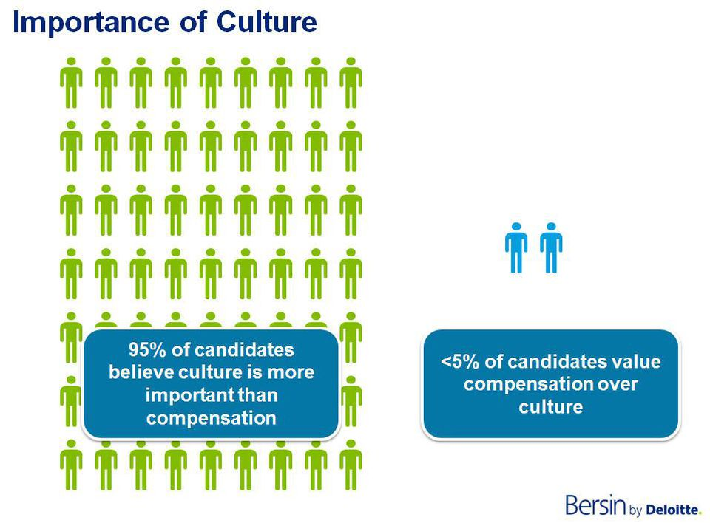
Starting from the impact that the factors mentioned above have on businesses, an analysis of the organisation`s culture is necessary.
There are several models of culture that could be used by senior managers to determine organisational culture in their organisations and to identify which elements contribute to improve the performance. The best known are:
Cultural Web, 2008 Johnson and Scholes
Handy Model
Schein Model, 1992
Deal and Kennedy, 2000

2.1.2 Analysis of Cultural Web at John Lewis Partnership
“The Cultural Web is a tool to map the culture of an organisation and is a way of seeing and understanding the different influences that affect organisational culture.” (Leadership Centre, 2021) It proposes six elements that could help to structure the model of the work environment. “Corporate culture can have a huge impact on an organization's work environment and output.” (Mind Tools, 2021)

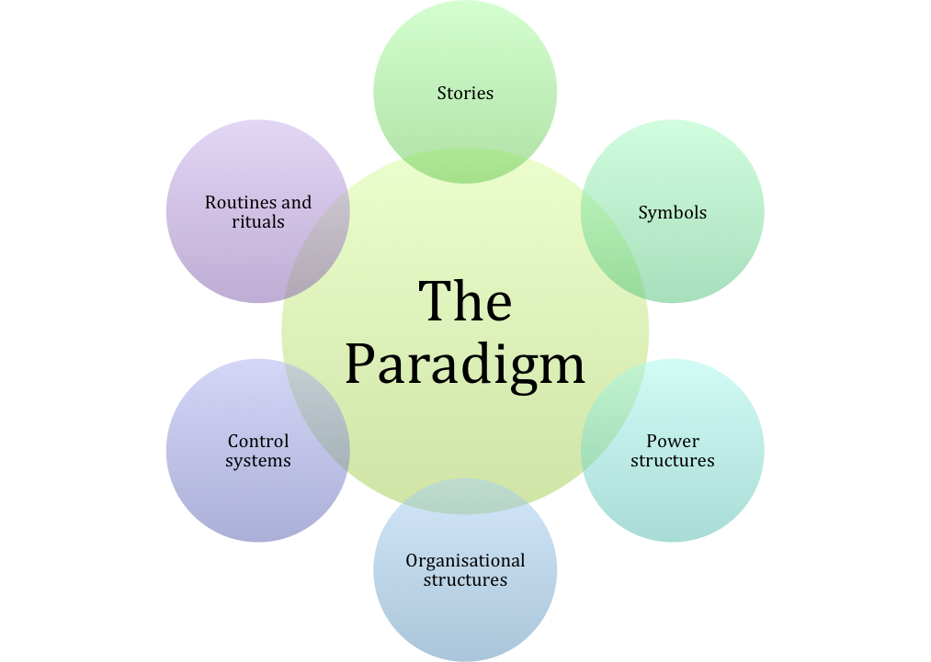

Why Cultural Web?
- “The Cultural Web provides a way of auditing an organisation`s culture.” (MBA Knowledge Base, 2014)
- To identify the elements which could be possible obstacles in the current culture.
- To see the bigger picture of the organisation culture
- To determinate what is working and what is not working
- To identify what needs to be changed to achieve a high-performance culture.
According to JLP 2020 Annual Report and Accounts their culture means:” The Partnership operates on democratic principle, sharing power with all Partners. Our first Democratic Council was set up over 100 years ago and today our Partnership Council, forums and Partner Voice enable Partners to participate in decision -making, challenge management on performance and have a say in how the business is run.” The purpose of John Lewis is “the happiness of its members, through their worthwhile and satisfying employment in a successful business.”

Applying the Cultural Web model, it will be possible to verify the statements of John Lewis:
- Routines and Rituals represent the daily actions and behaviour of people.
- Happy and motivated employees/ partners offer high quality service to customers. Stewart (2018) wrote an article about John Lewis and “its foundation of the idea that:
happy partners = happy customers = more profit.”
It was Spedan Lewis `vision` as he created the company Constitution with seven principles, and first principle being: `The Partnership`s ultimate purpose is the happiness of its members, through their worthwhile and satisfying employment in a successful business.
On the other hand, last year they should pay out £23m to upset consumers due botched orders, as Sharon White said at a staff meeting. (Butler, 2019)

- Indeed, has conducted an opinion poll among John Lewis employees about the company's culture. In line with 502 reviews of John Lewis employees the Culture rating is 3.8.
The most `PROs`: Flexible culture, great place to work, great benefits and great management, team driven, effective and supportive, food and drinks for staff, good pension, bonus.
The most `CONs`: No rewards, stressful, level of bonus, poor communication, physical work demanding, bulling colleagues.
- Stories
John Spedan Lewis is always presented as a hero. He is the Founder of the Partnership. He started as an experiment and succeeded by creating a new model of business, including the employees in decision -making. (John Lewis Partnership-Our history). In 1920 Partners have received their first partnership bonus in the form of share promises.
Nowadays there are stories about cutting staff bonus at the lowest level since 1953 as Sarah Butler (2019) wrote in an article in The Guardian: “The John Lewis Partnership has slashed its staff bonus to the lowest level in 66 years, after a severe slump in profits at the department store chain.”
- Symbols (dress codes, logos, how well know are)

Logos:
- `A better way of doing business` John Spedan Lewis was a visionary who developed an employee-owned business which was a different model than anything in the economy at the time. (Salaman and Storey, 2016)

- `Never Knowingly Undersold` is the oldest slogan created in 1925, and at all times it was like an identity for The Partnership. (BBC, 2020)
Nowadays, online commerce has become increasingly difficult to compete with. So, the new chairman of John Lewis Partnership, Sharon White plans to replace this slogan. “The proposition is important because it signifies being fair to society, We`re reviewing it to improve it.” she told Sunday Times. (BBC, 2020

- `For Us It`s Personal` promise to their customers. In 2018 John Lewis and Waitrose carried out a brand campaign and for the first time the logos of the two brands were reunited. This campaign launched: `For us it's personal`, a new concept that deviates from the slogan` Never knowingly undersold`. Through this new concept the Partnership shifts the accent on the service offered by employees (partners). A video suggests that when employees are also owners of their business "they put their heart into it", achieving extraordinary performance. (Stewart, 2018)
Inglis, customer director for John Lewis, said: “Our customers tell us time and again that they love the exceptional service delivered by our partners and that that`s makes us special in their eyes.” This new `logo` came as a promise to consumers that they will receive even better services.
Strong brands: `John Lewis`, and `Waitrose` that means high quality of products and services. “Waitrose and John Lewis are two of the UK’s most loved and trusted brands and we have adapted to the challenges of the pandemic by responding to the new needs of customers,” as Sharon White said to Forbes in July 2020.
- Control systems

In the Governance Report-2020, John Lewis Partnership has stipulated that they have “a structure approach designed to identify, manage, monitor and communicate risks consistently, and take advantage of opportunities across the Partnership. This is supported by our risk management governance structure.”
In the Constitution they have stated: “the highest-paid partner can get up to 75-times average basic pay.”
Staff is rewarded fairly through bonus, respect, involvement. (Culture Consultancy, 2020)

- Power Structures

John Lewis Partnership has three governing authorities:
- the Chairman
- the Partnership Board
- Partnership Council
They have a common aim: “to safeguard the Partnership `s future, to enhance its prosperity and to ensure its integrity.” (JLP Governance Report, 2020) Their power to direct the Partnership’s affairs depends on the consent of Partners. The partners express their consent through the Partners` Voice, thus reducing the possibility of a potential abuse of this power.
- Organisational Structure
John Spedan Lewis, the founder of John Lewis Partnership had created the governance system for the company, and it is established in the company`s Constitution.
“The Partnership operates on democratic principles and as much sharing of power among its members and representative bodies as is consistent with efficiency.” (JLP Annual Report 2020) This organizational structure offers employees (partners) the right to be actively involved in running the business.
Web Cultural analysis at John Lewis identified:
- The elements which are barriers in the culture of the organisation are negative aspects of the culture:
- Stories about cutting staff bonus because the department store chain has significantly decreased its profit. In this way in 2020 the new chairman, Sharon White launched a review of the business and one objective was to `resized` the stores. Thus, eight stores were closed in 2020, followed by another eight in 2021.Along an article in The Guardian, Sarah Butler wrote: “ John Lewis has confirmed plans to permanently close eight more outlets, with the potential loss of almost 1,500 jobs. “ The latest closures come after John Lewis permanently shut eight stores in 2020 amid a shift to online shopping, which has been accelerated by the Covid-19 pandemic.” Another barrier that leads to change the culture: losing 1500 employees (partners).
- By replacement of the significant slogan: `Never Knowingly Undersold` the culture of John Lewis changes, they took the opportunity to invest heavily in online commerce.
2.To see the bigger picture of the organisation culture
Employee ownership business represent the base of a distinctive and highly successful organisational culture for John Lewis. (Riley, 2013)
“As employee-owners we all have a share in the business and a shared commitment to go above and beyond for each other, our customers, and the communities and environments in which we operate. We have a set of five values that were created by Partners to explain what it means to be a Partner.” When the employees are motivated, determined, and have the same values as the company the performance is substantially improved leading to a strong culture. (Wren, 2016)
If staff is happy and they feel part of the business they will provide top quality services thus, promoting the brand.
The two strong brands John Lewis, and Waitrose represent another positive element also. They have loyal customers who love these brands as well the partners who delivery the services.
Their purpose to keep partners happy remain a priority for the company. Even if the company has losses, the Partnership Board approved a 2% bonus for the partners.
After the closure of the stores, the spaces left vacant were transformed into offices and homes, new activities being developed: rental and housing. In the year that changed retail, when most companies focused to selling online, Sharon White has pushed the company to forge new opportunities taking innovative steps in completely new directions. (Powell, 2020) White took over as Chairman of the John Lewis Partnership in February 2020 coming from the role as CEO at Ofcom, so no retail experience. This is the first lesson from White: to make a team that help to implement innovative ideas. The second lesson Powell was referring to is to play to the unique company`s strengths. White realised that the people`s lifestyle has change due the Covid pandemic, and she focused more onto home goods, and for the first time John Lewis offered furniture rental and garden supplies to customers.
Along with an article in the Guardian, John Lewis is owned by a trust on behalf of its employees. Its purpose is not to make short-term profit for greedy shareholders, but `the happiness of its members, through their worthwhile and satisfying employment in a successful business`. (Henley, 2010)
According to Mindtools (2011) John Lewis culture “is one of a customer focused, enthusiastic culture which supports its employees”.

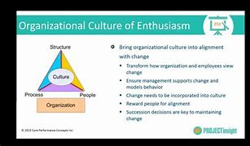

  - Critical Analysis of organisation`s ethical stance
    - Definition of business ethics
“Ethical judgment is an individual`s personal evaluation of the degree to which come behaviour or course of action is ethical or unethical.” (Sparks, J., R. and Pan, Y., 2009) Ethical judgment was defined “the belief that a particular alternative is the most ethical alternative.” Within an organisation, managers deal how to manage and value the workforce. They should know to do this in an ethical and moral way to achieve a strong and correct culture for the company.
    - Critical Analysis of John Lewis Partnership`s ethical stance
The sixth principle in the Partnership stated: “The Partnership aims to conduct all its business relationship with integrity and courtesy, and scrupulously to honour every business agreement.” Their Constitution still works today, after more than 100 years.
They respect and apply all regulations, principles, values, beliefs to create a healthy work environment within the organisation. The relationship between the management and employees, customers, suppliers and community are based on respect, trust and wellbeing.
During the Covid pandemic John Lewis has launched new programme to help community:
- They donated clothing to families with needs,
- They supported NHS with gifts and approximate 2000 packages, (Nazir, 2021)
- They made donations to vulnerable customers.
Building good relationship and helping people within the organisation, as well as the people from outside is the key to show their vision for ethics and sustainability and long-term business success. (John Lewis Partnership-ethic & sustainability)
Current management led by Sharon White is reviewing the organization's sustainability and ethics committee to be updated in line with the partnership's five-year strategy.
For their employees John Lewis offers a mixed pension`s system with the company contribution, as well as the employees. Also, they provide drinks, refreshments for staff `s breaks. Their purpose is wellbeing and happiness of their partners.
As shown above, employees perform better when they manage to align their values and beliefs with those of the Partnership.

Critical Analysis of Skills, Knowledge and behaviour of an Employee from John Lewis Partnership
The purpose of the Partnership is to make a profit in order to honours its partners with the bonus promised by the Constitution. It looks for people with ability and integrity and who know how to respect the values of the organization. It is preferable that the values and beliefs of the employees be as close as possible to those of the company. JLP, Constitution, p7)
The more the individual values and the values of the organisation are aligned, the more motivated and involved will be the employees, they will achieve the organisation objectives and that will lead to a successful business and a force for good in community. At John Lewis they share the responsibilities to run the business as well as the rewards: profit, knowledge and power. The employees/partners are empowered, and they feel as part of the business.
They have established five values:
Do right, integrity.
All or nothing. Put everything in what we do.
Give more than you take more out.
Be yourself.
We not me. Working together – anything is possible.
There are ten levels within the Partnership. Every candidate is viewed as an individual and HR department determined which role is the best, because they consider the impact that the future employee can have on the organisation culture.
After closing the stores for dismissed employees, the company offers other existing jobs, for example in Waitrose stores. During the pandemic, customer requirements increased, and vacancies arose. For partners who want to progress in their careers The partnership ensures an optimal climate by announcing vacancies and guiding those interested to the most appropriate role
The main skill that John Lewis is looking for the candidates are team worker, integrity, communication, honesty, creativity, critical thinking, willing to develop the personal performance by training and experience.

- Conclusion
In conclusion, John Lewis is an organization with a solid and positive culture, with a tradition of more than a century. They have always followed the provisions of the Constitution and their cultural web looks clear, clean, with no secrets. They have true and trustworthy stories, routines and rituals that have shown that employees trust management and the company. Power is shared between partners and shareholders. As it turned out, the partners were satisfied with 2% and 3% bonuses, and as shown in the analysis, there are not many unhappy partners in John Lewis.
But as nothing is perfect, but perfectible, some recommendations are to be made.

- Recommendations
Firstly, the management teams must monitor in time the effects of the very diminished bonus from the last two consecutive years. Employees have families and expectations.
Secondly, they must be listened to, because if their current and real needs are known, ways can be found to meet the company's offers and people's needs.
In addition, creating flexible working conditions would help motivate the workforce.

- References
- BBC, (2021) John Lewis suspends click and collect due to virus safety 13 January. Available at: http://www.bbc.com/news/business (Accessed: 25 March 2021)
- BBC, (2020) John Lewis warns stores could close as bonuses cut 5 March. Available at: http://www.bbc.com/news/business (Accessed: 25 March 2021)
- BBC, (2020) John Lewis to pull `Never knowingly undersold` pledge 23 August Available at: http://www.bbc.com/news/business (Accessed: 27 March 2021)
- Bersin, J. (2015) Culture: Why It`s The Hottest Topic In Business Today 13 March. Available at: http://www.forbes.com (Accessed: 12 March 2021)
- Bremer, M. (2019) Performance Boost via a Positive Culture 15 January. Available at: http://www.leadershipandchangemagazine.com (Accessed: 12 March 2021)
- Busby, (2020) John Lewis Closes Eight Stores In Order To Safeguard The Future Of The Business 9 July 2020. Available at: http://www.forbes.com (Accessed: 28 March 2021)
- Butler, (2019) John Lewis cut its staff bonus for 2019-2020 to 2% of annual pay, the lowest level in 67 years. 7 March Available at: http://www.theguardian.com. (Accessed: 15 March 2021)
- Butler, S. (2021) John Lewis to close eight more stores, putting 1,500 jobs at risk 24 March. Available at: http://www.theguardian.com (Accessed:25 March 2021)
- CIPD, (2020) PESTLE Analysis/ Factsheets. Available at: http://www.cipd.co.uk (Accessed: 6 March 2021)
- Culture Consultancy, (2020) So, What can you learn from John Lewis`s culture? Available at: http://www.cultureconsultancy.com/blogs. (Accessed: 26 March 2021)
- Henley, J. (2010) Is John Lewis the best company in Britain to work for? 16 March. Available at: http://www.the guardian.com (Accessed: 23 March 2021)
- Indeed, (2021) John Lewis & Partners Mission, Benefits and Work Culture. Available at: https://uk.indeed.com (Accessed: 22 March 2021)
- John Lewis Partnership Constitution October 2019 Available at: http://www.johnlewispartnership.co.uk (Accessed: 25 March 2021)
- John Lewis Partnership Ethic & Sustainability. Available at: http://www.john lewispartnership.co.uk (Accessed: 22March 2021)
- John Lewis Partnership- who-we-are. Available at: http://www.johnlewispartnership.co.uk (Accessed: 26 February 2021)
- John Lewis Partnership Annual Report and Accounts Available at: http://johnlewispartnership.co.uk (Accessed: 26 March 2021)
- John Lewis Partnership. Governance Report-2020. Available at: http://www.johnlewispartnership.co.uk (Accessed: 27 March 2021)
- Leader centre, (2021) Cultural Web/ Art of change making. Available at: http://www.leadercentre.org.uk (Accessed@ 25 March 2021)
- MarketLine Industry Profile, (2020) Available at: http://www.marketline.com. February (Accessed: 9 March 2021)
- MBA Knowledge Base, (2014) Johnson and Scholes Cultural Web Model of an Organizational. 15 January Available at: http://www.mbaknol.com. (Accessed: 26 March 2021)
- Mellor, J. (2019) John Lewis makes loss as it warns of dangers of no-deal Brexit. Available at: https://www.thelondoneconomic.com 12 September (Accessed: 9 March 2021)
- Mind Tools, (2011) The Cultural Web Aligning Your Organisation`s Culture with Strategy. Available at: http://www.mindtools.com (Accessed: 24 March 2021)
- Nazir, S., (2021) John Lewi. s Partnership to send “refuelling” care packages to NHS staff 1 February. Available at: http://www.retailgazette.co.uk (Accessed: 25 March 20210
- Powell, G. (2020) Lesson From Sharon White In How To Radically Change Your Business Strategy 9 December. Available at: http://ww.forbes.com (Accessed: 20 March 2021)
- Read, S. (2021) John Lewis among UK firms scrapping overseas. Available at: http://www.bbc.news/business. 8 January. (Accessed: 9March 2021)
- Riley, j. (2013) Organisational Culture: How Partnership Works at John Lewis Partnership. Available at: http://www.tutor2u.net/business/blog (Accessed:27 March 2021)
- RM2, (2020) Top 50 employee-owned companies in 2020. Available at: http://www.rm2.co.uk 20 June (Accessed: 7 March 2021)
- Salaman, G. Storey, J. (2016) A Better Way of Doing Business? Lessons from the John Lewis Partnership Oxford University Press: New York
- Sparks, J., R., Pan, Y., (2009) Ethical judgments in business. Available at: http://www.scolargoogle.co.uk (accessed: 26 March 2021)
- Stewart, (2018) How John Lewis Puts the Happiness of its Staff at the Core of its Business. 18 June. Available at: https://www.happymanifesto.com (Accessed: 26 March 2021)
- Wren, D. (2016) Cultures of Performance and reward in UK employee-owned business. Available at: http://www.shura.shu.ac.uk (Accessed 25 March 2021)

