

MODULE:
Changemakers: Creativity and Value Creation

ASSIGNMENT TITLE:
E-Portfolio: Evidence of Learning
(The Negative Impact of Technology in Educational Development on Students)

LECTURER:
Myfanwy Davies

SUBMISSION DEADLINES:
25th August 2023

NUR ADRIANA BT MOHD SAIFULLIZAN | 2120984

Content Page
Task 1 – Research Question………………………………………….Pg.1
Task 2 – Research Techniques………………………………………Pg.2
Task 3 – Presentation of Idea……………………………………….Pg. 3
Task 4 – Data Analysis………………………………………………….Pg. 4
References

Task 1- Research Question

As technology evolves in teaching and learning systems these days, what could be the impact of these evolutions on students?

First and foremost, the more advanced the technology becomes, the more it controls our lives. It has impacted society in a good or bad manner as most of us are shaped by technology (GeeksforGeeks, 2022). In regards to the main focus, today’s educational system is becoming more and more dependent on technology. Many schools have set aside money to carry out the "one-to-one" project. “One-to-one” is defined as a direct way to learn between a student and a teacher rather than working in a group. In other words, it is well-known when that students are given the opportunity to study the resources given at any time they want to (Singh, 2022).

Back during the pandemic days, educational systems were fully done online and students had no choice but to attend despite a lot of complications whereby, according to the article (Sharaievska et al., 2022), students give a lot of perspectives on the impact of transitioning educational to fully online, for such, it gives them massive headache as they have to stare at the laptop or computer all day. Ever since then, students become more dependent on technology, hence, we need to be aware of the negative impacts that technology cause on students. One of the few examples, students who must utilize social media for academic purposes often experience information overload. In which, the students supposedly feel obligated to go through all posted content while they are still in the learning process (Qurbani, 2022). As the rapid advancement of technology, it can also hinder student’s interpersonal skills as it damages the problem- solving ability as they are relying more on that. Excessive usage of technology can give big impact on both physical and mental health. In terms of the physical effects, it can give poor eye side, lesser blood circulation, it can curved backbone and so much more. As for mental effects, it can leads to depression, anxiety and distraction. Students can also use the internet not only for educational purposes but also for amusement. When people have more access to insufficient information for enjoyment it will be a waste of time or reduces their learning capabilities towards educational knowledge (Singh, 2023).

In a nutshell, it can be seen that advanced technology can sometimes make it harder not just for the students but also for the teachers too. The purpose of this report is to identify the fine line between the negative impacts of technology on students because, from my observation, there are not many studies in regard to the negative impacts of technology give to students. Therefore, with more surveys and observations found, this may increase public awareness of the important effect that technology innovation has on student health. Next, in order to get more evidence in regards of this issue, research approach methods are applied. The report will focus more on deductive approach methods, in other words, it is known when researcher start off by testing the hypotheses to prove wether it is relevant or not (Refer to Figure 1).
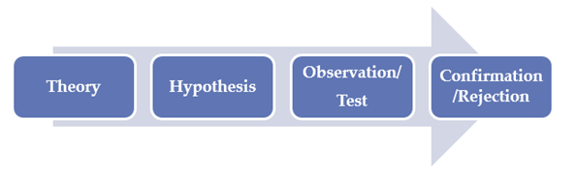

Figure 1 Deductive Approach

Also, deductive approach can be found through surveys, experiments, statistical analysis and content analysis. There are three methods under this approach, qualitative, quantitative and mixed method. The first method, qualitative is known as data collection methods. It focuses more on observations, interviews, focus group, surveys and secondary research (Bhandari, 2023). One of the benefits of applying qualitative method in a research is because it is possible to comprehend experiences and context more deeply (Cleland, 2017). As for the second method, the quantitative method is to collect and analyse numerical data which can be used to identify trends and averages, formulate hypotheses, examine connections, and generalise findings to larger populations. Therefore, the benefits are known in large samples which allow researchers to make predictions and generalization larger and universal populations (Gcu, 2021). Lastly, the combination of quantitative and qualitative methods enables to help gain a more complete picture of study as it integrates both methods (George, 2023). As it combines with two methods, it can give a stronger evidence as well as clear results.

In relation to the topic and based on the evidence found, mixed method is apply. In Figure 2, it is seen that there was a data stating the impact of using technology in classroom. It can clearly observe that the students who use laptops and tablets in the classroom got worsen in achieving the grade compared to those who do not. As seen in Figure 2, laptops used by the students were scored five points lower on the math assessment, yet there is no specific result in science and reading socred. This goes along with the use of tablets, whereby, most of the students who use it in the classroom gets half mark.
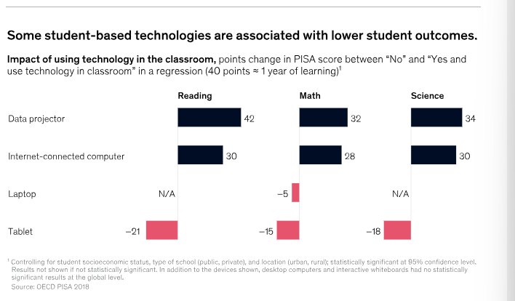

Figure 2 Data of technology impact in the classroom

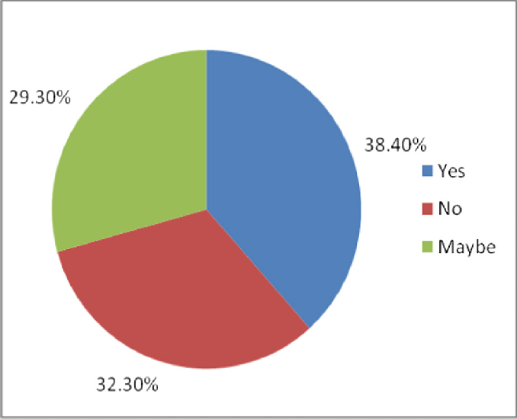
Moreover, there was a poll made to get the relevant statistical data at Ryerson University back during the Covid-19 pandemic. It is then found that there are 62% of students and 76% of faculty believe that online learning give negative impact on education quality (Kristin, 2020). In figure 3, it is a result of students giving opinion on the negative impact of smartphones on the study. There were 38.40% students agreed on the decision, as for another 29.30% students were unsure. In conclusion, the use of technology hinders academic performance.

Figure 3, Percentage of students’ opinions on the negative impact on the study

The evidence found can also prove that most of the observations, surveys or experiments are went through by secondary data. Secondary data is known when the data collected by someone else earlier (Research Guides: Public Health Research Guide: Primary & Secondary Data Definitions, n.d.). The benefit of finding out more in regards to the chosen topic via surveys, experiments and more is to get a more updated statistical data, low costs, and it is the fastest way to get the results due to the today’s mobile and online tools advancement (Gaille, 2020). As seen in previous figure 1,2,3, the negative impact of technology on students has been observed or data were collected by researcher before.

Last but not least, according to (Sample Size and Power, n.d.), sample size refers to the quantity of subjects or observations that a study includes. Usually, n is used to indicate this number. Two statistical aspects in sample size are the accuracy of our estimations, and the study's ability to make conclusions. Therefore, there are only 30 sample size to be tested in this research. The reason 30 samples of people are big enough for this research due to it results in a more thorough representation of a histogram that enables to see the data's underlying distribution (Bizpi, 2021).

Task 2- Research Techniques

Firstly, primary research is known as a self-conducted research method whereby the purpose is to gather data and provide new queries with new answers (McCrocklin, 2022). In addition, primary research is more likely to known as a time-consuming as well as it can be a high-cost research method compared to the other research. Additionally, primary research is also known to be one of the research methods that uses more resources than secondary. In relation to this, the research is done through google form as that is the most used app and it has no limitations as well as it is cost-free. The link below is the result for the whole research.

Moving on, as for secondary research, it is known whereby all the observations were done or conducted by others. Most of the informations are already available online, academic databases, published books or journals and etc (McCrocklin, 2022). The negative impact of technology in educational development on student’s research is done through survey. In accordance to (What Is a Survey? Benefits, Tips & Free Tool - Qualtrics, 2022), survey is about gathering information by listing out all the relevant questions and giving it to a few samples of people. Other than that, it is easier to do survey is because it is more selective, in other words, it helps to reach specific target demographic. In terms of the literature review, this research refers to other researcher’s survey, observation, university research or report. Most of the references from secondary research goes along or support the questionnaire or survey conducted and given to these 30 people.

https://forms.gle/jupD7RmeEiGJt5Vk7

https://docs.google.com/forms/d/e/1FAIpQLScVK6GowfCHFHHaGfiYkyFFxS9RAM1COnCgzu-3fkH4G14zkw/viewanalytics

Task 3- Presentation on Ideas

Presentation skills are vital because it will help us for future careers and so much more. With good presentation skills, it can lead to self-confidence, improvise communication skills and etc. However, not everyone enjoy presentation as it can be stressful and nervous to do but there are several elements that people can do to improve presentation skills, be more active in classroom presentations, meetings, conferences or interviews and always be prepared with proper outline and structure. In reference to the comment received regarding the elevator pitch, I need to improve in terms of sizing the pictures or diagrams in the slides as it will make it easier for other people to read it clearly. Other than that, I have to improve my time management during my presentation because the longer it is the harder or the more audience will lose interest to focus. In other words, I need to well-organised my slides more proper in order to ensure audience get my presentation.

Task 4- Data Analysis

To conclude, technology do give a lot of advantages on educational development on students in which they help them to do less work due to the high convenience. However, technology does have a dark side, and we must be aware of it because when it is misuse, it can cause unfavourable consequences. Therefore, this research specifically is an indicator to prove how dangerous or harmful technology can be to the students. With that being said, by doing this research and conducting surveys to get more updated and honest feedback from people around showed some accurate or reliable data to compare with secondary research. In the end, students need to learn on how to balance the use of technology with study life and never make technology as a center in people’s lives.
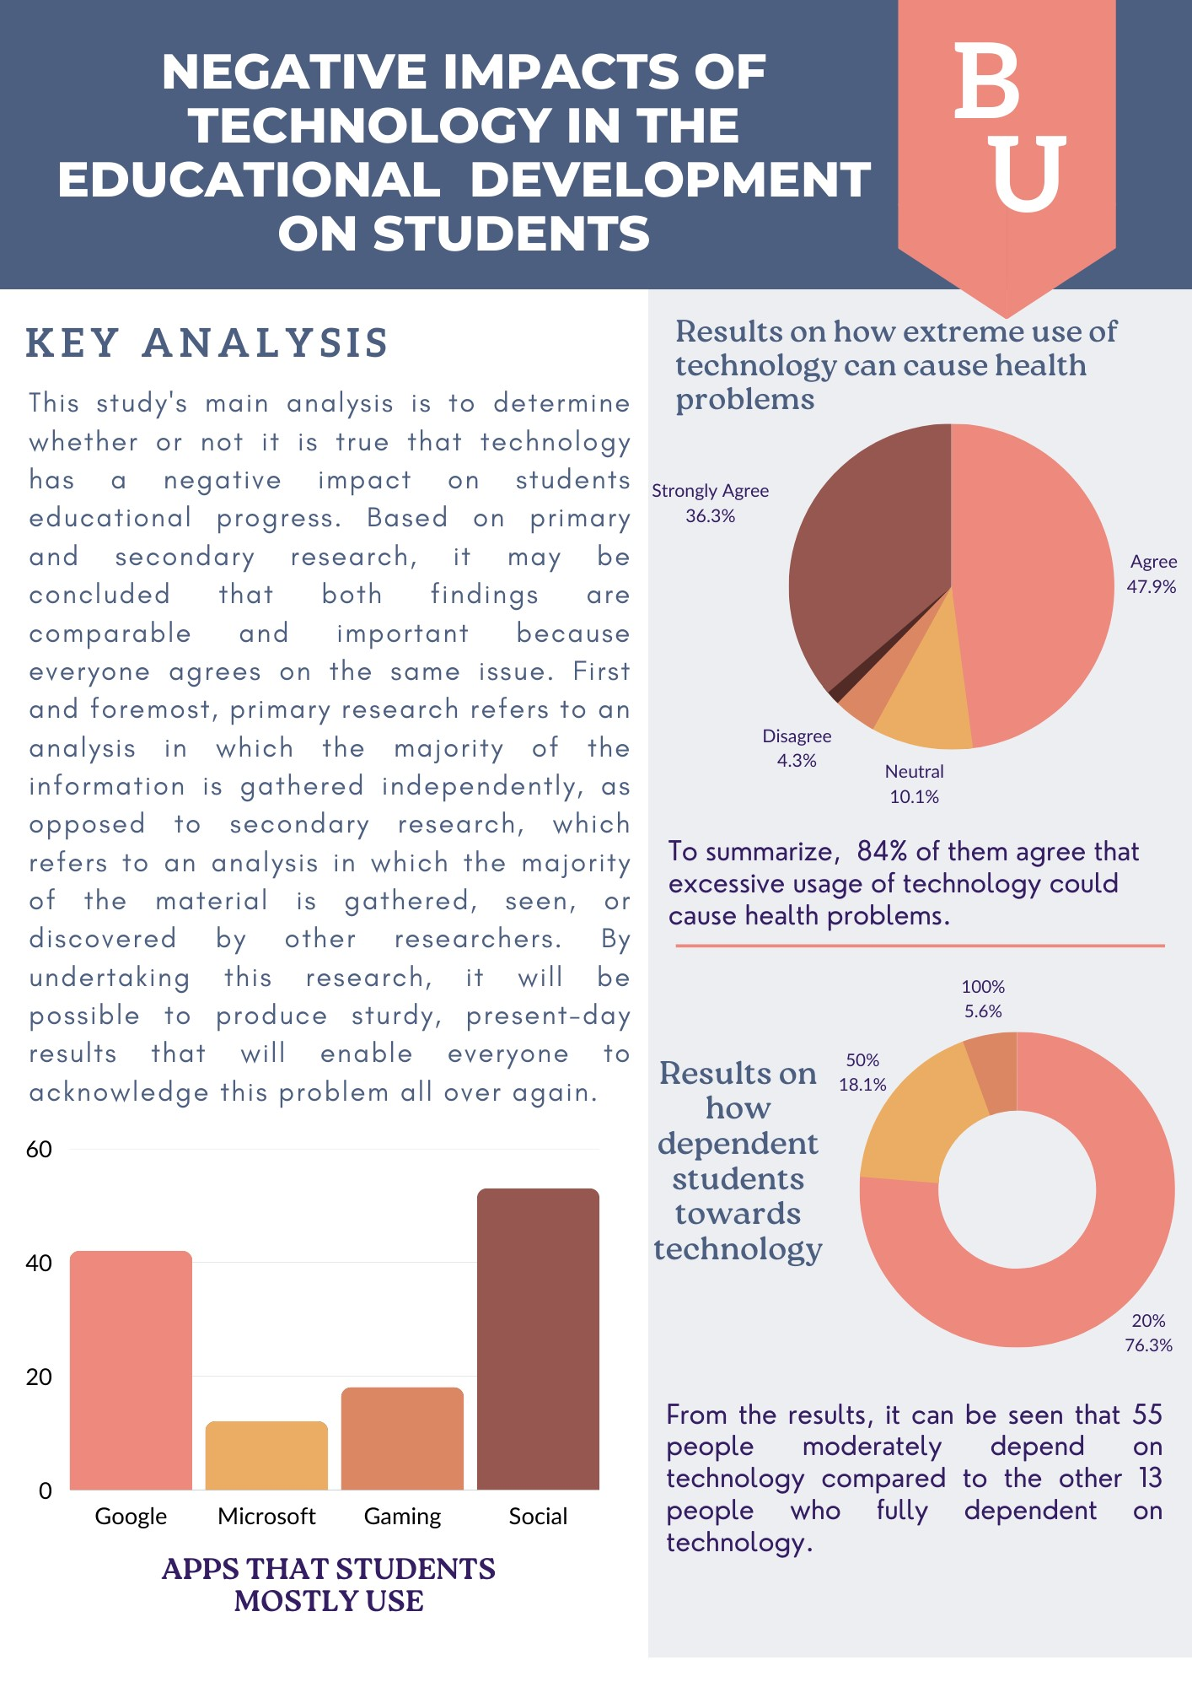

Figure 4
Conference Poster

References

- GeeksforGeeks. (2022). Impact of technology on society. GeeksforGeeks. https://www.geeksforgeeks.org/impact-of-technology-on-society/
- Sharaievska, I., McAnirlin, O., Browning, M. H., Larson, L. R., Mullenbach, L. E., Rigolon, A., D’Antonio, A., Cloutier, S., Thomsen, J., Metcalf, E. C., & Reigner, N. (2022). “Messy transitions”: Students’ perspectives on the impacts of the COVID-19 pandemic on higher education. Higher Education. https://doi.org/10.1007/s10734-022-00843-7
- Qurbani, W. (2022, July 31). Negative impacts of using technology in higher education. Pressbooks. https://pressbooks.pub/techcurr20221/chapter/impacts-of-using-technology-in-higher-education/
- Singh, A. (2022). One-on-One Teaching : The Right Method To Accommodate Diverse Learners? University of the People. https://www.uopeople.edu/blog/benefits-of-one-on-one-teaching/#:~:text=What%20is%20One%2Dto%2DOne,more%20interaction%20with%20less%20distractions.
- Deductive approach (Deductive reasoning). (n.d.). Research-Methodology. https://research-methodology.net/research-methodology/research-approach/deductive-approach-2/
- New global data reveal education technology’s impact on learning. (2020, June 12). McKinsey & Company. https://www.mckinsey.com/industries/education/our-insights/new-global-data-reveal-education-technologys-impact-on-learning
- Kristin, R. Q. P. B. (2020). Most university students and professors say online learning has ‘negative impact,’ new survey finds. Toronto Star, 1. https://www.thestar.com/politics/provincial/most-university-students-and-professors-say-online-learning-has-negative-impact-new-survey-finds/article_6abf32ea-5391-5253-b88e-2f52056b06a6.html
- Research Guides: Public Health Research Guide: Primary & Secondary Data Definitions. (n.d.). https://researchguides.ben.edu/c.php?g=282050&p=4036581#:~:text=Primary%20data%20refers%20to%20the,collected%20by%20someone%20else%20earlier.&text=Surveys%2C%20observations%2C%20experiments%2C%20questionnaire,journal%20articles%2C%20internal%20records%20etc.
- Gaille, L. (2020, January 10). 20 Advantages and Disadvantages of survey research. https://vittana.org/20-advantages-and-disadvantages-of-survey-research
- Fig. 2. Percentages showing students’ opinions on the negative impact. . . (n.d.). ResearchGate. https://www.researchgate.net/figure/Percentages-showing-students-opinions-on-the-negative-impact-on-the-study_fig2_333304840
- Singh, R. (2023, July 10). Positive and negative impacts of technology on education. Tech Baji. https://techbaji.com/technology/positive-negative-impact-of-technology-on-education/#:~:text=One%20negative%20effect%20technology%20has%20had%20on%20education%20is%20that,also%20allow%20students%20to%20cheat.
- Sample size and power. (n.d.). https://www.iwh.on.ca/what-researchers-mean-by/sample-size-and-power#:~:text=What%20is%20sample%20size%20and,the%20study%20to%20draw%20conclusions.
- Bizpi. (2021, March 6). Why do we need 30 data samples? – Business Performance Improvement (BPI). https://www.biz-pi.com/why-do-we-need-30-data-samples/
- Bhandari, P. (2023). What is qualitative research? | Methods & Examples. Scribbr. https://www.scribbr.com/methodology/qualitative-research/
- Cleland, J. (2017). The qualitative orientation in medical education research. Korean Journal of Medical Education, 29(2), 61–71. https://doi.org/10.3946/kjme.2017.53
- Gcu. (2021, June 7). Why is quantitative research important? GCU. https://www.gcu.edu/blog/doctoral-journey/why-quantitative-research-important
- George, T. (2023). Mixed Methods Research | Definition, Guide & Examples. Scribbr. https://www.scribbr.com/methodology/mixed-methods-research/
- McCrocklin, S. (2022). Primary vs. secondary research. GeoPoll. https://www.geopoll.com/blog/primary-vs-secondary-research/#Primary_Research
- What is a Survey? Benefits, Tips & Free Tool - Qualtrics. (2022, July 11). Qualtrics. https://www.qualtrics.com/au/experience-management/research/survey-basics/#:~:text=A%20survey%20is%20a%20method,understanding%20populations%20as%20a%20whole.

