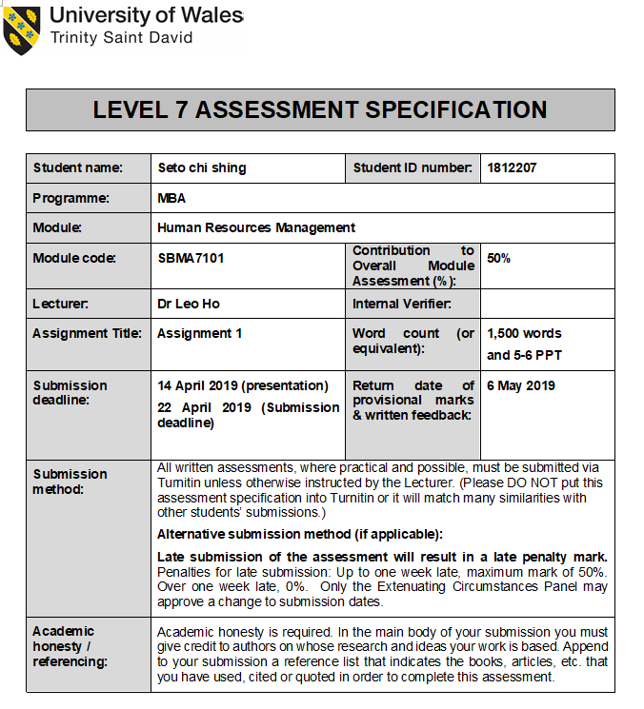

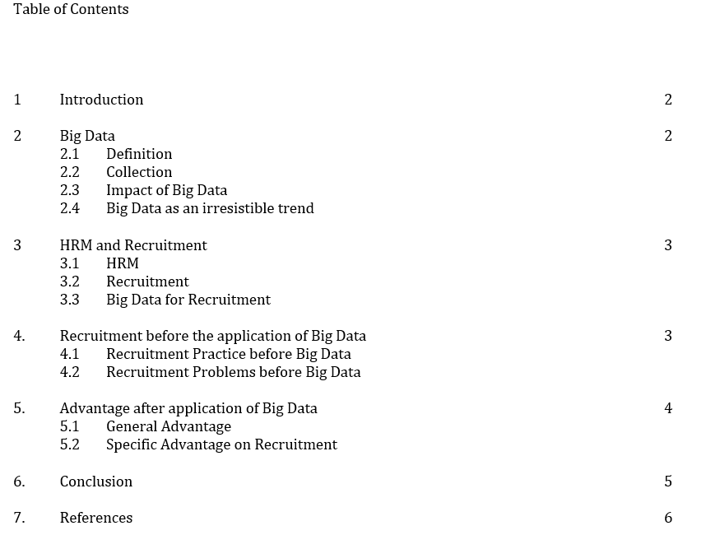

1

Impact of Big Data on Recruitment in Human Resources Management (HRM)

1. Introduction

With the irresistible advancement of modern technology, our life has been changing rapidly. In terms of the commercial world, regardless of the size of the entity, the impact of technology is unavoidable. In the below, we are going to analyze the impact of Big Data technology on Human Resources Management, specifically on Recruitment area.

2. Big Data

2.1 Definition
Big Data is a method of collecting a very large volume of data from various sources for analysis, with a purpose to come out with useful information and values, resulting in better our planning and strategies in all areas.

2.2 Collection
Big Data is to be collected from various sources, such as government agencies, internet service providers and commercial organizations. Many of our personal data, commercial data and government data has been collected and be categorized in the Big Data database.

2.3 Impact of Big Data
Big Data is a database containing huge amount of data of various areas. When someone, company, school or government needs to make a decision or policy, they can retrieve the relevant data. Through analyzing the related data, we can come to a result based on facts which are supported by a comparatively boarder base. Therefore, the conclusion we draw will be more objective and convincing. It is crucially important for many huge organizations.

2.4 Big Data as an irresistible trend
“”Big Data” is not just a concept, is actually a description of a state of society. In the era of big data, data become important social resources and production data, how to open, collection, preservation, maintenance, management, integration, analysis, Shared data, is a joint project of the enterprise, government, through the analysis, data mining can acquire new knowledge, can create value, study, work, production, investment, finance, management cannot leave the data, everybody to collect data, using data, the management of society, business need to use more advanced technology to deal with huge data. Who owns the data, master data, data and application integration and who is occupying the important status in the society.”
(Research of Big Data Driven Media Industry to Enhance the Effectiveness of Human Resource Management, The Open Automation and Control Systems Journal, 2015, 7, 2107-2110, Yunyan Liang)
“The application of data analytics to improve efficiency and effectiveness is a growing trend in business (Acito & Khatri, 2014)”

2
3. HRM and Recruitment

3.1 HRM
The main responsibility of HR is to manage the staff effectively and maximize staff performance, which benefits the organization in return. HRM is composed of different areas, such as recruitment, dismissal, payroll and compensation, staff planning, training and development and all sorts of data entry processing.

3.2 Recruitment
One of the functions of HRM is to perform Recruitment process for the company. It is the process of finding and hiring the best and most qualified candidate for a job opening, in a timely and cost effective manner. Recruitment procedures include advertising vacancies, hiring, conducting job interviews, performing background checks, reviewing application documents and screening. It plays a very crucial role in an organization because it is involving all the details of each personnel, while each personnel are contributing to the success or failure of a company.

3.3 Big Data for Recruitment
If the HR manager can be equipped with essential tools, which can maximize the effectiveness and efficiency of the recruitment procedure, as a result, it will be beneficial to the company. Big Data, as a new trend, is definitely bringing breakthrough to the traditional recruitment procedures.

4. Recruitment before the application of Big Data

4.1 Recruitment Practice before Big Data
Company may conduct their recruitment processes their own way, without a system or set guidelines in place. There is a high chance the company would incur more expenses than it should have. The common practice is the HRM would react in all the manual way whenever there is a vacancy. The main purpose is to fill up the space with the best candidate as soon as possible. Undoubtedly, the HRM would try their best to make sure the candidate they choose is the best choice. However, with everything performed by the most primitive and traditional way, there would be risk of failing to make the best decision on choosing on the right candidate.

“Currently, information on supply and demand in the labor market is stored electronically as CVs in the form of text databases. These semi-structured data typically come from portals and recruitment sites. But there is a huge amount of information on social networks, collaborative platforms of universities and specialized forums. This data is unstructured.”
(Exploring Data in Human Resources Big Data, Database Systems Journal vol. VI, no.3/2015, Adela BARA, luliana SIMONCA (BOTHA), Anda BELCIU, Bogdan NEDELCU Academy of Economics Studies, Bucharest)

4.2 Recruitment Problems before Big Data
Without Big Data, company tends to make their decisions based on simple, internal and standard information. For example, the resume being handed in by the candidate, results from the interviews and basic background check of the candidate. All these information are carrying subjective elements in it. The package offering to the candidate will also be mainly based on the narrow result of research. The company may end up choosing the wrong or unqualified person, which will create problem for the company in a long run. Not only it will be a waste of its resources in training, the worst part falls in the consequences of having the wrong person in the wrong place. The cost of dismissal sometimes can be unexpectedly huge.
3

5. Advantage after application of Big Data

5.1 General Advantage

With Big Data, HRM can access to a broader database with more comprehensive information for analysis purpose. Generally, Big Data is stored systematically in software format. The retrieve is easy and categorization is clear. When the user needs to retrieve data, he or she only needs to input certain key terms and all the relevant information will be provided systematically and efficiently.

For HR manager, firstly, company data can now be stored in a more systematic manner. Secondly, when retrieving information, it will not be as difficult as before. In a timely fashion, HR manager can have a full understanding of a broad quantity of data to the specific topic he or she requires.

5.2 Specific Advantage on Recruitment

5.2.1 Compliance with employment polices and laws
There are various rules, laws and regulations that a company must comply with in terms of recruitment, such as equal opportunity employment and non-discrimination in hiring. With the assistance of Big Data, no matter how much the company is expanding globally and how many new roles are emerging, HRM can easily manage and make sure the hiring process and result is in compliance with the laws required. Big Data is representing a big database providing all necessary data and information, protecting the interest of the HRM and thereby the company through the recruitment process.

5.2.2 Salary structure
If a company is known to give higher salaries, it will usually attract more applicants and vice versa. With the higher salary package, there usually comes with more choice on stronger candidate. Salary itself also contributes a high proportion of a company expense. Therefore, for a company to set a suitable salary range to itself is vital. With Big Data, there will be uncountable salary sampling from all sources. Relevant information can be retrieved in a timely fashion and HRM can therefore set up a salary range for the vacancy, resulting in the best result for recruitment both for the candidate and the company. Such salary decision, being presented in an objective manner, supported by data, will be convincing to both management and employee.

5.2.3 Staff planning and growth rate
For global organization, HRM needs to look after the company growth both locally and globally. The company will be highly beneficial if Big Data is being applied, where it can help greatly in making decision on staff planning and study on growth rate by referencing the data of other global organizations. With a thorough understanding on company staff planning and growth rate, HRM can make good decision on recruitment policy accordingly.

5.2.4 Job description analysis
Conduct a job description is a very initial and basic step before recruitment. It is also a step with huge impact on both the candidate and the company, which can easily be overlooked. A job description also carries a weight on overall staff planning. Therefore, it is crucial to get this significant part right. With the assistance of Big Data, HRM can reference to the job description sample of the other companies of the related industry. By summarizing the experience of others, deciding on the most suitable job description for each recruitment case.

4
5.2.5 Qualification assessment
In a traditional way, we hire our candidate with the right match of qualifications. For some professional and standardized positions, it is an easy match, such as medical doctor, lawyer and accountant. For some other qualifications with broader sense, such as MBA, Information Science and Mathematics, HRM will be beneficial from Big Data. With a huge amount of data, HRM can summarize the general performance and development of the graduates of these subjects and their career trend. With this statistics, HRM can make better judgment on their choice of candidate through recruitment and ensure they will fit the need of the role in the company.

5.2.6 Recruitment advertising
When there is a vacancy, HRM usually will advertise through a few channels: networking, word-of-mouth, career fairs, internal posting, print and media or recruitment agency. When making decisions on the use of channels, Big Data can provide great help for HRM by providing the recruitment data of these areas. For different category of job, there are advantage and disadvantage with various channels. Even through recruitment agencies, there are different varieties of specialty existing.
In a study published by Meisha Rouser, it appears that, in 2012, more than 36.6 million workers or employees found their jobs through various social media platforms such as Facebook, Twitter and LinkedIn.
Big Data tells the company the main directions in all aspects for recruitment process.

6. Conclusion

By comparing the time before and after the application of Big Data, we can see its impact on Recruitment. Overall, with the reference to a broader database, it has a tremendous positive impact in enhancing the effectiveness and efficiency of recruitment process. The previous defects of traditional method have also been resolved by the Big Data age. To conclude, Big Data has been bringing unprecedented positive impact to Recruitment procedures.

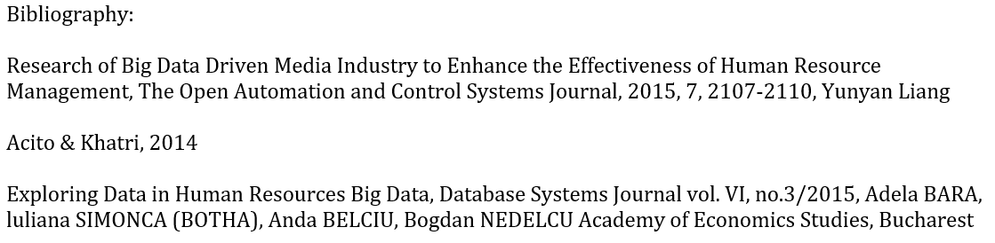
5
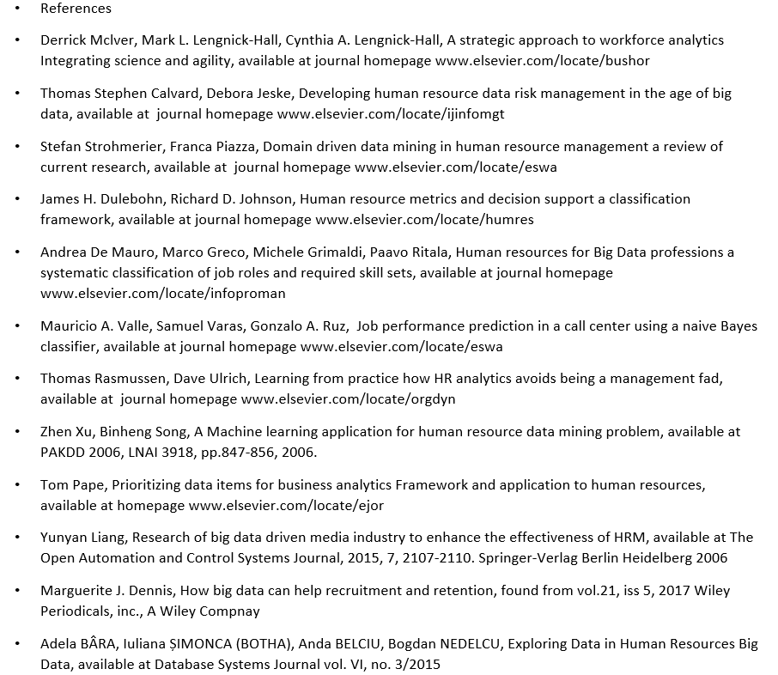

6

