Assignment Submission Form / Ffurflen Cyflwyno Aseiniad
WIWBL Copy
Student Number: 1922505

Student’s Name: Walt Fritz

Tutor Name: Debbie Winter

Assignment Title: Extended Work Based Learning Project

Module Code: BMPF7010

Submission Date: 2 September 2024

Your work will not be marked unless it is accompanied by this statement.
I confirm that this is my original work and that I have adhered to the University’s policy on plagiarism.
Student’s Name: Walt Fritz Signature: 

WIWBL Staff only
Received by:_____________________Date submitted:____________________

Student Receipt
Student Number: ______________________________________________

Student’s Name: _______________________________________________

Tutor Name: _________________________________________________

Assignment Title: ______________________________________________

Module Code: __________________________________________________

Submission Date: _____________________________________________

WIWBL Staff only
Received by:_____________________Date submitted:____________________

Wales Institute for Work Based Learning
BMPF7010
Walt Fritz
Student ID 1922505
2 September 2024

Gaging clinician satisfaction with the person-centered, shared decision-making approach to manual therapy (MT) with voice and swallowing disorders.

Proposal

Background
Throughout my program at UWTSD, my course of research has been directed towards refining and better defining components of a person-centered model of MT that I teach to clinicians. Before beginning this program, earlier interpretations of these methods were included in my continuing education seminars, taught to speech-language pathologists (SLPs) starting in 2013. I now see that those early concepts were crude attempts at explaining a complex process. Armed with a deeper understanding of how another person responds to MT-style touch and how their responses to taking responsibility for their care have influenced treatment outcomes, I’ve updated my curriculum. Though the informal feedback received from learners regarding integrating the approach into their treatments has been positive, the feedback is only in the form of general course evaluations completed immediately at the end of each seminar. No data has been collected (or requested) to gauge the quality of their experiences in the clinic and how this new information has allowed them to evolve as clinicians. This project probes deeper, looking for details my shorter course evaluations could not gather.

My approach contrasts sharply with existing models of manual therapy in the SLP field (Dehqan, 2020; Marszałek et al., 2012; Rubin and Lieberman, 2002), with these and other author’s work having published validity. My method differs from traditional MT with voice and swallowing in two ways. First, the hands-on aspects are slower, less aggressive, and provide sustained input compared to traditional MT. Second, the patient is seen as an equal and capable of giving valuable input throughout the evaluation and treatment. Such a shared decision-making (SDM) approach differs from the clinician-as-expert approach taken by most traditional MT models, where the clinician is tasked with determining problems and implementing solutions. With my approach unpublished, it is incumbent on me to produce data to support my claims.

Purpose of Research Activity
To determine end-user (typically an SLP) experiences from adding a person-centered, shared decision-making model of a slower, less aggressive, and sustained model of MT into their interventions. As it was the intended desire that treatment outcomes from this approach improve (objectively measured and subjectively reported by the SLP), this project will survey SLPs who have taken one of my seminars since to gauge these experiences.

Research Question
To what extent have my courses changed the clinical encounters of the SLP end-user who utilizes this work?

Aims of Research Activity/Learning Outcomes of This Project
- To determine the value of my courses to the end user SLPs and their patients.
- To determine how the content from my courses has become embedded into the practice of the end user SLP.
- Consolidate SLP feedback to determine the utility of this approach and identify areas in need of change.
- To modify my model to maximize value to the end user SLP and to add the potential for greater change to the patients they serve.

Methodology
A design-based research model will be utilized to evaluate the survey results and filter them back into my “product,” my continuing education seminars. These updates will allow my product to be better accepted by the governing body I rely on to grant continuing education approval to my end-users (ASHA, or the American Speech and Hearing Association), to SLPs interested in taking future classes, and to the ultimate end-user, the patients those SLP serve.

Using a mixed-methods design, a combination of a quantitative 5-point Likert Scale (Awang, 2016) and qualitative free-text (Abraham et al., 2020) survey will be distributed to graduates of my live seminars (2020 and later) to gauge their a) satisfaction and experiences applying the person-centered MT concepts taught in the classes, and b) their satisfaction and experiences applying the slow, gentler, and lingering style of MT services taught in the seminars. These questions would include:
- The initial questions would determine if the end-user had previous experience applying a different model of MT before taking my training. If yes, I would collect their feedback to ask if they felt one model (traditional aggressive, minimal to non-SDM version or my model) had characteristics that made it more desirable in terms of ease of use and patient outcomes. Through individual responses, I would be able to extract trends to record the perceptions of the efficacy of this model regarding the ease of implementation of this model and personal perceptions of its advantages and limitations. In this scenario, I will compare previously held experiences and opinions from the more traditional form of MT (minimal to non-SDM and a more aggressive input style) with my model.
- If the end-user had no prior experience using MT with their interventions and, if none, collect data to determine the relative ease or lack of ease in incorporating this model into their daily interventions. Through individual responses, I would be able to extract trends to record the perceptions of the efficacy of this model regarding the ease of implementation of this model and personal perceptions of its advantages and limitations. I would be surveying feedback on the ease and apparent effectiveness of using the SDM model and using a slower, gentler, and lingering style of MT.
- No matter the end user’s experience with MT, the survey would determine the patient’s feedback regarding the intervention style. Did the patient feel heard and respected? Were they surprised at the level of input they were requested?
- No matter the end user’s prior experience with MT, the survey would help determine whether the person-centered model taught from the perspective of MT was transferrable to the more general intervention methods used by the SLPs who had taken my class.
I plan to use a survey consisting of a Likert-style scale and free text commentary to poll past class participant on how my course has influenced their practice. This data will be analyzed and reported in the final paper. The data will then be translated into changes in my future classes to maximize benefit and value for the end user SLP and the patients they serve. Additionally, I anticipate the study outcomes will incentivize further research into the model.

Participants
Participants will be secured by contacting SLPs who have taken my class since 2020 through the start of the survey (August 2023). The 2020 inclusionary date was chosen as my courses underwent a significant update during that year and became more aligned with my current thinking. As not all the SLPs attending my seminars have been trained in any form of MT, I will explore the experiences of both groups: those with prior training who added my model and those with no previous experience who implemented my model as a first experience. Each will be contacted via email via a direct email list procured through an opt-in process. Additionally, to reach those whose email may have changed since it was supplied to me, an appeal will be made through social media for feedback from this identical demographic group.

With this information available, a more objective understanding of the utility of my model will be realized. It is hoped that such information would lead others to pursue quantitative and qualitative research into this person-centered model of MT care.

Ethical Considerations
A fundamental philosophical dilemma exists if the views of my end-user conflict with my views (Reeves et al., 2005). With the goal of this project being a positive evolution of my teaching model, I must lean into deciding for changes (or lack of) that best benefit the patient, even if they conflict with my core beliefs. These beliefs have not been externally vetted, and this project serves that purpose.

Protection of patient confidentiality will be assured through a written request for no patient-identifying characteristics in the free-text sections of the survey. Any potential confidential information or identifiers will be anonymized or omitted from the final paper. Though the initial pool of SLPs asked to participate in this study will be known, respondents' privacy will be assured using an anonymous online survey tool. Survey results will be stored on this researcher’s private password-protected computer, with data stored in a secure HIPAA-compliant cloud-based platform (Dropbox Professional).

As the model I taught end-users originated, insider researcher concerns must be addressed. Fleming (2018) addresses the concerns of insider researchers and helps resolve these issues. Fleming’s principles will be used throughout this project, including recognizing the influence of bias, where respondents may filter their opinions, knowing their comments are reflected directly onto me. I will work to avoid data contamination (Fleming, 2018, pg. 313) by requesting respondents answer the questions without regard for my feelings. I will add to this assurance by reminding them that their responses are gathered and analyzed via an anonymous survey tool.

Methods
Methods for information acquisition include an integrative literature review (Torraco, 2016) to uncover strengths and stumbling blocks of my model, an examination of the survey respondents’ views, and self-reflection to incorporate these views into new incarnations of my approach. The opinions and feedback of respondents will be compared to my professional goals to allow one not to overshadow the next. I may discover aspects of my approach that respondents feel need revision. Some feedback will result in changes to my curriculum.

Such a mixed methods design (Ryu, 2020) will allow current perspectives from the existing literature, individual perspectives and experiences from end-users, and triangulation with my personal and professional goals to coalesce to evolve my teaching model.

An expected timeline for this project is as follows:
July 1, 2023: Approval from my tutor for this research proposal and begin project.
August 1, 2023: Surveys distributed to potential respondents.
September 1, 2023: Deadline for surveys to be returned.
Program pause initiated: September 22, 2023
Return to studies: April 1, 2024
December 4, 2023: Draft submission.
January 1, 2024: Finished project presented to tutor.

Table of Contents
Introduction 9
Literature Review 11
Methodology 20
Findings 22
Conclusions 60
Appendix 1: Ethics Form 62
Appendix 2: Original Survey 85
Appendix 3: Survey Results (PDF) 85
Appendix 4: Survey Results (Excel) 85
References 85

Gaging clinician satisfaction with the person-centered, shared decision-making approach to manual therapy (MT) with voice and swallowing disorders.

Introduction
The research question presented here is to be examined from the results of the surveyed material that forms the foundation of this paper. The purpose of this study is to allow me to explore aspects of my work not covered in previous papers in this academic program, with a long-term goal of translating these discoveries to improve the quality and utility of my course work to benefit both the end user and the patients they serve.

My original undertaking of this MA program was to build a more academically credible narrative to ground the course work I teach to speech-language pathologists (SLP). I've established that foundation through earlier papers (Fritz 2020, 2021, 2023). However, in reviewing those previous papers in this program and considering the overall research question to be answered, unanswered questions remain.

Do the changes I made in my curriculum represent an improvement on existing models, or are they just a different translation with similar outcomes? I have previously examined the history of the development and explanation of manual therapy’s effects within the speech-language pathologist (SLP) population and compared that evolution with that seen in the more general manual therapy community. I have discussed perceived limitations and gaps in existing models of laryngeal manual therapy (LMT) and proposed alternatives and improvements to update them to align with current standards in the general manual therapy (MT) communities (Fritz, 2020; Fritz, 2024). Left unanswered is whether there has been an advancement of outcomes vs. another interpretation of existing models.
Though I teach SLPs a broader perspective on the potential mechanism of action for MT, do they add value to the interventions? A universally accepted narrative of the mechanisms of action for manual therapy with voice and swallowing disorders does not exist, though there are many firmly held positions (Fritz, 2024). Historically, authors narrow their explanations to a few traditional tissue-based or pathology-based perspectives. Still, with the literature composed of what appear to be completely different models, many may feel confused at the lack of explanation for these discrepancies (Roy et al., 1993; Rubin and Lieberman, 2000; Marszalek et al., 2012; Asher, 2013). With the inclusion of magnetic resonance imaging of the brain before and after LMT (Spengler et al., 2017; Roy et al., 2019), more recent advances have been made in understanding the broader impacts of peripheral touch in the resolution of voice disorders. However, current research perpetuates historically simplistic views of these mechanisms (Toles and Harris, 2023). Given this lack of standardization, reasonable recommendations could be made to attempt to collate these narratives, which, in a recent paper published outside this program, I’ve written on this topic with the hope of sparking others to work to understand and accept a broader range of mechanisms (Fritz 2024). Do SLPs consider these changes relevant, applicable, and valuable to their practice?

Does shared decision-making (SDM) differ from existing LMT models used by SLPs, and if so, does it add value to the therapeutic outcomes? I previously explored SDM inside and outside the manual therapy field (Fritz, 2021). As SDM is at the core of my approach, it became one of the pillars from which the survey questions were stated. Though SDM was examined in the above reference paper, newer material will be presented in the literature review below. Will SLPs find SDM helpful?

This final paper aims to move beyond the theoretical and examine the direct experiences of those applying my approach to gauge the utility and efficacy of the model I’ve promoted.

Literature review

In my previous papers in this program, an integrative literature review model (Torraco R., 2016) was used to explore the underpinnings of core topics that form the basis of my approach, and this paper and study are layered on the concepts established in those previous papers (Fritz, 2020, 2021, 2022). Those previous reviews allow me to examine my findings and conclusions through the lens of newer information, forming a state-of-the-art review (SotA) process (Grant, 2009; Barry, 2022). Since the conclusion of my last paper in 2022, additional resources were presented to me that have caused me to reflect on the need for changes and bolstered my beliefs in the validity of my approach. As these resources were not obtained through a more rigorous literature review, I questioned my biases in their inclusion. However, Barry (2022) permitted me to see my opinions in reviewing these new resources as one based on subjectivism, as "(t)he SotA review generates an interpretation of the data that is informed by the expertise, experiences, and social contexts of the researcher" Barry, 2022, p. 285). While one interpretation of the SotA review process states that the aim is for a comprehensive review of the current literature (Grant, 2009, p. 95), I've deviated from this course with my focus on two pieces of newer literature. As the study survey was formulated and distributed to study participants before acquiring these two new sources (due to a necessary pause in my academic course of studies), there is no recognition of recent findings reflected in the questions provided. This gap will be discussed later.

Manual therapy (MT) is traditionally described as an intervention that affects the peripheral level of tissues or structures, viewing the underlying mechanism of action as occurring peripherally where the intervention is applied (Bialosky, 2018; Kolb., 2020). Such perspectives are "based on biomechanical assumptions at the root of the patient's symptoms, with palpatorily identifiable dysfunctions, that can be treated employing specific techniques aimed at joint tissue, myofascial tissue, or nervous tissue" (Geri et al., 2019, pg.2). Laryngeal manual therapy (LMT) follows a similar line of reasoning, with dysphonia seen as due to shortening of, or increase in tension in the perilaryngeal musculature, poor posture, and structural limitations of hard tissues of the cricothyroid visor (Rubin and Lieberman, 2000, pg. 1022), and a successful LMT intervention as increasing muscle length, diminishing muscle tension, improving posture through alterations in local conditions, and improving movement in the cricothyroid visor (Nasrin et al., 2022). The evolution of MT from its historically viewed local effects to updated explanations has been thoroughly explored and deconstructed in previous papers and through a paper I recently published that examined the gaps in the literature (Fritz, 2020, 2021, 2022, 2024). In that paper, I discuss the multiple mechanisms of action that potentially influence any MT encounter. The new information inserts itself as an additional influencer on therapeutic outcomes and can present a range of possible mechanisms that can help shape clinician behaviors.

Since writing my previous papers, I've been made aware of two concepts that have expanded my understanding of the underpinnings of my approach and caused me to re-examine the core principles of how I treat patients and educate others. Lacking a specific blueprint for including SDM in the MT setting, many mechanics of interpreting and applying SDM in the manual therapy setting were created organically and modified through trial and error. However, as I share my approach with others, I've received input that has validated specific aspects of my teachings and raised questions. These questions were exposed in the previous introduction.
Meta-therapy is a concept that, when applied in voice therapy, explains the effects of clinical expertise (Helou, 2017). Clinicians often see the technique (or modality) as the primary driver of change, but the principles of meta-therapy describe a more extensive process. Helou has written about the concept of meta-therapy as it applies to her work in transgender voice and communication training: "(P)atients can participate in therapy tasks (e.g., resonant voice therapy, flow phonation, or conversational training therapy), but in the absence of a clinical dialogue that helps the patients learn to pin these techniques onto a conceptual framework, the approaches will likely fall short of full effectiveness (Helou, 2019). Looking back at my broad-based MT education and through the feedback of others who’ve shared similar observations, it could be argued such patterns appear to exist across much of the MT field.
Through my experiences, I have seen learners new to MT encounter similar pitfalls. Armed with techniques taught in school, on-the-job training, and continuing education, they often fail to meet the reported outcomes that other, more experienced clinicians achieve. Mastery was stated to be a product of becoming proficient in applying techniques through proper hand placement, correct engagement of the targeted tissues, and other mechanistic processes, with re-taking of seminars recommended to accomplish mastery. The specificity of techniques was implied to be essential, though studies often show the opposite (Behlau, 2018; Cherkin et al., 2013; Kennard et al., 2015).
Even before encountering Helou’s works, I suspected that successful outcomes were more than just developing expertise with the techniques. I began to see that course repetition helped to create a deeper understanding of the context in which the methods were presented and helped me learn the meta-therapy of that modality. Translating these past experiences into how I run my seminars, we immediately dive into the meta-therapy concepts from the start. In speaking about voice therapy, Petty (2022) encapsulated this view of the need to emphasize the meta-aspects of the treatment with "(t)he patient is introduced to both the "what" of therapy—the specific exercises designed to improve voice quality—and also the "how," the dialogue about treatment rationale and expectations for ongoing voice change and ultimate therapeutic success" (p. 1).
An internet search was performed using Google Scholar (scholar.google.com) to explore the concept of meta-therapy through the lens of manual therapy, with the search query “manual therapy” and meta-therapy, with 11 results. One was my paper (Fritz, 2024). Van Stan et al. (2024) mention how two popular methods of LMT utilize meta-therapy for patient inclusion in the MT process by “they have multiple ways of providing error feedback (patient-directed vs. clinician-directed) as well as cueing, educating, and motivating the patient to improve engagement and adherence” (Van Stan et al., 2024, p. 1777), however, fail to discuss those processes. Of the remaining results from the search, the remaining articles were either non-applicable or referred to references discussed below without setting examples of how meta-therapy can be applied to MT. Lacking external blueprints, a discussion of papers within the SLP domain yielded the most information.

Through the numerous papers authored and co-authored by Helou (Helou, 2017; Helou, 2019; Helou et al., 2021) and related works (Tilton-Bolowsky et al., 2021; Donohue and Coyle, 2022; Petty et al., 2022), my comprehension of meta-therapy was refined from multiple perspectives. Through an online introduction, Helou became aware of my approach to manual therapy, where the environment created around the touch-based intervention is often a more critical driver of change than the hands-on work itself. She noted the strong parallels with her work on meta-therapy. The parallels she saw related to my concepts of the conversation surrounding MT, setting the proper context for the empowered patient to play a more prominent role in the therapeutic encounter.

Donohue and Coyle (2022) state that “clinicians can easily state what they do in therapy, but describing the process of how they do therapy can be a challenge” (p. 1). Though often thought of as a skill clinicians learn over time, the authors emphasize that meta-therapy skills can be taught to clinicians to improve the effectiveness of an intervention and hasten the acquisition of that intervention. The authors emphasize the need to increase patient awareness of the involved processes. In the case of their paper, education on the process of swallowing is necessary to incentivize the therapy process (p. 3), which aligns well with my process of incentivizing patient feedback to share in treatment decisions. In a step-by-step fashion, they define the differences in beginner vs. expert dialoguing as concrete examples of how the meta-therapy occurs, allowing contextualization of the process (p. 4). As clear and meaningful conversation and language are essential to my work, the examples provide a template for improving my teaching methods.

Further expanding Helou’s initial applications of meta-therapy beyond transgender voice therapy into work with cognitive communication disorders, Tilton-Bolowsky et al. (2022) speak of the progression of the new graduate SLP’s modeling communication styles of supervisors. Over time, that same SLP can adapt and modify those dialogues to meet the various needs of the person in treatment. They speak of this transition into understanding the “how” of therapy yet is seldom taught in the educational system (Tilton-Bolowsky et al., 2022, p. 2). Encouraging the patient’s active role in their treatment is stressed, and learning to exercise power in the therapeutic process (p. 9) strongly mirrors the approach used in my work. With such self-efficacy, they better make decisions about their care and goals.

Petty et al. (2022) state that meta-therapy “is not the “what” of the treatment, that is, the specific techniques to be learned by the patient, but rather the “how,” that is, the crafted dialogue that guides the patient through the treatment rationale, the behavioral expectations for both clinician and patient and the anticipated outcomes of the therapeutic process” (p. 1). The authors describe the voice assessment process, one that often includes stroboscopy to allow a view of the laryngeal mechanism during speech, as a potential motivator for the patient, as it will enable them to visualize their dysfunctional voice and, with treatment, how the imaging depicts improvements in sounds (p. 3). Such exercises are seen as a meta-therapy process, allowing the clinician to translate therapeutic gains to the patient with tools beyond the auditory awareness of vocal gains. Such methods align with a frequent practice at workshops, where laryngeal visual imaging is combined with MT, allowing learners to witness the internal effects of an externally applied MT process.

Helou et al. (2021) map out similar inclusions of patient self-efficacy as necessary conditions for successful outcomes, allowing the patient to see they have a locus of control over outcomes (p. 12). Such factors enable the patient to see their role in therapy as more than passive. The task assigned to the patient in the SDM-based MT model I teach seeks to leverage self-efficacy, with treatment outcomes dependent on how the clinician frames the treatment process. I consider patient introspection throughout the MT process a significant factor in successful outcomes, with the patient actively involved throughout the therapeutic process. My views align with those seen as parts of the mechanisms of action for successful voice therapy (Helou et al., 2021, p. 7), one I had not included in my recent paper (Fritz, 2024).

In my seminars, I routinely mention that new learners believed they attended the workshop to learn new therapeutic models of impact via touch-based interventions. However, I desired to translate SDM concepts via the envelope surrounding the MT work, as I saw those principles applying broadly across the spectrum of interventions performed by the SLP. Previously, I saw myself as an outlier, asking clinicians to look beyond what others see as the vital components of manual therapy interventions, but with little external validation for such an approach. Helou's writings allowed me to establish and ground this approach not as that of the outlier but as one supported in our current literature.

Helou (2017) was not the first to introduce meta-therapy concepts into the SLP domains and cited earlier writings by Iwarsson (2014), stressing the views that clinical expertise should be taught to the clinician in their education rather than learned over time. Helou's work inspired me by providing a philosophical framework to validate my approach. Instead of relying on clinician trial and error or requiring learners to take multiple seminars to gain knowledge, meta-therapeutic principles are instilled from the first exposure to this work.

Another fortuitous encounter gave me further insight into my process and made me reflect on possible errors and needs for recalibration in my approach. As explained in my previous writings, in efforts to maximize SDM, I strive to elevate patient input. However, patients are often comfortable deferring treatment decisions to the clinician, expressing these thoughts through statements like "Do what you feel is best; you are the expert." Such declarations are joint in physical therapy practice, as, being highly trained in a specialized field, the public sees us as knowing how to help them through their current struggles. Evolving from earlier clinician-as-expert perspectives, I’d begun to downplay my expertise in efforts to elevate patient perspectives. When questioned on why I would defer telling a patient what was best for them, I would confirm that though I am well-trained and have strong opinions based on my training and education, I would then tell them that I've not lived their life, nor can I know what sort of intervention feels like it might be helpful until they give me their opinions. I worked hard to incentivize their input, potentially improving our chances of treatment success. In my seminars, I encouraged learners to hold fast to striving for equality of decision-making, even in the face of patient refusal to commit to such a model. However, another perspective that made me rethink this strategy was presented.

My model was based on ensuring shared decision-making, a standard I sought in every interaction. My understanding of that process, which I had only a rudimentary knowledge of, caused me to run headlong into actioning those principles when a more balanced look at power in the therapeutic relationship was in order.

Throughout my MA process, I've interrupted my studies twice. One was due to a family medical issue, and the second was for personal reasons. It is often said that everything happens for a reason, and, in the case of better understanding the strengths and limitations of my model, this adage is true. Earlier in 2024, I was asked by two SLPs who had attended a past seminar to present a virtual talk to members of the Voice Foundations Southern California Chapter. In the lead-up to that presentation, I had a brief online discussion with one of those SLPs, who shared a paper she had co-written with me. The paper "Self-Determination Theory Applications in Culturally Responsive Voice Therapy" (Castro, Enclade, and Biel, 2023) thrust upon me a rationale that caused me to rethink my position on striving to elevate patient input into the SDM process when their personal choice caused them to choose to defer decisions to the clinician. I did not understand the need to recognize cultural, social, and economic diversity and how it can influence a person's ability, willingness, and sense of necessity of their input into healthcare decisions. I’d also neglected to respect a person’s request to have me choose and decide on their behalf. I had been using basic tenets of SDM as motivation to empower patient input into the MT treatment process with little regard for the individual's cultural biases and perspectives and their freedom of choice. I'd viewed patient motivation as something I could (and should) influence via incentivization without looking into more profound aspects of those norms and values unique to every person and group.

Previously, while researching prior papers and setting up my survey questions for this paper, I anticipated that my study results would culminate in a final refinement of my approach. However, lessons learned from these recent discoveries are unlikely to appear in the data collected for this study. It is anticipated that reflection on the data and subjective impressions from study participants, coupled with a more thorough grounding in the underpinning of my approach via meta-therapy principles and self-determination theory concept, will advance and evolve my work.

While the wording may differ, traditional MT and LMT broadly view the impact of the intervention being accomplished through tissue manipulation, with the "hypothesized physical effect of such massage is reduced laryngeal height and stiffness along with increased mobility. Once laryngeal tension is normalized, and range of motion is restored, an improvement in vocal effort, quality, and dynamic range reportedly follows" (Dromey et al., 2008, pg. 197). While none of the myriad of LMT papers and books published since Aronson (1990) specifically advise or caution against promoting a shared model of decision-making, none state patient input as a necessary condition for change, and little emphasis is placed on the benefits of establishing a therapeutic alliance between clinician and patient. Contrast these views with more recent observations on the improvements in clinical outcomes when the intervention is based on an established therapeutic relationship between the patient and clinician (Miciak et al., 2018). While the nature of clinical relationships continues to vary widely, with operator-driven (clinician-as-expert) models at one end of the continuum and interactor-driven (SDM) models at the other (Jacobs and Silvernail, 2011), the needle is moving away from exclusionary approaches and into more egalitarian, patient-centered ones.

In drawing out the differences between traditional LMT and my SDM-based model, I wish to clarify my biases. I retold history in earlier papers that described my aversion to MT models that did not appear to value elevating patient input into the therapeutic process. My early training encouraged clinical expertise as a desired motivation, and it was established to permit the therapist to become an expert in solving the problems of others. While our biomedical world is firmly set up in such ways, I noted how patients were often disenfranchised from their healing process. They were usually expected to stifle opinions in deference to the expert. My choice to extract myself from such a therapeutic model was an early step in recognizing that disempowerment, and I sought a path to allow for an increased voice for those I serve. Castro et al. (2024) lay out a clear pathway for promoting and establishing patient autonomy by including principles of SDM in clinical practice, with explicit references to my ethics and professional therapeutic approach.

As mentioned in my previous papers in this program (Fritz, 2020, 2021, 2022), my approach is not the typical perspective in traditional MT and LMT encounters. I acknowledge that this historical, clinician-as-expert, non-patient-driven approach has been shown, through years of LMT-published research, to be effective in reducing the problems facing our patients; these models contrast sharply with emerging trends in healthcare that call for increasing patient input (Gustin, 2019; Kon, 2010; Leng, 2017; Moore, 2018; Santana, 2018; Thomson and MacMillan, 2023).

Besides the wake-up call to allow more patient choice, Castro et al. (2023) outline strategies for supporting patient autonomy, competence, and relatedness to support their psychological needs concerning SDM. Comparing those principles with my own, I saw tremendous common ground, bolstering my enthusiasm for the direction of my approach. I view this new information as a better grounding in how I view the SLP feedback gleaned from this study.

Methodology
I undertook a mixed methods design (Ryu, 2020) to allow current perspectives from the existing literature, individual perspectives and experiences from end-users, and triangulation with my personal and professional goals to coalesce to evolve my teaching model.

My survey was distributed, and data was collected from 8/18/23 – 9/1/23, with invitations sent to SLPs who participated in seminars from April 2020 - August 2023. One thousand twenty survey invitations were distributed via previously provided email addresses. Additionally, social media posts were made, inviting qualified individuals to participate. Of the 1020 requests, 53 completed surveys were returned. The survey was intended only for SLPs, and although through the survey responses, two participants identified themselves as professionals other than SLPs. The data from those two respondents were removed, leaving 51 qualified participants.

Before beginning this study, I reflected on the question I wished to answer and the biases that needed to be addressed and discussed, ones that would impact the reach of any conclusions gathered. The cohort for this survey consisted of SLPs worldwide, though most learners reside in the United States. Though all accepted responses came from SLPs, and I am a physical therapist, we share common characteristics as health care providers, and we are interested in expanding our knowledge from what might be viewed as working from the edges in each given profession. In my experience, physical therapists seldom work with voice, swallowing, and related problems, while SLPs often are not exposed to MT as a foundational intervention in their profession. As an expert in the field and understanding my possible influence over class participants, I acknowledge that their feedback does not represent a random sample (Mulisa, 2022). While random sampling would require that any person (or any SLP) could act as a potential candidate for inclusion in this study (any SLP), Mulisa would describe my participant selection as non-random, or, more accurately, a non-probability sampling (Mulisa, 2022, pg. 76). My participants were selected from a small pool of SLPs across the globe, and from within that group, they had the potential to be influenced by my ideals. However, it was this exact group I wished to poll to determine their relative satisfaction from the information I provided, and non-probability sampling was a means to achieve this end.

To further elaborate on issues relating to bias, some of the questions asked requested clinicians to compare traditional laryngeal manual therapy (LMT) and the approach taught in my workshops, Foundations in Manual Therapy (FMT). While an individual’s opinions matter, the clinicians surveyed for this study spent considerable time with me in a 2-day classroom setting. Additionally, my social media (and other) promotional materials could have raised an interest in influencing their decisions to participate in my workshop. Each learner was required to complete my 2-hour online course before sitting for the in-person seminar. During this time, I related my opinions on the different manual therapy (MT) styles to them, including thoughts on how one approach may be more patient-centered than others. Through hearing my views, many may have adopted them as their own, drawing them into my tribe (Kanuha, 2000). As traditional LMT does not work from a patient-centered, shared decision-making (SDM) perspective, my seminars set up a potential dualistic conflict (Kristjánsson, 2021), discussing my opinions on the limitations in the LMT model and expressing my preferences towards approaches that optimize SDM. While I knew they represented a minority of the total participants, those SLPs with prior experience in LMT were asked to compare this approach with FMT.

When creating the questions for the survey, I was fully aware that there are few opportunities for an SLP to attend an in-depth workshop that teaches LMT. Canvassing learners at every seminar, most of whom have had some training in LMT, relate that a peer or supervisor introduced them to that model, and it is rarely reported that they underwent formalized training such as that presented in my seminars. Gleaning from these SLPs that their training in LMT was typically limited in time and scope, I understand that if exposed to a different model, one where they had a financial and time-spent investment (such as my seminar), I would be capable of exerting influence, skewing the objectivity of the comparisons I sought through this survey. Ideally, finding participants in my seminars who had undergone a similar level of training in LMT would have allowed a better metric for comparing the two models. However, this was not possible, nor was it sought. Acknowledging this lack of equality for comparison, I found the questions relevant, with the responses potentially helpful. Given the conditions mentioned above, there is no quantitative data to explore, as even Likert scale ratings are embedded within the above-mentioned biases. The results were intended to guide future practice, not to determine objective analyses of one model’s superiority or whether SDM reflects an improvement over the existing clinician-driven model. While motivations for such guidance are personal, I hope these results may filter into the more general research and practice domains. Combining the Likert scale, yes/no questions, and free-text responses allowed data triangulation (Bans-Akutey, 2021), allowing multiple perspectives on the class content and questions to validate my data.

Within the discussions, as my sample is non-probability, my representations of statistics are not intended to convey quantitative proof but merely to discuss preferences and actions within the sampled group. 1-5 Likert scale responses were converted to percentages, with a response of 1 represented by 0% and 5% by 100%. As my survey was developed based on what I viewed as a logical and linear progression of information, results will be presented and discussed in that exact order. From the open-ended questions, responses were reviewed for themes (Saldana, 2005) to determine patterns to establish overall learner preferences best. The numbering of discussed elements (below) matches those on the survey. After each free-text response, the 1-5 Likert Scale rating is noted as (x). Verbatim free-text responses are posted in bold italics, with my comments on specific responses interspersed as appropriate. Though not fully inclusive, I included a sampling of the free-text responses in this section, as they can allow me to translate my perceptions of responses to the reader. Annotations were provided to some of the responses to establish the repeating themes and to note the strengths and limitations of the survey tool. In the few instances where a response used professional abbreviations, I edited the comment to allow a broader understanding. Redundant free-text responses were excluded, and no attempt was made to make grammatical corrections to avoid altering the context provided in each respondent’s free-text replies.

Findings
1. Did you take the Foundations in Manual Therapy: Voice and Swallowing Disorders Seminar (Introductory or Advanced) on or after April 2020? If not, please answer "NO" and do not complete the remainder of the questions.
This was the initial question to determine a potential respondent’s inclusion in the survey. In hindsight, an additional question would have asked if the respondent was an SLP.

2. Since taking the Foundations in Manual Therapy: Voice and Swallowing Disorders (FMT) seminar, did/do you use the techniques and aspects of the approach taught in the class in your practice?

From the beginning of embarking on providing education for SLPs, one of my goals had been to ensure I was giving helpful information to that audience. In the United States, continuing education is required for regular professional licensing renewal. With such standards in place, it is not uncommon for professionals to choose courses that are easily accessed or more affordable vs. those that provide valuable insight and may require travel or an outlay of personal funds. Was I giving value that my audience would use?
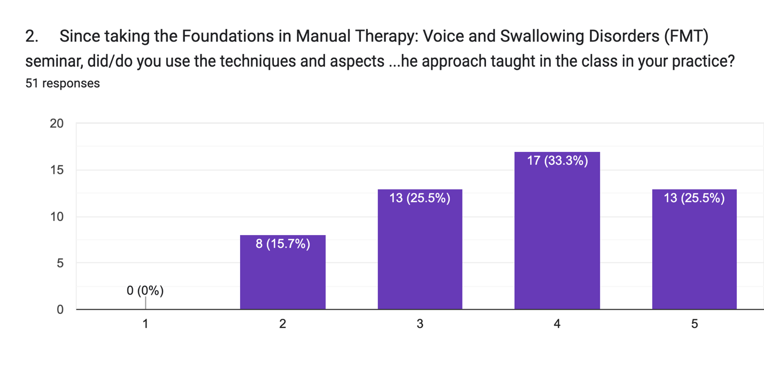There was a 67% rating from 51 respondents, indicating a significant usage of the course content in regular practice. In hindsight, asking participants if barriers kept them from reporting higher usage may have highlighted areas needing improvement.
Not at all
Frequently or daily

3. If you answered “Not at all” to question #1, why don’t you use it? If you answered “Not at all” to question #1, please answer only those questions below that apply.
There were no free text responses from the SLPs who participated in this survey.

4. Before taking the FMT seminar, did you receive any training in your SLP education (undergraduate or graduate level) or through work-based mentoring to use manual therapy interventions?
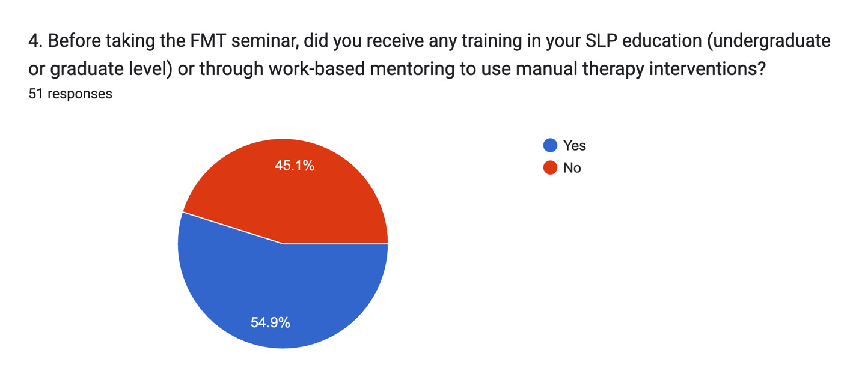
Of 51 respondents, 55% replied “Yes” to this question. This high number was surprising, as when I asked a similar question at every in-person class, I estimated that only 10% answered in the affirmative. This may indicate that those motivated to participate in this survey had more prior training and experience applying manual therapy than the overall attendees in my courses. It might also be speculated that this cohort had higher internal drivers to pursue MT training of any type.

5. If yes to question 3, was your previous exposure to manual therapy from the more traditional laryngeal manipulation perspective?
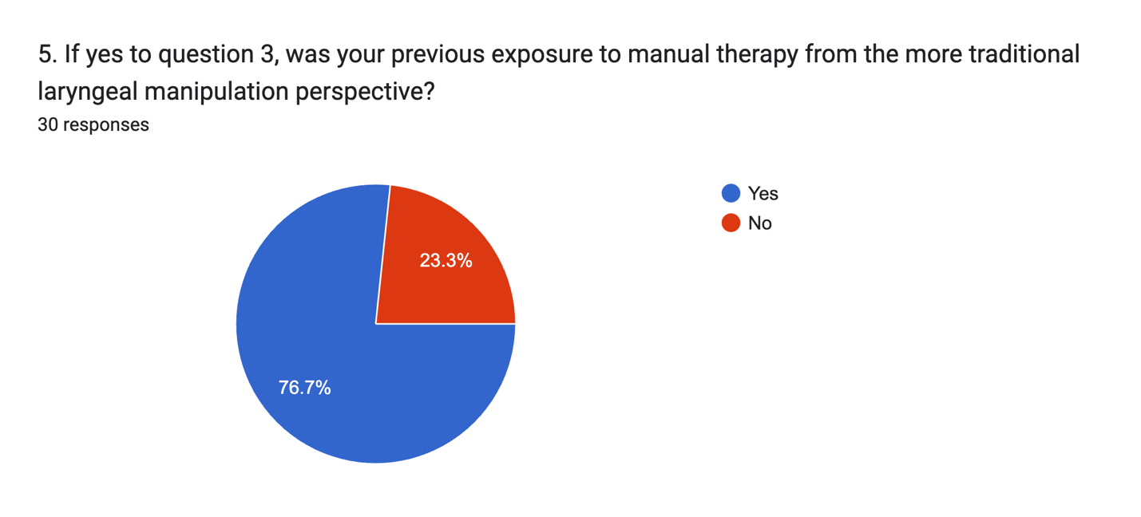
As mentioned previously, more aggressive styles of LMT are the most represented manual therapy intervention mentioned in the literature (Dunphy, 2013), skewing the probability of responses towards this model being what was previously taught. Given the inclusion of clinicians from the UK responding (such demographics were not asked to avoid any ability to identify respondents), some responses may have included a model taught there (vocal massage, Flock, 2023). Of 30 responses, 23 signified that LMT was their original experience. As there were no follow-up questions, the type of training of the remaining 7 participants is unknown. The 23 participants who learned LMT can now be tracked to determine their preferences when comparing their original learning with the FMT model.

Reviewing the question, I failed to query those who answered “No” about the type of MT training they attended.

6. If you did learn traditional laryngeal manipulation at university or on the job, did that training give you the skills and confidence to use it in your practice?

Concepts intended to improve outcomes need to be translatable into practice. Of those who received prior training in LMT, was that training sufficient to be used in practice? The responses were well scattered in the results below, with an obvious mean at the mid-point of the Likert scale. I interpret this as the average previously trained clinician felt only 50% equipped to use LMT in clinical practice. As mentioned, nearly all LMT training in the USA is given informally via peer or supervisor training. Under the correct mentoring, this level of training may be sufficient for some, but from the results, it appears many felt not sufficiently trained. Of note: 35 people responded to this question, which should only reflect the 30 who answered “yes” to question 5. As my survey did not wall off questions based on a previous response, I cannot account for this discrepancy.
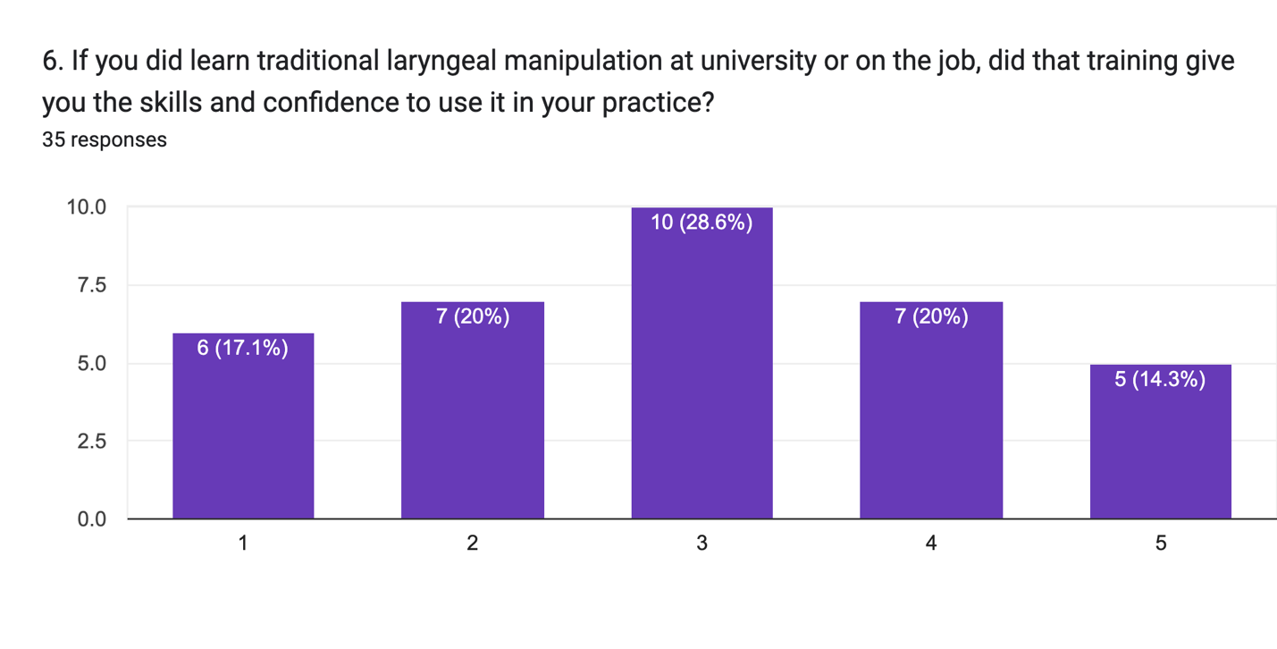
Completely
Not at all

7. Do you have any comments to share regarding your traditional laryngeal manipulation training regarding providing you the skills and confidence to use it in your practice?

A few themes repeated themselves, with negatives from their LMT training, including a lack of in-depth training, fear of harm, unrealistic expectations, and non-lasting effects seen with frequency. Positive comments spoke to patient preferences for that work and that their training adequately prepared them for success with the work.

- My SLP program generally discouraged the use of touch and seemed to consider it a potential liability. There was no hands-on practical work at any stage of training. I was, however, introduced to laryngeal massage/manipulation while studying on a graduate level voice course in the UK. Workshops were taught by Jacob Lieberman and Barbara Houseman. These were brief experiences without sufficient carryover/follow-up on the course, and limited partner work (This person left no response to Question 6).
The scope of practice (SOP) for the SLP in the United States does not specifically allow or disallow the use of manual therapy. Interpreting this document (Scope of Practice in Speech-Language Pathology, 2016) allows the SLP to determine if the intervention addresses diagnoses within their SOP, determine if adequate evidence exists to support the intended intervention, and pursue training to ensure competence in carrying out the intervention. Within the broadness of these SOP interpretations come differing opinions. Some learners have expressed concerns or doubts about whether MT is an allowable intervention in past classes despite the freely available evidence within and outside the SLP-specific research literature stating its applicability.

- (t)he actual "hands on" instruction was very limited (4).

- It is very different from the FMT work. It is not as in-depth and not based on principles of exercise physiology or anything like what I learned with Walt Fritz (3).

- It felt very brief and subjective, and I felt that if not done properly it would result in harming my patient (1).
Lacking a thorough grounding in the principles of manual therapy, fear of harm is a legitimate concern. However, when this fear is instilled through graduate education, such cautions cause clinicians to hesitate to attempt MT (Dugan, 2020, p. 79). Though it is not well represented in the literature, when using aggressive methods or working in what are viewed as danger zones, there is an implied logic that potential risks rise as the levels of force (or supposed depth of work) increase, with the possible result in an underutilization of MT of any style (Dutta et al., 2018; Posadzki and Ernst (2013). If, instead, an MT method is presented across a more significant time frame, backed by a grounding in the underlying principles of the positive effects of MT regardless of the amount of force used, coupled with supportive mentoring throughout the training, such fears of harm.

- Coursework prior to FMT, implied a more cookbook approach that following steps 1, 2, and 3 would always result in outcome A, B, and C. If a different outcome occurred, you weren't doing it right (and that was wrong) (3).
In outcome-based studies, protocols are typically used to assess a model’s validity effectively and provide the same standard of care to all study participants. Many may believe that to match a study’s outcome, the protocol must be followed. However, at every seminar I lead, I ask learners, “Who adheres to protocols in their daily work?” A few clinicians raise their hands, as most use protocols as templates for their practice, modified to match each patient's needs. To my knowledge, in the general manual therapy literature, there has been no study that shows that efficacy is optimized by holding an MT stretch for X number of minutes when compared to the hold times of another model. I’ve encountered relatively rigid colleagues and educators who feel protocols must be followed, while others see the gray areas and allow them to influence their clinical decision-making.
- The training was standard with no variance per patient. It was not an individualized approach but a “boxed” one size fits all approach (3).
- It was very involved and uncomfortable for the clients. I was worried about hurting somebody and I have been put off using it for these (amongst other) reasons (1).
Though more aggressive methods may allow the voicing of patient boundaries at the deepest end of pressure, my experiences of the range of pressures used in many MT models of clinician-dictated pressure levels ignore patient perspectives. The individual narrative of a model often determines the amount of pressure used, with users of each model following the lead of their education, LMT included. A quote from Aronson (1990), “less aggressive techniques often fail“(p. 315), re-appears in later LMT research (Roy and Leeper, 1993, pg. 243), is implied in others (Ross, 1999, p. 139), and referenced as a need even in a recent paper (Daniels et al., 2024, p. 9). However, wide variations in pressures exist across the MT spectrum, from the very light (Muñoz-Gómez, E, 2022) to the very aggressive (Koren and Kalichman, 2018), all citing positive outcomes. With a broader view, Behlau (2019) reflects on the benefits of the various LMTs, no matter what pressure level is used (p. 674). With this in mind, I teach that the patient should be included in determining the proper pressure. With this comes the need to ensure patients understand their role in the process, which is one very crucial difference between LMT and FMT.
- It was helpful to patients but didn't have lasting effects in most (4).
In my previous papers (Fritz, 2020, 2021, 2022, 2024), I outlined the concepts that underpin how and why MT interventions may foster lasting changes. When models frame the peripheral tissue anomaly (i.e., abnormal muscle tension) as the target for remediation, success is not reached until the clinician judges that tension to have been reduced. Such models seemingly ignore the multifactorial nature of any disorders, choosing instead to single out one peripheral concept, which was assessed in what I view as a very subjective manner (Steppe, 2011). If more central factors are ignored in favor of isolating what might be a product of an overly sensitized nervous system, behavioral by-products of trauma or injury, or mismatches in contextual factors between clinician and patient, even an appropriately applied MT intervention may fail to produce lasting results (Fritz, 2024).
- I have always felt confident using manual techniques including: circumlaryngeal massage, laryngeal manipulation and reposturing. I had excellent hands-on mentorship and guidance during my training and have felt well-versed in these techniques and confident with implementing them even when I was a new clinician. I continue to add to my armamentarium with learning new techniques (5).
My experience in training in LMT occurred in the UK, where I took an immersive 2-day small group workshop led by a well-regarded educator in LMT. This training had similarities to my own workshops in that the work was presented in a manner where each participant was mentored correctly, with a deep model presented throughout. As mentioned previously, such trainings are rare in the USA, which may result in few study participants witnessing such educational opportunities in the LMT field.
8. Did the education supplied in the FMT seminar give you the skills and confidence to use it in your practice?

This question was individually asked to determine learner satisfaction with the FMT training. By inference, it also allowed me to compare the responses from nearly identical questions asked in #6 regarding LMT training. Of 52 respondents, all replied with a rating of 3 or higher, with a mean score of 4.2 (compared to a mean of 2.9 in Question 6). From these scales, I can assume that my product leads to greater confidence for clinicians beginning to apply FMT.
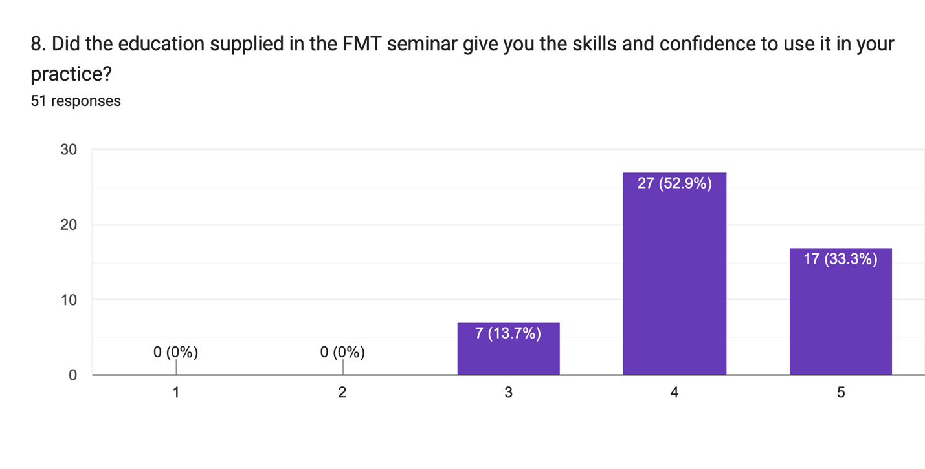
Completely
Not at all

9. Do you have any comments to share regarding your FMT training regarding providing you the skills and confidence to use it in your practice?

Knowing most participants felt that the FMT training gave them the skills and confidence to use in their practice, the free-text comments allowed me access to a broader range of responses.
- Partner work was essential to applying techniques and gaining feedback from a diverse group of people. By repeating the seminar, confidence is building. New clinicians were supported through opportunities for CF seats. Skills go beyond manual therapy to include encouraging guidance from the individual (3).

- Walt presents the information precisely with a hands on approach while emphasizing dialogue with the person and not the “patient”. What a loving way to connect (5).

- Walt uses a fantastic hands-on approach which allows you to practice and get real time feedback from your client. He allows time to ask questions and receive additional feedback, if needed (5).

- It really helped that Walt Fritz backed up the work with research. This is pivotal when communicating with MDs and other professionals re: the relevance of MFR (myofascial release) (5).

- FMT has completely changed the way I practice when treating people with head and neck cancer. It has been a vital component of my clinical practice and has been beneficial in improving patient outcomes both functionally as seen with FEES/MBSS and per their reports (5).

- FMT took away the cookbook and the idea that there can only be one right way. The focus was shifted back to the patient and the patient determined what was meaningful, where therapy needed to progress to. This acknowledgment in the coursework about the "gray areas" of manual therapy boosted my confidence. Confidence continues to build through time and patient experience/feedback (4).
- I want to practice more on my colleagues or on patients I know very well before using it with more patients (4).
Learning styles vary. Some new learners initiate using the FMT approach on their first day back in the clinic, while others are more restrained.

- I haven’t had a chance to put the skills into practice yet as I just took it recently and my patients are awaiting their follow up appointments. I’m confident that I will be able to template this into practice and look forward to taking the advanced class next year (4).

10. If you’ve learned both traditional laryngeal manipulation and the FMT approaches, did/do you prefer one approach over the other?

At the onset of planning this study, I was, in part, seeking to determine the clinician’s opinions on the superiority or preference of one model over the other. Though it may go without mentioning, I hoped that my class participants saw advantages in the FMT model that were not offered in the LMT model. Much of the responses supported my hopes, but since the study was initiated (mid-2023), I’ve realized that the choice need not be an either/or. Instead, working from not only the positive comments received in my survey regarding the use of LMT but also recognizing the weight of the evidence that supports the use of LMT (Behlau, 2019; Dehqan, 2020; Dromy et al., 2008; Kennard et al., 2015; Marszalek et al., 2012; Roy et al., 2019), I have begun incorporating aspects of traditional LMT into my Introductory and Advanced seminars. Reading and commenting on the responses here reinforced my initial quest, as from 33 responses, 32 preferred my FMT approach. While rewarding, I can see how recency bias may have impacted responses, creating suboptimal medical care potential (Featherston, 2020, p. 3).
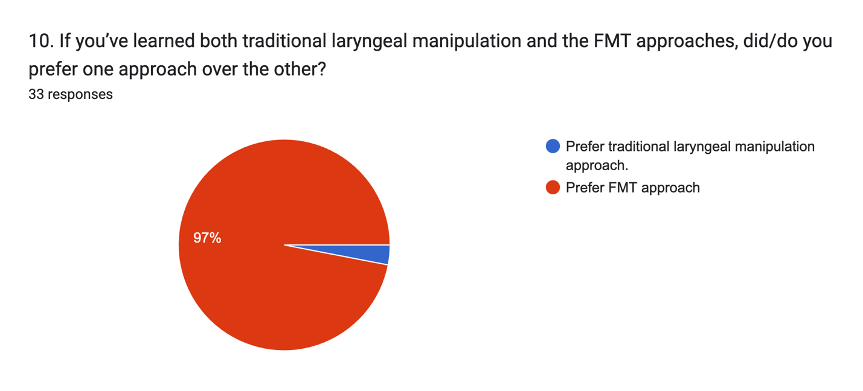
In my seminars, I discourage learners from considering FMT a standalone intervention and instead teach that it should be embedded with all other current models of care. However, as previously mentioned, with a typically more extended training period in FMT vs. LMT, most end users tend to be enthusiastic about adopting the model of care taught in the seminars based on this intensive training. With a better understanding of recency bias, I will endeavor to position FMT as sharing a common purpose with LMT rather than one being superior to the other. As mentioned above, LMT manipulation components, though applied more slowly to allow patient awareness and input, should capture a broader range of patient preferences and values without sacrificing outcomes.

11. Can you comment on what informed your preference?

- FMT seems more patient focused. They are an equal in the process (4).
Allowing manual therapy to be seen as patient-focused is one of my primary goals when presenting my work to others. However, as discussed above, my transition towards a middle ground between FMT and LMT allows me to see one person’s experiences of both models displaying equality in effect as reassuring.
- My preference is for a shared decision-making, person-centered approach (FMT) rather than the clinician-as-expert model I observed in my experiences of traditional laryngeal manipulation. Elevating the provider may lead to passivity, confirmation bias, unrealistic expectations, dependency, or diminishing personal role in meeting/maintaining outcomes over time. Furthermore, I have found that, for myself, manual therapy to improve mobility/sensation in supporting structures has been more relevant to my vocal goals than obsessing over the larynx (3).
- The FMT approach provides the patient/client with an invitation. Upon consent communication is instigated followed by a non-invasive and a patient/client directed touch and potentially manipulation. The patient becomes an active participant in the process whereas traditional laryngeal manipulation was taught to me as a static exercise (4).
- It feels more like a collaborative process with the patient rather than something that the therapist does TO the patient (4).
Working to evolve manual therapy from the traditional clinician-as-expert model into one of shared decision-making is another one of my motivations for teaching. Though never worded in such a way, every LMT study I’ve read hands decision-making power to the clinician (Aronson, 1990; Rubin and Lieberman, 2000; and Roy et al., 2019), while in the more general manual therapy literature, shared decision-making is being seen as an integral aspect of medical care (Devisch, 2015; Grenier, 2024). Seeing my views be handed down to another professional provides me with a rich reward.
- I wish there was an answer for "no preference". I believe they are different and both have their application, depending on the patient. For oral, head, and neck cancer patients, I prefer FMT. For muscle tension dysphonia (MTD), traditional laryngeal manipulation still tends to be my go-to because it is generally effective and I have years of experience successfully applying it. FMT is a back up for me in those cases (4).
While not offered an option that met their needs, this person best meets my goals in this work. Combine what I teach with everything else that you’ve found effective.
- The acknowledgement of the fluidity of the work - there is no one right way to improve patient outcomes. The patient is the driving force in directing care (Rating 4).
12. Did/do you modify the material presented in the FMT class, or did/do you closely follow how it was initially presented?
As a new learner in MT, I mimicked the educator’s words and actions. Over time, I began to improvise, making my models with language and techniques. I passed this practice onto learners at my workshops, telling them that it is acceptable to use the in-class demonstrations and concepts from the manual when starting. However, each person is asked to view each patient (and every encounter with that patient) as a unique experience, one in which a technique performed as taught may not connect with a person’s lived experience. I encourage others to modify my work to align with the individual.

The views encouraging flexibility understandably conflict with protocol-driven models, with the latter requiring conformity to understand better an intervention’s effect across a spectrum of subjects. Based on my career-long experiences in manual therapies, having fidelity with flexibility is commonly followed in my physical therapy profession (Kendall, 2018). Such views frequently conflict with suggestions in the literature, citing models such as my own’s lack of conformity and protocol (Daniels, 2024) as limitations. These conflicting views are addressed at each seminar presentation, with a polling of my audiences for learners’ professional approach to protocols vs. flexibility. After the discussion, there is an observable consensus that protocols have a place, but nearly the entire audience confesses to the flexibility of shaping interventions to individual needs. However, as I introduce my approach in a setting that is often the only time I have contact and get feedback from SLPs before they begin applying the seminar content, having the ability to gather input on these potentially controversial conflicts may prove to be enlightening.
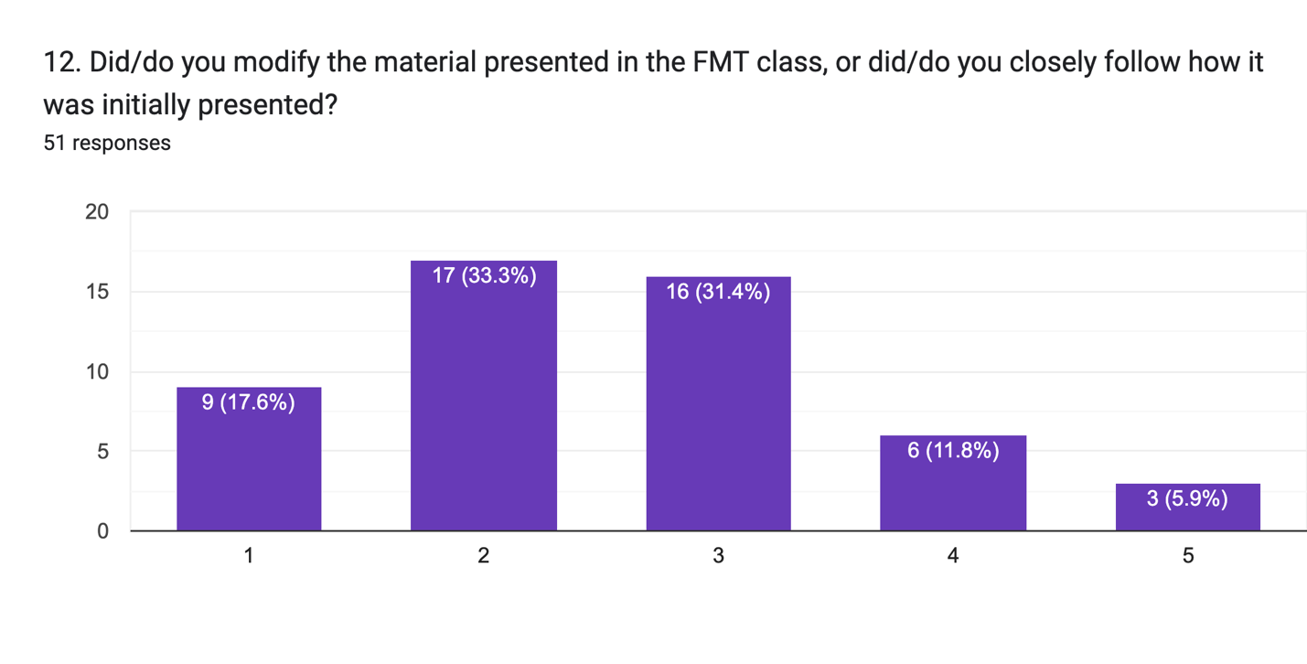
Modified the work greatly
Followed it exactly as taught in the FMT seminar
The results of the Likert Scale question showed a higher tendency to remain faithful to the material and the techniques as presented in the seminar. With the scale choices that ranged from “Followed it exactly as taught in the FMT seminar” as a score of “1” to “Modified the work greatly” as a score of “5”, more found themselves sticking to a more literal translation of the presented techniques. After reviewing these results, I realized that I might have been well-served by adding an additional question to shed more light on these tendencies. Had I asked survey participants how long they’d been using the concepts, I may have been better able to determine if there was a tendency for less experienced users to stick more closely to the techniques with less deviation. As I believe flexibility (with fidelity to the patient’s preferences and the evidence) is a crucial component of successful manual therapy interventions, I see a limitation in this section of my research.

13. If you made modifications to the FMD approach, what sort of modifications did you make?

- I adjust hold time based in the patient’s comfort levels with physical contact (2).
- I have altered some of the suggested dialogue (2).
- Depended on what the patient wanted. Some patients wanted movement, sometimes I included aspects of MNRI in the mouth (4).
- Hand placement, combine some elements of laryngeal massage with FMD (3).
- I modify some of the techniques for people with head and neck cancer if they have had anatomical changes due to surgery and/or radiation (ex. partial glossectomy - I may not always be able to do tongue stretching the same way.) (3).
- Adding manual lymph drainage to the neck/face before/after manual work. I find that the patient is more comfortable both with the expectation of the therapist's touch, the pace of movements, the creates patient willingness to provide feedback on location/pressure/duration. Sometimes stretches are static, sometimes the stretches including minute fluctuations in pressure/direction similar to bouncing/rotating a digit or slowly transferring pressure from palm of hand onto the fingertips. All depends on the needs of that patient and what we are trying to accomplish (3).
- I often switch between the FMD and traditional approaches quite fluidly (2).
- Combined it with traditional laryngeal manipulation (4).
The above two responses mirror each other, yet each person’s self-described rating differed. In hindsight, I may have worded questions 12 and 13 poorly. I would assume that the SLP would see blending two different models as significantly modifying what was taught in my workshop (Note: When the survey period closed, I had yet to add traditional LMT to my seminars).
- The language we used in the workshop... it doesn't work so well in Greek... in modifying the language, I feel it impacted on the approach somewhat as well. Also, I feel I was more rushed (time-wise) than you were in the workshop. And though I understand how being patient is of the essence. I also felt pressured by my very own "result-centered" inner pressures..(3).
This respondent identified a potential limitation in my model of presentation. The specific class the respondent referred to was one in Athens, Greece, where the workshop was translated in real-time into another language. I am aware that differences in the cultural, social, religious, ethnic, and economic background of the individual patient (and provider) may necessitate modifications in the presentation of the MT work. However, this comment made me realize that I must be more aware of potential conflicts. My approach, which relies on language-based interaction, may require adjustments to overcome such obstacles (McCarthy et al., 2024; Reis et al., 2022; Stewart and Loftus, 2018).
Of the three respondents who scored Question 12 with a 5 (“Modified the work greatly”), only one provided a free text response in Question 13. Reviewing the comments provided above from those who scored Question 12 lower on the Likert Scale, everyone’s interpretation of their applied flexibility/variance from how the work was initially presented varied greatly. From how my questions were worded and arranged, I cannot know if this variability reflects a standard interpretation deviation or a flaw in my survey.
14. When you began using the work, did you initially find the model presented in the FMT approach easy to incorporate into your interventions?
57% of respondents had prior experience learning and incorporating MT before their seminar with me (Question 4). Believing that new learners of any model may feel awkward incorporating new concepts into practice, I would have anticipated a high level of reported difficulty incorporating the work into practice. This topic is discussed at every seminar presentation. Types of work not modeled as the norm in their profession, of which MT qualifies, are often challenging. Frequent questions asked of me in workshops reflect this apparent awkwardness, and we try to work through this dilemma in various ways. I regularly pose a scenario to the SLPs in my classes. I state, “When a patient is sent to see a physical therapist for the first time, most have a mental picture of the interaction. However, when a patient is set to see an SLP for the first time, most have little idea what an SLP does. They probably do not know that many (most) SLPs do not use MT regularly. It is you (the SLP) who feels it is out of place. Maybe we need to look within and ask if each of you can accept that the potential role of the SLP is larger than what many in the profession envision. Boxing oneself into a predefined role may limit our potential to help others.”

Though I present this concept of artificially narrowing one’s range of potential expertise, I have had no way to gauge the effectiveness of my invitation to expand one’s range of intervention choices.
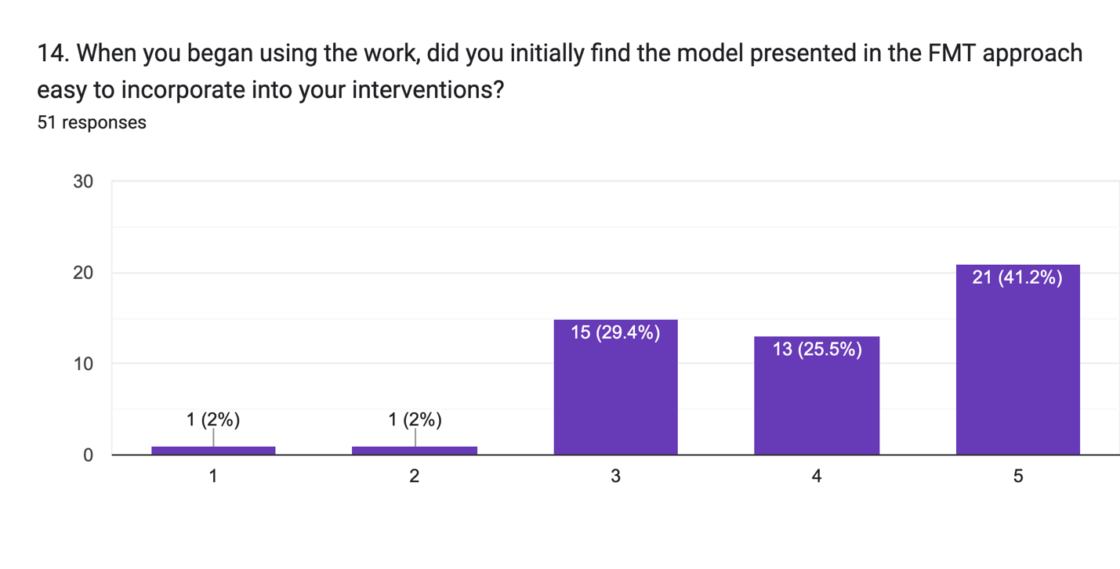
Easy to incorporate into interventions
Difficult to incorporate into interventions
Regarding the ease of incorporating MT into the practice of the SLP, the results have given me confidence that specific aspects of my presentation have met with success. I expected results to be highest at the 50% mark, anticipating a normal distribution of responses. However, with 42% reporting a “5” (Easy to incorporate into interventions), SLPs who have taken my seminar have easily found ways to add MT to their interventions.

15. Do you have any comments on the ease of incorporations of the FDM approach into your interventions?

- I was able to use it immediately (5).
- You allowed and encouraged engaging the patient and their needs and wants. That was a great way to introduce and incorporate MFT in my sessions (5).
- If I listen, the person will guide me (5).
- It was a very smooth, easy transition and most patients were very receptive (5).
The feedback I’ve received over the years of teaching this work (and applying the principles with my physical therapy patients) has shown that when a clinician is met with positive outcomes and patient alignment with the SDM MT model taught, willingness to dig deeper improves for the SLP.
- Just have to get past the part of being afraid to touch patients (5).
- The feedback loop is challenging with some people. Some patients are not very in tune with their bodies and they don't provide enough feedback to make the treatment successful. Another challenge is everyone feels different, anatomy can vary between people (3).
In my career using MT as my primary intervention, I’ve read and witnessed many reasons why some patients cannot accept some models and their narratives. These excuses include explanations that some people simply are out of touch with their feelings, or poor interoception. Interoception can be defined as one’s ability to self-regulate based on internal and external cues (Chen, 2021). One can correlate with reports that others cannot connect with their inner experiences (“being in tune with their bodies”) and poorly developed or nurtured interoceptive awareness. Touch has been shown to foster interoceptive sense (McParlan, 2022), making the process of MT a potential path to allowing a greater sense of self easier. I’ve also witnessed some clinicians, when met with pushback from the patient regarding the attempted intervention, brush off those responses as a limitation on the part of the patient. While diminished interoception may be an issue, I also see such reports as a limitation in the clinician’s ability to connect with their patient adequately. While I do not see this happening frequently in my workshops, this response showed that this topic is one to address in future presentations.
- The difficulties are more in the ergonomic limitations of the office space I practice in (3).
This response made me regret not including a question to gauge the length of time since taking the seminar and, possibly, when each person took the class. Respondents could participate in my survey if they completed the workshop from April 2020 through August 2023. In 2022, I transitioned the "patient" treatment position in class lab experiences from supine (lying face up) to sitting. This change was instituted for several reasons: most SLPs lacked easy access to a massage table-like work area. Additionally, I began to understand that many of the voice, swallowing, breathing, and oral motor/feeding disorders treated by the SLP occur more frequently while a person is upright (sitting or standing), treatment effects and the underlying process may vary from supine to sitting (Johnsson et al., 1995; Shiino et al., 2016; Iizumi, 2017). Therefore, learning/applying MT may be more relevant to the patient when taught and used from an upright position. I’m unable to ascertain if this respondent was commenting on conditions as taught before or after the modification mentioned above.
- It many ways FMT was a natural extension of what I was already working on with patients; manual lymph drainage, on/off the mat table, emphasis on patient perception, teaching patients the technique for carry over/generalization (5).
- It’s really easy to add in FMT while patient is completing traditional dysphagia exercises (5).
- It was very easy to incorporate these techniques into my practice (5).
Based on the selected free-text comments and the ratings noted in Question 14, I feel I’ve created a relatively easy product to incorporate into an existing treatment program for the SLP.
16. Did/do you find the variability presented in the FMT seminar regarding the need to modify the amounts of pressure, the direction of stretch, and other factors in response to patient feedback easy to incorporate?
Presenting new information is challenging, as new learners often feel more comfortable with a roadmap, a guide to get started. Some see this as a benefit of an established protocol, where steps, timing, and sequencing are mapped out in advance. Early in my teaching career, I resisted such maps, seeing them as a potential way to bypass the individual patient's needs. I was taught this in my early training, with repeated warnings to avoid seeing any patient acting and responding as a previous one did. Though I moved on from that model, current viewpoints support treating the patient as a unique individual (Anjum, 2016). How would new learners respond to my model that presents variability as a central component?
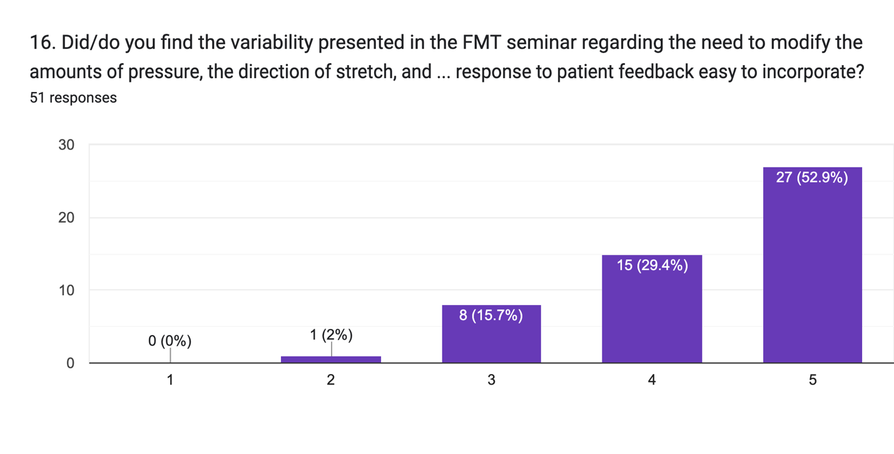
I had difficulty with the allowable variability of the FDM
I had no difficulty with the allowable variability of the FDM

With response 1 being, “I had difficulty with the allowable variability of the FDM approach,” to response 5, “I had no difficulty with the allowable variability of the FDM approach,” my concerns appear to have been unwarranted. Only one respondent replied with a score of 1 or 2, while the highest percentage rated this question 5. I was able to dive deeper into this ease of incorporation through the free-text responses given in the next question.
17. Do you have any comments on the inclusion of variability into the FDM approach into your interventions?
- I appreciate the variability and the focus on that in the course. No approach is a one size fits all (5).
- I like the open approach. That’s new for us speechies (5).
- I am thankful for it and feel like I am finally treating for long term success for each patient (5).
- Yes, that was fantastic. Patients so much WANT to be included and so asking them to guide my pressure, direction, etc. was super fabulistic! (5).
- Working with stroke patients who have very often cognitive impairments can make it difficult for them to answer my questions and to know what feedback to give me (difficulty to identify what they are feeling; ex., sensory impairment, anosognosia, etc.) (4).
Such challenges are not unique to the FMT model and require adaptability on the part of the therapist to reach their patients where they are. Throughout my classes, I give examples of how I work to overcome obstacles, such as the one described in the above free-text reply. I include the difficulties one can encounter within those examples, even from patients with intact cognition, sensation, and communication. Though the response given by this participant was an isolated one, I need to be mindful of further working through these potential issues in future presentations.
18: Does shared decision-making add value to your interventions?
SDM is the core of my approach. My long view of MT is that SDM adds value, honors patients’ rights, and potentially increases outcomes. Though evidence in the literature has yet to be fully confirmed in the MT setting (Tousignant-Laflamme, 2017), it has been found to offer greater opportunities for change in the setting of physical therapy (Coronado and Bialosky, 2017; Moore and Kaplan, 2018), within the field of speech pathology (Isaksen, 2018; Jovanovic et al., 2022; Askren and Leslie, 2019) and across the spectrum of healthcare (Leng, 2017).
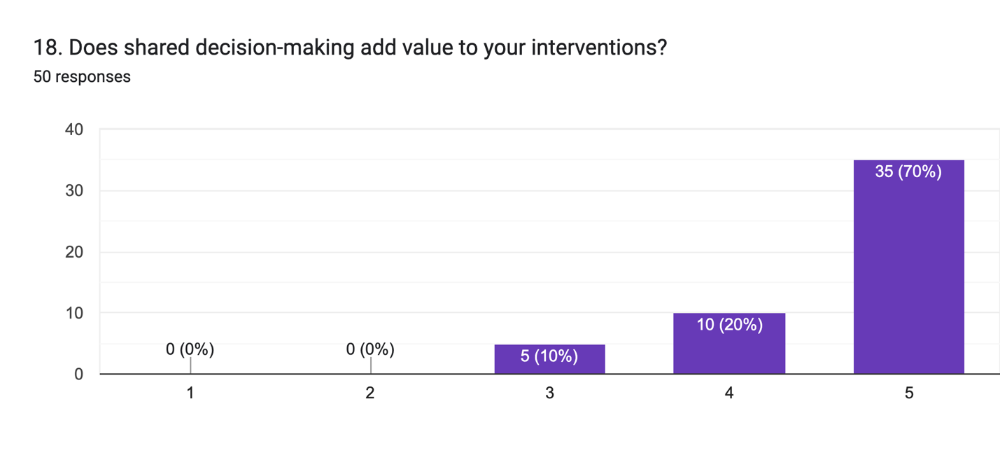
No value added from shared decision-making.

Great value added from shared decision-making.

Respondents felt optimistic about the value of SDM, but what might be some of the comments from the 30% who responded with a response of 3 or 4?
19. Do you have any comments on the value shared decision-making added to your interventions?
- Amazing for adults and older peds; not so great for littles (2-5) (Response 3)
- I'm still working on it. Often I get the sense patients are providing answers they think I want to hear or hold onto a belief that tolerating more pressure means quicker healing. Taking the extra time to work through these issues with patients is beneficial in the long run and I think builds better patient/therapist trust (Response 4).
- This person’s awareness that patients need time to adapt to a different model and may substitute other behaviors to compensate for lack of understanding reflects well on how the information is translated in seminars. Some patients grasp and appreciate the concepts quickly, while others adapt slowly, if at all.
- Unfortunately, only two respondents in the 3-4 category left a free-text response. I discuss the difficulties of using an SDM approach with small children in class. Though challenging, the task is not impossible. Overcoming underlying patient beliefs (more pressure = quicker results) can be difficult. However, an understanding of self-determination theory (Castro, 2023) may lead the clinician to allow those perceptions on the part of the patient.
20. Was it difficult for your patient to understand why you asked them for their input with the shared decision-making approach presented in the FMT class?
Clinical encounters of the physical therapist and SLP are often based on the biomedical perspective, where the problem is “they presume that pain, illness and disease is due to an objective mechanical deviation in structure, function or physiology. Such biomedical assumptions about illness positions osteopaths as knowing and skilled agents who can reach into the workings of their patients machinery to intervene in its function” (Thomson, 2023, p. 2). Contrast these views with “models of healthcare which reposition the patient as a person, motivating the practitioner to take part in meaning-making” (Thomson, 2023, p. 2). I teach such a meaning-making model, and I was curious if patients had difficulty adapting to such a perspective.
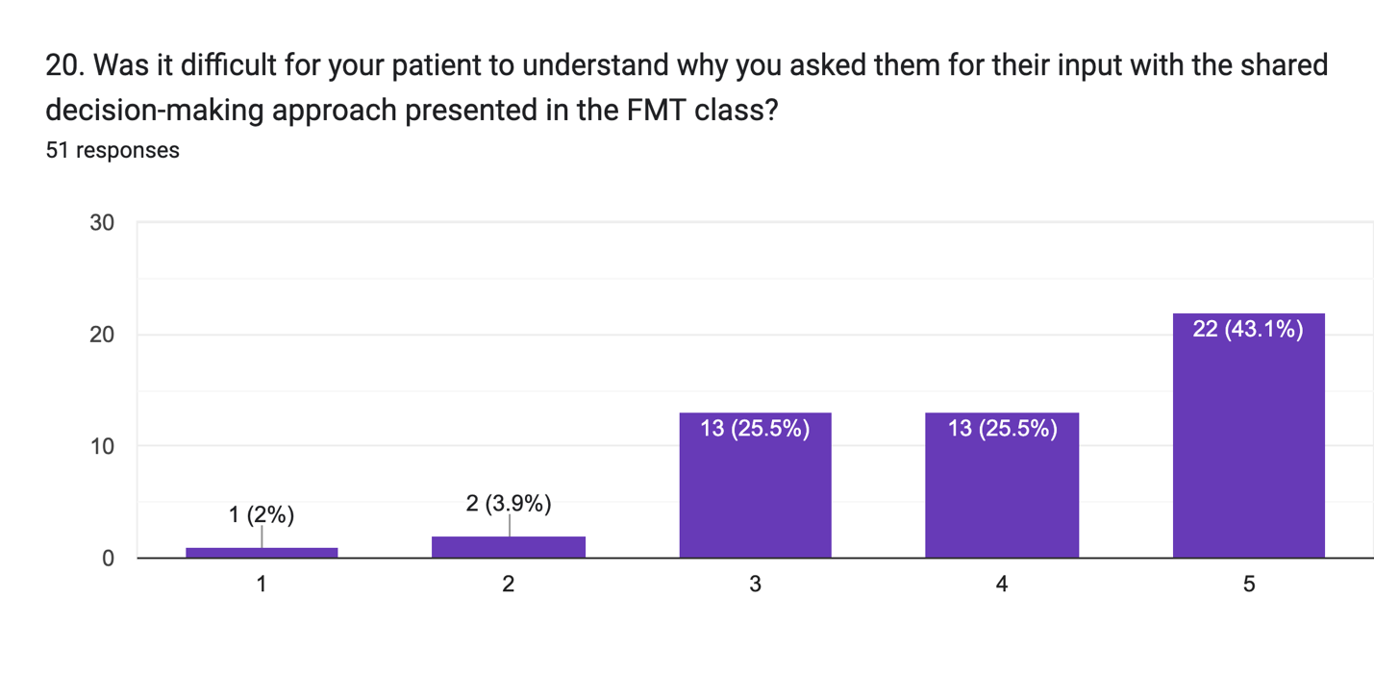
Very easy for the patient to understand
Very difficult for the patient to understand
The graphic shows that most clinicians reported their patients had little trouble adapting. Not fleshed out was whether this ease was a natural tendency of the patient when exposed to being offered a choice, a reflection of the education clinicians provided to their patients before beginning treatment, or a combination of these two variables. I was encouraged by these results; if a model cannot be understood and followed, it seems of little value.

21. Are there specific disorders or diagnoses you find more appropriate for manual therapy?
A concept repeated often by some people I follow on social media related to the caution that if you expect to use one tool for every problem, you’ve probably limited the patient’s potential gains. Having a broad skill set, including multiple models and intervention choices, gives the clinician a better chance to meet the individual needs of each person who comes for help. While I believe this to be true, I recognize that I break from this perspective. I believe strongly in the value of movement, exercise, and strengthening, but use means that would be considered non-traditional in my physical therapy profession. I do not prescribe rote exercises but instead, determine the preferences of my patient and work with them to use their preferences to resume a more normal movement. MT is my primary treatment tool, with movement as how each patient begins to move forward from the gains made through MT. When a patient comes to see me, MT is my primary tool, with movement not being secondary but the progression of events that treatment follows.
Based on my decade-plus experience working with SLPs in an educational setting, I’ve found them grounded in the desire for a clinical decision-making model. Such a model, expected in medical fields, allows one to use the decision-making tree to determine if the treatment matches the diagnosis. Still, it is the antithesis of how I’ve spent the past thirty years in the clinic. I encourage SLPs to respect the diagnosis but deviate towards the functional deficit. I can recall being challenged at a seminar by a clinician who asked why we would even consider using MT with progressive neurological diseases, such as Parkinson’s. Such diagnoses give us little hope for functional gains. I responded by saying that while we can certainly not change the trajectory of this neurological problem, were the functional deficits the patient was dealing with totally immune to help or improvement? Only later did a published study address using MT with this diagnosis (Ateras, 2017).

I pride myself on transparency in the work I use and teach. As a physical therapist teaching SLPs, I know only a tiny part of the larger world of the patient populations, functional deficits, and foundational education of the SLP. I relate this ignorance at every seminar presentation. As such, I’m unaware of how my work translates to those in other fields. This question gave me a chance to know more.

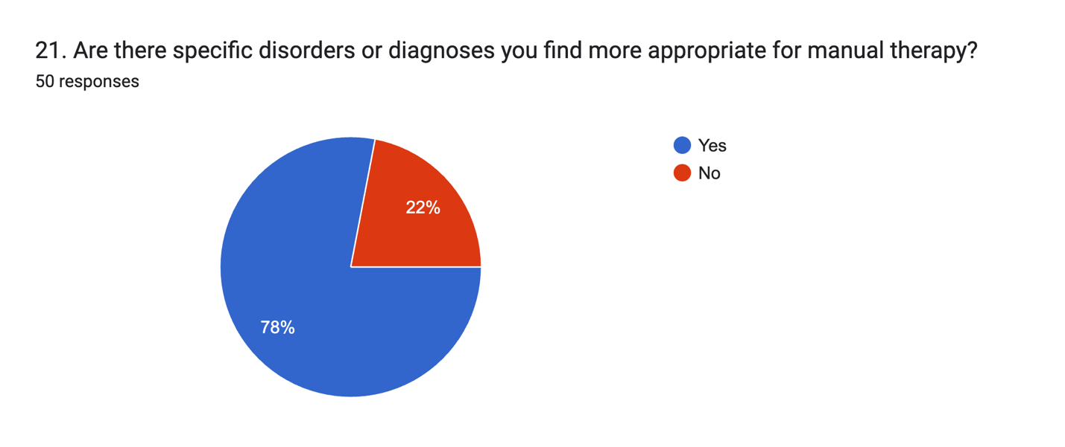
Responses to this question were surprising and, to a small extent, disappointing. I’d hoped that SLPs could translate the seminar principles across a broad spectrum of patient populations and disorders. However, such a view is myopic, magnified by my lack of understanding of the SLP profession. After reflecting on these results, I was able to understand them better when I placed them in the context of the general physical therapy patient population.
My practice is a niche one, as I do not see patients fresh from surgery or those whose physicians sought an exercise-based approach for them. These patients filter into the more typical physical therapy practice. Patients who seek me out are often those that traditional physical therapy left them with incomplete results or people who had an inherent bias towards a hands-on, MT approach. As a result, I’m mindful that I see a narrow range of problems in my MT practice and, as such, see the logic behind the survey responses here.

22. Do you have any comments on the diagnoses you find more (or less) appropriate for the use of manual therapy?
- Seems to work well with HNC and MTD patients (5).
- Anxiety induced dysphagia/dysphonia, post CVA, post accident, it has been helpful for some folks post radiation therapy (5).
- More: HNC, Less: Acute CVA (4).
- Tongue ties and related feeding/swallowing difficulties (5).
- Voice patients have been the most appropriate (4).
- More for the actor/singer (5).
- It is very helpful for the head and neck cancer population, TMJ issues and muscle tension dysphonia (5).
Additional responses followed the trend posted here. The questions that were lacking from my questions established the context for the given responses here. SLPs replied with what they found FMT most helpful, but few answered with what FMT is not well-suited for. Also, an additional question asking for the primary diagnoses each respondent works with would have allowed me to understand this model's utility better. It is possible that the diagnoses/disorders reported to be helped by FMT were the only diagnoses/disorders the individual sees in the clinic. These issues are seen as a limitation of the survey tool.
23. Considering the various support provided in and after the seminar's conclusion (pre-seminar online course, hands-on manual, Facebook group for discussion and viewing of videos, the ability to contact Walt Fritz with questions), were they valuable resources to help shape your use of the work?
Creating an environment of support was a concern from the beginning of teaching this work to SLPs. As such, I created support mechanisms via a dedicated Facebook group and other resources intended to act as a means for further learning. To better support learners, I recently added a new video series called “Peer-to-Peer Mentoring Videos,” where past participants shared how they began incorporating MT into various job scenarios. (Note: this video series premiered after the survey was completed)
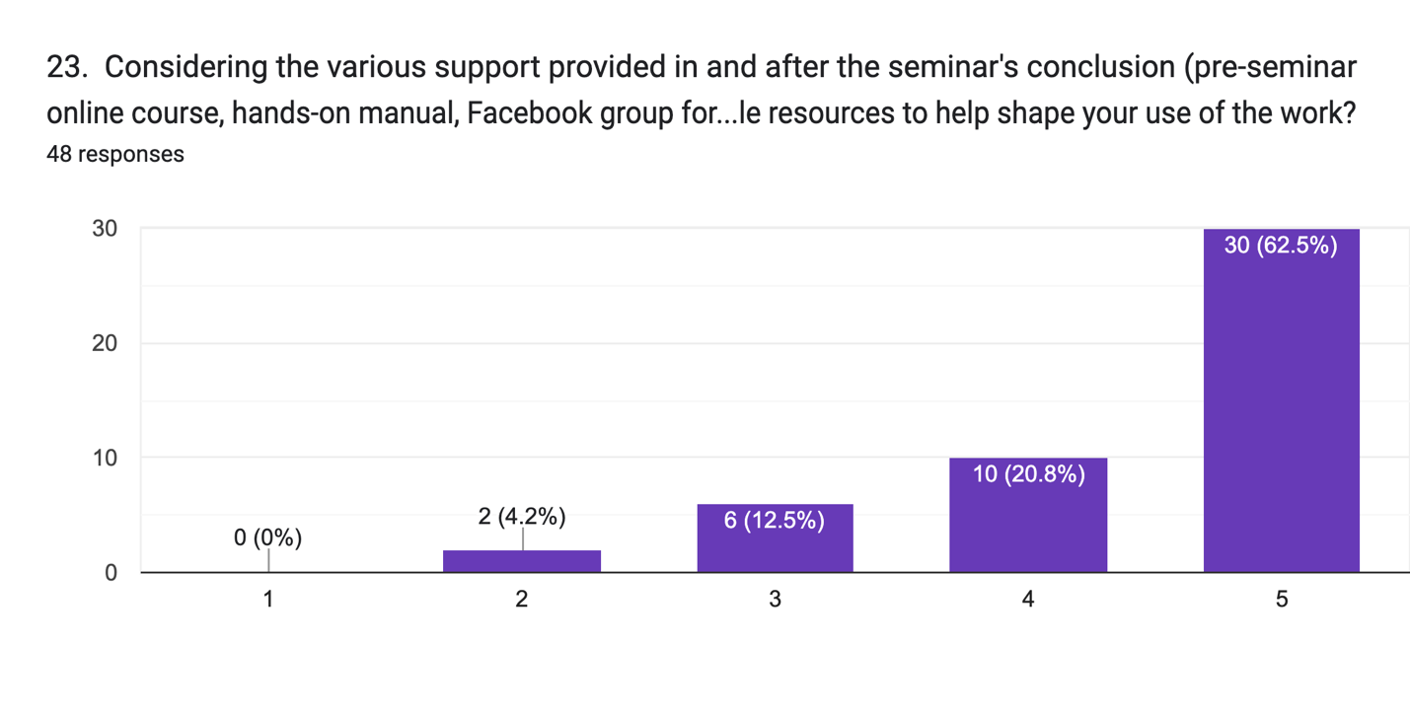
The survey results left me satisfied that I met most respondents' needs. However, those who responded on the lower rating scale left me curious.
Very helpful
Not at all helpful

24. Do you have any comments on the support provided? Do you have features you wish were available?
I chose to display only comments in the 2-3 range on the Likert Scale here, but only two respondents in that category chose to leave a free-text response.

- More documentation support (2).
- I suspect all these modalities are hugely valuable, and I only marked a 3/5 because I haven't actually sat my butt down to use any of your support!!... YET!!! (3).
The second response supplies no beneficial information, but the first aligns with frequent questions heard in seminars. I provide an extensive documentation PDF to all learners through a Google Drive folder distributed before each workshop. It is possible the respondent was unaware of this document; I may have failed to remind learners in that class, or the person found the PDF insufficient to provide benefit. Even this lone comment is sufficient for me to expand on specific examples I supply, a combination of my example notes and samples from past participants.

25. Does manual therapy add value to your interventions?
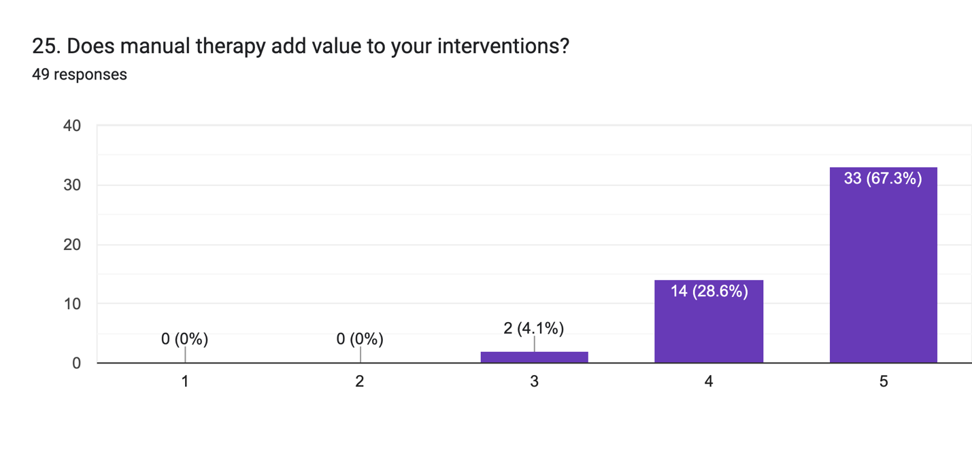
Great value added.
Not at all.
Continuing the line of thought in Question 18 (Does SDM add value to your interventions?), I am again pleased with the positive responses from participants and curious about the two people who gave the question a response of 3.

26. Do you have comments on the value manual therapy adds (or doesn't add)?
After reviewing responses, no free-text replies were given from respondents who supplied a scale of 3, as was the case for the 14 who responded with a 4 rating. These gaps leave me unable to reimage my class presentation to ensure a higher perception of value. From those who gave a rating of 5, some of the responses were:
- The majority of my patients are for breathing and oral function. It takes my therapy to a greater level of effectiveness.
- My coworkers see the value and are sending me their patients.
- FDM has assisted me in improving patient outcomes; particularly with the more severe or complicated patients who do not immediately respond to more traditional approaches.
- Manual therapy completely changed my career and patient outcomes - specifically for people with head and neck cancer. It was the missing tool I needed to help my patients succeed.
- I am working on recognizing the patterns I see; I've found that a lot of patients with tongue tie have a lot of tightness in the neck, face, and jaw and respond really well to those exercises. It almost adds a diagnostic lens to my evaluation process (if I'm on the fence whether there is a tie, if the manual therapy "doesn't stick" then I tend to lean towards the pt needing a frenectomy).
- One value I think it adds is that it makes it easy for the patient to be seen as a whole person, not just their disorder, and to emphasize the patient's sense of control over their recovery.
This final remark was professionally and personally satisfying. Seeing my place in helping others recover is rewarding and allows me to feel my work is valuable.

27. Do you feel the approach taught in the FDM seminar is aligned with evidence-based practice?
In my early experiences learning MT in the 1990s, evidence-based practice (EBP) was not a topic stressed as a necessary component of the work. In hindsight, this omission may have been influenced by the lack of quality evidence supporting myofascial release and related MT models. It was not until the mid-2000s that I began to learn more about EBP and how it can apply to the work I was using and teaching. Looking back at my first five years of teaching this work to SLPs, my attempts to elevate my content to match the ideals of EBP were clumsy and rudimentary. In full disclosure, it was not until I began this MA program in 2020 that I understood the correct way to support, explain, and implement MT from an EBP perspective.
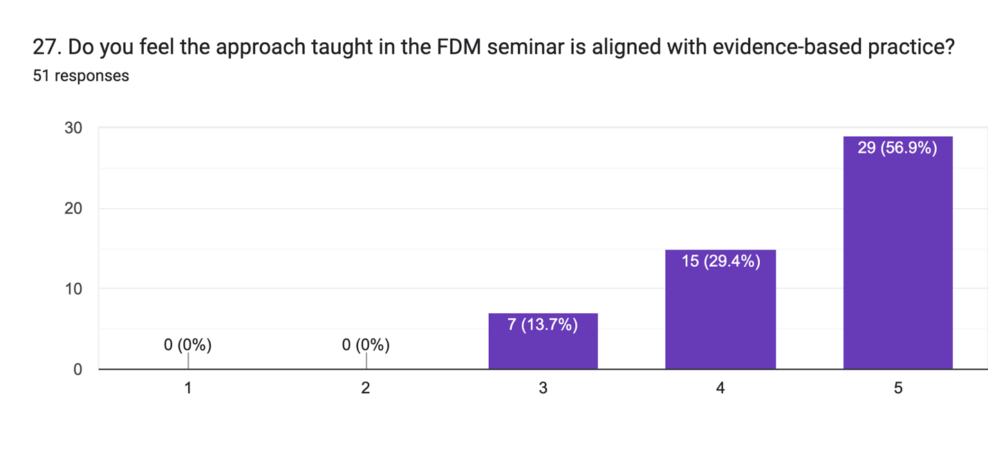
Completely evidence-based
Not at all evidence-based
The graph shows a profile like the last few graphs shown above. Pleased with the 4’s and 5’s, I look to learn more from the people who responded with a rating of 3.
28. Do you have any comments on the alignment of the FDM approach with evidence-based practice?
- I find it difficult to give evidence/ articles if/when people ask me (3).
Of those who rated Question 27 at a 3, only one of seven responded. Without attempting to imagine context from the reply, I can draw little in the way of conclusions. Did I not supply sufficient evidence? Was the evidence I did supply not sufficiently arranged and accessible? Or was the evidence supplied deemed insufficient?
Earlier this year, I introduced a revision to the course manual supplied to all learners. Among other changes, with this revision came an update to the references that support each section of the seminar. I work to provide evidence not only for the techniques but also for the underlying SDM approach taken through the workshop. Without additional input from those survey participants who were less than pleased with the evidence supplied, I hope the new course manual makes it easier for future learners to locate references to support this work to their colleagues and patients.
29. Do you feel the information taught in the FMT seminar allowed your patient to feel respected and heard (patient validation)?
One of the significant differences between FMT and LMT is the inclusion of patient input, where the patient is given a potentially equal share in the decisions that go into every intervention. The responses to this question are of great importance.
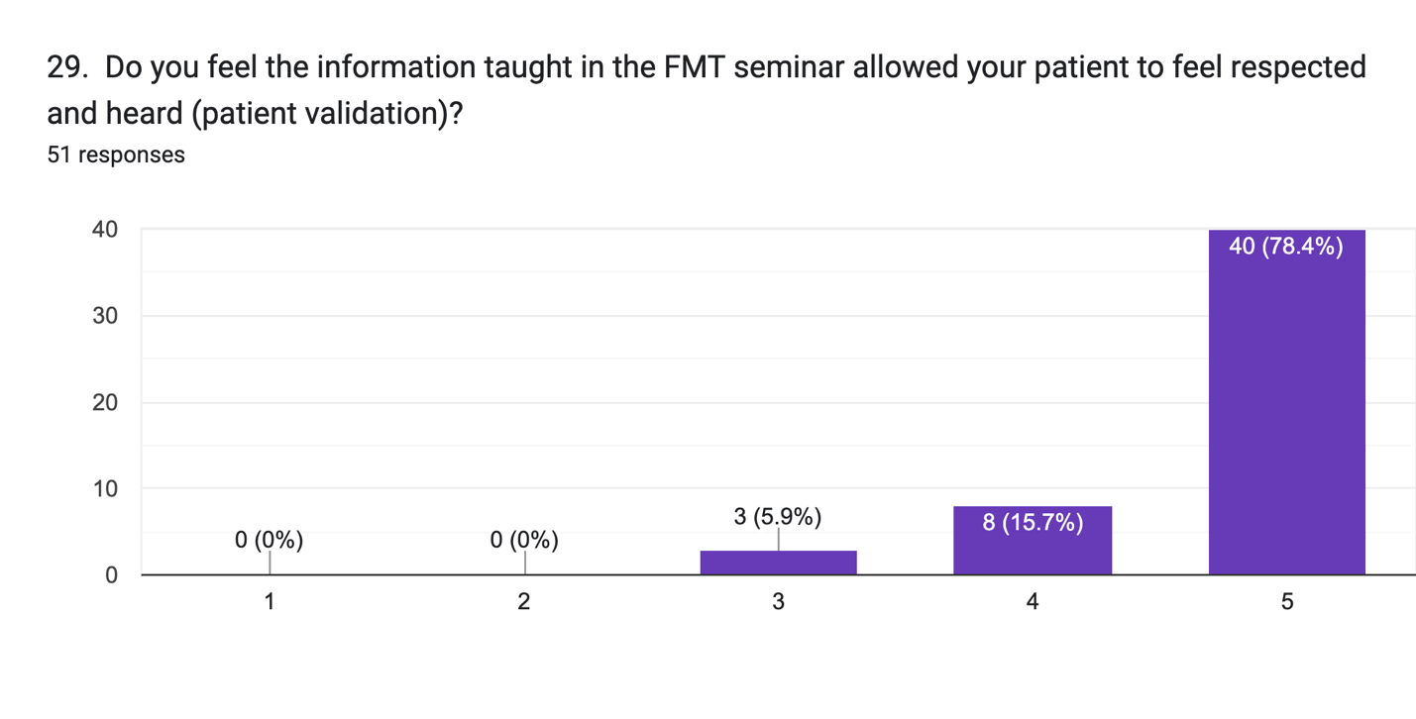
There was again a propensity for positive responses, with the nearly 79% agreement at a response level of 5 being the highest seen throughout this survey.
30. Do you have any comments on if and how patient validation impacted outcomes?
As the only free-text responses to this question came from those who gave a rating of 5, in this case, I can only learn from the positives.
Greatly validated
Not at all validated

- I finished the course last Saturday. This past week my patients opened up and shared many important aspects about their health which they hadn't shared before.
- Builds therapeutic alliance to increase participation.
- It keeps them coming back for therapy until they reach their goals. MFR is rarely offered with speech/swallowing therapy so that also makes our clinic unique in our geographical area. (Note: “MFR” refers to myofascial release, the title of this work before rebranding in 2020. Many class participants refer to this work through those old descriptors.)
- I think FMT fosters an environment that encourages (requires) patient feedback and validation for success. I think patients are not always used to being seen as a person or having their statements being taken seriously and this can create some initial hesitation when starting FMT
- I can speak of measurably improved outcomes yet, but, as an inner sense, I feel that it is a huge shift in the quality of the outcome.
31. Thanks for your responses. If you have additional comments or suggestions for changes to the curriculum, please leave them below.
- Sure thing. Walt, thanks for all you do. You have made a huge impact on our profession ♥️

Conclusions
Reflecting on my initial research proposal, no changes were made throughout the study.
Based on the feedback, I’ve received validation that the product I sell to SLPs provides value to themselves and their consumers. The positive replies incentivize me to continue my work, with changes as mentioned throughout the Findings section. Limitations and gaps were noted, which is to be expected and were, in part, my purpose. These constructive comments have already been or will be addressed through the implementation of the new Peer-to-Peer video series, improvements in the manual and references, the need for more clarity in documentation samples and examples, being mindful of cultural, social, religious, and economic barriers to accepting a role within the model of SDM and blending traditional LMT into my teaching model.

Some frustrations resulted from my survey, as I left holes in areas where constructive criticism could have been given. These gaps will be addressed by amending my post-seminar evaluation forms, allowing learners to flesh out their feedback from the completed course better. However, with the newness of this just-learned model, learners may not have enough experience introducing the work to their patients to be equipped to comment in the manner collected through this survey. I learned a lot about how my survey lacked cohesiveness, yet I was able to collect sufficient data to answer my research question.

Additionally, those past learners who chose to devote time to answering the survey could have had more positive feelings toward me and the FDM model. Such positives could skew feedback. For example, those who had a less positive experience in a seminar or failed to see the relevancy of the materials may have chosen not to participate. A trend noted throughout the survey responses was that those with higher Likert Scale ratings tended to provide free-text responses.

My survey distribution to the target cohort did not collect data on emails that were returned due to changes in email addresses, or my email being blocked by the recipient. As judged from the tone of the many free-text responses from those who did respond, there was a feeling of positivism towards the model. Though this expression may indicate underlying preferences, values, and experiences favoring the FDM model, I have only these responses to work with.

Many educational and practical resources were obtained through this study. Most were discussed throughout this paper and have and will prove invaluable for future seminars and my physical therapy practice.
Research question: To what extent have my courses changed the clinical encounters of the SLP end-user who utilizes this work?
I can conclude that participants' responses and experiences reflect a significant change and advancement in the clinical encounters of SLPs. While the hands-on components of the FMT approach appealed to many, I believe that the elevation of patient participation and the many benefits of the SDM model elucidated through the free-text responses indicate that SLPs found value in the materials. Considering the reactions, SDM allowed them to evolve their therapeutic encounters because of the workshop.
In hindsight, I regret not asking if participants found themselves using the core principles of SDM in their other non-MT-related SLP interventions. This goal is something I state in every class, but from the results of this survey, I will not know the answer. However, as I have blended SDM principles across my physical therapy intervention spectrum, I hope SLPs will follow suit.

Appendix 1: Ethic Form
APPLICATION FOR ETHICAL APPROVAL

In order for research to result in benefit and minimise risk of harm, it must be conducted ethically. A researcher may not be covered by the University’s insurance if ethical approval has not been obtained prior to commencement.

The University follows the OECD Frascati manual definition of research activity: “creative work undertaken on a systematic basis in order to increase the stock of knowledge, including knowledge of man, culture and society, and the use of this stock of knowledge to devise new applications”. As such this covers activities undertaken by members of staff, postgraduate research students, and both taught postgraduate and undergraduate students working on dissertations/projects.

The individual undertaking the research activity is known as the “principal researcher”.

Ethical approval is not required for routine audits, performance reviews, quality assurance studies, testing within normal educational requirements, and literary or artistic criticism.

Please read the notes for guidance before completing ALL sections of the form.

This form must be completed and approved prior to undertaking any research activity. Please see Checklist for details of process for different categories of application.

Delete the Guidance Notes at the end of the form BEFORE submitting your application

SECTION A: About You (Principal Researcher)
1 | Full Name: |  | Walter Millard Fritz
2 | Tick all boxes which apply: |  | Member of staff: | ☐ | Honorary research fellow: | ☐
3 | Undergraduate Student | ☐ | Taught Postgraduate Student | ☐ | Postgraduate Research Student | ☒

4 | Institute/Academic Discipline/Centre: | WAPPAR
5 | Campus: | Carmarthen
6 | E-mail address: | 1922505@student.uwtsd.ac.uk
7 | Contact Telephone Number: | 1-585-451-2794
 | For students:
8 | Student Number: | 1922505
9 | Programme of Study: | MA in Professional Practice
10 | Director of Studies/Supervisor: | Debbie Winter

SECTION B: Approval for Research Activity
1 | Has the research activity received approval in principle?  (please check the Guidance Notes as to the appropriate approval process for different levels of research by different categories of individual) |  | YES | ☒ | NO | ☐
 |  |  |  |  | Date
2 | If Yes, please indicate source of approval (and date where known): Approval in principle must be obtained from the relevant source prior to seeking ethical approval | Research Degrees Committee |  | ☐
3 |  | Institute Research Committee |  | ☐
4 |  | Other (write in)  WAPPAR Ethics Board Representative |  | ☒ | May 24, 2022

SECTION C: Internal and External Ethical Guidance Materials
 | Please list the core ethical guidance documents that have been referred to during the completion of this form (including any discipline-specific codes of research ethics, and also any specific ethical guidance relating to the proposed methodology). Please tick to confirm that your research proposal adheres to these codes and guidelines.
1 | UWTSD Research Ethics & Integrity Code of Practice | ☒
2 | UWTSD Research Data Management Policy | ☒
3 |  | ☐

SECTION D: External Collaborative Research Activity
1 | Does the research activity involve collaborators outside of the University? |  | YES | ☐ | NO | ☒
2 | If Yes, please provide the name of the external organisation and name and contact details for the main contact person and confirmation this person has consented to their personal data being shared.as part of this collaboration.
3 | Institution
4 | Contact person name
5 | Contact person e-mail address
6 | Has this individual consented to sharing their details on this form? |  | YES | ☐ | NO |  |  | ☐
7 | Are you in receipt of a KESS scholarship? |  | YES | ☐ | NO |  |  | ☐
8 | Is your research externally funded |  | YES | ☐ | NO |  |  | ☐
9 | Are you specifically employed to undertake this research in either a paid or voluntary capacity? | Voluntary | YES | ☐ | NO |  | ☐
10 |  | Employed | YES | ☐ | NO |  | ☐
11 | Is the research being undertaken within an existing UWTSD Athrofa Professional Learning Partnership (APLP) | If YES then the permission question below does not need to be answered. | YES | ☐ | NO |  |  | ☐
12 | Permission to undertake the research has been provided by the partner organisation | (If YES attach copy)  If NO the application cannot continue | YES | ☐ | NO |  |  | ☐

Where research activity is carried out in collaboration with an external organisation
13 | Does this organisation have its own ethics approval system? | YES | ☐ | NO | ☐
14 | If Yes, please attach a copy of any final approval (or interim approval) from the organisation

SECTION E: Details of Research Activity
1 | Indicative title: | Assessing clinician experiences and satisfaction with shared decision-making approach to manual therapy with voice and swallowing disorders
2 | Proposed start date: | April 22, 2023 | Proposed end date: | January 1, 2024
3 | Introduction to the Research (maximum 300 words)  Ensure that you write for a Non-Specialist Audience when outlining your response to the three points below:  - Purpose of Research Activity  - Proposed Research Question  - Aims of Research Activity  - Objectives of Research Activity  Demonstrate, briefly, how Existing Research has informed the proposed activity and explain  - What the research activity will add to the body of knowledge  - How it addresses an area of importance.
4 | Purpose of Research Activity  To determine speech-language pathologist’s and voice clinician’s experiences from adding a shared decision-making model of MT into their interventions for voice, swallowing, and related disorders as taught by this researcher.
5 | Research Question  How does training Manual Therapy from a shared decision making perspective impact the practice of the speech-language pathologist and voice clinician delivering interventions for voice and swallowing related disorders?
6 | Aims of Research Activity  - The aim of the research is to examine the impact on the practice of speech-language pathologists and voice clinicians who move from a traditional clinician as expert model to a shared decision making model in the context of manual therapy  - To critically assess the value of my educational programme.
7 | Objectives of Research Activity  - Carry out a literature review on the differences between shared decision-making and the clinician as expert model in the context of manual therapy  - To evaluate a training program via qualitative questionnaire  - Based on questionnaire feedback, to make appropriate revisions in the current program to best meet the needs of speech-language pathologist and voice clinician learners.
8 | Proposed methods (maximum 600 words)  Provide a brief summary of all the methods that may be used in the research activity, making it clear what specific techniques may be used. If methods other than those listed in this section are deemed appropriate later, additional ethical approval for those methods will be needed.  - Integrative Literature Review: Through synthesis of literature reviewed in previous papers in my program of study and newer resources, I will look at how shared decision-making has been presented from within the manual therapy model, both inside and outside of the speech-language pathology and voice domain. This information will serve to provide context for the model I teach and how it fits as a new perspective.  - Reflective Journal: Based on my professional history, I will discuss how the model emerged and how I view its acceptance from within the speech-language pathology and voice clinician communities.  - Development of a questionnaire will flow from my observations of informally gathered feedback from past learners in my program to gauge:  - Ease of implementation of manual therapy from a shared decision-making perspective for clinicians new to both perspectives.  - Clinician’s subjective and objective feedback on the efficacy of this model.  - Whether clinicians were able to observe objective gains in their outcomes through the implementation of this model.  - The need for further change to best meet the needs of my learners.  - Questionnaire feedback: Through an analysis of the data, I will be able to modify my curriculum to promote improvements in the learning experiences of future participants. These changes will contribute to the knowledge base of the speech-language pathology and voice clinician communities, and to the manual therapy community at-large.
9 | I will be using three methods to arrive analyse gathered information and synthesize these results into improvement of my educational program:  - Diary: Through self-reflection I will draw from my own experiences in the years leading up to beginning to teach manual therapy to speech-language pathologists and voice clinicians and since that point.  - Analysis: Using in-place learning objectives from my seminar, questions will be established that reflect the outcomes I wish to assess.  - Questionnaire: Data will be collected through an anonymous survey sent to past participants (speech-language pathologists and self-identified voice clinicians/professionals) in my in-person courses. As significant course revisions took place in in my program in 2020, the surveys will be sent to learners from January 1, 2021 to the present. The questionnaire will be distributed through an online survey program, assuring anonymity of the respondent.  (this box should expand as you type)

10 | Location of research activity  Identify all locations where research activity will take place.
11 | Research will occur off-site from the University of Wales and from my office in New York, USA.  (this box should expand as you type)
12 | Research activity outside of the UK  If research activity will take place overseas, you are responsible for ensuring that local ethical considerations are complied with and that the relevant permissions are sought. Specify any local guidelines (e.g. from local professional associations/learned societies/universities) that exist and whether these involve any ethical stipulations beyond those usual in the UK (provide details of any licenses or permissions required). Also specify whether there are any specific ethical issues raised by the local context in which the research activity is taking place, for example, particular cultural and/or legal sensitivities or vulnerabilities of participants.
13 | The purpose of the study is to engage in pedagogical development within my own practice. Under current IRB regulations my study consists of PRACTICA. The purpose of the work based learning project is to engage in professional development, and it constitutes an educational exercise. The audience for the results of the activity is myself. IRB approval is not required. If the data offers a scholarly contribution, US IRB application can be sought subsequently to enable dissemination  (this box should expand as you type)

14 | Use of documentation not in the public domain: Are any documents NOT publicly available? | NO | ☒
14 |  | YES | ☐
15 | If Yes, please provide details here of how you will gain access to specific documentation that is not in the public domain and that this is in accordance with prevailing data protection law of the country in question and England and Wales.  (this box should expand as you type)

SECTION F: Scope of Research Activity
1 | Will the research activity include: | YES | NO
2 | Use of a questionnaire or similar research instrument? | ☒ | ☐
3 | Use of interviews? | ☐ | ☒
4 | Use of diaries? | ☐ | ☒
5 | Participant observation with their knowledge? | ☐ | ☒
6 | Participant observation without their knowledge? | ☐ | ☒
7 | Use of video or audio recording? | ☐ | ☒
8 | Access to personal or confidential information without the participants’ specific consent? | ☐ | ☒
9 | Administration of any questions, test stimuli, presentation that may be experienced as physically, mentally or emotionally harmful / offensive? | ☐ | ☒
10 | Performance of any acts which may cause embarrassment or affect self-esteem? | ☐ | ☒
11 | Investigation of participants involved in illegal activities? | ☐ | ☒
12 | Use of procedures that involve deception? | ☐ | ☒
13 | Administration of any substance, agent or placebo? | ☐ | ☒
14 | Working with live vertebrate animals? | ☐ | ☒
15 | Other primary data collection methods, please explain in this box  For example, ‘focus groups’. Please indicate the type of data collection method(s) in this box and tick the accompany box. | ☐ | ☒
16 | Details of any other primary data collection method:  (this box should expand as you type) | ☐ | ☒
If NO to every question, then the research activity is (ethically) low risk and may be exempt from some of the following sections (please refer to Guidance Notes).

If YES to any question, then no research activity should be undertaken until full ethical approval has been obtained.

SECTION G: Intended Participants
1 | Who are the intended participants: | YES | NO
2 | Students or staff at the University? | ☐ | ☒
3 | Adults (over the age of 18 and competent to give consent)? | ☒ | ☐
4 | Vulnerable adults? | ☐ | ☒
5 | Children and Young People under the age of 18? (Consent from Parent, Carer or Guardian will be required) | ☐ | ☒
6 | Prisoners? | ☐ | ☒
7 | Young offenders? | ☐ | ☒
8 | Those who could be considered to have a particularly dependent relationship with the investigator or a gatekeeper? | ☐ | ☒
9 | People engaged in illegal activities? | ☐ | ☒
10 | Others (please identify specifically any group who may be unable to give consent) please indicate here and tick the appropriate box. | ☐ | ☒
11 | Other – please indicate here:  (this box should expand as you type) | ☐ | ☒

12 | Participant numbers and source  Provide an estimate of the expected number of participants. How will you identify participants and how will they be recruited?
13 | How many participants are expected? | The questionnaire will be emailed to all in-person class participants who have taken the class since January 1, 2021. It is anticipated that 700-800 past learners will be sent the questionnaire.  (this box should expand as you type)
14 | Who will the participants be? | The questionnaire will ask that only speech-language pathologists, speech-language therapists, and those who self-identify as voice professional complete and return the survey. Each learner in my in-person seminars supplies one or more email addresses, which will be used for contact.  (this box should expand as you type)
15 | How will you identify the participants? | As returned questionnaires will be anonymous, participants will be assigned a unique number.  (this box should expand as you type)

16 | Information for participants: | YES | NO | N/A
17 | Will you describe the main research procedures to participants in advance, so that they are informed about what to expect? | ☒ | ☐ | ☐
18 | Will you tell participants that their participation is voluntary? | ☒ | ☐ | ☐
19 | Will you obtain written consent for participation? | ☒ | ☐ | ☐
20 | Will you explain to participants that refusal to participate in the research will not affect their treatment or education (if relevant)? | ☒ | ☐ | ☐
21 | If the research is observational, will you ask participants for their consent to being observed? | ☐ | ☐ | ☒
22 | Will you tell participants that they may withdraw from the research at any time and for any reason? | ☒ | ☐ | ☐
23 | With questionnaires, will you give participants the option of omitting questions they do not want to answer? | ☒ | ☐ | ☐
24 | Will you tell participants that their data will be treated with full confidentiality and that, if published, it will not be identifiable as theirs? | ☒ | ☐ | ☐
25 | Will you debrief participants at the end of their participation, in a way appropriate to the type of research undertaken? | ☒ | ☐ | ☐
26 | If NO to any of above questions, please give an explanation
27 | Direct observation is not a part of this study.  (this box should expand as you type)

28 | Information for participants: | YES | NO | N/A
29 | Will participants be paid? | ☐ | ☒ | ☐
30 | Is specialist electrical or other equipment to be used with participants? | ☐ | ☒ | ☐
31 | Are there any financial or other interests to the investigator or University arising from this study? | ☐ | ☒ | ☐
32 | Will the research activity involve deliberately misleading participants in any way, or the partial or full concealment of the specific study aims? | ☐ | ☒ | ☐
33 | If YES to any question, please provide full details
34 | (this box should expand as you type)

SECTION H: Anticipated Risks
1 | Outline any anticipated risks that may adversely affect any of the participants, the researchers and/or the University, and the steps that will be taken to address them.  If you have completed a full risk assessment (for example as required by a laboratory, or external research collaborator) you may append that to this form.
2 | Full risk assessment completed and appended? |  | Yes | ☐
2 |  |  | No | ☒
3 | Risks to participants  No personal patient-related data is being requested. Sex, age, and race of the results of the Participant’s experiences is asked to be omitted.
4 | Risk to Participant:  - Participants risk negative perceptions of themself by providing criticism of the Investigator’s views. Despite anonymity, providing candid and potentially negative feedback may place Participants in an uncomfortable position.  (this box should expand as you type) | How will you mitigate the Risk to Participant  - To properly mitigate such risks, the Investigator will assure Participants that honesty if of foremost importance, no matter how it may seem to cast a negative light on the work.  (this box should expand as you type)
5 | If research activity may include sensitive, embarrassing or upsetting topics (e.g. sexual activity, drug use) or issues likely to disclose information requiring further action (e.g. criminal activity), give details of the procedures to deal with these issues, including any support/advice (e.g. helpline numbers) to be offered to participants. Note that where applicable, consent procedures should make it clear that if something potentially or actually illegal is discovered in the course of a project, it may need to be disclosed to the proper authorities
 | (this box should expand as you type)
6 | Risks to investigator  For example: personal safety, physical harm, emotional distress, risk of accusation of harm/impropriety, conflict of interest
 | Risk to Investigator:  - Exposing weaknesses and flaws in the investigator’s model not previously known.  - There is an inherent emotional distress risk for this investigator from obtaining feedback that reflects negatively on my professional stance.  (this box should expand as you type) | How will you mitigate the Risk to Investigator:  - No mitigation of risks from #1 is needed.  - The investigator must have a clear boundary between criticisms of his model and criticisms of himself as a person.
7 | University/institutional risks  For example: adverse publicity, financial loss, data protection
 | Risk to University:  Association of the University with the Investigator’s model, and any negative feedback on this work, may be seen as reflecting negatively on the University.  The risk to the University will be of data protection.  (this box should expand as you type) | How will you mitigate the Risk to University:  An disclaimer will be included in the questionnaire provided to each Participant releasing the University of any responsibility for potentially negative reviews of the Investigator’s model.  All data will be received by this examiner in an anonymous manner and will be stored on my password-protected computer, with only myself having access to that password.

8 | Disclosure and Barring Service
9 | If the research activity involves children or vulnerable adults, a Disclosure and Barring Service (DBS) certificate must be obtained before any contact with such participants. | YES | NO | N/A
10 | Does your research require you to hold a current DBS Certificate? | ☐ | ☒ | ☐

SECTION I: Feedback, Consent and Confidentiality
1 | Feedback  What de-briefing and feedback will be provided to participants, how will this be done and when?
An email address will be provided to Participants should they have questions or wish a summary of study findings.

(this box should expand as you type)
2 | Informed consent  Describe the arrangements to inform potential participants, before providing consent, of what is involved in participating. Describe the arrangements for participants to provide full consent before data collection begins. If gaining consent in this way is inappropriate, explain how consent will be obtained and recorded in accordance with prevailing data protection legislation.
Using an online questionnaire, the Investigator will obtain consent through the inclusion of a NEXT button on an initial screen. Once confirmed, the Participant will be moved onto the study questions contained on subsequent screens.

(this box should expand as you type)
3 | Confidentiality / Anonymity  Set out how anonymity of participants and confidentiality will be ensured in any outputs. If anonymity is not being offered, explain why this is the case.
The online questionnaire will not collect personal data, allowing the Participant anonymity.
(this box should expand as you type)

SECTION J: Data Protection and Storage
In completing this section refer to the University’s Research Data Management Policy and the extensive resources on the University’s Research Data Management web pages (http://uwtsd.ac.uk/library/research-data-management/).
1 | Does the research activity involve personal data (as defined by the General Data Protection Regulation 2016 “GDPR” and the Data Protection Act 2018 “DPA”)? | YES | NO
 | “Personal data” means any information relating to an identified or identifiable natural person (‘data subject’). An identifiable natural person is one who can be identified, directly or indirectly, in particular by reference to an identifier such as a name, an identification number, location data, an online identifier or to one or more factors specific to the physical, physiological, genetic, mental, economic, cultural or social identity of that natural person. | ☐ | X
2 | If YES, provide a description of the data and explain why this data needs to be collected:
 | (this box should expand as you type)
3 | Does it involve special category data (as defined by the GDPR)? | YES | NO
 | “Special category data” means sensitive personal data consisting of information as to the data subjects’ –  (a) racial or ethnic origin,  (b) political opinions,  (c ) religious beliefs or other beliefs of a similar nature,  (d) membership of a trade union (within the meaning of the Trade Union and Labour Relations (Consolidation) Act 1992),  (e) physical or mental health or condition,  (f) sexual life,  (g) genetics,  (h) biometric data (as used for ID purposes), | ☐ | X
4 | If YES, provide a description of the special category data and explain why this data needs to be collected:
 | (this box should expand as you type)

5 | Will the research activity involve storing personal data and/or special category data on one of the following: | YES | NO
6 | Manual files (i.e. in paper form)? | ☐ | ☒
7 | University computers? | ☐ | ☒
8 | Private company computers? | ☐ | ☒
9 | Home or other personal computers? | ☐ | ☒
10 | Laptop computers/ CDs/ Portable disk-drives/ memory sticks? | ☐ | ☒
11 | “Cloud” storage or websites? | ☐ | ☒
12 | Other – specify: | ☐ | ☒
13 | For all stored data, explain the measures in place to ensure the security of the data collected, data confidentiality, including details of password protection, encryption, anonymisation and pseudonymisation:
All data will be stored on the Investigator’s password protected personal computer and password protected Dropbox cloud-based storage system. Should such identification be necessary, all participants will be given a unique numerical identifier to ensure confidentiality and this list will be kept securely in the password protected folder.

(this box should expand as you type)
14 | All Data Storage
15 | Will the research activity involve any of the following activities: | YES | NO
16 | Electronic transfer of data in any form? | ☒ | ☐
17 | Sharing of data with others at the University? | ☒ | ☐
18 | Sharing of data with other organisations? | ☐ | ☒
19 | Export of data outside the European Union or importing of data from outside the UK? | ☒ | ☐
20 | Use of personal addresses, postcodes, faxes, emails or telephone numbers? | ☒ | ☐
21 | Publication of data that might allow identification of individuals? | ☐ | ☒
22 | Use of data management system? | ☐ | ☒
23 | Data archiving? | ☐ | ☒
24 | If YES to any question, please provide full details, explaining how this will be conducted in accordance with the GDPR and DPA (and/or any international equivalent):
All data will be encrypted and kept in password protected cloud storage on the Participant’s password protected Dropbox services which will not be shared. Any USB sticks used to store or transfer data will be password protected. All data transfers will be encrypted, and password protected. All participants will be given a unique identifier to ensure confidentiality and this list will be kept securely in the password protected folder. The data will be stored until the completion of the project and then deleted. In accordance with the DPA2018, participants will have the right to ask to see what data is held relating to them, and this data will be deleted immediately if the participant requests this, in which case the data will not be used in the project.

(this box should expand as you type)
25 | List all who will have access to the data generated by the research activity:
Only the Investigator will have access to the generated data.

(this box should expand as you type)
26 | List who will have control of, and act as custodian(s) for, data generated by the research activity:
Only the Investigator will have control of to the generated data and will act as the custodian.

(this box should expand as you type)
27 | Give details of data storage arrangements, including security measures in place to protect the data, where data will be stored, how long for, and in what form. Will data be archived – if so how and if not why not.
All data will be encrypted and kept in password protected cloud storage (Dropbox) on the Investigator’s system which will not be shared. Any USB sticks used to store or transfer data will be password protected and will be reformatted at the end of the project to destroy the data. The data will be stored until the completion of the project and then deleted.

(this box should expand as you type)
28 | Please indicate if your data will be stored in the UWTSD Research Data Repository (see https://researchdata.uwtsd.ac.uk/ ). If so please explain. (Most relevant to academic staff)
The date will not be stored in the UWTSD Research Data Repository.

(this box should expand as you type)
29 | Confirm that you have read the UWTSD guidance on data management (see https://www.uwtsd.ac.uk/library/research-data-management/) | YES | ☒
29 |  | NO | ☐
30 | Confirm that you are aware that you need to keep all data until after your research has completed or the end of your funding | YES | ☒
30 |  | NO | ☐

SECTION K: Declaration
31 | The information which I have provided is correct and complete to the best of my knowledge. I have attempted to identify any risks and issues related to the research activity and acknowledge my obligations and the rights of the participants.  In submitting this application I hereby confirm that I undertake to ensure that the above named research activity will meet the University’s Research Ethics and Integrity Code of Practice which is published on the website: https://www.uwtsd.ac.uk/research/research-ethics/
 | Signature of applicant: | 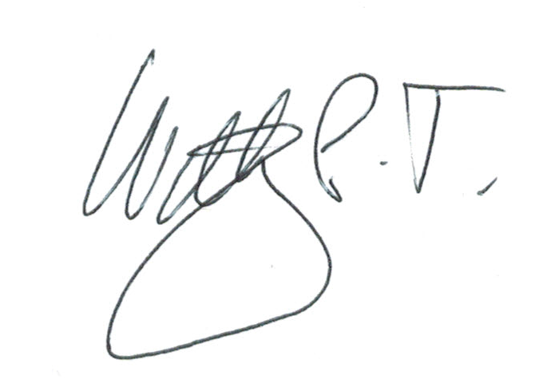 | Date:  22 April 2023

For STUDENT Submissions:
32 | Director of Studies/Supervisor: | Louise Emanuel | Date: 25.4.23
33 | Signature: | Louise Emanuel | Date: 25.4.23

For STAFF Submissions:
34 | Academic Director/ Assistant Dean: |  | Date:
35 | Signature: |  | Date:

Checklist: Please complete the checklist below to ensure that you have completed the form according to the guidelines and attached any required documentation:
☒ | I have read the guidance notes supplied before completing the form.
☒ | I have completed ALL RELEVANT sections of the form in full.
☒ | I confirm that the research activity has received approval in principle
☒ | I have attached a copy of final/interim approval from external organisation (where appropriate)
☐ | I have attached a full risk assessment (and have NOT completed Section H of this form) (where appropriate) ONLY TICK IF YOU HAVE ATTACHED A FULL RISK ASSESSMENT
☒ | I understand that it is my responsibility to ensure that the above named research activity will meet the University’s Research Ethics and Integrity Code of Practice.
☒ | I understand that before commencing data collection all documents aimed at respondents (including information sheets, consent forms, questionnaires, interview schedules etc.) must be confirmed by the DoS/Supervisor, module tutor or Academic Director.
☒ | I have deleted the guidance notes before submitting the PG2 for consideration

RESEARCH STUDENTS AND STAFF ONLY
All communications relating to this application during its processing must be in writing and emailed to pgresearch@uwtsd.ac.uk , with the title ‘Ethical Approval’ followed by your name.
You will be informed of the outcome of your claim by email; therefore it is important that you check your University and personal email accounts regularly.
STUDENTS ON UNDERGRADUATE OR TAUGHT MASTERS PROGRAMMES should submit this form (and receive the outcome) via systems explained to you by the supervisor/module leader.

This form is available electronically from the Academic Office web pages: https://www.uwtsd.ac.uk/academic-office/appendices-and-forms/

Application Process

All staff research projects and all research students must submit the Ethical Approval Form to the University Research Ethics Committee via the Academic Office (pgresearch@uwtsd.ac.uk). Staff research directly in relation to personal study for taught undergraduate or Masters programmes should be submitted via the Institute procedures explained below.

Taught masters and taught undergraduate research Ethical Approval Forms are considered within Institutes. Institutes will provide details of the specific processes for this. Where the Ethical issues within any single ethical application are of particular concern the Institute will refer these to the University Research Ethics Committee. Any student activity that involves the collection of primary data needs to undergo Ethical approval, this includes assignment work as well as dissertations.

Notes for guidance in completion of this form

Section A: About You
Please complete all relevant sections

Section B: Approval for research activity
Research proposals must be approved in principle before applying for Ethical Approval. The proposal approval only becomes final when the ethical approval is received.

The process for proposal approval varies according the individual and programme of study:
- Research students, by application on form PG1 to the Research Degrees Committee
- Taught students by review of research proposal within Institutes (Institutes provide specific details of these processes)
- Staff, by agreement by the Academic Director/Assistant Dean

Section C: External Ethical Guidance materials
Many discipline areas are required to operate with the discipline specific codes of research ethics (for example health, psychology, education etc.), any such codes must be listed and you must tick to confirm that you have consulted with these.

Section D: External Collaborative Research Activity
Provide details of the external collaborative partners, where appropriate you might want to submit a copy of the external collaboration agreement with the Ethical Approval Form. If the partner requires the research to be subject to its own internal Ethical approval process then please provide details of that process and a copy of any final (or interim) approvals received from the organisation.

Section E: Details of Research Activity
Remember that the individuals reviewing this Ethical Approval Form may not have seen your research proposal, and also may not be experts in the specific area of your research. The information provided should therefore be jargon free and clearly stated.

Indicative Title: please use the same title as used on the research proposal.

Purpose: the Ethical approval process will want to ensure that the methods you propose are adequate and appropriate to address the research aims and objectives. Excessive additional data collection can be seen as unethical.

Proposed Methods: the Ethical approval process seeks to ensure that you understand the methods that are intended, and that the implementation of those methods will be appropriate and without unnecessary impact on respondents. This section must explain how the methods described will lead to the collection of necessary and sufficient data, but not excessive data. Please be specific.

Location: this needs to mention geographical location and also local situation (for example, within Local Authority Offices in Cardiff, using a private room but close to other individuals). If you are collecting data within an organisational setting then you need to explain the permissions that you have obtained to do this.

Research Activity outside of the UK: please complete this section in detail, and note any guidance you have received. Also describe your own familiarity (or not) with the location that you will be utilising.

Section F: Scope of Research Activity
Please tick ALL of the research activities that might be undertaken. If any additional types of activity are intended then please add an extra box and describe these.

If you have answered no to all questions in F then sections G and I do not need to be completed. . Signatures are still required in section K.

Section G: Intended Participants
Please tick all categories that might apply.

Numbers & Source: if you are using a series of different methods or research activities please list numbers for each stage/phase. Be clear about how you will find respondents. Will you use intermediaries, and if so how? How will you ensure compliance with your sampling strategy?

Information for participants: all participants should be appropriately informed about the research, what is expected of them and what will happen to the information that they provide. The Ethical review process does not ask to see this documentation, but requires this to be reviewed and approved by the Director of Studies in the case of research students, the supervisor/module tutor in relation to students on taught programmes and the Academic Director/Assistant Dean in relation to staff research.

Section H: Anticipate Risks
All research carries some level of risk. The answers you provide to questions in this section will be reviewed to ensure that you have an appropriate understanding of the type of risks involved and how you can mitigate against these risks. If you have completed a full risk assessment, as required for example for laboratory work, field work, clinical tests, diving operations, or by a collaborative partner, you may append that to this form. In that case, please tick the box indicating this has been provided. You will not then be required to complete Section H.

Risk to participants Think very carefully about how your actions/questions/discussions might affect the people you are involving as participants. You might identify the risk as small but it would still be a risk. Many types of question have the potential to make respondents less content with their life / job; you need to recognise and try to ameliorate any such effects
If these are business owners, time with you may reduce profit.
In some locations physical risk is very real to both participants and yourself, please consider this.

Risk to you, the researcher Think about where you will meet people, if there are any dangers involved in the location. If you are meeting people as individuals think about using a public place. In general do not visit people in their own homes or remote locations. If you are talking to individuals about certain issues think about how their responses might affect you emotionally. What about the risk of collecting insufficient data?

Risk to the University When undertaking your research, you are acting as a member of the University (student or staff). Professionalism is important, so it is important to be well organised and well prepared. Punctuality, clarity etc. are all part of this. What will you do to ensure this? You must ensure you do not harm the good name of the University in any way and do nothing to undermine the reputation of the research it conducts and sponsors. Upholding high standards of conduct and integrity are vital in this regard. You must also conduct the research in such a way to minimise the potential for claims of negligence made against the University, its researchers and any collaborating individual or organisation. In this respect you should always comply with ethical, legal and professional frameworks, obligations and standards as required by statutory and regulatory authorities, as well as the university’s Research Integrity and Ethics Code of Practice. Research misconduct in this respect can take many forms, including:
- fabrication: making up results or other outputs (eg, artefacts) and presenting them as if they were real
- falsification: manipulating research processes or changing or omitting data without good cause
- plagiarism: using other people’s material without giving proper credit
- failure to meet ethical, legal and professional obligations: for example failure to declare competing interests; misrepresentation of involvement or authorship; misrepresentation of interests; breach of confidentiality; lack of informed consent; misuse of personal data; and abuse of research subjects or material
- improper dealing with allegations of misconduct: failing to address possible infringements such as attempts to cover up misconduct and reprisals against whistle-blowers

Adverse Outcomes. Think carefully about the possibilities, and cover here

Section I: Feedback, Consent and Confidentiality

Feedback to participants: outline your approach. Will interview transcripts be shared with respondents to check accuracy? Will summaries of questionnaire analysis be made available to respondents in some way? Will an overview report be provided? How and when?

Informed consent: Draft letter / e-mail / or heading (or footer) section of questionnaire must be approved by DoS/supervisor (if research student), supervisor/module tutor if taught student, or Academic Director / Assistant Dean if a member of staff.
Confidentiality/Anonymity. Explain clearly how you will ensure confidentiality and anonymity.

Section J: Data Protection and Storage
Before completing this section it is necessary to read the University’s Research Data Management information. The questions that follow are designed to ensure compliance with the Data Protection Act as well as established research protocols.

Many research activities will involve electronic transfer of data and use of data management systems in the summarisation and analysis of data. You will need to explain these in relation to compliance with the Data Protection Act.

Think carefully about who will have access to your data, this will include supervisors and examiners. Also that a thesis will be made available via the University library and the British Library system. If you are seeking an access bar for a period of time after completion then mention it here. If you will provide a copy of your findings, or intend to give a presentation, to a facilitating/ supporting/accessing organisation then explain that in this section. But also think about the general principle of data sharing, as explained in the Research Data Management information.

In terms of storage of data please ensure security, and also mitigate against loss of data.

Section K: Declaration
Ensure the appropriate countersignatures have been provided
Look carefully at the checklist and ensure that you comply with and tick all that are relevant to your research.
Appendix 2: Original Survey (uploaded with submission). Also at https://drive.google.com/file/d/1erQQ63QTzHe6dKbI23dGtJHaYtFmbzU9/view?usp=sharing

Appendix 3: Survey Results (PDF uploaded with submission). Also at: https://drive.google.com/file/d/1cbr3WkI_hX_n-jqLxtsqLszv13NzsgzI/view?usp=sharing

Appendix 4: Survey Results (Excel file uploaded with submission). Also at: https://docs.google.com/spreadsheets/d/1wNetalzK0c4S0MR_GgWj2p3ehLf9VXes/edit?usp=sharing&ouid=117196383401721208405&rtpof=true&sd=true

References

Abraham, T. H., Deen, T.L., Hamilton, M, et al. (2020). Analyzing free-text survey responses: An accessible strategy for developing patient-centered programs and program evaluation. Evaluation and Program Planning, 78, 101733.

Anjum, R. (2016). Evidence Based or Person Centered? An Ontological Debate. European Journal for Person Centered Healthcare, 4(2), 421-429.

Aronson, A. (1990). Clinical Voice Disorders: An Interdisciplinary Approach. Thieme.

Asher, B. (2013). "Complementary and Integrative Treatments The Voice." Otolaryngology Clinics of North America, 437-445.

Askren, A., and Leslie, P. (2019). Complexity of Clinical Decision Making: Consent, Capacity, and Ethics. Seminars in Speech and Language, 40(3), 162–169.

Ateras, B. and von Piekartz, H. (2017). Integration of a neurodynamic approach into the treatment of dysarthria for patients with idiopathic Parkinson's disease: A pilot study. Journal of Bodywork & Movement Therapies, https://doi.org/10.1016/ j.jbmt.2017.12.004.

Awang, Z., Afthanorhan, A., Mamat, M. (2016). The Likert scale analysis using paramec based Structural Equation Modeling (SEM). Computational Methods in Social Sciences, 4(1), 13-21.

Bada, S. (2015). Constructivism Learning Theory: A Paradigm for Teaching and Learning. IOSR Journal of Research & Method in Education, 5(6), 66-70.

Bans-Akutey, A. A. and Tiimub, B.M. (2021). Triangulation in Research. Academia Letters, https://doi.org/10.20935/AL3392.

Barry, E. S., Merkebu, J., Varpio, L. (2022). State-of-the-art literature review methodology: A six-step approach for knowledge synthesis. Perspectives on Medical Education, 11(5), 281–288.

Behlau M. (2019). The 2016 G. Paul Moore Lecture: Lessons in Voice Rehabilitation: Journal of Voice and Clinical Practice. Journal of Voice, 33(5), 669–681.

Bialosky, J. E., Cleland, J. A., Mintken, P., et al. (2022). The healthcare buffet: preferences in the clinical decision-making process for patients with musculoskeletal pain. The Journal of Manual & Manipulative Therapy, 30(2), 68–77.

Bialosky, J. E., Beneciuk, J. M., Bishop, M. D., et al. (2018). Unraveling the Mechanisms of Manual Therapy: Modeling an Approach. The Journal of Orthopaedic and Sports Physical Therapy, 48(1), 8–18.

Cammel, S. A., De Vos, M. S., van Soest, D., et al. (2020). How to automatically turn patient experience free-text responses into actionable insights: a natural language programming (NLP) approach. BMC Medical Informatics and Decision Making, 20(1), 97.

Cardenas, S. and Valcarcel, M. (2005). Analytical features in qualitative analysis. Trends in Analytical Chemistry, 24(6), 477-487.

Carter, N., Bryant-Lukosius, D., DiCenso, A., et al. (2014). The use of triangulation in qualitative research. Oncology Nursing Forum, 41(5), 545–547.

Castro, M. E., Enclade, H., Biel, M. (2023). Self-Determination Theory Applications in Culturally Responsive Voice Therapy. ASHA SIG 3, https://doi.org/10.1044/2023_PERSP-23-00168.

Chen, W. S., Schloesser, D., Arensdorf, A.M., et al. (2021). The Emerging Science of Interoception: Sensing, Integrating, Interpreting, and Regulating Signals within the Self. Trends in Neuroscience, 44(1), https://doi.org/10.1016/j.tins.2020.10.007.

Cherkin, D. C., Sherman, K. J., Kahn, J., et al. (2011). A comparison of the effects of 2 types of massage and usual care on chronic low back pain: a randomized, controlled trial. Annals of Internal Medicine, 155(1), 1–9.

Coronado, R. and Bialosky, J.E. (2017). Manual physical therapy for chronic pain: the complex whole is greater than the sum of its parts. Journal of Manual & Manipulative Therapy, 25(3), 115-117.

Cotton, W.A., Lockyer, L., Brickell, G.J. (2009). A Journey Through a Design-Based Research Project.

Daniels, K., Chanda, A., Berry, L et al. (2024). A Survey of Manual Therapy Techniques and Protocols Used to Prevent or Treat Dysphagia in Head and Neck Cancer Patients During and after Radiation Therapy. Global Advances in Integrative Medicine and Health, 13, 27536130241263349.

Dehqan, A. (2020). Outcomes of Cricothyroid Visor Maneuver (CVM) for Treatment of Vocal Polyp: A Case Report. Journal of Voice, 37(1), https://doi.org/10.1016/j.jvoice.2020.11.002.

Dennick, R. (2016). Constructivism: reflections on twenty five years teaching the constructivist approach in medical education. International Journal of Medical Education, 7, 200-205.

Devisch, I. D., Dierckx, K., Van de Velde, D., et al. (2015). Patient’s Perception of Autonomy Support and Shared Decision Making in Physical Therapy. Open Journal of Preventative Medicine, 387-399.

Donohue, C. and Coyle, J. (2022). Application of Meta-Therapy to Dysphagia Rehabilitation. SIG 3 Voice and Upper Airway Issues, https://pubs.asha.org/doi/10.1044/2022_PERSP-22-00082.

Dromy, C. N., Nissen, S.L., Roy, N., et al. (2008). Articulatory Changes Following Treatment of Muscle Tension Dysphonia: Preliminary Acoustic Evidence. Journal of Speech, Language, and Hearing Research, https://doi.org/10.1044/1092-4388(2008/015).

Dugan, C. (2020). A Survey of Speech Pathologists Regarding Self-Administered
Laryngeal Massage on Singers. Miami: University of Miami.

Dunphy, C. (2013). Critical Review: The Hands On Approach: Perilaryngeal Manual Therapies in the Treatment of Muscle Tension Dysphonia. Retrieved from Univ. of Western Ontario: https://www.uwo.ca/fhs/lwm/teaching/EBP/2012_13/Dunphy_C.pdf

Dutta, G., Jagetia, A., Srivastava, A. K., et al. (2018). "Crick" in Neck Followed by Massage Led to Stroke: Uncommon Case of Vertebral Artery Dissection. World Neurosurgery, 115, 41–43.

Dwyer, S. A. and Buckel, J.L. (2009). The Space Between: On Being an Insider-Outsider in Qualitative Research. International Journal of Qualitative Methods, 8(1), 54-63.

Dzwigol, H. (2022). Research Methodology in Management Science: Triangulation. Virtual Economics, 5(1), 78-93.

Featherston, R. D. (2020). Decision making biases in the allied health professions: A systematic scoping review. PloS, 15(10), https://doi.org/10.1371/journal.pone.0240716.

Featherston, R., Downie, L. E., Vogel, A. P., et al. (2020). Decision making biases in the allied health professions: a systematic scoping review. PLoS One, 15(10), e0240716.

Flock, L. and King, S. (2023). Developing a Vocal Manual Therapy Intervention for the Treatment of Laryngopharyngeal Reflux in Professional Voice Users: A Pilot Study of Two Elite Singers. Journal of Singing, 79(5), 27-35.

Fritz, W. (2020). An investigation into the multifactorial impacts of manual therapy on voice. Historical perspectives and their perceived limitations. Unpublished.

Fritz, W. 2021. Module 4: BMPF7013F. Unpublished

Fritz, W. (2022). Module 5: BMPF7013G. Unpublished.

Fritz, W. (2024). The mechanism of action for laryngeal manual therapies: the need for an update. Current Opinion in Otolaryngology & Head and Neck Surgery, 32(3), 151-155.

Geri, T., Viceconti, A., Minacci, M., et al. (2019). Manual therapy: exploiting the role of human touch. Musculoskeletal Science and Practice, 44, 102044.

Grant, M. J. (2009). A typology of reviews: an analysis of 14 review types and associated methodologies. Health Information and Libraries Journal, 29, 91-108.

Grenier, J. P., and Rothmund, M. (2024). A critical review of the role of manual therapy in the treatment of individuals with low back pain. Journal of Manual & Manipulative Therapy, 1-14, https://doi.org/10.1080/10669817.2024.2316393.

Gustin, A. (2019). Shared Decision-Making. Anesthesiology Clinics, 37(3), 573-580.

Helou, L. (2017). Crafting the Dialogue: Meta-Therapy in Transgender Voice and Communication Training. SIG 10 Perspectives of the ASHA Special Interest Groups, 2(2).

Helou, L. (2017). Crafting the Dialogue: Meta-Therapy in Transgender Voice and Communication Training. Perspectives of the ASHA Special Interest Groups, SIG 10, 2(Part 2), 83-91.

Helou, L. (2019). Beyond Successful Voice Therapy Techniques and Tasks: The Concept of Meta-Therapy. In J. A. Stemple, Voice therapy: Clinical case studies (pp. 28-31). Plural Publishing, Inc.

Helou, L., Gartner-Schmidt, J.L., Hapner, E.R., et al. (2021). Mapping Meta-Therapy in Voice Interventions onto the Rehabilitation Treatment Specification System. Seminars in Speech and Language, 42(1), 5-18.

Iwarsson, J. (2015). Reflections on clinical expertise and silent know-how in voice therapy. Logopedics Phoniatrics Vocology, 40, 66–71.

Iizumi, T., Magara, J., Tsujimura, T., et al. (2017). Effect of body posture on chewing behaviours in healthy volunteers. Journal of Oral Rehabilitation, 44(11), 835–842.

Isaksen, Jytte. (2018). “Well, You Are the One Who Decides”: Attempting Shared Decision Making at the End of Aphasia Therapy. Topics in Language Disorders, 38(2) 126-142.

Jacobs, D. and Silvernail, J. (2011). Therapist as operator or interactor? Moving beyond the technique. Journal of Manual and Manipulative Therapy, 19(2), pp. 120-121.

Johnsson, F., Shaw, D., Gabb, M., et al. (1995). Influence of gravity and body position on normal oropharyngeal swallowing. The American Journal of Physiology, 269(5 Pt 1), G653–G658.

Jovanovic, N., Coyle, P.C., Theurer, J.A. (2022). Supporting Patient Autonomy in Shared Decision Making for Individuals With Head and Neck Cancer. American Journal of Speech Pathology, https://doi.org/10.1044/2022_AJSLP-21-00339.

Kanuha, V. (2000). "Being" native versus "going native": Conducting social work research as an insider. Social Work, 45(5), 439-447.

Kendall, P. C. and Frank, H.E. (2018). Implementing evidence-based treatment protocols: Flexibility within fidelity. Clinical Psychology, 25(4).

Kennard, E. J., Lieberman, J., Saaid, A., et al. (2015). A preliminary comparison of laryngeal manipulation and postural treatment on voice quality in a prospective randomized crossover study. Journal of Voice, 29(6), 751-754.

Kolb, W. H., McDevitt, A. W., Young, J., et al. (2020). The evolution of manual therapy education: what are we waiting for? Journal of Manual & Manipulative Therapy, 28(1), 1-3.

Kon A. A. (2010). The shared decision-making continuum. Journal of the American Medical Association, 304(8), 903–904.

Koren, Y., & Kalichman, L. (2018). Deep tissue massage: What are we talking about? Journal of Bodywork and Movement Therapies, 22(2), 247–251.

Kristjánsson, K. (2021). Reason and intuition in Aristotle’s moral psychology: why he was not a two-system dualist. Philosophical Explorations, 25(1), 42-57.

Leng, G., Clark, C. I., Brian, K., Partridge, G. (2017). National commitment to shared decision making. British Journal of Medicine (Clinical research ed.), 359, j4746. https://doi.org/10.1136/bmj.j4746

Madondo, S. (2021). Data Analysis and Methods of Qualitative Research: Emerging Research and Opportunities. Hershey: IGI Global.

Marszalek, S., Niebudek-Bogusz, E., Woznicka, E., et al. (2012). Assessment of the influence of osteopathic myofascial techniques on normalization of the vocal tract functions in patients with occupational dysphonia. International Journal of Occupational Medicine and Environmental Health 25(3), 225-235.

McCarty, D. B., Sierra-Arevalo, L., Caldwell Ashur, A. C., et al. (2024). Spanish Translation and Cultural Adaptations of Physical Therapy Parent Educational Materials for Use in Neonatal Intensive Care. Patient Preference and Adherence, 18, 93–100.

McParlin, Z., Cerritelli, F., Friston, K. J., et al. (2022). Therapeutic alliance as active inference: the role of therapeutic touch and synchrony. Frontiers in Psychology, 13, 783694.

Menard, M. T., & Farber, A. (2014, March). The BEST-CLI trial: a multidisciplinary effort to assess whether surgical or endovascular therapy is better for patients with critical limb ischemia. In Seminars in Vascular Surgery, 27(1), 82-84.

Miciak, M. (2015). Bedside Matters: A Conceptual Framework of the Therapeutic Relationship in Physiotherapy. PhD Dissertation, Alberta.

Miciak, M., Mayan, M., Brown, C., et al. (2018). The necessary conditions of engagement for the therapeutic relationship in physiotherapy: an interpretive description study. Archives of Physiotherapy, 8, 1-12.

Migiro, S. O., and Magangi, B. A. (2011). Mixed methods: A review of literature and the future of the new research paradigm. African Journal of Business Management, 5(10), 3757-3764.

Moore, C. L., and Kaplan, S. L. (2018). A framework and resources for shared decision making: opportunities for improved physical therapy outcomes. Physical Therapy, 98(12), 1022-1036.

Mulisa, F. (2022). Sampling techniques involving human subjects: Applications, pitfalls, and suggestions for further studies. International Journal of Academic Research in Education, 8(1), 75-84.

Muñoz-Gómez, E., Inglés, M., Aguilar-Rodríguez, M., et al. (2022). Effect of a craniosacral therapy protocol in people with migraine: A randomized controlled trial. Journal of Clinical Medicine, 11(3), 759.

Nasrin, S., Ali, D., Jamshid, J., et al. (2022). The effects of Cricothyroid Visor Maneuver (CVM) therapy on the voice characteristics of patients with muscular tension dysphonia: A Case Series Study. Journal of Voice, March 20.

Petty, B. E., Gillespie, A. I., van Leer, E. (2023). Meta-therapy applications for the voice evaluation. Perspectives of the ASHA Special Interest Groups, 8(4), 620-624.

Posadzki, P., and Ernst, E. (2013). The safety of massage therapy: an update of a systematic review. Focus on Alternative and Complementary Therapies, 18(1), 27–32.

Reeves, T. (2000). Enhancing the Worth of Instructional Technology Research through “Design Experiments” and Other Development Research Strategies. International Perspectives on Instructional Technology Research for the 21st Century, 29, 1-16.

Reeves, T. C., Herrington, J., Oliver, R. (2005). Design research: A socially responsible approach to instructional technology research in higher education. Journal of Computing in Higher Education, 16, 96-115.

Reis, F.J.J., Nijs, J., Parker, R., et al. (2022). Culture and musculoskeletal pain: strategies, challenges, and future directions to develop culturally sensitive physical therapy care. Brazilian Journal of Physical Therapy, 26(5), 100442.

Ross, S. (1999). Dysphonia: osteopathic treatment. Journal of Bodywork and Movement Therapies, 3(3), 133-142.

Roy, N., Dietrich, M., Blomgren, M., et al. (2019). Exploring the neural bases of primary muscle tension dysphonia: a case study using functional magnetic resonance imaging. Journal of Voice, 33(2), 183-194.

Roy N. (2008). Assessment and treatment of musculoskeletal tension in hyperfunctional voice disorders. International Journal of Speech Language Pathology. 10, 195 – 209.

Roy, N., and Leeper, H. A. (1993). Effects of the manual laryngeal musculoskeletal tension reduction technique as a treatment for functional voice disorders: perceptual and acoustic measures. Journal of Voice, 7(3): 242-249.

Rubin, J.S. and Lieberman, J. (2000). Laryngeal Manipulation. Otolaryngologic Clinics of North America, 33 (5): 1017-1034.

Ryu, S. (2020). The role of mixed methods in conducting design-based research. Educational Psychologist, https://doi.org/10.1080/00461520.2020.1794871, 1-12.

Saldana, J. (2016). The Coding Manual for Qualitative Researchers. London: Sage.

Santana, M. J., Manalili, K., Jolley, R. J., et al. (2018). How to practice person‐centred care: A conceptual framework. Health Expectations, 21(2), 429-440.

Scope of Practice in Speech-Language Pathology. (2016). Retrieved from American Speech-Language-Hearing Association: https://www.asha.org/policy/sp2016-00343/

Sharif, F., & Armitage, P. (2004). The effect of psychological and educational counselling in reducing anxiety in nursing students. Journal of Psychiatric and Mental Health Nursing, 11(4), 386-392.

Shiino, Y., Sakai, S., Takeishi, R., et al. (2016). Effect of body posture on involuntary swallow in healthy volunteers. Physiology & Behavior, 155, 250–259.

Spengler, F. B., Becker, B., Kendrick, K. M., et al. 2017. Emotional Dysregulation in Psychogenic Voice Loss. Psychotherapy and Psychosomatics, 86(2): 121-123.

Stepp, C. E., Heaton, J. T., Braden, M.N. et al. (2011). Comparison of neck tension palpation rating systems with surface electromyographic and acoustic measures in vocal hyperfunction. Journal of Voice, 25(1), 67-75.

Stewart, M., and Loftus, S. (2018). Sticks and Stones: The Impact of Language in Musculoskeletal Rehabilitation. The Journal of Orthopaedic and Sports Physical Therapy, 48(7), 519–522.

Thomson, O. P., and MacMillan, A. (2023). What's wrong with osteopathy? International Journal of Osteopathic Medicine, 48, 100659.

Tilton-Bolowsky, V. E., Davis, A. S., and Zipse, L. (2023). Mapping meta-therapy onto the treatment of cognitive-communication and language disorders in adults. Perspectives of the ASHA Special Interest Groups, 8(4), 640-658.

Toles, L.E. and Harris, A.L. (2023). Direct and Indirect Voice Therapy Approaches for Unloading the Laryngeal Mechanism in Professional Voice Users. Current Otorhinolaryngology Reports. https://doi.org/10.1007/s40136-023-00483-0.

Torraco, R. (2016). Writing Integrative Literature Reviews: Using the Past and Present to Explore the Future. Human Resource Development Review, 15(4), 404-428.

Tousignant-Laflamme, Y., Christopher, S., Clewley, D., et al. (2017). Does shared decision making results in better health related outcomes for individuals with painful musculoskeletal disorders? A systematic review. Journal of Manual & Manipulative Therapy, 25(3), 144-150.

van den Akker, J. B. (1999). Principles and methods of development research. In J. N. van den Akker, Design methodology and developmental research in education and training (pp. 1-14). The Netherlands: Kluwer Academic Publishers.
Van Stan, J.H., Roy, N., Stemple, J., et al. (2024). Rehabilitation Treatment Specification System: Content and Criterion Validity Across Evidence-Based Voice Therapies for Muscle Tension Dysphonia. American Journal of Speech Pathology, 33, 1774-1791.

Willits, F. K., Theodori, G. L., and Luloff, A. E. (2016). Another look at Likert scales. Journal of Rural Social Sciences, 31(3), 6.

