Info Skills Unit Evidence
MODULE: BMHP CODE:4028
STUDENT NAME: OPHELIA A. KWARTENG
STUDENT NUMBER:2406439

Info Skills: Finding Information: Unit 1 Types of Information

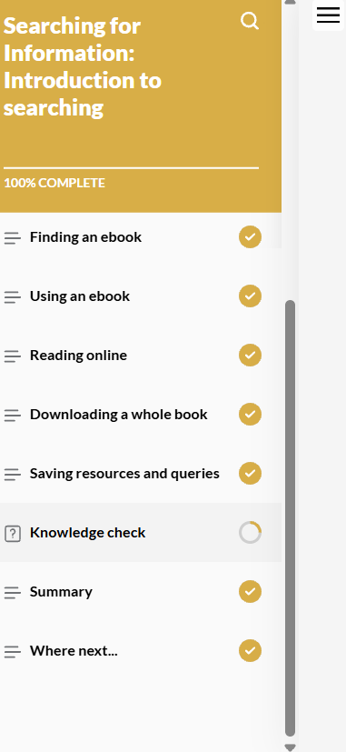

Info Skills: Finding Information: Unit 4, Section 1 (Critical Awareness)

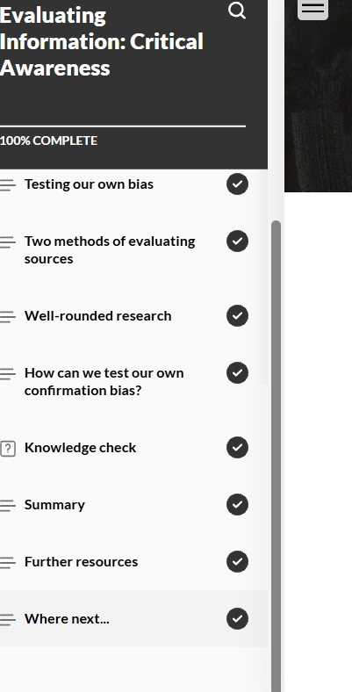

Info Skills: Referencing Basics

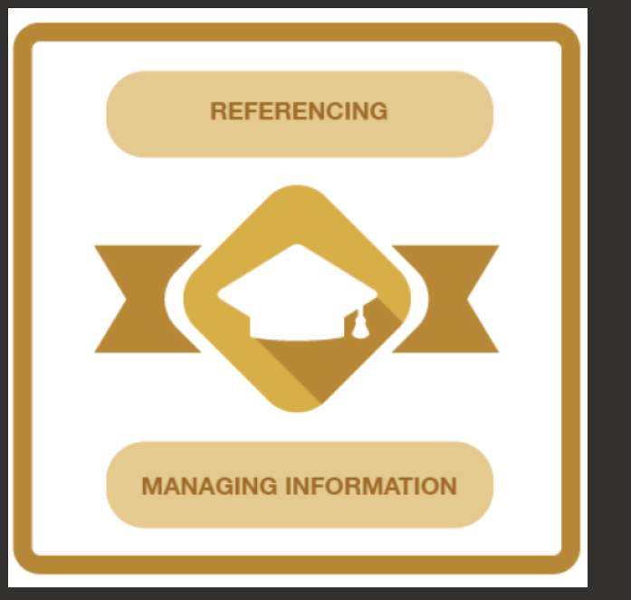

Info Skills: Academic Integrity

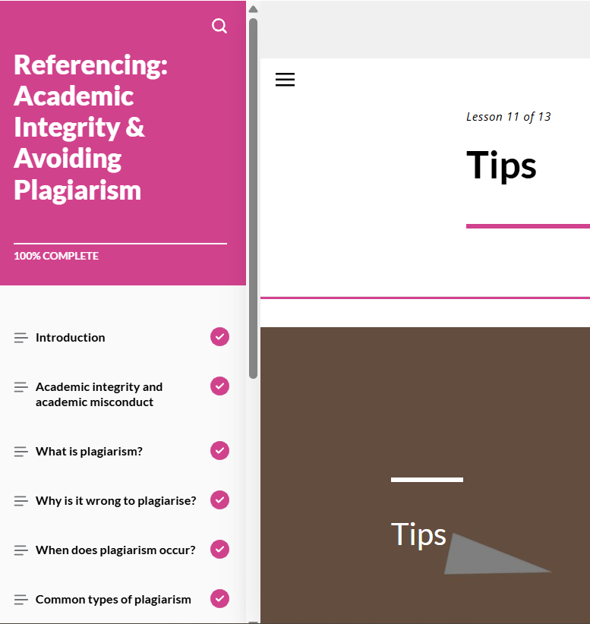

Info Skills: Evaluating Information

