Data Security and Compliance

  - Research and Case Scenario in Data Security and Compliance
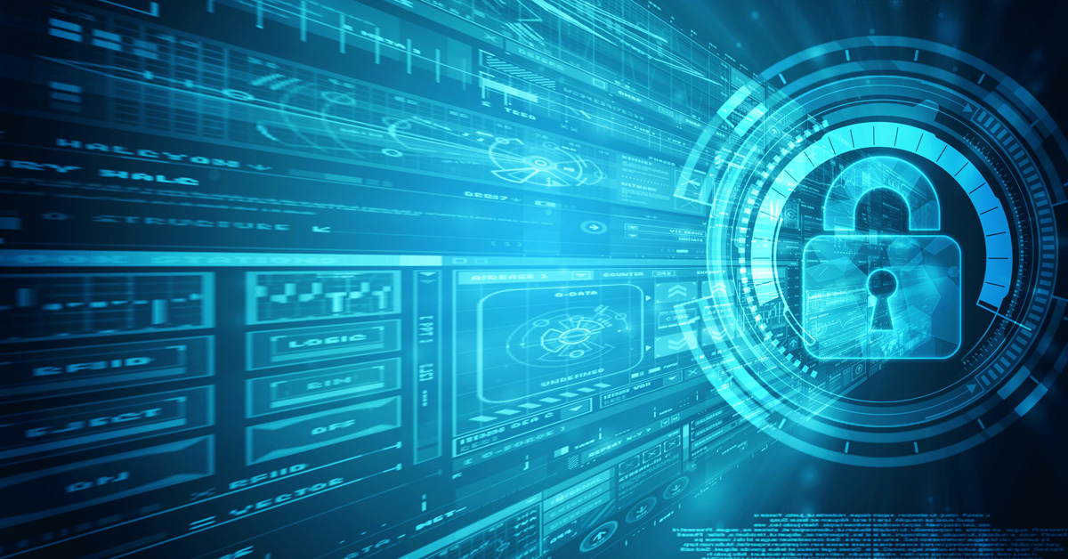

Software Engineering

Kayleigh Davies
Student Number: 2316137
Contents

Implementing Information Security 3
1. Introduction 3
2. Standard Security Frameworks 3
3. System Development Life Cycles (SDLC) 4
4. Risk Management 4
5. Policies and Procedures 5
6. Training and Awareness 5
7. Conclusion 5
Case Scenario 6
1. Introduction 6
2. Organisation and Structures 6
3. Policies and Procedures 7
3.1. Access Control Policy 7
3.2 Network Security Policy 8
3.3 Incident Response Policy 9
4. Data Protection Compliance 9
5. Security Standards 10
5.1 Information Security Management Systems and ISO 27001 10
5.2 ISO 27001 Annex A 12
6. Contingency Planning 13
7. Governance and Strategic Planning for Security 14
8. Risk Management 15
9. Conclusion 16
References 17

Implementing Information Security
Kayleigh Davies
Student University of Wales Trinity St David, Swansea, Wales
2316137@student.uwtsd.ac.uk

Why should modern organizations create an environment that protect, detect, react and safeguards applications using the organization’s IT systems and infrastructure?
Keywords –Information Security, General Data Protection Regulation (GDPR), National Institute of Standards and Technology (NIST), Information Security Management System (ISMS)

1. Introduction
The purpose of this paper is to explain why organizations must defend and preserve their data, infrastructure and IT systems against cyberattacks, as well as the need for having appropriate techniques in place to quickly identify potential data risks and establish measures to mitigate any damage.
Implementing effective security measures is critical for ensuring that businesses adhere to security standards and regulations by applying solutions that address all aspects of their organizational security requirements. Protecting information is key for any organization to avoid the risk of data loss, data breaches, disruption, and reputational damage [1].
There are various security policies, standards, and procedures available to support companies in complying with the correct guidelines for their security systems to protect the confidentiality, integrity, and availability of data [1]. Protecting the important information assets that help businesses achieve their objectives is a critical objective for all organizations [1].
Complying with standards such as ISO 27001, GDPR, and NIST will guide companies through each stage of development for strong security management systems to protect their data and improve resilience. Including both technical and physical controls ensures that security systems comply with requirements, especially when it is clear how each would improve the performance of a security system.
Controlling access to information assets is another key part of protecting sensitive information since it reduces the likelihood of data being accessed by unauthorized individuals and used illegally [6]. Including Access Control Policies and verification methods can help with this.

2. Standard Security Frameworks
Numerous organizations offer information security blueprints for businesses to incorporate into their security development strategies.
An example of this is the Information Security Management Systems outlined in the ISO 27001 standards. Using this approach allows companies to manage sensitive data within the organization while continuously improving their security measures to eliminate any vulnerabilities [14].
The ISMS focuses on the objectives of maintaining confidentiality, integrity, and availability of data to meet the ISO 27001 standards, it encourages businesses to consider ways to improve their security management systems so they can respond effectively to cyberattacks [17-18]. Having regular reviews of security management systems and procedures is an important part of safeguarding data as it encourages companies to adapt their plans to tackle the “changing nature” of cybersecurity threats [15].

3. System Development Life Cycles (SDLC)
The SDLC approach is a method used by organizations to work through several stages of development to ensure each of the proposed security measures are carefully considered throughout the systems life cycle [25] The image below shows the different stages included in the system development.
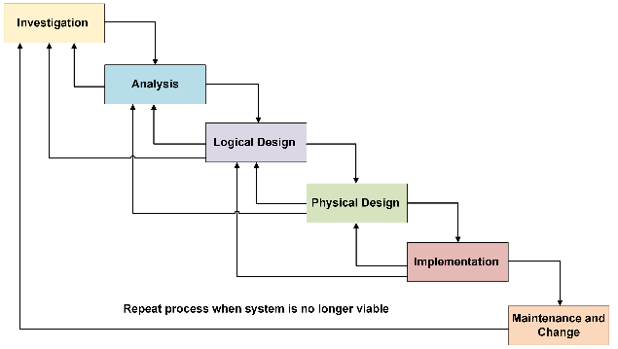

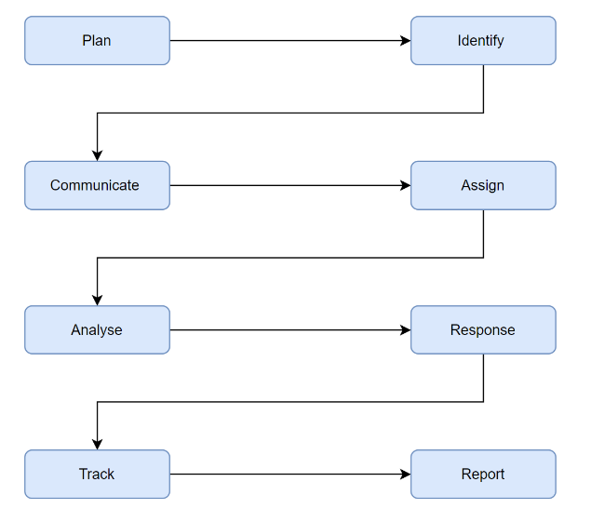
When working towards the goal of protecting information, S. Radack states “The most effective way to protect information and information systems is to integrate security into every step of the system development process” meaning that it is a factor to be considered from the beginning of the development process to the very end [25]. Applying this to system development plans will ensure appropriate protection methods are implemented for the information systems will transmit, store, and process [25].
Integrating security measures into the early stages of a system development life cycle has the advantage of identifying security vulnerabilities far earlier in the development process, giving enough time to prepare risk mitigation measures. In addition, it may reveal potential system issues before to implementation, allowing time for modifications [25].

4. Risk Management
Increasing the understanding and awareness of the risks involved in security systems will support organizations in safeguarding their assets and information systems [23]. Understanding the nature and severity of security risks allows firms to examine weaknesses in their mitigation processes and amend them accordingly. This will remove the failure to provide confidentiality, integrity, and availability of data when adequate security measures are in place [23].
The risk management strategies used to protect information should describe the risk and the procedures to take for handling, assessing, and reducing it. Having these principles will help security personnel deal with the problems of combating cyber threats. Working through each of the stages in the diagram below will guarantee that enough information is gathered concerning every potential risk.

Once risk assessments have been completed, businesses will be able to determine which policies and processes need to be evaluated, as well as whether extra guidelines should be followed.

5. Policies and Procedures
Following the guidance provided in the security policies and procedures will support organizations in protecting their data [6]. It will ensure that organizations comply with the most recent regulations, allowing them to rely on the security measures they have implemented.
Information security policies act as a “foundation for establishing a secure environment and mitigating potential risk” [6]. Understanding the organization's goals and requirements can make it easier to determine which policies are most suited to help you manage and safeguard data.
Each policy aims to protect the privacy of sensitive information by describing effective techniques for reducing the risk of security threats such as data breaches and unauthorized access [6].

6. Training and Awareness
Improving the understanding of the importance of protecting data, reacting to security threats, and safeguarding data will improve the way an organization operates. Explaining to employees how they may incorporate these aspects into their daily roles can increase their awareness, develop a security culture, and contribute to the organization's overall resilience and efficiency
Training personnel to use new systems is another crucial issue to consider when developing security policies. If new unfamiliar processes are implemented, employees will require assistance in adapting to the new ways in place to boost security protection throughout the firm.

7. Conclusion
Organizations should establish effective security systems for a variety of reasons, the most important of which is to protect information from dangers and ensure that the confidentiality, integrity, and availability of data are not jeopardized.
Throughout the paper, numerous methods for creating a safe environment for an organization's data, infrastructure, and IT systems were explained, as well as the importance of doing so.

Case Scenario
Setting up a new information security unit in your organization

1. Introduction
This paper emphasizes the critical importance of information security within organizations, highlighting key factors for the development of reliable information security units. It addresses topics such as data protection compliance, security standards, and risk management.
Given our reliance on technology for accessing, managing and protecting our data, having effective information security units is crucial. Developing systems to mitigate vulnerabilities and counteract cyberattacks is essential for businesses to achieve their goals [1]. To ensure the information security unit meets the standard of providing confidentiality, integrity, and availability of our data, we will carefully consider each of these requirements.

As a manager responsible for establishing a new information security unit, I will prioritize developing a clear organizational structure, solid security policies, and ensuring compliance with data protection laws and regulations. In addition, we will implement effective contingency plans to enable us recover quickly following any incidents. This strategy will improve our security while also aligning with our company's goals.

2. Organisation and Structures
When implementing information security measures, having a well-defined organizational structure is essential. It allows managers to guide their teams, clarify roles and responsibilities, and promote collaboration.

The figure below illustrates a hybrid organisational structure designed to create our new information security unit. This structure allocates roles and responsibilities while encouraging collaboration and supporting the implementation of innovative plans [4].

In doing so, it uses the team’s creativity and expertise to solve problems and achieve their goals [4]. For the hybrid model to be successful, clear objectives and frequent communication among employees are crucial. To support this, we will conduct team meetings to review progress against our objectives.

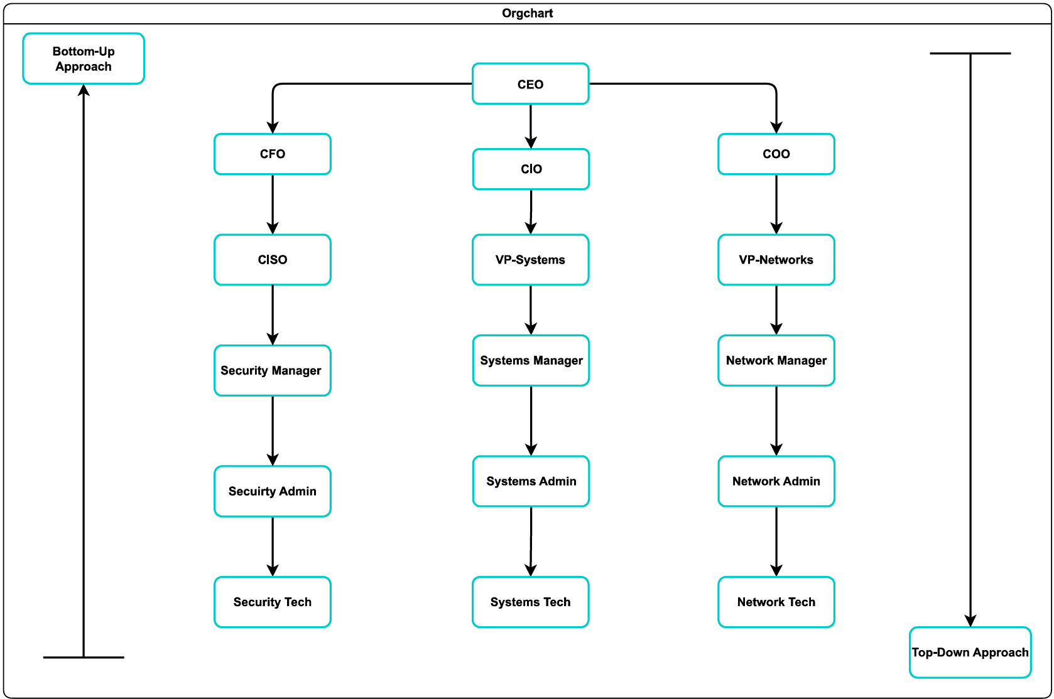

3. Policies and Procedures
Information security policies can be described as a set of rules, guidelines, and procedures that explain how organizations should be managing, protecting, and distributing their information assets [6].

Policies should be reviewed regularly to reflect changes to factors such as security risks, technology, and the business environment. They support businesses in establishing secure environments by mitigating potential risks [6]. The following are some examples of policies that will be used throughout our organization, as well as the procedures in place to implement them.

3.1. Access Control Policy
The access control policy will be implemented in our new security system to ensure that employees have access to the information and resources they need. To manage access to our data assets, we can grant permissions to users, when necessary, along with assessing and monitoring user rights within the organisation [6]. For example, only providing access to the information employees need to perform their tasks and removing the permissions once the tasks are completed or when an employee has left the company or changed teams [9].

Another example of how we will use the access control policy is ensuring employees use a two-factor authentication process to log into their accounts. We will provide support and guidance for setting strong passwords using special characters and numbers to meet our security requirements.

Another control strategy is reminding employees to update their passwords and applying validation tools to ensure passwords are not reused [6-9]. Having policies like this in place reduces the chance of data being accessed by incorrect persons, as well as the possibility of data breaches [6].

3.2 Network Security Policy
Network policies are used to control the network environment of organizations by implementing protection measures against threats to manage systems more efficiently [7]. The policies establish guidelines for repetitive tasks such as accessing the organization's networks, adding and updating system devices or services, and ensuring network integrity and safety [7].

Security policies assist firms in remaining compliant by offering simple, consistent, policies that are easy to enforce [7]. To comply with this policy, we will set clear rules to ensure that networks and data assets are safe and used responsibly [9].

Other controls include training our employees on mandatory network security practices and the processes of requesting new software on our systems to reduce the danger of virus attacks from unsafe websites [9].

Monitoring and maintaining our firewalls will improve our safeguarding measures by protecting our networks from hackers and being susceptible to the threat of cyberattacks. Restricting user access to websites and software will avoid the risk of employees accessing unauthorized content [10].

3.3 Incident Response Policy
Complying with the incident response policies will ensure we can communicate how our teams should respond to security incidents within our networks allowing us to minimize the impact and recover time [10].

Having clear procedures for reporting and categorizing incidents based on their nature and impact is critical for our team to understand the severity of the risks and the processes required to remove the problem [10]. To ensure our employees are familiar with these procedures we will have clear instructions for them to follow and an outline of the roles and responsibilities among the team making incidents easier to tackle.

4. Data Protection Compliance
Data protection compliance focuses on handling and managing sensitive data to ensure the methods in place meet the required standards. As Infotech explains data security is” the practice of safeguarding information against access by unauthorized individuals” [11]. Keeping sensitive data safe and preventing improper use of data is crucial for any organization as it will reduce the chances of unauthorized access and data breaches [11-13].

Ensuring that our organization is open about our data collection processes and the safety measures in place will help us comply with legislation such as the General Data Protection Regulation (GDPR) [13]. The GDPR protects personal and sensitive data to make certain that it’s protected to the “highest levels of discretion” [12]. As many departments within the organisation may require access to this information a clear structure must be developed to understand how to store and share it among our teams.

Regular checks on our data compliance methods are required to verify they are appropriate for identifying and addressing issues. This will enable us to develop reliable data security policies while improving our understanding of how to prepare for and manage data breaches to minimize their consequences [13].

As mentioned before, having an access control system ensures that only authorized individuals may access sensitive data through two-factor authentication checks. Depending on their role, control systems may grant employees different types of permissions. For example, some employees may only be able to view information, while others may have read-write permissions to update it.

5. Security Standards
Various security frameworks and standards are available for supporting organizations to protect their data and develop a well-managed security system. To do this, we must have appropriate knowledge of the standards and understand how to comply with them [14].

The frameworks focus on managing risk and reducing vulnerabilities by defining the tasks needed to prepare for compliance. They provide a starting point for “establishing processes, policies and administrative activities for information security management” [14]. To assist with the development of a new information security unit, we will be using an Information Security Management System.

5.1 Information Security Management Systems and ISO 27001
Implementing a new information security unit requires a “systematic approach for managing an organization’s information” [14]. Using a framework like ISMS will assist in establishing, implementing, maintaining, and developing our information security systems along with the required mitigation measures for risk management [14].

The objectives of the framework focus on the confidentiality, integrity, and availability of data while ensuring our system meet the required standards outlined in the policies, procedures and regulations for organisations to comply with. “The ISMS is based on the international standards such as ISO/IEC 270001” [14].

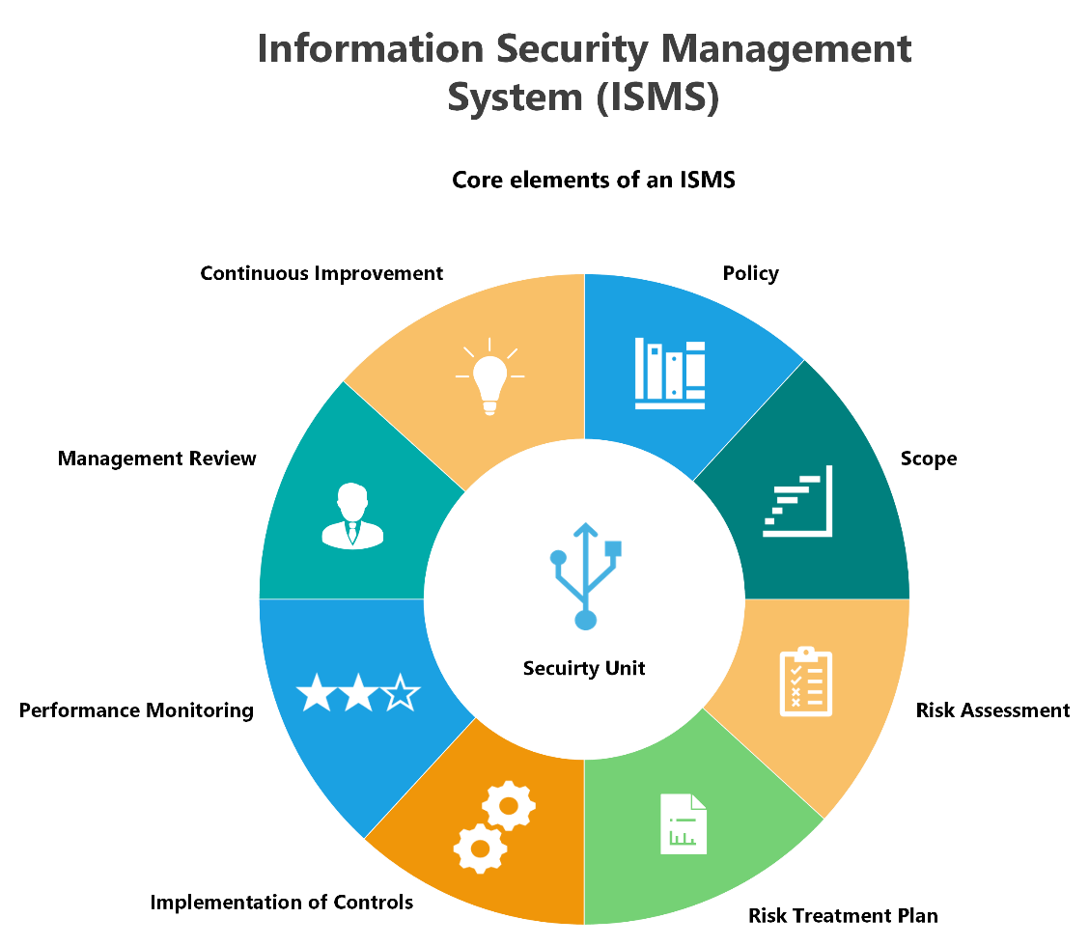

Working through each stage of the framework will aid in the design of an efficient information security management system as well as providing an opportunity to gather ideas for future revisions.

The benefits of implementing ISO 27001 standards include bringing the company up to speed on the legal and regulatory requirements for information security, allowing us to improve our understanding. Additionally, it provides the opportunity to enhance the systems and technologies used and the way our firm operate. This is beneficial given the "changing nature of cybersecurity" [15]. Another consideration is that once our firm obtains ISO 27001 certification, it will develop trust and confidence with our clients [15].

Using a plan-do-check-act cycle will help with structuring each of the processes outlined in the ISMS [16]. The figure below explains the objectives for each stage of the cycle.

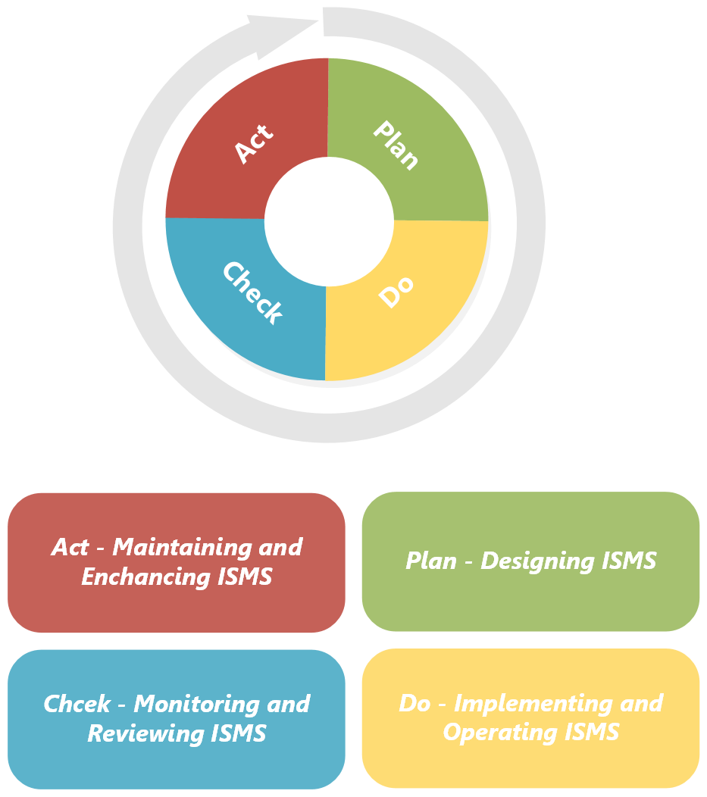

5.2 ISO 27001 Annex A

Various controls are outlined in ISO 27001 Annex A to support companies in increasing resilience by protecting the confidentiality, integrity, and availability of data and responding to threats of cyberattacks [17-18]. There are technical and physical controls to apply to an ISMS to ensure the security systems comply with the regulations.

The controls are divided into 14 sections for businesses to review and implement based on their applicability to the security requirements [17-18]. The image below demonstrates each of the controls that could be applied to our security unit.
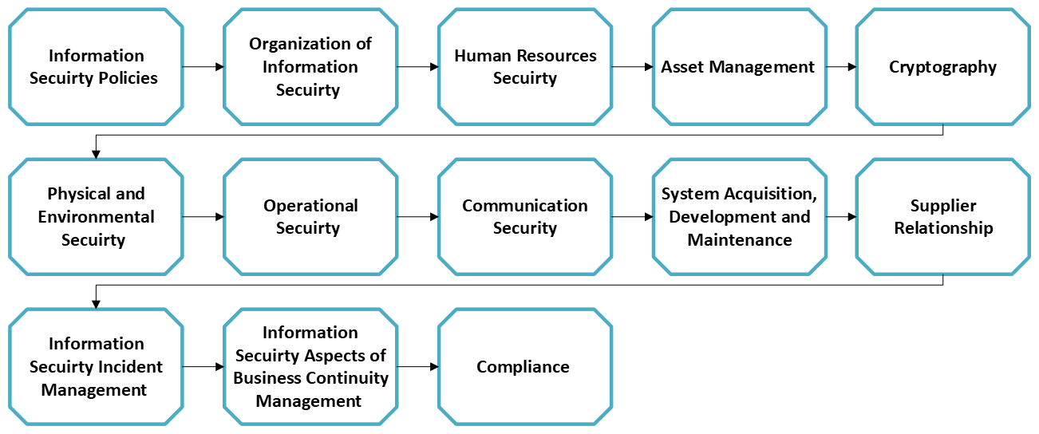

To understand which controls are needed within our systems, we will review how each can improve our security and how they can be included in the design of the new security unit. To ensure the correct measures are included in developing the security unit to adhere to the required standards we will conduct a gap analysis.

6. Contingency Planning
Contingency planning can be defined as "thinking ahead and preparing to maintain the accessibility, confidentiality, and integrity of all information" so that an organization can carry out essential tasks and operations with minimal disruption in the event of an incident [19].

Developing a contingency plan will ensure we have the required information for system recovery, covering aspects such as roles and responsibilities, assessment and recovery procedures, and system testing techniques [19].

Understanding the processes that are critical for our organization to operate will make it easier to plan for the other components of the contingency plan. Some examples to be included in the plans are “software, data files, system components, and vital records” [19].

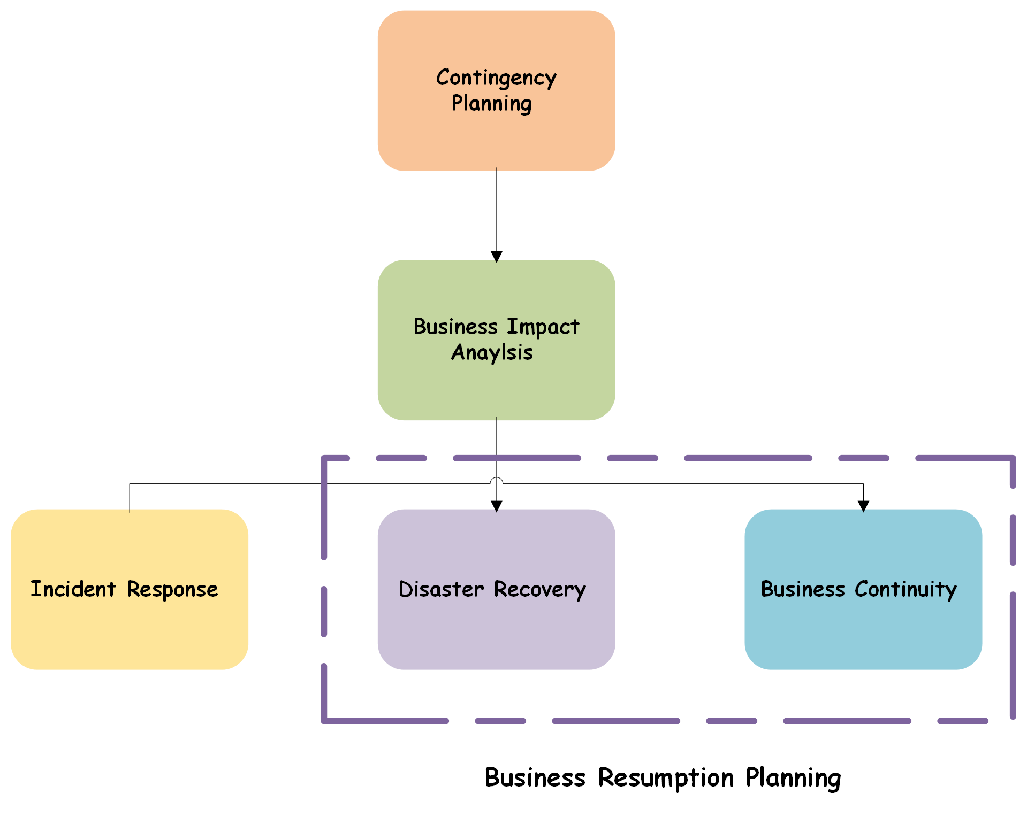
Contingency planning is used to integrate security into all stages of the development life cycle, including risk assessments, security, and emergency preparations [20]. By doing so, effective response strategies will be in place to mitigate the effects of interruptions.

Disaster recovery planning is an essential component of our contingency plans, guiding our team through managing physical disruptions to our services that prevent our staff from accessing our systems and performing tasks. Depending on the size of the security unit, we may need to develop various contingency plans for the recovery of our systems [20].

7. Governance and Strategic Planning for Security
Information security governance and strategic planning are systems that influence "how organizations' goals are set and achieved, cyber threats are monitored and assessed, and how our overall security performance is evaluated" [21]. Government helps structure an organization by considering elements such as its culture, decisions, and business procedures [21].

To keep working toward the goal of complying with security business strategies, we will allocate the necessary time to assess the organizational processes in place to ensure we are on track to fulfil our goals and align with our company values [21]. We intend to develop additional policies and procedures to address broader concerns and encourage solid safety behaviours.

Reviewing the organization's present security policies, programs, and activities will allow us to assess their effectiveness to current requirements and regulations. Furthermore, it will highlight areas for improvement to verify that the updated procedures comply with information security standards and outline clear mitigation techniques. [21].

To establish successful governance, the organization will require support from the board and other senior members to promote governance and its benefits. Encouraging employees to attend forums will support this. Providing training programs throughout the organization will identify any skill gaps within the organisation and its governance programs [21].

Welcoming learning in the workplace will help our firm achieve security certifications and increase the tools available to upskill employees. Individuals could attend online webinars and conferences that cover the subjects of security governance and other security policies and procedures. [22].

8. Risk Management
Risk management can be described as a “strategy for managing uncertainty by setting better methodological approaches” [23]. It is the challenge of recognizing the components that can cause failures in the confidentiality, integrity, and accessibility of data when appropriate security measures are not in place [23].

To be certain that our risk management plans are effective, they should meet our organization's goals, which include preserving and managing information, lowering the risk of cyber threats, and adhering to security standards and regulations. The example below illustrates a risk management process used to reduce uncertain events to secure our systems and data [23].

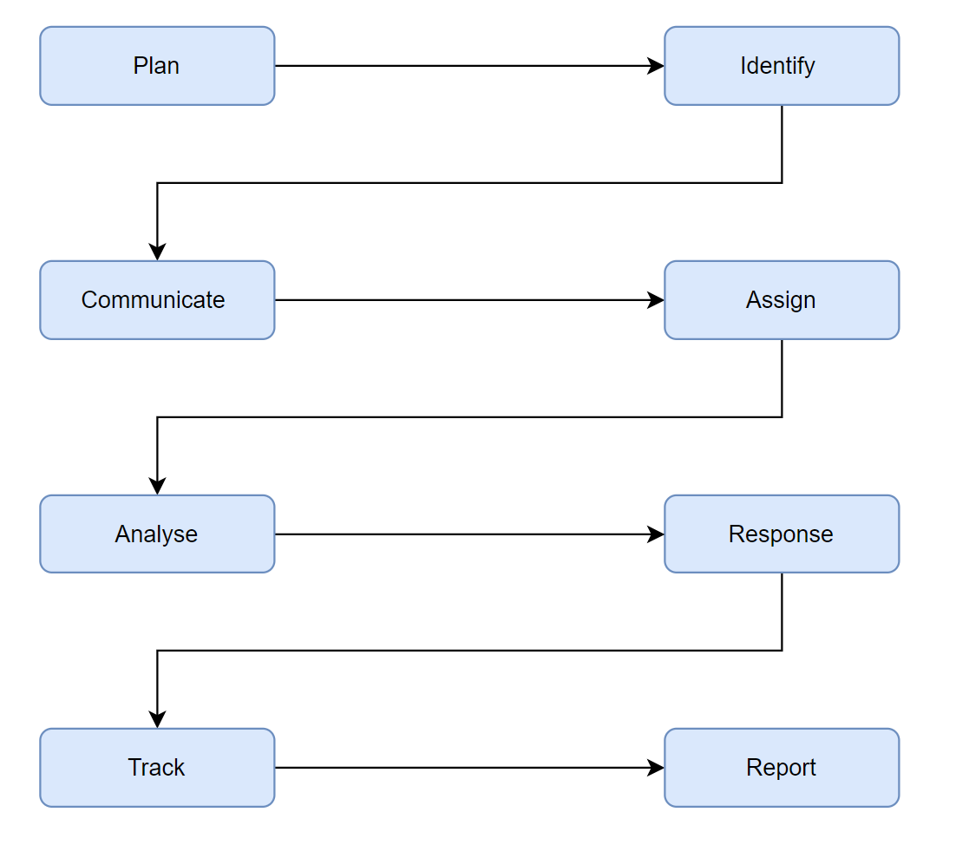
While we are going through the risk management process, we can evaluate the potential security risks to our systems and ensure that appropriate protection and solutions are available to mitigate them. [24].

Once a suitable risk assessment has been completed, the next part of our procedure is to start a risk treatment plan. The risk treatment plan encourages employees to compare the risk against levels and determine whether new measures should be implemented [24]. Treatment plans demonstrate how our organization manages threats to our information assets with the support of various measures.

Due to rapid technological advancements and cyberattacks, our risk management and treatment plans should be reviewed regularly. Additionally, vulnerability evaluations and work prioritization will help us improve our security systems. Plus, this will ensure that our security policies and procedures are up to date and comply with the most recent legislation.

9. Conclusion
Throughout this report, I have highlighted a variety of topics that will be explored when we establish our information security unit. This covers rules and procedures, as well as contingency and risk management plans. Regular communication and reviews of existing systems and procedures will be completed to ensure that our security measures are following changing policies and the nature of cyber threats.

References
[1] Data Guard, “What is information security (InfoSec): Policy, principles and threats,” www.dataguard.co.uk. https://www.dataguard.co.uk/knowledge/information-security/ (accessed Jul. 29, 2024).
[2} GeeksforGeeks, “Approaches to Information Security Implementation,” GeeksforGeeks, Feb. 26, 2020. https://www.geeksforgeeks.org/approaches-to-information-security-implementation/ (accessed Jul. 29, 2024).
[3} G. Casella, “Structuring the Information Security Organization Structuring the Information Security Organization,” Day Blink, Feb. 2019. Accessed: Jul. 29, 2024. [Online]. Available: https://www.dayblinkconsulting.com/wp-content/uploads/2019/04/Structuring-the-InfoSec-Org_vFINAL_04.pdf#:~:text=Generally%20speaking%2C%20four%20common%20models%20exist%3A%20Functional%2C%20Divisional%2C
[4] Velosio, “Top or Bottom? A Hybrid Model is Key to Business Innovation,” Velosio, May 12, 2023. https://www.velosio.com/blog/top-or-bottom-a-hybrid-model-is-key-to-business-innovation/#:~:text=A%20hybrid%20approach%20combines%20both%20top-down%20and%20bottom-up (accessed Jul. 26, 2024).
[5] S. Goundar, Impact of digital transformation on security policies and standards. Hershey, Pennsylvania: IGI Global, 2020. doi: 10.4018/978-1-7998-2367-4.
[6] HackerOne, “Information Security Policy: Examples & 11 Key Elements,” www.hackerone.com, 2024. https://www.hackerone.com/knowledge-center/information-security-policy (accessed Jul. 28, 2024).
[7] Cisco, “What Is Network Security Policy Management?” Cisco. https://www.cisco.com/c/en/us/products/security/what-is-network-security-policy-management.html#:~:text=Network%20security%20policy%20management%20streamlines%20security%20policy%20design (accessed Jul. 29, 2024).
[8] J. Ochieng, “Network Security Policy - A Complete Guide - Cyber Experts %,” Cyber Experts, Dec. 01, 2019. https://cyberexperts.com/network-security-policy/ (accessed Jul. 29, 2024).
[9] A. Velimirovic, “What Is a Network Security Policy and Why Is It Important?” phoenixNAP Blog, Dec. 07, 2023. https://phoenixnap.com/blog/network-security-policy#:~:text=Here%27s%20an%20overview%20of%20what%20a%20typical%20network (accessed Jul. 29, 2024).
[10] Simplilearn, “What Is A Firewall? | Firewall Explained | Firewalls and Network Security | Simplilearn,” YouTube. Aug. 03, 2021. Accessed: Jul. 29, 2024. [Online]. Available: https://www.youtube.com/watch?v=9GZlVOafYTg
[11] B. S. Kumar, Ed., Data integrity and data governance. London: IntechOpen, 2023.

[12] B. Dobran, “Compliance Guide to GDPR, The General Data Protection Regulation,” phoenixNAP Blog, Mar. 23, 2018. https://phoenixnap.com/blog/gdpr-general-data-protection-regulation (accessed Jul. 29, 2024).
[13] IBM, “What is data compliance? | IBM,” www.ibm.com. https://www.ibm.com/topics/data-compliance (accessed Jul. 29, 2024).

[14] CyberCompare, “Importance and structure of an ISMS,” CyberCompare, Jul. 17, 2023. https://cybercompare.com/importance-and-structure-of-an-isms/#:~:text=An%20ISMS%20provides%20a%20structured%20set%20of%20policies%2C (accessed Jul. 26, 2024).

[15] IMSM GB, “ISO/IEC 27001 | ISO Specialists | IMSM LTD,” IMSM GB. ISO/IEC 27001 | ISO Specialists | IMSM LTDIMSM GB/ (accessed Jul. 26, 2024).

[16] Z. Hamdi, A. Anir Norman, N. Nuha Abdul Molok, and F. Hassandoust, “A Comparative Review of ISMS Implementation Based on ISO 27000 Series in Organizations of Different Business Sectors,” Journal of physics. Conference series, vol. 1339, no. 1, pp. 12103-, 2019, doi: 10.1088/1742-6596/1339/1/012103.

[17] IT Governance Ltd, “What is ISO 27001? | A Brief Summary of the Standard,” www.youtube.com. https://www.youtube.com/watch?v=x792wXSeAhA
[18] ControlCase: IT Certification and Compliance, “ISO 27001 Controls Overview | ControlCase,” YouTube, Aug. 21, 2023. https://www.youtube.com/watch?v=9Pb5JrR4TKE (accessed Jul. 28, 2024).
[19] J. Maurer, B. Clark, and Y. B., “SOHO: Information Security Awareness in the Aspect of Contingency Planning,” International journal of advanced computer science & applications, vol. 6, no. 10, 2015, doi: 10.14569/IJACSA.2015.061003.
[20] S. Radack, “ITL BULLETIN FOR JULY 2010 CONTINGENCY PLANNING FOR INFORMATION SYSTEMS: UPDATED GUIDE FOR FEDERAL ORGANIZATIONS.” Accessed: Jun. 29, 2024. [Online]. Available: https://csrc.nist.gov/files/pubs/shared/itlb/itlbul2010-07.pdf
[21] S. Durbin, “6 principles for building engaged security governance | TechTarget,” Security, Mar. 15, 2023. https://www.techtarget.com/searchsecurity/post/6-principles-for-building-engaged-security-governance (accessed Jul. 29, 2024).
[22] T. Fitzgerald and T. Peltier, Information security governance simplified: from the boardroom to the keyboard, 1st edition. Boca Raton: CRC Press, 2012. doi: 10.1201/b11357.

[23] S. Loganathan, “A Step-by-Step Procedural Methodology for Improving an Organization’s IT Risk Management System,” in Information Technology Risk Management and Compliance in Modern Organizations, IGI Global, 2018, pp. 21–47. doi: 10.4018/978-1-5225-2604-9.ch002.
[24s] G. Wahlgren and S. Kowalski, “IT Security Risk Management Model for Handling IT-Related Security Incidents: The Need for a New Escalation Approach,” in Security and Privacy Management, Techniques, and Protocols, 2018, pp. 129-. doi: 10.4018/978-1-5225-5583-4.ch005.
[25] S. Radack, “THE SYSTEM DEVELOPMENT LIFE CYCLE (SDLC),” csrc.nist.gov, 2009.Accessed: Jul. 26, 2024. [Online]. Available: https://csrc.nist.gov/CSRC/media/Publications/Shared/documents/itl-bulletin/itlbul2009-04.pdf

