Business Plan for

Rex Royale

Produced By:

Ayesha Amir

Dated: ___24/04/26___

Student Number: 2306141
Module Name: Leading Restaurant Strategy
Module Code: BMGM6001

CONTENTS

 |  |  | PAGE
1. | Executive Summary |  | ………3…………
2. | The Business Idea |  | ………4…………
3. | The Team |  | ………6…………
4. | Market Research |  | ………9…………
5. | Marketing Plan |  | …….12……….
6. | Key Resources |  | ………14…….
7. | Finances & Start-Up Support |  | ………18.…….
APPENDICES:
Appendix A |  |  | SWOT Analysis
Appendix B |  |  | PEST Analysis

1. EXECUTIVE SUMMARY
Rex Royale is a Pakistani food business based in Bristol, offering authentic Karachi-style food through dine-in, takeaway, and home delivery services. The business focuses on providing traditional flavours in a convenient and affordable way for customers who enjoy quality ethnic food. The menu includes popular dishes such as biryani, nihari, karahi, haleem, samosa chaat, pani puri, Kashmiri chai, malai boti, chicken tikka, and quick options like sandwiches and chicken rolls, along with a unique Pakistani-style breakfast menu. All food is halal and prepared using authentic recipes, giving customers a genuine cultural food experience without needing to travel far. There is a strong market opportunity in Bristol due to its diverse population, large student community, and growing demand for ethnic food and delivery services. Rex Royale targets students, young professionals, families, and older customers who value taste, authenticity, value for money, and convenience. Rex Royale’s key competitive advantage is its clear focus on Karachi-style Pakistani food, combined with flexible service, affordable pricing, and strong cultural branding. Unlike many competitors, it brings street food, traditional meals, and breakfast together under one brand. Financial projections show first-year sales of £91,000 with a projected profit of £7,700. Start-up costs will be supported through a mix of owner capital, funding, and loans. In the short term, Rex Royale aims to complete a successful soft launch, build a loyal customer base, gain positive reviews, and establish itself as a trusted name in Bristol for authentic Pakistani food at everyday prices.

2. THE BUSINESS IDEA

2.1 The Product/Service
Rex Royale is a food business based in the centre of Bristol, operating in the restaurant and hospitality industry. It will serve authentic Pakistani food to a wide range of customers, including local residents, students, and professionals, as well as anyone interested in trying something new. The business will be especially appealing to those who enjoy or want to experience genuine Karachi-style flavours. The menu will offer a variety of Pakistani Karachi-style dishes, including biryani, nihari, samosa chaat, and pani puri, as shown in appendix e. In addition, Rex Royale will provide a unique Pakistani-style breakfast menu. Customers will have the option to dine in, order takeaway, or have their food delivered to their homes, making the service convenient and accessible, as shown in appendix m. What makes Rex Royale stand out is its focus on authentic Karachi recipes combined with a wide selection of both traditional meals and street food. The flexibility of its service dine-in, takeaway, and delivery adds further value for customers. The main benefit for customers is the ability to enjoy real, authentic Pakistani flavours without needing to travel far. It also offers something different from the typical food choices available in Bristol, creating a unique cultural dining experience. Overall, Rex Royale combines quality, authenticity, and convenience in one place. The brand identity is reflected in its logo, which uses green, gold, and black. These colours are chosen to represent key values: green symbolises sustainability, gold represents luxury, and black conveys a sense of sophistication and formality. This aligns with colour psychology principles discussed in sources such as Finshots (2023) and Empower Yourself with Color Psychology (2018), as shown in appendix c and i.

2.2 SWOT Analysis Summary

The SWOT analysis in Appendix A shows that the business has a solid base to grow from. One of its main strengths is its location in Bristol, which is a busy and diverse city with a large number of potential customers. Another key strength is the unique concept of offering Pakistani food alongside a cultural dining experience, helping the business stand out from competitors. The focus on halal food also widens the customer base, and strong branding further supports its appeal. That said, there are also some weaknesses to consider. The business will face strong competition in the area, rising ingredient costs, and the challenge of managing both café operations and events at the same time, especially during busy periods when demand is high. Despite this, there are clear opportunities for growth. There is increasing demand for events across England and Wales, which creates a chance to boost income through catering and event services. Social media also offers a cost-effective way to promote the business and attract customers, particularly students who make up a large part of the local market. In addition, platforms like Uber Eats and Deliveroo can help reach a wider audience through delivery services. Working with local event planners and introducing new menu items could also support future expansion. However, the business also needs to be aware of potential threats. These include rising costs, staff shortages, strong competition, negative online reviews, and possible changes in regulations. To manage these risks, it will be important to control costs carefully, invest in staff training, and maintain high standards of food quality and customer service. Responding to customer feedback and using social media in a positive and consistent way will also help protect the business’s reputation and support long-term success.

Mullins and Dossor (2013b, pp. 131–138) highlight that strategic planning and a clear understanding of strengths, weaknesses, opportunities, and threats are essential before starting a business, as they support better decision-making and long-term stability.
3. THE TEAM

3.1 Key Personnel

Name and Company Position: Ahtisham Khan – General Manager
Skills and Experience: Ahtisham has experience working in a range of roles within the hospitality industry, from starting as a waiter to taking on responsibilities in restaurant marketing and management. This has helped him develop a strong understanding of how restaurants operate, both in terms of customer service and business promotion.

He has strong IT skills, which support tasks such as marketing, social media management, and general business operations. In addition, he has experience organising and managing events, including a fashion show in Pakistan, where he was responsible for coordination and planning.

Overall, he has a solid understanding of the hospitality industry and is motivated to continue developing his skills, with a long-term goal of gaining experience in different cities around the world.

Role and Responsibilities: Ahtisham will be responsible for supporting the overall management of the business and ensuring that daily operations run smoothly. He will oversee staff performance, assist with scheduling, and help maintain high standards of customer service.

His role will also include managing marketing activities, including social media and promotions, using his strong IT skills to help grow the business. In addition, he will support event planning and coordination, help manage customer experience, and work closely with the owner to ensure the business operates efficiently and successfully.

Name and Company Position: Padawan – Chef

Skills and Experience: Padawan has experience working in kitchen environments where he has supported chefs with food preparation, cooking, and day-to-day kitchen tasks. Over time, he has learned how a professional kitchen runs and understands the importance of teamwork, speed, and maintaining high standards.

He is confident working in busy environments and has developed practical skills in preparing food and following instructions under pressure. He is also keen to keep learning and improving his cooking skills.

Role and Responsibilities: Padawan will be responsible for helping to prepare and cook food for customers, making sure dishes are served to a good standard and look presentable. He will support the head chef in daily kitchen tasks, keep the kitchen clean and organised, and help ensure service runs smoothly during busy times.
As a new business, I will start with a small team made up of two key roles: a Manager and a Chef. These are essential at the beginning because they cover the core day-to-day operations of the business, including running the café, managing staff, and preparing food. As the business grows and becomes more financially stable, I plan to gradually hire more staff to support increased demand and events.
In larger organisations, Cousins and Weekes (2020a, pp. 330–331) explain that there is usually a dedicated events team with a clear structure, including roles such as managers, assistant managers, and specialist coordinators. This allows events to be managed separately and in a more formal way, as shown in appendix F, G and I.
However, in smaller businesses, the structure tends to be much simpler and more flexible. Staff often take on multiple responsibilities as part of their role. For example, employees may support both day-to-day café operations and event work, including roles such as events support, food and beverage service, and general customer service. For Rex Royale, I will follow a simplified version of this structure. At the top will be the owner, followed by general managers for events and operations, who oversee the overall running of the business. Below them will be roles such as café managers, events lead, head chef, barista, and floor supervisors, alongside other operational staff as needed. This structure is shown in Appendix D, F, G and I (Cousins and Weekes, 2020b, pp. 18–24; Mullins and Dossor, 2013a, p.141).
3.2.2 Training and Development:
To make sure the business runs smoothly and maintains high standards, staff training will be important from the beginning. Even though some team members already have experience, training will help everyone understand how things are done within this specific business and ensure service is consistent across the board. All new staff will complete an induction training when they start. This will be delivered by the General Manager and will cover key areas such as customer service expectations, hygiene standards (Food Standards Agency, n.d.), health and safety procedures (HSE, n.d.), and an overview of how the business operates on a day-to-day basis. Kitchen staff, including the Chef, will also complete food hygiene and safety training (Food Standards Agency, n.d.) to make sure food is prepared safely and in line with legal requirements. Front-of-house staff will receive customer service training to help them communicate effectively with customers, deal with complaints in a professional way, and create a positive overall dining experience. This training may be delivered internally or supported by short online hospitality courses. The General Manager and supervisors will also take part in basic leadership and management training, focusing on areas such as staff organisation, managing busy periods, and problem-solving under pressure. Overall, training will be a combination of internal support and external courses, helping to ensure the team is confident, well-prepared, and able to consistently deliver high-quality service.

3.2.3 Outsourced Support / Key Partners:
The business will use a professional accountant or accounting service to manage financial records, payroll, and tax returns. This is important because it ensures the business remains financially accurate, compliant with UK regulations, and avoids costly mistakes. It also saves time for management, allowing them to focus on running the café and events rather than handling complex financial tasks. The cost of small business accounting support is typically around £50–£150 per month, depending on the level of service required. The business will also rely on food safety and hygiene inspection services, such as those provided through local authorities or CIEH-approved professionals. This is essential to ensure the business meets legal food hygiene standards, maintains a high hygiene rating, and builds customer trust. Regular inspections and certification help reduce risk and ensure compliance with the Food Standards Agency (n.d.) requirements. Costs for training and certification can range from £50–£200 per staff member, depending on the course provider. the business will partner with delivery platforms such as Uber Eats and Deliveroo to expand its customer reach. These services provide access to a much larger customer base without needing additional physical expansion. However, they typically charge a commission fee of around 20–35% per order, which needs to be factored into pricing and profit margins. The business may also work with local event planners and suppliers for larger events. This provides specialist support in event coordination, equipment hires, and additional staffing when needed. Costs vary depending on the scale of the event but are usually agreed per project or per booking. Finally, these outsourced services and partnerships help the business stay efficient, compliant, and competitive while allowing internal staff to focus on delivering high-quality food and customer service.
4. MARKET RESEARCH

4.1 Market Information, Trends and External Factors

Market research shows that Rex Royale fits well into the Bristol food scene. Bristol is a busy, diverse city with many students, young professionals, and multicultural communities. These groups are more open to trying new foods, especially ethnic and halal cuisine, which supports the demand for authentic Pakistani food. A key trend is the growing interest in cultural and street food experiences rather than standard fast food. Customers now look for authentic flavours and something different, which gives Rex Royale a strong position with its Karachi‑style dishes and breakfast menu. Another important trend is the increased use of delivery platforms such as Uber Eats and Deliveroo. These services are especially popular with students and working professionals who value convenience, making delivery a key part of the business model. Social factors also strongly support the business idea. Eating out is often a social activity in Bristol, with people meeting friends, celebrating events, and attending group gatherings. Social media plays a big role in deciding where people eat, as reviews and recommendations heavily influence customer choices. This creates a strong opportunity for Rex Royale to build a positive online presence. The PEST analysis (Appendix B) highlights some external challenges. Rising food, energy, and staffing costs may affect profit, so careful pricing and cost control will be important. At the same time, technology such as online ordering, QR‑code menus, and digital payments offers opportunities to improve efficiency and reach more customers. Overall, the findings support Rex Royale as a realistic and well‑timed business idea, if risks are managed carefully.

4.2 Customer Profiles

Rex Royale is aimed at a wide customer base in Bristol; however, market research highlights three main customer groups: young customers, families, and older customers. Each group has different needs, behaviours, and reasons for choosing the business.
1. Young Customers
Young customers, including students and young professionals aged roughly 18–30, are a key target market. This group enjoys trying new foods, socialising with friends, and frequently using food delivery apps. They are highly influenced by social media, online reviews, and promotional offers. Because of their busy lifestyles, they value convenience as well as affordable but exciting food choices. Rex Royale appeals to this group through its authentic Pakistani street food, unique breakfast options, and delivery services such as Uber Eats and Deliveroo.
2. Families
Families, particularly those living locally, are another important customer group. Families often look for good-quality food, reasonable pricing, and a comfortable environment where everyone can enjoy eating together. They are more likely to dine in or order takeaway for group meals, especially at weekends. Rex Royale appeals to families through its halal menu, generous portion sizes, and traditional Pakistani dishes that encourage shared dining experiences and familiarity.
3. Older Customers
Older customers, typically aged 45 and above, often value traditional food, authenticity, and good customer service. They are generally less influenced by food trends and social media and instead focus on taste, quality, and cultural connection. This group is more likely to choose dine-in experiences during quieter periods rather than delivery services. Rex Royale’s authentic Karachi-style recipes and calm dining atmosphere provide comfort and familiarity, making the business appealing to this customer group.
According to Cousins and Weekes (2020c, pp. 25–54), understanding what customers value is essential in creating strong customer relationships, while also ensuring health and safety for both staff and customers. Similarly, Chaffey and Smith (2023, p. 24) state that effective marketing is based on understanding customer needs, meeting those needs efficiently, and anticipating future wants. By understanding these customer profiles, Rex Royale can deliver greater customer value and support long-term business success.

4.3 Competitor Profiles

Rex Royale will face competition from other businesses offering South Asian food and drinks. By identifying and analysing competitors, the business can understand how to stand out and meet customer needs more effectively. As Barrow (2021) explains, customers do not just buy food, but solutions to their needs, making competitor research essential for shaping a strong strategy.
1. Desi Dera is known for offering traditional Pakistani and Indian dishes in a casual restaurant setting. One of its main strengths is its familiar and traditional menu, which attracts customers looking for classic South Asian food. It often appeals to families and older customers who value large portions and well‑known dishes. However, a weakness of Desi Dera is that it focuses mainly on standard curry‑house meals, with limited focus on street food, breakfast options, or strong modern branding.
Rex Royale will compete by offering authentic Karachi‑style street food and Pakistani breakfasts, which Desi Dera does not specialise in. Rex Royale’s USP is its strong cultural identity, modern branding, and variety, combining traditional meals with street food and flexible service options such as dine‑in, takeaway, delivery, and events. This allows Rex Royale to appeal to younger customers as well as families.
2. Spice Village London is a well‑established South Asian restaurant brand with a strong reputation for quality food. Its strengths include brand recognition, a large menu, and consistency, which help attract loyal customers. However, being a larger and more established brand in London, it may feel less local and less personalised to customers in Bristol. It may also be more expensive and less flexible in adapting to local tastes.
Rex Royale’s advantage is its local focus and personalised experience. By operating in Bristol and understanding the local community, Rex Royale can create a more welcoming and relatable dining experience. Its USP compared to Spice Village is authentic Karachi flavours, halal food, affordability, and a relaxed cultural atmosphere, making it more accessible to students and local customers.
3. Chaiiwala is a popular brand known mainly for South Asian tea, snacks, and light meals. Its strengths include strong branding, social media presence, and popularity among young customers, especially for casual meet‑ups. However, Chaiiwala focuses more on drinks and snacks rather than full traditional meals, and it does not offer a full restaurant or dining experience. Rex Royale will compete by offering a complete food experience, including breakfasts, street food, full meals, and event catering. While Chaiiwala focuses mainly on tea culture, Rex Royale’s competitive edge is its broader menu, cultural dining experience, and flexibility, making it suitable for everyday meals, family dining, and special occasions. Rex Royale’s key competitive advantage is its focus on authentic Karachi-style Pakistani food, combined with flexibility and cultural experience. Unlike competitors, Rex Royale offers: Traditional Pakistani Street food and breakfasts, Halal food to reach a wider customer base, dine-in, takeaway, delivery, and event services and Affordable pricing with strong cultural and modern branding As Barrow (2021) highlights, understanding competitors helps businesses deliver real value and avoid poor customer experiences. By clearly differentiating itself, Rex Royale can attract customers looking for authenticity, variety, and convenience.

5. MARKETING PLAN

5.1 Price
Rex Royale will use a value-based pricing strategy, offer affordable prices while still reflecting good quality and authentic Pakistani food. The aim is to attract students, families, and local customers without making the food feel cheap. Prices will show that Rex Royale offers high-quality, freshly prepared Karachi-style food at fair and reasonable prices.
Some business costs stay the same regardless of how busy the restaurant is, such as rent, staff wages, and insurance. These are known as fixed costs. Other costs, such as ingredients, packaging, and electricity, increase when sales increase and are known as variable costs. A few costs, like utilities, are a mix of both. Understanding these costs helps the business price products correctly and calculate the break-even point, which is the stage where total income covers total costs. Before this point, the business makes a loss, and after it, it begins to make a profit (Atrill and McLaney, 2019, pp. 67–74). Rex Royale’s prices will be: Lower than premium restaurants like Spice Village, slightly higher than basic takeaways, showing better quality and experience, Student-friendly, especially for street food and breakfasts and Good value for families, with generous portions. This pricing sends a message that Rex Royale is affordable but not low-quality, combining authenticity, quality ingredients, and convenience. Comparison with Competitors: Desi Dera: Similar pricing for curries, but Rex Royale offers street food and breakfast, which Desi Dera does not, Spice Village London: Higher prices and more formal dining. Rex Royale will be more affordable and more relaxed and Chaiiwala: Lower prices for drinks and snacks, but Rex Royale offers fumeals and dining experience, giving better overall value.
Rex Royale’s USP in pricing is offering authentic Karachi flavours at everyday prices, not just snack-based or premium dining prices.

5.2 Product

Rex Royale is designed to feel royal but relaxed, combining authentic Karachi Street food culture with a clean, modern cafe look. The brand focuses on quality, warmth, and cultural pride rather than fine dining. The dark green, gold, and cream colour scheme gives the brand a strong identity and reflects freshness, trust, and premium value without making the prices feel expensive. The menu design highlights traditional Pakistani foods such as biryani, nihari, karahi, haleem, samosa chaat, pani puri, Kashmiri chai, malai boti, and chicken tikka, alongside quick options like sandwiches and chicken rolls. The layout is clear and easy to understand, making it suitable for customers ordering in‑store, takeaway, or online. Popular items are clearly highlighted so customers can quickly choose. The cafe space will match the branding with warm lighting, simple seating, framed menus, and cultural design touches. The aim is to make customers feel comfortable whether they are sitting in, collecting takeaway, or waiting for delivery. Branding mock‑ups, menu designs, and promotional visuals are included in the Appendices e.

5.3 Placement
Rex Royale sits in the casual dining and street-food sector, offering better quality and authenticity than basic takeaways, but at more affordable prices than premium restaurants. The business focuses on everyday Pakistani comfort food, suitable for individuals, families, and groups. The service is offered through are home delivery via platforms like Uber Eats and Deliveroo, Takeaway for customers who want quick and convenient food and Table service for customers who want to sit and enjoy the café atmosphere. Customers can expect fast service, generous portions, authentic Karachi flavours, and flexibility in how they order. Whether someone wants a biryani delivered at home, pani puri as takeaway, or to sit down for nihari and Kashmiri chai, Rex Royale aims to deliver a consistent and enjoyable experience.

5.4 Promotion

Promotion is a key part of Rex Royale’s success, especially as the business relies on home delivery, takeaway, and repeat customers. The main aim is to build awareness, gain trust, and turn first-time customers into regulars. Rex Royale will begin with a soft launch for family and friends to test food quality, packaging, service speed, pricing, and the overall customer experience, using their feedback to make improvements before the official launch. Promotion will mainly focus on digital platforms such as Instagram and TikTok to showcase food, behind-the-scenes cooking, and special offers, while WhatsApp will be used for direct orders and customer communication. Google reviews will be encouraged, particularly for delivery and takeaway orders. Traditional methods such as printed menus, posters, word-of-mouth, and introductory offers will also be used. By listening to customer feedback, responding to reviews, and offering discounts for repeat orders, Rex Royale aims to build strong customer relationships and become known for authentic Karachi-style food at affordable prices.

6. KEY RESOURCES

6.1 Premises
Rex Royale will operate from a rented restaurant space in Bristol, ideally close to the city centre where footfall is high and customers can easily access dine-in, takeaway, and delivery services. The premises will include a fully equipped kitchen for food preparation, a small seating area for customers, and storage space for ingredients and equipment. Day-to-day administrative tasks, such as staff scheduling, ordering supplies, and marketing, will be managed on site using digital systems.
Based on current commercial property listings in Bristol, the average rent for a small café or restaurant ranges between £1,800 and £2,500 per month, depending on size and location. Rex Royale’s planned rent of £21,600 per year (approximately £1,800 per month) is realistic and affordable for a start-up food business (Zoopla, 2026), as shown in appendix k. In addition to rent, the business will be required to pay business rates, which are set by the local council. Smaller hospitality businesses in Bristol may be eligible for small business rate relief, which can significantly reduce costs during the early stages of operation. Health and safety will be treated as a top priority. Learning from past incidents highlights the importance of strict safety standards in commercial premises. For example, a fatal fire at Gul Plaza shopping mall in Pakistan, where safety equipment and emergency exits were lacking, resulted in the loss of over 80 lives (Tanoli, 2026; ARY News, 2026; Davies, 2026). This incident reinforces the need for Rex Royale to fully comply with UK health and safety regulations, including proper fire exits, safety equipment, and staff training, to protect both customers and employees. Choosing a sensibly sized and well-regulated premises will help manage costs while ensuring a safe, compliant, and comfortable environment that supports future growth.

6.2 Equipment
To run Rex Royale successfully, the business will need the right mix of kitchen equipment, furniture, decor, and technology. As a new business, it is important to keep costs low while still making sure everything is safe, reliable, and good quality. For this reason, Rex Royale will use a combination of second-hand items and brand-new equipment. The most important items are kitchen equipment, such as cookers, ovens, fridges, freezers, microwaves, and food preparation tables. These are used every day and must meet hygiene and safety standards. Because of this, Rex Royale will buy new appliances from trusted suppliers like Currys (2026), as these products are designed for commercial use and are built to last over many years. Investing in new kitchen equipment helps reduce breakdowns and supports smooth day-to-day operations. To save money, Vinted (n.d.) will be used for less essential items such as décor, wall art, lighting, and electronic items like TVs. These items do not affect food safety and can often be found in good condition at much cheaper prices. Using second-hand platforms like Vinted allows the business to create a nice atmosphere for customers without spending too much during the start-up stage.
Facebook Marketplace will be used to source furniture such as tables, chairs, and additional décor. Many businesses sell items locally when refurbishing or closing, which means good-quality furniture can often be bought at low prices. Buying locally also helps avoid high delivery costs and makes it easier to inspect items before purchasing (Facebook, 2026). In terms of technology, Rex Royale will need a point-of-sale (POS) system, card payment machines, and internet access. These systems will be used to manage customer orders, payments, and online delivery platforms like Uber Eats and Deliveroo. Using digital tools helps improve efficiency, reduce mistakes, and meet customer expectations. Overall, using platforms like Vinted and Facebook Marketplace alongside suppliers such as Currys allows Rex Royale to operate efficiently while keeping start-up costs affordable. This approach supports the business in staying competitive without lowering quality or customer experience, as shown in appendix J.

6.3 Key Suppliers
To operate effectively on a day-to-day basis, Rex Royale will rely on a small number of key suppliers that provide food ingredients, kitchen supplies, and essential materials needed to serve customers consistently and safely. Bristol Sweet Mart will be one of the main suppliers for specialist ingredients. This supplier is important because it provides a wide range of South Asian and Pakistani food products, including spices, rice, lentils, and specialty items that are essential for authentic Karachi-style cooking. Using a local supplier also helps reduce delivery time and transport costs, while ensuring ingredients are fresh and culturally accurate (Bristol Sweet Mart, 2016). Bidfood will be used as a core wholesale supplier for everyday food items. Bidfood supplies restaurants and cafés across the UK with chilled, frozen, and dry goods. This includes products such as meat, vegetables, cooking oils, and basic food ingredients that are used daily. Buying in bulk from a wholesaler helps keep unit costs lower and ensures consistent availability, which is important for a food business (Bidfood, 2026). Nisbets will be the main supplier for kitchen equipment, utensils, and catering supplies. This includes items such as cookware, storage containers, food preparation tools, cleaning equipment, and health-and-safety products. Nisbets specialises in catering and hospitality supplies, making it a reliable source for durable equipment that meets industry standards (Nisbets, 2026). Tesco will be used as a flexible secondary supplier, mainly for emergency purchases and smaller quantities of everyday items such as fresh produce, dairy products, and general supplies. Tesco is widely accessible and allows the business to quickly restock items when needed, helping to avoid shortages during busy periods (Tesco, 2026). Overall, using a combination of local, wholesale, and retail suppliers allows Rex Royale to balance cost, quality, and convenience. This supplier mix ensures that the business can operate smoothly, maintain food quality, control costs, and respond quickly to day-to-day operational needs.
7. FINANCES AND START-UP SUPPORT

EXPENDITURE | Year 1  £
Company Registration | £100
Rent/Rates | £21600
Staff Wages | £22000
Travel/Accomodation | £500
Telephone (mobile) | £300
Broadband | £300
Utilities | £4500
Marketing and materials | £2000
Insurance | £1500
Capital Expenditure/Equipment | £10,000
Training & Development | £500
Accounting/Legal | £1000
Outside Services | £500
Stock/Materials Purchases | £11,000
Bank Charges | £300
Office Consumables | £200
Loans Repayments | £12,000
Total Expenditure | £ 83,300
INCOME | Year 1  £
Sales A | £77,000
Sales B | £8500
Sales C | £5500
Capital Introduced | £10,000
Funding | £10,000
Loans/Borrowing | £20,000
Total Income | £ 131,000

YEAR ONE PROFIT/LOSS | £
Total Income | £91,000
Total Expenditure | £83,300
Profit/Loss | £ 7,700

7.1 Financial Summary

In the first year, the business earns income from three main areas. Sales A (Café sales) comes from everyday purchases like hot and cold drinks and food, which is expected to be the main and most regular source of income. Sales B (Events) includes workshops and private bookings such as group sessions or special events held at the café or outside, which bring in less frequent but higher-value income. Sales C (Catering) involves providing food and drinks for external events.
Together, these sales generate £91,000 in Year 1. The business also receives additional money through funding, loans, and capital introduced, bringing total cash received to £131,000, although this is not counted as trading income.
Total costs for the year are £83,300, covering rent, wages, stock, utilities, marketing, equipment, and other running expenses. After covering these costs, the business makes a profit of £7,700 in its first year.
Overall, the figures show the business is financially stable, with enough sales to cover costs and generate a small profit while it gets established.

APPENDICES

Appendix A – SWOT Analysis

Appendix B – PEST Analysis

Appendix C -


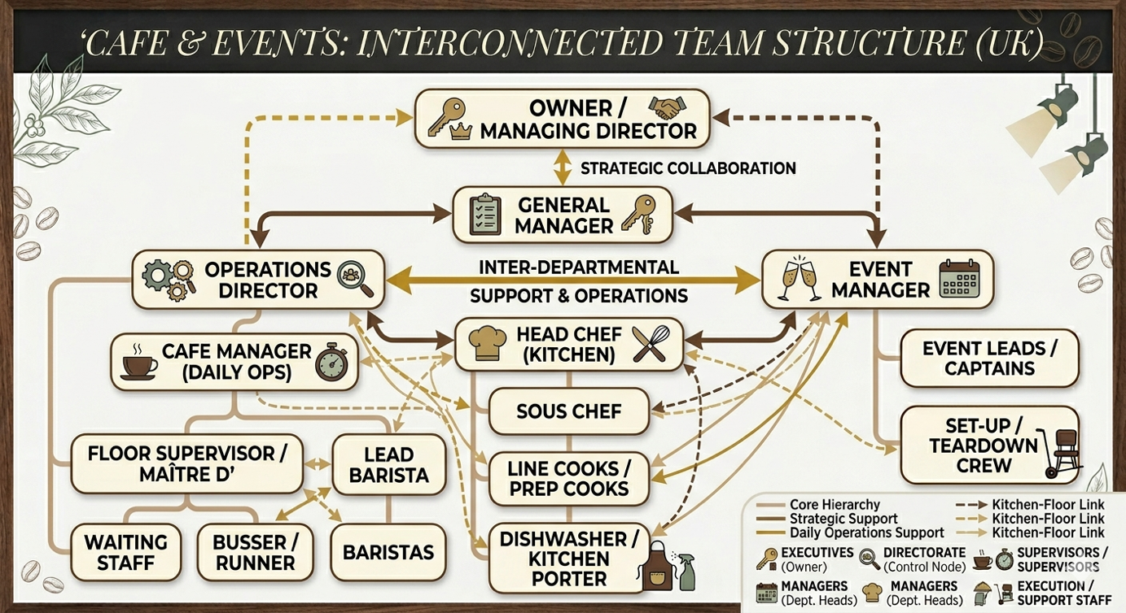
Appendix D -

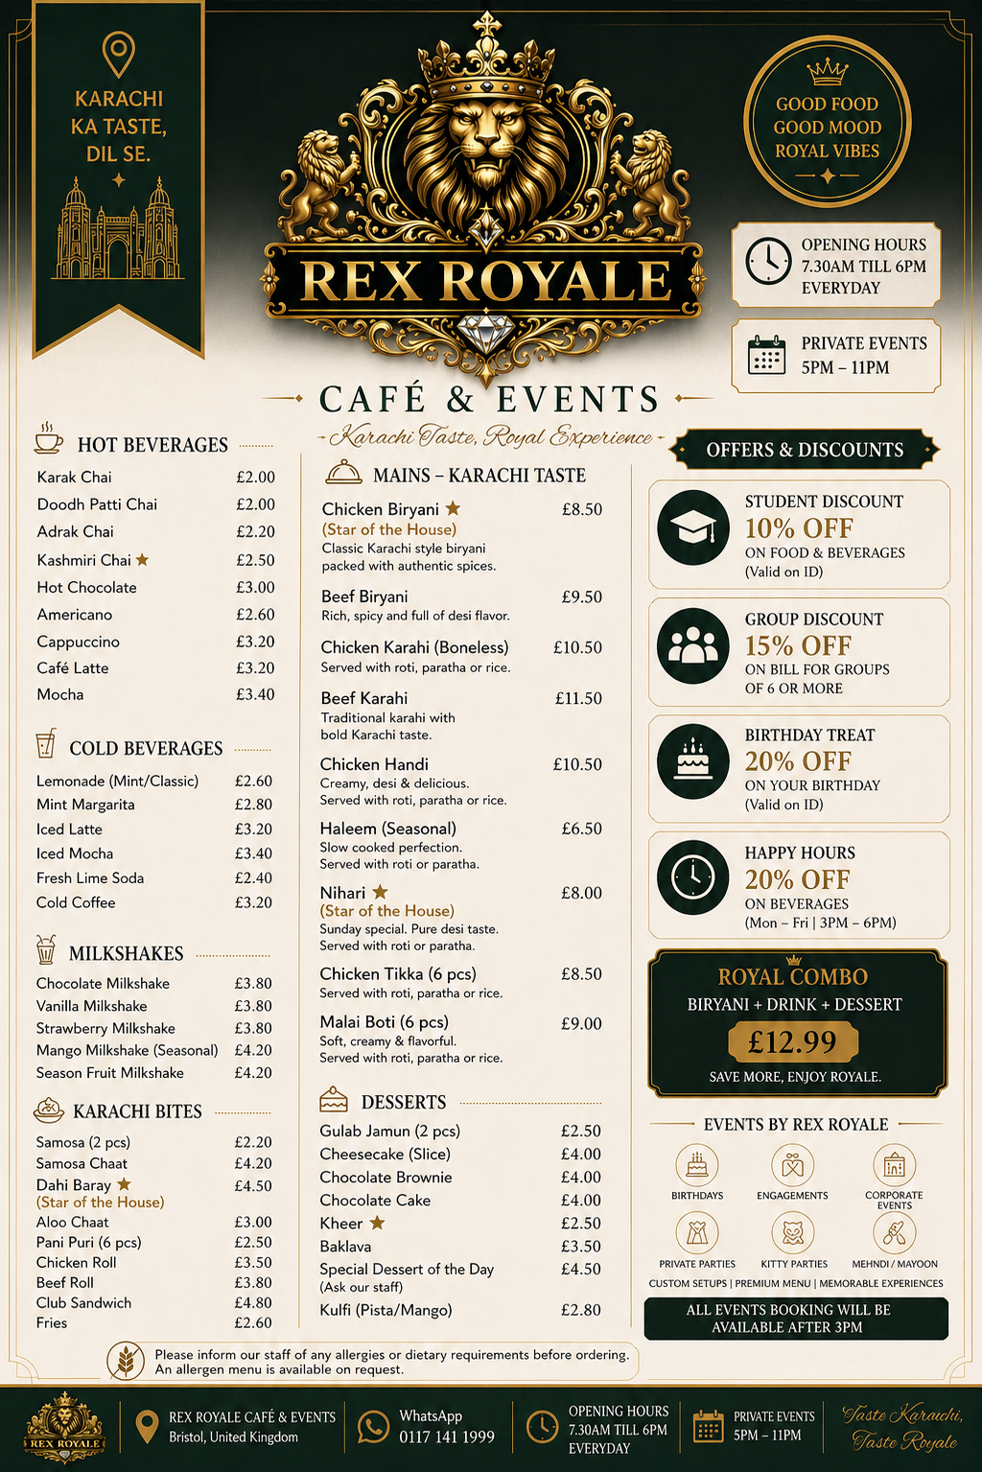
Appendix E -
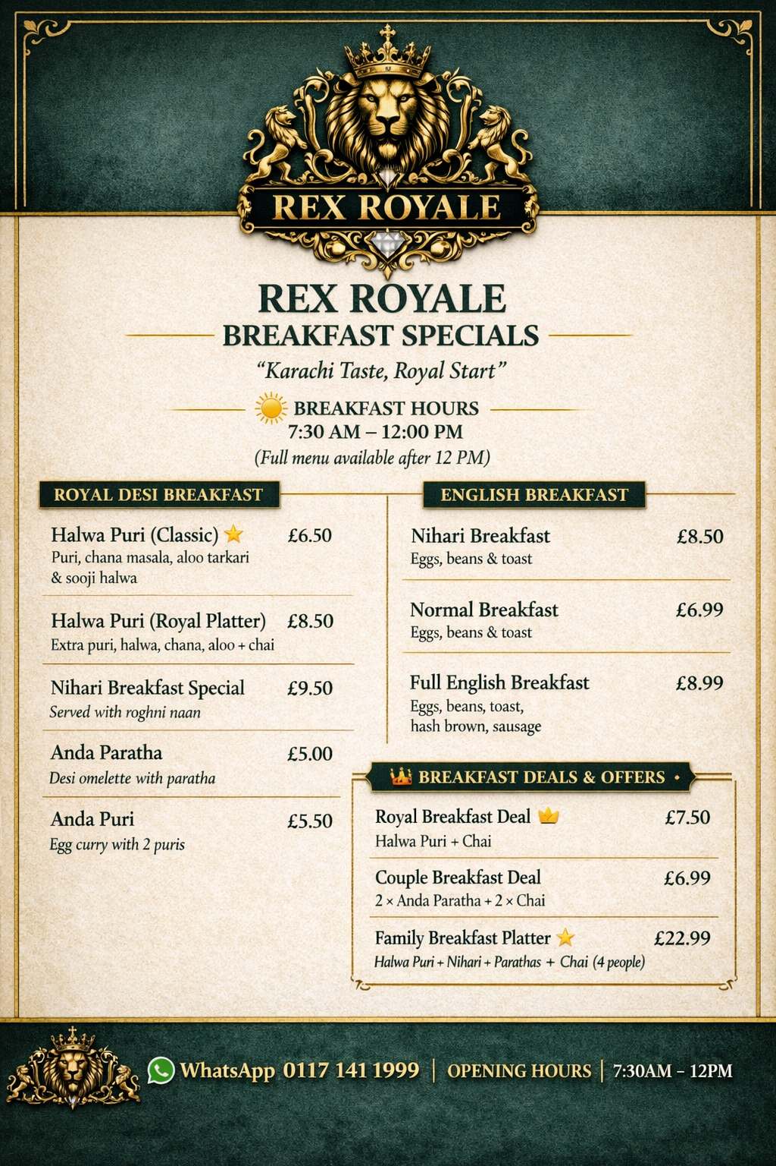

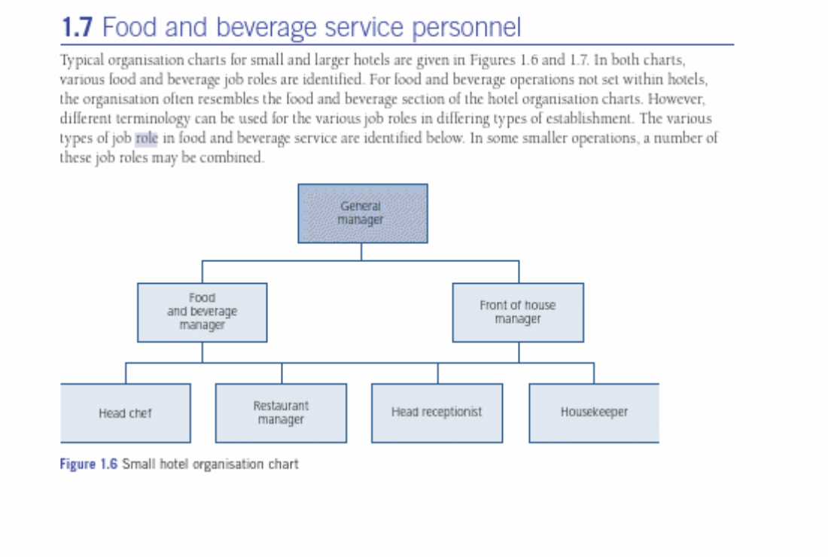
Appendix F - (Cousins and Weekes, 2020b, pp.18–24)
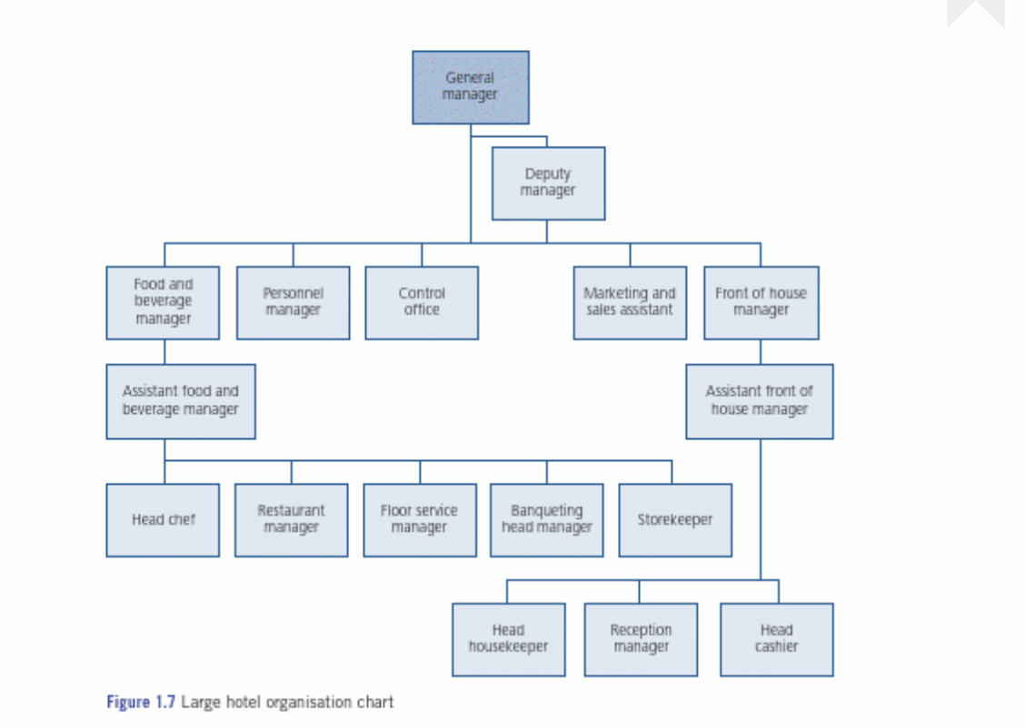
Appendix G - (Cousins and Weekes, 2020b, pp.18–24)
Appendix H - (Cousins and Weekes, 2020b, pp.18–24)
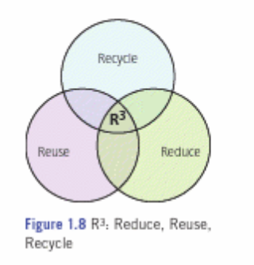

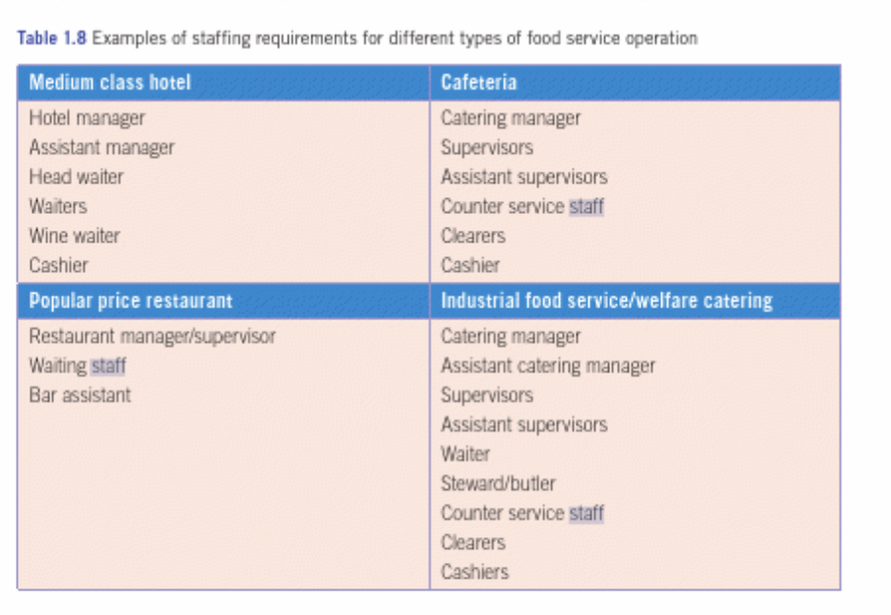
Appendix I - (Cousins and Weekes, 2020b, pp.18–24)

Appendix J - Facebook Marketplace for business item (Facebook (2026)
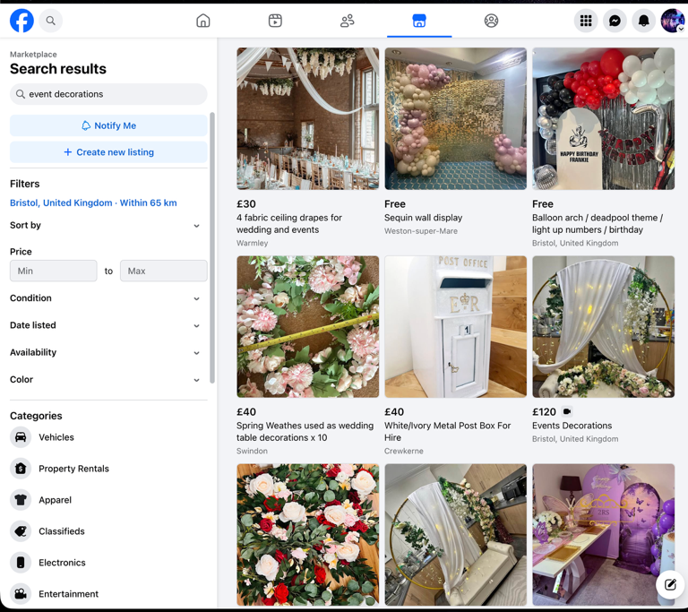
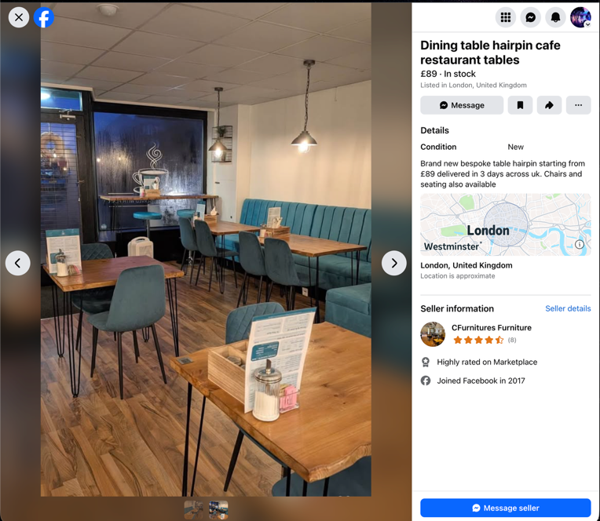
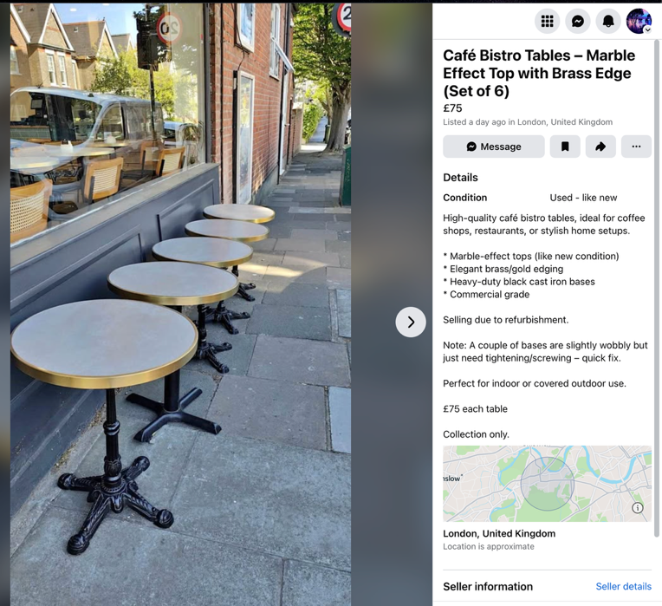
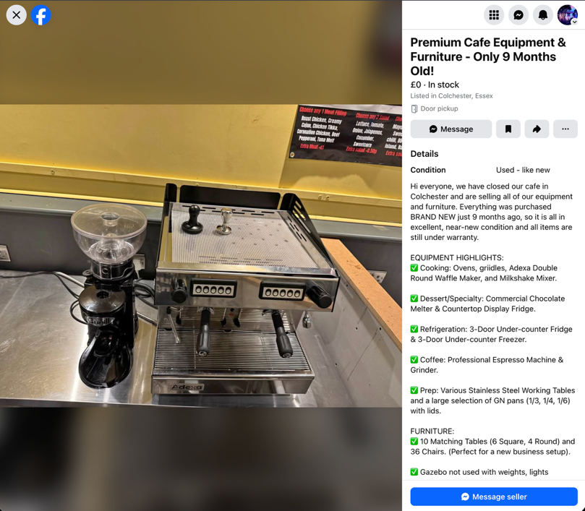
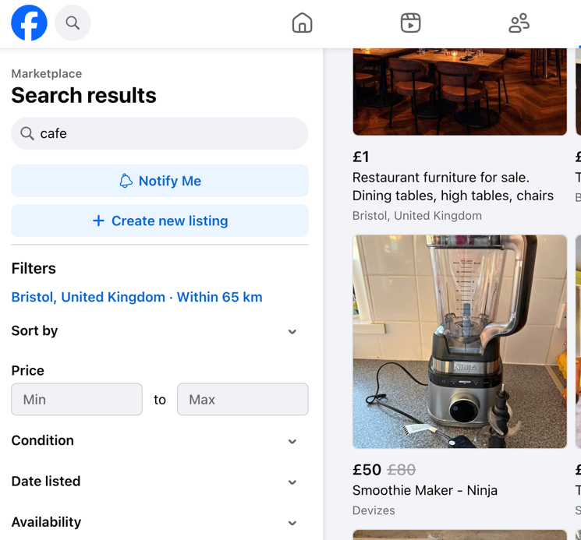
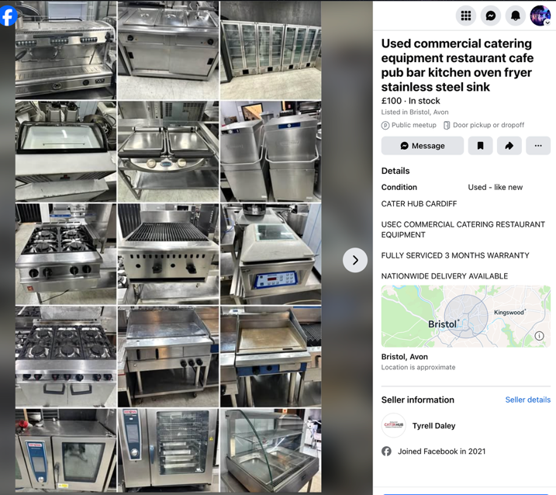
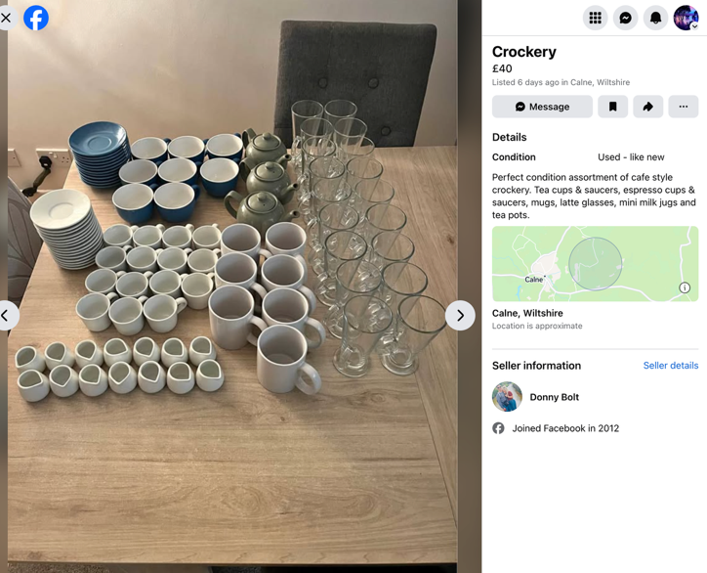

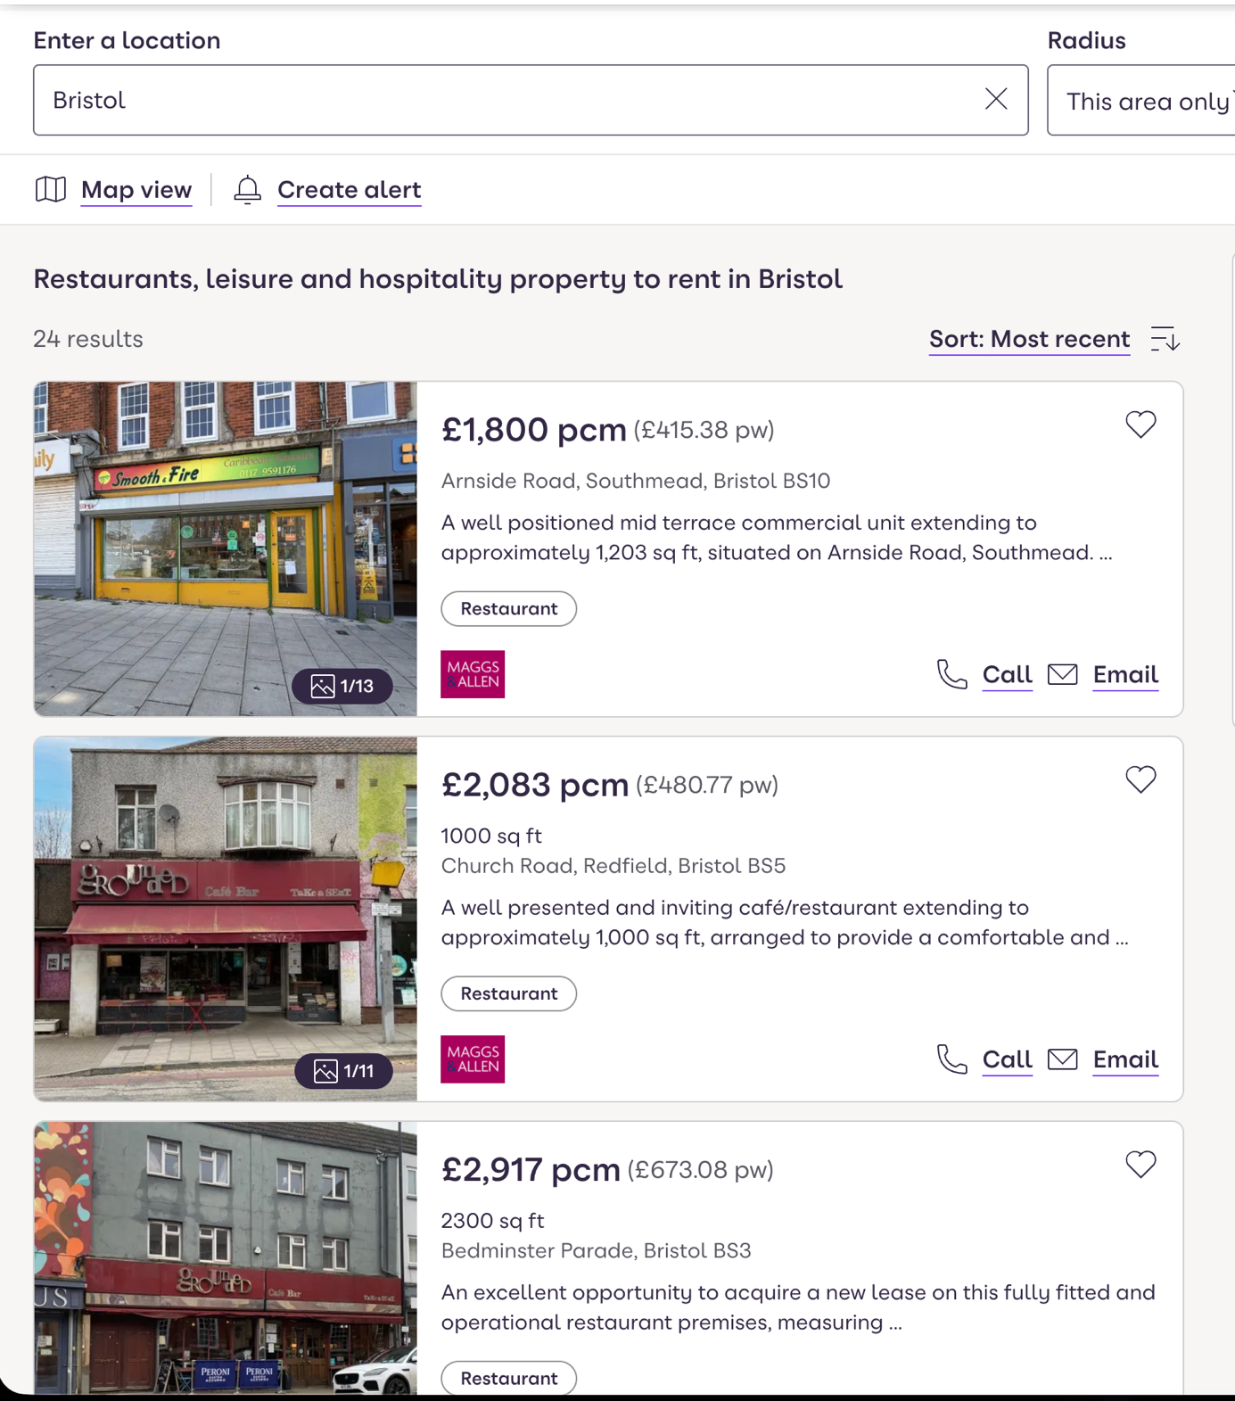
Appendix K – Business Rent (Zoopla, 2026)

Appendix L – Logo colour meaning (Finshots, 2023)
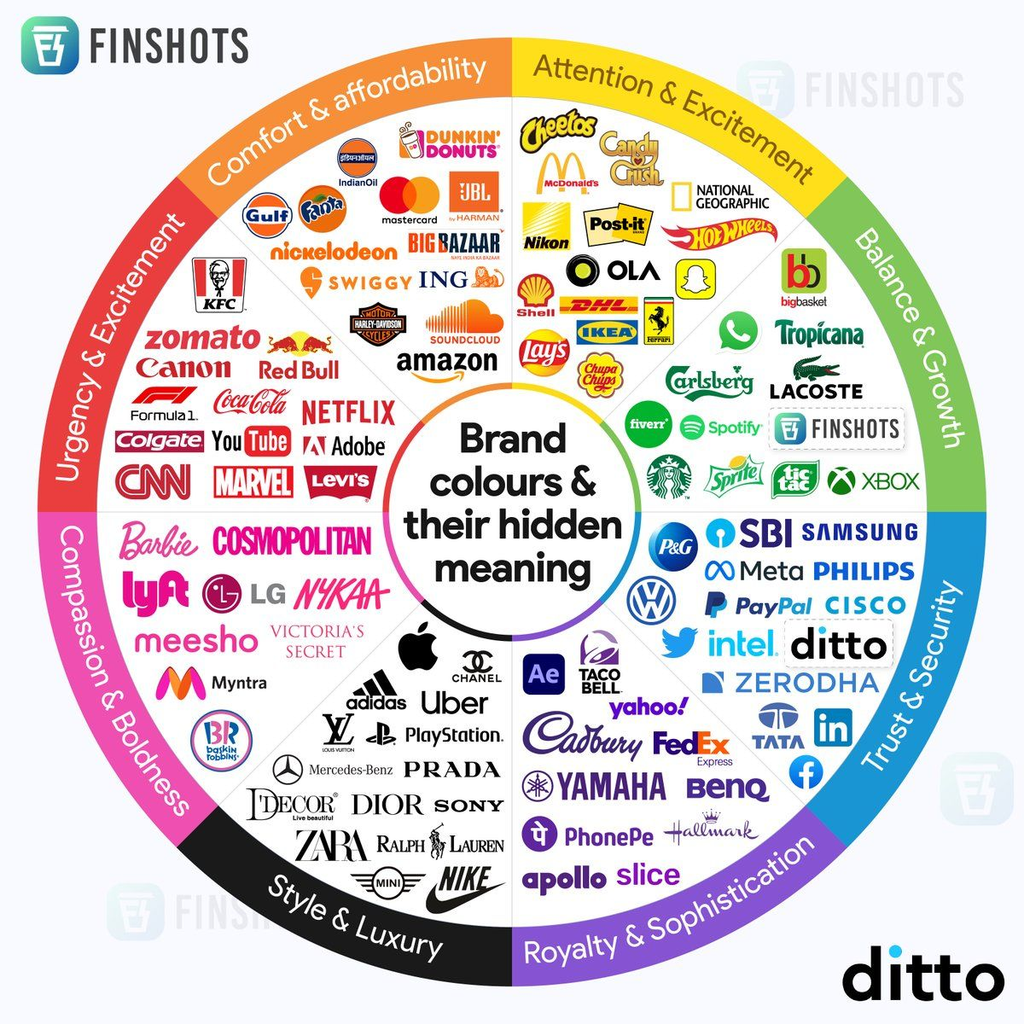

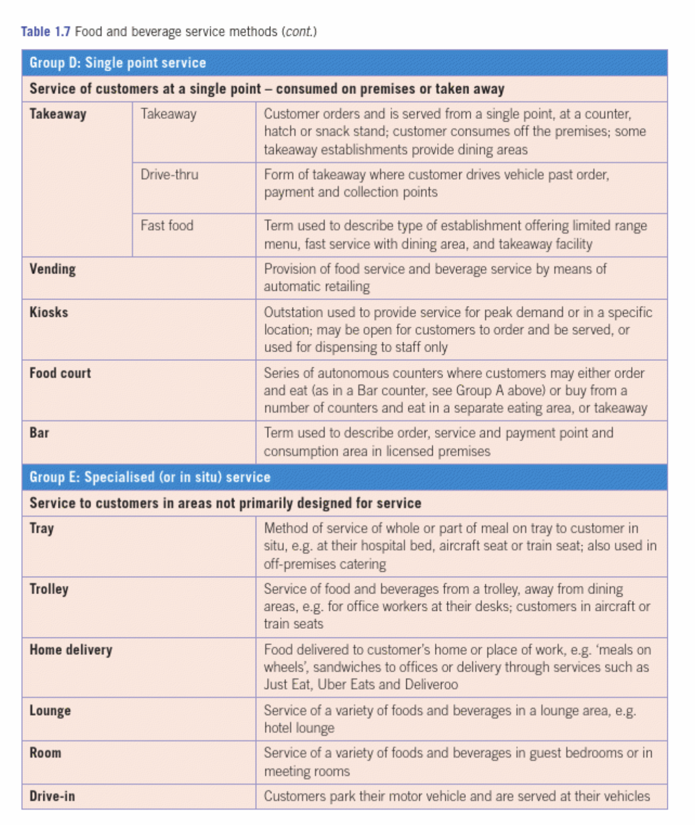
Appendix M - (Cousins and Weekes, 2020d, p.17)
REFERENCE LIST:

ARY News (2026). Gul Plaza fire: Building construction was flagged-Jan 28, 2026. [online] ARY News. Available at: https://arynews.tv/gul-plaza-fire-building-construction-was-flagged-jan-28-2026 [Accessed 29 Jan. 2026].
Atrill, P. and Mclaney, E. (2019). Management accounting for decision makers. 10th ed. [online] Harlow, United Kingdom: Pearson Education, pp.67–74. Available at: https://librarysearch.uwtsd.ac.uk/permalink/44WHELF_UWTSD/18o90jg/alma99100407602602421 [Accessed 1 Mar. 2026].
Barrow, C. (2021). BUSINESS PLAN WORKBOOK : a step-by-step guide to creating and developing a successful business. 10th ed. [online] London: Kogan Page, pp.41–64. Available at: https://librarysearch.uwtsd.ac.uk/permalink/44WHELF_UWTSD/177qm82/alma99100661486702421 [Accessed 3 Mar. 2026].
Bid Food (2026). Bidfood: Foodservice, Food Wholesalers, Suppliers and Distributors. [online] Bidfood. Available at: https://www.bidfood.co.uk/ [Accessed 14 Mar. 2026].
Bristol Sweet Mart (2016). Home. [online] Bristol Sweet Mart. Available at: https://www.sweetmart.co.uk/home/ [Accessed 13 Mar. 2026].
Castell Howell Foods (n.d.). Castell Howell Foods. [online] Castell Howell. Available at: https://www.castellhowellfoods.co.uk/ [Accessed 14 Mar. 2026].
Chaffey, D. and Smith, P.R. (2023). Digital Marketing Excellence: Planning, Optimizing and Integrating Online Marketing. 6th ed. [online] New York: Routledge, Taylor & Francis Group, p.24. Available at: https://librarysearch.uwtsd.ac.uk/permalink/44WHELF_UWTSD/177qm82/alma99100678027602421 [Accessed 5 Mar. 2026].
Cousins, J. and Weekes, S. (2020a). Food and Beverage Service, 10th Edition. 10th ed. [online] London: Hodder Education Group, pp.330–331. Available at: https://librarysearch.uwtsd.ac.uk/permalink/44WHELF_UWTSD/177qm82/alma99100402882402421 [Accessed 7 Mar. 2026].
Cousins, J. and Weekes, S. (2020b). Food and Beverage Service, 10th Edition. 10th ed. [online] London: Hodder Education Group, pp.18–24. Available at: https://librarysearch.uwtsd.ac.uk/permalink/44WHELF_UWTSD/177qm82/alma99100402882402421 [Accessed 7 Mar. 2026].
Cousins, J. and Weekes, S. (2020c). Food and Beverage Service, 10th Edition. 10th ed. [online] London: Hodder Education Group, pp.25–54. Available at: https://librarysearch.uwtsd.ac.uk/permalink/44WHELF_UWTSD/177qm82/alma99100402882402421 [Accessed 7 Mar. 2026].
Cousins, J. and Weekes, S. (2020d). Food and Beverage Service, 10th Edition. 10th ed. [online] London: Hodder Education Group, p.17. Available at: https://librarysearch.uwtsd.ac.uk/permalink/44WHELF_UWTSD/177qm82/alma99100402882402421 [Accessed 7 Mar. 2026].
Cousins, J.A., Foskett, D., Graham, D. and Hollier, A. (2023). Food and beverage management : for the hospitality, tourism and event industries. 6th ed. [online] Oxford: Goodfellow Publishers, pp.77–80. Available at: https://librarysearch.uwtsd.ac.uk/permalink/44WHELF_UWTSD/177qm82/alma99100759100602421 [Accessed 10 Mar. 2026].
Currys (2026). Currys | Washing Machines, Laptops, TVs, Consoles. [online] currys. Available at: https://www.currys.co.uk/ [Accessed 10 Apr. 2026].
Davies, C. (2026). Pakistan: Gul Plaza fire death toll jumps to 67. BBC News. [online] 23 Jan. Available at: https://www.bbc.co.uk/news/articles/cwy11485jeno [Accessed 29 Jan. 2026].
Empower Yourself With Color Psychology (2018). Gold in Business. [online] Empowered By Color. Available at: https://www.empower-yourself-with-color-psychology.com/gold-in-business.html [Accessed 13 Apr. 2026].
Facebook (2026). Facebook. [online] Facebook.com. Available at: https://www.facebook.com/marketplace/bristol [Accessed 10 Apr. 2026].
Finch, B. (2022). How to write a business plan : win backing and support for your ideas and ventures. 7th ed. [online] London: Kogan Page. Available at: https://librarysearch.uwtsd.ac.uk/permalink/44WHELF_UWTSD/177qm82/alma99100661486802421 [Accessed 4 Mar. 2026].
Finshots (2023). Brand Colours and Their Hidden Meanings. [online] Finshots. Available at: https://finshots.in/infographic/brand-colours-and-their-hidden-meaning/ [Accessed 11 Apr. 2026].
Food Standards Agency (n.d.). Food hygiene. [online] Food Standards Agency. Available at: https://www.food.gov.uk/food-hygiene [Accessed 4 Apr. 2026].
HSE (n.d.). HSE: Information about health and safety at work. [online] Hse.gov.uk. Available at: https://www.hse.gov.uk/ [Accessed 4 Apr. 2026].
Kotler, P., Armstrong, G. and Balasubramanian, S. (2023). Principles of Marketing. 19th ed. [online] Harlow: Pearson Higher Ed, pp.28–29. Available at: https://librarysearch.uwtsd.ac.uk/permalink/44WHELF_UWTSD/18o90jg/alma99100648036202421 [Accessed 2 Mar. 2026].
Mullins, L.J. and Dossor, P. (2013a). Hospitality management and organisational behaviour. 5th ed. [online] Harlow: Pearson, p.141. Available at: https://librarysearch.uwtsd.ac.uk/permalink/44WHELF_UWTSD/177qm82/alma99100284559002421 [Accessed 28 Feb. 2026].
Mullins, L.J. and Dossor, P. (2013b). Hospitality management and organisational behaviour. 5th ed. [online] Harlow: Pearson, pp.131–138. Available at: https://librarysearch.uwtsd.ac.uk/permalink/44WHELF_UWTSD/177qm82/alma99100284559002421 [Accessed 28 Feb. 2026].
Nisbets (2026). Nisbets Catering Equipment – Catering Supplies & Kitchen Equipment. [online] Nisbets.co.uk. Available at: https://www.nisbets.co.uk/ [Accessed 14 Mar. 2026].
Tanoli, I. (2026). Gul Plaza built in violation of approved building plan, Sindh Building Control Authority tells commission. [online] Dawn. Available at: https://www.dawn.com/news/1982800 [Accessed 26 Mar. 2026].
Tesco (2026). Small Kitchen & Home Appliances - Tesco Groceries. [online] Tesco. Available at: https://www.tesco.com/shop/en-GB/browse/electronics-and-gaming/small-kitchen-and-home-appliances/all?_gl=1 [Accessed 20 Mar. 2026].
Vinted (n.d.). Vinted | Sell and buy clothes, shoes and accessories. [online] Vinted. Available at: https://www.vinted.co.uk/ [Accessed 20 Mar. 2026].
Zoopla (2026). Arnside Road, Southmead, Bristol BS10, Restaurant to let, £21,600 pa - Zoopla. [online] Zoopla.co.uk. Available at: https://www.zoopla.co.uk/to-rent/commercial/details/72854121/?search_identifier=a09eaa92973e5f3b134a609a77518c436766f4b8262b42308d1519994037d343 [Accessed 10 Apr. 2026].

