Is sacred space a human construct or a natural phenomenon? Discuss this question through a research project with reference to the work of at least three theorists.
5250 word essay
Was the mountain near Guggisberg once considered a Venus mountain and therefore represented a potentially culturally conflicting entity to the Christian Church of the area?

Introduction

This essay examines the sacredness of the rock-and-hill configuration adjacent to the small village of Guggisberg, in the pre-alpine region between Bern and Fribourg, Switzerland (Figure 1). The rock-and-hill formation ‘Guggershornli’ and ‘Schwendelberg’ might once have been considered a Venusberg and thus viewed as sacred by the local people. Clearly visible from both the South and the North, yet embedded in the pre-alpine region of soft meadows before a backdrop of higher mountains, its silhouette resembles a lying pregnant woman, Kurt Derungs noted. The idea that the rock-and-hill formation is sacred derives from the ancient Swiss folksong ‘the Guggisberg song’, which suggests it may be a Venusberg. Based on the Guggisberg song, which links it to Venus via the name of the song's protagonist, he claimed that it was related to a possible ancient belief in a pagan landscape goddess. Mountains have historically been assessed based on their position within the landscape and the extent to which their elevation stands out relative to the surrounding terrain, Gunzburg and Brady argued. Today, the rock-and-hill formation is marketed by the area’s tourist office, which features a local museum and several hiking trails that portray the song’s narrative of an alleged tragic love story between two locals in the eighteenth century. The song is well known throughout Switzerland and is one of the most beautiful and oldest folk songs, according to Otto von Greyerz. The idea that the themes of love in the region may be older and involve the once-revered ‘Frau Venus’, the Roman goddess and protector of love and bringer of abundance, is suggested by various sources. This Roman goddess, Ronald Hutton argued, evolved into a familiar character in medieval romantic literature and by the 14th century, stories commonly placed her court in a mountain, the Venusberg. A few centuries earlier, not far from the rock-and-hill formation, the first German-speaking monastery of the Cluny abbey was founded. Therefore, the question of whether the rock-and-hill formation was ascribed sacredness by the locals as the palace of the goddess Venus, or whether it was regarded as possessing agency, will be examined against the backdrop of the region's folkloric and ecclesiastical traditions as well as the key theorists on sacred geography.
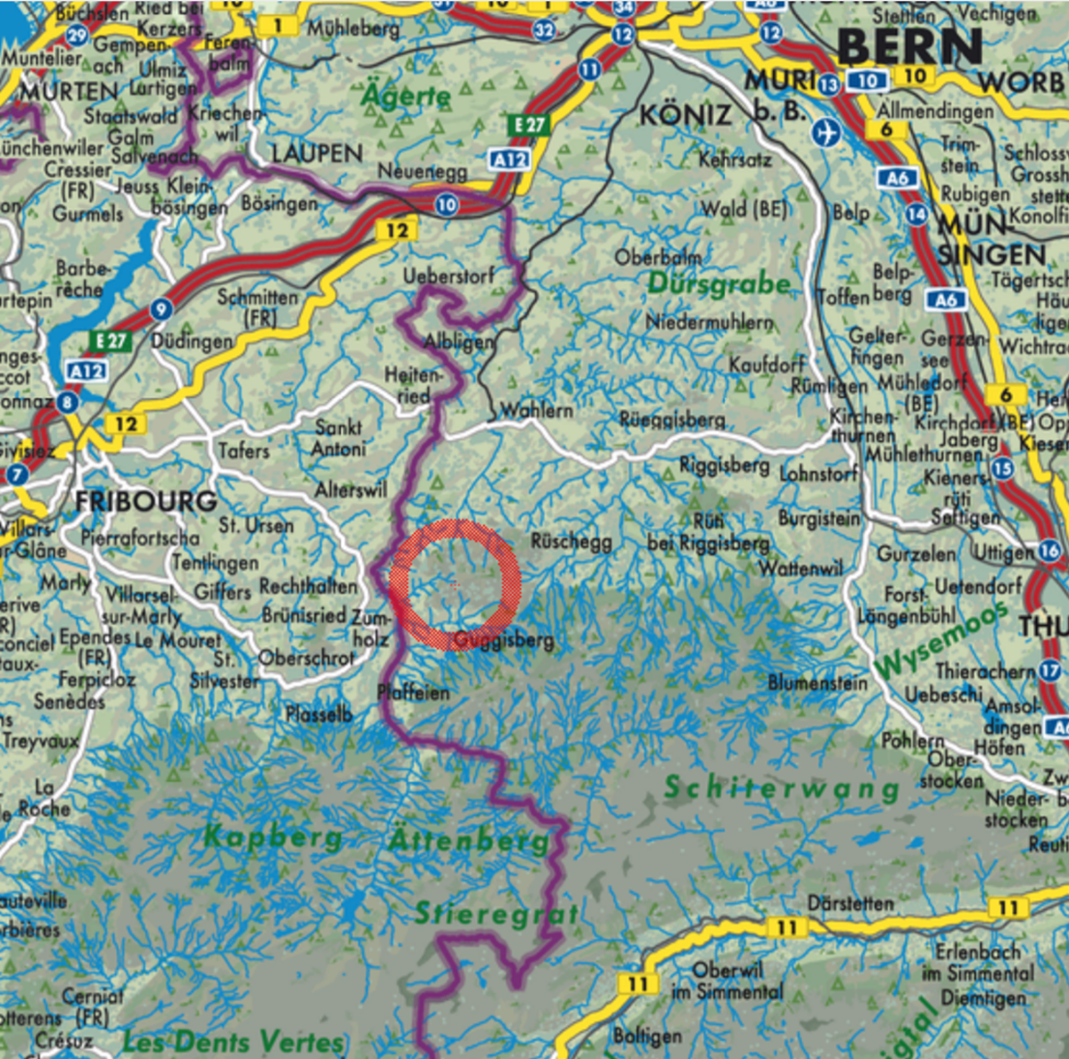
Figure 1: Map of Guggisberg in the pre-alpine area adjacent
to the border (purple line) between the Canton of Bern and the Canton of Fribourg.

Literature Review
The possible sacredness of the rock-and-hill formation in Guggisberg will be explored through the works of Mircea Eliade, Emile Durkheim, Belden C. Lane, Tim Ingold, Darrelyn Gunzburg, Anna-Leena Siikala, and Bernadette Brady. Eliade’s assertion that ‘where the sacred manifests itself in space, the real unveils itself, and the world comes into existence’ will be taken as a groundwork for the examination, supplemented by Durkheim's perspective that ‘the notion of the sacred is always and everywhere separate from the notion of the profane in man’s mind.’ I will contemplate Lane’s argument that an interesting shift in awareness takes place when a seemingly insignificant location, just a tiny point on the map, transforms into a site of remarkable importance. In addition, I will consult Peter M. Broadwell and Timothy R. Tangherlini’s research on geo-semantic explorations, which enhances visualizations of narratives related to geographical locations. They claimed that ‘Since its inception, the study of folklore (folkloristics) has been closely linked to the study of the relationship between stories and places.’ Additionally, a chronicle of the Canton of Bern and literature on the foundation of the monastery. The literature on the Guggisberg Song will be examined, including the foundational study by Otto von Greyerz and various local folktale collections. Particularly, two fairy tales will be examined closer, one of which appears in the Brothers Grimm’s Household Stories and can be connected directly to the Guggisberg Song, and the other is a tale directly referring to the Schwendelberg. In relation to the Venusberg and the Wild Hunt, a theme closely associated with the concept of Venus mountains, I will consult Ronald Hutton, Claude Lecouteux, Leah Garrett, and Gary K. Waite. For insights into the astronomy of Venus, I will consult Ivan Sprajc and Nicholas Campion. Additionally, in exploring the importance of the planet Venus to the monks in a monastery, I will draw on the works of Mary W. Helms and Roger Beck.

Methodology

This essay will take an almost purely literary approach. However, not quite following Brady’s statement that ‘the sacred geographer can also be a researcher of current or historical texts and thus never tread upon sacred soil’, I did visit the trails and museum promoted by the Guggisberg tourist office and hiked on and around the rock-and-hill formation. (Figure 3) However, as they fail to address the possible sacredness of the landscape itself, I suspected what Eva Kingsepp called a taboo surrounding the paranormal in the Swedish tourist region she studied. She observed that the tourist attraction she studied in Sweden, just like the Guggisberg trail and museum, was based exclusively on the common framework of folklore and cultural heritage. She noted: ‘When we encounter an unknown, often emotionally charged phenomenon, we tend to use culturally established mechanisms and frameworks of interpretation to understand it and thus defuse it.’ In my view, this is also the case in Guggisberg, prompting me to apply a literature-based method to uncover the possible sacredness of the hill-and-rock formation in the light of medieval beliefs. To do so, I will consult studies of the Guggisberg song text and local folktales, while considering, however, Hutton's argument that such works could be problematic. The reason for this is that they were ‘based on the premise that common people, and especially rural people, unthinkingly practised and believed things inherited from earlier epochs, which they no longer understood and were incapable of altering.’ Therefore, I will follow his suggestion to narrow my focus to the historical context of medieval and early modern sources regarding the beliefs of the time in the German-speaking areas near Guggisberg, without presuming the existence of a cohesive system of ancient beliefs behind them. I will thus focus on the period between the eleventh and sixteenth centuries, when the monastery was built in the community of Guggisberg, and the Reformation rendered it obsolete.

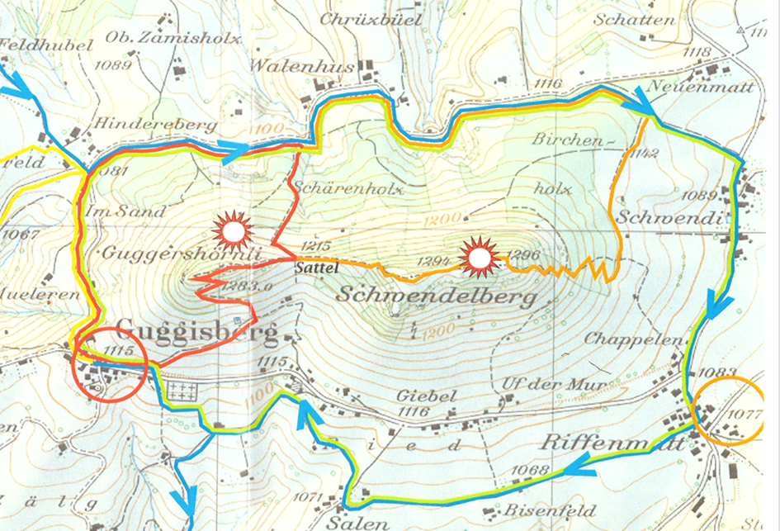
Figure 2: Hiking map of the rock-and-hill formation ‘Guggershornli’ and ‘Schwendelberg’. (Credit: Guggisberg Tourist Office)
Findings/Discussion
The song
Lane argued that an awareness shift occurs when a seemingly normal place, which is just a dot on the map, suddenly or over time becomes important. In the case of Guggisberg, it is curious that a rather unremarkable rock-and-hill formation, which is by no means higher or more dramatic than the mountains behind it, has national significance. This is not due to the tourist office’s efforts to promote it, but rather because the Guggisberg song transports a memory of the formation’s sacredness in its text and melody. Von Greyerz wrote that ‘no one can completely escape the quiet power that this ancient, solemn minor key’ song exerts. While the tourist office promotes the song as based on an alleged eighteenth-century love story, this claim is highly debated. Similar to Kingsepp's observations in the Swedish tourist region she studied, when faced with an unfamiliar and often emotionally intense situation, people typically rely on culturally established methods and interpretive frameworks to make sense of it and alleviate any concerns. The municipality of Guggisberg, in the Canton of Berne, has been Protestant for centuries, whereas its direct neighbours in the Canton of Fribourg have remained Catholic. Some folktales still directly address the inner dilemma of some individuals. However, by applying Ingold’s suggestion to ‘making one’s way, actively and attentively, through the text’ and music, re-integrating looking and listening, it is possible to go beyond the culturally established framework. The text and melody suggest that the song reflects very old beliefs that extend beyond the Reformation's disruptions. Von Greyerz recognized, alongside older structural motifs and forms in the verses, the influence of church hymns, which gained popularity outside church services in the sixteenth century through Protestant congregational singing. Therefore, melodies that had once been sung in Catholic church services were now transported into folksongs.

The folktales
There are several folktales in Guggisberg about a fairy who lives inside a mountain and invites a young man into her realm. He is in love with her and is permitted to dine with her and listen to beautiful music. The fairy is willing to share her riches and secrets with him, but forbids him to overstep the threshold to her sanctuary, where she regularly retreats. The stories end, as they must, with him trespassing on her order. He is immediately expelled from the mountain. According to Eliade, the threshold is the dividing line between two realms. Paradoxically, it's also the space where these realms interact, allowing for a transition from the ordinary to the sacred. The ultimate sanctuary of the fairy must be the place where the sacred becomes manifest in space, following Eliade’s argument. The tales, therefore, exemplify an experience Eliade described as: ‘Where the sacred manifests itself in space, the real unveils itself, the world comes into existence.’ In verses 9 and 10 of the Guggisberg song, there is mention of a mill deep down in the hill, which mills nothing but love, night and day. It indicates the changing rhythms of day and night and the seasons, according to Derungs. Consequently, this must be the site of world creation, providing fairytale heroes with an opportunity to gain insight into the underlying realities beyond the veil. Hutton noted that this might well suggest a prehistoric worldview, since ‘the basic pattern of the wheel of the year endured, and was truly prehistoric’.

The riches
There is a folktale that very explicitly addresses the alleged riches inside the Schwendelberg in Guggisberg. It is one of the few Swiss fairy tales that was taken into the Brothers Grimm’s collection of Household Stories. By the name of ‘Simeli Berg’ and numbered KHM 142, the story can be directly tied to the Guggisberg song, because in the song, the first line of every verse ends with the word ‘Simeli-Berg!’, a word that does not make much sense to modern ears. However, the folksong archive offers an explanation, arguing that the word is derived from the old Swiss word ‘simel’, meaning ‘bucket’, and refers to a round mountain. The Schwendelberg, therefore, seems to have been viewed as a container, like a bucket. In that particular Grimm folktale, a poor farmer witnesses twelve robbers and hears them call out in front of the hill: ‘Semsi Mountain, Semsi Mountain, open up!’ ‘Semsi’ is another word for ‘semeli’ or ‘simeli’, meaning ‘round’, the archive further stated. Interestingly, according to the Swiss dialect dictionary, words such as ‘semsi’ or ‘semeli’ also point to a hill in St. Gallen, Switzerland by the name of ‘Senwelberg’, which is in fact very close to the name of the Guggisberg hill ‘Schwendelberg’. After the twelve robbers in the Grimm tale utter the magical words ‘Semsi Mountain, Semsi Mountain, open up!’, the mountain opens up, and a hall full of gold, silver, pearls, and gemstones is revealed. The poor farmer crosses the threshold after them and witnesses the riches. He seems to have the necessary reverence in the face of the sacred realm he is entering, sensing its heightened intensity. He only takes enough to feed and clothe his children and to share with those in need in his community. Durkheim noted that the sacred forces are not simply more intense than the profane; they are fundamentally different and possess unique qualities that the profane lack. The humble farmer appears to model appropriate behaviour in the face of such sacredness, whereas his greedy brother does not display the necessary reverence upon entering the sacred space. He not only forgets the magical words that will let him out again, but he is also caught by the twelve robbers and executed on the spot. ‘The sacred thing is, par excellence, that which the profane must not and cannot touch with impunity,’ Durkheim argued. However, this restriction cannot completely prevent communication between the two realms. If the ordinary could never interact with the sacred, then the sacred would lose its significance. The humble brother models how interaction with the sacred might nevertheless be possible. Eliade argued that every ‘threshold has its guardians’, divine beings and spirits that prevent both humans and demons, as well as forces of disease, from crossing into the sacred realm. According to the tale, the twelve robbers are the guardians of the Schwendelberg.

The Wild Hunt
Gary K. Waite argued that the Venusberg can be understood as an enduring remnant of the traditional Germanic conception of paradise or the afterlife. It derives from the ancient popular belief in the female deity Venus, who, at the turn of the seasons, would lead the ‘Wild Hunt. Claude Lecouteux argued that the Wild Hunt comprises the deceased and is connected to the extensive traditions of ancestor veneration and the worship of the dead, who serve as intermediaries between humans and the material world. It is the lower-level scene in the vertical model. In Germanic and Celtic legends, the Wild Hunt consisted of a group of spirits or ghosts riding through the night, usually led by a divine female figure, Hutton elaborated. The connection between the Wild Hunt and the tale of the Venusberg was first made in the sixteenth century, Lecouteux stated. There is a Guggisberg ballad by the very name ‘The wild hunt at the Schwendelberg ' listed in a chronicle of 1857, further confirming that the rock-and-hill formation could have been held for a Venusberg. Anthony Thorley and Celia Gunn argued that the word ‘sacred’, next to its meaning of ‘set apart for a religious purpose’, also has a connotation of ‘damned, detestable, or dreadful’, something which the Wild Hunt represents well. In this particular story tied to the Schwendelberg, a father cautions his son against going outside on a night when a fierce storm is raging. Despite the warning, the son ventures out and quickly feels an unsettling presence drawing near. Suddenly, a ghostly train, accompanied by various animals, rushes by, filled with shouting, cursing, and wailing. When a green man suddenly stands before him, he must answer correctly, as his father had told him. The question is: ‘Can you tell me what time it is?’ and the correct answer is: ‘It is the time that is right for the dear Lord.’ It is evident that the the concept of the Wild Hunt, which is rooted in a pre-Christian tradition as part of a complex framework for understanding the world, according to Lecouteux, was reworked to fit the prevailing Christian perspective in this case. He argued that while Venus, or a local deity-like figure, initially led the Wild Hunt, she was later demonized. Originally, Venus or the fairy in the hill was a benevolent figure providing nourishment and riches for their people. However, as Hutton noted, by the fifteenth century, Venus had become the embodiment of the temptress, a danger to the human soul.

The rock-and-hill within a horizontal context
The rock-and-hill formation, consisting of the rock ‘Guggershornli’, and the round hill ‘Schwendelberg’, might have once been viewed as a Venusberg and thus held sacred. It is clearly visible across the region and lies within the municipality of Guggisberg. Derungs noted that the silhouette of the rock-and-hill formation resembles a lying pregnant woman and described it as a natural sanctuary. Whether or not mountains have a distinct personality, they serve as mediators between heaven and earth, embodying transitional areas, protectors, entrances, and connections between various realms, as noted by Gunzberg and Brady. Focusing on a mountain’s mediation function as a transitional area, from a geographically horizontal perspective, the rock-and-hill formation is located in a pronounced transitional area, geographically, politically, linguistically, and in terms of religion. It is the entrance to the alpine region of Gantrisch and is adjacent to the border of the Canton of Fribourg, with one area Protestant and German-speaking, the other Catholic and French-speaking (Figure 1). However, the folktales reflect common cultural roots and a strong interconnectedness, despite differences in spoken languages and belief systems, that could be due to the alternating political rule between Bern and Fribourg, which changed every 5 years until 1798. Gunzburg and Brady further argued that, regardless of a mountain’s physical presence, it often evokes feelings of reverence, a quality that can be harnessed for religious purposes, not only to create a space for monastic groups seeking a closer connection to the divine, but also to enhance the experience of the divine itself. In 1072, the first monastery of the Cluny abbey on German-speaking territory was founded in the very municipality of Guggisberg. As it would suggest that the monastic group sought a closer connection to the divine in an area that hosted the curious rock-and-hill formation, there is also the debate, whether it was placed there because the local population had to be converted from paganism to Christianity. However, according to Franz Wäger, although there was some bias in the monastery's founding, Christianity had already been established in the area for many centuries. The ecclesiastical texts sought to highlight the holiness of the monastery’s founder, Saint Ulrich, and thus portrayed the local population as uncivilised and animal-like, requiring guidance toward salvation. Therefore, the theme of an imposed separation, be it political or by the Catholic church, where there was actually none, can be seen, though the rock-and-hill formation seems to hold it together subliminally.

The rock-and-hill within a vertical context
After the rock-and-hill formation of Guggisberg has been set in a horizontal context, Anna-Leena Siikala’s model offers insights through a vertical argument. The rock-and-hill’s sacredness could be viewed as the universe comprising three main tiers consisting of a central axis, often referred to as a pillar, a tree, or a mountain, which connects these three levels and allows passage. The rock Guggershornli, which rises like a needle into the sky, could well represent such an axis (Figure 3). According to Siikala, the lower world lies beneath this axis, and the journey to the upper world begins at its summit. The Guggisberg song implies the existence of such a lower dimension by referring to a mill that generates nothing but love, by night and day. Additionally, local folklore mentions a fairy living there and treasures hidden in the Schwendelberg, which may all indicate a prehistoric perspective, further reinforced by the theme of the Wild Hunt, which will be discussed further down. The Guggisberg rock and hill appear to form the heart of an area that allows passage between the three vertical levels and between the horizontal levels. Durkheim's argument that the concept of the sacred is consistently distinct from the concept of the profane in human awareness does not hold in the vicinity of the rock-and-hill formation.
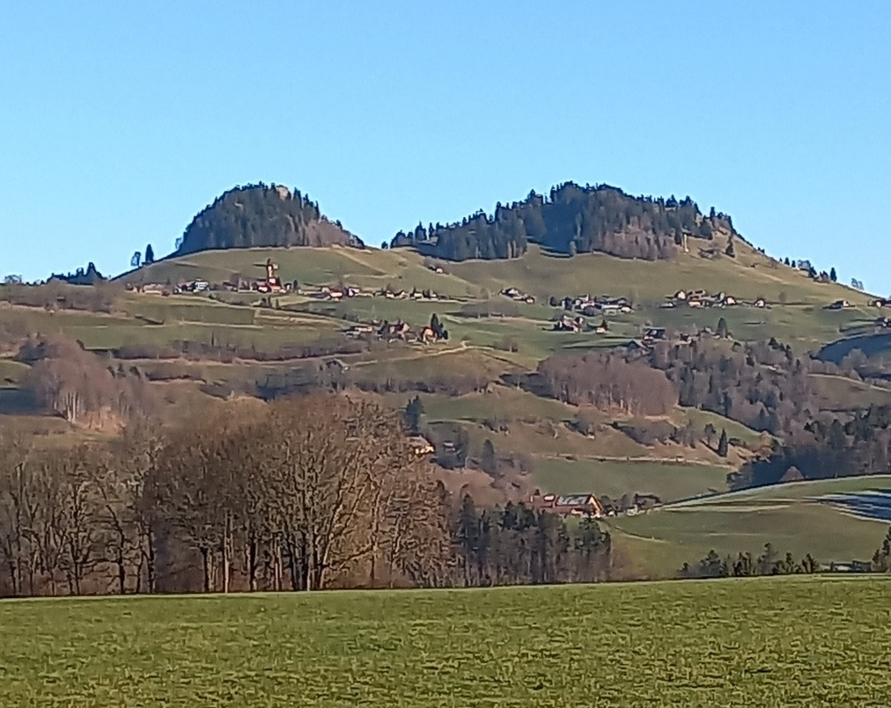
Figure 3: The rock-and-hill formation of Guggisberg. To the left, the Guggershornli,
to the right, the Schwendelberg. (Photo: A. Hofmann)

A possible Venusberg
The Guggisberg song implies that the rock-and-hill formation might be a Venusberg, as it features a love story and a woman named ‘Vreneli’, which is a diminutive of ‘Verena’. According to Wolfgang Golther, ‘Verena’ stood in Swiss folklore for Venus. The Roman goddess Venus, Hutton argued, embodied various meanings associated with her ancient status as the protector of love, ranging from sensual, earthly, and lustful to honourable and virtuous. In the fourteenth-century medieval romance, her court was commonly set within a mountain, the Venusberg. Nicholas Campion argued that Aphrodite, the goddess of love, and the planet Venus were associated with qualities of seduction and passion and were symbols that encompassed everything from erotic love to religious rituals, the playing of beautiful music, and the adornment with gold. However, already a century later, according to Hutton, German writers began to portray her as a negative figure, representing sensuality that leads people away from salvation. Her palace was no longer viewed as a source love and abundance, but of corrupt pleasures. There is a famous opera by Richard Wagner by the name of ‘Tannhäuser’ based on a 1515 version of the ballad, which displays this kind of narrative, according to Leah Garrett. Tannhäuser was a hero who ventured into the Venusberg out of curiosity to discover its marvels; however, after a year there, he realized that he wanted to leave. According to Ernst L. Rochholz, the German ballad lyrics are comparable to the Swiss version, where her title became ‘Frau Venus’ in her palace of Venusberg. Garrett further argued that the stories’ origins are widely debated; however, they predate this version significantly and also differ substantially.

Change of premises

According to Waite, the Church continued its efforts to transform the Venusberg from a sacred place to a place of evil. Garrett noted that the story of Venusberg had originally migrated from Italy to German-speaking regions, and as its story changed over time, so did its geographical locations. However, in the sixteenth century, wandering preachers told credulous people that they had been on the Venusberg, where they had seen extraordinary things, gained knowledge of the past and the future, and received magical remedies for protection against witches and hail. They even claimed that they could willingly summon the Wild Hunt and took money not to do so, according to Waite. He cited the sixteenth-century Dutch Anabaptist David Joris, who argued that ‘Vrouw Venus’ was ‘the whore and female devil’ and the counterpart of the mountain of heaven. By then, Waite noted, the Venusberg was no longer understood as a geographical place but rather as a universal principle. Interestingly, the folktales surrounding the rock-and-hill formation emphasize these very traits of the people of Guggisberg: they are often called the witches of Guggisberg, skilled in magic, healing, catching thieves, seeing the future, and influencing the weather, and are on good terms with the dwarves. The tales thus convey two things: first, a remarkably high proportion of tales in which Guggisberg people are portrayed as possessing magical abilities; and second, that people were far more ambiguous about it than the Church might have liked.
In their geo-semantic research, Peter M. Broadwell and Timothy R. Tangherlini found evidence that stories of witches are especially prominent in close geographic proximity to Catholic monasteries. They argued that they found a clear connection between religious sites, particularly those of the Catholic Church, and witchcraft in the Danish Folklore corpus. Their tool for establishing connections between narratives and geographic locations showed that monasteries symbolize both the Church's power and the fear of witches, thereby illustrating a complex relationship among religion, power, and societal anxieties. When the formerly revered ‘Frau Venus’ was rewritten as a danger to the human soul in the fifteenth century, it might be attributed to what Durkheim observed: ‘Christianity itself was obliged to make a place in its mythology for the spirit of evil’, although impure, it was not a profane being.

The Venusberg and the morning star
Humans play a key role in shaping how a landscape is perceived by weaving ‘a narrative that embraces the energies of land and sky’, Lane claimed. A narrative around a possible Venusberg would not be complete without examining the role of the sky and the planet Venus. A possible astronomical alignment should also be considered if the rock-and-hill formation in Guggisberg was once regarded as a Venusberg. The local dialect in its name suggests that Guggershornli, which rises like a needle into the sky, is a pointed horn for observing. In this function, the rock could well have served as a reference point for observing the sky. However, the question arises: from which fixed point were the horn and the sky observed? Since there is no point in the vicinity that could be identified as an observation reference point, such as a menhir, we may never know. Ivan Sprajc argued that Venus’ brightness is only surpassed by the Sun and the Moon, and ‘was undoubtedly a primary reason underlying its importance in many cultures’. Yet, he pointed out, as the morning star's extreme positions barely surpass those of the Sun, it is difficult to establish evidence for a Venus observation without additional supporting information. Supporting information is available only in the song and tales, as mentioned. There is no direct archaeological evidence, except for the discovery of Roman coins near Guggisberg, which indicates a cultural connection to Rome and further supports the identification of the Roman goddess Venus in the area. However, Roger Beck noted that Venus, as the morning star, signifies the arrival of dawn. When it appears in the eastern sky, its light radiates upward and outward, commonly called the phosphoros, the light-bringer. The 10th-century monk Notker praised the phosphorescent glow of Venus, signaling the end of the dark night and its transformation into a golden star. According to Mary W. Helms, early European monks were very preoccupied with the night. She linked the darkness within the early medieval abbey church to the deep darkness of the universe beyond its walls, representing a fundamental, unformed state of existence. She further claimed that astronomical observations of the night sky during nocturns would have inspired reflections on the universe's orderliness. As the monks gathered in a structured manner, they sought to emulate and connect with the enduring cosmic order and harmony of the celestial scene through their organized chants. After experiencing such a night as a monk, the rising of the morning star, Venus, must have been a glorious moment. Only later, when Christianity rewrote its mythology, did the Church come into conflict with Venus's virtues. Regarding her celestial influence, Thomas Aquinas, who was the most significant friar and priest of the thirteenth century, held that celestial bodies affected only the physical aspect of a person, whereas the soul remained unaffected. Therefore, even if the planet Venus sparked passionate thoughts, a person would still have the ability to decide how to react to it. At the outset, when the monastery in Guggisberg was founded, Venus did not yet pose a threat to the Catholic Church.

Conclusion
This essay examined the sacredness of the rock-and-hill formation in Guggisberg between Bern and Fribourg, Switzerland. Based on the ancient folksong known as the Guggisberg song, it is associated with Venus and the medieval concept of a Venusberg. Since the formation resembles a pregnant woman, it has, however, also been associated with a local landscape goddess or a fairy. My examination concludes that the rock-and-hill formation in Guggisberg may very well have been considered a Venusberg at one point in history. Initially, it posed no issue for the Catholic Church or locals. Over time, as it became a romantic Venusberg, its reputation not only declined but also came to be regarded as a danger to the human soul. Over the centuries, amid changing religious beliefs and political rule, what was once called a Venusberg held the entire region together and united the locals, regardless of which language they spoke, under which political rule or belief system they lived. The song's text and melody reflect very old beliefs that extend far beyond all the political and clerical disruptions. The sacred is not consistently distinct from the profane in local people’s awareness, as Durkheim argued. Rather, it has subtly worked its magic in how Eliade described it, as a hierophany, a ‘manifestation of something of a wholly different order, a reality that does not belong to our world’. The place still has its distinct voice, as Brady described it. While the local tourist activity programme may seem somewhat superficial and fails to capture the essence in full, it still provides an opportunity to hear the song and listen to the voice of the rock-and-hill, engage with its love story, and sense the sacredness it exudes over the entire region.

Bibliography
Brady, Bernadette, ‘Introduction Part I’, Sacred Geography: Conversations With The Other, (Ceredigion, Wales: Sophia Center Press, 2024).

Durkheim, Émile, The Elementary Forms of Religious Life (New York: The Free Press, 1995).

Eliade, Mircea, The Sacred and the Profane: The Nature of Religion (New York: Harcourt, Inc., 1987).

Lane, Beldon C., Landscapes of the Sacred: Geography and Narrative in American Spirituality (Baltimore: The John Hopkins University Press, 2001).

Thorley, Anthony and Gunn, Celia M., ‘Sacred Sites: An Overview’, A Report for The Gaia Foundation, 2008 <https://www.academia.edu/103607950/Sacred_Sites_An_Overview> [accessed 7 October 2025]

Otto von Greyerz, ‘Das Alte Guggisberger Lied’ in Schweizerisches Archiv für Volkskunde Schweizerische Gesellschaft für Volkskunde, 16 (1912), pp. 193-212.
Kurt Derungs, Geheimnisvolles Bern: Sakrale Stätten an der Aare (Grenchen: Amalia Books, 2016), p.212.
Darrelyn Gunzburg and Bernadette Brady, Space, Place and Religious Landscapes: Living Mountains (London, New York, Oxford, New Delhi, Sydney: Bloomsbury Academic, 2021), p. 1.
Von Greyerz, ‘Das Alte Guggisberger Lied’, p. 195. <https://doi.org/10.5169/seals-111443>
Ronald Hutton, Queens Of The Wild: Pagan Goddesses In Christian Europe: An Investigation, (New Haven and London: Yale University Press, 2023), p. 126.
Mircea Eliade, The Sacred And The Profane: The Nature Of Religion (New York: Harcourt, Inc., 1987),
Émile Durkheim, The Elementary Forms Of Religious Life (New York: The Free Press, 1995).
Beldon C. Lane, Landscapes Of The Sacred: Geography And Narrative In American Spirituality (Baltimore: The John Hopkins University Press, 2001).
Tim Ingold, Lines: A Brief History (London: Routledge, 2007).
Darrelyn Gunzburg and Bernadette Brady, Space, Place And Religious Landscapes: Living Mountains (London, New York, Oxford, New Delhi, Sydney: Bloomsbury Academic, 2021).
Anna-Leena Siikala, Myth And Mentality Studies In Folklore And Popular Thought (Helsinki: Studia Fennica Folkloristica, 2002).
Bernadette Brady and Darrelyn Gunzburg, Space, Place And Religious Landscapes: Living Mountains (London, New York, Oxford, New Delhi, Sydney: Bloomsbury Academic, 2021), and ‘Introduction Part I’, Sacred Geography: Conversations With The Other, (Ceredigion, Wales: Sophia Center Press, 2024).
Eliade, The Sacred and the Profane, p. 63.
Durkheim, The Elementary Forms of Religious Life, p. 37.
Lane, Landscapes of the Sacred, p. 39.
Peter M. Broadwell and Timothy R. Tangherlini, ‘WitchHunter: Tools For The Geo-Semantic Exploration Of A Danish Folklore Corpus’ in The Journal of American Folklore, 129. 511 (Winter 2016), pp. 14-42 (p.15).
Albert Zahn, Chronik des Kantons Bern (Bern: Stämpflische Verlagshandlung, 1857).
Franz Wäger, ‘Die Gründung Des Priorates Rüeggisberg, Geschichte Des Kluniazenser-Priorates’ in Freiburger Geschichtsblätter, Deutscher Geschichtsforschender Verein des Kantons Freiburg, 22 (1915). <https://doi.org/10.5169/seals-334144>
Volksliederarchiv <https://www.volksliederarchiv.de/s-isch-aeben-e-moensch-uf-aerde/> [accessed 18 December 2025]
Otto von Greyerz, ‘Das Alte Guggisberger Lied’ in Schweizerisches Archiv für Volkskunde Schweizerische Gesellschaft für Volkskunde, 16 (1912), pp. 193-212.
Wilhelm and Jacob Grimm, KHM 142 ‘Simeli Mountain’, The Complete Illustrated Works of The Brothers Grimm (London: Octopus Publishing Group Ltd., 2006).
Hans Nydegger, ‘Die Wilde Jagd Am Schwendelberg’, in Heimathkunde des Amtes Schwarzenburg, Bern, (1869).
Ronald Hutton, ‘The Wild Hunt and the Witches' Sabbath’ in Folklore, 125. 2 (August 2014), pp. 161-178. Ronald Hutton, Queens Of The Wild: Pagan Goddesses In Christian Europe: An Investigation, (New Haven and London: Yale University Press, 2023).
Claude Lecouteux, Phantom Armies of the Night: The Wild Hunt and the Ghostly Processions of the Undead, (Rochester and Toronto: Inner Traditions, 2011).
Leah Garrett, ‘The Original Tannhäuser Ballad’, in A Knight At The Opera, Heine, Wagner, Herzl, Peretz, And The Legacy Of Der Tannhäuser (Purdue University Press, 2011)
Gary K. Waite, ‘Talking animals, preserved corpses and Venusberg: the sixteenth century magical world view and popular conceptions of the spiritualist David Joris (c. I5OI-56)’ in Social History, 20. 2 (May 1995), (Taylor & Francis) pp. 137-156.
Ivan Sprajc, ‘Alignments upon Venus (and Other Planets)- Identification and Analysis’, Handbook of Archaeoastronomy and Ethnoastronomy, C.L.N. Ruggles (ed.), (New York: Springer Science + Business Media, 2015) pp. 507-516.
Nicholas Campion, Astrology and Cosmology in the World’s Religions (New York and London: New York University Press, 2012).
Mary W. Helms, ‘Before the Dawn. Monks and the Night in Late Antiquity and Early Medieval Europe’ in Anthropos, 99. 1. (2004), pp. 177-191.
Roger Beck, ‘Imagery And Narrative In An Ancient Horoscope: P. Lond. 130 (Greek Horoscopes No. 81)’ In The Imagined Sky: Cultural Perspectives, ed. by Darrelyn Gunzburg (Bristol: Equinox Publishing Ltd, 2016)
Bernadette Brady, ‘The Sacred Geography papers and their methodologies’ in Spica, Postgraduate Journal for Cosmology in Culture, 4.2 (Autumn 2016), pp. 9-11 (p. 11).
Guggisberg Vreneli Museum and trail <https://www.vreneli-museum.ch/>
Eva Kingsepp, Ghosts, Extraterrestrials, and (Re-)enchantment, in Jack Hunter and Rachael Ironside, Folklore, People, and Place: International Perspectives on Tourism and Tradition in Storied Places (London and New York: Routledge Taylor & Francis Group, 2023) pp 186-198 (p. 192).
Ronald Hutton, ‘The Wild Hunt and the Witches’ Sabath’, p. 163.
Hiking map of Guggisberg Tourismus: file:///C:/Users/andre/Documents/Sophia%20Center%20University%20of%20Wales/Sacred%20Geography/Sacred%20Geography_Assignment%202/Fotos%20Guggisberg/wandervorschlaege_guggisberg.pdf
Lane, Landscapes of the Sacred, p. 39.
Von Greyerz, ‘Das Alte Guggisberger Lied’, p. 195.
<https://www.guggisberg-tourismus.ch/vreneli-ab-em-guggischbaerg/>
Eva Kingsepp, Ghosts, Extraterrestrials, and (Re-)enchantment, in Jack Hunter and Rachael Ironside, Folklore, People, and Place: International Perspectives on Tourism and Tradition in Storied Places (London and New York: Routledge Taylor & Francis Group, 2023) pp 186-198 (p. 192).
Tim Ingold, Lines, p. 27.
Von Greyerz, ‘Das Alte Guggisberger Lied’, p. 211.
List of fairy tales around Guggisberg with fairy in mountain
Eliade Sacred and Profane, p. 25.
Eliade, The Sacred and the Profane, p. 63.
Von Greyerz, ‘Das Alte Guggisberger Lied’, p. 194.
Derungs, Geheimnisvolles Bern, 213.
Hutton, Ronald. Queens of the Wild: Pagan Goddesses in Christian Europe: An Investigation (New Haven and London: Yale University Press,2022) p.126.
Volksliederarchiv <https://www.volksliederarchiv.de/s-isch-aeben-e-moensch-uf-aerde/> [accessed 18 December 2025]
Grimm, KMH 142
Volksliederarchiv <https://www.volksliederarchiv.de/s-isch-aeben-e-moensch-uf-aerde/> [accessed 18 December 2025]
Friedrich Staub and Ludwig Tober, Schweizerisches Idiotikon: Wörterbuch der Schweizerdeutschen Sprache, Antiquarische Gesellschaft Zürich, (Frauenfeld: Verlag J. Huber, 1901), p. 1562. <https://digital.idiotikon.ch/idtkn/id4.htm#!page/41559/mode/2up>, [accessed 15 December 2025]
Durkheim, The Elementary Forms, p. 82.
Durkheim, The Elementary Forms, p. 38.
Eliade, The Sacred and the Profane, p. 25.
Gary K. Waite, p. 152?
Lecouteux 2011, 2 and 199
Hutton, Wild Hunt, p. 161.
Claude Lecouteux, Phantom Armies of the Night: The Wild Hunt and the Ghostly Processions of the Undead (Rochester and Toronto: Inner Traditions, 2011), p. 146.
Anthony Thorley and Celia M Gunn, ‘Sacred Sites: An Overview’, A Report for The Gaia Foundation, 2008, p. 8. <https://www.academia.edu/103607950/Sacred_Sites_An_Overview> [accessed 7 October 2025].
Nydegger, Hans, Die wilde Jagd am Schwendelberg: Guggisberger Volkssage, 1895, in Schwyzerlüt : Zytschrift für üsi schwyzerische Mundarte, 16 (1954), 3
Lecouteux, p. 82.
Hutton, Ronald. Queens of the Wild: Pagan Goddesses in Christian Europe, p. 126.
Kurt Derungs, Geheimnisvolles Bern: Sakrale Stätten an der Aare (Grenchen: Amalia Books, 2016), p.212.
Darrelyn Gunzburg and Bernadette Brady, Space, Place and Religious Landscapes: Living Mountains (London, New York, Oxford, New Delhi, Sydney: Bloomsbury Academic, 2021), p. 2.
Zahn, Chronik des Kantons Bern, p. 632.
Darrelyn Gunzburg and Bernadette Brady, Space, Place and Religious Landscapes: Living Mountains (London, New York, Oxford, New Delhi, Sydney: Bloomsbury Academic, 2021), p. 2.
Franz Wäger, Die Gründung des Priorates Rüeggisberg, Geschichte des Kluniazenser-Priorates, Freiburger Geschichtsblätter Herausgeber, Deutscher Geschichtsforschender Verein des Kantons Freiburg 22 (1915)
Franz Wäger, Die Gründung des Priorates Rüeggisberg, p. 14.
Anna-Leena Siikala, Myth and Mentality, p. 20.
Anna-Leena Siikala, Myth and Mentality, p. 20.
Durkheim, The Elementary Forms, p. 37.
Von Greyerz, ‘Das Alte Guggisberger Lied’, p. 193.
Wolfgang Golther, ‘Zur deutschen Sage und Dichtung’ (Leipzig: Xenien-Verlag, 1911), p. 39. <https://www.deutsche-digitale-bibliothek.de/item/ATGCMA62U7UEVO6OEGLDSQ3ZWYYSSNYE>
Hutton, Queens of the Wild: Pagan Goddesses in Christian Europe: An Investigation, p. 126.
Nicholas Campion, Astrology and Cosmology in the World’s Religions (New York and London: New York University Press, 2012), p. 157.
Hutton, Queens of the Wild: Pagan Goddesses in Christian Europe: An Investigation, p. 126.
Ernst L. Rochholz, ‘Wassergöttin Verena’ in Mythologische Landschaft Schweiz, edited by Kurt Derungs, (Bern: Edition Amalia, 1997), p. 57.
Leah Garrett, Chapter Title: The Original Tannhäuser Ballad, pp. 8-9.
Gary K. Waite, p152-153..
Garrett, p. 9.
Gary K. Waite, p152-153..
Marie-Alexandre Bovet, Légendes de la Gruyère, Lausanne (Die Supiletta), and Pater Nikolaus Bongard, Sensler Sagen, Freiburg 1992 (Wetterhexen, Sassos Schwend, Hexerei im Sensegebiet, Die Fuchsscheune), and J. J. Jenzer, Heimathkunde des Amtes Schwarzenburg, Bern, 1869 (Der Küher am Ganterisch).
Peter M. Broadwell and Timothy R. Tangherlini, WitchHunt, p. 22.
Durkheim, P. 423
Beldon C. Lane, Landscapes of the Sacred: Geography and Narrative in American Spirituality (Baltimore: The John Hopkins University Press, 2001), p. 58.
Ivan Sprajc, Alignments upon Venus, pp. 512-513.
Saladin, Guntramam, Zur Siedelungsgeschichte des freiburgischen Sensebezirks
Roger Beck, Imagery and Narrative in an Ancient Horoscope: P.Lond.130 (Greek Horoscopes No. 81).The Imagined Sky, edited by Darrelyn Gunzburg, p. 49.
Labeo Notker, Die Schriften Notkers und seiner Schule, P. 787. https://archive.org/details/dieschriftennot00capegoog/page/787/mode/2up)
Mary W. Helms, Before the Dawn, pp. 177, 183 and 184.
Campion, Nicholas. Astrology and Cosmology in the World’s Religions (English Edition) (S.170)
Durkheim, The Elementary Forms, p. 37.
Eliade, The Sacred and the Profane, p. 11
Bernadette Brady, ‘Introduction Part I’, Sacred Geography: Conversations With The Other, (Ceredigion, Wales: Sophia Center Press, 2024), p. 9.

