ACADEMIC AND EMPLOYABILITY SKILLS

Salica Dsouza
2028772

Table of Contents
Introduction 3
Gibbs model of reflection 3
Use of the below-listed topic (what was known and what was learnt) 3
1. Time management / Organising study 3
2. Academic Writing 3
3. Paraphrasing 4
4. Reflection 5
Implementation of Gibbs model in individual topics 5
Conclusion 7
References 8

Introduction
In recent years, research has helped the students in achieving skill development that can help them identify a particular problem and reach a possible solution to develop a specific point of view on the particular topic. This assignment focuses on providing the students with underlying research strategies and study skills so that they can achieve effective knowledge on learning and study especially when they are embarking on a journey to pursue higher education.

Gibbs model of reflection

Figure 1: Gibbs reflective model
(Source: Kirk, 2017)
The Gibbs model of reflection is one of the most famous and widely used cyclical models that help in reflecting on a particular experience via 6 important stages. These stages help in exploring human experience. These stages are description, evaluation, feelings, analysis, conclusion and action plan. While Reflecting through these stages, a student can make a clear analysis of the situation and their personal feelings while evaluating the experiences so that they can make sense out of it and implement the same in their academic and professional field of work.

Use of the below-listed topic (what was known and what was learnt)

1. Time management / Organising study
Time management skills have been known to have a wide impact on the overall learning process of the students contributing to positive academic outcomes. I agree with Adeani, Febriani and Syafryadin (2020) when they indicated that the ability of a student to successfully manage the time is a benchmark in developing better research skills contributing to academic excellence. Since I turned 18 and began to make personal life decisions, I realised that managing my time can effectively improve the work-life balance and contribute to my happiness. Good time management has reduced the stress level substantially and has allowed me to achieve my personal goals faster and more easily. However, I reaped the benefits of time management More effectively when I enrolled myself in the module (Bickford, 2020).
The module introduced me to various time management habits that can contribute to greater productivity. Improvement in time management has increased my focus and allowed me to build confidence so that I can plan my day more effectively. I was able to achieve bigger results in a shorter period giving me more freedom to focus on areas where I lack the excellence.

2. Academic Writing
Writing has been a very useful learning activity that has promoted the quality of thought process especially when I was a student. Chung, Chen and Olson (2021) Tested the importance of academic writing and concluded that students become much more comprehensive and are in a better position to make significant differences in the knowledge creation process when they are involved in academic writing. Dressler et al. (2018) offered an explanation that academic writing has served as a tool of communication that allowed me to convey my knowledge into the specific study which I was conducting. Academic writing has helped me to analyse and critically think about a particular field of study and focus on the style or a technique that can help identify problems and come out with various solutions.
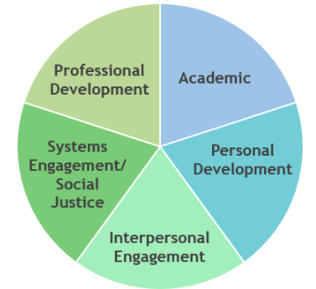
Figure 2: Academic skill development reflection
(Source: Kirk, 2017)
Before enrolling myself in the module, I was aware of the benefits of academic writing. However, after being a part of the module I came to know ways, I can improve my academic skills to produce high-quality academic writing. I have been in a position to produce better academic work by using sources and proofreading tools that have significantly strengthened my writing. The module also taught me to never forget the importance of planning and structure. Ekelin et al. (2021) evaluated that writing anything for strictly academic purposes can involve the use of a lot of significant information that is tied up with my personal opinions and the opinion of other scholars either dismissing or strengthening my views. A good Academic piece does not include more information. On the contrary, academic writing which has a reflection of a well-structured and well-planned information inclusion can seek to achieve better success in imparting knowledge to the targeted readers. As a result, I focused more on remembering the needs and requirements of my readers and developing a work that gets my ideas straight to the readers rather than telling them what they already know regarding the topic (Hussein, 2018).

3. Paraphrasing
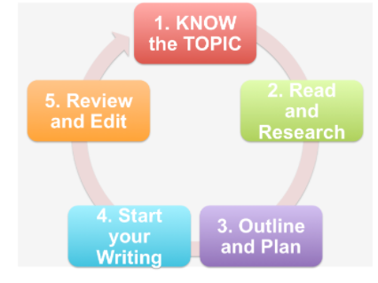
Figure 3: Paraphrasing steps
(Source: Lindenman et al. 2018)
As an academic writer and researcher, paraphrasing has been the most important skill at the disposal of the students that allows them to know the source well enough so that they can write in their own words. It is essential to develop paraphrasing skills and capabilities so that both you and your reader are in a position to understand the resource and disseminate the information to other researchers without falling prey to plagiarism. Ibrahima, Khalfb and Khalilc (2020) stated that paraphrasing has been the most effective way allowing me to condense, restate and clarify the ideas of other authors that provides greater credibility to my analysis or argument. Lindenman et al. (2018) evaluated that with the help of paraphrasing, I have been able to either propose an argument in favour or against my claims making my academic writing stronger and relevant. Paraphrasing has often resulted in Plagiarism contributing to a lack of academic integrity (Kirk, 2017).
The module has not only evaluated the importance of paraphrasing and contributed to my knowledge regarding its benefits but also helped me to achieve greater paraphrasing skills so that I maintain my academic integrity. It has helped me identify a process that can be used to paraphrase academic writing. Whenever I start with my work, I focus on reading the source carefully nearly 3 to 4 times and identify the keywords and main points associated with the work. I then rewrite the source in my own words and use my writing style to accurately reflect on the original text. This way I am not only familiarising myself with the original resource but also contributing to knowledge creation and focusing on enriching the available literature on the given topic.

4. Reflection
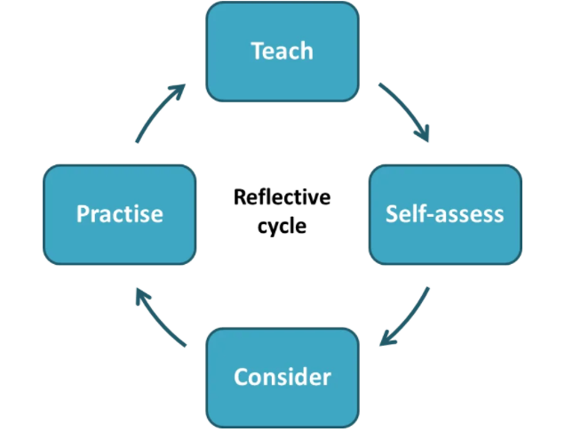
Figure 4: Reflective cycle
(Source: Kirk, 2017)
Reflection is the final perhaps one of the most important skills that can help in developing communication and interpersonal capabilities among the students. I have been using reflective writing skills to better understand a particular topic that I am studying. Back when I was in school and college, I used reflective writing to help me review my progress at the educational institution. I also enrolled myself in various courses that specifically used reflective writing as a part of the assignment course that I got myself enrolled upon (Markkanen et al. 2020).
Reflecting writing is perhaps the most important skill that is propagated by the module. The module has effectively identified the purpose of reflection and provided me with certain tips that I can use as an academic researcher to critically analyse a thought process and develop a clear line of argument. This also allows me to use evidence in a manner that can enrich my work.

Implementation of Gibbs model in individual topics
Gibbs model of reflection has allowed me to reflect upon my time management skills and capabilities in a much how several structured manners. I need to maintain my time management skills so that I can achieve the necessary standard of practice that is expected out of me from my educational institution. During my first and second weeks of placement within the institution, I faced several difficulties with time management. One of the primary reasons I found it difficult to manage time was because there were too many tasks given to me that needed to be performed within a small period. I was overwhelmed with the number of tasks that I needed to complete in such a small time. Okamoto et al. (2017) opined that with experience and constant repetition of the tasks, I was able to become much more efficient and effective in my workplace environment. Completing certain tasks within the time provided contributed to my confidence level. With the help of Gibbs reflective cycle, I concluded that five important themes are associated with effective time management. These are planning, analysis, support, flexibility and fulfilment of the tasks. In the planning phase, I specifically described the experience and evaluated my manners and feelings about the struggles I faced to manage my time and complete the task within the time provided. In the analysis phase, I evaluated the experience and analysed it to make sense of the situation (Ono and Ichii, 2019).
I again followed the six steps identified in the Gibbs reflective model to evaluate the academic writing skills that I have gathered. I concluded that it is not sufficient to have the experience to learn. Shannahan, Gilliland and Kwon (2020) noted that without a proper reflection on the experience, the learning can quickly be forgotten. Planning and structure were the major takeaway from the module about academic writing. The module allowed me to effectively evaluate the importance of planning and structuring the content of the study so that it remains relevant to the needs and requirements of the leaders. In my experience, planning and structuring all the information about the topic of research has allowed me to include only information that is enriching enough to Significantly contribute to the body of research (Shube and Moloi, 2019). In the third step, I evaluated the negative and positive aspects of the experience. Planning and structuring undoubtedly allowed me to use only that significant information that is associated with my personal opinions and views. I was able to include only the information that has a better chance of imparting knowledge to the targeted readers. However, one of the negative aspects of the experience was that it was a highly time and resource-consuming process. Fulfilling all the needs and requirements of the targeted readers took a toll on the time management aspect of my study (Tawanwongsri and Phenwan, 2019). However, I was able to overcome these challenges with the help of previous experiences in carrying out research work. I constantly consulted with my seniors to overcome these issues and adopt a much more planned and structured manner of approaching academic writing. Finally, from the experience, I learned that academic writing requires a lot of patience and time to master. It is not a one-day process. My focus has been on building specific skills and knowledge that can help improve academic writing. I also enrolled myself in various training sessions that helped me to learn new ideas about academic skill development from people who have already mastered the science.
Ullmann (2019) evaluated that paraphrasing has been perhaps the most important skill that I focused on developing when I enrolled myself in the module. The game is reflective cycle has helped me to identify my current state of paraphrasing skills and the advances that I need to make to make my piece of work much more condensed and clarified about the ideas proposed by other authors. There were a lot of instances when my work was facing plagiarism issues. This was perhaps the most negative experience that I had. I was not believing that I wrote something which has plagiarism issues. As a result, I reflected on the factors that contributed to plagiarism. One of the most important reasons for plagiarism was my inability to understand the text and rewrite the same in my words. I was focusing too much on Developing my English language skills rather than identifying the core context of the research. The Gibbs model allowed me to develop an action plan so that I can overcome these challenges.
Using the Gibbs model of reflection, I have been developing my reflective writing skills by reflecting on the past experiences that are associated with learning. Van Der Loo, Krahmer and Van Amelsvoort (2019) influenced me to focus on developing particular ideas and concepts that suited my needs and requirements. There is not a correct structure for developing a reflective society. However, I do not spend much time describing or analysing. My focus is to develop an action plan that can help me overcome the challenges that I faced while developing a reflection-oriented skill. Reflection involves thinking about the past. Yaacob and Asraf, (2021) stated that its primary purpose is to see what is learned from the experience and how these new insights can shape my future experiences. The gives reflective model has cleverly Described the experiences associated with reflection and evaluated the negative and positive aspects associated with it. In the fourth stage, a proper analysis of these negative and positive experiences allowed me to take account of the factors that have contributed to the pleasantness of all the distress associated with these experiences. I focused on whatever I learnt and then created an action plan that helped me develop my skills and knowledge associated with reflection.

Conclusion
In recent years, academic research has gained enormous prominence due to its capabilities of adding value to the personal growth and development of students. This assignment also aims to enable students to gain competence and confidence in developing a range of employability skills that can use time management, reflection, academic writing and paraphrasing as some of the most important tools to employ effective presentation and learning capabilities in the workplace.

References
Adeani, I.S., Febriani, R.B. and Syafryadin, S., 2020. USING GIBBS’REFLECTIVE CYCLE IN MAKING REFLECTIONS OF LITERARY ANALYSIS. Indonesian EFL Journal, 6(2), pp.139-148.
Bickford, C., 2020. Digitalization and the Writing Classroom: A Reflection on Classroom Practices. Journal of Academic Writing, 10(1), pp.146-153.
Cahusac de Caux, B.K.C.D., Lam, C.K.C., Lau, R., Hoang, C.H. and Pretorius, L., 2017. Reflection for learning in doctoral training: Writing groups, academic writing proficiency and reflective practice. Reflective Practice, 18(4), pp.463-473.
Chung, H.Q., Chen, V. and Olson, C.B., 2021. The impact of self-assessment, planning and goal setting, and reflection before and after revision on student self-efficacy and writing performance. Reading and Writing, pp.1-29.
Dressler, R., Becker, S., Kawalilak, C. and Arthur, N., 2018. The cross-cultural reflective model for post-sojourn debriefing. Reflective Practice, 19(4), pp.490-504.
Ekelin, M., Kvist, L.J., Thies-Lagergren, L. and Persson, E.K., 2021. Clinical supervisors’ experiences of midwifery students’ reflective writing: a process for mutual professional growth. Reflective Practice, 22(1), pp.101-114.
Hussein, H., 2018. Examining the Effects of Reflective Journals on Students' Growth Mindset: A Case Study of Tertiary Level EFL Students in the United Arab Emirates. IAFOR Journal of Education, 6(2), pp.33-50.
Ibrahima, M.K., Khalfb, A.A. and Khalilc, Z.M., The Effectiveness of the Use of the Gibbs Meditative Model in Academic Achievement and the Development of Visual Thinking in Fourth Students in Biology.
Kirk, S., 2017. Waves of reflection: Seeing knowledge (s) in academic writing. In EAP in a Rapidly Changing Landscape: Issues, Challenges and Solutions-Proceedings of the 2015 Baleap Conference. Reading: Garnet Education.
Lindenman, H., Camper, M., Jacoby, L.D. and Enoch, J., 2018. Revision and reflection: A study of (dis) connections between Writing knowledge and writing practice. College Composition and Communication, 69(4), pp.581-611.
Markkanen, P., Välimäki, M., Anttila, M. and Kuuskorpi, M., 2020. A reflective cycle: Understanding challenging situations in a school setting. Educational Research, 62(1), pp.46-62.
Okamoto, R., Koide, K., Maura, Y. and Tanaka, M., 2017. Realities of Reflective Practice Skill among Public Health Nurses in Japan and Related Learning and Lifestyle Factors. Open Journal of Nursing, 7(5), pp.513-523.
Ono, A. and Ichii, R., 2019. Business students’ reflection on reflective writing assessments. Journal of International Education in Business.
Sekarwinahyu, M., Rustaman, N.Y., Widodo, A. and Riandi, R., 2019, February. Development of problem based learning for online tutorial program in plant development using Gibbs’ reflective cycle and e-portfolio to enhance reflective thinking skills. In Journal of Physics: Conference Series (Vol. 1157, No. 2, p. 022099). IOP Publishing.
Shannahan, J., Gilliland, B. and Kwon, C., 2020. Dialogue journals for critical reflection on community issues and academic writing. In Effects of Service-Learning in Foreign and Second Language Courses (pp. 88-108). Routledge.
Shube, I.M. and Moloi, K.C., 2019. ICSS-2019-028 CONTINUOUS REFLECTION AMONG CONSULTANTS AT THE WRITING CENTRE OF A UNIVERSITY OF TECHNOLOGY IN SOUTH AFRICA. cÜxytvx, p.82.
Tawanwongsri, W. and Phenwan, T., 2019. Reflective and feedback performances on Thai medical students’ patient history-taking skills. BMC medical education, 19(1), pp.1-8.
Ullmann, T.D., 2019. Automated analysis of reflection in writing: Validating machine learning approaches. International Journal of Artificial Intelligence in Education, 29(2), pp.217-257.
Van Der Loo, J., Krahmer, E. and Van Amelsvoort, M., 2019, March. Reflection in Learning to Write an Academic Text. How does reflection affect observational learning and learning-by-doing in a research synthesis task?. In Frontiers in Education (Vol. 4, p. 19). Frontiers.
Yaacob, A. and Asraf, M., 2021. Empowering Learners' Reflective Thinking through Collaborative Reflective Learning. International Journal of Instruction, 14(1), pp.709-726.

