Seamless hospital discharge using a strategy to achieve a digital solution.

- Introduction

  - Strategy aims and rationale
The Parliamentary Review of Health and Social Care in Wales (2018) highlighted that health and social care should be:
Organised around the individual and their family as close to home as possible, be preventative with easy access and of high quality, in part enabled via digital technology, delivering what users and the wider public say what really matters to them, care and support should be seamless, without artificial barriers between physical and mental health, primary and secondary care, or health and social care.
(The Parliamentary Review of Health and Social Care in Wales, 2018).
‘A healthier Wales: long term plan for health and social care’ was developed by the Welsh Government in response to the Parliamentary Review, which set out the future vision for a 'whole system approach to health and social care through prevention, health improvement and equality based on person-centred planning and delivery of care for the whole person – in other words, a seamless service’ (Welsh Government, 2021).
Seamless is defined as smooth and continuous, with no apparent gaps or spaces between one part and the next (Stevenson, 2015). In health information technology, seamless care "addresses what is required to remove the discontinuities that might exist between sites of care, levels of care, the focus of care, direct patient care and any other activities related to care" (Hammond, 2010).
Seamless health and social care would see a whole system approach with health and social care working seamlessly together to deliver a single care and support package, even if the person is receiving support from several different providers. Seamless service would result in people being supported both before and after a hospital stay with access to community-based resources, thus reducing their hospital stay. It would also result in a smoother transition from the hospital back into the community (Welsh Government, 2021).
A seamless service would also mean a better continuity of care across health and social care. The definition of continuity of care is about the quality of care over a period of time. From a patient perspective, it is about their experience of a 'continuous caring relationship' with professionals from health and social care. From a service provider perspective, it is the "delivery of a 'seamless service' through integration, coordination and sharing information between different providers" (Gulliford, Naithani, & Morgan, 2006).
According to The Health Foundation (2016), if NHS Wales does nothing to reduce the pressure or improve efficiency, its spending will continue to rise by 3.2% a year to keep up with the current demand. This would see the spending increasing to £10.4bn by 2030/31 from £6.5bn in 2015/16. The sustainability of the NHS is intertwined with the sustainability of other public services, particularly social care. It is projected that the spending on social care will increase faster than on the NHS, increasing by 4.1% per year. As funding for public services is unlikely to increase at the same rate, there is an increased risk that the need for care services in Wales will not be met.
  - Service improvement
A study was carried out on older people and their carer's experiences of support with medication on discharge home from the hospital. The finding from this study is that there was scope for improved communication and the development of effective partnership between the hospital, carers and primary care professionals in managing the medicines interface between hospital and primary care (Knight et al. 2011).
For the policy goal of seamless care to be realised, service improvements need to include the integration, coordination and sharing of information between the hospital, community pharmacy and home care provider, including joint working arrangements between all providers. A much quicker discharge from the hospital back into the community, plus improved information and communication flow between the hospital, community pharmacy and home care services are required. The patient will not be expecting to wait to be discharged whilst the hospital pharmacy is dispensing their medication and can be discharged into the community with their medication ready for collection by the home carer.
A platform would be required to enable patient records to be viewed and communicated between separate patient record systems used by hospitals, community pharmacies and home care providers. This service improvement needs to include removing the need for duplicating information and enabling information about the person's care and support to be shared across multiple agencies: the hospital, community pharmacy and home care provider. This will require training and equipping the hospital, community pharmacy and home care provider with a digital technological solution to provide a seamless hospital discharge into the community, for the person receiving the care.
This paper focuses on health and social care services provided for those aged 65 and over living in the Monmouthshire area who have been discharged from hospital back into the community needing long term support, including medication support from the local authority home care provider.
- Methods

  - Technological requirements
The service improvements that the seamless care policy goal would realise across health and social care were analysed to derive the digital technology requirements by describing the functional and non-functional requirements. The functional requirement is a list of statements of what the system is expected to do, how it should respond to input, and how it is expected to behave in different situations. The non-functional requirement defines the system's attributes, such as security, performance, reliability, and clinical safety. These are known as the constraints on service provided by the system, and constraints could be linked to timing, development processes or imposed by standards (Sommerville, 2016).
To achieve seamless care, patient records will need to be shared across health and social care. In the Informing Healthcare (2003), it was highlighted that health and social care settings did not have access to the 'whole records', which hindered patient outcomes and created a barrier to integrating health and social care (Welsh Government, 2003). The Welsh Government published the Informed health and care: a digital health and care strategy for Wales, acknowledging that health and social care has still not achieved its goal of a single patient record. It outlines its ambitions involving the use of portals to gather information from multiple systems across health and social care (Welsh Government, 2015).
Welsh Community Care Information System (WCCIS) is a platform that enables sharing of information between health and social care through a single system. It is intended to support the coordination of patient care through a single shared record for the front line, community nurses, mental health workers and therapists (Wales Audit Office, 2018).
  - Gap analysis methodology
A gap analysis was carried out on the current technical capabilities across the hospital, community pharmacy and home care provider in Monmouthshire and what technical capabilities are required to achieve the future state. To support both the gap analysis and options appraisal, the informatics systems in NHS Wales (Wales Audit Office, 2018) and WCCIS Strategic Review (Digital Health and Care Wales, 2022) were reviewed to assess where the hospital, community pharmacy and homecare provider were in meeting the Welsh Government’s ambition of using portals to gather information from multiple systems.
  - Options appraisal methodology
An options appraisal was carried out using a five-phase approach outlined in the options appraisal workbook (Local Partnership, 2012). There were a number of critical steps for each of the phases, and due to scope and timescale, a complete detailed options appraisal was not carried out (Table 1). An options appraisal was carried out to determine whether to build or buy the additional technical requirements. A full options appraisal is summarised in the result section of this report.
Table 1- Options Appraisal
Phase 1
- Identify the different delivery options available.
To deliver the key digital technical requirements, there are two delivery options that are available that would need to be appraised:
- To build digital technology using in-house software developers across health and social care IT departments
- To buy digital technology from software suppliers
Phase 2
- Develop the appraisal criteria.
- Options appraisal (in the results section of the report).
Appraisal criteria:
The Technology Code of Practice guidance (2021) was used to identify a set of criteria as part of appraising whether to build or buy the additional technical requirements (Government Digital Services, 2021). The guidance provides a list of criteria, and only those relevant to the project scope below were selected:
      - Open source: does the selected option provide an open source technology whereby code can be downloaded, used, and changed by anyone?
      - Open standards: does the selected option provide open standards to ensure technology works and communicates with other technology systems?
      - Cloud technology: does the selected option provide cloud computing where data can be stored over the internet?
      - Security: does the selected option meet the health and social care providers’ security requirements?
      - Privacy: does the selected option meet the legal requirements outlined in the general data protection regulation (GDPR)?
Other considerations:
  - Do in-house software developers have the skills and capability to build the technical requirements?
  - What are the timescales?
  - What is the cost to build and buy the technical requirements?

The information for this paper, including the gap analysis and options appraisal, was gathered through observations across health and social care, interviews with system users and literature reviews.
- Results

  - Key technical requirements
This section provides an overview of the digital technology requirements to support service improvement.
    - Functional requirements
Below is a list of functional requirements to support seamless hospital discharge to the community.
- The hospital system shall alert the home care provider of the planned discharge date.
- The home care provider shall have the ability to search for the hospital system for the planned discharge date.
- On discharge, the hospital system shall send summary notes to the home care provider's system.
- The home care provider shall be able to view hospital discharge summary notes on the home care system.
- A home carer shall be able to view hospital discharge summary notes as part of their home visit notes on their mobile application.
- On discharge from hospital, clinicians shall have the ability to send medication prescription requests from the hospital patient record system to the community pharmacy patient record system.
- On discharge, the hospital patient record system shall send medication information to the home care provider patient record system.
- The community pharmacy patient record system will alert the home care provider when medication is ready for collection.
- The community pharmacy patient record system shall automatically generate an electronic medication administration record detailing medication, route type, frequency, and dosage for home carers to complete.
- A platform shall enable hospitals, home care providers and pharmacies to read and update integrated care and support plans.
- A home carer shall be able to view the integrated care and support plan on their mobile application.
    - Non-functional requirements

- Performance
  - The system should have the capability to enable multiple users to access the system simultaneously.
  - The system shall be available to users 24 hours and seven days a week.
- Security
  - A single sign-on (SSO) shall allow users to access multiple applications.
  - Authorised users only should access the system, and the system should lock after three attempts if an incorrect username or password is entered.
  - The system must comply with General Data Protection Regulation (GDPR) and health and social care's information governance and security requirements.
- Reliability
  - Unexpected system downtime should be minimal and must not impact patient safety.
  - Off-line access to the system should be available during system failure and power outages.
  - All system activities must be backed up periodically.
  - All system downtime should be scheduled, and critical repair should be no more than 8 hours.
  - A system-level agreement needs to outline the process for reporting system failures and expected downtime and response times.
- Clinical safety
  - The user should be familiar with using the system after two hours of training on using the system.
  - Following training, the user should not exceed several system errors per hour of system use.
  - The system should provide a clear audit trail of system activities.
  - The system must ensure that the system makes zero medication errors.

    - Data analysis and collection
The system must collect the following data:
- Response time for processing and dispensing medication.
- Audit trail of system activities by the user.
- Number of downtime occurrences.
- Response time to fix technical issues.
- Data on the number of providers accessing and contributing to care and support plans.
- The number of errors and alerts if the user exceeds a certain number of errors per hour.
    - Knowledge Management
As patients transition between health providers, medication errors are common due to discrepancies and miscommunication (Wheeler et al., 2018). A study showed that at least 25% - 80% of patients had at least one medication discrepancy or failure to communicate in-hospital medication changes at discharge (Lehnbom et al., 2014).
    - Technical standards
The information will need to be exchanged and communicated across health and social care patient record systems. The system needs to be interoperable, using the patient's NHS number as a unique identifier. The information within the system must be standardised using either Health Level 7 (HL7) or Fast Healthcare Interoperability Resources (FHIR).
  - Gap analysis

    - Current state
The Welsh Clinical Portal (WCP) has gone live in every health board in Wales; however, not all wards within the health board are using the WCP. WCCIS supports exchanging information between primary and secondary care are either entirely in place or partially in place. There is no electronic prescribing system in place. Not all informatics systems within NHS Wales can communicate with each other or other systems (Wales Audit Office, 2018).
In Monmouthshire, the hospital uses WCP, and home care providers use Access People Planner and Access Care Planning. These systems do not communicate with each other or with the community pharmacy patient record system. This paper focuses on the Gwent area, where Aneurin Bevan University Health Board (ABUHB) are in the process of deploying WCCIS and Monmouthshire Local Authority are not planning to move to WCCIS. Figure 2 shows WCCIS live in 17 of 29 areas of Wales; 4 are moving on or working towards deployment, and eight areas with no expressed plans to move to WCCIS (Digital Health Care and Wales, 2022).
A patient has separate care and support plans from each provider, not shared electronically. The hospital discharge summary notes are electronically sent to the General Practitioner system but not to the home care provider. There is no electronic prescribing and dispensing medication system between hospitals and pharmacies. The Access People Planner already interfaces with the Access Care Planning mobile app, which home carers use to access information about their home care visits.

Figure 2 – system status and plans (Digital Health Care and Wales, 2022).
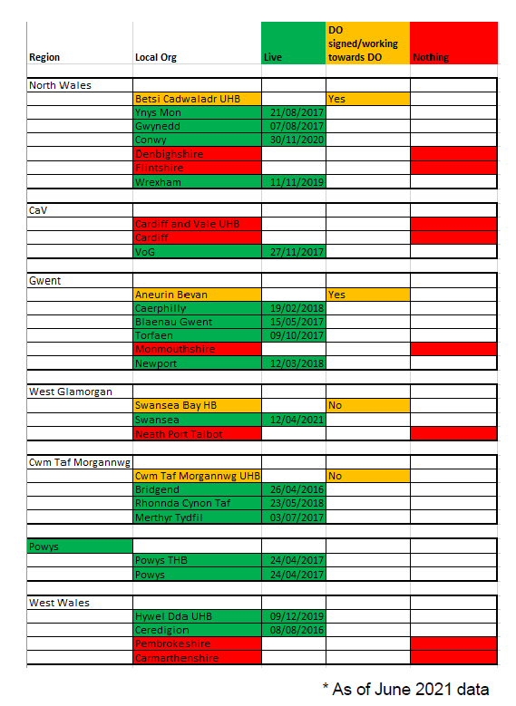
    - Future state
To achieve seamless discharge from the hospital back into the community, a platform is needed to enable the hospital and home care provider to create and access a single care and support plan and share hospital discharge summary notes, including planned discharge dates and information about medication. An electronic prescribing and dispensing system is required by the hospital and community pharmacy, which must also integrate with the home care provider system to generate medication administration records and enable care workers to record that they have administered or prompted medication electronically.
  - Options appraisal
Phase 2
Options appraisal.
Option 1 – to ‘build’ digital technical requirements.
Building the technical requirement means complete control of code and development schedule (Shahzad, 2017). To build a platform that integrates the information between the hospital, home care provider, and community pharmacy, all the patient record systems will need to be open source to enable both open and closed source software to work together. The system must also be an open standard for systems to be compatible and interoperable (Government Digital Services, 2021).

The downside of building the technical requirement is that this will require constant user engagement; the system could come with a lower functionality than one purchased off the shelf and be more challenging to update as it will require complete iteration of development. The software building could be expensive in terms of time, cost, and human resources (Shahzad, 2017).

Wilson stated that building technical requirements should be considered if trying to solve a unique problem, and there is a development team within the organisation (Wilson, 2020). The problem that being solved is not unique to the organisation. There are platforms and electronic medication systems readily available to integrate the patient record systems.

Building the technical requirements will require in-house software developers across health and social care with the skills and capabilities. As separate IT departments manage the patient record systems, this will require collaborative working.

Option 2 – to ‘buy’ digital technical requirements.
Buying technical requirements means seeking a technology that is a ready-made solution with enhanced functionality (Shahzad, 2017). To buy the technical requirements would require a platform to be purchased that can access all the patient record systems across the hospital, home care provider and community pharmacy and integrate the data. Purchasing the digital technology requirement will still require all technologies to be open source and open standard.

The downside of buying the technical requirements is that the vendor determines the system's functionality and controls the code. Users will need to rely on vendors for support with technological issues and updates (Shahzad, 2017).

Wilson argued that buying technical requirements from a vendor should be considered when the use of the software is critical; the problem is common, the software is used organisation-wide and there is a gap in the software development department (Wilson, 2020).

Option 3 – to ‘do nothing’.
If it is decided to do nothing, the seamless hospital discharge strategy would not be achieved, and the quality of care for people receiving support would not improve.

- Discussion

  - Strategy implementation
To successfully deliver the seamless hospital discharge strategy, it will require health and social care providers (including the hospital ward, community pharmacies and the home care provider) to work through the following topics together to ensure alignment:
- Consider how the strategy aligns with their priorities, vision, and principles.
- Consider and prioritise what areas of the business require investment to deliver this strategy. This could include upskilling the workforce with informatics skills.
- Consider how the patient experience will change due to introducing this strategy and whether they are required to access mobile applications or websites to access information.
- Agree on interoperability priorities. The providers need to agree on which data flow needs to focus on first, what tools and capabilities are available within their existing system, and what needs to be done to achieve interoperability between each system.
- Consider how to deliver a single patient record system. This strategy aims to integrate care and support records to move toward a 'whole system approach and seamless care delivery’.
- Consider information governance and data security requirements across all providers.
- Agree on a procurement framework. The providers need to agree on which procurement framework to use.
The strategy will be delivered by adopting some of the core characteristics of an excellent digital strategy outlined in the building a digital strategy report (NHS Providers and Public Digital, 2021). For this strategy to be delivered, it will need to be integral to the health and social care providers' strategies. The strategy will need to be integral to the Welsh Government's ambition of achieving a single electronic patient record system (Welsh Government, 2015) and for health and social care to work seamlessly together (Welsh Government, 2021). The strategy will also need to be integral to the NHS Wales core principles of putting patients first through co-production and improving care through effective use of resources (NHS Wales, 2016), as well as the pharmacy vision of delivering care within the local community by integrating with other services to improve patient knowledge through co-production (Welsh Pharmaceutical Committee, 2019). The home care provider advocates the Well-Being Future Generation Act principles of taking an integrated approach and working collaboratively with others.
The strategy will need to address the essential needs of patients and staff across health and social care. A user-centred approach will be taken to implement the strategy by engaging with patients and all health and social care providers using health information technology (HIT). One of the learnings from the Wachter report is that the failure to develop a single integrated patient record system in NHS England as part of the National Programme for Information Technology (NPfIT) was due to a lack of engagement with clinicians and those using HIT. A top-down approach to implementation was used to design and implement, and NHS leaders did not have organisational clout or budgetary authority (Watcher, 2016).
In implementing this strategy, a 'middle-out' approach will be used that is neither top-down (benefits leaders or managers) nor 'bottom-up (benefits patients or those using the HIT) (Coiera, 2004). A 'middle out' approach will be used by getting into the core of the real experience of patients, clinicians, and care providers. As part of implementing this strategy, engagement with mainstream users and those with specific and unique needs is required, for example, an IT department. As well as engaging with users as part of implementing this strategy, it is essential to build trust with users, as we have learnt from the Watcher report where staff experienced being let down with HIT implementations.
As part of implementing this strategy, the health and social care providers will need to agree on which procurement framework to use to purchase the technical requirements. A framework is an agreement between the government and suppliers and provides a faster and cheaper way of buying a service rather than going into an individual procurement contract. The Digital Marketplace provides a framework known as Government Cloud (G-Cloud) that enables the government to buy cloud services. There are 31,000 cloud services on this framework (Government Digital Services, 2019).
  - Strategy evaluation
The strategy will be evaluated using the modified Donabedian causal chain (figure 3). The policy intervention would be the strategy of seamless discharge, and this intervention's effect would be achieved by implementing the digital technical requirements discussed in this paper as intervening variables. The intervening variables, once introduced, are expected to affect the generic processes (policy adopted by the organisation), targeted processes (processes could be training, the introduction of HIT that improves the clinical processes (treatments) and outcomes (Lilford et al., 2010).
Figure 3 – Modified Donabedian Casual chain (Lilford et al., 2010).
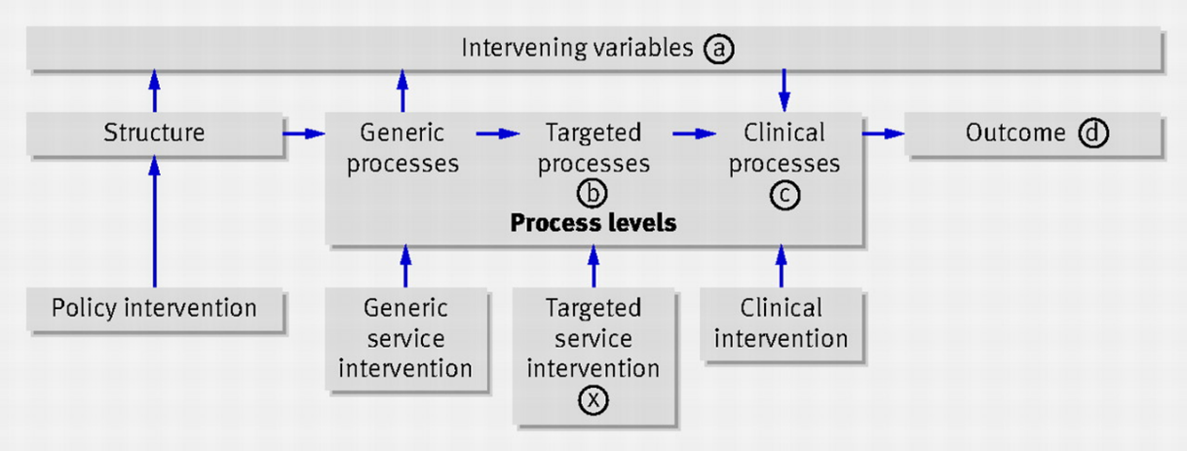

References:
Coiera, E. (2004). ‘Four rules for the reinvention of health care’, BMJ 2004, 238(77449), pp. 1197 – 1199. Doi: https://doi.org/10.1136/bmj.328.7449.1197
Digital Health and Care Wales (2022) WCCIS Strategic Review. Unpublished.
Government Digital Service (2021) The Technology Code of Practice. Available at: https://www.gov.uk/guidance/the-technology-code-of-practice (Accessed: 12 May 2022).
Government Digital Services (2019) G-Cloud buyers’ guide. Available at: https://www.gov.uk/guidance/g-cloud-buyers-guide#buying-services-through-the-g-cloud-framework (Accessed: 14 May 2022).
Gulliford, M., Naithani, S. & Morgan, M. (2006) 'What is "continuity of care"?' Journal of Health Services Research & Policy, 11(4), pp. 248–250. DOI: 10.1258/135581906778476490.
Hammond, W.E., 2010, May. Seamless Care: What is it; what is its value. In Seamless Care, Safe Care: The Challenges of Interoperability and Patient Safety in Health Care: Proceedings of the EFMI Special Topic Conference, June 2-4, 2010, Reykjavik, Iceland (Vol. 155, p. 3). IOS Press.
Knight, D.A. et al. (2011) ‘‘Seamless care? Just a list would have helped!’ Older people and their carer’s experiences of support with medication on discharge home from hospital' Health Expectations, 16(3), pp. 277 – 291. DOI: 10.1111/j.1369-7625.2011.00714.
Lehnbom, E. C. et al. (2014) ‘Impact of Medication Reconciliation and Review on Clinical Outcomes’, Annals of Pharmacotherapy, 48(10), pp. 1298–1312. DOI: 10.1177/1060028014543485.
Lilford, R. et al., (2010). Evaluating policy and service interventions: a framework to guide selection and interpretation of study endpoints. BMJ 341:c4413. Available from https://doi.org/10.1136/bmj.c4413
Local Partnerships (2012). Options Appraisal Workbook. Available at: https://www.local.gov.uk/sites/default/files/documents/pas-options-appraisal-wor-7f5.pdf (Accessed: 04 April 2022).
NHS Providers and Public Digital (2021). Building a Digital Strategy. Available at: https://nhsproviders.org/media/691167/building-a-digital-strategy-1i.pdf (Accessed: 05 May 2022).
NHS Wales. Core Principles. Available at: http://www.wales.nhs.uk/documents/NHS_Core%20Principles_leaflet.pdf (Accessed: 05 May 2022).
Shahzad, B. et al., (2017). Build Software or Buy: A Study on Developing Large Scale Software. IEEE Access, vol. 5, pp. 24262-24274. DOI: 10.1109/ACCESS.2017.2762729.

Sommerville, I. (2016) Software Engineering. 10th edn. Pearson Education.

Stevenson, A (2015) Oxford Dictionary of English. Available at: https://www.oxfordreference.com/view/10.1093/acref/9780199571123.001.0001/m_en_gb0746500 (Accessed: 6 May 2022).
The Health Foundation (2016) The path to sustainability. Funding projections for the NHS in Wales to 2019/20 and 2030/31. Available at: https://www.health.org.uk/publications/reports/the-path-to-sustainability (Accessed: 30 April 2022).
The Parliamentary Review of Health and Social Care in Wales. (2018) A Revolution from Within: Transforming Health and Care in Wales. Available at: https://gov.wales/sites/default/files/publications/2018-01/Review-health-social-care-report-final.pdf (Accessed: 4 April 2022).
Wachter, R. (2016). Making IT work: Harnessing the Power of Health Information Technology to Improve Care in England. London, Department of Health and Social Care. Available at: https://www.gov.uk/government/publications/using-information-technology-to-improve-the-nhs/making-it-work-harnessing-the-power-of-health-information-technology-to-improve-care-in-england. (Accessed: 01 April 2022).
Wales Audit Office (2018) Informatics systems in NHS Wales. Available at: https://senedd.assembly.wales/documents/s73101/PAC5-08-18%20P3%20-%20AGW%20Report%20%20Informatics%20Systems%20in%20NHS%20Wales.pdf (Accessed: 29 April 2022).
Welsh Government (2021) A Healthier Wales: our plan for health and social care. Available at: https://gov.wales/sites/default/files/publications/2021-09/a-healthier-wales-our-plan-for-health-and-social-care.pdf (Accessed: 04 April 2022).
Welsh Government (2015) Informed Health and Care. A Digital Health and Social Care Strategy for Wales. Available at: https://gov.wales/sites/default/files/publications/2019-03/informed-health-and-care-a-digital-health-and-social-care-strategy-for-wales.pdf (Accessed: 29 April 2022).
Welsh Government (2003) Informing Healthcare: Transforming healthcare using information and IT. Available at: http://www.wales.nhs.uk/documents/A5_English.pdf (Accessed: 29 April 2022).
Welsh Pharmaceutical Committee (2019) Pharmacy: Delivering a Healthier Wales. Available at: https://www.rpharms.com/Portals/0/RPS%20document%20library/Open%20access/Policy/Pharmacy%20Vision%20English.pdf?ver=2019-05-21-152234-477
(Accessed: 05 May 2022).
Wheeler, Amanda J et al. (2018). Reducing medication errors at transitions of care is everyone's business. Australian prescriber vol. 41,3: 73-77. doi:10.18773/austprescr.2018.021
Wilson, A. (2020). Build vs. Buy: Should you buy software or develop it internally? Available at: https://blog.kainexus.com/continuous-improvement-software/build-vs-buy/should-you-buy-software-or-develop-it-internally (Accessed: 12 May 2022).

