Cerys Versey 2217178Learning in a digital Era - Workshop skills
University of Wales Trinity Saint David
Non-Inverting amplifier circuit

Logbook
Non - Inverting op amp

Components list
3 x 1uf capacitors
2x 10 k resistors
1 x 20k resistor
1 x 741 op amp

Gain for a non-inverting op amp
G = 1 + rf/r1

Building the circuit in a simulated environment proteus

Method
I started off by building the circuit in Proteus and adding a sine wave as an input. To do this I placed all the components onto the board and then arranged them, and then finally connected the wires together I did this to make sure that the final circuit design would be organized and neat.
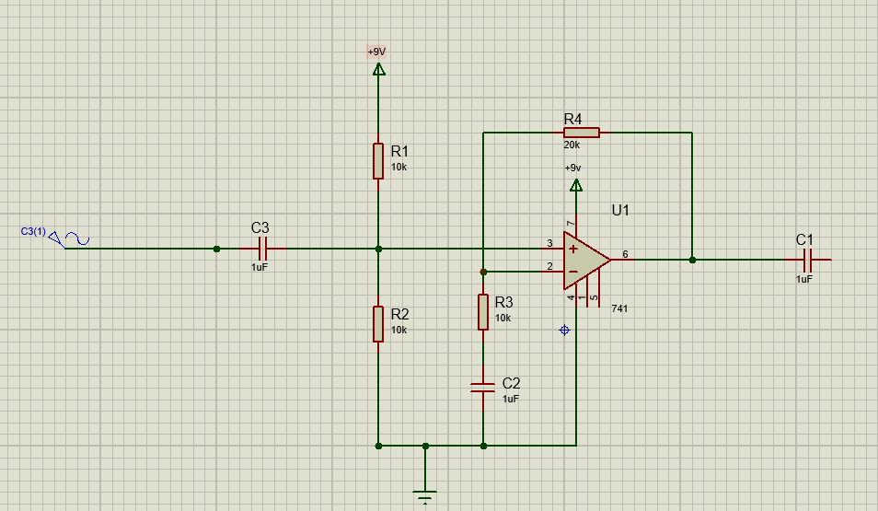

Then I went on to add an oscilloscope in to make sure the circuit was working as expected in response to the sinusoidal input.

As can be seen from the image below the output produced was a non-inverting signal.

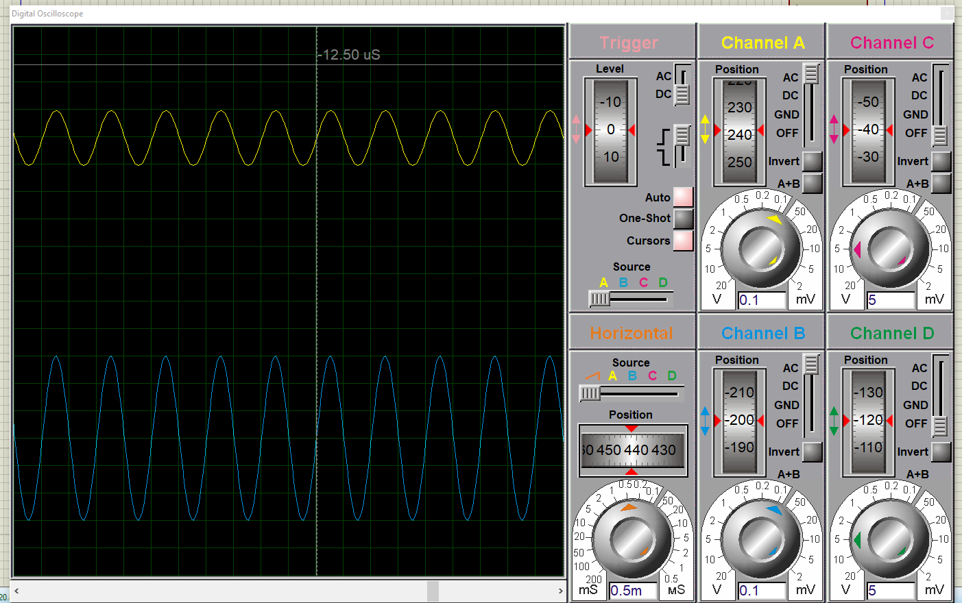

I then worked out the gain using the non-inverting gain formula to compare the value that was being shown on the oscilloscope verses the calculated value.

G = 1 + rf/r1

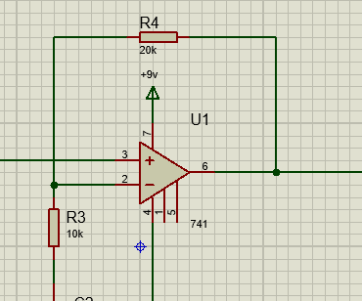
R1
Rf
This meant the calculated circuit gain was 3.

G = 1 + (2/1) = 3

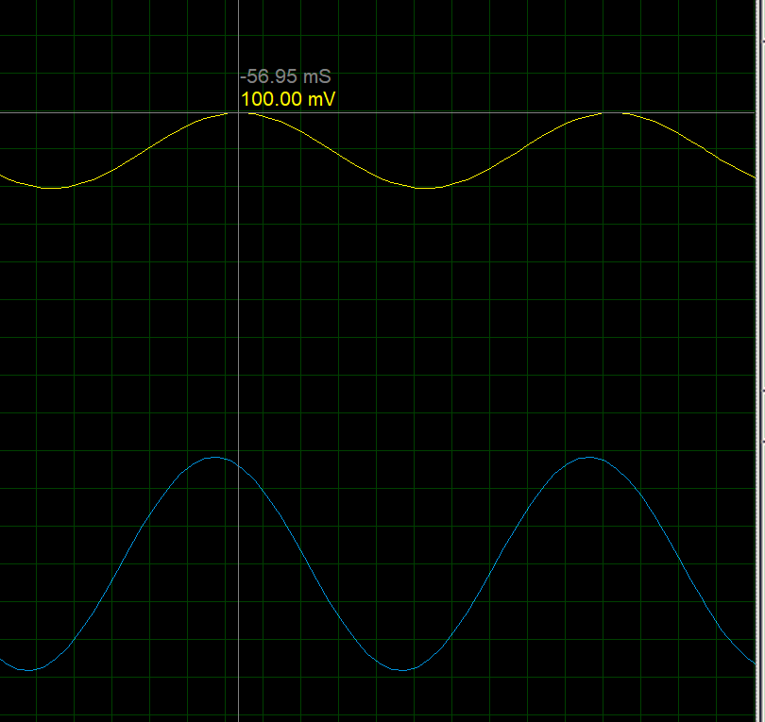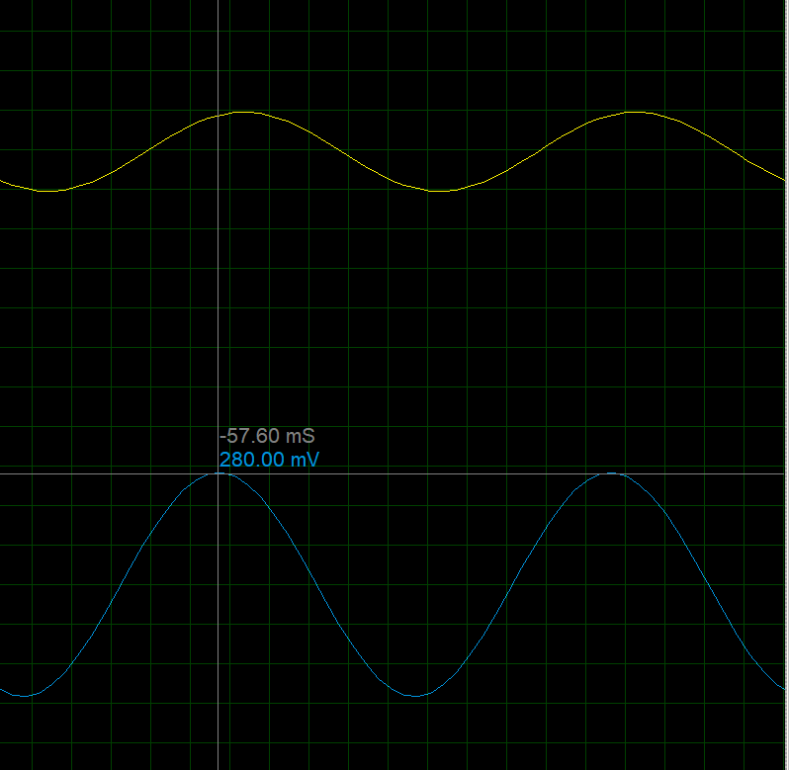

An example of a piece of data collected for the gain, G = Vout / Vin = 280x10^-3 / 100x10^-3 = 14/5 = 2.8

The calculated gain is slightly different to the gain on the simulation of the circuit but it isn’t a huge concern it is just something I will have to think about when I think about parameters and uses of my circuit.

I then went on to add in a signal generator to be able to change the frequency of the signal I was inputting into the circuit rather than just a standard sine wave with a set frequency.

I then took readings of the output voltage and input voltage at different frequency’s and collated the data in the table below and produced a graph to match.

Data collected
Frequency | Output mv | Frequency | Output mv | Frequency | Output mv
100 | 283 | 200 | 290 mv | 500 | 295 mv
1 k | 300 | 2 k | 300 mv | 5 k | 300 mv
10 k | 300 | 20 k | 300 mv | 50 k | 295mv
100 k | 286 | 200 k | 255 mv | 500 k | 157.5 mv
 |  | 300 | 297.5 mv | 400 | 300 mv
 |  | 3 k | 300 m v | 4k | 300 mv
 |  | 30k | 292.5 mv | 40k | 292.5 mv
 |  | 300k | 217.50 mv | 400k | 185 mv

Gain

frequency (Hz) | Input voltage (mv) | Output voltage (mv) | Gain
100 | 100 | 283.0 | 2.830
200 | 100 | 290.0 | 2.900
300 | 100 | 297.5 | 2.975
400 | 100 | 300.0 | 3.00
500 | 100 | 295.0 | 2.950
1k | 100 | 300.0 | 3.000
2k | 100 | 300.0 | 3.000
3k | 100 | 300.0 | 3.000
4k | 100 | 300.0 | 3.000
5k | 100 | 300.0 | 3.000
10k | 100 | 300.0 | 3.000
20k | 100 | 300.0 | 3.000
30k | 100 | 292.5 | 2.925
40k | 100 | 292.5 | 2.925
50k | 100 | 295.0 | 2.950
100k | 100 | 286.0 | 2.860
200k | 100 | 255.0 | 2.550
300k | 100 | 217.50 | 2.170
400k | 100 | 185.0 | 1.850
500k | 100 | 157.5 | 1.575

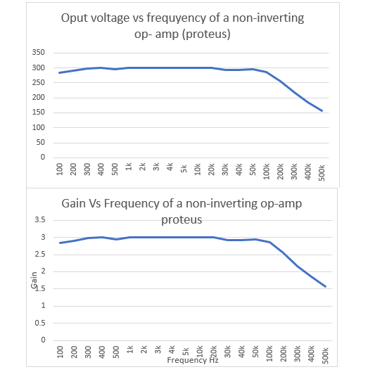

Results / analysis of the data
This is my final circuit design on proteus using a sine wave.
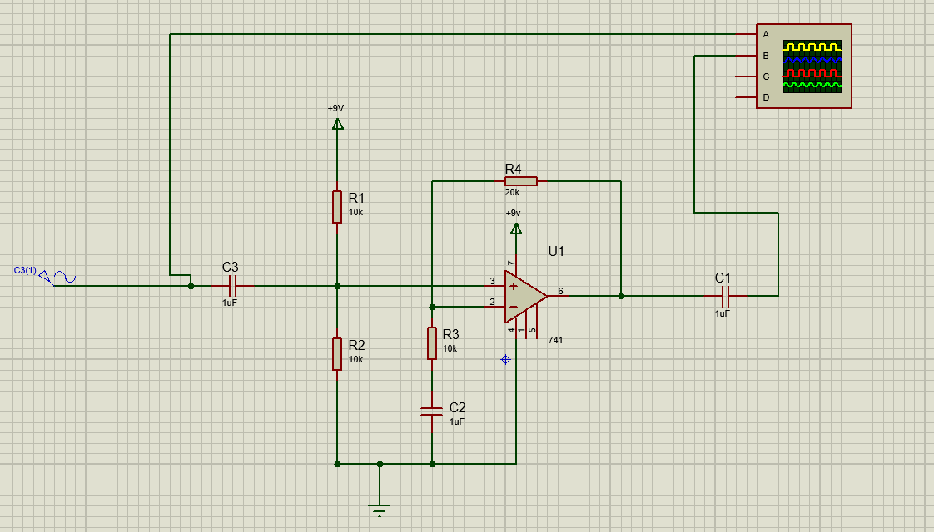
Below is the final circuit diagram for my proteus deign with a signal generator. 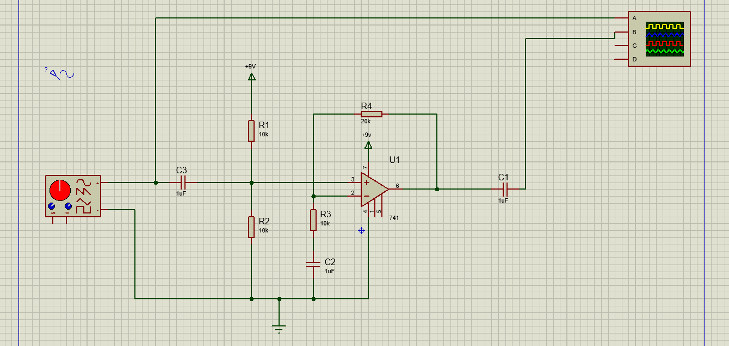

As can be seen from the graph the gain is steady for a considerable range of frequencies. It is reacting as it is expected to in its ideal way which is expected as it is in a simulation so won’t suffer the real-world challenges that can happen if you produce it out of a simulated environment.

Simulation on proteus to PCB board on easy pc

The first step was to transfer the design on to easy pc this meant I had to rebuild the circuit as a schematic drawing.
To-do this I had to go in and pick out the components that were required which is the same as the above circuit. However rather than putting in a signal generator as an input I put in terminals instead. As this was to simply design the PCB not to recreate the entire testing process again, so I didn’t need to put in a real oscilloscope it also meant that it gave me terminals to connect the supply to on the final PCB board. I then needed to add in a key for what each on the terminals meant, so if someone else looked at my circuit they could understand what was going on. (example of one below)

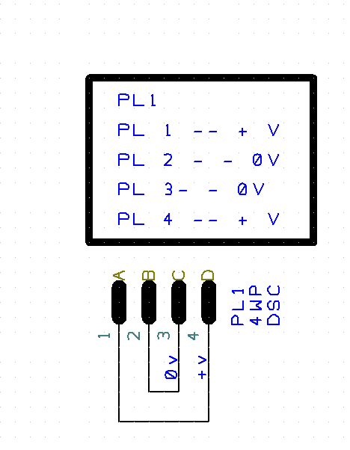
I then went on to add in +V rails and 0V rails to do this I had to change the net, to the relevant one i.e. positive or 0V. To make it clear I had done this I turned on the net names for them as can be seen on the terminal above.

Once I had completed the circuit schematic (see below) I went onto creating the PCB board itself. 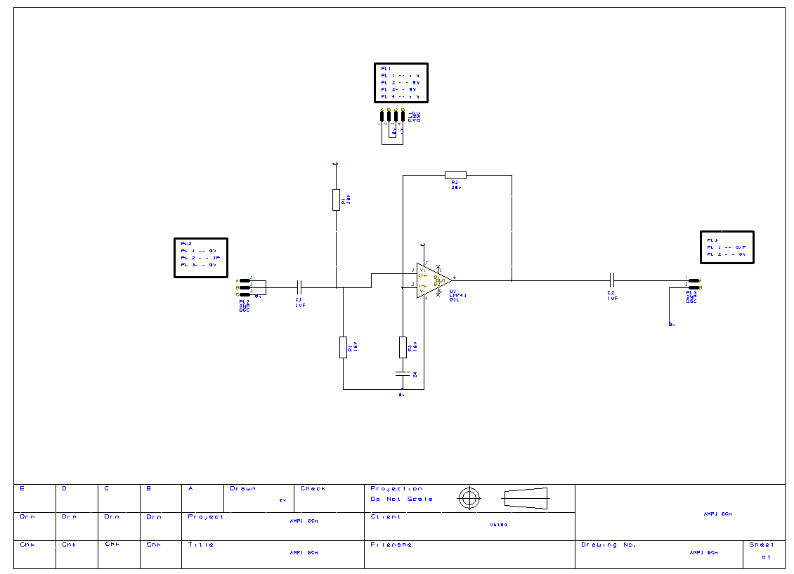

To do this I had to pull in all the components one at a time making sure that all the components’ connections were going to the right place and connected correctly. This allowed for me to get the smallest design possible as board space is expensive so the smaller the cheaper the board is to build.

I decided to see how big the design of the board was so used the measure tool to measure the dimensions of the board.
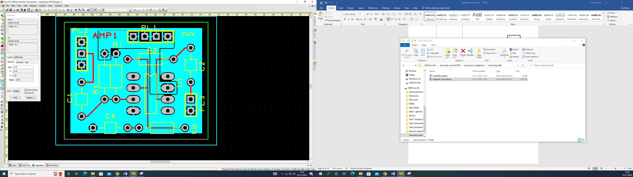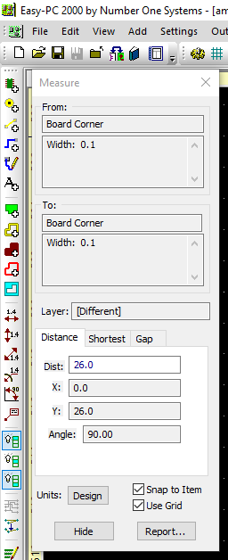

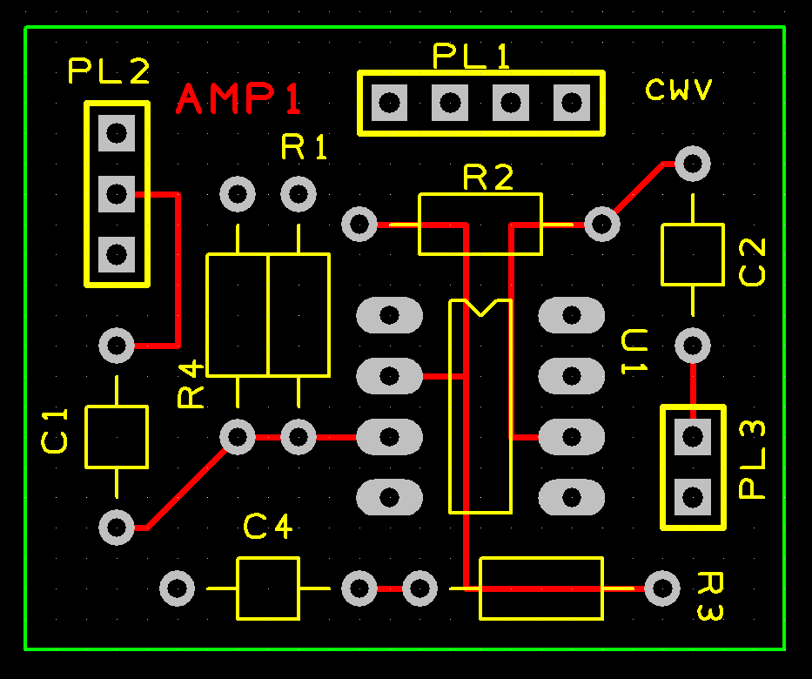

Once I was happy all the connections were in the right place, I then went onto remove some layers that weren’t required for the final PCB whilst also adding in some dummy layers.

The layers started out as
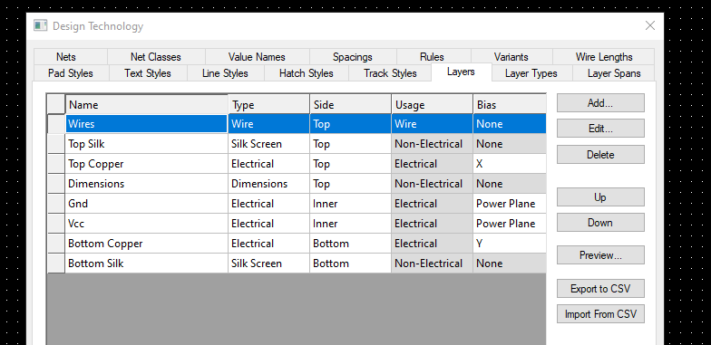
Became
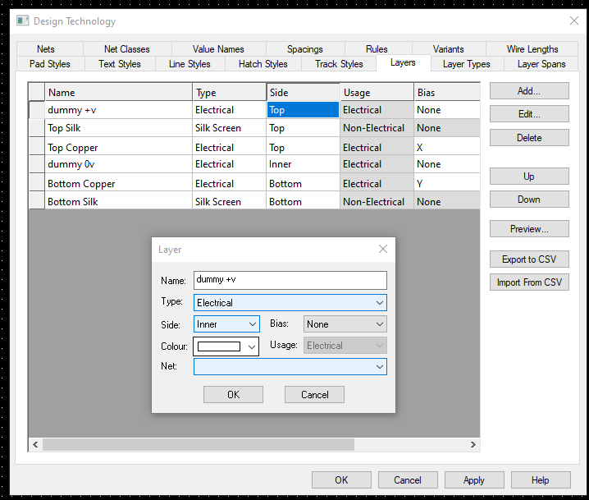
I had to make sure that the dummy layers were on the inside of the board and were electrical.
The reason I put the dummy layers in were to eliminate the total amount of connections needed, by bypassing other parts of the board making it easier to build.

Dummy layers were used to eliminate the number of connections required to then make sure that we could bypass the proper layers and then bypass the dummy layers to overall reduce the number of connections needed.

Once I was happy with the layout of the board and the connections, I added in coper tracks for the +v using the square tool, I then went on to add in the negative copper tracks with the square tool. Then poured in the coper to fill the area required.
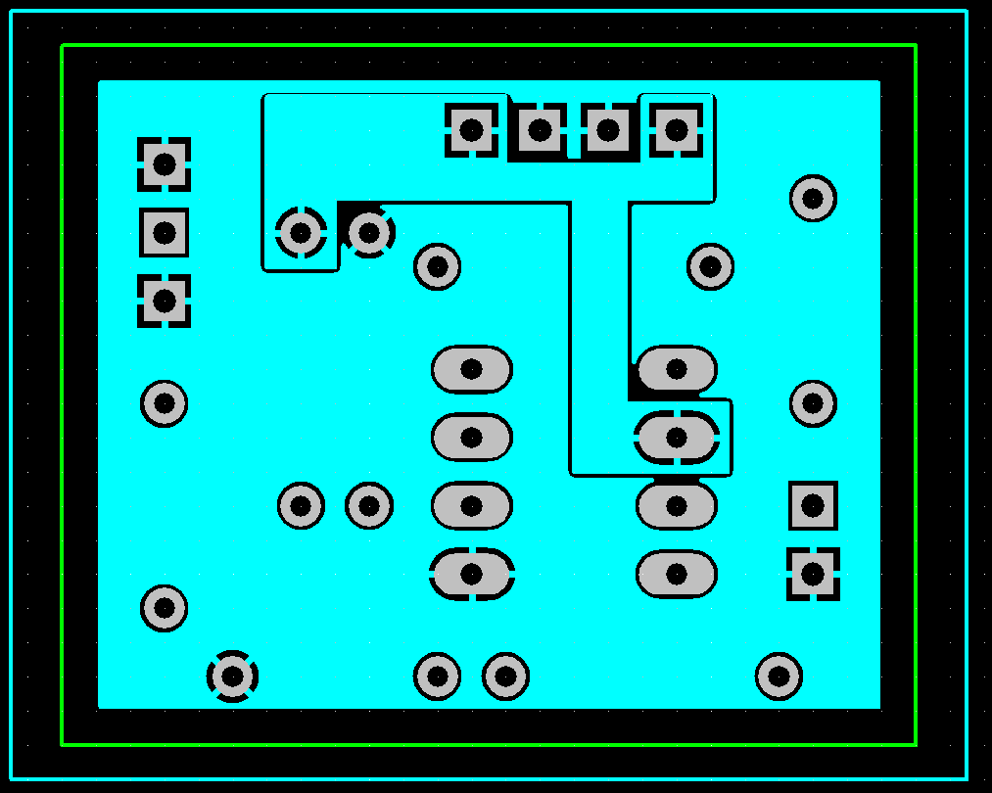
The blue and green shows the bounds of the plastic and cooper board layers.
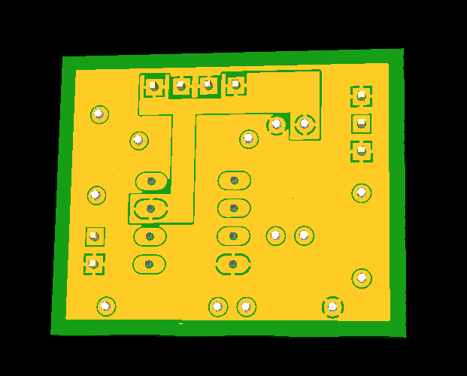

The red outline shows the area where I used the square tool to create a square area in which I could then pour the copper in and see how it looks on the 3d version of the board.

The next step was to delete the dummy layers I had implemented and to add in the name of the project and my name to the board itself. I added the name of the circuit in copper as it needs to last as whereas my name doesn’t need to be on there permanently.

I then needed to run several checks:

- Connectivity checks
- Design rule check
- Integrity check

All the different checks do a number of tests and checks on the circuit, for example the design rule check checks the nets, pads, and tracks and a whole host of other (see below).
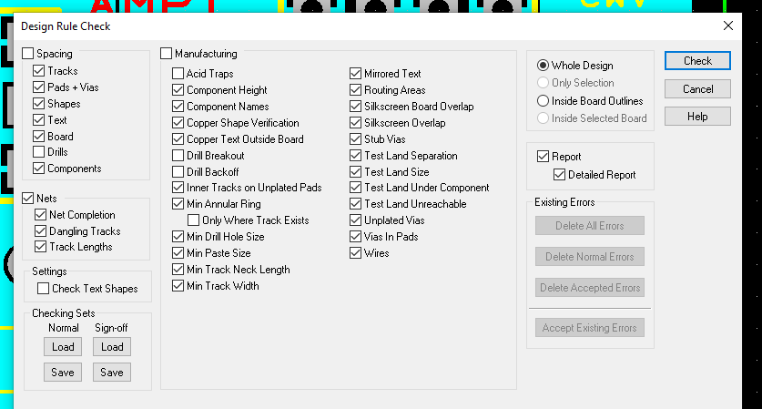

I then ran the check and asked Proetus to produce a full report on it.
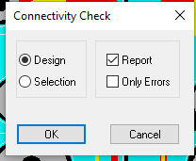

As can be seen below all the checks I ran passed and produced no errors.
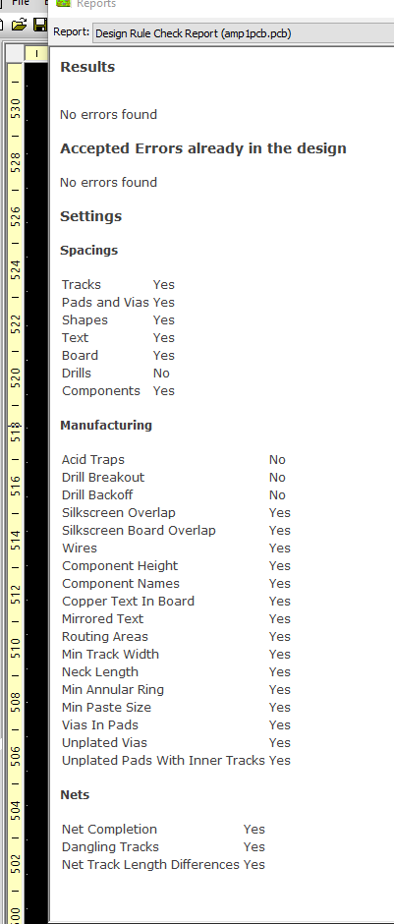
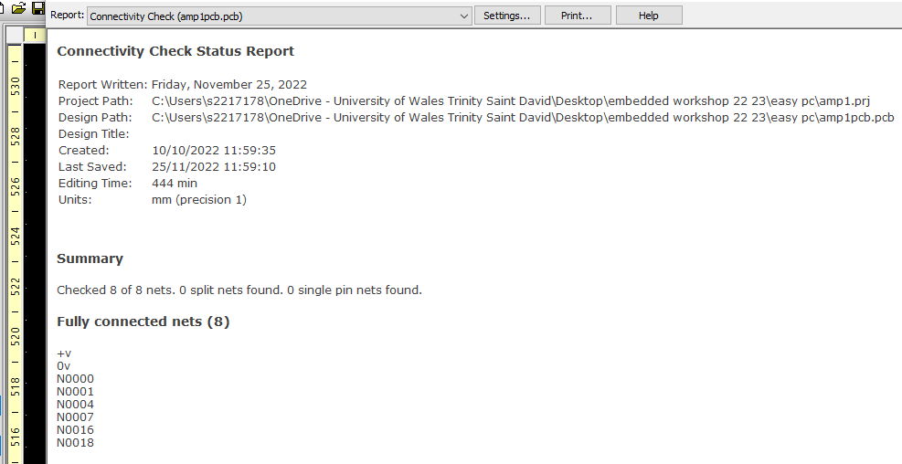
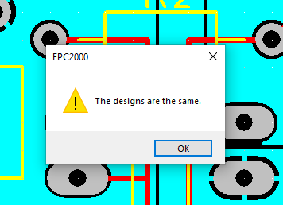

Once I was fully happy with the PCB board design I changed the file format (Gerber file), made a final adjustment of the layers and turned them into a zip file so I could upload the design to the manufacturers website JLCPCB.

3d view of the finished PCB design
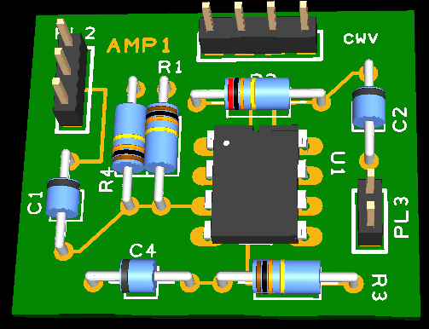
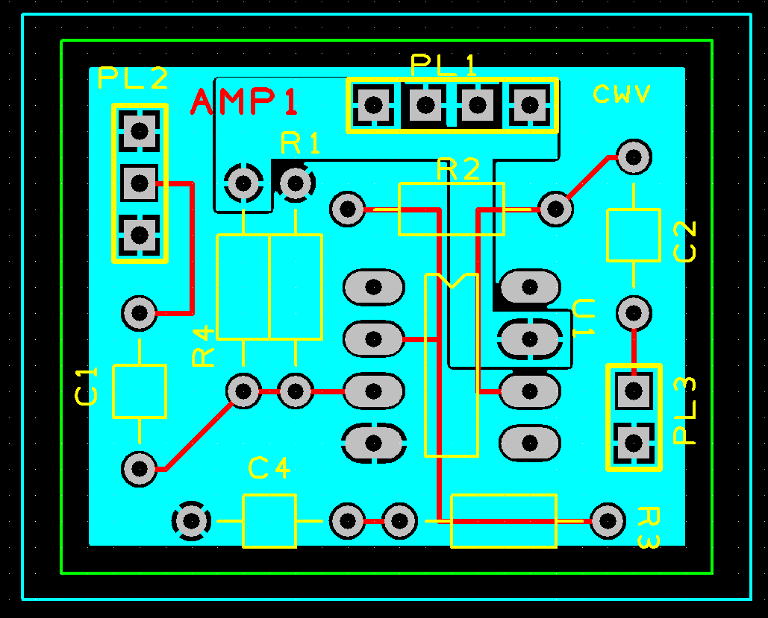

Once the board was printed the next thing I had to do was solder the different components in and test the board.

Printed circuit board without components

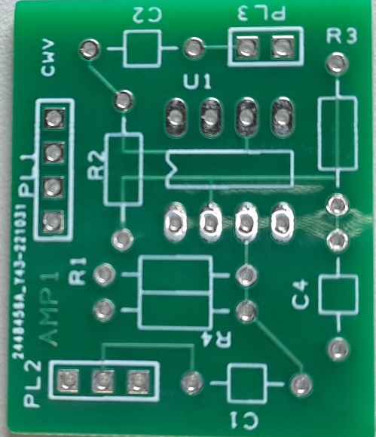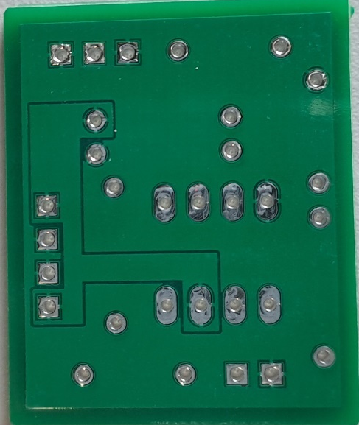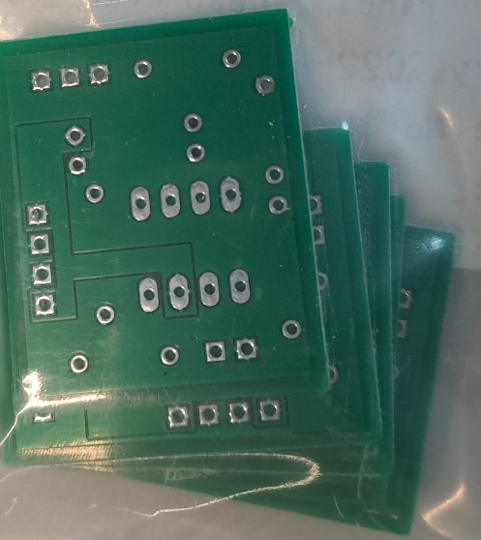

Printed circuit boards with components soldered in

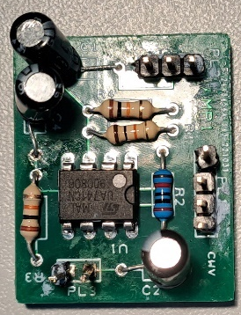

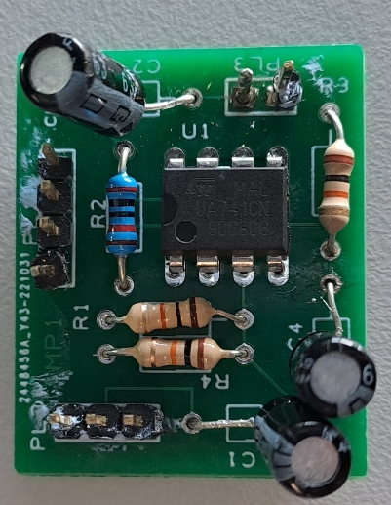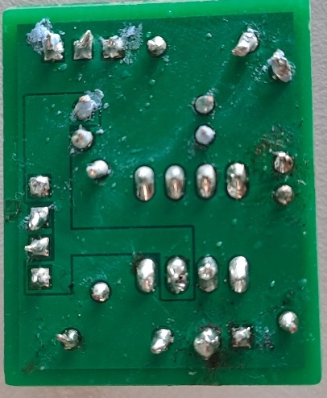

Testing PCB board

To test the PCB I took the same approach as I did for the breadboard, connecting one probe straight to the input to check the signal coming from the signal generator and the other coming out of the output of the circuit so I can directly compare the two. To test the PCB I used connecters that plugged straight onto the board as can be seen below). I then tested the PCB using a 200mv signal.

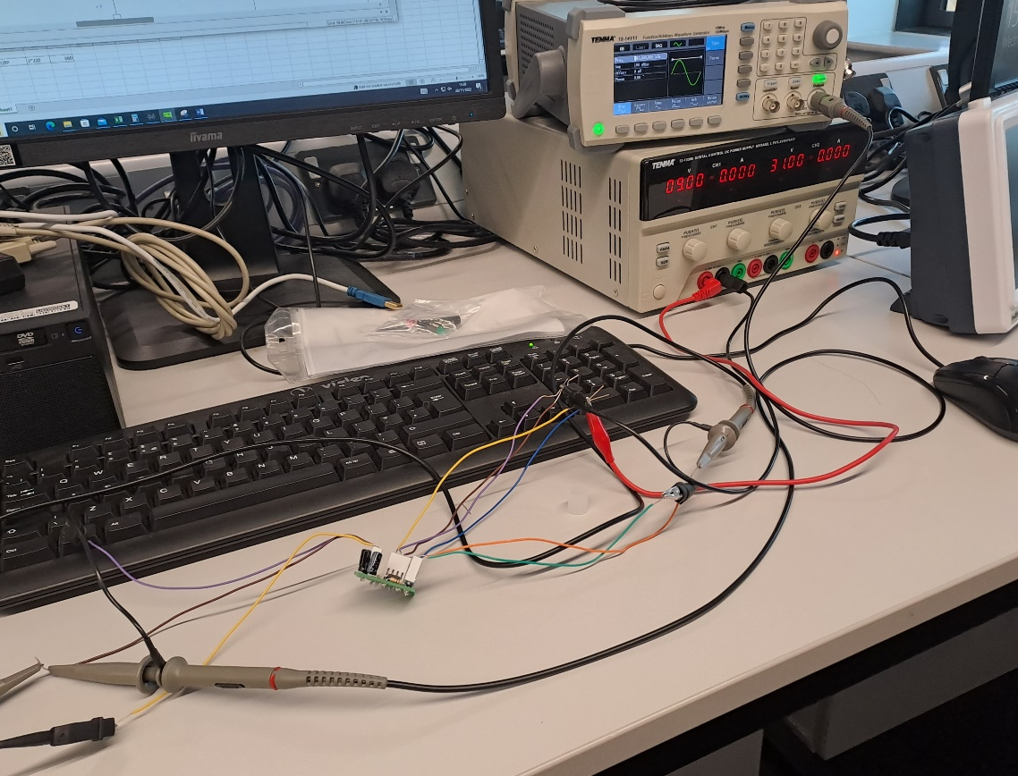
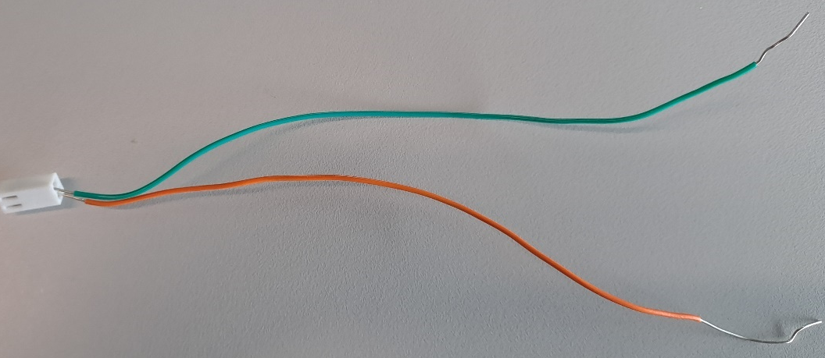
I then collected my data in a table and plotted a graph.
Frequency (Hz) | Output voltage (mv) | Gain
100 | 532 | 2.66
200 | 548 | 2.74
300 | 545488 | 2.73
400 | 548 | 2.74
500 | 560 | 2.80
600 | 560 | 2.80
700 | 560 | 2.80
800 | 560 | 2.80
900 | 558 | 2.79
1000 | 558 | 2.79
2000 | 560 | 2.80
3000 | 558 | 2.79
4000 | 560 | 2.80
5000 | 560 | 2.80
6000 | 540 | 2.70
7000 | 540 | 2.70
8000 | 560 | 2.80
9000 | 560 | 2.80
10000 | 560 | 2.80
100000 | 560 | 2.80
200000 | 340 | 1.70
300000 | 240 | 1.10
400000 | 160 | 0.8
500000 | 124 | 0.62
600000 | 96 | 0.48
700000 | 80 | 0.40
800000 | 64 | 0.32

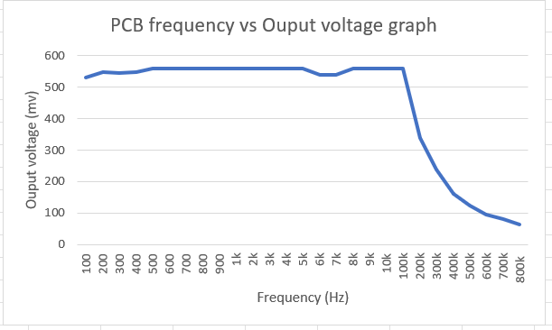
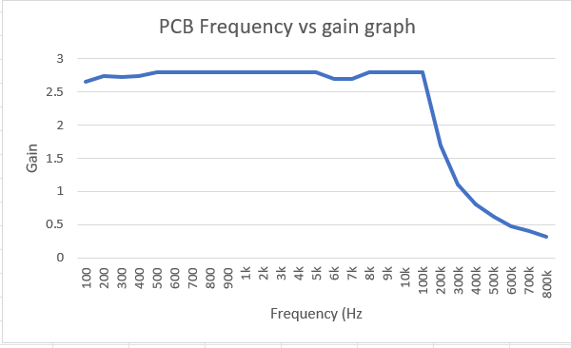

As can be seen from the graph the gain is consistent in the range 100 Hz to 100Khz however it is just shy of the ideal gain of 3 .

Bread Board version of the non-inverting op-amp

To build the bread board version accurately and neatly I utilised a tool called pebble to help me design the breadboard version of the system. Pebble allows you to add in your components in and visualise what the final bread board will look like.
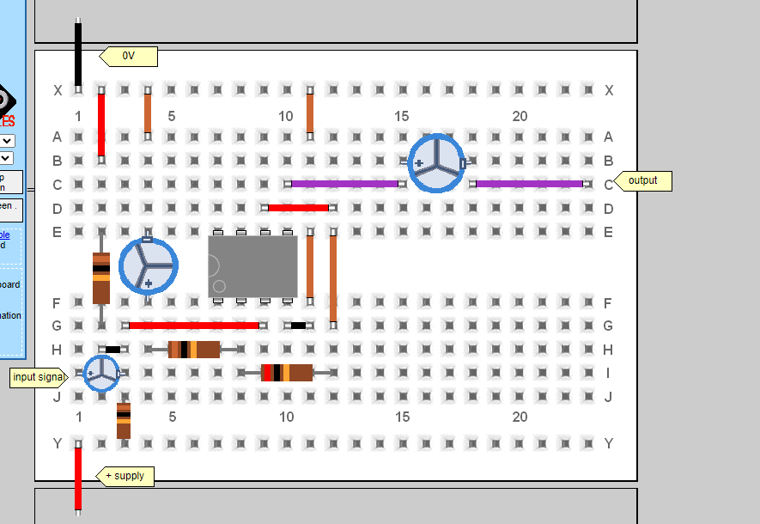
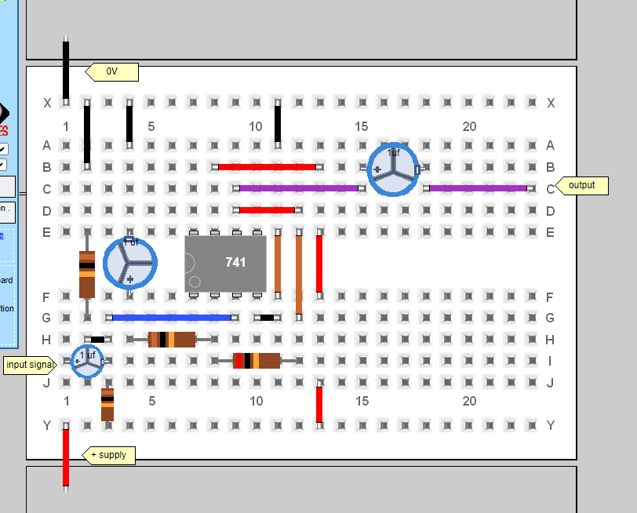
Testing

How I tested my circuit on breadboard

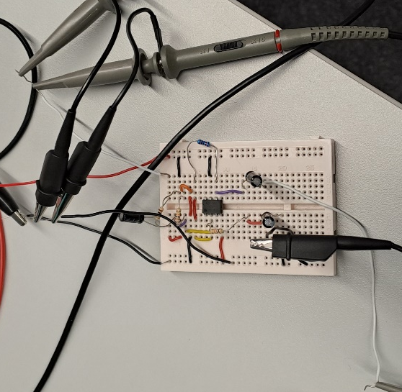

I used a series of probes to test my breadboard, I put two probes on the input one running from the signal generator to the input the other running from the input to the oscilloscope so I could check the output from the signal generator to make sure it was at the right frequency and was the correct input for my circuit. I then ran a probe from the output from my circuit to the oscilloscope to see what that signal was doing. (As can be seen above and below) . I then tested the circuit using a 200mv input signal.

Bread board signal output

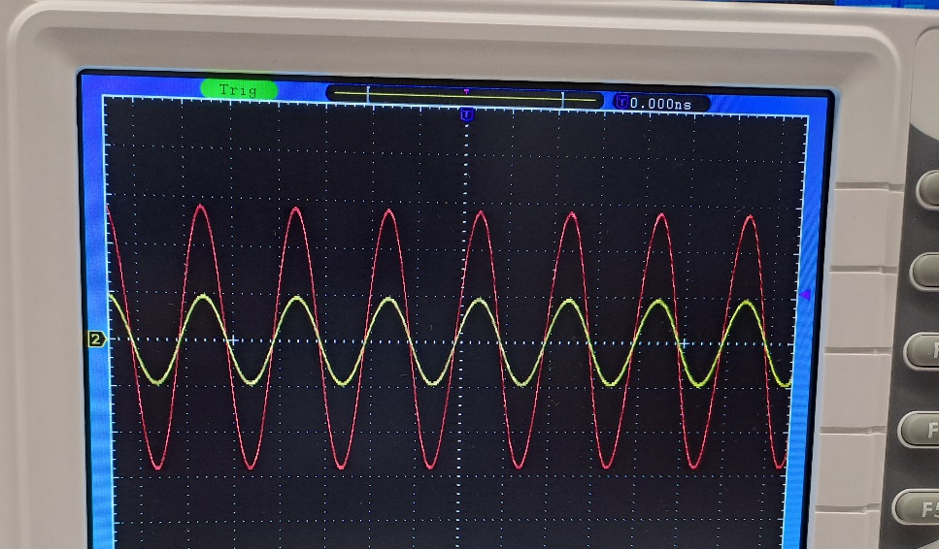
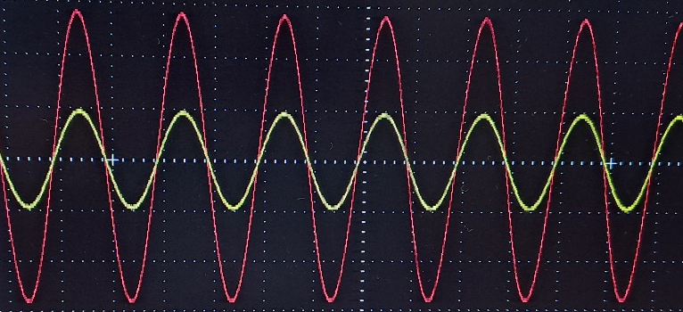

As can be seen from the above oscilloscope graph the red output signal is three times greater than the yellow input signal which is the expected gain, so the circuit is working as expected.

Once I had created the amp on breadboard, I tested the board to make sure that the system worked as intended in the real world and gave me the correct gain as required. I tested across a large range of data to see how it works at both extremes.

Bread board data

All data collected for breadboard testing

Frequency (Hz) | Voltage output (mv) | Gain (ouput/input)
100 | 536 | 2.68
200 | 556 | 2.78
300 | 564 | 2.82
400 | 568 | 2.84
500 | 560 | 2.80
600 | 564 | 2.82
700 | 587 | 2.94
800 | 568 | 2.84
900 | 564 | 2.82
1000 | 564 | 2.82
2000 | 564 | 2.82
3000 | 568 | 2.84
4000 | 564 | 2.82
5000 | 564 | 2.82
6000 | 568 | 2.84
7000 | 564 | 2.82
8000 | 572 | 2.86
9000 | 564 | 2.82
10000 | 572 | 2.86
100000 | 552 | 2.76
200000 | 452 | 2.26
300000 | 238 | 1.19
400000 | 252 | 1.26
500000 | 192 | 0.96
600000 | 152 | 0.76
700000 | 124 | 0.62
800000 | 100 | 0.50

I then plotted a graph of frequency vs output voltage and another of frequency vs gain.

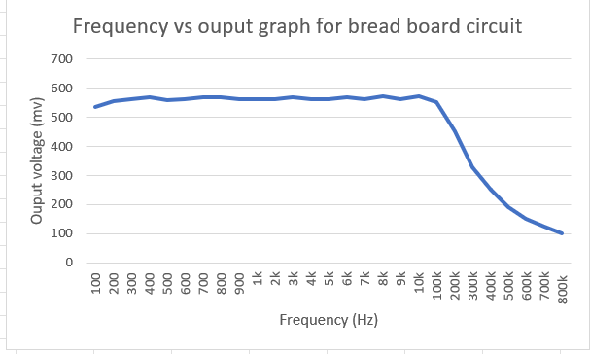
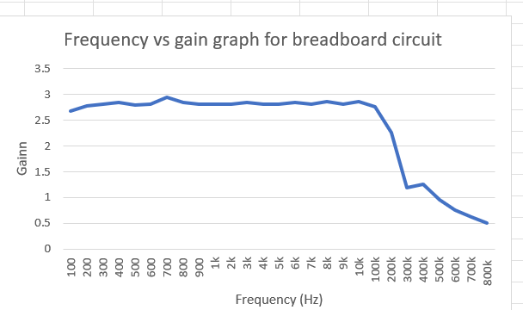
Compare of gain across all three circuits

The Bread board gain is closest to the goal of 3 between 100 Hz to 10KHz.
The PCB gain is closest to the goal of 3 in the range between 100Khz and 100 Hz.
The simulation gain is closest to the goal of 3 in the range 100 Khz and 100 Hz.

All three of the amplifiers work well in the 100 Hz to 100Khz range and work and produce the expected frequency vs gain graphs.

GBP graphs
Gain bandwidth product (GBP) = bandwidth x frequency
Bread board
Frequnecy (Hz) | GBP calcualtion | GBP
100 | 2.68*100 | 268
200 | 2.78*200 | 556
300 | 2.82*300 | 864
400 | 2.84*400 | 1136
500 | 2.8*500 | 1400
600 | 2.82*600 | 1692
700 | 2.94*700 | 2058
800 | 2.84*800 | 2272
900 | 2.82*900 | 2538
1000 | 2.82*1000 | 2820
2000 | 2.82*2000 | 5640
3000 | 2.84*3000 | 8520
4000 | 2.82*4000 | 11280
5000 | 2.82*5000 | 14100
6000 | 2.84*6000 | 17040
7000 | 2.82*7000 | 19710
8000 | 2.86*8000 | 22880
9000 | 2.82*9000 | 25380
10000 | 2.86*10000 | 28600
100000 | 2.76*100000 | 260000
200000 | 2.26*200000 | 452000
300000 | 1.19*300000 | 357000
400000 | 1.26*400000 | 504000
500000 | 0.96*500000 | 480000
600000 | 0.76*600000 | 456000
700000 | 0.62*700000 | 434000
800000 | 0.5*800000 | 400000

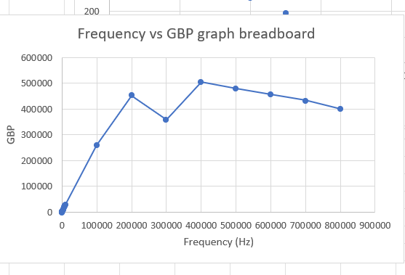
To best show the GBP I needed to have plotted the GBP on a logarithmic scale.

PCB Board

Frequency | GBP Calculations | GBP
100 | 100*2.66 | 266
200 | 200*2.74 | 548
300 | 300*2.73 | 819
400 | 400*2.74 | 1096
500 | 500*2.8 | 1400
600 | 600*2.8 | 1680
700 | 700*2.8 | 1960
800 | 800*2.8 | 2240
900 | 900*2.79 | 2511
1000 | 1000*2.79 | 2790
2000 | 2000*2.8 | 5600
3000 | 3000*2.79 | 8370
4000 | 4000*2.8 | 11200
5000 | 5000*2.8 | 14000
6000 | 6000*2.7 | 16200
7000 | 7000*2.7 | 18900
8000 | 8000*2.8 | 22400
9000 | 9000*2.8 | 25200
10000 | 10000*2.8 | 28000
100000 | 100000*2.8 | 280000
200000 | 200000*1.7 | 340000
300000 | 300000*1.1 | 330000
400000 | 400000*0.8 | 320000
500000 | 500000*0.62 | 310000
600000 | 600000*0.48 | 288000
700000 | 700000*0.4 | 280000
800000 | 800000*0.32 | 256000

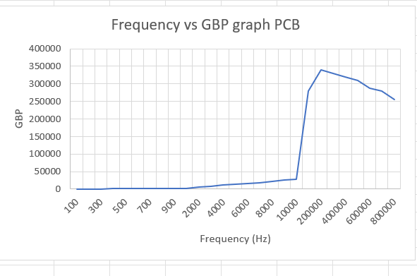

To best show the GBP I needed to have plotted the GBP on a logarithmic scale.

Proteus
Frequency | GBP Calculations | GBP
100 | 100*2.66 | 266
200 | 200*2.74 | 548
300 | 300*2.73 | 819
400 | 400*2.74 | 1096
500 | 500*2.8 | 1400
600 | 600*2.8 | 1680
700 | 700*2.8 | 1960
800 | 800*2.8 | 2240
900 | 900*2.79 | 2511
1000 | 1000*2.79 | 2790
2000 | 2000*2.8 | 5600
3000 | 3000*2.79 | 8370
4000 | 4000*2.8 | 11200
5000 | 5000*2.8 | 14000
6000 | 6000*2.7 | 16200
7000 | 7000*2.7 | 18900
8000 | 8000*2.8 | 22400
9000 | 9000*2.8 | 25200
10000 | 10000*2.8 | 28000
100000 | 100000*2.8 | 280000
200000 | 200000*1.7 | 340000
300000 | 300000*1.1 | 330000
400000 | 400000*0.8 | 320000
500000 | 500000*0.62 | 310000
600000 | 600000*0.48 | 288000
700000 | 700000*0.4 | 280000
800000 | 800000*0.32 | 256000



