MBA Dissertation: Employee Engagement Within the British Army
Student Name: Odoi Nathaniel Laryea
Student Number: 1810442
Module: Dissertation (BMMB703D)
Supervisor: Roisin Mullin

Abstract
This dissertation was aimed at evaluating the level of employee engagement within the British Army. There were three objectives for this research which are to measure the level of engagement within the British Army, determine how job loss within the organisation is having impact on engagement and lastly to determine ways to engage employee’s level of engagement within the British Army. Employee engagement is a multi-layered and a multidimensional construct, with over 70 different definition. In analysing employee engagement levels within the British Army, the research engrossed on Kahn’s (1990) definition of engagement which incorporates three dimensions of engagement namely cognitive, physical and emotional engagement.
A quantitative research approach was used simply because the emphasis was based on scope rather than depth. A survey was used to gather the primary data, and this was done using a modified questionnaire from a 2006 employee engagement survey completed by Truss et al (2006) for the Chattered Institute for personnel and Development (CIPD). Areas utilised consist of working lives of the employer, job, employees, job satisfaction, communication and leadership and management. The scales for the measurement of this were obtained from the Kingston Business School and Ipsos MORI.

The research also discovered that British Army has a high level of engagement within the sector, however, there were some concerns in some areas such as high level of stress, pressure and PTSD and sometimes dissatisfaction with work/life balance and communication.
The implication of these to the management and ways to motivate and engage employees have also been discovered

Declaration/Statements
This work has not been previously recognised in substance for any degree and is not being simultaneously submitted in candidature for any degree.

Signed …………………………………………… (candidate)

Date: …. 25th May 2021 ….
STATEMENT 1
This work is the product of my personal investigations, apart from where otherwise stated.
Supplementary sources are acknowledged and giving clear references. A bibliography is attached.

Signed ……………………………………………. (candidate)

Date: …25th May 2021….

Acknowledgement
I would like to express my profound gratitude to my academic supervisor Roisin Mullin for his time and patience in guiding and directing me to the right path in writing this dissertation.
I would also like to thank my work colleagues for their immense support during the survey. Finally, I would like to thank my family and friends especially my wife Dr Mrs Esther Amankwah-Odoi and everyone who contributed in motivating me to finish this challenging dissertation.

Table of Contents
Abstract 0
Declaration/Statements 0
Acknowledgement 0
Chapter One Introduction 3
Chapter Two – Literature Review 8
Employee engagement Interest 8
Defining engagement 9
Employee Involvement 11
Consequences of Engagement 12
Other Theories vs Engagement 13
Engagement and motivational Concepts 15
Employee engagement in context 22
Hofstede’s Cultural Dimensions 24
Conclusion 26
Chapter 3 – Methodology 26
Research Aims and Objectives 27
Hypothesis 28
Research Method 28
Survey Design 29
Sections of Questionnaire in detail 31
Section one 31
Section two 32
Section three 32
Section four 32
Section five 33
Section six 33
Section seven 33
E–Survey 34
Administration of the Survey 35
Limitations of the Research Method 35
Analysis 36
Chapter 4 – Findings and Analysis 37
Findings 37
Analysis of Results 57
Methodology 59
Summary 65
CHAPTER 5 – Discussion, Conclusion and Recommendation 68
Discussion 68
Summary and Conclusion 72
Recommendation for researches in the future 73
References 74
Appendices 82
Appendix 1 – Employee Engagement Survey 82

Chapter One Introduction
We all wake up in the morning and begin to get ready for our daily and routine job. Some do this in much enthusiastic manner others also drag their feet and get ready with a lackadaisical attitude. The former does this with smile, smartness and utmost joy whereas the later only go to work simply because is their source of living and means of earning income for livelihood. This boils down to the fact that some employees are disengaged whilst others are more engaged with their job. The backbone of this could be traced down to three different force which are, physical engagement, psychological engagement and emotional attachment of employees to their job.
Managers and Team leaders may perhaps prefer their employees to be the later in order to be more engaged to achieve organisational objectives leading to success. But obtaining this from employees is not as simple as that but will require them to be well engaged.
Employee engagement is known to be a broad term with variant definitions within both academic researchers and practitioners. The term is used in various ways dependant on the traits, behaviours and psychological states (Macey and Schneider, 2020). Employee engagement has also been defined as “the harnessing of organisation members’ selves to their work roles; in engagement, people employ and express themselves physically, emotionally and cognitively during role performances” (Kahn, 1990:694). He furtherly argues, as an Organisational Psychologist, an employee needs to be involved in all the activities of the organisation and be considered as a true partner in that case, the employee will be present both physically and psychologically and that will lead to massive engagement (Peakon, 2020).
Physical engagement, Emotional engagement and Cognitive engagement which are the three dimensions of employee engagement by Kahn (1990) will be the focal point of study in this research as this impacts work and contributes to positive or negative performance. There has been a more simplified definition by Truss et al (2006) as: Cognitive engagement, the ability to concentrate or focus positively in work, Physical engagement thus working with zeal and to go beyond what is expected of you and lastly Emotional engagement which is addressing your work as part of you (Truss et al, 2006).
The British Army has undergone a series of reform tracing from July 2013, the then Prime Minister Mr David Cameron and his government introduce a new future reserve 2020 (FR2020) which was a wide defence policy. The rationale behind the policy was to maximise the reserve strength and to limit the regular capacity leading to reduction in the overall strength of the Army (Bury and Catignani, 2020). For this reformation to hold water, the employee engagement will have to play a dominant role. The overarching aim of this reform has several dimensions according various scholars. Some believe military can be transform as a response to bottom-up-or tactical-pressures. It was defined by farewell as ‘top-down innovation’ and ‘bottom-up adaptation’. As many believe the aim was based on innovation, it is also believed that the reform has historical force duet to civil-military relations as innovations normally occur during peacetime. Other school of thoughts also believe that there are external factors leading to these innovations as military chiefs would like to choose how they implement their desired change; external political pressures compel military leaders to synchronise with civilian leaders in implementing changes in the organisation.
The Sun newspaper reported in July 2020 that the Army could be cut down by about 20,000 troops as part of the plans drawn by the defence chiefs (Dathan, 2020). This plan has been reported to be part of the reform due to the Treasury’s policy for every department in Whitehall to cut down spending by 5 per cent minimum. Security sources also claimed that Dominic Cummings the PM’s chief aide wants to shift a huge amount of funds from the army to cyber warfare, artificial and space intelligence (Dathan, 2020).
In other news published by the Express, Ms Dodds the leader of the Liberal Democrats also has accused the Prime Minister Boris Johnson of the intention to sized down the size of the British Army just 8 months after promising to protect the Armed Forces. The reason behind the cut down is said in most newspapers as the course to save money (Perring, 2020).
This brings job insecurity in the organisation as many do not know their faith soon. A Gallup study has highlighted on the link job security has with employee engagement. A significant outcome of the research was that lack of job security reduced the odds of employee engagement (Gallup, 2004). There was a decrease in employee engagement by 37% among employees who felt there were job insecurity within (Gallup, 2004). The redundancies and constant awareness of possible job loss through the cut is likely to bring about job insecurity leading to the generating of hypothesis that employees working within the British Army will be less engaged.
The British Army which forms part of the Defence sector has a success story of contributing effectively to the UK economy. It is known to be providing highly skilled and rewarding jobs and also encouraging investment in every region of the country by being among the largest UK apprentice employer (MOD.Gov.UK, 2020). The tremendous work of the defence which the Army forms part underpins the UK’s industrial and economy strategies and continually driving the UK’s innovation on the global stage (MOD.Gov.UK, 2020). These great outputs can be well achieved when the workforce is motivated and engaged. The last thing the Army would expect is its employees being disengaged as this can have a massive effect which can include a crush on the economy too. A UK Regular Armed Forces Continuous Attitude Survey study, stated that more Service personnel are more likely to stay in the Army because of job security. However, with the recent tensions on job cut and Military reforms, Personnel are more likely to change their intentions as Employees will no longer know their faith in the Army (Assets.publishing.service.gov.uk. 2020). Performance is affected by engagement (Kahn, 1990) and productivity is always likely to increase with highly engaged staff (Lockwood, 2007). As the saying goes “A sound mind lives in a sound body”, Mauno et al. (2007) and Rothbard (2001) conducted a study which showed that engagement may lead to positive feelings towards work and good health effects as well. All these serves as yardstick for organisations to promote engagement for the employees for the good and benefits of the sector.
Another study was carried out by Kahn (1990), this has been considered as one of the most influential study on engagement. He begun abstractly considering the work of Goffman’s (1961) work which proposed that “people’s attachment and detachment to their role varies”. Kahn was with different opinion; his view was that Goffman’s work was not that suitable because it did not clarify engagement very well but rather highlighted more on person-to-person encounters. Therefore, Kahn thought of a different notion which scrutinized numerous disciplines to gain additional understanding of the stages of attachment individuals expressed Kahn (1990). His work laid the groundwork for other studies on engagement.
Other such study includes Truss et al. (2006) which was bespoke by the Chattered Institute of Personnel and Development and has been conducted by the Kingston Business School and IPSOS MORI. A study was conducted in 2006, as part of the research, a bedded sample of 2000 workers within the UK were used. Kahn’s (1990) three dimensions of engagement was the focal point of this research which discovered a higher level of engagement within the UK than former studies did. A comparatively new study by Kular et al. (2008) which was a literature review of employee engagement. In conclusion, the study deduced that irrespective of the country, most employers were in the “not engaged” category. This is not encouraging looking at the fact that employee engagement is not just prudent for the organisation but also good for the employee. In spite of, enormous study on employee engagement, this research will use the above authors’ studies as the focal point. Kular et al. (2008) pointed out clear that there has been enormous research in the US and the CIPD has also conducted some series of engagement research in the UK so this will not be the first however is going to be unique looking at the current recession created by the COVID and the involvement of the British army.
The purpose of this research is to evaluate employee engagement within the British Army and the effects of the cut off leading to job losses and to determine if job insecurities have consequences on engagement within the sector. The questions for the research are as follows:

- What is the level of engagement within the British Army?
- Have job losses within the Army adversely impacted on engagement?
- What categories of staff are more engaged?

This research has three main objectives which comprises of measuring the level of engagements within the British army, determine how recent cut off and job losses has adversely impacted on engagement within the Army and looking for ways to get the employees engaged within the Army. Providing and independent picture of the empiricist point of view within the sector is the rationale behind the chosen and pursue of this research questions. The research will reveal the outcome of job losses and also the reform of the sector as a whole on engagement. Lastly, knowing which category of the workforce is more engaged is very prudent. This is because senior category of the employee could be more or less engaged as compared to that of the lower rank. The Army needs the senior ranks to be more engaged in order to inspire the lower ranks. Managers have an important role to play when more engaged, this is because they need to find ways to engage junior managers but not just motivating them (Truss et al., 2006). In this research, both primary and secondary data will be used. However, secondary data will be used a lot in the literature review. Quantitative method of research will be used to represent primary data and will be selected over secondary because it throws more light on objective measurement and analysing of data (Babbie, 2010; Mujis, 2010). Researching qualitatively emphasises on gathering of data numerically and generalising across groups or expatiating of phenomenon (Babbie, 2010; Mujis, 2010). As stated earlier, it is very important to use this in the research as the emphasis is on scope rather than depth. On the other hand, qualitative research produces thorough picture of data therefore suitable for depth of understanding reason being it emphasise on the “intimate relationship of the researcher and what is being studied” (Denzin and Yyonna, 2010).

Chapter Two – Literature Review

Employee engagement Interest

Most organisations if not all will prefer their workforce to be well engaged in order to drive together in achieving the targeted objective. Employees who are well engaged will definitely have the organisation at heart and will never oppose to any strategy laid out by their higher command. This will then increase performance which will not just contribute to the continual existence of the organisation but lead to competitive advantage. This is when an organisation increases their profit margin by reducing their cost of production or by recording more sales than its cohorts or they can do both (Johnson et al, 2011). This however is different in the case of the British Army. The core objective of the Army is to protect national security, provide Humanitarian support, work closely with its Allies in fighting terrorist, preventing conflicts and fighting the Nation’s enemies (What We Do, 2021). The Army do not look for competitive advantage but rather make sure all soldiers from Other ranks through to Senior Officers are well engaged to be able to achieve operational objective. Operational objective could be the providing of national security, providing of Humanitarian aids and fighting of terrorism both at home or overseas. The Army needs its employees to be both covertly and overtly motivated in order to feel engaged to perform. In achieving this, the right people must be recruited and employed to the right sectors (Grigorov, 2021). The best condition of living must also be provided to the soldiers, in that case they can go all out in reaching operational objective. Above all, people who are intrinsically motivated should be recruited as they will always be engaged no matter what.

Defining engagement

Employee engagement has not got one mutual definition but rather has over 80 different definition that best explains it Macleod and Clarke, 2009). Talking about employee engagement, different people could be talking about completely separate or different things with the same terminology. To curb this confusion, we need to find a common subject matter then we could be singing from the same song sheet. I will set the ball rolling with Kahn’s definition of employee engagement. “the harnessing of organisation numbers’ selves to their roles; in engagement, people employ and express themselves physically, cognitively and emotionally during role performances” (Kahn, 1990:964). In Kahn’s definition, he described three dimensions of engagement which are Cognitive, physical and emotional (Kahn, 1990). These are very important areas where particular attention is given throughout the terminology. The term engagement has been described by others in different ways like “Passion for work” (Truss et al, 2006). “Psychological state which encompasses Kahn’ss 1990 three dimensions” (Kular et al, 2008:3). Kahn cannot be left out when we talk about employee engagement. The same way we can say Sigmund Freud is the father of Psychoanalysis, Kahn can be said to be the father of Employee engagement. To that end it will be prudent to go into his definition in detail since he started lots of foundation work on employee engagement. Truss et al, (2006) definition of engagement outlines the emotional attachment of an employee to his work, thus calling the work your own and forming part of you. The cognitive part has to do with intense focus one has at work and the physical aspect is having the zeal to contribute your quota to your work even when there is the need to go a step further. Truss et al (2006) descriptions on engagement have been used by CIPD report on a research focussed at experts and meant for policy change, this is for the uncomplicatedness to be right in the setting explained below; being involved in one’s work is not easy to explain but rather a bit vague and measuring it independently is a bit difficult and so as being willing to go a step further to work. A much-detailed explanation of Kahn’s description of the three dimensions have been given by Kular et al, (2008). The cognitive aspect of engagement illustrates the beliefs of workers about their organisation, its top hierarchy and the working conditions they face (Kular et al, 2008). This is very different from the definition Truss et al, (2006) gave about being involved with your work. Kular et al, (2008) describes the emotional part as the feelings of employees on each of the dimensions and if their attitudes towards the organisation and its hierarchy is positive or negative. Whereas the physical part directs to the physical energies the workers exhibit. Engaged employee do not work for pay check nor promotion or even allowances but rather have the objectives of the company at heart, this means the prospect of the company is what they care about most (Employee Engagement and Organizational Commitment: Journal of Management, 2021). Reiterating what my earlier submission stated, there has not been an accepted and the general definition on employee engagement. This is because it is broad and has not got a clear and distinct narrow area for it, rather it has enormous definition and explanations to it. Engagement has also been defined as the level in which individual workers in an organisation used their own initiative in implementing strategies that goes a long way to benefit the company (Frank et al, 2004). Due to the diverse definitions on engagement, it is only the context at which a research is been conducted that will elaborate more on what the actual meaning of engagement will be. The absence of a common definition makes hard to manage and measure, this is because there wouldn’t be any better way to improve and to determine if it’s actually work in progress or not (Fegurson, 2007). One study could be focussing on the emotional intelligent of workers and its interest could be based on workers exhibiting their own discretion in their various roles to meet the goals of their organisation, another study could focus more on the general behaviour of workers in the area of putting in more physical effort an organisational objective. These two researches would yield different results hence contributing to more complexity and complicated outcome of engagement.
We’ve discussed more detailed about engagement, now let’s talk about disengagement. It is erroneously assumed that the opposite of engagement is disengagement but, in an organisation, workers may be either engaged, not engaged or disengaged (Truss, 2006). Disengagement has been defined by Kahn (1990) as the disentanglement of one’s selves from their roles in work. Hochchild (1983) defined disengagement as when employees uncoupled themselves from their work roles and extract passionately and cognitively. These group of workers can be present at work on time, physically but not passionately, they also have a habit of clock watching and refuse to bring something on the table. A study discussed by Huckerby (2002) suggests that only 17 percent of UK employees are truly “engaged” in their companies, and 20 percent are “disengaged” thus mentally shut down but still stay on where as the remaining 63 percent are “not engaged”.

Employee Involvement
Employee engagement is the behavioural attitude of an employee either physical, cognitive and emotional in performing their daily activities in their work. Involvement is rather the opportunity given to workers to be part of decision making of the firm. Involvement refers to the opportunities that are given to employees to be part of decisions that affects their work, this could be task discretion or organisational participation (Duran et al, 2021). Participation could be in two forms; direct and indirect. Indirect is the representation of workers through groups or associations like Trade Unions and direct is the participation of workers straight through interactions (Duran et al, 2021). The main motive of Employee involvement is to get decisions made in an organisation directly influenced by employees but not through representatives. The argument is, does employee involvement leads to employee engagement? When an employee is given the opportunity to feed their opinions and voice upwards, it becomes one of the main drivers of employee engagement (Truss et al, 2006). Employee involvement in an organisational operation do not just motivate them but also helps workers to contribute more effectively and efficiently (Price, 2004). He furtherly explains involvement as a process which constitutes participation, communication and decision-making process which contributes to industrial democracy leading to employee motivation. Marching Ton et al. (1993) have also used participation is a different context, it has been used as an overarching terminology that seeks to retrieve the best out of employees. Their involvement in an organisational set up are used by the managerial hierarchy to aim at winning their hearts and their highest level of commitments. Judge and Gennard (2005) has outlined some other importance of Employee involvement as a practice that leads to job satisfaction and job security leading to greater performance towards organisational objectives. A CIPD survey (2006) concluded that most organisations are not good in giving workers the opportunity to voice upwards and the outcome of the lack of employee’s ability to air their voice in decision making do not promote engagement in an organisation. On the other hand, a study by Towers Perrin (2003) showed opposing result. It was concluded that employers are actually pulling their weight by creating the avenue for workers to be part of decisions with a whooping percentage of 62 respondents admitting they have the proper authority to decisions.

Consequences of Engagement
There are positive outcomes of employee engagement in general. It can also be said that there is a correlation between engagement and performance. Research has proven that engagement influences both role behaviour and proactive behaviour (Sonnentag, 2003). Employee who are engaged are more productive because they are motivated beyond personal factors. They work with much of zeal and with the interest of the company in mind at all times. Harter et al. (2009) conducted a research on engagement and relationship on performance, the findings of the research revealed that there was a significant difference between top and bottom work unit on engagement. There was additional 18% drop in productivity and 60 percent drop in product quality too. Gallup organisations discovered critical links between customer loyalty, engagement, profitability and growth of business (Gallup Organisation, 2004). There was also another correlation found by Levinson (2007) that exist between engagement, retention and customer loyalty. Engaged staff are happier to promote the culture of an organisation and determined to market its products and services to the world (Scottish Executive Research, 2007).

Other Theories vs Engagement
In spite of the fact that employee engagement has been defined in many different ways, it has been argued that the definitions mostly sound similar to most well accepted ones like ‘Organisational Commitment’ OC and ‘Organisational Citizenship Behavioural’ OCB Robinson et al. (2004). He simply put engagement to be “one step up from commitment”. Thus, working above average for organisational success. The question to ask is, is there a thin line between organisational commitment and engagement? Commitment could be said to be moving an extra mile of engagement base on what definition of engagement is been followed. There is a distinction from other theories as compared to that of Sacks (2006). He believes there is a correlation between engagement and commitment but different from organisational Behaviour. Robinson et al. (2004) thinks this distinction is prudential. They are of the view that engagement consist of many of the essentials of commitments and OCB but they are not flawless contests. They furtherly explained that the two types of engagements and how engaged employees are expected to have components of business awareness cannot be explained sufficiently by neither commitment nor OCB. This is due to the fact that there is no universally approved engagement definition. Sacks (2006) is of the opinion that engagement and organisational commitments are different and believes that engagement is the rated at which a worker becomes very attentive at work and the output that is achieved through their performance and not just his attitude whereas organisational commitments is a worker’s attitude and attachment to work. He also explains OCB as informal and voluntary behaviours that benefits both employees and the organisation as a whole whilst engagement is explained as formal performance of on an individual about their job role or work (Sacks, 2006). In the quest to find the difference existing between OCB and commitment from engagement, the use of “performance” by Sacks (2006) in the above examples. Engagement is not tied with performance although it is not just an attitude. A research conducted by Truss et al (2008) showed that personnel could be engaged but may not have matching rise in performance. In spite of the various definitions of engagement known, none of them used performance as main variable in any of the definitions. For that reason, it makes it difficult to draw a conclusion as to whether the variance between the two concepts discussed above (commitment and OCB) are important or not.
Job involvement and ‘flow’ will be the next theories to be discussed in relation to engagement. Engagement could be said to be accepting the company’s objectives and values partially which in a way help increase the company’s productivity. Involvement on the other hand is how the objectives of the company will be hunted actively. Job involvement could be defined as the situation where a job is central and can be identified with a person. It is the cognitive or belief state of identification psychologically.
Most theorist explain engagement as emotional, behavioural or physical state of the employee whereas Involvement deals with the cognitive state of an employee.
‘Flow’ This is the cognitive state of a person performing an activity is holistically immersed in that activity and in an energised mood which makes him fully involved. Csikszentmihalyi (1975:36) defined Flow as the full sensation that individuals feel when the perform with involvement. There is a case that people who work with “Flow” do not need external drive nor any further reinforcement and rewards to perform as the activity and the job itself is rewarding and challenging for them (Kular et al, 2008). Engagement and ‘Flow’ has two main difference. Engagement is multifaceted whereas ‘flow’ is cognitively based. Engagement is mostly based on long-term considering the various definitions whereas ‘flow’ is of short term which normally is based on monetary circumstances (Kahn, 1990; Holbeche and Springett, 2003). Theorist may argue that ‘flow’ and engagement may be related, however, there are some substantial differences in them. Employee engagement and its related concepts has a longstanding derivation from concepts of motivation.

Engagement and motivational Concepts
Undoubtedly, motivation should work hand in hand with engagement. This because in the quest to get workers well engaged, there is the need to identify what drives or motivate them. Understanding what motivates employees will turn to drive engagement. Has described motivation as having concerned about how people engage in particular activities as compared to others for a period of time and also why a specific course of action is taken over a long period of time by individuals even at challenging times (Krech et al, 1962). Motivation has been described as the direction and willpower of carrying out an activity (Mullins and Christy, 2010). In simple terms, motivation can be said to be the zeal one has in doing something. Employees can go all out to achieve the organisational objective but the organisation will have to give the employees a reason for doing that which should be in a form of motivation (Krech et al, 1962). It is evidently clear that motivation has correlation with engagement based on several definitions. Many schools of thoughts have explained motivation in similar ways but it very prudent for Theorists to explain the behaviour of certain individuals at a particular period (Mullins and Christy, 2010). Thinkers will ask ‘what motivates employees’ but the question has no straight forward answers, this is because every organisation and its nature of business would determine the kind of motivation that will best fit the situation. The variance in theories will direct attention to what is the problem and the best pursuit of motivation in tackling it (Mullins and Christy, 2010). Three main handy theories associated with motivation and engagement will be discussed in this chapter. The three are: Hertzberg’s two factor theory, Alderfer’s modified need hierarchy theory and Maslow’s hierarchy of needs theory.
The famous hierarchy of needs was developed by Abraham Maslow to describe how people are or can be motivated. The theory explains that individuals have a lot of needs and it will not stop just there but will continue to want more. The needs are in five steps represented in a pyramid shape representing those on the lower-level needs are basic therefore large number of people and those at the top are few. It also explains that once a level is completed, then a high tendency of climbing for the next level because needs of individuals grow and never ends. These are the levels from the lowest to the highest; Physiological needs (Basic needs), Safety needs, Love and acceptance, Self-esteem needs and the highest one Self actualisation needs (Maslow, 1954).
Fig 1: Maslow hierarchy of needs theory

Source: https://www.simplypsychology.org/maslow.html
Maslow’s hierarchy of needs theory can be related to activities in the working environment with salary being very instrumental in the first stage as it will be used to purchase food, water and basic comfort (Kelleher, 2014). At this level, engagement is absent according to Kelleher (2014) as these are the basic needs of every employee. The next stage which is safety needs is associated with job security and long-term commitment of employees. According to Albrecht (2010), a sense of safety and job security is branded and could be increased by incentives, good working conditions and long-term objectives. A study by Gallup (2004), revealed that job insecurity decreases engagement meaningfully. It was detected that engagement decreased by 37% within workers who were insecure about their jobs (Gallup, 2004). The third level which is belonginess is linked the need to build social relationship such as friendship. Kelleher (2014) pinpoint the need for the working place to be an atmosphere of fraternity which has been endorsed by Deci and Ryan as a laudable component that drives engagement. In the Gallup study, a question was raised “Do you have a best friend at work”? Kelleher (2014) deduced that those who answered ‘yes’ to the question were more engaged than those who said no. the next stage which is the self-esteem, employees at this stage would like to be respected, to be assured and also to be appreciated by others (Hoffman et al, 2009). It is believed that when the esteem needs are met in an organisation, engagement is always increased which leads to good performance (Kelleher, 2014). Self-actualisation, the fifth and the highest stage of them all, at this stage, employees are at their finest and are very well engaged with the company they work with (Hoffman et al, 2009). According to Albrecht (2010) believes that in spite of employees working at their very finest, they are still vulnerable if engagement reduces in the organisation. This could be as a result of redundancies which mostly causes job insecurity across board. One thing managers and leaders need to know is once a particular need is met, then it no longer becomes motivating factor but rather focus should be on the next higher stage as that will become the next motivator (Mullins and Christy, 2010).

Table 1: Applying Maslow’s Theory
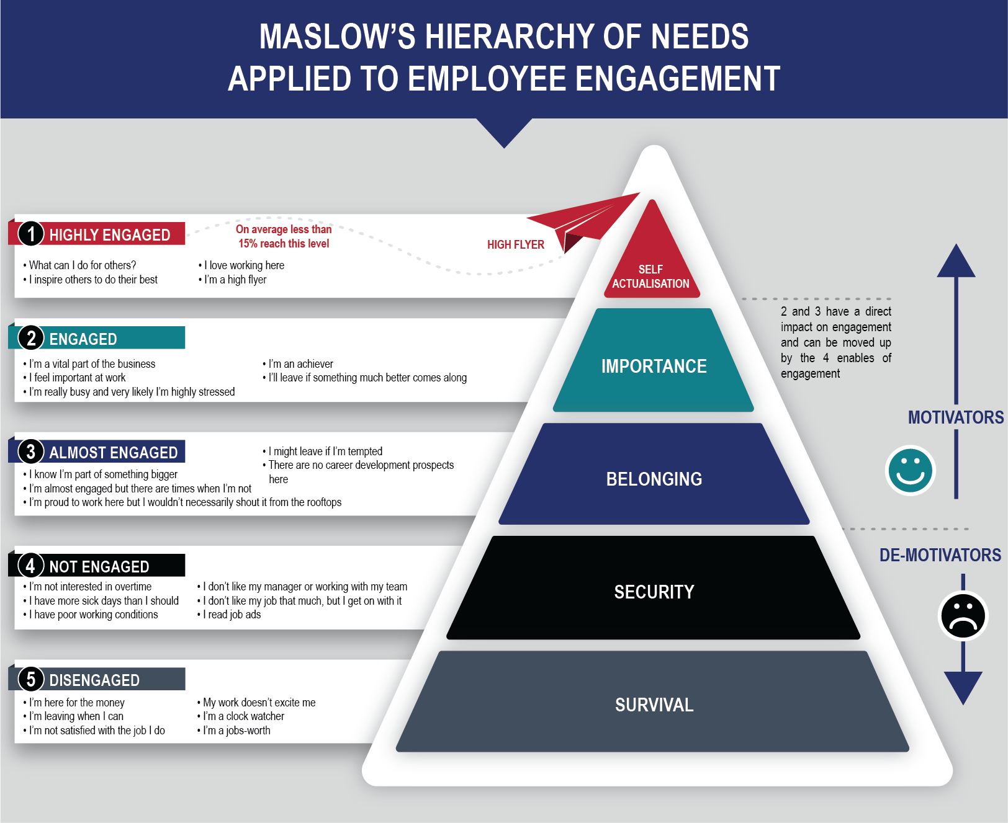
Source: https://www.incentivesolutions.com/employee-engagement-hierarchy-needs

Maslow’s theory of needs does a great work when it comes to motivation however there are some constructive criticisms that should not be left without bringing to the lime light. The five steps which begins with physiological needs through to self-actualisation needs does not follow the sequence for everyone. This is because some work their way through from the top through to the lower step so it’s not always the case of everyone and Abraham Maslow admits that himself (Mullins and Christy, 2010). A typical example is a volunteer worker may be motivated with self-actualisation first before coming down to think about the other four levels that shows it varies from a person to another (Mullins and Christy, 2010).

Maslow’s hierarchy of needs has been altered by another theorist called Alderfer. He has condensed the five stages into three levels which are existence, relatedness needs and growth needs (ERG) the reason why the model is often called the ERG model (Alderfer, 1972).
Mullins and Christy (2010) have explained the existence needs to be safety needs and physiological needs which are more of survival. Relatedness needs are more concerned with belongingness and relationship, love and affiliation and interpersonal relationships (Mullins and Christy, 2010). Growth stage covers esteem needs and self-actualisation thus pointing out potential and moulding or developing it. Notwithstanding the difference in the number of levels in each of the model, Alderfer and Maslow both share some similarities as they both believe people progress through the stages from Existence, Relatedness and then to Growth just as Maslow’s will begin from physiological needs through to self-actualisation needs. One conflicting view is that, whereas Maslow believes the stages are hierarch and must conform to the steps, Alderfer is of the opinion that the stages are more of continual bases than hierarch (Mullins and Christy, 2010). Alderfer is also of the opinion that is not always the case of progressing from a lower level to the top but there could be a starting point from the top to the lower level instead.
Fredrick Hertzberg believes there are yet another two factors that influence work and motivation. In his research, he identified two factors which are hygiene and motivating which denotes relationship between Maslow’s hierarchy of needs (Mondy et al, 1940).

Dissatisfaction at work is prevented by hygiene factors whereas individuals are motivated by the motivating factors to higher performance. Factors that can drive motivation at work can be named as promotion and growth, the nature of the work, recognition, involvement, responsibility and achievement. Factors such as work atmosphere, pay and working conditions such as benefits, organisation policy and administration, relationship with colleagues, supervision, work and life balance, job security, job satisfaction, status and leadership style come under the hygiene factors. Below shows the relationship that exists between Maslow’s hierarchy of needs and Hertzberg’s two factor model.

Fig 2: Similarities between Maslow’s model and Hertzberg two factor theory
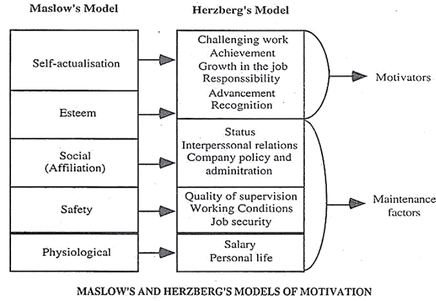
Source: https://www.iedunote.com/maslow-herzberg
Motivating factors are those factors that initiate engagement by establishing the right conditions to finally achieving self-actualisation for the employee and finest performance for the organisation which is win for both. Hygiene factors on the other hand are set to avoid disengagement within the workers. There is also a corelation between Maslow’s, Alderfer’s and Hertzberg’s motivation theories.

Table 2: relationship between Maslow’s Alderfer’s and Hertzberg’s theories of motivation.
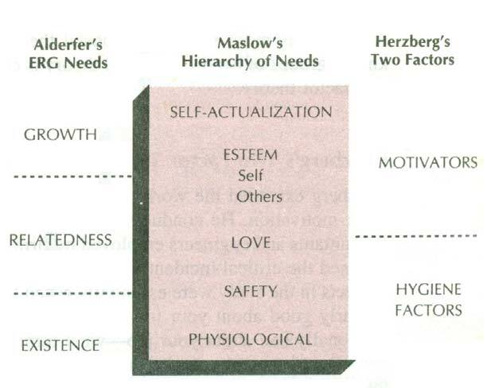
Source: (Luthans, 1998)

Table 3: Applying Alderfer’s ERG to the Objectives of this research
ser | Objectives | Alderfer’s ERG
1 | Measure the level of engagement within the British Army | Growth – for workers to be able to reach the Growth stage, Career progression and recognition may have adverse impact on their engagement level. Personnel in the Army will be well engaged if they can see progress in their career path
2 | Determine how recent job losses and limited operational deployments within the Army is impacting on employee engagement. | Relatedness – safety and job security
3 | Determine ways to engage employees. | Existence – this will take motivating employees with wages, good working conditions, suitable accommodations and allowances to satisfy their physical needs

Employee engagement in context

Globally, there is a low rate of employee engagement and this is evidenced by the various researches conducted by the Gallup organisation in many countries. There is an argument that engagement should be handled with maximum caution due to cultural diversity and difference in definitions as well as general evaluation of engagement (Kular et al, 2008). In 2005, a survey was conducted in Thailand by Gallup which revealed that 86 percent were actively disengaged, 6 percent too were disengaged and only 12 percent were engaged (Kular et al, 2008). Towers Perrin consulting firm survey conducted in 2005 revealed that only 14 percent of employees globally were engaged. Another survey conducted in the USA revealed that half of American workforce are disengaged or in other words not fully engaged (Johnson, 2004). These are not encouraging outcomes looking at the fact that engagement has vast benefits for the individual and the organisation as a whole (Serjits and Crim, 2006). Similar study conducted by Gallup in Singapore, New Zealand, Japan, China and Australia showed engagement level as 9 percent, 17 percent, 12 percent 18 percent and … percent respectively (Gallup, 2004).
A major research was conducted in 2004 by the International research consultancy International Research Survey (IRS). The research was conducted in about 10 of the world largest economy about nature and causes of engagement and how that can affect performance positively. The countries involved were France, The Netherlands, Hongkong Brazil, Australia, USA, Singapore, UK and Germany. It was emphasized that there was a massive disparity in employee involvement and commitment with employers among the countries. As an illustration, 59 percent of employees in France were found to be engaged with their organisation as compared to that of 75 percent of US and Brazil.
This is a clear indication that what will constitute as a determinant of employee engagement will be different to that of a different country. This means that management should consider the culture and beliefs of their employees in their specific country but not to follow the global researches conducted about employee engagement as this may not suit the drive of a particular workforce in a different region. Global research can be used as a framework or a tool to start with (ISR, 2004 cited in Kular et al, 2008). This is to avoid the placing of round pegs in square holes. Framework to address this would-be Hofstede Cultural Dimensions model.

Hofstede’s Cultural Dimensions

The beliefs, behaviours that governs how an organisation’s management and workforce handles and interrelate outside business operation is known as corporate culture (Tarver, 2021). The culture of a company is determined by the dress code, employee benefits, office set up, working hours, treatment of clients, its turnover, client satisfaction and every other operations or dealings. Hofstede has labelled his model as ‘mental programming’ or software of the mind (Hofstede, 1991). In a nutshell, culture is the way a group of people live, share common values together and how they behave. Employee engagement should be considered in different context because different countries have different culture and therefore one set up will not be suitable for the other. What works very well in France will not be the same as that of Germany because of different cultural settings. Hofstede’s cultural dimensions model was made to highlight the cultural differences in many countries and the extent to which this culture relates with engagement and performance. This also applies to various organisation as what may work for one organisation may differ from that of another organisation in that case the company values and set up will have to be different from the other.

Fig. 3: Employee engagement model

2. Working life
- Working hours and leave
- Flexible work-life balance
- Pay
4 Attitudes to work
- Satisfaction
- Commitment
- Stress and pressure
- Emotional response
- loyalty

6 Outcome
- Individual performance
- Intent to quit

1. Individual factors
- Gender
- Age
- Dependants

3 Management, leadership and communication
- Perception of line and senior managers
- Communication
- Appraisal
- Perception of organisational performance

5 Engagement
- Emotional
- Cognitive
- Physical

The diagram above shows the various aspects which are going to be addressed to answer the research questions.

Conclusion

Employee engagement is a complicated and multidimensional concept which has been intricated by more than 80 diverse meanings. It is of no doubt that majority of the definitions examined and used for this research is from Kahn’s (1990) definition which is focused around cognitive, emotional and physical engagement.
One definition that seems to have captured essence of engagement in almost every definition is Truss et al’s (2006). Employee engagement does not measure productivity and result but rather the mental and behavioural state of individuals making it difficult to measure precisely.
It is worthy of note that, the workforce is the focal point and the backbone of every organisation, for that reason their wellbeing contributes immensely to the success of every organisation. Without the workforce not a lot could be achieved. Management must always rate the conditions of their employees always high and that will contribute to high engagement that will lead to performance.

Chapter 3 – Methodology
This chapter is presented with research aims and objectives summary, additionally it also presents the overall research methodology implemented and the reason. It furtherly explains the method used for the research to attain and analyse the results used as well as putting and affirming the restrictions of the research into context. In a nutshell, it defines how the research was steered.

Research Aims and Objectives
Evaluating employee engagement within the British Army was the purpose of this research. Determining the effects of general sense of job losses and job insecurity within the British Army is the main aim of this research. These are the research questions:
- What is the level of engagement within the British Army?
- Have job losses within the Army adversely impacted on engagement?
- What categories of staff are more engaged?
The research is made up of three objectives which are:
- Measure the level of engagement within the British Army.
- Determine how recent job losses and limited operational deployments within the Army is impacting on employee engagement.
- Determine ways to engage employees.

These research questions have been preferred and pursued because they deliver an independent representation of experience of work within the British Army. The effects of job losses and the Army reform has on engagement should be discovered in the research. Lastly it is also more prudent to know which class is more engaged. It is the prior motive of every organisation to get its workers more engaged but if the managers of the organisation are less engaged than the non-managers, then it has to be taken less likely as that may have adverse effects on overall engagement (Truss et al., 2006). This is because managers are not just to motivate non-managers but more importantly to find ways of getting them engaged. This being one of the many researches made in this area, it is going to reveal enormous information which wasn’t revealed earlier so future researches in this sector can build their case on them.

Hypothesis

A 2019 BBC report stated that there has been a fall in the size of the British Army and figures showed that the Army was more than 7000 troops short of the government’s target of 82,000 (BBC, 2019). Some of the contributing factors are inadequate pay rise, limited deployment leading to boredom and Government intention to cut down the size of the Army which could lead to job insecurity.
A study by Gallup confirmed the link between job security and employee engagement. The main outcome of the study stated job insecurity meaningfully reduced the odds of employee engagement (Gallup, 2019). There was a decrease in employee engagement by 37% within workers who felt insecure about their jobs (Gallup, 2019). Current loss of jobs and possible future job losses are also probable to result in job insecurity and thus the generation of hypothesis 1 below.
Hypothesis 1
Employees working within the British Army will be less engaged.

Research Method

In this research, both primary and secondary data will be utilised. Literature review will mainly be comprised of the secondary data. After careful consideration, a quantitative method was chosen over qualitative. This decision was because quantitative research method emphasises objective measurements and the mathematical, statistical or numerical analysis of data (Babbie, 2010; Mujis, 2010). Its main focus is gathering numerical data and making a generalisation across groups or explaining a phenomenon (Babbie, 2010; Mujis, 20).
This is going to be an ideal approach if the research purpose is scope rather than depth. A qualitative method of research on the other hand focuses on “the intimate relationship between researcher and what is being studied, and the situational constraints that shape the inquiry” (Denzin and Yyonna, 2010 in Denzin and Yyonna, 2005: p.10). Quantitative method provides a comprehensive report of date hence suitable for profundity of understanding. Due to time and resource restriction, this research will emphasise on scope rather than depth. Similar researches have been conducted on the Army but there hasn’t been any since the last Redundancy tranche therefore interest will be to explore a wide range of areas. Future research can focus on a slender area. Quantitative will allow for a wide study, greater objectivity and accuracy of results, and avoiding personal bias. The downside of this is that although qualitative data is more efficient and able to test hypothesis, contextual detail may be missed (Babbie, 2010).
A survey has been deemed the most appropriate way to gather the primary data for the purposes of this research, due to the scope of the sample size. The survey will be based on the Charted Institute of Personnel and Development (CIPD) attitude and engagement survey carried out by Truss et al (2006). It has been tested for validity and covered the scope of the questioning required (Knight, 2011). The survey was used to conduct independent research by the Kingston Business School and Ipsos MORI. It was used to measure attitudes and engagement of 2000 employees in the UK. A modified version of the survey will be used to measure engagement levels of employees working within the British Army. The questionnaire will focus on the three dimensions which are: emotional engagement, being emotionally involved with work; cognitive engagement, focussing hard while at work; and physical engagement, willing to go above and beyond for an employer (Truss et al, 2006).

Survey Design

The survey has been designed to measure the level of employee engagement within the British Army. Engagement needs to be examined wholistically, this is because it holds aspects of job satisfaction, flexibility and the content of a job which has also been captured in the survey. Engagement should target both the individual and the entire organisation in order to achieve relevant result. Individual preference, job specification and managerial deed should form part of engagement. The survey used these two criteria, one is how participants feel and think about a particular issue and the other is centred on the individual’s age and gender. For participants to be given the opportunity to choose any of the outcome, a Likert scale was given to handle that.
Example:
In general, would you say your job is:

Mildly stressful

Moderately stressful

Very stressful

Extremely stressful

The response is scored as follows:
Response Score
Mildly stressful 1

Moderately stressful 2

Very stressful 3

Extremely stressful 4

The scores were then analysed via a data base
The survey was sectioned into 6 various areas in order to examine various aspects of engagement. The segments are enumerated below:

Table 3: Breakdown of survey
Section | Area | Question number
Section 1 | Working life | Q1 – Q3
Section 2 | Employer | Q4 – Q7
Section 3 | Job | Q8 – Q14
Section 4 | Job satisfaction | Q15 – Q18
Section 5 | Leadership and management | Q19
Section 6 | Communication | Q20 – Q23
Section 7 | The Future | Q24 – Q27

Sections of Questionnaire in detail

Section one

In every questionnaire, by default it begins with introduction as this did then followed by consent and also screen questions then followed by the actual survey questions. The introduction explains what the research seems to achieve and the rationale behind it. It also confirms that the research is anonymous and not commissioned by any organisation it furtherly informs potential correspondents that it is confidential. Participants were asked how intrinsically motivated are they to go to work each morning. They were also asked about job satisfaction and if they always have the zeal about the work they do. They were also asked how meaningful their job is to them. Theorist have argued that without working life balance, engagement will be low and that can greatly affect performance leading to low retention rate as covered in the literature review. Working life among members of the British Army is very sensitive and the seriousness the stakeholders of the Army take it the better, so information about working life in the survey could be used to shape the engagement rate in the Army which could improve employee engagement as a whole and increase performance and retention rate.

Section two

Section two is about the employer of the participants. It is imperative for every organisation to know how its employers communicate to the general public about the organisation for that reason, questions were asked about the organisation the participants work for. Just as every organisation would like to know how their employees speak about them to the entire world, the army is also keen to know if its employees speak highly of them or speak negative about them. This section is mainly about how the Army is branded in the employees’ point of view and that was covered from the very lower rank through to senior officers of the Army. Again, managers or stakeholders of the British Army can use this information to improve employees’ advocacy.

Section three

This section puts emphasis on the participants’ job and their emotional attachment to their daily workload. It also talks about the fact that there are some distractions in performing their job and why. The survey asked about how absorbed they are in performing their task thus whether they put their self into their job or just wait for the clock to tick. Other questions were also asked about the stress and pressure level and how they are supported when it comes to working life balance.

Section four

This section comprises of questioning the respondents about job satisfaction. Questions were asked about how satisfied they are and other job areas including performance, physical working conditions, freedom to operate as they desire, standard of work, rate of pay, knowledge and standard of work, recognition, chances of promotion and job security. The literature review talked about how job insecurity can bring about disengagement among employees. Relationship between them and their managers were also asked in this section. Most of the questions in this section are very crucial as they can easily bring about disengagement if not handled properly.

Section five

Section five asked participants about the leadership and management of their organisation. Questions such as recognition, consultation of employees, feedback on performance, training and development needs, fairness, supportiveness and recognition from management. Participants were again asked if their contribution counts and if their comments and concerns are taken on board too.

Section six

Communication which is the transfer of information from one party to the other with the information been understood is the key area here. Respondents were asked how well they are informed about the happenings in the organisation and how trusted the source is. The ability to channel their views upward was also asked. Ability for employees to feed their views upwards and feeling well-informed about what is going on is among the key drivers of engagement in Truss et al (2006) study. This makes employees feel that their grievances will be dealt with utmost fairness. Managers and leaders in the Army must take this information from the survey serious as it could be key to employee engagement.

Section seven

This section asked respondents about their future intentions of the Army. Intentions like whether they want to carry on with their job or to quit and if they want to quit why that decisions and what options they have or choose over their current job. The section is designed to ask respondents if their immediate future intention is to leave the Army and if is a s a result of disengagement. Also, if they have plan to leave and if they have done something about it.

E–Survey

Google Forms was used to make the electronic version of the questionnaire. The consent and the introduction screen used forced response. At this stage, a participant is made to respond to a question before progressing to the next one. If they don’t consent, then they are moved straight to the end of the survey. If they consent, then they can continue. The questionnaire was sub divided into sections and at each time its only one section that could be seen on the screen and could be answered before proceeding to the other section. This was done to control all the questions displaying on the screen to avoid putting the respondents off. There was also a bar to show the progress and what is left for the respondent to complete. After answering all the questions, respondent can then submit and also get confirmation of completion.

Sample
Soldiers of the British Army across many Regiments and Cap Badges were questioned. This included junior soldiers and senior soldiers. This was chosen to avoid biases and tunnel response. 180 respondents in total participated. 190 participants in total responded to the survey but some were rejected from the analysis because they were not members of the British army therefore do not meet the requirement.

Administration of the Survey

I personally spoke to the top hierarchy as well as the lower ranks of the British Army based is Dishforth-Airfield in Yorkshire and others who were even on assignment outside of the UK. I explain to them that I am embarking on an MBA and I have chosen this topic as my dissertation so I will need their utmost responds and they all welcomed the idea happily. I therefore designed electronic version of the questionnaire using Google Forms which I sent to them individually to participate and submit.

Limitations of the Research Method

Quantitative research was best for this study as its focus was on scope rather than depth. Quantitative data is better at testing hypothesis and also more efficient, contextual detail may be lost and this will be considered as a limitation. Notwithstanding, this limitation, there is an option on how to reduce this from occurring and this is by linking the data with Hofstede’s cultural dimensions to make available some framework which relate to engagement and the culture of the British Army. The CIPD 2006 questionnaire developed by Truss et al (2006) which has been tested for validity was adapted to avoid biases. There was another setback that if rectified and handled would have given a fair representation of the respondent, participants were not able to be grouped in a fair representation as to married soldiers and single soldiers as the working conditions that will motivate the other may differ. Also, another key point is, soldiers who were nearing their last stage of their career may not actually be bothered about giving the perfect representation of the Army and what changes would be embraced. I believe if there could be a clear data to rectify this that would not be bad but to counter that I think few of them may give in all as their families may still be in the Army and change will go a long way for them. The chosen of random participants is the best for this study and all limitations have been taken into consideration before coming out with the conclusion.

Analysis

The survey results were extracted from Google Forms to SPSS (Statistical Package for Social Sciences), after which SPSS was used to analysed. The three dimensions of engagement which are physical, cognitive and emotional were used to arrive at the final engagement level. Descriptive statistics such as means and standard deviation was established using preliminary data (Bryman, 2005). Three types of data analysis were used which are cross tabulation, regression analysis and correlation. In order to observe the variance existing between sub-groups, cross tabulation was used. They were then compared to be sure if there was importance in the difference. A typical example is determining if managers are more engaged than non-managers in the case of the Army, if higher ranks are more engaged than lower ranks. The data gathered in each sub groups were used to realise any statistical significance in the differences. Any variance in two sub groups is either real or by chance. Statistical testing was used by the researcher to determine real and significance variances between groups. There should be a clear difference in percentagewise in order to be considered as significant.
In this research, direction and strength of association amongst two variables were studied using correlation analysis. Gathering of associations rather than casualties was what the analysis was about.
Regression analysis was used to explore the relationship between two sets of variables outcome or dependant variables and predictor or input variables. To predict outcome such as engagement and performance, regression was used. It observes the possibility of association amongst variables. In other words, the degree to which relationship is likely to happen by chance Truss et al (2006).

Assessing engagement
Kahn’s (1990) definition is the pivot of this dissertation, everything is centred around his definition of engagement which is based on three components namely emotional engagement, physical engagement and cognitive engagement which has been well captured in the literature review.

Chapter 4 – Findings and Analysis

Findings

General Overview of Respondents
The survey received 178 participants in total out of which 10 were excluded from the analysis as they answered no to been in the British Army remaining 168. Of which 88.8% representing males were identified, 10.1% identified as females and 1.1% stated they prefer not to state their gender. Age wise, 57.3% represented ages 35-44, 19.7% represented ages 30-34, 10.1% represented ages18-24, 9% represented ages 25-29 and 3.9% represented ages 45-54. None of the respondent represented ages 55-65. Explanation in detail could be found in the Analysis section. The age distribution could be found in chart 1 below.
Chart 1 – Age of respondents
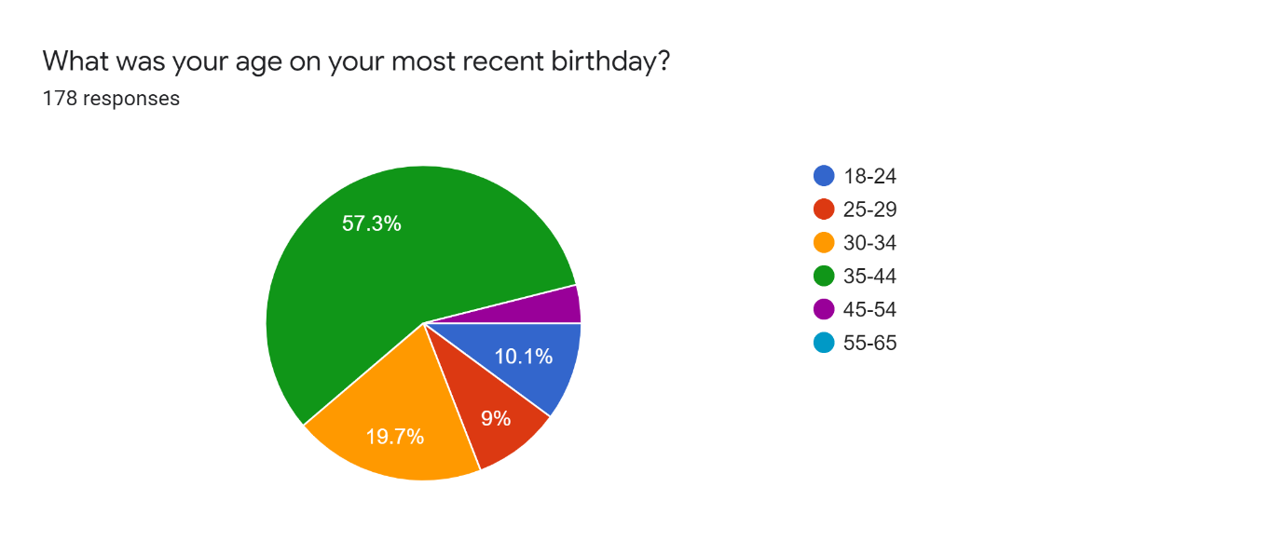
61.8% were identified as managers and 38.2% were identified as non-managers.
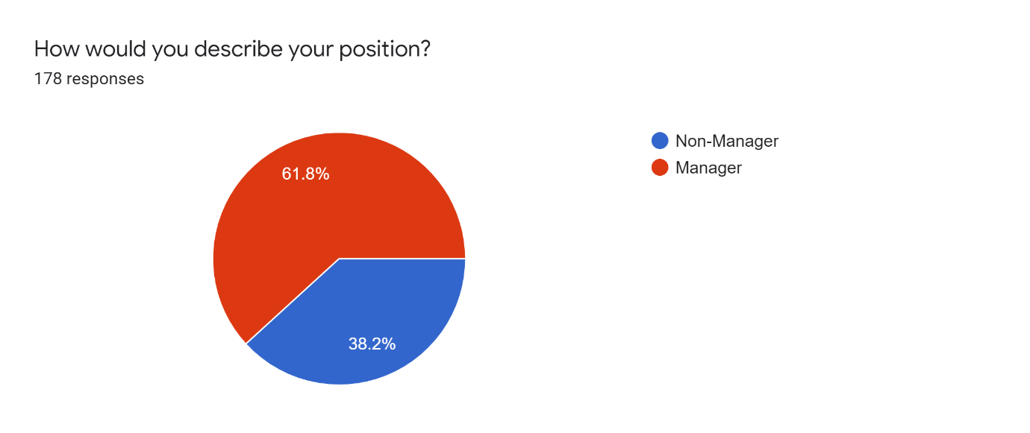
Looking forward to work
39.9% stated they look forward to work most of the time, 31.5% answered they look forward to work sometimes, 14.9% said the look forward to work all the time, 12.5% said they rarely look forward to work and 1.2% said they never look forward to work.
Chart – 2 Looking forward to work
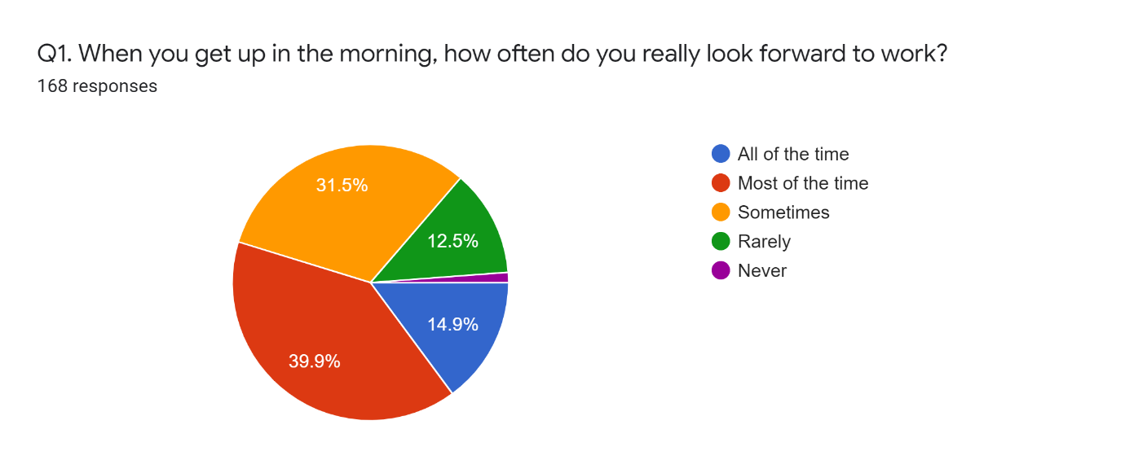

Emotional experience over past few weeks
Participants were asked how much of a time they feel miserable or optimistic at work in the past few weeks. 43.7% said they occasionally feel miserable, 32.5% said they feel miserable some of the time, 18.5% they were never miserable at work and 5.3% said they felt miserable most of the time. 39.6% also said they felt optimistic some of the time, 29.8% said they felt optimistic occasionally, 23.2 said they felt optimistic most of the time, 5.5% said they never felt optimistic and 1.8% said their job made them felt optimistic all of the time.
Chart-3 Emotional experience
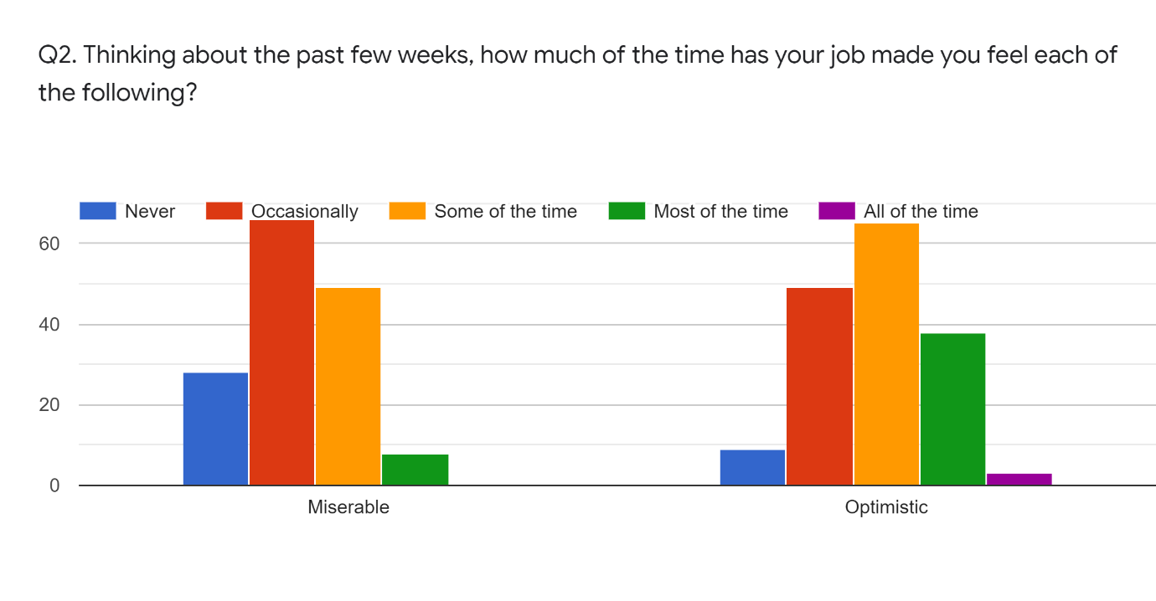
Meaningfulness
When respondents were asked if their job role was meaningful to them, 43.5% agreed, 23.8% said they neither agree nor disagree, 14.3% strongly agreed, 14.3% strongly disagreed and 4.2% disagreed to that.

Chart 4-Meaningfulness
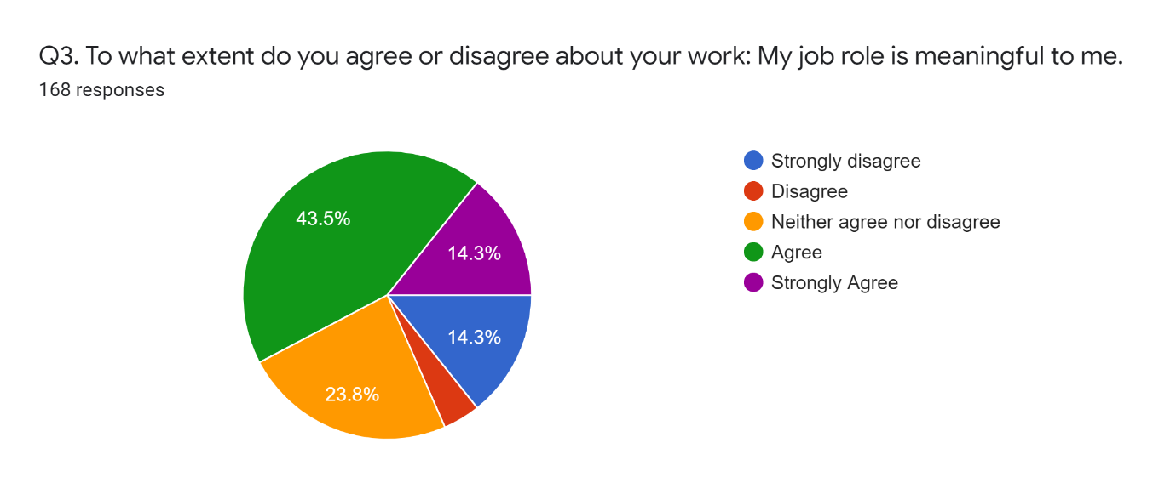

Employer
The participants were questioned about their employer through the survey, their loyalty and advocacy in working for their organisation, their pride and interest they have in their organisation.
Opinion on Employer
The survey sought to find out how participants would speak about their organisation as an employer, to the outside world. 36.9% said they would speak highly of their organisation if asked, 28% also said they would be neutral towards their organisation, 26.2% said they would speak highly of their organisation without being asked, 8.3% also answered they would be critical of their organisation if asked and 0.6% said they would be critical of their organisation without being asked.

Chart 5-opinion on employer
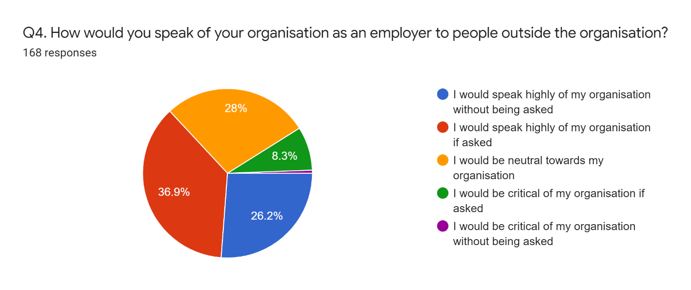

Pride
Respondents were asked how proud they are to tell people who they work for, 52.4% said they were very proud indeed 42% said they are quite proud and 5.4% said they are not very proud. None of the respondent said they were not at all proud.
Chart 6 - pride in employer
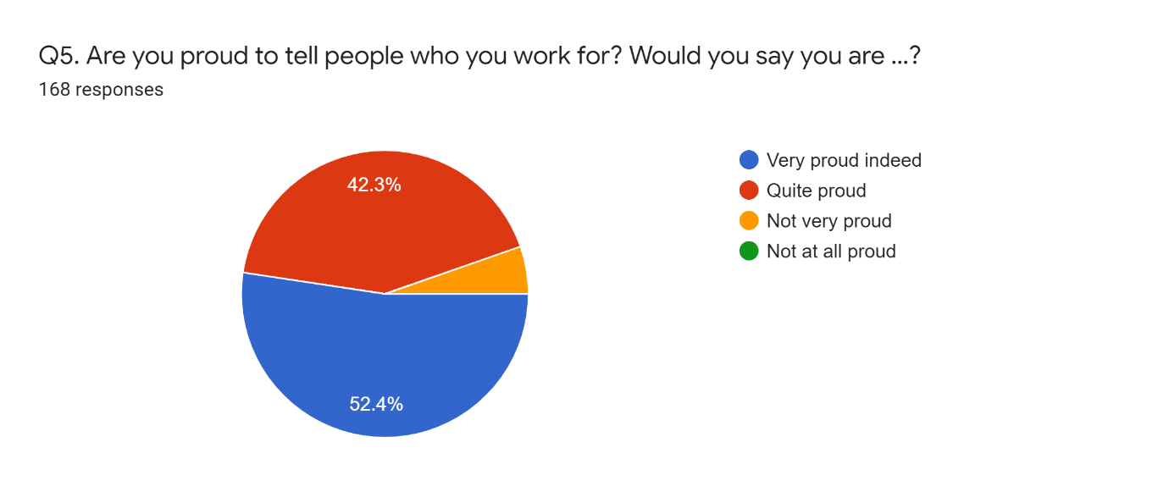

Interest in organisation
When respondents were asked about their views on working for their organisation, 53% said they would like to know what is going on and get more involved, 30.7% said they would like to know what is going and are already involved, 9.6% also said they are not really interested in their organisation it’s just a job and 6.6% said they would like to know what’s going on but they don’t want to get involved.
Chart 7 – interest in organisation
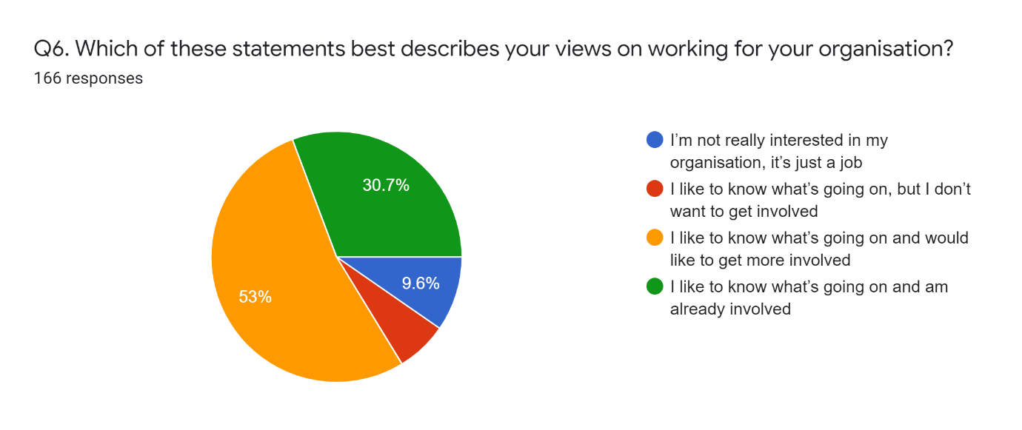

Loyalty
When participants were asked how much loyalty they felt towards their organisation and their immediate supervisor, 70.83% said they felt a lot of loyalty towards their organisation, 19.6% said they felt some loyalty towards their organisation, 5.95% also said they felt only a little loyalty towards their organisation and 3.57% said they had no loyalty at all. On loyalty towards immediate supervisors, 48.21% said they had a lot of loyalty, 34.52% said they had some loyalty, 7.74% said they had only a little loyalty whereas 3.57% said they had no loyalty at all and 1.79% answered they didn’t know how they feel towards their immediate supervisor.
Chart 8 – loyalty towards organisation and immediate supervisor
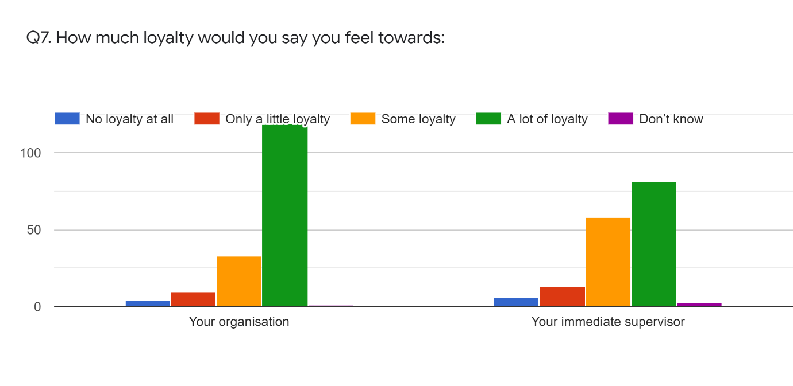
Job
Participants were asked about work, pressure, stress, work/life balance and control in order to access their engagement level.
Engagement with work
Chart 9 gives details of the engagement level reached in the whole research and details of this is given in the Analysis section.
Chart 9 – engagement with work
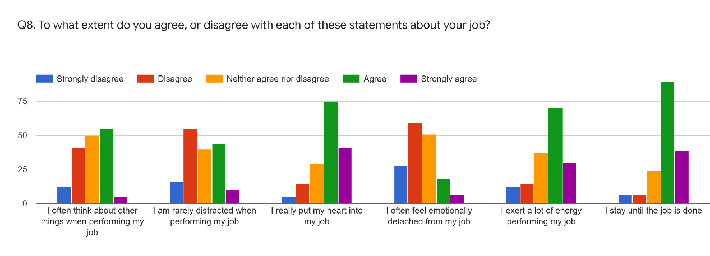
Stress
Respondent were asked about how stressful their work is and 52.4% said they were moderately stressful, 20.2% said they were very stressful, 17.3% said they were mildly stressful, and 6.5% said they were extremely stressful and 3.6% said they were not stressful at all.
Chart 10 – stress
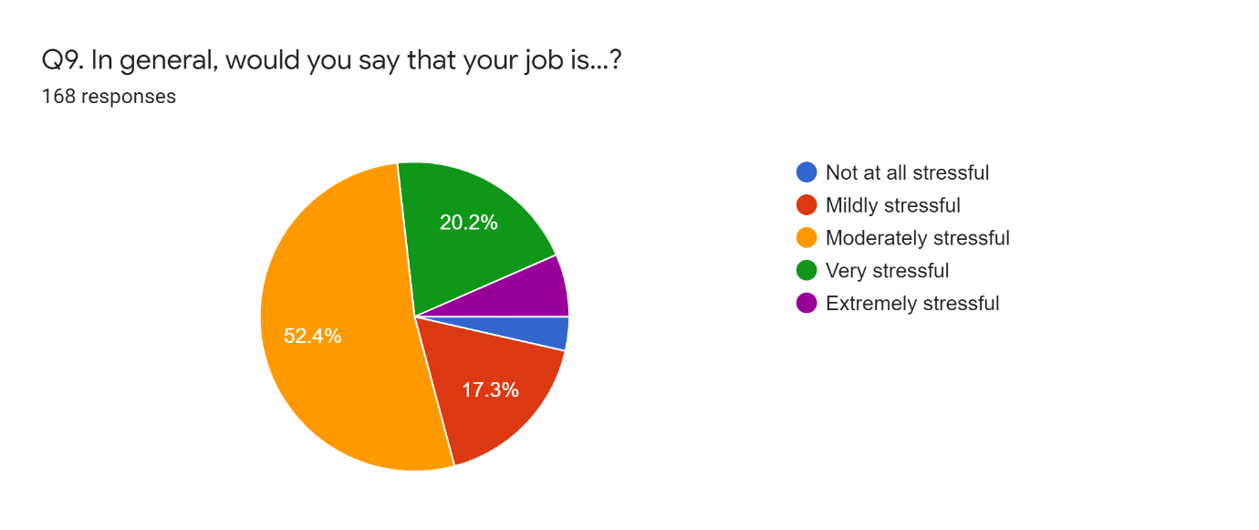Pressure
When participants were asked about how much of a time they feel under excessive pressure in their job, 38.1% answered once or twice in a month, 36.3% answered once or twice a week, 20.2% said every day and 5.4% said every day.
Chart 11 – Pressure
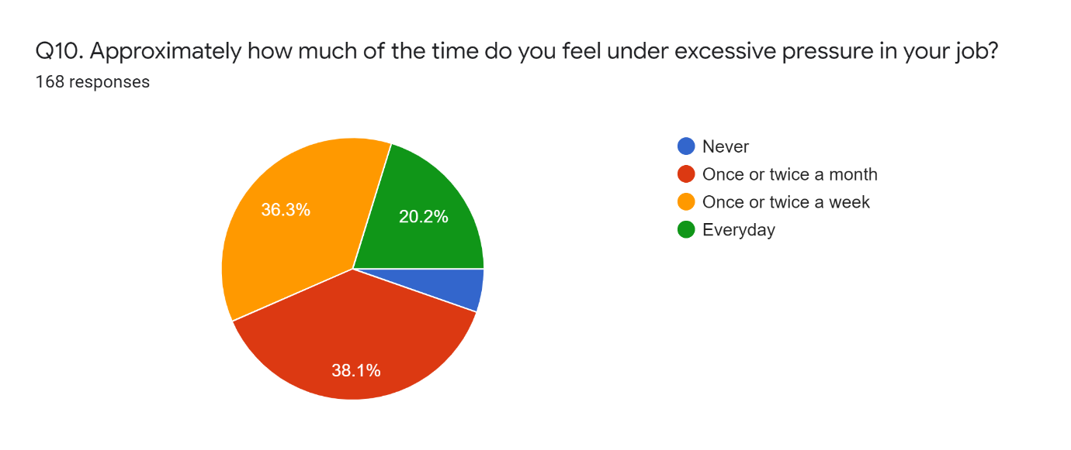
Control
When participants were asked how much of control, they have over the way they do their job, 57.5% said they had a fair amount of control, 15% said they had a great deal of control, 13.8% said they did not have much of control, 10.8% said they had just a little control and 3% said they had no control at all.
Chart 12 – Control
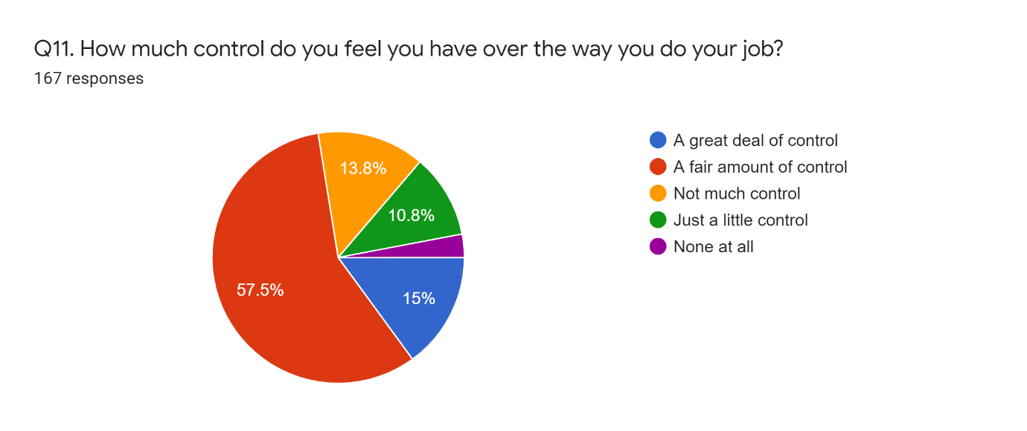

Work/life balance
When participants were asked if they do get the right balance between home and work lives, 36.3% said they neither agree nor disagree, 28.6% said they agree, 21.4% said they disagree, 7.1% said they strongly disagree and 6.5% said they strongly agree.

Chart 13 - Work /life balance
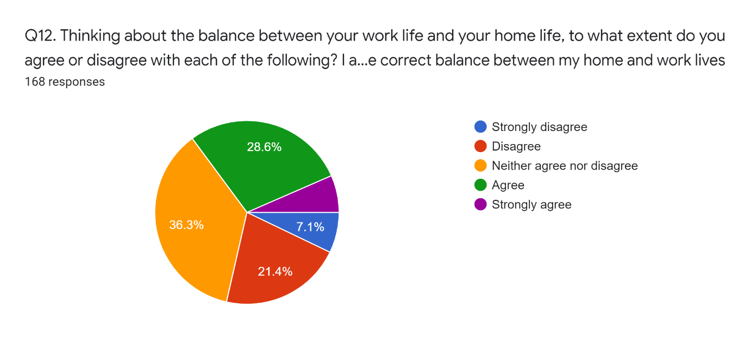
Manpower reduction and limited Operational Tour
When asked if the recent reform relating to manpower reduction and limited Operational Tour changed their approach to work, 41.7% said they neither agree nor disagree, 24.4% said they agree, 21.4% said they disagree, 7.1% said they strongly agree and 5.4% said they strongly disagree.

Chart 14 – Manpower reduction and limited Operational Tour
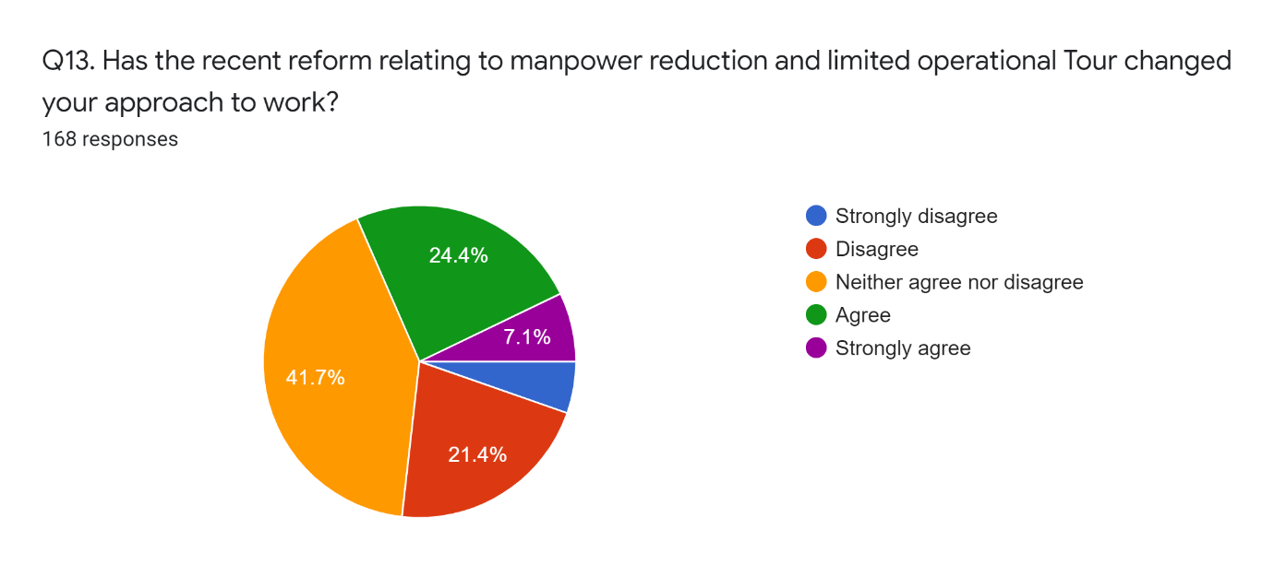
Engagement and Motivation
When asked if they feel more engaged and motivated with salary increment as compared to deploying on Operations, 32.7% said they neither agree nor disagree, 31% said they agree, 26.2% said they disagree, 6% said they strongly agree and 4.2% said they strongly disagree.
Chart 15 – Engagement and Motivation
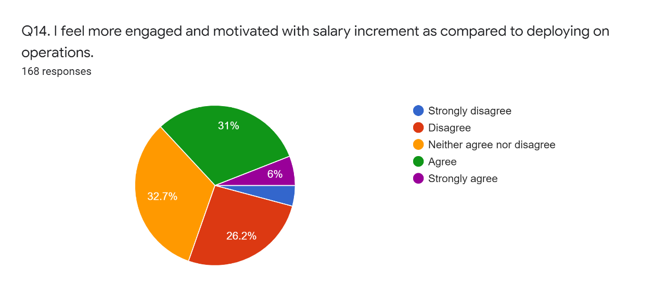

Job satisfaction
To be able to assess job satisfaction, respondents were questioned about their rate of pay, recognition, overall satisfaction, performance and job security.
Rate of pay
When participants were asked about their rate of pay and the extent to which they agree or disagree with it, 34.5% said they neither agree nor disagree, 34.5% said they agree, 23.2% said they disagree, 5.4% said they strongly disagree and 1.2% said they strongly agree.

Recognition
Participants were asked the extent to which they agree or disagree with the recognition given them when a good work is achieved, of which 38.1% said they agree, 29.8% said they neither agree nor disagree, 16.7% said they disagree, 8.9% said they strongly disagree and 5.4% said they strongly agree.
Overall satisfaction
Participants were asked how satisfied they are with their current job and 54.2% said they are satisfied, 19% said they are neither satisfied nor dissatisfied, 12.5% said they are dissatisfied, 10.1% said they are very satisfied and 4.2% said they are very dissatisfied.
Performance
They were asked if overall they perform to their best ability, 47.6% said yes, they agree, 34.5% said they strongly agree, 11.9% said they neither agree nor disagree, 5.4% said they strongly disagree and 0.6% said they disagree.

Job security
Participants were asked to what extent do they agree or disagree with their job security, of which 53% said they agree, 32.1% said they strongly agree, 11.3% said they neither agree nor disagree, 2.4% said they disagree and 1.2% said they strongly disagree.

Chart 16 – Recognition, Rate of pay and Job security
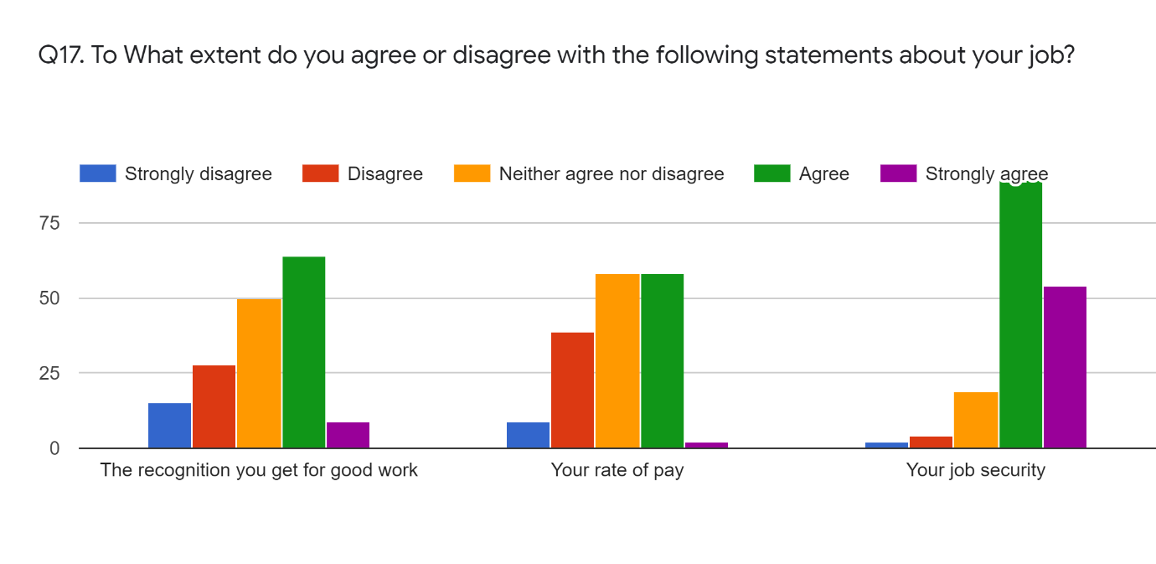
Performance: Participants were asked about how they think their performance was comparing with others doing similar job, 45.8% said their performance was higher, 25.6% said their performance was much higher, 17.3% said their performance is about the same as others in similar role, 8.3% answered they don’t know, 1.8% said their performance was much lower and 1.2% said their performance was lower.

Leadership and management
Chart 17 – Leadership and Management
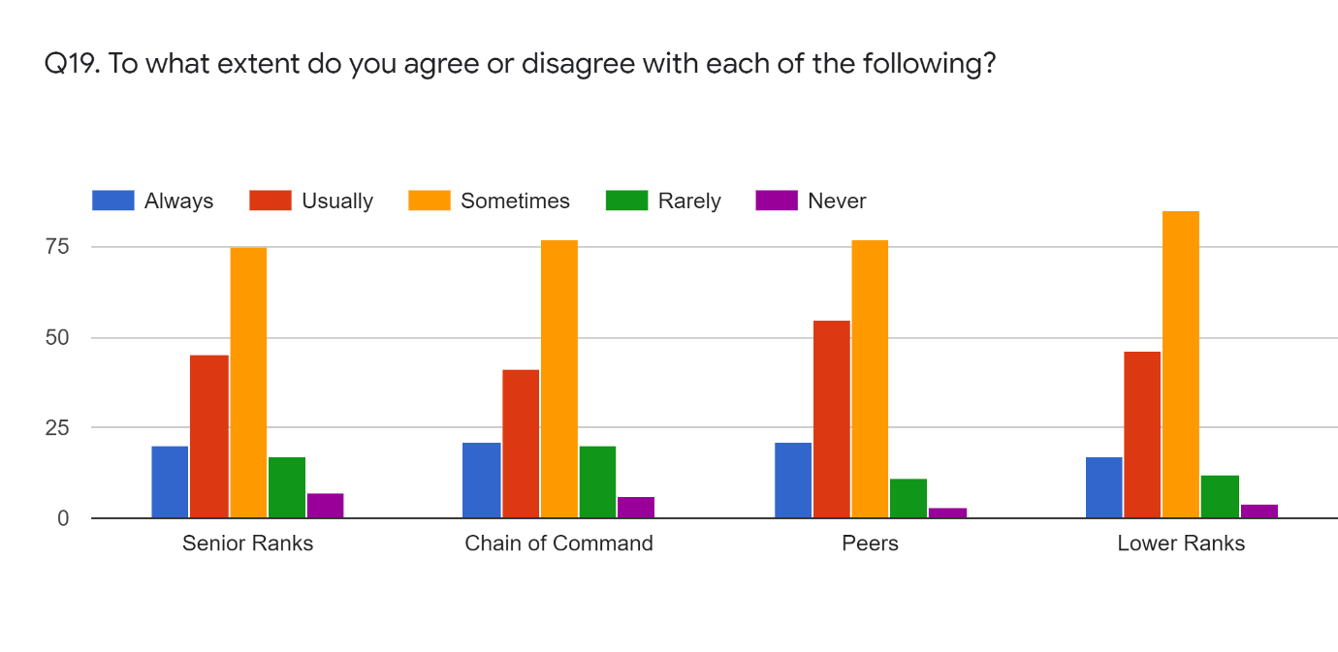
Assessing the views of participants on leadership and management of their organisation, they were questioned to what extent do they agree with the views of their senior ranks, chain of command, peers and lower rank. Of which 44.6% said they agree with senior ranks sometimes, 26.8% said they usually agree with senior ranks, 11.9% said they always agree with senior ranks, 10.1% said they rarely agree with their senior ranks and 4.2% said they never agree with their senior ranks. When asked to what extent do, they agree or disagree with their Chain of Command, 45.8% said they agree with them sometimes, 24.4% said they usually agree, 12.5% said they always agree, 11.9% said they rarely agree and 3.6% said they never agree.
When senior ranks were asked to what extent do, they agree with the views of their lower ranks (subordinates), 50.6% said they agree with them sometimes, 27.4% said they usually agree, 10.1% said they always agree, 7.1% said they rarely agree and 2.4% said they never agree.

Communication
To be able to assess communication within their organisation, participants were asked if they believe in the information they receive, conflict resolution and feedback opportunities as well as if they are kept well informed.
Believe of information
Out of 168 participants, 42% said they usually believe information they receive, 26% said they believe it about half of the time, 15.5% said they usually believe it, 8.3% they seldom believe it, 3.6% said they never believe it whereas 3% said they have no opinion.
Chart 18 – Believe information
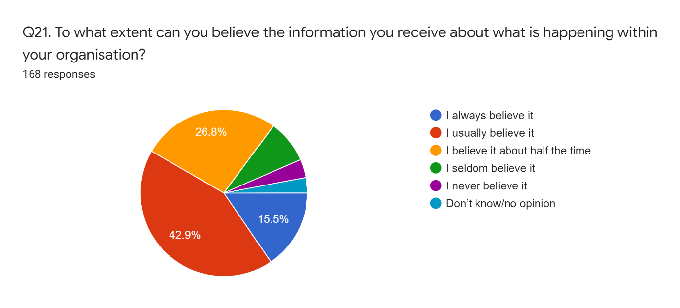

Conflict Resolution
Participants were asked if they would be confident that if they have a problem at work, it would be dealt with fairly. These were the response, 39.5% said they agree, 34.7% said they neither agree nor disagree, 10.2% said they disagree, 9% said they strongly disagree and 6.6% said they strongly agree.
Chart 19 – Conflict Resolution
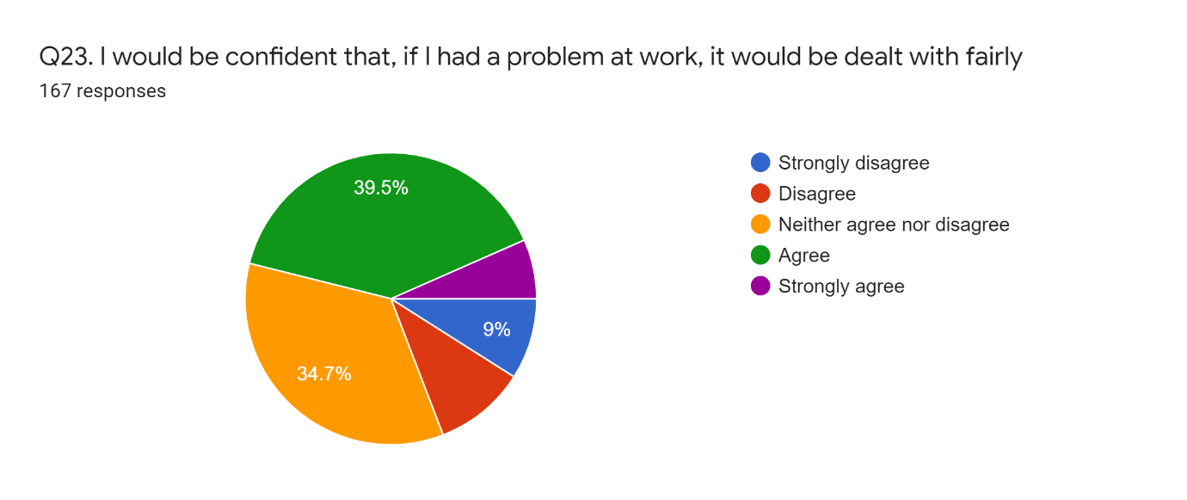
Employee voice (Feedback opportunities)
Participants were asked how satisfied they are with opportunities to feed their views upwards, 36.3% said they are satisfied, 35.7% said they are neither satisfied nor dissatisfied, 17.3% said they are dissatisfied, 6.5% said they are very satisfied, 2.4% said they are very dissatisfied and 1.8% said they don’t know.
Chart 20 – Feedback opportunities
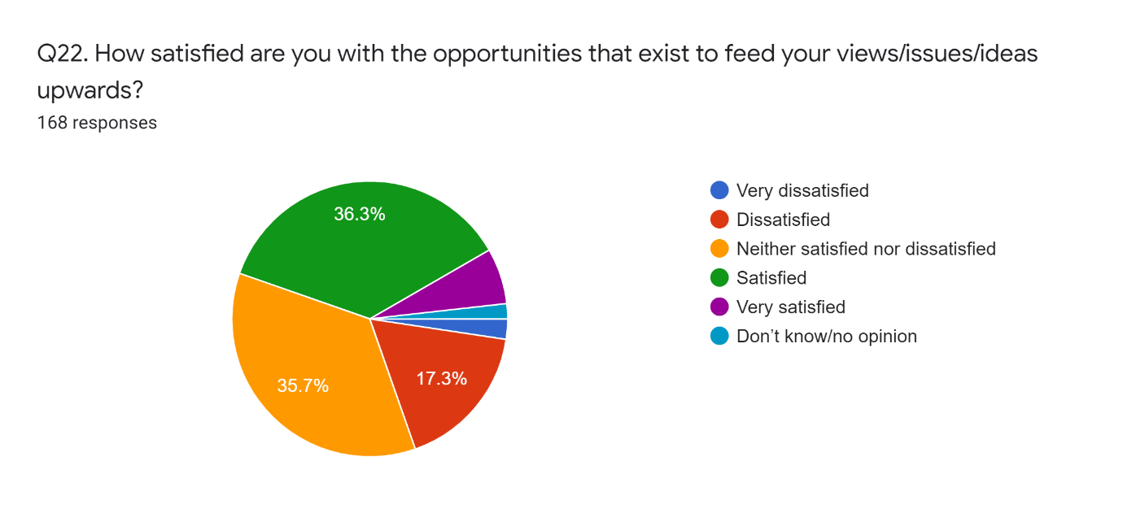

Kept informed
When participants were asked how well informed are they with activities going on in the organisation, 44.6% said they are been kept well informed by their organisation, 27.4% said they are being given only limited amount of information, 16.1% said their organisation keeps them fully informed whilst 11.9% said their organisation doesn’t tell them much at all about the happenings in the organisation.
Chart 21 – Kept informed
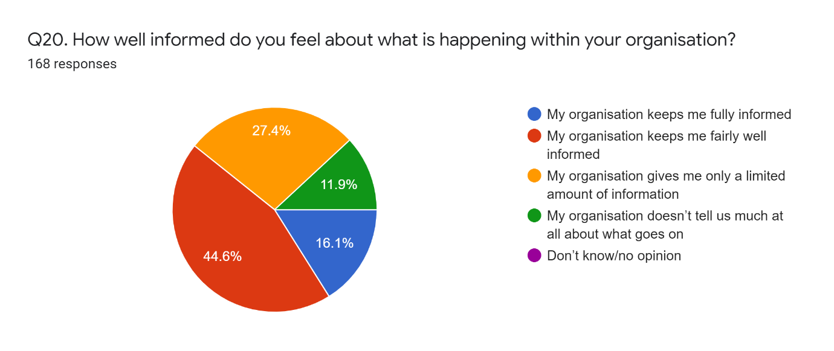

The Future
The future intentions of participants about their organisation were assessed by asking questions about their intentions to remain with current employer, intentions to leave and reasons to quit current job and intentions to stay in current job.

Intentions to remain with current employer
When participants were asked about their intentions to remain with current employer, 65.5% said yes, 17.9% said they don’t know and 16.7% also said no.
Chart 22 – Remain with current employer
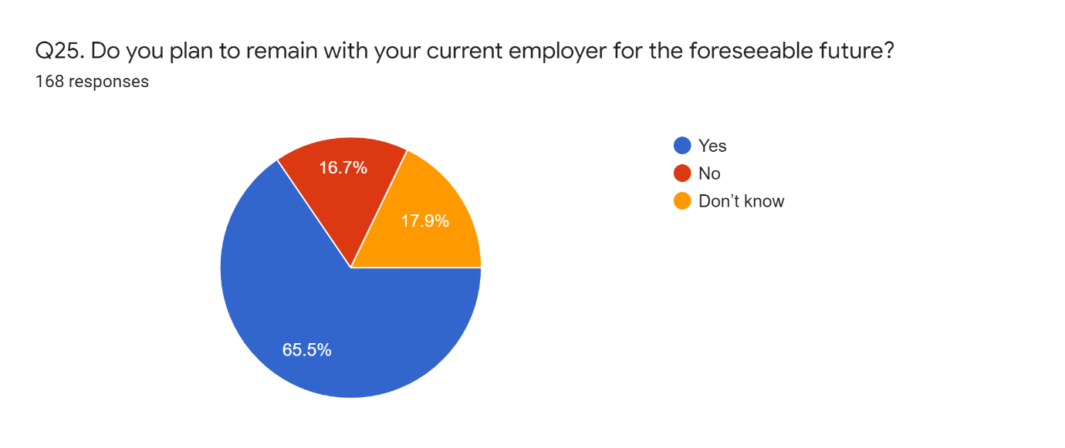
Intentions to leave
When participants were asked if they had ever thought about or done anything to leave their current job, 49.4% said they have sometimes thought about leaving their job but have never done anything about it, 29.8% said they have never thought of leaving their job, 15.5% said they have looked around for other jobs and 5.4% said they are currently in the process of leaving this job.
Reasons to quit
When asked about reasons to quit their current job, 18.1% said to find better pay/benefits elsewhere, 16.1% said for job and satisfaction and similar percentage also said to do a different type of work, 14.8% said opportunities for promotion, 14.1% said to be self-employed, 10.1% to find a different job within their organisation and 0.7 % said family and welfare, not enough family time, they are not leaving their job, be closer to their newly bought house, the chance to do the job they opted for. This was the only question that was optional so the responses were 149 so the percentage was not representative of the whole survey.
Intentions to stay in the current job
Participants were asked to what extent do they intend to stay where they are in their current job within the next year. These were their responses: 67.9% said they will gain upward promotion to a higher level, 13.1% said they will move to a position of similar responsibility in another area of their organisation, 9.5% said they will stay where they are in their current job, 7.1% said none of the above and 2.4% said they do not know.

Chart 23 – Intentions to stay in current job
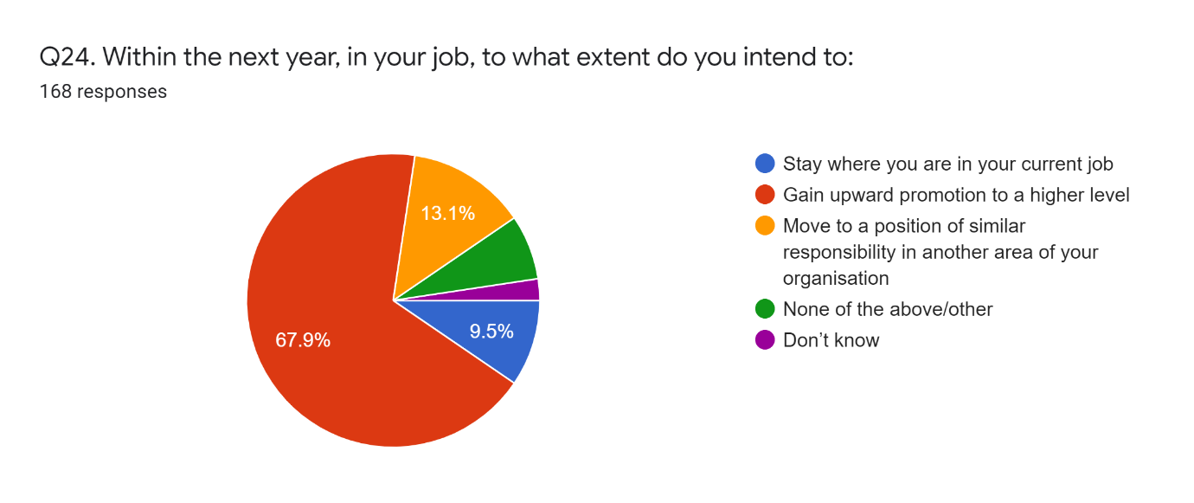

Analysis of Results

Assessment of cognitive, physical and emotional engagement
This report contains the results of reliability, cross-tabulation and correlation analyses. It is structured as the following.

Reliability analysis

The first step was to test the reliability of the concepts that will be used as dependent and independent variables of this research. Cronbach’s Alpha was used for this. The results are shown below. None of the scales that have more than a single item have achieved the minimum acceptable level for Alpha (0.700). Thus, the individual items need to be considered separately on the remaining analyses.

The table below is extracted from question number 8 which is about Emotional, Cognitive and Physical engagement of the employee and question 17 which is also about the recognition and respect the workers get from their organization.
These survey questions can be found in Appendix 1.

 | Question | N | Mean | Cronbach's Alpha
COGNITIVE | Cognitive 1 | 162 | 3.01 | -0.382
COGNITIVE | Cognitive 2 | 162 | 2.85 | -0.382
EMOTIONAL | Emotional 1 | 162 | 3.81 | -0.287
EMOTIONAL | Emotional 2 | 162 | 3.51 | -0.287
PHYSICAL | Physical 1 | 163 | 3.56 | 0.610
PHYSICAL | Physical 2 | 163 | 3.87 | 0.610
TOTAL | Cognitive 1 | 161 | 3.01 | 0.331
TOTAL | Cognitive 2 | 161 | 2.85 | 0.331
TOTAL | Emotional 1 | 161 | 3.80 | 0.331
TOTAL | Emotional 2 | 161 | 3.51 | 0.331
TOTAL | Physical 1 | 161 | 3.57 | 0.331
TOTAL | Physical 2 | 161 | 3.87 | 0.331
RECOGNITION/RESPECT | Respect 1 | 166 | 3.14 | 0.548
RECOGNITION/RESPECT | Respect 2 | 166 | 3.03 | 0.548
RECOGNITION/RESPECT | Respect 3 | 166 | 4.13 | 0.548

All the above variables have been individually considered separately in the analyses.

Cross-Tabulations

Methodology
The goal of this analysis was to assess the differences that different groups have in terms of the engagement indicators. The results can be found on the ‘Results’ excel file. The tab ‘Graphs_PerQuestion’ shows the frequencies of each question per gender, age and position. This table is supported by a statistical test for proportion differences.
This test is used when you wish to explore the relationship between two categorical variables. Each of these variables can have two or more categories. This test compares the observed frequencies or proportions of cases that occur in each of the categories, with the values that would be expected if there was no association between the two variables being measured. It is based on a cross-tabulation table, with cases classified according to the categories in each variable (e.g. male/female; smoker/non-smoker) (Pallant, 2010).
In the case of this study, the association between age, gender and position with engagement were evaluated. Statistical differences are represented as subscript letters. If any pair of groups show different letters, that means that the different proportions observed are statistically different. These tests are sensitive to sample size, so a lack of statistical significance does not necessarily mean that differences do not exist, but that there is no sufficient statistical power in the test. According to the table shown in the ‘Graphs_PerQuestion’ tab, there is a difference between males and females when it comes to being engaged considering the question ‘Emotional - I often feel emotionally detached from my job’ (29.41% for females against 55.56% for males). The different subscript letters indicate that. The rest of the table follows the same logic.
The second tab shows the average frequencies for each engagement dimension. This test does not have the statistical assessment as integrating the question was shown to be not reliable as demonstrated earlier. Nevertheless, the results might be useful.
The third tab shows a total average considering all the six engagement questions.

Correlations

Correlation coefficients are indicators of associations between variables (Pallant, 2010). Values between 0.10 and 0.29 indicate a small degree of association, while values between 0.30 and 0.49 are considered medium and values higher than 0.50 represent a high degree of association (Cohen, 1988). This test will be used to measure the association between different types of engagement and several other variables.
There are a number of different statistics available, depending on the level of measurement and the nature of your data. Pearson’ coefficient ‘r’ is designed for interval level (continuous) variables, whereas Spearman’s ‘rho’ is designed for use with ordinal level or ranked data and is particularly useful when the data does not meet the criteria for Pearson correlation (Pallant, 2010). As the variables under study are measured in an ordinal level (5-points), Spearman’s test was used. Age was evaluated through cross-tabulations and was not included in the correlation analysis since it is a categorical variable.
The first figure (below) shows the correlation coefficients between engagement and performance. The ‘Sig.’ line refers to the p-values of each pair of variables. P-values lower than 0.05 indicate statistically significant correlations. The last column shows that performance is significantly associated with ‘COGNITIVE - I am rarely distracted when performing my job’ (r = 0.169, p < 0.05). The relationship is positive and the strength of the correlation is low. Performance is also significantly positively associated with ‘EMOTIONAL - I really put my heart into my job’ (r = 0.182, p < 0.05) with a low intensity as well.
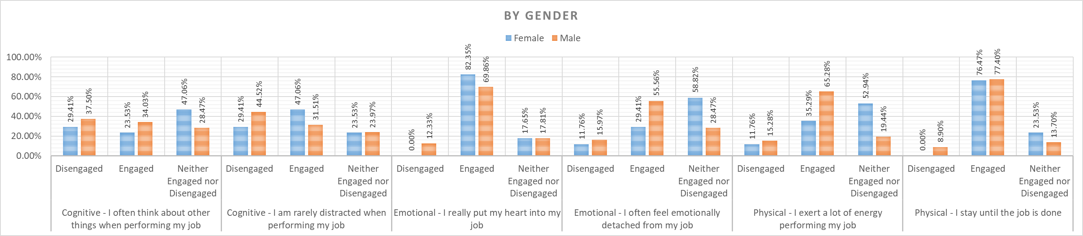
Statistical evidence of the summary analysis has been given below:

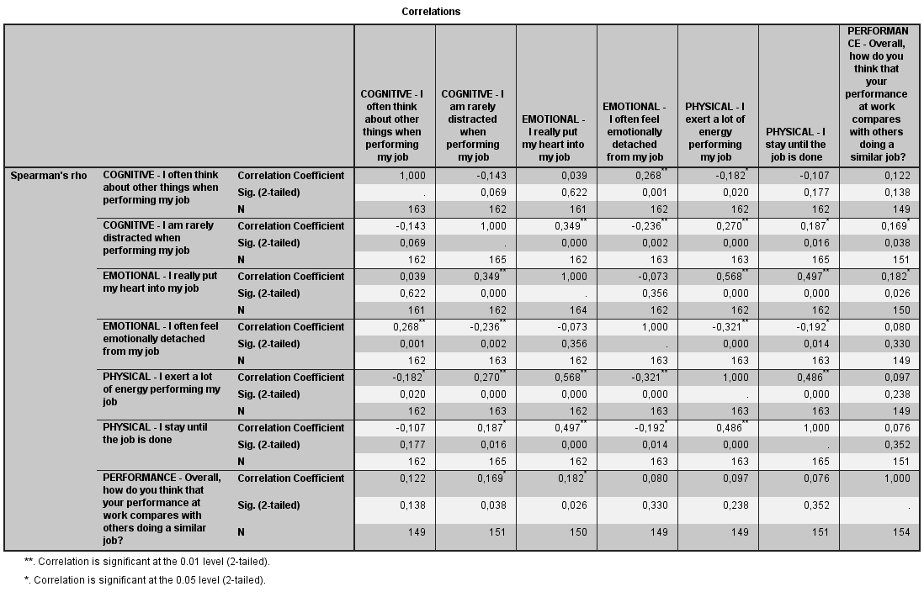
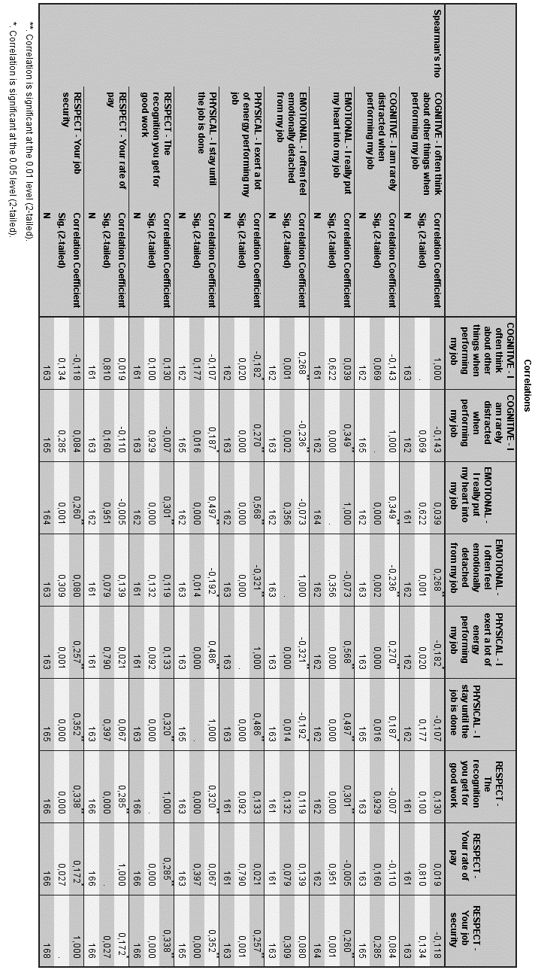
The next figure shows the correlations between engagement and ‘Respect’ variables.

All significant associations are marked with a star next to the coefficient. The table shows that there is a moderate association between ‘RESPECT – Your job security’ and ‘PHYSICAL - I stay until the job is done’. This item is also significantly correlated with ‘PHYSICAL - I exert a lot of energy performing my job’. The positive sign of the coefficient means that when one variable increases, the second variable increases as well. This ‘Respect’ item also correlates with ‘EMOTIONAL - I really put my heart into my job’. In terms of ‘Your rate of pay’, agreement with the rate of pay is not statistically correlated with any of the engagement items, whilst ‘Recognition you get from work’ is positively associated with putting the heart in the job and staying until the job is done.
Lastly, the figure below shows the correlations between engagement and intention to quit.

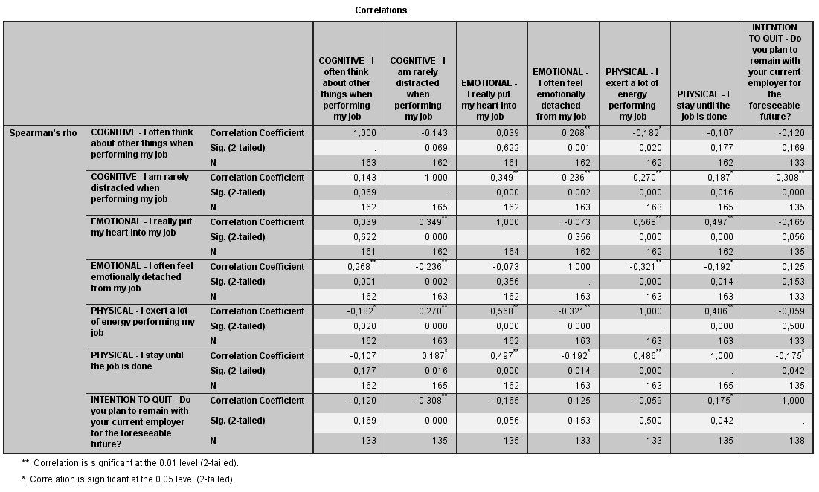

Intention to quit is moderately associated with being rarely distracted when performing the job. The association is negative which means that the less the engagement, the higher the intention to quit. Intention to quit is also negatively associated with staying until the job is done, but with a low intensity.
The table below shows a summary of the statistical result:

Summary

The table below shows the main highlights that can be extracted from the analyses.

Analysis | Main Highlights
Group comparisons | - Males are more engaged in terms of exerting a lot of energy performing the job;  - Workers from 35-44 years old are more engaged in terms of exerting a lot of energy performing the job;  - Workers from 18-24 years old are less engaged in terms of putting their hearts into the job.  - Workers from 35-44 years old are more engaged in terms of rarely being distracted when performing the job;  - There are no statistical differences in terms of being a manager or not in terms of engagement.
Correlations - Performance | Putting the heart into the job and being rarely distracted when performing the job are positively correlated with performance.
Correlations – Respect/Recognition | - Putting the heart into the job and staying until the job is done is positively correlated with the feeling of being recognized for good work.  - Putting the heart into the job, staying until the job is done and exerting a lot of energy in the work are positively correlated with ‘Job security’.  - ‘Your rate of pay’ is not significantly correlated with any of the engagement indicators.
Correlations – Intention to Quit | Being rarely distracted and staying until the job is done are negatively correlated with intention to quit the job.

The diagram below shows statistical result of engagement level by age.

CHAPTER 5 – Discussion, Conclusion and Recommendation

Discussion

The research exhibited quite high levels of employee engagement in some areas whilst some areas also were neither high nor low. Because the survey was made to cover scope rather than depth, it answered questions on ‘What’ but does not answer the ‘Why’ on most areas and this can be attributed to limited time at hand for the participants. The question one may ask is, why is engagement level still high in the British Army in spite of the reforms. Could it be that it has proven to be a reliable source of income during the COVID-19 era or there is job security in this vulnerable COVID era? Could it also be that the sector employs dedicated and committed workforce who would remain engaged no matter what. It could also be argued that, the most engaged ones are the majority and happen to be dominating the survey. Truss et al (2006) Employee engagement is linked with performance but not enough to hinder it. The research revealed a potent workforce overall with majority of them willing to speak highly of their job and look forward to going to work each day. Majority also stated that their job is also meaningful to them and would recommend to others any day. Also, very good amount of the workforce was happy with their pay and has respect and loyalty for their organisation. Good number of the workers are willing to commit for the next foreseeable future which is good for retention and will save the organisation a lot of resources and money from recruitment.
Notwithstanding all the good reasons why the workforce is satisfied with their organisation, there were some areas that had some concerns.

Work/life balance
There were over 28% wo had issues with work/life balance and over 36% neither agree nor disagree, this means that employees think they do not have the correct balance in their home lives and working which can also affect their performance and commitment level leading to disengagement.
Stress and Pressure
There were over 20% in each of these areas who said their work gives them stress and there is a lot of pressure in performing their job. This can have impact on their mental well-being which can in turn affect performance so the management should look at way of neutralising this in order to get their employees working with little or no stress at all.
Thought of leaving the job
With 49.4% ever thought of leaving the job before, it doesn’t matter if they have done something about that thought or not, that means that needs to be looked at because there could be a negative reason that needs to be tackled.
Communicate/respect
To every organisation, communication is very paramount and key to the success of the organisation which the Army is not an exception. The fact that some percentage has shown concerns on information passage, that means it is an area that needs to be looked at. This is because there is a slogan in the Army that “every man is a link man” therefore effective communication is key.

Implication
Finding ways managers can engage employees was one of the objectives of this research. Even though engagement levels were generally high, there were areas where managers can improve to lift the level of engagement or if for nothing at all to prevent disengagement within the sector. These areas will now be discussed with their management implications when it comes to employee engagement.
Work/Life balance
Work/life balance is an area where every organisation is keen in blending very well for their employees as it makes workers feel they are not only glued to their work but can also have their personal life to live too. With 21.4% disagreeing, 36.3% staying neutral and 7.1% saying they strongly disagree is a clear indication that there is a problem in this area.
Stress and Pressure
Performance can be affected if employees are constantly stressed out and pressurised in their daily activities. 20.2% said they were very stressful, 17.3% said they were mildly stressful, and 6.5% said they were extremely stressful. This area should be looked at as this can affect engagement.
Thought of leaving current job
For 49.4% to say they have sometimes thought about leaving their job but have never done anything about it that means there could be something that is not right in the organisation that needs to be looked at. Even though, 29.8% said they have never thought of leaving their job, 15.5% said they have looked around for other jobs and 5.4% said they are currently in the process of leaving this job.

Communication/respect
A very delicate area where attention must be paid to the concerns here as 26% said they believe information given to them by the company about half of the time with only 15.5% saying they usually believe it, 8.3% said they seldom believe it and 3.6% said they never believe it which means there is lack of effective communication in the organisation.

Validity
The research survey has been deemed the most appropriate way to gather the primary data for the purposes of this research. The sample was based on CIPD attitude and engagement survey carried out by Truss et al (2006) which has been tested for validity and also covered the scope of the questioning required. A modified version of the survey was used to measure the levels of engagement within the British Army.

Limitations of the study
There were no interviews for this research because it was centred on scope rather than depth therefore conclusion should be limited in this context. Also, there were resource and time constraints that still leaves some questions unanswered.

Summary and Conclusion

Employee engagement is a complex concept which has over 80 modifications of definitions. Because it is not straight forward on which definition to use, it is very easy to lose track in the study of engagement. In evaluating the levels of employee engagement within the British Army, Kahn’s (1990) definition of engagement was the main focus. His definition comprehends the three dimensions of engagement which are physical, emotional and cognitive engagement. These are the bases of which the study was assessed with. Evaluating the level of engagement with the British Army was the overall aim of the study. There were three objectives for this study which were to measure the level of engagement within the British Army, determine how recent job losses and limited operational deployments within the Army has impacted employee engagement and determine ways to engage employees within the Army. All the three objectives were met. The overall engagement was very high. The hypothesis that employee engagement within the British Army will be less engaged due to the fact that there is government reform which is reducing the strength of the Army and also the limited deployment was not the case according to the data gathered. These issues faced by the Army did not actually affect the outcome and this could be as a result of the time of the survey which is years before the last tranche and months after which the next announcement was made. Also, there could be the possibility that those who took part in the survey are majority of engaged workers. These could be just speculations that need future researches to get the right facts. Notwithstanding the high engagement level in this sector, there are still some areas that needs to be looked at, areas such as issues with communication, stress and pressure as well as concerns of employees with work and life balance.
The Army has a vital role to play in every country and British Army is not an exception in the case of the UK therefore employees within this force needs the maximum of engagement and issues with stress, communication and working life balance needs to be tackled with utmost good faith. The workforce needs to be engaged very well which can be considered as motivation drive which goes a long way in the building of the Nation. Employee engagement has a lot of benefits for both the employer and the employee. Lastly, we must remember that, employee engagement should never be looked down on as engaged workforce at present could be disengaged in the future so it should be a continuous practice for every organisation.

Recommendation for researches in the future

Throughout this research, focus was on scope rather than depth due to limitations that has to do with time and resources. There are enormous questions which remain unanswered in this research due to the research method used. in spite of the several interesting facts that got revealed, they will still not be classed as enough. This depicts that many contextual information may have not been covered. Example, there are no statistical differences in terms of being a manager or not in terms of engagement this is very perplexing. could it be attributed to the limited amount of time for the research? Rate of pay is not significantly correlated with any of the indicators, with all these highlighted, is only when there are vivid answers to such questions that managers can get ways of engaging their employees to the max.

References

Alderfer, C. P. (1972) Existence, Relatedness and Growth, Collier Macmillan.

Army.mod.uk. 2021. What We Do. [online] Available at: <https://www.army.mod.uk/what-we-do/> [Accessed 9 January 2021].

Assets.publishing.service.gov.uk. 2020. [online] Available at: <https://assets.publishing.service.gov.uk/government/uploads/system/uploads/attachment_data/file/811689/Armed_Forces_Continuous_Attitude_Survey_2019_Main_Report.pdf> [Accessed 22 December 2020].

Babbie, E. R (2010) The Practice of Social Research. 12th ed. Belmont, CA: Wadsworth Cengage

Baumruk, R. (2004) ‘The missing link: the role of employee engagement in business success’, Workspan, Vol 47, pp48-52.

Blessing White. (2006). Employee Engagement Report 2006 Blessing White, Inc. Princeton, New Jersey.

Blessing White (2008), The State of Employee Engagement. [online]. Available at: http://blessingwhite.com/wp-content/uploads2014/02/chapter1.pdf [Accessed: 13 Feb. 2020]
Bury, P. and Catignani, S., 2020. Future Reserves 2020, The British Army And The Politics Of Military Innovation During The Cameron era.

Bryman, A. 2015. Social Research Methods. OUP Oxford Publishing. London.

Cohen, J., 1998. Statistical power analysis for the behavioural sciences, 2nd ed. Erlbaum, Hillsdale, NJ.

Csikszentmihalyi, M (1975) Beyond boredom and anxiety: San Francisco, Jossey-Bass.

Csikszentmihalyi, M (1990) Flow: The Psychology of Optimal Experience. New York, Harper.

Dathan, M., 2020. Army Slashed By 20,000 Under New Plans By Defence Chiefs. [online] The Sun. Available at: <https://www.thesun.co.uk/news/12036805/army-to-be-slashed-by-20000/> [Accessed 18 December 2020].

Deci, E. L., & Ryan, R. M. (2008). Facilitating optimal motivation and psychological well-being across life’s domains. Canadian Psychology, 49, 14-23.

Denzin, K. and Yvonna S. L. “Introduction: The Discipline and Practice of Qualitative Research.” In The Sage Handbook of Qualitative Research. Norman. K. Denzin and Yvonna S. Lincoln, eds 3rd edition. (Thousand Oaks, CA: Sage, 2005), p. 10.

Eurofound. 2021. Employee Involvement And Participation At Work: Recent Research And Policy Developments Revisited. [online] Available at: <https://www.eurofound.europa.eu/publications/report/2016/eu-member-states/employee-involvement-and-participation-at-work-recent-research-and-policy-developments-revisited> [Accessed 24 January 2021].
Goffman, E. (1961) Encounters: Two Studies in the Sociology of Interaction. Indianapolis, Bobbs-Merrill Co.

GOV.UK. 2020. How Defence Contributes To The Prosperity Of The UK And Supports The UK Economy. [online] Available at: <https://www.gov.uk/government/collections/how-defence-contributes-to-the-prosperity-of-the-uk> [Accessed 22 December 2020].

Grigorov, G., 2021. Models And Approaches For Motivation, Recruitment And Retention Of Military Personnel In The British Armed Forces. [online] Stumejournals.com. Available at: <https://stumejournals.com/journals/confsec/2020/1/27> [Accessed 9 January 2021].

Hair, J.F., Black, W., Babin, B., Anderson, R., 2014. Multivariate data analysis, Seventh. ed. Pearson Education, Inc., Edinburgh.

Harter, J.K., Schmidt, F.L. and Hayes, T.L. (2002) ‘Business-unit level relationship between employee satisfaction, employee engagement, and business outcomes: a meta- analysis’, Journal of Applied Psychology, Vol 87, pp268-79.

Hyman, J. and Mason, B (1995) Management Employee Involvement and Participation. London, Sage Hoffman, E., & Soglian, F. (2009). Enhancing employee engagement: A validation study in Italy. IHRIM Journal. Vol 13, No 3

Hofstede, G., (1997) Culture and Organisation: Software of the Mind, Intercultural cooperation and its Importance for Survival. London: Harper Collins Business.

Hofstede, G. (1991) Culture and Organisations Software of the Mind. (London et al,: McGraw-Hill. German translation by G Hofstede, Lokales Denken, global Handeln. Kulturen, Zusammenkarbeit und Management, 5th ed. (Mu”nchen: Beck, 2009

Holbeche, L. and Springett, N. (2003) In Search of Meaning in the Workplace. Horsham, Roffey Park.

iEduNote.com. 2021. Comparison of Maslow and Herzberg Theory of Motivation. [online] Available at: <https://www.iedunote.com/maslow-herzberg-theory-comparison> [Accessed 26 February 2021].

Incentivesolutions.com. 2021. Employee Engagement & Maslow's Hierarchy of Needs Theory. [online] Available at: <https://www.incentivesolutions.com/employee-engagement-hierarchy-needs/> [Accessed 22 February 2021].

Investopedia. 2021. How to Tell If Your Corporate Culture Is Healthy. [online] Available at: <https://www.investopedia.com/terms/c/corporate-culture.asp> [Accessed 1 March 2021].

Johnson, G., Whittington, R., Scholes, K. (2011) Exploring Corporate Strategy: Text and Cases, 9th ed. Harlow: FT Prentice Hall

Johnson, G. (2004) ‘Otherwise engaged’, Training, Vol 41, No 10, p4.

Kahn, W. A., (1990) ‘Psychological conditions of personal engagement and disengagement at work’, Academy of Management Journal, 33(4), 692-724

Kanungo, R.N. (1982) ‘Measurement of job and work involvement’, Journal of Applied Psychology, Vol 67, pp341-349.

Kelleher, B. (2014) Employee Engagement For Dummies. New Jersey. John Wiley & Sons, Inc.

Knight, R. (2011). Employee engagement: A study of employee engagement at Topaz’s South Dublin Region Service Station. Unpublished Master’s dissertation, National College of Ireland, Dublin.
Krech, D., Crutchfield, R. S. and Ballachey, E. L. (1962). Individual in Society. McGraw-Hill

Kular, S., Gatenby, M., Rees, C., Soane, E. and Truss, K (2008) “Employee Engagement: A Literature Review”, Kingston Business School, Kingston University

Levinson, E., (2007), Developing High Employee Engagement Makes Good Business Sense. [online] Available at: www.iteractionassociates.com/ideas/2007/05/developing_high_employee_engagement_makes_good_business_sense.php [Accessed 02 Dec, 2019].

Lockwood, N.R., (2007) Leveraging employee engagement for competitive advantage: HR’s strategic role. Society for Human Resource Management Quarterly

Lucas, R., Lupton, B. and Mathieson, H. (2006) Human Resource Management in international Context. London, CIPD.

Macleod, D. and Clarke, N. (2009) Engaging for Success (London Office of Public Sector information).

Maslow, A. (1954) Motivation and Personality. New York, Harper and Row.

Mauno., S., Kinnunen, U. and Ruokolainen, M., (2007) Job demands and resources as antecedents of work engagement: a longitudinal study. Journal of Vocational Behaviour, 70, 149-171.

May, D.R. Gilson, R.L. and Harter, L.M. (2004) ‘The psychological conditions of meaningfulness, safety and availability and the engagement of the human spirit at work’, Journal of Occupational and Organisational Psychology, Vol 77, pp11-37.

Mondy, R.W., Holmes, R. E. and Flippo, E.B., (1940): Management: Concepts and Practices. Allyn and Bacon, Inc., 269-276

Muijs, D. (2010) Doing Quantitative Research in Education with SPSS. 2nd edition. London: SAGE Publications.

Mullins, L.J. and Christy G. (2010) Management and Organisational Behaviour, Pearson Education.

Myassignmenthelp.com. 2021. Employee Engagement and Organizational Commitment: Journal of Management. [online] Available at: <https://myassignmenthelp.com/free-samples/employee-engagement-and-organizational-commitment-journal-of-management> [Accessed 12 January 2021].

Pallant, J., 2010. SPSS Survival Manual, 4th ed. McGraw-Hill, Berkshire, England.

Purcell, J., Kinnie, N., Hutchinson, S., Rayton, B. and Swart, J. (2003) Understanding the People and Performance Link: Unlocking the Black Box. London, CIPD.
Peakon. 2020. William Kahn: The Founding Father Of Employee Engagement - Peakon. [online] Available at: <https://peakon.com/blog/future-work/william-kahn-employee-engagement/> [Accessed 17 December 2020].

Perring, R., 2020. Leave Our Troops Alone! Fury At Plans To 'Cut British Army By 20,000'. [online] Express.co.uk. Available at: <https://www.express.co.uk/news/uk/1305583/british-army-cuts-dominic-cummings-boris-johnson-royal-marines-cuts> [Accessed 18 December 2020].

Robinson, D., Perryman, S. and Hayday, S. (2004) The Drivers of Employee Engagement. Brighton, Institute for Employment Studies.

Saks, A.M. (2006) ‘Antecedents and consequences of employee engagement’, Juournal of Managerial Psychology, Vol 21, No 6, pp600-619.

Scottish Executive social Research (2007), Employee engagement in the Public Sector: a review of literature. [online] Available at:
www.scotland.gov.uk/Publications/2007/05/09111348/3 [Accessed: 02 Dec. 2020]

The Gallup Organisation (2004) [online] Available at: www.gallup.com. Accessed 18 Dec. 2020.

Truss, C., Soane, E., Edwards, C., Wisdom, K., Croll, A. and Burnett, J. (2006) Working Life: Employee Attitudes and Engagement 2006. London CIPD.

Ukdiss.com. 2021. Employee Involvement And Participation In Service Industry. [online] Available at: <https://ukdiss.com/examples/employee-involvement-and-participation.php> [Accessed 24 January 2021].

Appendices

Appendix 1 – Employee Engagement Survey

Dear Reader,
I am currently studying for a Master of Business Administration with the University of Wales, TSD. As part of the course, I have to complete a dissertation. The topic for my dissertation is Evaluating Employee Engagement within the British Army. My aim is to determine how engaged employees working within the British Army are motivated and retained given the recent reforms by the British Army.
This is an independent research and is not commissioned by any organisation. The survey takes about ten minutes and the information collected is not identifiable and therefore cannot be traced to you. This is strictly anonymous and confidential. All data collected will be destroyed after analysis. Thank you.
Kind regards,
Nathaniel Odoi

Consent
By continuing with this survey, you agree to participate in this research.

Employee Engagement Within the British Army
Screening Questions
- Are you currently employed in the British Army? *
Mark only one oval.
Yes
No
- Are you?
Mark only one oval.
Male
Female
Prefer not to say
- What was your age on your most recent birthday? *
Mark only one oval.
18-24
25-29
30-34
35-44
45-54
55-65
- How would you describe your position?
Mark only one oval.
Non-Manager
Manager
About Your Working Life
- Q1. When you get up in the morning, how often do you really look forward to work?
Mark only one oval.
All of the time
Most of the time
Sometimes
Rarely
Never
- Q2. Thinking about the past few weeks, how much of the time has your job made you feel each of the following?
Mark only one oval per row.
Never
Occasionally
Some of the
time
Most of the
time
All of the
time
Miserable
Optimistic
- Q3. To what extent do you agree or disagree about your work: My job role is meaningful to me.
Mark only one oval.
Strongly disagree
Disagree
Neither agree nor disagree
Agree
Strongly Agree
Your Employer
- Q4. How would you speak of your organisation as an employer to people outside the organisation?
Mark only one oval.
  - would speak highly of my organisation without being asked
I would speak highly of my organisation if asked
I would be neutral towards my organisation
I would be critical of my organisation if asked
I would be critical of my organisation without being asked
- Q5. Are you proud to tell people who you work for? Would you say you are …?
Mark only one oval.
Very proud indeed
Quite proud
Not very proud
Not at all proud
- Q6. Which of these statements best describes your views on working for your organisation?
Mark only one oval.
I’m not really interested in my organisation, it’s just a job
  - like to know what’s going on, but I don’t want to get involved
I like to know what’s going on and would like to get more involved
I like to know what’s going on and am already involved
- Q7. How much loyalty would you say you feel towards?
Mark only one oval per row.
No loyalty
at all
Only a little
loyalty
Some
loyalty
A lot of
loyalty
Don’t
know
Your organisation
Your immediate
supervisor
Your Job
- Q8. To what extent do you agree, or disagree with each of these statements about your job?
Mark only one oval per row.
Strongly
disagree
Disagree
Neither agree
nor disagree
Agree
Strongly
agree
I often think about other
things when performing
my job
I am rarely distracted
when performing my job
I really put my heart into
my job
I often feel emotionally
detached from my job
I exert a lot of energy
performing my job
I stay until the job is done
- Q9. In general, would you say that your job is…?
Mark only one oval.
Not at all stressful
Mildly stressful
Moderately stressful
Very stressful
Extremely stressful
- Q10. Approximately how much of the time do you feel under excessive pressure in your job?
Mark only one oval.
Never
Once or twice a month
Once or twice a week
Everyday
- Q11. How much control do you feel you have over the way you do your job?
Mark only one oval.
A great deal of control
A fair amount of control
Not much control
Just a little control
None at all
- Q12. Thinking about the balance between your work life and your home life, to what extent do you agree or disagree with each of the following? I achieve the correct balance between my home and work lives Mark only one oval.
Strongly disagree
Disagree
Neither agree nor disagree
Agree
Strongly agree
- Q13. Has the recent reform relating to manpower reduction and limited operational Tour changed your approach to work?
Mark only one oval.
Strongly disagree
Disagree
Neither agree nor disagree
Agree
Strongly agree
- Q14. I feel more engaged and motivated with salary increment as compared to deploying on operations.
Mark only one oval.
Strongly disagree
Disagree
Neither agree nor disagree
Agree
Strongly agree
Job Satisfaction
- Q15. Overall, how satisfied or dissatisfied would you say you are with your current job?
Mark only one oval.
Very dissatisfied
Dissatisfied
Neither dissatisfied nor satisfied
Satisfied
Very satisfied
- Q16. Please tell us the extent to which you agree or disagree with each of the following statements relating to your knowledge, skills and job performance: Overall, I perform to the best of my ability
Mark only one oval.
Strongly disagree
Disagree
Neither agree nor disagree
Agree
Strongly agree
- Q17. To What extent do you agree or disagree with the following statements about your job?
Mark only one oval per row.
Strongly
disagree
Disagree
Neither agree
nor disagree
Agree
Strongly
agree
The recognition you get
for good work
Your rate of pay
Your job security
- Q18. Overall, how do you think that your performance at work compares with others doing a similar job?
Mark only one oval.
My performance is much lower
My performance is lower
My performance is about the same as other people in a similar role
My performance is higher
My performance is much higher
Don't know
Your Leadership and Management
23. Q19. To what extent do you agree or disagree with each of the following?
Mark only one oval per row.
Always
Usually
Sometimes
Rarely
Never
Senior Ranks
Chain of Command
Peers
Lower Ranks
Communications In Your Organisation
- Q20. How well informed do you feel about what is happening within your organisation?
Mark only one oval.
My organisation keeps me fully informed
My organisation keeps me fairly well informed
My organisation gives me only a limited amount of information
My organisation doesn’t tell us much at all about what goes on
Don’t know/no opinion
- Q21. To what extent can you believe the information you receive about what is happening within your organisation?
Mark only one oval.
I always believe it
I usually believe it
I believe it about half the time
I seldom believe it
I never believe it
Don’t know/no opinion
- Q22. How satisfied are you with the opportunities that exist to feed your views/issues/ideas upwards?
Mark only one oval.
Very dissatisfied
Dissatisfied
Neither satisfied nor dissatisfied
Satisfied
Very satisfied
Don’t know/no opinion
- Q23. I would be confident that, if I had a problem at work, it would be dealt with
fairly
Mark only one oval.
Strongly disagree
Disagree
Neither agree nor disagree
Agree
Strongly agree
The Future
- Q24. Within the next year, in your job, to what extent do you intend to:
Mark only one oval.
Stay where you are in your current job
Gain upward promotion to a higher level
Move to a position of similar responsibility in another area of your organisation
None of the above/other
Don’t know
- Q25. Do you plan to remain with your current employer for the foreseeable future?
Mark only one oval.
Yes
No
Don’t know
- Q26. Which of the following statements best describes your situation?
Mark only one oval.
I have never even thought about leaving this job
about it
I have sometimes thought about leaving this job but have never done anything
I have looked around for other jobs
I am currently in the process in trying to leave this job
- Q27. If you intend to leave your job within the next year, what are your reasons?
Mark only one oval.
To find a different job within your organisation
To find another similar job with a different organisation
To do a different type of work
To be self-employed
Job satisfaction
Better pay/benefits elsewhere
Opportunities for promotion Other:

This content is neither created nor endorsed by Google.

