

Course: BSc (Hons) Health and social care
Module: Community care and development
(BMHP6022)
Assignment 2
Chosen community – BAME community in the UK

Student ID: 1905625
Word Count: 4021
Date of submission: 22/08/22

Table of Contents
Introduction 3
Main Body 3
Understanding the demography and diversity of the chosen community 3
Exploration of issues faced by the community 4
Critical examination and evaluation of approaches in place for the development of awareness impacting positive change 5
Conclusion 6
References 8

Introduction
Community is identified as the web of personal relationships enclosed by the groups of related networks within a geographical region (Bale, et al., 2020). The persistence of a community is majorly influenced by the categorical levels of existence, which are divided on the basis of locality, territory, or shared experiences. In this assignment, the main aim is to explore the demographic condition of the distribution for the chosen community, living in the UK, i.e., BAME in this case. The Black, Asian, and Minority Ethnic community constitute around 14% of the residents in the country, having representation in the local government bodies, and this helps in the changed policy decisions being made. The assignment hereafter focuses on the understanding of demographic diversity and exploration of the issues related to the community issues in place. In this consideration, the assignment also focuses on the relevant outcomes related directly to the critical examination of the evaluated approaches under the placement of diversity awareness.

Main Body

Understanding the demography and diversity of the chosen community
The demographic distributions of the ethnic population communities are depicted by the latest census of 2011 that took place in the UK. Within the region of England and Wales, as per the 2011 census reports, 40.2% of the residents are currently belonging to either black, Asian or other ethnic populations, which has led to the influence of the overall policy decisions being taken and hence, also suggests the changed views under the formulated outcomes (Ethnicity-facts, 2022).
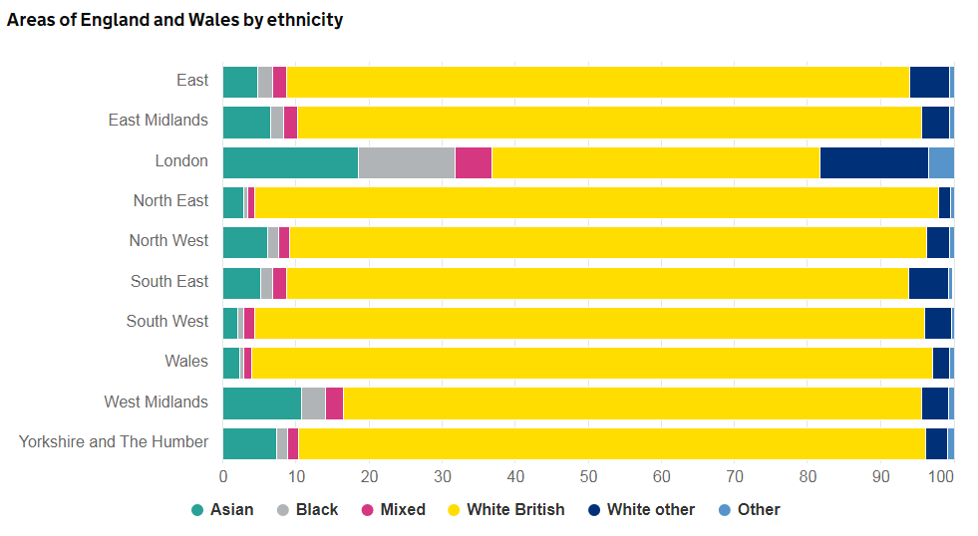
Figure 1: Population Distribution; Source: (Ethnicity-facts, 2022)
Under the census, the distribution of the BAME communities in the rural and urban regions are proportionately oriented towards 18.5% and 81.5%, respectively (Ethnicity-facts, 2022). Out of all these, the majority of the ethnic population living in the urban centres are Asian out of the BAME groups. The lowest proportion of the white population is found in the Newham region of London, with only 29.0% of white people remaining belonging to different communities under the BAME.
The diversity of the BAME communities is well-established, particularly within London, wherein the majority of the population seemingly belongs to the minority proportions and hence influences the overall decision making frameworks. In this respect, the overall significance is laid on the perspectives of essential focus leading towards the implied benefits for the situational factors in place (Ethnicity-facts, 2022). The socio-economic status, especially among the BAME community people, has increased substantially, leading to improved health and wellbeing status. The biopsychosocial model in this process has evaluated the significance in outlining the effective outcomes in place, leading towards the effective mechanism for the outputs in place, thus leading to improved living standards.
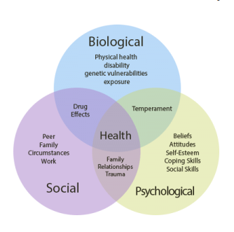
Figure 2: The Biopsychosocial model; Source: (Mikkelsen and Novotny, 2016)
According to the Biopsychosocial model, the influence of the biological factors is essentially linked with the prospectus for improved outcomes and hence related to better developments in terms of effective outcomes. In this place, the overall situational factors in place have the overall significance in place (The Guardian, 2022). In the case of the BAME communities as well, the improved lifestyle has impacted their overall capacity, and lack of humiliation has resulted in mental peace, thus resulting in the overall effective outputs.

Exploration of issues faced by the community
Community engagement is defined as the steps taken by the organisations in place to encourage, engage, and improve relationships with the said communities across the country or region. In this aspect, the National Institute for Health and Care Excellence (NICE) has designed the stakeholder map for increased engagement within the communities by taking supportive actions in place. The main issue identified during the process of the stakeholder mapping is the lack of healthcare facilities, and even unequal delivery of healthcare needs to the individuals. In this case, Bi and Zhang (2018) have stated that the BAME groups have currently outlined the overall standards of efforts in place for the improvement of the position of the individuals and taken actions to solve the issue of unequal health care delivery. Under this purview, Crowl (2017), in support of this claim, has denoted effectively that the improved outcomes are in place for the overall improved situation in place. The higher level of healthcare services being delivered has been impactful for the conditioning for the effective positioning.
The health conditions of the BAME population, as per Demirkol and Nalla (2017), have been mainly impacted due to the lack of strategic focus by the government bodies in place for the effective delivery of the outcomes. In this aspect, the overall focus is laid on the perspectives of discrimination and exclusion, which have been impacted heavily due to the health outcomes. As per Falender et al. (2014), the main focus is laid on the discriminatory services and the stakeholders identified are mainly the people from the BAME community, who are heavily impacted due to the issues of unequal healthcare delivery. According to Grytten (2017), the overall significance is related to the abolition of the issues in relation to discrimination and exclusion. The process of social exclusivity is often practised in the mechanism for delivery of outputs aligned with the medical services, and this is identified as one of the main issues for the BAME community.
The second major issue for the BAME communities is economic exclusion, which leads to outcomes of poverty. In this process, the overall outputs are based on the mechanism for the outputs in relation to the situational factors, which has shown that poverty among the BAME community has increased substantially. In this case, the overall implications have been laid with the perspective of the reduced intervention from the Government for the maintenance of the equality in payments scheme (Murray, 2020). Reference has shown that more than 19% of the BAME members are currently suffering from poverty in the UK. In this context, the overall significance is laid out from the perspectives under the overall impact due to the implications of the output in policy decisions (The Guardian, 2022). In addition to this, the impacts are laid out on the scale of outputs under the focus, which has been seemingly focused on the outputs for the impact on poverty. As per the latest census report of 2011, in Great Britain, around 45% of the Black Africans, 25% of Indians, and 45% of Bangladeshis belonging to the Asian region suffer from poverty (JRF, 2022). From this segment, the overall implications are laid on the overall perspectives under the reduced health standards and hence impact the overall mechanism of output. This also impacts the health standards of the people, and it is outlined that the majority of the poor BAME members have poor living conditions. In addition to this, the overall significance of the output is based on the mechanistic overview and hence related to the sociological conditions (Burrell and Morgan, 2019). In this mechanism, the overall implication is laid out on the mechanism of the impact, thus directly influencing the standards of living and hence relating to the standards of outputs.
The inequality in income divisions and implications of health outcomes are associated with the major reasons which therefore impact the situational factors in place. The implications of the low-income groups in the BAME community are also linked directly with the overall implications of the outputs focusing on the mechanism for benefits. The social classes in the UK are divided, so BAME members face discrimination. Against this, as per Wingard (2019), the Government has successfully taken actions in order to stay put bans on social exclusivity, leading to the implications of the inclusive circumstances being developed.

Critical examination and evaluation of approaches in place for the development of awareness impacting positive change
The approaches taken by the British Government are aligned with the development of efficient standards for encouraging its population to outline the overall implication in place, due to which the examination of the approaches is important for improved outcomes. The steps taken by the Government are aligned directly with the benefits in place, which has been denoted by the effective outcomes (Zimmerman and Weible, 2017). In this proposition, the overall significance is laid under the circumstances for the critical examination, which needs to be outlined on the basis of the significance and hence taken in order to focus on change. In addition to this, the national empowerment partnership is a scheme taken by the local governments in order to support the BAME communities in place. In this mechanism, the overall significance is laid on the perspectives for the outputs, which are in the mechanism for the nine regional empowerment which has been taken up by the overall outputs. In addition to this, supportive schemes are launched in order to support the poor BAME community. In this respect, the overall significance is laid out so as to improve the stakeholder’s participation in the process of outcomes associated with the situational factors (Poisat, et al., 2018). In addition to this, the BAME community members are also impacted due to the Government’s regulation for the improvement of living standards and hence related to the significant outputs.
The New Deal for Communities Programme, which was started in 1998 as a flagship project, is helpful in national strategies for the improvement of the area-based governance programmes (SHU, 2022). In this aspect, the basic mechanism for output is laid on the significant positioning for the improved outcomes related to the NDC partnerships and hence associated directly with the focus under which the outcomes are outlined. In this process, the six key areas are tested for significant positioning and hence impact the overall significance of the outputs in place, thus leading to the main areas under development. In this aspect, the main key areas are determined by the significant outputs in place, which focuses on parameters like education, health, crime, worklessness, housing, and physical environment.
The main implications are laid out on the parameters for improved beneficence under the Government’s move for the Area Based Initiative (ABI), which helps in the significant positioning in terms of effective outputs (Lindsey, 2020). For this reason, the overall implications have focused on the implied benefits, which tactfully orient towards the implications of change. In this process, the overall changes are aligned directly with the benefits for the significant outputs, which are currently based on the mechanism for outputs. In this code of conduct, the health benefits need to be provided equally by the NHS facilities and hospitals without any discrimination occurring on a massive scale (Murray, 2020). The implications are therefore suggested for the growth in the organisational capacitance, and this implies the benefits under which the mechanism of change is considered for the major benefits under view. In this process of change with respect to the BAME communities, the implications are laid on the perspectives of the implications, which therefore benefit the individuals within the ethnic community (Hargreaves, et al., 2020). Non-peer health advocacy, on the other hand, considers the benefits for the situational factors under place, which then orients to the situational factors (Mikkelsen and Novotny, 2016). Henceforth, from this discussion, it has been found that the changes are considered by the Government and hence proven to be impactful in the long term.

Conclusion
In conclusion, it has been gained that the BAME communities are aligned with their needs and suffer from main issues like poverty and unequal health outcomes. In this consideration, it has been concluded that their benefits are directly aligned with the overall focus of change and hence related to the steps ensured by the Government so as to improve the situational factors in place. Moreover, the conclusions are laid out so as to improve the understanding related to the patterns of thought and hence related to the situational factors in place, which benefits the overall process of outcomes directly relating to the overall focus on changed schemes. The significance of the schemes taken by the Government is denoted by the situational factors in place, thus relating to the situational factors in place.

References
- Bale, I., Broadhead, S., Case, K., Hussain, M., and Woolley, D. (2020). Exploring the black, Asian and ethnic minority (BAME) student experience using a Community of Inquiry approach. Widening Participation and Lifelong Learning, 22(1), 112-131, DOI: 10.5456/WPLL.22.1.112.
- Bi, J., and Zhang, C. (2018). An empirical comparison on state-of-the-art multi-class imbalance learning algorithms and a new diversified ensemble learning scheme. Knowledge-Based Systems, 158(7), 81-93,DOI-10.1016/j.knosys.2018.05.037.
- Burrell, G., and Morgan, G. (2019). Sociological paradigms and organisational analysis: Elements of the sociology of corporate life. London: Routledge.
- Crowl, J. (2017). The effect of community policing on fear and crime reduction, police legitimacy and job satisfaction: an empirical review of the evidence. Police Practice and Research, 449-462, DOI: 10.1080/15614263.2017.1303771.
- Demirkol, I., and Nalla, M. (2017). How does police culture shape officers’ support for community policing? Policing and Society, 122, DOI: 10.1007/978-1-4614-5690-2_394.
- Ethnicity-facts. (2022). Regional ethnic diversity. Retrieved August 18, 2022, from https://www.ethnicity-facts-figures.service.gov.uk/uk-population-by-ethnicity/national-and-regional-populations/regional-ethnic-diversity/latest#main-facts-and-figures
- Ethnicity-facts. (2022). UK population by ethnicity. Retrieved August 18, 2022, from https://www.ethnicity-facts-figures.service.gov.uk/uk-population-by-ethnicity
- Ethnicity-facts. (2022). Working age population. Retrieved August 18, 2022, from https://www.ethnicity-facts-figures.service.gov.uk/uk-population-by-ethnicity/demographics/working-age-population/latest
- Falender, C., Shafranske, E., and Falicov, C. (2014). Multiculturalism and diversity in clinical supervision: A competency-based approach (01 ed.). London: American Psychological Association, ISBN-13: 978-1433816857.
- Grytten, J. (2017). Payment systems and incentives in dentistry. Community dentistry and oral epidemiology, 45(1), 1-11, DOI 10.1111/cdoe.12267.
- Hargreaves, M., Coffee‐Borden, B., and Verbitsky‐Savitz, N. (2020). Advancing the Measurement of Collective Community Capacity and the Evaluation of Community Capacity‐Building Models. New Directions for Evaluation, 2020(65), 123-138,DOI: 10.1002/ev.20394.
- JRF. (2022). Poverty rates among ethnic groups in Great Britain. Retrieved August 18, 2022, from https://www.jrf.org.uk/report/poverty-rates-among-ethnic-groups-great-britain
- Lindsey, A. (2020). Community Policing as a Tool to Strengthening Police and Community Relations. A student-based journal devoted to discussions on law and criminal justice, 29, DOI: 10.1177/088541229701200105.
- Mikkelsen, B., and Novotny, R. (2016). Multi-level, multi-component approaches to community based interventions for healthy living—a three case comparison. International journal of environmental research and public health, 13(10), 1023, Doi: 10.3390/ijerph13101023.
- Murray, K. (2020). Impact of Covid-19 on the BAME community and voluntary sector. . Journal of community, 45(5), 12, DOI: 10.12/7T6773892.
- Poisat, P., Mey, M., and Sharp, G. (2018). Do talent management strategies influence the psychological contract within a diverse environment? SA Journal of Human Resource Management, 16(1), 1-10,DOI:10.4102/sajhrm.v16i0.1044.
- SHU. (2022). The New Deal for Communities Programme:. Retrieved August 18, 2022, from https://extra.shu.ac.uk/ndc/downloads/general/Volume%20one%20-%20Achieving%20a%20neighbourhood%20focus%20for%20regeneration.pdf
- Skogan, W., and Hartnett, S. (2019). Community policing. Police innovation: Contrasting perspectives, 12(3), 27-44, DOI:10.1073/pnas.1910157116/-/.
- The Guardian. (2022). Nearly half of BAME UK households are living in poverty. Retrieved August 18, 2022, from https://www.theguardian.com/society/2020/jul/01/nearly-half-of-bame-uk-households-are-living-in-poverty#:~:text=It%20found%20that%2019%25%20of,African%2FCaribbean%2FBlack%20British.
- The Guardian. (2022). UK doubles number of people from minority ethnic backgrounds in prominent roles. Retrieved August 18, 2022, from https://www.theguardian.com/inequality/2021/jul/27/uk-doubles-number-of-people-from-minority-ethnic-backgrounds-in-prominent-roles
- Wingard, D. (2019). Data-driven automated decision-making in assessing employee performance and productivity: Designing and implementing workforce metrics and analytics. Psychosociological Issues in Human Resource Management, 7(2), 13-18.
- Zimmerman, H., and Weible, J. (2017). Learning in and about rural places: Connections and tensions between students’ everyday experiences and environmental quality issues in their community . Cultural Studies of Science Education, 12(1), 7-31,DOI-10.1007/s11422-016-9757-1.

