Question 1Aa:
Inverting amplifier
Question 1Ab:
Gain= -RF/R1
Question 1Ac:
Gain= -29k/2k
Gain= -14.5 k
Question 1Ad:
0.345*-14.5= -5.0025 Volts
Question 1Ae:
180 degrees out of phase
Question 1Ba:
non-inverting amplifier
Question 1Bb:
Gain= 1+R1/R2
Question 1Bc:
Gain= 1+ 27/2
Gain=14.5
Question 1Bd:
0.62*14.5= 8.99 Volts
Question 1Be:
In Phase
Question 2Aa:
Bin= 0 10000010 1
Bin= 10000010
Bin= 0100 0001
Question 2Ab:
Hex= 41
Char= A
Question 2Bc:
Bin= 0 10101010 1
Bin= 1010 1010
Bin= 0101 0101
Question 2Bc:
Hex= 55
Char= U
Question 3a:
The transmission protocol shown is I2C.
Question 3b:
This transmission method is a Serial Transmission Protocols

Question 3c:
Data for the I2C transfers bit by bit along the length of one single wire using a SPI (Serial Peripheral Interface). This system is synchronised so that the sampling bits are synchronised by a clock signal to the output bits.
Question 3d:
An example of where this device would be used is in a low-speed device like microcontroller.
Question 4a:
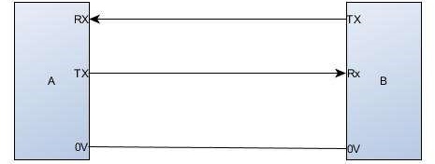
Question 4b:
Common, Data, Timing and Control Signals
Question 4c:
An example of where this device would be used is to connect a television to a video terminal.
Question 4d:
Hex= A5
Bin= 10100101
Bin= 0 1010 0101 1


