

Creating a single page application containing an epidemiology map of the Corona Virus Outbreak
by
Nathan Morgan

Supervisor: Bev Holland
Second Marker: weaaeadaaww

Submitted as part of the requirements for the award of
BSc (Hons) Software Engineering

aweaa2021

DECLARATION
I, Nathan Daniel Morgan declare that I am the sole author of this Project; that all references cited have been consulted; that I have conducted all work of which this is a record, and that the finished work lies within the prescribed word limits.
This work has not previously been accepted as part of any other degree submission.

FORM OF CONSENT
I Nathan Daniel Morgan hereby consent that my Project, submitted in candidature for the BSc (Hons) Software Engineering degree, if successful, may be made available for inter-library loan or photocopying (subject to the law of copyright), and that the title and abstract may be made available to outside organisations.

ABSTRACT
The goals of the project were simply to produce a single page application using modern JavaScript frameworks that utilizes visualization frameworks to display data that incites public engagement in response to the SARS-Covid-19 outbreak.
The key area of study being the software development side of the project.

The data needs to be displayed in many ways to make it easy to absorb by the end user. The end user must be able to look at it and make decisions based on what they see, so concise information must be delivered, and delivering such a vast amount of information can become a balancing act of not over-whelming the user and providing an appropriate amount for them to make the decisions on how to respond.

The key focus of the literature review will be looking at the design concepts of a web application, investigating material that has a focus on delivering content such as visualizations to the end user and will be investigating the Modern JavaScript frameworks used in building a full stack application.

THE OVERARCHING AIM
The overarching aim is to produce a single page application using modern JavaScript frameworks and implement several different visualizations for the display of Covid-19 data.

THE OBJECTIVES
Looking at available data sources and finding the most reliable, in terms of end point up time and accuracy to the reality of the situation.
Looking at available software platforms for developing the solution, evaluating the suitability of each.
Learn how to use the selected framework and investigate the implementation.
Comparing the existing websites that aim to do the same thing.
Looking at public perception of data and how data can influence the decisions made by the public through public engagement.

Summary of methods used.

Summary of deliverables

Conclusion

Contents

DECLARATION 2
FORM OF CONSENT 2
ABSTRACT 3
THE OVERARCHING AIM 3
THE OBJECTIVES 3
Summary of methods used. 3
Summary of deliverables 3
Conclusion 3
Contents 4
Tables and Figures 8
Chapter 1 Introduction 9
Chapter 2 Literature Review 10
2.1 Data and design 10
2.1.1 What is data? 10
2.1.2 Acquiring the data. 10
2.1.3 Intuitive design 10
2.1.4 Colour Theory 11
2.2 Theory of visualization 12
2.2.1 How do we visualize data? 12
2.2.2 Why do we visualize data? 13
2.3 Geo-visualization 13
2.3.1 Maps for visualization 13
2.3.2 The different ways we display data. 14
2.4 Design and Experience Principles 15
2.4.1 Software environments 15
2.4.2 Front-end frameworks 15
2.4.3 Framework for Visualizing the data 15
2.4.4 Backend frameworks 16
2.4 Conclusion of software choices 16
2.5 Review of similar websites 16
2.5.1 Table of features 16
2.5.2 Public tableau: - Public Health Wales: Rapid Covid-19 virology 17
2.5.2.1 Public tableau Public Health Wales: Rapid Covid-19 virology: - pros and cons 17
2.5.2.2 Different ways of visualizing 17
2.5.2.3 Colour Choices 18
2.5.3 John Hopkins University of Medicine: - Coronavirus resource centre 18
2.5.3.1 Table of John Hopkins University of Medicine: - pros and cons 18
2.5.3.2 Different ways of visualizing 18
2.5.3.3 Colour Choices 19
2.5.4 Google 19
2.5.4.1 Google - pros and cons 19
2.5.4.2 Different ways of visualizing 19
2.5.4.3 Colour Choices 19
2.5.5 New York Times: - Coronavirus World Map: Tracking the Global Outbreak 19
2.5.5.1 New York Times: - Coronavirus World Map: Tracking the Global Outbreak pros and cons. 19
2.5.5.2 Different methods of visualizing 20
2.5.5.3 Colour Choices 20
2.5.6 Angular websites 20
2.5.7 Deutsche Bank 20
2.5.8 Forbes 21
2.5.9 GitHub Community 21
2.5.10 Blender 21
2.6 Conclusion 22
Chapter 3 Methodology 23
3.1 Research Methodology 23
3.1.1 Philosophy 23
3.1.2 Strategy 23
3.1.3 Approaches 23
3.1.3.1 Literature review 23
3.1.3.2 Case study 24
3.1.3.3 Experimentation & Software development 24
3.1.4 Risks & limitations 24
3.1.5 Validity, reliability & generalisability 24
3.1.5.1 Validity 24
3.1.5.2 Reliability 24
3.1.5.3 Generalisability 25
3.1.6 Data Evaluation Methods 25
3.1.6.1 Presented data. 25
3.1.6.2 Testing data 25
3.1.6.3 Quantitative results 25
3.2 Development methodology 25
3.2.1 Software Development methodology 25
3.3 Resources 26
3.3.1 Hardware resources 26
3.3.2 Software resources 26
3.4 Conclusion 26
Chapter 4 Design & Implementation 27
4.1 Design 27
4.1.1 Front End Design 27
4.1.2 The infographic 28
4.1.2 SVG design 29
4.1.3 Map Design 30
4.1.4 User interface 31
4.1.5 Backend Design 31
4.2 Implementation 32
4.2.1 Node.js and express server basic CRUD implementation 32
Node.js: Using JavaScript to Build High-Performance Network Programs 32
Eloquent JavaScript 32
4.2.2 User accounts 32
4.2.2.1 User Accounts, The User Model 33
4.2.2.2 The User Model, Instance Methods 35
4.2.2.3 The User Model, Model Methods 35
4.2.2.4 The User Model, Model Middleware 35
4.2.2.5 The User Model, Helper Methods 35
4.2.2.6 User sessions, A Vanity Project 36
4.2.3 Confirming accounts. 36
4.2.4 Password reset. 36
4.2.5 Admin controls. 37
4.2.6 Building a proxy. 37
4.2.7 Middleware 37
4.2.7.1 Verify Session middleware 37
4.2.7.2 Check Authorization middleware 37
4.2.7.3 Check Admin Authorization middleware 37
4.2.8 Routes 38
4.3.0 Front end framework 40
Factors and actors leading to the adoption of a JavaScript framework 40
Designing with JavaScript : creating dynamic web pages 40
4.3.1 Angular material 40
4.3.1.1 Angular material: Custom theming 40
4.3.2 Login Component 41
4.3.3 Register 42
4.3.4 Auth service 43
4.3.5 Token interceptor 44
4.3.6 Auth Guard 45
4.3.7 Navigation 45
4.3.8 User Settings 46
4.3.8.1 Active sessions 47
4.3.8.2 Updating password. 47
4.3.8.3 Delete account. 48
4.3.9 Confirming account module. 48
4.3.9.1 “Thank you for confirming.” 49
4.3.9.2 Confirmation email sent. 50
4.3.10 Password reset. 51
4.3.11 Lazy Loading and Eager Loading 52
4.4.0 Visualizations 52
4.4.1 Data service 52
4.4.2 Covid Symbol infographic 52
4.4.3 Map 55
4.4.4 Scatter & Bar chart 55
Dependencies & their uses (APPENDIX) 56
Material Modules (APPENDIX) 57
https://whel-primo.hosted.exlibrisgroup.com/primo-explore/fulldisplay?docid=TN_cdi_doaj_primary_oai_doaj_org_article_1673144815a949788a3c73d49c365bdf&vid=44WHELF_UWTSD_VU1&search_scope=CSCOP_EVERYTHING&tab=tab1&lang=en_US&context=PC 58
CHAPTER 5 – EVALUATION 60
CHAPTER 6 - CONCLUSIONS AND RECOMMENDATIONS 61
CHAPTER 7 – REFLECTION 61
CHAPTER 8 – REFERENCES 63

Tables and Figures

Chapter 1 Introduction

This chapter should start off by setting the context for the work:

- What is the project about? What are the initial aims and objectives for the project?
- Aim - what is the overall research question you're trying to answer?
- Objectives - what are the actions you're going to take to try to satisfy the aim?
- A brief description of what is coming up in the following chapters (this should be the final paragraph of the introduction).

Usually, you start with a very broad statement of the problem and refine that down to more specific items. Unless yours is a problem area with which all readers of your report will be familiar (very unlikely), you will want to describe the problem in some detail and give sufficient background information so that everyone can understand it.

You should then describe the objectives, aims or goals of your particular piece of work. Your overall aim was presumably to solve a particular problem or to answer a particular question. This could be broken down into a number of specific objectives that together work towards achieving the aim.

The introduction should end with a section that leads the reader in to the rest of the report. The important thing is to give your reader a clear picture of what your report is setting out to do.

Chapter 2 Literature Review

2 Introduction
In this literature review, the key focus will be looking at the design concepts of a web application, investigating material that has a focus on delivering content such as visualizations to the end user and will be investigating the Modern JavaScript frameworks used in building a full stack application.

2.1 Data and design

2.1.1 What is data?
Data is essentially information that has been processed for the audience receiving it, Data can come in many shapes and sizes, but typically raw data is literally just text and numbers on a screen, and that becomes tedious to interact with at large scales.
Because of the requirement of working with large amounts of data is becoming more normal in society the tools used to interact with the data must evolve with the requirements of the end users.
Data can be interacted with at many different levels but commonly it is subjected to categorization, abstraction, and translation into a graphical representation [2].

2.1.2 Acquiring the data.
For the visualisation of anything, there must be something to visualize. Acquiring the data through several reputable sources such as JHU, WHB, WHO. With the nature of the data and there being many sources available there will be some overlay and discrepancies and this margin of error must be accounted for.
UK government has a source that provides daily and historical data [3].
https://coronavirus.data.gov.uk/details/developers-guide
NHS API [4] is very similar to the UK governments API and it has a source that provides daily and historical data.
https://developer.api.nhs.uk/coronavirus/api
This is an interesting API [5] that seems to have everything that would be required for working with historic data, it appears to have every case documented from the first case to the present time. This can be quite a large request taking a long time to fulfil so this would be a key.
https://documenter.getpostman.com/view/10808728/SzS8rjbc
This API returns some vital statistics about the virus in general and can be used for plotting a variety of data. [6]
https://corona-virus-stats.herokuapp.com/api/v1/cases/general-stats
This API returns all the different countries statistics for the day, this will be an essential component in visualizing the data with a map as the map will used for displaying the daily statistics [7].
https://coronavirus-19-api.herokuapp.com/countries
With all interactions with a public API, you must be mindful of issues such as rate limits, and if the application had a high volume of traffic you would meet the limit very quickly and not have any data to visualize. This was resolved by developing a proxy on the server. The proxy works by checking if any data is cached, if there is no data cached to interact with the endpoint, if there is data cached to check the age of it. If the data is older than 1 hour, make a request for new data. This will ultimately reduce the number of calls with the end points, so we do not get rate limited by the API’s and hold a copy on our server to ensure peak performance is maintained when the users are interacting with the data. This also adds considerations to server memory and the overhead caused by holding such large volumes of data.

2.1.3 Intuitive design
When building any type of program or application it is important that the layout is following the standard norms that people are familiar with, typical example of this is having the cross to exit the application in the top corners, this is now such an accepted design philosophy that if you go against it, people become wildly confused. If the user is in a situation where the design goes against the principles, they are familiar with from other domains they are likely to feel less comfortable because they are having to consciously navigate the content. When intuitive design is achieved a user will be able to interact with it effectively by applying knowledge subconsciously [8].

2.1.4 Colour Theory
Colour in data visualisation is import for dividing data, implying severity, and showing there is a difference between items. An example of this in the john Hopkins health university map
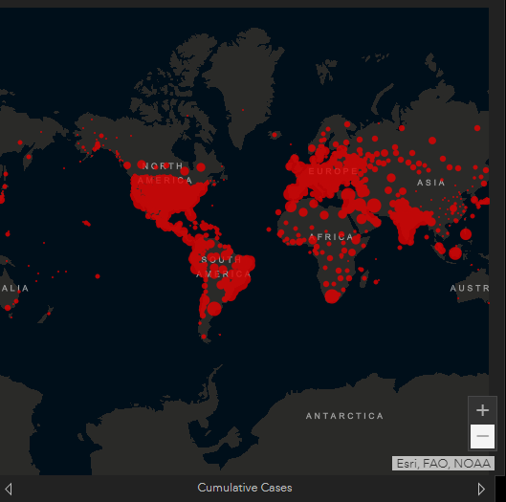
Fig 1
Where throughout the map a dark themed background colour is used with a bold red to represent the active covid-19 cases to contrast the severity of the data, this could be improved upon by using lighter shades to show the areas with less significant amounts of cases, or even a colour gradient with red denoting large elements scaling down to blue for the small elements [9].
Colour can be very important for conveying an emotion, or tone. In this instance it is quite a negative tone but the idea behind it is to incite public participation.
Colour can have a lasting impact on the audience as seen with the London underground where the routes may well be memorized by the colour of the lines [10].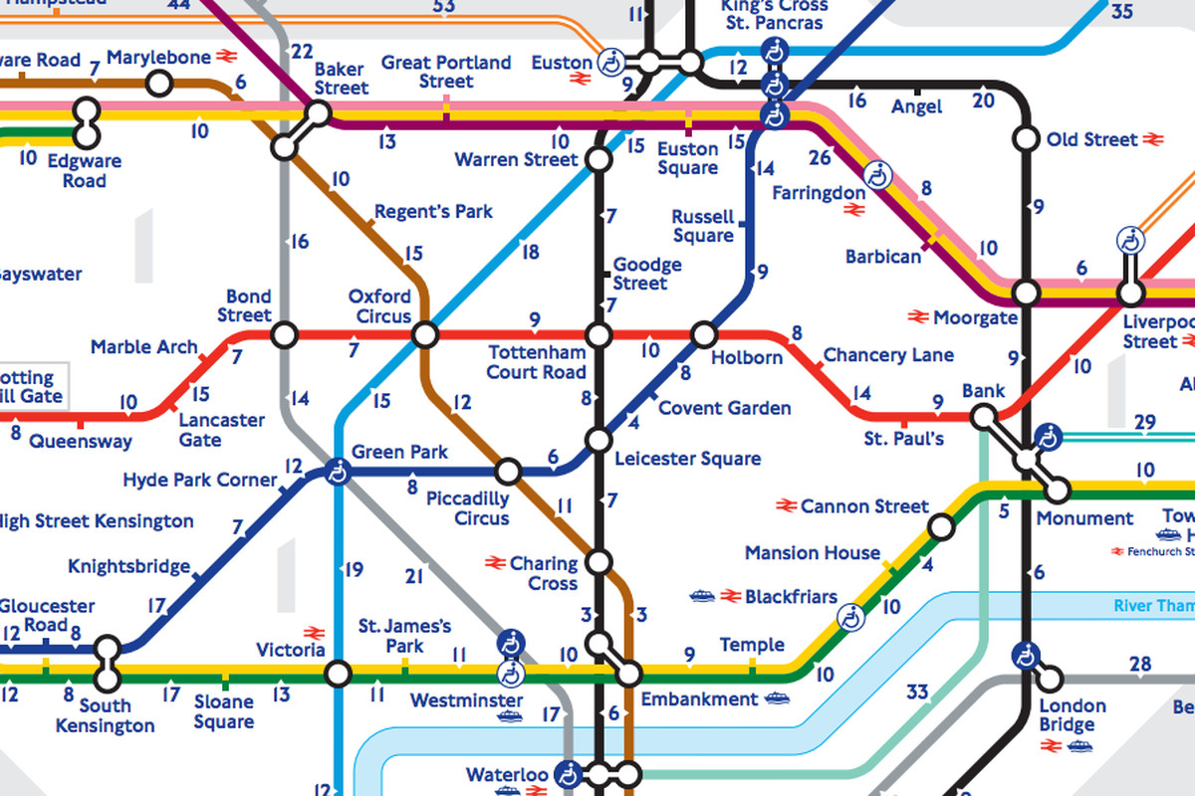
Fig 2

2.2 Theory of visualization

2.2.1 How do we visualize data?
There are many ways of taking a bulk of data and representing it using different methods.
The most common choices are charts, graphs, maps, and tables.
Each different option will be better for displaying the different types of data, and this raises the question of which is best? The answer to that is it depends on the task but generally ‘we don’t know’ [11].
Because we do not know, we try to use a variety to try and make sure every proverbial base is covered, this may not be the most efficient approach but what we do know is that maps are the best way of displaying spatial data at a geographic level and is a widely accepted fact [12].
Using layers of different data on top of a map creates a neat and interactive way that allows the user to specify what they want to see and get the relevant selective data from the geo-visualisation tool through a menu of options that can be toggled to fit the user’s needs [13].
Even in the current age of information there are not many options better for displaying spatial data, as it provides a compact and elegant approach to the task [14].
A visualisation has several goals when conveying data such as indicating how values relate to each other, and that the data is representing the quantities correctly for easier comparison. Allowing the target audience to digest the data and use it appropriately [15].

2.2.2 Why do we visualize data?
Visualization helps the target audience see a large amount of data and quickly interpret the data [16] and understand what they are seeing using a format that is visually appealing. Because of the variety in different ways, we can display the data it caters to the different way people engage with the data. For example, some people may respond better to a map compared to a chart and vice versa, and that is why using a range of different techniques to display the data will ultimately create something that promotes a high level of engagement that caters to all types of audience. The key idea to take away from this is, not everyone interacts with the data the same way and the different methods of displaying data will resonate with people differently, using a larger range of techniques will help create an easier to absorb format and provide an opportunity for additional insight into that data [17].
Using such a wide variety of techniques together in data visualizations creates novel types of communication and interactivity [18] That can aid in communicating the data in a way that words alone cannot compare too, this has been referred to as a picture being worth a thousand words. But that was before the power of visualization reached the internet and now an interactive representation is worth a thousand pictures.
With these types of tool, the effectiveness can be enhanced immensely if the software responds to the user’s actions within a fraction of a second, as the added latency would break immersion and reduce the desire to interact [19].

The effectiveness can also be enhanced by allowing the user to interact with the data at higher levels, providing a degree of additional insight, such as allowing for the arrangement of the data to be manipulated in ways like moving the content around the screen, and manipulating the content seen using layer toggles, filtering, searching, and sorting [19]. An effective level of interaction with the data will be vital in adding variety to the means of presenting data. Visualizing in a way that can be used for creating different views that can be used to show a relationship or show relative proportion, measure changes of time and make general comparisons.
An effective implementation of a visualisation will allow the user to see the data in a way that it is easy to recognise what is happening and can almost immediately understand what they are seeing and take this understanding and use it to make informed decisions. Getting a visualization correct is a feat of human perception theory that is a science and an art, and may change person to person, and that is why the variety in display methods will increase the visualizations effectiveness on a larger audience [15]. An example of a visualization with a public engagement purpose was in 1845 when Dr John Snow used a map to relate the user of a popular water pump with the transmission of cholera and using his map, he was able convey data showing the correlation between deaths in the area around the pump, this led to a decrease in use of the pump and deaths [20]
The visualization as seen is simplistic, using black dots to represent deaths. The simplicity is key because it does not distract from the key goal, the purpose of correlating the use of the central pump with the deaths.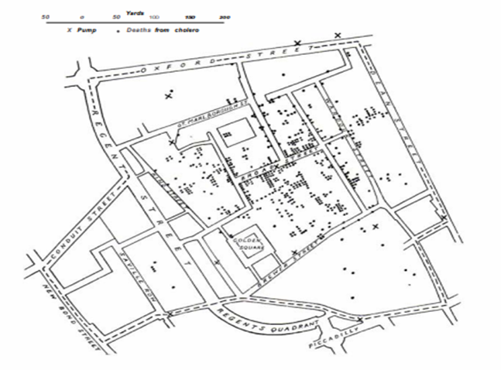 Fig 3

2.3 Geo-visualization

2.3.1 Maps for visualization
A Map is typically a visualization of a landscape, in recent years the digital maps have become more commonplace and are seen in every representation of land, they are everywhere. The initial feature of the original maps was for navigation of areas that were unfamiliar. In modern times a map can be more useful than just for navigation, since the first GIS was created with the intention of relating information with geographical areas.
A Geographic information system is essentially a map with extra levels of information provided, the data overlayed on top of a map allows for a user to correlate the data with the area and make the associations like “oh that really is close to home”, these types of realizations can greatly impact the audience’s decision making, and when the public make decisions being made based on presented scientific data it is called public participation.
The use of selective display is widely seen in GIS, and the additional layers provide an additional degree of insight [13]].
A map is a tried and tested way of relating information to areas, Maps are considered to be the most efficient method of communicating spatial information [21].

Not only is it the most efficient means of displaying spatial information, but it is also the most elegant and compact [22].
In every implementation of a GIS system there are several tasks and purposes that it must be designed to fulfil, such analysis of large volumes of data in a quick and easy manner, the ability to select data by different categories such as by characteristics or by area to aid in analysing the dataset, and creating several different types of outputs, not limited to maps such as graphs and tables of the relevant statistics [23].

2.3.2 The different ways we display data.
There are many ways of displaying data, the key features of any visualization are to covey data in a manner that is easy to look at and quickly get the right information. There are many different techniques used to improve the way the information is interacted with such as using colour to highlight key data, filtering and other types of searching for limiting what is on the screen, allowing the user to move, manage and highlight specific objects all come together to make different unique user experiences that will ultimately improve the usability of the tool and create a lasting impacting experience.
There are many different types of visualization tools such as...
- Histogram
- Animations
- GIFS
- Scatter charts
- Bubble chart
- Pie chart
- Bar chart
- Line chart
- Stem and leaf
- Column chart
- Maps
- Gauges

And there are many other types of visualizations that can be used for the display of data and then there are many different variants of each, and hybrid combinations of each. And finally, there are tables. Tables are one of the more straight forward means of displaying data. They are very bland and have very little in the means of visual appeal and focus entirely on delivering figures [24].
There are many additional benefits to using these different types of visualizations, such as animating them, colour coding them. Highlighting the features of the data using colour and creating distinctions with annotations and labels. When the time is taken to improve the means of conveying data the end users will have a more pleasant experience when it comes to interpreting the data. This leads to a higher level of engagement.

2.4 Design and Experience Principles

2.4.1 Software environments
For developing the project Visual code [25] was used, this is a light version of visual studio developed by the community and is an open-source IDE that was developed with web development technologies like Node.js and Node packet manager in mind.
Alternatively Brackets [26] or Atom [27] would have been good choices for developing the project.

2.4.2 Front-end frameworks
The project is being built around the popular JavaScript framework developed by google called Angular. Angular is currently in its 10th version and boasts a range of features for building a single page application using typescript though its command line interface for creating modules and components etc.
There are many other frameworks that would have also had been suitable such as Vue.js or React.
React and Vue are very close in popularity for this type of task, but angular is more of a full-fledged framework with a command line interface but it was ultimately down to a matter of personal preference in the choice.

2.4.3 Framework for Visualizing the data
D3.js [28] was the chosen framework for creating visualizations.
D3.js [28] is an incredibly powerful JavaScript library for creating powerful visualizations by manipulating the document object model, by applying data-driven transformations to the DOM using the JavaScript framework and CSS. This incredibly powerful framework is not a finished solution to a problem, rather it is a means to create a solution to the problem.
“D3 is not a monolithic framework that seeks to provide every conceivable feature. Instead, D3 solves the crux of the problem: efficient manipulation of documents based on data”. [28]
D3.js [28] is a well-documented framework, where the community have collectively created every type of visualization you could think of.
Chart.js [29] was an option but it did not have all the functionality required when it comes to these types of projects there is more to be learned by developing a more bespoke solution.
Building it from scratch using vanilla JavaScript and SVGs would have required a lot of time and research to achieve, and the solution would have been niche yet a great test of skill and patience.
Python flask [30] website could have been used, as Python is very powerful when it comes to visualizing data, but it also would have taken away from the original direction of the project of using a JavaScript Framework.
Leaflet [31] is an option for creating a map, but that is where it reaches its limits as it is exclusively a map framework that works in a very specific way and this project aims to display data using more than just a map, with a higher level of interactivity than what would be possible using the leaflet framework. Leaflet does boat an impressive array of features, but the desired outcome would be limited by this framework and that is why a more extensive framework will be required.
Alternative vis tool New York times used by map box [32].
This tool used by the New York times is also a valid candidate for building a map for visualizing the data, but ultimately this is a complete solution that would not allow for the level of customisation desired, and because of the completeness of the framework there would not be much to be learned by using it.
Open Street maps
Open street maps [33] are just another framework that can be compared to leaflet, a JavaScript framework with a small range of features for displaying spatial data with its primary role being used for displaying a business’s location on a map.
John Hopkins university used this framework by esri [34] to produce their fantastic map.
This is a beautiful map, very elegant in design and ultimately this met all the criteria of the initial scope, except that it is also a closed source, paid project that would have not allowed for any of the customisations that were desired after initial scope was defined.
Google
Google maps [35] was also an option considered for the spatial data, but much like open street maps and leaflet, it did not provide the features required to fit the scope and is more suited to showing spatial data such as a company’s business location.

2.4.4 Backend frameworks
There were many backend frameworks to choose from, the ones within the comfort zone were Node.js, Asp.net, Deno and Python, given that the frontend was built using Angular, node.js is a very common pairing with it and it offers as easy to manage bridge between the two.

2.4 Conclusion of software choices
In conclusion to this section Angular, node.js and D3.js were the chosen tools for the project.
Angular will offer a great solution for dynamically rendering the content to the screen, D3.js will be the key component for the visualizations and node.js will serve the front end the content.

2.5 Review of similar websites
Here is a table of the different websites that were reviewed. Where each website has its features listed to see what websites have similar features and where the grey areas in the visualizations are.

2.5.1 Table of features
 | Map of data | Bar/line chart | histogram | Stem and leaf | Tabled data | Different map layers for different data
Public Health Wales | x | x | x | x | x
John Hopkins University of Medicine | x | x |  |  | x | x
Google | x | x |  |  | x
New York Times | x | x |  |  | x | x

2.5.2 Public tableau: - Public Health Wales: Rapid Covid-19 virology
Public health wales have a visualization tool for displaying SARS-COVID-19 Statistics, and it provides all the relevant data using public tableau to visualize the data [36].
this experience was bad for UIX because of the design flow of the website. Specifically, the navigation between pages, it was slow to use with each page taking a long time to load. More content that can fit on a standard screen so responsive design was completely lacklustre. The home page was a bit overpopulated, showing way too much in one small space, a more distributed visualization would have helped make it more digestible and less intimidating.

2.5.2.1 Public tableau Public Health Wales: Rapid Covid-19 virology: - pros and cons
PRO | CON
Wide variety of data | No colour scale for severity on the map
Wide variety of different types of visualizations | Very over busy interface
Filter by source of data | Poor Colour choices
Sources of data are publicly available to be used as an API. | Bad navigation, so much content hidden behind poorly labelled layers
Fig 5

2.5.2.2 Different ways of visualizing
On this page, Public health wales are visualizing the data using Tables for plain text representations.
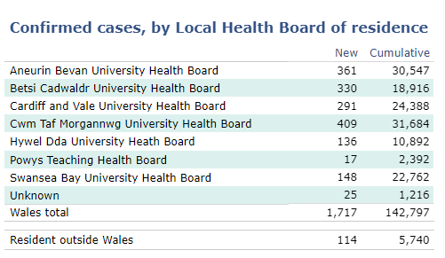
Fig 6
Line chart & column charts for appropriate comparisons such as testing vs results.
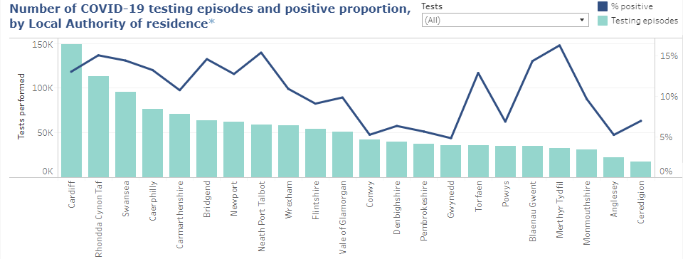Fig 7

Open Street maps for a visual representation of each area and their infection rate, this was a very nice and simplistic approach to displaying the data for the United Kingdom, there are other web pages available that do this in a much larger scale, covering the global pandemic [33].
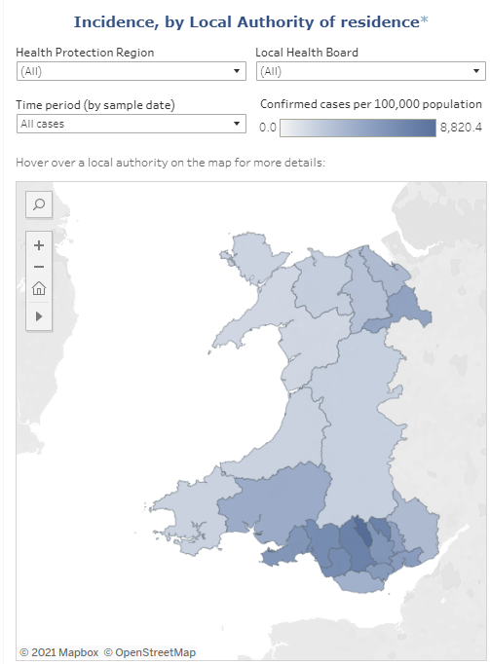
Fig 8
Histogram for displaying data over time, using two different colours to differentiate between new and old cases, this is a very simplistic but effective approach to displaying historic data.
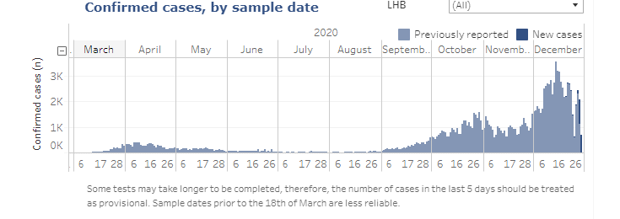
Fig 9
Leaf and stem for comparing percentages over ages and sex. 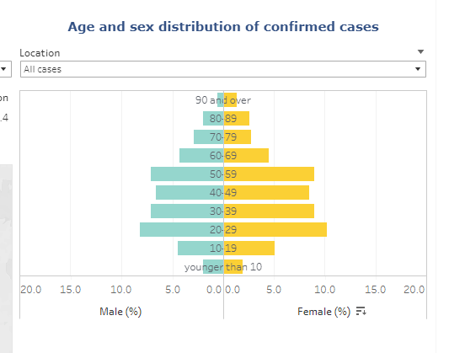
Fig 10

2.5.2.3 Colour Choices
Throughout the page the colour scheme was well designed, use of key colours was visually appealing, especially in the graphs.
Main colour used for the background is the standard white, with a dark blue for Navigation and footer but this may be the hosts choice. A lighter blue for accenting within tables was used, and this gave a nice separation.
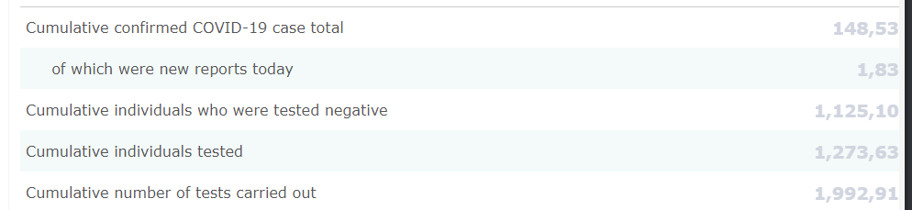
Fig 11

2.5.3 John Hopkins University of Medicine: - Coronavirus resource centre
The John Hopkins university map [37] is the most frequently referenced ‘dashboard’ for displaying COVID-19 data, it is very informative in a small space, but even with the information overload the data is concise so it is not too overwhelming. The key aspect of this page is the map. It is a fantastic map using ‘esri’ [34] to plot the data to a map. Esri [34] are the main producers of ArcGIS [38] maps that are being used to create these fantastic maps.

2.5.3.1 Table of John Hopkins University of Medicine: - pros and cons
PRO | CON
Detailed map | No colour scale for severity on the map
Map layers | Very over busy interface
Tabled data
Sources of data are publicly available to be used as an API.
Colour choices
Fig 12

2.5.3.2 Different ways of visualizing
The first keyway this data is being visualised is using the map from esri [34], there are several pages that utilize different colour schemes as a key for the different types of data being displayed, in a very effective way of displaying the data using darker more intimidating colours to represent the danger of the data being displayed. And then to contrast that, in the more positive data such as recovering cases there
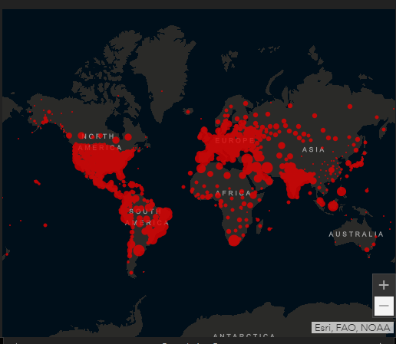 Fig 13
Outside of the map, the rest of the data is loosely displayed in text and table form with pagination for scrolling through the different variants of data, with some statistics displayed in bold to really catch the eye.
  - 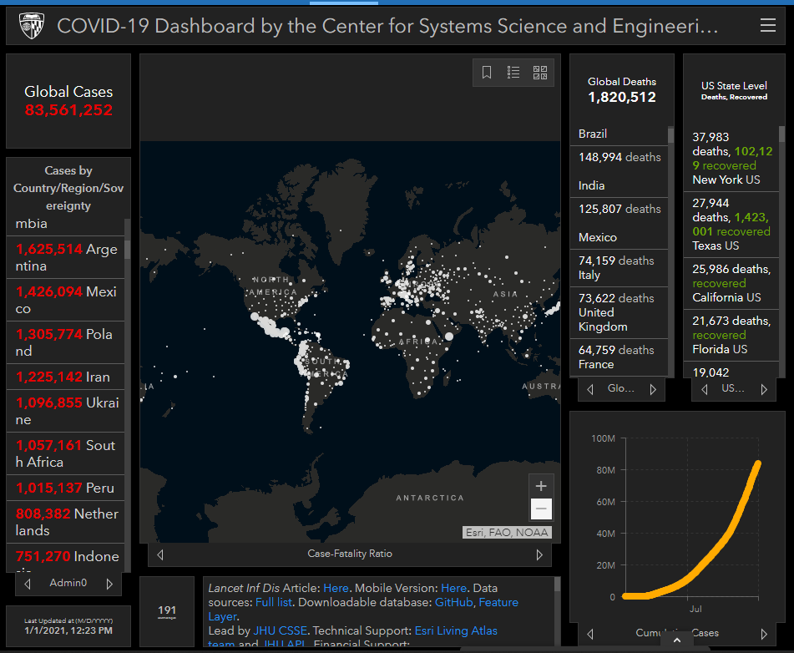Fig 14
And then finally there is a line chart for showing cumulative data seen in the bottom left corner.

2.5.3.3 Colour Choices
Throughout the web page a palette of dark themed colours is used with bold colours like red and white to contrast the severity of the data, these are striking colours that really stand out when looking at the page in whole. The more positive statistics being represented with more positive colours also really helps divide the data into more digestible forms.

2.5.4 Google
Google [35] also took the time to create some concise visualization when you type any of the COVID-19 buzzwords into their search engine. This is a very concise and attractive way of quickly giving some statistics to an everyday search engine user, without anything too morbid or detailed flooding the screen or taking away from the actual results the user may be looking for. Google is a great example for comparison because it is also built using the angular framework for the front end.

2.5.4.1 Google - pros and cons
PRO | CON
Attractive display of data | No colour scale for severity on the map
Use of angular | Not much displayed
 | Colour choices
Fig 15

2.5.4.2 Different ways of visualizing
they have utilized a line chart, a table, and a map to display some current data.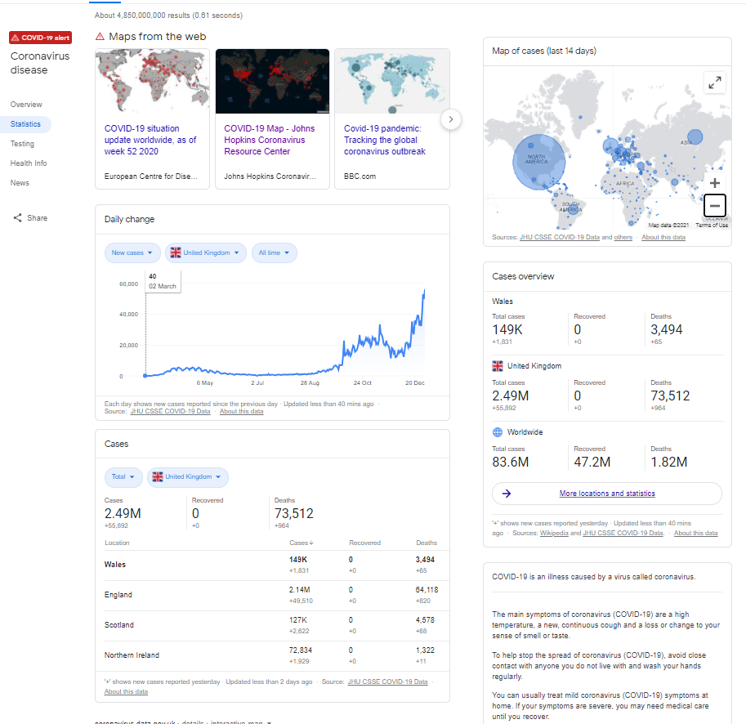
Fig 16

2.5.4.3 Colour Choices
In typical google fashion, their approach is rather plain in terms of colour using simplistic white and black text with a blue used contrast.

2.5.5 New York Times: - Coronavirus World Map: Tracking the Global Outbreak
The New York Times [39] have a very informative web page covering all the common ways of mapping the data, and in a very concise and eloquent manner.
The New York Times used MapBox [32] for producing the map visualization that is seen on their page and is a solution worth investigating.

2.5.5.1 New York Times: - Coronavirus World Map: Tracking the Global Outbreak pros and cons.
PRO | CON
A nice map | Colours are not scaled by severity
Wide variety of data | Not many options for layers on the map for total cases. this would have been nice
Good colour choices
Wide variety of different types of visualizations
Tabled data
Sources of data are publicly available to be used as an API.
Fig 17

2.5.5.2 Different ways of visualizing
An effective use of line and bar chart to show the new cases by date with a line chart overlay to show a 7-day average, this is a very appealing approach.
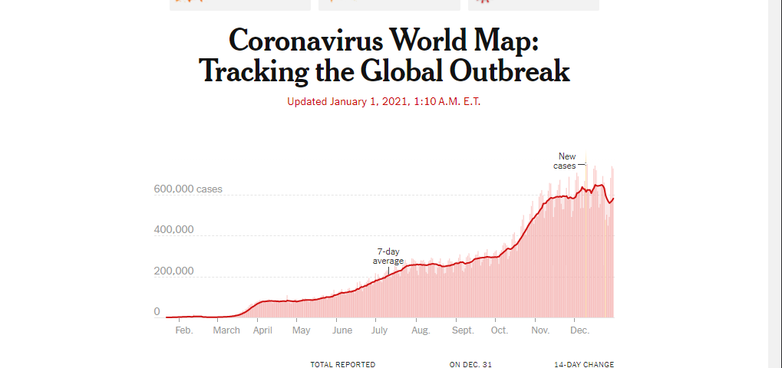
Fig 18

As seen this Map has a hotspot feature that shows the areas with a high number of cases using a colour scale, this is a great approach, and the colour scale is fitting to the nature of the data. 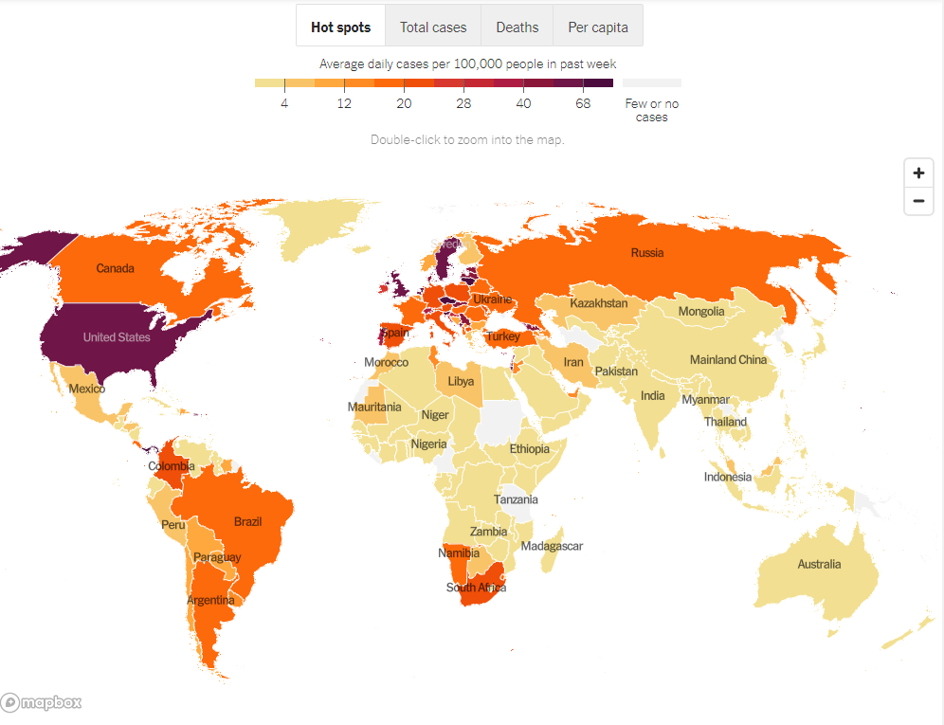Fig 19
For the total cases filter the background is quite faint and the circles are scaled to the number of cases to the area, this is an interesting approach, and it is clearly showing the areas that were significantly affected by SARS-COVID-19.
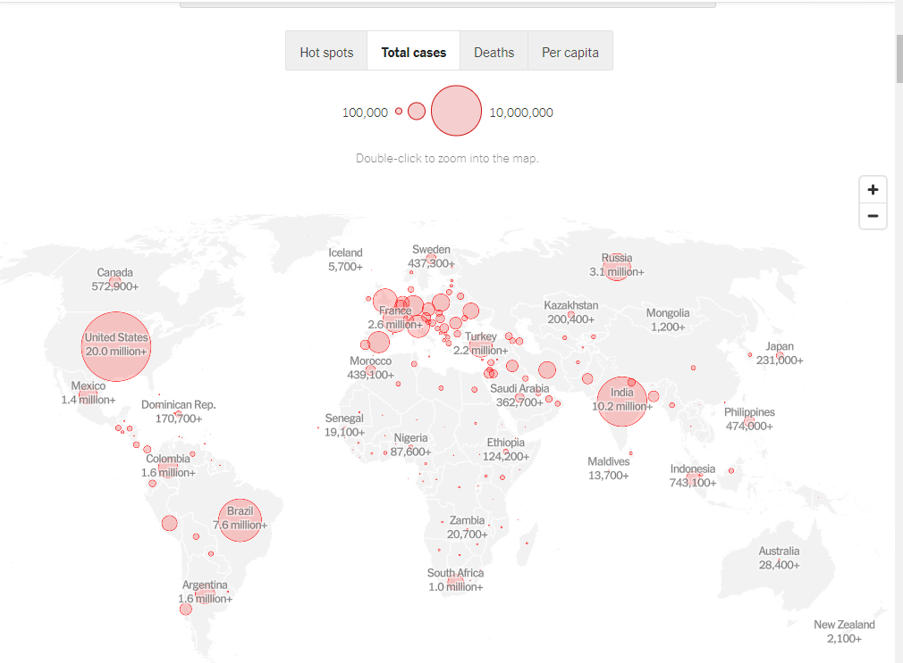
Fig 20

2.5.5.3 Colour Choices
Throughout the website a great selection of colours is used, and a particular good use of red in the maps can really show the severity of the data.

2.5.6 Angular websites
Looking at popular websites developed using the Angular [40] framework, and identifying the key visual features provided by the framework. Inspiration will be taken from these for shaping the layout and features of the finished product.

2.5.7 Deutsche Bank
The Deutsche Bank [41] developer portal utilizes angular for its front end, allowing users to interact with their content through the framework.
One of the first signature features of Angular seen as a re-occurring theme amongst the websites is the toolbar for navigation with the hamburger menu in the top left with a dark theme. This is a very common feature that is very intuitive to use and is seen widely across Angular sites.

Fig 21

The next feature that stands out is how all the content is contained within the relevant cards, this is a concept that helps modularizing the content within components and loading the cards as components when required.
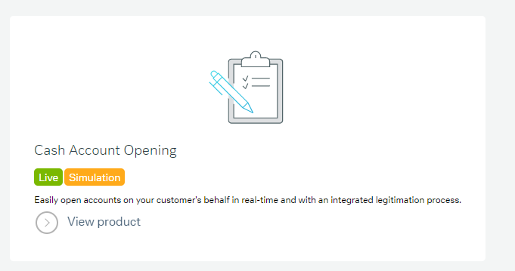
Fig 22

2.5.8 Forbes
Forbes [42] is a global media company that delivers most of its content through magazines and their website. The website is built upon the angular [40] framework with a few key identifying features that give this away. Such as the commonly seen tool bar navigation
Figure 23
Card based components are another common aspect of angular development and will likely be seen in any implementation of the framework. 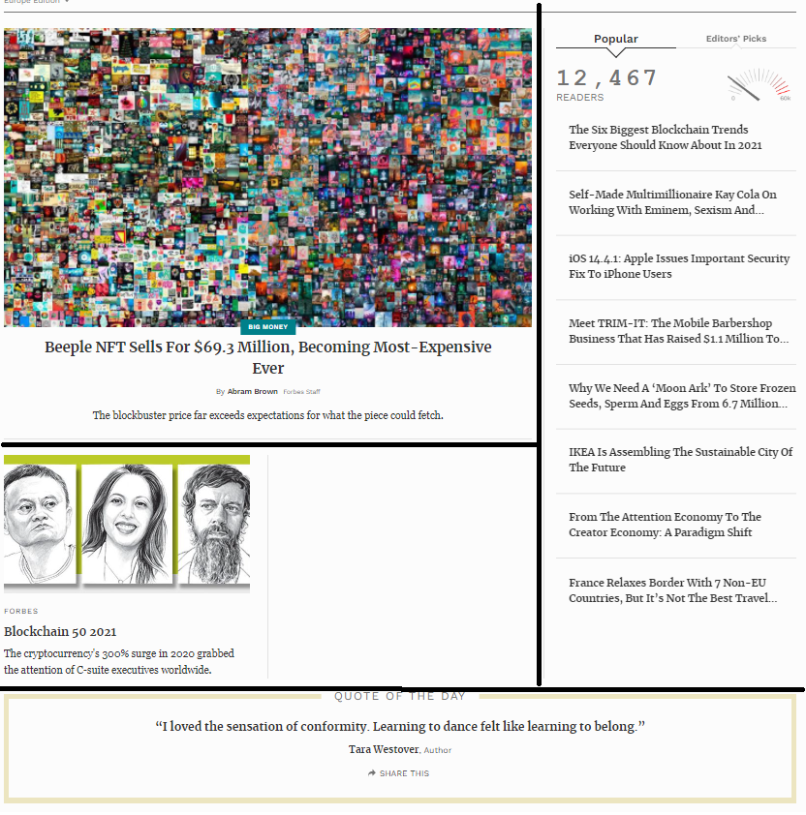Fig 24
In figure 23 the cards have been divided with a black line to illustrate that the content is delivered on cards and how cards can be used to divide the content within the DOM and each card can be created and loaded individually. This allows for content to be delivered at different times or in different use cases, such as regional content, or pattern-based suggestions.

2.5.9 GitHub Community
The GitHub [43] Community page is a great example of an Angular [40] implementation, featuring some of the concepts seen so far such as the tool bar navigation, the content contained within cards and concept not seen in the examples so far, Lazy loading scrolling. This works by as the user scrolls the content is fetched from the backend as the user scrolls down, this keeps the page initial load time lower and only loads the content onto the DOM as required. This is a great optimising feature that allows for infinite scrolling without a performance impact on initial load, features like this are a huge improvement over eager loading where all the content is loaded on initialisation.

2.5.10 Blender
Blender [44] the open-source 3D creation tool utilizes Angular for their website, typically their video section of their website is very much like YouTube in functionality but for the niche purpose of sharing of resources relating to their tool. Utilizing the common features such as the tool bar nav, the content cards and the lazy loading infinite scroll.

2.6 Conclusion
In conclusion using visualization tools such as graphs and maps using a range of colours the tool will be able to be used within public participation to ideally spread awareness on the Covid-19 pandemic and increase the use of precautionary measures taken by the public.

The development will take a slight change in direction using more intuitive layout and a stronger grasp on the colours used to increase engagement and animations to appease the users and create an interesting eye-catching tool.
A heightened use of interactivity will be pursued to increase user engagement and a strong focus on minimizing any form of latency will be taken to ensure the responsiveness of the visualizations.

The layout of the page will be an important factor to ensure that all the content will be accessible easily without the issues faced of navigating content slowly and response design with appropriate feedback to the user’s interactions and inputs.

Chapter 3 Methodology

3.1 Research Methodology
In this section the chosen research methodology will be evaluated, and the approaches will be justified.

3.1.1 Philosophy
A Positivistic approach will be taken using case study and software development and experiments to produce results through the research objectives.
“The only things that one can be certain of are those that are publicly observable, namely, sense experiences that can be shared with other people” - Isidore Marie Auguste François Xavier Comte
Positivism is the most appropriate choice given the approaches to research taken.
The software solution produced will be tested using automated testing and through a test schedule to investigate the data at different stages of the experiment and the data will be documented and analysed to compare to the performance guidelines laid out by the governing bodies and to ensure the features work to the initial scope. This is to ensure the performance is optimal and the program works as expected.
Development will conform to existing software development principles such as object-oriented design, mobile first responsive design, and REST architecture principles.
https://www.researchgate.net/publication/309102603_Understanding_research_philosophies_and_approaches

3.1.2 Strategy
Deductive approach using experimental software development to investigate the most descriptive way of presenting the data using a single page application as a means of delivering the content in a performant manner.
The literature review concluded that a map was a powerful if not incomparable means of displaying spatial data and set the goal of investigating the implementation of a graphical representation of the data using a map. The map will not be the only focus and a range of visualizations will be implemented for the variety and the investigation will conclude with a comparison of the implemented techniques.
An investigation will also be carried out onto the suitability of the chosen framework and the performance and security will be analysed to ensure the criteria is met.
https://saylordotorg.github.io/text_principles-of-sociological-inquiry-qualitative-and-quantitative-methods/s05-03-inductive-or-deductive-two-dif.html#:~:text=A%20deductive%20approach%20to%20research,that%20emerge%20from%20those%20theories.

3.1.3 Approaches
The 3 chosen approaches provide a mixed approach to the problem.

3.1.3.1 Literature review
A review of literature will shape the investigation and attempt to reinforce the documented details found through the research review and if any discrepancies are found, investigate, and challenge them as appropriate.
Also, in the literature review, similar websites were compared to the scope of the project and the similar websites were investigated and their key features were highlighted and evaluated, and inspiration was taken from them to further improve the concept.
Can apply other types of data to this project and it could be used to display other types of pandemics of a viral nature if the provided data fits the schema.

3.1.3.2 Case study
A case study approach will be used as the data used throughout the project is a case study into the contemporary phenomenon that is the corona virus outbreak.
The data used is quantitative, the statistics are collected from various reputable sources and the data relating to the outbreak is a large case study that will be used in the created visualizations for presenting the data to the public.
- J. W. Cresswell, J. D. Cresswell, “Research Design: Qualitative, Quantitative, and Mixed Methods Approaches”, Sage Edge, 5th Jan 2018, ISBN 9781506386768

3.1.3.3 Experimentation & Software development
The design and building of a software solution will be the basis of experimentation and the product will be created from existing knowledge and knowledge gained through the literature review to develop a single page application that will circumnavigate the performance issues the competitors faced as detailed in the literature review, using lazy loading techniques only available in these types of frameworks.
Most of the knowledge acquired for the development will be knowledge gained through experimenting and from primary sources such as the developers of the framework official documentation.

ν FRASCATI MANUAL 2002 – ISBN 92-64-19903-9 – © OECD 2002, p.30

3.1.4 Risks & limitations
Risks to project completion
Case study data is secondary data that is collected by various sources and because of this the data is less controlled that if it was a product of primary collection.

3.1.5 Validity, reliability & generalisability
https://www.healthknowledge.org.uk/content/validity-reliability-and-generalisability

3.1.5.1 Validity
Using knowledge gained from the literature review it proves the product will be fit for use for the end user.

3.1.5.2 Reliability
If another researcher wanted to display this type of data, they would come to the same conclusion with their research and that a map is one of the best methods for display spatial data as outlined in the literature review.
And if another developer wanted to create a single page application in this fashion, their research would lead to the same evidence of the MEAN stack implementation and their investigations would lead to the same conclusions and follow the same development principles such as implementing lazy loading and object-oriented design philosophy.

3.1.5.3 Generalisability
Because the target audience of the project is the public, there is an untold number of potential users that the product of the project will be applicable too creating a generalisable solution.
https://ebm.bmj.com/content/23/1/17

3.1.6 Data Evaluation Methods
The different data collected, the sources of the data and the validity of the collected data.

3.1.6.1 Presented data.
Throughout development data will be collected from various sources to be used in the presentation of the data, and because of the nature of the collected data the sources must be of high and reputable quality. These factors will be a key aspect in the end users trusting the presented data. Therefore, the sources must be investigated to ensure their validity and reliability.

3.1.6.2 Testing data
To ensure that all of components of the SPA act according to the design specification there will be a series of automated and manually tests carried out to ensure each component works as specified & designed and the data acquired from these tests will be logged. This testing will be carried out at different stages of design to ensure results are acted on upon appropriately.
Testing data can be used to eliminate faults in the solution and look for performance issues that can be rectified before the product is finalized.
Testing will also cover usability and inhouse testing will be performed to ensure all aspects work as intended.

3.1.6.3 Quantitative results
Not only will testing data be collected, but the results will also be measured against the initial scope to determine if the objective has been met.

3.2 Development methodology
In this section the chosen development methodology will be evaluated, and the approaches will be justified.

3.2.1 Software Development methodology
The development methodology follows a mixed approach of generic software process models leading to a bespoke approach to the task. By utilizing the key aspects of the generic models, it allows for a more flexible approach to the task.
The features of the waterfall model are the four activities that are a fundamental to software development: specification, development, validation and then evolution.
- Specification is where the scope of the project is defined.
- Development is where the project is designed and implemented.
- Validation is where the software solution is checked against the initial scope.
- Evolution is where improvements are made to meet the changing demand.
1.1 page 9 http://index-of.co.uk/Engineering/Software%20Engineering%20(9th%20Edition).pdf
Incremental development is very similar to the waterfall model but instead the first 3 activities of specification, development and validation are adhered to constantly, but evolution comes as a series of versions which are improvements on previous implementations.
Utilizing the structure of the waterfall model while benefiting from the flexibility of incremental development allows for a more result driven approach to the task. It is not uncommon to mix these two methods and will be frequently seen in development of larger scale applications.
Page 30 Chapter 2 Software processes http://index-of.co.uk/Engineering/Software%20Engineering%20(9th%20Edition).pdf
This approach would allow for at each stage of development to look at the progress so far and evaluate if the project is within the scope of the specification and further improve on the design and upgrade the features in an iterative manor, like in iterative rapid prototyping.

3.3 Resources

3.3.1 Hardware resources
A computer for the development
Server resources for hosting

3.3.2 Software resources
- Word – used in writing the report.
- Postman – used for testing endpoints.
- Visual studio code – for developing the project.
- Google Chrome - for researching.
- Visio – for creating visuals i.e., Gantt charts.
- Notepad++ - for testing and editing SVG paths.
- GitHub – for version control.
- JavaScript – for the final project
- Typescript*
- SASS*
- CSS*
- HTML*
- Angular*
- Node.js*
- Express*
- MongoDB*
- D3.JS*
- Lodash*
- Angular material *
- Mongoose*
- Bcrypt*
- Jwt*
- Several Javascript frameworks for micro tasks. *
- UWTSD library & databases
* items marked with Asterix will be covered thoroughly in the relevant chapter.

3.4 Conclusion
Positivistic and deductive approach using software development and experiments to find the most descriptive way of presenting the data.
Experimentation will be based on designing and building the web application using iterative rapid prototyping to achieve the desired result.
This may follow a mixed approach.

Chapter 4 Design & Implementation
Initial research through the literature review produced several options for implementing a single page application and JavaScript frameworks to pursue one of two common choices, the MEAN stack or the MERN stack.
MEAN= mongo, express, angular node
MERN = mongo, express, react, node
After careful consideration, MEAN was chosen due to the research concluding that the MEAN stack would have a lot more depth, a steeper learning curve and more documentation due to the age of the framework. After the initial research the development began, with no previous experience with any of these technologies a sizeable portion of the research was to learn the fundamentals of creating a web service the different fundamental concepts associated with an implementation of this scale such as REST [1], the CRUD operations [2] and the concepts of virtualization and the research taken from the literature review regarding user interface design, and user experience.

4.1 Design

4.1.1 Front End Design
The initial design started out with researching the different frameworks and getting an idea of what was available for the front end and after that research was complete it led down the design route of how it was expected to look, and a concept was simply drawn to illustrate the layout desired in the final product.
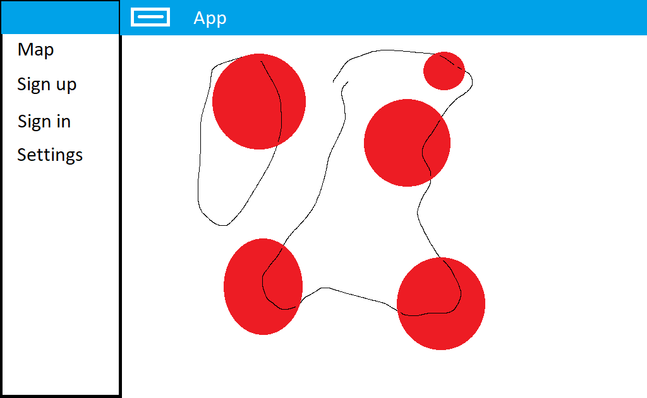
Fig #
This concept resembled a tableau dashboard and that led down the research of how tableau dashboards are utilized and the common features among them such as infographics and charted data. The research led to not only desiring a map but a variety of different charting and bespoke infographic techniques to convey the data with variety.
4.1.2 The infographic
To try and convey the Covid-19 data in an original yet relatable to the cause manner an original infographic was conceptualized. Looking at the hemagglutinin that has been used to visually represent the Covid-19 virus throughout the media, it has become a symbol for identification, and this became the CenterPoint for the idea behind the infographic.


Fig#
Looking at this hemagglutinin if it were to be broken down it would be seen as two different shapes, the inner circle that is the centre of the protein and the leg like shapes on the outside that are receptors. The idea formed that the receptors on the outer edge could be used to represent data in a gauge like manner for example having each leg represent a portion of cases to convey the number of cases out of the total population.

Fig #
In this hand drawn sketch of the concept, the darker triangles are to represent the active cases and the lighter triangles to represent the total cases, to give a gauge like representation and as the active number grows the grey triangles turn to black triangles and vice versa for when the number of active cases decline.

4.1.2 SVG design
The design began with the knowledge that to achieve these types of custom shapes an SVG https://en.wikipedia.org/wiki/Scalable_Vector_Graphics
Will be used to create the shape that can be used within the infographic.
Prototyping the shapes to try and achieve the desired result was a long and arduous process of trial and error at first. Research into the different path types made the process less tedious and utilizing an eclipse shape #9 was produced. 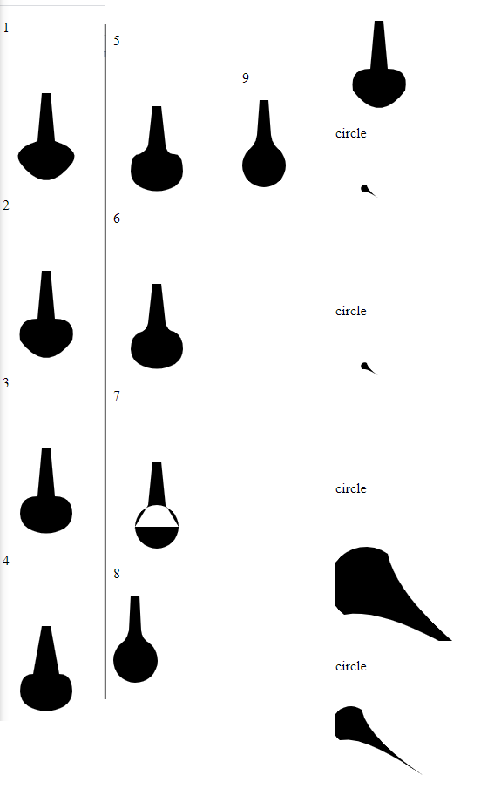
Fig #
Until item #9 was decided to be the most fitting receptor shape creating a path that looked like
Fig #
This SVG path can now be used within the implementation of the infographic along with other basic shapes that will not require path design at this level. This will be essential in implementing the infographic.

4.1.3 Map Design
The map was a familiar concept thanks to the literature reviews vast coverage of similar websites that had implemented a map for conveying the spatial data, knowing that a Geo-Mercator https://github.com/d3/d3-geo style map was planned to be implemented using circles to represent severity using the size scale and colour to help convey the information.
The influence for these types of markers was from the JHU covid map seen in the review of similar websites. The literature review has a section that highlights how colour choices can have a huge impact on emotional decision making and can convey a lot of tone with how colour is interpreted subconsciously, and this ultimately showed how the combination of red on a lighter background will highlight severity in an intense manner.
https://en.wikipedia.org/wiki/Mercator_projection

4.1.4 User interface
The user interface was to follow the standard design principles of a website, with intuitive design and a mobile first approach kept as a priority to ensure a responsive layout was implemented to ensure continuity across devices. This is a key aspect of the development to ensure that the website is usable across a range of devices. https://books.google.co.uk/books?hl=en&lr=&id=fcfarreMQ9sC&oi=fnd&pg=PT12&dq=responsive+design&ots=Zu5eXk_SUl&sig=BaY6PUrBy5bpXJI-lCxPxCzsPBw&redir_esc=y#v=onepage&q=responsive%20design&f=false
The investigation in the literature review of similar website concepts showed that a typical angular implementation already had a high element of responsiveness and the provided tools aided in this. Similar websites used the angular material library tool bar for navigation as a common theme and used card components for a module design. This allows for a modular approach to the overall design, allowing for components to be called as required.

4.1.5 Backend Design
Throughout the design of the backend the most important aspect of it is following the standard REST specification utilizing a token-based authentication method for a stateless interaction.
Using a model, route, controller, and middleware architecture style will help divide the functions up into relevant files that are made for each purpose.
This architecture style will allow for a more human readable and modular programming style that will reduce the size of each individual file and follow an easy to navigate format.
The route will be the publicly accessible URL to the function, the controller will contain the function at the end point and the model will be the interface to the database, in this case a document database and the middleware will be the function that determines if the user attempting to access the route in question is authorised.

4.2 Implementation

4.2.1 Node.js and express server basic CRUD implementation
The research into the development of a web server resulted in the development of a CRUD service using node.js, express and mongo DB. The basic implementation was a strong basis for the expansion and taught the valuable lessons in using the tools of the language to create a basic web service that interacts with a database through REST methods. The first step was installation of node.js and the node package manager and this led to using the command line to install the required dependencies for the project such as express, nodemon and Angular to start with.
https://nodejs.org/en/
https://www.mongodb.com/

Node.js: Using JavaScript to Build High-Performance Network Programs
https://whel-primo.hosted.exlibrisgroup.com/permalink/f/mqg008/TN_cdi_proquest_journals_761013661

Eloquent JavaScript
https://whel-primo.hosted.exlibrisgroup.com/permalink/f/14dj339/44UWTSD_ALMA21165825450002421

4.2.2 User accounts
The preliminary implementation was quickly expanded with the addition of user accounts and middleware.
Initial research was conducted investigating the standard procedures with implementing a user with authentication in an express node.js server and this was furthered by researching JSON web tokens as a means of passing authentication data between the server and client. https://www.sohamkamani.com/blog/javascript/2019-03-29-node-jwt-authentication/#:~:text=The%20JSON%20web%20token%20(JWT,js%20to%20implement%20it.
JWT authentication would allow interaction between the client and server without storing any of the user’s sensitive data on the client and implement a REST service.
At first, it was unclear the safety of storing a JWT in the local storage of concerns this would be unsafe, and a cookie would have been a better alternative, but research contradicted this and reassured the safety of both are equally satisfactory.
https://www.syncfusion.com/blogs/post/best-practices-for-jwt-authentication-in-angular-apps.aspx#:~:text=Cookie%20storage,vulnerable%20to%20CSRF%2FXSRF%20attacks.
Research into authorization showed that an appropriate strategy for server side verification was using middleware for verifying the tokens in the header of each interaction with the server, can verify if the token has been tampered with to ensure validity, once complete allowing the request to continue with its original task.
After some time researching the different types of security for storing user credentials on a database, the investigation resulted in hashing and salting the passwords with tools such as bcrypt. This allowed for a custom amount of security to be applied through “salting” this is how many groups of random characters and symbols are added to the string to obfuscate the original string before it is hashed.
https://whel-primo.hosted.exlibrisgroup.com/permalink/f/mqg008/TN_cdi_gale_infotracacademiconefile_A530153374
A consideration was made about the expenses of holding a document database in the cloud and the costs associated and going over the allocated amount of storage will incur more costs. This resulted in tracking when the account was created and if the account has been confirmed. If the account has not been confirmed it is likely that the user will not be returning, and the account can be marked for removal from the cloud server, not necessarily permanent deletion. This consideration led to the implementation of account confirmation and the relevant additions to the user model.

4.2.2.1 User Accounts, The User Model
The user model is the shape of the data that is stored on the document database, this ensures the data is stored in a certain format using validation and methods to control the shape.
Field | Field description | Field data type | Validation name | Validation description
Email | The users email address | string | required | It cannot be left blank or empty.
Email | The users email address | string | trim | removes any whitespace from the end for the reduction of user error.
Email | The users email address | string | Unique | ensures only 1 exists.
Email | The users email address | string | min length | sets a desired minimum length, ultimately negated by the regex but kept for redundancy.
Email | The users email address | string | Match | using this regex ensures the email is within the standard email format.  /[a-z0-9!#$%&'*+/=?^_`{|}~-]+(?:\.[a-z0-9!#$%&'*+/=?^_`{|}~-]+)*@(?:[a-z0-9](?:[a-z0-9-]*[a-z0-9])?\.)+[a-z0-9](?:[a-z0-9-]*[a-z0-9])?/
Password | The users hashed password | String | required | It cannot be left blank or empty.
Password | The users hashed password | String | min length | sets a desired minimum length, ultimately negated by the regex but kept for redundancy.
Fname | The users first name | String | No validation
Lname | The users last name | String | No validation
Dob | The users date of birth | date | No validation
UserStatus | The users occupation | String | No validation
Created | The date the account was initially created | date | No validation
Confirmed | If the account has been confirmed by the user | Boolean | Required | It cannot be left blank or empty.
 |  |  | Default | defaults to false so when the account is initially created it is of default value “false”
Admin |  | Boolean | Defaults | Also defaults to false, cannot be assigned programmatically, admin will be assigned manually at the DB level.
Sessions | This is the array where the current active sessions are held | Array [3] | Required
Session field [0] 1: Token | The session token generated on successful login. | String | Required | It cannot be left blank or empty.
Session field [1] 2: expires at | When the generated token expires. | date | Required | It cannot be left blank or empty.
Session field [2] 3: device type | The type of device associated with the token | String | Required | It cannot be left blank or empty.
Session field [3] 4: IP | The IP address the token was generated on | String | Required | It cannot be left blank or empty.

https://whel-primo.hosted.exlibrisgroup.com/permalink/f/mqg008/TN_cdi_proquest_reports_215995520

4.2.2.2 The User Model, Instance Methods
The first method uses lodash to omit certain values from any returns of get requests to the user. This method is for ensuring certain values are always removed before data is returned to the user such as a password or session data. https://lodash.com/
The next method is for generating an access token using JWT https://jwt.io/
The third method utilizes crypto to generate a random 64-character session token. https://www.npmjs.com/package/crypto-js
The fourth instance method takes in the “device IP” and “device type” as parameters and then calls the third method that generates a session token and then this method appends an expiry time to the token using the helper method that creates the expiry time.
Then saves the session to the DB using the helper method for saving to the database and then returns the token to the user.

4.2.2.3 The User Model, Model Methods
Many of these methods are for the querying of users in a secure manner.
The first method queries by user id and session token, this is used in the case of granting a new access token.
The second and third methods are used for querying if an email address has already been registered in two different ways.
The fourth and fifth methods find the user by id/email and password, this can be used for logging in.
The final method checks if the session token has expired yet, this is used in verifying validity of the session.

4.2.2.4 The User Model, Model Middleware
This middleware intercepts the save command, before a new user is saved to the database and encrypts the user’s password with 10 rounds of salt.

4.2.2.5 The User Model, Helper Methods
These two helper methods are used in previously mentioned instance methods. First is for saving sessions to the database, then the finally for generating the session tokens expiry time.

4.2.2.6 User sessions, A Vanity Project
user model having an array of sessions that had a randomly generated string for a session token, with an expiry time, the sessions ip and device type collected and associated with the token.
The user on the front end can see the array of active sessions and chose to delete them at their discretion.
Using a session token like this the normal JWT tokens can be used as a short life token and then for refreshing the access token the session/refresh token can be sent to the server along with the user id to get a fresh access token, as the server will check the sent session token with the users array of tokens and if it exists the server can issue a fresh access token. <too long sentence
An alternative approach would have been to use redis to blacklist tokens.

4.2.3 Confirming accounts.
Research was carried out into the implementation of an emailing service called node mailer and to implement this securely a business google account was created for the purpose of the web application.
For confirming the account via email, a prototype was created that could send and receive the response and to achieve this a JWT was attached in the URL sent to the user.
This works by when the user clicks on the received URL in the email it will launch a link that is to be returned to the server with the JWT in the parameters of the URL, when the JWT is received on the server the server uses an approach like middleware that decodes the token, grabs the user’s id from within the token and the patches it to be a confirmed account. Because a JWT is a signed token it is possible to ensure that it has not been tampered with and the correct account is confirmed.

4.2.4 Password reset.
This module works by the user following a link for “forgotten password” on the front end that asks them to enter their current email, the server receives the email and checks if the user has an active account on the database.
Then if a user does not exist return a relevant http status code to the front end to be displayed in a more meaningful error message.
But if a user does exist the server uses the node mailer system implemented for account confirmation to send the user an email with a JWT token embedded in a URL to the users email inbox, Once clicked it will navigate the user to the front end where the token is retrieved from the parameters of the URL.
Then the user is prompted to enter their new password and confirm it using front end validation, then the password and the token are sent to the server, the server then decodes the token to get the user id, queries for the user by id and then patches the account with the new password and then removes all the users’ active sessions so they are remotely logged out wherever else they are signed in.

4.2.5 Admin controls.
For the ease of management of users and in the instance of additional insight being required or a requirement to patch a specific user a selection of routes was developed. These routes have a different type of middleware that checks that the account accessing them are authorized to do so as the nature of these routes.

4.2.6 Building a proxy.
Several routes were implemented for querying different external API end points for the gathering of data for use on the front end. These different endpoints have limitations on them such as rate limits that reduce the number of calls made to them, so utilizing axios a proxy was developed that would also solve a cross origin resource scripting problem and allow the caching and polling from the server. This was an ideal solution to not resulting in no data being fetched due to rate limits. https://www.npmjs.com/package/axios

4.2.7 Middleware
A variety of middleware tools were created for intercepting requests before they reach the relevant controllers, this allows for managing user access and ensure that the relevant authorization was granted before accessing specific areas of the server.

4.2.7.1 Verify Session middleware
The verify session middleware is used to check if the session token is valid, i.e., exists in the sessions of the user on the database and has not expired.

4.2.7.2 Check Authorization middleware
The check AUTH middleware is used to check If the access token is valid using the JWT verify functions it will call verify on the token and decode it, if the verify fails the token has likely expired or has been tampered with.

4.2.7.3 Check Admin Authorization middleware
The admin Auth middleware is used to check if the current user has admin Boolean in their user data set to true. This is stored within the database and can only modified at the root access of the database.

4.2.8 Routes
The routes are divided into 3 key sections.
/API Typically in the user of user’s activities relating to users.
/content The Proxy server routes for caching of data.
/confirm is just for the confirming of a user’s email address.
  - The Api routes
Route | Method | Path | Description | Associated middleware | Controller
/api | get | /all | the query of all users, paginated | admin | adminController
/api | Patch | /:userid | And patching any user by their id. | admin | adminController
/api | post | / Sign-up | for creating an account | Public route | userController
/api | delete | / Delete | for deleting an account | checkAuth | userController
/api | get | /:userid | for retrieving the associated accounts data | checkAuth | userController
/api | get | /resetEmail/:uemail | User sends email address, receives email to follow to enter new password | Public route | pwResetControler
/api | Post | /resetEmail | The new password to be patched to the server | Public route | pwResetControler
/api | get | /sessions/:userid | Gets the users active sessions | checkAuth | userController
/api | delete | /sessions/:userid/remove/:token | Removes a session from the users’ active sessions. | checkAuth | userController
/api | post | /login | Creates a session and grants an access token | Public route | userController
/api | get | /findAvailEmail/:email | Returns a bool | Public route | userController
/api | get | /findByEmail/:email | Returns a bool | Public route | userController
/api | get | /users/me/access-token | Grants an access token if valid session token | verifySession | Nill
  - The content Routes.
Route | Method | Path | Description | Associated middleware | Controller
/content | get | /specialData | In depth per country data | checkAuth | generalStatsController
/content | get | /generalStats | Overall statistics | checkAuth | generalStatsv2Controller
/content | get | /stats | Basic per country stats with coordinates | checkAuth | Jhustatscontroller
/content | get | /map | The map path | checkAuth | Map controller
/content | get | /summaryStats | In depth per country and region data | checkAuth | summaryStats
/content | get | /historic | Historic data, a large volume of data. | checkAuth | Historic

4.3.0 Front end framework
The implementation of the Angular [3] front end framework to build a single page application and the process involved and the additional frameworks added to aid in development.

Factors and actors leading to the adoption of a JavaScript framework
https://whel-primo.hosted.exlibrisgroup.com/permalink/f/mqg008/TN_cdi_gale_infotracacademiconefile_A563697457

When the project began angular was in its 9^{h} version, it is currently in its 11th iteration. The project has survived two major version upgrades during the design phase.
Angular is an incredibly robust full-fledged framework with an immense amount of depth and a wide variety of ways of accomplishing a task.
While adding to an angular implementation anything you require in terms of generation can be achieved through the command line interface and this is an incredibly powerful aspect as you can achieve a lot of work in a very short amount of time using a single command, with parameters to enhance the commands achieving the desired results within a very terse line in the command shell. https://angular.io/cli

Designing with JavaScript : creating dynamic web pages
https://whel-primo.hosted.exlibrisgroup.com/permalink/f/14dj339/44UWTSD_ALMA21167469620002421

4.3.1 Angular material
Angular material is a collection of material design components built by the Angular team to be used seamlessly within angular. It offers customizable, versatile, high-quality components to be used within any angular application. https://material.angular.io/
The implemented components from the material library will be discussed in the dependency section of the report.
Angular material icons can be seen throughout the implementation of the application.
https://material.io/icons/

4.3.1.1 Angular material: Custom theming
All the components within angular material use the default theme provided by standard, and for the sake of simplicity you can create your own theme that overrides the default theme provided. This is a very convenient way of changing the entire theme of the application with a few lines of code as they all share the same theming attributes, Primary, Accent and warn. This allows for changes to be made in mass with very little work required.

4.3.2 Login Component
A login component was created using angular material for the components seen by the user such as the form inputs, the card containing the content and the buttons.
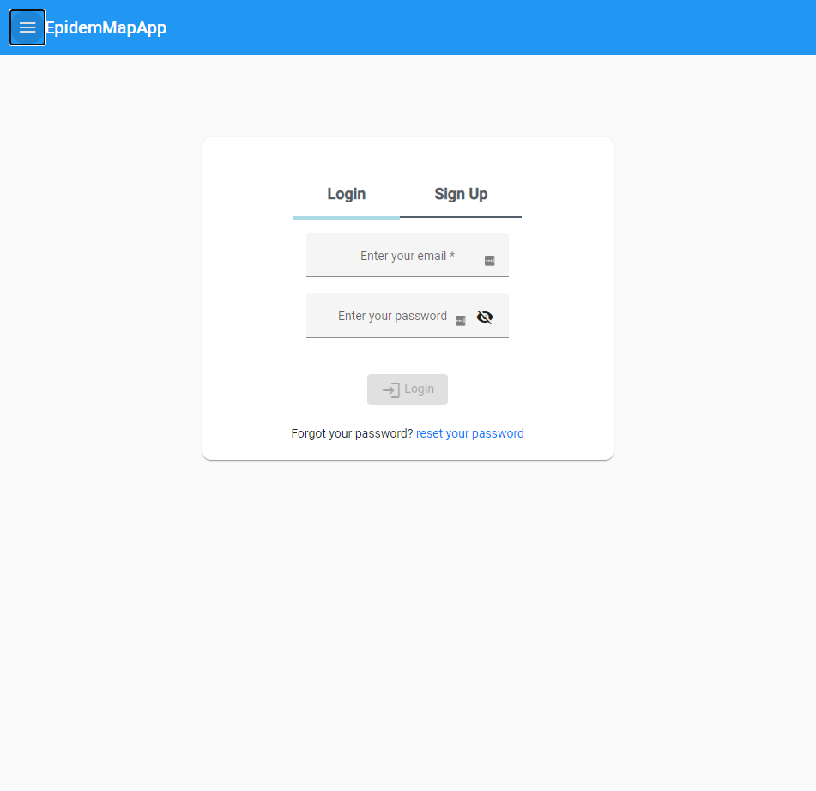
The logic for the form is handled by angular form build and form group services that provide a range of validation tools.
Upon connection to the login component the users IP address and device are captured for the sake of storing within the session array upon successful login, if the user is unable to login successfully this data is not stored.
The login is handled by the Auth service and takes the username, password, IP address and device type as an input and returns a token.
This component is lazy loaded.

4.3.3 Register
The register component utilizes angular material for the components much like the login component with a few additions such as the data selector and an option select box.
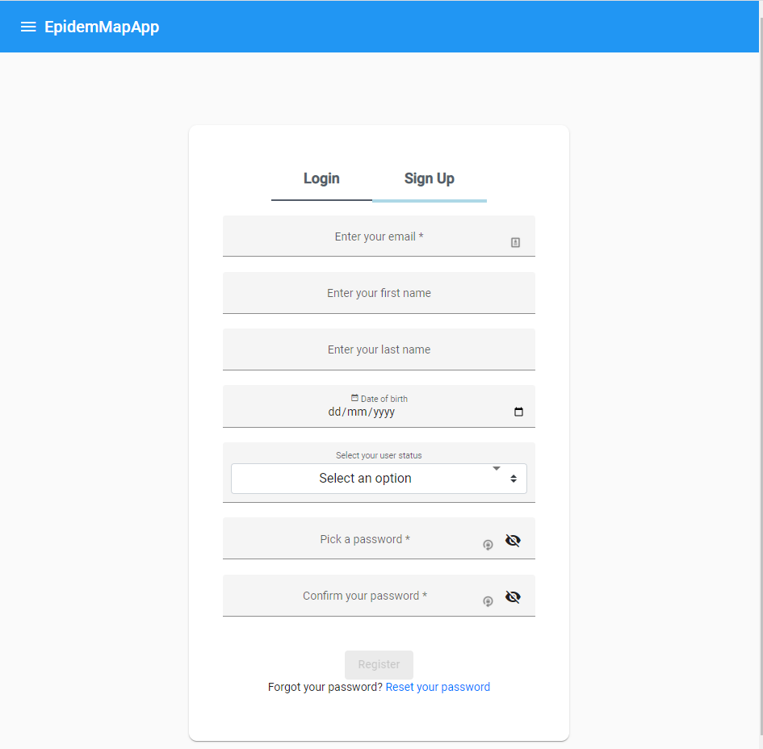
The required fields are marked with an Asterix so the user can streamline the sign-up process by simply opting to not fill out certain values, but at a minimum the user must provide an email address and a password.
The form utilizes angular form builder for validation, and a custom password validator that compares the two passwords to ensure they are identical and checks that their lengths meet the minimum requirements.
Validation on the email field using a custom async email validator that ensures that the email the user is trying to register with is not already registered to the site and that it is within the standard format of an email address before they proceed to fill out the rest of the form.
Validation on the form is to ensure that the form is filled out correctly before being submitted to the server. Upon connection to the sign-up component the users IP address and device are captured for the sake of storing within the session array upon successful registration & login, if the user is unable to register & login successfully this data is not stored.

4.3.4 Auth service
Handles communication with the server regarding logging in and signing up.
Function name | Params | Objective | Method | Route accessed
registerUser | userdata | Posts the users data on to the server. | post | /api/sign-up
loginUser | Email, password | Creates a session on the server and receives access and refresh tokens | post | /api/login
logout |  | Removes tokens from client and deletes session token from the server.
getToken |  | Gets the access token
setToken |  | Sets the access token
isLoggedIn |  | Checks tokens are stored on client
getRefreshToken |  | Gets refresh token
setSession | User id, access token, refresh token | Stores tokens and user id in local storage
removeSession |  | Removes tokens and id from local storage
getUid |  | Gets user id from local storage
getNewToken |  | Queries server for a new access token | get | /api/users/me/access-token`
deleteUser | Password | Deletes account from the server | delete | `${this._URL}/api/${uid}/&/${pw}`
getUserData | User | Gets the users data | get | this._URL + `/api/` + user
removeSessionToken | Token | Deletes a session from the server | delete | `${this._URL}/api/sessions/${_id}/remove/${token}`
getEmail | Email | Checks if an email is already registered on the server | get | `${this._URL}/api/findByEmail/${email}`
sendResetEmail | Email | Sends the server the email address to check if it exists then send the user an email to follow. | get | `${this._URL}/api/resetEmail/${email}`
resetEmail | Token, password | Sends the token and password in the body | get | `${this._URL}/api/resetEmail/`
getActiveSessions | _id | Gets the users current active sessions | get | this._URL + `/api/sessions/` + _id
errorHandler

4.3.5 Token interceptor
The token interceptor looks at all the interactions with the server and monitors the errors and if the server returns a 401 (unauthorized) it will check if the client has tokens in the local storage, and if they do not contain tokens a call to log the user out is made.
If a session token exists it will send the session token to the server to get a new access token. If this call fails, the user is logged out.
Whenever an error leads to a user being logged out the tokens are deleted from the client immediately.
If a fresh token is granted, the original server request is re-attempted with the fresh access token so the user can continue without ever realizing this interaction was happening in the background.

4.3.6 Auth Guard
Auth guard utilizes the auth service function “isLoggedIn()” to check if tokens exist on the client, and with each auth guard protected route it will have a server interaction to get the relevant data, so the tokens are verified on the server.

4.3.7 Navigation
Navigation is performed utilizing the Material component for side navigation, icons and tool bars, the hamburger menu button will reveal this menu. This is eager loaded as it is persistent across the entire application.
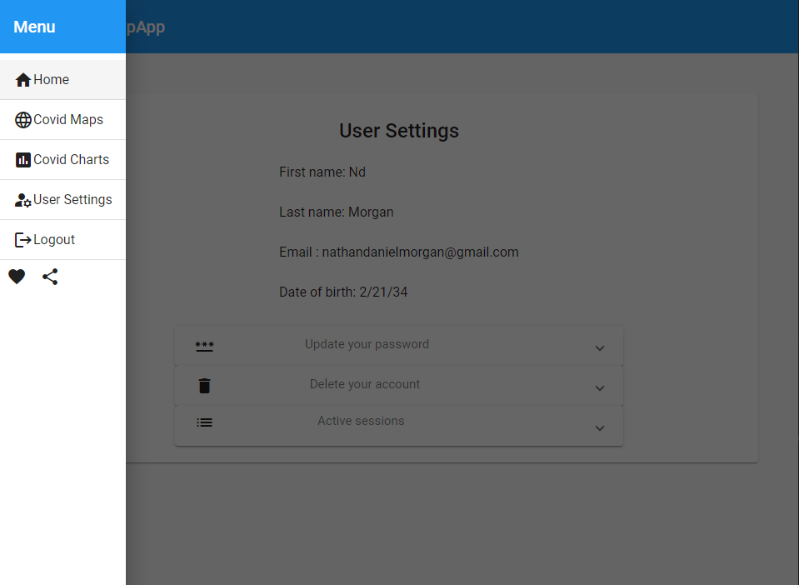
Utilizing the Auth guard to ensure that the user is authenticated before accessing the protected routes, if the user is not authenticated, they see a different variety of options.
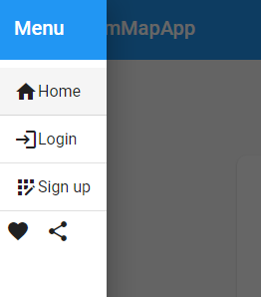

4.3.8 User Settings
In the user settings the user can see all the held data associated with their account and make appropriate changes.
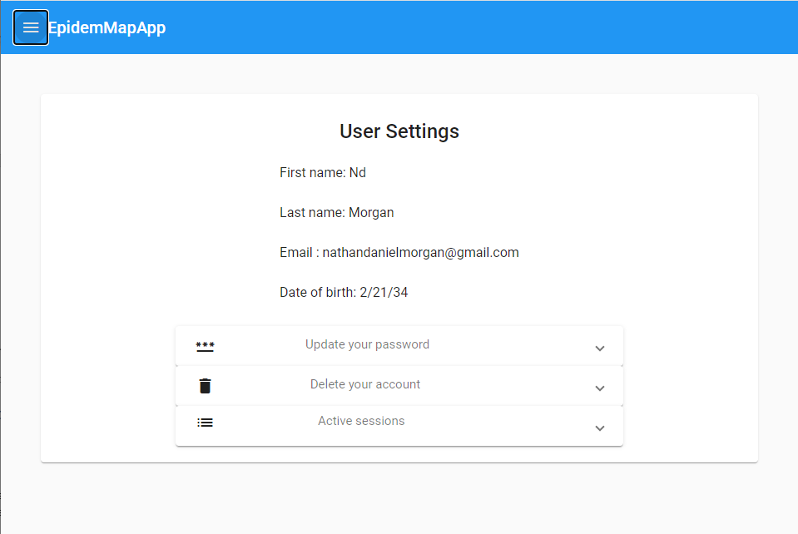

4.3.8.1 Active sessions
In this component, the user can see their active sessions, this means they can see what device type they logged in from, such as mobile, tablet or computer and the associated IP address of the login. Then they have the option to end each session remotely upon click it will prompt the user to confirm their decision. This also utilizes angular material for the pagination and the table. 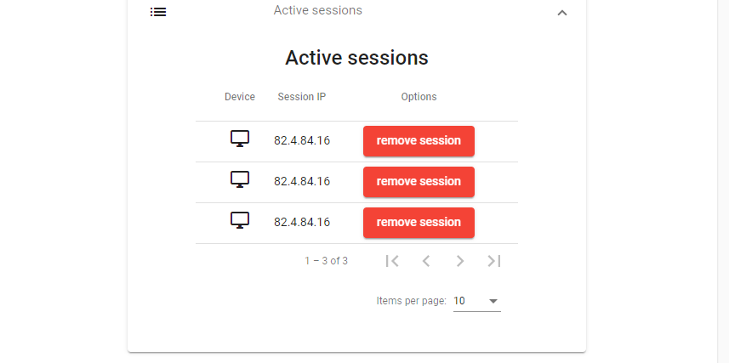
4.3.8.2 Updating password.
This will allow the user to change their current password, this requires them to enter their current password, the password the wish to change to and then confirm the new password, this will then send the two passwords to the back end to be updated.
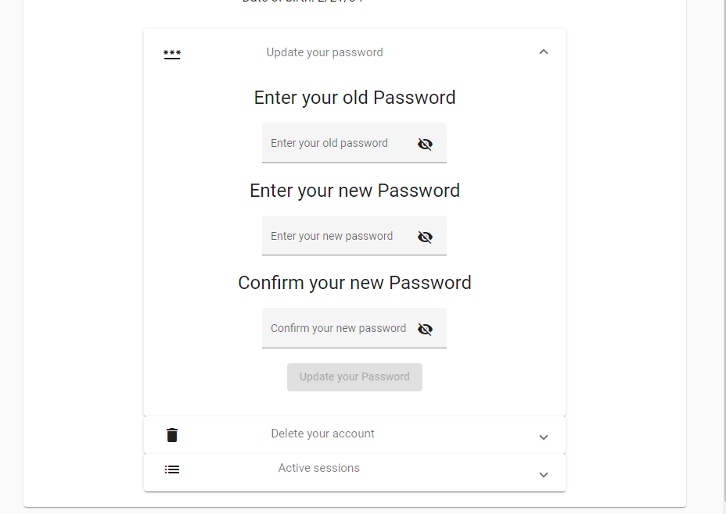

4.3.8.3 Delete account.
This component is quite simply for the deletion of the current account, it will prompt the user to enter their password and then ask them to confirm their decision with a pop up confirmation box.
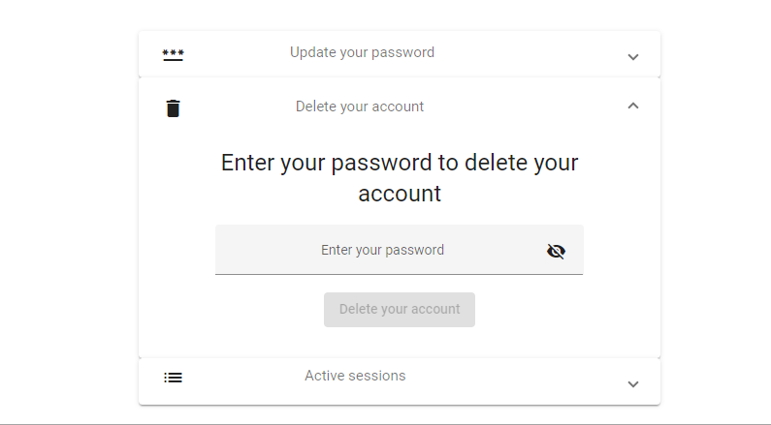

4.3.9 Confirming account module.
This module is comprised of a few components that come together to create a system for the use of confirming the account.

4.3.9.1 “Thank you for confirming.”
The user will receive the email and upon clicking it will bring them to another screen for feedback saying thank you for confirming, and then redirecting them to the login screen.
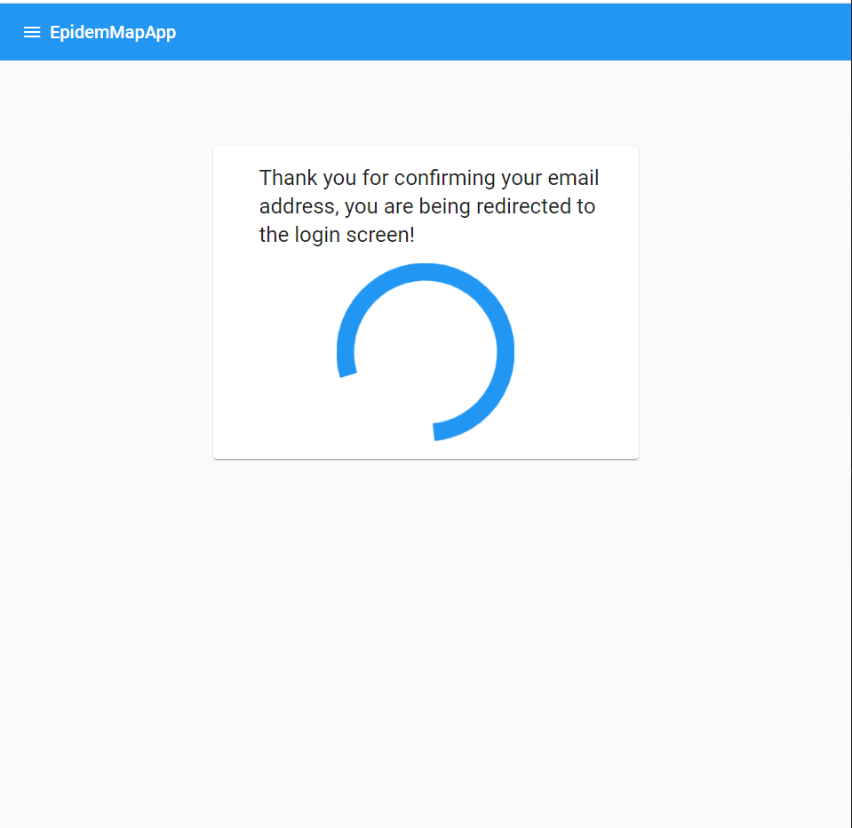

4.3.9.2 Confirmation email sent.
After registration, the server will send the user an email and the front end will present the user with some onscreen feedback 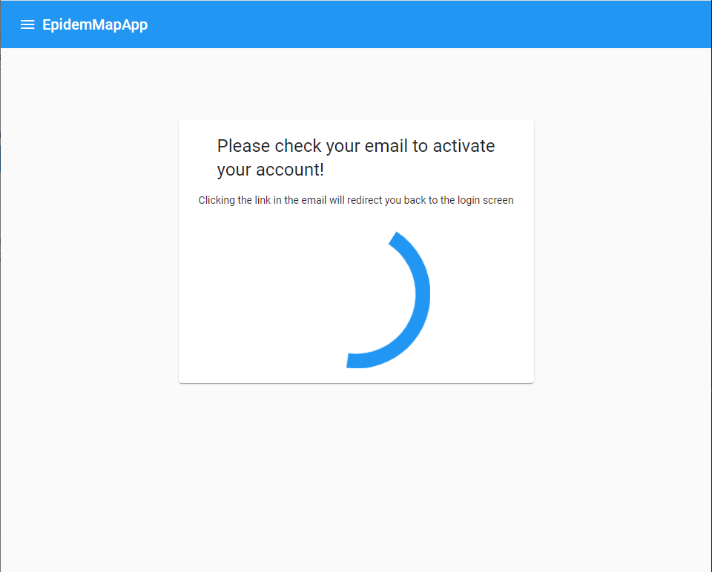

4.3.10 Password reset.
This option on the login and register components directs to a module that takes in an email in the input field.
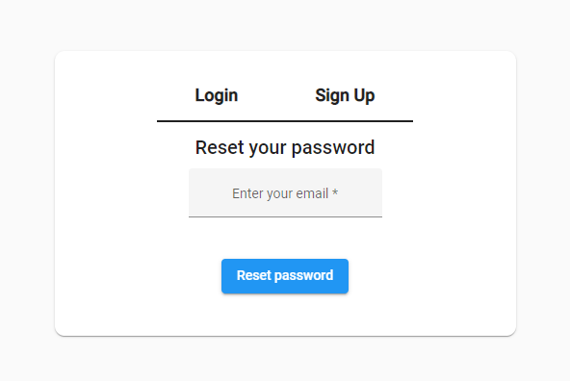
This captured email is sent to the server route for handling password resets, Then the user receives an email with the URL.
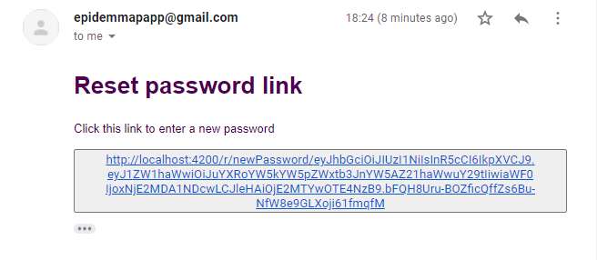
Upon following up the email the user will be navigated to the next password reset page where they enter their new password
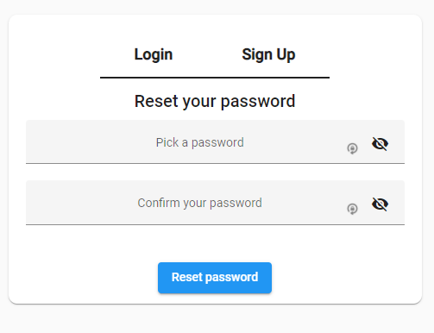
Using client-side validation to ensure the passwords match and are of a suitable strength then it can be passed to the server for patching the users’ details. Upon patch success the user is navigated to the login page.

4.3.11 Lazy Loading and Eager Loading
Within the Angular framework there are many optimizations that can be implemented to improve the performance, with Angular being designed around large-scale implementations of the framework considerations into the way components are loaded.
For the sake of performance Lazy loading was implemented halfway through the development of the application, the process was lengthy, but every component was sorted, with relevant modules generated for the components and then routing was implemented.
The modules are what groups the components. Lazy loading works by loading a module as a component is called into a viewport, where the module can load all the required dependencies, providers, and imports with the component. This compartmentalizes the requirements of the components. https://angular.io/guide/lazy-loading-ngmodules
Alternatively, there is eager loading where everything Is loaded when the page initially loads and keeps it loaded constantly but this is not performant and does not scale up well.
Implementing lazy loading increased overall performance substantially with the visualizations previously taking a considerable amount of time to load individually due to factors such as fetching the data from the server, latency over a wide area network and the end user available computational power.

4.4.0 Visualizations
All visualizations are made using the D3.Js library. D3.Js was investigated through the Literature review and the research methodology and the conclusion was that it was the most powerful library available for making visualizations from scratch using scalable vector graphics. The library offers a huge range of tools that can be used to manipulate the data and display it on the DOM.

4.4.1 Data service
This service is for the interaction with backend and provide the data for the visualizations.
Service name | Service description | Service usage | Service authorization required
GeneralService | In depth per country data | For the infographic seen on the home page | Public
mapService | The map path | For the data on the map. | Registered user
generalStatsService | Basic per country stats with coordinates | For the data on the map. | Registered user
SummaryStatsService | In depth per country and region data | Seen in the scatter and bar chart. | Registered user
generalStatsServicev2 | Overall statistics | Written statistics as seen on the home page | Public
historic | Historic data, a large volume of data. | TBC | Registered user
Fig #

4.4.2 Covid Symbol infographic
This visualization is an original creation that required investigation into the creation of custom shapes using SVG paths, utilizing angular material components for interactivity, the use of tooltips, and an immense amount of iterative prototyping into how to position the receptors and how many receptors to show depending on the data set selected by the user.
The aim of this visualization is to give a comparison of how the current active cases stands up to the overall number of cases, this will give an idea of how the current situation stands.
Throughout the iterations of the implementation the issues faced were of a similar nature and that was how it would scale and look the same with scale, this was a large issue with the scaling of the receptors and experimentation was carried out to try and find a balance to the size and number of receptors to be displayed at a time to find a good balance.
The initial implementation began with the SVG path that was seen in the design section.
Then the SVG canvas was created using the standard D3.Js append method.
Then the data import was written using the data service.
Then the function for calculating the range were created, this was an iterative process as slight adjustments to the range has an impact on the aesthetics of the result.
Then for displaying the number of receptors a function was created that is based on the function for the range, this takes the data and passes it through the function for creating the range and this determines how many receptors are visible out of the total receptors.
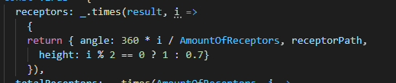
Using this calculation then the scale of the receptor can be alternated to give a varied height for reach receptor, this could have been randomized but the odd and even approach was quite visually appeasing. This snippet of code is then called and appended for each receptor.
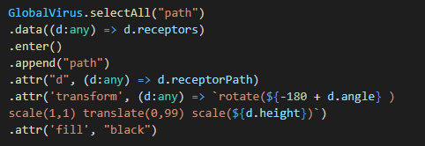
Then a second similar function was created for displaying an outline of the maximum number of receptors, this will be useful for showing a percentage like amount, like currently the UK is 3/14 receptors, and the total receptors is shown with a low opacity outline.
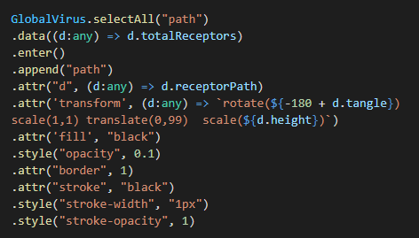
Next a layer with a circle is added directly in the middle, so the receptors have something to connect to and stem out of. Appending to this middle circle text saying “Covid – 19“to add a bit of description to make it more of a recognizable symbol and then appending on top of this several smaller circles added to represent the receptors on the front, to give a more 3d design and add a bit of additional detail to capture the eyes attention.
After the middle section was implement, a legend was created to reflect what data the visualization is representing when the mouse moves over the SVG element the legend appears to the side of the cursor.
Finally, a select box was implemented using angular material so the user can visualize the data for each country individually.

4.4.3 Map
The map carried a lot of the weight of the desired result, and because of this a lot of time was invested in researching the techniques for implementing it and exploring the different frameworks available for displaying spatial data. The literature review covered several books that investigated the implementations of maps for visualizing data, the types of maps that could be used and the types of markers that can be overlayed for representing data, and the different colours used will convey different tones.
In the initial prototypes of the map the real challenges faced were overlaying data accurately and lining up the countries on the map with the data. Another issue was scaling the map with different screen sizes and devices with the overlayed data would prove even more challenging.
The issue was overcome by using a coordinate system that lined up with the maps projection technique with this took some experimentation to find a map system that fit the data correctly, but a system was implemented that would work perfectly and scale as required.
The literature review also alluded to the fact of how responsive a visualization was would have a larger impact on the user and the slightest delay and latency could have a detrimental effect on the usability of the implemented visualization. This put the performance high on the priority list and required a higher level of consideration when implementing.
Initial prototypes suffered with a performance issue that was traced back to the data from the API being in such a grand scale that it took a while to render each point on the map, this was obstacle was ultimately traversed by eliminating the irrelevant data and displaying it with other visualizations.
After an appropriate level of implementation was achieved additional features were added.
The first additional feature that was added was the ability to pan and zoom, this offered a vast amount of interactivity that will benefit the overall engagement of the map.
The next additional feature was the ability to mouse over the different markers on the map. Given the number of markers that contain region and county level data, when hovering a mouse above a marker a popup fades in with additional information.
The final additional feature was to be able to have the markers represent the different available data, this was achieved using angular material tabs for changing the component in the view using a lazy loading technique to minimize performance impact. This has potential to have further varieties such as different styles of map markers.

4.4.4 Scatter & Bar chart
The literature review concluded that a variety of different visualization techniques should be used to deliver the content in a wide variety of formats. This will have an impact on how the data is absorbed and understood.
The process of implementing these visualizations followed a similar approach to previously implemented D3.Js of setting the SVG, defining the resolution and appending the data to the SVG, what made developing the charts unique were the different approaches to the scales and the axis.

CHAPTER 5 – EVALUATION

Evaluation usually comes in one of two forms: either you compare what you did with your objectives, or you can compare what you did with what someone else did.

- What conclusions can be drawn from your data?
- Did your data back up the research in your literature review or disagree with it?
- Did you meet your objectives? If not, why not?
- Did you meet your aim? If not, why not?
- Overall, are the answers what you would expect? If not then why not?
- If you were to do it again, what would you do differently?

CHAPTER 6 - CONCLUSIONS AND RECOMMENDATIONS

- This section should summarise everything you've done
- Does your project suggest any further avenues for research?

This chapter is where you tie up all the loose ends in the previous chapters. It is most important that it relates to what you have described previously, and that it does so in a relevant and concise fashion.

In your summing-up, you need to show how what you did contributed to meeting the objectives you set in the introduction. In doing so, it is appropriate to repeat (in summary form) key points from your review, design, implementation and evaluation as necessary.

Any further work that can, or should, be undertaken to expand upon your work is to be highlighted, fully explained and justified. The benefits gained from your work should be identified (these are not to include personal benefits). Also, any recommendations should be included here.

It is perfectly OK to have some loose ends left at the end of a project. Sometimes there will be aspects you simply did not have time to address. Other times there will be things that you were unable to do because of force of circumstances. Above all, there will have been pointers raised during the course of the project that you did not anticipate and were not within your scope to tackle. All these things can be discussed in this chapter and, where further work can be identified, a distinct sub-section, “Suggestions for further work”, should be included.

CHAPTER 7 – REFLECTION
The key question here is:

- What did you learn while doing the project? How did it change you as a person?

You will need to reflect upon the work that you have done and there is a specific mark allocated to this in the marking scheme. Reflection is the process of looking back at something which has happened in order to show what you have learned from it. The purpose of reflective writing is to help you learn from a particular practical experience. It will help you to make connections between the documented theory and what you did in practice. Through reflection, you should be able to make sense of what you did and help yourself to do a superior job next time. Put simply - could you have done it better and, if so, how?

CHAPTER 8 – REFERENCES
A list of references (work directly quoted or paraphrased in your text) and its source. For more information on this, see Appendices 4 and 5.

[1] | N. J. Obermeyer, The Evolution of Public Participation GIS, 2013.
[2] | M. E. H. Kennedy, Data Visualization in Society, 2020, p. page 21.
[3] | U. Government. [Online]. Available: https://coronavirus.data.gov.uk/details/developers-guide.
[4] | NHS. [Online]. Available: https://developer.api.nhs.uk/coronavirus/api.
[5] | [Online]. Available: https://documenter.getpostman.com/view/10808728/SzS8rjbc#00030720-fae3-4c72-8aea-ad01ba17adf8.
[6] | [Online]. Available: https://corona-virus-stats.herokuapp.com/api/v1/cases/general-stats.
[7] | [Online]. Available: https://coronavirus-19-api.herokuapp.com/countries.
[8] | https://www.interaction-design.org/.
[9] | R. Spence, Information Visualization, 2014, pp. 4.12 Colour, .
[10] | R. Spence, Information Visualization, 2014, p. chapter 1.2.
[11] | R. Spence, “ Comment,” in Information Visualization, 2014, p. chapter 4.13.
[12] | D. I. H. S. Cornelius and S. Carver, “Output: from new maps to enhanced decisions,” in An introduction to geographical information systems, p. Chapter 8 page 284.
[13] | R. Spence, “Z-thru mapping,” in Information Visualization, 2014, p. chapter 7.4.2.
[14] | D. I. H. S. Cornelius and S. Carver, “Output: from new maps to enhanced decisions,” in An introduction to geographical information systems, 2011, p. chapter 8 Page 258 .
[15] | S. Few, “ Pictures for the Eyes and Mind,” in The Encyclopaedia of Human-Computer Interaction, 2nd Ed. , p. Chapter 35.2.
[16] | R. Spence, “Introduction,” in Information Visualization, 2014, p. Chapter 1.2.
[17] | R. Spence, “Conclusion,” in Information Visualization, 2014, p. chapter 2.9.
[18] | H. K. a. M. Engebretsen, “1. Introduction: The relationships between graphs, charts, maps and meanings, feelings, engagements,” in Data Visualization in Society, 2020.
[19] | R. Spence, “A graphic is a moment in the process of decision making,” in Information Visualization, 2014, p. chapter 2.1.
[20] | R. Spence, “An outbreak of cholera,” in Information Visualization, 2014, p. Chapter 1.5.4.
[21] | D. I. H. S. Cornelius and S. Carver, “Chapter 8: from new maps to enhanced decisions,” in An introduction to geographical information systems, 2011, p. 284 chapter 8.
[22] | D. I. H. S. Cornelius and S. Carver, “chapter 8: Output: from new maps to enhanced decisions introduction,” in An introduction to geographical information systems, 2011, p. 258.
[23] | D. I. H. S. Cornelius and S. Carver, “Chapter 1- what is GIS: output capabilities such as maps, graphs and address lists and summary statistics,” in An introduction to geographical information systems, p. chapter 1 page 18.
[24] | L. Li, “5 Main Usages for Distinction of Chart Types,” 2018. [Online]. Available: https://medium.com/@Lynia_Li/as-you-know-there-are-many-types-of-charts-to-be-used-in-data-visualization-54da9b97092e.
[25] | microsoft. [Online]. Available: https://visualstudio.microsoft.com/.
[26] | brackets. [Online]. Available: http://brackets.io/.
[27] | atom. [Online]. Available: https://atom.io/.
[28] | M. Bostock. [Online]. Available: https://d3js.org/.
[29] | chartjs, [Online]. Available: https://www.chartjs.org/.
[30] | python flask, [Online]. Available: https://flask.palletsprojects.com/en/1.1.x/.
[31] | leaflet.js, [Online]. Available: https://leafletjs.com/.
[32] | MapBox. [Online]. Available: https://www.mapbox.com/.
[33] | O. s. maps. [Online]. Available: https://www.openstreetmap.org/#map=5/57.065/-4.768.
[34] | esri. [Online]. Available: https://www.esri.com/en-us/home.
[35] | Google. [Online]. Available: https://www.google.com/search?rlz=1C1GCEA_enGB873GB873&sxsrf=ALeKk01yks-Gl3fak0fWVbekwei1E3XJKw%3A1609515570923&ei=MkLvX6z3N5eAhbIP1qCKuAU&q=covid+map&oq=covid+map&gs_lcp=CgZwc3ktYWIQAzIECCMQJzIFCAAQkQIyCggAELEDEBQQhwIyAggAMggIABCxAxCDATICCAAyAggAMggIABCx.
[36] | p. t. a. p. h. wales. [Online]. Available: https://public.tableau.com/profile/public.health.wales.health.protection#!/vizhome/RapidCOVID-19virology-Public/Headlinesummary.
[37] | jhu. [Online]. Available: https://coronavirus.jhu.edu/map.html.
[38] | arcgis. [Online]. Available: https://www.arcgis.com/index.html.
[39] | The New York Times, [Online]. Available: https://www.nytimes.com/interactive/2020/world/coronavirus-maps.html.
[40] | G. Angular. [Online]. Available: https://angular.io/start.
[41] | D. Bank. [Online]. Available: https://developer.db.com/.
[42] | “Forbes,” [Online]. Available: https://www.forbes.com/?sh=50b0d87e2254 .
[43] | “Github,” [Online]. Available: https://github.community/ .
[44] | “Blender,” [Online]. Available: https://video.blender.org/videos/trending?sort=-trending&page=1 .
[45] | D. I. H. S. Cornelius and S. Carver, An introduction to geographical information systems, Harlow : Prentice Hall, 2011.
[46] | arcgis. [Online]. Available: https://www.arcgis.com/apps/MapJournal/index.html?appid=ccb20fdda2d54a69a2526213b4d5b10f.
[47] | D. Crockford, “ "the JavaScript Object Noation",” Internet Engineering Task Force (IETF) , december 2017. [Online]. Available: https://tools.ietf.org/html/rfc8259#page-16.
[48] | gov, “gdpr,” [Online]. Available: https://gdpr-info.eu/.
[49] | R. T. fielding, “Chapter 5 part 0,” 2000. [Online]. Available: https://www.ics.uci.edu/~fielding/pubs/dissertation/rest_arch_style.htm.
[50] | R. T. Fielding, “Hypertext Transfer Protocol (HTTP/1.1): Semantics and Content Section 4,” Internet Engineering Task Force , June 2014. [Online].
[51] | R. T. Fielding, “Section 5.1.3,” 2000. [Online]. Available: https://www.ics.uci.edu/~fielding/pubs/dissertation/rest_arch_style.htm#sec_5_1_3.
[52] | IEEE, “Standards for Electronics for consumer goods and antennas,” [Online].
[53] | IEEE. [Online]. Available: https://ieeexplore.ieee.org/abstract/document/5617064.
[54] | IET, “Rules of conduct,” [Online]. Available: https://www.theiet.org/about/governance/rules-of-conduct/.
[55] | w. n. js, “wiki node js,” [Online]. Available: https://en.wikipedia.org/wiki/Node.js.
[56] | i. c. office, “Guide to the general data protection regulation GDPR,” [Online]. Available: https://assets.publishing.service.gov.uk/government/uploads/system/uploads/attachment_data/file/711097/guide-to-the-general-data-protection-regulation-gdpr-1-0.pdf.

[figure 1 John Hopkins university map]
[figure 2 London underground map https://www.theverge.com/2015/11/11/9712376/london-walk-tube-underground-map]
[figure 3 An I845 map of London's Soho district, showing deaths from cholera and the locations of water pumps Source: Tufte (l983) https://www.edwardtufte.com/tufte/]
[figure 4 table of features of the websites under review]
[figure 5 Public tableau Public Health Wales: Rapid Covid-19 virology: - pros and cons]
[figure 6 Public tableau Public Health Wales: Rapid Covid-19 virology: - table]
[figure 7 Public tableau Public Health Wales: Rapid Covid-19 virology: - Number of COVID-19 testing episodes and positive proportion, by Local Authority of residence]
[figure 8 Public tableau Public Health Wales: Rapid Covid-19 virology: - Map]
[figure 9 Public tableau Public Health Wales: Rapid Covid-19 virology: - Histogram of confirmed cases by sample date]
[figure 10 Public tableau Public Health Wales: Rapid Covid-19 virology: - stem and leaf diagram]
[figure 11 Public tableau Public Health Wales: Rapid Covid-19 virology: - table of data showing colour choices]
[ figure 12 table of john Hopkins university of medicine: - pros and cons]
[figure 13 table of john Hopkins university of medicine: - map]
[figure 14 table of john Hopkins university of medicine: - screenshot of web page]
[ figure 15 Google pros and cons]
[ figure 16 google screenshot of the page]
[figure 17 New York Times: Coronavirus world map: tracking the global outbreak pros and cons]
[figure 18 New York Times: Coronavirus world map: tracking the global outbreak line and bar chart]
[figure 19 New York Times: Coronavirus world map: tracking the global outbreak map hotspots]
[ figure 20 New York Times: Coronavirus world map: tracking the global outbreak map total cases]
Figure 21 Deutsch bank nav bar
Figure 22 Deutsch bank card content
Figure 23 Forbes nav bar
Figure 24 Forbes card content

CHAPTER 9 – BIBLIOGRAPHY
A list of background reading undertaken, but not necessarily directly quoted in the text.

https://aihubprojects.com/visualizing-predicting-corona-cases/
https://www.amcharts.com/demos/#maps
https://whel-primo.hosted.exlibrisgroup.com/permalink/f/mqg008/TN_cdi_doaj_primary_oai_doaj_org_article_78ca7421005a4f13a2019a2623900a13 for research

https://whel-primo.hosted.exlibrisgroup.com/primo-explore/fulldisplay?docid=TN_cdi_doaj_primary_oai_doaj_org_article_1673144815a949788a3c73d49c365bdf&vid=44WHELF_UWTSD_VU1&search_scope=CSCOP_EVERYTHING&tab=tab1&lang=en_US&context=PC
[https://www.ejgm.co.uk/download/perceived-risk-of-covid-19-pandemic-the-role-of-public-worry-and-trust-7856.pdf ]
[ https://www.interaction-design.org/literature/book/the-encyclopedia-of-human-computer-interaction-2nd-ed/user-experience-and-experience-design?r=dr_nik_whitehead ]
https://www.interaction-design.org/literature/book/the-encyclopedia-of-human-computer-interaction-2nd-ed/data-visualization-for-human-perception?r=dr_nik_whitehead ]
https://whel-primo.hosted.exlibrisgroup.com/primo-explore/fulldisplay?docid=44UWTSD_ALMA21190153950002421&context=L&vid=44WHELF_UWTSD_VU1&lang=en_US&search_scope=CSCOP_EVERYTHING&adaptor=Local%20Search%20Engine&tab=tab1&query=any,contains,Node%20js&offset=0
https://whel-primo.hosted.exlibrisgroup.com/permalink/f/mqg008/TN_cdi_pubmedcentral_primary_oai_pubmedcentral_nih_gov_3624812
https://whel-primo.hosted.exlibrisgroup.com/permalink/f/mqg008/TN_cdi_gale_infotracacademiconefile_A563697457

Dependencies & their uses (APPENDIX)
node.js the server’s engine, built upon chromium v8. https://nodejs.org/en/
Express: makes the creation of a REST service fast to implement, as it essentially wraps all the functions into a fast to implement shorthand equivalent. https://expressjs.com/
Mongoose: for interacting with the mongo dB. https://mongoosejs.com/
Morgan: for debugging while in development.
https://www.digitalocean.com/community/tutorials/nodejs-getting-started-morgan
https://www.npmjs.com/package/morgan ,
nodemon installed for restarting the server after making changes.
https://www.npmjs.com/package/nodemon ,
helmet for helping secure by setting http headers https://www.npmjs.com/package/helmet ,
body-parser (for molding the responses to a json format) https://www.npmjs.com/package/body-parser ,
cors allows for cross origin resources scripting. https://www.npmjs.com/package/cors
Node mailer: for sending emails
https://nodemailer.com/about/
https://youtu.be/EzNcBhSv1Wo
Process env: Using dot env to create a .env file, this allowed for the storage of any sensitive variables that you would not want to upload directly to a host or GitHub etc, most hosts will have their own implementation of this and because of this we will typically redact this file from the upload and manually enter these variables wherever they are required. https://www.npmjs.com/package/dotenv
Angular animations: for the various animations seen by default in angular.
Angular forms: A replacement for the standard html form that has extra utility such as validation and form control.
Angular material: the library that has many additional modules.
Angular router: the navigation module
d3: as previously mentioned in the literature review this framework is the backbone of visualizations. https://d3js.org/
lodash: this is a utility library that has lots of minor functions https://lodash.com/
ngx-device-detector: used for detecting the device type https://www.npmjs.com/package/ngx-device-detector
rxjs: often used in interacting with observables https://rxjs-dev.firebaseapp.com/guide/overview
topojson: the map data in a json format https://github.com/topojson/topojson
axios: this package is used for querying the api’s within the backend. https://www.npmjs.com/package/axios
bcrypt: used for hasing and salting the passwords before saving them to the database. https://www.npmjs.com/package/bcrypt
jsonwebtoken: the JWT’s are a type of token generated for communicating between the client and the server in a stateless manner. https://jwt.io/
rand-token: used in generating a random token for the session tokens. https://www.npmjs.com/package/rand-token

Material Modules (APPENDIX)
These are all the material components that have been implemented.
MatBadgeModule https://material.angular.io/components/badge/overview
MatSliderModule https://material.angular.io/components/slider/overview
MatButtonModule https://material.angular.io/components/button/overview
MatIconModule https://material.angular.io/components/icon/overview
MatProgressSpinnerModule https://material.angular.io/components/progress-spinner/overview
MatListModule https://material.angular.io/components/list/overview
MatMenuModule https://material.angular.io/components/menu/overview
MatFormFieldModule https://material.angular.io/components/form-field/overview
MatInputModule https://material.angular.io/components/input/overview
MatCardModule https://material.angular.io/components/card/overview
MatDividerModule https://material.angular.io/components/divider/overview
MatPaginatorModule https://material.angular.io/components/paginator/overview
MatSidenavModule https://material.angular.io/components/sidenav/overview
MatToolbarModule https://material.angular.io/components/toolbar/overview
MatTableModule https://material.angular.io/components/table/overview
MatSnackBarModule https://material.angular.io/components/snack-bar/overview
MatDialogModule https://material.angular.io/components/dialog/overview
MatExpansionModule https://material.angular.io/components/expansion/overview
MatSelectModule https://material.angular.io/components/select/overview
MatGridListModule https://material.angular.io/components/grid-list/overview
MatTabsModule https://material.angular.io/components/tabs/overview
MatTooltipModule https://material.angular.io/components/tooltip/overview
MatDatepickerModule https://material.angular.io/components/datepicker/api

Definitions
UIX – user interface experience
GUI – Graphical user interface
GIS - Geographic Information System
API – Application programming interface
DOM

